# Australian COmmission on Safety and Quality in Health Care logo with Radar imageOn the Radar

Issue 240

14 September 2015

*On the Radar* is a summary of some of the recent publications in the areas of safety and quality in health care. Inclusion in this document is not an endorsement or recommendation of any publication or provider. Access to particular documents may depend on whether they are Open Access or not, and/or your individual or institutional access to subscription sites/services. Material that may require subscription is included as it is considered relevant.

*On the Radar* is available online, via email or as a PDF document from <http://www.safetyandquality.gov.au/publications-resources/on-the-radar/>

If you would like to receive *On the Radar* via email, you can subscribe on our website <http://www.safetyandquality.gov.au/> or by emailing us at H[Umail@safetyandquality.gov.auU](mailto:mail@safetyandquality.gov.au).   
You can also send feedback and comments to H[Umail@safetyandquality.gov.auU](mailto:mail@safetyandquality.gov.au).

For information about the Commission and its programs and publications, please visit <http://www.safetyandquality.gov.au>

You can also follow us on Twitter @ACSQHC.

**On the Radar**

Editor: Dr Niall Johnson [niall.johnson@safetyandquality.gov.au](mailto:niall.johnson@safetyandquality.gov.au)

Contributors: Niall Johnson, Alice Bhasale, Catherine Marshall

**Books**

*Comprehensive Cancer Care for Children and Their Families: Summary of a Joint Workshop by the Institute of Medicine and the American Cancer Society*

Institute of Medicine

Nass SJ, Patlak M, editors

Washington, DC: The National Academies Press; 2015. 126 p.

|  |  |
| --- | --- |
| URL | <http://www.nap.edu/catalog/21754/comprehensive-cancer-care-for-children-and-their-families-summary-of> |
| Notes | In March 2015, the National Cancer Policy Forum of the [US] Institute of Medicine and the American Cancer Society co-hosted a workshop looking at specific opportunities and suggestions for driving optimal care delivery supporting survival with high quality of life. The workshop attendees discussed and developed a menu of options for action to improve research, quality of care, and outcomes for paediatric cancer patients and their families. Parents of children with cancer and paediatric cancer survivors shared their experiences with care and provided personal perspectives on specific quality of life concerns and support needs for children and families across the life spectrum. This report summarises the presentations and discussion of the workshop. |

**Journal articles**

*Suboptimal medication-related quality of care preceding hospitalisation of older patients*

Caughey GE, Kalisch Ellet LM, Goldstein S, Roughead EE

Medical Journal of Australia. 2015;203(5):220.

|  |  |
| --- | --- |
| DOI | <http://dx.doi.org/10.5694/mja14.01479> |
| Notes | The authors developed evidence-based medication-related quality of care indicators and applied them to 5 years of Australian Government Department of Veterans’ Affairs administrative claims data. The study aimed to investigate the prevalence of suboptimal medication-related processes of care that preceded hospitalisation of older patients. Of 21 indicators, 13 were based on Level I evidence.  Of the total 164 813 hospitalisations, 25.2% (41 546 hospitalisations) were preceded by suboptimal medication-related processes of care.  At least one in 10 hospitalisations for chronic heart failure, ischaemic stroke, asthma, gastrointestinal ulcer or bleeding, fracture, renal failure or nephropathy, hyperglycaemia or hypoglycaemia were preceded by suboptimal medication-related processes of care.  The frequency of a medicine with adverse effects that increased the risk of falls, before hospitalisation for a fracture was particularly high (85.4%).  The authors highlight the need to review appropriate prescribing of these medications for older people, who may be particularly vulnerable to their adverse effects. The potential for routine prospective monitoring of trends in suboptimal processes of care associated with medicine use as a tool for both monitoring and improving health system performance is discussed. |

For information on the Commission’s work on medication safety, see <http://www.safetyandquality.gov.au/our-work/medication-safety/>

*Health Affairs*

1 September 2015; Vol. 34, No. 9

|  |  |
| --- | --- |
| URL | <http://content.healthaffairs.org/content/34/9.toc> |
| Notes | A new issue of *Health Affairs* has been published, with the theme ‘Noncommunicable Diseases: The Growing Burden’. Articles in this issue of *Health Affairs* include:   * The Growing Burden Of **Noncommunicable Diseases** (Alan R Weil) * Renewed Prescriptions For An Old Remedy: **Physical Activity** (D Tuller) * **Noncommunicable Diseases**: Three Decades Of Global Data Show A Mixture Of Increases And Decreases In **Mortality Rates** (Mohammed K Ali, Lindsay M Jaacks, Alysse J Kowalski, Karen R Siegel, and M Ezzati) * An Integrated Framework For The Prevention And Treatment Of **Obesity** And Its Related Chronic Diseases (William H Dietz, Loel S Solomon, Nico Pronk, Sarah K Ziegenhorn, M Standish, M M Longjohn, D D Fukuzawa, I U Eneli, L Loy, N D Muth, E J Sanchez, J Bogard, and D W Bradley) * Understanding The Relationships Between **Noncommunicable Diseases**, Unhealthy **Lifestyles**, And Country **Wealth** (Thomas J Bollyky, Tara Templin, Caroline Andridge, and Joseph L Dieleman) * Neighborhood Factors During **Adolescence**: Modest Effects On Cardiovascular Risk, Small Impact On Obesity And Depression (Jason M Fletcher and Stephen M McLaughlin) * Framing Progress In Global Tobacco Control To Inform **Action On Noncommunicable Diseases** (Heather L Wipfli and Jonathan Samet) * **Innovations In Diabetes Care** Around the World: Case Studies Of Care Transformation Through Accountable Care Reforms (Andrea Thoumi, Krishna Udayakumar, Elizabeth Drobnick, A Taylor, and M McClellan) * **Integrating Mental Health In Care For Noncommunicable Diseases**: An Imperative For Person-Centered Care (Vikram Patel and Somnath Chatterji) * Key Features Of **Peer Support In Chronic Disease Prevention And Management** (Edwin B Fisher, Juana Ballesteros, Nivedita Bhushan, Muchieh M Coufal, Sarah D Kowitt, A Manuela McDonough, Humberto Parada, Jennifer B Robinette, Rebeccah L Sokol, P Y Tang, and D Urlaub) * Living In A Country With A **Strong Primary Care System** Is Beneficial To People With **Chronic Conditions** (Johan Hansen, Peter P. Groenewegen, Wienke G W Boerma, and Dionne S Kringos) * **Cardiovascular Disease Screening** By Community Health Workers Can Be Cost-Effective In Low-Resource Countries (Thomas Gaziano, Shafika Abrahams-Gessel, Sam Surka, Stephen Sy, Ankur Pandya, Catalina A Denman, Carlos Mendoza, Thandi Puoane, and Naomi S Levitt) * A Review Of Innovative International **Financing Mechanisms To Address Noncommunicable Diseases** (Ankita Meghani and Sanjay Basu) * Five Policy Levers To Meet The **Value Challenge In Cancer Care** (Ryan Callahan and Ara Darzi) * Medical Myths: Unprepared For The End Stages Of **End-Stage Kidney Disease** (Farrin A. Manian) |

*Australian Journal of Primary Health*

Volume 21(3) 2015

|  |  |
| --- | --- |
| URL | <http://www.publish.csiro.au/nid/261/issue/7503.htm> |
| Notes | A new issue of *Australian Journal of Primary Health* has been published. Articles in this issue of *Australian Journal of Primary Healt*h include:   * Importance of c**ommunity engagement** in **primary health care**: the case of Afghan refugees (I-Hao Cheng, Sayed Wahidi, Shiva Vasi and S Samuel) * **Service planning** in the Victorian community health sector (Véronique Roussy and Charles Livingstone) * **Access to medication and pharmacy services** for resettled refugees: a systematic review (Kim Bellamy, Remo Ostini, N Martini and T Kairuz) * Changing practice to support **self-management and recovery in mental illness**: application of an implementation model (Melanie Harris, Phil Jones, Marie Heartfield, Mary Allstrom, J Hancock, S Lawn and M Battersby) * **Emergency department mental health presentations** by people born in refugee source countries: an epidemiological logistic regression study in a Medicare Local region in Australia (Joanne C. Enticott, I-Hao Cheng, Grant Russell, Josef Szwarc, George Braitberg, Anne Peek and G Meadows) * Are we adequately providing support services for **optimal infant nutrition** in Australia? A study in regional NSW (Jessica Hegedus and Judy Mullan) * Evaluating the prevention of premature cessation of exclusive **breastfeeding** in the general practice setting during the scheduled child immunisation consultation: a pilot study (Jennifer Ayton, Faline Howes, Emily Hansen and Mark Nelson) * Searching for answers and validation: Australian women’s experiences of coping with the **adverse sexual effects of antidepressants** (Cathy O'Mullan, Maryanne Doherty, Rosemary Coates and P. J. Matt Tilley) * A mystery caller evaluation of **emergency contraception supply practices** in community pharmacies in Victoria, Australia (Safeera Y. Hussainy, Kay Stewart and My-Phuong Pham) * Health actions prompted by **health assessments for people with intellectual disability** exceed actions recorded in general practitioners' records (Jacqueline H. Byrne, Robert S. Ware and Nicholas G. Lennox ) * Feasibility of an intervention to enhance **preventive care for people with low health literacy** in primary health care (Nighat Faruqi, Jane Lloyd, Raghib Ahmad, Lin-Lee Yeong and Mark Harris) * Health and social correlates of Internet use for diabetes information: findings from Australia’s **Living with Diabetes Study** (Chi-Wai Lui, Joseph R. Coll, Maria Donald, Jo Dower and Frances M. Boyle) * Tobacco use among urban Aboriginal Australian young people: a qualitative study of reasons for smoking, barriers to cessation and motivators for **smoking cessation** (Suzanne Cosh, Kimberley Hawkins, Gemma Skaczkowski, David Copley and Jacqueline Bowden) * **Patients’ experiences** of the management of **lower back pain** in general practice: use of diagnostic imaging, medication and provision of self-management advice (Mariko Carey, Heidi Turon, Stacy Goergen, Rob Sanson-Fisher, Sze Lin Yoong and Kay Jones) * **Consumer satisfaction** with **practice nursing**: a cross-sectional survey in New Zealand general practice (Elizabeth Halcomb, Deborah Davies and Yenna Salamonson) * Recruiting general practitioners as participants for **qualitative and experimental primary care studies** in Australia (Shannon McKinn, Carissa Bonner, Jesse Jansen and Kirsten McCaffery) * **Interprofessional learning** in **residential aged care**: providing optimal care for residents (Karla L. Seaman, Caroline E. Bulsara and Rosemary D. Saunders) |

*BMJ Quality and Safety* online first articles

|  |  |
| --- | --- |
| URL | <http://qualitysafety.bmj.com/content/early/recent> |
| Notes | *BMJ Quality and Safety* has published a number of ‘online first’ articles, including:   * **Patient safety incident reporting**: a qualitative study of thoughts and perceptions of experts 15 years after ‘To Err is Human’ (Imogen Mitchell, Anne Schuster, Katherine Smith, Peter Pronovost, Albert Wu) * The problem with **incident reporting** (Carl Macrae) * **Work conditions, mental workload and patient care quality**: a multisource study in the **emergency department** (Matthias Weigl, Andreas Müller, Stephan Holland, Susanne Wedel, Maria Woloshynowych) * Reducing the number and impact of outbreaks of **nosocomial viral gastroenteritis**: time-series analysis of a multidimensional quality improvement initiative (Caroline Mitchell, Paul Meredith, Matthew Richardson, Peter Greengross, Gary B Smith) * **Sleep deprivation** and **starvation** in hospitalised patients: how medical care can harm patients (Tim Xu, Elizabeth C Wick, Martin A Makary) * Implementation of a quality improvement initiative to reduce **daily chest radiographs** in the intensive care unit (Eric Sy, Michael Luong, Michael Quon, Y Kim, S Sharifi, M Norena, H Wong, N Ayas, J Leipsic, P Dodek) * Electronic health record-based triggers to detect **adverse events** after outpatient **orthopaedic surgery** (Mariano E Menendez, Stein J Janssen, David Ring) |

*International Journal for Quality in Health Care* online first articles

|  |  |
| --- | --- |
| URL | <http://intqhc.oxfordjournals.org/content/early/recent?papetoc> |
| Notes | *International Journal for Quality in Health Care* has published a number of ‘online first’ articles, including:   * A multimodal intervention to improve **hand hygiene in ICUs** in Buenos Aires, Argentina: a stepped wedge trial (Viviana Rodriguez, Carolina Giuffre, Silvia Villa, Griselda Almada, Nittita Prasopa-Plaizier, Monica Gogna, Luz Gibbons, Ezequiel Elorrio GarcÍa, The Argentinian Group Hand Hygiene Improvement) |

**Online resources**

*Clinical Communiqué*

Victorian Institute of Forensic Medicine

Volume 2 Issue 3 September 2015

<http://www.vifmcommuniques.org/volume-2-issue-3-september-2015/>

*Clinical Communiqué* is a newsletter written by clinicians, using a case-study approach to report on lessons learned from deaths investigated by the Coroners’ Court.

This edition explores the subject of fitness to drive. As noted in the editorial, “This is an area of practice that is pertinent to every healthcare professional and is not solely limited to a small group of medical experts whose role it is to determine a person’s suitability to hold a licence. Whether a patient is fit to drive is a clinical question, which should be posed every time we see a patient, whether in an acute hospital, outpatient, or general practice setting.”

*[UK] Communications in health care improvement - a toolkit*

<http://www.health.org.uk/collection/communications-health-care-improvement-toolkit>

The [UK] Health Foundation have produced this online communications toolkit for health care improvement. The toolkit’s guidance and resources are designed to help health workers tell people about their improvement work, engage with stakeholders and spread their successes. The toolkit is written for health care professionals working in improvement who want to understand and use communications to better plan, implement and spread their work.

The toolkit has the following sections:

* Section 1 – Planning for success
* Section 2 – Getting started
* Section 3 – Sustaining interest
* Section 4 – Spreading the word
* Communications toolkit – the evidence (proof of what works, and how well)
* Communications toolkit – Glossary.

*[UK] Improving NHS Culture*

<http://www.kingsfund.org.uk/projects/culture>

The importance of culture – as the context in which health care is practiced is widely understood. The [UK] King’s Foundation has developed this information examining six characteristics of a healthy culture. They also offer a tool for organisations to assess their culture and to identify the ways in which it is working well and the areas that need to change.

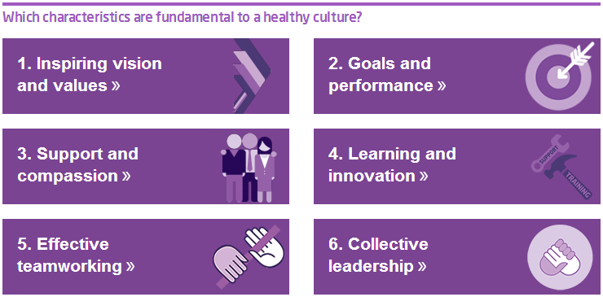

*[UK] Better knowledge, better care*

<http://www.nhsiq.nhs.uk/capacity-capability/knowledge-and-intelligence/better-knowledge-better-care/bkbc-animations.aspx>

A series of animations from NHS Improving Quality that “explore the value of knowledge in health care”, explaining key concepts and building an understanding of what better knowledge means in health and care. They “demonstrate that no matter where you work in the system, small changes to capture, store, share and apply knowledge can lead to improved quality of care, outcomes and patient experience”. The four animations are:

* What is knowledge?
* Knowledge through the ages
* Introducing knowledge management
* Better knowledge, better care

*[USA] National Quality Strategy Webinar on Innovative Community Health Initiatives*

<http://www.ahrq.gov/workingforquality/events.htm>

The US National Quality Strategy (NQS) hosted a Webinar featuring speakers from the Office of the Surgeon General of the United States and Boston Children’s Hospital who highlighted innovative community health initiatives that are improving the health of Americans. The transcript and slides are now available.

*[UK] Delicious diagrams inspire medical students to sweet success*

<http://www.theguardian.com/science/blog/gallery/2015/sep/03/delicious-diagrams-inspire-medical-students-to-sweet-success>

A UK medical student found an alternative method of learning anatomy – using sweets.

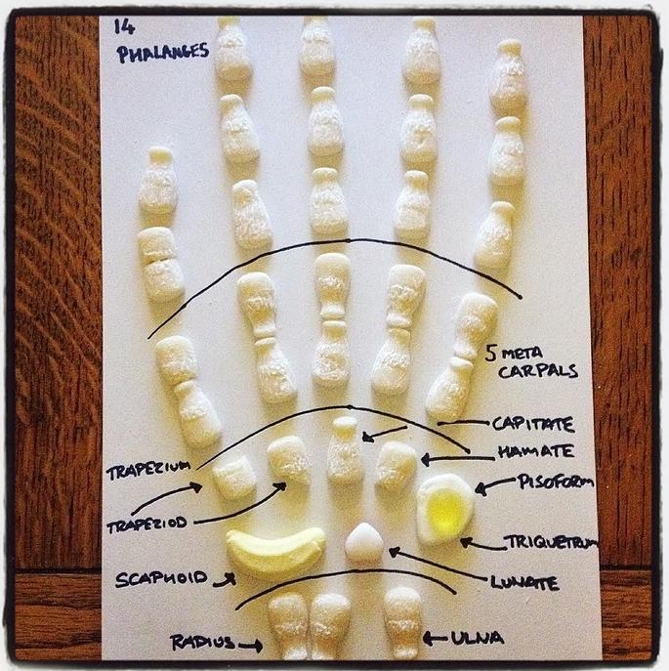

**Disclaimer**

*On the Radar* is an information resource of the Australian Commission on Safety and Quality in Health Care. The Commission is not responsible for the content of, nor does it endorse, any articles or sites listed. The Commission accepts no liability for the information or advice provided by these external links. Links are provided on the basis that users make their own decisions about the accuracy, currency and reliability of the information contained therein. Any opinions expressed are not necessarily those of the Australian Commission on Safety and Quality in Health Care.