# Australian COmmission on Safety and Quality in Health Care logo with Radar imageOn the Radar

Issue 244

12 October 2015

*On the Radar* is a summary of some of the recent publications in the areas of safety and quality in health care. Inclusion in this document is not an endorsement or recommendation of any publication or provider. Access to particular documents may depend on whether they are Open Access or not, and/or your individual or institutional access to subscription sites/services. Material that may require subscription is included as it is considered relevant.

*On the Radar* is available online, via email or as a PDF document from <http://www.safetyandquality.gov.au/publications-resources/on-the-radar/>

If you would like to receive *On the Radar* via email, you can subscribe on our website <http://www.safetyandquality.gov.au/> or by emailing us at H[Umail@safetyandquality.gov.auU](mailto:mail@safetyandquality.gov.au).   
You can also send feedback and comments to H[Umail@safetyandquality.gov.auU](mailto:mail@safetyandquality.gov.au).

For information about the Commission and its programs and publications, please visit <http://www.safetyandquality.gov.au>

You can also follow us on Twitter @ACSQHC.

**On the Radar**

Editor: Dr Niall Johnson [niall.johnson@safetyandquality.gov.au](mailto:niall.johnson@safetyandquality.gov.au)

Contributors: Niall Johnson, Naomi Poole

**Consultation: Patient centred care and consumer engagement**

The Royal Australasian College of Physicians, in collaboration with Health Issues Centre, is developing a patient centred care and consumer engagement framework to improve the way the College engages with health care consumers. A series of consultation workshops are being held. The remaining workshops are to be held in:

Sydney, Thurs 15 October 2015

Gold Coast, Wed 21 October 2015

Adelaide, Thurs 22 October 2015

You can register your interest by emailing [evaluation@racp.edu.au](mailto:evaluation@racp.edu.au)

**Reports**

*How should we think about value in health and care?*

Realising the Value. 2015. p. 24.

|  |  |
| --- | --- |
| URL | <http://www.nesta.org.uk/publications/how-should-we-think-about-value-health-and-care> |
| Notes | One of the debates that has emerged from discussions of variation, waste and appropriateness is that of value(s). For example *The Commissioning Review* has an item on ‘The right values’ written by the co-founders of NHS Right Care (available at <http://www.thecommissioningreview.com/article/right-values>). NHS Right Care identifies three types of value:   * Allocative value * Technical value, (similar to efficiency) * Personalised value.   The UK’s Realising the Value consortium have released this brief Discussion Paper as is a step towards creating a new articulation of value” as part of “demonstrating the value of people and communities in their own health and care.” The paper is intended to provoke consideration – and discussion – of the issues of value in health care and readers are invited to offer their feedback and perspectives. |

**Journal articles**

*Who is less likely to die in association with improved National Emergency Access Target (NEAT) compliance for emergency admissions in a tertiary referral hospital?*

Sullivan C, Staib A, Eley R, Griffin B, Cattell R, Flores J, et al

Australian Health Review. 2015 [epub].

|  |  |
| --- | --- |
| DOI | <http://dx.doi.org/10.1071/AH14242> |
| Notes | Paper reporting on the examination of the changes in patient mortality in a Queensland hospital that had reported “a near halving in mortality in association with a doubling in National Emergency Access Target (NEAT) compliance over a 2-year period from 2012 to 2014.” The retrospective analysis revealed that “Improved NEAT compliance as a result of clinical redesign is associated with **improved in-patient mortality** among particular subgroups of emergency admissions, namely **older patients with complex medical conditions**, **those presenting after hours** and on weekends and those presenting with time-sensitive **acute cardiorespiratory conditions**.” |

*Avoidability of hospital deaths and association with hospital-wide mortality ratios: retrospective case record review and regression analysis*

Hogan H, Zipfel R, Neuburger J, Hutchings A, Darzi A, Black N

BMJ. 2015 2015-07-14 22:01:15;351.

|  |  |
| --- | --- |
| DOI | <http://dx.doi.org/10.1136/bmj.h3239> |
| Notes | This UK study was based on retrospective case record review of 100 randomly selected hospital deaths from each trust in 34 English acute hospital trusts (10 in 2009 and 24 in 2012/13) that were randomly selected from across the spectrum of hospital standardised mortality ratio results. The authors report that in their sample, the **proportion of avoidable deaths was 3.6%** (95% confidence interval 3.0% to 4.3%). The authors fall on one side of the debate on HSMRs and asset that “reviews of individual deaths should focus on identifying ways of improving the quality of care, whereas the use of standardised mortality ratios should be restricted to assessing the quality of care for conditions with high case fatality for which good quality clinical data exist.” |

*Increased mortality associated with weekend hospital admission: a case for expanded seven day services?*

Freemantle N, Ray D, McNulty D, Rosser D, Bennett S, Keogh BE, et al.

BMJ. 2015 2015-09-05 22:15:46;351.

|  |  |
| --- | --- |
| DOI | <http://dx.doi.org/10.1136/bmj.h4596> |
| Notes | Another contentious topic in the UK (as the use of HSMRs is) is that of the weekend effect and seven day operation of acute hospitals. This paper reports on a study updating an earlier analysis that had shown that “admission at the weekend (Saturday and Sunday) was associated with a significantly increased risk of in-hospital death compared with midweek admission, but being in hospital at the weekend was associated with reduced risk of death.”  This study had three main objectives:   1. characterise the patient population admitted at weekend 2. examine whether, after robust adjustment for case mix, weekend admission carries an increased 30 day mortality risk compared with midweek admission 3. estimate whether mortality risk differs between hospital stay at weekends and during the week.   The key findings from the study are summarised as:   * **Patients admitted at the weekend** are more likely to be in the **highest category of risk of death** * **Patients admitted on Saturday or Sunday** face an **increased likelihood of death** even when severity of illness is accounted for * An **additional risk of death exists for admission on Monday and Friday** extending the weekend effect to these two days * [In England] Around 11 000 more patients die each year within 30 days from admission occurring between Friday and Monday compared with admission on the remaining days of the week. |

*High risk of adverse events in hospitalised hip fracture patients of 65 years and older: results of a retrospective record review study*

Merten H, Johannesma PC, Lubberding S, Zegers M, Langelaan M, Jukema GN, et al.

BMJ Open. 2015 September 1, 2015;5(9).

|  |  |
| --- | --- |
| DOI | <http://dx.doi.org/10.1136/bmjopen-2014-006663> |
| Notes | Paper reporting on a retrospective record review study 616 hip fracture patients admitted to surgical or orthopaedic departments in four Dutch hospitals in 2007 that sought to examine the scale, preventability, causes and prevention strategies of adverse events in this patient group.  The review found a high rate of adverse events: “114 (**19%**) of the 616 patients in the study **experienced one or more adverse events**; 49 of these were preventable. The majority of the adverse events (70%) was related to the **surgical procedure** and many resulted in an intervention or additional treatment (67%). Human causes contributed to 53% of the adverse events, followed by patient-related factors (39%).”  The authors conclude that “The high percentage of preventable adverse events found in this study shows that care for older hospitalised hip fracture patients should be improved. More training and quality assurance is required to provide safer care and to reduce the number of preventable adverse events in this vulnerable patient group.” |

*Health Affairs*

Vol. 34, No. 10, October 2015

|  |  |
| --- | --- |
| URL | <http://content.healthaffairs.org/content/34/10.toc> |
| Notes | A new issue of *Health Affairs* hasbeen published. Articles in this issue of the *Health Affairs* include:   * The **Interplay Between Health And Social Supports** (Alan R. Weil) * An **Overdose Antidote** Goes Mainstream (Keith Humphreys) * Connecticut’s ‘Money Follows The Person’ Yields Positive Results For **Transitioning People Out Of Institutions** (Julie Robison, Martha Porter, Noreen Shugrue, Alison Kleppinger, and Dawn Lambert) * US Prevalence And Predictors Of **Informal Caregiving For Dementia** (Esther M. Friedman, Regina A. Shih, Kenneth M. Langa, and M D Hurd) * The Disproportionate **Impact Of Dementia On Family And Unpaid Caregiving** To Older Adults (Judith D Kasper, Vicki A Freedman, Brenda C Spillman, and Jennifer L Wolff) * **Integrated Payment And Delivery Models** Offer Opportunities And Challenges For Residential Care Facilities (David C Grabowski, Daryl J Caudry, Katie M Dean, and David G Stevenson) * Broad **Hepatitis C Treatment** Scenarios Return Substantial Health Gains, But Capacity Is A Concern (Karen Van Nuys, Ronald Brookmeyer, Jacquelyn W Chou, David Dreyfus, Douglas Dieterich, and D P Goldman) * **Risk Selection Threatens Quality Of Care** For Certain Patients: Lessons From Europe’s Health Insurance Exchanges (Wynand P M M van de Ven, Richard C van Kleef, and Rene C J A van Vliet) |

*BMJ Quality and Safety* online first articles

|  |  |
| --- | --- |
| URL | <http://qualitysafety.bmj.com/content/early/recent> |
| Notes | *BMJ Quality and Safety* has published a number of ‘online first’ articles, including:   * Role of emotional competence in **residents’ simulated emergency care** performance: a mixed-methods study (Leonore Bourgeon, Mourad Bensalah, Anthony Vacher, Jean-Claude Ardouin, Bruno Debien) * Secular trends and evaluation of **complex interventions**: the rising tide phenomenon (Yen-Fu Chen, Karla Hemming, A J Stevens, R J Lilford) * Why evaluate ‘common sense’ **quality and safety interventions**? (Angus IG Ramsay, Naomi J Fulop) |

**Online resources**

*[USA] RightCare Action Week*

<http://rightcareactionweek.org/>

Stemming from concerns about waste, over-utilisation, inappropriateness of care and the potential for harm from these, this RightCare Alliance network, with the Lown Institute will launch RightCare Action Week (18–24 October) — calling for clinicians all over the USA to take action to highlight a specific dysfunction in health care and demonstrate to their colleagues and the public how it can be changed for the better.

*[USA] The ‘Must Do’ List: Certain Patient Safety Rules Should Not Be Elective*

<http://healthaffairs.org/blog/2015/08/20/the-must-do-list-certain-patient-safety-rules-should-not-be-elective/>

This blog post at the *Health Affairs* site, written by Robert Wachter, sets out his belief that “the time has come to articulate criteria for **“must do” safety practices**: practices that have sufficiently compelling supportive evidence that clinicians should not have the right of individual veto.” He goes on to describe the “proposed criteria for “must do” practices and argue that two practices—**hand hygiene** and **influenza vaccination** for health care workers—should currently qualify.”

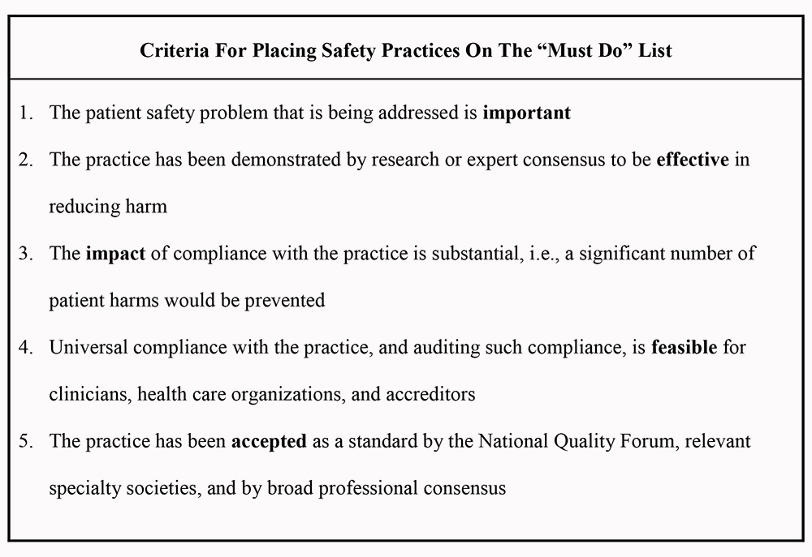

**Disclaimer**

*On the Radar* is an information resource of the Australian Commission on Safety and Quality in Health Care. The Commission is not responsible for the content of, nor does it endorse, any articles or sites listed. The Commission accepts no liability for the information or advice provided by these external links. Links are provided on the basis that users make their own decisions about the accuracy, currency and reliability of the information contained therein. Any opinions expressed are not necessarily those of the Australian Commission on Safety and Quality in Health Care.