
On the Radar
Issue 249
16 November 2015

On the Radar is a summary of some of the recent publications in the areas of safety and quality in health care. Inclusion in this document is not an endorsement or recommendation of any publication or provider. Access to particular documents may depend on whether they are Open Access or not, and/or your individual or institutional access to subscription sites/services. Material that may require subscription is included as it is considered relevant.

On the Radar is available online, via email or as a PDF document from http://www.safetyandquality.gov.au/publications-resources/on-the-radar/

If you would like to receive On the Radar via email, you can subscribe on our website http://www.safetyandquality.gov.au/ or by emailing us at HUmail@safetyandquality.gov.auU.
You can also send feedback and comments to HUmail@safetyandquality.gov.auU.

For information about the Commission and its programs and publications, please visit http://www.safetyandquality.gov.au
You can also follow us on Twitter @ACSQHC.
On the Radar
Editor: Dr Niall Johnson niall.johnson@safetyandquality.gov.au
Contributors: Niall Johnson, Anne Cumming

Books

Health at a Glance 2015: OECD indicators
Organisation for Economic Cooperation and Development
Paris: OECD Publishing; 2015. p. 220.
DOI | http://dx.doi.org/10.1787/health_glance-2015-en
TRIM | D15-40161
Notes | The latest edition of the OECD’s summary report on health and health care in the OECD nations (by-and-large the world’s wealthier nations). This edition of Health at a Glance presents the most recent comparable data on the performance of health systems in OECD countries. Where possible, it also reports data for partner countries (Brazil, China, Colombia, Costa Rica, India, Indonesia, Latvia, Lithuania, Russian Federation and South Africa). This edition also includes a new set of dashboards of health indicators to summarise in a clear and user-friendly way the relative strengths and weaknesses of OECD countries on different key indicators of health and health system performance, and also a special focus on the pharmaceutical sector. This edition also contains new indicators on health workforce migration and on the quality of health care.  The key findings include:  - New drugs will push up pharmaceutical spending unless policy adapts  - Life expectancy continues to rise, but widespread differences persist across countries and socio-demographic groups  - The number of doctors and nurses has never been higher in OECD countries  - Out-of-pocket spending remains a barrier to accessing care  - Too many lives are still lost because quality of care is not improving fast enough.  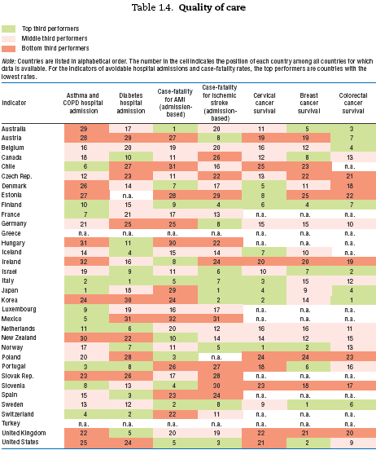

Continuous improvement of patient safety: The case for change in the NHS. Learning report
Illingworth J
London: The Health Foundation; 2015. p. 40.
URL | http://www.health.org.uk/publication/continuous-improvement-patient-safety
Notes | The UK charity the Health Foundation have published this ‘learning report’ that attempts to synthesise the lessons from their work on improving patient safety in the NHS.  According to the Health Foundation’s website:  - Part I of the report illustrates why improving safety is so difficult and complex, and why current approaches need to change.  - Part II looks at some of the work being done to improve safety and offers examples and insights to support practical improvements in patient safety.  - In Part III, the report explains why the system needs to think differently about safety, giving policymakers an insight into how their actions can create an environment where continuous safety improvement will flourish, as well as how they can help to tackle system-wide problems that hinder local improvement.

Journal articles

Clinical deterioration in older adults with delirium during early hospitalisation: a prospective cohort study
Hsieh SJ, Madahar P, Hope AA, Zapata J, Gong MN
BMJ Open. 2015 September 1, 2015;5(9).
DOI | http://dx.doi.org/10.1136/bmjopen-2014-007496
Notes | This prospective cohort study measured the prevalence and incidence of delirium in older adults( 65 years and over) as they transitioned from emergency department(ED) to the inpatient ward. Patients were assessed on a daily basis for three days using the Confusion Assessment Method for the Intensive Care Unit. (CAM-ICU). 15% were delirious at least once. Patients with persistent delirium (ED through hospital day 3) and incident delirium (no delirium in ED but delirium on day 2 or 3) had greater unanticipated ICU admissions, in-hospital deaths and decline in discharge status compared to patients whose delirium resolved or patients who did not become delirious. The authors noted that while the association between delirium and poor outcomes is likely to be multifactorial, the lack of detection of delirium (not recognised in 52% of ED patients with delirium ) could be a possible explanation. Better serial delirium monitoring would identify those who would benefit from diagnostic work-up and intervention.

For information on the Commission’s work on safe and high-quality care for patients with cognitive impairment, including the A better way to care resources, see http://www.safetyandquality.gov.au/our-work/cognitive-impairment/

For information on the Commission’s work on recognising and responding to clinical deterioration, see http://www.safetyandquality.gov.au/our-work/recognising-and-responding-to-clinical-deterioration/

Improving Diagnosis in Health Care — The Next Imperative for Patient Safety
Singh H, Graber ML
New England Journal of Medicine. 2015 [epub].
DOI | http://dx.doi.org/10.1056/NEJMp1512241
Notes | This Perspective piece in the New England Journal of Medicine is an indication of how issues of diagnosis are now gaining mainstream recognition as a patient safety (and care quality) issue. This piece has been prompted by (and discusses) the recent Institute of Medicine report Improving Diagnosis in Health Care (noted in On the Radar Issue 242). The authors welcome the report and “are optimistic that the report will spark a renaissance of interest in improving diagnosis and reducing patient harm from diagnostic error.”

Impact of an electronic alert notification system embedded in radiologists’ workflow on closed-loop communication of critical results: a time series analysis
Lacson R, O'Connor SD, Sahni VA, Roy C, Dalal A, Desai S, et al
BMJ Quality & Safety. 2015 [epub].
DOI | http://dx.doi.org/10.1136/bmjqs-2015-004276
Notes | The notification of text results, especially of significant or abnormal results, is often a crucial step and missed communications can potentially have very serious implications for patients. This paper describes the implementation of an electronic alert notification system in a US hospital. The system allows radiologists to send alerts from within their workflow – by pager for critical results via pager and by email for abnormal but noncritical results. The alerts persisted until they were acknowledged by the treating clinician.  From the time series analysis the authors report that the system led to higher levels of documented communication for abnormal findings without increasing documented communication of normal reports.

Medical-Imaging Stewardship in the Accountable Care Era
Durand DJ, Lewin JS, Berkowitz SA
New England Journal of Medicine. 2015;373(18):1691-3.
DOI | http://dx.doi.org/10.1056/NEJMp1507703
Notes | Another item on imaging. In this case, a call for better ‘stewardship’. In recent years, stewardship has mostly been heard in terms of antibiotic or antimicrobial stewardship and the need to make more appropriate choices of which agents to use. This Perspective piece in the New England Journal of Medicine applies the concept of stewardship to medical imaging. Again it is about finding the appropriate use of a resource, balancing use and value, benefit and potential harm. The piece starts by observing that “Medical-imaging technology plays an essential role in the timely diagnosis and management of many conditions. Lately, however, it's become equally well known for its low-value uses and as the single largest source of per capita radiation exposure. Imaging is by far the most common service on the lists of unnecessary tests and procedures of the Choosing Wisely campaign, and an estimated 20 to 50% of imaging is unnecessary.”  The authors conclude by suggesting “a more robust stewardship model that encourages the use of imaging technology to improve patient outcomes and more reliably create value at the point of care.”

'Trust but verify' - five approaches to ensure safe medical apps
Wicks P, Chiauzzi E
BMC Medicine. 2015;13:205.
DOI | http://dx.doi.org/10.1186/s12916-015-0451-z
Notes | ‘There’s an app for that’ has become so commonplace as to be a used as a joke. And indeed there are many apps, including many apps for health issues and conditions. But how is anyone, be they consumer or clinician, to know which app to trust. In many ways this is an extension of the trust issue with the internet and websites. This paper offers ‘five approaches to ensure safe medical apps’:  - Boost app literacy  - App safety consortium  - Enforced transparency  - Active medical review  - Government regulation.  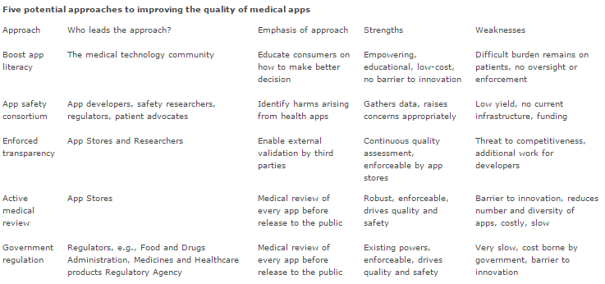

BMJ Quality and Safety online first articles
URL | http://qualitysafety.bmj.com/content/early/recent
Notes | BMJ Quality and Safety has published a number of ‘online first’ articles, including:  - To RCT or not to RCT? The ongoing saga of randomised trials in quality improvement (Gareth Parry, Maxine Power)  - Lost information during the handover of critically injured trauma patients: a mixed-methods study (Tanya Liv Zakrison, Brittany Rosenbloom, Amanda McFarlan, Aleksandra Jovicic, Sophie Soklaridis, Casey Allen, Carl Schulman, Nicholas Namias, Sandro Rizoli)  - The prevalence of medical error related to end-of-life communication in Canadian hospitals: results of a multicentre observational study (Daren K Heyland, Roy Ilan, Xuran Jiang, John J You, Peter Dodek)  - Half-life of a printed handoff document (Glenn Rosenbluth, Ronald Jacolbia, Dimiter Milev, Andrew D Auerbach)  - Implementing an institution-wide quality improvement policy to ensure appropriate use of continuous cardiac monitoring: a mixed-methods retrospective data analysis and direct observation study (Michael F Rayo, Jerry Mansfield, Daniel Eiferman, T Mignery, S White, S D Moffatt-Bruce)

Online resources

[UK] Better use of care at home
http://www.nhs.uk/NHSEngland/keogh-review/Documents/quick-guides/Quick-Guide-better-use-of-care-at-home.pdf
This guide is one of a series of quick, online guides produced by NHS England with partners providing practical tips and case studies to support health and care systems. This quick guide provides case studies, ideas and practical tips to commissioners, health professionals and care providers on how to improve the relationships, processes and use of homecare and housing support to help people home from hospital.
Other Quick Guides in the series (available at http://www.nhs.uk/NHSEngland/keogh-review/Pages/quick-guides.aspx) include:
- Clinical input to care homes
- Identifying local care home placements
- Improving hospital discharge into the care sector
- Sharing patient information
- Technology in care homes.

[USA] Doing Health Care Differently: An Animated Video Series
http://www.commonwealthfund.org/publications/blog/2015/oct/doing-health-care-differently
A series of short animations from the (US) Commonwealth Fund illustrating new approaches to paying for and delivering health care services. The videos look at how these reforms could make life better for patients, doctors, and other health professionals, as well as for hospitals and other health care organisations.

[NZ] Stroke Riskometer
https://www.strokeriskometer.com/
This app has been produced with the claims that it “is a unique and easy to use tool for assessing your individual risk of a stroke in the next five or ten years and what you can do to reduce the risk.
The app can also give you an indication of your risk of heart attack, dementia, and diabetes.”

Australian absolute cardiovascular disease risk calculator
http://www.cvdcheck.org.au/
This calculator has been produced by the National Vascular Disease Prevention Alliance. Designed for use by consumers and patients it also includes resources for health professionals. The alliance is made up of Diabetes Australia, the National Heart Foundation of Australia, Kidney Health Australia and the National Stroke Foundation.

[UK] NICE Guidelines and Quality Standards
http://www.nice.org.uk
The UK’s National Institute for Health and Care Excellence (NICE) has published new (or updated) guidelines and quality standards. The latest updates are:
- NICE Guideline NG23 Menopause: diagnosis and management http://www.nice.org.uk/guidance/ng23

Disclaimer
On the Radar is an information resource of the Australian Commission on Safety and Quality in Health Care. The Commission is not responsible for the content of, nor does it endorse, any articles or sites listed. The Commission accepts no liability for the information or advice provided by these external links. Links are provided on the basis that users make their own decisions about the accuracy, currency and reliability of the information contained therein. Any opinions expressed are not necessarily those of the Australian Commission on Safety and Quality in Health Care.

