
On the Radar
Issue 253
14 December 2015

On the Radar is a summary of some of the recent publications in the areas of safety and quality in health care. Inclusion in this document is not an endorsement or recommendation of any publication or provider. Access to particular documents may depend on whether they are Open Access or not, and/or your individual or institutional access to subscription sites/services. Material that may require subscription is included as it is considered relevant.

On the Radar is available online, via email or as a PDF document from http://www.safetyandquality.gov.au/publications-resources/on-the-radar/

If you would like to receive On the Radar via email, you can subscribe on our website http://www.safetyandquality.gov.au/ or by emailing us at HUmail@safetyandquality.gov.auU.
You can also send feedback and comments to HUmail@safetyandquality.gov.auU.

For information about the Commission and its programs and publications, please visit http://www.safetyandquality.gov.au
You can also follow us on Twitter @ACSQHC.
On the Radar
Editor: Dr Niall Johnson niall.johnson@safetyandquality.gov.au
Contributors: Niall Johnson

Reports

The state of play in person-centred care:
A pragmatic review of how person-centred care is defined, applied and measured, featuring selected key contributors and case studies across the field
Harding E, Wait S, Scrutton J
London: The Health Policy Partnership; 2015. p. 139.
URL | http://www.healthpolicypartnership.com/example-work/person-centred-care/
TRIM | D15-44225
Notes | The [UK] Health Policy Partnership was commissioned to undertake an international environment scan in person-centred care. A key aim of this work was to identify some of the key contributions to the evolving field of person-centred care and to gain a better understanding of where this global discussion is going. In addition to the full report there is a 12-page summary. In the summary, the authors conclude: “Person-centred care is a rich and evolving global discussion. It has been enshrined into formal policy and guidance in many countries and fields, and enjoys considerable influence. However, the implementation of person-centred approaches in the mainstream is still tentative and limited to specific settings or conditions, and lags behind more ambitious policy aspirations. Across the field, a number of barriers and opportunities were identified which inform the challenges ahead in securing a more person-centred healthcare system.”
A practical guide to self-management support: Key components for successful implementation
de Longh A, Fagan P, Fenner J, Kidd L
London: The Health Foundation; 2015. p. 56.
URL | http://www.health.org.uk/publication/practical-guide-self-management-support
Notes | The UK’s Health Foundation have published this short (56-page) ‘Quick guide’ offering an overview of self-management support and the key components for effective implementation. The guide explains what self-management support is and why it is important. It then looks at various aspects of putting it into practice, including planning and commissioning, building knowledge, skills and confidence, and measurement and evaluation.

America’s Hospitals: Improving Quality and Safety. The Joint Commission’s Annual Report
The Joint Commission
Oak Brook, IL: The Joint Commission; 2015. p. 72.
URL | http://www.jointcommission.org/tjc_annual_report_2015/
Notes | The [US] Joint Commission has released its annual report on the state of American hospitals and their safety and quality performance. The report summarises data on 49 accountability measures reported by more than 3,300 Joint Commission-accredited hospitals in 2014.

Journal articles

Primary Care Physicians In Ten Countries Report Challenges Caring For Patients With Complex Health Needs
Osborn R, Moulds D, Schneider EC, Doty MM, Squires D, Sarnak DO
Health Affairs. 2015 December 1, 2015;34(12):2104-12.
DOI | http://dx.doi.org/10.1377/hlthaff.2015.1018
Notes | The US Commonwealth Fund conducts annual surveys of clinicians and patients in a range of comparable countries (usually including Australia). This article reports on the finding of the latest survey, the eighteenth in the series. This survey focused on primary care doctors (general practitioners) in 10 countries (Australia, Canada, Germany, the Netherlands, New Zealand, Norway, Sweden, Switzerland, the United Kingdom, and the United States) to examine how well prepared their practices are to manage the care of patients with complex needs and about their variable experiences in coordinating care and communicating with specialists, hospitals, home care, and social service providers.  The doctors in all surveyed nations reported that their practices struggled to coordinate care and communicate with other health and social service providers. They also questioned their preparedness/ability to care for patients with challenging issues such as dementia and severe mental illness, as well as those who need long-term home care or community-based social services.  Whereas in most of the Commonwealth Fund surveys Australia has tended to rate quite well, in this study Australia’s performance is, at best, middling with some areas where the comparison with peer nations is not particularly flattering.  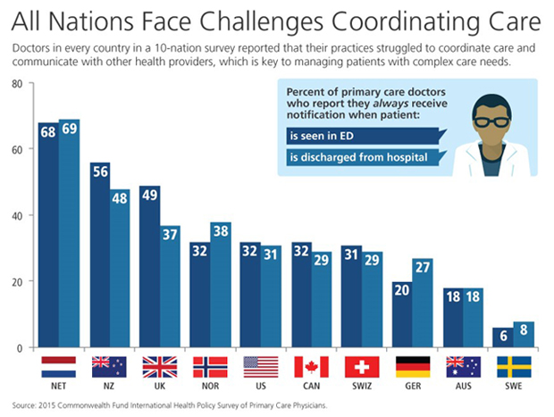

BMJ Quality and Safety online first articles
URL | http://qualitysafety.bmj.com/content/early/recent
Notes | BMJ Quality and Safety has published a number of ‘online first’ articles, including:  - Editorial: The health information technology safety framework: building great structures on vast voids (Ross Koppel)  - Supporting adherence for people starting a new medication for a long-term condition through community pharmacies: a pragmatic randomised controlled trial of the New Medicine Service (Rachel Ann Elliott, Matthew J Boyd, Nde-Eshimuni Salema, James Davies, Nicholas Barber, Rajnikant Laxmishanker Mehta, Lukasz Tanajewski, Justin Waring, Asam Latif, Georgios Gkountouras, A J Avery, Antony Chuter, Christopher Craig)  - Beyond clinical engagement: a pragmatic model for quality improvement interventions, aligning clinical and managerial priorities (Samuel Pannick, Nick Sevdalis, Thanos Athanasiou)  - Obstacles to research on the effects of interruptions in healthcare (Tobias Grundgeiger, S Dekker, P Sanderson, B Brecknell, D Liu, L M Aitken)

International Journal for Quality in Health Care online first articles
URL | http://intqhc.oxfordjournals.org/content/early/recent?papetoc
Notes | International Journal for Quality in Health Care has published a number of ‘online first’ articles, including:  - No-fault compensation for treatment injuries in Danish public hospitals 2006–12 (Jens Tilma, Mette Nørgaard, Kim Lyngby Mikkelsen, and Søren Paaske Johnsen)  - Examining the attitudes of hospital pharmacists to reporting medication safety incidents using the theory of planned behavior: reply (Samantha Robinson)  - Opportunities and challenges for quality and safety applications in ICD-11: an international survey of users of coded health data (Danielle A Southern, Marc Hall, Deborah E White, Patrick S Romano, Vijaya Sundararajan, Saskia E Droesler, Harold A Pincus, and William A Ghali)

Online resources

[UK] NICE Guidelines and Quality Standards
http://www.nice.org.uk
The UK’s National Institute for Health and Care Excellence (NICE) has published new (or updated) guidelines and quality standards. The latest updates are:
- Quality Standard QS103 Acute heart failure: diagnosis and management in adults https://www.nice.org.uk/guidance/qs103
- Quality standard QS104 Gallstone disease https://www.nice.org.uk/guidance/qs104

[USA] Patient Safety in Ambulatory Settings
http://www.effectivehealthcare.ahrq.gov/search-for-guides-reviews-and-reports/?pageaction=displayProduct&productID=2151
The [US] Agency for Healthcare Research and Quality has posted a draft technical brief on patient safety in ambulatory care settings. The draft technical brief, explores the evidence-based hospital patient safety practices that may be applicable to the ambulatory care setting and what tools, settings, and other factors may influence the implementation and spread of ambulatory care patient safety practices.

[USA] Effective Health Care Program reports
http://effectivehealthcare.ahrq.gov/
The US Agency for Healthcare Research and Quality (AHRQ) has an Effective Health Care (EHC) Program. The EHC has released the following final reports and updates:
- Nonpharmacological Versus Pharmacological Treatments for Adult Patients With Major Depressive Disorder http://www.effectivehealthcare.ahrq.gov/search-for-guides-reviews-and-reports/?pageaction=displayproduct&productID=2155
- Management and Outcomes of Binge-Eating Disorder http://www.effectivehealthcare.ahrq.gov/search-for-guides-reviews-and-reports/?pageaction=displayproduct&productID=2157

Disclaimer
On the Radar is an information resource of the Australian Commission on Safety and Quality in Health Care. The Commission is not responsible for the content of, nor does it endorse, any articles or sites listed. The Commission accepts no liability for the information or advice provided by these external links. Links are provided on the basis that users make their own decisions about the accuracy, currency and reliability of the information contained therein. Any opinions expressed are not necessarily those of the Australian Commission on Safety and Quality in Health Care.

