
On the Radar
Issue 284
1 August 2016

On the Radar is a summary of some of the recent publications in the areas of safety and quality in health care. Inclusion in this document is not an endorsement or recommendation of any publication or provider. Access to particular documents may depend on whether they are Open Access or not, and/or your individual or institutional access to subscription sites/services. Material that may require subscription is included as it is considered relevant.

On the Radar is available online, via email or as a PDF document from http://www.safetyandquality.gov.au/publications-resources/on-the-radar/

If you would like to receive On the Radar via email, you can subscribe on our website http://www.safetyandquality.gov.au/ or by emailing us at HUmail@safetyandquality.gov.auU.
You can also send feedback and comments to HUmail@safetyandquality.gov.auU.

For information about the Commission and its programs and publications, please visit http://www.safetyandquality.gov.au
You can also follow us on Twitter @ACSQHC.
On the Radar
Editor: Dr Niall Johnson niall.johnson@safetyandquality.gov.au
Contributors: Niall Johnson, Jai Gupta

Books

OECD health-care quality indicators for Australia 2015
Cat. no. PHE 209
Australian Institute for Health and Welfare
Canberra: AIHW; 2016.
URL | http://www.aihw.gov.au/publication-detail/?id=60129555874
Notes | This document from the Australian Institute for Health and Welfare summarises information provided to the Organisation for Economic Co-operation and Development’s (OECD’s) Health at a glance 2015 report for a common set of indicators about the quality of health care delivered across OECD member countries. The indicators included cover a number of areas, including primary care, acute care, cancer care, patient safety and patient experience.  The graphic below represents Australia’s performance compared with the OECD  average for each indicator. Indicators for which Australia performed favourably are listed toward the top of the graphic, and indicators where Australia performed less favourably are listed toward the bottom. For the indicators in the middle of the graphic Australia performed about the same as the OECD average.  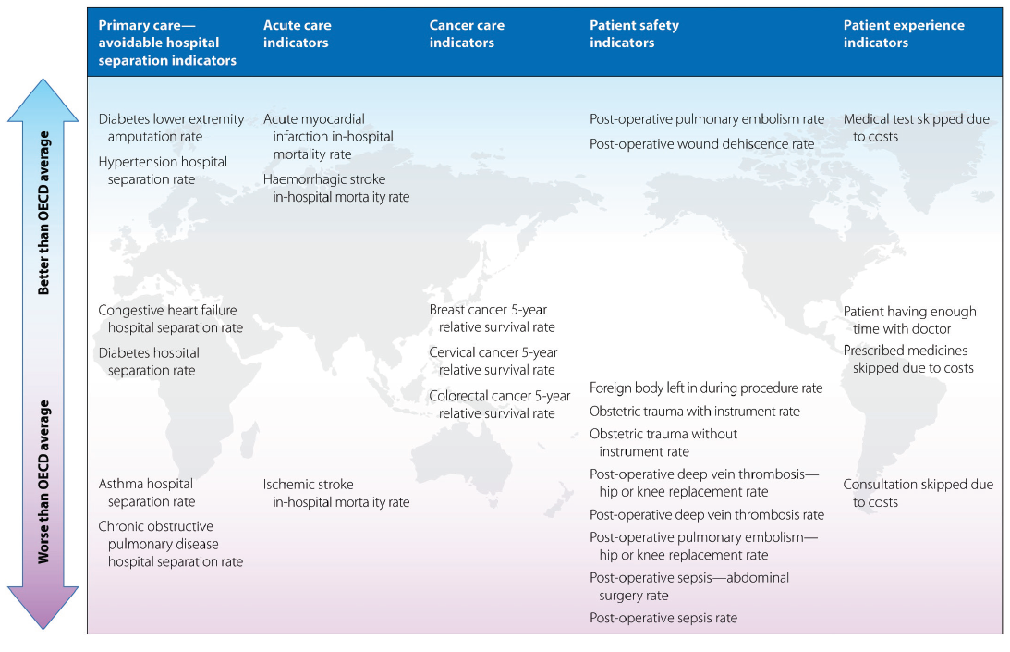

A clear road ahead: Creating a coherent quality strategy for the English NHS
Molloy A, Martin S, Gardner T, Leatherman S
London: The Health Foundation; 2016. 108 p.
URL | http://www.health.org.uk/publication/clear-road-ahead/
Notes | This report from the UK charity The Health Foundation recommends the creation of a single, coherent and compelling quality strategy for the NHS in England. The authors believe that this strategy should be an iterative, living approach based on a shared understanding of a framework leading to a clear ‘road’ ahead.  The authors suggest that the new quality strategy could initially form the means to implement current priorities on quality. In the medium term, it could become fully embedded as a strategic framework for driving improvements in quality across the health service, in a balanced and coherent way.  This document sets out a practical and feasible set of actions for policymakers to safeguard and improve care within current priorities, as well as support the development of the NHS for years to come. It recommends that national bodies undertake coordinated action to:  - articulate a single set of quality goals and common definition of quality  - provide unified national and regional leadership for quality  - build on experience and evidence  - update a set of core quality metrics  - articulate a shared understanding of how improvements in quality and costs are linked – and pursue both in tandem  - inform the future quality agenda.

Reports

Perils of place: identifying hotspots of health inequalities
Duckett S, Griffiths K
Melbourne: Grattan Institute; 2016. 59 p.
URL | http://grattan.edu.au/report/perils-of-place-identifying-hotspots-of-health-inequality/
Notes | This latest report from the Grattan Institute looks at the issue of potentially preventable hospitalisations (PPH). Focussing on two states (Victoria and Queensland) the report identifies a number of geographical areas where high rates of potentially preventable hospital admissions have persisted for a decade – 38 places in Queensland and 25 in Victoria that have had PPH rates at least 50% higher than the state average in every year for a decade.  Among the findings is that in each location a relatively small number of patients account for a substantial number of the readmissions. This suggests that interventions that support those particular patients and assist them in staying out of hospital could be beneficial.

Patient Safety Collaboratives: Making care safer for all
Patient Safety Collaboratives
London: NHS Improvement; 2016. p. 16.
URL | https://improvement.nhs.uk/news-alerts/patient-safety-collaborative-teams-reduce-harm-patients-nationwide
Notes | The National Health Service (NHS) created 15 Patient Safety Collaboratives (PSCs), founded in response to a report by Don Berwick. The 15 collaboratives, funded by NHS Improvement and owned by local patients and NHS  staff, are the largest patient initiative in the history of the NHS. This short (16 page) report. The PSCs are delivering approaches to continual learning and safety improvement. They have provided local learning and created improvement hubs, bringing together clinicians, managers, academics and patients to develop and test solutions to meet local priority safety issues. They are providing a basis for the most successful innovations to be shared on a national scale, so that proven best practice can be adopted elsewhere. This report describes achievements including:  - developing care bundles that reduced mortality after emergency laparotomies by 42 per cent  - establishing safety ‘huddles’ that has reduced inpatients falls by 60 per cent  - achieving a 50 per cent increase in patients returning to mental health wards on time  - producing guidance that improves the communication of information on acute kidney injury between healthcare teams when a patient is discharged  - reducing inpatient medication errors.

Journal articles

The impact of Public Reporting on clinical outcomes: a systematic review and meta-analysis
Campanella P, Vukovic V, Parente P, Sulejmani A, Ricciardi W, Specchia ML
BMC Health Services Research. 2016;16(1):1-14.
DOI | http://dx.doi.org/10.1186/s12913-016-1543-y
Notes | The public release of quality and clinical performance of the healthcare providers is becoming increasingly common among the healthcare systems worldwide. A systematic review of 27 published studies on impact of Public Reporting (PR) at different levels of the healthcare sector shows it can stimulate providers to improve healthcare quality. This study found a positive effect of PR on clinical outcomes. Meta-analysis regarding overall mortality included, in a context of high heterogeneity, 10 studies with a total of 1,840,401 experimental events and 3,670,446 control events and resulted in a RR of 0.85 (95 % CI, 0.79-0.92).  However, authors suggest caution should be placed in interpreting the results of the quantitative synthesis made for mortality outcome because of the heterogeneity in the papers reviewed.

Exercise therapy versus arthroscopic partial meniscectomy for degenerative meniscal tear in middle aged patients: randomised controlled trial with two year follow-up
Kise NJ, Risberg MA, Stensrud S, Ranstam J, Engebretsen L, Roos EM
BMJ. 2016 2016-07-20 22:25:32;354.
DOI | http://dx.doi.org/10.1136/bmj.i3740
Notes | This Danish and Norwegian study reports on a randomised controlled trial to compare exercise therapy with arthroscopic surgery in middle-aged patients with degenerative meniscal tears. Looking at 140 adults (with an average age of 50) with degenerative medial meniscal tears, half of the patients completed a supervised exercise program while the other half underwent arthroscopic surgery followed by simple daily exercises. From the outcomes at 3 months and 2 years the authors concluded: “The observed difference in treatment effect was minute after two years of follow-up, and the trial’s inferential uncertainty was sufficiently small to exclude clinically relevant differences. Exercise therapy showed positive effects over surgery in improving thigh muscle strength, at least in the short term. Our results should encourage clinicians and middle aged patients with degenerative meniscal tear and no definitive radiographic evidence of osteoarthritis to consider supervised exercise therapy as a treatment option.”

BMJ Quality and Safety online first articles
URL | http://qualitysafety.bmj.com/content/early/recent
Notes | BMJ Quality and Safety has published a number of ‘online first’ articles, including:  - Socioeconomic status influences the toll paediatric hospitalisations take on families: a qualitative study (Andrew Finkel Beck, Lauren G Solan, Stephanie A Brunswick, Hadley Sauers-Ford, Jeffrey M Simmons, Samir Shah, Jennifer Gold, Susan N Sherman)  - Six ways not to improve patient flow: a qualitative study (Sara Adi Kreindler)`  - A ‘busy day’ effect on perinatal complications of delivery on weekends: a retrospective cohort study (Jonathan M Snowden, Katy Backes Kozhimannil, Ifeoma Muoto, Aaron B Caughey, K John McConnell)

Online resources

[USA] Antimicrobial Stewardship Project
http://www.cidrap.umn.edu/asp
The CIDRAP (Center for Infectious Disease Research and Policy) team at the University of Minnesota have created this website offering freely available, high-quality information and educational resources on antimicrobial stewardship practice (ASP), research, and policy. The site is designed to establish a diverse, international community to help offer solutions. The site includes:
- Expert webinars and podcasts
- Latest ASP-related news and information
- Online resources available from the United States and other countries
- Online journal club
- Policy updates
- Comprehensive bibliographies of latest research
- Events calendar and conference summaries.

For information about the Commission’s work on antimicrobial stewardship, see http://www.safetyandquality.gov.au/our-work/healthcare-associated-infection/antimicrobial-stewardship/

[UK] NICE Guidelines and Quality Standards
http://www.nice.org.uk
The UK’s National Institute for Health and Care Excellence (NICE) has published new (or updated) guidelines and quality standards. The latest updates are:
- NICE Quality Standard QS126 Motor neurone disease https://www.nice.org.uk/guidance/qs126
- NICE Clinical Guideline CG71 Familial hypercholesterolaemia: identification and management https://www.nice.org.uk/guidance/cg71

[USA] Effective Health Care Program reports
http://effectivehealthcare.ahrq.gov/
The US Agency for Healthcare Research and Quality (AHRQ) has an Effective Health Care (EHC) Program. The EHC has released the following final reports and updates:
- Clinician summary of the systematic review Diagnosis of Celiac Disease: Current State of the Evidence https://www.effectivehealthcare.ahrq.gov/ehc/index.cfm/search-for-guides-reviews-and-reports/?pageAction=displayProduct&productID=2259

Disclaimer
On the Radar is an information resource of the Australian Commission on Safety and Quality in Health Care. The Commission is not responsible for the content of, nor does it endorse, any articles or sites listed. The Commission accepts no liability for the information or advice provided by these external links. Links are provided on the basis that users make their own decisions about the accuracy, currency and reliability of the information contained therein. Any opinions expressed are not necessarily those of the Australian Commission on Safety and Quality in Health Care.

