
On the Radar
Issue 306
16 January 2017

On the Radar is a summary of some of the recent publications in the areas of safety and quality in health care. Inclusion in this document is not an endorsement or recommendation of any publication or provider. Access to particular documents may depend on whether they are Open Access or not, and/or your individual or institutional access to subscription sites/services. Material that may require subscription is included as it is considered relevant.

On the Radar is available online, via email or as a PDF or Word document from http://www.safetyandquality.gov.au/publications-resources/on-the-radar/

If you would like to receive On the Radar via email, you can subscribe on our website http://www.safetyandquality.gov.au/ or by emailing us at HUmail@safetyandquality.gov.auU.
You can also send feedback and comments to HUmail@safetyandquality.gov.auU.

For information about the Commission and its programs and publications, please visit http://www.safetyandquality.gov.au
You can also follow us on Twitter @ACSQHC.
On the Radar
Editor: Dr Niall Johnson niall.johnson@safetyandquality.gov.au
Contributors: Niall Johnson

Reports

Technical Series on Safer Primary Care
Geneva: World Health Organization
URL | http://www.who.int/patientsafety/topics/primary-care/technical_series/en/
Notes | The World Health Organization has produced the Technical Series on Safer Primary Care – a series of nine short monographs exploring the magnitude and nature of harm in the primary care setting from various perspective. Each monograph describes the scope, approach, potential solutions, practical next steps, concluding remarks, and then provides links to online toolkits and manuals to provide practical suggestions for countries and organizations that have committed to moving forward this agenda.  The nine monographs cover:  - Patient engagement  - Education and training  - Human factors  - Administrative errors  - Diagnostic errors  - Medication errors  - Multimorbidity  - Transitions of care  - Electronic tools.
Tackling Wasteful Spending on Health
OECD
Paris: OECD Publishing; 2017. 306p.
DOI | http://dx.doi.org/10.1787/9789264266414-en
TRIM | D17-955
Notes | The topics of appropriateness, overuse/underuse, value and waste can be considered to have some degree of overlap. This is reflected in, among other things, this new report from the OECD.  In the report’s foreword it is noted that “it is alarming that around one-fifth of health expenditure makes no or minimal contribution to good health outcomes. Put in other words, governments could spend significantly less on health care and still improve patients’ health. Efforts to improve the efficiency of health spending at the margin are no longer good enough.  This report suggests that policy makers can make smarter use of health care budgets and cut waste with surgical precision, while improving patients’ health. Actions to tackle waste are needed in the delivery of care, in the management of health services, and in the governance of health care systems. Strategies include stopping spending on actions that do not result in value – for example, unnecessary surgeries and clinical procedures. Swapping inputs or changing approaches when equivalent but less pricy alternatives of equal value exist are valid strategies, too – for example, encouraging the use of generic drugs, developing advanced roles for nurses, or ensuring that patients who do not require hospital care are treated in less resource-consuming settings.”  In addition to the more obvious waste of money and resources, waste and overuse also have an opportunity cost in that those resources cannot be used for other patients.

Improving end-of-life care in Australia
Deeble Institute Evidence Brief No 19
Jones A, Silk K
Canberra: Australian Healthcare and Hospitals Association; 2016. p. 15.
URL | https://ahha.asn.au/publication/issue-briefs/improving-end-life-care-australia
Notes | This evidence brief from the Deeble Institute seeks to raise awareness of the issues that surround end of life care and provide recommendations to further conversations among consumers and all sectors of the health system including:  - Education about end of life care options for medical professionals  - Conversations around preferences when nearing end of life, and understanding when care becomes futile  - Improved capacity to identify people who will die in the short to medium term  - A nationally consistent legislative framework to support end of life decision-making, including harmonisation of advance care plans  - Enhanced integration of advance care planning documents in My Health Record with primary, hospital and community health IT systems  - Improved access to end of life care in multiple care settings  - Public awareness programs that promote and support EOL conversations.

For information on the Commission’s work on end of life care, see https://www.safetyandquality.gov.au/our-work/end-of-life-care-in-acute-hospitals/

ParkinsonNet: An Innovative Dutch Approach to Patient-Centered Care for a Degenerative Disease
Gray BH, Sarnak DO, Tanke M
New York: The Commonwealth Fund; 2016.
URL | http://www.commonwealthfund.org/publications/case-studies/2016/dec/parkinsonnet
Notes | This Commonwealth Fund case study profiles a Parkinson’s disease program in the Netherlands that’s been shown to improve quality of life, as well as lower treatment costs. The program, called ParkinsonNet, stresses guideline-based care provided in the home and community by networks of multidisciplinary professionals, including neurologists, pharmacists, and physical, occupational, speech, and sex therapists. The program is built around a web-based platform that provides patients with information about the disease and treatment options, and allows them to participate in online communities and provide feedback on their care.  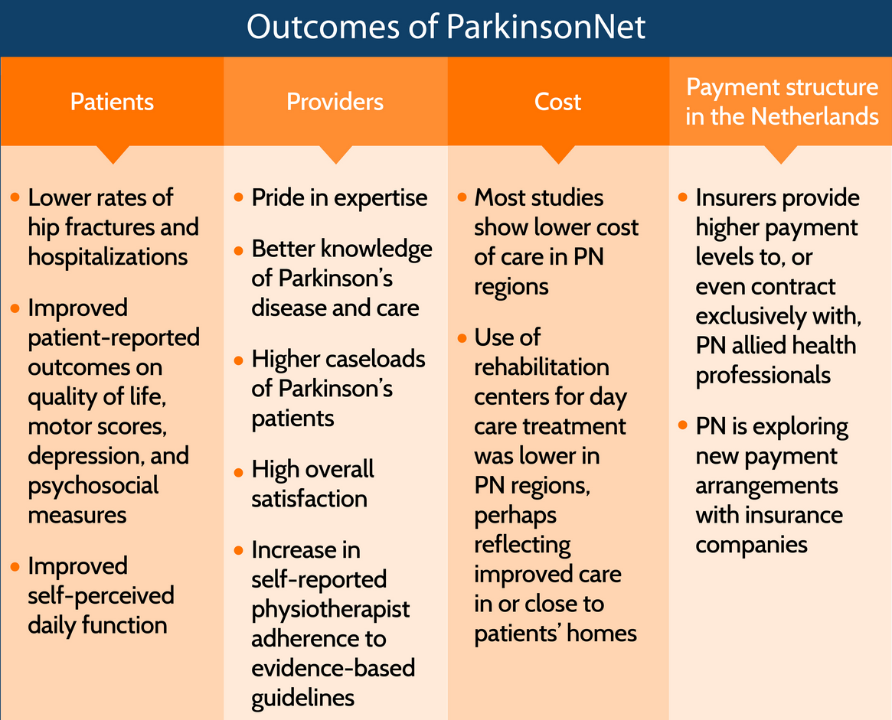

Journal articles

Right Care
The Lancet
URL | http://www.thelancet.com/series/right-care
Notes | The British medical journal The Lancet publishes occasional ‘series’ that focus on a specific area or topic. The latest is on ‘right care’. The journal describes the series thus:  Many countries struggle with the question about sustainability, fairness, and equity of their health systems. With the focus firmly on universal health coverage as a central part to the UN Sustainable Development Goals, there is an opportunity to examine how to achieve optimum access to, and delivery of, health care and services. Underuse and overuse of medical and health services exist side-by-side with poor outcomes for health and wellbeing. This Series of four papers and accompanying comments examines the extent of overuse and underuse worldwide, highlights the drivers of inappropriate care, and provides a framework to begin to address overuse and underuse together to achieve the right care for health and wellbeing. The authors argue that achieving the right care is both an urgent task and an enormous opportunity.  Articles in the series include:  - From universal health coverage to right care for health (Sabine Kleinert, Richard Horton) http://dx.doi.org/10.1016/s0140-6736(16)32588-0  - Avoiding overuse—the next quality frontier (Donald M Berwick) http://dx.doi.org/10.1016/s0140-6736(16)32570-3  - Addressing overuse and underuse around the world (Vikas Saini, Shannon Brownlee, Adam G Elshaug, Paul Glasziou, Iona Heath) http://dx.doi.org/10.1016/s0140-6736(16)32573-9  - Evidence for overuse of medical services around the world (Shannon Brownlee, Kalipso Chalkidou, Jenny Doust, Adam G Elshaug, Paul Glasziou, Iona Heath, Somil Nagpal, Vikas Saini, Divya Srivastava, Kelsey Chalmers, Deborah Korenstein) http://dx.doi.org/10.1016/s0140-6736(16)32585-5  - Evidence for underuse of effective medical services around the world (Paul Glasziou, Sharon Straus, Shannon Brownlee, Lyndal Trevena, Leonila Dans, Gordon Guyatt, Adam G Elshaug, Robert Janett, Vikas Saini) http://dx.doi.org/10.1016/s0140-6736(16)30946-1  - Drivers of poor medical care (Vikas Saini, Sandra Garcia-Armesto, David Klemperer, Valerie Paris, Adam G Elshaug, Shannon Brownlee, John P A Ioannidis, Elliott S Fisher) http://dx.doi.org/10.1016/s0140-6736(16)30947-3  - Levers for addressing medical underuse and overuse: achieving high-value health care (Adam G Elshaug, Meredith B Rosenthal, John N Lavis, Shannon Brownlee, Harald Schmidt, Somil Nagpal, Peter Littlejohns, Divya Srivastava, Sean Tunis, Vikas Saini)  http://dx.doi.org/10.1016/S0140-6736(16)32586-7

Clinicians’ Expectations of the Benefits and Harms of Treatments, Screening, and Tests: A Systematic Review
Hoffmann TC, Del Mar C
JAMA Internal Medicine. 2017 [epub].
DOI | http://dx.doi.org/10.1001/jamainternmed.2016.8254
Notes | In the drive for appropriate care there is an assumption that clinicians have good knowledge and expectations of the benefits and harms of the various treatments, diagnostics, etc. This study problematizes that assumption. Clinicians’ knowledge logically influences the care they deliver and their patients receive.  Describing a systematic review of 48 studies covering 13,011 clinicians the authors of this paper report that most participants correctly estimated just 13% of the 69 harm expectation outcomes and 11% of the 28 benefit expectations. Further, the “majority of participants overestimated benefit for 32% of outcomes, underestimated benefit for 9%, underestimated harm for 34%, and overestimated harm for 5% of outcomes.” These figures led the authors to conclude that “Clinicians rarely had accurate expectations of benefits or harms, with inaccuracies in both directions, but more often underestimated harms and overestimated benefits.” As is noted, “If the benefits and harms are not known or communicated, effective interventions may be underused, low value interventions overused and patients' informed decision making hampered.”

BMJ Quality and Safety online first articles
URL | http://qualitysafety.bmj.com/content/early/recent
Notes | BMJ Quality and Safety has published a number of ‘online first’ articles, including:  - Combining qualitative and quantitative operational research methods to inform quality improvement in pathways that span multiple settings (Sonya Crowe, Katherine Brown, Jenifer Tregay, Jo Wray, Rachel Knowles, Deborah A Ridout, Catherine Bull, Martin Utley)  - Modifying head nurse messages during daily conversations as leverage for safety climate improvement: a randomised field experiment (Dov Zohar, Yaron T Werber, Ronen Marom, Bruria Curlau, Orna Blondheim)

International Journal for Quality in Health Care online first articles
URL | http://intqhc.oxfordjournals.org/content/early/recent?papetoc
Notes | International Journal for Quality in Health Care has published a number of ‘online first’ articles, including:  - Assessing patient safety culture in Tunisian operating rooms: A multicenter study (Manel Mallouli, Mohamed Ayoub Tlili, Wiem Aouicha, Mohamed Ben Rejeb, Chekib Zedini, Amrani Salwa, Ali Mtiraoui, Mohamed Ben Dhiab, Thouraya Ajmi)  - Comparability of health service use by veterans with multisymptom illness and those with chronic diseases (Stella M Gwini, Andrew B. Forbes, Malcolm R. Sim, Helen L Kelsall)  - Healthcare resource utilization and clinical outcomes associated with acute care and inpatient rehabilitation of stroke patients in Japan (Kyoko Murata, Shiro Hinotsu, Nobutake Sadamasa, Kazumichi Yoshida, Sen Yamagata Shoji Asari, Susumu Miyamoto, Koji Kawakami)

Online resources

[USA] Patient Safety Primers
https://psnet.ahrq.gov/primers/
The Patient Safety Primers from the (US) Agency for Healthcare Research and Quality (AHRQ) discuss key concepts in patient safety. Each primer defines a topic, offers background information on its epidemiology and context, and provides links to relevant materials.
- Safety in Long-term Care Many people require care in skilled nursing facilities, inpatient rehabilitation facilities, or long-term acute care hospitals, often after an acute hospitalization. Data indicates that more than 20% of patients in these settings experience an adverse event during their stay. https://psnet.ahrq.gov/primers/primer/39
- Failure to Rescue Failure to rescue is both a concept and a measure of hospital quality and safety. The concept captures the idea that systems should be able to rapidly identify and treat complications when they occur, while the measure has been defined as the inability to prevent death after a complication develops. https://psnet.ahrq.gov/primers/primer/38

For information about the Commission’s work on recognising and responding to clinical deterioration, see https://www.safetyandquality.gov.au/our-work/recognising-and-responding-to-clinical-deterioration/

[UK] NICE Guidelines and Quality Standards
http://www.nice.org.uk
The UK’s National Institute for Health and Care Excellence (NICE) has published new (or updated) guidelines and quality standards. The latest updates are:
- Quality Standard QS141 Tuberculosis https://www.nice.org.uk/guidance/qs141
- Quality Standard QS142 Learning disabilities: identifying and managing mental health problems https://www.nice.org.uk/guidance/qs142

Disclaimer
On the Radar is an information resource of the Australian Commission on Safety and Quality in Health Care. The Commission is not responsible for the content of, nor does it endorse, any articles or sites listed. The Commission accepts no liability for the information or advice provided by these external links. Links are provided on the basis that users make their own decisions about the accuracy, currency and reliability of the information contained therein. Any opinions expressed are not necessarily those of the Australian Commission on Safety and Quality in Health Care.

