
On the Radar
Issue 316
27 March 2017

On the Radar is a summary of some of the recent publications in the areas of safety and quality in health care. Inclusion in this document is not an endorsement or recommendation of any publication or provider. Access to particular documents may depend on whether they are Open Access or not, and/or your individual or institutional access to subscription sites/services. Material that may require subscription is included as it is considered relevant.

On the Radar is available online, via email or as a PDF or Word document from http://www.safetyandquality.gov.au/publications-resources/on-the-radar/

If you would like to receive On the Radar via email, you can subscribe on our website http://www.safetyandquality.gov.au/ or by emailing us at HUmail@safetyandquality.gov.auU.
You can also send feedback and comments to HUmail@safetyandquality.gov.auU.

For information about the Commission and its programs and publications, please visit http://www.safetyandquality.gov.au
You can also follow us on Twitter @ACSQHC.

On the Radar
Editor: Dr Niall Johnson niall.johnson@safetyandquality.gov.au
Contributors: Niall Johnson

Report

Call to Action: Preventable Health Care Harm Is a Public Health Crisis and Patient Safety Requires a Coordinated Public Health Response
National Patient Safety Foundation.
National Patient Safety Foundation, Boston, MA; 2017.
URL | http://www.npsf.org/?page=public_health_crisis
Notes | The (US) National Patient Safety Foundation – which is recently announced it will merge with the Institute for Healthcare Improvement (IHI) – has released this brief ‘Call for action’.  The NSPF argues that preventable harm in health care is a public health crisis and consequently it calls on health care leaders and policymakers to initiate a coordinated public health response to improve patient safety and drive the collective work needed to ensure that patients and those who care for them are free from preventable harm. They believe that such an approach has already contributed to significant reductions in health care–associated infections and can be used to reduce other forms of preventable harms.  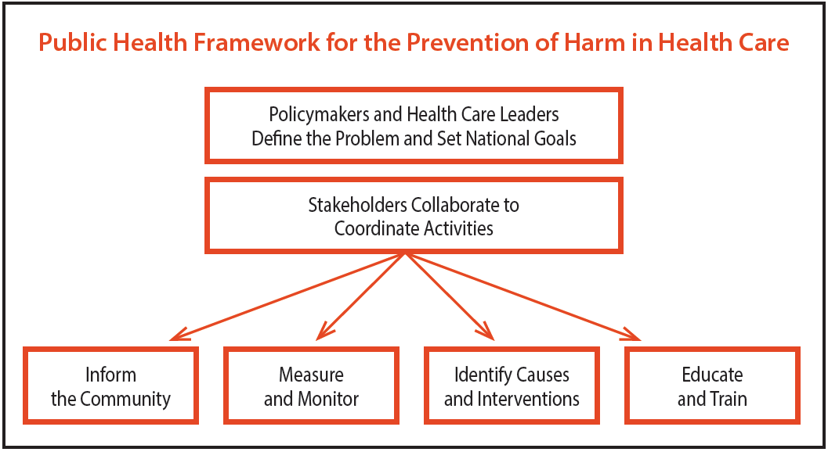

Journal articles

How Doctors Think: Common Diagnostic Errors in Clinical Judgment—Lessons from an Undiagnosed and Rare Disease Program
Kliegman RM, Bordini BJ, Basel D, Nocton JJ
Pediatric Clinics of North America. 2017;64(1):1-15.

Cognitive biases associated with medical decisions: a systematic review
Saposnik G, Redelmeier D, Ruff CC, Tobler PN
BMC Medical Informatics and Decision Making. 2016;16(1):138.

A Learning Health Care System Using Computer-Aided Diagnosis
Cahan A, Cimino JJ
J Med Internet Res. 2017;19(3):e54.
DOI | Kliegman et al http://dx.doi.org/10.1016/j.pcl.2016.08.002  Saposnik et al http://dx.doi.org/10.1186/s12911-016-0377-1  Cahan and Cimino http://dx.doi.org/10.2196/jmir.6663
Notes | A number of papers united by their focus on issues of diagnosis.  Kliegman and colleagues discuss the particular diagnostic challenges that rare diseases pose and how clinicians may address cognitive biases and flawed decision-making. They also reflect on the potential harms of “misdiagnosis or lack of a specific diagnosis leading to unnecessary diagnostic testing and invasive procedures, which, in addition to increasing patient suffering and risking complications, add major costs to the health care system.”  Saposnik and colleagues further examine the issue of cognitive biases in clinical decision making. Their systematic review reported that “Overconfidence, the anchoring effect, information and availability bias, and tolerance to risk may be associated with diagnostic inaccuracies or suboptimal management.”  Cahan and Cimino look to the future in suggesting a framework that captures clinician knowledge so as to enhance decision support tools that can potentially improve diagnsoses. This view sees all the installations of this tool – and each interaction using it – as part of a diagnosis support tool that learns and grows.
Comparison of the Effects of a Pharmaceutical Industry Decision Guide and Decision Aids on Patient Choice to Intensify Therapy in Rheumatoid Arthritis
Martin RW, Enck RD, Tellinghuisen DJ, Eggebeen AT, Birmingham JD, Head AJ
Medical Decision Making. 2017 [epub].
DOI | https://doi.org/10.1177/0272989X17696995
Notes | Paper reporting on a study comparing patient responses to different sources of information on medication use. The 402 patients were presented with a hypothetical decision scenario where they were asked to consider adding a medication (etanercept) to their current regimen. Each patient was randomised to review 1 of 3 forms of an etanercept-specific decision support: a long Patient Decision Aid (PtDA), a short PtDA, or the manufacturer’s Enbrel decision guide.  The authors report that “Patients supported by the Pharm Booklet were twice as likely to choose to intensify therapy.” They proceed to suggest that the manufacturer’s decision guide “effects are partially mediated through persuasive communication techniques that influence patients’ beliefs that symptoms will improve, and increase social normative beliefs, rather than by increasing the relevant knowledge, clarifying patient values about positive or negative treatment outcomes, or increasing their self-efficacy.”

For information on the Commission’s work on shared decision making, see https://www.safetyandquality.gov.au/our-work/shared-decision-making/

The effectiveness of payment for performance in health care: A meta-analysis and exploration of variation in outcomes
Ogundeji YK, Bland JM, Sheldon TA
Health Policy. 2016;120(10):1141-50.
DOI | http://dx.doi.org/10.1016/j.healthpol.2016.09.002
Notes | The merit and utility (or otherwise) of pay for performance approaches in health care has been somewhat contested over the years. This meta-analysis attempted to survey the impact of such approaches based on 96 studies. The authors report that “Adjusting for other design features and the evaluation method, the odds of showing a positive effect was three times higher for schemes with larger incentives (>5% of salary/usual budget) (OR = 3.38; 95% CI: 1.07–10.64). There were non-statistically significant increases in the odds of success if the incentive is paid to individuals (as opposed to groups) (OR = 2.0; 95% CI: 0.62–6.56) and if there is a lower perceived risk of not earning the incentive (OR = 2.9; 95% CI: 0.78–10.83). Schemes evaluated using less rigorous designs were 24 times more likely to have positive estimates of effect than those using randomized controlled trials (OR = 24; 95% CI: 6.3–92.8).”  These results led them to suggest that “Estimates of the effectiveness of incentive schemes on health outcomes are probably inflated due to poorly designed evaluations and a focus on process measures rather than health outcomes. Larger incentives and reducing the perceived risk of non-payment may increase the effect of these schemes on provider behavior.” These findings are perhaps more positive than some of the other studies have suggested. For example, Hall and van Gool KC. Paying hospitals for quality: can we buy better care? (http://dx.doi.org/10.5694/mja15.01110)

Systematic review of a patient care bundle in reducing staphylococcal infections in cardiac and orthopaedic surgery
Ma N, Cameron A, Tivey D, Grae N, Roberts S, Morris A
ANZ Journal of Surgery. 2017 [epub]
DOI | http://dx.doi.org/10.1111/ans.13879
Notes | Paper reporting on the impact of a care bundle introduced to address surgical site infections (SSIs). The bundle, including pre-theatre nasal and/or skin decolonization has been used in an attempt to reduce the risk of staphylococcal infection. The review sought to assess the effectiveness of the bundle in preventing SSIs for cardiac and orthopaedic surgeries. The review included six RCTs and 19 observational studies. The authors report that the bundled treatment regimens varied substantially across all studies. However, they still concluded that “SSIs in major cardiac and orthopaedic surgeries can be effectively reduced by approximately 50% with a pre-theatre patient care bundle approach.”

For information on the Commission’s work on healthcare associated infection, see https://www.safetyandquality.gov.au/our-work/healthcare-associated-infection/

Association of preceding antithrombotic treatment with acute ischemic stroke severity and in-hospital outcomes among patients with atrial fibrillation
Xian Y, O’Brien EC, Liang L, Xu H, Schwamm LH, Fonarow GC, et al
Journal of the American Medical Association. 2017;317(10):1057-67.
DOI | http://dx.doi.org/10.1001/jama.2017.1371
Notes | Antithrombotic therapies are known to prevent stroke for patients with atrial fibrillation (AF). This US observational study covered 94 474 patients with acute ischemic stroke who had a known history of atrial fibrillation. The study sought to examine the role of antithrombotic treatment in patients with atrial fibrillation who experienced an ischemic stroke, and any association with stroke severity and in-hospital outcomes? The authors report that 84% did not receive guideline-recommended therapeutic anticoagulation preceding their stroke. Therapeutic anticoagulation with warfarin or non–vitamin K antagonist oral anticoagulants was significantly associated with lesser stroke severity and lower odds of in-hospital mortality. Of this population, the vast majority did not receive the recommended care.

BMJ Quality and Safety
April 2017, Vol. 26, Issue 4
URL | http://qualitysafety.bmj.com/content/26/4
Notes | A new issue of BMJ Quality and Safety has been published. Many of the papers in this issue have been referred to in previous editions of On the Radar (when they were released online). Articles in this issue of BMJ Quality and Safety include:  - Editorial: Opening up to Open Notes and adding the patient to the team (Caroline Lubick Goldzweig)  - Editorial: Triggering safer general practice care (Susan M Dovey, Sharon Leitch)  - When doctors share visit notes with patients: a study of patient and doctor perceptions of documentation errors, safety opportunities and the patient–doctor relationship (Sigall K Bell, Roanne Mejilla, Melissa Anselmo, Jonathan D Darer, Joann G Elmore, Suzanne Leveille, Long Ngo, James D Ralston, Tom Delbanco, Jan Walker)  - Towards optimising local reviews of severe incidents in maternity care: messages from a comparison of local and external reviews (Anjali Shah, Bryn Kemp, Susan Sellers, Lisa Hinton, Melanie O'Connor, Peter Brocklehurst, Jenny Kurinczuk, Marian Knight)  - How does audit and feedback influence intentions of health professionals to improve practice? A laboratory experiment and field study in cardiac rehabilitation (Wouter T Gude, Mariëtte M van Engen-Verheul, Sabine N van der Veer, Nicolette F de Keizer, Niels Peek)  - Assessing content validity and user perspectives on the Team Check-up Tool: expert survey and user focus groups (Jill A Marsteller, Yea-Jen Hsu, Kitty S Chan, Lisa H Lubomski)  - A scoping review of online repositories of quality improvement projects, interventions and initiatives in healthcare (Jessica P Bytautas, Galina Gheihman, Mark J Dobrow)  - Socioeconomic status influences the toll paediatric hospitalisations take on families: a qualitative study (Andrew Finkel Beck, Lauren G Solan, Stephanie A Brunswick, Hadley Sauers-Ford, Jeffrey M Simmons, Samir Shah, Jennifer Gold, Susan N Sherman, H2O Study Group)  - A patient feedback reporting tool for OpenNotes: implications for patient-clinician safety and quality partnerships (Sigall K Bell, Macda Gerard, Alan Fossa, Tom Delbanco, Patricia H Folcarelli, Kenneth E Sands, Barbara Sarnoff Lee, Jan Walker)  - Theory-based and evidence-based design of audit and feedback programmes: examples from two clinical intervention studies (Sylvia J Hysong, Harrison J Kell, Laura A Petersen, Bryan A Campbell, Barbara W Trautner)  - Implementation of the trigger review method in Scottish general practices: patient safety outcomes and potential for quality improvement (Carl de Wet, Chris Black, Sarah Luty, John McKay, Catherine A O'Donnell, Paul Bowie)  - What is the potential of patient shadowing as a patient-centred method? (Elisa Giulia Liberati)

International Journal for Quality in Health Care online first articles
URL | https://academic.oup.com/intqhc/advance-access?papetoc
Notes | International Journal for Quality in Health Care has published a number of ‘online first’ articles, including:  - Attributes of primary care in relation to polypharmacy: a multicenter cross-sectional study in Japan (Takuya Aoki, Tatsuyoshi Ikenoue, Yosuke Yamamoto, Morito Kise, Yasuki Fujinuma, Shingo Fukuma, Shunichi Fukuhara)  - Development and implementation of a risk identification tool to facilitate critical care transitions for high-risk surgical patients (Rebecca L Hoffman, Jason Saucier, Serena Dasani, Tara Collins, Daniel N Holena, Meghan Fitzpatrick, Boris Tsypenyuk, Niels D Martin)  - Monitoring the quality of cardiac surgery based on three or more surgical outcomes using a new variable life-adjusted display (Fah Fatt Gan; Xu Tang; Yexin Zhu; Puay Weng Lim)  - Improving safety culture in hospitals: Facilitators and barriers to implementation of Systemic Falls Investigative Method (SFIM) (Aleksandra A. Zecevic; Alvin Ho-Ting Li; Charity Ngo; Michelle Halligan; Anita Kothari)

Online resources

[NZ] How-to guide: Reducing opioid-related harm through the use of care bundles
http://www.hqsc.govt.nz/our-programmes/medication-safety/projects/collaborative/how-to-guide-reducing-opioid-related-harm-through-the-use-of-care-bundles/
The New Zealand Health Quality & Safety Commission has produced a range of resources to support the use and testing of four emerging care bundles to reduce opioid-related harm. The bundles were developed as part of a safe use of opioids national ‘formative’ collaborative. The four bundles are:
- uncontrolled pain emerging care bundle
- opioid-induced ventilatory impairment emerging care bundle
- opioid-induced constipation emerging care bundle
- emerging composite care bundle to reduce opioid-induced related harm.

[UK] NICE Guidelines and Quality Standards
http://www.nice.org.uk
The UK’s National Institute for Health and Care Excellence (NICE) has published new (or updated) guidelines and quality standards. The latest updates are:
- NICE Guideline NG66 Mental health of adults in contact with the criminal justice system https://www.nice.org.uk/guidance/ng66
- NICE Clinical Guideline CG80 Early and locally advanced breast cancer: diagnosis and treatment https://www.nice.org.uk/guidance/cg80
- NICE Clinical Guideline CG164 Familial breast cancer: classification, care and managing breast cancer and related risks in people with a family history of breast cancer https://www.nice.org.uk/guidance/cg164

[UK] Patient experience of primary care
http://www.dc.nihr.ac.uk/highlights/patient-experience/
The UK’s National Institute for Health Research (NIHR) has produced this ‘Highlights’ web page drawing together findings from the annual survey of patients and their experiences of primary care. Every year since 2007 the NHS in England has asked patients what they think about their GP practice in a large national survey. The survey findings are intended to inform patients, healthcare professionals and planners about patients’ experience of the care provided by individual practices in England. This Highlight shares insights obtained from research using this general practice survey data. The authors discuss findings about what patients really think about their care, how this varies for different patient groups and how practices can act on patient feedback.

[USA] Patient and Family Engagement in Primary Care toolkit
https://www.ahrq.gov/professionals/quality-patient-safety/patient-family-engagement/pfeprimarycare/interventions.html
Also in the primary care setting is this toolkit from the (US) Agency for Healthcare Research and Quality (AHRQ). This is a compilation of evidence-based best practices for improving patient safety through patient, family, and caregiver engagement. This comprehensive guide provides primary care practices with four strategies that they can adopt to improve patient safety. A practice may choose to adopt one or all of the strategies. The four strategies and the materials to support adoption of each are:
- Teach-Back
- Be Prepared To Be Engaged
- Medication Management
- Warm Handoff.

Disclaimer
On the Radar is an information resource of the Australian Commission on Safety and Quality in Health Care. The Commission is not responsible for the content of, nor does it endorse, any articles or sites listed. The Commission accepts no liability for the information or advice provided by these external links. Links are provided on the basis that users make their own decisions about the accuracy, currency and reliability of the information contained therein. Any opinions expressed are not necessarily those of the Australian Commission on Safety and Quality in Health Care.

