
On the Radar
Issue 328
3 July 2017

7 years of On the Radar
The first issue of On the Radar appeared on 5 July 2010. Initially produced as an internal resource for Commission personnel it quickly developed an audience beyond the Commission. Seven years and 328 issues later my editorial task remains much the same – compiling a succinct synopsis of recent material relevant to safety and quality in health care. I hope you find it useful and relevant.
Dr Niall Johnson
Editor

On the Radar is a summary of some of the recent publications in the areas of safety and quality in health care. Inclusion in this document is not an endorsement or recommendation of any publication or provider. Access to particular documents may depend on whether they are Open Access or not, and/or your individual or institutional access to subscription sites/services. Material that may require subscription is included as it is considered relevant.

On the Radar is available online, via email or as a PDF or Word document from http://www.safetyandquality.gov.au/publications-resources/on-the-radar/

If you would like to receive On the Radar via email, you can subscribe on our website http://www.safetyandquality.gov.au/ or by emailing us at HUmail@safetyandquality.gov.auU.
You can also send feedback and comments to HUmail@safetyandquality.gov.auU.

For information about the Commission and its programs and publications, please visit http://www.safetyandquality.gov.au
You can also follow us on Twitter @ACSQHC.

On the Radar
Editor: Dr Niall Johnson niall.johnson@safetyandquality.gov.au
Contributors: Niall Johnson

Reports

Tackling variations in clinical care: Assessing the Getting It Right First Time (GIRFT) programme
Timmins N
London: The King's Fund; 2017. p. 32.
URL | https://www.kingsfund.org.uk/publications/tackling-variations-clinical-care
Notes | Variations in care, what extent the variation is unwarranted or in appropriate and how to improve the appropriateness of care are themes that are being considered widely. This report looks at a programme, Getting It Right First Time (GIRFT), that has been rolled out in the English NHS. The GIRFT programme aims to bring about higher-quality care in hospitals, at lower cost, by reducing unwanted variations in services and practices.  The programme began with orthopaedics and is now being rolled out to 32 different surgical and medical domains across the English NHS. This report describes the programme is, the need for such a programme, what it has achieved, the challenges and potential it has. The report includes vignettes illustrating hospitals’ experiences of the programme.

For information the Commission’s work on variation, including the Australian Atlas of Healthcare Variation and the Second Australian Atlas of Healthcare Variation, see https://www.safetyandquality.gov.au/atlas/

Driving improvement: Case studies from eight NHS trusts
Care Quality Commission
Newcastle upon Tyne: Care Quality Commission; 2017. p. 48.
URL | http://www.cqc.org.uk/publications/evaluation/driving-improvement-case-studies-eight-nhs-trusts
Notes | The UK’s Care Quality Commission has published this report looking at eight NHS Trusts that have shown significant improvement in their performance since a previous inspection. The CQC sought to explore what a selection of trusts had done to become 'well-led'. People in each trust were how they had achieved improvements, looking at the steps their leaders had taken and the effect of those actions on staff and patients. A range of people from each trust were interviewed, including chief executives, medical and nursing directors, non-executives, heads of communications, frontline staff, patient representatives and external stakeholders.  The CQC identified the key themes as including how the trust had reacted to their initial, particularly seeing it as an opportunity to drive change. Other key themes included Leadership, Cultural change, Vision and values, Governance, Safety, Patient and public involvement, and Looking outwards. An item on this report in the BMJ (https://doi.org/10.1136/bmj.j2921) noted that the Trusts had improved “by better engagement with staff and ensuring that clinicians are more involved in organising and managing care”

Engaging patients in patient safety: A Canadian guide
Patient Engagement Action Team
Ottawa: Canadian Patient Safety Institute; 2017. p. 67.
URL | http://www.patientsafetyinstitute.ca/en/toolsResources/Patient-Engagement-in-Patient-Safety-Guide/Pages/default.aspx
Notes | The Canadian Patient Safety Institute (CPSI) brought together a large number of organizations to develop this evidence-based resource to help patients and families, patient partners, providers, and leaders work together more effectively to improve patient safety. The Patient Engagement Action Team who developed the resource argue that working collaboratively, “we can more proactively identify risks, better support those involved in an incident, and help prevent similar incidents from occurring in the future. Together we can shape safe, high-quality care delivery, co-design safer care systems, and continuously improve to keep patients safe.”  The guide has been written for anyone involved with patient engagement, including:  - Patients and families interested in how to partner in their own care  - Patient partners interested in how to help improve patient safety  - Providers interested in creating collaborative care relationships with patients and families  - Managers and leaders responsible for patient engagement, patient safety, and/or quality improvement  - Anyone else interested in partnering with patients to develop care programs and systems.  The authors also note that while the guide focuses primarily on patient safety, many engagement practices apply to other areas, including quality, research, and education. The guide is designed to support patient engagement in any healthcare sector.

For information the Commission’s work on patient and consumer centred care see, https://www.safetyandquality.gov.au/our-work/patient-and-consumer-centred-care/

Report on the Supply and Management of Schedule 8 Controlled Drugs at Certain Public Hospitals in Western Australia
Corruption and Crime Commission
Perth: Corruption and Crime Commission; 2017. 49 p.
URL | https://www.ccc.wa.gov.au/sites/default/files/Report%20on%20the%20Supply%20and%20Management%20of%20Schedule%208%20Controlled%20Drugs%20at%20Certain%20Public%20Hospitals%20in%20Western%20Australia.pdf
Notes | The Western Australian Corruption and Crime Commission has published this report on Schedule 8 drugs. The report is the output from the investigation of a pharmacist who had become highly addicted to a potent opioid drug (hydromorphone) and subsequently circumvented controls on various Schedule 8 drugs at two hospitals so as to steal the drugs for his personal use.  While noting that responsibility in the specific case lies with that person, the report made recommendations for WA Health and its poisons permit holders around:  - After-hours access to pharmacy and safe  - Reconciling supply and receipt  - Separation of duties  - Regular compliance checks  - Registers  - Updating and consolidating policies, procedures and practices  - Knowledge sharing  - Modernising requisition and register system  - Enhancing automated systems  - Introducing automated Electronic Storage and Supply Unit systems.

For information the Commission’s work on medication safety, see https://www.safetyandquality.gov.au/our-work/medication-safety/

Journal articles

Recognizing Sepsis as a Global Health Priority — A WHO Resolution
Reinhart K, Daniels R, Kissoon N, Machado FR, Schachter RD, Finfer S
New England Journal of Medicine. 2017 [epub].
DOI | http://dx.doi.org/10.1056/NEJMp1707170
Notes | The last issue of On the Radar included an item on sepsis mandates that have been introduced in some states in the USA. This issue we include this item on the World Health Organization’s adoption of a resolution on improving the prevention, diagnosis, and management of sepsis. The article notes that it is estimated that there are some 30 million episodes of sepsis and 6 million deaths per year, but “The true burden of disease arising from sepsis remains unknown.”  Among the examples of programs addressing sepsis that are identified is the ‘Sepsis Kills’ program of the Clinical Excellence Commission in New South Wales (https://cec.health.nsw.gov.au/patient-safety-programs/adult-patient-safety/sepsis-kills).  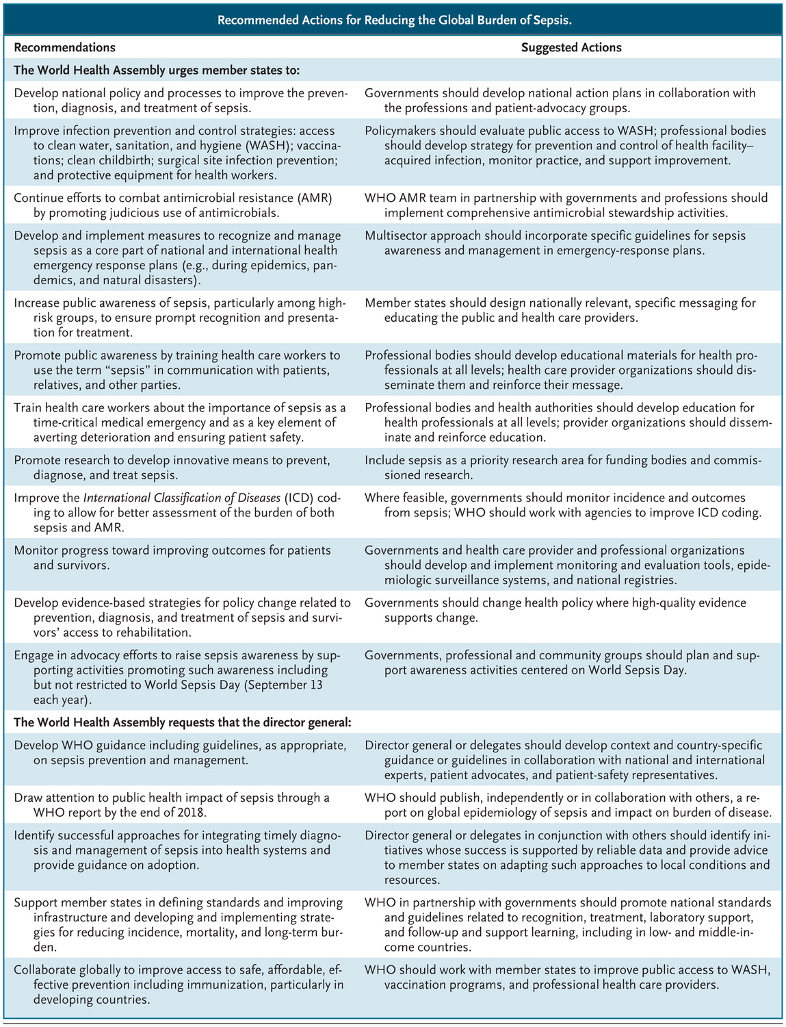

International Journal for Quality in Health Care
Volume 29, Issue 3
June 2017
URL | https://academic.oup.com/intqhc/issue/29/3
Notes | A new issue of the International Journal for Quality in Health Care has been published. Many of the papers in this issue have been referred to in previous editions of On the Radar (when they were released online). Articles in this issue of the International Journal for Quality in Health Care include:  - Editorial: Healthcare improvements from the unit to system levels: contributions to improving the safety and quality evidence base (David Greenfield; Usman Iqbal; Yu-Chuan (Jack) Li)  - Measuring patient experience: a systematic review to evaluate psychometric properties of patient reported experience measures (PREMs) for emergency care service provision (Leanne Male; Adam Noble; Jessica Atkinson; Tony Marson)  - Integrated care for older populations and its implementation facilitators and barriers: A rapid scoping review (Diane E. Threapleton; Roger Y. Chung; Samuel Y.S. Wong; Eliza Wong; Patsy Chau; Jean Woo; Vincent C H Chung; Eng-kiong Yeoh)  - Assessing the impact of diabetes on quality of life: validation of the Chinese version of the 19-item Audit of Diabetes-Dependent Quality of Life for Taiwan (Huey-Fen Wang; Clare Bradley; Tien-Jyun Chang; Lee-Ming Chuang; Mei Chang Yeh)  - Improved implementation of the risk-adjusted Bernoulli CUSUM chart to monitor surgical outcome quality (Matthew J. Keefe; Justin B. Loda; Ahmad E. Elhabashy; William H. Woodall)  - A cross-national comparison of incident reporting systems implemented in German and Swiss hospitals (Tanja Manser; Michael Imhof; Constanze Lessing; Matthias Briner)  - Patient reporting of undesirable events: a pilot study in China (Jia Yan; Ke Liu; Lifeng Zhang; Ting Chu; Xuehua Wang)  - The proportion of errors in medical prescriptions and their executions among hospitalized children before and during accreditation (Tal Margalit Mekory; Hilla Bahat; Benjamin Bar-Oz; Orna Tal; Matitiahu Berkovitch; Eran Kozer)  - Improving safety culture in hospitals: Facilitators and barriers to implementation of Systemic Falls Investigative Method (SFIM) (Aleksandra A. Zecevic; Alvin Ho-Ting Li; Charity Ngo; Michelle Halligan; Anita Kothari)  - Attributes of primary care in relation to polypharmacy: a multicenter cross-sectional study in Japan (Takuya Aoki; Tatsuyoshi Ikenoue; Yosuke Yamamoto; Morito Kise; Yasuki Fujinuma; Shingo Fukuma; Shunichi Fukuhara)  - Assessing archetypes of organizational culture based on the Competing Values Framework: the experimental use of the framework in Japanese neonatal intensive care units (Hatoko Sasaki; Naohiro Yonemoto; Rintaro Mori; Toshihiko Nishida; Satoshi Kusuda; Takeo Nakayama)  - The effects of patient education on patient safety: can we change patient perceptions and attitudes?: Lessons from the Armed Forces Capital Hospital in Korea (JinOk An; Seung Ju Kim; Sohee Park; Ki Tae Moon; Eun-Cheol Park)  - How did market competition affect outpatient utilization under the diagnosis-related group-based payment system? (Seung Ju Kim; Eun-Cheol Park; Sun Jung Kim; Kyu-Tae Han; Sung-In Jang)  - Unannounced versus announced hospital surveys: a nationwide cluster-randomized controlled trial (Lars Holger Ehlers; Katherina Beltoft Simonsen; Morten Berg Jensen; Gitte Sand Rasmussen; Anne Vingaard Olesen)  - Development and implementation of a risk identification tool to facilitate critical care transitions for high-risk surgical patients (Rebecca L Hoffman; Jason Saucier; Serena Dasani; Tara Collins; Daniel N Holena; Meghan Fitzpatrick; Boris Tsypenyuk; Niels D Martin)  - Improving the quality of radiological examinations: effectiveness of an internal participatory approach (Francisco Manuel Batista Mamede; Zenewton André da Silva Gama; Pedro Jesus Saturno-Hernández)  - Monitoring the quality of cardiac surgery based on three or more surgical outcomes using a new variable life-adjusted display (Fah Fatt Gan; Xu Tang; Yexin Zhu; Puay Weng Lim)  - Reducing the incidence of pressure ulcers in critical care units: a 4-year quality improvement (Annette Richardson; Joanna Peart; Stephen E. Wright; Iain J. McCullagh)

BMJ Quality and Safety online first articles
URL | https://qualitysafety.bmj.com/content/early/recent
Notes | BMJ Quality and Safety has published a number of ‘online first’ articles, including:  - Editorial: Keep calm… and prepare (Tobias Gauss, Fabrice Cook)  - Is everyone really breathing 20 times a minute? Assessing epidemiology and variation in recorded respiratory rate in hospitalised adults (Jack Badawy, Oanh Kieu Nguyen, Christopher Clark, Ethan A Halm, Anil N Makam)  - Peers without fears? Barriers to effective communication among primary care physicians and oncologists about diagnostic delays in cancer (Allison Lipitz-Snyderman, Minal Kale, Laura Robbins, David Pfister, Elizabeth Fortier, Valerie Pocus, Susan Chimonas, Saul N Weingart)

International Journal for Quality in Health Care online first articles
URL | https://academic.oup.com/intqhc/advance-access?papetoc
Notes | International Journal for Quality in Health Care has published a number of ‘online first’ articles, including:  - Linking quality indicators to clinical trials: an automated approach (Enrico Coiera; Miew Keen Choong; Guy Tsafnat; Peter Hibbert; W B Runciman)  - Prioritizing quality measure concepts at the interface of behavioral and physical healthcare (Harold Alan Pincus; Mingjie Li; Deborah M Scharf; Brigitta Spaeth-Rublee; Matthew L Goldman; P P Ramanuj; E K Ferenchick)  - Improving inpatient medication adherence using attendant education in a tertiary care hospital in Uganda (Patricia Alupo; Richard Ssekitoleko; Tracy Rabin; Robert Kalyesubula; Ivan Kimuli; Benjamin E. Bodnar)

Online resources

Medicines Safety Update
https://www.tga.gov.au/publication-issue/medicines-safety-update-volume-8-number-3-june-2017
Volume 8 Number 3, June 2017
The Therapeutic Goods Administration (TGA) has released the latest edition of its medicine safety bulletin. Topics covered in this issue include:
- Intravenous solution bags are designed for single use only – health professionals are reminded that intravenous (IV) solution bags are designed for single use only and there are no circumstances where they should be reconnected (re-spiked) after first use.
- Improved labelling for allergens – the TGA is implementing new rules for medicine labels to include improved information about potential allergens
- MedSearch app offers quick and easy access to PIs and CMIs –up-to-date Product Information and Consumer Medicine Information for registered prescription medicines is available using the TGA's new MedSearch app.

Clinical Communiqué
Volume 4 Issue 2 June 2017
http://www.vifmcommuniques.org/?p=4990
Clinical Communiqué is a newsletter written by clinicians, using a case-study approach to report on lessons learned from deaths investigated by the Coroners’ Court.
This edition focuses on the treatment of pain and the risks associated with combining sedative medications. It also includes an expert commentary from Dr Shaun Greene, a clinical toxicologist and emergency medicine physician.
A number of the observations made in this issue include “It is important to optimise ‘simple analgesia,’ such as ibuprofen and paracetamol before using opiates. When opiates are required, it is best to use only one type, and to ensure it is used in an appropriate dose for that patient. Care should be taken to consider concurrent medications which could interact with what is being prescribed.” This is echoed in Dr Greene’s commentary when he says “Pain should be treated with a ladder approach. Initial utilisation of effective analgesics associated with minimal adverse effects such as paracetamol, should occur before provision of high potency opioid analgesics.”

[UK] NICE Guidelines and Quality Standards
https://www.nice.org.uk
The UK’s National Institute for Health and Care Excellence (NICE) has published new (or updated) guidelines and quality standards. The latest reviews or updates are:
- Quality Standard QS152 Liver disease https://www.nice.org.uk/guidance/qs152
- Quality Standard QS153 Multimorbidity https://www.nice.org.uk/guidance/qs153
- Quality Standard QS154 Violent and aggressive behaviours in people with mental health problems https://www.nice.org.uk/guidance/qs154

[USA] Effective Health Care Program reports
https://effectivehealthcare.ahrq.gov/
The US Agency for Healthcare Research and Quality (AHRQ) has an Effective Health Care (EHC) Program. The EHC has released the following final reports and updates:
- Venous Thromboembolism Prophylaxis in Major Orthopedic Surgery: Systematic Review Update https://www.effectivehealthcare.ahrq.gov/index.cfm/search-for-guides-reviews-and-reports/?pageaction=displayproduct&productid=2480

[UK] National Institute for Health Research
https://discover.dc.nihr.ac.uk/portal/search/signals
The UK’s National Institute for Health Research (NIHR) Dissemination Centre has released the latest ‘Signals’ research summaries. This latest release includes:
- Parents want more balanced information on risks and benefits in advance of vaccinations
- Computerised interpretation of fetal heart rate during labour does not improve outcomes
- Vitamin D supplements may reduce the chance of developing a chest infection
- Moisturisers improve eczema symptoms and lessen the need for corticosteroids
- A focus on treating fever does not improve survival in sepsis
- Induction of labour may be considered in pregnant women with a large baby
- Acupuncture shown to have benefits for treatment of some chronic pain
- An end of life strategy probably improved choice of where to die for people with severe respiratory disease
- Benchmarking study helps hospitals improve measurement of adverse events
- Asthma self-management programmes can reduce unscheduled care.

[USA] Optimizing a Business Case for Safe Health Care: An Integrated Approach to Safety and Finance
http://www.ihi.org/resources/Pages/Tools/Business-Case-for-Safe-Health-Care.aspx
The Institute for Healthcare Improvement (IHI) has produced this resource to assist patient safety leaders with tools for developing a business case for organisational investments in patient safety by demonstrating the value and return on investment for safer, quality care.. The main document offers guidelines to assess organisational readiness for a safety initiative, gather information and data, draft a business case, and deliver a presentation to decision makers.

[USA] International Profiles of Health Care Systems
http://www.commonwealthfund.org/publications/fund-reports/2017/may/international-profiles
The (US) Commonwealth Fund regularly publishes these overviews of the healthcare systems of a number of countries. This is available as report and as an interactive. It presents overviews of the health care systems of Australia, Canada, China, Denmark, England, France, Germany, India, Israel, Italy, Japan, the Netherlands, New Zealand, Norway, Singapore, Sweden, Switzerland, Taiwan, and the United States. Each overview covers health insurance, public and private financing, health system organization and governance, health care quality and coordination, disparities, efficiency and integration, use of information technology and evidence-based practice, cost containment, and recent reforms and innovations. In addition, summary tables provide data on a number of key health system characteristics and performance indicators, including overall health care spending, hospital spending and utilization, health care access, patient safety, care coordination, chronic care management, disease prevention, capacity for quality improvement, and public views.

Disclaimer
On the Radar is an information resource of the Australian Commission on Safety and Quality in Health Care. The Commission is not responsible for the content of, nor does it endorse, any articles or sites listed. The Commission accepts no liability for the information or advice provided by these external links. Links are provided on the basis that users make their own decisions about the accuracy, currency and reliability of the information contained therein. Any opinions expressed are not necessarily those of the Australian Commission on Safety and Quality in Health Care.

