# Australian COmmission on Safety and Quality in Health Care logo with Radar imageOn the Radar

Issue 333

7 August 2017

*On the Radar* is a summary of some of the recent publications in the areas of safety and quality in health care. Inclusion in this document is not an endorsement or recommendation of any publication or provider. Access to particular documents may depend on whether they are Open Access or not, and/or your individual or institutional access to subscription sites/services. Material that may require subscription is included as it is considered relevant.

*On the Radar* is available online, via email or as a PDF or Word document from <https://www.safetyandquality.gov.au/publications-resources/on-the-radar/>

If you would like to receive *On the Radar* via email, you can subscribe on our website <https://www.safetyandquality.gov.au/> or by emailing us at H[Umail@safetyandquality.gov.auU](mailto:mail@safetyandquality.gov.au).   
You can also send feedback and comments to H[Umail@safetyandquality.gov.auU](mailto:mail@safetyandquality.gov.au).

For information about the Commission and its programs and publications, please visit <https://www.safetyandquality.gov.au>

You can also follow us on Twitter @ACSQHC.

**On the Radar**

Editor: Dr Niall Johnson [niall.johnson@safetyandquality.gov.au](mailto:niall.johnson@safetyandquality.gov.au)

Contributors: Niall Johnson

**AURA 2017: second Australian report on antimicrobial use and resistance in human health**

Australian Commission on Safety and Quality in Health Care (ACSQHC)

Sydney: ACSQHC; 2017. p.238.

<https://www.safetyandquality.gov.au/antimicrobial-use-and-resistance-in-australia/2017-report/>

As part of the Australian Government’s First National Antimicrobial Resistance Strategy 2015–2019 1 to prevent and contain antimicrobial resistance, the Australian Commission on Safety and Quality in Health Care established the national surveillance system for Antimicrobial Use and Resistance in Australia (AURA).

The Commission has released *AURA 2017: Second Australian report on antimicrobial use and resistance in human health.* This report increases the comprehensiveness of the picture of antimicrobial use, resistance and the appropriateness of prescribing in Australia across all healthcare settings.

Key findings include:

* In 2015, 44.7% of the Australian population (10.7 million people) had at least one antimicrobial dispensed in the community
* More than 30 million antimicrobial prescriptions were dispensed through the PBS/RPBS in 2015
* Antimicrobial resistances require focused infection control effort in hospitals to reduce their spread
* On any given day in an Australian hospital in 2015, 40.5% of patients were being administered an antimicrobial; of these, 23.3% of antimicrobial prescriptions were not compliant with guidelines, and 21.9% were considered inappropriate
* Antibiotics used in hospitals for surgery (surgical prophylaxis) are often not required and are given for too long. In 2015, 40.5% of surgical prophylaxis in hospitals was inappropriate, mainly because of incorrect duration (29.9%); incorrect dose or frequency (27.6%); or the procedure did not require antibiotics (22.0%)
* Colds and flu are viral respiratory infections that cannot be treated with antibiotics; the use of antibiotics for these conditions exposes patients to the risk of unwanted side effects and drives antimicrobial resistance
* There are concerning levels of use of antimicrobials in aged care homes for residents who do not have documented signs and symptoms of infection, and there is poor documentation of the indication of antibiotics and a review or stop date.

The report contains a range of findings on antimicrobial resistance and highlights a number of areas for action to help reduce antimicrobial resistance, including reducing unnecessary prescribing in the community, actions to control carbapenemase-producing Enterobacteriaceae*,* monitoring resistant gonococcal infections, minimising the spread of vancomycin-resistant enterococci, improving the appropriateness of antimicrobial use for surgical prophylaxis.

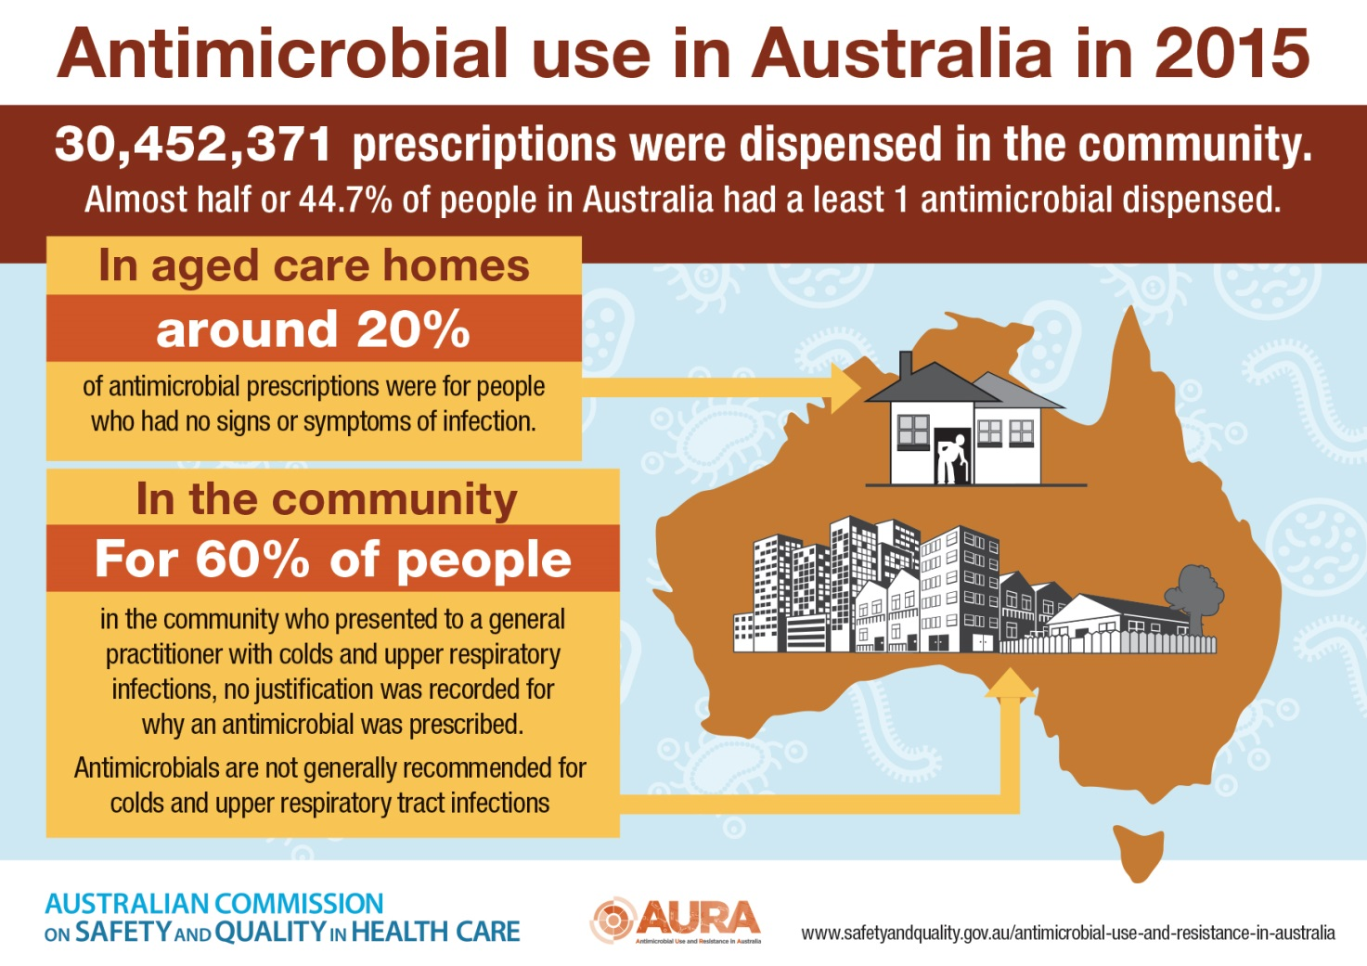

**Reports**

*Economic evaluation of investigator-initiated clinical trials conducted by networks*

Australian Clinical Trials Alliance

Sydney: ACSQHC; 2017. p.74.

|  |  |
| --- | --- |
| URL | <https://www.safetyandquality.gov.au/our-work/clinical-trials/> |
| Notes | The Australian Commission on Safety and Quality in Health Care sought to understand the full potential of clinical trials to influence health outcomes as well as their economic impact. The Commission engaged the Australian Clinical Trials Alliance, in partnership with Quantium Health Outcomes, to evaluate the overall health and economic impact of investigator-initiated clinical trials conducted by networks.  The study assessed investigator-initiated clinical trials conducted by select clinical trials networks in Australia, including the Australasian Stroke Trials Network (ASTN), the Interdisciplinary Maternal Perinatal Australasian Collaborative Trials (IMPACT) Network and the Australian and New Zealand Intensive Care Society Clinical Trials Group (ANZICS CTG).  Focussing on 25 high-impact clinical trials evaluated across the three networks, the report found that if the results of these trials were implemented in 65% of the eligible Australian patient populations for one year:   * The gross benefit would be approximately $2 billion measured through better health outcomes and reduced health service costs * Reductions in health service costs would account for 30% ($580 million) of the gross benefit, and this alone would exceed the total costs for the three networks and all of their research activity from 2004 to 2014. * The overall consolidated benefit-to-cost ratio for the networks is 5.8:1, or a return of $5.80 for every $1 invested * The results of the 25 trials only needed to be implemented in 11% of the eligible patient populations for benefits to exceed costs * For every $1 awarded in National Health and Medical Research Council (NHMRC) grants to the 25 trials, a return of $51.10 was achieved |

**Journal articles**

*Drug shortage leading to serendipitous adoption of high-value care practice*

Gupta A, Rahman A, Alvarez KS, Gard JW, Johnson DH, Agrawal D

BMJ Quality & Safety. 2017.

|  |  |
| --- | --- |
| DOI | <http://dx.doi.org/10.1136/bmjqs-2017-007015> |
| Notes | This piece describes the initial impact and lasting effect of a shortage of a particular medication in a hospital. In this instance a large (870-bed) teaching hospital was informed of a critical shortage of an intravenous proton pump inhibitor (PPI). As the authors point out, “PPIs are one of the most overused medications, and the intravenous route is often used when oral administration would suffice, significantly increasing medication and administration costs…Intravenous PPIs are recommended only in patients with active upper gastrointestinal bleeding prior to endoscopy, and sometimes after endoscopic treatment of an ulcer.” A retrospective review of the 12 months prior to the shortage found only 16% of orders were for active upper gastrointestinal bleeding.  When the shortage was announced, a number of interventions were implemented, including:   1. on single order entry, a clinical decision support message was created in the electronic medical record advising limiting the use of intravenous PPI to patients with active upper gastrointestinal bleeding 2. all remaining intravenous PPI orders required pharmacy approval prior to execution 3. order panels including continuous intravenous PPI had automatic stop orders after 24 hours panelled with a step down to oral PPI to complete therapy.   These were than retained even after the shortage was resolved. The authors report that “Over the next 2 years, the decrease in use of intravenous PPI has been sustained, an approximate **75% reduction** from baseline use. The estimated cumulative **cost saving** of this intervention has been $200 000. More importantly, we noticed a change in the ordering pattern of providers, and pharmacists had to perform minimal order entry outside of the prebuilt order sets and panels as time passed. There were **no reported adverse clinical outcomes**.”  They also note that “rapid adoption of high-value change is possible”. It also reinforces the adage about never letting a crisis go to waste. It can be an opportunity to review practice and behaviour.  \\central.health\dfsuserenv\Users\User_07\JOHNNI\Desktop\bmjqs-2017-007015-F1.large.jpg |

For information the Commission’s work on medication safety, see <https://www.safetyandquality.gov.au/our-work/medication-safety/>

*The third global patient safety challenge: tackling medication-related harm*

Sheikh A, Dhingra-Kumar N, Kelley E, Kieny MP, Donaldson LJ

Bulletin of the World Health Organization. 2017;95:546-a.

|  |  |
| --- | --- |
| DOI | <http://dx.doi.org/10.2471/BLT.17.198002> |
| Notes | Editorial in the Bulletin of the World Health Organization describing the WHO’s recent announcement of its third global patient safety challenge, **Medication without harm**. This challenge aims to reduce the global burden of iatrogenic medication-related harm by 50% within five years. A number of priority areas that most affect patients have been identified. These include high-risk situations, polypharmacy and transitions of care.  The WHO’s challenge invites health ministers to initiate national plans addressing four domains of medication safety:   * engaging patients and the public * medication as products * education, training and monitoring of health-care professionals * systems and practices of medication management.   The WHO’s role in this challenge would be to drive forward a range of global actions on medication safety. The WHO’s webpage for this challenge is at <http://www.who.int/patientsafety/medication-safety/en/> |

*A trip to healthcare*

Matz DE

Patient Experience Journal. 2017;4(2):9-12.

*The paradigm of patient must evolve: Why a false sense of limited capacity can subvert all attempts at patient involvement*

deBronkart D

Patient Experience Journal. 2017;4(2):4-8.

|  |  |
| --- | --- |
| URL | Matz <http://pxjournal.org/journal/vol4/iss2/3/>  deBronkart <http://pxjournal.org/journal/vol4/iss2/2> |
| Notes | A pair of items in the latest issue of the *Patient Experience Journal* that use narratives of complex or critical patient journeys (again, make use of the crises) to draw out important themes or learnings.  David Matz’s experience (two colonoscopies and three surgeries)prompted him to recommend:   * Every doctor in a diagnostic-decision-making interview should use the sentence “You have some choices here.” The doctor will have preferences, of course, but the patient needs to hear that there is more than one way to take the next step. * For diagnostic-decision-making moments, all doctors (and hospitals) should provide patients with support personnel to help the patients use decision-aids, prepare for discussions with doctors, and make the decisions.   David deBronkart’s experience (Stage IV renal cell carcinoma) makes him reflect on the definition and role(s) of the patient with him advocating for much more engagement, **activation** and **empowerment** of the patient. He reminds us of the World Bank’s definition : “Empowerment is increasing [someone’s] **capacity to make choices**, and to convert those choices into **effective actions and outcomes**.” |

For information the Commission’s work on patient and consumer centred care, see <https://www.safetyandquality.gov.au/our-work/patient-and-consumer-centred-care/>

*Australian Health Review*

Volume 41 Number 4 2017

|  |  |
| --- | --- |
| URL | <http://www.publish.csiro.au/ah/issue/8492> |
| Notes | A new issue of *Australian Health Review* has been published. Articles in this issues of *Australian Health Review* include:   * Are organisational factors affecting the **emotional withdrawal of community nurses**? (Leila Karimi, Sandra G. Leggat, Cindy Cheng, Lisa Donohue, Timothy Bartram and Jodi Oakman) * Experience of **clinical supervisors of international medical graduates** in an Australian district hospital (David Henderson, Pam D McGrath and Mary Anne Patton) * Survey of parent and carer experiences and expectations of **paediatric rheumatology** care in New South Wales (Andrea Coda, Julie Jones, Debra Grech and Davinder Singh Grewal) * Identification of major factors in Australian **primary care pharmacists’ practice environment** that have a bearing on the implementation of professional models of practice (John K Jackson, Safeera Y Hussainy and Carl M J Kirkpatrick) * Beyond clinical priority: what matters when making operational decisions about **emergency surgical queues**? (Anneke Fitzgerald and Yong Wu) * Growth of **linked hospital data use** in Australia: a systematic review (Michelle Tew, Kim M Dalziel, Dennis J Petrie and Philip M Clarke) * Parental preferences for **paediatric specialty follow-up care** (Marina Kunin, Erin Turbitt, Sarah A Gafforini, Lena A Sanci, Neil A Spike and Gary L Freed) * Identifying areas of **need** relative to **liver disease**: geographic clustering within a health service district (Nathan El-Atem, K M Irvine, P C Valery, K Wojcik, L Horsfall, T Johnson, M Janda, S M McPhail and E E Powell) * **Patients’ experiences in Australian hospitals**: a systematic review of evidence (Reema Harrison, Merrilyn Walton, Elizabeth Manias, Steven Mears and Jennifer Plumb) * **Informed consent in a vulnerable population group**: supporting individuals aging with intellectual disability to participate in developing their own health and support programs (Stuart Wark, Catherine MacPhail, Kathy McKay and Arne Müeller) * Improving the accuracy of **admitted subacute clinical costing**: an action research approach (Sharon Hakkennes, Ross Arblaster and Kim Lim * What systems participants know about **access and service entry** and why managers should listen (Rohena Duncombe) * Social participation as an indicator of **successful aging**: an overview of concepts and their associations with health (Heather Douglas, Andrew Georgiou and Johanna Westbrook) * Practical applications of **rapid review methods** in the development of **Australian health policy** (Robyn Lambert, Thomas D Vreugdenburg, Nicholas Marlow, N Ann Scott, Lynda McGahan and David Tivey) * **Caries and periodontal disease in Indigenous adults in Australia**: a case of limited and non-contemporary data (Andrea M de Silva, Jacqueline M Martin-Kerry, Katherine McKee and Deborah Cole) |

*Patient Experience Journal*

Volume 4, Issue 2 (2017)

|  |  |
| --- | --- |
| URL | <http://pxjournal.org/journal/vol4/iss2/> |
| Notes | A special issue of the *Patient Experience Journal* (PXJ) has been published. This special issue focused on Patient Involvement. The editors state that “By including the voices of patients, practitioners and researchers in the publication, this special issue is focused on how involving patients and families as partners drives better healthcare outcomes overall.” Articles in this special issue of the *Patient Experience Journal* include:   * Pushing the boundaries of **patient experience** (Jason A Wolf) * The paradigm of patient must evolve: Why a false sense of limited capacity can subvert all attempts at **patient involvement** (Dave deBronkart) * A trip to healthcare (david e matz) * Lack of **patient involvement** in care decisions and not receiving written discharge instructions are associated with **unplanned readmissions** up to one year (Kyle A Kemp, Hude Quan, and Maria J Santana) * Understanding the role of **patient and public involvement** in **renal dietetic research** (Andrew Morris, Deborah Biggerstaff, Nithya Krishnan, and Deborah Lycett) * Integrating **person directed care** into the client experience (Tammy L Marshall, Joann P Reinhardt, Orah Burack, and Audrey S Weiner) * Increasing **sustainability** in **co-design** projects: A qualitative evaluation of a co-design programme in New Zealand (Lynne Margaret Maher, Brooke Hayward, Patricia Hayward, and Chris Walsh) * **Experience-based co-design**: A method for patient and family engagement in **system-level quality improvement** (Bianca Fucile, Erica Bridge, Charlene Duliban, and Madelyn P. Law) |

*International Journal for Quality in Health Care* online first articles

|  |  |
| --- | --- |
| URL | <https://academic.oup.com/intqhc/advance-access?papetoc> |
| Notes | *International Journal for Quality in Health Care* has published a number of ‘online first’ articles, including:   * Reporting of medication **administration errors** by nurses in South Korean hospitals (Eunjoo Lee) * Evaluating the impact of **accreditation** on **Brazilian healthcare organizations**: A quantitative study (Ana Maria Saut; Fernando Tobal Berssaneti; Maria Carolina Moreno) * A comparison of **in-hospital acute myocardial infarction management** between Portugal and the United States: 2000–2010 (Mariana F. Lobo; Vanessa Azzone; Luís Filipe Azevedo; Bruno Melica; Alberto Freitas; Leonor Bacelar-Nicolau; Francisco N. Rocha-Gonçalves; Cláudia Nisa; Armando Teixeira-Pinto; José Pereira-Miguel; Frederic S. Resnic; Altamiro Costa-Pereira; Sharon-Lise Normand) * Are children presenting with non-IMCI complaints at greater risk for **suboptimal screening**? An analysis of outpatient visits in Afghanistan (Maya Venkataramani; Anbrasi Edward; Paul Ickx; Motawali Younusi; Syed Ali Shah Alawi; David H Peters) |

*BMJ Quality and Safety* online first articles

|  |  |
| --- | --- |
| URL | <https://qualitysafety.bmj.com/content/early/recent> |
| Notes | *BMJ Quality and Safety* has published a number of ‘online first’ articles, including:   * How to attribute **causality** in **quality improvement**: lessons from epidemiology (Alan J Poots, Julie E Reed, T Woodcock, D Bell, D Goldmann) * Factors influencing the **reporting** of **adverse medical device events**: qualitative interviews with physicians about higher risk implantable devices (Anna R Gagliardi, Ariel Ducey, Pascale Lehoux, Thomas Turgeon, Sue Ross, Patricia Trvovich, Anthony Easty, Chaim Bell, David Urbach) * The use of **patient feedback** by **hospital boards** of directors: a qualitative study of two NHS hospitals in England (Robert Lee, Juan I Baeza, N J Fulop) * Drug shortage leading to serendipitous adoption of **high-value care practice** (Arjun Gupta, A Rahman, K S Alvarez, J W Gard, D H Johnson, D Agrawal) * Does early return to theatre add value to rates of revision at 3 years in assessing **surgeon performance** for elective **hip and knee arthroplasty**? National observational study (Alex Bottle, H E Chase, P P Aylin, M Loeffler) * **Outpatient CPOE orders** discontinued due to ‘erroneous entry’: prospective survey of **prescribers’ explanations for errors** (Thu-Trang T Hickman, Arbor Jessica Lauren Quist, Alejandra Salazar, Mary G Amato, Adam Wright, Lynn A Volk, David W Bates, Gordon Schiff) * Consistency of **pressure injury documentation** across interfacility **transfers** (Lee Squitieri, David A Ganz, Carol M Mangione, Jack Needleman, Patrick S Romano, Debra Saliba, Clifford Y Ko, Daniel A Waxman) * Enhancing **problem list documentation** in **electronic health records** using two methods: the example of prior splenectomy (Dustin McEvoy, Tejal K. Gandhi, Alexander Turchin, Adam Wright) |

**Online resources**

*[UK] National Institute for Health Research*

https://discover.dc.nihr.ac.uk/portal/search/signals

The UK’s National Institute for Health Research (NIHR) Dissemination Centre has released the latest ‘Signals’ research summaries. This latest release includes:

* **Type 2 diabetes** is becoming more common in children
* Treatments for reducing **menopausal hot flushes** are ranked for effectiveness
* Physical activity in the community improves **mobility** for **cancer survivors**
* Regional anaesthesia could improve **fistula** function for **kidney dialysis**
* Tenofovir reduces mother-to-child **hepatitis B transmission**
* Online education, pain coaching and advice by video conference can reduce **knee pain**
* Intensive **speech therapy** helps **stroke survivors** with persistent communication difficulties
* Screen reminders for GPs did not improve **anticoagulant** prescribing in **atrial fibrillation**
* Continuous **insulin pumps** may help manage poorly controlled **type 2 diabetes**
* **Public health interventions** may offer a return on investment of £14 for each £1 spent

**Disclaimer**

*On the Radar* is an information resource of the Australian Commission on Safety and Quality in Health Care. The Commission is not responsible for the content of, nor does it endorse, any articles or sites listed. The Commission accepts no liability for the information or advice provided by these external links. Links are provided on the basis that users make their own decisions about the accuracy, currency and reliability of the information contained therein. Any opinions expressed are not necessarily those of the Australian Commission on Safety and Quality in Health Care.