
On the Radar
Issue 337
4 September 2017

On the Radar is a summary of some of the recent publications in the areas of safety and quality in health care. Inclusion in this document is not an endorsement or recommendation of any publication or provider. Access to particular documents may depend on whether they are Open Access or not, and/or your individual or institutional access to subscription sites/services. Material that may require subscription is included as it is considered relevant.

On the Radar is available online, via email or as a PDF or Word document from https://www.safetyandquality.gov.au/publications-resources/on-the-radar/

If you would like to receive On the Radar via email, you can subscribe on our website https://www.safetyandquality.gov.au/ or by emailing us at HUmail@safetyandquality.gov.auU.
You can also send feedback and comments to HUmail@safetyandquality.gov.auU.

For information about the Commission and its programs and publications, please visit https://www.safetyandquality.gov.au
You can also follow us on Twitter @ACSQHC.

On the Radar
Editor: Dr Niall Johnson niall.johnson@safetyandquality.gov.au
Contributors: Niall Johnson, Lauren Deutsch

Consultation open: Venous Thromboembolism Prevention Clinical Care Standard

In collaboration with consumers, clinicians, researchers and health organisations, the Australian Commission on Safety and Quality in Health Care (the Commission) has developed a draft Venous Thromboembolism (VTE) Prevention Clinical Care Standard.

Clinical care standards can play an important role in guiding the delivery of appropriate care and reducing unwarranted variation, as they identify and define the care people should expect to be offered, regardless of where they are treated in Australia. They target areas of variation where improvement can be made.

Development of a VTE Prevention Clinical Care Standard was proposed by state and territory health departments given that VTE prevention has been identified as an ongoing safety and quality issue in Australian hospitals.

Consultation on the draft VTE Prevention Clinical Care Standard and associated resources is now open until 30 September 2017. Submissions are requested via online survey available at https://www.surveymonkey.com/r/VTEPreventionClinicalCareStandard or by email to CCS@health.gov.au.

For more information on the consultation process, including access to the draft resources and survey, see https://www.safetyandquality.gov.au/our-work/clinical-care-standards/current-consultations/
Reports

Developing accountable care systems: Lessons from Canterbury, New Zealand
Charles A
London: The King's Fund; 2017. p. 27.
URL | https://www.kingsfund.org.uk/publications/developing-accountable-care-systems
Notes | The UK’s King’s Fund has published this short report describing how integrated care was designed and implemented in Canterbury, New Zealand by the local Canterbury District Health Board (DHB). The report found that three key approaches were central:  - a clear, unifying vision behind the ‘one system, one budget’ message  - sustained investment in giving staff skills to support them to innovate and giving them permission to do so  - developing new models of integrated working and new forms of contracting.  The transformation programme focused on keeping people (particularly older people) well and healthy in their homes and communities. A number of new programmes and ways of working were developed with the common themes of integrating care across organisational and service boundaries; increasing investment in community-based services; and strengthening primary care.  Canterbury’s health system has seen moderated demand for hospital care, particularly among older people. Compared with the rest of New Zealand, Canterbury has lower acute medical admission rates; lower acute readmission rates; shorter average length of stay; lower emergency department attendances; higher spending on community-based services; and lower spending on emergency hospital care. Improving the interface between primary and secondary care has led to better-quality referrals, reductions in waiting times and reduced spending on pathology and imaging tests.

Primary Care Home: Evaluating a new model of primary care
Research report
Kumpunen S, Rosen R, Kossarova L, Sherlaw-Johnson C
London: Nuffield Trust; 2017. p. 96.
URL | https://www.nuffieldtrust.org.uk/research/primary-care-home-evaluating-a-new-model-of-primary-care
Notes | This report also examines an effort to re-organise primary care in order to provide better integrated care in the community. In this report from the UK’s Nuffield Trust the subject was the Primary Care Home (PCH) model. The model seeks to link staff from general practice, community-based services, hospitals, mental health services, social care and voluntary organisations to deliver more integrated care. The report offers lessons from implementation and evaluation for both the services and for the greater system. Among the report’s key messages were:  - Participating in the primary care home programme had strengthened inter-professional working between GPs and other health professionals, and stimulated new services and ways of working tailored to the needs of different patient groups.  - Policy-makers must accept that these new working relationships will take time to establish, as widespread service change requires support from people at all levels and across organisational boundaries.  - Developing the PCH model needs significant investment in time, money and support to enable change.  - Good quality data – and the ability to use it – are essential for future evaluations of these models.
For information on the Commission’s work on primary health care, see https://www.safetyandquality.gov.au/our-work/primary-health-care/

Journal articles

Association of Adverse Events With Antibiotic Use in Hospitalized Patients
Tamma PD, Avdic E, Li DX, Dzintars K, Cosgrove SE
JAMA Internal Medicine. 2017 [epub].
DOI | http://dx.doi.org/10.1001/jamainternmed.2017.1938
Notes | If concerns about antimicrobial resistance and appropriateness of use were not enough to raise concerns about the use of antimicrobials this study reveals a high level of adverse drug events (ADEs) associated with their use. This cohort study reviewed the medical records of 1488 adult patients admitted to general medicine wards at a US academic medical centre for 30 days after starting antibiotics for the development of the following antibiotic-associated ADEs: gastrointestinal, dermatologic, musculoskeletal, hematologic, hepatobiliary, renal, cardiac, and neurologic; and 90 days for the development of Clostridium difficile infection or incident multidrug-resistant organism infection. Of these 1488 patients, 298 (20%) patients experienced at least 1 antibiotic-associated ADE. The authors also note that 56 (20%) non–clinically indicated antibiotic regimens were associated with an ADE, including 7 cases of C difficile infection. As the authors conclude “Although antibiotics may play a critical role when used appropriately, our findings underscore the importance of judicious antibiotic prescribing to reduce the harm that can result from antibiotic-associated ADEs.”

For information on the Commission’s work on healthcare associated infection, see https://www.safetyandquality.gov.au/our-work/healthcare-associated-infection/

We Want to Know: Eliciting Hospitalized Patients' Perspectives on Breakdowns in Care
Fisher KA, Smith KM, Gallagher TH, Burns L, Morales C, Mazor KM
Journal of Hospital Medicine. 2017 Aug;12(8):603-9.
DOI | http://dx.doi.org/10.12788/jhm.2783
Notes | That there are lapses in care (and these can lead to harm) and that patients have important perspectives on their care (they are only person present for the entire journey) are both now incontrovertible.  This study reports on a survey of 979 patients in two American hospitals that revealed almost 40% considered that they had experienced a breakdown in their care.  Of the 979 patients, 386 (39.4%) believed they had experienced at least one breakdown in care. The most common reported breakdowns involved information exchange (16.1%), medications (12.3%), delays in admission (9.2%), team communication (6.6%), providers’ manner (6.3%), and discharge (5.7%).  140 of the 386 patients (36.3%) perceived associated harm with the breakdown in care. The harms they reported included physical (eg, pain), emotional (eg, distress, worry), damage to relationship with providers, need for additional care or prolonged hospital stay, and life disruption.  The authors report that younger patients (<60 years old), those with some level of tertiary education and those with another person (family or friend) present during the interview or interviewed in lieu of the patient were more likely to report breakdowns.

For information on the Commission’s work on patient and consumer centred care, see https://www.safetyandquality.gov.au/our-work/patient-and-consumer-centred-care/
Patient-centred care is a way of doing things: How healthcare employees conceptualize patient-centred care
Fix GM, VanDeusen Lukas C, Bolton RE, Hill JN, Mueller N, LaVela SL, et al
Health Expectations. 2017 [epub].
DOI | http://dx.doi.org/10.1111/hex.12615
Notes | This paper describes a study that survey 107 employees ( including leadership, middle managers, front line providers and staff) at four US Veteran Health Administration (VHA) medical centres on their perspectives on patient-centred care. From these, the authors consider that “Patient- centred care ideals have permeated into healthcare systems.” Indeed, they found that “patient- centred care has been expanded to encompass a cultural shift in care delivery, beginning with patients’ experiences entering a facility.” But it is not without concerns as “some healthcare employees, namely leadership, see patient- centred care so broadly, it encompasses on- going hospital initiatives, while others consider patient- centred care as inherent to specific positions. These latter conceptualizations risk undermining patient- centred care implementation by limiting transformational initiatives to specific providers or simply repackaging existing programmes.” So while patient-centred care is recognised, how it is understood within health systems and facilities varies.

What role does performance information play in securing improvement in healthcare? a conceptual framework for levers of change
Levesque J-F, Sutherland K
BMJ Open. 2017;7(8):e014825.
DOI | http://dx.doi.org/10.1136/bmjopen-2016-014825
Notes | In this paper the authors identify and describe eight different levers for change in healthcare that are each enabled by performance information. Their framework structures these levers in terms of the source of motivation (internal/external) and whether change is planned or emergent.  The eight levers identified are:  - Cognitive – a means to gauge one’s own performance  - mimetic – inform about the performance of others  - supportive – provide facilitation, implementation tools or models of care to actively support change  - formative – develop capabilities and skills through teaching, mentoring and feedback  - normative – set performance against guidelines, professional standards, norms, certification and accreditation processes  - coercive – use policies, regulations incentives and disincentives to force change  - structural – organisational constraints  - competitive – attract patients or funders.  These have then been mapped in a matrix of quadrants each quadrant representing a different way in which change occurs (source of motivation and origin of change).  In any given context (and context matters) multiple levers may operate; but there are also instances whether different levers may act in different directions.  The authors make a number of apposite observations, including:  - Measuring performance in healthcare is …about quantifying what healthcare systems, organisations and professionals are really achieving  - Routine release of information can guide planned efforts to improve and provide formative feedback according to agreed regular schedules. However, routine reporting can also lose salience if too many measures or too frequent reporting generates indicator chaos or fatigue.  - Levers are the way to harness the power of data to secure improvement. However, a lever rarely operates in isolation—any system, organisation or healthcare professional is subject to multiple levers simultaneously. Meaningful and sustained change is more likely to be secured when different levers work in concert—aligning and reinforcing efforts to improve.  - the efficacy of levers is context dependent… t need informed and often nuanced application  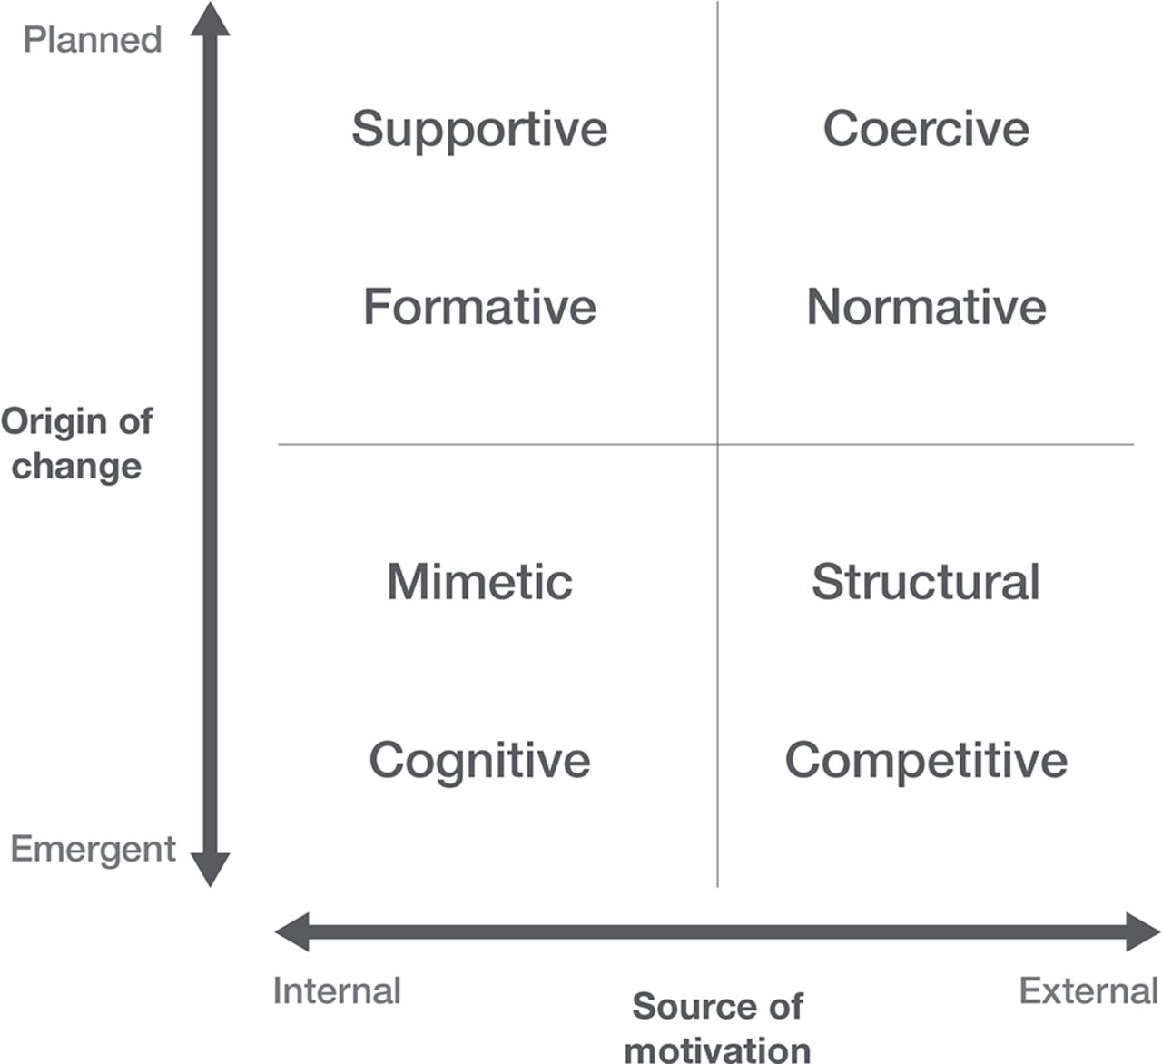

Evaluation of the effects of the French pay-for-performance program—IFAQ pilot study
Lalloué B, Jiang S, Girault A, Ferrua M, Minvielle E
International Journal for Quality in Health Care. 2017 [epub].
DOI | https://doi.org/10.1093/intqhc/mzx111
Notes | This evaluation of the French pay-for-performance (P4P) IFAQ compared 185 eligible hospitals that participated in a pilot program with 192 eligible hospitals that were not selected for the pilot using nine process quality indicators to derive an aggregate score Several characteristics known to have an influence on P4P results (patient age, socioeconomic status, hospital activity, casemix and location) were used to adjust the models. The analyses showed that while “all hospitals improved from 2012 to 2014, the difference-in-differences effect was positive but not significant both in the crude (2.89, P = 0.29) and adjusted models (4.07, P = 0.12)” The authors suggest that a number of factors contribute to this, including low level of financial incentives, unattainable goals, too short study period. But they also suggest that “lack of impact for the first year should not undermine the implementation of other P4P programs. Indeed, the pilot study helped to improve the final model used for generalization.”
Clinical Practice Guideline: Safe Medication Use in the ICU
Kane-Gill SL, Dasta JF, Buckley MS, Devabhakthuni S, Liu M, Cohen H, et al
Critical Care Medicine. 2017;45(9):e877-e915.
DOI | http://dx.doi.org/10.1097/CCM.0000000000002533
Notes | The American College of Critical Care Medicine has developed this clinical practice guideline in order to provide intensive care unit (ICU) clinicians evidence-based guidance on safe medication use practices for the critically ill.

For information on the Commission’s work on medication safety, see https://www.safetyandquality.gov.au/our-work/medication-safety/

Development of a trigger tool to identify adverse drug events in elderly patients with multimorbidity
Toscano Guzmán MD, Galván Banqueri M, Otero MJ, Alfaro Lara ER, Casajus Lagranja P, Santos Ramos B
Journal of Patient Safety. 2017 [epub].
DOI | http://dx.doi.org/10.1097/PTS.0000000000000389
Notes | Multimorbidity (and polypharmacy) are known contributors to adverse drug events (ADEs) and other forms of medication misuse. This paper describes the development of a set of (51) triggers for detecting ADEs in elderly patients with multimorbidity. This is a work in progress as, the authors observe, “Subsequent validation in clinical practice is needed to confirm the accuracy and efficiency of these triggers for this population.”

BMJ Quality and Safety online first articles
URL | https://qualitysafety.bmj.com/content/early/recent
Notes | BMJ Quality and Safety has published a number of ‘online first’ articles, including:  - Variation and statistical reliability of publicly reported primary care diagnostic activity indicators for cancer: a cross-sectional ecological study of routine data (Gary Abel, Catherine L Saunders, Silvia C Mendonca, Carolynn Gildea, Sean McPhail, Georgios Lyratzopoulos)

International Journal for Quality in Health Care online first articles
URL | https://academic.oup.com/intqhc/advance-access?papetoc
Notes | International Journal for Quality in Health Care has published a number of ‘online first’ articles, including:  - How well do general practitioners manage laboratory test results for patients with diabetes mellitus and cardiovascular disease?: A systematic review (Euan J. McCaughey; Julie Li; Tony C. Badrick; Johanna I. Westbrook; Andrew Georgiou)  - Avoidable emergency department visits: a starting point (Renee Y Hsia; Matthew Niedzwiecki)  - Evaluation of the effects of the French pay-for-performance program—IFAQ pilot study (Benoît Lalloué Shu Jiang Anne Girault Marie Ferrua Philippe Loirat Etienne Minvielle)

Online resources

[USA] Public Reporting of Surgical Outcomes: Surgeons, Hospitals, or Both?
https://newsatjama.jama.com/2017/08/24/jama-forum-public-reporting-of-surgical-outcomes-surgeons-hospitals-or-both/
Post on the JAMA Forum by Ashish Jha providing a succinct summary of the arguments around public reporting, focusing on surgical outcomes and the issue of whether reporting should be about individual surgeon performance, the hospitals (or units) they operate within or both. Public reporting is not necessarily used by the public (to date) but rather the importance of timely feedback and reporting can be a spur to quality and safety, Jha’s final sentence urges us forward to individual reporting “Because if the goal is to improve surgical care, we must ensure that the person most influential in the process remains accountable for its outcome.”

[UK] National Institute for Health Research
https://discover.dc.nihr.ac.uk/portal/search/signals
The UK’s National Institute for Health Research (NIHR) Dissemination Centre has released the latest ‘Signals’ research summaries. This latest release includes:
- Drug reduces deaths from bleeding after childbirth
- Carers of stroke survivors voice an unmet need for practical and emotional support
- Humidified oxygen linked to increased chest infections
- Silk clothing for children does not reduce objective measures of eczema severity
- Using mesh does not improve results in vaginal prolapse surgery
- Talking therapy given by parents shows promise for childhood anxiety disorders
- Stop smoking services can work for people in treatment or recovery from substance misuse disorders
- Treating subclinical thyroid dysfunction in pregnancy probably has no benefit
- Dexamethasone before bowel surgery reduces postoperative nausea and vomiting
- Prescribing regular drugs to prevent febrile convulsions risks more harm than benefit

Disclaimer
On the Radar is an information resource of the Australian Commission on Safety and Quality in Health Care. The Commission is not responsible for the content of, nor does it endorse, any articles or sites listed. The Commission accepts no liability for the information or advice provided by these external links. Links are provided on the basis that users make their own decisions about the accuracy, currency and reliability of the information contained therein. Any opinions expressed are not necessarily those of the Australian Commission on Safety and Quality in Health Care.

