# Australian COmmission on Safety and Quality in Health Care logo with Radar imageOn the Radar

Issue 350

4 December 2017

*On the Radar* is a summary of some of the recent publications in the areas of safety and quality in health care. Inclusion in this document is not an endorsement or recommendation of any publication or provider. Access to particular documents may depend on whether they are Open Access or not, and/or your individual or institutional access to subscription sites/services. Material that may require subscription is included as it is considered relevant.

*On the Radar* is available online, via email or as a PDF or Word document from <https://www.safetyandquality.gov.au/publications-resources/on-the-radar/>

If you would like to receive *On the Radar* via email, you can subscribe on our website <https://www.safetyandquality.gov.au/> or by emailing us at H[Umail@safetyandquality.gov.auU](mailto:mail@safetyandquality.gov.au).   
You can also send feedback and comments to H[Umail@safetyandquality.gov.auU](mailto:mail@safetyandquality.gov.au).

For information about the Commission and its programs and publications, please visit <https://www.safetyandquality.gov.au>

You can also follow us on Twitter @ACSQHC.

**On the Radar**

Editor: Dr Niall Johnson [niall.johnson@safetyandquality.gov.au](mailto:niall.johnson@safetyandquality.gov.au)

Contributors: Niall Johnson, Alice Bhasale, Claire Farmer

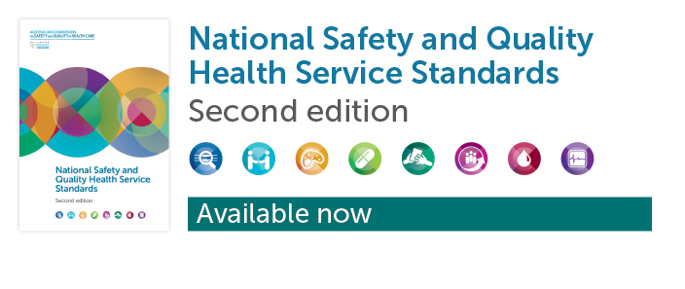

**National Safety and Quality Health Service Standards. 2nd edition**

Australian Commission on Safety and Quality in Health Care

Sydney: ACSQHC; 2017. p.86.

<http://www.safetyandquality.gov.au/second-edition>

The second edition of the National Safety and Quality Health Service (NSQHS) Standards, which was endorsed by Health Ministers in July 2017, [is now available](http://www.safetyandquality.gov.au/second-edition).

Over the past five years the successful implementation of the first edition of the NSQHS Standards has been a significant landmark in our journey to improving health care in Australia.

The Commission has worked closely with the Australian Government, states and territories, private sector partners, clinicians, consumers, technical experts and many stakeholders to review the NSQHS Standards and develop the second edition and its supporting resources.

The second edition of the NSQHS Standards addresses gaps identified in the first edition, including mental health and cognitive impairment, health literacy, end-of-life care, and Aboriginal and Torres Strait Islander health. It also updates the evidence for actions, consolidates and streamlines standards and actions to make them clearer and easier to implement.

Health service organisations will be assessed to the second edition of the NSQHS Standards from January 2019. The Commission will provide information on the transition arrangements for assessment well in advance of implementation.

The [Commission’s National Model Clinical Governance Framework is also available](http://www.safetyandquality.gov.au/second-edition). Leaders of health service organisations have a responsibility to the community for ensuring that their services are person-centred, safe and effective. Building on the NSQHS Standards, the Framework provides information about corporate and clinical governance, and roles and responsibilities for people within a health service organisation.

The Commission has developed a range of other resources to support implementation of the NSQHS Standards. These are also available at <http://www.safetyandquality.gov.au/second-edition>

For more information on the second edition and related resources please contact the National Standards team on 1800 304 056 or [accreditation@safetyandquality.gov.au](mailto:accreditation@safetyandquality.gov.au)

The eight NSQHS Standards are:

* **Clinical Governance**, which describes the clinical governance, and safety and quality systems that are required to maintain and improve the reliability, safety and quality of health care, and improve health outcomes for patients.
* **Partnering with Consumers**, which describes the systems and strategies to create a person-centred health system by including patients in shared decision making, to ensure that patients are partners in their own care, and that consumers are involved in the development and design of quality health care.
* **Preventing and Controlling Healthcare- Associated Infection**, which describes the systems and strategies to prevent infection, to manage infections effectively when they occur, and to limit the development of antimicrobial resistance through prudent use of antimicrobials, as part of effective antimicrobial stewardship.
* **Medication Safety**, which describes the systems and strategies to ensure that clinicians safely prescribe, dispense and administer appropriate medicines to informed patients, and monitor use of the medicines.
* **Comprehensive Care**, which describes the integrated screening, assessment and risk identification processes for developing an individualised care plan, to prevent and minimise the risks of harm in identified areas.
* **Communicating for Safety**, which describes the systems and strategies for effective communication between patients, carers and families, multidisciplinary teams and clinicians, and across the health service organisation.
* **Blood Management**, which describes the systems and strategies for the safe, appropriate, efficient and effective care of patients’ own blood, as well as other supplies of blood and blood products.
* **Recognising and Responding to Acute Deterioration**, which describes the systems and processes to respond effectively to patients when their physical, mental or cognitive condition deteriorates.

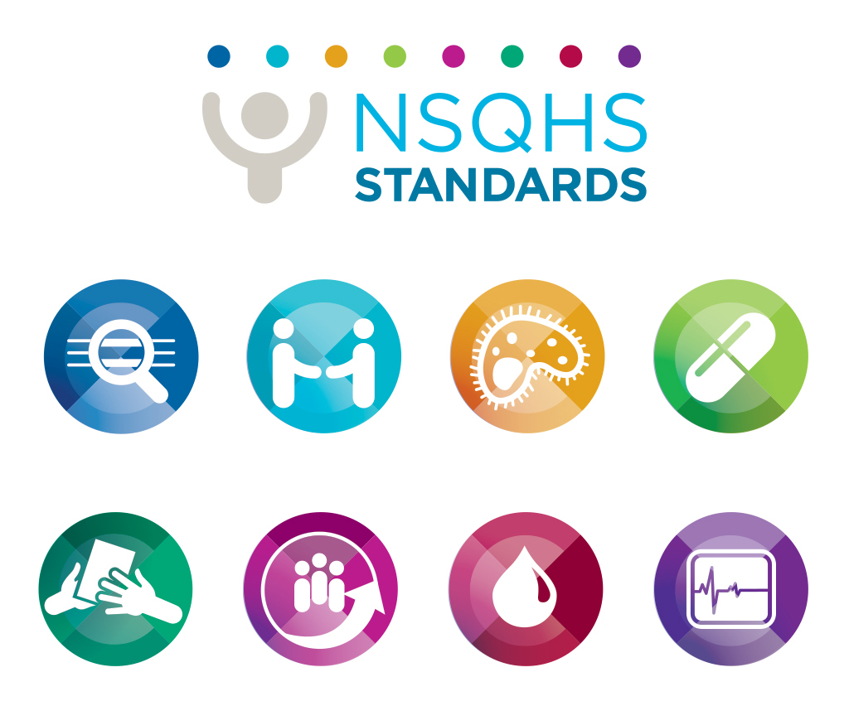

**Reports**

*Some assembly required: implementing new models of care*

Starling A

London: The Health Foundation; 2017. p. 36.

|  |  |
| --- | --- |
| URL | <http://www.health.org.uk/publication/some-assembly-required> |
| Notes | The UK’s Health Foundation has published this ‘learning report’ that captures some of the experiences of those working on the ‘vanguard sites’ of the new care models programme in England. The report sets out 10 lessons for those seeking to systematically make improvements across local health and care services for those patients who are in most need of integrated care. The report emphasises the value of local co-creation and testing of new care models, and offers learnings for those seeking to drive the development of new models of care within sustainability and transformation partnerships and accountable care systems.  The 10 lessons are:   1. Start by focusing on a specific population. 2. Involve primary care from the start. 3. Go where the energy is. 4. Spend time developing shared understanding of challenges. 5. Work through and thoroughly test assumptions about how activities will achieve results. 6. Find ways to learn from others and assess suitability of interventions. 7. Set up an ‘engine room’ for change. 8. Distribute decision-making roles. 9. Invest in workforce development at all levels. 10. Test, evaluate and adapt for continuous improvement. |

**Journal articles**

*State-wide reduction in in-hospital cardiac complications in association with the introduction of a national standard for recognising deteriorating patients*

Martin C, Jones D, Wolfe R

Resuscitation. 2017;121(Supplement C):172-8.

|  |  |
| --- | --- |
| DOI | <https://doi.org/10.1016/j.resuscitation.2017.08.240> |
| Notes | This study assessed the impact of National Safety and Quality Health Service (NSQHS) Standards Standard 9: Recognising and Responding to Acute Clinical Deterioration on patient outcomes. Using Victorian hospital data, the study found a **significant decrease** in **in-hospital cardiac arrests** in the time since the introduction of NSQHS Standard 9: Recognising and responding to acute clinical deterioration. A reduction in myocardial infarction and other acute coronary syndromes was also shown. Greatest benefit was seen in the elderly, female and surgical patients. A reduction in mortality was seen over the time period but this was not associated with the introduction of the national standard. |

*Comprehensive geriatric assessment for older adults admitted to hospital*

Ellis G, Gardner M, Tsiachristas A, Langhorne P, Burke O, Harwood RH, et al.

Cochrane Database of Systematic Reviews 2017.

|  |  |
| --- | --- |
| DOI | <http://dx.doi.org/10.1002/14651858.CD006211.pub3> |
| Notes | This week’s Cochrane Journal Club features an update to the review of comprehensive geriatric assessment for older adults with frailty. The review found that **patients** undergoing a **comprehensive geriatric assessment** on hospital admission were **more likely to be living independently** in their own homes 3–12 months after admission. An associated [podcast](http://thehearingaidpodcasts.org.uk/episode-1-1-comprehensive-geriatric-assessment/?elq_mid=22932&elq_cid=10281492) explains the benefits of comprehensive geriatric assessment, which is a multidisciplinary approach to assessing, planning and caring for elderly patients.  In a related vein, the NHS has recently announced the first emergency department specifically for over 80-year-olds. For more information, see the news item at <http://www.bbc.com/news/uk-england-norfolk-41898684> |

*Factors influencing the activation of the rapid response system for clinically deteriorating patients by frontline ward clinicians: a systematic review*

Chua WL, See MTA, Legio-Quigley H, Jones D, Tee A, Liaw SY

International Journal for Quality in Health Care. 2017 [epub].

|  |  |
| --- | --- |
| DOI | <https://doi.org/10.1093/intqhc/mzx149> |
| Notes | Review article that examined 30 studies to understand the factors influencing the activation of the rapid response system (RRS) and reasons for suboptimal RRS activation by ward nurses and junior physicians. The review found that the “process to RRS **activation** was **influenced** by the **perceptions** and **clinical experiences** of ward nurses and physicians, and **facilitated by tools and technologies**, including the sensitivity and specificity of the **activation criteria**, and **monitoring** technology. However, the task of enacting the RRS activations was challenged by seeking **further justification**, **deliberating over reactions** from the rapid response team and the impact of **workload and staffing**. Finally, adherence to the **traditional model of escalation of care**, **support** from colleagues and hospital leaders, and staff **training** were organizational factors that influence RRS activation.” |

For information on the Commission’s work on recognising and responding to clinical deterioration, see <https://www.safetyandquality.gov.au/our-work/recognising-and-responding-to-clinical-deterioration/>

*The new diagnostic team*

Graber ML, Rusz D, Jones ML, Farm-Franks D, Jones B, Gluck JC, et al

Diagnosis. 2017 [epub]

|  |  |
| --- | --- |
| DOI | <https://doi.org/10.1515/dx-2017-0022> |
| Notes | Issues around diagnosis have emerged as areas of interest in terms of safety and quality of care. This article suggests how a team approach to diagnosis is founded on patient--centred care and needs to draw on the input and expertise of a range of clinicians and other professionals. |

*A Standard-Setting Body for US Health Care Quality Measurement*

Austin JM, Black B, Pronovost PJ

American Journal of Medical Quality. 2017 [epub].

*Measuring patient safety in real time: An essential method for effectively improving the safety of care*

Classen DC, Griffin FA, Berwick DM

Annals of Internal Medicine. 2017 [epub].

|  |  |
| --- | --- |
| DOI | Austin et al <https://dx.doi.org/10.1177/1062860617741977>  Classen et al <https://dx.doi.org/10.7326/M17-2202> |
| Notes | A pair of pieces advocating for ‘infrastructure’ to improve health care.  Austin et al offer a commentary piece reviewing some of the issues around quality measurement in the US health setting (many of which apply elsewhere of course) and propose the establishment of a “new standard-setting body for US health care performance auditing and measurement.” However, auditing and measurement must be accompanied or followed by analysis and time feedback so as to improve care.  Classen et al call for “leveraging the HER” [Electronic Health Records] to develop “a reliable approach to measuring all causes of harm in all hospitalized patients, with minimal additional resources and in a time frame that allows for concurrent mitigation and prevention. In fact, the Centers for Medicare & Medicaid Services recently announced the development of a new EHR-based patient safety measure using such electronic approaches **All hospitals should use their EHRs to measure harm and better guide and monitor the real effect of their patient safety efforts**.” |

*Where should patient safety be installed?*

Sine DM, Paull D

Journal of Healthcare Risk Management. 2017 [epub].

|  |  |
| --- | --- |
| DOI | <http://dx.doi.org/10.1002/jhrm.21285> |
| Notes | Commentary piece pondering the appropriate place in an organisational structure of patient safety. As structures do have an influence on the way people work and what gets done where work units and individuals are then placed, the reporting lines and workgroups reflect signals power, prestige, and privilege. The authors suggest (perhaps self-evidently) that how a given organisation defines patient safety will affect the placement in that organisation’s framework or structure. |

*Australian Health Review*

Volume 41(6) 2017

|  |  |
| --- | --- |
| URL | <http://www.publish.csiro.au/ah/issue/8496> |
| Notes | A new issue of *Australian Health Review* has been published. Articles in this issue of *Australian Health Review* include:   * **Structured interdisciplinary bedside rounds** do not reduce **length of hospital stay** and **28-day re-admission** rate among older people hospitalised with acute illness: an Australian study (Elizabeth Huynh, David Basic, Rinaldo Gonzales and Chris Shanley) * Is the Australian **75+ Health Assessment** **person-centred**? A qualitative descriptive study of older people’s perceptions (Kay Price, Karen Grimmer and Jan Foot) * Changes in the profile of Australians in 77 **residential aged care facilities** across New South Wales and the Australian Capital Territory (Robert Borotkanics, C Rowe, A Georgiou, H Douglas, M Makeham and J Westbrook) * **Embedding health literacy** into health systems: a case study of a regional health service (Lucia Vellar, Fiorina Mastroianni and Kelly Lambert) * **Capturing religious identity during hospital admission**: a valid practice in our increasingly secular society? (David Glenister and Martin Prewer) * Can a **clinical senate** enhance state-wide clinician engagement? A survey study (Julie A Quinlivan, Mary Miller and Marani Hutton) * What is the role of **health systems** in responding to **domestic violence**? An evidence review (Jo Spangaro) * Going digital: a narrative overview of the clinical and organisational impacts of **eHealth technologies in hospital practice** (Justin Keasberry, Ian A Scott, Clair Sullivan, Andrew Staib and Richard Ashby) * **General practitioner management of chronic diseases** in adults with severe mental illness: a community intervention trial (Cate M. Cameron, Jose Cumsille Nazar, C Ehrlich, E Kendall, D Crompton, A M Liddy and S Kisely) * Exploring **interhospital transfers and partnerships** in the hospital sector in New South Wales, Australia (Hassan Assareh, Helen M Achat, Jean-Frederic Levesque and Stephen R Leeder) * Doctors’ attitudes regarding **not for resuscitation orders** (Gaya Sritharan, Amber C Mills, Michele R Levinson and Anthea L Gellie) * Inconsistencies in authoritative **national paediatric workforce data** sources (Amy R Allen, Richard Doherty, Andrew M Hilton and Gary L Freed) * Investigation of **training and support needs in rural and remote** disability and mainstream service providers: implications for an online training model (Genevieve Johnsson, Rachel Kerslake, Sarah Crook and Corinne Cribb) * It’s more than money: policy options to secure **medical specialist workforce for regional centres** (Jennifer May, Judi Walker, M McGrail and F Rolley) * Factors affecting job satisfaction of **Aboriginal mental health workers** working in community mental health in rural and remote New South Wales (Catherine Cosgrave, Myfanwy Maple and Rafat Hussain) * **Home enteral nutrition**: are we providing a quality service? (Alison Qvist) * Evidence-based review, not change in usage patterns, should drive **Medicare Benefit Schedule (MBS) disinvestment decisions** (John W Orchard, Jessica J Orchard and David J. Samra) * Reply to ‘Evidence-based review, not change in usage patterns, should drive **Medicare Benefit Schedule (MBS) disinvestment decisions**’ (Linda Mundy) |

*BMJ Quality and Safety* online first articles

|  |  |
| --- | --- |
| URL | <https://qualitysafety.bmj.com/content/early/recent> |
| Notes | *BMJ Quality and Safety* has published a number of ‘online first’ articles, including:   * Editorial: Lending a hand: could machine learning help hospital staff make better use of **patient feedback**? (Chris Gibbons, Felix Greaves) * **Inpatient bedspacing**: could a common response to hospital crowding cause increased patient mortality? (Finlay A McAlister, Kaveh G Shojania) * Transportation characteristics associated with **non-arrivals to paediatric clinic appointments**: a retrospective analysis of 51 580 scheduled visits (David J Wallace, Kristin N Ray, Abbye Degan, Kristen Kurland, Derek C Angus, Ana Malinow) * Increasing the use of **patient decision aids in orthopaedic care**: results of a quality improvement project (Mahima Mangla, Thomas D Cha, Janet M Dorrwachter, Andrew A Freiberg, Lauren J Leavitt, Harry E Rubash, Leigh H Simmons, Emily L Wendell, Karen R Sepucha) * Effect of a population-level performance dashboard intervention on **maternal-newborn outcomes**: an interrupted time series study (Deborah Weiss, Sandra I Dunn, Ann E Sprague, Deshayne B Fell, Jeremy M Grimshaw, Elizabeth Darling, Ian D Graham, JoAnn Harrold, Graeme N Smith, Wendy E Peterson, Jessica Reszel, A Lanes, M C Walker, M Taljaard) * Performance of statistical process control methods for **regional surgical site infection surveillance**: a 10-year multicentre pilot study (Arthur W Baker, Salah Haridy, Joseph Salem, Iulian Ilieş, Awatef O Ergai, Aven Samareh, Nicholas Andrianas, James C Benneyan, Daniel J Sexton, D J Anderson) * **Implementation science** at the crossroads (Richard J Lilford) |

*International Journal for Quality in Health Care* online first articles

|  |  |
| --- | --- |
| URL | <https://academic.oup.com/intqhc/advance-access?papetoc> |
| Notes | *International Journal for Quality in Health Care* has published a number of ‘online first’ articles, including:   * Healthcare providers’ perceptions of a **situational awareness** display for **emergency department resuscitation**: a simulation qualitative study (Lisa A Calder; Abhi Bhandari; George Mastoras; Kathleen Day; Kathryn Momtahan; Matthew Falconer; Brian Weitzman; Benjamin Sohmer; A Adam Cwinn; Stanley J Hamstra; Avi Parush) * Impact of **bundled payments** on **hip fracture outcomes**: a nationwide population-based study (Yu-Chi Tung; Hsien-Yen Chang; Guann-Ming Chang) * **Relationship-centered health care** as a Lean intervention (Jennifer Dunsford; Laura E Reimer) * Psychometric analysis of the TRANSIT **quality indicators for cardiovascular disease prevention in primary care** (Cynthia Khanji; Céline Bareil; Eveline Hudon; Johanne Goudreau; Fabie Duhamel; Marie-Thérèse Lussierl; Sylvie Perreault; Gilles Lalonde; Alain Turcotte; Djamal Berbiche; Élisabeth Martin; Lise Lévesque; Marie-Mireille Gagnon; Lyne Lalonde) * Examining influences on **speaking up** among critical care healthcare providers in the United Arab Emirates (Hanan H Edrees, Mohd Nasir Mohd Ismail, Bernadette Kelly, Christine A Goeschel, Sean M Berenholtz, Peter J Pronovost, Ali Abdul Kareem Al Obaidli, Sallie J Weaver) |

**Online resources**

*[UK] NICE Guidelines and Quality Standards*

<https://www.nice.org.uk>

The UK’s National Institute for Health and Care Excellence (NICE) has published new (or updated) guidelines and quality standards. The latest reviews or updates are:

* NICE Guideline NG80 ***Asthma****: diagnosis, monitoring and chronic asthma management* <https://www.nice.org.uk/guidance/ng80>
* Quality Standard QS25 ***Asthma*** <https://www.nice.org.uk/guidance/qs25>

*[USA] Effective Health Care Program reports*

<https://effectivehealthcare.ahrq.gov/>

The US Agency for Healthcare Research and Quality (AHRQ) has an Effective Health Care (EHC) Program. The EHC has released the following final reports and updates:

* Management of **Suspected Opioid Overdose** with Naloxone by Emergency Medical Services Personnel <https://www.effectivehealthcare.ahrq.gov/topics/emt-naloxon/systematic-review>

*[UK] National Institute for Health Research*

https://discover.dc.nihr.ac.uk/portal/search/signals

The UK’s National Institute for Health Research (NIHR) Dissemination Centre has released the latest ‘Signals’ research summaries. This latest release includes:

* Faecal transplant effectively treats recurrent or unresponsive ***Clostridium difficile***
* Aerobic exercise moderately reduces **depressive symptoms in new mothers**
* **Blood pressure self-monitoring** works best when people are well-supported
* Exercise improves symptoms and function for people with **ankylosing spondylitis**
* Comprehensive assessment when **older people** are **in hospital** improves their chances of getting home and living independently
* Checklists are no substitute for experience in spotting **patients** who are **deteriorating**
* Uncertain benefit of adding amisulpiride to clozapine for **treatment-resistant schizophrenia**
* Using a ‘telephone first’ approach may increase the total **time GPs spend consulting**
* A commonly used treatment does not improve **chronic low back pain**
* Being **overweight or obese** is linked with **heart disease** even without other metabolic risk factors.

**Disclaimer**

*On the Radar* is an information resource of the Australian Commission on Safety and Quality in Health Care. The Commission is not responsible for the content of, nor does it endorse, any articles or sites listed. The Commission accepts no liability for the information or advice provided by these external links. Links are provided on the basis that users make their own decisions about the accuracy, currency and reliability of the information contained therein. Any opinions expressed are not necessarily those of the Australian Commission on Safety and Quality in Health Care.