# Australian COmmission on Safety and Quality in Health Care logo with Radar imageOn the Radar

Issue 367

30 April 2018

*On the Radar* is a summary of some of the recent publications in the areas of safety and quality in health care. Inclusion in this document is not an endorsement or recommendation of any publication or provider. Access to particular documents may depend on whether they are Open Access or not, and/or your individual or institutional access to subscription sites/services. Material that may require subscription is included as it is considered relevant.

*On the Radar* is available online, via email or as a PDF or Word document from <https://www.safetyandquality.gov.au/publications-resources/on-the-radar/>

If you would like to receive *On the Radar* via email, you can subscribe on our website <https://www.safetyandquality.gov.au/> or by emailing us at H[Umail@safetyandquality.gov.auU](mailto:mail@safetyandquality.gov.au).   
You can also send feedback and comments to H[Umail@safetyandquality.gov.auU](mailto:mail@safetyandquality.gov.au).

For information about the Commission and its programs and publications, please visit <https://www.safetyandquality.gov.au>

You can also follow us on Twitter @ACSQHC.

**On the Radar**

Editor: Dr Niall Johnson [niall.johnson@safetyandquality.gov.au](mailto:niall.johnson@safetyandquality.gov.au)

Contributors: Niall Johnson, Cate Quoyle

**Save Lives: Clean Your Hands 5 May 2018**

<http://www.who.int/infection-prevention/campaigns/clean-hands/5may2018/en/>

It’s in your hands – prevent sepsis in health care

The World Health Organization calls on health facilities to prevent health care-associated sepsis through hand hygiene and infection prevention and control (IPC) action. Sepsis is estimated to affect more than 30 million patients every year worldwide. At the Seventieth World Health Assembly in May 2017, Member States adopted a resolution on improving the prevention, diagnosis and treatment of sepsis.

Health care-associated infections, infections acquired during health care delivery, are common and are a risk factor for developing sepsis but we can prevent this. Effective hand hygiene plays a key role. On World Hand Hygiene Day (5 May), the focus for everyone should be on prevention of sepsis in health care.

The WHO hand hygiene and sepsis campaign home page (<http://www.who.int/infection-prevention/campaigns/clean-hands/5may2018/en/>) has a range of resources to promote and encourage hand hygiene.

***5 May 2018 calls to action***

* Health workers: “Take 5 Moments to clean your hands to prevent sepsis in health care."
* IPC leaders: “Be a champion in promoting hand hygiene to prevent sepsis in health care.”
* Health facility leaders: "Prevent sepsis in health care, make hand hygiene a quality indicator in your hospital.”
* Patient advocacy groups: "Ask for 5 Moments of clean hands to prevent sepsis in health care."

[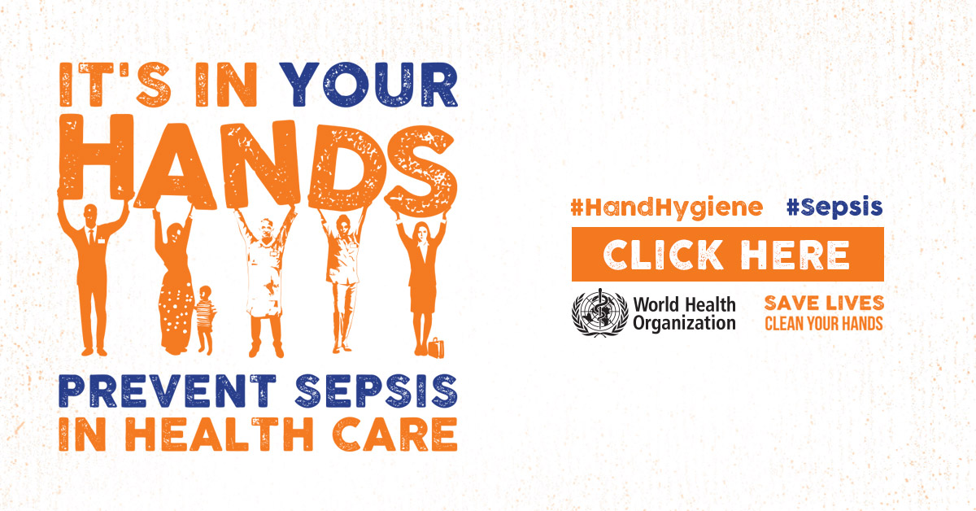](http://www.who.int/infection-prevention/campaigns/clean-hands/5may2018/en/)

**Consultation on the draft Australian Guidelines for the Prevention and Control of Infection in Healthcare**

<https://consultations.nhmrc.gov.au/public_consultations/infection-healthcare>

Public consultation on the draft revised *Australian Guidelines for the Prevention and Control of Infection in Healthcare* is open and will close at 5:00pm (AEST) Tuesday 15 May 2018.

The Guidelines are being updated to reflect new national and international evidence and guidance on infection prevention that has been published since 2010. The draft Guidelines provide evidence-based recommendations that outline the critical aspects of infection prevention and control, focusing on core principles, risk assessment and priority areas for action. The draft Guidelines are for use by all those working in healthcare (acute and non-acute) including healthcare workers, management and support staff. They should inform best practice, policy development and service delivery protocols.

**Reports**

*Developing new models of care in the PACS vanguards: A new national approach to large-scale change?*

Naylor C, Charles A, editors

London: The King's Fund; 2018.

|  |  |
| --- | --- |
| URL | <https://www.kingsfund.org.uk/publications/developing-new-models-care-pacs-vanguards> |
| Notes | The King’s Fund in the UK has published this report that was commissioned by NHS England as part of a package of support provided to primary and acute care system (PACS) vanguard sites. The PACS model is an attempt to bring about closer working between GPs, hospitals, community health professionals, social care and others. The report provides first-hand perspectives into the experience of those leading a major programme at the national level and those ‘living it’ at the local level. The editors argue that the insights shared will be invaluable to those constructing national support programmes intended to facilitate transformation in local health and care systems. The lessons learned could also be relevant to those involved in the ongoing implementation of PACS and similar models of care. |

*Less waste, more health: A health professional’s guide to reducing waste*

Royal College of Physicians

London: Royal College of Physicians; 2018. p. 14.

|  |  |
| --- | --- |
| URL | <https://www.rcplondon.ac.uk/projects/outputs/less-waste-more-health-health-professionals-guide-reducing-waste> |
| Notes | Given contemporary debates about value and appropriateness of care, many readers might expect a report with the title ‘Less waste, more health’ to be part of this debate. However, this report takes a much more environmental line and brings to mind the exhortation to households to ‘reduce, reuse and recycle’ that was prevalent in the late 20th century. Indeed, reduce, reuse and recycle are all sub-headings in this brief report. The report seeks to show how health professionals can positively influence societal health and wellbeing by making simple changes to the procurement and disposal of medical supplies. The report has a number of case studies and 12 recommendations setting out how everyone from individual to trust level can influence the health of patients, aid financial savings and shape the impact on the environment. |

*Multimorbidity: A priority for global health research*

Academy of Medical Sciences

London: Academy of Medical Sciences; 2018. p. 127.

|  |  |
| --- | --- |
| URL | <https://acmedsci.ac.uk/more/news/global-burden-of-multiple-serious-illnesses-must-be-urgently-addressed> |
| Notes | Multi-morbidity (having several conditions simultaneously) is becoming more and more common, especially when it comes to chronic conditions. This report from the UK’s Academy of Medical Sciences suggests that multimorbidity is most common in women and people with low income, but is also increasingly common in young people as well as in older people.  The authors also observe that most health services, including the NHS, are not designed to care for patients with multiple illnesses. This is likely to contribute to the increasing pressures on health systems and budgets worldwide, the report suggests. It concludes that without a better understanding of multimorbidity, it will not be possible for any country to plan future healthcare resources and redesign services effectively.  Health conditions that frequently group together include heart disease, high blood pressure, diabetes, cancer, depression, anxiety, chronic obstructive pulmonary disease (COPD) and chronic kidney disease. However, it is unclear why some of these conditions cluster together, making it difficult to predict which patients may be most in need of preventive steps or increased care.  There is also a paucity of guidance, including clinical guidelines, dealing with multi-morbidity. Most guidance is for single conditions with little consideration of how different conditions (and treatments) can interact. |

**Journal articles**

*Bridging the gap: using ‘Paired Learning’ to improve clinician/management understanding*

Monaghan H, Swenson C, Kerins J, Sloan S

BMJ Leader. 2018.

|  |  |
| --- | --- |
| DOI | <http://dx.doi.org/10.1136/leader-2017-000064> |
| Notes | In the 1950s and 60s the British scientist and novelist C. P. Snow became somewhat (in)famous for his lecture and book describing Two Cultures of science and the humanities. In health it can seem that clinicians and managers also represent two distinct, if not opposing, cultures.  This short paper discusses how an NHS region in Scotland (NHS Lothian) has piloted paired learning (PL) approach in which clinicians and senior managers were paired together and engaged in conversation, shadowing and reflection. The paper reports that the programme “had a positive impact on preparedness to lead, and participants described a shift in attitudes with increased understanding of the ‘other’ group and increased ability to work collaboratively together in the future.” |

*Association between workarounds and medication administration errors in bar-code-assisted medication administration in hospitals*

van der Veen W, van den Bemt PMLA, Wouters H, Bates DW, Twisk JWR, de Gier JJ, et al

Journal of the American Medical Informatics Association. 2018;25(4):385-92.

|  |  |
| --- | --- |
| DOI | <https://doi.org/10.1093/jamia/ocx077> |
| Notes | In an earlier issue of *On the Radar*, I wrote “Work-arounds, improvisations, hacks, shortcuts or whatever else you want to term them are commonplace. In health care they offer the potential for harm. But they can also be potential opportunities for critical thinking and innovation.” This paper rather reiterates the former – the potential for harm. This papers reports on a prospective study undertaken in hospitals in the Netherlands that observed 5793 medication administrations to 1230 inpatients using barcode-assisted medication administration (BCMA). They found that workarounds occurred in about two-thirds of medication administrations and that there was a **significant association between workarounds and medication administration errors**.  The most frequently observed procedural workarounds were not scanning at all (36%), not scanning patients because they did not wear a wristband (28%), incorrect medication scanning, multiple medication scanning, and ignoring alert signals (11%)  The most frequently observed errors included omissions, administration of drugs not actually ordered, and dosing errors. |

*International Journal for Quality in Health Care*

Volume 30, Issue Supplement 1, April 2018

|  |  |
| --- | --- |
| URL | <https://academic.oup.com/intqhc/issue/30/suppl_1> |
| Notes | The *International Journal for Quality in Health Care* has published this Supplement stemming from the Salzburg Global Seminar Session 565 - Better Health Care: How do we learn about improvement? Articles in this supplement to the *International Journal for Quality in Health Care* include:   * Editorial: Salzburg Global Seminar Session 565—‘Better Health Care: how do we **learn about improvement**?’ (M Rashad Massoud; Leighann E Kimble; Don Goldmann; John Ovretveit; Nancy Dixon) * **Quality improvement and emerging global health priorities** (Nana Mensah Abrampah; Shamsuzzoha Babar Syed; Lisa R Hirschhorn; Bejoy Nambiar; Usman Iqbal; Ezequiel Garcia-Elorrio; Vijay Kumar Chattu; Mahesh Devnani; Edward Kelley) * A framework for **learning about improvement**: embedded implementation and evaluation design to optimize learning (Danika Barry; Leighann E Kimble; Bejoy Nambiar; Gareth Parry; Ashish Jha; Vijay Kumar Chattu ;M Rashad Massoud; Don Goldmann) * Unpacking the **black box of improvement** (Rohit Ramaswamy; Julie Reed; Nigel Livesley; Victor Boguslavsky; Ezequiel Garcia-Elorrio; Sylvia Sax; Diarra Houleymata; Leighann Kimble; Gareth Parry) * **Adapting improvements to context**: when, why and how? (John Ovretveit; Lisa Dolan-Branton; Michael Marx; Amy Reid; Julie Reid; Bruce Agins) * **Research versus practice in quality improvement**? Understanding how we can bridge the gap (Lisa R Hirschhorn; Rohit Ramaswamy; Mahesh Devnani; Abraham Wandersman; Lisa A Simpson; Ezequiel Garcia-Elorrio) * Practical recommendations for the **evaluation of improvement initiatives** (Gareth Parry; Astou Coly; Don Goldmann; Alexander K Rowe; Vijay Chattu; Deneil Logiudice; Mihajlo Rabrenovic; Bejoy Nambiar) * **Learning about improvement** to address global health and healthcare challenges—lessons and the future (John Ovretveit) |

*Patient Experience Journal*

Volume 5, Issue 1 (2018)

|  |  |
| --- | --- |
| URL | <http://pxjournal.org/journal/vol5/iss1/> |
| Notes | A new issue of the *Patient Experience Journal* (PXJ) has been published. Articles in this issue of *Patient Experience Journal* include:   * Editorial: The consumer has spoken: **Patient experience is now healthcare’s core differentiator** (Jason A Wolf) * The Sherpa meets Maslow: **Medicine and the hierarchy of needs** (Rana Lee Adawi Awdish) * Original parts: Aging and reckoning with **cystic fibrosis related kidney disease** (Alexandra C H Nowakowski) * The **gift of pain** with transformative possibilities (Richard B Hovey) * A framework for conceptualizing how narratives from health-care consumers might improve or impede the use of **information about provider quality** (Melissa L Finucane, Steven C Martino, Andrew M Parker, Mark Schlesinger, Rachel Grob, Jennifer L Cerully, Lise Rybowski, and Dale Shaller) * Patients’ stories of **encounters with doctors**: Expectations and anxieties (Daniella Arieli and Batya Tamir) * How patients view their contribution as **partners in the enhancement of patient safety** in clinical care (Marie-Pascale Pomey, Nathalie Clavel, Ursulla Aho-Glele, Noemie Ferré, and Paloma Fernandez-McAuley) * The **patient experience with shared decision-making** in lung cancer: A survey of patients, significant others or care givers (Laurie E Gaspar, Howard J West, Bonnie J Addario, and D Ross Camidge) * Barriers and facilitators to **family participation in the care** of their hospitalized loved ones (Lynda Bélanger, Marie Desmartis, and M Coulombe) * **Family-centered caregiving** from hospital to home: Coping with trauma and building capacity with the HOPE for Families model (Anna Newcomb, L Gordon Moore, and Holly C Matto) * An exploration of **patients’ experience of nurses’ use of point-of-care information technology** in acute care (Leigh McNicol, Anastasia F Hutchinson, Beverley Wood, Mari Botti, and Bernice Redley) * **Nursing transfer of accountability** at the bedside: partnering with patients to pilot a new initiative in Ontario community hospitals (Kristina B A Miller, Aden Hamza, Kateryna Metersky, and Dianne M. Gaffney) * Exploring **workforce confidence and patient experiences**: A quantitative analysis (Katie M Owens and Stephanie Keller) * What are the most important dimensions of **quality for addiction and mental health services** from the perspective of its users? (Priscilla Liu, Shawn Currie, and Jassandre Adamyk-Simpson) * **Homeless and marginally housed Veteran perspectives** on participating in a photo-elicitation research study (Keri L Rodriguez, Daniel O Hedayati, Lauren M Broyles, Melissa E Wieland, Michael A Mitchell, James W Conley, Shaddy K Saba, and Adam J Gordon) * How to build a robust provider improvement partnership program to **enhance patient experience** – A case study (Venkat Iyer, Pamela Prissel, Karee Munson, Jennifer Eide, R Brustad, N Kranz, L P Madson, and B Frase) |

*BMJ Quality and Safety* online first articles

|  |  |
| --- | --- |
| URL | <https://qualitysafety.bmj.com/content/early/recent> |
| Notes | *BMJ Quality and Safety* has published a number of ‘online first’ articles, including:   * **Ethical decision-making climate in the ICU**: theoretical framework and validation of a self-assessment tool (Bo Van den Bulcke, Ruth Piers, Hanne Irene Jensen, Johan Malmgren, Victoria Metaxa, Anna K Reyners, Michael Darmon, Katerina Rusinova, Daniel Talmor, Anne-Pascale Meert, Laura Cancelliere, Làszló Zubek, Paolo Maia, Andrej Michalsen, Johan Decruyenaere, Erwin J O Kompanje, Elie Azoulay, Reitske Meganck, Ariëlla Van de Sompel, Stijn Vansteelandt, Peter Vlerick, Stijn Vanheule, D D Benoit) |

*International Journal for Quality in Health Care* online first articles

|  |  |
| --- | --- |
| URL | <https://academic.oup.com/intqhc/advance-access?papetoc> |
| Notes | *International Journal for Quality in Health Care* has published a number of ‘online first’ articles, including:   * **Speaking up behaviors and safety climate** in an Austrian university hospital (David Schwappach; Gerald Sendlhofer; Lynn Häsler; Veronika Gombotz; Karina Leitgeb; Magdalena Hoffmann; Lydia Jantscher; G Brunner) * **Assessing improvement capability in healthcare organisations**: a qualitative study of healthcare regulatory agencies in the UK (Joy Furnival; Ruth Boaden; Kieran Walshe) |

**Online resources**

*Future Leaders Communiqué*

<http://vifmcommuniques.org/5403-2/>

Victorian Institute of Forensic Medicine

Volume 3 Issue 2 April 2018

This issue of the *Future Leaders Communiqué* focuses on the coronial inquest into the death of a woman shortly after her attendance at a small rural hospital. The doctor presiding over this patient’s care was a junior doctor who was operating in an under-resourced and under-supported environment. This is not an uncommon experience for junior doctors, so the issue examines this area in some detail.

*[UK] NICE Guidelines and Quality Standards*

<https://www.nice.org.uk>

The UK’s National Institute for Health and Care Excellence (NICE) has published new (or updated) guidelines and quality standards. The latest reviews or updates are:

* Clinical Guideline CG90 ***Depression*** *in adults: recognition and management* <https://www.nice.org.uk/guidance/cg90>
* Clinical Guideline CG137 ***Epilepsies****: diagnosis and management* <https://www.nice.org.uk/guidance/cg137>
* Clinical Guideline CG173 ***Neuropathic pain*** *in adults: pharmacological management in non-specialist settings* <https://www.nice.org.uk/guidance/cg173>
* Clinical Guideline CG185 ***Bipolar disorder****: assessment and management* <https://www.nice.org.uk/guidance/cg185>
* Clinical Guideline CG192 ***Antenatal and postnatal mental health****: clinical management and service guidance* <https://www.nice.org.uk/guidance/cg192>

[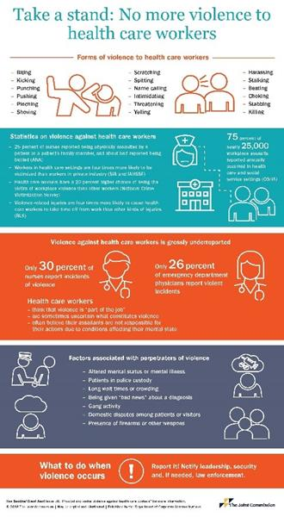](https://www.jointcommission.org/sea_issue_59/)*[USA] Sentinel Event Alert 59: Physical and verbal violence against health care workers*

<https://www.jointcommission.org/sea_issue_59/>

The Joint Commission in the USA has issued this Sentinel Event Alert ono violence inflicted upon health care workers. The Joint Commission Sentinel Event Alerts identify specific types of sentinel and adverse events and high risk conditions, describes their common underlying causes, and recommends steps to reduce risk and prevent future occurrences. This alert focusses physical and verbal violence as a major problem in the workplace, particularly in areas such as the emergency department and psychiatric units. Other factors associated with violence in health care settings include stressful conditions, understaffing, and lack of policies for identifying and responding to hostile behaviour. The alert suggests strategies for mitigating workplace violence, such as reporting systems and initiatives to reduce such incidents.

**Disclaimer**

*On the Radar* is an information resource of the Australian Commission on Safety and Quality in Health Care. The Commission is not responsible for the content of, nor does it endorse, any articles or sites listed. The Commission accepts no liability for the information or advice provided by these external links. Links are provided on the basis that users make their own decisions about the accuracy, currency and reliability of the information contained therein. Any opinions expressed are not necessarily those of the Australian Commission on Safety and Quality in Health Care.