# Australian COmmission on Safety and Quality in Health Care logo with Radar imageOn the Radar

Issue 372

4 June 2018

*On the Radar* is a summary of some of the recent publications in the areas of safety and quality in health care. Inclusion in this document is not an endorsement or recommendation of any publication or provider. Access to particular documents may depend on whether they are Open Access or not, and/or your individual or institutional access to subscription sites/services. Material that may require subscription is included as it is considered relevant.

*On the Radar* is available online, via email or as a PDF or Word document from <https://www.safetyandquality.gov.au/publications-resources/on-the-radar/>

If you would like to receive *On the Radar* via email, you can subscribe on our website <https://www.safetyandquality.gov.au/> or by emailing us at H[Umail@safetyandquality.gov.auU](mailto:mail@safetyandquality.gov.au).   
You can also send feedback and comments to H[Umail@safetyandquality.gov.auU](mailto:mail@safetyandquality.gov.au).

For information about the Commission and its programs and publications, please visit <https://www.safetyandquality.gov.au>

You can also follow us on Twitter @ACSQHC.

**On the Radar**

Editor: Dr Niall Johnson [niall.johnson@safetyandquality.gov.au](mailto:niall.johnson@safetyandquality.gov.au)

Contributors: Niall Johnson, Karla Lister, Ruth Daniels, Ben Prest

**Avoidable Hospital Readmissions**

<https://www.safetyandquality.gov.au/our-work/indicators/avoidable-hospital-readmissions/>

The Australian Commission on Safety and Quality in Healthcare (The Commission) was tasked by the Australian Health Ministers’ Advisory Council (AHMAC), and under the National Health Reform Agreement (NHRA) Addendum, with developing “a list of clinical conditions that arise from complications of the management of the original condition, which can be considered avoidable hospital readmissions, including suitable condition-specific timeframes [readmission intervals] for each of the identified conditions.”

The list, which has been endorsed by AHMAC, was developed in consultation with clinical and consumer experts, taking into account relevant literature and analysis of Australian public hospital data, namely the admitted patient care national minimum data set.

The Commission is now working with the Independent Hospital Pricing Authority (IHPA) to finalise specifications for the list of avoidable hospital readmissions, that include the related codes for each condition. Further to this, and in line with the NHRA, the Independent Hospital Pricing Authority will be canvassing options for pricing and funding for avoidable readmissions in its Consultation Paper on the Pricing Framework for Australian Public Hospital Services 2019-20. The paper will be released on IHPA’s website <https://www.ihpa.gov.au/> on 12 June 2018 for a 30 day consultation period.

**Transvaginal mesh care pathways**

<https://www.safetyandquality.gov.au/our-work/transvaginal-mesh/resources/>

The Australian Commission on Safety and Quality in Healthcare (The Commission) has produced a number of resources and guidance documents to improve health care for women considering the use of transvaginal mesh for pelvic organ prolapse (POP) and stress urinary incontinence (SUI).

The care pathways describe clinical considerations to be made when clinicians are assessing women who have POP and SUI. The pathways provide clinicians with an evidence-based approach to first line management, specialised surgical and non-surgical care and the types of medical specialists who may be involved in providing care.

The pathways have two components, the first of these provide an opportunity for alignment with the pathways used by a number of Primary Health Networks to guide the discussions between women and their general practitioners:

* *Care pathway for general practitioners for the management of pelvic organ prolapse* <https://www.safetyandquality.gov.au/wp-content/uploads/2018/02/TV-Mesh-Care-pathway-for-GPs-POP-landscape.pdf>

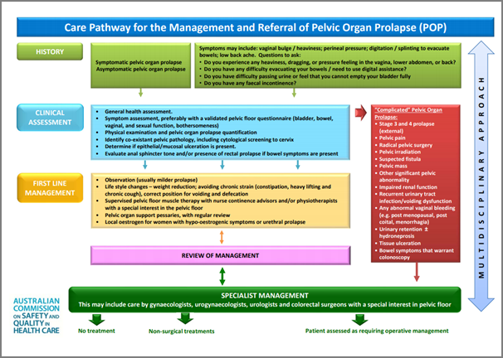

* *Care pathway for general practitioners for the management of urinary incontinence* <https://www.safetyandquality.gov.au/wp-content/uploads/2018/02/TV-Mesh-Care-pathway-for-GP-SUI-landscape.pdf>

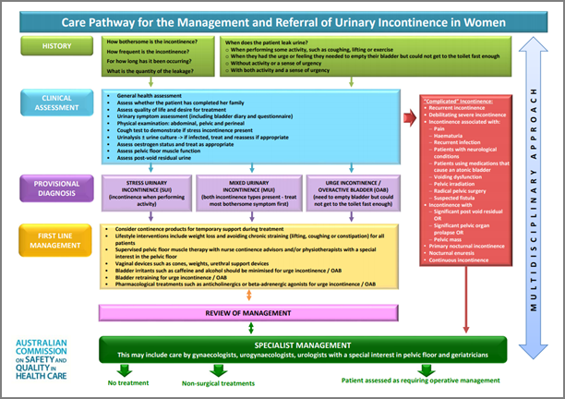

The second component of the pathways are the surgical pathways for POP and SUI. These use a traffic light approach (red, amber, green) to identify options for surgical treatments, based on the strength of evidence and potential patient outcomes for each type of procedure:

* *Surgical care pathway for the management of pelvic organ prolapse* <https://www.safetyandquality.gov.au/wp-content/uploads/2018/02/TV-mesh-Surgical-Care-Pathway-POP-portrait.pdf>
* *Surgical care pathway for the management of urinary incontinence* <https://www.safetyandquality.gov.au/wp-content/uploads/2018/02/TV-mesh-Surgical-Care-Pathway-SUI-portrait.pdf>

The Reference Group developed the pathways based on the work of the International Collaboration on Incontinence. The Commission acknowledges the contribution of this group in the development of the Commission’s versions of the resources. The pathways are being developed as an interactive web version to allow easier access for clinicians reviewing treatment options and also in explaining various pathways to women considering treatment which will be available in June 2018.

**Reports**

*Under pressure: safely managing increased demand in emergency departments*

Care Quality Commission

Newcastle-upon-Tyne: Care Quality Commission; 2018. p. 32.

|  |  |
| --- | --- |
| URL | <http://www.cqc.org.uk/publications/themed-work/under-pressure-safely-managing-increased-demand-emergency-departments> |
| Notes | The Care Quality Commission (CQC) in the UK has released this report looking at how emergency departments coped with a high workload in the British winter of 2017/18. The CQC found:   * specific concerns around delayed ambulance handovers * people waiting for long periods of time before their first clinical assessment * patients who needed urgent care were not always identified in a timely way.   The report recommends solutions which focus on:   * what can be done to help keep people well and reduce visits to emergency departments * what emergency departments can do to manage how patients flow through the hospital * ways to help avoid unnecessary admissions and ensure early discharge. |

**Journal articles**

*Caring for older patients in the emergency department: Health professionals’ perspectives from Australia – The Safe Elderly Emergency Discharge project*

Lennox A, Braaf S, Smit De V, Cameron P, Lowthian Judy A

Emergency Medicine Australasia. 2018 [epub].

|  |  |
| --- | --- |
| DOI | <https://doi.org/10.1111/1742-6723.13108> |
| Notes | This paper reports on a qualitative study that sought the views of emergency nursing, medical and allied health staff from the emergency department of a large metropolitan public hospital in Melbourne on caring for older patients. The clinicians ‘described **tailoring their approach** when caring for older patients, including adopting a specific communication approach (i.e. increased voice volume, slower rate of speech). Caring for older patients was **perceived as challenging** given the need to balance the expectations of family members to deal with associated complex needs and limited time for transitional care planning in the ED. The environment and equipment were perceived as unsuitable, alongside a lack of geriatric‐specific knowledge; contributing to what health professionals described as a poor fit between the ED system and older patients’ needs.’ In their conclusion, the authors note that growing proportion of older patients and that we need to think about issues, such as ‘Creating **older person‐friendly** areas, **improving transitional care** and **providing staff with specific education** would foster an environment that promotes person‐centred care, safety, independence and functional wellbeing.’ Such an approach is an expression of the need and value of patient-centred care, care that appreciates the needs, values and specifics of the individual patient. |

For further information on the Commission’s work on patient and consumer centred care, see <https://www.safetyandquality.gov.au/our-work/patient-and-consumer-centred-care/>

*BMJ Quality and Safety* online first articles

|  |  |
| --- | --- |
| URL | <https://qualitysafety.bmj.com/content/early/recent> |
| Notes | *BMJ Quality and Safety* has published a number of ‘online first’ articles, including:   * Incidence and trends of **central line associated pneumothorax** using radiograph report text search versus administrative database codes (Marc Reeson, Alan Forster, Carl van Walraven) * Standardisation of perioperative urinary catheter use to reduce **postsurgical urinary tract infection**: an interrupted time series study (Mahsa Sadeghi, Jerome A Leis, Claude Laflamme, Darrel Sparkes, Wendy Ditrani, Aaron Watamaniuk, Ru Taggar, F Jinnah, M Avaness, M Vearncombe, A B Nathens) |

*International Journal for Quality in Health Care* online first articles

|  |  |
| --- | --- |
| URL | <https://academic.oup.com/intqhc/advance-access?papetoc> |
| Notes | *International Journal for Quality in Health Care* has published a number of ‘online first’ articles, including:   * Providing meaning to **quality assessment work** (Anthony Staines) |

**Online resources**

*National Safety and Quality Health Service (NSQHS) Standards*

<http://nationalstandards.safetyandquality.gov.au/>

The Australian Commission on Safety and Quality in Healthcare (The Commission) has created this microsite to house all of the information on the second edition of the National Safety and Quality Health Service (NSQHS) Standards. The NSQHS Standards provide a nationally consistent statement of the level of care consumers can expect from health service organisations. The microsite is optimised for phone, tablet and laptop devices and provides quick and easy access to information for clinicians, consumers, managers and others to support the implementation of the second edition of the Standards.

*Medical Devices Safety Update*

Volume 6, Number 3, May 2018

<https://www.tga.gov.au/publication-issue/medical-devices-safety-update-volume-6-number-3-may-2018>

The Therapeutic Goods Administration (TGA) has released the latest edition of its medical device safety bulletin. Topics covered in this issue include:

* How the TGA uses Australian **joint replacement registry data**
* Focus on skills for **vacuum-assisted births**
* TGA reviews **product safety of ventilators.**

*[UK] Good rostering guide*

<http://www.nhsemployers.org/case-studies-and-resources/2018/05/good-rostering-guide>

NHS Employers and the British Medical Association have produced this guidance that suggests ways in which good rostering practice can be used to develop rotas. It aims to support and create an effective training environment that also meets the needs of the health service, while enabling flexibility for doctors and employers, both of whom have a stake in the process.

**Disclaimer**

On the Radar is an information resource of the Australian Commission on Safety and Quality in Health Care. The Commission is not responsible for the content of, nor does it endorse, any articles or sites listed. The Commission accepts no liability for the information or advice provided by these external links. Links are provided on the basis that users make their own decisions about the accuracy, currency and reliability of the information contained therein. Any opinions expressed are not necessarily those of the Australian Commission on Safety and Quality in Health Care.