# Australian COmmission on Safety and Quality in Health Care logo with Radar imageOn the Radar

Issue 376

2 July 2018

*On the Radar* is a summary of some of the recent publications in the areas of safety and quality in health care. Inclusion in this document is not an endorsement or recommendation of any publication or provider. Access to particular documents may depend on whether they are Open Access or not, and/or your individual or institutional access to subscription sites/services. Material that may require subscription is included as it is considered relevant.

*On the Radar* is available online, via email or as a PDF or Word document from <https://www.safetyandquality.gov.au/publications-resources/on-the-radar/>

If you would like to receive *On the Radar* via email, you can subscribe on our website <https://www.safetyandquality.gov.au/> or by emailing us at H[Umail@safetyandquality.gov.auU](mailto:mail@safetyandquality.gov.au).   
You can also send feedback and comments to H[Umail@safetyandquality.gov.auU](mailto:mail@safetyandquality.gov.au).

For information about the Commission and its programs and publications, please visit <https://www.safetyandquality.gov.au>

You can also follow us on Twitter @ACSQHC.

**On the Radar**

Editor: Dr Niall Johnson [niall.johnson@safetyandquality.gov.au](mailto:niall.johnson@safetyandquality.gov.au)

Contributors: Niall Johnson, Vannary Sar, Joanna Wooles

**Review of key attributes of high-performing person-centred healthcare organisations**

Australian Commission on Safety and Quality in Health Care

ACSQHC; 2018. p. 118.

<https://www.safetyandquality.gov.au/our-work/patient-and-consumer-centred-care/person-centred-organisations/>

Person-centred care is the foundation for achieving safe, high-quality health care. By focusing on the delivery of person-centred care, and doing it well, healthcare organisations will achieve better outcomes for patients; better experiences for patients and the workforce; and better value care.

To support healthcare organisations deliver person-centred care, the Australian Commission on Safety and Quality in Health Care has identified seven key attributes common to all high-performing person-centred healthcare organisations:

* Comprehensive care delivery
* Clear purpose, strategy and leadership
* People, capability and person-centred culture
* Person-centred governance systems
* Strong external partnerships
* Person-centred technology and built environments
* Measurement for improvement.

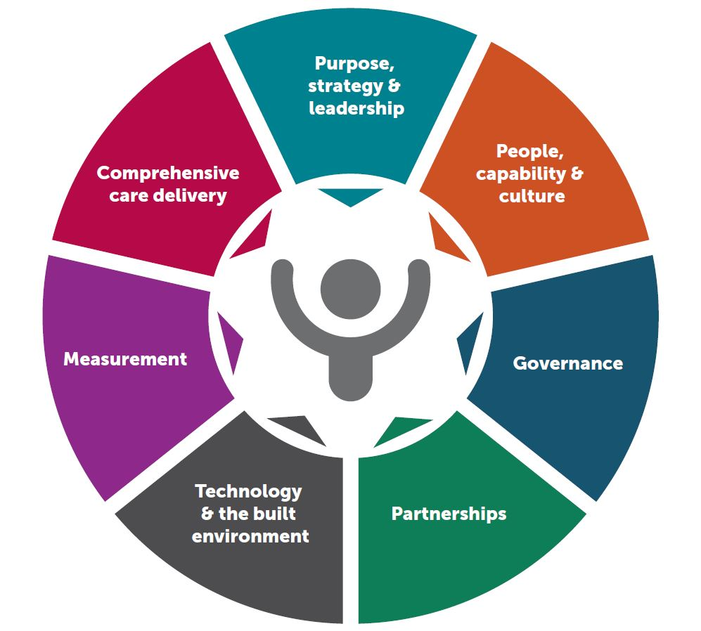

Collectively, these seven attributes provide an ideal organisational model for supporting consistent and excellent person-centred care. All attributes are interrelated and mutually reinforcing. Achieving great person-centred will require incremental change and a long-term commitment across all areas of an organisation.

Excelling in these attributes will help healthcare organisations meet some of the requirements in the second edition of the National Safety and Quality Health Service (NSQHS) Standards.

The review report, supporting resources (fact sheets, self-assessment tool and PowerPoint presentation) and case studies are available at [www.safetyandquality.gov.au/our-work/patient-and-consumer-centred-care/person-centred-organisations](http://www.safetyandquality.gov.au/our-work/patient-and-consumer-centred-care/person-centred-organisations)

For further information about the Commission’s work on person-centred care, see [www.safetyandquality.gov.au/our-work/patient-and-consumer-centred-care](http://www.safetyandquality.gov.au/our-work/patient-and-consumer-centred-care)

**Reports**

*Nudge vs Superbugs: A behavioural economics trial to reduce the overprescribing of antibiotics*

Behavioural Economics & Research Team (BERT) and Behavioural Economics Team of the Australian Government (BETA).

Canberra: Department of Health and the Department of the Prime Minister and Cabinet; 2018. p. 54.

|  |  |
| --- | --- |
| URL | <http://behaviouraleconomics.pmc.gov.au/projects/nudge-vs-superbugs-behavioural-economics-trial-reduce-overprescribing-antibiotics> |
| Notes | In June 2017, Australia’s Chief Medical Officer wrote to many GPs about the issue of overprescribing of antimicrobials. This report describes how that actually there were 4 different forms of that letter and they were part of a behavioural economics trial. The trial saw letters composed to 6,649 GPs whose prescribing rates were in the top 30 per cent for their region. The letters aimed to prompt GPs to reflect on whether there were opportunities to reduce prescribing where appropriate and safe. The four versions of the letter from the CMO were:   * **Education-only letter** containing the usual education messages about antimicrobial resistance (AMR), antibiotic prescribing and two National Prescribing Service (NPS) posters. * **Education with peer comparison letter** including the same education information and a tagline providing the GP with their prescribing rate compared to peers in their region. * **Peer comparison with graph letter** including the peer comparison tagline along with a visual attention-grabbing graph. * **Peer comparison with delayed prescribing letter** including the peer comparison tagline with delayed prescribing material (stickers and the NPS’s action plan for managing respiratory tract infections).   The report estimates that **126,352 fewer scripts** were filled over the six-month period. The three letters containing peer comparison information outperformed the education-only letter, and resulted in a substantial reduction in prescription rates. Compared to GPs who did not receive a letter, the peer comparison letters resulted in a 9.3–12.3% per cent reduction in prescription rates over six months. In comparison, the education-only letter reduced antibiotic prescriptions by 3.2% over six months. The **peer comparison with graph** performed best. This letter **reduced prescription rates by 12.3% over the six-month period**, and by **14.6% in the best month**.  The report is available along with a one-page snapshot and the pre-analysis plan.  \\central.health\dfsuserenv\Users\User_07\JOHNNI\Desktop\nudge.png |

For information on the Commission’s work on antimicrobial use and resistance in Australia/, see <https://www.safetyandquality.gov.au/antimicrobial-use-and-resistance-in-australia/>

For information on the Commission’s work on healthcare associated infection, see <https://www.safetyandquality.gov.au/our-work/healthcare-associated-infection/>

**Journal articles**

*Screening for Osteoporosis to Prevent Fractures: US Preventive Services Task Force Recommendation Statement*

U. S. Preventive Services Task Force

Journal of the American Medical Association. 2018;319(18):1901-13.

*Screening for Osteoporosis*

Cauley JA

Journal of the American Medical Association. 2018;319(24):2483-5.

*Screening for Osteoporosis to Prevent Fractures*

Jin J

Journal of the American Medical Association. 2018;319(24):2566.

|  |  |
| --- | --- |
| DOI | US Preventive Services Task Force <https://doi.org/10.1001/jama.2018.7498>  Cauley <https://doi.org/10.1001/jama.2018.5722>  Jin <https://doi.org/10.1001/jama.2018.8361> |
| Notes | The US Preventive Services Task Force (USPSTF) has released their Recommendation Statement on the screening for osteoporosis in order to prevent fractures. The same issue of JAMA includes an editorial (Cauley) and ‘patient page’ (Jin) discussing, respectively, the significance and context of the recommendations and what they may mean for patients. The recommendations (and the strength of the evidence) are such that the USPSTF   * **Recommends screening** for osteoporosis with bone measurement testing to prevent osteoporotic fractures in **women 65 years and older**. (B recommendation) * \\central.health\dfsuserenv\Users\User_07\johnni\Desktop\OSteo screening a.png**Recommends screening** for osteoporosis with bone measurement testing to prevent osteoporotic fractures in **postmenopausal women younger than 65 years at increased risk of osteoporosis**, as determined by a formal clinical risk assessment tool. (B recommendation) * Concludes that the current **evidence is insufficient** to assess the balance of benefits and harms of screening for osteoporosis to prevent osteoporotic fractures in **men**. (I statement). |

*National quality program achieves improvements in safety culture and reduction in preventable harms in community hospitals*

Frush K, Chamness C, Olson B, Hyde S, Nordlund C, Phillips H, et al.

Joint Commission Journal on Quality and Patient Safety. 2018 [epub].

|  |  |
| --- | --- |
| URL | <https://www.jointcommissionjournal.com/article/S1553-7250(18)30216-2/fulltext> |
| Notes | Paper describing how a US health system joint venture implemented a National Quality Program (NQP). The NQP had a framework of **leadership**, **performance improvement**, and the importance of **culture** with a comprehensive **quality assessment** performed for **each hospital** leading to a customised **improvement plan** specific to the performance level of each hospital and aligned with strategic organisational goals. The authors claim that the implementation “has led to **significant improvements** in **patient safety** metrics and in **safety culture**, which have now been **sustained** for more than seven years. Aggregate **harm**, as measured by administrative claims data–based harms per 1,000 inpatient-days, was **reduced by 62.5%** between January 2011 and December 2017, as compared to 2010 baseline data.” |

*Statewide collaborative to reduce surgical site infections: results of the Hawaii Surgical Unit-Based Safety Program*

Lin DM, Carson KA, Lubomski LH, Wick EC, Pham JC

Journal of the American College of Surgeons. 2018.

|  |  |
| --- | --- |
| DOI | <http://doi.org/10.1016/j.jamcollsurg.2018.04.031> |
| Notes | Surgical site infections (SSI) can cause patients substantial harm that can be long-lasting. This study reports on a collaboration that saw all15 hospitals in Hawaii implement the Comprehensive Unit-Based Safety Program and specific bundles of interventions to reduce SSIs. The primary end point was colorectal SSIs with the measurement of safety culture as a secondary output. From January 2013 to June 2015, the collaborative colorectal **SSI rate decreased 61.7%** (from 12.08% to 4.63%; p < 0.01), with a linear decrease during the 10-quarter period (p = 0.005). The **safety culture**, measured with the AHRQ Hospital Survey on Patient Safety Culture, saw **improvements** in 10 of 12 domains. |

*Association of hospital participation in a regional trauma quality improvement collaborative with patient outcomes*

Hemmila MR, Cain-Nielsen AH, Jakubus JL, Mikhail JN, Dimick JB

JAMA Surgery. 2018 [epub].

|  |  |
| --- | --- |
| DOI | <https://doi.org/10.1001/jamasurg.2018.0985> |
| Notes | US study confirming a pattern seen elsewhere that collaboratives can help drive care improvements. The paper sought to evaluate the association of participation in the American College of Surgeons Trauma Quality Improvement Program (ACS TQIP) [provides feedback to hospitals on risk-adjusted outcomes] or the Michigan Trauma Quality Improvement Program (MTQIP) [benchmark reporting and collaborative quality improvement] with outcomes, including when compared with control hospitals that did not participate in either. This cohort study used data from 2009 to 2015 covering 2 373 130 trauma patients 16 years 98 ACS TQIP hospitals, 23 MTQIP hospitals, and 429 nonparticipating hospitals and assessed in-hospital mortality, mortality or hospice, major complications, and venous thromboembolism events. From the analyses, the MTQIP, with benchmark reporting and collaborative quality improvement, was most clearly associated with “improved patient outcomes beyond benchmark reporting alone while promoting compliance with processes of care.” |

*The nexus of nursing leadership and a culture of safer patient care*

Murray M, Sundin D, Cope V

Journal of Clinical Nursing. 2017;27(5-6):1287-93.

|  |  |
| --- | --- |
| DOI | <https://doi.org/10.1111/jocn.13980> |
| Notes | The importance of culture is well understood. Murray and colleagues argue that “As nurses have the highest patient interaction, and leadership is discernible at all levels of nursing, nurse leaders are the nexus to influencing organisational culture towards safer practices.” They recognise that organisational safety culture requires the presence of “supportive **leadership**, effective **communication**, an orientation programme and ongoing **training**, appropriate **staffing**, open **communication regarding errors**, **compliance** to policy and procedure, and **environmental safety and security**.” |

*A Systematic Review of Primary Care Safety Climate Survey Instruments: Their Origins, Psychometric Properties, Quality, and Usage*

Curran C, Lydon S, Kelly M, Murphy A, Walsh C, O'Connor P

Journal of Patient Safety. 2018;14(2):e9-e18.

|  |  |
| --- | --- |
| DOI | <https://doi.org/10.1097/PTS.0000000000000393> |
| Notes | Safety and quality in the acute setting has emerged as a substantial field. Safety and quality in some other settings are less well considered. This study sought to review the tools used to measure the safety climate in primary care, focussing on the origins, psychometric properties, quality, and safety culture domains measured by these tools. The reviewers found 17 English language studies, but the “quantity and quality of psychometric testing varied considerably”. They also found that management commitment to safety was the most frequently measured safety culture theme (87.5%), while workload was infrequently measured (25%). |

For information on the Commission’s work on primary care, see <https://www.safetyandquality.gov.au/our-work/primary-health-care/>

*The complexity, diversity, and science of primary care teams*

Fiscella K, McDaniel SH

The American psychologist. 2018 May-Jun;73(4):451-67.

|  |  |
| --- | --- |
| DOI | <http://doi.org/10.1037/amp0000244> |
| Notes | As has been often observed, health is a team sport. This review paper looks at the literature on teams in primary care. It looks at innovative primary care team approaches, the importance of care coordination, the roles of various team members, as well as key factors that support or hinder primary care teamwork, as well as evidence of the impact of these team-based models on patient outcomes, costs, and team members. |

*Healthcare Quarterly*

Volume 21, Number 1, 2018

|  |  |
| --- | --- |
| URL | <http://www.longwoods.com/publications/healthcare-quarterly/25519> |
| Notes | A new issue of *Healthcare Quarterly* has been published. Articles in this issue of *Healthcare Quarterly* include:   * The **Mental Health of Adults with Developmental Disabilities** in Ontario: Lessons from Administrative Health Data (Yona Lunsky, Robert Balogh, Anna Durbin, Avra Selick, Tiziana Volpe and Elizabeth Lin) * **Seniors** in Transition: Exploring **Pathways Across the Care Continuum** (Kim Nuernberger, Steve Atkinson and Georgina MacDonald) * **Healthcare in Canada**: Choices Going Forward (Terrence Montague, Bonnie Cochrane, Amédé Gogovor, John Aylen, Lesli Martin and J Nemis-White) * **Patient Relations Measurement and Reporting** to Improve Quality and Safety: Lessons from a Pilot Project (Patricia Sullivan-Taylor, Rachel Frohlich, Anna Greenberg and Michael Beckett) * Using an Evidence-Informed Framework and a Self-Assessment Tool to Drive Priority Setting and Action toward **Senior-Friendly Care** (Ada Tsang, Ken Wong, David Ryan, Marlene Awad and Barbara Liu) * The Mobility Volunteer Program: Stepping into the Future of **Senior Friendly Care** (Jocelyn Denomme, Deborah Brown, Patsy Cho, Jacques Lee, Meaghan Kinlin, Beth O'Leary, Beth Singleton and Barbara Liu) * The Burden of **Repeat Prescribing Medications after a Related Adverse Drug Event** (Blayne Welk, Lucie Richard, Jennifer Winick-Ng, Salimah Z Shariff and Kristin K Clemens) * **Ethics Review of Projects** (ERoP): A Conceptual Framework (Don Flaming, Marie Pinard and Debbie Mallett) * Without Compromising Integrity: **Research and Planning Around the Primary Healthcare Landscape** in Southwestern Ontario (Shannon L Sibbald, Andrew F Clark, Jamie A Seabrook and Jason Gilliland) |

*BMJ Quality and Safety* online first articles

|  |  |
| --- | --- |
| URL | <https://qualitysafety.bmj.com/content/early/recent> |
| Notes | *BMJ Quality and Safety* has published a number of ‘online first’ articles, including:   * **Speaking up about patient safety concerns**: the influence of safety management approaches and climate on nurses’ willingness to speak up (Carien W Alingh, Jeroen D H van Wijngaarden, Karina van de Voorde, Jaap Paauwe, Robbert Huijsman) * **Implementing infection prevention practices** across European hospitals: an in-depth qualitative assessment (Lauren Clack, Walter Zingg, Sanjay Saint, Alejandra Casillas, Sylvie Touveneau, Fabricio da Liberdade Jantarada, Ursina Willi, Tjallie van der Kooi, Laura J Damschroder, Jane H Forman, Molly Harrod, Sarah Krein, Didier Pittet, Hugo Sax) * Developing a **hospital-wide quality and safety dashboard**: a qualitative research study (Anne Marie J W M Weggelaar-Jansen, Damien S E Broekharst, Martine de Bruijne) |

*International Journal for Quality in Health Care* online first articles

|  |  |
| --- | --- |
| URL | <https://academic.oup.com/intqhc/advance-access> |
| Notes | *International Journal for Quality in Health Care* has published a number of ‘online first’ articles, including:   * Not feeling ready to go home: a qualitative analysis of **chronically ill patients’ perceptions on care transitions** (Kim J Verhaegh; Patricia Jepma; Suzanne E Geerlings; Sophia E de Rooij; Bianca M Buurman) |

**Online resources**

*Reducing inappropriate use of antipsychotics*

<http://cognitivecare.gov.au/resources/campaign-resources/>

As part of the Caring for Cognitive Impairment campaign, the Commission has produced an infographic targeted at reducing inappropriate use of antipsychotics. It summarises why this is such an important issue for people with behavioural and psychological symptoms of dementia (BPSD) across multiple healthcare settings. It was developed as a result of work undertaken in response the Commission’s first *Australian Atlas of Healthcare Variation* that found high and variable use in people aged 65 and over.

Please share and promote the infographic with your networks, and please feel free to print the infographic. If you would like further information, please contact [cognitive.impairment@safetyandquality.gov.au](mailto:cognitive.impairment@safetyandquality.gov.au) or visit [www.cognitivecare.gov.au](http://www.cognitivecare.gov.au)

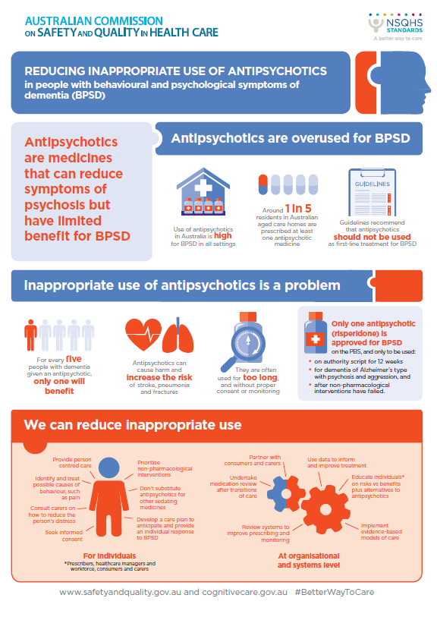

*Australian Hospital Patient Experience Question Set (AHPEQS) Community of Practice*

<https://www.safetyandquality.gov.au/our-work/indicators/hospital-patient-experience/>

Are you using the Australian Hospital Patient Experience Question Set (AHPEQS)? Want to talk to others doing the same? We’ve just launched a community of practice for AHPEQS implementers to share knowledge and avoid reinventing the wheel. Email pex@safetyandquality.gov.au to join.

*Clinical Communiqué*

Volume 5 Issue 2 June 2018

<http://vifmcommuniques.org/clinical-communique-volume-5-issue-2-june-2018/>

This *Clinical Communiqué* examines three cases of patients who died shortly after being assessed and discharged from a hospital emergency department. In each case, an evolving abdominal problem was missed, and the symptoms were attributed to other causes. Fluctuating signs were misinterpreted, investigative abnormalities not fully appreciated, and ultimately, diagnoses of life-threatening conditions missed. This issue also has an expert commentary on **diagnostic error** that explores the concept of cognitive bias and the debiasing strategies that can be employed to make the diagnostic process safer.

*[UK] Medication Safety Dashboard*

<https://apps.nhsbsa.nhs.uk/MOD/MedicationSafety/atlas.html>

The NHS plans to introduce a series of indicators to show whether a prescription may have contributed to a patient being admitted to hospital. The indicators will work by linking prescribing data in primary care to hospital admissions. This will allow the NHS to monitor and better understand medication errors, with the aim of preventing them from happening. The first indicators focus on how different medicines may be contributing to people being admitted to hospital with gastrointestinal bleeding. The dashboard includes national and regional data shown in tables, graphs and maps and allows users to see trends over time.

*[UK] NICE Guidelines and Quality Standards*

<https://www.nice.org.uk>

The UK’s National Institute for Health and Care Excellence (NICE) has published new (or updated) guidelines and quality standards. The latest reviews or updates are:

* Quality Standard QS170 ***Spondyloarthritis*** <https://www.nice.org.uk/guidance/qs170>

*[UK] National Institute for Health Research*

https://discover.dc.nihr.ac.uk/portal/search/signals

The UK’s National Institute for Health Research (NIHR) Dissemination Centre has released the latest ‘Signals’ research summaries. This latest release includes:

* Group-based diet and exercise programmes can lead to **weight loss**
* Yoga-based exercise can improve **well-being for older people**
* Early, intense rehabilitation helps recovery after **serious traumatic head injury**
* **Balanced electrolyte solutions** give marginal benefit over **saline** for very ill patients
* Balance of long-term benefits and risks of **caesarean delivery** explained
* Single routine offer of a blood test for **prostate cancer** did not save lives
* Fewer side-effects and similar benefits from shorter chemotherapy after **bowel cancer surgery**
* Mesh repair of **small umbilical hernias** reduces recurrence compared to sutures
* Prescribing anti-inflammatories for **urine infection** reduces antibiotic use but increases complication risk
* Aspirin may be a follow-on option to prevent **blood clots**, starting five days after **hip or knee surgery**.

**Disclaimer**

On the Radar is an information resource of the Australian Commission on Safety and Quality in Health Care. The Commission is not responsible for the content of, nor does it endorse, any articles or sites listed. The Commission accepts no liability for the information or advice provided by these external links. Links are provided on the basis that users make their own decisions about the accuracy, currency and reliability of the information contained therein. Any opinions expressed are not necessarily those of the Australian Commission on Safety and Quality in Health Care.