
On the Radar
Issue 377
9 July 2018

8 years of On the Radar
The first issue of On the Radar appeared on 5 July 2010. Initially produced as an internal resource for Commission personnel it quickly developed an audience beyond the Commission. Eight years and 377 issues later my editorial task remains much the same – compiling a succinct synopsis of recent material relevant to safety and quality in health care. I hope you find it useful and relevant.
Dr Niall Johnson
Editor

On the Radar is a summary of some of the recent publications in the areas of safety and quality in health care. Inclusion in this document is not an endorsement or recommendation of any publication or provider. Access to particular documents may depend on whether they are Open Access or not, and/or your individual or institutional access to subscription sites/services. Material that may require subscription is included as it is considered relevant.

On the Radar is available online, via email or as a PDF or Word document from https://www.safetyandquality.gov.au/publications-resources/on-the-radar/

If you would like to receive On the Radar via email, you can subscribe on our website https://www.safetyandquality.gov.au/ or by emailing us at HUmail@safetyandquality.gov.auU.
You can also send feedback and comments to HUmail@safetyandquality.gov.auU.

For information about the Commission and its programs and publications, please visit https://www.safetyandquality.gov.au
You can also follow us on Twitter @ACSQHC.
On the Radar
Editor: Dr Niall Johnson niall.johnson@safetyandquality.gov.au
Contributors: Niall Johnson, Alice Bhasale, Naomi Poole, Deb Picone, Vesta Sajadi, Diana Shipp

Better health and care for all: A 10-point plan for the 2020s
The Lord Darzi Review of Health and Care. Final Report
Darzi AW
London: Institute for Public Policy Research; 2018. p. 88.
URL | https://www.ippr.org/research/publications/better-health-and-care-for-all
Notes | In the earlier interim report, Lord Darzi’s review panel concluded that a bold and long-term funding and reform plan is now needed to secure the UK’s National Health Service and social care for the future. This final report of the Lord Darzi Review puts forward a 10-point plan to achieve this, as well as a 10-point offer to the public which sets out what the health and care system will be able to offer if this plan for investment and reform is adopted.  The investment and reform plan has the following 10 points:  - Invest in health, not just healthcare with a ‘health in all policies’ approach  - ‘Tilt towards tech’ to create a digital first health and care system  - Unlock the potential of health as a driver of wealth  - Make social care free at the point of need  - Establish a ‘New Deal’ for general practice, mental health and community services with more integrated care  - A radical simplification of the system by creating one NHS HQ  - Revitalise quality as the organising principle of health and care with a coherent quality strategy for health and care focused on improvement  - Invest in the talent of the team  - Provide time and resource to transform health and care  - Set out a long term funding settlement for health and care.  The ‘offer to citizens’ encompasses:  - Free personal and nursing care for everyone who needs it  - Fast and convenient access to primary care  - A digital NHS  - A single named GP, a joint care plan, a personal budget and regular check-ups for people with long term conditions.  - Shorter waiting times and better access to care  - Quality of care in England for people with poor mental health and cancer on par with best practise abroad.  - Never knowingly under-staffed  - Elimination of the postcode lottery in treatment  - A reduction in health inequalities  - An NHS that helps to create good jobs.

Delivering Quality Health Services: A Global Imperative for Universal Health Coverage
OECD.
Paris, 2018.
URL | http://www.oecd.org/fr/social/delivering-quality-health-services-a-global-imperative-9789264300309-en.htm
Notes | The WHO, the World Bank Group, and the OECD have jointly released this report focussing on universal health coverage (UHC). UHC should be aim to provide health security and universal access to essential care services without financial hardship to individuals, families and communities. UHC should be implemented with a focus on the quality of the care provided. Quality means care that is effective, safe, people-centred, timely, equitable, integrated and efficient. High-quality care improves health outcomes and reduces waste. It is integral to a high-value, sustainable health system. It can be achieved in all settings with strong leadership, planning and implementation. This report describes the current situation with regard to UHC and global quality of care, and outlines the steps governments, health services and their workers, together with citizens and patients need to urgently take.

Journal articles

Multimorbidity among Aboriginal people in New South Wales contributes significantly to their higher mortality
Randall DA, Lujic S, Havard A, Eades SJ, Jorm L
Medical Journal of Australia. 2018;209(1):19-23.

Patient-centred care for multimorbidity: an end in itself?
Dowrick, C
The Lancet. 2018.
DOI | Randall et al https://doi.org/10.5694/mja17.00878  Dowrick https://doi.org/10.1016/S0140-6736(18)31386-2
Notes | It is recognised that Aboriginal and Torres Strait Islander people have a significant lower life expectancy than other Australians. The authors demonstrate that multimorbidity is a key factor contributing to this increased mortality. The rate of multimorbidity in Aboriginal Australians was 2.59 times higher than non-Aboriginal people, and persisted across all age groups. One-year mortality showed a similar disparity (2.43 vs 1.51).  As Dowrick noted in an article in The Lancet, there are increasing calls for treatment of multimorbidity, but unfortunately little outcomes evidence for chronic disease treatment programs. This may reflect the difficulty in conducting research in heterogeneous populations plagued by ‘wicked problems’ – problems with multiple complex contributing factors including social inequity, health literacy and poorer access to health care. However, Dowrick also discussed research showing that while multimorbidity programs have a greater focus-on patient centred care may not improve outcomes, they do not make them worse either. Further, patients are more satisfied with this type of care. According to the author “this raises a further question, of whether patient-centred care for patients with multimorbidity is a means to an end, or an end in itself.”  For Aboriginal and Torres Strait Islander Australians, culturally safe and appropriate healthcare which is targeted to management of multimorbidity is clearly needed.

Continuity of care with doctors—a matter of life and death? A systematic review of continuity of care and mortality
Pereira Gray DJ, Sidaway-Lee K, White E, Thorne A, Evans PHBMJ Open. 2018;8(6).
DOI | https://doi.org/10.1136/bmjopen-2017-021161
Notes | Paper describing a systematic review that examined the literature to ascertain a relationship between the receipt of continuity of doctor (not just in the GP setting) care and mortality. The review focused on 22 studies, with 18 “high-quality studies reported statistically significant reductions in mortality, with increased continuity of care.” The authors assert that the review reveals “increased continuity of care by doctors is associated with lower mortality rates”.

Human-Centered Design and Performance Improvement: Better Together
Kachirskaia I, Mate KS, Neuwirth E
NEJM Catalyst. 2018.
URL | https://catalyst.nejm.org/hcd-human-centered-design-performance-improvement/
Notes | Item in NEJM Catalyst describing how one US health system (Kaiser Permanente) designed, implemented and refined human-centred design HCD). The authors suggest that combination of human-centred design and performance improvement can boost the impact of both approaches for bettering the health care experience and outcomes of patients and providers.  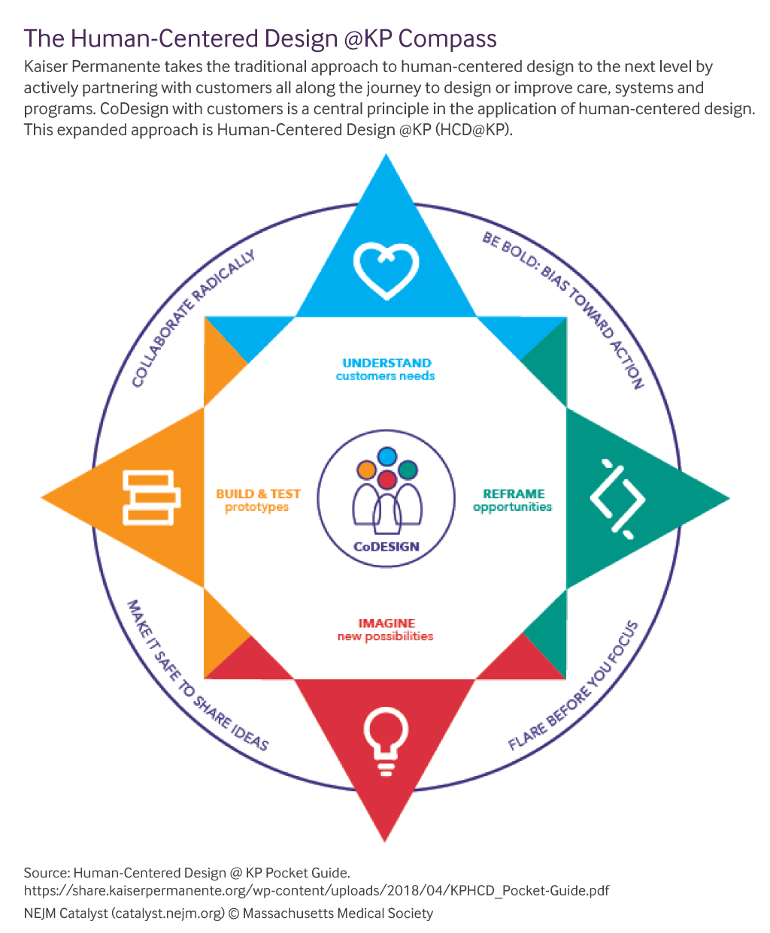

Classification of patient-safety incidents in primary care
Cooper J, Williams H, Hibbert P, Edwards A, Butt A, Wood F, et al
Bulletin of the World Health Organization. 2018;96:498-505.
DOI | http://dx.doi.org/10.2471/BLT.17.199802
Notes | Following the development of the World Health Organization’s development of the International Classification for Patient Safety and a large scale analysis of patient safety incidents in primary care were, it was apparent that the harm-severity element of the International Classification lacked sufficient granularity for the classification to be used in primary-care settings. As the authors observe “Previous attempts to identify and learn from the most important sources of harm to patients in primary care have been restricted by the lack of a universal standard system for classifying the severity of such harm and the general neglect of psychological harm in this context. Health-care leaders must develop robust mechanisms for generating useful reports of patient-safety incidents and acting on those reports to improve.”  This has led to the development of a more comprehensive system for the classification of harm severity in patient-safety incidents occurring in primary care. The proposed Primary Care Harm Severity Classification System has the following severity categories:  - No harm  - No harm due to mitigating action  - Mild harm  - Moderate harm  - Severe harm  - Death  - Insufficient detail.

Hospitals are learning from industry how to cut medical errors
The Economist
URL | https://www.economist.com/international/2018/06/30/hospitals-are-learning-from-industry-how-to-cut-medical-errors
Notes | In the 28 June issue of The Economist, is this article looking at how medicine may and can draw on the lessons of other industries (and behavioural science) in addressing errors. Much of this is familiar to those who read the specialised journals, but this indicates how this is now being seen in more mainstream media and common knowledge.

Journal of Patient Safety and Risk Management
Volume: 23, Number: 3 (June 2018)
URL | http://journals.sagepub.com/toc/cric/23/3
Notes | A new issue of Journal of Patient Safety and Risk Management has been published. Articles in this issue of Journal of Patient Safety and Risk Management include:  - Gained in translation: The Third Global Ministerial Summit on Patient Safety, Tokyo (Albert W Wu)  - Improving guideline compliance and healthcare safety using human factors engineering: The case of Ebola (Ayse P Gurses, Michael A Rosen, and Peter J Pronovost)  - The case of Dr Bawa-Garba: How the fallout can damage patient safety (Peter Walsh)  - “SACCIA Safe Communication”: Five core competencies for safe and high-quality care (Annegret F Hannawa)  - Current and future challenges facing medico-legal experts – An expert’s view (Pat Price)  - Trust liable for hypoxic birth injury and psychiatric injury caused to mother and grandmother: RE v Calderdale & Huddersfield NHS Foundation Trust [2017] EWHC 824 (QB) (High Court, 12 April 2017 – Goss J) (Dan Clarke)  - Causation not proven in head injury case: Harding v Buckinghamshire Healthcare NHS Trust (High Court, 13 September 2017 – Sir Alistair Macduff) (John Mead)  - Receptionist not required to give detailed advice on waiting times: Michael Darnley v Croydon Health Services NHS trust (Court of Appeal, 23 March 2017) (John Mead)  - Unintended consequences of quality improvement programs on the prevention of hospital-acquired conditions: Avoiding the temptation to bite into low-hanging fruit (William V Padula, Patricia M Davidson, Debra Jackson, Rachel Pedreira, and Peter J Pronovost)  - Case study: Reducing preventable maternal mortality in Rwandan healthcare facilities through improvements in WASH protocols (Andrea Guzman)

Journal of Health Services Research & Policy
Volume: 23, Number: 3 (July 2018)
URL | http://journals.sagepub.com/toc/hsrb/23/3
Notes | A new issue of Journal of Health Services Research & Policy has been published. Articles in this issue of Journal of Health Services Research & Policy include:  - Editorial: Post-compromise Democrats, Medicare for all, and the possible futures of American health policy (Scott Greer)  - Dementia buddying as a vehicle for person-centred care? The performance of a volunteer-led pilot on two hospital wards (Claire Preston and S Burch)  - A logic model for pharmaceutical care (Carolina Moltó-Puigmartí, Robert Vonk, Gerlise van Ommeren, and Ingrid Hegger)  - What constitutes meaningful engagement for patients and families as partners on research teams? (Agnes Black, Kimberly Strain, Christine Wallsworth, Sara-Grey Charlton, W Chang, K McNamee, and C Hamilton)  - Moving upstream in health promoting policies for older people with early frailty in England? A policy analysis (Vari Drennan, K Walters, C Avgerinou, B Gardner, C Goodman, R Frost, K Kharicha, S Iliffe, and J Manthorpe)  - Introducing consumer directed care in residential care settings for older people in Australia: views of a citizens’ jury (Kate Laver, E Gnanamanickam, C Whitehead, S Kurrle, M Corlis, J Ratcliffe, W Shulver, and M Crotty)  - Exploring Dutch surgeons’ views on volume-based policies: a qualitative interview study (Roos Mesman, Marjan J Faber, G P Westert, and B Berden)  - The evolving role of paramedics – a NICE problem to have? (Georgette Eaton, Kamal Mahtani, and Matt Catterall)  - Updated meta-review of evidence on support for carers (Jane Dalton, Sian Thomas, Melissa Harden, Alison Eastwood, and Gillian Parker)

Healthcare Policy
Volume 13, Number 4, 2018
URL | https://www.longwoods.com/publications/healthcare-policy/25492
Notes | A new issue of Healthcare Policy has been published. Articles in this issue of Healthcare Policy include:  - Cybersecurity in Health: A 21st Century Imperative (Jennifer Zelmer)  - What’s Canadian about Medicare? A Comparative Perspective on Health Policy (Carolyn Hughes Tuohy)  - Ontario and New Zealand Pharmaceuticals: Cost and Coverage (Leah T Kelley, Tim Tenbensel and Ana Johnson)  - An Exploration of the Content and Usability of Web-Based Resources Used by Individuals to Find and Access Family Physicians (Karen L Tang, Fartoon Siad, Dima Arafah and Jocelyn Lockyer)  - Tokenism and Mending Fences: How Rural Male Farmers and Their Health Needs Are Discussed in Health Policy and Planning Documents (Bradley Hiebert, Sandra Regan and Beverly Leipert)  - Centralized Waiting Lists for Unattached Patients in Primary Care: Learning from an Intervention Implemented in Seven Canadian Provinces (Mylaine Breton, Sabrina T Wong, Mélanie Ann Smithman, Sara Kreindler, Jalila Jbilou, Jason Sutherland, Astrid Brousselle, Jay Shaw, Valorie A Crooks, Damien Contandriopoulos, Martin Sasseville and Michael Green)

Healthcare Papers
Volume 17, Number 3, 2018
URL | https://www.longwoods.com/publications/healthcarepapers/25502
Notes | A new issue of Healthcare Papers has been published with the theme ‘Rural and Remote Health Services’. Articles in this issue of Healthcare Papers include:  - The Challenge of Rural and Northern Health Systems (Adalsteinn D Brown)  - Addressing the Duality of Access to Healthcare for Indigenous Communities: Racism and Geographical Barriers to Safe Care (Carrie Bourassa)  - Reconciliation and Health Systems Performance in Northern, Indigenous and Rural Communities (Susan Chatwood)  - Challenges of Capacity and Development for Health System Sustainability (Roger Strasser, Don Mitchell, Jessica Logozzo, Paul Preston and Neil Walker)  - Regional Inequalities in All-Cause and Premature Mortality in Ontario (David Henry, Emmalin Buajitti and Laura Rosella)  - A Policy Research Agenda for Health Systems in Canada’s North (Gregory P Marchildon)

Journal for Healthcare Quality
Vol. 40, No. 4, July/August 2018
URL | https://journals.lww.com/jhqonline/toc/2018/07000
Notes | A new issue of the Journal for Healthcare Quality has been published. Articles in this issue of the Journal for Healthcare Quality include:  - “Hot Seat” Simulation Model for Conflict Resolution: A Pilot Study (Sara Kim, Elise Frans, Isaac Bohannon, Karen Barr, Elizabeth Buttrick, Ryan Fehr, Sarah E. Shannon)  - Uses and Limitations of Claims-based Performance Feedback Reports: Lessons From the Comprehensive Primary Care Initiative (Margaret Gerteis, Deborah Peikes, Arkadipta Ghosh, Lori Timmins, Ann S O'Malley, Michael Barna, Erin F Taylor, Timothy J Day, K Swankoski, P W Payne, Jr, R Brown)  - Enhanced Adherence in Patients Using an Automated Home Medication Dispenser (Charles Hoffmann, Anne Schweighardt, Kelly M. Conn, Dallas Nelson, Richard Barbano, Frederick Marshall, Jack Brown)  - Highlighting a Common Quality of Care Delivery Problem: Overuse of Low-value Healthcare Services (Stephanie MacLeod, Shirley Musich, Kevin Hawkins, Kay Schwebke)  - Effect of Socioeconomic Status on Surgery Waiting Times and Mortality After Hip Fractures in Italy (Alessio Petrelli, Giuliana De Luca, Tania Landriscina, Giuseppe Costa, Roberto Gnavi)  - Reducing Readmissions Post-tonsillectomy: A Quality Improvement Study on Intravenous Hydration (Eileen Hession-Laband, Patrice Melvin, Herminia Shermont, Jane M. Murphy, Bola Bukoye, Manali Amin)  - Evidence for Misspecification of a Nationally Used Quality Measure for Substance Use Treatment (Soeren Mattke, Zachary Predmore, Elizabeth Sloss, Asa Wilks, Katherine E Watkins)  - Technology Solutions to Support Care Continuity in Home Care: A Focus Group Study (Dawn W Dowding, David Russell, N Onorato, J A Merrill)  - Breaking the Barriers in Resident Education: A Quality Improvement Initiative (Larissa H Cabarga, Luigi X Cubeddu, Jiny Olickal, Samira Habibnejad, Elizabeth Kury-Perez, Pooja Pundhir, D Pirela, R C Goldszer)  - Impact of Surgeon Self-evaluation and Positive Deviance on Postoperative Adverse Events After Non-cardiac Thoracic Surgery (Jelena Ivanovic, Fargol Mostofian, Caitlin Anstee, Sebastien Gilbert, Donna E Maziak, Farid M. Shamji, R S Sundaresan, P J Villeneuve, A J E Seely)

International Journal for Quality in Health Care online first articles
URL | https://academic.oup.com/intqhc/advance-access
Notes | International Journal for Quality in Health Care has published a number of ‘online first’ articles, including:  - Improving the identification and treatment of depression in low-income primary care clinics: a qualitative study of providers in the VitalSign6 program (Farra Kahalnik; Katherine Sanchez; Afrida Faria; Bruce Grannemann; Manish Jha; Corey Tovian; E Will Clark; Sara Levinson; Ronny Pipes; Meaghan Pederson; Madhukar H Trivedi)  - A positive legacy of trauma? A study on the impact of natural disasters on medical utilization (Usman Iqbal; Yu-Chuan Jack Li; Kung-pei Tang; Hui-Chen Chien; Ya-Ting Yang; Yi-Hsin Elsa Hsu)  - Is patient loyalty associated with quality of care? Results of a patient survey over primary care in Switzerland (Katja Goetz; Marianne Jossen; Thomas Rosemann; Sigrid Hess; Marc Brodowski; Paula Bezzola)

Online resources

10 Facts on Patient Safety
http://www.who.int/features/factfiles/patient_safety/en/
The World Health Organization has updated its 10 facts on patient safety. As the page notes: “Patient safety is a serious global public health concern. There is a 1 in a million chance of a person being harmed while travelling by plane. In comparison, there is a 1 in 300 chance of a patient being harmed during health care. Industries with a perceived higher risk such as the aviation and nuclear industries have a much better safety record than health care.” The ten facts (with more details given on the site) are:
- Patient harm is the 14th leading cause of the global disease burden, comparable to diseases such as tuberculosis and malaria
- While in hospital, 1 in every 10 patients is harmed
- Unsafe use of medication harms millions and costs billions of dollars annually
- 15% of health spending is wasted dealing with all aspects of adverse events
- Investments in reducing patient safety incidents can lead to significant financial savings
- Hospital infections affect 14 out of every 100 patients admitted
- More than one million patients die annually from surgical complications
- Inaccurate or delayed diagnoses affect all settings of care and harm an unacceptable number of patients
- While the use of radiation has improved health care, overall medical exposure to radiation is a public health and safety concern
- Administrative errors account for up to half of all medical errors in primary care.

National Advance Care Directive Prevalence Study
www.advancecareplanning.org.au/prevalence
Advance Care Planning Australia (ACPA) is leading pioneering research to build a national picture of the prevalence of Advance Care Directives (ACDs) and other advance care planning documentation across all health and care services, and to evaluate how well an individual’s clinical care plan aligns with their documented personal preferences. ACPA is inviting GP clinics, aged care providers and hospitals to participate in the National Advance Care Directive Prevalence Study 2018.

Disclaimer
On the Radar is an information resource of the Australian Commission on Safety and Quality in Health Care. The Commission is not responsible for the content of, nor does it endorse, any articles or sites listed. The Commission accepts no liability for the information or advice provided by these external links. Links are provided on the basis that users make their own decisions about the accuracy, currency and reliability of the information contained therein. Any opinions expressed are not necessarily those of the Australian Commission on Safety and Quality in Health Care.

