DECISION AID

for consumers

Acute bronchitis:   
Should I take antibiotics?

## What is this decision aid for?

* This decision aid can help you decide whether to use antibiotics when you or your child has acute bronchitis (acute cough).
* It is designed to be used with your doctor to help you make a shared decision about what is best for you or your child.

## What causes acute bronchitis?

* It can be caused by a viral or bacterial infection. It is hard for your doctor to tell which it is.
* The infection is in the airway (bronchi) leading to the lungs. Acute means it is a short-term infection.

## How long does the cough last?

The cough will usually get better by about **10–20 days**, without taking antibiotics.

## What are the treatment options?

There are two options that you can discuss with your doctor:

1. **Not taking antibiotics**. This means letting the infection get better by itself.
2. **Taking antibiotics**.

Symptoms, such as fever, can be treated with over-the-counter medicines which can be used with either option. See below for some examples.

## What are the likely benefits and harms of each option?

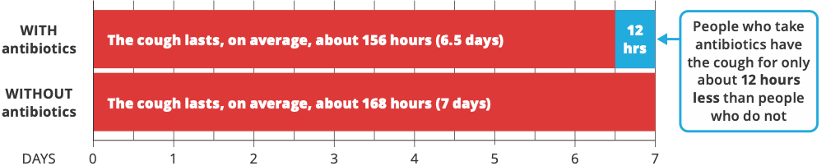

These figures show what is likely to happen to people with acute cough who **do not** take antibiotics and those who **do**. Each circle is one person. We can’t predict who will get better sooner or who will have problems.

## Possible benefits

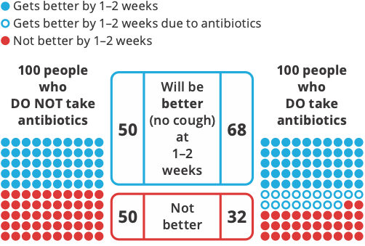

With antibiotics, **18 more people** will be better after 1–2 weeks.

## Possible harms

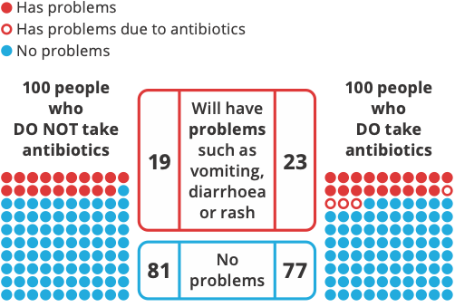

With antibiotics, **4 more people** will have problems such as vomiting, diarrhoea or rash. Other **antibiotic downsides** are:

* The **cost** of buying them
* **Remembering** to take them
* The risk of **antibiotic resistance** (see below).

## Where do these estimates of benefits and harms come from?

* They are from the most up-to-date medical evidence of benefits and harms about what works best.1,2,3 This is a review of 17 studies, and over 5,000 people, that looked at antibiotic use in people with acute bronchitis.
* The quality of this research evidence is ranked as high. This means that further research is very unlikely to change these estimates.

## Why might antibiotics be used?

If the infection is in the lung, it is called pneumonia. This is not common, however if you have pneumonia, it can be serious. Your doctor may also talk with you about why antibiotics might be needed, such as if you have a chronic disease. Coughing up coloured phlegm (spit) is not a sign that antibiotics are needed.

## What is antibiotic resistance?

* Using antibiotics means the bacteria, including the healthy ones in your body, can develop resistance to the antibiotic.
* This means that **antibiotics may not work if you or your child needs them in the future** to treat a bacterial infection.
* A person who has recently used antibiotics is more likely to have resistant bacteria in their body.

## Are there other things I can do to manage acute bronchitis?

* Some people find that taking **honey** for a day or two helps to settle the cough. Take one to two teaspoons, just before bedtime. The honey can be given in a drink such as warm water. Honey should not be given to children less than 12 months old.
* Fever is best treated with over-the-counter **paracetamol and/or ibuprofen**. Do not give more than the maximum recommended dose. Read the dose information on the packet.
* Aspirin should NOT be used with children who are younger than 16 years.

## When should you see a doctor and get further help?

If the person with the cough has any of these signs:

* Very drowsy
* Fast or difficult breathing, wheezing, or shortness of breath
* Cold or discoloured hands and/or feet with a warm body
* Pain in the arms and/or legs
* Coughing blood
* Unusual skin colour (pale or blue) around the lips
* A rash that does not fade when the skin is pressed.

## Questions to consider when talking with your doctor

* Do I need antibiotics?
* What happens if I do not take antibiotics?
* Do I know enough about the benefits and harms of:
  + taking antibiotics?
  + not taking antibiotics?
* Am I clear about which benefits and harms matter most to me?
* Do I have enough information and support to decide?

## ****References****

1. Smith SM, Fahey T, Smucny J, Becker LA. Antibiotics for acute bronchitis. Cochrane Database of Systematic Reviews 2017, 6(6):CD000245. doi:10.1002/14651858.CD000245.pub4. [www.cochranelibrary.com](http://www.cochranelibrary.com)
2. Oduwole O, Udoh EE, Oyo‐Ita A, Meremikwu MM. Honey for acute cough in children. Cochrane Database of Systematic Reviews 2018, Issue 4. Art. No.: CD007094. DOI: 10.1002/14651858.CD007094.pub5.
3. Gillies M, Ranakusuma A, Hoffmann T, Thorning S, McGuire T, Glasziou P, & Del Mar C. Common harms from amoxicillin: a systematic review and meta-analysis of randomized placebo-controlled trials for any indication. Canadian Medical Association Journal, 2015, 187; doi:10.1503/cmaj.140848.

The information in this decision aid is provided for general information only. It is not intended as medical advice and should not be relied upon as a substitute for consultations with a qualified health professional who can determine you or your child’s individual medical needs.

Last reviewed: June 2023. Update due: July 2025. Decision Aids funded by the Australian Commission on Safety and Quality in Health Care and developed by Professor Tammy Hoffmann, Professor Chris Del Mar, and Mr Peter Coxeter – Institute for Evidence-Based Healthcare, Bond University.

[**safetyandquality.gov.au**](http://www.safetyandquality.gov.au)

Creative Commons Licence© Australian Commission on   
Safety and­­ ­Quality in Health Care 2023