National Standard for User-applied Labelling of Injectable Medicines, Fluids and Lines

Perioperative sterile field
To identify contents of containers (syringes and hollowware) on the sterile field in the operating room use:
labels preprinted with medicine/fluid name and concentration OR
a generic closed-practice environment label with medicine and concentration prompts.
Type of label | Example label | Instructions
Preprinted closed-practice label | Example of a preprinted label sheet produced to service a perioperative sterile field  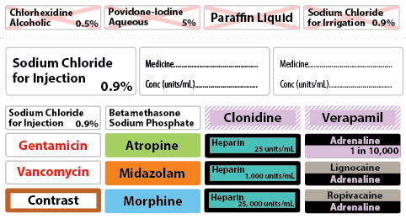 | Use individual labels, a sheet of labels for a perioperative suite, or a sheet of labels for a specific operating procedure.  Preprinted labels include full generic names (except contrast media).  Colour coding to follow International Standard ISO 26825:2008.  Concentration optional except for adrenaline when used as single medicine.  Concentration may be preprinted or completed at the time of preparation in the space provided with a sterile marker pen.
Generic closed-practice environment label | 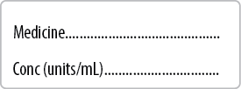 | Use the generic closed-practice environment labels when preprinted labels are not available (requires a sterile marker pen).
All closed-practice environment container labels | No example | Adhesive must ensure the label remains attached to the container for the procedure duration.  Adhesive must allow the label to be completely removed after the procedure when using reusable hollowware containers.  Apply away from the pouring spout and avoid graduations.

To be read in conjunction with the National Standard for User-applied Labelling of Injectable Medicines, Fluids and Lines, 2015.
© Commonwealth of Australia 2015

