Australian Commission on Safety and Quality in Health Care logo 


TRIM: D18-27543

March 2019

Public reporting of safety and quality in public and private hospitals

Literature review and environment scan

Published by the Australian Commission on Safety and Quality in Health Care  
Level 5, 255 Elizabeth Street, Sydney NSW 2000

Phone: (02) 9126 3600  
Fax: (02) 9126 3613

Email: mail@safetyandquality.gov.au   
Website: www.safetyandquality.gov.au

ISBN: 978-1-925665-80-2

© Australian Commission on Safety and Quality in Health Care 2019

All material and work produced by the Australian Commission on Safety and Quality in Health Care (the Commission) is protected by copyright. The Commission reserves the right to set out the terms and conditions for the use of such material.

As far as practicable, material for which the copyright is owned by a third party will be clearly labelled. The Commission has made all reasonable efforts to ensure that this material has been reproduced in this publication with the full consent of the copyright owners.

With the exception of any material protected by a trademark, any content provided by third parties and where otherwise noted, all material presented in this publication is licensed under a [Creative Commons Attribution–NonCommercial–NoDerivatives 4.0 International licence](http://creativecommons.org/licenses/by-nc-nd/4.0/).



Enquiries about the licence and any use of this publication are welcome and can be sent to [communications@safetyandquality.gov.au](mailto:communications@safetyandquality.gov.au).

The Commission’s preference is that you attribute this publication (and any material sourced from it) using the following citation:

Australian Commission on Safety and Quality in Health Care. Public reporting of safety and quality in public and private hospitals: Literature review and environment scan. Sydney: ACSQHC; 2019

**Disclaimer**

The content of this document is published in good faith by the Commission for information purposes. The document is not intended to provide guidance on particular healthcare choices. You should contact your health care provider for information or advice on particular healthcare choices.

The Commission does not accept any legal liability for any injury, loss or damage incurred by the use of, or reliance on, this document.

# Contents

Key findings 1

Summary 2

Introduction 6

Project background and context 6

Structure of this document 7

Literature review 8

Scope of the review 8

Guiding questions for the literature review 8

Search strategy 8

Common aims of public reporting safety and quality data 9

How public reporting can achieve its aims 10

Positive factors and perverse impacts of public reporting 13

Evidence of efficacy of public reporting 13

Barriers and challenges for consumers 15

Barriers and challenges for healthcare organisations 17

Features of an effective public reporting framework 18

Environment scan 20

Scope of the environment scan 20

Guiding questions for the environment scan 20

Search strategy 20

Australian national reporting mechanisms 21

Jurisdictional reporting on public hospitals 22

Public reporting by private hospitals 27

Non-government public reporting mechanisms in Australia 35

International examples of public reporting 37

Appendix A : Detailed outline of public reporting across jurisdictions 45

Appendix B : List of organisations searched 55

Glossary 59

References 60

# Key findings

* + - * The commonly cited aims of publicly reporting safety and quality data included supporting patient choice, increasing consumer literacy, driving provider quality improvement, enhancing transparency and promoting public trust in the health system.
      * The benefits of public reporting can be predominantly realised through:
        + Selection (consumer empowerment), whereby public reporting empowers health consumers and other relevant health sector stakeholders such as health insurers to identify and choose services from healthcare organisations that perform better and have better outcomes
        + Changes in care (provider quality improvement), whereby public reporting provides greater visibility of organisational performance, generating momentum within an organisation to drive ongoing quality improvement activities to maintain or enhance its reputation.
* An effective public reporting framework should have a well-defined purpose, specific audience and clear outcomes, and be built around an institutional culture that recognises the value of reporting. Evidence-based indicators selected for public reporting should accurately capture quality outcomes and have minimal or no unintended consequences.
* Most states and territories across Australia report healthcare quality and safety information, and the extent and approach varies. For the private hospital sector, participation in the national public reporting mechanism (MyHospitals) is relatively high and the majority of the private hospital providers reported safety and quality performance on their websites. There are also non-government public reporting mechanisms in place where consumers can share their experiences with healthcare organisations and providers.
* An increase in volume and complexity of public reporting can make the information available to consumers difficult to navigate and understand in order to make choices. However, good examples of more consumer-friendly presentation of public reporting were seen, for example in Canada and the United States of America (USA), through the Leapfrog Group.
  + - * Multiple reporting requirements can lead to reporting fatigue and lack of participation in voluntary public reporting mechanisms. Where public reporting occurs at a provider level, a focus on individual responsibility can have a negative impact on collaborative team culture that is essential to patient safety. There is also potential for public reporting to lead to selection bias against high risk consumers, which may impact equity of health access.
      * There is value in combining patient generated reviews with more traditional indicator-based information, to provide a comprehensive view of both the workforce and organisations’ safety and quality of care. A multifactorial approach to monitoring and reporting patient safety is becoming increasingly common across the globe with countries such as the Netherlands, USA and Canada having implemented such an approach, and realising improved outcomes as a result.
      * Public reporting has had a positive influence on provider quality improvement activities, particularly in the USA, and supports public reporting of agreed safety and quality indicators with risk adjustment, to facilitate accurate comparisons between healthcare organisations. Evidence of benefits from public reporting at the hospital level is typically identified through increased quality improvement activities, overall performance and outcomes, or both.

# Summary

This report provides a summary of findings from a literature review and environment scan undertaken to inform options for national public reporting standards of safety and quality in health care across public and private hospitals in Australia.

This literature review and environment scan is part of a project that was undertaken by the Australian Commission on Safety and Quality in Health Care (the Commission) in response to the request from the Council of Australian Governments (COAG) Health Council (CHC). In August 2017, the Commission was asked to identify options to align public reporting standards for the safety and quality of health care across public and private hospitals nationally, with a view to this work being incorporated in the national work being progressed on the Australian Health Performance Framework (AHPF).

This document includes findings regarding public reporting in Australia and three other Organisation for Economic Co-operation and Development (OECD) countries: the Netherlands, Canada and the USA.

The document is presented in two parts: the literature review and the environment scan. The research questions and findings for each part are shown throughout the report and are summarised below. Along with this report, a number of focus groups with clinicians and consumers were undertaken and this has been reported separately.

**Literature review**

**Purpose of the literature review**

A review of relevant literature on public reporting frameworks was undertaken to inform responses to a range of guiding questions. In addition, the literature review considered research that outlined factors necessary for a successful public reporting framework, based on the lessons learned from various initiatives undertaken nationally and internationally over the past several decades.

The research questions guiding this literature review are as follows:

1. What are the commonly cited aims of publicly reporting safety and quality data?
2. What are the mechanisms by which public reporting is thought to achieve these aims?
3. What factors are associated with positive and/or perverse impacts of public reporting of safety and quality information?

**Findings of the literature review**

A summary of findings of the literature is presented below, by research question or other consideration that the review sought to address.

**What are the commonly cited aims of publicly reporting safety and quality data?**

The commonly cited aims of publicly reporting safety and quality data in the literature included supporting patient choice, increasing consumer literacy, driving provider quality improvement, enhancing transparency and promoting public trust in the health system.

**What are the mechanisms by which public reporting is thought to achieve these aims?**

In broad terms, the benefits of public reporting have been categorised into two areas:

* Selection (consumer empowerment), whereby public reporting empowers health consumers and other relevant health sector stakeholders such as health insurers to identify and choose services from healthcare organisations that perform better and have better outcomes
* Changes in care (provider quality improvement), whereby public reporting provides greater visibility of organisational performance, generating momentum within an organisation to drive ongoing quality improvement activities to maintain or enhance its reputation.

Safety and quality information that is publicly reported can focus on a single condition or cover a range of conditions and long-term health outcomes. The information is usually derived using either administrative, surveillance or bespoke data (or a collection of these data).

User-generated reviews of healthcare providers and organisations are increasing in volume, through mechanisms such as social media channels and government websites.

In some countries, a composite indicator is used to provide an overall view on performance, although this does not happen consistently. Public reporting now typically occurs via publicly accessible websites.

Typically the data that are publicly reported are collected as part of a broader performance framework. Australia is currently transitioning towards using a single framework, the AHPF that has been endorsed by AHMAC in September 2017. Existing indicators from the National Health Reform Performance and Accountability Framework (PAF) and the National Health Performance Framework (NHPF) will initially be transitioned and presented as a single set of indicators in the new framework (AHPF).

**What factors are associated with positive and/or perverse impacts of public reporting of safety and quality information?**

There is limited evidence of public reporting influencing consumer behaviours. There is more evidence in the literature that public reporting has had a positive influence on provider quality improvement activities, particularly in the USA. Evidence of benefits from public reporting at the hospital level is typically identified through increased quality improvement activities, overall performance and outcomes, or both.

An increase in volume and complexity of public reporting can make the information available to consumers difficult to navigate and to understand in order to make informed choices. Uptake and use of public reporting information has been minimal and much lower amongst disadvantaged groups.

There is potential for public reporting to lead to selection bias against high risk consumers, which may impact equity of health access.

The use of accurate risk adjustment and appropriate sample sizes to make meaningful comparisons is a key challenge for broader acceptance of public reporting amongst health care organisations.

Multiple reporting requirements can also lead to reporting fatigue and lack of participation in voluntary public reporting mechanisms. Where public reporting occurs at a provider level, a focus on individual responsibility can have a negative impact on collaborative team culture that is essential to patient safety.

**Factors for a successful public reporting framework**

The reviewed literature identifies that an effective public reporting framework should have a well-defined purpose, specific audience and clear outcomes, and be built around an institutional culture that recognises the value of reporting.

The indicators that comprise the framework need to be evidence-based, carefully designed to accurately capture quality, closely linked to the outcomes being measured and have minimal or no unintended consequences.

Public reporting initiatives should consider the value of combining patient generated reviews with more traditional indicator-based information to provide a more comprehensive view of an organisation’s performance.

**Environment scan**

**Purpose of the environment scan**

The environment scan involved an investigation into publically available safety and quality information across the Australian healthcare landscape. The collation of this information provides the current baseline for public reporting and identifies key differences in the type of quality and safety information reported publicly by both private and public healthcare organisations across Australia. In addition, this environment scan included three OECD countries to provide an overseas comparison.

The environment scan responded to the following guiding questions:

1. What safety and quality information is currently publicly reported in Australia about publicly- and privately-funded hospitals and how is it reported?
2. What are the differences between safety and quality information reported about public and private hospitals?
3. What safety and quality information is currently publicly reported in selected OECD countries, how is it reported, and how does this differ from what is reported in Australia?
4. What are the emergent trends in the type of information reported and in the way it is reported, and what does this mean for the future shape of public reporting in Australia?

**Findings of the environment scan**

A summary of findings of the environment scan are presented below, by research question.

**What safety and quality information is currently publicly reported in Australia about publicly- and privately-funded hospitals and how is it reported?**

Within Australia, there is a broad patchwork of public reporting systems at state/territory and national levels. The national portal for public reporting information (MyHospitals) arguably contains the least amount of information (with seven out of the proposed 16 performance indicators currently reported), amongst all of the public reporting portals currently available in Australia.

Across the Australian states/territories, NSW and (more recently), Victoria, have the most extensive public reporting mechanisms. Other jurisdictions, such as Queensland, are actively seeking to move toward more public reporting of safety and quality data. Websites in Australia varied in terms of patient accessibility. The portal provided by the NSW Bureau for Health Information (BHI) was the most similar for usability to international portals.

In Australia, there are also a number of non-government public reporting mechanisms in place through which health consumers can write reviews of their experiences with healthcare organisations and providers. This type of patient review information is not available through any of the national and jurisdictional public reporting mechanisms.

**What are the differences between safety and quality information reported about public and private hospitals?**

For the private hospital sector, participation in the national public reporting mechanism (MyHospitals), while voluntary, is relatively high. In addition the majority of the private hospital providers identified through the environment scan provided information on performance against safety and quality indicators on their own websites. However this information is not always easy to locate on these websites.

**What safety and quality information is currently publicly reported in selected OECD countries, how is it reported, and how does this differ from what is reported in Australia? What are the emergent trends in the type of information reported and in the way it is reported, and what does this mean for the future shape of public reporting in Australia?**

Data provided at the national level by the three OECD countries included in the review were more comprehensive, but also more variable, than the level of data reported at the national level in Australia (via MyHospitals).

Canada, which is most similar in health system structure to Australia of all of the countries included in the review, has a particularly extensive national public reporting mechanism currently in place.

The Netherlands and the USA have good examples of public reporting that is specifically targeted at consumers with supportive context information and outlines of actions being undertaken by hospitals to drive improvements in their performance; for example, through the Quality Window program and the Leapfrog Hospital Safety Grade program.

The information presented in Canada and in the USA (through the Leapfrog Group) were good examples of more consumer-friendly presentation of public reporting data. These portals used interactive tools and clear explanations to present the data.

# Introduction

The Australian Commission on Safety and Quality in Health Care (the Commission) is a government agency that leads and coordinates national improvements in safety and quality in health care across Australia. The Commission is an Australian Government agency, funded jointly by all state and territory governments and the Commonwealth government. It is established under the *National Health and Hospitals Network Act 2011* and its role codified in the *National Health Reform Act 2011* to lead and coordinate national improvements in safety and quality in health care.

The Commission works in partnership with the Australian, state and territory governments and the private sector to achieve a safe, high-quality and sustainable health system. In doing so, the Commission also works closely with patients, carers, clinicians, managers, policymakers and healthcare organisations.

Key functions of the Commission include developing national safety and quality standards, developing clinical care standards to improve the implementation of evidence-based health care, coordinating work in specific areas to improve outcomes for patients, and providing information, publications and resources about safety and quality.

The Commission works in four priority areas:

1. Patient safety
2. Partnering with patients, consumers and communities
3. Quality, cost and value
4. Supporting health professionals to provide care that is informed, supported and organised to deliver safe and high-quality health care.

## Project background and context

In August 2017, the CHC asked the Commission to identify options to align public reporting standards of safety and quality in health care across public and private hospitals nationally. The CHC requested that on finalisation, this work be incorporated in the national work being progressed on Australia’s health system performance and information reporting frameworks. The Commission was requested to report back to AHMAC and the CHC in early 2019.

A number of reports have signalled a commitment by the Australian Government for increased transparency in reporting about public services, particularly to promote informed decision making by the consumers of those services. Firstly, in December 2016 the Australian Government Productivity Commission released the report *Introducing Competition and Informed User Choice into Human Services: Identifying Sectors for Reform*. This report sets out the Productivity Commission’s view on priority areas for reform that will improve individual and community wellbeing. One area of focus for the report was improving consumer choice through increased transparency and public reporting, and a final report making recommendations to the Australian Government was submitted in October 2017.[1]

Secondly, in November 2017, the CHC endorsed the Australian Health Performance Framework. The Framework arose following the AHMAC *Review of Australia’s health system performance information and reporting frameworks: final report.* This report recommended a single national performance reporting framework for primary and hospital care across both public and private sectors, identifying in particular the current lack of public reporting about private hospitals’ performance. The Heads of Agreement[2] on public hospital funding and health reform February 2018, which sets out the agreement between the Commonwealth and the states and territories (Clause 7.d.ii) on public hospital funding and health reform, endorsed the implementation of the Framework. Governance of the Framework is undertaken by the Health Services Principal Committee, under AHMAC.[3]

In late 2017, the Queensland Government undertook a public consultation process to gauge community views about the collection, reporting and use of health care quality and patient safety information in Queensland through the release of a discussion paper. The Queensland Government received overwhelmingly supportive responses to public reporting on safety and quality across public and private hospitals within the state. The Queensland Government found through this consultation that public reporting was seen to support a safety and quality culture, increase transparency and drive improvements in performance.[4]

The Commission convened the Patient Safety Reporting Steering Committee to advise on the deliverables of a four-phase project to develop the options for public reporting on safety and quality in health care. The phases involved:

* **Phase 1. Evidence collection and analysis**
* Step 1. Environment scan
* Step 2. Literature review
* Step 3. Focus groups and interviews
* **Phase 2.** **Options development**
* **Phase 3.** **Validation of draft options**
* Step 1. Public consultation survey
* Step 2. Key stakeholder workshops
* Step 3. Consensus through the Commission’s governance processes
* **Phase 4.** **Finalise and report on options**

Along with this report, Phase 1 of the project includes undertaking a number of focus groups with clinicians and consumers, as well as targeted expert interviews, to answer the following overarching research question:

What does evidence from research, policy and practice, and consumers tell us about the best ways to ensure every person has timely access to relevant, valid, and trustworthy information to enable well-informed decision-making?

## Structure of this document

This document comprises a literature review and an environment scan on public reporting in Australia and three other OECD countries: the Netherlands, Canada and the USA.

The document is presented in two parts.

Firstly, findings from the literature review are described, outlining the nature of public reporting, the aims of reporting systems, and the benefits and challenges of public reporting. The characteristics of a successful public reporting framework are also distilled.

Secondly, the environment scan follows the literature review and sets out the current landscape of public reporting at a national, state/territory and at an international level across three selected OECD countries.

# Literature review

## Scope of the review

A review of relevant literature on public reporting frameworks was undertaken to inform responses to a range of guiding questions (outlined in the following sub-section). In addition, the literature review considered research that outlined factors necessary for a successful public reporting framework, based on the lessons learned from various initiatives undertaken nationally and internationally over the past several decades. The intention of this information is to assist with the development and refinement of options for public reporting, once the project moves beyond the current research and evidence collection phase.

## Guiding questions for the literature review

The research questions guiding this literature review are as follows:

1. What are the commonly cited aims of publicly reporting safety and quality data?
2. What are the mechanisms by which public reporting is thought to achieve these aims?
3. What factors are associated with positive and/or perverse impacts of public reporting of safety and quality information?

## Search strategy

### Search terms and parameters

This literature review was informed by an analysis of publicly available literature. Searches were conducted via two main search engines, Google and PubMed.

Using the Google search engine, searches were conducted using combinations of the following keywords:

* Public
* Reporting
* Health
* Information
* Data
* Transparency
* Accountability

From the Google search, a range of documents were identified, including policy documents, presentations and scholarly articles. Where relevant, references from these documents were identified and original source documents retrieved.

A search of the PubMed database was also conducted. Medical Subject Headings (MeSH) used to direct the search were combined in a number of permutations and included:

* Patient safety
* Risk management
* Quality indicators
* Healthcare

The following limits were applied and included in all circumstances: English language and humans. The PubMed search was also restricted to articles from the past 10 years.

### General exclusions and limitations

This literature review is not intended to be a comprehensive, academic review of all relevant literature. It has been undertaken to provide high level findings to the guiding questions outlined previously.

## Common aims of public reporting safety and quality data

### Moving towards greater public reporting in health care

The overall view that openness and transparency about hospital system performance is fundamental to improving safety is one that is broadly accepted within the health care community. In 2009, Leape et al. stated that, ‘in complex, tightly coupled systems like health care, transparency is a precondition to safety. Its absence inhibits learning from mistakes, distorts collegiality and erodes patient trust’.[5]

Historically, consumers have had very little, if any, user-friendly access to quality and cost information in health care, in comparison to most other industries.[6] However, as the value of transparency in promoting ongoing clinical quality improvement and consumer empowerment became more apparent, the level of information gathered and reported began to increase.

Some of the first public reporting initiatives commenced in the USA (through the Joint Commission) as recently as 1988.[7] In the USA, public reporting of safety and quality data (public reporting) has been given added impetus over recent years following increasing concern with the growing costs of healthcare provision, coupled with awareness that the quality of care provided had been often been suboptimal. The concern for actions to improve the quality of health care were further heightened following the release of two landmark Institute of Medicine (IOM) reports —*To Err Is Human: Building a Safer Health System* in 2000and *Crossing the Quality Chasm: A New Health System for the 21st Century* in 2001.[8] Similar policy considerations have been made across various other countries, including Australia, since the release of these reports.

### Aims for greater public reporting in health care

There are a number of commonly cited reasons that underpin the push toward greater public reporting, including to:

* Support patient choice
* Improve community health literacy
* Stimulate provider actions
* Enhance transparency of the provider-funder relationship
* Promote public trust, through holding healthcare providers and funders to account for the quality of care they provide and the purchasing decisions they make.[9] [10]

At a community level, public reporting can not only increase knowledge to assist consumers to make informed choices and motivate provider performance improvement, it can also serve to improve overall community quality and safety health literacy through the open and transparent disclosure of health system performance information.[11]

**Finding summary**

The commonly cited aims of public reporting in the literature are to support patient choice, increase consumer literacy, drive provider quality improvement, enhance transparency and promote public trust in the health system.

## How public reporting can achieve its aims

### Public reporting in healthcare quality improvement

In broad terms, the benefits of public reporting have been categorised into two areas. These were outlined by Berwick et al. (2003) and form a fundamental basis for much of the literature outlining the ways in which public reporting can lead to ongoing quality improvement in the healthcare setting. [12] [13] [14]

The improvements are gained through:

* Selection (consumer empowerment), whereby public reporting empowers health consumers and other relevant health sector stakeholders such as health insurers to identify and choose services from healthcare organisations that perform better and have better outcomes
* Changes in care (provider quality improvement), whereby public reporting provides greater visibility of organisational performance, generating momentum within an organisation to drive ongoing quality improvement activities to maintain or enhance its reputation.[15]

The literature further identifies ways in which provider quality improvement can be enhanced through public reporting. These include:

* Benchmarking, which may motivate poor performers to catch up with other providers
* Driving high performers to maintain their ‘good’ reputation
* Increasing overall responsiveness of providers.[16]

### Structure and extent of public reporting

As the interest in public reporting has grown, a variety of mechanisms to present this information have been developed and used. These mechanisms vary depending on their specific purpose, being a product of their specific health system context and policy setting.[17] The overarching policy context (including funding and governance of the health system) has a direct bearing on the type of information that is publicly reported.

Public reporting varies in extent and scope. It can be narrow in scope and focused on a single condition or procedure (for example, to inform waiting times only) or can be much broader systems with detailed information on provider quality, covering multiple conditions or procedures and overall outcomes.[18] [19] In practice, this ranges from basic information on select indicators, to detailed information on a range of performance and quality of care indicators at an individual provider level (for example the Weisse List in Germany, Hospital Compare in the USA and Sundhedskvalitet in Denmark) [20].

Kumpunen et al identified three categories of information from which public reporting information is derived: administrative, surveillance and bespoke. Examples for the types of data used to generate public reporting information within each category are at Table 1.

**Table 1: Types of data used in generating public reporting information**[21]

|  |  |  |
| --- | --- | --- |
| **Administrative** | **Surveillance** | **Bespoke** |
| * Hospital records and activity * General practice patient records * Insurance records | * Clinical registers * Assessment instruments * Screening data * Immunisation coverage * Waiting times * Delayed transfers of care | * Inspections * Accreditation schemes * Patient experience and outcome surveys * Staff surveys * Clinical audits |

In addition to the reporting of information by health systems, user-generated reviews of healthcare providers and organisations are increasing in volume, through mechanisms such as social media channels and government websites, for example NHS Choices.[22]

### Health performance frameworks

Literature indicates that public reporting in most countries is guided by a broader health performance framework or frameworks at a state-wide or national level. Having an overarching performance framework is broadly recognised as an important element in guiding the development of appropriate and relevant performance indicators, as it sets the overall rationale and design principles for those indicators.

In some instances, public reporting mechanisms include a composite indicator of quality, for example, through an overall star rating. This is intended to support consumers to more easily digest a complex set of information presented on healthcare performance. [23] [24] Braithwaite et al. noted that the use of a single composite indicator of performance has largely been replaced in favour of multidimensional frameworks, which is recognition of the difficulties in trying to simplify a complex set of health information.[25] In Australia, public reporting has been informed by a number of performance frameworks from which information is publicly released to cater to a wide number of stakeholders. These include policymakers, healthcare administrators and consumers, amongst others.

The Australian Health Performance Framework (AHPF) which was released in September 2017, was developed to provide a single framework for system-wide reporting on Australia’s health and healthcare performance. The AHPF is owned by AHMAC and intends to learn from previous frameworks to inform future work in a more contemporary approach.

The performance frameworks on which the AHPF is based include:

* The National Health Reform Performance and Accountability Framework (PAF), designed to improve accountability and transparency of health service provision across both the primary and acute care sectors, using a combination of service delivery and population health outcomes.[26] The framework comprises 48 national indicators, 31 covering primary care (at a primary health network level) and 17 covering acute care (at a local health network or equivalent level)
* The Productivity Commission’s National Health Performance Framework (NHPF) for the Review Of Government Services (ROGS). This framework includes sector-wide indicators and specific indicator sets for Primary and Community Health, Public Hospitals (including Maternity Services) and Mental Health Management.

Existing indicators from these two frameworks, the NHPF and the PAF, will initially be transitioned and presented as a single set of indicators in the new framework. Over time, it is expected that these indicators will be subject to further review and a new set of revised indicators will be developed.[27]

AHPF allows for health system activities and outputs to be measured against quality dimensions including safety, accessibility, appropriateness, continuity, effectiveness and efficiency. Health system activities and outputs may include policy and governance, healthcare management, health protection and promotion, service delivery and clinical care, and health system improvement activities.[28]

The uses of the AHPF may include:

* ‘Traditional’ measurement and assessment of health system performance at national, state and territory and local areas to determine and report on progress against indicators
* Evaluation of policies and programs
* Guiding, prioritising and supporting system-level improvement activities
* Facilitating international comparisons
* Providing a stronger platform to assess value in health care and sustainability of the Australian health system
* Providing a flexible vehicle and ‘container’ to significantly expand the use of patient reported measures.

Crucial for reporting under the AHPF will be the ability to provide tiered reporting, allowing for showing multiple perspectives, such as:

* Individual providers, local (primary health network, local health network), state/territory, national and international
* Specific population groups including Aboriginal and Torres Strait Islander people
* Funding sources (including out-of-pocket costs)
* Health conditions
* Demographic and socio-economic groups
* Public and private healthcare providers and funders.

**Finding summary**

In broad terms, the benefits of public reporting have been categorised into two areas:

* Selection (consumer empowerment), whereby public reporting empowers health consumers and other relevant health sector stakeholders such as health insurers to identify and choose services from healthcare organisations that perform better and have better outcomes
* Changes in care (provider quality improvement), whereby public reporting provides greater visibility of organisational performance, generating momentum within an organisation to drive ongoing quality improvement activities to maintain or enhance its reputation.

Safety and quality information that is publicly reported can focus on a single condition or cover a range of conditions and long-term health outcomes. The information is usually derived using either administrative, surveillance or bespoke data (or a collection of these data).

User-generated reviews of healthcare providers and organisations are increasing in volume, through mechanisms such as social media channels and government websites.

In some countries, a composite indicator is used to provide an overall view on performance, although this does not happen consistently. Public reporting now typically occurs via publicly accessible websites.

Typically the data that are publicly reported are collected as part of a broader performance framework. Australia is currently transitioning towards using a single framework, the Australian Health Performance Framework (AHPF) that has been endorsed by AHMAC in September 2017. Existing indicators from the National Health Reform Performance and Accountability Framework (PAF) and the National Health Performance Framework (NHPF) will initially be transitioned and presented as a single set of indicators in the new framework (AHPF).

## Positive factors and perverse impacts of public reporting

While the notion of public reporting as a concept is broadly supported, establishing a public reporting mechanism that achieves its stated aims is not a straightforward task. The global experience with public reporting has led to an extensive body of literature that has identified both negative and perverse impacts of public reporting. This section presents evidence of efficacy as well as some of the challenges and unintended consequences that can result from public reporting.

## Evidence of efficacy of public reporting

### Efficacy in impacting consumer behaviour

There is limited evidence of the impact of public reporting on consumer behaviour. An intervention review undertaken by Ketelaar et al. in 2011 to identify the impact of public release of performance data in changing the behaviour of healthcare consumers, professionals or organisations examined four studies covering 35,000 consumers and 1,560 hospitals. The review found the evidence was limited and of low quality, thereby preventing the ability to arrive at any definitive conclusions on the impact of public reporting on consumer behaviour. [29]

In a study conducted in 2011 of a representative sample of Californians, it was found that only 17% of individuals had accessed publicly reported quality information on hospitals, with just 1% indicating that they had made a change in their selection of provider based on these data.[30]

Kumpunen et al. also reviewed the literature for evidence of public reporting influencing consumer behaviours. They identified some limited evidence of a small increase in patient volumes following the publication of the outcomes of cardiac surgery in New York in the early 1990s [31]; however, a number of other studies have yet to find any effect. Further evidence they reviewed from the Netherlands and the United Kingdom showed only between 3-4% of people had accessed available quality information before making a choice about a hospital. Even high-profile investigations and publication of reports and newspaper coverage of problems with infections in three hospitals in England did not prompt patients to switch hospitals. The authors also found research from the USA that indicated individuals were more likely to spend more time researching the quality of a car or fridge before purchasing than researching a hospital before having a surgical procedure.

### Influencing clinical safety and quality improvement activities

From a healthcare provider perspective, there is evidence to suggest that public reporting stimulates ongoing quality improvement activities. In a survey of hospital leaders from 380 hospitals on the indicators found on the USA Centre for Medicare & Medicaid Services Hospital Compare website conducted in 2012, more than 70% agreed with the statement that ‘public reporting stimulates quality improvement activity at my institution’.[32] A systematic review undertaken by the USA Agency for Healthcare Research and Quality in 2012 indicated that there is a high strength of evidence that public reporting is more likely to result in improvements in quality if the clinician or hospital organisation is operating within a competitive market.[33] This has implications for the Australian context, particularly the potential relative efficacy of public reporting on the public and private sectors.

Evidence of benefits from public reporting at the hospital level is typically identified through increased quality improvement activities, overall performance and outcomes, or both. A RAND Corporation report on the experience of public reporting in seven countries cited a number of studies from the USA that highlighted quality improvements that were likely due to public reporting initiatives. This included research demonstrating how hospitals improved in clinical areas following the public release of performance data on those areas.

Other cited research demonstrated how patients receiving treatment in hospitals that were subject to public reporting had a significantly lower risk of in-hospital mortality for a range of frequent, high mortality conditions, compared with those receiving treatment in other areas with limited or no public reporting.[34] Tu et al. undertook a cluster randomised trial to determine whether publicly-released report card data could improve the quality of cardiac care in Ontario, Canada. They found the public release of hospital-specific quality indicators did not significantly improve the process-of-care indicators for acute myocardial infarction or congestive heart failure. However, the data potentially stimulated hospital-specific changes in the delivery of care that may have contributed to the better outcomes observed at the hospitals that received early feedback (as opposed to a second group that received delayed feedback on their indicators).[35]

In a separate RAND Corporation systematic review undertaken to identify if public release of performance results leads to improve care quality, 18 relevant studies were identified. In particular, there were a number of studies that identified a decline in risk-adjusted mortality rates following the introduction of the New York State Cardiac Surgery Reporting System discussed above.[36] However, the authors have cautioned that attributing public reporting as the cause of declining mortality rates is problematic and also noted that there were other studies cited in the review, which did not demonstrate similar results.

Hospitals identified as outliers through the public reporting of coronary artery bypass graft (CABG) surgery outcomes were subject to sanction by the New York Department of Health. Winthrop University Hospital’s cardiac surgery program was put on probation because it had one of the highest risk-adjusted mortality rates. The hospital undertook a detailed review and hired a full-time head of cardiac surgery in response. The operational changes arising from the review and new staffing structure had a strong positive impact and risk-adjusted mortality at the hospital fell from 9.2% in 1989 to 2.3% in 1991.[37]

Hibbard et al. compared the performance of 24 hospitals in south central Wisconsin, allocated to three groups: those which published the ‘QualityCounts’ quality measures externally; those who published internally; and those who did not publish at all. Measures were taken before and after publication. Hospitals were rated as better than expected (fewer deaths/complications), worse than expected, or as expected. There was wide press coverage and substantial public interest and dissemination of this information. Their research indicated hospitals that reported publicly put more quality improvement activities in place, and subsequently showed clear improvements in performance, compared with hospitals that reported internally or not at all.[38]

**Finding summary**

There is limited evidence of public reporting influencing consumer behaviours. There is more evidence in the literature that public reporting has had a positive influence on provider quality improvement activities, particularly in the USA. Evidence of benefits from public reporting at the hospital level is typically identified through increased quality improvement activities, overall performance and outcomes, or both.

## Barriers and challenges for consumers

### Barriers to the use of reporting to inform consumer choice

Evidence suggests that the typical cost-benefit analysis that consumers may use when selecting other goods and services does not always apply in a health care context. Sixty per cent of consumers said they would choose a hospital that was familiar over one that was rated ‘much higher’ from a quality standpoint, assuming that no problems had previously been experienced at the lower-rated facility by the consumer or his or her family members, according to research undertaken by the Kaiser Family Foundation.[39]

A 2011 study of 16 community collaboratives undertaken by the USA’s Agency for Healthcare Research and Quality (AHRQ) found that some websites comparing hospital performance were not used frequently by vulnerable populations, and only about half of those visiting the sites indicated they were likely to use the data to choose a hospital.[40]

The AHRQ has identified four key challenges that potentially limit the positive impacts of presenting performance data to consumers. While these are US-centric, they are nevertheless informative in outlining the difficulties in impacting consumer behaviours.[41] These challenges include:

* Consumers are not aware that there is a quality gap, with messages about the ‘significant and pervasive quality gaps in health care have been much less omnipresent’ in the USA than broader messaging that the USA has the most advanced healthcare system in the world
* Consumers and clinical experts define quality differently, with consumers tending to value affordability, access and doctors’ qualifications over the more complex clinical and patient outcome measures that public reporting currently tends to involve
* Existing public reporting measures are complicated and not meaningful to consumers,citing length of stay (LOS) indicators as an example, which some consumers interpret as they are more likely to be allowed to stay longer to complete their recovery and rehabilitation
* Making informed choices based on existing public reporting measures is cognitively challenging and giving people large amounts of information to make a choice can be counterproductive.

The final point above is a particularly important consideration and relevant not just in the USA but across any health system that has public reporting in place. As the AHRQ research identifies, using public reporting to inform care choices involves three distinct tasks whereby consumers must process a large amount of information, select relevant factors, and differentially weight them based on what is important to them and the specific choice they need to make at that time. The evidence suggests these are tasks that people are not very adept at undertaking; for example differentially weighting factors according to their preferences.[42]

As Cacace et al. note, this problem is compounded because the information typically published for consumers presents the same data aimed at informing and healthcare administrators and policymakers. They note that many information systems are classified as primarily aimed at commissioners and regulators and also made publicly available, which is not particularly useful, ‘as this information is often not presented in a way that is meaningful or accessible to patients'.[43]

Consumer decision-making (for example, choosing a healthcare provider) using public reporting data is made even more complex due to the growing number of public reporting bodies. In healthcare systems such as the USA, the number of public reporting mechanisms have grown significantly (through both commercial and non-commercial public reporting bodies) and have, in some cases, provided differing ratings on the same hospitals and providers, leading to, ‘distressing cognitive dissonance’ for consumers.[44] There are so many providers of public reporting information that a website has been set up with the sole purpose of helping consumers find the most useful publicly reported information for them.[45]

### The influence of reporting on provider behaviour and equity

The literature also indicates that one perverse impact of public reporting may be a reduction in the overall equity of access to health care. Public reporting of performance data such as mortality rates can increase the likelihood that individual providers and hospitals become less likely to treat higher-risk patients (known as selection bias), given the potential impact on their performance data. In this regard, research conducted on the New York State Cardiac Surgery Reporting system found a greater reluctance to care for high-risk patients once the system began to publicly release performance data.[46] Research has also indicated that the implementation of the cardiac surgery reporting system is linked to a greater frequency in out-of-state referrals from New York to Ohio for bypass surgery.[47]

In Pennsylvania, public reporting of physician risk-adjusted in-hospital mortality rates has been mandated for cardiothoracic surgery since the early 2000s. A survey of cardiologists conducted in Pennsylvania found that 59% said they had difficulty locating a cardiothoracic surgeon willing to perform a surgical procedure for a patient who is severely ill. In addition, 63% of Pennsylvanian cardiac surgeons reported decreased willingness to operate on patients who were severely ill.[48]

Public release of performance data may also lead to a growing incentive for healthcare organisations to manipulate or ‘game’ the system, particularly where the risks (for example, reputational and financial) are significant.

An example of potential gaming is suggested in research conducted by Bevan and Hamblin in 2009 on Ambulance Trusts in England, Scotland and Wales. Targets were set for ambulance response times in all three countries. However, only England opted to use a ‘star rating’ system that was widely disseminated. In Scotland and Wales, similar targets were set with no ranking system, relying on internal pressures alone to meet those targets. Outwardly, the impact of using star ratings seemed overwhelmingly positive, as English ambulance response times improved dramatically to and above the target of 75% of urgent calls being answered by an ambulance within eight minutes. In Wales and Scotland, little improvement was seen in the same area. However, it was subsequently thought that there may have been some gaming of the data, based on a huge spike in numbers of calls being answered just before the eight-minute mark and then an equally significant drop straight after the eight-minute mark.[49]

It should be noted that a systematic review looking into potential harms has indicated the evidence is inconsistent at best in terms of whether public reporting does generate harm, either through selection bias or gaming behaviour.[50] The review authors noted almost all studies did not identify access restrictions (i.e. selection bias against higher risk consumers) occurred. They did, however, caution that the few cases where such restrictions were identified merited attention because of the likelihood of persistent effects and contribution to overall health care disparities. For example, the finding that racial and ethnic disparities in access to services increased after public reporting and persisted for 9 years.[51]

**Finding summary**

An increase in volume and complexity of public reporting can make the information available to consumers difficult to navigate and to understand in order to make informed choices. Uptake and use of public reporting information has been minimal and much lower amongst disadvantaged groups.

There is potential for public reporting to lead to selection bias against high risk consumers, which may impact equity of health access.

## Barriers and challenges for healthcare organisations

### Impact of reporting on culture and provider behaviour

The benefits of public reporting have been questioned at a healthcare provider and organisational level. One concern with public reporting is the potential to damage morale due to poor results, which may have an impact on performance.[52]

Research also indicates that there is a level of fatigue possible through the requirements of public reporting, particularly when multiple reporting requirements exist. In California, the withdrawal of support by the California Hospital Association for the voluntary public reporting program known as the California Hospital Assessment and Reporting Taskforce (CHART) was blamed partly on the fact that the emergence of national reporting systems made state-wide and other reporting mechanisms redundant and often burdensome.[53]

Where reporting is occurring at an individual provider level (for example, surgeon outcomes), there is a particular risk that providers may respond by increased assertion of the importance of individual responsibility to the detriment of a focus on teamwork, with the perverse potential for increased variation in practice and poorer outcomes overall.[54] Research has indicated that that cardiac surgical patient mortality rates did not follow a particular surgeon moving between institutions (i.e. that their performance was not fully ‘portable’). Patient outcomes were not tied to an individual surgeon; rather, they were dependent on other factors related to team, facility, and organisation. The USA Veterans Health Administration discourages use of surgeon specific outcomes for this reason.[55] This view aligns closely with broader patient safety science that increasingly focuses on organisational culture and teamwork as a key driver of safety improvement.

### Adjustment to account for varied risks or population size

A commonly cited concern is the challenge of developing appropriate indicators that can enable unbiased public reporting. A large range of external factors including social, demographic and environmental issues may impact on the nature of the consumer cohort that attends a particular hospital, thereby increasing or decreasing particular risk factors and influencing overall outcomes. Appropriate risk adjustment is therefore vital to ensuring that accurate comparisons can be made between healthcare organisations, but this can be quite difficult to achieve in reality.[56]

In addition, some healthcare organisations may deal with much smaller patient populations and small sample sizes can also hinder public reporting, by presenting a skewed perception of performance.[57]

**Finding summary**

The use of accurate risk adjustment and appropriate sample sizes to make meaningful comparisons is a key challenge for broader acceptance of public reporting amongst health care organisations.

Multiple reporting requirements can also lead to reporting fatigue and lack of participation in voluntary public reporting mechanisms. Where public reporting occurs at a provider level, a focus on individual responsibility can have a negative impact on collaborative team culture that is essential to patient safety.

## Features of an effective public reporting framework

On the whole, the literature suggests that public reporting of safety and quality measures, when properly implemented, makes health care better.[58] However, this requires a strong focus on ensuring the public reporting framework is carefully developed. Through a review of stakeholder perspectives on strengthening the impact of public reporting, Bismark et al. outlined a number of factors that need to be considered when developing an effective public reporting framework.[59] These factors included the following:

* Scoping and defining the meaning of ‘public’ reporting, as currently the concept of this has differing meanings across stakeholder groups, from information genuinely designed for public use, to any type of public reporting information in the public domain (whether or not it is designed for ease of public interpretation)
* Identifying the primary audience, objectives and outcomes of the information to be provided
* Encouraging institutional reporting cultures, which can be achieved through developing and supporting institutional cultures across healthcare settings that genuinely believe in the benefits of public reporting.

In terms of the public reporting system itself, ensuring the quality of the indicators developed and utilised for this purpose is critical to the widespread acceptance of the information gathered through the system. This is a critical role for those designing the systems, which will include policymakers, healthcare professionals and consumers. Chassin et al. outlined four characteristics that outcome indicators used for public reporting should contain. They note the messages should:

* Be based on strong research (i.e. more than a single study) that links the process captured by that measure, when performed correctly and leads to improved clinical outcomes
* Accurately capture whether evidence-based care has been delivered (for example, a measure simply requiring a clinician to check a box to indicate an activity has occurred will not be a sufficient indicator of quality)
* Address a process proximate to the desired outcome to ensure the contribution of the process to the outcomes is clear
* Have minimal or no unintended adverse consequences.[60]

The literature also identifies that presentation of the public reporting data in a manner that is user-friendly and accessible to consumers is essential to its overall success. Faber et al. reviewed a range of studies to identify how consumers use public reporting information and considered the impact of presentation formats on consumer behaviours in this regard. Unsurprisingly, the review found that the addition of context information (for example, risk messages) and easy-to-read lay-out styles (for example, star ratings and rank ordering) were success factors in these. In two of the studies they reviewed, a clear differential effect of easy-to-read presentation formats and information content was observed; elderly participants and participants with poor numeracy benefit most from these approaches.[61]

The rapid evolution of social media also provides lessons for the overall design and dissemination of public reporting data in a manner that can be most effective for consumers. Lagu and Greaves discuss research that found hospitals with lower risk-adjusted readmission rates reported on the USA’s Hospital Compare reporting system were associated with a higher number of stars patients gave hospitals as part of their Facebook reviews and vice versa.[62]

While making clear that the use of Facebook or other social media reviews should not be seen as a definitive indicator of quality, Lagu and Greaves argue that reviews, and particularly narrative reviews, are easier to interpret than numeric data such as process measures or risk-adjusted mortality rates, which has been one of the reasons why traditional public reporting frameworks have not influenced consumer behaviour as had been hoped. To maximise the impact of the existing investments into government-led public reporting websites and portals, the authors suggest that patient review data be published alongside the traditional indicator information, to connect with consumers on an emotional level.[63] Taking this approach would overcome what they see is a significant limitation of current reporting practice, which is that, ’powers that be…define and assess quality and decide which data patients should use to make decisions’, which is counter to the approach of social reporting used as part of these social media platforms.[64]

**Finding summary**

The reviewed literature identifies that an effective public reporting framework should have a well-defined purpose, specific audience and clear outcomes, and be built around an institutional culture that recognises the value of reporting. The indicators that comprise the framework need to be evidence-based, carefully designed to accurately capture quality, closely linked to the outcomes being measured and have minimal or no unintended consequences.

Public reporting initiatives should consider the value of combining patient generated reviews with more traditional indicator-based information to provide a more comprehensive view of an organisation’s performance.

# Environment scan

## Scope of the environment scan

The environment scan involved an investigation into publically available safety and quality information across the Australian healthcare landscape. The collation of this information provides the current baseline for public reporting and identifies key differences in the type of quality and safety information reported publicly by both private and public healthcare organisations across Australia. In addition, this environment scan included three OECD countries to provide an overseas comparison.

## Guiding questions for the environment scan

The environment scan has been structured to provide responses to the following guiding questions:

1. What safety and quality information is currently publicly reported in Australia about publicly- and privately-funded hospitals and how is it reported?
2. What are the differences between safety and quality information reported about public and private hospitals?
3. What safety and quality information is currently publicly reported in selected OECD countries, how is it reported, and how does this differ from what is reported in Australia?
4. What are the emergent trends in the type of information reported and in the way it is reported, and what does this mean for the future shape of public reporting in Australia?

## Search strategy

### Search terms and parameters

The environment scan only considered publicly available quantitative and qualitative safety and quality information that is currently reported online in Australia and internationally.

The environment scan was informed by two templates provided by the Commission, one for private hospitals and one for public hospitals, which specified the parameters for the search. Further, a list for private and public healthcare organisations was provided, outlining healthcare organisations within the scope of the research.

The environment scan includes the completion of a purposive web search for both public and private hospitals and healthcare organisations in Australia. The purposive web search was also extended to three OECD countries: Canada; the Netherlands; and the USA. The following information available online was collected:

* Quantitative and qualitative safety and quality information reported by private and public healthcare organisation in Australia
* Prominence or accessibility to publically available safety and quality information
* Type of safety and quality indicators reported, benchmarking and frequency of reporting
* Presentation, rationale and intended audience for reporting
* Miscellaneous background information relevant to this topic.

Findings from the purposive web search have been summarised in this report.

### General exclusions and limitations

The international search was limited to three OECD countries that have a health system comparable to Australia. These countries included: Canada; the Netherlands; and the USA.

## Australian national reporting mechanisms

### National Safety and Quality Health Service Standards

The National Safety and Quality Health Service (NSQHS) Standards (second edition) were developed by the Commission with the Australian Government, state and territory partners, consumers and the private sector. The primary aim of the NSQHS Standards is to protect the public from harm and improve the quality of health care.

They provide a quality assurance mechanism that tests whether relevant systems are in place to ensure that expected standards of safety and quality are met. The Standards provide a nationally consistent statement about the level of care consumers can expect from health services.

There are eight national Standards focusing on areas that are essential to the implementation and use of safety and quality systems:

1. Clinical Governance
2. Partnering with Consumers
3. Preventing and Controlling Healthcare-Associated Infections
4. Medication Safety
5. Comprehensive Care
6. Communicating for Safety
7. Blood Management
8. Recognising and Responding to Acute Deterioration.[65]

Each of the NSQHS Standards specifies a range of tasks and actions that must be undertaken to ensure compliance. Healthcare organisations have an obligation to collect and monitor relevant indicators associated with actions to the NSQHS Standards and to report these to the highest appropriate level of governance within the organisation. Health service organisations must pass external assessments to show they have implemented all of the requirements of the NSQHS Standards in order to become accredited.

The information collected as part of the NSQHS Standards compliance monitoring process by accredited healthcare organisations therefore typically forms a fundamental component of the data they report publicly through the mechanisms outlined below.

### The Australian Institute of Health and Welfare

The Australian Institute of Health and Welfare (AIHW) is the national agency that leads the collection and dissemination of health and welfare information in Australia. Its work helps to drive improvements in health services by publishing nationally comparable, local-level information about how healthcare organisations are performing against a set of nationally agreed indicators. The AIHW collects a range of hospital data, which is used to regularly inform the publication of its Australian hospital statistics suite of reports. The AIHW runs the MyHospitals website, providing performance information for public and private hospitals.

As part of safety and quality reporting, the AIHW publishes an annual report on *Staphylococcus Aureus Bacteraemia* *(SAB) in Australian hospitals*. The report provides a four year summary of SAB activity across all public and select private hospitals in Australia, which are compared to the national benchmark, at the jurisdictional level.[66]

### MyHospitals

In 2010, the Australian Government developed the MyHospitals website to provide easily accessible and user friendly information about the performance of Australia’s healthcare system. Reporting via MyHospitals is mandatory for public hospitals but voluntary for private hospitals. The website provides users with access to performance information of more than 1,000 public and private hospitals on indicators related to waiting times in emergency departments, waiting times for some types of surgery, rates of bloodstream infections acquired in hospital, the length of time patients spend in hospital after being admitted for various conditions or procedures, amongst other indicators.

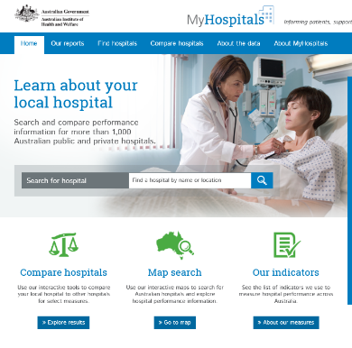The website enables users to:

* [Search for a hospital by state or postcode](https://www.myhospitals.gov.au/browse-hospitals)
* [View a hospital's profile and the services a hospital offers](https://www.myhospitals.gov.au/search/hospitals)
* [See how a hospital performs against health performance indicators](https://www.myhospitals.gov.au/search/hospitals)
* [See changes in results for a hospital over time](https://www.myhospitals.gov.au/search/hospitals)
* [Compare a hospital’s results with similar hospitals or peers](https://www.myhospitals.gov.au/compare-hospitals)
* [Download Hospital Performance reports](https://www.myhospitals.gov.au/our-reports).

While the MyHospitals website was intended to provide data from 17 indicators (based on the national Performance and Accountability Framework), only seven of these indicators currently have reporting capability. Of these indicators, the only safety and quality information available is related to health care associated infections and hand hygiene rates. This is made available for both public and private hospitals.

*Image: example of MyHospitals homepage. Source:* [*https://www.myhospitals.gov.au/*](https://www.myhospitals.gov.au/)*. Accessed 13/05/2018.*

## State and territory reporting on public hospitals

The environment scan found that most jurisdictions across Australia report healthcare quality and safety information, and it is evident that there is variance in the level of reporting and approach taken. It is noted that both Queensland and the Australian Capital Territory have recently undertaken reviews about public reporting of healthcare indicators in their jurisdictions. A high-level summary of findings is outlined in Table 2; a detailed outline of public reporting across jurisdictions is at Appendix A.

South Australia, Tasmania and Western Australia publish safety and quality information in annual reports. Western Australia also publishes a range of information and graphs for a number of indicators on their website at varying frequencies, enabling users to drill into the information. Both New South Wales and Victoria have a significant amount of safety and quality information reported publically, published by a number of various organisations, including independent health information agencies. The Northern Territory does not currently publish any quality and safety information.

**Table 2: Summary of public healthcare safety and quality information reported by Australian jurisdiction**

| Jurisdiction | Summary of findings | Information reported | Method & frequency of reporting |
| --- | --- | --- | --- |
| Australian Capital Territory  *ACT Health* | * ACT Health reports limited safety and quality information publically. * Recent comprehensive system-wide review of health data undertaken, including collection, analysis and reporting is being undertaken to inform future health data governance system requirements. * Information is best found using relevant ‘keyword’ searches. | * *staphylococcus aureus bacteraemia* (SAB) * Hand hygiene * Unplanned readmissions * Unplanned return to operating theatre within an episode of care | * PDF Performance Reports published quarterly. |
| New South Wales  *Bureau for Health Information (BHI)*  *Clinical Excellence Commission (CEC)* | * CEC publishes clinical incident information falls, patient identification pressure injuries and sentinel events, as well as the number and types of Root Cause Analyses (RCAs) undertaken and complaints received. * Information on the CEC website is relatively easy to retrieve. * The BHI publishes details on emergency department waiting times and transfer of care times as well as elective surgery waiting times, at a state-wide, Local Hospital District (LHD) / Specialty Health Network (SHN), and facility level. BHI also publishes patient-reported data gathered through various patient surveys. * BHI provides an interactive website to allow users to search for publicly reported data. | * Sentinel events * Patient falls * Pressure injuries * Complaints * Patient experience * Healthcare-associated Infection (HAI) * SAB | * PDF Performance reports are published bi-annually or annually (depending on lead Agency) * Interactive data based on the performance reports developed by the BHI available through the BHI’s online Health Observer portal. |
| Northern Territory  *Department of Health* | * No public safety and quality information published about the healthcare system. |  |  |
| Queensland  *Health* | * Limited public hospital performance information published. * Information that is publically reported relates to the activity of immunisation rates, emergency departments, elective surgery, hospital activity, specialist outpatient and patient experience. * The Queensland Government is currently considering options on how to progress public reporting of safety and quality information. An interactive website has been proposed; consultation underway during October 2018 to January 2019 to inform content. * Information is not prominent but can be found easily using a search for hospital performance. | * Patient experience (emergency department and maternity patient categories only) | * Results are presented in a table format at state-wide level. |
| South Australia  *SA Health* | * SA Health produces two key reports related to quality and safety: Patient Safety Annual Report and Measuring Consumer Experience Annual Report. * Information is best accessed through the clinical link on the department’s landing page. * SA Health also has a dashboard for major hospitals that is updated every 30 minutes on patient activity and waiting times. | * Patient experience * Sentinel events * Accreditation * HAI * Medication safety * Patient identification incidents * Blood transfusions * Pressure injuries * Patient falls * Hand hygiene | * PDF Reports are published annually. |
| Tasmania  *Department of Health and Human Services* | * Limited data reported publically on safety and quality. * Tasmanian Acute Public Hospitals Healthcare Associated Infection Surveillance Report is published publically every year. * A HealthStats dashboard provides current hospital performance information related to emergency department, elective surgery, outpatients, ambulance, mental health, breast screening and oral health data. No safety and quality performance metrics reported on the dashboard. * Information is best found with relevant ‘keyword’ searches. | * Central Line Associated Blood Stream Infection (CLABSI) - intensive care unit (ICU) * SAB * Clostridium difficile infection (CDI) Vancomycin-resistant enterococci (VRE) Hand hygiene | * PDF Reports are published quarterly and annually. |
| Victoria  *Department of Health and Human Services*  *Safer Care Victoria (SCV)*  *Victorian Agency for Health Information (VAHI)*  *Victorian Hospital Acquired Infection Surveillance System(VICNISS)* | * There are three organisations that report on and publish various reports on safety and quality. * Hospital performance reports relating to safety and quality measures are published by the Department of Health and Human Services quarterly on its performance website. * SCV is responsible for publishing the triennial report on sentinel events, perinatal services performance indicators and Victorian Quality Accounts. * VAHI has published an adult patient experience report and is working towards developing their public reporting work plan. * VICNISS publishes reports on health care-associated infections. * Information is not prominent and relevant ‘keyword’ searches are required to find it. | * Patient experience * Accreditation * Health worker immunisation rates * SAB * CDI * CLASBI (ICU) * Surgical site infection (SSI) * Apgar score <7 * Rate of severe fetal growth restriction * Sentinel events | * PDF reports are published annually (or on an ad hoc basis) depending on the lead agency. |
| Western Australia  *Department of Health* | * Health service and hospital level (where possible) performance reports are published at varying frequencies. * There are there are four core safety and quality areas of reporting: monitoring and reporting of hand hygiene, patient safety surveillance, healthcare infection surveillance and healthcare-associated SAB. * Reports on hand hygiene compliance rates and SAB are published regularly, represented in visual graphs. * A comprehensive annual report on patient safety is published annually. * Information is prominent. A link to performance can be found on the landing page. | * Accreditation * Sentinel events * Medical safety * Patient identification incidents * Clinical handover incidents * Blood transfusions * HAI * SAB * Methicillin-resistant *Staphylococcus aureus (*MRSA * CLASBI * CDI * VRE * Pressure injuries * Clinical deterioration incidents * Patient falls * Hand hygiene * Complaints | PDF reports are published annually (and depending on the topic, at various times).  Other performance information is presented in graphs. |

## Public reporting by private hospitals

### Background and context

In Australia, approximately 30% of the healthcare sector is comprised of private hospitals. They are mainly owned and managed by private organisations, either for-profit companies or not-for-profit non-government organisations. Some private facilities provide services on a day-only basis.

Private hospitals and day procedure centres primarily provide elective surgery, catering for patients who are treated by a doctor of their choice. Patients are charged fees for accommodation and other related health services provided by the provider. Private hospitals and day procedure centres operate under fee-for-service funding models that reward additional activity, which means that they are incentivised to maximise the number of people they treat.

Private hospitals must be licensed by the relevant state or territory health authority to operate. Free-standing day hospitals that are approved by the Commonwealth for the purposes of health insurance benefits must also be registered with their respective state/territory health authority. Each jurisdiction sets its own requirements under state/territory legislation on how they monitor and enforce patient safety and quality of care requirements in private healthcare organisations.

For example, in Victoria a condition of licencing requires each private hospital and day procedure centre to be accredited under the NSQHS Standards and assessed by a third party accreditation organisation. Failure to meet regulatory requirements, which may include detailed reporting of safety and quality information to the regulatory authority, may result in loss of licence to operate and potential closure of a hospital.

In addition, health funds are at liberty to choose which private hospitals they enter into a contractual agreement with to provide healthcare services to their privately insured members. Failure to satisfy the quality requirements of a major health funder resulting in the loss of a contract would have significant financial implications for a private hospital, threatening its ongoing viability.

These factors contribute to the decision by a number of private hospital organisations to publicly report on various patient safety outcomes, reporting on their own facility and/or group website or via the MyHospitals website. These reported outcome measures are aligned with the NSQHS Standards.

### Public reporting of safety and quality information by private healthcare organisations

The environment scan reviewed safety and quality information publically available online for 24 private healthcare organisations and five private health insurance providers in Australia.

The search found that that indicators reported publically varied, with larger private health organisations currently reporting on indicators covering most of the NSQHS Standards. The search also found that 19 of the 24 private health services reviewed as part of this scan reported some form of safety and quality information on their website. At a minimum, information was provided on accreditation and hand hygiene. However, it was noted that, with the exception of Mercy Health, all private hospitals that did not provide safety and quality performance information were specialised, for cancer care, vision surgery or endoscopy healthcare services only.

Larger private health service organisations currently publicly report on all or most of the following:

* Accreditation status
* Infection rates – SAB and CDI
* Hand hygiene
* Patient falls
* Unplanned readmissions within 28 days
* Unplanned returns to theatre
* Medication safety errors
* Blood transfusion outcomes
* Patients developing pressure injuries while in hospital
* Adverse transfusion events
* Patient satisfaction
* Rehabilitation outcomes – Functional Independence Measure
* Improvement in mental health – Health of the Nation Outcome Scales  (HoNOS) score
* Healthy Apgar score
* Emergency department waiting times (where applicable)

Generally, quality and safety information is presented graphically with individual hospital performance compared to a relevant industry benchmark and supported by explanatory text.

The intended audiences of these websites generally appeared to be patients, consumers and the general public, and for some websites, the intended audiences also included researchers and clinicians. The prominence of the available performance reporting varied, with some organisations providing information that was easily available from their homepage while other websites required searching and accessing multiple pages to find the relevant information.

A summary of the public reporting of safety and quality information reported by private healthcare organisations that was found as part of the search is at Table 3.

**Table 3: Summary of public reporting of safety and quality information by private healthcare organisations**

| Organisation | Stated purpose for reporting and prominence of information | Indicators reported |
| --- | --- | --- |
| Ramsay Health Care | * States it provides information about its performance, which reflects the quality and safety of its network of 46 hospitals. * States that one part of its program is to maintain and continually improve high standards. * Patients and clinicians are the primary audience. * Data are prominent to find and displayed in a consumer friendly way. * Explanations given as to how it is using the data for improvement. * Provides links to resources for clinicians (for example, hand hygiene interactive video training). | * Accreditation * Mental health * Rehabilitation outcomes * Infection rates * SAB * Hand hygiene * Patient falls * Pressure injuries * Blood transfusions * emergency department waiting times * Unplanned overnight stay * Unplanned admissions * Unplanned theatre return * Unplanned baby to ICU * Baby with Apgar score * Length of stay after childbirth |
| Healthscope Limited | * States it is committed to ongoing improvement of patient care in all areas. * States it has an excellent record in delivering quality patient care and managing risks, with continuing focus on improvements. * States it has a strong commitment to safety and quality that is reflected in its approach to: * Creating safe environments and systems of work for staff * Reviewing and improving on a continuous basis the performance of patient safety and quality systems * Assisting healthcare professionals and Visiting Medical Practitioners to monitor the safety and quality of care they provide * Ensuring accountability for the safety and quality of care at all levels of our organisation reporting through to the Board of Ramsay Health Care. * Information is for consumers and clinicians and is prominent. | * Accreditation * Mental health * Rehabilitation outcomes * Infection rates * SAB * CDI * Hand hygiene * Patient falls * Pressure injuries * Blood transfusions * Medication safety * Unplanned admissions * Unplanned theatre return * Baby with Apgar score * Patient satisfaction |
| St John Of God Health Care | * States that it actively benchmarks and shares quality, clinical risk and performance metrics as well as patient satisfaction results, so that consumers can rest assured that they are receiving the best possible care in a safe environment. * Information is for patients and semi-prominent to find. * Relevant information is best found by searching through homepage. | * Accreditation * Infection rates * SAB * Hand hygiene * Patient falls * Pressure injuries * Patient satisfaction |
| Cura Day Hospitals Group | * No information found. | Reference made to NSQHS Standards |
| Healthe Care | * States it has a strong commitment to safety and quality, which underpins everything that it does, creating safe environments and systems of work to support healthcare professionals to provide the safest possible care. * States this is achieved through a strong clinical governance framework. * Participates in the Australian Council for Healthcare Standards (ACHS) Clinical Indicators Program. * Describes the program and provides measures of the outcomes of patient care: twice yearly (1H (first half) and 2H (second half)), the ACHS provides each hospital with a report on their own indicator set, comparing the rate achieved for each individual indicator with the rate expected for that indicator. * States that are benchmarked against all public and private hospitals within its general peer groups. * Also participates in the Australian Private Hospitals Association’s (APHA) safety and quality indicator collection. The industry benchmark rates in the following graphs are sourced from the ACHS Clinical Indicator reports for audit periods 2H2012, 1H2013, 2H2013 and 1H2014, 2H2014 (latest data available). * Information is for clinicians and patients. * Information is not prominent best found by searching the webpage. | * Accreditation * Infection rates * SAB * Hand hygiene * Patient falls * Pressure injuries * Unplanned readmissions * Unplanned theatre return * Medication safety |
| Fresenius Medical Care Australia Pty Ltd | * States that clinics are committed to providing high quality, evidence-based care to patients. To ensure that it is constantly evaluating and improving practise, it monitors standards of care regularly. * One of its key commitments is to maintain an optimum level of hand hygiene, which is essential in preventing healthcare associated infections (HAI) and improving patient safety. * Information is for patients and not prominent to find. | * Hand hygiene |
| Calvary Health Care | * States purpose is to ensure that the communities Calvary serves have access to information about the quality of services provided. * Information is for patients and clinicians. * Information is semi-prominent to find. | * Accreditation * Infection rates * SAB * Hand hygiene * Patient falls * Medication safety |
| Marie Stopes International | * States it strives to provide the best care for patients. As part of its Quality and Safety program, it continually monitors known complications arising from procedures. * Information is not prominent and intended for patients and clinicians. | * Accreditation * Patient satisfaction * Complication rates (compared to international) |
| Epworth Foundation | * States it measures performance against national standards and, where no national standards exist, it sets its own (often set higher standards – don’t just want to provide good care, want to provide the best care). * Information is for patients and clinicians and semi-prominent to find. | * Accreditation * Patient satisfaction |
| Pulse Health | * No information found. | n/a |
| St Vincent's Health Australia | * States it wants every person to feel welcome, valued and safe when in its care. Like all Australian health services, it closely monitors performance on a wide range of safety indicators. * Information is prominent and for patients and clinicians. | * Overall rating of care * Patient recommendation * Hand hygiene * Infections * Pressure injuries * Falls (injury and death) * Medication error |
| Icon Cancer Care | * No information found. | Reference made to NSQHS Standards |
| Uniting Church In Australia Property Trust (Q) | * States that it provides information to help people make informed decisions about their care by publishing hospitals’ patient safety performance statistics on its websites. * States it is committed to regularly gathering and monitoring clinical and quality outcome and patient experience data. * Information is not prominent to find and is designed for patients and clinicians. | * Hand hygiene * Infections (HAI) * Pressure injuries * Falls (injury and death) * Emergency department waiting time |
| Vision Eye Institute | * No information found. | Reference made to NSQHS Standards |
| Independent Private Hospitals Of Australia | * States that its Quality Management Program in Essendon Private Hospital ensures continual improvement in the quality of its processes, products and services by having a fully implemented ISO9001:2008 Quality Management System. This system is audited annually by an accredited third party certification body. * States its philosophy of the Quality Management System is to emphasise the reaction to process variance, stakeholder process ownership, the importance of measurement, the role of the customer and the involvement of employees at all levels in the organisation in pursuit of such improvements. * States its certification also ensures ongoing compliance with The National Safety and Quality in Healthcare (NSQHS) Standards. * Information is for patients and not prominent – individual hospital websites need to be searched and only one hospital had information available. | * Falls * Pressure injuries * Hand hygiene |
| Mercy Health And Aged Care Central Queensland Limited | * No information found. | No |
| Montserrat Day Hospitals | * States to ensure compliance with evidence-based standards, an audit program for both clinical and non-clinical practices and processes is in place. * Information is for patients and is not prominent to find. | * Hand hygiene * Infection rates * Patient falls |
| Virtus Health | * Information is provided to help patients make an informed decision about their care. * States it is committed to sharing information about its quality and safety outcomes. These measures were selected because they form part of a set of key clinical indicators outlined in the NSQHS Standards.. * Information is for patients and not prominent – required campus level search. | * Hand hygiene * Infection rates * Patient falls * Pressure injuries |
| Affinity Group Ltd | n/a | n/a |
| Cabrini Health Limited | * States that quality and safety is paramount at Cabrini. A culture of quality improvement requires strong governance. * Cabrini’s clinical governance structure includes its Patient Experience and Clinical Governance Board Committee and a range of risk committees. Its planned approach is continuous quality improvement, involving reviewing and improving each stage of the patient journey and includes audit, feedback, service redesign activities and innovation. * States that quality improvement approach ensures ongoing development of strategies and measures to enhance safety for patients and residents, minimise risk and optimise service quality. * Information is for patients and clinicians and prominent to find. | * Pressure injuries * Falls * Blood transfusion * Infection control * SAB * Unplanned admission ICU * Medication safety * % patients with multi-disciplinary discharge plan following rehabilitation * Rehabilitation PROMs |
| Diaverum Pty Ltd | * No information found. | n/a |
| Evolution Healthcare | * States that Waratah Private Hospital is committed to continuous quality improvement to ensure the safe and effective delivery of care and services to its patients. * States it assesses its level of performance for a range of patient quality and safety indicators in relation to established national and industry standards. * Information is for patients and not prominent to find – campus level search required. | * Pressure injuries * Falls * Blood transfusion * Infection control * SAB * Unplanned theatre return * Patient satisfaction |
| Mater Misericordiae Ltd | * Has a SafeQuest portal for data. * States it is fortunate to have an excellent safety record for staff, patients and visitors. * States it is committed to exceptional care, and has commenced an organisational-wide program to change the way they approach safety in health care. * Information is located on a portal – prominent to find and designed for patients, clinicians and researcher. | * Accreditation * Emergency care * Falls prevention * Infection control * Medication safety * Pressure injury safety * Rehabilitation |
| Melbourne Endoscopy Group | * No information found. | Reference made to NSQHS Standards |
| Bupa | * No information found. | No |
| HBF Health Fund | * No information found. | No |
| HCF Health Insurance | * States it collects information from the [myhospitals.gov.au](http://www.myhospitals.gov.au/) website on two key performance indicators: hand hygiene and health care-associated *Staphylococcus aureus* bloodstream infections (commonly known as Golden Staph). * Provides information on hand hygiene; states that health providers washing and sterilising their hands is a critical step in reducing the risk of hospital-acquired infection. The national benchmark is for healthcare workers to clean their hands correctly in at least 80% of cases. * Provides information on *Staphylococcus aureus*bloodstream infections * Information is for consumers and not prominent to find. | * Infection control * Hand hygiene |
| Medibank | * No information found. | No |
| NIB | * No information found. | No |

## Non-government public reporting mechanisms in Australia

### Health Roundtable

### The Health Roundtable was established in 1995 as a non-for-profit membership organisation. Currently, the membership is made up of 90 health services, 177 hospitals and over 4,000 users across Australia and New Zealand. Its purpose is to:[67]

* Provide opportunities for health executives to learn how to achieve Best Practice in their organisations
* Collects, analyses and makes information available to members comparing organisations and identifying ways to improve operational practices; and
* Promote interstate and international collaboration and networking amongst health organisation executives.

The Health Roundtable provides members with a range of opportunities and information to support best practice and improvements in health care. The Health Roundtable also has a number of sub-committees that focus on specific aspects of healthcare improvements. Of these, there is a patient safety improvement group that meets annually to share ideas and innovations that focus on improving the safety and quality of care within their health services. During the meetings, members also review results from the patient safety report, which has a range of indicators that health services provide data for every six months. Members can log into the portal and access various health performance data. However, while there is some contextual information about the work of the organisation, no safety and quality information is reported publically through its website.

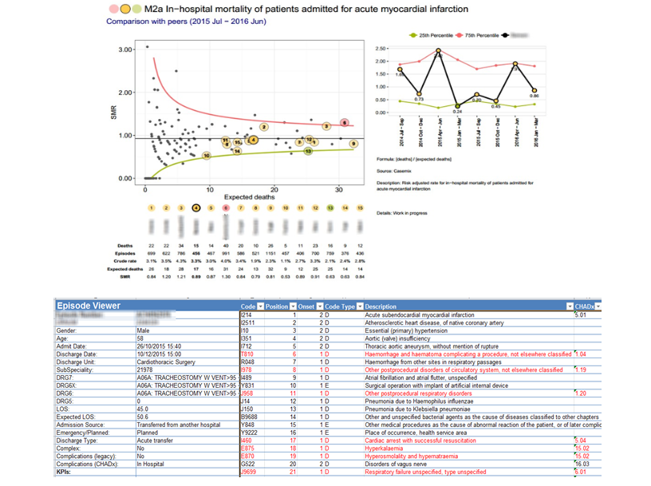

*Image: an example of reporting accessible to members on the Health Roundtable website. Source:* [*https://www.healthroundtable.org/JoinUs/ImprovementGroups/PatientSafety.aspx*](https://www.healthroundtable.org/JoinUs/ImprovementGroups/PatientSafety.aspx)*.*

### Patient Opinion

Patient Opinion, originally founded in the United Kingdom, was established as an independent, non-for-profit organisation in Australia in 2012. It is a consumer friendly feedback platform between patients and health services that enables patients to post about their recent experiences and stories about a health service in the public domain. The concept behind this is that each story is an opportunity to learn and improve.

So far, a total of 4,816 stories have been shared. The website indicates that there was an 82% response rate to all stories reported in the previous 90 days. The website also shows the percentage of responses where the response indicates that a change is planned or has been made, noting that a change might not need to be made for every story, for example where stories are entirely positive. Healthcare services can become subscribers to get access to feedback about their hospitals. To date, there are 2,161 healthcare professionals registered to the website.[68]

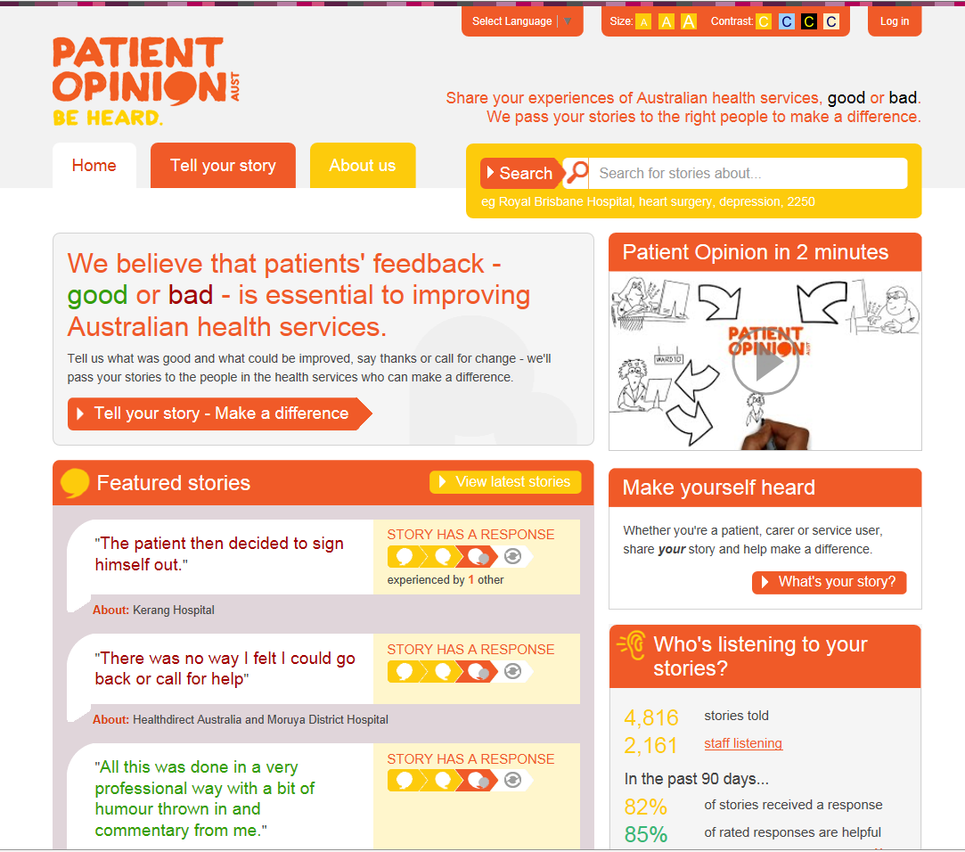

*Image: Patient Opinion Australia homepage, with featured stories and a summary of number of stories told and healthcare staff registered for the website. Source:* [*https://www.patientopinion.org.au/*](https://www.patientopinion.org.au/)*. Accessed online: 24/01/2019.*

### Whitecoat

Whitecoat is a website that was established in 2013 to provide the public with a comprehensive online healthcare provider directory and customer reviews. There are over 210,000 healthcare providers listed on Whitecoat and over four million people have visited the website since it was launched. The website has received over 250,000 reviews to date.

The purpose of the website is to allow all Australians to search and compare healthcare providers and allow them to make better and more informed choices when selecting healthcare providers. The website states that it is particularly useful for people who have moved to a new area or need treatment for a specialist service for the first time, as well as those wanting a recommendation from patients who have already visited a healthcare provider.

Consumers can use the website to search by healthcare provider type and major city. Consumers are able to locate a healthcare provider in their local area, read or make a review or even make an appointment to see the provider. However, the website does not provide any information about safety and quality outcomes for the providers listed.

**Finding summary**

Within Australia, there is a broad patchwork of public reporting systems at state/territory and national levels. The national portal for public reporting information (MyHospitals) arguably contains the least amount of information (with seven out of the proposed 16 performance indicators currently reported), amongst all of the public reporting portals currently available in Australia.

Across the Australian states/territories, NSW and (more recently), Victoria, have the most extensive public reporting mechanisms. Other jurisdictions, such as Queensland, are actively seeking to move toward more public reporting of safety and quality data. Websites in Australia varied in terms of patient accessibility. The portal provided by the NSW BHI was the most similar for usability to international portals.

For the private hospital sector, participation in the national public reporting mechanism (MyHospitals), while voluntary, is relatively high. In addition the majority of the private hospital providers identified through the environment scan provided information on performance against safety and quality indicators on their own websites. However this information is not always easy to locate on these websites. In Australia, there are also a number of non-government public reporting mechanisms in place through which health consumers can write reviews of their experiences with healthcare organisations and providers. This type of patient review information is not available through any of the national and jurisdictional public reporting mechanisms.

## International examples of public reporting

The environment scan searched for public reporting of safety and quality across three specific OECD countries: Canada, the Netherlands and the USA. These countries were selected because they have a federated model that is comparable to the Australian healthcare system. They were also considered to be significantly advanced in the undertaking of public reporting of hospital outcomes. In particular, both the USA and the Netherlands have made significant strides in developing public reporting systems that ae more specifically geared to health consumers.

### Canada

Health Canada is the federal government portfolio that is responsible for setting the national health agenda, ensuring the delivery of safe and high-quality health services and providing financial support to provinces and territories for the delivery of health care. Canada’s ten provinces and three territories are responsible for establishing, maintaining and administering hospitals and delivering high-quality safe health care.[69] As such, each province and territory has its own provincial / territory government and health department that oversees this role.

The Canadian Institute for Health Information (CIHI) was established in 1994 by Health Canada as an independent, non-for-profit organisation to provide centralised, consistent, un-biased and comparable health system information across Canada. CIHI produces a broad range of health system information, measurements and standards, and evidence-based reports and analyses to accelerate improvements in health care and health system performance.[70]

The CIHI website provides a large amount of health care performance information and interactive reporting tools categorised by themes, such as health system performance, patient outcomes, patient experience, quality and safety and international comparisons, amongst other important topics. Patients, consumers and healthcare professionals are able to view health care performance information via *Your Health System: Insight.* Thisis an interactive online tool that enables users to explore and understand health care activity and performance at an organisational, health region or province/territory level. Performance is compared to the Canadian average score. Data are provided for an annual period (aligned to an Australian financial year). However, data for some indicators appear to be lagged by a year or in some cases, two years. Safety and quality indicators reported include:[71]

* In hospital sepsis (rate per 1,000)
* Obstetric trauma (with instrument)
* Potentially inappropriate medication prescribed to seniors
* Falls in the last 30 days in long-term care
* Worsened pressure ulcer in long-term care
* Readmissions within 30 days of discharge
* Hospital standardised mortality ratio
* Repeat hospital stays for mental illness (at least 3 stays per year)
* Potentially inappropriate use of antipsychotics in long-term care

The Canadian Patient Safety Institute (CPSI) was established by Health Canada in 2003 as an independent national body. CPSI works with governments, health organisations, leaders and healthcare providers to improve patient safety across the healthcare system. The four priority areas of focus are informed by the work of CIHI and include: medication safety; surgical safety; infection control; and home care safety.[72] While CIPI does not publish safety and quality information per se, it does provide progress reports on actions taken to improve patient safety across the nation.

There was great variation observed in safety and quality information reported by province and territory Health Ministries. The Province of British Columbia Ministry of Health and The Health and Social Services System in Quebec do not appear to publically report any safety and quality measures. However, the Ontario Ministry of Health and Long-term Care implemented public reporting of patient safety indicator results in 2012 as part of their initiative to strengthen patient safety its province.[73] The indicators and frequency for reporting are outlined in table 4.

**Table 4: Ontario Ministry of Health and long-term care patient safety indicator reporting**

|  |  |  |
| --- | --- | --- |
| Patient Safety Indicator | Date of initial Public Reporting | Reporting Frequency |
| *Clostridium difficile* Infection (CDI) rate | 26 Sept. 2008 | Monthly |
| Methicillin-resistant *Staphylococcus aureus* (MRSA) rate | 30 Dec. 2008 | Quarterly in January, April, July and October |
| Vancomycin-resistant *Enterococci* (VRE) rate | 30 Dec. 2008 | Quarterly in January, April, July and October |
| Hospital-Standardized Mortality Ratio (HSMR) | 30 Dec. 2008 | Annually in December |
| Ventilator-Associated Pneumonia (VAP) rate | 30 April 2009 | Quarterly in January, April, July and October |
| Central Line-Associated Primary Blood Stream Infection (CLI) rate | 30 April 2009 | Quarterly in January, April, July and October |
| Surgical Site Infection (SSI) prevention rate in hip and knee joint replacement surgeries | 30 April 2009 | Quarterly in January, April, July and October |
| Hand Hygiene Compliance | 30 April 2009 | Annually in April |
| Surgical Safety Checklist (SSC) compliance | 30 July 2010 | Bi-annually in January and July |

*Source:* [*http://www.health.gov.on.ca/en/public/programs/patient_safety/*](http://www.health.gov.on.ca/en/public/programs/patient_safety/) *(26/04/2018)*

### The Netherlands

In the Netherlands, oversight for quality in health care sits with the Healthcare Inspectorate (IGZ) and the Dutch Healthcare Authority (NZA). IGZ monitors the quality, safety and accessibility of health care. The Inspectorate is an impartial, expert organisation that also safeguards the rights of patients. NZA monitors the conduct of care providers and insurance companies. Once a year, all Dutch hospitals are required to submit a mandatory set of quality indicators, including process and outcomes measures to the NZA.[74]

There are two national programs that provide patients with information about provider performance. Both involve the development of indicators at a national level. Participation is mandatory for providers.

The first, Zichtbare Zorg (‘Transparent care’), was established in 2007 and is operated through the IGZ. It publishes data online that covers hospitals, general practice, maternity care, oral health, physiotherapy, chronic care, as well as pharmaceutical care, mental health, disabled care and nursing care and home care. The program has 80 indicators linked to hospital care covering process, structural and outcome measures. Although the database is owned by Zichtbare Zorg, primary data remain the property of providers who are responsible for ensuring overall data quality.

The second, KiesBeter (‘Choose better’), is a publicly available health portal published by the National Institute of Public Health and the Environment (RIVM). It uses a finite set of indicators (which includes the use of star ratings) to assess the quality, accessibility and affordability of the Dutch healthcare system. The website offers general information on hospital facilities, availability of services and specialities, waiting times, and a range of quality indicators. Results are compared internationally.[75]

Recognising the need to make accessible and understandable data available for public use and thereby support consumer decision-making, in 2014 the Dutch Hospital Association launched the Quality Window program. A set of 10 indicators were co-developed with health consumers and are reported annually by hospitals through a public portal. These indicators cover areas such as medicine reconciliation in hospital, standardised mortality ratios, staff satisfaction, complaints, infection control and patient experience. The indicators are published via an online platform. Indicators are accompanied by an explanation on what they mean and hospitals that report also often include information on actions they are taking to improve their performance against the indicators.[76]

On its website, the Ministry of Health, Welfare and Sport publishes infographics on patients’ experiences and health expenditure in the Netherlands. Annual reports on Dutch Health Care Performance are also published for years 2006 to 2014. The 2010 annual report stated that suitable information about quality of care and about patient outcomes in particular, was lacking.[77] There are no further reports on their website to indicate what public reporting has been implemented since this publication.

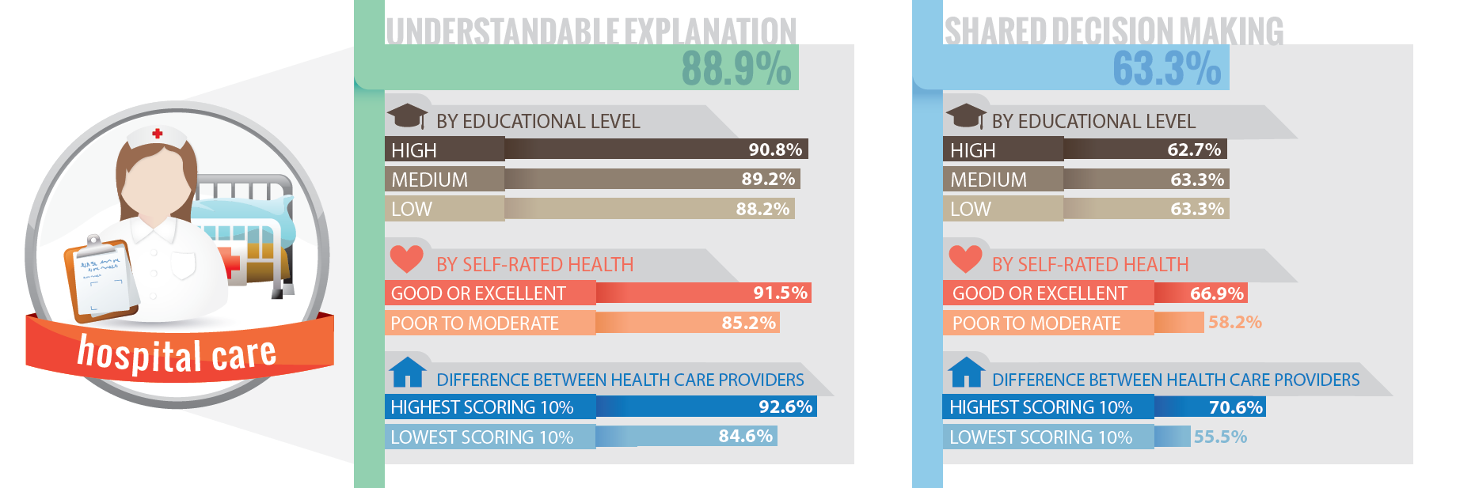Image: an infographic of patients’ experiences (2007-2010) from the Netherlands’ Ministry of Health, Welfare and Sport. Source: Health and Youth Care Inspectorate, Ministry of Health, Welfare and Sport. Source: <https://www.gezondheidszorgbalans.nl/dsresource?type=pdf&disposition=inline&objectid=rivmp:258320&versionid=&subobjectname>= Accessed online 1/05/2018.

### United States of America

The healthcare system in the USA is highly complex and has extensive regulation at both federal and state level. Within this system, the federal government has devolved primary responsibility for the oversight of licensing of healthcare providers. As part of the USA Department of Health and Human Services performance monitoring initiatives, health care measures aligned to national quality and prevention strategies are meant to be publicly available on a dashboard called ‘the Health System Measurement Project’. However, this dashboard was not accessible during the search.[78]

Insights from the search suggest that much of the oversight of the USA healthcare system occurs through a self-policing approach by providers. Many healthcare organisations participate voluntarily in the inspection, accreditation and certification process by the Joint Commission on Accreditation of Hospital Organisations as well as other independent hospital performance monitoring overseers. There are multiple healthcare performance reporting organisations that capture, analyse, publically report on and compare hospitals for a range of healthcare indicators, such as sentinel events, infection control, and medical errors.

In 2010, the Patient Protection and Affordable Care Act (also known as ‘Obamacare’) was introduced that had a number of safety and quality initiatives targeted at reducing healthcare costs and improving quality. Quality and safety initiatives have been implemented to discourage hospital-acquired conditions and reduce hospital-acquired infections. Initiatives and incentives were tied to hospital performance and changes were made to the Medicare payment scheme, whereby hospitals are penalised for higher than expected readmission rates.

##### Medicare.gov

The official USA Government website for all information related to hospitals that receive Medicare funding is Medicare.gov: Hospital Compare. Hospital Compare has information about the quality of care at over 4,000 Medicare-certified hospitals, including over 130 Veterans Administration medical centres, across the country. Its website provides a number of interactive datasets and downloadable databases. Users are able to compare hospitals based on their overall ‘star’ rating and may also compare doctors. There are Medicare data for 57 healthcare measures across seven categories, such as mortality, safety of care, readmission and patient experience. Within the safety of care category, data are provided for the following measures:[79]

* Central line-associated bloodstream infections (CLABSI)
* Catheter-associated urinary tract infections (CAUTI)
* Surgical site infections from colon surgery (SSI: Colon)
* Surgical site infections from abdominal hysterectomy (SSI: Hysterectomy)
* Methicillin-resistant Staphylococcus Aureus (MRSA) Blood Laboratory-identified Events (Bloodstream infections)
* *Clostridium difficile* (CDI) Laboratory-identified Events (Intestinal infections)
* Rate of unplanned readmission after discharge from hospital (hospital-wide)

##### Agency for Healthcare Research and Quality

The Agency for Healthcare Research and Quality (AHRQ) is the lead federal agency responsible for improving the safety and quality of America's healthcare system. It also develops knowledge, tools and data needed to improve the healthcare system and help Americans, healthcare professionals, and policymakers make informed health decisions. AHRQ stated collected healthcare data in 1988 and holds the largest repository of hospital care data in America. It is estimated that data are collected for 97% of patients discharged from hospitals that participate in the federal-state-industry partnership across 40 different states.[80]

On the website, there are four categories of quality indicators: prevention quality indicators; inpatient quality indicators; patient safety indicators; and paediatric quality indicators. Healthcare providers can download a free software package to implement monitoring and reporting against these standardised quality indicators from the AHRQ website. This encourages a standardised and evidence-based performance monitoring framework across America.[81]

The AHRQ reports on a range of patient safety and quality indicators, including sentinel events. The most recent report uses data from 2013, which is presented as an observed rate per 1,000 patients. Patient safety indicators reported include:[82]

* Pressure ulcer rate
* Central venous catheter-related blood stream infection rate
* Postoperative sepsis rate
* Transfusion reaction count.

##### The Leapfrog Group

The Leapfrog Group was established in 2002 as a national non-for-profit organisation and watchdog for quality and safety across the American healthcare system. Its purpose is to provide hospital transparency to ensure consumers have the necessary information they need to make informed decisions about their health care. Currently, the Leapfrog Group has a regional partnership with 38 states and reports data for over 1,800 hospitals[83].

The Leapfrog Group provides consumers with easily accessible information about patient safety, breaking down the meaning of hospital errors, accidents, injuries and infections and the importance of making the choice on safety, in a manner that is easy to comprehend.

The Leapfrog Hospital Safety Grade (formerly known as the Hospital Safety Scores) also scores general acute-care hospitals on their patient safety performance against the ‘gold standard’, similarly to a student’s school report card. It enables consumers to compare hospitals by performance at a state level. The safety grade is based on 27 national performance measures including process/structural measures and outcome measures. The safety and quality measures reported include:[84]

* Hand hygiene
* Foreign object retained
* Pressure ulcer rate
* Falls and trauma
* CLABSI
* SSI (Colon).

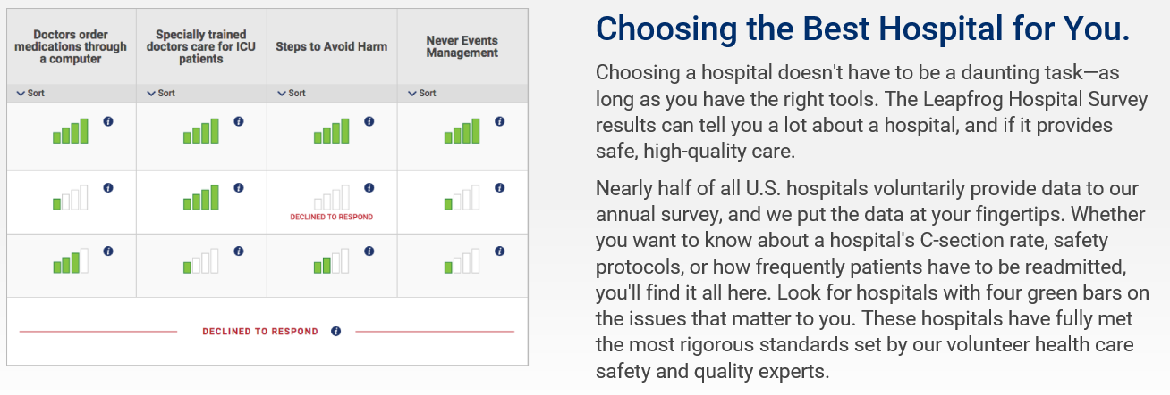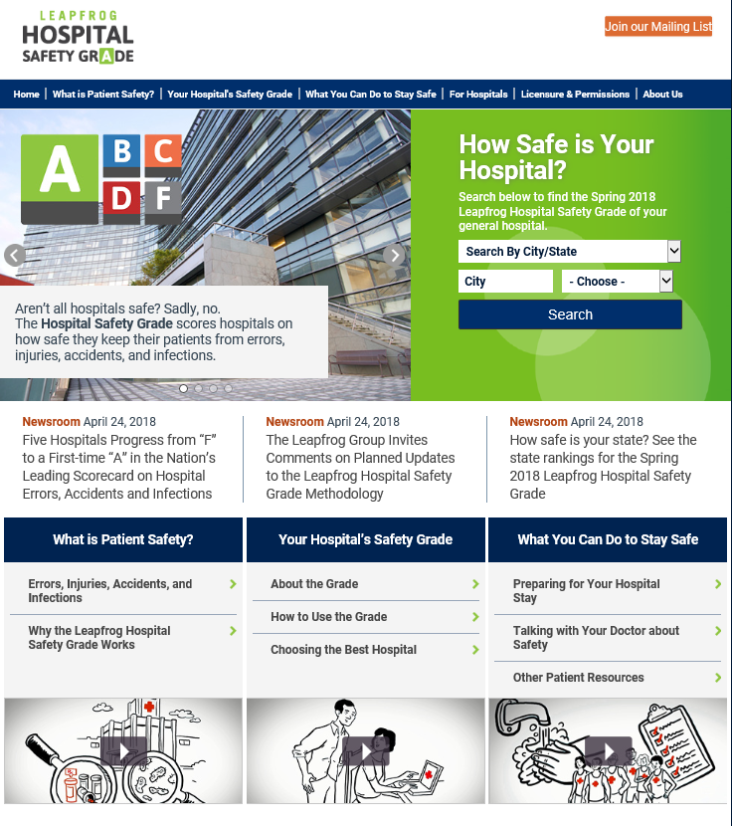

*Image: example of the Leapfrog Hospital Safety Grade. Source:* [*http://www.hospitalsafetygrade.org/your-hospitals-safety-grade/about-the-grade*](http://www.hospitalsafetygrade.org/your-hospitals-safety-grade/about-the-grade)*. Accessed 30/04/2018.*

The Leapfrog Group produces hospital performance reports and competitive benchmarking reports. The reports are produced twice a year and designed to help hospitals present their survey results in an easy-to-understand format to engage multiple stakeholder groups, including medical staff, administrators, consumers, front-line caregivers, and boards of directors. An example of consumer-friendly presentation of public reporting information by Leapfrog is provided below.

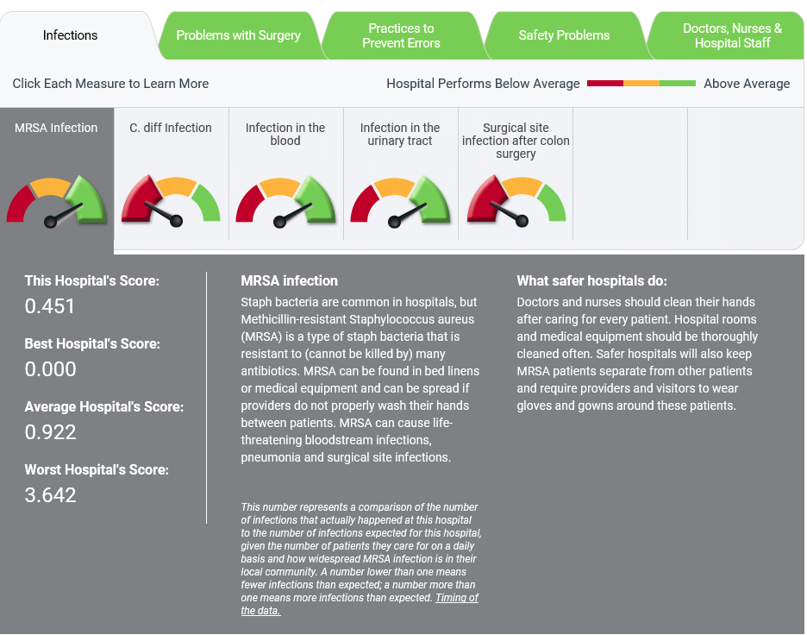

*Image: example of consumer-friendly presentation of public reporting by Leapfrog from its website. Source:* [*http://www.leapfroggroup.org/compare-hospitals*](http://www.leapfroggroup.org/compare-hospitals)*. Accessed 15/05/2018*.

In addition to summarising performance on over 20 national measures of safety, quality, and efficiency, the reports can also be used to highlight areas of excellence and identify areas for improvement. All reports are supplemented by explanatory notes.[85]

##### The Joint Commission

The Joint Commission was established in 1951 as a national non-for-profit organisation to set safety and quality standards and act as an independent accrediting body. Currently, there are 21,000 healthcare organisations in America that are accredited/certified by the Joint Commission. Accreditation/certification is voluntary and occurs every 39 months. Safety standards within the scheme relate to sentinel events, infection control and blood transfusions.

The Joint Commission has a ‘Quality Check’ website that allows stakeholders to view the accreditation and certification status of its member healthcare organisations. Healthcare organisations flagged with performance improvement opportunities are identified on this website, with a high level description of the issues. This information is updated when the organisation provides evidence or corrective actions. Only those organisations with a status of Contingent Accreditation, Preliminary Denial of Accreditation, or Denial of Accreditation have items that are out-of-compliance listed.[86]

The Joint Commission also prepares public reports on the safety and quality of care for all of their accredited and certified healthcare organisations. Quality reports include:

* Accreditation decision and date
* Programs and services accredited by the Joint Commission and other bodies
* National Patient Safety Goal performance
* Hospital National Quality Improvement Goal performance
* Special quality awards.

##### Kaiser Permanente

Kaiser Permanente) was established in 1945 as a not-for-profit organisation that is recognised as a leading healthcare provider. Kaiser Permanente has a long history of conducting research addressing healthcare policy and quality and has contributed to a number of independent reports on quality of care and services. It has also publishes safety and quality information on its website to inform clinical decision-making and initiatives for innovation, quality, safety, and value in health care.[87]

Kaiser Permanente considers the strongest quality incentive is the performance data it shares with physicians. Performance data allow clinicians to directly examine the results of their actions and to identify ways in which they can further improve patient care. As such, Kaiser Permanente has implemented a process by which physicians agree on the targets to achieve and the metrics that will be monitored. This process is periodically repeated to ensure that the treatment approaches remain up to date.

Performance data are supported by a strong IT system. When a patient registers at a Kaiser Permanente hospital or physician office, ‘care recommendations’ for the patient, such as a notification that the patient has not picked up prescriptions, are displayed on the screen. The system also automatically gives physicians and staff specific quality indicators such as what percentage of patients with diabetes or cardiovascular disease are not at the target level for lipid control.

Other tools such as ‘backsweep’ reports identify when recommended care (the agreed care pathway) is not provided, then tags it back to the specific physician and assistant, and asks that follow-up with the patient be done. A ‘re-sweep’ report 30 days later is also performed to make sure the care was provided while a ‘forward sweep’ report makes it easier to consider preventive care in an upcoming appointment.

**Findings summary**

Data provided at the national level by the three OECD countries included in the review (Canada, Netherlands and the US) were more comprehensive, but also more variable, than the level of data reported at the national level in Australia (via MyHospitals).

Canada, which is most similar in health system structure to Australia of all of the countries included in the review, has a particularly extensive national public reporting mechanism currently in place.

The Netherlands and the US have good examples of public reporting that is specifically targeted at consumers with supportive context information and outlines of actions being undertaken by hospitals to drive improvements in their performance; for example, through the Quality Window program and the Leapfrog Hospital Safety Grade program.

The information presented in Canada and in the US (through the Leapfrog Group) were good examples of more consumer-friendly presentation of public reporting data. These portals used interactive tools and clear explanations to present the data.

1. : Detailed outline of public reporting across jurisdictions
   1. Australian Capital Territory

Australian Capital Territory Health (ACT Health) reported on its comprehensive system-wide review of health data in August 2018. The review presented findings and recommendations for domains including data management, governance and security and privacy. ACT Health notes that the review has been instrumental to reset and enable effective data management practices and bring a definitive Performance, Reporting and Data Management Strategy that will transition ACT Health to a best practice data and reporting agency. 88

ACT Health currently reports limited safety and quality information publically. The ACT Public Health Services Quarterly Performance Report compares hospital performance against existing targets. The Quality and Safety section of the report encompasses indicators such as the hospital-acquired *staphylococcus aureus bacteraemia* (SAB) infection rate and hand hygiene audit results, consistent with the information that is reported nationally on the MyHospitals website. ACT Health does not report adverse clinical incidents and sentinel events publically.66

ACT Health discontinued its report on targets implemented through the *National Health Reform Agreement (NHRA); Improving Public Hospitals* in the 2014‑15 Quarterly Report following the Federal Government’s decision, announced in the 2014‑15 Federal Budget, to remove associated incentives.[88]

* 1. New South Wales

A.2.1 New South Wales Ministry of Health

In 2004 the New South Wales (NSW) Department of Health (now Ministry of Health) established the Patient Safety and Clinical Quality Program (PSCQP), in the wake of the Walker Inquiry into a number of clinical incidents in south-western Sydney.

The NSW Ministry of Health retains statutory and policy responsibility for patient safety and clinical quality within the NSW public health system under the PSCQP, while the local hospital districts (LHDs) and specialty health networks (SHNs) are responsible for the quality and safety of the services provided by their facilities, staff and contractors.

A.2.2 Clinical Excellence Commission

The PSCQP reform led to the establishment of the Clinical Excellence Commission (CEC) as a statutory health corporation (an evolution of the Institute for Clinical Excellence). As a lead agency for safety and quality improvement in the NSW public health system, the CEC has a key role to play in analysing and reporting on the information reported by frontline staff in the NSW clinical incident management system. The CEC also publishes the outcomes from projects and programs developed in response to clinical incident reporting.

The CEC has been regularly publishing clinical incident information in the public domain since its inception and NSW was the first jurisdiction to publicly report clinical incident data (in 2005). Information was originally reported in PDF format; in 2013 the CEC published its first web-based clinical incident management report, which contained bi-annual data summaries (Jan-Jun, Jul-Dec) at a state-wide level. This includes details on incidents (at a state-wide level) relating to falls, patient identification pressure injuries and sentinel events, as well as the number and types of Root Cause Analyses (RCAs) undertaken and complaints received. Examples of reporting on these indicators from the NSW CEC website are provided below.

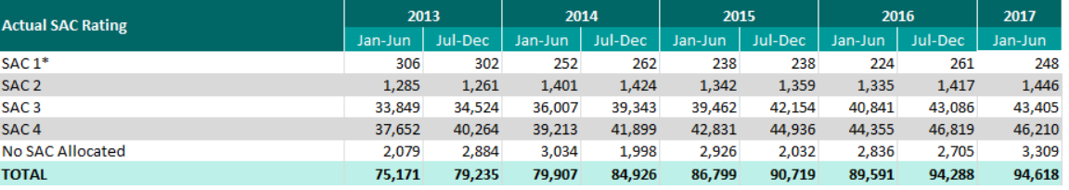

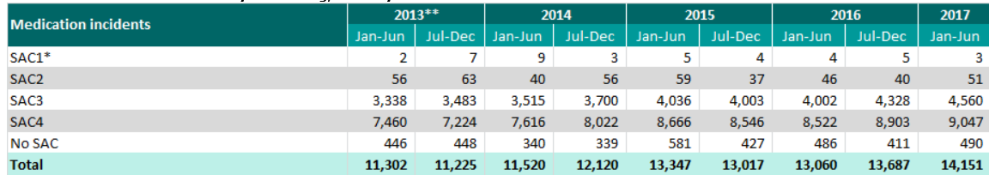

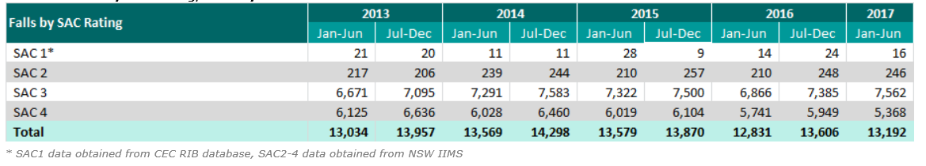

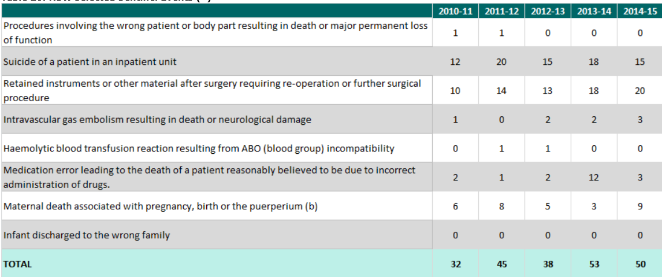

*Images: examples of indicator reporting on the NSW CEC website. Source:* [*http://www.cec.health.nsw.gov.au/*](http://www.cec.health.nsw.gov.au/)*. Accessed 20 April 2018.*

A.2.3. Bureau of Health Information

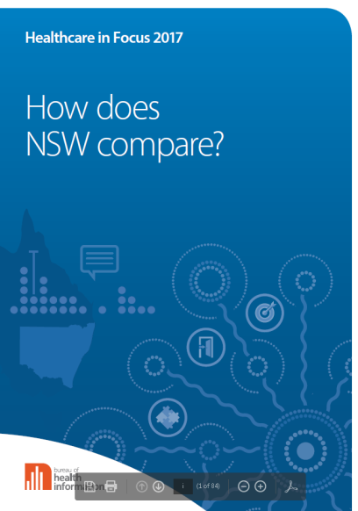The Bureau of Health Information (BHI) was established by the NSW Government in 2009 as an independent, board-governed statutory authority following the Garling Special Commission of Inquiry into Acute Care Services in NSW Public Hospitals. BHI is responsible for reporting on the performance of the health system in NSW. This includes details on emergency department waiting times and transfer of care times as well as elective surgery waiting times (at a state-wide, LHD/SHN and facility level). BHI also publishes patient-reported data gathered through various patient surveys, for example, outpatient surveys and admitted children and young patients surveys.

BHI releases a consolidated yearly report series, *Healthcare in Focus – How does NSW compare?*, using 140 indicators across six dimensions of performance: accessibility; appropriateness; effectiveness; efficiency; equity; and sustainability. The report places NSW results, where possible, in an international or national context. The reports are used to inform efforts to improve patient care and wellbeing as well as strengthen healthcare policy in NSW.[89]

*Image: BHI ‘How does NSW compare?’ report, 2017.*

The reports include data from indicators such as treatment waiting times, medication management, emergency department re-presentations, ambulance care outcomes, hospital infections (*Staphylococcus aureus* bacteraemia), post-surgical complication rates, falls, mental health readmissions and patient safety data (related to the data also published by the NSW CEC and detailed above).

BHI is the only established Australian partner in The Commonwealth Fund International Health Policy Survey that seeks information about health care access, cost and quality from patients around the world. Results are used to provide a comparison of the NSW healthcare system with Australia and 10 other countries[90]. Northern Territory

The Northern Territory Department of Health does not provide any information on hospital performance, safety and quality in health care or patient experience information on its website. The department’s website does provide consumers with an option to make a complaint or suggestion or ask a question on behalf of the Top End Health Service and the Central Australian Health Service as a mechanism to improve the NT health services. It is not stated how this information is used.[91]

* 1. Queensland

According to the Queensland Department of Health *Strategic Plan 2016-2020*, Queensland Department of Health has a key role in supporting and monitoring safety and quality across the healthcare system. M*y health, Queensland’s future: Advancing health 2026* builds on the strategic plan and describes a vision and 10 year strategy for a world class health system, aiming for continuous improvement, transparency and accountability. Future effort focuses on improving equitable access to quality and safe health care and increasing availability of electronic health data to consumers.[92]

Currently, Queensland Department of Health provides hospital performance information to the public through its Hospital Performance website. Activity and performance information relates to immunisation rates, emergency department attendances, elective surgery operations, hospital admission activity, percentage of patients waiting within the clinically recommended waiting times for specialist outpatient and patient experience for emergency department and maternity patient categories. Data can be viewed at a state-wide, regional or hospital level. In addition, the department’s Statistical Services Branch has developed a series of interactive data dashboards. No information is provided for specific safety and quality indicators on these sites although the Health Performance website provides links to the MyHospitals sites from which hospital level information on hand hygiene and SAB infection rates for Queensland public hospitals can be accessed, [93]

The annual report published by the Clinical Excellence Division provides a high level overview of safety and quality initiatives implemented in the 2016-2017 financial year. A new suite of patient safety and quality indicators and reporting for hospital-acquired complications, maternity and paediatrics were introduced in 2017 to support monitoring of patient safety and quality. The report also presented data as an infographic for pressure injuries, showing the reduction in activity as a percentage between 2003 and 2016.[94]

In 2017, Queensland Department of Health released the *Expanding healthcare quality and patient safety reporting across Queensland’s health system* discussion paper as the first step towards better understanding views on the collection, use and public reporting of safety and quality information. Responses were received from a wide range of stakeholders. Of the 135 responses, 99% of respondents supported a consistent approach to reporting across public and private healthcare organisations.[95] The Queensland Government is currently considering options for progressing public reporting across the state.

In August 2018, it was announced that an interactive website would be launched to enable the public to compare public and private hospitals on a range of information for Queensland. During October 2018 to January 2019, Queensland Department of Health has undertaken further consultation with a range of stakeholders. This consultation aimed to seek input into the type of content that would be presented on the proposed website.[96]

* 1. South Australia

The South Australian (SA) Department of Health and Ageing aligns its safety and quality programs, frameworks and reporting with the NSQHS Standards.

SA Department of Health and Ageing produces two key reports related to quality and safety: Patient Safety Annual Report and Measuring Consumer Experience Annual Report. While the Patient Safety Report has been published since 2004, only the latest two editions are available online. Five editions of the Measuring Consumer Experience Report are available online.[97] These reports are supported by a suite of materials including short community reports, factsheets and infographics. The SA Department of Health and Ageing Annual Report also has a chapter on safety and quality and its focus is primarily on how the state is responding to this agenda.

The Patient Safety Report reports contain detail on the number of clinical incidents and sentinel events, compliance with accreditation, as well as consumer feedback (complaints), healthcare-associated infections, medication incidents, patient identification incidents, incidents relating to transfusion of blood and blood products, pressure injuries, falls, and hand hygiene. Findings from the Measuring Consumer Experience Annual Report are also incorporated into the Patient Safety Report. Data is reported at a state-wide aggregate, and compared to other jurisdictions. Data are benchmarked against national standards and targets. SA Department of Health and Ageing also compares hand hygiene compliance to the state target. Quantitative analysis is supported by detailed information on the programs, initiatives, and actions being undertaken to learn from, and prevent future occurrences of patient harm.[98]

In addition to these public reports, SA Department of Health and Ageing has a public *Our hospital dashboard,* which provides performance information on four dashboards including: Ambulance Service, Emergency Department, In Patient and Elective Surgery across the state’s major hospitals. Information on the dashboards is updated every 30 minutes by the hospitals. Data are presented for all major metropolitan and country hospitals and three years of data are compared.[99] While these dashboards assist hospitals to monitor and manage their patient activity and provide the public with information about waiting times, no information related to safety and quality is reported on them.

* 1. Tasmania

The Tasmanian Department of Health and Human Services reports limited data on healthcare-associated infection surveillance. Data has been reported publically since 2009. Reports are published quarterly, with an annual report at the end of each financial year. Information is presented in a report format and data are compared at de-identified hospital level. Safety and quality information presented in the reports is very limited. Results are benchmarked against national targets and include:[100]

* CLABSI (ICU)
* SAB
* CDI
* Vancomycin Resistant Enterococcus (VRE)
* Hand hygiene compliance.

In addition, the Tasmanian Department of Health and Human Services has published quarterly *Your health progress chart* performance reports on their website since 2006. In 2015, the HealthStats dashboard was launched, which summarises Tasmania’s statistics on its public health system and elective surgery. The dashboard is an interactive tool that provides an overview of important aspects of its public health system aggregated at state and major hospital level. Data are provided for the most recent March quarter and statistics are available for the last 12 months.[101] The hospital performance information provided on the dashboard includes emergency department, elective surgery, outpatients, ambulance, mental health, breast screening, and oral health data. However, there are no safety and quality performance metrics reported on the dashboard.

* 1. Victoria

A6.1 Victorian Department of Health and Human Services

In Victoria, the Department of Health and Human Services is responsible for ensuring that high quality and safe health care services are delivered to the community.

The *Victorian health service performance monitoring framework* is the overarching framework that outlines the Victorian Government’s approach to overseeing the health care sector’s performance. The framework is underpinned by the *Health Services Act 1988* and aims to promote transparency and shared accountability for performance improvement across the health system. There are four key performance domains:

1. High quality and safe care
2. Strong governance, leadership and culture
3. Timely access to care
4. Effective financial management.

The framework is supplemented by service standards, accompanied by a business rules dictionary, as set out in the Statement of Priorities. All Victorian public health services agree to an annual Statement of Priorities. These are accountability agreements between each Victorian health service and Minister for Health, outlining key performance indicators, targets and risk ratings. Health services’ performance against these measures is directly linked to their funding agreements.[102]

Since 2015, performance measures have been incrementally introduced to strengthen the focus on safety and quality, particularly maternity and newborn. Performance measures have been aligned to the NSQHS Standards. Health services provide quarterly performance reports and annual reports.

Public reporting was first introduced on the Victorian Health Service Performance website in the 2016-2017 financial year. Since the introduction of public reporting, there has been an increase in the number of safety and quality performance indicators for which health services data are available. Safety and quality indicators reported are as follows:[103]

* Accreditation
* Infection control
* Health worker immunisation rates
* Hand hygiene
* Patient experience
* HAIs
* CLABSI (ICU)
* SAB
* SSI
* Maternity and newborn
* Apgar score <7
* Rate of severe fetal growth restriction.

The Victorian health sector has undergone significant reform following the recent inquiry into a cluster of potentially preventable newborn and stillborn deaths at Djerriwarrh Health Service in 2013 and 2014 and the following reviews.As such, the Victorian Government has placed greater focus on the quality and safety of patient care through improving patients’ experience, reducing avoidable harm, and maximising equitable access and reduced waiting times, which is evident by the incremental introduction of performance measures in the framework and public reporting through the Victorian Health Service Performance website.[104]

In October 2016, the Victorian Government released the *Targeting Zero: supporting the Victorian hospital system to eliminate avoidable harm and strengthen quality of care* (Targeting Zero) report*.* The review found that found that while Victoria has one of the most efficient health systems in the world, supported by some of the best healthcare professionals, the Victorian Department of Health and Human Services did not provide adequate governance or oversight of safety and quality across the public healthcare system.

The review also highlighted that although safety and quality data was collected routinely, often clinicians and hospitals did not have access to this information in a timely or convenient format that allowed clinicians to identify opportunities for improvement. Further, the review highlighted that the public had limited access to information on hospital safety and that no member of the public was likely to be able to answer the question: ‘Which is the best hospital for a patient like me?’[105]

*Targeting Zero* made 179 recommendations for health care system improvements and reform. Recommendations relating to safety and quality data include:

* The public should be provided with hospital safety and quality performance data on a quarterly basis that covers all safety and quality indicators against which hospitals are monitored; the names of all hospitals should be identified
* Hospitals and department leadership should be provided with a monthly report detailing hospital performance against all safety and quality indicators
* Clinical networks and hospitals should be provided with an interactive data portal that enables users to explore patient outcomes and patient journeys in their hospital, and compare their outcomes with other hospital outcomes.

As part of the reforms to strengthen safety and quality, the Victorian Department of Health and Human Services has established two agencies (Safer Care Victoria and the Victorian Agency for Health Information) that have an integral role in the monitoring and reporting on safety and quality and leading sector-wide performance improvements. In the future, the department intends to formalise arrangements to support cross agency information sharing with the Victorian Managed Insurance Authority (VMIA), the Office of the Health Complaints Commissioner (HCC) and the Mental Health Complaints Commissioner as part of the new risk assessment approach and advice on concerns relating to patient safety, governance and cultural risks.84

A6.2 Safer Care Victoria

Safer Care Victoria (SCV) was established in 2017 as an administrative office, in response to the Targeting Zero review. It is a peak state authority for leading quality and safety improvements in health care. Its main purpose is to oversee and support Victorian health services to provide safe, high quality care by monitoring the standards of care provided.85

In doing so, SCV is partnering with consumers, their families, clinicians and health services to ensure a co-design and patient-centred approach to safety and quality that supports continuous improvement in health care.[106] Furthermore, the VPMF indicates that SCV will play a fundamental role in setting expectations and leading safety and quality improvement efforts across the sector. 84

According to the recent Performance Monitoring Framework, SCV will work with health services to identify key performance indicators for quality and safety across the sector,, which will form a core part of performance accountability.[107] The performance reporting aspect of these will be led by the Victorian Agency for Health Information (VAHI) in partnership the Victorian Department of Health and Human Services.

Since its establishment, SCV has undertaken a number of initiatives to improve safety and quality across the healthcare system including the publication of the *Sentinel event program triennial report 2013-2016* and *Victorian perinatal services performance indicators 2015‑16*.[108]

In addition to this, the management of Quality Account reporting and associated quality and safety improvement activities has been transferred to SCV. The Victorian Quality Accounts are an annual mandatory report where all public health services are required to develop a report that describes the systems and processes in place to monitor and improve various safety and quality requirements, such as infection control. Reports are published on the Victorian Department of Health and Human Services website. Health services are also encouraged to publish their Quality Accounts report on their hospital website. However, only a proportion of health services do so.[109]

A6.3 Victorian Agency for Health Information

The Victorian Agency for Health Information (VAHI) is an Administrative Office, independent of the Victorian Department of Health and Human Services that was also established in response to the *Targeting Zero* review. Its primary purpose is to monitor and report on public and private health services that support health and well-being, which in turn aim to stimulate quality and safety improvements, increase transparency and accountability, and inform health services, consumers and the broader Victorian community of an accurate picture of the health systems performance.[110]

More specifically, VAHI has been established as a central repository for health information and hence has an integral role in collecting, managing, analysing and sharing information about Victoria’s healthcare system through the development of timely, relevant, accurate and meaningful reports that measure patient care and outcomes, such as rates of potentially preventable infections and readmissions, for the purpose of public reporting, oversight and clinical improvement.

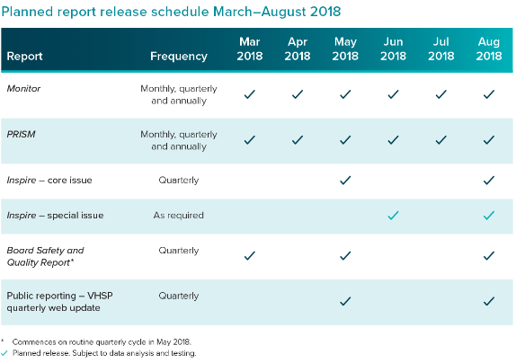VAHI produces a suite reports, designed to meet the needs of a range of audiences, including the general public. Reports focus on safety and quality and health service performance. However, it is noted that the primary audience for five out of six reports includes health services and their Executives, Clinical Leads, Boards and the Victorian Department of Health and Human Services.[111] As such, the only publically available report on the VAHI website at this stage is a state-wide report on *Adult experiences of care in public hospitals – 2016,* which presents insights and opportunities for health services to improve the quality and safety of care that 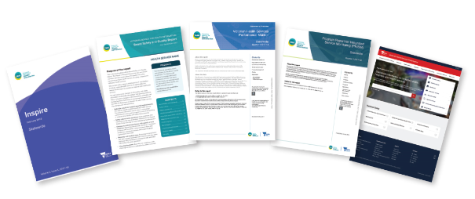they provide.[112] The report provides a comparison of health service level data for a range of performance measures relating to the overall patient experience, key aspects of care and transition of care. However, information related to infection control, such as cleanliness, was not provided.

VAHI intends to release public reports on Victorian Health Service Performance (VHSP). Currently VHSP is reported through the department portal. Information reported through this system include a range of measures relating to healthcare-associated infections, accreditation against the NSQHS Standards, infection control, patient experience and maternity and newborn measures. Performance is reported at a state-wide and health service level and data are provided quarterly from the July-September 2016 to July-September 2017 reporting periods (noting that patient experience information is lagged by three months).

*Images: VAHI reports on safety and quality and health service performance.* Source: *Victorian Agency for Health Information. Accessed 19/04/2018.*

At this stage, VAHI has not developed any reports on safety and quality of private health services. However, according to VAHI’s Statement of Functions, VAHI intends on ‘publishing regular reports on public and private services that impact health, wellbeing, quality and safety in order to support transparency, oversight, risk assessment and improvement’.[113]

A6.4 VICNISS Healthcare Associated Infection Surveillance Coordinating Centre

VICNISS Coordinating Centre was established in 2002 as an independent organisation aimed at reducing the occurrence of healthcare-associated infections, including those acquired during an outpatient treatment, such as haemodialysis. It is funded by the Victorian Department of Health and Human Services and auspiced by Melbourne Health and has been vital for monitoring and reporting healthcare-associated infections in Victoria for over 16 years.[114]

All public hospitals, through their accountability agreements with the Minister for Health are required to report data through VICNISS on a range of mandatory national and state infection control indicators[115], including:

Mandatory reporting for all public health services:

* ***Staphylococcus aureus* Bacteraemia (SAB) (national indicator)**
* ***Clostridium difficile* Infection (CDI) (national indicator)**
* **Health care worker seasonal influenza vaccination (state indicator)**

**Mandatory reporting for public health services with an ICU or NICU:**

* **Central line-associated bloodstream infections in intensive care**
* **Central line and peripheral line associated bloodstream infections in neonatal intensive care**

**Mandatory for all public health services performing a significant amount of surgery:**

* **Surgical site surveillance (SSI)**

Private hospitals are not required to provide data to VICNISS. However, in its recent report, the Coordinating Centre indicated that there has been a steady increase in interest and participation rates from private hospitals, particularly with their contribution to data related to central line associated bloodstream infection surveillance and/or surgical site infection surveillance.[116]

Data collected and analysed is reported back to the Victorian Department of Health and Human Services, which is then published on the VHSP. Data is also provided to participating health services, and national agencies such as the Australian Institute of Health and Welfare.

A range of general information about preventable healthcare-associated infections is made available for patients on the VICNISS website. The website also provides consumers with a comprehensive list of links to other important safety and quality resources, such as the Australian Guidelines for the Prevention and Control of Infection in Healthcare, Better Health Channel or MyHospitals.

In addition to these, VICNISS also produces a routine *Healthcare-associated infection in Victoria Surveillance* report that is made available to the public on their website. This report provides an aggregate of state-wide health care related infection data collected, which is compared to the aggregate data for a select peer group defined as ‘major teaching hospital’. In the most recent report, 2014-15 data is compared to 2015-16 data. The report is very comprehensive and provides clear specifications and narrative of the findings.

* 1. Western Australia

The Western Australian (WA) Department of Health produces a number of performance reports at varying frequencies.[117] Reports provide a state-wide picture of the health care system’s performance. Information is also provided at health service and hospital level (where possible) and performance is compared against state and national targets. Information about system performance is prominent and readily available to the public.

WA Department of Health reports on six key areas across system performance including: elective surgery, emergency department, specialist outpatient, safety and quality, public health and Aboriginal health. Within safety and quality, there are four core safety and quality areas of reporting:

* Monitoring and reporting of hand hygiene
* Patient safety surveillance
* Healthcare infection surveillance
* Healthcare-associated SAB

WA Department of Health publishes regular reports on hand hygiene compliance rates. Information is published at state-wide and hospital level. Hospitals are compared by peer group and the state benchmark of 80%.[118]

Since 2012, WA Department of Health has published the, *Your safety in our hands in hospital: An Integrated Approach to Patient Safety Surveillance by WA Health Service Providers, Hospitals and the Community* report on its website. This is a comprehensive annual report on patient safety that draws information from various sources. The report provides aggregated state-wide rates of clinical incidents. The report has evolved over time to include information on nine NSQHS Standards (version 1): partnering with consumers, healthcare-associated infections, medication clinical incidents, patient identification clinical incidents, clinical handover incidents, blood and blood product clinical incidents, pressure injuries, clinical deterioration incidents and falls. Complaints data relating to safety and quality in health care is also incorporated in the report.[119]

Healthcare Infection Surveillance Western Australia (HISWA) reports are produced quarterly and annually by the department’s Healthcare Associated Infection Control Unit. Similarly to other jurisdictions, reports provide rates of various infections such as infections following various procedures, healthcare-associated *Staphylococcus aureus* bloodstream infection, hemodialysis access-associated bloodstream infections, central line-associated bloodstream infection, methicillin-resistant *Staphylococcus aureus* healthcare-associated infection, hospital-identified *Clostridium difficile* infection and Vancomycin-resistant enterococci sterile-site infections. Data is reported for individual hospitals and for tertiary hospital benchmarking.[120]

HISWA also produces quarterly data on the state’s rate of healthcare-associated *Staphylococcus aureus* bloodstream infection. Rates are compared against the national benchmark. Information is presented at a state-wide level with the option to drill down to individual hospital level.[121]

WA Department of Health is an advocate for Patient Opinion and the MyHospital website. It encourages consumer participation in these resources by providing links from its safety and quality information.

1. : List of organisations searched

|  |  |  |
| --- | --- | --- |
| Private Organisations in Australia | | |
| Organisation Name | **Organisation type** | **Homepage URL** |
| Ramsay Health Care | Private health service | <http://www.ramsayhealth.com.au/> |
| Healthscope Limited | Private health service | <http://www.healthscope.com.au/> |
| St John Of God Health Care | Private health service | <https://www.sjog.org.au/> |
| Cura Day Hospitals Group | Private health service | <http://www.curagroup.com.au/> |
| Healthe Care | Private health service | <http://www.healthecare.com.au/> |
| Fresenius Medical Care Australia Pty Ltd | Private health service | <https://www.fmc-au.com/> |
| Calvary Health Care | Private health service | <https://www.calvarycare.org.au/> |
| Marie Stopes International | Private health service | <https://www.mariestopes.org.au/> |
| Epworth Foundation | Private health service | <http://www.epworth.org.au/Pages/Home.aspx> |
| Pulse Health | Private health service | <http://www.pulsehealth.net.au/> (Now owned by Healthe Care) |
| St Vincent's Health Australia | Private health service | <https://svha.org.au/home> |
| Icon Cancer Care | Private health service | <http://www.iconcancercare.com.au/> |
| Uniting Church In Australia Property Trust (Q) | Private health service | <http://unitingcarehealth.com.au/> |
| Vision Eye Institute | Private health service | https://visioneyeinstitute.com.au/ |
| Independent Private Hospitals Of Australia | Private health service | <http://www.iphoa.com.au/> |
| Mercy Health And Aged Care Central Queensland Limited | Private health service | <https://www.mercycq.com/mh/home> |
| Montserrat Day Hospitals | Private health service | https://www.montserrat.com.au/ |
| Virtus Health | Private health service | https://www.virtushealth.com.au/ |
| Affinity Group Ltd | Private health service | Could not be found |
| Cabrini Health Limited | Private health service | https://www.cabrini.com.au/ |
| Diaverum Pty Ltd | Private health service | https://www.diaverum.com/en-AU/Home/ |
| Evolution Healthcare | Private health service | <http://www.evolutionhealthcare.com.au/> (Now owned by Healthe Care) |
| Mater Misericordiae Ltd | Private health service | http://www.mater.org.au/ |
| Melbourne Endoscopy Group | Private health service | <http://melbendoscopy.com.au/> |
| bupa | Private health insurer | <https://www.bupa.com.au/> |
| HBF Health Fund | Private health insurer | <https://www.hbf.com.au/> |
| HCF Health Insurance | Private health insurer | <https://www.hcf.com.au/> |
| Medibank | Private health insurer | <https://www.medibank.com.au/> |
| NIB | Private health insurer | <https://www.nib.com.au/> |
| Public Organisations in Australia | | |
| Organisation name | **Organisation type** | **Homepage URL** |
| Australian Government Department of Health | Commonwealth Agency | <http://www.health.gov.au/> |
| Australian Institute of Health and Welfare | Commonwealth Agency | https://www.aihw.gov.au/ |
| National Health and Medical Research Council | Commonwealth Agency | <https://www.nhmrc.gov.au/> |
| Australian Bureau of Statistics | Commonwealth Agency | <http://www.abs.gov.au/> |
| National Health Priority Areas | Commonwealth Agency | <http://www.health.gov.au/internet/nhpa/publishing.nsf/Content/Our-reports> |
| MyHospitals | Commonwealth | <https://www.myhospitals.gov.au/> |
| Patient Opinion | Other | <https://www.patientopinion.org.au/> |
| WhiteCoat | Other | https://www.whitecoat.com.au/ |
| ACT Department of Health | State Government | <http://www.health.act.gov.au/> |
| NT Department of Health | State Government | <https://health.nt.gov.au/> |
| NSW Health | State Government | <http://www.health.nsw.gov.au/Pages/default.aspx> |
| Bureau of Health Information | NSW Statutory Body | <http://www.bhi.nsw.gov.au/home/_nocache> |
| Clinical Excellence Commission | NSW Statutory Body | http://www.cec.health.nsw.gov.au/ |
| Westmead Hospital | NSW Public hospital | https://www.wslhd.health.nsw.gov.au/Westmead-Hospital |
| Prince of Wales Hospital | NSW Public hospital | <http://www.princeofwalesprivatehospital.com.au/> |
| Random NSW Public hospital | St Vincent’s Hospital | https://www.svhm.org.au/ |
| Victorian Department for Health & Human Services | State Government | <https://dhhs.vic.gov.au/sites/default/files/documents/201610/Hospital%20Safety%20and%20Quality%20Assurance%20in> %20Victoria.pdf |
| Victorian Agency for Health Information | State Government | https://www2.health.vic.gov.au/hospitals-and-health-services/vahi |
| Safer Care Victoria | State Government | <https://www2.health.vic.gov.au/hospitals-and-health-services/safer-care-victoria> |
| Royal Women’s Hospital | Public health provider | https://www.thewomens.org.au/ |
| Monash Health | Public health provider | http://www.monashhealth.org/index.php |
| Royal Children’s | Public health provider | https://www.rch.org.au/home/ |
| Alfred Health | Public health provider | https://www.alfredhealth.org.au/ |
| Northern Health | Public health provider | <https://www.nh.org.au/> |
| SA Health | State Government | https://www.sahealth.sa.gov.au/wps/wcm/connect/public+content/sa+health+internet |
| Royal Adelaide Hospital | Public health provider | <https://www.rah.sa.gov.au/> |
| Queen Elizabeth Hospital | Public health provider | <http://www.sahealth.sa.gov.au/wps/wcm/connect/public+content/sa+health+internet/health+services/hospitals+and+health+services+metropolitan+adelaide/the+queen+elizabeth+hospital/about+the+queen+elizabeth+hospital> |
| Flinders Medical Centre | Public health provider | https://www.flindersmedical.com.au/ |
| Queensland Health | State Government | https://www.health.qld.gov.au/ |
| Royal Brisbane and Women’s Hospital | Public health provider | https://metronorth.health.qld.gov.au/rbwh/ |
| Redcliffe Hospital | Public health provider | https://metronorth.health.qld.gov.au/redcliffe/ |
| Tasmanian Department of Health | State government | http://www.dhhs.tas.gov.au/ |
| Hobart Hospital | Public health provider | http://www.dhhs.tas.gov.au/hospital/royal-hobart-hospital |
| WA Department of Health | State Government | http://ww2.health.wa.gov.au/ |
| Royal Perth Hospital | Public health provider | <http://www.rph.wa.gov.au/> |
| South Perth Hospital | Public health provider | <http://www.sph.org.au/> |
| International Organisations |  |  |
| Organisation name | **Organisation type** | **Homepage URL** |
| Canadian Institute for Health Information | Independent non-for-profit | <https://www.cihi.ca/en> |
| Canadian patient safety institute | Independent non-for-profit | http://www.patientsafetyinstitute.ca/en/Pages/default.aspx |
| Province of British Columbia Ministry of Health | Canadian government | https://www2.gov.bc.ca/gov/content/health |
| Ontario Ministry of Health | Canadian government | http://www.health.gov.on.ca/en/ |
| Netherlands | National Government | https://www.government.nl/topics/quality-of-healthcare/safety-and-healthcare |
| US Department of Health and Human Services | National government | https://www.hhs.gov/ |
| Medicare.gov | National government | <https://www.medicare.gov/> |
| Agency for Healthcare Research and Quality | National government | <https://www.ahrq.gov/> |
| Leapfrog Group | Independent non-for-profit | <http://www.leapfroggroup.org/> |
| Joint Commission | Independent non-for-profit | <https://www.jointcommission.org/> |
| Kaiser Permanente | Independent non-for-profit | <https://healthy.kaiserpermanente.org/> |

Glossary

AHMAC Australian Health Ministers’ Advisory Council

AHPF Australian Health Performance Framework

AHRQ Agency for Healthcare Research and Quality

AIHW Australian Institute of Health and Welfare

Apgar **A**ppearance, **P**ulse, **G**rimace, **A**ctivity, and **R**espiration Score

BHI Bureau for Health Information (New South Wales)

CAUTI Catheter-associated urinary tract infections

CDI *Clostridium difficile* infection

CEC Clinical Excellence Commission (New South Wales)

CHC Council of Australian Governments (COAG) Health Council

CIHI Canadian Institute for Health Information

CLABSI Central Line-Associated Bloodstream Infection

COAG Council of Australian Governments

Commission Australian Commission on Safety and Quality in Health Care

HAC Hospital-Acquired Complication

HoNOS Health of the Nation Outcomes Scale Score

ICU Intensive Care Unit

IGZ Dutch Healthcare Inspectorate

MRSA Methicillin-resistant *Staphylococcus Aureus*

NICU Neonatal Intensive Care Unit

NSQHS National Safety and Quality Health Service (Standards)

NZA Dutch Healthcare Authority

OECD Organisation for Economic Co-operation and Development

NHPF National Health Performance Framework

PAF National Health Reform Performance and Accountability Framework

SAB *Staphylococcus aureus* bloodstream infection

SAC Safety Assessment Code score

SCV Safer Care Victoria

SSI Surgical site infection

VAHI Victorian Agency for Health Information

VHSP Victorian health service performance

VRE Vancomycin Resistant Enterococcus

References

1. Australian Government Productivity Commission. Introducing Competition and Informed User Choice into Human Services: Reforms to Human Services. Report No.85, 27 2017. Available from: <https://www.pc.gov.au/inquiries/completed/human-services/reforms/report/human-services-reforms.pdf>.
2. Council of Australian Governments. Heads of Agreement between the Commonwealth and the States and Territories on public hospital funding and health reform. February 2018. Available from: <https://www.coag.gov.au/about-coag/agreements/heads-agreement-between-commonwealth-and-states-and-territories-public-0>.
3. National Health Information and Performance Principal Committee. The Australian Health Performance Framework. September 2017. Available from: <https://www.coaghealthcouncil.gov.au/Portals/0/OOS318_Attachment%201.pdf>.
4. Queensland Government. Expanding healthcare quality and patient safety reporting. 25 January 2019. Available from: <https://www.health.qld.gov.au/system-governance/strategic-direction/improving-service/expanding-patient-safety-reporting>.
5. Leape L, Berwick D, Clancy C, et al. Transforming healthcare: a safety imperative. BMJ Quality & Safety 2009; 18:424-428.
6. Brandt C, Patel K, Masi D. Health Policy Issue Brief: Recommendations to Achieve a More Transparent Health Care System for Consumers. Brookings. 3 February 2018. Available from: <http://www.brookings.edu/research/papers/2015/02/04-medicare-transparency-health-consumers-patel>.
7. Chassin et al. Accountability Measures – Using Measurement to Promote Quality Improvement. New England Journal of Medicine 2010; 363:683-688.
8. Chen JC. Public reporting of health system performance: Review of evidence on impact on patients, providers and healthcare organisations: An Evidence Check rapid review brokered by the Sax Institute for the Bureau of Health Information; 2010. Available from: <https://www.saxinstitute.org.au/wp-content/uploads/17_Public-reporting-of-health-system-performance....pdf>.
9. Cacace M, Etterlt S, Brereton L, Pedersen J, Nolte E. How health systems make available information on service providers: Experience in seven countries. RAND Corporation 2011. Available from: <https://www.rand.org/pubs/technical_reports/TR887.html>.
10. Australian Commission on Safety and Quality in Health Care. Australian Safety and Quality Framework for Health Care. ACSQHC; 2010. Available from: <http://www.safetyandquality.gov.au/wpcontent/uploads/2009/01/Developing-a-Safety-and-Quality-Framework-for-Australia.pdf>.
11. Victorian Department of Health and Human Services. Quality of care reporting: A critical literature review. Melbourne: State of Victoria, Department of Health 2013.
12. Campanella P, Vukovic V, Parente P, et al. The impact of public reporting on clinical outcomes: a systematic review and meta-analysis. BMC Health Serv Res 2016;16:296
13. Canaway R, Bismark M, Dunt D, Prang K, Kelaher M. What is meant by public?: Stakeholder views on strengthening impacts of public reporting of hospital performance data. Social Science & Medicine 2018; 202:143-150.
14. Pearse J, Mazevska D. The Impact of Public Disclosure of Health Performance Data: an Evidence Check Review Brokered by the Sax Institute. Ultimo: Sax Institute; 2010.
15. Berwick DM, James B, Coye MJ. Connections between quality measurement and improvement. Med. Care 2003; 41: I30–I38.
16. Kumpunen S, Trigg, L, Rodrigues R. Public reporting in health and long-term care to facilitate provider choice, European Observatory on Health Systems and Policies. World Health Organisation; 2014. Available from: <http://www.euro.who.int/__data/assets/pdf_file/0020/263540/Public-reporting-in-health-and-long-term-care-to-facilitate-provider-choice-Eng.pdf>?
17. Cacace M, Etterlt S, Brereton L, Pedersen J, Nolte E. How health systems make available information on service providers: Experience in seven countries. RAND Corporation; 2011. Available from: <https://www.rand.org/pubs/technical_reports/TR887.html>.
18. Ibid.
19. Pross C, Geissler A, Busse R. Measuring, Reporting, and Rewarding Quality of Care in 5 Nations: 5 Policy Levers to Enhance Hospital Quality Accountability. The Milbank Quarterly: A Multidisciplinary Journal of Population Health and Health Policy 2017; 95(1):136-183.
20. Cacace M, Etterlt S, Brereton L, Pedersen J, Nolte E. How health systems make available information on service providers: Experience in seven countries. RAND Corporation; 2011. Available from: <https://www.rand.org/pubs/technical_reports/TR887.html>.
21. Kumpunen S, Trigg, L, Rodrigues R. Public reporting in health and long-term care to facilitate provider choice, European Observatory on Health Systems and Policies. World Health Organisation. 2014. Available from: <http://www.euro.who.int/__data/assets/pdf_file/0020/263540/Public-reporting-in-health-and-long-term-care-to-facilitate-provider-choice-Eng.pdf>?
22. Ibid.
23. Cacace M, Etterlt S, Brereton L, Pedersen J, Nolte E. How health systems make available information on service providers: Experience in seven countries. RAND Corporation; 2011. Available from: <https://www.rand.org/pubs/technical_reports/TR887.html>.
24. Pross C, Geissler A, Busse R. Measuring, Reporting, and Rewarding Quality of Care in 5 Nations: 5 Policy Levers to Enhance Hospital Quality Accountability. The Milbank Quarterly: A Multidisciplinary Journal of Population Health and Health Policy 2017; 95(1):136-183.
25. Braithwaite J, Hibbert P, Blakely B. et al. Health system frameworks ad performance indicators in eight countries: A comparative international analysis. SAGE Open Medicine 2017; 5: 1-10.
26. Canaway R, Bismark M, Dunt D, Prang K, Kelaher M. What is meant by public?: Stakeholder views on strengthening impacts of public reporting of hospital performance data. Social Science & Medicine 2018; 202:143-150.
27. National Health Information and Performance Principal Committee. The Australian Health Performance Framework September 2017. Available from: <https://www.coaghealthcouncil.gov.au/Portals/0/OOS318_Attachment%201.pdf>
28. Ibid.
29. Ketelaar NABM, Faber MJ, Flottorp S et al Public release of performance data in changing the behaviour of healthcare consumers, professionals or organisations. Cochrane Systematic Review; 2011.
30. Teleki S, Shannon M. In California, quality reporting at the state level is at a crossroads after hospital group pulls out. Health Affairs (Millwood) 2012 Mar;31(3):642-6.
31. Kumpunen S, Trigg, L, Rodrigues R. Public reporting in health and long-term care to facilitate provider choice, European Observatory on Health Systems and Policies. World Health Organisation; 2014. Available from: <http://www.euro.who.int/__data/assets/pdf_file/0020/263540/Public-reporting-in-health-and-long-term-care-to-facilitate-provider-choice-Eng.pdf>?
32. Lindenauer PK, Lagu T, Ross JS, et al. Attitudes of Hospital Leaders Toward Publicly Reported Measures of Health Care Quality. JAMA Intern Med. 2014;174(12):1904–1911.
33. Totten AM, Wagner J, Tiwari A, et al. Closing the Quality Gap: Revisiting the State of the Science (Vol. 5: Public Reporting as a Quality Improvement Strategy). Rockville MD: Agency for Healthcare Research and Quality (US); 2012 Jul. (Evidence Reports/Technology Assessments, No. 208.5.). Available from: <https://www.ncbi.nlm.nih.gov/books/NBK99885>
34. Cacace M, Etterlt S, Brereton L, Pedersen J, Nolte E. How health systems make available information on service providers: Experience in seven countries. RAND Corporation; 2011. Available from: <https://www.rand.org/pubs/technical_reports/TR887.html>.
35. Tu J, Donovan LR, Lee DS, et al. Effectiveness of Public Report Cards for Improving the Quality of Cardiac Care. The EFFECT Study: A Randomized Trial, JAMA 2009; 302(21): 2330-2337.
36. Shekelle PG, Lim Y, Mattke S, Damberg C. Does public release of performance results improve quality of care? A systematic review. London: The Health Foundation; 2008. Available from: <https://www.health.org.uk/sites/health/files/DoesPublicReleaseOfPerformanceResultsImproveQualityOfCare.pdf>
37. Chassin MR. Achieving and sustaining improved quality: lessons from New York State and cardiac surgery. Health Affairs 2002; 21(4):40-51.
38. Hibbard JH, Stockard J, Tusler M. Hospital performance reports: impact on quality, market share, and reputation. Health Affairs 2005; 24(4): 1150–60, cited in the Health Quality and Safety Commission New Zealand, 2016, Position paper on the transparency of information related to health care interventions. Wellington: Health Quality & Safety Commission; 2016.
39. Teleki S, Shannon M. In California, quality reporting at the state level is at a crossroads after hospital group pulls out. Health Affairs (Millwood) 2012 Mar;31(3):642-6.
40. Public reporting on quality and costs. Do report cards and other measures of providers’ performance lead to improved care and better choices by consumers. Health Affairs Health Policy Brief. 8 March 2012.
41. Hibbard, J Sofaer S. Best practices in public reporting no. 1: How to effectively present health care performance data to consumers. Rockville MD: Agency for Healthcare Research and Quality; 2010.
42. Ibid.
43. Cacace M, Etterlt S, Brereton L, Pedersen J, Nolte E. How health systems make available information on service providers: Experience in seven countries. RAND Corporation; 2011. Available from: <https://www.rand.org/pubs/technical_reports/TR887.html>.
44. Shahian DM. Beyond Public Reporting. J Thorac Cardiovasc Surg 2017;153:1627-9.
45. Kumpunen S, Trigg, L, Rodrigues R. Public reporting in health and long-term care to facilitate provider choice, European Observatory on Health Systems and Policies. World Health Organisation. 2014. Available from: <http://www.euro.who.int/__data/assets/pdf_file/0020/263540/Public-reporting-in-health-and-long-term-care-to-facilitate-provider-choice-Eng.pdf>?
46. Shekelle PG, Lim Y, Mattke S, Damberg C. Does public release of performance results improve quality of care? A systematic review. London: The Health Foundation; 2008. Available from: <https://www.health.org.uk/sites/health/files/DoesPublicReleaseOfPerformanceResultsImproveQualityOfCare.pdf>
47. Cohoon KP, Mack MJ, Holmes DR. Public reporting: A new threat to high-risk patients and medical innovation. Catheterization Cardiovascular Interventions 2016; 89(2):335-337.
48. Ibid.
49. Bevan G, Hamblin R. Hitting and missing targets by ambulance services for emergency calls: effects of different systems of performance measurement within the UK. J R Stat Soc Ser A Stat Soc 2009;172(1): 161–90,cited in Health Quality and Safety Commission New Zealand. Position paper on the transparency of information related to health care interventions. Wellington: Health Quality & Safety Commission; 2016.
50. Totten AM, Wagner J, Tiwari A, et al. Closing the Quality Gap: Revisiting the State of the Science (Vol. 5: Public Reporting as a Quality Improvement Strategy). Rockville MD: Agency for Healthcare Research and Quality (US); 2012 Jul. (Evidence Reports/Technology Assessments, No. 208.5). Available from: <https://www.ncbi.nlm.nih.gov/books/NBK99885>
51. Ibid.
52. Health Quality and Safety Commission New Zealand. Position paper on the transparency of information related to health care interventions Wellington: Health Quality & Safety Commission; 2016.
53. Teleki S, Shannon M. In California, quality reporting at the state level is at a crossroads after hospital group pulls out. Health Affairs (Millwood) 2012 Mar;31(3):642-6.
54. Health Quality and Safety Commission New Zealand. Position paper on the transparency of information related to health care interventions Wellington: Health Quality & Safety Commission; 2016.
55. Ibid.
56. Kumpunen S, Trigg, L, Rodrigues R. Public reporting in health and long-term care to facilitate provider choice, European Observatory on Health Systems and Policies. World Health Organisation. 2014. Available from: <http://www.euro.who.int/__data/assets/pdf_file/0020/263540/Public-reporting-in-health-and-long-term-care-to-facilitate-provider-choice-Eng.pdf>?
57. Ibid.
58. Health Quality and Safety Commission New Zealand. Position paper on the transparency of information related to health care interventions Wellington: Health Quality & Safety Commission; 2016.
59. Canaway R, Bismark M, Dunt D, Prang K, Kelaher M. ‘What is meant by public?’: Stakeholder views on strengthening impacts of public reporting of hospital performance data, Social Science & Medicine 2018; 202:143-150.
60. Chassin MR, Loeb, JM, Schmaltz SP, Wachter RM. Accountability measures – using measurement to promote quality improvement. Engl J Med 2010; 363:683-688.
61. Faber M, Bosch M, Wollersheim H, Leatherman S, Grol R, Public Reporting in Health Care: How Do Consumers Use Quality-of-Care Information?: A Systematic Review. Medical Care 2009; 47(1):1-8.
62. Lagu T, Greaves F. From Public to Social Reporting of Hospital Quality. J Gen Intern Med 2015; 30(10):1397–9.
63. Ibid.
64. Ibid.
65. Australian Commission of Safety and Quality in Health Care. National Safety and Quality Health Service Standards (Second edition). Sydney: ACSQHC; 2017.
66. Australian Institute of Health and Welfare. Staphylococcus aureus bacteraemia in Australian hospitals 2017. Available from: <https://www.aihw.gov.au/reports/hospitals/ahs-2016-17-sab/contents/introduction>.
67. Health Roundtable. Patient Safety Improvement Group Accessed: 24/01/2019. Available from: <https://www.healthroundtable.org/JoinUs/ImprovementGroups/PatientSafety.aspx>
68. Patient Opinion Australia. Homepage. Accessed 13/05/2018. Available from: <https://www.patientopinion.org.au/>.
69. Government of Canada. Canada’s Health Care System. Accessed 31/01/2019. Available from: <https://www.canada.ca/en/health-canada/services/canada-health-care-system.html>.
70. Canadian Institute for Health Information. About CIHI. Accessed: 26/04/2018. Available from: <https://www.cihi.ca/en/about-cihi>.
71. Canadian Institute for Health Information. Your Health System. Accessed: 26/04/2018. Available from: <https://yourhealthsystem.cihi.ca>.
72. Canadian Patient Safety Institute. Homepage. Accessed 26/04/2018. Available from: <http://www.patientsafetyinstitute.ca/en/Pages/default.aspx>.
73. Ontario Ministry of Health and Long-term Care. Patient Safety: Patient Safety Indicator results at Health Quality Ontario. Accessed: 26/04/2018. Available from: <http://www.health.gov.on.ca/en/public/programs/patient_safety/>.
74. Government of the Netherlands. Monitoring the quality of healthcare. Accessed: 1/05/2018. Available from: <https://www.government.nl/topics/quality-of-healthcare/monitoring-the-quality-of-healthcare>.
75. Cacace M, Etterlt S, Brereton L, Pedersen J, Nolte E. How health systems make available information on service providers: Experience in seven countries. RAND Corporation; 2011. Available from: <https://www.rand.org/pubs/technical_reports/TR887.html>.
76. Dutch Hospital Association. Quality Window. Accessed 1/06/2018. Available from: <https://en.nvz-ziekenhuizen.nl/topics/quality-window/>
77. Government of the Netherlands Ministry of Health, Welfare and Sport. Dutch Health Care Performance Report 2010. Accessed 1/05/2018. Available from: <https://www.gezondheidszorgbalans.nl/English>.
78. US Department of Health and Human Services. Performance improvements. Accessed: 1/05/2018. Available from: <https://aspe.hhs.gov/report/performance-improvement-2013-2014#tab-106-1>.
79. Medicare.gov. Hospital compare overall rating. Accessed: 27/04/2018. Available from: <https://www.medicare.gov/hospitalcompare/Data/Measure-groups.html>.
80. Agency for Healthcare Research and Quality. What we do. Accessed 27/04/2018. Available from: <https://www.ahrq.gov/>.
81. Agency for Healthcare Research and Quality. AHRQ Indicators. Accessed 27/04/2018. Available from: <http://www.qualityindicators.ahrq.gov>.
82. Agency for Healthcare Research and Quality. Patient Safety Indicators v6.0 ICD-9-CM Benchmark Data Tables. Accessed: 27/04/2018. Available from: <http://www.qualityindicators.ahrq.gov>.
83. The Leapfrog Group. About us and our mission. Accessed: 30/04/2018. Available from: <http://www.leapfroggroup.org/about>.
84. Leapfrog Hospital Safety Grade. About the Grade. Accessed 30/04/2018. Available from: <https://www.hospitalsafetygrade.org/your-hospitals-safety-grade/about-the-grade>.
85. The Leapfrog Group. Competitive Benchmarking. Accessed 30/04/2018. Available from: <http://www.leapfroggroup.org/ratings-reports/competitive-benchmarking>.
86. The Joint Commission. About Quality Check. Accessed 1/05/2018. Available online: <https://www.qualitycheck.org/>.
87. Kaiser Permanente. Health Research. Accessed: 1/05/2018. Available from: <https://share.kaiserpermanente.org/article/about-kaiser-permanente-research/>.
88. ACT Health. ACT Public Health Services Quarterly Performance Report. Accessed 13/05/2018. Available from: <https://health.act.gov.au/about-our-health-system/data-and-publications/reports/act-public-health-services-quarterly>
89. Bureau of Health Information. Healthcare in Focus 2017 - How does NSW compare?. Chatswood: Bureau of Health Information 2018. Available from: <http://www.bhi.nsw.gov.au/BHI_reports/healthcare_in_focus/2017>.
90. Bureau of health information. International Surveys. Accessed 18/04/2018. Available from: <http://www.bhi.nsw.gov.au/nsw_patient_survey_program/international_surveys>.
91. NT Department of Health. Client complaints, suggestions and questions. Accessed 16/04/2018. Available from: <https://health.nt.gov.au/health-governance/compliments-complaints-and-feedback/health-complaints-suggestions-questions>.
92. Queensland Health. My health, Queensland’s future: Advancing health 2026. Accessed: 25/04/2018. Available from: <https://www.health.qld.gov.au/__data/assets/pdf_file/0025/441655/vision-strat-healthy-qld.pdf>.
93. Queensland Health. Hospital performance. Queensland Reporting Hospitals. Accessed online 25/04/2018. Available from: <http://www.performance.health.qld.gov.au/hospitalperformance/service-areas.aspx?hospital=99999>.
94. Clinical Excellence Division. Year in Review 2016-17. Accessed 25/04/2018. Available from: <https://clinicalexcellence.qld.gov.au/sites/default/files/docs/clinical-excellence-year-in-review.pdf>.
95. Queensland Health. Expanding quality and safety reporting. Accessed online: 26/04/2018. Available from: <https://www.health.qld.gov.au/system-governance/strategic-direction/improving-service/expanding-patient-safety-reporting>.
96. Queensland Health. Expanding healthcare quality and patient safety reporting. Accessed 31/1/2018. Available from: <https://www.health.qld.gov.au/system-governance/strategic-direction/improving-service/expanding-patient-safety-reporting>.
97. SA Heath. Safety and quality reports. Accessed 24/04/2018. Available from: <http://www.sahealth.sa.gov.au/wps/wcm/connect/public+content/sa+health+internet/clinical+resources/safety+and+quality/safety+and+quality+reports>.
98. SA Health. South Australian Patient Safety Report 2015-2016. Accessed 24/04/2018. Available from: <http://www.sahealth.sa.gov.au/wps/wcm/connect/6932c580419c3b938dbbbfdb31a1ff3d/16151.1+Patient+Safety+Report%28v6%29WebS.pdf?MOD=AJPERES&CACHEID=ROOTWORKSPACE-6932c580419c3b938dbbbfdb31a1ff3d-lPiC.KM>.
99. SA Health. Our hospital dashboards. Accessed 24/04/2018. Available from: <http://www.sahealth.sa.gov.au/wps/wcm/connect/public+content/sa+health+internet/about+us/our+performance/our+hospital+dashboards/our+hospitals+dashboards>.
100. Department of Health and Human Services Tasmania. Healthcare associated infection surveillance. Accessed 22/04/2018. Available from: <http://www.dhhs.tas.gov.au/publichealth/tasmanian_infection_prevention_and_control_unit/HAI_Surveillance>.
101. Department of Health and Human Services Tasmania. Health System Dashboard. Accessed: 22/04/2018. Available from: <http://www.healthstats.dhhs.tas.gov.au/healthsystem>.
102. Victorian Department of Health and Human Services. Performance monitoring framework. Accessed 26/04/2018. Available from: <https://www2.health.vic.gov.au/hospitals-and-health-services/funding-performance-accountability/performance-monitoring>.
103. Victorian Agency for Health Information. Victorian Health Services Performance: Quality, Safety and Patient Experience. Accessed 26/04/2018. Available from: <http://performance.health.vic.gov.au/Home/Category.aspx?CategoryKey=5#Anchor>.
104. Victorian Department of Health & Human Services. Review of hospital safety and quality assurance in Victoria. Accessed 26/04/2018. Available from: <https://www2.health.vic.gov.au/hospitals-and-health-services/quality-safety-service/hospital-safety-and-quality-review>.
105. Victorian Department of Health & Human Services. Targeting zero, the review of hospital safety and quality assurance in Victoria. Accessed 26/04/2018. Available from: <https://www.dhhs.vic.gov.au/publications/targeting-zero-review-hospital-safety-and-quality-assurance-victoria>.
106. Safer Care Victoria. About Safer Care Victoria. Accessed: 20/04/2018.Available from: <https://www2.health.vic.gov.au/hospitals-and-health-services/safer-care-victoria/about>.
107. Victorian Department of Health & Human Services. Victorian Health Services Performance monitoring framework 2017-18. Accessed: 20/04/2018. Available from: <https://www2.health.vic.gov.au/hospitals-and-health-services/funding-performance-accountability/performance-monitoring>.
108. Safer Care Victoria. Publications. Accessed 20/04/2018. Available from: <https://www2.health.vic.gov.au/hospitals-and-health-services/safer-care-victoria/scv-publications>.
109. Victorian Department of Health & Human Services. Victorian quality account. Accessed 20/04/2018. Available from: <https://www2.health.vic.gov.au/about/participation-and-communication/quality-account>.
110. Victoria State Government. Victorian Agency for Health Information. Accessed 19/04/2018. Available from: <https://www2.health.vic.gov.au/hospitals-and-health-services/vahi>.
111. Victorian Agency for Health Information. Guide to VAHI Reports. Accessed 19/04/2018. Available from: <https://bettersafercare.vic.gov.au/sites/default/files/2018-03/Guide-to-VAHI-Reports.pdf>
112. Adult experiences of care in public hospitals – 2016 Report. Available: <https://www2.health.vic.gov.au/hospitals-and-health-services/vahi/vahi-publications/adult-experience-public-hospitals-2016-report>. Accessed 19/04/2018.
113. Victorian Agency for Health Information. Corporate Plan: 2017-18 (October 2017). Accessed 19/04/2018. Available from: <https://bettersafercare.vic.gov.au/sites/default/files/2018-03/VAHI-corporate-plan-2017-18.pdf>.
114. VICNISS. What is VICNISS. Accessed 20/04/2018. Available from: <https://www.vicniss.org.au/about/what-is-vicniss/>.
115. VICISS. VICNISS Surveillance Activities in Our Hospitals. Accessed 20/04/2018 Available from: <https://www.vicniss.org.au/about/surveillance-activities/>.
116. Doherty Institute. Healthcare-associated infection in Victoria Surveillance report for 2014-15 and 2015-16. Melbourne: State of Victoria Department of Health and Human Services 2017. Accessed 20/04/2018. Available from: <https://www.vicniss.org.au/media/1787/21373-pdi_vicniss_report_2014-16_a4_v6_web.pdf>.
117. WA Health Our performance. Accessed: 25/01/2019. Available from: <http://ww2.health.wa.gov.au/Our-performance>.
118. WA Health. Monitoring and reporting of hand hygiene. Accessed online 23/04/2018. Available from: <http://ww2.health.wa.gov.au/Our-performance/Hand-hygiene/Monitoring-and-reporting-of-hand-hygiene>.
119. WA Health. Your safety in our hands in hospital. Accessed 23/04/2018. Available from: <http://ww2.health.wa.gov.au/Reports-and-publications/Your-safety-in-our-hands-in-hospital>.
120. WA Health. HISWA reports. Accessed 23/04/2018. Available from: <https://ww2.health.wa.gov.au/Articles/F_I/Infectious-disease-data/Healthcare-Infection-Surveillance-Western-Australia-HISWA-reports>.
121. WA Health. Healthcare associated *Staphylococcus aureus* bloodstream infection. Accessed 23/04/2018. Available from: <https://ww2.health.wa.gov.au/Reports-and-publications/Staphylococcus-aureus-bloodstream-infections>.