

D19-1691

QUICK REFERENCE GUIDE – REMOTENESS STRUCTURE CAPABILITY

In November 2018, a capability was added to OrgTRx to allow users to map their data according to the Australian Statistical Geography Standard (ASGS) Remoteness Structure, July 2016. This document takes users through the steps to view data against the structure.

**Mapping methodology**

Introduced in 2011, the ASGS provides a framework of statistical areas used by the Australian Bureau of Statistics and other organisations to enable the publication of statistics that are comparable and spatially integrated. The ASGS provides users with an integrated set of standard areas that can be used for analysing, visualising and integrating statistics produced by the ABS and other organisations.

The ASGS Remoteness Structure divides Australia into five classes of remoteness on the basis of a measure of relative access to services:

* Major cities of Australia
* Inner regional Australia
* Outer regional Australia
* Remote Australia
* Very remote Australia.

Access to services are measured using the Accessibility and Remoteness Index of Australia (ARIA+), produced by the [Hugo Centre for Migration and Population Research](https://www.adelaide.edu.au/hugo-centre/spatial_data/aria/) at the University of Adelaide. This objective process for classifying the remoteness of areas creates consistency between different editions of Remoteness Areas despite changes to the boundaries. This allows users to make comparisons and undertake statistical analysis on data published on Remoteness Areas over time. Further information on the ASGS Remoteness Structure can be found on [the Australian Bureau of Statistics website](the%20Australian%20Bureau%20of%20Statistics%20website).

**Instructions**

By following the steps below users will be able to view data for ASGS Remoteness Structure from the grid and insert the map component to view geographical data.

**Step 1**. Click to highlight an Organism (e.g. Escherichia coli) choose *Select highlighted members*

Step 1 screen shot

**Step 2**. Click to highlight an Antibiogram (e.g. Amoxicillin and enzyme inhibitor) choose *Select highlighted members*

Step 2 screen shot

**Step 3**. Click to highlight *Show Slicers*

Step 3 screen shot

**Step 4**. Click *All Slicers*

**Step 5**. Type remoteness into the *search pane* and select *Remoteness Area* tick box

Step 5 screen shot

**Step 6**. Click image of Apply button discussed under Step 6 *Apply*

**Step 7*.*** Click to highlight *Organism List*, navigate to *Replace Organism* *list with* and select *Remoteness Area*

Step 7 screen shot

**Step 8**. Click and drag the Step 8 image of Map component button *Map* component into the workboard via the *Design* tab

Step 8 screen shot of Design option

**Step 9**. Select a Step 9 image of placeholder button *Placeholder* for placement of the *Map* component

**Step 10**. Make additional changes using the buttons within the *Map* tab e.g. select *Legend*, show on left, change the *Basemap* to Physical map.

Step 10 screen shot

**Step 11**. There is additional functionality available to edit a map and use the *Map Designer* which is available via the Image of Edit button discussed in Step 11 *Edit* button on the *Map* tab.

Step 11 screen shot

**Additional formatting options**

**Step 12**. The following descriptions are available to assist users to apply additional formatting. Make selections within the Visualisations screen drop down boxes and click OK to apply.

Screen shot of Map designer

***Classification and Colour***

Use **Classification** and **Colour** to define the colour scheme. Classification determines how the values on the map will be distributed among the colours. Choose one of the following methods:

***Linear****:* With this method you can use 3, 5, 7 or 9 colours, and the range of values will be divided into equal-sized sub-ranges among the colours. You can manually set the lowest and the highest values. Values lower than the minimum will be represented by the colour representing the minimum, and values higher than the maximum will be represented by the colour representing the maximum.

***Linear by interval***: With this method you can use 3, 5, 7 or 9 colours. Here you specify an interval by which to equally divide the range of values. The interval is a value (not the number of intervals). You can also manually set the lowest value. Necto will order members by values and separate them according to the interval value, determining the number of partitions automatically based on the interval.

***Threshold***: With this method you can use only two colours. The threshold for distributing the values between the two colours is determined automatically. You can change the threshold by entering a percentage value.

***Quantile***: With this method you can use 2, 3, 5, 7 or 9 colours, and each partition will contain an equal number of items to be presented.

***Partitioning***

**Natural breaks**: With this method you can use 2, 3, 5, 7 or 9 colours. Partitions will be based on natural groupings inherent in the data. Necto identifies break points by picking the partition breaks that best group similar values, and maximizes the differences between partitions using Jenks natural breaks optimization.

**STD (Standard Deviation)**: With this method you can use 2, 3, 5, 7 or 9 colours. It will show you how much an item's value varies from the mean. Necto will calculate the mean values and the standard deviations from the mean. Partition breaks are then created using these values. You can set the size of the median partition in **Partitions**.

**Continuous**: With this method you can use only 2 or 3 colours. The values will be distributed continuously between the lowest value and the highest.

**Manual**: Open the dropdown and select the number of partitions. Set/change the interval for each colour.

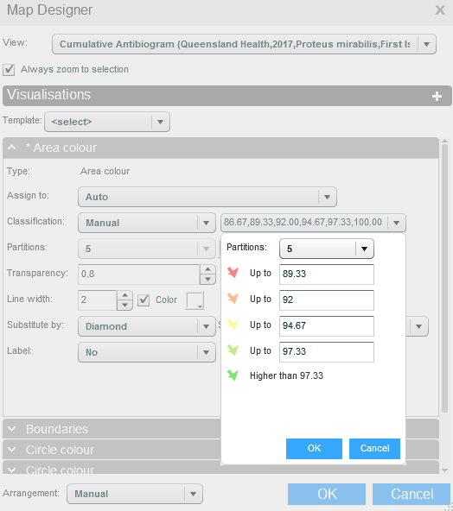

**Percentile**: Open the dropdown and select the number of partitions. Set/change the intervals in terms of percents.

**Support**

If you have any problems using or accessing this OrgTRx feature, support is available via [orgtrx‑support@health.qld.gov.au](mailto:orgtrxsupport@health.qld.gov.au).