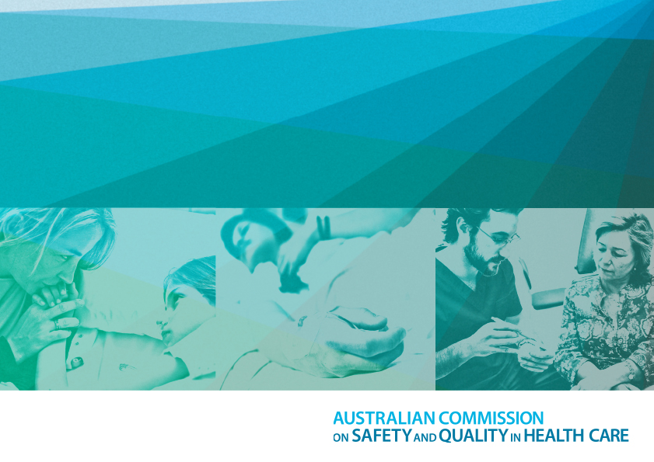

VITAL SIGNS 2016

The State of Safety and Quality in Australian Health Care

Published by the Australian Commission on Safety and Quality in Health Care

Postal Address: GPO Box 5480, Sydney NSW 2001

Phone: (02) 9126 3600 International +61 2 9126 3600

Email: mail@safetyandquality.gov.au

Website: [www.safetyandquality.gov.au](http://www.safetyandquality.gov.au)

ISSN 2002-7696 (print)

ISSN 2206-9771 (online)

ABN 97 250 687 371

© Commonwealth of Australia 2016

All material and work produced by the Australian Commission on Safety and Quality in Health Care is protected by Commonwealth copyright. It may be reproduced in whole or in part for study or training purposes, subject to the inclusion of an acknowledgement of the source.

The Commission’s preference is that you attribute this publication (and any material sourced from it) using the following citation:

Australian Commission on Safety and Quality in Health Care. Vital Signs 2016: The State of Safety and Quality in Australian Health Care. Sydney (Au), 2016.

An online version of this report can be accessed at www.safetyandquality.gov.au

Enquiries regarding the use of this publication are welcome and can be made by contacting the Commission’s Communications team via email at communications@safetyandquality.gov.au

In some early printed copies of this document some figures were incorrectly numbered. The figure numbers have been adjusted in this version.

# Contents

Abbreviations. . . . . . . . . . . . . . . . . . . . . . . . . . . . . . . . . . . . . . . . . . . . . . . . . . . . . . . . . . . . . . . . . . . . . . . . . . . . . . . . . . . . . . . . . . . . . . . . 04

**INTRODUCTION . . . . . . .** **. . . . . . . . .** **. . . . . . . . .** **. . . . . . . . .** **. . . . . . . . .** **. . . . . . . . .** **. . . . . . . . .** **. . . . . . . . .** **. . . . . . . . .** **. . . . . . . . .** **. . . . . . . . . .05**

**WILL MY CARE BE SAFE? .** **. . . . . . . . .** **. . . . . . . . .** **. . . . . . . . .** **. . . . . . . . .** **. . . . . . . . .** **. . . . . . . . .** **. . . . . . . . .** **. . . . . . . . .** **. . . . . . . . . . . . . . . . 06**

What difference are the NSQHS Standards making to patient safety? . . . . . . . . . . . . . . . . . . . . . . . . . . . . . . . . . . . . . . . . . . . . . . . . . . . 07

Governing to ensure your care will be safe . . . . . . . . . . . . . . . . . . . . . . . . . . . . . . . . . . . . . . . . . . . . . . . . . . . . . . . . . . . . . . . . . . . . . . . . 14

**WILL I GET THE RIGHT CARE? .** **. . . . . . . . .** **. . . . . . . . .** **. . . . . . . . .** **. . . . . .** **. . . . . . . . .** **. . . . . . . . .** **. . . . . . . . .** **. . . . . .** **. . . . . . . . .** **. . . . . . . . . 17**

Antimicrobial resistance and appropriate use of antibiotics .. . . . . . . . . . . . . . . . . . . . . . . . . . . . . . . . . . . . . . . . . . . . . . . . . . . . . . . . . . . 19

Medicines, digital health and clinical safety: making sure technology supports clinicians to provide safe care to consumers . . . . . . . . 26

**WILL I BE A PARTNER IN MY CARE? .** **. . . . . . . . .** **. . . . . . . . .** **. . . . . . . . .** **. . . . . .** **. . . . . .** **. . . . . . . . .** **. . . . . . . . .** **. . . . . . . . .** **. . . . . .** **. . .** **. . . 28**

What do Australians want and need during a hospital stay? . . . . . . . . . . . . . . . . . . . . . . . . . . . . . . . . . . . . . . . . . . . . . . . . . . . . . . . . . . .29

Understanding health literacy . . . . . . . . . . . . . . . . . . . . . . . . . . . . . . . . . . . . . . . . . . . . . . . . . . . . . . . . . . . . . . . . . . . . . . . . . . . . . . . . . . .33

**CASE STUDIES . .** **. . . . . . . . .** **. . . . . . . . .** **. . . . . . . . .** **. . .** **. . . . . . . . .** **. . . . . . . . .** **. . . . . . . . .** **. . .** **. . . . . . . . .** **. . . . . . . . .** **. . . . . . .** **. . . . . .** **. . . . .37**

Case Study 1: *Australian Atlas of Healthcare Variation*  . . . . . . . . . . . . . . . . . . . . . . . . . . . . . . . . . . . . . . . . . . . . . . . . . . . . . . . . . . . . . . .38

Case Study 2: Clinical quality registries . . . . . . . . . . . . . . . . . . . . . . . . . . . . . . . . . . . . . . . . . . . . . . . . . . . . . . . . . . . . . . . . . . . . . . . . . . . 46

Case study 3: Reducing unnecessary radiation exposure to children and young people from CT scans . . . . . . . . . . . . . . . . . . . . . . . . . .48

**CONCLUSION** **. . . . . . . . .** **. . . . . . . . .** **. . . . . . . . .** **. . . . .** **. . . . . . . . .** **. . . . . . . . .** **. . . . . . . . .** **. . .**  **. . . . . . . . .** **. . . . . . . . .** **. . . . . . . . .** **. . . . . .** **. . . . 53**

**REFERENCES**  **. . . . . . . . .** **. . . . . . . . .** **. . . . . . . . .** **. . . .** **. . . . . . .** **. . . . . . . . .** **. . . . . . . . . . . . . . . .** **. . . .** **. . .** **. . . . . . . . .** **. . . . . . . . .** **. . . . . . .** **. . . . 55**

# Abbreviations

**AMR**

Antimicrobial resistance

**AMS**

Antimicrobial stewardship

**ANZASM**

Australian and New Zealand Audit

of Surgical Mortality

**ANZDATA**

Australia and New Zealand Dialysis

and Transplant Registry

**AOANJRR**

Australian Orthopaedic Association

National Joint Replacement Registry

**AURA**

Antimicrobial Use and Resistance in Australia

**CBCT**

Cone beam computed tomography**CT**

Computed tomography

**EMM**

Electronic medication management

**IT**

Information technology

**MBS**

Medicare Benefits Schedule

**MRSA**

Methicillin-resistant Staphylococcus aureus

**NSQHS**

National Safety and Quality Health Service

**OECD**

Organisation for Economic Co-operation and Development

**PBS**

Pharmaceutical Benefits Scheme**RACS**

Royal Australasian College of Surgeons

**SAC**

Safety assessment code

**WHO**

World Health Organization

# Introduction

Welcome to this fourth annual edition of *Vital Signs*, produced by the Australian Commission on Safety and Quality in Health Care (the Commission) to report on the state of safety and quality of health care in Australia in 2015–16.

The Commission’s role is to lead and coordinate national improvements in the safety and quality of health care. The Commission works in partnership with patients, carers, clinicians, managers, policy makers and healthcare organisations to achieve a sustainable, safe and high-quality health system.

Key functions of the Commission include developing national safety and quality standards, developing clinical care standards to improve the implementation of evidence-based health care, coordinating work in specific areas to improve outcomes for patients, and providing information, publications and resources about safety and quality.

The Commission works in four priority areas:

1. patient safety

2. partnering with patients, consumers and communities

3. quality, cost and value

4. supporting health professionals to provide care that is informed, supported and organised to deliver safe and high-quality health care.

One of the Commission’s key functions is to report on the state of safety and quality in the Australian health system. This is important because it will inform how the health system is performing, and how successful efforts are at ensuring safety and quality health care for patients. This in turn assists the Commission and its partners to determine priorities for the future.

This report, *Vital Signs 2016*, is structured around three important questions members of the public ask about their health care:

**Will my care be safe?**

**Will I get the right care?**

**Will I be a partner in my care?**

Australia performs very well in international comparisons about healthcare outcomes. The Australian population has high life expectancy, a relatively low rate of avoidable death and good survival rates from major cancer types and cardiovascular disease. However, measuring the safety and quality of care can be challenging. While there is information about surgery, emergency department attendances and visits to general practitioners, there is less complete information about safety and quality. *Vital Signs 2016* brings together information from a range of sources to provide a snapshot of safety and quality outcomes in a number of patient care areas.

*Vital Signs 2016* also includes three case studies that provide an in-depth analysis of safety in the context of healthcare variation, clinical quality registries and reducing unnecessary radiation exposure to children and young people. The case studies illustrate the type of work that is needed to properly understand if we are improving

the safety and quality of healthcare delivery.

# Part One

WILL MY CARE BE SAFE?

The Australian health system provides safe and high-quality care in the majority of cases. Unfortunately, some people do not always receive all the care that is recommended and adverse events occur. Doctors, nurses and everyone involved in the health care system work very hard to ensure that patients receive the best possible care and are protected from harm. But health care is a complex process that requires much planning and coordination – and sometimes things go wrong.

In order to minimise the risk that patients may be harmed, it is essential to ensure good processes are in place. Health services should have systems to ensure patient safety; likewise, people working in health services should be aware of those systems and use them properly.

This is one of the most important roles of the Commission – to ensure, through collaboration with its partners, that good systems are in place to protect patients. The Commission has worked with the Australian Government, state and territory governments, the private sector, clinical groups

and patients, carers and consumers to develop rigorous national safety and quality standards, against which all hospitals and day procedure services in Australia must be assessed.

This section provides information on patient safety outcomes as a result of the implementation of the National Safety and Quality Health Service (NSQHS) Standards.

# What difference are the NSQHS Standards making to patient safety?

The National Safety and Quality Health Service (NSQHS) Standards were developed by the Commission in collaboration with states and territories, clinical experts, patients and carers.

The primary aims of the NSQHS Standards are to protect the public from harm and to improve the quality of health service provision. They provide a quality-assurance mechanism that tests whether relevant systems are in place to ensure expected standards of safety and quality are met.

There are 10 NSQHS Standards, which cover high-prevalence adverse events, healthcare associated infections, medication safety, patient identification and procedure matching, clinical handover, the prevention and management of pressure injuries, the prevention of falls and responding to clinical deterioration. Importantly, these NSQHS Standards have provided, for the first time, a nationally consistent statement about the standard of care consumers can expect from their health service organisations.

The implementation of the NSQHS Standards in hospitals and day procedure centres has contributed to significant improvements in patient safety. The NSQHS Standards have provided the impetus for new activities and they have led to increased priority being given to existing activities that aim to improve patient safety. Examples are an increased focus on the effective and appropriate use of antibiotics, better documentation of adverse drug reactions and medication history, and an increase in the number of hospitals reporting information nationally so that blood usage can be better monitored.

## How do the NSQHS Standards make a difference?

People working in health services in

Australia report that the NSQHS Standards are making a difference by enhancing:

* leadership for safety and quality – emphasising the responsibility of local hospital boards and executives for monitoring and taking action to improve safety and quality issues and encouraging a culture of safety
* clinical engagement – deepening the involvement of clinicians in designing and using safety and quality processes and tools that are focused on safe patient care
* effective systems – helping to ensure targeted systems and processes are used and continually monitored through clinical audits and other methods to evaluate effectiveness of interventions.

The following sections provide examples of the some of the improvements that have been observed in the context of specific NSQHS Standards.

## Leadership for safety and quality –NSQHS Standard 1

The NSQHS Standards require that each health service organisation has an incident-monitoring system that enables reporting of incidents of patient harm and ‘near misses’, and which is used by health service leaders to improve care. Incident monitoring helps to identify factors that are contributing to patient harm so they can be addressed at a local level, and at a wider system level if necessary.

### Reporting incidents to reduce serious harm

Most state and territory government health departments receive incident reports alerting them to issues or events that did, or could have, put patient safety at risk. In South Australia (SA), incident monitoring is integral to SA Health’s approach to patient safety. As part of a patient safety culture, all health service staff report incidents routinely through the SA Safety Learning System interface. Hospital managers, senior executives and SA Health can easily monitor how often incidents are occurring, their severity, their causes and whether remedial action has taken place. For staff, reporting incidents helps them to learn and contribute to improving systems and processes.

Tracking and analysing incidents in this way brings benefits. While participation in safety reporting of incidents and near misses has increased in SA, the number of high harm incidents of any kind has almost halved since 2011 **(see Figure 1)**. This suggests that greater awareness and willingness to report incidents has improved safety.

## Integrating clinical and health service governance to improve surgical safety

The Royal Australasian College of Surgeons (RACS) has a system for reporting and investigating the death of any patient admitted under the care of a surgeon in hospitals participating in the Australian and New Zealand Audit of Surgical Mortality (ANZASM). The ANZASM process is designed to highlight clinical events, adverse trends, and system and process errors that may affect the delivery of safe and effective surgical care.

While originally used for review and learning within the surgical profession, the ANZASM process has started providing clinical governance reports for individual health services to support quality, accreditation and standards assessments, largely initiated in response to the NSQHS Standards.

## Safe and appropriate prescribing of antimicrobials – NSQHS Standard 3

Between 30% and 40% of hospitalised patients in Australia are prescribed antibiotics.1,2 However, not all of those prescriptions are of the appropriate type of antibiotic, dose or duration. Resistance to antibiotics, as well as to other types of microbe-fighting medicines such as antifungal and antiviral drugs, is growing, so it is critical that these medicines (called antimicrobials) are used wisely and well.

Antimicrobial stewardship (AMS) programs optimise the use of antimicrobials through activities such as prescribing audits, providing feedback to prescribers about how frequently they prescribe these medicines compared to their peers, and prescribing restrictions. These types of activities have the double benefit of reducing inappropriate use as well as improving patient outcomes.1,3

The inclusion of antimicrobial stewardship in the NSQHS Standards has contributed to a near-trebling of the percentage of health service organisations that reported having any AMS program, to a point where they are now almost universal.

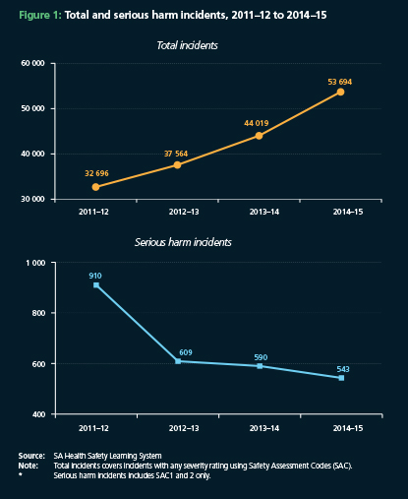In 2015, 98% of respondents to a Commission survey reported having an AMS program, compared with 36% before the NSQHS Standards **(see Figure 2)**.

## Pressure injuries – NSQHS Standard 8

Pressure injuries are a known and largely preventable complication associated with immobility and extended bed rest. The NSQHS Standards require health service organisations to screen patients for their risk of pressure injuries and, for those at risk, to conduct a comprehensive risk assessment and regular skin assessments.

A pressure injury management plan should be prepared and implemented if appropriate.

### Auditing of timely assessment

A survey of private hospitals found that in

2010, before the NSQHS Standards were introduced, less than 30% of respondents reported routinely auditing timeliness of pressure injury risk assessment. By 2014, these audits were reported as being routinely performed by all respondent hospitals **(see Figure 3)**.

# SPOTLIGHT: Improved awareness of surgical adverse events–clinical governance and audits of surgical mortality

The Australian and New Zealand Audit of Surgical Mortality (ANZASM) collects data from surgical mortality audits conducted in each state and territory. The aim of the audits is to identify system or process errors, which can highlight priorities for improvement. Reports on national audit results have been published since 2009.

The ANZASM has broad participation, and in 2014 included 97.5% of surgeons, 100% of public hospitals and 97.5% of private hospitals.

## What has changed since the introduction of the NSQHS Standards?

The Royal Australasian College of Surgeons (RACS) has recently produced clinical governance reports for individual hospitals, which include data on surgical mortality, potentially preventable deficiencies of care identified by peer review, and comparisons with state and national data for similar hospitals.

“We were collecting all this data for educational purposes, and with the clinical governance reports we are giving the hospitals something they can use practically.” – Professor Guy Maddern, Chair, ANZASM Steering Committee.

The RACS has also produced a smartphone app that allows ANZASM de-identified national case note reviews to be searched and cross-referenced against items in the NSQHS Standards.

Current cases highlight clinical lessons related to healthcare-associated infections, medication safety, pressure injuries, falls, clinical handover and recognising clinical deterioration.

## What prompted the change?

The reports support action 1.2.1 of the

NSQHS Standards: ‘Regular reports on safety and quality indicators and other safety and quality performance data are monitored by the executive level of governance.’

“The reports were very much influenced

by the Standards – we were looking

for a way our data could be made more use of, and there is no doubt that hospitals are pursuing ways to satisfy the Standards. Giving them the information in a form that helps hospitals satisfy Standard 1 meant they were more likely to support it and make use of it.” – Professor Guy Maddern.

## How are the reports being used?

The first series of clinical governance reports was delivered to hospital CEOs, directors of surgery, and managers of safety and quality in late 2014 and early 2015.

“The reports talk about your hospital and your peers as well as national data, and this gives an assurance to hospital executives.” – Ms Michele McKinnon, Director, Safety and Quality, SA Health.

The reports are also delivered to state and territory health departments, allowing a jurisdictional view of patterns in surgical mortality.

“We had broad mortality data before this report, but not this level of detail.

We find it invaluable because now we can see what we should target with quality improvement activities such as grand rounds and webinars. The reports are telling us a story about our care, and this gives opportunities for quality improvement rather than blame.” – Ms Michele McKinnon.

### GraphGraphAssessment and management

In Queensland’s public hospitals, the percentage of patients assessed for pressure injury risk on admission rose from 71% to 82% between 2011 and 2014 **(see Figure 4)**.

## Recognising and responding to clinical deterioration in acute health care – NSQHS Standard 9

Before a patient goes into cardiac arrest, there are often changes in the person’s vital signs, such as their blood pressure and respiratory rate. Putting systems in place to recognise these signs of deterioration can help prevent cardiac arrest and other serious outcomes.

Surveys conducted by the Commission in 2010 and 2015 highlight improvements in the recognition and response systems reinforced and supported by NSQHS Standard 9. In 2015, substantially more hospitals had established recognition and response systems, including early warning or track-and trigger tools **(see Figure 5).** Similarly, in 2010, only 18% of hospitals reported that their rapid-response systems could be activated by patients, families and carers. By 2015, this had more than trebled to 56% **(see Figure 5)**, supported in some jurisdictions by statewide programs such as the Patient and Family Activated Escalation (REACH) program in New South Wales (which empowers patients and families to escalate care if they are concerned about the condition of the patient) and Ryan’s Rule in Queensland (which provides an avenue for patients, families and carers to seek help for a patient whose condition is causing them concern).

In Queensland, the proportion of public hospital patients that had a complete set of core observations recorded rose from 53% in 2011 to 81% in 2014. An appropriate chart was in place to record those observations for nearly 100% of patients in 2014 **(see Figure 6)**.

All these results suggest that NSQHS Standard 9 has improved practices for recognising and responding to clinical deterioration in hospitals. Over 80% of respondents to the 2015 Commission survey agreed that the NSQHS Standard had had a positive impact.

## Preventing falls and harm from falls – NSQHS Standard 10

Falls are a significant safety issue in health care, and prevention of harm from falls is the primary aim of NSQHS Standard 10. Falls prevention has been a long-standing concern in hospitals, as shown by the high rate of monitoring falls in private hospitals since 2010 **(see Figure 7)**.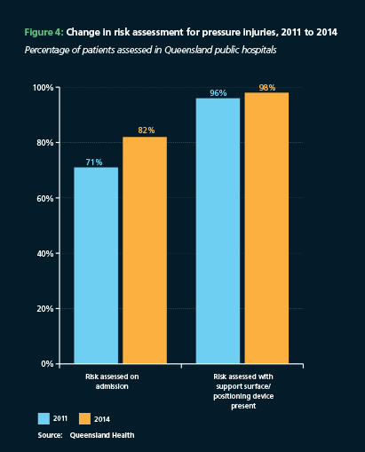Graph
Graph


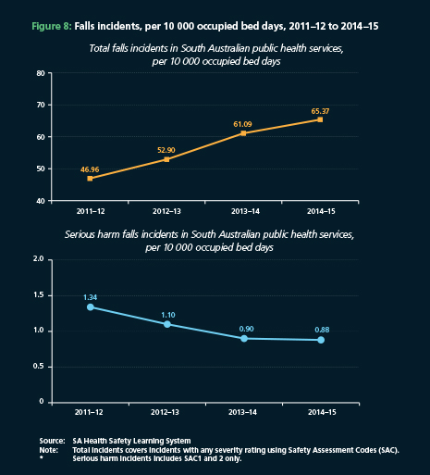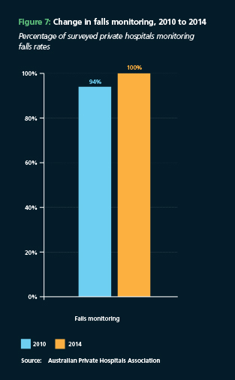

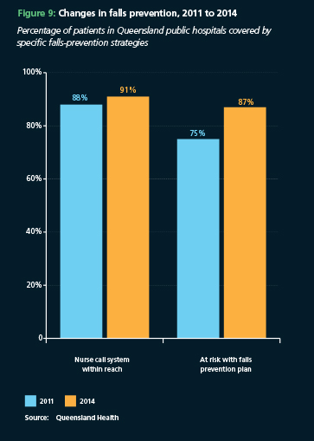In South Australia, health service staff are supported to report all the falls and near misses that occur. While the reporting of falls incidents has increased with time, the rate of falls involving serious patient harm has decreased from 1.34 to 0.88 per 10 000 occupied bed days since the NSQHS Standards were introduced **(see Figure 8).**

In Queensland, the percentage of at-risk patients for whom falls-prevention plans were conducted rose from 75% in 2011, before the NSQHS Standards were introduced, to 87% in 2014 **(see Figure 9)**.

## What the Commission will do next

The Commission will continue to support implementation of the NSQHS Standards by developing a range of measures to support safety and quality improvement.

To help health service organisations apply the standards, they need guides that can explain and provide examples of ways that they can introduce improvements. A series of Safety and Quality Improvement guides are being prepared for hospitals, day procedure and other health services. There are also fact sheets for consumers and clinicians.

To help clinicians and managers access information quickly and easily, the Commission will provide suitable resources, information and tools to help implement the NSQHS Standards. Information sessions, training tools and communication resources will be made available to assist health service organisations inform and engage their workforce in the use of the NSQHS Standards.

The Commission is also planning to provide training for assessors from each accrediting agency. It is the assessors’ job to examine the safety and quality systems that health service organisations have in place. The training will ensure that each assessor has the same understanding of what is required when they assess a health service.

By 2019–20, health service organisations in a range of sectors and settings will be implementing and being assessed against version 2 of the NSQHS Standards. This can be expected to improve outcomes further for patients, with an associated reduction in adverse events. Version 2 of the NSQHS Standards will have an increased focus on integrated systems of governance to support best possible clinical outcomes, organisational safety culture and professional accountability, and a new national model clinical governance framework is being developed. Health service organisations will be expected to partner with consumers in governance processes, and version 2 of the NSQHS Standards will help embed partnerships between patients and health care providers in health care systems.

Version 2 of the NSQHS Standards will continue to emphasise systems to improve patient safety in key areas such as the prevention of healthcare-associated infections and recognition and response to acute deterioration. They also include new areas that will further improve safety for patients. In particular, a new NSQHS Standard about comprehensive care has been added that includes recognition and care of people with dementia and deliriums.

The Commission will provide resources, training and support to help organisations meet version 2 of the NSQHS Standards, and will monitor the implementation and effectiveness of version 2 of the NSQHS Standards.

# Governing to ensure your care will be safe

“If you or a loved one is having a heart attack, your most pressing concerns probably include how quickly you can get to the hospital and the quality of care you’ll receive. You’re probably not thinking about the hospital’s board room, even though quality of care for heart attacks and many other conditions may be determined in large part by decisions made there.”

– The New York Times, 15 February, 2015.4

Boards of health service organisations, like the boards of all organisations, are responsible for corporate governance. In a health service or health facility, this is the system of practices and processes that control the operation of the service. Governance determines how health services are delivered, and it has a direct impact on the safety and quality of care.

The board has ultimate responsibility for the governance of clinical care within the health service organisation. It is responsible for ensuring that effective safety and quality systems and robust organisation-wide governance practices are in place; that safety and quality is monitored; and that the organisation responds appropriately to safety and quality problems when they occur. Clinical governance is an integrated component of corporate governance of health service organisations. It encompasses the systems by which health service organisations, from boards to frontline clinicians, account to patients and the community for assuring the delivery of safe, effective, consistent and patient-centred health care, and for continuously improving the safety and quality of health services.

## Boards and the NSQHS Standards

To help boards carry out their function in relation to patient safety, the Commission developed a specific NSQHS Standard. ‘Standard 1: Governance for safety and quality in health service organisations’ requires the leaders of health service organisations to implement governance systems to set, monitor and improve the performance of their organisations, and to communicate the importance of the patient experience and quality management systems to all members of their workforces.

## How does a board do this to ensure that your care will be safe?

Boards and management must ensure that the facilities are appropriate for their intended purposes, that they are built to an acceptable standard and that they are equipped with technology that allows clinicians to achieve the best possible outcome for all patients under their care.

Boards need to ensure that the staff employed within the organisation are appropriately trained, are sufficient in number, and possess the necessary skills to safely carry out any procedures for which they have appropriate credentials. Boards oversee the appointment and performance of their chief executives, who, together with members of the management teams, are responsible for the day-to-day management of their health service organisations and for the design and implementation of safety and quality systems.

The framework that delivers the assurance to the board that the services the organisation provides to patients are safe is known as the clinical governance framework.

## Guide for boards

Feedback that the Commission has received from the states and territories and assessors indicated that boards, and management, welcomed advice on how to establish a clinical governance system. In response, the Commission published a guide for boards to use in exercising their governance responsibilities and accountabilities, specifically with reference to the implementation of the NSQHS Standards. Broadly, the guide suggests that board members:

* see themselves as institutional champions of safety within their facilities
* familiarise themselves with the risks inherent in the delivery of health care, both generally and within their particular service
* ensure that management has in place strategies to mitigate these risks
* monitor the performance of the organisation and receive feedback from a range of sources, including consumers.

At a more detailed level, the guide advises board members about:

* committees or groups to address issues in detail
* such as audit and risk, advice from consumers and feedback on clinical processes and outcomes
* comparing their facility’s performance against that of other like facilities
* policies, procedures and guides
* setting goals
* resourcing issues, including the number, training and qualifications of staff; the maintenance of buildings and equipment; the timely provision of supply items; the cleanliness of the environment; and the standards of those who provide services to the organisation.

# Part Two

WILL I GET THE RIGHT CARE?

Ensuring that best-practice approaches are applied at the point of clinical care provision is an aspect of the Commission’s work – making sure that people get the right care.

The Commission explores whether clinicians have the right information to assist in providing appropriate care to patients. It also examines if this knowledge is being applied, and if not, why not.

This section of *Vital Signs 2016* looks at the part of the Commission’s work that focuses on ensuring people get the right care in a range of clinical areas, including understanding resistance to and appropriate use of antibiotics in Australia, and supporting the safe use of online health resources.

# Antimicrobial resistance and appropriate use of antibiotics

Antimicrobials are medicines designed to kill or slow the progress of infections, especially those caused by bacteria and fungi. There are many kinds of antimicrobials; the most common are antibiotics for treating bacterial infections. There are also antifungals, antivirals and anti-parasitics. These antimicrobials are essential to modern medicine.

However, antimicrobials are losing their effectiveness because many organisms that were once successfully treated by antimicrobials have become resistant to them. Some organisms have become completely resistant to many different antimicrobials. This phenomenon is known as antimicrobial resistance (AMR).

The development of resistance is a natural feature of bacterial evolution. However, as a community, we have been contributing to AMR by using antimicrobials too often, when they are not needed, or for the wrong types of infection. Resistance is spreading; once thought to be a problem only in hospitals, it is now found just as often in the community.

AMR is a significant healthcare issue that can result in medical treatments becoming more complex and expensive, and in some patients needing to stay in hospitals longer. Some people may die because they have infections that can no longer be treated. Many health organisations around the world, including the World Health Organization, recognise AMR as a major threat to public health affecting every country.5 Australia is no exception.

The Commission’s Antimicrobial Use and Resistance in Australia (AURA) Surveillance System, funded by the Australian Government Department of Health, will help prevent and slow the progress of AMR by increasing understanding of how antimicrobials are being used, and of patterns and trends in AMR.

## What is Australia doing to fight AMR?

In Australia, laboratories and surveillance programs detect and monitor AMR. Hospitals, residential aged-care facilities and some parts of the community use audit tools and systems to monitor antimicrobial use and its appropriateness. While these programs provide valuable surveillance data, a nationally coordinated approach was needed so that policy makers could see a clearer picture. The AURA Surveillance System, and the Commission’s work more broadly, supports a number of the objectives of the *National Antimicrobial Resistance Strategy 2015–19*.6

The Commission has been working with a range of partners to expand coverage by increasing the number of hospitals and laboratories that contribute data. It is also working to enhance analysis and reporting to system users, and will establish new systems where information gaps need to be filled.

## Graph

## AURA Surveillance System program partners

* Australian Group on Antimicrobial Resistance
* National Centre for Antimicrobial Stewardship: National Antimicrobial Prescribing Survey
* South Australia Health National Antimicrobial Utilisation Surveillance Program
* National Neisseria Network
* National Notifiable Diseases Surveillance System
* NPS MedicineWise MedicineInsight Program
* Australian Government Pharmaceutical Benefits Scheme and Repatriation Pharmaceutical Benefits Scheme
* Queensland Health OrgTRx system
* Sullivan Nicolaides Pathology, Brisbane
* Mater Misericordiae Health Services, Brisbane
* States and territories.

## The *First Australian Report on Antimicrobial Use and Resistance in Human Health*

The Commission has released the *First Australian Report on Antimicrobial Use and Resistance in Human Health (AURA 2016)* using data from the AURA Surveillance System.a[1]

*AURA 2016* focuses on resistance rates for organisms that have been identified as priority organisms in Australia. If these organisms develop high resistance to the ‘last-line’ antimicrobials, it is likely that there will be significant increases in morbidity and mortality rates.

Of the priority organisms, one of the *Enterococcus* species is most resistant to antimicrobials. *Enterococcus* species are opportunistic pathogens that cause a range of infections in patients whose immune system is already compromised due to surgery or invasive devices.

The proportion of *Enterococcus faecium* strains that are resistant to the antimicrobial vancomycin is almost 50% – one of the highest rates in the world. Resistance to ampicillin was even higher in this species, at about 90% **(see Figure 11)**.

These resistances have a major impact on seriously ill patients in hospital and require significant efforts and investment of resources by hospitals to control their spread.

There are variations between the states and territories for specific types of resistant organisms. For example, in 2014, the overall rate of resistance for methicillin-resistant *Staphylococcus aureus* (MRSA) ranged from 3.8% in Tasmania to 42.2% in the Northern Territory **(see Figure 12)**.

## What does *AURA 2016* say about antimicrobial use in Australia?

In 2014, 46% of the Australian population were prescribed antimicrobials in the community, which is high by international standards **(see Figure 13)**.

In hospitals, 23% of antimicrobial prescriptions were deemed to be in appropriate, most commonly because the antimicrobial was not indicated in the patient medical chart, the spectrum was too broad, the duration of treatment was incorrect, or the dose or frequency was incorrect.

In residential aged-care facilities in 2014, a pilot study found that 11.3% of residents were on antimicrobial treatment, but only

4.5% of residents had suspected or confirmed infections. Further work will be undertaken in conjunction with stakeholders to better understand this issue and promote more appropriate prescribing in these facilities.

## CARAlert

Eight types of resistance to antimicrobials, which are currently uncommon, but have the potential to increase and become a major health care problem, are being monitored through the AURA

Surveillance System using CARAlert – the national alert system for critical antimicrobial resistances.

CARAlert collects data from a network of laboratories around Australia and sends alerts on confirmed critical AMR to health departments for action, where necessary. CARAlert also produces regular reports to inform states and territories of further detail on these critical resistances.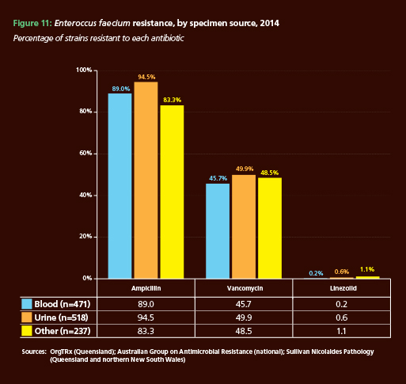

## Priority organisms for AURA Surveillance System

* Enterobacteriaceae
* Enterococcus species
* Mycobacterium tuberculosis
* Neisseria gonorrhoeae
* Neisseria meningitidis
* Salmonella species
* Shigella species
* Staphylococcus aureus
* Streptococcus pneumonia.

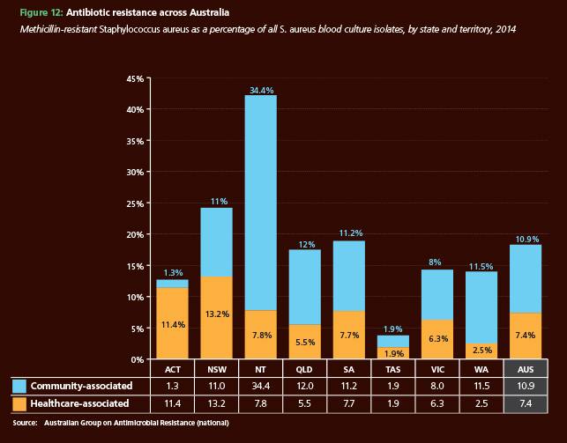

## GraphWhat the Commission will do next

The Commission will continue to improve the AURA Surveillance System by expanding the number of hospitals and pathology laboratories contributing data, and the number of organisms under surveillance. This will provide data and information to clinicians and policy makers to better inform strategies and programs to prevent and contain AMR.

While the availability and accuracy of data is critical, these data must lead to action. For example, hospitals and healthcare facilities can use the reporting from the AURA Surveillance System to monitor trends in their local antimicrobial use, appropriateness and AMR. The information can be used to inform and enhance their infection prevention and control programs and antimicrobial stewardship programs. Governments and healthcare organisations can also use the information to inform policy and influence change. The Commission will use the AURA program to inform and support these activities.

# Medicines, digital health and clinical safety: making sure technology supports clinicians to provide safe care to consumers

Medicines are the most common treatment used in health care and contribute to significant improvements in health when used appropriately.

However, medicine use can also be associated with harm, and the high use of medicines means they are associated with more errors and adverse events than any other aspect of health care.

While rates of serious harm are low, errors do affect health outcomes for people and increase healthcare costs. For example, medication related hospital admissions in Australia account for about 2% to 3% of all admissions.7

The prevalence of medication errors is of particular concern because most of these errors are preventable.

In order to improve the safety and quality of medicine use, we need to know how adverse medication events occur and how they can be prevented. This is true both at the level of individual practice and within systems for managing medicines.

New technologies offer a promising avenue for improving medication safety. The role of digital health in this regard will be fundamental.

There are clear benefits to implementing digital health systems that could reduce errors. For example, an electronic medication management (EMM) system can help reduce the frequency of medication-associated hospital admissions by:

* improving the legibility of medication information8
* providing warnings to prescribers regarding adverse reactions with existing conditions or other medications the patient is taking.

In addition, the increasing utilisation of the My Health Record system is also likely to help reduce medication errors and improve health outcomes.

However, the rapid uptake and use of digital health systems can also cause new risks to clinical safety.9 The risks and the benefits of digital health must be balanced. The introduction of these systems needs to be accompanied by measures that ensure they are safe and are used in a way that protects patients. Steps being taken by the

Commission to contribute to the safe use of digital health systems are discussed below.

## Safety issues with the use of digital health

Clinical safety needs to be built into the planning and development phases of any system rollout if risks to patients are to be minimised. For example, hardware, software and the networks underpinning digital health systems must be robust and must recover quickly from breakdowns and failures with minimal impact.

Digital health systems also need to be usable by and intuitive for clinicians. For example, a poorly designed interface might not display important clinical information in a manner that a clinician would expect, leading to an incorrect interpretation of patient data.

Once digital health systems are in place and in use, ongoing, proactive monitoring to identify clinical safety issues that may arise is essential.

Also, there are standard issues that affect all systems. These include system failures (often measured as down time), lack of system backup and integration problems between connected systems. For example, a hospital patient administration system and its electronic medical record system might not be set up to share information for the same patient.

## My Health Record system

The Commission has been appointed by the Australian Digital Health Agency to provide a clinical safety oversight program for the My Health Record. The Commission supports efforts by the Australian Digital Health Agency, as the system operator, to enhance the clinical safety of the My Health Record system by undertaking clinical safety reviews. Recent review topics have included:

* examining the impact on clinical workflows as a result of emergency department clinicians using the My Health Record system
* identifying potential improvements to the My Health Record system for safer decision-making and to promote broader uptake by clinicians
* advising on how to embed more clinical useability-testing into new releases of the system.

The Commission also provides clinical safety advice for consideration when new My Health Record system functionality is being planned and developed.

When potential clinical safety issues are identified involving the My Health Record system, these are escalated to the Commission by the system operator. The Commission reviews the issues with expert users, and if necessary, conducts a formal investigation, to identify factors contributing to these issues, and to recommend ways to improve the system.

The Commission has developed a clinical incident management framework for the My Health Record system, to support a more structured and evidence-based approach to clinical incident management. The framework puts in place a process to rapidly identify, escalate and investigate clinical incidents that arise.

The Commission has also reviewed the processes in place to assess clinical software systems for conformity with clinical safety requirements before those systems can connect to the My Health Record system.

To support the My Health Record system and to drive the broader national digital health safety agenda, the Commission has published national guidelines for safe on-screen presentation of medicines. These guidelines aim to increase the ability of clinicians to clearly and safely interpret this data when using clinical information systems in routine patient care.

Similarly, the Commission has also developed guidelines for the safe on-screen presentation of discharge summaries. These guidelines identify what information is critical for readers, and how to present this information in a clear and precise manner for appropriate handover of care.

## What the Commission will do next

The Commission will continue its My Health Record clinical safety program and will support the new Australian Digital Health Agency as the system operator. The Commission will also continue its broader digital health safety functions, and has commenced:

* a literature review on best practice management of digital health safety incidents to understand what is happening internationally
* consultation and a literature review to inform the development and publication of the third edition of the guide to safe implementation of hospital EMM systems
* development of a self-assessment tool for hospitals where EMM is implemented.

# Part Two

WILL I BE A PARTNER IN MY CARE?

The Commission supports the right of people to be partners in their health care. It is a priority for the Commission to have a health system in which patients, consumers and members of the community participate with health professionals as partners in all aspects of health care.

Bringing together the two perspectives of consumers and clinicians to form this partnership can be challenging. Many clinicians are very busy and may question how much time they will need, while consumers may not understand how they can effectively contribute to their own health care.

The Commission has provided tools, strategies and approaches to support all involved in healthcare provision to form effective partnerships. It is working to make the health system easier to understand for consumers, so they can be in a better position to form a true partnership.

This section looks at some of the Commission’s research around the patient experience, and looks at health literacy and how it affects partnerships, as well as good examples of effective partnerships.

# What do Australians want and need during a hospital stay?

“When someone acknowledges us, or listens to us, or comforts us, or explains things to us, it’s so much better … we just feel better because someone has cared for us” – Consumer, WA.

In an Australia-first study conducted in late 2015, the Commission asked 86 consumers and carers what a good experience of hospital meant to them. These people came from all over Australia, from diverse backgrounds and different generations, and had varied experiences of health care. Over the course of 17 in-depth group discussions, the Commission found that people very clearly knew what they wanted and needed when they used the health system.

Some needs and preferences appeared to be simple or obvious. People wanted to be treated like a person – not like an object, a collection of vital signs, a disease, or a body part. They wanted their concerns to be taken seriously, not dismissed. They wanted to be told what was happening, not be kept in the dark. They wanted their expertise about their own body and their own illness to be respected. They wanted to be free from harm and to feel safe and secure.

Importantly, the Commission learned that even when a health professional or service did not meet a person’s needs or expectations, or when a mistake had been made, this did not necessarily leave the patient with a poor experience. Honest and clear explanations and disclosures could make mistakes a less negative experience.

## The 20 dimensions of a positive patient experience

Many of the dimensions of a positive experience related to how a person was treated. Consumers did not only see their ‘treatment’ in terms of what medication they were given or the type of surgery performed, but also in terms of the attitudes and behaviours of health professionals displayed during interpersonal encounters.

These 20 key dimensions can be grouped into four types of interaction that a person has with a health service **(see Figure 14)**. The dimensions most often mentioned by the study participants were aspects of interpersonal encounters with health professionals and other staff members (including being heard and being informed), and the quality and safety of clinical treatment and procedures (including concerns about mistakes, infection control practices, and staff skill in basic procedures such as cannula insertion).

“I feel comforted by the fact that somebody is telling me this is what’s going on. This is what we’re doing. You might have to be in for a little bit longer. I just find that that sort of feeling – like you’re a part of your care – is really important to me and – feeling like you’re a human being.” – Consumer, ACT.

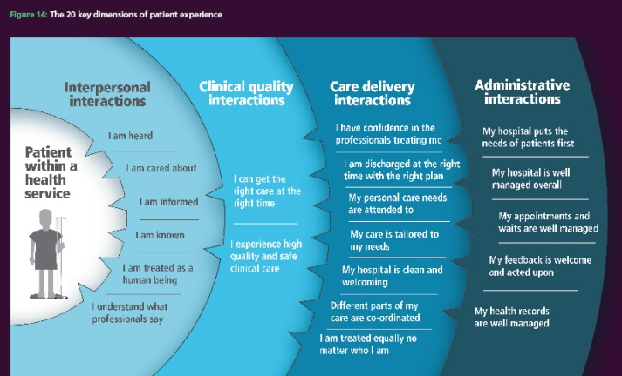

“I was there actually to have an operation on my left eye. The form said right eye. So I thought okay. So I said look, I think there’s an error here. There is an error here. It’s my left eye, not my right eye. Oh okay, we’ll just check the doctor’s letter. So she went to the doctor’s letter and it definitely said left eye.” – Consumer, SA.

Consumers said that their experiences were influenced by care design and delivery – the organisation of care and the way it was delivered to them (including coordination of care), and also by their impressions of the priorities and administrative processes of the hospital more generally (including responsiveness to complaints).

“Throughout the whole thing, everyone looked at their little bit of the puzzle, whether it’s been surgery or chemo or physio or whatever; very few of them have looked at the whole person to say, well this girl is really struggling right now.” – Consumer, NSW.

“I had an amazing response [to my complaint], which I was actually thrilled about. They’re actually having me back to talk to the ward staff next in a couple of weeks’ time about what happened.” – Consumer, NSW.

The 20 dimensions of a positive patient experience identified in the study reinforce the findings of other research with Australian patients. A recent review of factors influencing a positive or negative experience in hospital assessed 39 Australian studies and found the following seven issues to be the most commonly occurring influences on the quality of experience:

* reciprocal communication and information-sharing
* interpersonal skills and professionalism of staff
* the care environment
* correct treatment and physical outcomes
* emotional support
* comfort, pain and clinical care
* discharge planning and process.

That review and the Commission’s study, supported by previous research, offer a comprehensive articulation of what Australian patients want and need from their healthcare stay. The Commission’s findings add to other studies by showing that while patients are most interested in the interpersonal and clinical aspects of their stay, the organisation of their care and their impression of a hospital’s priorities are also vital to a satisfactory patient experience.

## Innovative examples of patient experience improvement

Here are three examples of innovative approaches to the collection and use of patient experience information.

### NSW Agency for Clinical Innovation

Many people have chronic or complex conditions that mean they have to see many different health professionals and services. Most approaches to assessing experiences are limited to one episode of care; for example, patient surveys most commonly ask about one stay in hospital, one day procedure or one attendance at an outpatient clinic. They therefore do not capture a patient’s entire experience of transition between services. These transitions are especially important for the increasing number of people with chronic conditions. In contrast, the Agency for Clinical Innovation in NSW is piloting interventions to improve the integration of care across primary care and hospital sectors. This means different organisations are working together to ensure that a person’s experience of their care is like a seamless pathway, rather than a disjointed series of visits to services, which do not talk to one another. To assess whether this is working or not, a patient-centred evaluation is being conducted across 10 sites. This is innovative in trying to measure patients’ experiences between as well as within services. It is also innovative in asking patients about their health outcomes after treatment as well as their experiences of care.

### SA Health

Patients’ experiences are traditionally assessed using telephone interviewing or written questionnaires. This means that many people cannot have their say because of language barriers, cognitive impairment or literacy skills. In South Australia, an innovative pilot program is testing a novel way of asking vulnerable and disadvantaged populations about their healthcare experiences. The program is using tablet computers and trained interviewers to ask people what they think. The questions are asked on the tablet using pictorial methods such as a cartoon character called Fabio the Frog, accompanied by audio in the appropriate language.

### Eye-tech Day Surgeries

One day hospital in Queensland, operated by Eyetech Day Surgeries, routinely invites a consumer to tell their story to healthcare professionals at the beginning of staff meetings. The staff then discuss what changes, if any, the hospital could make to improve their service. A record is kept of consumers’ suggestions along with actions taken by staff in response. This helps ensure continuous quality improvement and staff development.

## Fabio the Frog What the Commission will do next

The Commission will continue to support services in all states and territories and across public and private sectors to improve the quality of their patients’ experiences. In particular, the Commission will build a set of questions for national use. These questions will enable services and governments to access patient perspectives in a consistent way all over the country. The question set will be tailored to the concerns of Australian consumers, health professionals and policy makers. It will be capable of producing information that will drive quality and safety improvement at ward, organisation and regional levels.

# Understanding health literacy

A person’s level of health literacy reflects the degree to which they understand information about health and health care, how they apply that information to their lives and how they use it to make decisions and act on them.

About 60% of adult Australians have low health literacy.14 The combination of low levels of health literacy in the population and the demands from an increasingly complex health system can have a significant impact on individual health outcomes and the safety and quality of health care.

There are two components to health literacy: individual health literacy, and the health literacy environment.

Individual health literacy can be understood as the skills and knowledge of a person, and their capacity and motivation to access, understand, appraise and use information to make effective decisions about their health and health care. Individual health literacy is dynamic and can change depending on issues such as stress, illness and life course. It is influenced by the environment and by a person’s upbringing. In some cases, the likelihood of lower individual health literacy is increased where disadvantage and vulnerabilities intersect.

The health literacy environment is the combination of infrastructure, policies, processes, materials, people and relationships within the health system that make it easier or more difficult for consumers to navigate, understand and use. The complexity of the health literacy environment influences how consumers make decisions and take action about health and health care.

Addressing health literacy has the potential not only to improve the safety and quality of health care, but also to increase equity and to reduce health disparities.

## Health literacy is important for effective partnerships

Partnerships at all levels of the health system are needed to reach mutually beneficial outcomes. Care that is based on partnerships provides many benefits for patients, consumers, clinicians, health service organisations and the health system. For partnerships to work effectively, everyone involved in the partnership needs to be able to give and to receive, interpret and act on information. Health literacy is fundamental to these relationships and processes.

There are different types of partnerships within the health system. At the level of the individual, partnerships relate to the interaction between health professionals and patients when care is delivered. Such partnerships involve providing respectful care, sharing information and supporting patients, carers and families to plan care and make decisions about their own care.

Partnerships also operate at the service level, where patients, carers, families and consumers participate in governance, policy and planning in areas such as patient safety, service and facility design, evaluation and quality improvement.

A focus on health literacy is one way of ensuring that patients, carers, families and consumers can participate fully in partnerships at all levels of health care provision.

## A national approach to health literacy

The Commission’s *National Statement on Health Literacy*, endorsed by all Australian health ministers in 2014, represents a coordinated national approach to addressing health literacy. It identifies three types of action needed for this to occur **(see Figure 15)**:

* embedding health literacy into systems – this involves developing and implementing systems and policies at an organisational and societal level that support action to address health literacy
* ensuring effective communication – this involves providing print, electronic or other communication that is appropriate for the needs of consumers, and also involves supporting effective partnerships, communication and interpersonal relationships between consumers, healthcare providers, managers, administrative staff and others
* integrating health literacy into education – this involves education of consumers and healthcare providers.

While recognising that everyone has a part to play in addressing health literacy, people and organisations working in the health system have a special responsibility to ensure that the health literacy environment makes it as easy as possible for patients, carers, families and consumers to access, understand and act on health-related information. This includes communicating with consumers in a way that supports safer care and better health outcomes.

## A focus on the health literacy environment

A range of tools is available to measure individual health literacy levels. However, these tools often focus on different elements and there is no one tool that is universally accepted. It may also not be practical or useful to try to assess the health literacy of every person within the timeframe of a consultation.

The Commission supports a ‘universal precautions’ approach to health literacy that works on the assumption that it is not possible to know a person’s level of individual health literacy without performing an assessment, which may not always be practical or desirable during an episode of care. It therefore assumes that there will be barriers to understanding and that there is a need to reduce the complexity of information and services that are provided.

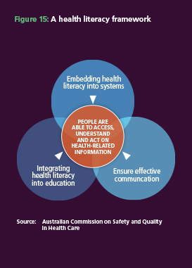Taking steps to make the health literacy environment more friendly to consumers, and to reduce unnecessary demands on people who interact with the health system, should improve the experiences of the health system for patients, carers and their families.

## How can the health literacy environment be influenced?

Several tools now exist, and others are being developed, that can be used to assess the health literacy environment of individual healthcare organisations.

There are several core components of the health literacy environment that can be reviewed and improved to make it easier for people to navigate, understand and use health services. These include:

* navigation and way-finding, such as telephone systems, signage, maps and reception areas
* print communication, including writing style and use of appropriate illustrations • oral communication, such as staff offering to help with filling in forms and healthcare providers checking that they have explained information in a way that consumers understand
* technology, such as the availability and functionality of televisions, telephones, computers, web pages, apps, online tools and kiosks
* policies and protocols, such as development of consumer-focused publications, staff orientation and ongoing training.

Investing in understanding a consumer’s experience of these components is a useful method to highlight where improvements may be needed. Strategies may target different points of the consumer journey: before they enter the health service organisation, when they arrive, and during and after their visit.

## Assisting health service organisations to improve their health literacy environment

To support local action, the Commission developed a series of fact sheets to help health service organisations improve their health literacy environment. These resources align with the actions in the *National statement on health literacy: Taking action to improve safety and quality* with a focus on:

* policies and procedures to support health literacy
* navigation and way-finding to support health literacy
* supporting the healthcare team to support health literacy
* developing, assessing and improving consumer information.

The Commission has also been active in continuing to raise awareness about health literacy, particularly through channels relevant to health professionals such as conferences, workshops and professional education events. This has involved the use and distribution of a suite of health literacy infographics and resources for clinicians and health service managers.

A fact sheet was also published to explain how actions in the NSQHS Standards relate to health literacy and some of the health literacy strategies that could be considered as health service organisations put systems in place to meet the NSQHS Standards.

## What the Commission will do next

The need to provide care that is based on partnerships and aligns with the expressed preferences and needs of consumers underpins all of the NSQHS Standards. These standards are currently being revised, and version 2 will place greater emphasis on partnerships with consumers.

Improving health literacy ensures that consumers can fully participate in partnerships with healthcare providers, and that the health system and healthcare organisations are oriented to support such partnerships. Version 2 will ensure that Australian health service organisations communicate with consumers in a way that supports effective partnerships, and will work to embed health literacy into the organisation’s systems.

The Commission will also develop a scoping paper to consider approaches that the Commission could take to foster improvements in the quality of health information for consumers in Australia, including looking at options for national guidance or standards.

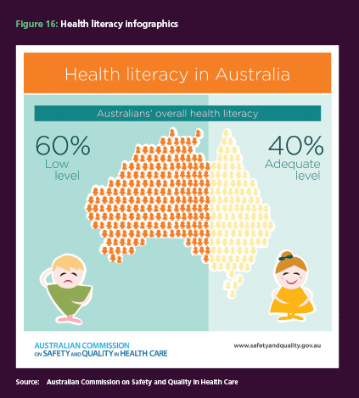

# Part Four

CASE STUDIES

Three case studies are included that provide an insight into the state of safety and quality in the Australian health care system, including some work that the Commission has been leading.

A highlight of the Commission’s work during the past year has been the development and launch of the first edition of the *Australian Atlas of Healthcare Variation*. This atlas is the result of years of work gathering and analysing data. It presents clear evidence of the variation in health care around Australia.

It will be an invaluable tool in years to come for policymakers, planners and health care managers to note the variation, to see if there are good reasons for it to exist, to think about the consequences for consumers of that variation and, if appropriate, to address it. Used wisely, the atlas could be an important tool in efforts to address inequalities in health care. This section contains a case study relating to the landmark atlas work.

There are two other case studies: one of which addresses the evidence of the benefits of clinical quality registries, while the other focuses on efforts to protect children and adolescents from the potentially harmful effects of unnecessary computed tomography (CT) scans.

# Case Study 1: *Australian Atlas of Healthcare Variation*

Modern medicine is characterised by an increasing expectation that people will receive care that is evidence-based. Despite this expectation, the safety and quality of health care varies, both across geographic areas and among individual clinicians.

Understanding this variation is critical to improving the quality, value and appropriateness of health care. Some variation is desirable and warranted: it reflects differences in people’s need for health care. But where variation is unwarranted, it signals that people are not getting appropriate care. Examining variation is an important first step in identifying and addressing unwarranted variation.

The Commission has collaborated with the Australian, state and territory governments, specialist medical colleges, clinicians and consumer representatives to develop the Australian Atlas of Healthcare Variation. For many years, Australia has been reporting on aspects of healthcare variation for performance and statistical purposes at both state16 and national levels.17, 18, 19 This is the first time that data from the Medicare Benefits Schedule (MBS), Pharmaceutical Benefits Scheme (PBS) and Admitted Patient Care National Minimum Data Set (APC NMDS) have all been used to explore variation across different healthcare settings. In addition, this is the first Australian atlas in which healthcare variation across the country has been presented alongside national recommendations for action.

We now have a clear picture of substantial variation in healthcare use across the country, and across many areas of health care. Some of this observed variation will be warranted and associated with need related factors such as underlying differences in the health of specific populations, or personal preferences.

However, the weight of evidence in Australia and internationally suggests that much of the variation documented in the atlas is likely to be unwarranted.20 It may reflect differences in clinicians’ practices, in the organisation of health care, and in people’s access to services. It may also reflect poor-quality care that is not in accordance with evidence-based practice. This unwarranted variation may mean that some people are missing out on health care that could have helped them– such as cataract surgery – while others are having interventions that are unlikely to be of benefit. Overuse of some interventions, such as unnecessary antimicrobials, may cause harm. Recognition is growing internationally that more health care is not necessarily better health care.

The atlas has identified opportunities for improving the health care that Australians receive. Importantly, it identifies a number of geographic and clinical areas where marked variation in practice is occurring. The important relationship between socioeconomic disadvantage and illness is reflected in many of the findings. In socioeconomically disadvantaged areas, people tend to have poorer health and thus a greater need for health care. People in disadvantaged areas may also have less access to healthcare services, which can compound the existing disadvantage. For example, one reason for the variation in the dispensing of psychotropic medicines may be a lack of access to affordable, accessible mental health services in rural or disadvantaged areas, with limited availability of psychosocial interventions as alternatives to medical treatments.

Some interventions are used more in areas of higher socioeconomic status, or are mainly provided in private settings. These are therefore less accessible for people who do not have private health insurance. For example, rates of cataract surgery are lowest in areas of low socioeconomic status and increase with rising socioeconomic status. The atlas suggests that it would be worthwhile examining this issue further by looking at provision in both the public and private sectors and the extent to which variation in interventions for some conditions is linked to access to private health insurance.

In addition to the general theme of socioeconomic status and equity, specific issues relate to the health of Aboriginal and Torres Strait Islander peoples. The findings add to the weight of evidence about the urgent need to address the determinants of Indigenous health inequality. Given the importance of improving the health and wellbeing of Indigenous people, unwarranted variation is unacceptable. It is vital that efforts to address unwarranted variation prioritise this population’s needs and concerns.

While the atlas highlights variation in a range of different procedures and treatments, it does not provide information about what the ideal rates for these interventions should be. The average rates displayed in the atlas are not necessarily the ideal; and high or low rates are not necessarily good or bad. More work is needed to assess the outcomes of interventions, to help identify appropriate treatment rates, and what level of variation is warranted.

International comparisons can help put Australian results into context. Although inconsistent data collection methods and indicators make it difficult to draw direct comparisons, a number of other countries have analysed healthcare variation – for example, the pioneering Dartmouth Atlas project in the United States21, the NHS Atlas of Variation in Healthcare series in England22, and the New Zealand

Health Quality and Safety Commission’s Atlas of Healthcare Variation.23 International comparisons have been referenced throughout the atlas.

This atlas is the first in a series, and while it represents a significant step forward, much more work is needed. The atlas should be seen as a catalyst for generating action, with the ultimate aim of improving people’s care and outcomes, through improving the efficiency and effectiveness of the healthcare system.

Six clinical areas are examined in the atlas, covering prescribing, diagnostic, medical and surgical interventions. Priority areas for investigation and action include the use of antimicrobials and psychotropic medicines; variation in rates of fibre optic colonoscopy, knee arthroscopy, hysterectomy and endometrial ablation; and inequitable access to cataract surgery.

Key points from the atlas:

**Antimicrobial dispensing**

* Australia has very high overall rates of community antimicrobial use compared with some countries. In 2013–14, more than 30 million PBS prescriptions for antimicrobials were dispensed.

**Diagnostic interventions**

* Nearly 600 000 MBS-funded fibre optic colonoscopies were performed in Australia in 2013–14. Very large variations were seen across the country – the area with the highest rate was 30 times higher than that of the area with the lowest rate.
* In 2013–14, 314 000 MBS funded computed tomography scans were performed on the lumbar spine with marked variation across the country. Inappropriate use of diagnostic imaging exposes patients to unnecessary radiation.

**Surgical interventions**

* Rates of MBS-funded knee arthroscopy in people aged 55 and over were seven times higher in some areas of Australia than in others. Despite the evidence that knee arthroscopy is of little benefit for people with osteoarthritis, and may in fact cause harm, more than 33 000 operations were performed in Australia.
* Women living in regional areas of Australia were up to five times more likely to undergo a hysterectomy or endometrial ablation for abnormal uterine bleeding than those living in cities.
* Patients in some areas of Australia were seven times more likely to undergo MBS-funded cataract surgery than those in some other areas, with more than 160 000 operations recorded in 2013–14.

**Opioid dispensing**

* In 2013–14, nearly 14 million prescriptions were dispensed through the PBS for opioid medicines. The number of prescriptions dispensed was 10 times higher in the area with the highest rate compared to the area with the lowest rate. There is no apparent explanation for this, although the availability of other options for treatment of non-cancer pain may be a factor.

**Interventions for chronic diseases**

* In remote areas, hospital admission rates for adults were markedly higher than in metropolitan areas for:
  + heart failure
  + asthma and chronic obstructive pulmonary disease
  + diabetes-related lower limb amputation
* While Australians have higher rates of asthma compared with other countries, hospitalisation rates are low. From 2010–11 to 2012–13, on average around
* 15 000 children and young people were admitted to hospital for asthma in Australia each year. This may reflect a strong emphasis on using asthma management plans in primary care.

**Interventions for mental health and**

**psychotropic medicines**

* A very high variation was seen in dispensing of psychotropic medicines for children and adolescents 17 years and under. More than 500 000 prescriptions were dispensed for attention deficit hyperactivity disorder medicines in Australia in 2013–14. The number of prescriptions per 100 000 people in the area with the highest rate was 75 times higher than in the area with the lowest rate.
* Australia is second only to Iceland in the use of antidepressants for OECD countries. Nearly 15 million PBS-funded prescriptions for antidepressant medicines were dispensed for people aged 18 to 64.
* More than 900 000 prescriptions for antipsychotic medicines were dispensed for people aged 65 and over. The number of prescriptions was seven times higher in the area with the highest rate compared to the area with the lowest rate. High and inappropriate prescribing of antipsychotic medicines has been documented in older people. These medicines may be prescribed outside guideline recommendations, such as for behavioural disturbances related to dementia or delirium, before secondary causes have been excluded and non-pharmacological measures have been tried.
* Also of significance in this age group was the variation in anticholinesterase medicines dispensing. The number of prescriptions dispensed for anticholinesterase medicines for people aged 65 and over was more than 15 times higher in the areas with the highest rate compared to the area with the lowest rate.

## Variation in prescriptions for antimicrobials

Countless lives have been saved since the arrival of penicillin, which ushered in the antibiotic revolution when it was introduced in the early 1940s. However, the miracle of this and other antimicrobials is being squandered by treating infections for which antimicrobials, particularly antibiotics, provide little or no benefit.

This includes nearly all upper respiratory tract infections and acute bronchitis, which are caused by viruses. Antibiotics have no effect on these or any other viruses, and the illnesses these particular viruses cause almost always get better without treatment. Using antibiotics and other antimicrobials when they are not needed exposes patients to side effects, wastes money and increases antimicrobial resistance in both the individual and the general population. If bacteria become resistant to a particular antibiotic, infections caused by them will no longer respond to that medicine.

The atlas compared the rates of PBS prescriptions dispensed for antimicrobials in different areas of Australia, and found the rate was 11.5 times higher in the area with the highest rates compared to the area with the lowest rate. The average number of prescriptions dispensed varied across states and territories, from 86 877 per

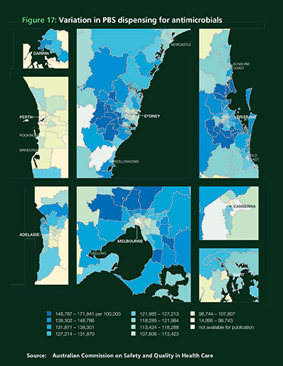100 000 people in the Northern Territory to 132 730 per 100 000 in Queensland.Potential reasons for this variation

include differences in:

* prescribing practices and patient expectations
* distribution of populations with high risk of infection, such as residents of nursing homes and Aboriginal and Torres Strait Islander people
* risk factors for infection such as smoking and household crowding.

Dispensing of antimicrobials by some Aboriginal Health Services is not captured by the PBS database, and this may also contribute to the variation found.

The Commission is working to support health service providers to reduce inappropriate prescribing of antimicrobials through the AURA project, as described in Chapter 3.

## Variation in treatment for heavy menstrual bleeding

Women who need treatment for heavy menstrual bleeding have a number of options.

One is a hysterectomy, which involves removing the uterus. It is a major operation, and is recommended when other treatments are not possible or have not helped. Hysterectomy is also used to treat uterine fibroids, cancer and other conditions.

Endometrial ablation is a surgical procedure to permanently remove the lining of the uterus, commonly via electrical or heat ablation.

An alternative for some women is to use a hormone-releasing intrauterine device.

In 2012–13, the rate of admission to hospitals across Australia for either hysterectomy or endometrial ablation was 297 admissions per 100 000 women. But there was significant variation around the country, with the highest rate being 5.2 times higher than the lowest rate.

There was also variation at a state level, with the Northern Territory rate being 225 admissions per 100 000 women and the Western Australian rate being 349 admissions per 100 000 women.

The rate for women living in some regional areas was five times higher than that for women living in some of the major cities. Such differences could occur for many different reasons, including:

* variations in the way doctors make decisions about what treatments to recommend
* variations in women’s preferences for different kinds of treatments
* variations in the use of the hormone releasing intrauterine device by general practitioners and specialists
* the lack of availability of specialists in some parts of Australia.

The Commission is developing a Clinical Care Standard for managing heavy menstrual bleeding, in consultation with the Royal Australian and New Zealand College of Obstetricians and Gynaecologists, other clinicians and consumers.

## Variation in colonoscopy rates

Colonoscopy is a procedure to check for bowel cancer and other bowel diseases. During a colonoscopy, a thin, flexible tube called a colonoscope is carefully fed into the bowel. The clinician can then look for any abnormalities, and take a sample (biopsy) or remove them if necessary.

National guidelines for bowel cancer screening endorse colonoscopies only for people who have had a positive result following a faecal occult blood test (which involves using a kit that allows a stool sample to be collected at home), and for people who have a moderate or high risk of bowel disease for other reasons.10 These other reasons include symptoms such as bleeding from the bowel, blood in the stool, unexplained abdominal pain, a change in bowel habits, a history of polyps (pre-cancerous growths) or a family history of bowel cancer.

Almost 600 000 MBS-funded fibre-optic colonoscopies were performed in Australia in 2013–14.b[2] Very large variations were seen in colonoscopy rates across the country – the highest rate was 30 times higher than the lowest rate. Rates were markedly higher in local areas in and around capital cities and were lower in remote areas. In major cities, rates were lowest in areas of low socioeconomic status and increased in areas of higher socioeconomic status. Participation in the National Bowel Cancer Screening Program follows similar trends, with higher participation in metropolitan areas.11

Potential reasons for the variation include differences in:

* clinical decision-making and clinicians’ adherence to guidelines
* use of colonoscopy in people who do not need it (no positive faecal occult blood test, no symptoms and not at higher risk)
* 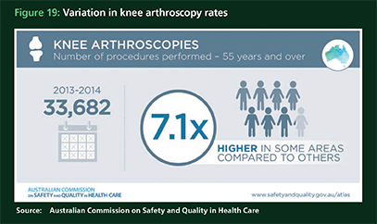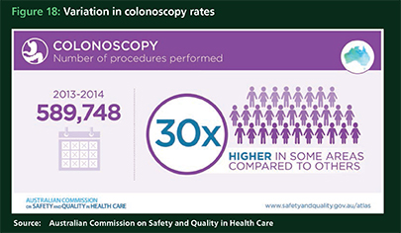rates of people choosing to have faecal occult blood test screening.
* levels of private health insurance; this may explain the higher colonoscopy rates in higher socioeconomic areas, where more people have private health cover
* local availability of colonoscopy services in rural and remote locations, where the need to travel long distances may be a barrier.

The Commission is working with partner organisations to make sure the people who would benefit most from colonoscopy do not miss out. Increasing awareness of faecal occult blood testing, and availability of colonoscopy services outside city areas, are important parts of this work.

## Variation in rates of knee arthroscopy

Knee arthroscopy is a surgical procedure for examining inside the knee joint and, if necessary, repairing it. A fibre-optic telescope is inserted through a small incision, and instruments can be inserted through other incisions to operate on the knee.

Many trials have shown that arthroscopy for degenerative knee disease (particularly osteoarthritis) gives an inconsequential benefit.12 The procedure can also cause harm and does not help to manage knee osteoarthritis.12,13 Exercise therapy has been shown to be more effective at reducing osteoarthritic knee pain than knee arthroscopy.12 Despite this evidence, the use of arthroscopic knee surgery has not decreased in recent years.14

In 2012–13, there were more than 33 000 knee arthroscopy admissions to hospital. Hospital admission rates for knee arthroscopy tended to be higher in inner and outer regional areas than in major cities. The rate of admissions was seven times higher in the area with the highest rate compared to the area with the lowest rate.

Possible reasons for the variation include differences in:

* clinicians not following evidence based guidelines
* rates of private health insurance cover and access to private hospitals – about 80% of admissions for knee arthroscopies are in the private sector14
* risk factors for knee problems, including obesity and occupational injuries
* access to imaging and alternatives to surgery such as physiotherapy for people in remote locations.

The Commission established the Knee Pain Expert Advisory Group to develop a number of approaches to identify and address unwarranted variation in knee surgery. These target clinician, consumer and system-level strategies, and include:

* commissioning a documentary about appropriate care in knee pain from Tonic Health Media, which aired on ABC 24 in February 2016 and is available on the Commission’s YouTube channel
* commissioning research to assess the available consumer information on knee arthroscopy
* reviewing the use and evidence for outpatient orthopaedic triage clinics run by physiotherapists and nurse practitioners
* referral of findings to the Medicare Benefits Schedule Review Taskforce.

The Commission is also developing a Clinical Care Standard for managing knee osteoarthritis to further support best practice in this area.

## What the Commission will do next

Identifying inappropriate variation is the first step to understanding the problem and addressing it. The atlas has been very effective at shining a spotlight on unwarranted variation in health care across Australia.

The 2015 atlas included possible reasons for the variations reported, and recommendations for action. The Commission and its partner organisations are working together to carry out these recommended actions.

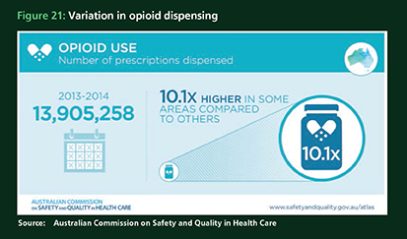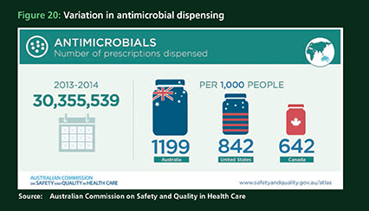Addressing unwarranted variation requires coordinated action and cooperation between many groups. The Commission has worked with a range of partners, including the Australian Government, all state and territory governments, clinicians and consumer representatives, to ask the right questions and find effective solutions.

# Case Study 2: Clinical quality registries

Another aspect of the Commission’s work

that has great potential to bring improvements in safety and quality in Australian health care relates to clinical quality registries.

Clinical quality registries collect, analyse and report health-related information. They work by tracking the health outcomes of patients with the same diagnosis (such as hip fracture), or who undergo the same type of procedure (such as prostate surgery). By finding out which patients have better outcomes, clinicians, researchers, policy makers and the public can tell what type of treatments work most effectively and improve treatments and processes.

The clinical quality registries use the information they collect to identify benchmarks – for example, what rate of readmission might be considered normal and potentially abnormal after a specific type of procedure. By tracking the progress of patients, clinical quality registries are able to identify variation in health outcomes, and analyse and feed back information into clinical practice and decision-making. Clinical quality registries, which are typically set up and operated by relevant clinical groups, provide information for the investigation and management of poor performance to improve health care quality.

Clinical quality registries are a fundamental part of the system of continuous improvement in health care safety and quality.

There is strong evidence already internationally to show that clinical quality registries can bring marked improvements, and do so efficiently. A 2012 international study found that if clinical quality registries provided information about the outcomes of health care practice to health practitioners and the public, health outcomes improved, and in many instances money was saved. C[3]

The study looked at 13 clinical quality registries set up in five countries: Australia, Denmark, Sweden, the UK and the US. The study concluded that well managed registries “enable medical practitioners to engage in continuous learning and to identify and share best clinical practices”. For example, the study estimated that the United States would have avoided

$US2 billion of an expected $US24 billion in total costs for hip replacement surgeries in 2015, if it had a clinical quality registry for these surgeries like the one in Sweden that enabled reductions in return surgery to replace or repair hip prostheses.d[4]

Historically, there has been relatively little work in Australia quantifying the value and benefits of Australian clinical quality registries. However, as interest in the benefits of these registries has increased, there has also been greater impetus for work to be done to quantify those benefits in this country. The Commission is aware of some work suggesting that, as Australia has a joint replacement registry similar to that in Sweden, Australia has already experienced a reduction in the number of revisions of hip and knee replacements, saving the health system an estimated $618 million between 1999 and 2014.

Some of the preliminary work in Australia to date has gathered evidence on the use of registry data by clinicians – for example, how did the clinicians receive the data, how did they use it, and what impact clinicians thought the data had on their clinical practices. It has also looked at system performance and changes in hospital and clinician practice.

Bearing out the findings internationally, there are strong suggestions that clinical quality registries have had an influence on clinical practice and have improved the value of healthcare delivery at relatively low cost. The benefits from these registries can be significant. Evidence suggests the benefit-to-cost ratios measured for the clinical quality registries can range from 2:1 to 7:1 – meaning that for every dollar spent, the return on that investment varies from $2 to as much as $7.

If confirmed, this would indicate that clinical quality registries in Australia, when sufficiently funded and operated effectively, improve the safety and quality of healthcare delivery, and achieve savings associated with improved health care delivery. Benefits include greater survival for patients, improvements in quality of life after treatment and avoided costs of treatment or hospital stay.

We know from experience overseas as well as in Australia that there a number of key characteristics that make a clinical quality registry successful. The benefits described here happen when the clinical quality registry provides health outcomes data to clinicians promptly and reliably. The influence of the clinical quality registry improves even further when this reporting includes health system managers and funders.

Clinical quality registry information, particularly where it assesses patient outcomes, is important in ensuring the quality of care delivered by individual practitioners and their teams. The action of a clinical team contributing to a clinical quality registry reduces variation in care and encourages teamwork.

Relatively small investments to expand and integrate registries have the potential to bring savings to the health system. However, not every clinical quality registry will be cost-effective. Problems such as low coverage, inadequate reporting and inadequate collection of information about patient outcomes will limit the effect of clinical quality registries, and their value to the health system.

## What the Commission will do next

Work is required to enable further development of a national policy context for clinical quality registries under the *Framework for Clinical Quality Registrie*s. The program of work, which the Commission will continue to progress, includes:

* developing a list of the highest priority clinical areas
* updating the F*ramework for Clinical Quality Registries* to clarify governance arrangements
* developing a standard for clinical quality registries (using the F*ramework for Clinical Quality Registries* as the basis for the standard).

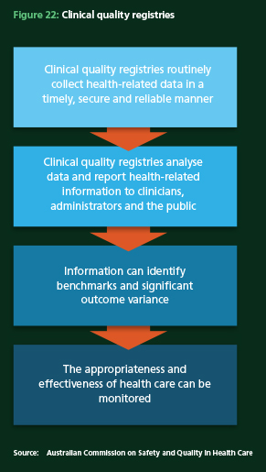

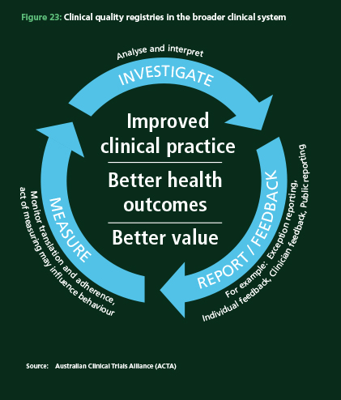

# Case Study 3: Reducing unnecessary radiation exposure to children and young people from CT scans

A CT scan uses X-rays to provide pictures of both hard and soft tissue. The X-rays are taken by a rotating ring that is moved around the body. A computer then turns all the X-ray images into three-dimensional images. Compared to other types of medical imaging, CT scans use higher levels of ionising radiation. Humans are exposed to radiation every day as small amounts are present in the natural environment. CT scans can increase this exposure substantially. For example, a single chest X-ray delivers approximately five days’ worth of natural background radiation, while a head CT scan delivers the equivalent of one year’s natural background radiation.

CT scans are a valuable diagnostic tool that have proven themselves of benefit in a wide range of clinical situations, but they should be used with caution. Use of CT scans in childhood or adolescence has been linked to a slight increase in the risk of developing cancer later in life.15

In Australia, Medicare data show more than

80 000 CT scans were performed in 2013–14 on people aged under 20, including cone beam CT scans performed by dental practitioners. To help reduce unwarranted radiation exposure to children and adolescents from CT scans, the Commission has developed a range of resources and is promoting new and existing resources to inform the referral and provision of CT scans.

## CT scans for children and young people

It is important to ensure that CT scans are used for time-critical conditions and when there are evidence-based protocols for a condition or a disease. For example, CT scanning for serious head trauma can provide important diagnostic information.

However, children and young people are more sensitive than adults to the ionising radiation used in CT scanning, as their bodies are still developing. CT scans should not be used if there is a valid alternative approach.

Children and young people might have a cone beam CT (CBCT) scan as part of their dental care. Dentists and specialists use these 3D images to assist in the examination and assessment of the mouth, including the teeth and jaws. Although the radiation dose used in CBCT is low compared to conventional CT, it is higher than other types of dental imaging. The use of radiation in oral health should be kept as low as possible.

## Developing resources to reduce exposure to children and young people from CT scans

Guided by an expert group, the Commission reviewed existing materials and tools that support clinicians, parents and carers in the use of CT scans. They were assessed to see whether they could be adapted for use across all states and territories.

Data was also analysed to further understand he patterns of use for CT scanning of children and young people. The patient journey was also mapped.

To develop the resources, the Commission worked with the states and territories and with organisations with specialist knowledge of the issues. Clinicians, technical experts, parents and carers were all involved.

The Commission then assessed the opportunities for positive intervention in the care pathway, and targeted development of resources to provide guidance for those involved. As a result, resources were developed for parents and carers, referring doctors and dentists who request CT scans, and those who perform the imaging. The Commission worked closely with Healthdirect Australia, a well-recognised provider of health information, to develop a website page, www.healthdirect.gov.au/ctscansforkids **(see Figure 24).**

This website page is dedicated to providing access to resources on CT scanning for children and young people and includes specific sections for parents and carers, referrers, medical imaging providers, dental practitioners and patients. The Commission developed a mobile app, DIP 4 Kids, that provides decision-making support for clinicians referring children and young people for medical imaging, including when to use CT scans. The app was developed in conjunction with the Western Australian Department of Health, and is based on the

## Image

## The Commission’s partners include:

* Australian Government Department of Health
* state and territory health departments
* Australian Radiation Protection and Nuclear Safety Agency
* NPS MedicineWise
* Healthdirect Australia
* Association for the Wellbeing of Children in Healthcare
* Royal Australian College of General Practitioners
* Royal Australasian College of Physicians, Paediatric Division
* Australian Institute of Radiography
* Royal Australian and New Zealand College of Radiologists
* Australasian College of Physical Scientists and Engineers in Medicine
* Australian Dental Association
* Australian Society of Orthodontists
* Australian and New Zealand Association of Oral and Maxillofacial Surgeons.

paediatric pathways in the Department’s Diagnostic Imaging Pathways clinical guidance tool, which has national and international endorsement from key stakeholders **(see Figure 25)**.

There are also brochures outlining the risks and benefits of CT scans for parents and carers, and posters that outline useful questions that parents and carers could ask their doctor, specialist or dentist about CT scans **(see Figures 26 and 27)**.

The Commission also produced a fact sheet targeted at clinicians who are able to refer children for CT scans, which provides information on typical radiation doses and key questions for clinicians to consider when deciding whether to provide such a referral for a child or young person. It was produced in conjunction with the Australian Radiation Protection and Nuclear Safety Agency **(see Figure 28)**.

Other resources include:

* answers to frequently asked questions about CT scanning for children and young people
* an online training module for radiographers to support the clinicians undertaking CT scans for children and young people, produced in conjunction with the Australian Institute of Radiography
* 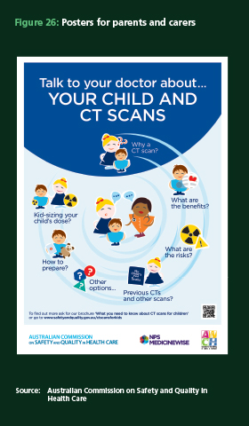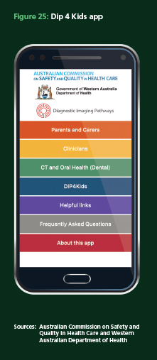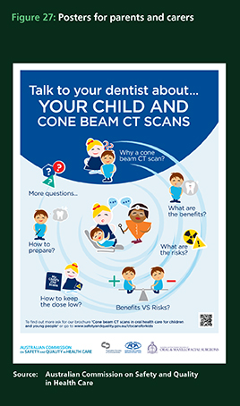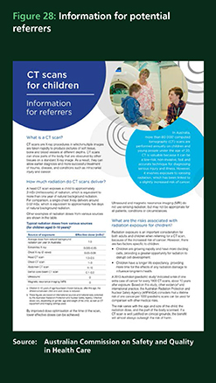content for a web page of the Australasian College of Physical Scientists and Engineers in Medicine that explains the role of dose optimisation for CT services
* a summary report – *Reduction in radiation exposure to children from computed tomography scans project summary report*.

The Commission has distributed these resources to the states and territories, general practitioners, dental practitioners, public hospitals, private radiology practices and early childhood health centres. The resources are also available on the Commission and Healthdirect Australia websites, and their release was supported by a national workshop, media releases and social media activities. In addition, a number of partners including the Western Australian Department of Health, NPS MedicineWise and the Association for the Wellbeing of Children in Healthcare are profiling the resources.

The Commission’s partnerships with other organisations provide improved access points to existing resources and to new resources. A key consideration throughout this work has been that the project outcomes address identified needs beyond the life of the project, through partnering with key organisations.

The resources developed and made available nationally by the Commission and its partners aim to support a reduction in unwarranted exposure from CT scans by raising awareness of the associated benefits and risks to children and supporting discussions between clinicians and parents and carers about their child’s care.

The message for parents and carers is: ‘If your child needs a CT scan, or has had one in the past, don’t be alarmed. It is important to talk to your doctor about the benefits and potential risks associated with CT scans’.

The new material has drawn on contemporary health literacy concepts and current best-practice evidence. As a result, parents and carers, requesters of services and medical imaging services now have better access to information to support their decision-making in relation to referral for, and conduct of, CT scans for children and young people.

For those children and young people who require CT scans, the online training module for radiographers will help keep the radiation dose delivered as low as possible. This resource will particularly support radiographers in rural and outer metropolitan hospitals who may see children less often.

## What the Commission will do next

The Commission will:

* develop new resources over the next three years
* continue promoting identified resources to inform the referral and provision of CT scans for children and young people

encourage and support ongoing discussion with relevant colleges and professional bodies to promote optimisation of radiation dose and upskilling of medical professionals and dentists.

# Conclusion

Ensuring safety and quality practices starts with establishing robust and effective safety and quality frameworks. This is the bedrock of the Commission’s work, most notably with the implementation of the NSQHS Standards. The 10 NSQHS Standards cover important areas: the implementation of an organisational clinical governance framework and clinical risk-mitigation strategies for high-prevalence adverse events; healthcare-associated infections; medication safety; patient identification and procedure matching; clinical handover; the prevention and management of pressure injuries; prevention of falls; and responding to clinical deterioration.

This document sets out five specific instances in which the NSQHS Standards have proved the catalyst for improved risk mitigation systems or surveillance. These either have already led, or can be expected to lead to better patient outcomes.

One such example is a requirement in the NSQHS Standards that each health service organisation addresses the issue of preventing falls and harm from falls. There is clear evidence that the incident monitoring system is detecting improvements for patients in South Australia, where there has been a near 50% reduction in the number of ‘high harm’ incidents since 2011 as a result of the harm-reduction strategies introduced by the state since that time. Improvements are also evident in other areas, including the safe and appropriate prescribing of antibiotics and other antimicrobials,. There is clear evidence to show that the proportion of health service organisations operating antimicrobial stewardship programs has nearly trebled since the introduction of the NSQHS Standard on safe and appropriate prescribing of antimicrobials. The Commission is working with its partners to expand the monitoring through the Antimicrobial Use and Resistance in Australia (AURA) Surveillance System, by encouraging more hospitals and laboratories to contribute data and increasing the number of organisms under scrutiny. These initiatives will help to combat the significant and increasing risk to the health of Australians posed by the global phenomenon of antimicrobial resistance.

The Commission has focused on a number of new initiatives designed to mitigate risks to patient safety and quality. These range from measures to encourage effective governance systems, through to providing guidance for boards on matters such as establishing feedback systems on risk and patient outcomes, and to identifying improvements to digital health systems, which can bring significant improvements in medication safety.

The *Australian Atlas of Healthcare Variation* has shone a light for the first time on the issue of unwarranted variation in health care and the opportunities that exist to identify treatment patterns that may be

unnecessary or even potentially harmful.

The Commission has collaborated with the Australian, state and territory governments, specialist medical colleges, clinicians and consumer representatives to develop the atlas, which provides a clear picture of substantial variation in healthcare use across the country, and across many areas of health care.

Some of this observed variation will be warranted and associated with need related factors such as underlying differences in the health of specific populations, or personal preferences. However, the weight of evidence in Australia and internationally suggests that much of the variation documented in the atlas is likely to be unwarranted.21 It may reflect differences in clinicians’ practices, in the organisation of health care, and in people’s access to services. It may also reflect poor-quality care that is not in accordance with evidence-based practice. This unwarranted variation may mean that some people are missing out on health care that could have helped them – such as cataract surgery – while others are having interventions that are unlikely to be of benefit. Overuse of some interventions, such as unnecessary antimicrobials, may cause harm. Recognition is growing internationally that more health care is not necessarily better health care.

Six clinical areas are examined in the atlas, covering prescribing, diagnostic, medical and surgical interventions. Priority areas for investigation and action include the use of antimicrobials and psychotropic medicines; variation in rates of fibre optic colonoscopy, knee arthroscopy, hysterectomy and endometrial ablation; and inequitable access to cataract surgery. In line with the key recommendations of the atlas, the Commission is working with its partners to develop a strategy to reduce unwarranted clinical variation.

The improvements in processes and, in many cases, outcomes that are set out in this document have occurred through the hard work of the clinicians, managers, executives and policy makers in local areas, and also as a result of the work done by the Commission in partnership with them and others such as consumers to create a robust safety and quality improvement framework.

# References

1. Duguid M, Cruickshank M, editors.

Antimicrobial stewardship in Australian hospitals. Sydney, 2010.

1. Australian Commission on Safety and Quality in Health Care. Antimicrobial prescribing practice in Australian hospitals: results of the 2014 National Antimicrobial Prescribing Survey. Sydney, 2015.
2. Dellit TH, Owens RC, McGowan JE, Jr. et al. Infectious Diseases Society of America and the Society for Healthcare Epidemiology of America guidelines for developing an institutional program to enhance antimicrobial stewardship. Clin Infect Dis 2007;44(2):159-77.
3. Frakt A. In Hospitals, Board Rooms Are as Important as Operating Rooms. New York: The New York Times, 2015.
4. World Health Organization. Antimicrobial resistance: global report on surveillance. Geneva: WHO, 2014.
5. Department of Health and Department of Agriculture. National Antimicrobial Resistance Strategy 2015-2019. Canberra: Commonwealth of Australia, 2015.
6. Australian Commission on Safety and Quality in Health Care. Literature Review: Medication Safety in Australia. Sydney, 2013
7. Devine et al. The impact of computerized provider order entry on medication errors in a multispecialty group practice. J Am Med Inform Assoc, 2010. and Abramson et al. A long-term follow-up evaluation of electronic health record prescribing safety. J Am Med Inform Assoc, 2013.
8. Institute of Medicine. Health IT and patient safety: building safer systems for better care. Washington, DC: National Academies Press, 2012.
9. Australian Cancer Network Colorectal Cancer Guidelines Revision Committee. Guidelines for the prevention, early detection and management of colorectal cancer. Sydney: Cancer Council Australia and Australian Cancer Network, 2005.
10. Australian Institute of Health and Welfare. National Bowel Cancer Screening Program: monitoring report 2013–14. Cancer Series No. 94. Cat. no. CAN 92. Canberra, 2015.
11. Thorlund JB, Juhl CB, Roos EM, Lohmander LS. Arthroscopic surgery for degenerative knee: systematic review and meta-analysis of benefits and harms. London, BMJ, 2015;350.
12. Australian Orthopaedic Association. Position statement from the Australian Knee Society on Arthroscopic Surgery of the Knee, with particular reference to the presence of osteoarthritis. Sydney, 2014.
13. Harris IA, Madan NS, Naylor JM, Chong S, Mittal R, Jalaludin BB. Trends in knee arthroscopy and subsequent arthroplasty in an Australian population: a retrospective cohort study. BMC Musculoskeletal Disorders. 2013;14:143.
14. Mathews JD et al. Cancer risk in 680,000 people exposed to computed tomography scans in childhood or adolescence: data linkage study of 11 million Australians. BMJ.2013;346:2360
15. Dartmouth Institute for Health Policy and Clinical Practice, Health Dialog, New South Wales Department of Health. New South Wales health care atlas final report. Sydney: Health NSW, 2010.
16. National Health Performance Authority. Hospital Performance reports. Sydney, 2015. (Accessed 18 September 2015 at [www.myhospitals.gov.au](http://www.myhospitals.gov.au))
17. National Health Performance Authority. My Healthy Communities. Sydney, 2015.
18. Australian Institute of Health and Welfare. Hospital resources 2013–14: Australian hospital statistics. Health services. Ser. no. 63 Cat. no. HSE 160. Canberra: AIHW, 2015.
19. Organisation for Economic Co-operation and Development. Geographic variations in health care: what do we know and what can be done to improve health system performance? Paris: OECD Publishing, 2014.
20. The Dartmouth Institute for Health Policy and Clinical Practice. The Dartmouth Atlas of Health Care 2015. Lebanen, USA, 2015
21. NHS Right Care. NHS Atlas, 2015. London, UK, 2015
22. New Zealand Health Quality and Safety Commission. Atlas of Healthcare Variation, 2015. Wellington, NZ, 2015

1. a All data is from 2014
2. b Data for publicly-funded hospital services are excluded.
3. C Use Of 13 Disease Registries in 5 Countries demonstrates the Potential to Use Outcome Data to Improve Health Care’s Value. Larsson, S., Lawyer P., Garellick G., Lindahl B., Lundström M. Health Aff January 2012 31:220-227. http://content.healthaffairs.org/content/31/1/220.abstract
4. d Use Of 13 Disease Registries in 5 Countries demonstrates the Potential to Use Outcome Data to Improve Health Care’s Value. Larsson, S., Lawyer P., Garellick G., Lindahl B., Lundström M. Health Aff January 2012 31:220-227. http://content.healthaffairs.org/content/31/1/220.abstract