Communicating with your healthcare provider:
improving the safety & quality of your care

What does effective communication look like?

family &

carers

the
patient
TWO-WAY COMMUNICATION

OPEN HONEST RESPECTFUL

healthcare
providers

Why is it important?

accuracy

information about your care is accurate and up to date

inclusive

self-care

you know your care plan & how to manage
your care when you leave a health service
your goals and needs are discussed with your healthcare provider and included in your care plan

participation

you are involved in decisions about your care

informed
& aware

you, your family & carer are given information about your care & understand your treatment options





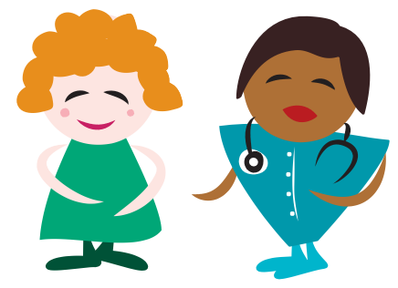

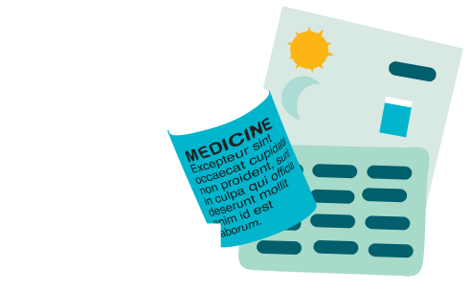
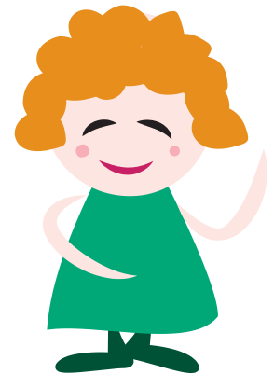


www.safetyandquality.gov.au

