Case Study - Safe and Appropriate use of Psychotropic Medicines - In-home Aged Care



Evidence-based clinical care for older people

Published by the Australian Commission on Safety and Quality in Health Care
Level 5, 255 Elizabeth Street, Sydney NSW 2000
Phone: (02) 9126 3600
Email: mail@safetyandquality.gov.au
Website: www.safetyandquality.gov.au
© Australian Commission on Safety and Quality in Health Care 2025
All material and work produced by the Australian Commission on Safety and Quality in Health Care is protected by copyright. The Commission reserves the right to set out the terms and conditions for the use of such material.
As far as practicable, material for which the copyright is owned by a third party will be clearly labelled. The Commission has made all reasonable efforts to ensure that this material has been reproduced in this publication with the full consent of the copyright owners.
With the exception of any material protected by a trademark, any content provided by third parties, and where otherwise noted, all material presented in this publication is licensed under a Creative Commons Attribution-Non-Commercial-No Derivatives 4.0 International licence.

Enquiries about the licence and any use of this publication are welcome and can be sent to communications@safetyandquality.gov.au.
Disclaimer
The content of this document is published in good faith by the Australian Commission on Safety and Quality in Health Care for information purposes. The document is not intended to provide guidance on particular healthcare choices. You should contact your healthcare provider on particular healthcare choices.

About this Case Study

This is one of a suite of resources to support aged care providers deliver evidence-based care to older people who receive government funded aged care services.

It has the dual aim of helping aged care providers to understand their role in mitigating the risks of using psychotropic medicines to manage behaviour in older people with cognitive disability or impairment as described in the Psychotropic Medicines in Cognitive Disability or Impairment Clinical Care Standard (2024) ; and assisting aged care providers meet their obligations to provide quality, evidence-based clinical care, as described in the Aged Care Quality standards.

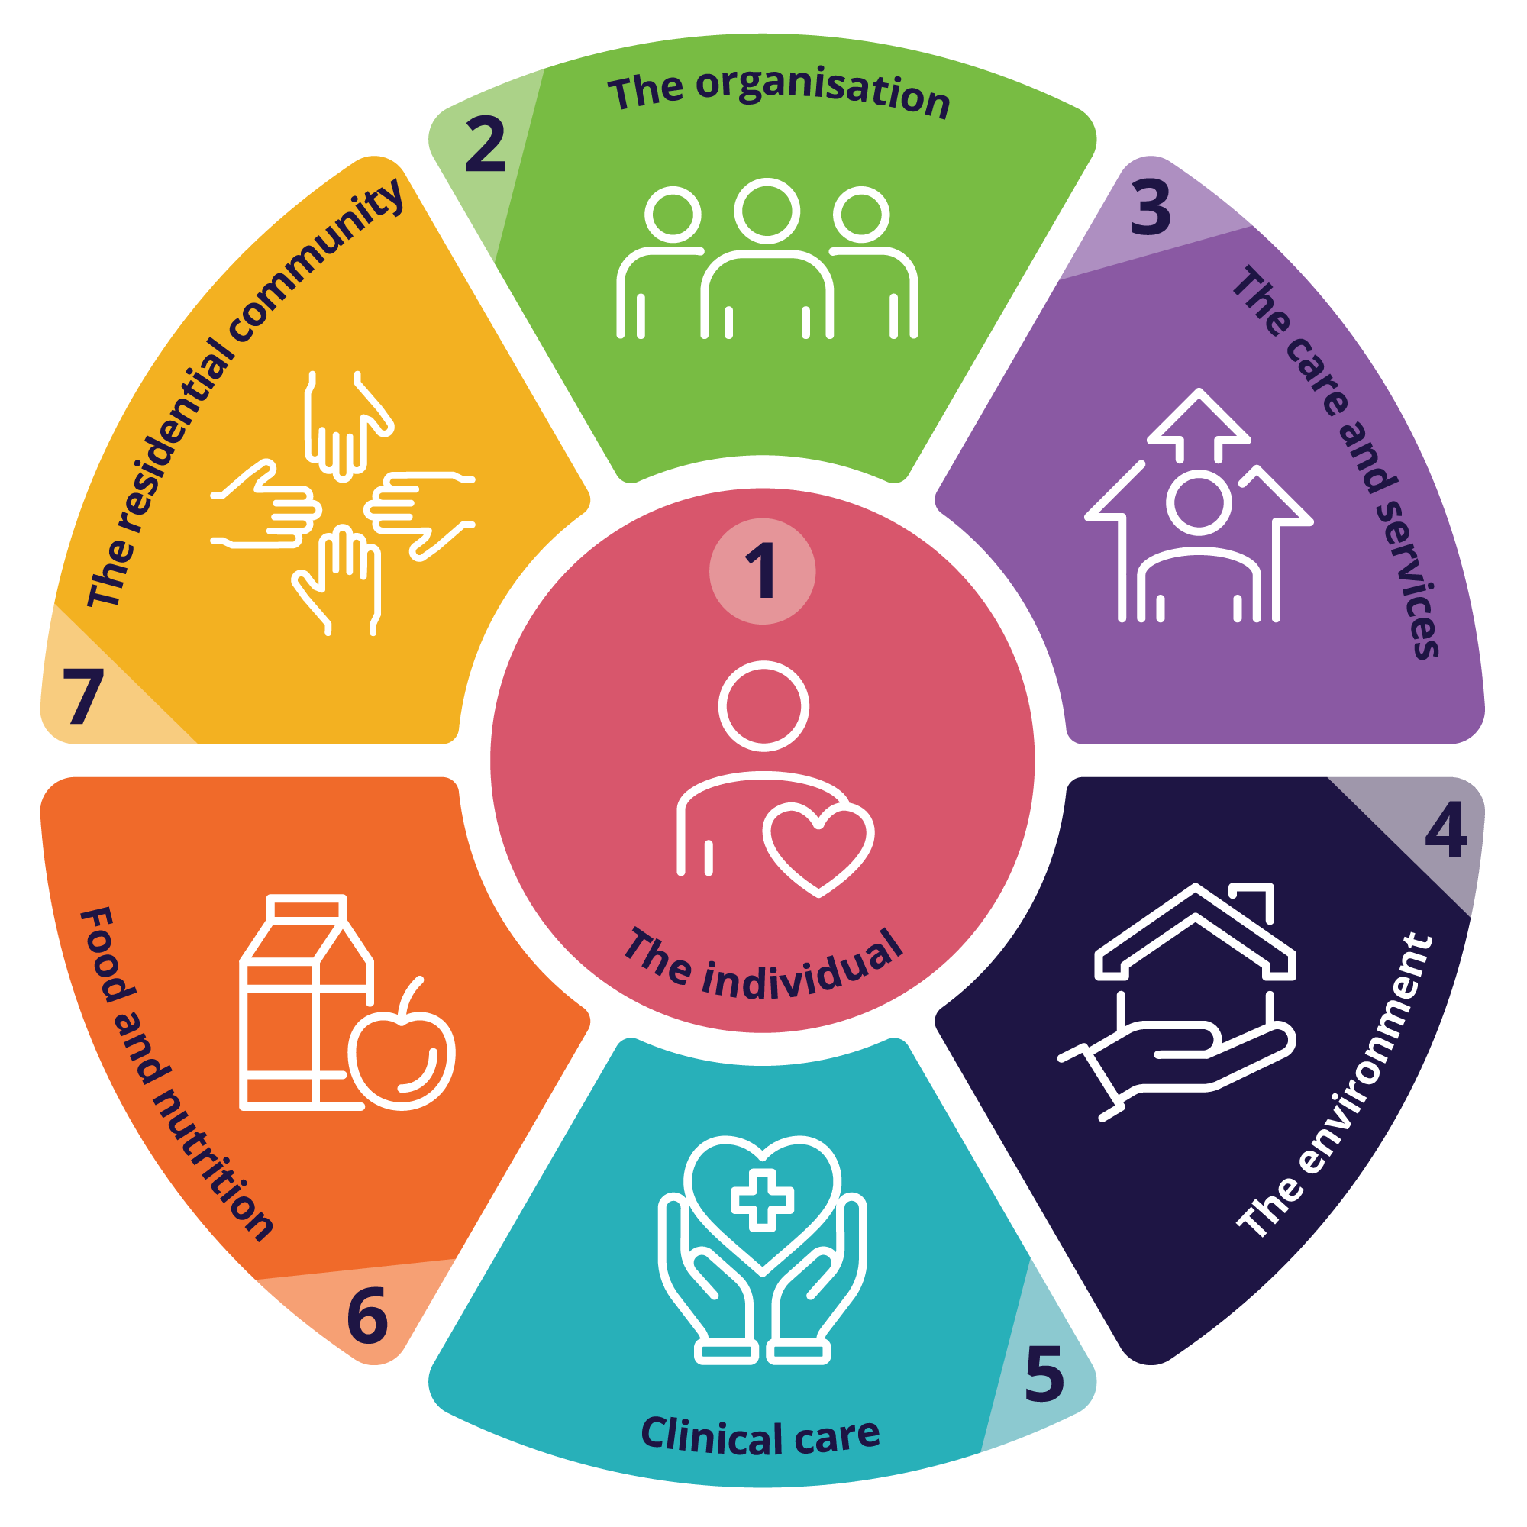
The Aged Care Quality Standards require providers to deliver quality care that is person-centred, safe, effective, coordinated, and evidence based. Aged Care Providers can do this by:

- making sure older people are at the centre of their care and included in care planning
- making sure staff know their roles and accountabilities for delivery of clinical care
- implementing processes and designing care that is based on current evidence
- agreeing on roles and responsibilities for communication and care with clinicians, internal and external to the provider
- working towards a digital system for clinical information that can communicate across IT platforms
- making sure sufficiently trained and qualified staff, deliver care that meets the needs, goals and preferences of older people using the service
- making sure the staff work within their scope of practice and are supervised where required
- implementing a medication management system that aligns with the Guiding principles for medication management in the community and relevant state and territory legislation as relevant to the service category.


For more information about the Psychotropic Medicines in Cognitive Disability or Impairment Clinical Care Standard and its application in aged care settings see the fact sheet Safe and Appropriate use of Psychotropic Medicines - Aged Care.

In this case study, “provider staff” includes all staff and health professionals employed or contracted by the provider. “Other health professionals” include the range of health professionals, including medical specialist and allied health professionals, who contribute to multidisciplinary care but are not directly employed by the provider. Where there are specific roles relevant to the case study, these are explicitly mentioned.

How to use this case study
The fictional scenarios follow the sequence of an older person’s care pathway with an in-home aged care provider rather than the numerical order of the CCS Quality Statements. The focus is on the systems and processes that should be in place to support care delivery. These are categorised as follows:
- Person-centred care – commencing with the provider, identifying their care needs and the roles and responsibilities for delivering care
- Medication management
- Managing changed behaviours
- Transitions of Care – acute deterioration resulting in hospital admission and discharge
Where there is a link to the Clinical Care Standard – Open this to view evidence-based practice for health professionals.
x | Key
The context | Scenario where John Smith, an 83-year-old, retired teacher has been diagnosed with dementia and has changed behaviours. He received aged care services from a fictitious in-home aged care provider, Lilywood home support.
The aged care service | Describes how the provider delivered care that aligns with the Psychotropic Medicines in Cognitive Disability or Impairment Clinical Care Standard (CCS) and the Aged Care Quality (ACQ)
Applying the standards | In this case study  Evidence-based practice examples in the case study  Evidence-based practice, aligned to the CCS and ACQ standards
Strategies for improvement | Where care could be improved in this scenario
Discussion Questions | Discussion questions can prompt discussion of concepts in this case study with  care workers or other non-clinical staff  clinical care staff and care coordinators or service managers  the governing body

Evidence-based practice care of older people with cognitive impairment or disability as outlined in the Quality Statements in the CCS

Related Outcomes (requirements) and the actions that describe evidence-based practice care of older people with cognitive disability or impairment in the Aged Care Quality (ACQ) standards

*This document includes a graphic represeting the Aged Care Quality standards owned by the Aged Care Quality and Safety Commission. For use of material that includes this logo please contact the Aged Care Quality and Safety Commission.

Translating Psychotropic Medicines in Cognitive Disability and Impairment - Clinical Care Standard for in-home Aged Care Providers
 | Person-centred Care
The Context   | Commencement of Care with local in-home care service, Lilywood home support  John Smith, a retired teacher, was diagnosed with dementia and has moderate cognitive impairment. He lived in his own at home with support from his daughter His daughter was concerned about her father’s ability to care for himself, and she had noticed he was often confused and sometimes, uncharacteristically, very agitated and verbally aggressive when she visited.  An Aged Care Assessment team (ACAT) determined he was eligible for in-home support.  Prior to commencement with Sunshine care, John had a regular GP.  He likes music and watching AFL.  John’s care team at commencement with the provider included a:  - Geriatrician  - General Practitioner (GP)  - Nurse Practitioner (employed by the general practice)  - Registered Nurse (RN) (employed by the aged care provider also provided care coordination)  - Care worker  - Occupational Therapist (OT)  - Community pharmacist  Comprehensive Assessment  John had three comprehensive assessments on or prior to commencement with Lilywood Home Support:  Comprehensive medical assessment with his GP  Aged Care Assessment Team (ACAT) used the integrated assessment tool (IAT) to determine his eligibility for aged care and identify his needs  Comprehensive assessment with the Lilywood care coordinator and RN to inform his care plan for Lilywood Home support
The Aged Care Service | The provider worked with John and his daughter, at John’s request, to access the outcomes of the comprehensive medical assessment recently undertaken with his GP and the aged care assessment to inform their own assessment and plans for John’s care. They worked with John and his daughter to understand what John likes to do, his preferences, needs and goals for care and how he prefers to communicate.  John, with support from his daughter, agreed with the provider on the supports the provider is accountable for and when they will be delivered. They also documented how John’s daughter would be involved, her contact details and any other arrangements for his support.  The provider noted John was able to make decisions with support, had an Advance Care Plan in place and he had nominated a substitute-decision maker in an Advance care directive.
Applying the standard  Evidence-based practice | Person-centred care considers a person’s individual needs, goals for care and preferences. This is a key concept in the CCS and the ACQ standards. It ensures the person is considered holistically and that contextual factors, such as cognitive impairment, are informing care planning and communication strategies.  In this case study the provider and John agreed on:  - the care they and John’s daughter would provide. This was documented in John’s care plan  - the implementation of outcomes from comprehensive assessments  - John’s daughter’s involvement in decisions about the care John would receive and how and when his son and daughter could be contacted  Comprehensive assessment ensures the care older people receive meets their individual needs and is in line with their goals and preferences.
Strategies for improvement | In this situation coordination of care for John could be improved by:  - establishing processes for communication between the aged care provider, GPs and other health professionals and community pharmacists.  - Identifying if John had a My Health Record (MHR) and asking his consent to access the information in MHR could support comprehensive care planning  - the provider knowing the impact of John’s cognitive impairment on his ability to communicate and make decisions.
Discussion questions | Care Worker How do you make sure you understand the older person’s needs, goals and preferences?  What do you do or ask to make sure those needs, goals and preferences are current?  Clinical/ Care co-ordinator/ service manager What processes are in place for older people without a regular GP or support from family?  What processes are in place to ensure the older person’s needs, goals and preferences for care are documented, regularly reviewed and able to be accessed by provider staff?  Is there a process to communicate with GPs or other health professionals not employed or contracted to the service?  What are the processes to agree on and document roles and responsibilities for care between the provider, other health professionals and family?  The Governing Body What measures are in place for the governing body to monitor the effectiveness of the older person’s involvement in designing their care?  How does the governing body support the organisation and staff to focus on the needs, goals and preferences of the older people using the service?
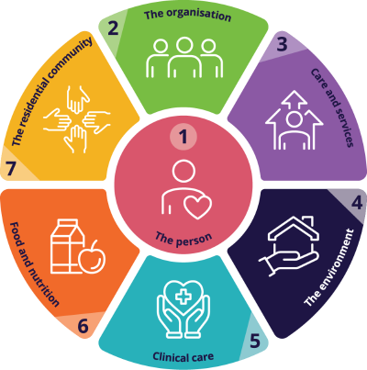 | Quality statement 1 - Person-centred care  A person receives health care that is driven by their individual preferences, needs and values, and that upholds their personal dignity, human rights and legal rights.  The person is supported to be an active participant in making informed choices about their care, together with people they choose such as their family, support people or nominated decision-maker as appropriate.  Aged Care Quality Standards  Standard 1: Outcome 1.1 (all) Outcome 1.2 (all) Outcome 1.3 (all)  Standard 2: Outcome 2.1 (all) Outcome 2.2 (action 2.2.2) Outcome 2.9 (action 2.9.6)  Standard 3: Outcome 3.1 (3.1.1, 3.1.2, 3.1.3, 3.1.4) Outcome 3.2 (3.2.1, 3.2.2, 3.2.6) Outcome 3.3 (3.3.1, 3.3.2) Outcome 3.4 (all)  Standard 5: Outcome 5.3 (action 5.3.1) 5.4 (action 5.4.1) 5.6 (action 5.6.2)

 | Medication management
The Context | This case has intentionally used a scenario where the use of a PRN antipsychotic may be inappropriate. This is to explore the role of aged care providers in identifying and responding to this risk.  The provider supported John with his medicines but did not administer medicines. The medicines prescribed to John included:  - Donepezil, 10 mg daily for cognitive symptoms,  - Metformin 500 mg, twice daily for diabetes,  - Amlodipine, 5 mg daily for hypertension,  - Vitamin D, 1000 IU daily for bone health.  He was regularly using paracetamol and taking a multi-vitamin.  John was prescribed PRN Risperidone, an antipsychotic, 0.5mg, to manage symptoms such as severe aggression and hallucinations. There were written instructions for the Risperidone including that it was only to be used when non-medication strategies were ineffective. John’s daughter supported him with his medicines and had instructions from the prescriber about use of PRN medicines.  CCS- Appropriate reasons for prescribing psychotropic medicines  CCS - non-medication strategies  The prescriber (Geriatrician) had provided information to John and his daughter about the risks involved with using Risperidone, including the increased risk of falls and obtained John’s consent for use of the medicine. The requirements for monitoring and documenting use to inform the prescriber was also provided to John’s daughter who had shared this with the provider on commencement of care. The provider noted that, in this case, use is considered a restrictive practice (chemical restraint). Johns’ daughter had a diary where she documented the reasons risperidone was used and when and used this to inform reviews with the prescriber.  CCS - Informed consent for psychotropic medicines
The Aged Care Service | John’s changing behaviour, severe agitation and his use of paracetamol prompted the provider to conduct a pain assessment. It was determined that he may have had pain related to osteoarthritis and this was noted in John’s notes to follow-up with the GP.  The provider documented John’s medicines in the mediciation management system in their care management system.  Trained care workers monitored John’s medicines use by checking his DAA to make sure he was taking his medicines on days they attended. His daughter monitored his use of medicines on the other days.  A care worker had noticed that when the Risperidone was used it did not make a positive difference to his behaviour and made John unsteady on his feet. They had received training on the risks involved with psychotropic medicines and escalated this by documenting their observations and alerting the RN.  The RN asked John to see his GP for review. His GP immediately removed the prn medication from his medication chart and referred him for a home medicines review with a credentialed pharmacist. This took a few weeks to arrange.
Applying the standards | While prescribing medicines is not always the responsibility of aged care provider staff, supporting safe use of medicines is a part of their role. Trained provider staff have an understanding the risks involved with use of psychotropic medicines, what is appropriate use and what is considered a restrictive practice as defined in legislation.  In this case study provider staff who monitor John’s use of medicines were trained and understood the risks associated with use of psychotropic medicines. They also knew when use was inappropriate or considered a restrictive practice.  Provider staff understood the processes for escalation and their role in identifying risk. When the care worker identified that the use of the PRN Psychotropic (risperidone) may have been ineffective and potentially increased John’s risk of falls, they raised their concerns with the RN.  John was reviewed by his GP and a Home Medicines Review was encouraged.  Providers also have responsibilities to ensure older people have the information they need to make decisions about their care, including for medicines they are prescribed. Informed consent, in this case is given to the prescriber, however a provider that administers medicines should ensure consent is documented in their system.  Understanding these concepts and demonstrating that a provider has processes in place to safely manage medicines, in line with Guiding principles for medication management in the community, meets the requirements of the ACQ standards and the intent of the CCS.
Strategies for improvement | In this situation knowing which medicines John took, the reason they were prescribed and the benefits or risks associated with them could support provider staff to monitor John’s response.  A complete and accurate medicines list documented in the providers system and including John’s prescriber (Geriatrician or GP) and community pharmacist’s contact details could support this.
Discussion Questions | Care worker Do you know who to tell if you notice something that worries you about an older person after they have taken medicines?  Clinical/ Care co-ordinator/ service manager Is there a process to ensure older people have consented to medicines when the provider supports administration of medicines?  How are Home Medication Reviews (HMRs) actively supported and facilitated in the service and what processes are in place to ensure medication is regularly reviewed by credentialed pharmacists?  How does the provider identify changes to an older person’s ability to manage medicines or self-administer with support?  Governing Body How does the governing body know that the providers medication management and administration practices align with relevant legislation and policies?
Quality statement 6 - Appropriate reasons for prescribing psychotropic medicines
Psychotropic medicines are considered in response to behaviours only when there is a significant risk of harm to the person or others, or when the behaviours have a major impact on the person’s quality of life and a reasonable trial of non‑medication strategies has been ineffective. Psychotropic medicines are also considered when a mental health condition has been diagnosed or is suspected following a documented clinical assessment. The reason for use is clearly documented in the person’s healthcare record at the time of prescribing.
Quality statement 2 - Informed consent for psychotropic medicines
If psychotropic medicines are being considered, the person – and their family, support people or nominated decision‑maker as appropriate – are informed about the reason, intended duration, and potential benefits and harms of treatment. Information about psychotropic medicines is presented to older people in a way they can understand. If use of a psychotropic medicine is agreed, informed consent is documented before use. In an emergency or if the person does not have capacity to decide even with support, processes are followed in accordance with relevant legislation

Aged Care Quality Standards
Standard 1: Outcome 1.3 (actions 1.3.1,1.3.5, 1.3.6)
Standard 2: Outcome 2.7 (all)
Standard 3: Outcome 3.1 (3.1.1, 3.1.2, 3.1.3) Outcome 3.2 (3.2.4, 3.2.6, 3.2.7) Outcome 3.3 (3.3.1)
Standard 5: Outcome 5.3 (actions 5.3.2, 5.3.4, 5.3.6) 5.4 (actions 5.4.2, 5.4.4) 5.6 (actions 5.6.3)

 | Managing Changed behaviours
The Context | Prior to commencement with the provider, John’s daughter noticed some situations that increased John’s confusion or other changes to his behaviour. These included when plans were changed, when people came to the house unexpectedly, when there was a lot of noise or in busy environments such as shopping centres or a crowded bus. She had accessed support from Dementia Support Australia and their community focused team that supports carers and providers of home care.  After commencement with the provider John’s behaviour towards provider staff was sometimes a concern as he would shout or get angry when he was confused or if he did not recognise someone that came to his home. His GP recommended using the behaviour support plan previously developed with John, his daughter and the GP so everyone that was involved in John’s care would know how to support him.  CCS - Behaviour Support Plans  The care worker that saw John during the week noticed strategies that had previously supported John and reduced the situations contributed to changes to his behaviour, but he was becoming increasingly agitated, even with his daughter, and more often became verbally aggressive (shouting loudly at people or objects, moving erratically and standing very close in a threatening way).
The Aged Care Service | Provider staff ensured they attended when scheduled and introduced themselves on arrival. When they were unsure about their safety or John’s they contacted the Lilywood RN or John’s daughter.  Strategies that reduced the likelihood of changes to John’s behaviour that would put him or others at risk were documented in a behaviour support plan in the providers system and available to provider staff. Non-medication strategies for calming John if he became agitated were also documented and available to provider staff for when they cared for John.  CCS - Non-medication strategies  When the care worker raised concerns about John’s behaviour the providers RN encouraged a review with John’s GP. The RN was trained and competent in assessment of older people with changed behaviours however was not available to provide assessment and care all of the time.  The behaviour support plan was regularly reviewed and updated to ensure that any changes to John’s behaviour or stimulus for changes were documented and available to all involved in his care.  Acute deterioration and situations that pose risk of harm to older people, workers or others may need immediate support from a health or ambulance services.  CCS - Assessing Behaviours
Applying the standards | In this case Lilywood staff identified the non-medication strategies that worked to support John with changing behaviours  A behaviour support plan was available in the providers care planning system to support provider staff and older people  The Provider reviewed care plans regularly so up-to-date information is available to provider staff  Lilywood home support had staff trained to assess the situation and older people with changed behaviours  John’s daughter had accessed support from Dementia Support Australia and other external organisations with expertise managing changed behaviour for people living with Dementia
Strategies for improvement | Check notes and individual care plans prior to visiting older people support the older person  If there are new, casual or substitute care workers, ensuring they have access to this information makes John feel safe.  Lilywood Home Support could support all provider staff to be aware that non-medication strategies for managing behaviour is preferable to use of psychotropic medicines and actively support this approach.  Advocating for use of medicines for managing behaviour with GPs is not evidence-based practice.  The provider could consider how the care plan system allows care plans to be easily accessible at point of care to provider staff  John’s care plan, including his behaviour support plan should be regularly reviewed and updated with strategies that may be observed to work better  For more information, refer to Safe and appropriate use of psychotropic medicines for aged care - Fact sheet | Australian Commission on Safety and Quality in Health Care
Discussion questions | Care worker What do you do to find out about the older person, so you understand what is usual behaviour for them?  How do you know what plans are in place to help you support older people when there are changes in their behaviour?  Clinical/ Care co-ordinator/ service manager What are the processes in place to alert provider staff to the best approach for each older person including how to respond to changed behaviours?  What is the process to ensure behaviours are documented and regularly reviewed?  How are care plans that detail the needs goals and preferences of older people made available to provider staff?  How is the need for assessments and reassessments determined?  What processes are in place to access support services such as Dementia Behaviour Management Advisory Service ?  What strategies are in place if an older person refuses entry to their home, declines the service that is planned, or the provider staff feels threatened?  Governing body How does the governing body prioritise behaviour support that aligns with national standards for care of people with cognitive impairment.
CCS Quality Statement 4 - Non-medication strategies
Non‑medication strategies are used first‑line and as the mainstay of care when responding to behaviours of concern. The choice of strategies is individualised to the person and is documented and communicated to all those involved in their care.

CCS Quality Statement 5 - Behaviour Support Plans

If a person has a plan to support their behaviour, it is used to inform and support their care. The person’s response to care provided under the plan – including any use of psychotropic medicines – is continually assessed, documented and communicated to inform regular updates to the plan.

CCS Quality Statement 3 - Assessing Behaviours
A person with behaviours of concern is initially assessed for immediate risks to their safety and others. The person is further assessed to identify clinical, psychosocial and environmental causes of the behaviours, and to understand the context in which they occur. Assessment is carried out by suitably trained individuals and considers existing plans to support the person’s care and information from others who know the person well.
Aged Care Quality Standards
Standard 1: Outcome 1.1 (actions 1.1.1, 1.1.2) Outcome 1.3 (action 1.3.6)
Standard 2: Outcome 2.1 (2.1.3) Outcome 2.7 (2.7.1, 2.7.2)
Standard 3: Outcome 3.1 (all) Outcome 3.2 (3.2.6) Outcome 3.3 (3.3.1) Outcome 3.4 (all)
Standard 5: Outcome 5.1 (actions 5.1.3) 5.3 (action 5.3.4) 5.4 (all) 5.6 (actions 5.6.1, 5.6.2)

 | Transitions of care
The Context | One afternoon a care worker found John distressed and severely agitated.  They tried many strategies to calm John but as these were unsuccessful and the care worker was concerned that John may leave the house or hurt himself or themselves, the providers escalation processes were followed, and an ambulance was called.  Once at the hospital the triage nurse had access to the notes provided by the paramedic but did not have access to John’s complete clinical information or a transfer summary.  John was assessed as being dehydrated but further assessment after treatment of his acute deterioration was required to understand if or how much the dyhydration contributed John’s ditress and changes to his behaviour. He was monitored for changes to his mental state to ensure delerium was adequately considered as a cause for his distress and changes to his behaviour.  At the hospital John became confused then aggressive while he was being treated for dyhdration/ there was a risk he would hurt himself or others around him.  He was admitted to hospital and discharged 2 days later. A discharge summary was shared with John’s GP and his daughter and his daughter shared this with the provider.
The Aged Care Service | As the RN was unavailable and the care worker was unable to contact John’s daughter, they called an ambulance. The care worker tried to keep John safe by encouraging him to stay in the house using strategies from his Behaviour Support Plan such as playing music, she knew he liked but she was concerned for John and her own safety.  The Care worker was able to share information available in his care plan and John’s medicines list verbally with the paramedics prior to transport to hospital.  Quality statement 8 - Information sharing and communication at transitions of care  The provider RN assessed John when he returned from hospital, informed by the discharge summary. A follow up appointment with the GP resulted in a referral to a dietitian and some changes to his medicines on a trial basis as the GP had concerns that some of the interactions between his medicines were causing the deterioration of his condition and the changes to his behaviour.  The GP and the provider RN communicated about the requirements for monitoring and and review and the provider care coordinator supported a reassessment of John to determine any additional support he might need.  CCS 7 Monitoring, reviewing and ceasing psychotropic medicines
Applying the standards | In this case Lilywood home support had processes in place, so the care worker knew what to do when they found John distressed and there was a risk of harm to John and the care worker.  Provider staff are trained to assess situations for risk and processes are available for escalation  There were processes to support older people with access to assessment of changed care needs on return from hospital
Strategies for improvement | In this situation John’s information was not shared with the hospital in a complete or timely way. The provider’s clinical information systems and processes could be reviewed to ensure they align with provider requirements in the Aged Care Quality Standards.  There could have been a system that supported safe sharing clinical information, such as behaviour support plans (if there is one in place) nursing care plans, medicines list and advanced care directives with hospitals or other health services when required.  Processes to transition older people in emergencies and when planned could be reviewed to consider the local context. (Availability of PHN support, hospital and health services, and GP systems)  Processes for the care coordinator to identify and implement changes made to John’s care needs such as during a hospital admission, could be used rather than waiting for John’s daughter to share the discharge summary used when older people transition into or return to the service. Changes are documented in the providers system and are monitored and implemented as appropriate.  Understand changes to the care needs of older people by reviewing changes documented in care plans.  Understand that older people may have deterioration that is acute or temporary and additional support may be required to regain their usual function.  For more information, refer to Transitions of Care | Australian Commission on Safety and Quality in Health Care
Discussion Questions | Care Worker How do you know if an older persons care needs have changed?  Clinical/ Care co-ordinator/ service manager What processes are in place for when a hospital in the home service (HITH) provides care?  Who is responsible for ensuring regular review of care plans, particularly after hospital admissions or when needs change?  What processes are used to facilitate access to external health professionals when required?  What are the processes for accessing discharge summaries if these are not shared when older people are discharged from hospital?  Governing Body How does the governing body ensure that the appropriate clinical information systems are resourced, so providers have access to systems that support safe communication at transitions of care?
Quality statement 7 – Monitoring, reviewing and ceasing
A person’s response to psychotropic medicines is regularly monitored and reviewed according to the person’s individual needs and goals of treatment. The benefits and harms of treatment and the potential for dose adjustment or cessation are considered at each review. The outcome is documented and communicated, along with the timing of the next review. The reason for use is clearly documented in the person’s healthcare record at the time of prescribing.
Quality statement 8 - Information sharing and communication at transitions of care
When the health care of a person is transferred, information about their ongoing needs is shared with the person, their family or support people and the healthcare and service providers continuing their care. This includes information about behaviour support plans or other strategies. If psychotropic medicines are prescribed, the reason for use, intended duration, timing of last administration, and plans for monitoring and review are documented and communicated to support the person’s ongoing care.
Aged Care Quality Standards
Standard 2: Outcome 2.7 (all)
Standard 3: Outcome 3.3 (all) Outcome 3.4 (action 3.4.3)
Standard 5: Outcome 5.1 (actions 5.1.3, 5.1.5) Outcome 5.3 (actions 5.3.1, 5.3.4) Outcome 5.4 (actions 5.4.4, 5.4.5) Outcome 5.6 (actions 5.6.1, 5.6.3)
 | Resources
- Aged Care Quality Standards | Aged Care Quality and Safety Commission
- Behaviour Support Plans | Dementia Support Australia
- Behavioural Assessment Form (dementia.com.au)
- Caring for Cognitive Impairment Videos - All Events (cognitivecare.gov.au)
- Communicating for Safety | Communicating for Safety resource portal (safetyandquality.gov.au)
- Consent for medication in aged care (agedcarequality.gov.au)
- Clinical guidelines for dementia - Cognitive Decline Partnership Centre
- Delirium Screen (dementia.com.au)
- Dementia Training Australia (DTA), Free online courses and resources
- Dementia in Australia, Behaviours and psychological symptoms of dementia - Australian Institute of Health and Welfare (aihw.gov.au)
- Dementia and psychotropic medicines - NPS MedicineWise
- Dementia and psychotropic medicines from NPS MedicineWise
- Fact sheet – Medication Management in the Community | Australian Government Department of Health and Aged Care
- Guiding principles for medication management in the community collection | Australian Government Department of Health and Aged Care
- Inappropriate use of restrictive practices | Aged Care Quality and Safety Commission
- Informed consent | Australian Commission on Safety and Quality in Health Care
- Management of changed behaviour in a person with dementia (nps.org.au)
- Medication: it’s your choice - OPAN
- Mood and behaviour changes | Dementia Australia
- Nationwide, 24-hour dementia carer support | Dementia Support Australia
- Prescribing psychotropic medications to people in aged care – information and resources
- Psychotropic self-assessment tool | Aged Care Quality and Safety Commission
- Psychotropic Medicines in Cognitive Disability or Impairment Clinical Care Standard | Australian Commission on Safety and Quality in Health Care
- Reducing inappropriate use of antipsychotics in people with behavioural and psychological symptoms of dementia (BPSD) - Infographic | Australian Commission on Safety and Quality in Health Care
- Shared decision making | Australian Commission on Safety and Quality in Health Care

For more information
Please visit: safetyandquality.gov.au
You can also contact the project team at: agedcarestandards@safetyandquality.gov.au
safetyandquality.gov.au
© Australian Commission on Safety
and Quality in Health Care 2025

While development and use of Behaviour Support Plans is not a current mandatory requirement for in-home aged care, considering the tools and resources available to support older people with changed behaviours and those who care for them is useful and good practice for planning care.
A better way to care (second edition) | Australian Commission on Safety and Quality in Health Care

