

July 2017
Economic evaluation of investigator-initiated clinical trials conducted by networks

Final report

The Australian Clinical Trials Alliance, in association with Quantium Health Outcomes, has prepared this report on behalf of the Australian Commission on Safety and Quality in Health Care.

Published by the Australian Commission on Safety and Quality in Health Care
Level 5, 255 Elizabeth Street, Sydney NSW 2000
Phone: (02) 9126 3600
Fax: (02) 9126 3613
Email: mail@safetyandquality.gov.au
Website: www.safetyandquality.gov.au
ISBN: 978-1-925665-00-0
© Australian Commission on Safety and Quality in Health Care 2017
All material and work produced by the Australian Commission on Safety and Quality in Health Care is protected by copyright. The Commission reserves the right to set out the terms and conditions for the use of such material.
As far as practicable, material for which the copyright is owned by a third party will be clearly labelled. The Australian Commission on Safety and Quality in Health Care has made all reasonable efforts to ensure that this material has been reproduced in this publication with the full consent of the copyright owners.
With the exception of any material protected by a trademark, any content provided by third parties, and where otherwise noted, all material presented in this publication is licensed under a Creative Commons Attribution-NonCommercial-NoDerivatives 4.0 International Licence.
Enquiries regarding the licence and any use of this publication are welcome and can be sent to communications@safetyandquality.gov.au.
The Commission’s preference is that you attribute this publication (and any material sourced from it) using the following citation:
Australian Clinical Trials Alliance. Economic evaluation of investigator-initiated clinical trials conducted by networks. Sydney: ACSQHC; 2017.
Disclaimer
The content of this document is published in good faith by the Australian Commission on Safety and Quality in Health Care (the Commission) for information purposes. The document is not intended to provide guidance on particular healthcare choices. You should contact your healthcare provider on particular healthcare choices.
This document includes the views or recommendations of its authors and third parties. Publication of this document by the Commission does not necessarily reflect the views of the Commission, or indicate a commitment to a particular course of action. The Commission does not accept any legal liability for any injury, loss or damage incurred by the use of, or reliance on, this document.

Preface
Investigator-initiated clinical trials are an important element of the quality improvement cycle. They provide independent evidence on the efficacy, effectiveness or cost-effectiveness of a healthcare intervention. The findings of these trials, if implemented, can lead to the adoption of new interventions, or the cessation of practices that do not lead to better health outcomes.

There is growing international evidence suggesting that programs of high-quality investigator-initiated clinical trials have had a major impact on healthcare quality and outcomes. There is yet to be, however, an evaluation to quantify the potential health and economic benefits generated by investigator-initiated clinical trials conducted in Australia. This report aims to address this gap, looking specifically at investigator-initiated clinical trials conducted by dedicated clinical trials networks.

The report that follows this preface was prepared by the Australian Clinical Trials Alliance in association with Quantium Health Outcomes (formerly Health Outcomes Australia), at the request of the Australian Commission on Safety and Quality Health Care (the Commission). This preface, which is written by the Commission, provides an overview of the project and how the findings may be used in future.

Key points
The study assesses the overall health and economic impact of investigator-initiated clinical trials conducted by select clinical trials networks in Australia, including the Australasian Stroke Trials Network (ASTN), the Interdisciplinary Maternal Perinatal Australasian Collaborative Trials (IMPACT) Network and the Australian and New Zealand Intensive Care Society Clinical Trials Group (ANZICS CTG). The study assessed trials conducted by these three well-established networks which collectively have overseen more than 460 individual trials.

The evaluation followed a six-stage process to:

- Understand the potential impact of the trials on clinical practice and/or policy
- Identify the number of people affected if the trial findings were implemented
- Calculate the benefit of trial findings on ongoing patient health outcomes
- Calculate the benefit of trial findings on ongoing direct health service costs
- Measure the benefits against clinical trial and network costs
- Undertake sensitivity analyses to investigate what would happen to the results if assumptions changed.

In total, 25 high-impact clinical trials were evaluated across the three networks. If the results of these trials were implemented in 65% of the eligible Australian patient populations for one year:

- The gross benefit would be approximately $2 billion (2014 dollars) measured through better health outcomes and reduced health service costs
- Reductions in health service costs would account for 30% ($580 million) of the gross benefit, and this alone would exceed the total costs for the three networks and all of their research activity from 2004 to 2014.

The report also finds:

- The overall consolidated benefit-to-cost ratio for the networks is 5.8:1, or a return of $5.80 for every $1 invested
- The results of the 25 trials only needed to be implemented in 11% of the eligible patient populations for benefits to exceed costs
- For every $1 awarded in National Health and Medical Research Council (NHMRC) grants to the 25 trials, a return of $51.10 was achieved
- Just 9% of the $2 billion gross benefit from the trials in this study was equivalent to all NHMRC funding received by all Australian networks between 2004 and 2014.

The report also found that investigator-initiated clinical trials conducted by networks influence clinical guidelines, identify ways to improve safety and quality and identify opportunities for more efficient resource use. In addition, increasing implementation of trial evidence into practice can lead to considerable additional health and economic gains. The analysis illuminates the health and economic impact of the selected clinical trials, which were investigator-initiated, designed and undertaken within mature, dedicated networks and supported predominantly by Australian funding. As such, the findings are limited to trials which align with these parameters. Further, it is important to recognise that the analysis relies upon modelling, based on various stated assumptions. This includes assumptions about the degree to which trial findings have been implemented in clinical practice, as this could not be readily measured within the scope of this analysis. Future analyses could be strengthened by developing means to collect real-world evidence to test the assumptions.

This is the Commission’s first report focusing on clinical trials. This report highlights the role of clinical trials in quality improvement through a focus on improving care, in a way that also optimises the value of health care. This is a core goal for the Commission. The report finds that each network influenced guidelines, identified ways to improve safety and quality, and identified opportunities for more efficient resource use. The report also quantifies the size of benefits both to patients and to the health system for clinical trials conducted in line with those included in the review. These findings are timely, complementing the Australian Government’s significant investment in clinical trials through the Medical Research Future Fund.

Conclusion
The Commission worked closely with the authors and thanks the Australian Clinical Trials Alliance for its commitment to the project. The Commission sees this report as a valuable contribution that offers insight into the impact of investigator-initiated clinical trials. Specifically, it highlights the scope of the potential health and economic impact of investigator-initiated trials, and the key role of networks in designing and conducting these trials. It also highlights the potential of well-designed clinical trials to lead to improvements in healthcare quality through the adoption or continuation of effective treatment and care, or the cessation of ineffective interventions. Given this, the report highlights the important role of investigator-initiated clinical trials in the quality-improvement cycle. As such, it will be used to better understand the relevance of investigator-initiated clinical trials to national policy within the context of quality improvement.
Contents
Executive Summary 8
1 Background and objectives 10
1.1 Introduction to clinical trials 11
1.2 Introduction to clinical trials networks 13
2 Overview of approach and methodology 16
2.1 Selection of networks 16
2.2 Selection of clinical trials 18
2.3 Evaluation of health and economic benefit 21
3 Results of the health and economic evaluation 27
3.1 Consolidated heath and economic impact 28
3.2 Sensitivity analysis 33
3.3 Case study results 35
4 Key findings and recommendations 41
4.1 Key findings 41
4.2 Suggested next steps 44
5 Acknowledgements 45
5.1 Steering Committee 45
5.2 Participating networks and investigators 46
6 Glossary of key health economic terms 49
7 List of tables and figures 50
8 Technical Appendices 51
8.1 Appendix A: Network level results 51
8.2 Supplementary Appendix B: Individual trial level results 51
The Australasian Stroke Trials Network (ASTN) 52
History…………………………………………………………………………………………………….. 52
Core functions 53
Structure and funding 54
Interdisciplinary Maternal and Perinatal Australasian Collaborative Trials (IMPACT) Network 58
History 58
Core functions 59
Structure and Funding 60
Australian and New Zealand Intensive Care Society Clinical Trials Group (ANZICS CTG) 65
History 65
Core functions 66
Structure and funding 67

Acronyms and abbreviations

ACSQHC
Australian Commission on Safety and Quality in Health Care (the Commission)
ACTA
Australian Clinical Trials Alliance
AIHW
Australian Institute of Health and Welfare
AR-DRG
Australian refined diagnosis-related group
ASTN
Australasian Stroke Trials Network
ANZICS CTG
Australian and New Zealand Intensive Care Society Clinical Trials Group
BCR
Benefit to Cost Ratio
HTA
Health Technology Assessment
IHPA
Independent Hospital Pricing Authority
IMPACT
Interdisciplinary Maternal Perinatal Australasian Collaborative Trials Network
Networks
Clinical Trials Networks
NHMRC
National Health and Medical Research Council
NICU
Neonatal Intensive Care Unit
NIH
National Institute of Health
NIHR
National Institute for Health Research
NINDS
National Institute of Neurological Disorders and Stroke
QALY
Quality Adjusted Life Year
RCT
Randomised Controlled Trials
TBI
Traumatic Brain Injury
WHO
World Health Organization

Executive summary
The delivery of high-quality health care relies on the availability of high-quality evidence to inform best practices. Historically, evidence-generating activities, such clinical trials, have been organised and carried out separately to other aspects of the healthcare system. Increasingly, governments are looking to foster greater coordination and systematic integration of these efforts embedded within routine clinical care in order to deliver better safety, quality and value.

Clinical trials provide evidence by testing the efficacy, effectiveness or cost-effectiveness of a healthcare intervention. They differ in their context (who is conducting them) and phase (from early phase testing of safety in small groups, to late-phase trials that monitor long-term effects in the whole population once an intervention is implemented). Their findings vary, from no difference between compared interventions, to highly significant differences that lead to changes in clinical practice.

Late-phase investigator-initiated trials (the focus of this evaluation) can be complex in logistics and methods. As a result, organised communities of experts with diverse skills, known as clinical trials networks (networks), have formed to bring together the skills and collective technical and logistical capability necessary to perform these trials. These networks often help to establish or build long-term partnerships with expert methods centres commonly referred to as clinical trial coordinating centres. Australia has a strong reputation for establishing highly successful networks across a number of clinical areas. A recent report commissioned by the NHMRC showed that Australian networks had together completed or initiated more than 1,000 studies involving more than one million participants in the years 2004 to 2014.

There is growing evidence suggesting that individual Australian-led clinical trials have had a major impact in terms of improving health care quality and outcomes. This evaluation was designed to evaluate their potential overall health and economic impact. Estimates of improvements to quality of life and direct service costs avoided were used. Interviews and a literature review were also performed to understand the unique ways in which networks add value to the clinical trial process.

A selection of three Australian networks were included in the evaluation based on their maturity, level of local investment and availability to participate:
- Australasian Stroke Trials Network (ASTN)
- Interdisciplinary Maternal Perinatal Australasian Collaborative Trials (IMPACT) Network
- Australian and New Zealand Intensive Care Society Clinical Trials Group (ANZICS CTG).

In total, 25 high-impact clinical trials were evaluated across the three networks. If the results of these trials were implemented in 65% of the eligible Australian patient populations for one year:

- The gross benefit would be approximately $2 billion (2014 dollars) measured through better health outcomes and reduced health service costs
- Reductions in health service costs would account for 30% ($580 million) of the gross benefit, and this alone would exceed the total costs for the three networks and all of their research activity from 2004 to 2014.

The report also finds:

- The overall consolidated benefit-to-cost ratio for the networks is 5.8:1, or a return of $5.80 for every $1 invested
- The results of the 25 trials only needed to be implemented in 11% of the eligible patient populations for benefits to exceed costs
- For every $1 awarded in National Health and Medical Research Council (NHMRC) grants to the 25 trials, a return of $51.10 was achieved
- Just 9% of the $2 billion gross benefit from the trials in this study was equivalent to all NHMRC funding received by all Australian networks between 2004 and 2014
- Trials conducted by networks influence clinical guidelines, identify ways to improve safety and quality and identify opportunities for more efficient resource use
- Increasing implementation of trial evidence into practice can lead to considerable additional health and economic gains.

These findings are indicative of the potential size of health and economic benefit of clinical trials conducted through Australian networks and represent the starting point for further evaluation. Measurement of the full size of in-kind support within trials, for example, and reliable measurement of the true percentage of implementation of trial evidence, were beyond the scope of this evaluation due to lack of readily available data.

Networks add value by ensuring highly relevant research questions are generated and the correct methodology is used to answer these questions. They provide efficiency through established trial infrastructure and site-based partnerships that provide access to patients and specialised trial coordination expertise and ensure capacity through the training and career development of trial experts (trialists). Networks are likely to enhance the implementation of evidence into practice, as they are composed of a large number of practicing clinicians that coordinate dissemination and knowledge sharing activities. Networks describe missed opportunities to maximise these impacts, however, related in large part to reliance on considerable in-kind contributions by clinicians and other experts to enable trials to be undertaken.

Background and objectives
This section provides a brief outline of the different types of clinical trials, the structure and functions of clinical trials networks and current thinking about the role and value of clinical trials within a quality-driven health system.

The delivery of high-quality health care relies on the availability of reliable evidence to inform best practice. Historically, evidence-generating activities (such as clinical trials) have been carried out separately to other aspects of the healthcare system (such as measurement of health outcomes or development of safety and quality policies). Governments are increasingly looking to foster greater coordination and systematic integration of these efforts in order to build self-improving systems of health care. Such systems are thought to deliver better outcomes and better value.

In a self-improving system (Figure 1) activities designed to investigate and produce evidence are embedded alongside activities to:

- Implement this evidence into practice
- Measure subsequent treatments, outcomes and variation within the system.

For example, evidence generated in clinical trials may inform the development of clinical guidelines. Clinical quality registries may measure the implementation of these guidelines and feed this information back to stakeholders (including clinicians, policy makers and researchers) to inform clinical practice and decision-making. This may ultimately lead to improvements in practice and identification of new research topics.
Figure 1. A self-improving healthcare system
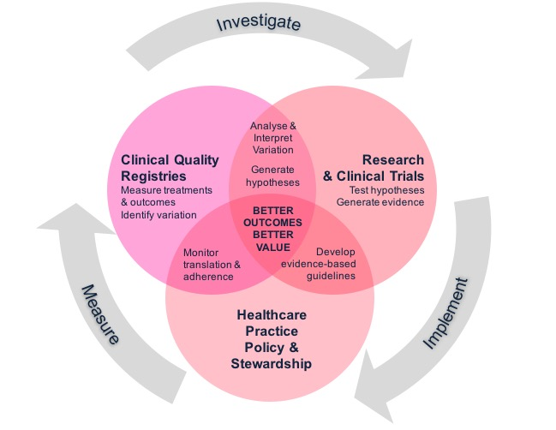

Introduction to clinical trials
Clinical trials test the efficacy, effectiveness or cost-effectiveness of healthcare interventions, including preventive measures, treatments, care pathways and diagnostic tests. Often trials will compare one intervention against another to see which is more effective or efficient in achieving a desired outcome. The most rigorous, and therefore influential, way to determine if a cause-effect relationship exists between a treatment and an outcome is for participants to be randomly allocated to the intervention they receive. This is known as a randomised controlled trial (RCT).

Clinical trials differ in terms of why they are conducted (context), what type of evidence they are designed to generate (phase) and what is learnt about the intervention being tested (findings) as illustrated in Figure 2 and explained further below.
Figure 2. Defining characteristics of clinical trials
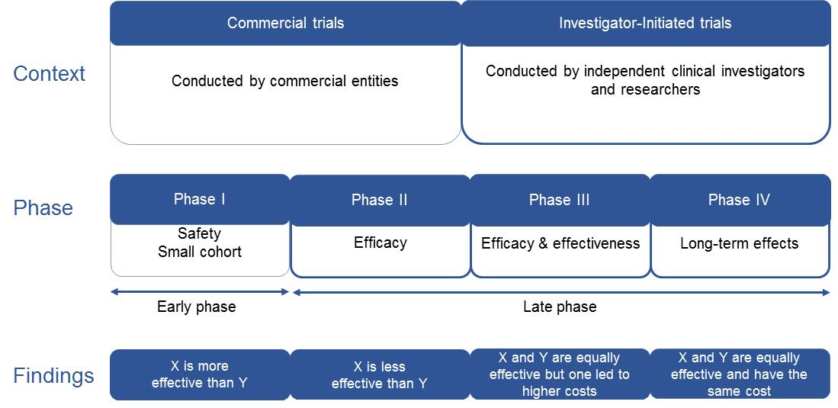

Context
Clinical trials can be conducted by commercial entities with a financial interest in the intervention being tested. These might include pharmaceutical companies or contract research organisations for example. These trials are conducted to support licensing or regulatory approval of new therapies or diagnostic methods.

Clinical trials are also conducted by independent clinical investigators and researchers. For example, those working within the healthcare system (including acute, sub-acute and primary care settings) or public institutions, such as universities. These trials are conducted to test therapies and generate clinical evidence to inform health-related decisions and improve the safety and quality of health care. These trials are often referred to as investigator-initiated or investigator-led trials.

Phases
In broad terms, clinical trials can be divided into four phases:

- Early testing of a new intervention to establish safety, usually among a small number of trial participants.
- Examination of whether a treatment does what it is intended to do (efficacy).
- Assessment of efficacy in a broader and more representative patient population and determination of how well a treatment does what it is intended to do (effectiveness) compared to alternatives.
- Monitoring of the long-term effects of interventions on the general population, after they have been introduced into practice.
There can also be pre-clinical stages that occur prior to Phase I, where scientific information such as a biological mechanism of action are evaluated. In practice, the four phases also overlap, with safety, efficacy and effectiveness considered to varying degrees throughout all phases. For this reason, trials are often grouped together and described as either late-phase or early-phase. For this evaluation, late-phase trials are defined as Phase II and beyond.

Findings
Trials may or may not find a difference in comparative effectiveness between the interventions being tested, meaning that the outcomes of intervention X may or may not be better than the outcomes of intervention Y. Furthermore, any difference in effectiveness may or may not be accompanied by a difference in cost.

Introduction to clinical trials networks
Late-phase clinical trials are usually complex, involve many patients over dispersed locations and include advanced scientific methods. Often participants are recruited across multiple hospitals in Australia and overseas in order to detect the effects of the evaluated intervention over a broad range of patients.

Clinical trials networks (networks), made up of a geographically dispersed and multidisciplinary communities of experts, have formed to overcome some of the challenges of designing and conducting these trials successfully. Common among all networks is the involvement of multiple healthcare facilities and practicing clinicians. As a result, networks are closely integrated within the healthcare system and provide a unique model for building, sharing and sustaining the complex infrastructure needed to conduct multiple, multicentre clinical trials.

Networks have a set of core functions that enable trials to be undertaken in a robust and efficient way (see Table 1). Many of these functions can be categorised as facilitating the design of trials. Some networks also independently manage or coordinate trials once they commence, although the majority form close working partnerships with large clinical trial coordinating centres that house a critical mass of expertise in trial methods, biostatistics, health economics, project coordination and data management.
Table 1. Core functions of clinical trials networks
Clinical trial facilitation | Clinical trial coordination
Identification of important clinical questions | Direct trial coordination and management*
Collaborative study protocol development | Site management*
Peer review and formal endorsement of trials | Data management*
Scientific meetings | Recruitment of trial participants*
Grant writing* | Monitoring*
Education/training/mentoring of researchers* | Statistical analysis*
Advocacy and industry/consumer liaison | Regulatory affairs*
Site selection and trial oversight* | May or may not act as study sponsor
Clinical guideline development
* Activities that are often undertaken in partnership with clinical trial coordinating centres.
The defining characteristics of networks provide levers that add value to the process of conducting investigator-initiated clinical trials (Table 2).
Table 2. Network characteristics that add value to clinical trials
Network characteristic | Value lever | Added value
A highly collaborative community of clinicians and research experts. | Shared values and insight of the most relevant front-line clinical issues.  Knowledge dissemination and expertise transfer. | Research questions are targeted to relevant clinical topics.  Maximises trial feasibility and awareness of findings. This is likely to enhance subsequent implementation of evidence in to practice.
Representation across multiple geographically dispersed sites, often including rural and regional centres. | Access to large numbers of patients often required in late-phase trials. | Capacity to recruit sufficient sample sizes quickly and efficiently.
Continuity of staffing and resourcing structure across projects. | Sequential commencement of new trials as old ones complete. | Greater efficiency and effectiveness in research design. Trial infrastructure doesn’t need to be dismantled and recreated.
Established network infrastructure. | Permanent central data and statistical expertise and experience. | Continuity of and longevity of training and mentoring.
Only requirement to participate is treating eligible patients. | Horizontally devolved and broadly inclusive structure. | High external validity of trials findings across broad settings.
High proportion of key clinical opinion leaders. | Engagement, mandate and trust of clinicians on the front line of care.  Knowledge dissemination and expertise transfer. | Maximises trial feasibility and awareness of findings. This is likely to enhance subsequent implementation of evidence in to practice.

Clinical trials networks exist across the world and are diverse in their size and structure. Australia has a strong reputation for establishing highly successful networks, across multiple clinical areas. A recent report commissioned by the NHMRC, found that Australian networks had together completed or initiated more than 1,000 studies from 2004 to 2014. These studies involved more than one million participants and generated at least $1 billion in total research funding. Conservative estimates suggest that between one quarter and one third of all NHMRC funding to support clinical trials between 2004 and 2014 was awarded to trials conducted by an established network.

Understanding the value proposition for clinical trials and networks
National and international assessments of the health and economic returns from health and medical research, and other activities that generate evidence, have demonstrated potentially large returns on investment.,, While the value of clinical trials activity within the broader health and medical research landscape has not been fully evaluated, there is growing evidence suggesting that a number of Australian-led investigator-initiated clinical trials have had a major impact in terms of improving health care quality and outcomes.

Returns from these trials are not simply associated with the discovery of new therapies. Much of the suggested benefit comes from identifying unexplained and unjustified variation in practices, identifying more efficient models of care, as well as flagging expensive services that are no more effective than lower cost alternatives.

Within the clinical trials sector, networks are widely regarded to be key drivers of impact and value for public investment. To date however, there has been no attempt to formally evaluate the economic impact of networks in Australia or describe the specific ways networks add value to the clinical trial process. In April 2016, the Australian Commission on Safety and Quality in Health Care (the Commission) commissioned the Australian Clinical Trials Alliance (ACTA), in association with Quantium Health Outcomes (formerly Health Outcomes Australia), to investigate the health and economic impact of clinical trials conducted by networks in Australia.

Overview of approach and methodology
This section provides an overview of the approach to network and clinical trial selection and the methodology used in the evaluation.

Selection of networks
The Report on the Activities and Achievements of Clinical Trials Networks in Australia 2004–2014 (the Profiling Networks Report) provided a starting point for the selection of case study networks and trials for the evaluation. The report identified a total of 37 established networks in Australia and presented comprehensive data from 34 of the networks for the period 2004 to 2014.

Networks from the Profiling Networks Report were included in the evaluation if they met the following criteria:

- Maturity: networks had to have been operational for 10 or more years and have five or more high-impact peer reviewed clinical trials where an influence (or potential influence) on local clinical policy and/or practice could be identified
- Local Investment: a significant proportion of the research funding received by the clinical trials had to be from Australian funders, primarily the NHMRC
- Feasibility: networks had to be available to participate for the duration of the project and be able to provide data and in-kind engagement.

Four networks were shortlisted on the basis that they met the first two criteria. As one of these networks was unable to participate for the duration of the evaluation, three networks were included in the evaluation, as described below and in Table 3.

- Australasian Stroke Trials Network (ASTN). The ASTN was established in 1996 and has completed or initiated more than 75 multicentre clinical trials and related studies in stroke care, diagnosis or prevention.
- Interdisciplinary Maternal Perinatal Australasian Collaborative Trials (IMPACT) Network. The IMPACT Network formed in 1994 and has completed or initiated close to 300 clinical trials and related studies in maternal and perinatal health.
- Australian and New Zealand Intensive Care Society Clinical Trials Group (ANZICS CTG). The ANZICS CTG was established in 1994 and has completed or initiated approximately 90 clinical trials and related studies in intensive care.

Table 3. Networks included in the analysis
Network | Year started | Studies | Funding | Publications | Known high- impact trials
Australasian Stroke Trials Network (ASTN) | 1996 | 40 Published  35 Current | >$50 million  Total  >$10 million NHMRC | 180+ | 5+ including  ARCH  Extend-IA  INTERACT-2  PROGRESS  AVERT  QASC  Enchanted
Interdisciplinary Maternal Perinatal Australasian Collaborative Trials (IMPACT)  Network | 1994 | 147 Published  150 Current | $10–25 million  Total  >$10 million NHMRC | 145+ | 5+ including  ICE  VIBeS Plus  COSMOS/M@NGO  MAP  COIN  ACTORDS  ACHOIS  ACTOMgSO4
Australian and  New Zealand Intensive Care Society Clinical Trials Group (ANZICS CTG) | 1994 | 41 Published  48 Current | >$50 million  Total  >$50 million NHMRC | 130+ | 5+ including  NICE-SUGAR  DECRA  SAFE  RENAL  CHEST  ARISE  EPO-TBI  SAFE-TBI
Data related to studies, publications and known high-impact trials sourced from the Profiling Networks Project were current at end 2014.
The three networks represent a variety of care settings and clinical disciplines and have been active for around twenty years. The networks also account for more than one-third of all published investigator-initiated clinical trials reported in the Profiling Networks Report. As such, they are considered to provide a comprehensive basis upon which to make high-level estimations of the health and economic benefit of clinical trials conducted through networks.

Selection of clinical trials
Clinical trials were suitable for inclusion in the evaluation if they:

- Were investigator-initiated
- Were identified as having had (or as having the potential to have) a significant impact on clinical practice or policy as part of the Profiling Networks Report.

Clinical trials which have these characteristics are generally late-phase RCTs that show whether the trial intervention is more effective than the alternative, less effective than the alternative, or equally effective but with different ongoing costs (Figure 3). They are often also large (in terms of patient numbers), multicentre, peer reviewed and published in high-profile journals.
Figure 3. Types of trials included in the analysis
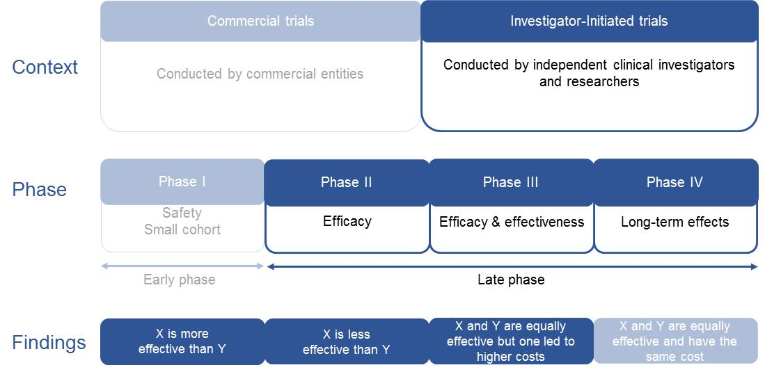
Identification of high-impact trials occurred as part of the Profiling Networks Report, and consequently, this report was used to identify trials for inclusion in the evaluation. In order to ensure that significant trials were not missed, networks were invited to confirm the trials that had been selected. One additional recent trial was subsequently identified (ENCHANTED), resulting in a sample of 25 trials across the three case study networks (Table 4). This represents a sample of approximately 10% of all studies (including early-phase, pilot and observational studies) ever completed by these three networks:

- 18% of completed ASTN studies
- 7% of completed IMPACT Studies
- 20% of completed ANZICS CTG studies.

Table 4. Individual trials selected for analysis
Network | Trial acronym | Trial publication reference
ASTN | ARCH | Clopidogrel plus aspirin versus warfarin in patients with stroke and aortic arch plaques. Stroke 2014; 45:1248–57.
ASTN | AVERT | Efficacy and safety of very early mobilisation within 24h of stroke onset (AVERT): a randomised controlled trial. Lancet 2015; 386: 46–55.
ASTN | ENCHANTED | Low-dose versus standard-dose intravenous alteplase in acute ischemic stroke. N Engl J Med 2016; 374:2313–23.
ASTN | EXTEND-IA | Endovascular therapy for ischemic stroke with perfusion-imaging selection.  N Engl J Med 2015; 372:1009–18.
ASTN | INTERACT2 | Rapid blood-pressure lowering in patients with acute intracerebral haemorrhage. N Engl J Med 2013; 368:2355–65.
ASTN | PROGRESS | Randomised trial of a perindopril-based blood pressure lowering regimen among 6,105 individuals with previous stroke or transient ischaemic attack. Lancet 2001; 358:1033–41.
ASTN | QASC | Implementation of evidence-based treatment protocols to manage fever, hyperglycaemia and swallowing dysfunction in acute stroke (QASC): a cluster randomised controlled trial. Lancet 2011; 378:1699–706.
IMPACT | ACHOIS | Effect of treatment of gestational diabetes mellitus on pregnancy outcomes. N Engl J Med 2005; 352:2477–86.
IMPACT | ACTOMgSO4 | Effect of magnesium sulfate given for neuroprotection before preterm birth: a randomised controlled trial. JAMA 2003; 290(20):2669–76.
IMPACT | ACTORDS | Neonatal respiratory distress syndrome after repeat exposure to antenatal corticosteroids: a randomised controlled trial. Lancet 2006; 367:1913–19.
IMPACT | COIN | Nasal CPAP or intubation at birth for very preterm infants.  N Engl J Med 2008; 358:700–8.
IMPACT | COSMOS | Effects of continuity of care by a primary midwife (caseload midwifery) on caesarean section rates in women of low obstetric risk: the COSMOS randomised controlled trial. BJOG 2012; 119:1483–92.
IMPACT | ICE | Whole-body hypothermia for term and near-term newborns with hypoxic-ischemic encephalopathy. Arch Pediatr Adolesc Med 2011; 165(8):692–700.
IMPACT | M@NGO | Caseload midwifery versus standard maternity care for women of any risk: M@NGO, a randomised controlled trial. Lancet 2013; 382:1723–32.
IMPACT | MAP | Management of asthma in pregnancy guided by measurement of fraction of exhaled nitric oxide: a double-blind, randomised controlled trial.  Lancet 2011; 378:983–90.
IMPACT | PPROMT | Immediate delivery compared with expectant management after preterm pre-labour rupture of the membranes close to term (PPROMT trial): a randomised controlled trial. Lancet 2015; 387: 444–52.
IMPACT | VIBES+ | Preventive care at home for very preterm infants improves infant and caregiver outcomes at two years. Pediatrics 2010; 126:e171–e178.
ANZICS CTG | ARISE | Goal-directed resuscitation for patients with early septic shock. N Engl J Med 2014; 371:1496–506.
ANZICS CTG | CHEST | Hydroxyethyl starch or saline for fluid resuscitation in intensive care. N Engl J Med 2012; 367:1901–11.
ANZICS CTG | DECRA | Decompressive Craniectomy in Diffuse Traumatic Brain Injury. N Engl J Med 2011; 364:1493.
ANZICS CTG | EPO-TBI | Erythropoietin in traumatic brain injury (EPO-TBI): a double-blind randomised controlled trial. Lancet 2015; 386: 2499–506.
ANZICS CTG | NICE-SUGAR | Intensive versus Conventional Glucose Control in Critically Ill Patients. N Engl J Med 2009; 360:1283–97.
ANZICS CTG | RENAL | Intensity of Continuous Renal-Replacement Therapy in Critically Ill Patients. N Engl J Med 2009; 361:1627–38.
ANZICS CTG | SAFE | A Comparison of Albumin and Saline for Fluid Resuscitation in the Intensive Care Unit. N Engl J Med 2004; 350:2247–56.

Evaluation of health and economic benefit
The evaluation followed a six-stage process to:

- Understand the potential impact of the trials on clinical practice and/or policy
- Identify the number of people affected if the trial findings were implemented
- Calculate the benefit of trial findings on ongoing patient health outcomes
- Calculate the benefit of trial findings on ongoing direct health service costs
- Measure the benefits against clinical trial and network costs
- Undertake sensitivity analyses to investigate what would happen to the results if assumptions changed.

Understanding the potential impact on clinical practice and/or policy
The first step was to understand what effect the clinical trials may have had on clinical practice and what might have happened if the trial had not taken place. For example, if a trial identified that a recently introduced treatment was unsafe for patients, this treatment may have been stopped. This would be particularly important if the treatment was already becoming a standard practice.

Since the goal of the analysis was to determine the benefits relating to changes in clinical practice or policy, the evaluation focused only on outcomes that were explicitly measured in each trial and that were considered to be clinically significant. That is, the difference in treatment outcomes had to be large enough that most clinicians would consider altering their practice based on the results. Generally speaking, statistically significant outcomes were also likely to be clinically significant.

Trials were included because the networks identified them as being high-impact studies. Insights into clinical impact and significance were derived from qualitative interviews with clinicians and trialists, review of treatment protocols, review of the literature (particularly review of the trial paper and earlier or associated publications) and basic analysis of available published data on trends in treatment practices. This method was also followed to understand the ways in which networks support trials. Sometimes it was also possible to verify treatment patterns through indirect routes, such as by checking the sales figures for treatment materials.

In a small number of cases clinical significance was thought to exist in spite of there being no statistically significant difference in specific outcomes from the trial. Clinical significance was still recorded for these findings for several reasons:

- When trial findings were joined with other parallel results, statistical significance did exist (e.g. ACTOMgSO4)
- Because statistical adjustment to overcome baseline differences in the health of patients within each intervention group doesn’t affect the impact of the overall findings on clinical decision-making (e.g. DECRA)
- The trial wasn’t sufficiently powered to detect statistical difference (e.g. ARCH), but the clinical findings were still considered to be significant and can or have been confirmed in further study.

Identifying the number of people affected if findings were implemented
The next step was to estimate how many patients would be affected by the findings of each trial. That is, what proportion of eligible patients (e.g. all patients who have a stroke in a year) would successfully receive the more effective intervention that was identified by the trial. Eligible patient data were sourced from public records, such as the Australian Institute of Health and Welfare (AIHW). If this information was not available, expected prevalence was taken directly from the trial background data.

Real-world measurement of the degree to which each of the trials’ findings have been implemented in clinical practice was beyond the scope of this report. For this reason, standardised assumptions were used to determine the potential size of the impact from the included case studies. These were based on the lifetime impact of trial findings on 65% of the patients who would be eligible to receive the trial intervention in any one year.

The lifetime benefit for patients means that if 10 people, each aged 70, were expected to have an illness each year, then each of these 10 people were included in the evaluation and benefits were calculated over their remaining life expectancy (15.5 years from Australian Bureau of Statistics data).

It is noted that for some trials, implementation in 65% of patients may be an overestimation, while for others it may be an underestimation. However, feedback from interviews with clinical opinion leaders indicated that this is likely to balance out across the set of trials included.

Assumptions were chosen based on the approach validated through other similar evaluations, including a recently published report on the economic impact of the National Institute for Health Research (NIHR) Health Technology Assessment program in the United Kingdom.

Calculating the benefit of trial findings on ongoing patient health outcomes
Improvements to life expectancy and/or quality of life (for example through better mental health in mothers with babies, or less ongoing impairment following a traumatic brain trauma) were valued using standard guidance on the Value of a Statistical Life Year (VSLY). This guidance assigns a year of life in full health a value of $180,000. Increased life expectancy was modelled based on life charts and the baseline disease characteristics of eligible patients. This ensures that benefit calculations take in to account that patients may have pre-existing chronic diseases as recorded in trial data.

Where trial outcomes were associated with substantial impairments to life expectancy or quality of life (for example, where patients underwent dialysis, or experienced side effects following surgery), adjustments were applied to this value using published health state utility weightings and disease specific life expectancy data published by the AIHW and the World Health Organization (WHO)., The resulting value is referred to as a Quality Adjusted Life Year (QALY).

Ongoing costs of care when the expected alternative with a different intervention was death, were not included unless any difference in mortality rates were explicitly measured in the trial. If ongoing service use costs were included, in many cases it would incorrectly imply that increased mortality was more economically viable. Given that macroeconomic gains (such as productivity) were not included in this evaluation, this would have been unbalanced.

Calculating the benefit of trial findings on ongoing direct health service costs
Avoided health service costs consisted of:

- The difference in the cost of implementing interventions
- The difference in the costs associated with primary and secondary outcomes of the interventions.

Only direct health service costs, for example costs for a visit to an intensive care unit (ICU), or the cost of providing stroke treatment, were evaluated. These included the cost of materials, clinician time and overheads, as appropriate for the trial. Additional macroeconomic impacts, like loss of personal income and government tax revenue due to ill health, were not included.

Two methodologies were considered for calculating avoided direct health service costs:

- Direct service input method, using estimates of avoided service use (e.g. avoided tests, medical treatments, surgeries, institutional care, bed days, time on mechanical ventilation) based on trial data in manuscripts and associated publications.
- Per patient surveillance cost, using actual individualised cost values by tracking individual patients as they use the health system.

Per patient surveillance costs were used where there were published papers available (MA@NGO, COSMOS and CHEST). Otherwise, the direct service input method was used as it provides a close estimate that doesn’t require complex modelling. This approach was verified by cross-comparing findings from both methodologies using the MA@NGO, COSMOS and CHEST trials. For each trial, very similar results were found.

Estimated service use was based on current clinical guidelines and verified with clinicians. Associated service costs were sourced from the Independent Hospital Pricing Authority (IHPA), AIHW or published costing studies. Individual cost elements were included on a case-by-case basis depending on if they were likely to change if the trial findings are implemented. Only additional costs or savings, compared to the expected regular expenditure, were included. For example, if a trial intervention leads to a reduction in the number of caesarean sections performed in a year, then the difference in cost between a normal vaginal delivery and caesarean section was used to work out the benefit.

Measuring benefits against costs
The relationship between networks, clinical trials and funding is depicted in Figure 4. Benefits were compared against the central operating costs of the networks (since inception) and the cost of performing all studies undertaken by the networks between 2004 and 2014.

Figure 4. Generic activity and funding structure of networks
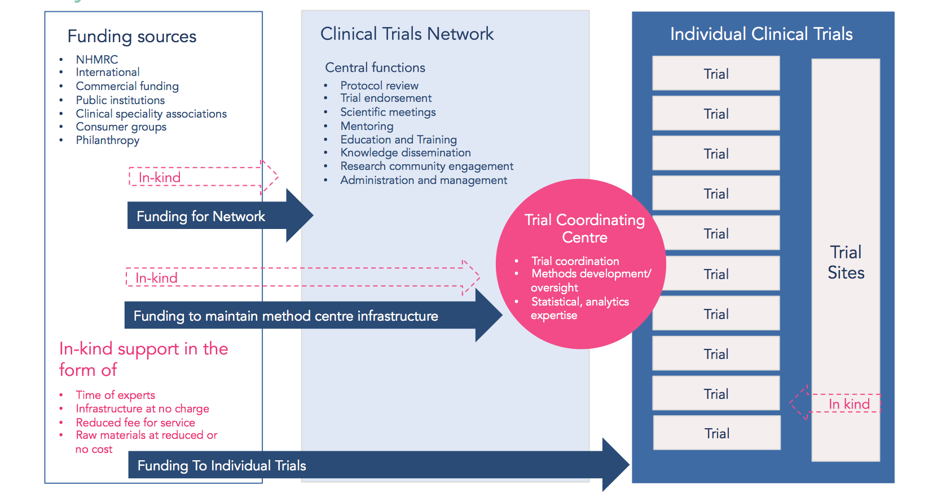

Calculating trial costs
The cost of performing all studies within the networks between 2004 and 2014 (inclusive) was included in the evaluation. Funding for early phase studies (including studies that did not lead to late-phase trials) was included on the basis that these studies may have contributed to late-phase trial benefits by providing introductory evidence, identifying trends or generating hypotheses for example. This approach overcame some of the risk of bias associated with analysing only a selection of high-impact trials. Costs (including in-kind) arising through trial coordinating centres that had formally established links with the networks were also included in the evaluation. Site level
in-kind support was noted by all three networks but these costs could not be readily quantified and were therefore not included in the analysis.

Only non-commercial funding was included in the evaluation. Funding data were sourced from the Profiling Networks Report and verified by chief investigators or their nominated representatives. The proportion of NHMRC funding within these figures was confirmed in the same manner and cross-checked with published NHMRC data sources. Funding data were readily available for approximately half of the trials within the networks. These data were used to calculate average costs per participant per clinical discipline. For trials where funding data were not readily available, funding was estimated based on the number of participants and corresponding average costs.

The ongoing costs of the preferred intervention were included, accounting for the fact that if these are more expensive than the alternative they reduce the overall estimated benefit. The costs of translation of evidence into clinical practice and the cost or benefit of potential third-order consequences of trial outcomes were not included unless explicitly measured in the trial. For example, if a trial resulted in a reduction in caesarean section rates, these mothers may have a reduced likelihood of undergoing caesarean sections (and their associated health outcomes) in any subsequent pregnancies. These were not included unless measured in the trial.

Calculating network costs
Total network costs since inception were supplied by the networks and included in the evaluation. This conservative approach was taken on the basis that the capacity and expertise developed over time may have contributed to the benefits being quantified. Network costs included the costs to establish, maintain and operate the network, cost of trial coordination (either internally within the network or via collaboration with an established trial-coordinating centre) and estimates of the value of in-kind contributions (expert time or facilities provided to the network at no cost). Any trial-coordination costs that could not be provided by the networks were estimated as a fixed proportion of clinical trial funding.

Sensitivity analysis
Sensitivity analyses are used to investigate what would happen to results if major assumptions used in calculations were to change. They answer the question ‘do the decisions made in the analysis impact the strength of the findings?’ If the answer to the question is no, then the results can be viewed with a higher degree of certainty. The following were tested through sensitivity analyses:

- Rate of implementation, what would happen to the results if the trial findings were implemented in a number other than 65% of the eligible population
- Value of a year of life in full health, what would happen to the results if a year of life in full health was valued at less than $180,000.

Results of the health and economic evaluation
This section presents the consolidated findings from the analysis. It is not the purpose of this evaluation to compare networks or individual trials, since sampling was uneven and economic differences between clinical specialties are to be expected.

All values are in 2014 dollars. Values over $10 million are rounded to the nearest million for presentation. Values over $1 billion are rounded to the nearest $100 million. Ratios are presented to the nearest whole number, except for the consolidated gross benefit to cost ratio. Full network level and individual trial level results are presented in appendices.

A 3% per annum discount rate was applied on costs and benefits to reflect that these accumulate over time and that the true value of money changes year on year.

Consolidated heath and economic impact
In total, 25 high-impact clinical trials were evaluated across the three networks. If the results of these trials were implemented in 65% of the eligible Australian patient populations for one year:

- The gross benefit would be approximately $2 billion (2014 dollars) measured through better health outcomes and reduced health service costs
- Reductions in health service costs would account for 30% ($580 million) of the gross benefit, and this alone would exceed the total costs for the three networks and all of their research activity from 2004 to 2014.

The report also finds:

- The overall consolidated benefit-to-cost ratio for the networks is 5.8:1, or a return of $5.80 for every $1 invested
- The results of the 25 trials only needed to be implemented in 11% of the eligible patient populations for benefits to exceed costs
- For every $1 awarded in NHMRC grants to the 25 trials, a return of $51.10 was achieved
- Just 9% of the $2 billion gross benefit from the trials in this study was equivalent to all NHMRC funding received by all Australian networks between 2004 and 2014
- Trials conducted by networks influence clinical guidelines, identify ways to improve safety and quality and identify opportunities for more efficient resource use
- Increasing implementation of trial evidence into practice can lead to considerable additional health and economic gains.

The consolidated gross benefits are estimated to be almost $2 billion. Benefits are gained through both improvements in patient health outcomes and savings from direct health service costs avoided. When the lifetime cost of operating the networks and the cost of performing all studies within the networks is deducted, the net benefit is over $1.6 billion. The breakdown of consolidated benefits and costs is shown in Figure 5. With a total gross benefit of almost $2 billion and a total cost of
$335 million, the benefit to cost ratio is 5.8:1. In other words, every dollar invested returns $5.80 in health and economic benefits.
Figure 5. Consolidated health and economic impact

Only non-commercial funding was included in this analysis. While some cross-subsidy of funding from commercial funding sources was reported by networks, the collection of accurate costing data for commercial funding was beyond the scope of the evaluation. The direction of effect is preserved if two sizeable unrestricted commercial grants reported for the CHEST and PROGRESS trials are included in the analysis.

The benefit to cost ratio increases to 22:1, or a return of $22 for every $1 invested, when the costs are limited to funding to the 25 trials (including a loading of 30% for coordinating centre costs) combined with the lifetime costs of running the networks and in-kind contributions.

Looking specifically at the returns from NHMRC funding, the benefit to cost ratio for NHMRC funding to the 25 trials is 51:1 (see Table 5). Furthermore, only 9% of the estimated gross benefit from these trials is required to cover all clinical trials-related funding awarded by the NHMRC to Australian networks over more than a decade (as reported in the Profiling Networks Report).
Table 5. Benefit to cost ratios
Trial costs included | Cost | Benefit to cost ratio
Total non-commercial funding to 25 trials included  (including coordinating centre costs)  + funding for all studies 2004–2014  + lifetime central network costs (including in-kind) | $335 million | 5.8:1
Total non-commercial funding to 25 trials included  (including coordinating centre costs)  + lifetime central network costs (including in-kind) | $87 million | 22:1
Total NHMRC funding to the 25 trials included | $38.5 million | 51:1

Benefits
Table 6 and Sections 3.1.1.1 and 3.1.1.2 provide more detail in relation to the benefits quantified during the evaluation. Each network was found to influence guidelines, identify ways to improve safety and quality and identify opportunities for more efficient resource use.

Benefits from improved patient health outcomes
Improvements in patient health outcomes accounted for the majority of the gross benefits. These improvements were achieved in different ways by each network.

Most of the ASTN trials identified ways to improve patients’ functional outcomes or reduce secondary vascular incidents after stroke (including myocardial infarction and pulmonary embolism). This was particularly evident in EXTEND-IA, PROGRESS and QASC.

In the IMPACT case study, there were as many clinical trials that identified ways to improve quality of life in mothers and babies, including the ICE, ACHOIS and ACTOMgSO4 Trials, as there were trials identifying interventions that reduced direct service costs. Evidence from trials in this case study impacted infant mortality, perinatal complications, including nerve palsies and shoulder dystocia and the incidence of cerebral palsy. There is also likely to be an associated improvement in the emotional and mental health of mothers.

Many of the ANZICS CTG trials reduced the mortality rate of patients in intensive care. They did so by examining existing treatment options and models of care in common or increasing use, to identify which were more effective at improving patient outcomes. Evidence generated by these trials led to the avoidance of potentially harmful interventions such as tight glycaemic control in the critically unwell (NICE-SUGAR), fluid resuscitation with albumin in traumatic brain injury (SAFE-TBI) and early decompressive surgical intervention in traumatic brain injury (DECRA study).
Table 6. Consolidated benefits
Gross benefits | Value
Patient health outcomes | $1,377 million
Direct health service costs avoided | $580 million
Avoided service costs from trial interventions | ($127 million)
Avoided service costs from better outcomes | ($453 million)
Total gross benefits | ~$2 billion

Benefits from avoided direct health service costs
Approximately 30% of the estimated benefits are derived from reduced direct health service costs. This saving alone would be sufficient to cover the costs of all of the studies conducted by these networks between 2004 and 2014. Trials that particularly contributed to this type of benefit set out to either examine the clinical comparative effectiveness and cost-effectiveness of two interventions already in common practice, or to compare a newly emerging intervention with existing options.

Overall, interventions recommended by the ASTN trials were more expensive than current practice. This was mainly driven by the costs of endovascular clot retrieval procedures (EXTEND IA study) and increasing the number of patients receiving anti-hypertensive treatment (PROGRESS study). However, better health outcomes from these interventions resulted in significant reductions in subsequent health service costs for stroke, myocardial infarction and inpatient neurological rehabilitation.

Interventions recommended by the IMPACT trials were less expensive overall than current practice. This was accompanied by a reduction in adverse patient outcomes and reduced health service costs, largely by lowering the rate of caesarean sections and reducing length of stay for mothers and babies in hospital (e.g. PPROMT, VIBES+ and M@NGO).

All of the interventions recommended by the ANZICS CTG trials were less expensive than current practice (with particularly large differences in SAFE, RENAL and CHEST). Interventions such as the use of saline instead of albumin or hydroxyethyl starch for fluid resuscitation resulted in equal or better health outcomes while costing less. Better health outcomes also led to a reduction in subsequent service costs, particularly in the SAFE-TBI study where there were major reductions in the costs (hospital, rehabilitation and equipment) of supporting patients with traumatic brain injury.

Costs
Table 7 provides more detail in relation to the costs quantified during the evaluation.
Table 7. Consolidated costs
Costs | Value
Network costs | $19 million
Central network funding | ($6 million)
In-kind contributions to networks | ($13 million)
Coordinating centre costs | $73 million
Trial costs | $243 million
25 trials included in the evaluation | ($52 million)
All other trials within the networks | ($191 million)
Total costs | $335 million

In general, there were no remarkable differences in funding patterns noted between the case study networks. A common finding was that funding did not cover total costs at either a network or individual trial level. In-kind support was relied upon to make up the shortfall.

The majority of the costs were direct trial-related costs. Of the $243 million in total trial costs calculated, only 21% ($52 million) came from the 25 case study trials, the remainder were generated by including all studies conducted by the three networks between 2004 and 2014. The NHMRC provided over 70% of the $52 million in non-commercial funding for the 25 case study trials. The remainder was made up mainly of overseas public funding sources, medical societies and funding from other Australian institutions. Site level in-kind costs could not be accurately quantified during the evaluation. However, anecdotal evidence from interviews suggests that this support could represent an additional 2–50% in trial funding.

Where trial coordinating centre costs were known, they represented approximately 30% on top of total funding received for individual clinical trials. Sometimes these costs were fully funded as part of the trial, at other times significant in-kind support was necessary. Funding for central network operation was comparatively small and many core network functions (as described in Table 1) were enabled through in-kind support. Predominantly the support provided was time given for free by senior clinicians and researchers. Interviewees reported that this support was heavily relied upon to support three key network activity areas:

- Peer review of clinical trial submissions, protocols and manuscripts and the endorsement and publication of clinical trials
- Education, training, mentoring and professional development for clinician researchers
- Maintaining central network processes and infrastructure.

Sensitivity analysis
The sensitivity analysis confirms that the results are robust under a range of different assumptions. For example, the integrity of the results is preserved if trial findings were implemented in fewer than 65% of eligible patients at a minimum; and only 11% of patients would need to receive the more effective trial intervention for benefits to exceed costs (Table 8). Benefit to cost ratios for higher rates of implementation were also modelled. A notional 10% increase in the implementation of trial evidence among the eligible Australian patient population would lead to an additional $300 million in gross benefit.

Sensitivity analysis was also used to investigate what would happen if the value of a year of life in full health is based on gross domestic product per capita ($83,000) rather than Office of Best Practice Guidance ($180,000). The benefit to cost ratio using an implementation rate of 50% and the lower value of a year of life in full health is 3:1, or a return of $3 for every $1 invested with a total gross benefit of over $900 million.

Table 8. Rate of implementation sensitivity analysis
Implementation % | Consolidated  benefit to cost ratio | Observation
0 | 0.10:1
10 | 0.97:1
11% | 1.05:1 | Threshold for benefits to exceed costs
20 | 1.84:1
30 | 2.72:1
40 | 3.60:1
50% | 4.49:1 | Integrity of conclusions maintained
60 | 5.38:1
65% | 5.83:1 | Assumption used in this evaluation
70 | 6.28:1
75% | 6.73:1 | Additional $300 million gross benefit gained
80 | 7.18:1
90 | 8.09:1
100 | 9.00:1 | Assumption used in similar evaluations

Case study results
A brief summary of the results for each case study network is presented here. Network profiles and more detailed presentations of each case study analysis are provided in Appendix A.

Case Study 1: Trials in stroke care and prevention
Seven late-phase investigator-initiated trials conducted by the ASTN were included in the analysis. Table 9 provides a summary of the main findings of each trial and the clinical context used to assess benefits.

A consolidated gross benefit of $1 billion was estimated, of which approximately 23% ($230 million) was derived from avoided direct service costs (Figure 6). Total costs amounted to $106 million, which included funding for the trials analysed ($25 million, of which $19 million was NHMRC funding), funding for all other studies conducted by the ASTN between 2004 and 2014 ($55 million), trial coordinating centre costs ($24.1 million), lifetime central network funding ($0.2 million) and
in-kind support ($1.1 million).
Figure 6. Benefits and costs for trials conducted by the ASTN
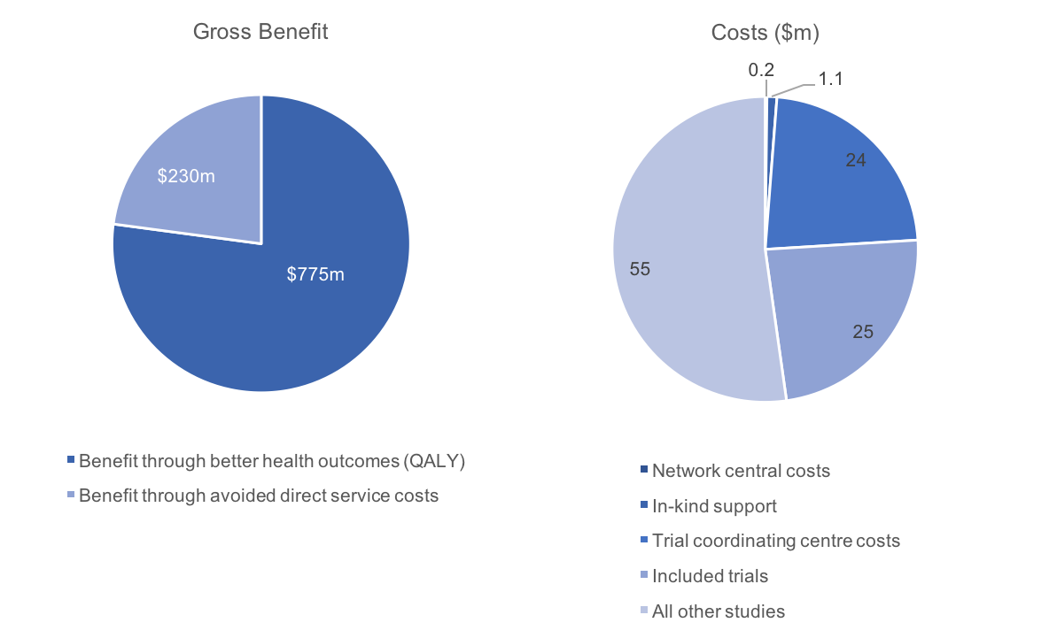
The benefit to cost ratio for the ASTN was 9.5:1

Table 9. Summary of main findings and clinical context for ASTN trials
Trial description | Main finding | Clinical context
ARCH: Clopidogrel plus aspirin versus Warfarin alone in patients with stroke and aortic arch plaques. | Treatment with clopidogrel plus aspirin was more effective in avoiding adverse events (myocardial infarction, pulmonary embolism, DVT). | Existing evidence comparing the two options was inconclusive. Treatment would not have been implemented without the trial.
AVERT: Efficacy and safety of very early mobilisation within 24 hours of stroke onset versus standard care. | Treatment with very early mobilisation was associated with poorer functional outcomes. | Prior to the trial, early higher dose mobilisation was becoming more common. The trial will prevent this continuing.
ENCHANTED: Enhanced control of hypertension and thrombolysis (lower dose alteplase versus higher dose). | Treatment with low dose alteplase is non-inferior and resulted in fewer intracerebral haemorrhages. | Variable dose regimens exist. The trial confirms non-inferiority of a lower dose. It is a more economical approach and has potential health benefits.
EXTEND-IA: Endovascular clot retrieval after intravenous thrombolysis in ischemic stroke. | Treatment was associated with faster and more complete reperfusion, reduction of infarct growth and better functional and neurological outcomes at three months. | Endovascular stroke therapy was virtually disappearing from practice before the trial. The trial led to changes in international guidelines and revisions are expected in Australia.
INTERACT 2: Intensive (versus standard) blood pressure reduction in acute intracerebral haemorrhage. | Treatment with intensive blood pressure reduction marginally improved functional outcomes and health-related quality of life. There was a non-significant difference in mortality in favour of the treatment. | The overall improvement in outcomes is thought to favour a shift to this treatment.
PROGRESS: Perindopril (ACE inhibitor) protection (versus placebo) against recurrent stroke. | Treatment with Perindopril reduced strokes and major vascular events across all subgroups (race, age and type of stroke). | Little prior evidence for blood pressure (BP) lowering in recurrent stroke. The trial provided evidence for those with known cardiovascular disease irrespective of baseline BP.
QASC: Implementation of evidence-based treatment protocols to manage fever, hyperglycaemia and swallowing (FeSS) dysfunction in acute stroke. | Treatment delivered better long-term outcomes following patient discharge (fewer deaths and improved dependency ratings). | Previous guidelines were poorly followed or excluded patients from recommended treatment. The trial led to guideline changes and implementation of FeSS  guideline-based interventions.

Case Study 2: Trials in maternal and perinatal health
Ten late-phase investigator-initiated trials conducted by the IMPACT network were included in the analysis. Table 10 provides a summary of the main findings of each trial and the clinical context used to assess benefits.

A consolidated gross benefit of $682 million was estimated, of which approximately
38% ($259 million) was derived from direct service costs avoided (see Figure 7). Total costs amounted to $173 million, which included funding for the trials analysed ($9 million, of which
$8 million was NHMRC funding), funding for all other studies conducted by the IMPACT network between 2004 and 2014 ($123 million), trial coordinating centre costs ($39 million), lifetime central network funding ($0.4 million) and in-kind support ($2.2 million).
Figure 7. Benefits and costs for trials conducted by the IMPACT network
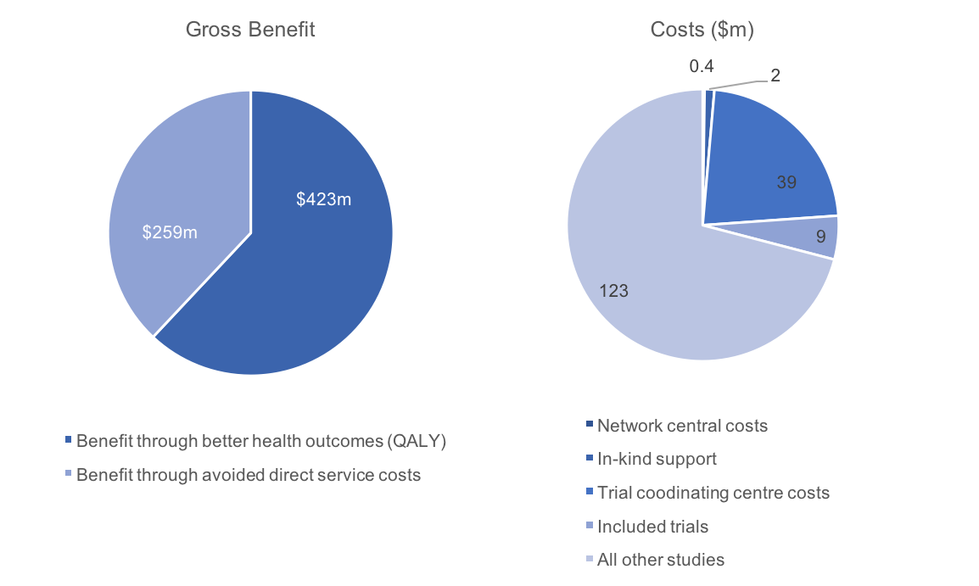
The benefit to cost ratio for the IMPACT network was 3.9:1

Table 10. Summary of main findings and clinical context for IMPACT Network trials
Trial description | Main finding | Clinical context
ACHOIS: Effect of treatment of gestational diabetes mellitus on pregnancy outcomes. | Treatment reduced serious perinatal morbidity and also improved maternal health-related quality of life. | Routine screening and treatment of gestational diabetes had not been common practice and would not have been introduced without the trial.
ACTOMgSO4: Effect of magnesium sulphate given for neuroprotection before preterm birth. | Treatment had no adverse effect and reduced motor dysfunction. | Treatment with magnesium sulphate should be considered as a result of this trial.
ACTORDS: Preterm neonatal respiratory distress syndrome after repeat exposure to antenatal corticosteroids (versus placebo). | Exposure to repeat doses of antenatal corticosteroids reduced neonatal morbidity. | Repeat doses of corticosteroid in prematurity were not endorsed before the trial but are now used in practice.
COIN: Nasal CPAP or intubation at birth for very preterm infants. | CPAP can be used from birth and reduced the rate of intubation and surfactant requirement. | Reduction in intubation and ventilation immediately after birth. Guidelines would not have changed without the trial.
COSMOS: Caseload midwifery care versus standard maternity care for women of low obstetric complication risk. | Treatment reduced C-section, epidural pain relief, episiotomy, postpartum length of stay, neonatal ICU use and low birth weight. | C-section rates were increasing leading up to the trial. Caseload midwifery rates have increased 31% since the trial.
ICE: Whole body hypothermia for term and near-term newborns with hypoxic-ischemic encephalopathy. | Intervention reduced mortality (increased survival free of disability). | Without the trial, whole body hypothermia would not have been implemented as practice.
MAP: Management of asthma in pregnancy guided by measurement of fraction of exhaled nitric oxide versus symptom based. | Treatment showed fewer exacerbations requiring GP attendance. | Awareness of asthma during pregnancy and management has increased since the trial.
M@NGO: Caseload midwifery care versus standard maternity care for women of any risk. | Caseload midwifery found to have a lower cost than standard care, with equal outcomes. | Caseload midwifery rates have increased 31% since the trial.
PPROMT: Immediate delivery versus expectant management after pre-labour rupture of the membranes close to term. | Expectant management had fewer adverse events. | Prior to the trial, immediate delivery was becoming common practice. The trial will prevent this from happening.
VIBES+: At home preventative care for very pre-term infants and their caregivers. | Improved behavioural outcomes for infants and reduced anxiety and depression in caregivers. | Associated with additional intervention costs, but is likely to improve patient health outcomes if implemented.

Case Study 3: Trials in intensive care
Eight late-phase investigator-initiated trials conducted by the ANZICS CTG were included in the analysis. Table 11 provides a summary of the main findings of each trial and the clinical context used to assess benefits.

A consolidated gross benefit of $271 million was estimated, of which approximately
35% ($95 million) was derived from direct service costs avoided (see Figure 8). Total costs amounted to $57 million, which included funding for the trials analysed ($18 million, of which
$11 million was NHMRC funding), funding for all other studies conducted by the ANZICS CTG between 2004 and 2014 ($13 million), trial coordinating centre costs ($10 million), lifetime central network funding ($6 million) and in-kind support ($10 million).
Figure 8. Benefits and costs for trials conducted by the ANZICS CTG. 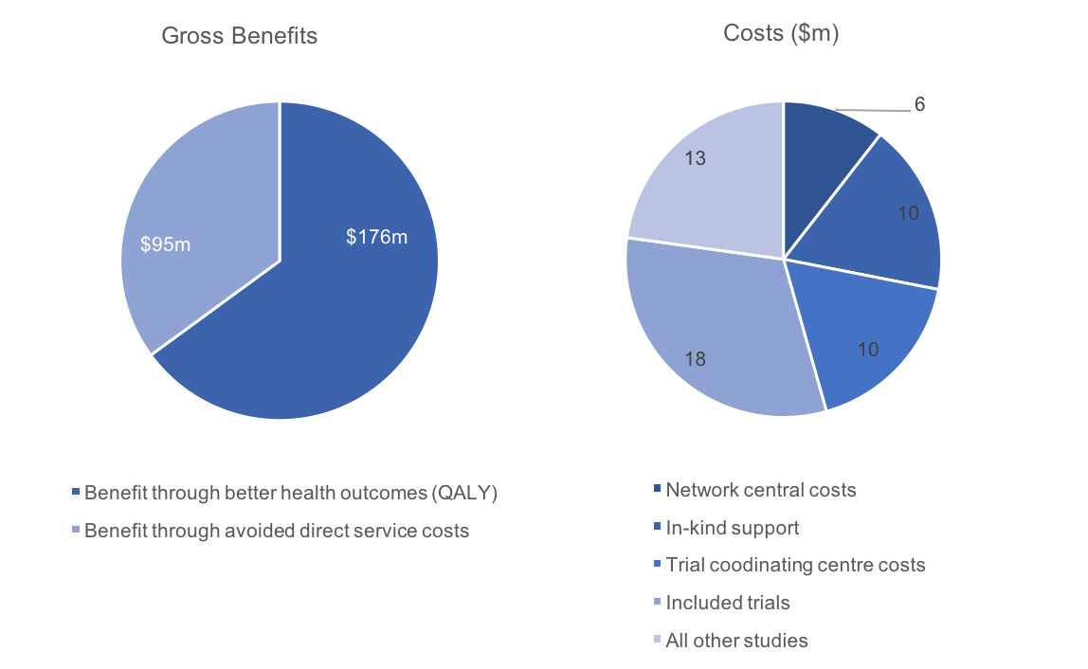
The benefit to cost ratio for the ANZICS CTG was 4.8:1
Table 11. Summary of main findings and clinical context for ANZICS CTG trials
Trial description | Main finding | Clinical context
ARISE: Early goal directed resuscitation versus standard care for patients with septic shock in the emergency department. | The treatment provided no improvement in mortality but there was an increase in treatment costs including the use of vasopressor support. | Previous studies led to surviving sepsis guidelines advocating the use of the early goal directed resuscitation protocol. These were revised globally following the trial.
CHEST: Hydroxyethyl starch or saline for fluid resuscitation in critically ill patients. | No difference in mortality, with greater costs and requirement for renal replacement therapy in the hydroxyethyl starch treatment group. | Hydroxyethyl starch had become the most commonly used colloid in fluid resuscitation in some places overseas and was increasingly being used in Australia before the trial. The trial reduced this trend.
DECRA: Decompressive craniectomy in diffuse traumatic brain injury (TBI) refractory hypertension. | Decompressive craniectomy reduced ICU length of stay but was associated with poorer patient health outcomes overall. | In eligible patients, decompressive craniectomy was becoming more common. The trial may prevent an increase in this practice.
EPO-TBI: Erythropoietin in traumatic brain injury versus placebo (testing neurocytoprotective effect). | No change was seen in functional outcomes or side effects such as deep vein thrombosis. | Previous equivocal RCT evidence for benefits in functional outcomes. This trial has stopped the widespread implementation of EPO in patients with traumatic brain injury.
NICE-SUGAR: Intensive versus conventional glucose control in ICU patients admitted for three or more days. | More deaths and adverse events in the treatment (intensive control) group. | Without the trial, intensive glucose control would have been implemented. This will not happen now.
RENAL: Augmented renal replacement therapy versus standard (lower intensity) in severe acute renal failure. | Higher intensity treatment did not decrease mortality and hypophosphatemia occurred more often. | Intensive renal replacement therapy was becoming increasingly common on the basis of smaller studies. The trial will prevent this continuing.
SAFE: Albumin versus saline for fluid resuscitation in ICU. | No difference in outcomes, but albumin is more expensive (and there is some indication of harm in patients with traumatic brain injury). | Albumin use was becoming common practice. The trial prevents an unnecessary increase in its use in ICU.
SAFE-TBI: Albumin or saline for fluid resuscitation in traumatic brain injury patients. | Fluid resuscitation with albumin was associated with higher mortality risk in this group of patients. | Prior to the SAFE trial, albumin use was becoming common. The SAFE-TBI study will prevent use of albumin in traumatic brain injury patients.

Key findings and recommendations

Key findings
Investigator-initiated clinical trials conducted by established networks identify opportunities for more effective and efficient use of resources and represent value for money for funders and the broader health system.

The evaluation shows investigator-initiated clinical trials identify opportunities for generating better health outcomes and realising better value within the healthcare system. For example, investigator-initiated clinical trials may result in the reduced use of expensive medications or treatment regimens or the avoidance of downstream health service costs. The evaluation also demonstrates that investigator-initiated clinical trials conducted through networks have the potential to deliver benefits well in excess of funding.

Importantly, the results of this evaluation are consistent with similar international studies and contribute to a growing body of evidence demonstrating exceptionally high rates of return from well designed, publicly funded, late-phase investigator-initiated trials. In the United States, all 28
Phase III RCTs funded by the National Institute of Neurological Disorders and Stroke prior to 2000 were associated with a benefit of US$15.2 billion over 10 years. This far exceeded costs of
$3.6 billion for the same period, with a resultant benefit to cost ratio of 4.2:1. In the United Kingdom, 10 (predominantly multicentre) RCTs funded under the NIHR health technology assessment program, were estimated to have a potential net benefit of £3 billion (based on 100% implementation for one year). Just 12% of this net benefit was required to cover the costs for all research undertaken within the HTA program from 1993–2012.
Investigator-initiated clinical trials inform clinical best practice and provide evidence for clinical guideline development and new models of care.

The evaluation illustrates the variety of mechanisms through which late-phase investigator-initiated clinical trials deliver better health outcomes and health service value. Some of the trials investigated the effectiveness of single interventions, while others evaluated the effectiveness of care pathways. It was commonly reported during the evaluation that late-phase investigator-initiated RCTs are trusted by healthcare professionals for their methodological rigor. Consequently, these trials are particularly influential in clinical decision making and are used to inform clinical best practice, clinical guideline development and new models of care.

Investigator-initiated clinical trials help reduce unwarranted variation in clinical practice by evaluating the impact of variation on patient outcomes.

The evaluation illustrates the critical role of investigator-initiated clinical trials in reducing unwarranted variation in clinical practice. This was seen in the PPROMT trial. Prior to the trial, there was disagreement among clinicians about the best way to manage pregnancy following pre-labour rupture of the mother’s membranes close to term. In the absence of definitive evidence, immediate delivery (as opposed to an expectant or waiting approach) was becoming more common. The trial provided clinicians with reliable evidence that expectant management is associated with better health outcomes for babies and is expected to dramatically reduce variation in practice by preventing routine immediate delivery from becoming common practice.

The very process of designing trials that can determine the comparative effectiveness of new approaches to treatment versus standard clinical care requires large groups of clinicians to be brought together to understand and define current practice. This is another mechanism through which networks can help to reduce unwarranted variation.

Translation of clinical trial results into practice needs to be both better understood and optimised.

The evaluation showed that large increases in the benefit to cost ratio of investigator-initiated clinical trials conducted by networks are possible through relatively small increases in implementation. Anecdotal evidence from the evaluation and international literature suggests that networks are well placed to drive such increases. The reasonable assumption being that clinicians who participate in a trial are more likely to implement the results of that trial in their own practice and help to translate new knowledge to their clinical colleagues.

Currently, late-phase investigator-initiated clinical trials conducted by networks in Australia are rarely measured or monitored to identify which trial findings have been implemented into practice or policy. Post-study evaluations are not routinely incorporated into study designs and there is a lack of relevant, routinely collected data on which to base these evaluations. Practical linkages between existing resources that have the potential to provide these data and insights are not currently optimised. For example, where a clinical quality registry exists alongside a network.

Quantifying the efficiencies and other benefits of conducting late-phase investigator-initiated trials through networks is an area of future research.

Conducting trials within established national networks is not the only way in which trials can be carried out. While this report suggests that there are significant efficiencies and other benefits associated with conducting trials through networks, quantifying these benefits was beyond the scope of this report. This represents an opportunity for future research to identify critical success factors and best practice operating models for establishing and maintaining effective and efficient networks.
In-kind support is valued and relied upon by networks and trial sites, however, the true quantum of this support is unknown and needs to be quantified.

During the evaluation, clinicians, networks and trialists highlighted the importance of in-kind support provided within networks, with networks noting a level of reliance in terms of both network sustainability and the ability to conduct individual trials. Time donated by staff was much valued to ensure essential core functions are preserved. Concerningly, this support was described as being finite, at capacity and in many instances, at risk of exhaustion. Furthermore, networks reported that reliance on in-kind support undermines the timeliness, volume and international competitiveness of trial research and results in missed opportunities. For example, in relation to supporting new trials activity, training and developing the next generation of researchers and formalised activities to drive the implementation trial evidence.

The total quantum of in-kind support associated with investigator-initiated clinical trials conducted through networks still needs to be determined, as site level in-kind costs could not be accurately quantified during the evaluation. Anecdotal evidence from interviews suggests that this type of support could represent an additional 2–50% in trial funding.

There is the potential for networks to achieve greater structural efficiency, enabling long-term sustainability and optimising their impact.

The evaluation showed that networks are diverse in structure and function, and operate across many different clinical domains. While networks have a range of funding models and operational structures, sustainable resourcing remains a clear challenge. The evaluation identified both site and network-level infrastructure support as an opportunity for improving capacity, effectiveness and impact.

Suggested next steps
The findings from this evaluation should be combined with additional evidence to develop a comprehensive strategy to guide further development of networks and investigator-initiated clinical trials activity in Australia.

In order to optimise the potential of networks and ensure their sustainability, work should be undertaken to determine best practice models of network operation in Australia. As part of this process, opportunities for continued efficiencies in infrastructure funding (including infrastructure that supports central network operation and trial coordination) should be investigated. This should include evaluation of the level of in-kind support at the network, trial coordinating centre and
trial site level. It is anticipated that projected economic benefits would continue to far outweigh the known costs to set up and run networks, even if in-kind support were fully funded. Investment to reduce the observed reliance on in-kind support should also therefore be considered.

Another area for further investigation is the identification of barriers and enablers to driving the implementation of trial results through networks. Continued efforts should be made to integrate clinical trials with frontline health care delivery and translational research (measuring if and to what degree clinical trials change clinical practice) should become a standard component of undertaking clinical trials.

Networks should explore opportunities for greater collaboration with associated clinical quality registries, or linkages to routinely collected data, to refine translation assumptions and determine patterns of real-world implementation. For example, the delay to, duration of, and degree of implementation of trial findings. Practical steps to achieve this would include closer functional compatibility between networks and clinical quality registries and the inclusion of investigator-initiated clinical trials within Australia’s broader digital health strategy. Optimising the associations between networks and existing data resources is an important area for future development by network leaders, registry operators and policy makers.

Acknowledgements

Steering Committee
- Professor Alan Cass, Australian Clinical Trials Alliance
- Dr Rick Ghosh, Health Outcomes Australia
- Ms Emma Hanmore, Australian Commission on Safety and Quality in Health Care
- Ms Suzanna Henderson, Australian Commission on Safety and Quality in Health Care
- Dr Robert Herkes, Australian Commission on Safety and Quality in Health Care
- Ms Catherine Katz, Australian Commission on Safety and Quality in Health Care
- Professor Ben Mol, Australian Clinical Trials Alliance
- Ms Charlotte Ramage, Health Outcomes Australia
- Professor John Simes, Australian Clinical Trials Alliance
- Dr Neil Soderlund, Health Outcomes Australia
- Ms Rhiannon Tate, Australian Clinical Trials Alliance
- Ms Leslie Trainor, Australian Commission on Safety and Quality in Health Care
- Professor Steve Webb, Australian Clinical Trials Alliance
- Professor John Zalcberg OAM, Australian Clinical Trials Alliance

Participating networks and investigators
We sincerely thank each of the networks and clinical trial investigators involved for graciously providing their time, expertise and access to data, along with their associated clinical colleagues for providing subject-specific information and expert advice.
Name | Position | Network
Professor Jamie Cooper | Professor of Intensive Care Medicine, Monash University  Interim Director Intensive Care and Hyperbaric Medicine, The Alfred Hospital, Melbourne | ANZICS CTG
A/Professor Craig French | Director of Intensive Care Western Health  Clinical Associate Professor, University of Melbourne  Chair, Australian and New Zealand Intensive Care Society Clinical Trials Group | ANZICS CTG
Dr Dashiell Gantner | Intensivist, The Alfred Hospital  PhD Candidate, ANZIC-RC | ANZICS CTG
Dr Parisa Glass | Deputy Director, Critical Care and Trauma Division  Business Manager, The George Institute Australia | ANZICS CTG
Ms Donna Goldsmith | Executive Officer, Australian and New Zealand Intensive Care Society Clinical Trials Group | ANZICS CTG
Ms Lisa Higgins | Research Fellow and PhD Scholar, ANZIC-RC | ANZICS CTG
Ms Lynnette Murray | Senior Research Manager, ANZIC-RC | ANZICS CTG
Professor John Myburgh AO | Director, Critical Care and Trauma Division  Professor of Critical Care Medicine, University of New South Wales  Senior Physician, Department of Intensive Care Medicine, St George Hospital, Sydney  Honorary Professor, University of Sydney and Monash University | ANZICS CTG
Professor Craig Anderson | Deputy Executive Director, The George Institute for Global Health, China  Professor of Stroke Medicine and Clinical Neuroscience, The University of Sydney  Head, Stroke Services, Royal Prince Alfred Hospital  NHMRC Senior Principal Research Fellow | ASTN
Professor Julie Bernhardt | Head of the Stroke Division at The Florey Institute of Neuroscience and Mental Health  Co-chair, Australian Stroke Trials Network | ASTN
A/Professor Bruce Campbell | Consultant Neurologist, Head of Hyperacute Stroke, Royal Melbourne Hospital Principal Research Fellow, Melbourne Brain Centre | ASTN
Ms Xiaoying Chen | Global Project Manager, ENCHANTED, Neurological and Mental Health Division | ASTN
Ms Janice Collier | Data Manager, AVERT Early Intervention Research Program, The Florey Institute | ASTN
Ms Simeon Dale | Clinical Research Fellow, T³ Trial Project Manager, Nursing Research Institute, St Vincent’s Health Australia (Sydney) and Australian Catholic University | ASTN
Professor Geoffrey Donnan AO | Director, Florey Institute of Neuroscience and Mental Health  Professor of Neurology, University of Melbourne, Austin Hospital in Australia  Co-founder of the Australian Stroke Trials Network | ASTN
Ms Fiona Ellery | Australian Stroke Trials Network Secretary | ASTN
A/Professor Andrew Lee | Associate Professor of Neurology, Flinders University School of Medicine | ASTN
Professor Sandy Middleton | Director, Nursing Research Institute, St Vincent’s Health Australia (Sydney) and Australian Catholic University | ASTN
Dr Peter Anderson | Principal Research Fellow, Victorian Infant Brain Study, Clinical Sciences, Murdoch Children’s Research Institute  Professorial Fellow, Department of Paediatrics, The University of Melbourne | IMPACT
Professor Caroline Crowther | Maternal Fetal Medicine Subspecialist, Professor of Maternal and Perinatal Health, The Liggins Institute, University of Auckland and the University of Adelaide | IMPACT
Professor Lex Doyle | Professor of Neonatal Paediatrics, Department of Obstetrics and Gynaecology, The Royal Women’s Hospital | IMPACT
Professor Vicki Flenady | Mater Research Institute, University of Queensland  Chair, Interdisciplinary Maternal Perinatal Australasian Collaborative Trials (IMPACT) Network, Perinatal Society of Australia and New Zealand | IMPACT
Professor Peter Gibson | Conjoint Professor, Centre for Asthma and Respiratory Diseases, University of Newcastle | IMPACT
Dr Katie Groom | Senior Lecturer, Department of Obstetrics and Gynaecology, University of Auckland | IMPACT
Professor Helen McLachlan | Professor of Midwifery, College of Science, Health and Engineering, School of Nursing and Midwifery, Judith Lumley Centre, LaTrobe University | IMPACT
Professor Colin Morley | Honorary, Obstetrics and Gynaecology Royal Women's Hospital and Mercy Hospital | IMPACT
Professor Jonathan Morris | Professor of Obstetrics and Gynaecology  Director, The Kolling Institute of Medical Research  Director, Biomedical and Health Informatics, Sydney Medical School | IMPACT
Dr Vanessa Murphy | NHMRC Career Development Fellow, School of Medicine and Public Health, Faculty of Health and Medicine, University of Newcastle | IMPACT
Ms Heather Powell | Data Manager, Hunter Medical Research Institute | IMPACT

Glossary of key health economic terms
Term | Description
Benefit to cost ratio | The ratio of the calculated economic benefits, relative to trial funding and network costs. Expressed in this report in 2014 dollars.
Future time preference | The relative valuation placed on a good at an earlier date compared with its valuation at a later date.
Gross domestic product (GDP) | The annual economic value of all finished goods and services produced within a country. The per-person GDP (GDP per capita) is this number divided by the mid-year population to show estimated economic contribution at an individual level.
Net present value (NPV) | The value of a sum of money in the present, in contrast to its future value should it be invested or otherwise maintained.
Quality adjusted life year (QALY) | A measure of disease burden that takes in to account the quality of life and quantity of life lived. Normally QALYs are formed using disease utility values to reduce the value of a year of life in perfect health, based on how unwell a patient is.
Sensitivity analysis | A technique used to investigate what would happen to the results if different assumptions were made about the value of a unit or variable.
Value of a statistical life year (VSLY) | A standard value for the economic value of a year of life lived in full health.

List of tables and figures

Table 1. Core functions of clinical trials networks 13
Table 2. Network characteristics that add value to clinical trials 14
Table 3. Networks included in the analysis 17
Table 4. Individual trials selected for analysis 19
Table 5. Benefit to cost ratios 30
Table 6. Consolidated benefits 31
Table 7. Consolidated costs 32
Table 8. Rate of implementation sensitivity analysis 34
Table 9. Summary of main findings and clinical context for ASTN trials 36
Table 10. Summary of main findings and clinical context for IMPACT Network trials 38
Table 11. Summary of main findings and clinical context for ANZICS CTG trials 40

Figure 1. A self-improving healthcare system 10
Figure 2. Defining characteristics of clinical trials 11
Figure 3. Types of trials included in the analysis 18
Figure 4. Generic activity and funding structure of networks 25
Figure 5. Consolidated health and economic impact 29
Figure 6. Benefits and costs for trials conducted by the ASTN 35
Figure 7. Benefits and costs for trials conducted by the IMPACT network 37
Figure 8. Benefits and costs for trials conducted by the ANZICS CTG. 39

Technical Appendices

Appendix A: Network level results
This appendix presents the results of the health and economic evaluation at case study network level. Results for the individual trials analysed within each network are provided. Findings are derived from a combination of the quantitative analysis described in the methodology section, and through literature review and qualitative interviews with network stakeholders and trialists.

Appendix A Table 1. ASTN historical activity profile 52
Appendix A Table 2. ASTN network costs 54
Appendix A Table 3. ASTN trial costs 55
Appendix A Table 4. ASTN trial benefits 56
Appendix A Table 5. IMPACT historical activity profile 58
Appendix A Table 6. IMPACT network costs 60
Appendix A Table 7. IMPACT trial costs 61
Appendix A Table 8. IMPACT trial benefits 62
Appendix A Table 9. ANZICS CTG historical activity profile 65
Appendix A Table 10. ANZICS CTG network costs 68
Appendix A Table 11. ANZICS CTG trial costs 68
Appendix A Table 12. ANZICS CTG trial benefits 70

Supplementary Appendix B: Individual trial level results
The supplementary online appendix contains detailed results for individual clinical trial analyses. Available at https://www.safetyandquality.gov.au/our-work/clinical-trials/

Appendix A: Network level results

The Australasian Stroke Trials Network (ASTN)

History
The Australasian Stroke Trials Network (ASTN) was established in 1996 as the key body in promoting, facilitating and coordinating both commercially-sponsored and investigator-initiated stroke trials in Australasia. The network developed from the investigator community that assembled for the Australian Streptokinase (ASK) Trial. The ASTN has over 200 members, and 35 centres located in Australia, New Zealand, Singapore, and Hong Kong. It facilitates the involvement of the Australasian-Pacific region in International Stroke Trials.

Appendix A Table 1. ASTN historical activity profile
Year first established | Members | Studies | Funding | Publications
1996 | Australia-wide  New Zealand  International | 40 published  35 current | >$50 million | 180+
Data related to studies, publications and known high impact trials sourced from the Profiling Networks Project were current at end 2014.

Core functions
The ASTN is a special interest group of Stroke Society Australasia. It is composed of an annually elected 12-member executive committee of coordinators, neurologists and trial investigators with over 20 years of trials experience. Its functions fall in to three broad categories.

Communication and liaison
The network plays an important role in providing a communication channel between local clinicians, research centres, trial sites and pharmaceutical companies seeking opportunities to initiate new clinical trials in Australasia. The network is a focal contact point for international and national researchers seeking to conduct trials in Australia. The network facilitates collaborative study development by acting as a conduit of information between members and study sponsors.

Protocol review
This involves assistance to study sponsors in assessment of feasibility of conducting new studies in the Australasian region through appropriate recruitment forecasts, review of study protocols, negotiating budgets and providing support with logistics in the context of competing studies. The network facilitates early identification and resolution of potential challenges, including issues such as ethical review, enabling timely progress.

Dissemination of best practices
The executive committee meets every two months to, among other things, identify best practice evidence relevant to areas of clinical uncertainty. Trial findings are showcased at the annual ASTN meeting, an educational and networking opportunity for members. Findings and relevant news are disseminated to members through quarterly newsletters. Workshops showcase high profile trials and provide educational opportunities for trial investigators.

Structure and funding
Much of the work conducted by ASTN is facilitated by contribution of time at no cost by senior clinicians and researchers. The network receives revenue for its role in trial protocol reviews from commercial trial sponsors, which partly subsidises the similar service offered to investigator-led trials for no charge or vastly reduced charges at less than service cost (in the case of NHMRC funded trials).

The ASTN has no formal relationships with methods or coordinating centres. Individual trials leverage methods, management and biostatistics resources of institutions associated with the researchers involved. These include centres such as the Florey Institute and Hunter Medical Research Institute. Trial coordination activities conducted through method centres are sometimes funded solely through trial funding, but more typically require separate funding in addition to considerable in-kind support provided in the form of analytical expertise and infrastructure.
Appendix A Table 2. ASTN network costs
Central network funding | Network in-kind contributions | Trial coordinating centre costs | Total network costs  (since inception)
$0.2 million over 20 years | $1.1 million | $24.1 million | $24 million

Appendix A Table 3. ASTN trial costs
Trial acronym | Main non-NHMRC funding | NHMRC funding | Total non-commercial funding
ARCH | – | $0.8 million | $0.8 million
AVERT | Chest Heart and Stroke Scotland | $4.9 million | $6.6 million
ENCHANTED | Stroke Association UK | $6.6 million | $9.7 million
EXTEND-IA | Royal Australasian College of Physicians | $0.7 million | $1.1 million
INTERACT2 | – | $4.6 million | $5.8 million
PROGRESS** | Servier (Unrestricted commercial funding) | $0.8 million | $0.8 million
QASC | St Vincent’s Clinic Foundation | $0.4 million | $0.5 million
Total estimated funding for all studies 2004–14 |  |  | $80 million
– means non-existent or not stated in the Profiling Networks Project or trial manuscript

Appendix A Table 4. ASTN trial benefits
Study | Description | Results | Clinical context | Gross economic benefit | % of benefit in service costs
ARCH | Clopidogrel plus aspirin versus warfarin alone in patients with stroke and aortic arch plaques. | Treatment with clopidogrel plus aspirin was more effective in avoiding adverse events (myocardial infarction, pulmonary embolism, DVT). | Existing evidence comparing the two options was inconclusive. Treatment would not have been implemented without the trial. | $32 million | 19%
AVERT | Efficacy and safety of very early mobilisation within 24h of stroke onset versus standard care. | Treatment with very early mobilisation was associated with poorer functional outcomes. | Prior to the trial, early higher dose mobilisation was becoming more common. The trial will prevent this continuing. | $58 million | 5%
ENCHANTED | Enhanced control of hypertension and thrombolysis (lower dose alteplase versus higher). | Treatment with low dose alteplase is non-inferior and results in fewer intracerebral haemorrhages. | Variable dose regimens exist. The trial confirms non-inferiority of a lower dose. It is a more economical approach and has potential health benefits. | $50 million | 45%
EXTEND-IA | Endovascular clot retrieval after intravenous thrombolysis in ischemic stroke. | Treatment was associated with faster and more complete reperfusion and reduction of infarct growth and better functional and neurological outcomes at 3 months. | Endovascular stroke therapy was virtually disappearing from practice before the trial. The trial led to changes in international guidelines and revisions are expected in Australia. | $187 million | 21%
INTERACT 2 | Intensive (versus standard) blood pressure reduction in acute intracerebral haemorrhage. | Treatment with intensive blood pressure reduction marginally improved functional outcomes and health-related quality of life. There was a non-significant difference in mortality in favour of the treatment. | The overall improvement in outcomes is thought to favour a shift to this treatment. | $49 million | 4%
PROGRESS | Perindopril (ACE inhibitor) protection (versus placebo) against recurrent stroke. | Treatment with perindopril reduced strokes and major vascular events across all subgroups (race, age and type of stroke). | Little prior evidence for blood pressure (BP) lowering in recurrent stroke. The trial provided evidence for those with known cardiovascular disease irrespective of baseline BP. | $347 million | 40%
QASC | Implementation of evidence-based treatment protocols to manage fever, hyperglycaemia and swallowing (FeSS) dysfunction in acute stroke. | Treatment delivered better long-term outcomes following patient discharge (fewer deaths and improved dependency ratings). | Previous guidelines were poorly followed or excluded patients from recommended treatment. The trial led to guideline changes and implementation of FeSS guideline-based interventions. | $281 million | 6%
Totals |  |  |  | ~$1 billion | 23%
The benefit to cost ratio for ASTN is 9.5:1

Interdisciplinary Maternal and Perinatal Australasian Collaborative Trials (IMPACT) Network

History
The Interdisciplinary Maternal and Perinatal Australasian Collaborative Trials (IMPACT) Network was formed in 1994 in Adelaide as part of the then Australian Perinatal Society. In 1997, it became a subcommittee of the Perinatal Society of Australia and New Zealand (PSANZ). IMPACT currently has over 200 interdisciplinary members, who are leaders in a number of fields, including obstetrics, neonatology and midwifery.
Appendix A Table 5. IMPACT historical activity profile
Year first established | Members | Studies | Funding | Publications
1994 | Australia-wide  New Zealand  International | 147 published  150 current | $10–25 million | 146
Data related to studies, publications and known high impact trials sourced from the Profiling Networks Project were current at end 2014.

Core functions
The network was established to improve outcomes for mothers and babies through conducting randomised controlled trials and the dissemination of their findings. IMPACT has a steering committee composed of 18 representatives from Australia and New Zealand. The functions of the network fall in to three broad categories.

Education and development
IMPACT holds three member meetings per year supported by the Perinatal Society of Australia and New Zealand. These meetings are primarily held for educational purposes and are an opportunity for exchange of intellectual capital on best research practices. Invited speakers are usually internationally regarded researchers and sessions are organised to enable interaction between experienced trial investigators and those developing their expertise.

Knowledge dissemination
Member meetings provide the proximity and opportunity for clinicians to disseminate findings from their trials activity. The network enables clinicians to collaborate through meetings and workshops and undertake the process of research priority setting. This encourages efficiency and validity of research activity as research questions are targeted at areas of need that are identified through shared knowledge about current clinical practices and challenges.

Endorsement process for new clinical trials
This process has increased in rigour over the last two years. Previously endorsed trials were performed by network members and presented for peer review at a minimum of two member meetings. Now, the process follows a two-tiered approach where trials are formally reviewed and endorsed by the steering committee. Endorsement of trials leads to greater engagement with findings by clinicians due to increased trust and engagement.

Structure and funding
Central administrative functions and trial facilitation are achieved through in-kind support of clinicians. Secretariat support is provided by PSANZ which covers the cost of providing the member meetings. All associated functions and activities are provided by the steering committee through the donation of their time.

The endorsement process for new clinical trials is also expected to benefit from the one-off funding of $20,000 received by IMPACT to develop its new website. In addition to providing information about IMPACT to the public and its members, the website will streamline the review process for new clinical trials.

The network has no formal relationships with methods or coordinating centres. Individual trials leverage methods, management and biostatistics resources of institutions associated with the researchers involved. These include centres such as the Australian Research Centre for Health of Women and Babies (ARCH). ARCH was established at the University of Adelaide to assist in the coordination of maternal and perinatal clinical trials, and has successfully contributed to a number of IMPACT trials. The Liggins Institute, based at the University of Auckland, is also involved with many clinical trials conducted by IMPACT. These are sometimes paid for through trial funding, but more typically require some separate funding in addition to provision of considerable in-kind support in the form of analytical expertise and infrastructure.
Appendix A Table 6. IMPACT network costs
Central network funding | Network in-kind contributions | Trial coordinating centre costs | Total network costs (since inception)
$0.4 million over 22 years | $2.2 million | $39 million | $42 million
Appendix A Table 7. IMPACT trial costs
Trial acronym | Main non-NHMRC funding | NHMRC funding | Total non-commercial funding
ACHOIS | – | $0.7 million | $0.8 million
ACTOMgSO4 | Chanel 7 Research Foundation of South Australia | $0.7 million | $0.7 million
ACTORDS | – | $1.5 million | $1.5 million
COIN | – | $0.5 million | $0.5 million
COSMOS | – | $0.6 million | $0.6 million
ICE | – | $0.4 million | $0.4 million
M@NGO | – | $0.8 million | $0.8 million
MAP | – | $0.8 million | $0.8 million
PPROMT | University of Sydney | $1.6 million | $1.8 million
VIBES+ | Cerebral Palsy Foundation | $0.6 million | $0.7 million
Total estimated funding for all studies 2004–14 |  |  | $131 million
– means non-existent or not stated in the Profiling Networks Project or trial manuscript
Appendix A Table 8. IMPACT trial benefits
Study | Description | Results | Clinical context | Gross economic benefit | % of benefit in service costs
ACHOIS | Effect of treatment of gestational diabetes mellitus on pregnancy outcomes. | Treatment reduced serious perinatal morbidity and also improved maternal health-related quality of life. | Routine screening and treatment of gestational diabetes had not been common practice and would not have been introduced without the trial. | $38 million | 0%
ACTOMgSO4 | Effect of magnesium sulphate given for neuroprotection before preterm birth. | Treatment had no adverse effect and reduced motor dysfunction. | Treatment with magnesium sulphate should be considered as a result of this trial. | $159 million | 0%
ACTORDS | Preterm neonatal respiratory distress syndrome after repeat exposure to antenatal corticosteroids (versus placebo). | Exposure to repeat doses of antenatal corticosteroids reduced neonatal morbidity. | Repeat doses of corticosteroid in prematurity were not endorsed before the trial but are now used in practice. | $9 million | 77%
COIN | Nasal CPAP or intubation at birth for very preterm infants. | CPAP can be used from birth and reduced the rate of intubation and surfactant requirement. | Reduction in intubation and ventilation immediately after birth. Guidelines would not have changed without the trial. | $2 million | 100%
COSMOS | Caseload midwifery care versus standard maternity care for women of low obstetric complication risk. | Treatment reduced C-section, epidural pain relief, episiotomy, postpartum length of stay, neonatal ICU use and low birth weight. | C-section rates were increasing leading up to the trial. Caseload midwifery rates have increased 31% since the trial. | $187 million | 97%
ICE | Whole body hypothermia for term and near-term newborns with hypoxic-ischemic encephalopathy. | Intervention reduced mortality (increased survival free of disability). | Without the trial, whole body hypothermia would not have been implemented as practice. | $136 million | 0%
MAP | Management of asthma in pregnancy guided by measurement of fraction of exhaled nitric oxide versus symptom based. | Treatment showed fewer exacerbations requiring GP attendance. | Awareness of asthma during pregnancy and management has increased since the trial. | $22 million | 100%
M@NGO | Caseload midwifery care versus standard maternity care for women of any risk. | Caseload midwifery found to have a lower cost than standard care, with equal outcomes. | Caseload midwifery rates have increased 31% since the trial. | $28 million | 100%
PPROMT | Immediate delivery versus expectant management after pre-labour rupture of the membranes close to term. | Expectant management had fewer adverse events. | Prior to the trial, immediate delivery was becoming common practice. The trial will prevent this from happening. | $26 million | 100%
VIBES+ | At home preventative care for very pre-term infants and their caregivers. | Improved behavioural outcomes for infants and reduced anxiety and depression in caregivers. | Associated with additional intervention costs, but is likely to improve patient health outcomes if implemented. | $75 million | 0%
Totals |  |  |  | $682 million | 38%
The benefit to cost ratio for the IMPACT Network is 3.9:1

Australian and New Zealand Intensive Care Society Clinical Trials Group (ANZICS CTG)

History
The Australian and New Zealand Intensive Care Society Clinical Trials Group (ANZICS CTG) was established in 1994 as a standing committee of the Intensive Care Society. It is now a collaboration of world leaders in the design and conduct of multicentre trials, committed to seeking better clinical research and greater quality evidence in intensive care medicine. The group is one of the world’s largest and most successful critical care research networks, with more than 500 members. The network is active in more than 70 Australian adult and paediatric ICUs.

Appendix A Table 9. ANZICS CTG historical activity profile
Year first established | Members | Studies | Funding | Publications
1994 | Australia-wide  New Zealand  International | 41 published  48 current | >$50 million | 130+
Data related to studies, publications and known high impact trials sourced from the Profiling Networks Project were current at end 2014.

Core functions
The ANZICS CTG executive committee has 18 representatives from across Australia and New Zealand. These professionals provide their time, mainly through in-kind support (in addition to their clinical commitments) to facilitate the strategic development of the network. CTG activities broadly fall within three areas.

Leading and contributing to special interest working groups and scientific meetings
Leading and contributing to special interest working groups maintains and develops the culture of innovation. The network’s engagement with scientific meetings supports a peer review process that is central to all aspects of trial activity from identifying the right clinical questions to implementing findings in practice. Three scientific meetings are held annually and are a key resource for the dissemination of intellectual capital, exchange of ideas and prioritisation of areas of clinical uncertainty.

Review of study protocols and manuscripts for CTG endorsement
This involves a significant time commitment with over 80 papers reviewed on average per year. The network assists with study design, project planning, scoping for funding and recruitment and the refinement of papers and manuscripts for publication. This enables large multicentre trials to take place efficiently. Study endorsement ensures the highest standards of scientific validity and feasibility are followed in endorsed trials. The process is dependent on presentation and peer review and increases the likelihood of implementation of endorsed trial findings, as these trials are believed to be relevant, valid and appropriate.

Mentoring, training and development
The network provides assistance to trial investigators throughout the process of a trial until completion. This is an essential service in the continuous improvement of standards in research activities. Mentoring is also central in developing the next generation of investigators.

Structure and funding
Individual member ICUs contribute to the running costs of the CTG through annual membership fees. The group has previously been awarded two NHMRC five-year enabling grants. Sponsorship funds meetings of the executive committee and an annual meeting, but all other activities described are achieved through in-kind contribution.

The ANZICS CTG collaborates with world class coordinating centres, the ANZIC Research Centre (ANZIC-RC) at Monash University and The George Institute for Global Health. These centres provide vital infrastructure in the form of trial coordination at an individual site level and capacity and expertise in management, biostatistics, scientific methods and analysis.

Both the ANZIC-RC and the George Institute provide training and development, principally through workshops targeted to early career researchers and annual or bi-annual conferences for the dissemination of best practices and evidence. These events provide opportunities for discussions between senior clinicians on the ways to move forward with areas of clinical research. Significantly, they allow for synergistic research determination so that duplication and overlap is avoided and relationships are developed to leverage complementary work. This is an important way in which ANZICS CTG reduces potential waste.

More than two thirds of the research activity carried out by the ANZIC-RC is for CTG endorsed studies or their sub-studies. Similar to central CTG costs, a significant proportion of the activities of the coordinating centres rely on the in-kind contribution of senior clinicians and research experts. Physical infrastructure for ANZIC-RC is provided through discounted pricing from Monash University, while The George Institute for Global Health is affiliated with the University of Sydney.

Appendix A Table 10. ANZICS CTG network costs
Central network funding | Network in-kind contributions | Trial coordinating centre costs | Total network costs (since inception)
$5.5 million over 22 years | $10 million | $10 million | $25 million

Appendix A Table 11. ANZICS CTG trial costs
Trial Acronym | Main non-NHMRC funding | NHMRC funding | Total non-commercial funding
ARISE | Alfred Foundation | $2.4 million | $2.7 million
CHEST** | Fresenius Kabi (Unrestricted commercial funding), Ministry of Health, NSW Government | $2.2 million | $2.5 million
DECRA | Transport Accident Commission | $0.5 million | $1.6 million
EPO-TBI | Transport Accident Commission | $2.0 million | $3.3 million
NICE-SUGAR | Health Research Council of New Zealand | $1.8 million | $5.5 million
RENAL | - | $1.9 million | $1.9 million
SAFE | - | $0.6 million | $0.9 million
SAFE-TBI | - | <$0.1 million | $0.1 million
Total estimated funding for all studies 2004-14 |  |  | $32 million
– means non-existent or not stated in the Profiling Networks Project or trial manuscript

Appendix A Table 12. ANZICS CTG trial benefits
Study | Description | Results | Clinical context | Gross economic benefit | % of benefit in service costs
ARISE | Early goal directed resuscitation versus standard care for patients with septic shock in the emergency department. | The treatment provided no improvement in mortality but there was an increase in treatment costs including the use of vasopressor support. | Previous studies led to surviving sepsis guidelines advocating the use of the early goal directed resuscitation protocol. These were revised globally following the trial. | $1 million | 100%
CHEST | Hydroxyethyl starch or saline for fluid resuscitation in critically ill patients. | No difference in mortality, with greater costs and requirement for renal replacement therapy in the hydroxethyl starch treatment group. | Hydroxethyl starch had become the most commonly used colloid in fluid resuscitation in some places overseas and was increasingly being used in Australia before the trial. The trial reduced this trend. | $38 million | 100%
DECRA | Decompressive craniectomy in diffuse traumatic brain injury refractory hypertension. | Decompressive craniectomy reduced ICU length of stay but was associated with poorer patient health outcomes overall. | In eligible patients, decompressive craniectomy was becoming more common. The trial may prevent an increase in this practice. | $15 million | 34%
EPO-TBI | Erythropoietin (EPO) in traumatic brain injury versus placebo (testing neurocytoprotective effect). | No change was seen in functional outcomes or side effects such as deep vein thrombosis. | Previous equivocal RCT evidence for benefits in functional outcomes. This trial has stopped the widespread implementation of EPO in patients with traumatic brain injury. | $0.3 million | 100%
NICE-SUGAR | Intensive versus conventional glucose control in ICU patients admitted for three or more days. | More deaths and adverse events in the treatment (intensive glucose control) group. | Without the trial, intensive glucose control would have been implemented. This will not happen now. | $112 million | 2%
RENAL | Augmented renal replacement therapy versus standard (lower intensity) in severe acute renal failure. | Higher intensity treatment did not decrease mortality and hypophosphatemia occurred more often. | Intensive renal replacement therapy was becoming increasingly common on the basis of smaller studies. The trial will prevent this continuing. | $7 million | 100%
SAFE | Albumin versus saline for fluid resuscitation in ICU. | No difference in outcomes but albumin is more expensive (with some indication of harm in traumatic brain injury patients). | Albumin use was becoming common practice. The trial prevents an unnecessary increase in its use in ICU. | $16 million | 100%
SAFE-TBI | Albumin or saline for fluid resuscitation in traumatic brain injury patients. | Fluid resuscitation with albumin was associated with higher mortality risk in this group of patients. | Prior to the SAFE trial, albumin use was becoming common. The SAFE-TBI study will prevent use of albumin in traumatic brain injury patients. | $82 million | 31%
Totals |  |  |  | $271 million | 35%
The benefit to cost ratio for the ANZICS CTG is 4.8:1

Level 5, 255 Elizabeth Street, Sydney NSW 2000
GPO Box 5480, Sydney NSW 2001
Phone: (02) 9126 3600
Fax: (02) 9126 3613
Email: mail@safetyandquality.gov.au
Website: www.safetyandquality.gov.au

Australian Clinical Trials Alliance for the National Health and Medical Research Council (2015). Report on the Activities and Achievements of Clinical Trials Networks in Australia 2004-2014. Melbourne.
The hierarchy of evidence is a five level rating scale, with I and II being the highest. It rates likely best evidence, ranging from opinion of experts, to systemic reviews of multiple randomised controlled trials. More information on this system can be found at this link http://www.cebm.net/ocebm-levels-of-evidence/
Australian Clinical Trials Alliance for the National Health and Medical Research Council (2015). Report on the Activities and Achievements of Clinical Trials Networks in Australia 2004-2014. Melbourne.
Lateral economics (2010). The economic value of Australia’s Investment in Health and Medical Research https://lateraleconomics.com.au/wp-content/uploads/2014/02/The-Ec-Value-of-Austs-Invmt-in-Med-Research.pdf
Deloitte Access Economics (2014). Extrapolated returns from investment in medical research future fund (MRFF)
Johnston SC et al. (2006). Effect of a US National Institutes of Health program of clinical trials on public health and costs. Lancet. 367: 1319-27
Simes J (2016). Strategies for supporting trials of high value. ACTA 2016 Summit, Melbourne. http://www.clinicaltrialsalliance.org.au/wp-content/uploads/2016/12/1-ACTA2016_Simes.pdf
Australian Clinical Trials Alliance for the National Health and Medical Research Council (2015). Report on the Activities and Achievements of Clinical Trials Networks in Australia 2004-2014. Melbourne..
Australian Clinical Trials Alliance for the National Health and Medical Research Council (2015). Report on the Activities and Achievements of Clinical Trials Networks in Australia 2004-2014. Melbourne.
Based on Victorian Prostate Cancer Registry data on guideline compliance for avoiding surgical intervention in low-risk patients reported in the Australian Commission on Safety and Quality in Health Care (2016). Economic evaluation of clinical quality registries: Final report. Sydney: ACSQHC. Validation through interviews with investigators. Measuring true implementation is beyond the scope of this work. Sensitivity analyses show the estimated benefit under a range of scenarios.
Guthrie S, Hafner M, Bienkowska-Gibbs T & Wooding S (2015). Returns on research funded under the NIHR Health Technology Assessment (HTA) Programme: Economic analysis and case studies. Santa Monica, CA: RAND Corporation. http://www.rand.org/pubs/research_reports/RR666.html
December 2014, Best Practice Regulation Guidance Note Value of statistical life https://www.dpmc.gov.au/sites/default/files/publications/Value_of_Statistical_Life_guidance_note.pdf
Department of Health Statistics and Information Systems, WHO (2013). Annex Table D, WHO methods and data sources for life tables 1990-2011. Global Health Estimates Technical Paper WHO/HIS/HSI/GHE/2013.1. Geneva: WHO. http://www.who.int/healthinfo/statistics/GlobalDALYmethods_2000_2011.pdf
Mathers C, Vos T & Stevenson C (1999). Annex Table B, The burden of disease and injury in Australia. Cat. no. PHE 17. Canberra: AIHW. http://www.aihw.gov.au/WorkArea/DownloadAsset.aspx?id=6442459211
Further information on Australian refined diagnosis-related group (AR-DRG) costing is available at https://www.ihpa.gov.au/what-we-do/nhcdc
NHMRC Research funding statistics and data https://www.nhmrc.gov.au/grants-funding/research-funding-statistics-and-data
A fixed proportion of 30% of clinical trial funding was used to estimate trial coordination costs where these were not known, based on estimates provided by senior trial-coordinating centre staff.
An alternate value of a year of life in perfect health can be estimated using a nation’s gross domestic product (GDP) per capita. The 2014-2015 figure $83,000 was sourced from the World Bank.
Harrison M (2010). Valuing the Future: the social discount rate in cost-benefit analysis, Visiting Researcher Paper, Productivity Commission, Canberra.
Australian Clinical Trials Alliance for the National Health and Medical Research Council (2015). Report on the Activities and Achievements of Clinical Trials Networks in Australia 2004-2014. Melbourne.
Further results for individual trials results are presented in Supplementary Appendix B.
Sourced from the world bank converted to $AUD at the daily exchange rate rounded to the nearest thousand http://data.worldbank.org/country/australia
December 2014, Best Practice Regulation Guidance Note Value of statistical life https://www.dpmc.gov.au/sites/default/files/publications/Value_of_Statistical_Life_guidance_note.pdf
Guthrie S, Hafner M, Bienkowska-Gibbs T & Wooding S (2015). Returns on research funded under the NIHR Health Technology Assessment (HTA) Programme: Economic analysis and case studies. Santa Monica, CA: RAND Corporation. http://www.rand.org/pubs/research_reports/RR666.html
Dawson et al. (2016). Implementing caseload midwifery: Exploring the views of maternity managers in Australia - A national cross-sectional survey. Women Birth; 29(3):214-22.
Johnston SC et al. (2006). Effect of a US National Institutes of Health program of clinical trials on public health and costs. Lancet 2006 367: 1319-27.
Guthrie S, Hafner M, Bienkowska-Gibbs T & Wooding S (2015). Returns on research funded under the NIHR Health Technology Assessment (HTA) Programme: Economic analysis and case studies. Santa Monica, CA: RAND Corporation. http://www.rand.org/pubs/research_reports/RR666.html
Kaukonen et al. (2013). Glycaemic control in Australia and New Zealand before and after the NICE-SUGAR trial: a translational study. Critical Care 17:R215.
Based on interviews with investigators.
Direct correspondence with Network Stakeholders, including Fiona Ellery.
Based on 57% of late-phase trials funding amounts being known (the remaining third is estimated based on average participant costs in the known group) **Servier (pharmaceutical industry) contributed significant unrestricted funding to the PROGRESS trial. If unrestricted commercial funding to the CHEST (ANZICS) and PROGRESS trials is included, consolidated benefit-to-cost ratio is 4.6:1.
Including early phase trials, pilot and feasibility trials and observation studies.
Direct correspondence with Professor Helen McLachlan.
Direct correspondence with Professor Vicki Flenady and Dr Katie Groom.
Direct correspondence with Professor Caroline Crowther.
Based on 31% of late-phase trials funding amounts being known (the remaining two thirds are estimated based on average participant costs in the known group). If unrestricted commercial funding to the CHEST (ANZICS) and PROGRESS (ASTN) trials is included consolidated Benefit to Cost ratio is 4.6:1.
Including early phase trials, pilot and feasibility trials and observation studies.
Dawson et al. (2016). Implementing caseload midwifery: Exploring the views of maternity managers in Australia - A national cross-sectional survey. Women Birth; 2E(3):214-22.
Australian and New Zealand Intensive Care Society (ANZICS).
http://www.anzics.com.au/pages/CTG/about.aspx
Direct correspondence with Donna Goldsmith and other network stakeholders.
Direct correspondence with Lynette Murray.
Based on 77% of late-phase trials funding amounts being known (the remaining third is estimated based on average participant costs in the known group) **Fresenius Kabi (pharmaceutical industry) contributed significant unrestricted funding to the CHEST trial. If unrestricted commercial funding to the CHEST and PROGRESS (ASTN) trials is included consolidated Benefit to Cost ratio is 4.6:1
Including early phase trials, pilot and feasibility trials and observation studies.

