National Standard for User-applied Labelling of Injectable Medicines, Fluids and Lines

Epidural
Type of label | Example label | Instructions
Bags with additives (and large syringes) | 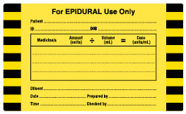 | Fluid name, batch number, expiry date and bag graduations to remain visible after label placement.  Complete ‘diluent’ prompt if fluid name not visible
Syringes (and small bags with additives |  | Graduations on syringe scale to remain visible after label placement.  ‘Flag’ label for smaller syringes.
Catheter (line) label/Route | 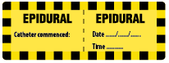 | Label near the injection port on the patient side.
Catheter (line) label/Medicine |  | Label near the injection port on the patient side.  Label adjacent to route label.

To be read in conjunction with the National Standard for User-applied Labelling of Injectable Medicines, Fluids and Lines, 2015.
© Commonwealth of Australia 2015

