Benzathine benzylpenicillin safety during supply disruption
This fact sheet aims to assist health service organisations (HSOs) and clinicians to understand and manage safety considerations related to the disrupted supply of benzathine benzylpenicillin (Bicillin L-A) in Australia.

Background
This fact sheet has been developed by the Australian Commission on Safety and Quality in Health Care (the Commission) at the request of the Department of Health, Disability and Ageing.
Benzathine benzylpenicillin is a long-acting antibiotic formulation that is typically used in uncomplicated syphilis and rheumatic heart disease (RHD) prevention. Refer to the Therapeutic Guidelines: Antibiotic for additional information.

Situation
The Therapeutic Goods Administration (TGA) has advised of a worldwide disruption to the
supply of:
- Benzathine benzylpenicillin tetrahydrate (Bicillin L-A) 600,000 units/1.17 mL suspension for injection pre-filled syringe
- Benzathine benzylpenicillin tetrahydrate (Bicillin L-A) 1,200,000 units/2.3 mL suspension for injection pre-filled syringe.
Updates and information about the shortage, and return to supply dates, are available on the TGA Medicine Shortage Reports Database.
To alleviate the impact, the TGA has approved the importation and supply of registered alternatives under Section 19A (S19A) of the Therapeutic Goods Act. At publication this includes the products below.
- Benzathine benzylpenicillin (LENTOCILIN S 1200) 1,200,000 units powder and solvent for suspension for injection (Neon Healthcare, Portugal) until 28 February 2026
- Penicillin G benzathine (BICILLIN L-A) 1,200,000 units/2mL injectable suspension syringe (Reach Pharmaceuticals, Canada) until 31 October 2025
- Benzylpenicillin benzathine 1,200,000 units powder and solvent for suspension for injection (Brancaster Pharma, United Kingdom (UK)) until 30 September 2025
- Benzathine benzylpenicillin (EXTENCILLINE) 1,200,000 units powder and solvent for suspension for injection (Delbert Pharma, France) until 30 September 2025.
For full details of approvals, including duration of approval, see the Section 19A approvals database. The S19A alternatives, available locally via ORSPEC Pharma, differ from the Australian registered product (Bicillin L-A) with a comparison of the products/formulations in Table 1 (at the end of this fact sheet).
The dose specifications (including for special populations), warnings and precautions and side effect information may vary across the products. Full details are found in the Product Information (PI) or Summary of Product Characteristics for each of the S19A products according to the country of registration. This information is appropriate at the time of initial renewed product registration.
For the recommended dosing information for the approved indications, prescribers are referred to the Australian PI for Bicillin L-A benzylpenicillin tetrahydrate 1,200,000 Units / 2.3 mL suspension for injection, pre-filled syringe with needle. Clinicians are expected to use their clinical judgement supported by the most recent evidence-based information to ensure safe and quality use of the products.

Safety and suitability considerations
There are safety considerations due to differences between Bicillin L-A and the S19A alternatives that require reconstitution with a diluent. Reconstitution and the requirement for immediate administration may make these products less suitable than pre-filled syringes for use in some patient cohorts and settings.
The need to reconstitute the S19A alternatives prior to administration, and a larger volume for administration, should be considered as part of conserving supply of available benzathine benzylpenicillin (Bicillin L-A) prefilled syringes for rural and remote settings and paediatric patients.
Lentocilin S 1200 (Portugal) contains a diluent of 1.5% lidocaine solution for injection. Caution is recommended in some patient groups if lidocaine is used. Alternatively, water for injection may be used to reconstitute Lentocilin S 1200. Note: Lidocaine 1.5% is a Schedule 4 medicine and requires a separate prescription in addition to that for Lentocilin S 1200.
The same safety and suitability considerations should be applied to any alternative brands of benzathine benzylpenicillin that might be sourced via the Special Access Scheme (SAS) but not approved by the TGA under S19A.

Practice points
The following practice points are recommended to support clinical decision-making around the use of benzathine benzylpenicillin:
- Confirm the need to use an antibiotic.
- Consider if prescribing for a priority indication of benzathine benzylpenicillin. Benzathine benzylpenicillin should be prioritised for use in the following conditions:
  - treatment of definite, probable and possible acute rheumatic fever (ARF)
  - secondary prophylaxis of ARF and secondary prophylaxis of RHD
  - treatment of syphilis in those with proven or suspected infection and their recent sexual contacts
  - patients who require treatment for group-A streptococcal infection of the respiratory tract and skin who are at high risk of ARF, RHD or post-streptococcal glomerulonephritis, where oral therapy is not acceptable or the likelihood of non-adherence is high.
- Seek advice from local Infectious Diseases experts and/or the Therapeutic Guidelines: Antibiotic (including the Antibiotic prescribing in primary care: Therapeutic Guidelines summary table 2025) for alternative agents for indications not identified as a priority indication.
- Conserve benzathine benzylpenicillin (Bicillin L-A) prefilled syringes where the medicine is administered in rural and remote settings (for example, Aboriginal Medical Services or Aboriginal Community Controlled Health Organisations); and for certain patient cohorts where the S19A alternatives may not be suitable (for example, in paediatric patients, including neonates, where the larger volume should be determined is appropriate for administration).
Key messages
The TGA has notified of a worldwide shortage of benzathine benzylpencillin: Bicillin L-A prefilled syringes.
To limit supply disruption, the TGA has approved the importation and supply of alternatives under Section 19A (S19A) of the Therapeutic Goods Act.
The S19A alternatives, locally available via ORSPEC Pharma, differ from the Australian registered Bicillin L-A in presentation, storage, and excipients. There are safety and suitability considerations due to these differences (see Table 1 for comparison).
During shortage, benzathine benzylpenicillin should be used for priority indications.
Bicillin L-A pre-filled syringes should be conserved for settings and patient cohorts, where the S19A alternatives may not be suitable.
Seek advice from Infectious Diseases/Microbiology and/or the Therapeutic Guidelines: Antibiotic (including the Antibiotic prescribing in primary care: Therapeutic Guidelines summary table 2025) for alternative antimicrobials in indications not identified as priority indications.
This factsheet is for use during a period of shortage only. If adequate stock of the Australian registered product of benzathine benzylpenicillin: Bicillin L-A (Pfizer brand) is assured, health services and clinicians should return to using it in line with relevant local and national evidence-based guidelines.
The same safety and suitability considerations should be applied for additional brands of benzathine benzylpenicillin available via SAS, but not approved by the TGA under S19A.

Useful resources
- Therapeutic Goods Administration (TGA) publishes medicines shortages, including CRITICAL shortages, on the Medicine Shortage Reports Database.
- Therapeutic Guidelines Antibiotic. Antibiotic prescribing in primary care: Therapeutic Guidelines summary table 2025.
- Australian Commission on Safety and Quality in Health Care general information for prescribers and pharmacists on how to manage shortages in acute and primary healthcare settings.
- National Centre for Antimicrobial Stewardship Medication Shortage Fact Sheets provide information about prescribing choices and alternatives for common infections.
- Therapeutic Guidelines [online]. Melbourne: Therapeutic Guidelines Limited.
- Australian Medicines Handbook [online]. Adelaide: Australian Medicines Handbook Pty Ltd.
- The RHD Australia Guidelines for prevention, diagnosis and management of acute rheumatic fever and rheumatic heart disease 3rd Edition.
- Australasian Society of Infectious Diseases (ASID) guidelines: Management of perinatal infections 3rd Edition.
- Australian Commission on Safety and Quality in Health Care Principles for safe selection and storage of medicines provides guidance on risk reduction strategies to address safe selection and storage of all medicines, including look-alike, sound-alike (LASA) medicines.
- Australian Commission on Safety and Quality in Health Care guidance on conserving medicines within a focus on medicines shortages.
- Australian Commission on Safety and Quality in Health Care information on antibiotic shortages for Aboriginal and Torres Strait Islander consumers.
- Australian Commission on Safety and Quality in Health Care general information for clinicians working in the Aboriginal and Torres Strait Islander health sector.
For more information
Please visit: TGA Medicine Shortage Reports Database or contact the Commission at MedSafety@safetyandquality.gov.au.

© Australian Commission on Safety and Quality in Health Care 2025

Safety considerations during Benzathine benzylpenicillin (Bicillin L-A) supply disruption
- Comparison of the ARTG listed 1,200,000 unit product and the S19A alternatives.
 | ARTG-listed product | S19A alternative (Portugal) | S19A alternative (Canada) | S19A alternative (UK) | S19A alternative (France) | Safety considerations
Brand and image of outer packaging | Bicillin L-A (Pfizer)  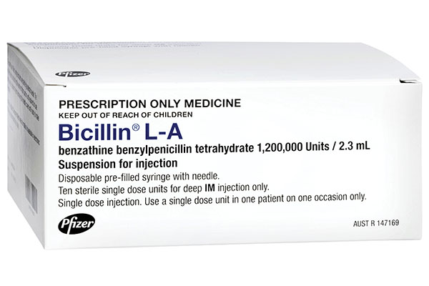 | 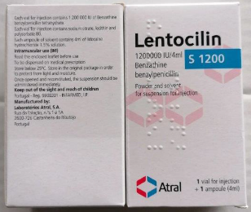  Lentocilin S 1200 | 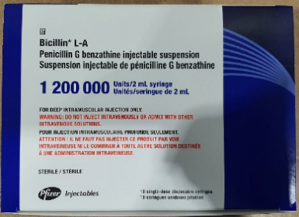  BICILLIN L-A | Brancaster Pharma (available from ORSPEC Pharma)  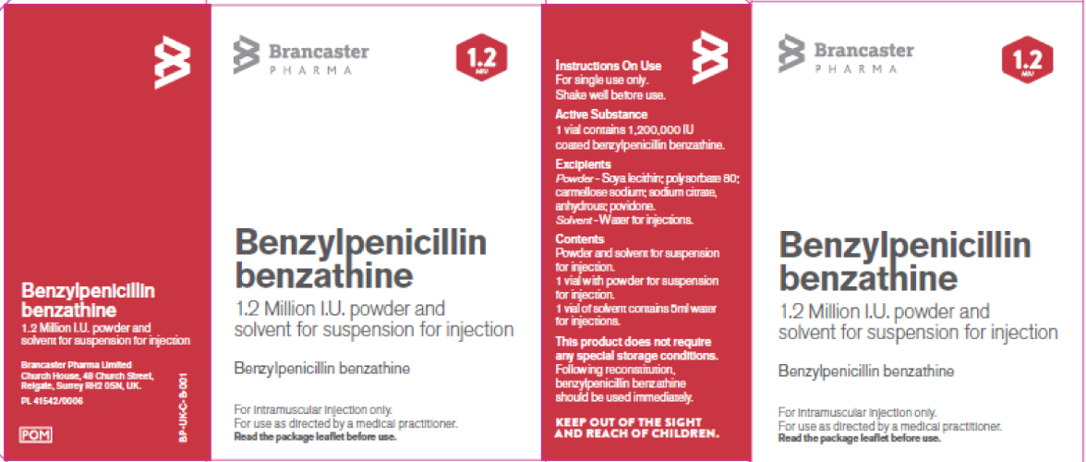 | Extencilline  Delbert Laboratories (available from ORSPEC Pharma)  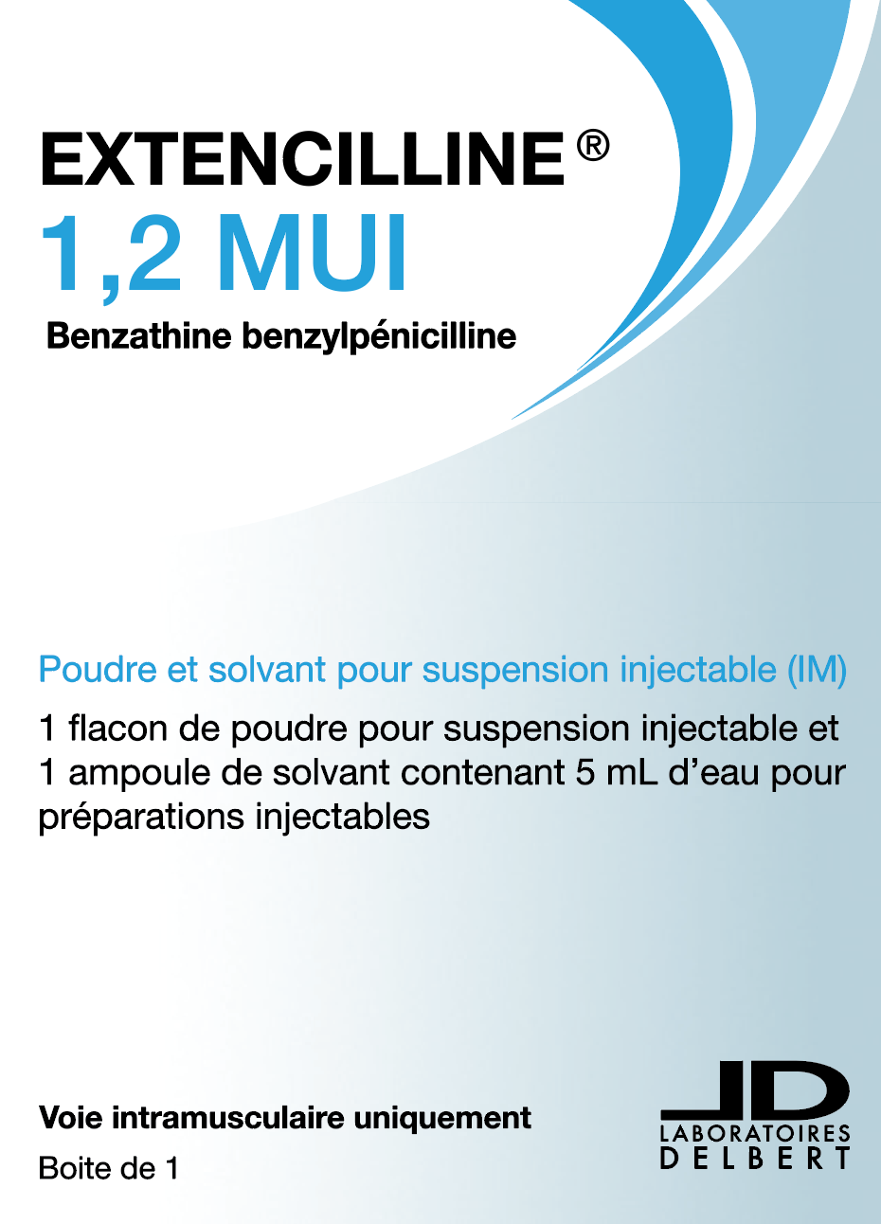 | The Principles for safe selection and storage of medicines should be applied given that the storage location will differ. The S19A alternatives are not stored in the fridge and could inadvertently be placed on a shelf adjacent to similar looking outer packaging.  Risk reduction strategies may need to be considered to ensure differentiation from other similar looking packaging. For example, storing in a separate location from other injectable medicines.
Active ingredient and strength | Benzathine benzylpenicillin tetrahydrate 1,200,000 units | Benzathine benzylpenicillin 1,200,000 units | Penicillin G benzathine 1,200,000 units | Benzylpenicillin benzathine  1,200,000 units | Benzathine benzylpenicillin 1,200,000 units (1.2 MIU¹)  French language labelling and packaging; strength expressed as 1,200,000 UI² or 1.2 MUI¹  1. MIU or MUI = million international units  2. UI or IU = international units | The active ingredient name on the UK S19A alternative is expressed differently. Benzathine benzylpenicillin tetrahydrate and benzylpenicillin benzathine are synonyms.  The strength on the French S19A alternative is expressed differently.  The Principles for safe selection and storage of medicines should be applied – for example, when selecting from a drop down menu within prescribing and dispensing systems.
Appearance and formulation | White fluid suspension in a pre-filled syringe  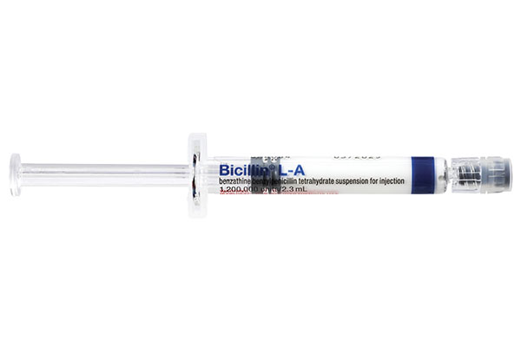 | 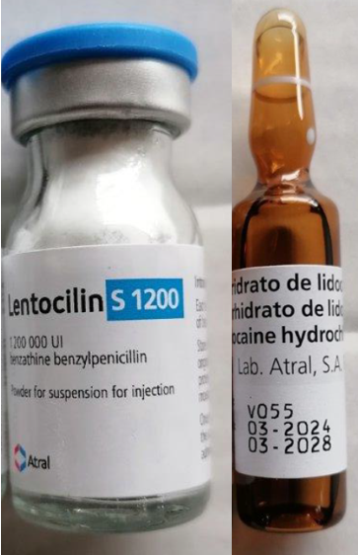  Powder (white/almost white) and solvent (clear, practically colourless) for suspension for injection | White aqueous suspension in a pre-filled syringe  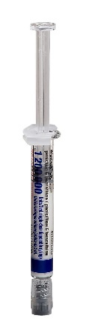 | Powder (white/off-white) for suspension for injection  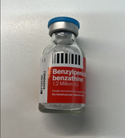  The image is a vial of powder for suspension  Reconstitution may be undertaken with water for injection (WFI) or injectable lidocaine solution 1% (not supplied) | Powder (white/off-white) and solvent (clear/colourless liquid) for suspension for injection  The image includes a vial of powder for reconstitution and a glass ampoule containing WFI  Reconstitution may be undertaken with 0.5% injectable lidocaine solution (not supplied) | The S19A alternatives, differ from the Australian registered (ARTG-listed) product in presentation and storage.  The S19A alternatives also require reconstitution prior to administration by:  - Drawing up 3.5 mL (UK) or 4 mL (France) of the water for injection (WFI) diluent or 4 mL lidocaine diluent (Portugal) and adding to the vial containing the powder  - Agitating the suspension carefully for at least 20 seconds until a homogeneous suspension is obtained.  The S19A alternatives must be administered immediately once reconstituted.
Volume required to administer 1,200,000 units dose | 2.3 mL | 4mL (plus powder displacement volume) | 2 mL | 3.5 mL diluent (WFI) + powder displacement volume (results in a final volume of approximately 4.5 mL) | 4 mL diluent (WFI) + powder displacement volume (results in a final volume of approximately 5 mL) | The final volume of both S19A alternatives is approximately double that of the ARTG-listed product. This has implications particularly in paediatrics.  The use of a local anaesthetic, such as lidocaine 1.5% (Portugal), 1% (UK) or 0.5% (France), in place of water for injection (WFI), will potentially reduce pain at the injection site. See product information relevant to each product.
Consumer medicines information (CMI) | Access the Australian CMI here | Access to TGA guidance here | Access to the Canadian patient medication information here | Access the UK leaflet here | Access the English translated version of the French product leaflet from ORSPEC Pharma | The medicines information leaflets for the S19A alternatives contain similar information but are not TGA approved.
Product Information (PI) | Access the Australian PI here | Access to TGA guidance here  Each LENTOCILIN S 1200 product is required to be packaged with an English language product information leaflet (either as a package insert, or included alongside). If additional copies of this product information are required, please contact the section 19A approval holder, Neon Healthcare Pty Ltd, on (02) 7255 8455 or via office@neonhealthcare.com.au. | Access to the Canadian product monograph here | Access the UK Summary of Product Characteristics (SmPC) here | Access the English translation of the French Summary of Product Characteristics (SmPC) from ORSPEC Pharma | The product information for the S19A alternatives contain similar information but are not TGA approved.
Labelling | English | Portuguese | English | English | French | The active ingredient is in English. However, the balance of the labelling for the S19A alternatives from France and Portugal are in French and Portuguese respectively.
Preparation requirements | The suspension for injection is already in a prefilled for single use only. | The suspension for injection must be reconstituted with diluent before administration. | The suspension for injection is already in a prefilled for single use only. | The suspension for injection must be reconstituted with 3.5 mL diluent before administration. | The suspension for injection must be reconstituted with 4 mL diluent before administration. | The S19A alternatives must be reconstituted using aseptic technique.
Route of administration | For deep intramuscular (IM) injection only |  |  |  |  | Refer local clinical practice guidelines on appropriate administration technique for deep IM injection in conjunction with full details on method of administration for each product including specific instructions for paediatric patients (including neonates).
Storage conditions | 2 to 8 degrees Celsius*  (Refrigerate, do not freeze)  [*Storage at 30°C, is allowed for a single period of 2 months prior to batch expiry.] | Below 25 degrees Celsius | 2 to 8 degrees Celsius*  (Refrigerate, do not freeze)  [*Storage below 30°C, is allowed for a single period of 7 days prior to batch expiry.] | Below 25 degrees Celsius | Below 25 degrees Celsius | The Principles for safe selection and storage of medicines should be applied given that the storage location of the S19A alternatives will differ.
Additional excipients | Sodium citrate; soy lecithin#; carmellose sodium; povidone; and preservatives:  methyl hydroxybenzoate  propyl hydroxybenzoate | Sodium citrate, lecithin# and polysorbate 80 | Lecithin, methylparaben, povidone USP C200, propylparaben NF sterile pulverized, sodium carboxymethylcellulose USP, sodium citrate USP anhydrous, water for injection USP | Soy lecithin#; polysorbate 80; sodium citrate; carmellose sodium; and povidone | Soy lecithin^#; anhydrous sodium citrate; carmellose sodium; and povidone.  ^The manufacturer describes the product as containing soyabean phospholipids originating from the lecithin. | The list of excipients within the S19A alternatives, differ from the Australian registered product.  #The presence of excipients such as soy lecithin should be considered, especially for consumers with a soy or peanut allergy.
Included solvent | Nil | Lidocaine hydrochloride 1.5% solution | Nil | Water for injection | Water for injection | Caution is recommended in some patient groups if lidocaine 1.5% is used as the solvent. Alternatively, water for injection may be used to reconstitute Lentocilin S 1200. Note: Lidocaine 1.5% is a Schedule 4 medicine and requires a separate prescription in addition to that for Lentocilin S 1200.
Doses per pack | 10 (individual pre-filled syringes) | 1 x vial of powder for suspension  1 x glass ampoule containing lidocaine 1.5% | 10 (individual pre-filled syringes) | 1 x vial of powder for suspension | 1 x vial of powder for suspension  1 x glass ampoule containing 5 mL WFI

