INFORMATION
for consumers

Intravenous (IV) fluids shortage

What you need to know
- There is a worldwide shortage of intravenous (IV) fluids that will continue throughout 2025
- Different brands of IV fluids may be used during this time
- During the shortage, healthcare providers will be:
  - getting you to drink fluids and/or take your medicines by mouth if you can
  - reviewing the need to use IV fluids or reducing the time you use them
  - using the smallest amount of IV fluids needed.

Your safety and the quality of your health care is most important.

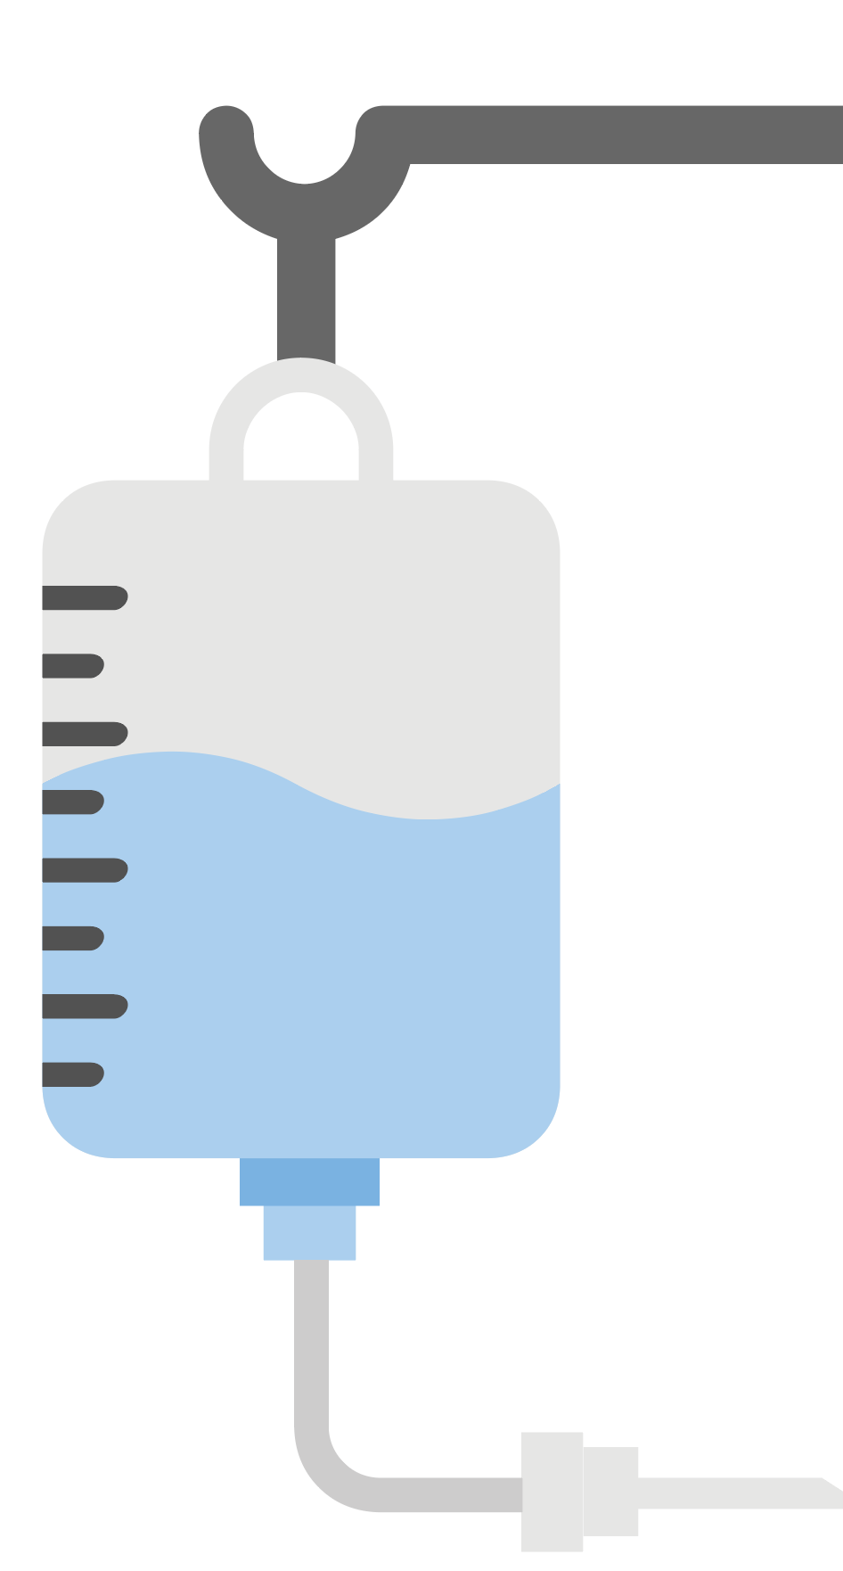
Why might you need IV fluids?
IV fluids are given through a needle into a vein your arm to:
- treat dehydration (due to vomiting, diarrhoea or not drinking enough)
- give you medicines.
They are also used when you have an operation.

What is happening?
There is currently a worldwide shortage of IV fluids which also affects Australia.

Healthcare providers have plans in place to make sure patients who need IV fluids are kept safe during the shortage. This includes changing the way IV fluids are used and saving them for when alternatives are not available.
You may notice some differences in the use of IV fluids:
- The brand of IV fluid may be different to the ones you have seen before
- There may be more air in the IV fluid bag
- Your healthcare provider may suggest that you drink fluids and take medicines by mouth rather than giving them IV.

Further information
Talk to your healthcare provider if you have concerns about how the shortage might affect you.
Visit the TGA website.
safetyandquality.gov.au
© Australian Commission on Safety
and Quality in Health Care 2025

