National Standard for User-applied Labelling of Injectable Medicines, Fluids and Lines

Intra-arterial
Type of label | Example label | Instructions
Syringes (and small bags with additives | 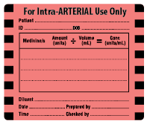 | Graduations on syringe scale to remain visible after label placement.  ‘Flag’ label for smaller syringes.
Catheter (line) label/Route |  | Label near the port on the patient side.  Invasive monitoring lines should be identified for route even if they are not intended for medicine administration.

To be read in conjunction with the National Standard for User-applied Labelling of Injectable Medicines, Fluids and Lines, 2015.
© Commonwealth of Australia 2015

