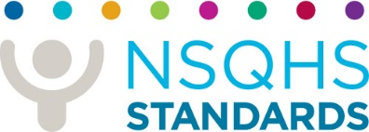
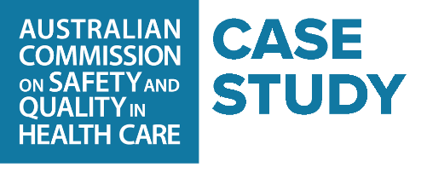
Thursday, 14 December 2023
The personal cost when cosmetic surgery goes awry
Charlotte Jerrim from Canberra was 19 years old when she was sold a dream of enhancing her body with a breast augmentation procedure. Unfortunately, this dream did not match the reality.
Over eight years, she faced many issues with her breast implants, and they were finally explanted in March 2022.
Like many young adults, Charlotte says she faced pressures around body image and confidence. She made the decision to have breast surgery “for purely cosmetic reasons, to enhance the way I looked”.
“Before the surgery, I didn’t know what to expect and only had a short consultation with the cosmetic surgeon. It was a fast, high-level overview of the procedure and the recovery,” Charlotte says.
“The cosmetic surgeon talked about the strong, textured breast implants and during my consultation, grabbed an implant and slammed it into the door to demonstrate how safe and durable they were.
“In hindsight, I probably wasn’t given enough information to make an informed decision. I wasn’t told much about the potential risks and complications, or about any future screening or post-operative care.”
Looking back, Charlotte says she was persuaded by social factors. She had many friends who had breast implants and was exposed to mainstream conditioning as a child and young adult.
“As women, we are influenced to look a certain way, and people my age have grown up with social media and magazines shaming celebrities’ bodies, so we have faced a lot of influences,” she explains.
“Until a few years ago, having breast implants was like a trend. In my opinion, body image should never be viewed as a ‘trend’, but sadly it is, with cosmetic surgery offering the promise of the ideal body.”
After surgery, Charlotte’s physical and mental health deteriorated, also affecting her financial circumstances. She developed a condition known as Systemic Symptoms Associated with Breast Implants (SSBI).
“Living with SSBI was an isolating, lonely and dark time for me. Initially, it was difficult to share what I was going through with my husband, close family and friends. Not many people had heard of it, and it was hard to convince people, including practitioners, of the severity of what I was experiencing,” she says.
“I spent a lot of time and money finding the right GP, and then a surgeon who could perform the explant.
“As a young person, having breast augmentation robbed me of the best years of my life. I developed anxiety, had re-occurring panic attacks and I was on medication as I wasn’t sleeping through the night.”
Today, Charlotte welcomes the new National Safety and Quality Cosmetic Surgery Standards, released by the Australian Commission on Safety and Quality in Health Care.
“The new standards will mean people being influenced by advertising and other pressures will have some protections. They can be confident that surgeries are being performed by suitably qualified providers, in approved and licensed spaces,” Charlotte explains.
“Clinicians will need to ensure the people they operate on are suitable for a procedure, which would include a psychological assessment. I wish someone had asked me about my motivations for getting implants and addressed it before my surgery.”

The value of informed decision-making
Charlotte believes her outcome may have been different if there had been a rigorous decision-making process before she had surgery.
She says she wasn’t given the opportunity for proper informed decision-making.
“Under the new Cosmetic Surgery Standards, people will be able to make informed decisions and understand the possible risks, and they will be required to provide consent.
“It can be overwhelming to make a decision that may significantly affect your future. I would say to others, don’t be afraid to ask questions, talk about the risks of your surgery, take a support person with you and do a follow-up consultation before you commit,” says Charlotte.
“Be sure to discuss your aftercare and what is likely to happen in the months and years after your operation, particularly if there are complications or issues.
“Everyone has their reasons for undergoing cosmetic surgery; we just need to make sure we can do it in a safe and supported way.”

To learn more, visit: safetyandquality.gov.au//cosmetic-surgery

Media enquiries
Angela Jackson, Communications and Media Manager
M: 0407 213 522 | E: angela.jackson@safetyandquality.gov.au

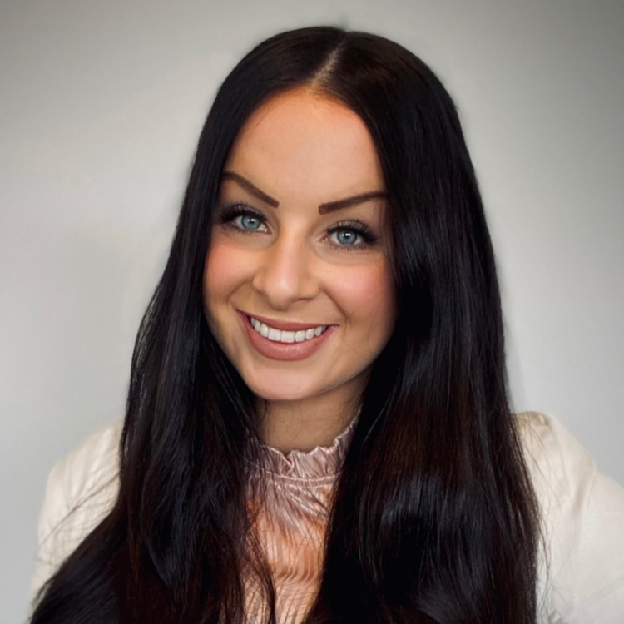
Charlotte Jerrim, who at age 19, had breast augmentation.

