National Standard for User-applied Labelling of Injectable Medicines, Fluids and Lines
Australian Commission on Safety and Quality in Health Care

© Commonwealth of Australia 2015
This work is copyright. It may be reproduced in whole or in part for study or training purposes subject to the inclusion of an acknowledgement of the source. Requests and inquiries concerning reproduction and rights for purposes other than those indicated above require the written permission of the Australian Commission on Safety and Quality in Health Care, GPO Box 5480, Sydney, NSW 2001 or mail@safetyandquality.gov.au.
ISBN 978-1-925224-17-7 (print), 978-1-925224-18-4 (online)
Suggested citation
Australian Commission on Safety and Quality in Health Care. National Standard for User-applied Labelling of Injectable Medicines, Fluids and Lines. Sydney: ACSQHC, 2015.
Acknowledgement
Many individuals and organisations have freely given their time and expertise to support the development of this document. In particular, the Commission wishes to acknowledge state and territory contacts who have coordinated implementation, and health services that have fed back implementation experiences, which are reflected in this document. The involvement and willingness of all concerned to share their experience and expertise are greatly appreciated.
The National Standard for User-applied Labelling of Injectable Medicines, Fluids and Lines (Labelling Standard) and support materials are available on the Commission web site (www.safetyandquality.gov.au).
The Labelling Standard supersedes the National Recommendations for User-applied Labelling of Injectable Medicines, Fluids and Lines, first edition (August 2010) and second edition (February 2012).

Contents
Contents iii
Tables vi
Figures vii
Acronyms and abbreviations ix
Executive summary x
Aims x
Practice principles x
Labelling requirements xi
National Safety and Quality Health Service Standards xi
National policy xii
1 Introduction 1
1.1 Administration errors with injectable medicines 1
1.1.1 Administration errors in the perioperative area 2
1.2 Support for safe labelling practices 2
1.2.1 Standardisation and colour coding of medicine labels 3
1.3 National Safety and Quality Health Service Standards 3
1.4 National Medicines Policy 4
1.5 Labelling Standard context 4
1.6 Labelling Standard structure 5
2 Scope of the Labelling Standard 6
2.1 Inclusions 6
2.2 Exclusions 7
3 General requirements for labelling 9
3.1 Governance 9
3.2 Properties of labels 9
3.2.1 Label quality 9
3.2.2 Label adhesive 9
3.2.3 Label readability 10
3.2.4 Preprinted labels 10
3.3 Colour coding 10
3.3.1 Route of administration 11
3.3.2 Medicine class 12
4 Labelling injectable medicine containers 19
4.1 General considerations for all containers 19
4.2 Fluid bags 19
4.3 Syringes 20
4.4 Containers in open- and closed-practice environments 20
4.5 When to discard containers of injectable medicines 21
4.6 Minimum requirements for labelling containers in the open-practice environment 21
Label inclusions 21
Sample label (not to scale) 22
Label placement – bags and bottles 22
Label placement – syringes for bolus use or infusion 22
4.7 Minimum requirements for labelling containers in the closed-practice environment 23
4.7.1 Injectable medicines 23
4.7.2 Non-injectable medicines and fluids 23
5 Labelling injectable medicine conduits, lines and catheters 25
5.1 Burettes 25
5.1.1 Minimum requirements for labelling burettes 25
5.2 Administration lines 26
5.2.1 Administration lines and catheters to identify route 26
5.2.2 Administration lines to identify medicine 27
5.2.3 Label placement for administration lines 28
5.3 Invasive monitoring lines 29
5.3.1 Minimum requirements for labelling invasive monitoring lines 29
5.4 Locked catheters 29
5.4.1 Minimum requirements for labelling locked catheters 30
5.5 Other catheters and lines 30
5.5.1 Pulmonary artery catheters 30
5.5.2 Intracranial pressure monitoring lines 30
5.5.3 Extraventricular and lumbar drains 30
5.5.4 Bladder irrigation lines 31
6 Labelling in perioperative areas 32
6.1 Open- and closed-practice environments 33
6.2 Containers on perioperative sterile fields 33
6.3 Interventional cardiology, radiology and other low-light procedure areas 35
6.4 Contrast media 37
6.5 Reusable containers 37
6.6 Using preprinted labels 37
7 Specific considerations 38
7.1 Containers and lines on sterile fields outside the perioperative area 38
7.2 Catheter lock 38
7.3 Cytotoxic medicines 39
7.4 Radiopharmaceuticals 39
7.5 Blood products 39
7.6 Non-injectable medicines and fluids 39
7.6.1 Oral and enteral route 40
7.6.2 Inhalation route 40
7.6.3 Topical route 41
7.7 Labelling at transitions of care 41
7.8 Labelling in an emergency 41
Glossary 42
Acknowledgements 46
National Injectable Medicines Labelling Project 46
Labelling Recommendations Reference Group 46
Hospitals contributing to evaluation of user-applied labelling implementation 47
National contributions 47
Appendix 1 Label guide and specifications 49
Appendix 2 Specifications for preprinted abbreviated container labels 54
Appendix 3 The Labelling Standard and other standards 55
Australian Standard 55
Label dimensions 55
Background and borders 55
Use of colour to identify target tissue/route 57
International Standard 57
Appendix 4 Labelling Standard development and maintenance 59
National Injectable Medicines Labelling Project 59
National Recommendations for User-applied Labelling of Injectable Medicines, Fluids and Lines, first edition, November 2010 59
National Recommendations for User-applied Labelling of Injectable Medicines, Fluids and Lines, second edition, February 2012 60
National Standard for User-applied Labelling of Injectable Medicines, Fluids and Lines, 2015 60
Evaluation of preprinted labels for identification of medicines and fluids on the perioperative sterile field (reports 1 and 2) 60
Evaluation of label adherence to hollowware containers in operating rooms (reports 1 and 2) 61
Evaluation of standardised medicine line labels for dedicated continuous infusions 61
Evaluation of standardised medicine syringe labels in interventional cardiac catheter and radiology laboratories 61
Labelling Standard maintenance 62
References 63

Tables
Table 1 Colour coding of user-applied labels for target tissue 11
Table 2 User-applied label colours for syringes containing medicines used during anaesthesia (adapted from ISO 26825:2008) 12
Table 3 Examples of preprinted medicine line labels 16
Containers: injectable medicines and fluids – route labels 49
Containers: open-practice environment (abbreviated label) – flush label 50
Containers: closed-practice environment (abbreviated medicine labels) 50
Containers: non-injectable medicines and fluids – route labels 51
Conduits: route label 52
Lines and catheters: injectable medicines and fluids – route labels 52
Lines and catheters: non-injectable medicines and fluids – route label 53
Lines and catheters: medicine labels 53
Table A.1 Modifications to AS 4940 used in the Labelling Standard: background and borders 56
Table A.2 Modifications to AS 4940 used in the Labelling Standard: colour for target tissue/route 57
Table A.3 Anaesthetic Labelling Standard colour coding to medicines lines labels and abbreviated container labels used outside anaesthesia 58

Figures
Figure 1 Examples of containers and conduits for injectable medicines that require user-applied labelling 6
Figure 2 User-applied labelling of medicines and fluids in the open- and closed-practice environments of the perioperative area 33
Figure 3 Examples of preprinted abbreviated container labels for user-applied identification in the closed-practice environment 34
Figure 4 Generic abbreviated container label for user-applied identification in the closed-practice environment 35
Figure 5 Examples of preprinted labels in cardiac catheter laboratories 36
Figure 6 Contrast media abbreviated container label 37
Figure 7 Line label for medicine used to ‘lock’ a catheter 38
Figure 8 Label for enteral use 40
Figure 9 Label for inhalation use 40

Acronyms and abbreviations
Acronym or abbreviation | Definition
Anaesthetic Labelling Standard | International Standard ISO 26825:2008 Anaesthetic and respiratory equipment – user-applied labels for syringes containing drugs used during anaesthesia – colours, design and performance
AS 4940:2002 | Australian Standard AS 4940:2002 User-applied identification labels for use on fluid bags, syringes and drug administration lines
the Commission | Australian Commission on Safety and Quality in Health Care
the Labelling Recommendations | National Recommendations for User-applied Labelling of Injectable Medicines, Fluids and Lines
the Labelling Standard | National Standard for User-applied Labelling of Injectable Medicines, Fluids and Lines
PMS | Pantone Matching System

Executive summary
Injectable medicines are a high-risk therapy for patients and health professionals. It is reported that 25% of all medication incidents in acute care involve injectable medicines, but nearly 60% of medication errors that result in serious patient harm or death involve injectable medicines (1).
Incomplete or inaccurate labelling of injectable medicines and fluids (and the devices used to deliver them) is a recognised risk to the safe administration of medicines and is potentially preventable. Improved labelling can reduce the risk of error and harm by safely communicating the contents of injectable medicines containers and the patients for whom they are intended (2).
One way of ensuring accurate communication of injectable medicines and fluids information is by standardised user-applied labelling. This National Standard for User-applied Labelling of Injectable Medicines, Fluids and Lines (the Labelling Standard) has been developed as a national solution to the risks posed by erroneous administration of injectable medicines. It replaces the 2012 National Recommendations for User-applied Labelling of Injectable Medicines, Fluids and Lines (the Labelling Recommendations) (3).

Aims
The Labelling Standard is designed to reduce the risk of patient harm from injectable medicines by helping healthcare professionals identify the correct:
injectable medicine or fluid (container)
route of administration of the injectable medicine (conduit)
patient for whom the medicine is intended.
The Labelling Standard sets out the requirements for label format, content and placement. The aim is to:
promote safer use of injectable medicines
provide standardisation for user-applied labelling of injectable medicines
provide minimum requirements for user-applied labelling of injectable medicines.
The Labelling Standard addresses one recognised risk point in the safe administration of injectable medicines by preventing medicine administration errors, such as wrong patient, wrong route, wrong medicine or wrong dose. It applies alongside other safe medicines practices.

Practice principles
The Labelling Standard is based on the following practice principles:
All medicines and fluids removed from the manufacturer’s or hospital pharmacy’s original packaging must be identifiable.
All containers (e.g. bags, syringes) containing medicines leaving the hands of the person preparing the medicine must be labelled.
Only one medicine at a time should be prepared and labelled before the preparation and labelling of a subsequent medicine.
Any medicine or fluid that cannot be identified (e.g. in an unlabelled syringe or other container) is considered unsafe and should be discarded.

Labelling requirements
The Labelling Standard sets out the requirements for user-applied labelling of:
containers of injectable medicines and fluids (bags, bottles and syringes) that can no longer be identified by their original packaging
conduits used to deliver injectable medicines and fluids (administration lines, invasive monitoring lines, catheters and burettes)
non-injectable fluids that can no longer be identified by their original packaging, including topical solutions, and oral and inhalational liquids.
The Labelling Standard identifies:
what should be labelled
what should be included on the label
where the label should be placed
where the Labelling Standard applies.
The Labelling Standard expands on the Labelling Recommendations (4) to include:
labelling of containers in perioperative settings (including cardiac catheter and interventional radiology units)
colour coded preprinted medicine labels for use on dedicated continuous infusion lines
liquid medicines for oral, enteral and inhalational use
labelling of non-injectable medicines and fluids prepared in the same area as injectable medicines.

National Safety and Quality Health Service Standards
Implementation of the Labelling Standard is a mandatory requirement for meeting the National Safety and Quality Health Service Standards (5).
Health services that are verifying their activities against the National Safety and Quality Health Service Standards are required to implement the Labelling Standard as outlined in this document and the accompanying source documents.

National policy
The Australian Commission on Safety and Quality in Health Care (the Commission) is responsible for maintaining the Labelling Standard, and for identifying and reducing national barriers to its implementation. The Labelling Recommendations (on which this Labelling Standard is based) were endorsed by Australian health ministers in 2010 for use in Australian health services (6).
Safe use of medicines is a key component of quality use of medicines, which forms part of Australia’s National Medicines Policy (7).

1 Introduction

1.1 Administration errors with injectable medicines
Injectable medicines are a therapy that pose a high risk for patients. The preparation of injectable medicines for bolus injection or infusion is complicated, and there are many opportunities for error (8). Preparation of a syringe for bolus injection has been estimated to have as many as 40 discrete steps (9). It is reported that 25% of all medication incidents in acute care involve injectable medicines, and nearly 60% of medication errors that result in serious patient harm or death involve injectable medicines (1).
Incomplete or inaccurate labelling of injectable medicines and fluids (and the devices used to deliver them) is a recognised risk to the safe administration of medicines (10-18). Omitting information such as the name of the medicine, or medicine dose or patient name, or not using a label at all, can result in the wrong medicine being administered, or medicines being administered by the wrong route or to the wrong patient (see box for examples).
Examples of errors made as a result of an unlabelled container
Wrong medicines administered
Medicine swaps with fatal consequences include contrast media and chlorhexidine (2), glutaraldehyde and spinal fluid (2), lignocaine with adrenaline and adrenaline 1 mg/mL (19), and pethidine and syntometrine*(20). Other medicine swaps have been reported between botulinum toxin and triamcinolone; heparin 25 000 units in 5 mL and ‘heparinised saline’ 50 units in 5 mL (21, 22); and 0.9% sodium chloride flush and:
- heparin for infusion (23)
- aminophylline (12)
- midazolam (24)
- vecuronium (25).
Wrong route errors
Medicines administered via the intrathecal route instead of intravenously with fatal consequences include bortezomib (three cases) (26) and vincristine* (27). A woman in labour injected with chlorhexidine into the epidural space suffered neurological damage* (28). Errors involving unlabelled lines include the connection of oxygen tubing to an intravenous line in a paediatric patient, resulting in a fatal outcome (29).
Wrong patient errors
An unlabelled bag containing magnesium sulfate was accidentally administered to a patient who already had a bag of magnesium sulfate in progress. The unlabelled bag was prepared for another patient. The patient sufferred a respiratory arrest and anoxic encephalopathy as a result of the overdose (30).
* Australian incidents
In the majority of cases, actual harm to patients is limited by routine checking of infusions and prescriptions at handover (16). However, there are many reports of administration errors resulting from inadequate labelling causing harm – including death.
An unpublished review of incidents reported by public hospitals to an Australian incident management system database from 2003 to 2009 found a number of incidents involving injectable medicines. They included unlabelled or incorrectly labelled bags or syringes, the assumption that unlabelled syringes/bags contained 0.9% sodium chloride, unlabelled insulin administration devices, lines not labelled with route of administration, lines not labelled or incorrectly labelled with medicine content, labels placed incorrectly, and no burette labels applied.

1.1.1 Administration errors in the perioperative area
The complex circumstances surrounding medicines administration in perioperative areas allow opportunity for errors (31, 32). In operating rooms, a multidisciplinary clinical team interacts with medicines in different ways and at different times. Solutions may be routinely drawn up into syringes and poured into sterile basins for transfer from nonsterile original containers to sterile fields. In addition, patients will transfer through various clinical areas requiring multiple handovers between healthcare providers.
Inconsistent labelling of injectable medicines before patient transfer has been reported in operating rooms (20, 33, 34), as has poor and inconsistent labelling of injectable medicines on sterile fields (2, 35). Medicine labelling has been cited as a contributor to the frequent errors relating to administration of injectable medicines in anaesthetic practice (17, 18, 36, 37). Similar opportunities for error occur in interventional cardiology and radiology units, where products on sterile fields at any one time may include skin preparation fluids, local anaesthetics, contrast media and medicines (such as heparin). Injection of a hazardous medicine or fluid stored in an unlabelled container in the interventional sterile field is preventable (38). Studies on perioperative sterile fields indicate that medicines and containers, including syringes, are more likely to be labelled correctly when preprinted medicine labels are available (4, 39).

1.2 Support for safe labelling practices
Safely communicating the contents of injectable medicines containers and the patient for whom they are intended, through improved labelling, can reduce the risk of error and harm (2). A number of international organisations and individual researchers (16, 40-42) have made recommendations regarding safe labelling practices, including the recommendation to standardise labelling of injectable medicines and administration lines. International organisations that have recommended actions for safer labelling practices include the:
World Health Organization (43)
former National Patient Safety Agency in the United Kingdom (5, 21, 27, 44-47)
Joint Commission in the United States (48, 49)
Institute for Safe Medication Practices in the United States (2, 12, 29, 30, 50-52)
Institute for Safe Medication Practices Canada (19, 53, 54).
Evidence shows that putting processes into place that are designed to improve safety is more successful at reducing harm than simply trying harder to avoid error. Standardised labelling is one of many processes that contribute to the safe administration of injectable medicines (55). Other processes that may be considered to improve safety include use of bar codes, uniform colour coding and development of safer connecting non-Luer devices for intrathecal, epidural and regional injection (56-60).

1.2.1 Standardisation and colour coding of medicine labels
Although labelling medicine infusion lines is a well-recognised strategy for preventing medication errors, standardised label design studies are limited, and there are varying degrees of uptake of user-applied labelling systems.
Simulation studies have shown that a standard system of labelling intravenous bags and syringes, lines and syringe pumps – including medicines labels (61), and the use of colour coded labels on the bag with additives and the line (62) – can significantly improve identification of the correct medicines.
The international Anaesthetic Labelling Standard (ISO 26825:2008 – Anaesthetic and respiratory equipment – user-applied labels for syringes containing drugs used during anaesthesia – colours, design and performance) introduced in 2008 provides guidance on implementing a standardised user-applied labelling system (63). It covers the colour, size, design and general properties of the label, and the typographical characteristics of the wording for the medicine name. The aim of the standard is to reduce the errors relating to administration of injectable medicines in anaesthetic practice.

1.3 National Safety and Quality Health Service Standards
Implementation of the Labelling Standard is a mandatory requirement for meeting the National Safety and Quality Health Service Standards (5).
Health services seeking accreditation under the Australian Health Service Safety and Quality Accreditation scheme are required to provide evidence of Labelling Standard implementation.
Implementing relevant action items in the National Safety and Quality Health Service Standards will assist clinicians to safely prescribe, dispense and administer injectable medicines. The two criteria of particular relevance to safe administration of medicines are:
Governance and Systems for Medication Safety
Medication Management Processes.
These encompass, but are not restricted to, the following processes:
Undertake regular assessments of injectable medicines management procedures in all clinical areas to identify risks and take action to reduce these risks (47, 48) (Safety Standard 4.5).
Develop, implement and maintain protocols and policies for prescribing, preparing and administering injectable medicines and fluids, including checking processes. This may include a policy to promote procurement of injectable medicines with inherent safety features, including safe labelling (Safety Standard 4.2).
Educate the relevant clinical workforce in prescribing, preparing, administering and monitoring injectable medicines and fluids, including staff who supervise and check these processes (Safety Standard 4.9).
Verify that the members of the clinical workforce who handle injectable medicines have medication authority that is appropriate to their scope of practice (Safety Standard 4.3).
Ensure that healthcare professionals have timely access to information and decision tools relevant to injectable medicines. Take action to regularly review and improve the materials (Safety Standard 4.9).
Regularly monitor, report on and investigate medication incidents, and take action to reduce adverse medication incidents (Safety Standard 4.4).
Identify high-risk medicines and regularly review their administration to reduce related patient harm (Safety Standard 4.11).

1.4 National Medicines Policy
The Commission is responsible for maintaining the Labelling Standard, and for identifying and reducing national barriers to its implementation. The Labelling Recommendations (on which this Labelling Standard is based) were endorsed by Australian health ministers in 2010 for use in Australian health services (6).
Safe use of medicines is a key component of quality use of medicines, which forms part of Australia’s National Medicines Policy (7).

1.5 Labelling Standard context
The Labelling Standard describes the minimum requirements for safe user-applied labelling of injectable medicines, fluids and lines. Health services are encouraged to put in place additional strategies that reflect the particular risks associated with local conditions, including patient population and procedures provided. Examples include:
using prefilled syringes and premixed solutions in standard strengths wherever they are available (e.g. Therapeutic Goods Administration–registered products, compounded product sourced from a licensed manufacturer or other aseptic compounding unit) and have been assessed as suitable by the relevant governance committee
barcoding preprinted container labels, particularly for small syringes, and syringes in syringe drivers and pumps. Barcoding is already in use in anaesthesia to assist identification (55).
Adequate labelling represents one step in the overall process of preventing medicine administration errors associated with injectable medicines. Labelling should be undertaken alongside other clearly defined quality and safety processes, consistent with existing policies and standards.

1.6 Labelling Standard structure
This document provides guidelines for labelling medicines and fluids removed from their original packaging, and transferred to containers and conduits at patient administration. The scope is clearly defined, and governance, label properties and appearance (specifically, colour coding) are introduced early in the document.
Considerations for labelling containers are described and tabulated with label inclusions, examples and placement details. This format is repeated for lines and catheters. The perioperative area has particular requirements and is covered in its own section, followed by other specific considerations (e.g. blood products, renal dialysis and radiopharmaceuticals). This Labelling Standard includes a glossary of terms, label specifications (Appendices 1 and 2), and a description of integration with other standards (Appendix 3). A large number of individuals and facilities have contributed to the Labelling Standard and they are acknowledged. Appendix 4 gives an overview of the development process.

2 Scope of the Labelling Standard
The purpose of the Labelling Standard is to improve patient safety. Clear labelling of injectable medicines and fluids by the user at the point of delivery should help to reduce the risk of medicine administration errors.

2.1 Inclusions
The Labelling Standard sets out the requirements for user-applied labelling of:
containers for injectable medicines and fluids (bags, bottles and syringes) in which the medicine can no longer be identified by its original packaging
conduits (administration lines, invasive monitoring lines, catheters and burettes) that are used to deliver injectable medicines and fluids
non-injectable fluids that can no longer be identified by their original packaging, including topical solutions, and oral and inhalational liquids.
The Labelling Standard identifies:
what should be labelled
what should be included on the label
where the label should be placed
where the Labelling Standard applies.
Figure 1 shows examples of injectable medicines, containers and conduits that require user-applied labelling.
Figure 1 Examples of containers and conduits for injectable medicines that require user-applied labelling
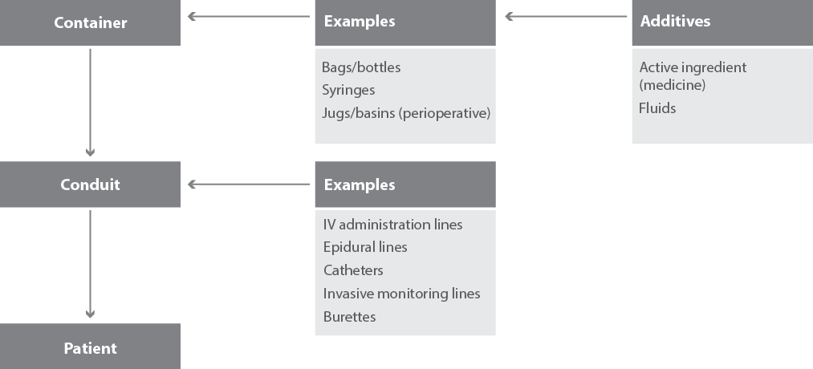
The Labelling Standard applies to:
all health services where injectable medicines and fluids are administered. These include, but are not limited to, hospitals (including day procedure units), primary care services (such as ambulance services) and community health services (such as immunisation clinics)
all clinical areas where injectable medicines and fluids are administered
all injectable medicines and fluids prepared in the ward or clinical area, including perioperative areas
injectable medicines, defined as any sterile medicine intended for administration by bolus injection, perfusion or infusion by the following routes: intravenous, intramuscular, intrathecal, intra-arterial, subcutaneous, intradermal, intraventricular, epidural, intravesicular, intravitreal, intrapleural and intra-ocular (46). This list is not exhaustive, and other routes of injection should also be considered in the context of the Labelling Standard
(e.g. intraosseous and intraperitoneal)
liquid medicines for oral, enteral and inhalational use (see Section 7.6)
non-injectable medicines and fluids that are prepared in the same area as injectable products, including solutions for topical use (see Section 7.6)
user-applied labelling of containers and conduits for any medicine or fluid in the perioperative area. In addition, the Anaesthetic Labelling Standard (ISO 26825:2008) applies to syringes containing medicines used during anaesthesia (63) (see Section 6 for labelling in the perioperative area).

2.2 Exclusions
The Labelling Standard does not apply to the labelling of:
topical products prepared when injectable medicines are not present; however, the same principles of identification translate to topical use of medicines, solutions, chemicals and reagents
injectable medicines and fluids prepared by hospital pharmacy departments – these must comply with the Society of Hospital Pharmacists of Australia’s Guidelines for Medication Prepared in Australian Hospital Pharmacy Departments (64)
injectable medicines and fluids prepared by external manufacturers or compounding centres (e.g. cytotoxic preparations, premixed solutions and prefilled syringes) – these must comply with Therapeutics Goods Order No. 69 (65)
injectable medicines and fluids that are not directly administered to the patient – the labelling of any container that cannot be used to administer an injectable medicine directly to the patient (e.g. ampoules and individual patient multidose vials) is the responsibility of the manufacturer as mandated by Therapeutic Goods Order No. 69 (65)
extemporaneously dispensed radiopharmaceuticals – best-practice guidelines for preparation of radiopharmaceuticals provide strict protocols for extemporaneous dispensing of a radiopharmaceutical prescription for a named patient. The end product is a syringe containing radioactive material with the whole unit enclosed in lead casing; this constitutes the original container (66). Additional user-applied labelling is not required, provided the syringe or its contents are not removed from the original container.

3 General requirements for labelling
This section outlines the requirements that apply to user-applied labels for all injectable medicines. Sections 4–7 provide additional requirements for labelling containers, conduits and non-injectable medicines, and labelling in perioperative areas.

3.1 Governance
All user-applied labels for medicines, fluids and lines must be approved by the relevant governance committee.
- One central committee should be responsible for the governance of processes related specifically to labels within each hospital or health service, including
- the introduction of new labels
- the approval of a range of preprinted labels
- version control
- inventory control
- procurement
the maintenance of stock levels.
Availability of an appropriate range of preprinted Labelling Standard labels is fundamental to successful implementation of the Labelling Standard. An adequate supply of labels must be established and maintained in all clinical areas, consistent with area requirements.

3.2 Properties of labels

3.2.1 Label quality
Labels should be printed on material of a quality that is durable and fit for purpose. Labels are required to:
remain intact for the duration of use
remain attached to the container or line for the duration of use
be written on in ink (where required) and the writing remain legible for the duration of use.
Replace labels that are damaged or displaced during use.
Labels may be repeatedly exposed to fluids during use and, in the case of containers used in perioperative areas, handled many times during a procedure. The quality of label stock and facings must be able to withstand this exposure for the duration of the label’s use.

3.2.2 Label adhesive
Adhesive strength should be appropriate to the label purpose.
All labels must adhere to the container/line and remain adhered for the duration of use. For the majority of containers, it is preferable that the label remains adhered to the container after use for audit purposes (see Australian Standard AS 4940:2002) (67, 68).
However, certain types of labels should be able to be peeled off after the medicine is administered or the procedure is complete, and should be ordered with adhesive designed for this purpose (see Section 7).
These are:
burette labels, to be removed after the medicine has run through the burette
abbreviated container labels for use in the perioperative sterile field on reusable containers (e.g. stainless steel bowls)
locked catheter labels that are required to be removed when the medicine lock is removed from the catheter (e.g. when the anticoagulant lock is removed from a dialysis catheter) without disturbing the dressing and introducing infection risk.

3.2.3 Label readability
All labels should be easily legible. A large, clear, sans serif font should be used (69). The label and font size of prepopulated labels is set to ensure consistency across the label range. Nonstandard labelling substitutes are discouraged as they contradict the intention of the Labelling Standard. Health facilities must consider the production, implementation, education and evaluation resources for a nonstandard labelling substitute. Where preprinted labels are customised for the health facility (such as for use on the perioperative sterile field), health facilities should ensure size and font are optimal for readability.

3.2.4 Preprinted labels
Health service organisations may use labels that have been preprinted with the medicine name for abbreviated container labels in the closed-practice perioperative environment and for medicine lines labels. See Sections 5.2.2 and 6.6, and Appendix 2 for information on preprinted labels.
Medicine names on preprinted labels should use:
the active ingredient name
names consistent with Australian Medicines Terminology (AMT) (70)
title case (an initial capital letter for every word and lower case for other letters)
Tall Man lettering for medicines on the National Tall Man Lettering List (69).

3.3 Colour coding
Colour coding can assist with identification; for example, it helps to match fluid bags, syringes and lines with the route of administration. However, colour coding is a relatively weak safety factor (71, 72), and there are risks when health professionals rely solely on colour for medicine identification. The written word is the primary identifier, with colour remaining a secondary identifier.
Two user-applied labelling standards for injectable medicines in Australian hospitals apply alongside each other:
the Labelling Standard, which colour codes injectable medicines labelling according to route of delivery (target tissue)
Anaesthetic Labelling Standard ISO 26825:2008, which describes colour coding, according to medicine class, for labels that are preprinted with medicine names (63).
The Australian and New Zealand College of Anaesthetists Guidelines for the Safe Administration of Injectable Drugs in Anaesthesia (73) recommends that any medicines used during anaesthesia should be labelled consistent with the Anaesthetic Labelling Standard ISO 26825:2008.

3.3.1 Route of administration
The Labelling Standard colour codes container or conduit labels according to the route of administration and target tissue (see Table 1, modified from AS 4940:2002) (67, 68).
There are container and line labels reserved for the identification of medicines and fluids to be given via routes that are not identified by any of the other labels (‘Miscellaneous’ in Table 1; e.g. intraosseous, intraperitoneal). They should not be used when the correct label is simply not available. Health facilities are expected to maintain stock labels appropriate to use.
Table 1 Colour coding of user-applied labels for target tissue
Target tissue type | Route of administration | Colour | PMS colour
Intra-arterial | Intra-arterial | Red | 1787
Intravenous | Intravenous | Blue | 2985
Neural | Epidural/intrathecal/regional | Yellow | Pantone Yellow
Subcutaneous | Subcutaneous | Beige | 723
Intragastric | Enteral | Green | 361
Respiratory | Inhalational | White | n/a
Miscellaneous | Other routes | Pink | 806
n/a = not applicable; PMS = Pantone Matching System

3.3.2 Medicine class
The Anaesthetic Labelling Standard (ISO 26825:2008) classifies medicines according to medicine class. It should be implemented in all areas where medicines are administered in syringes during anaesthesia.
Colour coding of medicine labels in the Labelling Standard is based on the Anaesthetic Labelling Standard (ISO 26825:2008) (see Table 2), and preprinted medicine labels consistent with the Anaesthetic Labelling Standard (ISO 26825: 2008) should be used for:
dedicated continuous infusion lines (see Section 5)
containers in closed-practice environments (see Section 6).
The above areas extend beyond anaesthesia. Additional colour coding of teal green (Pantone Matching System [PMS] 3255) has been developed to be used in association with anticoagulant/antiplatelet medicines.
Medicines of opposite action, including antagonists, should have the centre of the label with full colour (i.e. behind the medicine name), with a coloured border with diagonal stripes. For example, labels for glyceryl trinitrate and sodium nitroprusside will be coloured violet (PMS 256) with a violet and white diagonal-stripe border; naloxone will be coloured blue (PMS 297) with a blue and white diagonal-stripe border (see Table 2).
Medicines in the Anaesthetic Labelling Standard (ISO 26825:2008) miscellaneous category (such as frusemide) should be printed with black text on white background. The exception is for high-risk medicines, which should be printed with red text on a white background.
Table 2 User-applied label colours for syringes containing medicines used during anaesthesia (adapted from ISO 26825:2008)
Medicine class | Colour | Colour identifiersª | Medicine examples | Label examples^{b}
Induction agents | Yellow | RGB: 255.255.0  CMYK: 0.0.100.0  PMS: Process yellow C | Propofol, ketamine | 
Benzodiazepines | Orange | RGB: 255.102.0  CMYK: 0.60.40.0  PMS: 151 | Diazepam, midazolam
Benzodiazepine antagonists | Orange with white diagonal stripes | RGB: 255.102.0  CMYK: 0.60.40.0  PMS: 151 | Flumazenil | 
Muscle relaxants | Fluorescent red or warm red. Exception: suxamethonium (red name reversed out of a black bar on the upper half of the label) | RGB: 253.121.86 or 245.64.41  CMYK: 0.52.65.1 or 0.75.90.0  PMS: 811 | Suxamethonium, pancuronium, vecuronium | 
Relaxant reversal agents | Fluorescent/ warm red with white diagonal stripes | RGB: 253.121.86 or 245.64.41  CMYK: 0.52.65.1 or 0.75.90.0  PMS: 811 | Neostigmine, pyridostigmine | 
Opioids | Blue | RGB: 133.199.227  CMYK: 37.11.0.11  PMS: 297 | Morphine, fentanyl, pethidine
Opioid antagonists | Blue with white diagonal stripes | RGB: 133.199.227  CMYK: 37.11.0.11  PMS: 297 | Naloxone | 
Vasopressors | Violet. Exception: adrenaline (violet name reversed out of a black bar on the upper half of the label) | RGB: 222.191.217  CMYK: 0.12.2.13  PMS: 256 | Adrenaline, metaraminol, noradrenaline | 
Hypotensive agents | Violet with white diagonal stripes | RGB: 222.191.217  CMYK: 0.12.2.13  PMS: 256 | Sodium nitroprusside, glyceryl trinitrate, phentolamine, hydralazine | 
Local anaesthetics | Grey | RGB: 194.184.171  CMYK: 0.4.9.24  PMS: 401 | Procaine, lignocaine, bupivacaine, ropivacaine
Anticholinergic agents | Green | RGB: 163.217.99  CMYK: 21.0.46.15  PMS: 367 | Atropine, glycopyrrolate
Antiemetics | Salmon | RGB: 237.194.130  CMYK: 0.17.42.7  PMS: 156 | Droperidol, metoclopramide
Anticoagulant/ antiplatelet agents^{c} | Teal green | RGB: 34.211.197  CMYK: 64.0.32.0  PMS: 3255 | Abciximab, bivalirubin, eptifabatide, tirofiban, urokinase
Heparin^{c} | Teal green with solid black border (1–2 mm) | RGB: 34.211.197  CMYK: 64.0.32.0  PMS: 3255 | Heparin
Protamine^{c} | Teal green with black diagonal-stripe border (1–2 mm) | RGB: 34.211.197  CMYK: 64.0.32.0  PMS: 3255 | Protamine | 
Heparinised saline^{c} | White with teal green border | RGB: 34.211.197  CMYK: 64.0.32.0  PMS: 3255 | Heparinised saline
Miscellaneous medicines | Black text on white background | n/a | Oxytocin
High-risk miscellaneous medicines | Red text on white background | n/a | Potassium chloride, insulin
Table notes:
CMYK = cyan, magenta, yellow, black; n/a = not applicable; PMS = Pantone Matching System, RGB = red green blue
a The Pantone Matching System is an example of a suitable commercially available product. ISO 26825:2008 and the Labelling Standard provide RGB and CMYK colours for the convenience of users (not as an endorsement of any products).
b A concentration prompt is optional, except in the case of adrenaline.
c Departure from the Anaesthetic Labelling Standard (ISO 26825:2008)
If a medicine is not described in Table 2, the general principle for attributing the appropriate medicine label colour is to categorise the medicine according to primary therapeutic use rather than pharmacological class. For example:
Isoprenaline is a sympathomimetic and chronotrope with vasodilatory action. It should be labelled violet with a violet and white diagonal-stripe border on four sides.
Papaverine is an opioid. However, its principal action is a vasodilator and, therefore, the label should be violet with a violet and white diagonal-stripe border on four sides.
Beta-blocker labels should be printed with black text on white background, because they do not fit any category precisely. Beta-blockers do not reverse adrenaline but have vasopressor antagonist properties in the myocardium. They also have anti-arrhythmic properties.

Preprinted medicine line labels for dedicated continuous infusion lines
Colour coding applied to preprinted medicine line labels should be consistent with the Anaesthetic Labelling Standard (ISO 26825:2008) and its extension (see Section 5). Labels that are most commonly administered by continuous infusion include, but are not limited to, the examples shown in Table 3. These labels are printed on separate rolls rather than a label sheet, and are therefore presented in alphabetical order in Table 3.
Table 3 Examples of preprinted medicine line labels
Medicine line | Label description | Label
Vasopressor, adrenaline | Violet, bold, reverse plate letters in a black bar on upper half of label. Violet on lower half of label
Miscellaneous | Black font on white background, Tall Man lettering
Miscellaneous | Black font on white background, Tall Man lettering
Anticholinergic | Green label with black font
Hypotensive | Violet label with white diagonal-stripe border | 
Benzodiazepine | Orange label with black font, Tall Man lettering
Vasopressor | Violet label with black font
Vasopressor | Violet label with black font
Opioid | Blue label with black font
Miscellaneous | Black font on white background
Hypotensive | Violet label with white diagonal-stripe border | 
Anticoagulant | Teal green label with 1–2 mm solid black border
Miscellaneous/high risk | White label with red font
Hypotensive | Violet label with white diagonal-stripe border | 
Induction agent | Yellow label with black font
Hypotensive | Violet label with white diagonal-stripe border | 
Local anaesthetic | Grey label with black font
Miscellaneous | Black font on white background
Vasopressor | Violet label with black font
Benzodiazepine | Orange label with black font
Hypotensive | Violet label with white diagonal-stripe border | 
Opioid | Blue label with black font
Opioid antagonist | Blue label with white diagonal-stripe border
Hypotensive | Violet label with white diagonal-stripe border, Tall Man lettering | 
Vasopressor | Violet label with black font
Opioid | Blue label with black font
Muscle relaxant | Fluorescent red label with black font
Miscellaneous/high risk | White label with red font
Induction agent | Yellow label with black font, Tall Man lettering
Anticoagulant antagonist | Teal green label with 1–2 mm diagonal-stripe black border
Muscle relaxant | Fluorescent red label with black font
Local anaesthetic | Grey label with black font
Miscellaneous | Black font on white background | 
Miscellaneous | Black font on white background | 
Miscellaneous/high risk | White label with red font
Hypotensive | Violet label with white diagonal-stripe border | 
Muscle relaxant, suxamethonium | Fluorescent red, bold, reverse plate letters in a black bar on upper half of label. Fluorescent red on lower half of label
Induction agent | Yellow label with black font | 
Anticoagulant | Teal green label with black font
Muscle relaxant | Fluorescent red with black font

4 Labelling injectable medicine containers
This section outlines the requirements for labelling containers of injectable medicines, including bags, syringes, basins and jugs.

4.1 General considerations for all containers
The following apply to all types of containers:
Each injectable medicine drawn up in a bag or syringe should be prepared and labelled as a single operation by the same person (74, 75).
The TOTAL amount of active ingredient (medicine name) added to the container must be identified, including units (e.g. milligrams, or mg).
The TOTAL volume of fluid in the container must be identified in millilitres (mL).
The concentration (units/mL) must be identified. The use of ratios to express medicine concentration (e.g. 1:1000, 1:10 000) is associated with medication errors and discouraged (76, 77). The exception is preprinted labels in closed-practice environments, which may be printed with a ratio to be consistent with expression of strength on the original packaging.
The pharmacy’s or manufacturer’s labelling of product name, batch number and expiry date must remain visible after the label has been applied (78).
A duplicate label should be applied to any overwrapper (i.e. outer wrapper) that does not allow clear visibility of the primary label attached to the bag or syringe.

4.2 Fluid bags
Exception
Additional user-applied labelling is NOT required for fluid bags and bottles for infusion when no additional injectable medicines are added before administration. Examples include intravenous fluids (e.g. 0.9% sodium chloride, 5% glucose), premixed solutions (e.g. potassium, heparin infusions) and peritoneal dialysis fluids.
All bags and bottles should be labelled IMMEDIATELY after an injectable medicine is added.
Bag additive labels should be placed on the front of the bag in a way that ensures that the name of the base fluid, the batch number and the expiry date remain visible (78).
Bag additive labels should be placed slightly off centre to ensure that graduations on one side of the bag remain visible to monitor fluid volume delivery.
This Labelling Standard should be cross-referenced to local, institutional or health service policies on use of premixed intravenous injections (e.g. premixed intravenous potassium chloride, heparin, magnesium, amino acids and chemotherapy).

4.3 Syringes
Exceptions
Labelling is not required when the preparation and bolus administration of a SINGLE medicine are one uninterrupted process, the syringe DOES NOT leave the hands of the person who prepared it and that same person administers the medicine IMMEDIATELY (45, 78, 79).
Additional labelling is NOT required for syringes that are prefilled for bolus use or infusion, and labelled by the manufacturer or hospital pharmacy.
All injectable medicines drawn up in a syringe that will leave the hand of the person filling it should be labelled IMMEDIATELY. This includes those intended for bolus use, even if only one injectable medicine is to be administered (2, 45, 48, 78, 79).
Any fluid drawn up to be used as an intravenous flush (e.g. 0.9% sodium chloride) MUST be labelled unless the exception in the above box applies (12, 24, 25). It is acceptable to use the abbreviated 0.9% sodium chloride label for this purpose (Appendix 1).
If multiple syringes are required, they should be prepared, labelled and administered sequentially as independent operations (54, 79).
Place the label parallel to the long axis of the syringe barrel with the top edge flush with (but not covering) the graduations (12, 78). When application of the entire label to the syringe is impractical (e.g. small syringes), the label should be applied as a flag.
Syringe pumps may be labelled consistent with the Labelling Standard. However, labelling the primary container (i.e. the syringe) is a minimum requirement – labelling the syringe pump or driver is in addition to this minimum requirement.

4.4 Containers in open- and closed-practice environments
Containers (bags and syringes) containing medicines that have been removed from their original containers must be identified with full label inclusions, including patient identification details.
The exception to this rule is the closed-practice environment, where:
the identity of the patient is beyond doubt – that is, when a SINGLE patient is receiving an injectable medicine, there is NO possibility that the patient’s identity is unknown, and the medicine is prepared in the presence of the patient
the identities of members of the patient care team are recorded
the medicine is administered completely within the closed-practice environment.
In this case, patient identifiers are not required and a preprinted abbreviated container label may be used (see Section 6.1).
Examples of closed-practice environments are operating rooms, endoscopy rooms, cardiac catheterisation laboratories and radiology suites.

4.5 When to discard containers of injectable medicines
Any unlabelled syringe (or other container) containing a solution must be immediately discarded (2, 12, 81).
Any syringe (or other container) where there is doubt regarding its contents must be discarded (2, 12, 81).
Any medicine remaining in the syringe (or other container) at the end of a procedure must be discarded (2, 12, 81).

4.6 Minimum requirements for labelling containers in the open-practice environment
The following shows the minimum labelling requirements for containers (e.g. bags and syringes) in the open-practice environment.
The full range of labels is shown in Appendix 1.
The minimum requirements apply to:
bags and bottles for infusion where injectable medicines are added in the clinical area before administration
syringes for bolus use or infusion filled by drawing up injectable medicine from the manufacturer’s original container in the clinical area before administration.

Label inclusions
Patient name (given and family names)
Patient identifier (ID) (e.g. medical record number)
Patient date of birth (DOB)
Active ingredient/s (medicine/s) added to the bag or syringe
Amount of medicine/s added (including units)
Total volume of fluid (mL) in bag or syringe
Concentration (units/mL)
Diluent (for syringes)
Date and time prepared
Prepared by (signature)
Checked by (signature)
Route of administration (where not specified by wording and colour)

Sample label (not to scale)
Label available in two sizes:
100 mm × 60 mm
60 mm × 50 mm
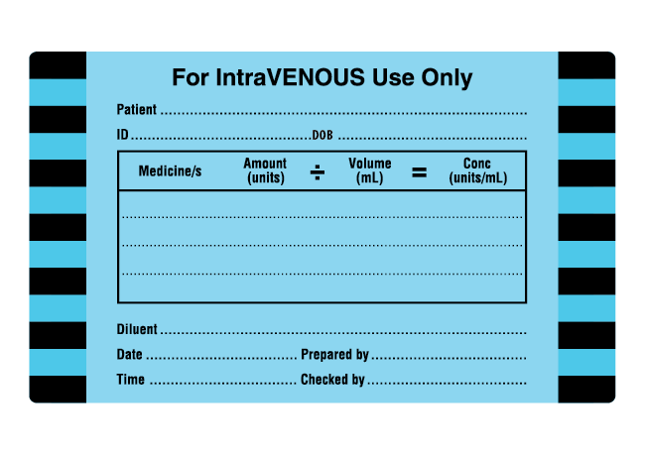

Label placement – bags and bottles
Place on front of container
Ensure fluid name, batch number, expiry date and graduations remain visible (78)

Label placement – syringes for bolus use or infusion
Place parallel to the long axis of the syringe barrel with the top edge of the label flush with (but not covering) the graduations (12, 78)
Choose label size and placement to ensure label content is visible on a syringe in a syringe driver or pump
On small syringes, consider folding the label back on itself (as a flag) or using a clear overlay flag
Exception: syringes containing 0.9% sodium chloride for flushing a line
Label inclusions
Preprinted ‘0.9% sodium chloride’
Sample label (not to scale)

4.7 Minimum requirements for labelling containers in the closed-practice environment
The following shows the minimum labelling requirements for containers (e.g. syringes, basins and jugs) in the closed-practice environment.
The minimum requirements apply to containers of medicines and fluids when patient identity is established and other means of recording, labelling and preparing signatures are available (e.g. operating rooms).

4.7.1 Injectable medicines

Label inclusions
Active ingredient/s (medicine/s) added to the container
Concentration (units/mL) optional, except for adrenaline when used as a single medicine

Sample labels (not to scale)
Preprinted labels should be used where possible (see Figures 3 and 5 for a wider range of examples).
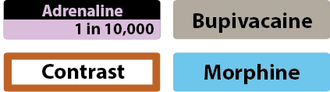
Use a generic label when a preprinted label is unavailable
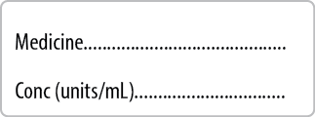

Label placement
Use peel-off labels on reusable containers
Avoid placing on graduations
Avoid placing on a pouring spout

4.7.2 Non-injectable medicines and fluids

Label inclusions
Active ingredient/s (fluid/s) added to the container
Concentration (optional)
Red (70%) St Andrew’s Cross watermark

Sample labels (not to scale)
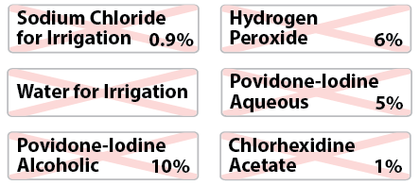

Label placement
Use peel-off labels on reusable containers
Avoid placing on graduations
Avoid placing on a pouring spout

5 Labelling injectable medicine conduits, lines and catheters

5.1 Burettes
All burettes should be labelled IMMEDIATELY after an injectable medicine is added.
Place the label so that the text is upright and ensure that the burette graduations are not obscured.
Peel-off labels should be used on burettes, and labels must be removed once the medicine has been administered to the patient.
The burette label may be applied temporarily to the syringe containing the medicine that is to be added directly to the burette. The label will then be transferred to the burette.

5.1.1 Minimum requirements for labelling burettes

Label inclusions
‘Burette Label for IntraVENOUS Use’
Patient name (given and family names)
Patient identifier (ID) (e.g. medical record number)
Patient date of birth (DOB)
Active ingredient (medicine) added to burette
Amount of medicine added (including units)
Volume of fluid added to burette (mL)
Concentration (units/mL)
Date and time prepared
Prepared by (signature)
Checked by (signature)

Sample label (not to scale)
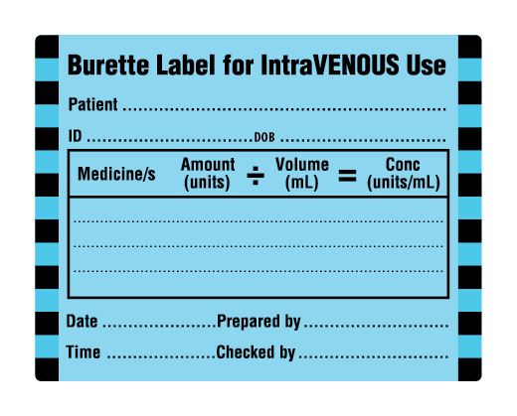

Label placement
Use peel-off labels reserved for use on burettes ONLY
A new label is required for each medicine administration
Remove label on completion of infusion
Do not obscure the burette graduations with the label
Place label so that text is upright
Label may be applied temporarily to the syringe containing the medicine to be added directly into the burette

5.2 Administration lines
All administration lines and catheters (including extension lines and giving sets used to deliver fluids and/or medicines into a patient by the parenteral route) must be labelled.

5.2.1 Administration lines and catheters to identify route
Administration lines and catheters must be labelled with the relevant route of administration (see Appendix 1) (29, 82, 83).
Labels should be colour coded according to target tissue (see Table 1).
The date and time the line was commenced should be documented on the label.
Catheters (e.g. epidural, intrathecal) must be identified when there is a risk of wrong route of administration (e.g. where the patient entry port is distant from the administration site) (27, 43, 46, 51, 53, 54).

Minimum requirements for labelling administration lines: route

Label inclusions
Route
Date and time commenced

Sample labels (not to scale)
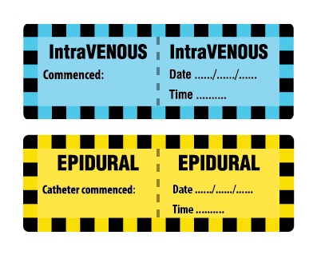

5.2.2 Administration lines to identify medicine
Administration lines dedicated to continuous infusions must be labelled to identify the medicine within the line.
Preprinted medicine line labels are recommended for commonly used medicines with specifications as follows:
Use the active ingredient name of the medicine or fluid (not the brand name).
- Colour coding should be consistent with the Anaesthetic Labelling Standard (ISO 26825:2008) (63), and colour should be assigned according to primary therapeutic use rather than pharmacological class. Exceptions are high-risk medicines and anticoagulant/antiplatelet agents.
- High-risk medicines that fall in the Anaesthetic Labelling Standard (ISO 26825: 2008) (63) miscellaneous category should be printed in red on a white background. Note that high-risk medicines include those with a low therapeutic index, and those that present a high risk when administered by the wrong route or when other system errors occur (84).
- Anticoagulant/antiplatelet medicines should be printed in black on a teal green background (see Table 2).
Other medicines in the Anaesthetic Labelling Standard (ISO 26825:2008) miscellaneous category (such as frusemide) should be printed in black on a white background.
The evaluation of medicine line labelling was conducted using continuous tape printed with a font size of 8 mm, allowing a 2 mm border on either side for printing diversion and leaving a gap of 10–15 mm between images (85). However, if preferred, labels may be printed as individual labels, noting that the medicine name should be printed twice to allow for visibility from both sides when the label is wrapped around the line.
A generic medicine label should be used for infrequently used medicines where a preprinted label is unavailable.
Lines for intermittent infusions may be labelled for medicine content, but the labels must be removed when the infusion is completed.

Minimum requirements for labelling administration lines: medicine

Label inclusions
Active ingredient (medicine) for CONTINUOUS infusions dedicated to a single medicine

Sample labels (not to scale)
Preprinted labels should be used where possible (see Table 3 for a wider range of examples).
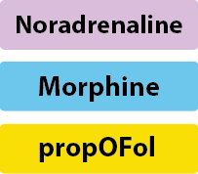
Use a generic label when a preprinted label is unavailable
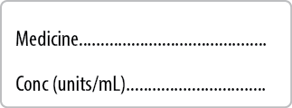

5.2.3 Label placement for administration lines
Labels should be placed near the injection port on the patient side. Place the labels far enough from the injection port to:
prevent interference with the mechanics of bolus administration
prevent introduction of infection.
An exception is made for paediatric patients and for patients who may tamper with the label. In those cases, place the label near the container.
For a multiway port, place the route label near the injection port on the patient side. Place the medicine label before the multiway tap and label each lumen.
Dedicated continuous infusion lines need two labels
Note that the route label and medicine label are separate labels, so a dedicated continuous infusion line should have two labels – one for the route and one for the medicine. For example, an intravenous line delivering noradrenaline would be identified with the following two labels (not to scale), placed adjacent to each other.
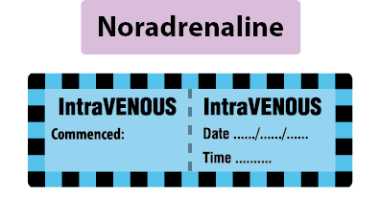

5.3 Invasive monitoring lines
All lines must be identifiable, including those where the primary purpose of the line is not for medicine administration (27).
Lines used for invasive monitoring should be identified with a label that is colour coded according to the target tissue (see Table 1). For example, intra-arterial monitoring lines have a red label that states ‘For Intra-arterial Use Only’.

5.3.1 Minimum requirements for labelling invasive monitoring lines

Label inclusions
Route
Date and time commenced

Sample label (not to scale)
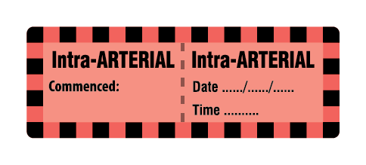

Label placement
Label near the port on the patient side

5.4 Locked catheters
Locked catheters with a medicine ‘in situ’ to ‘lock’ the catheter (e.g. dialysis catheter with a heparin lock) must be labelled.

5.4.1 Minimum requirements for labelling locked catheters

Label inclusions
Active ingredient (medicine)
Date prepared
- For both the arterial lumen and venous lumen
- Volume of lumen (mL)
Final amount of medicine (units)

Sample label (not to scale)
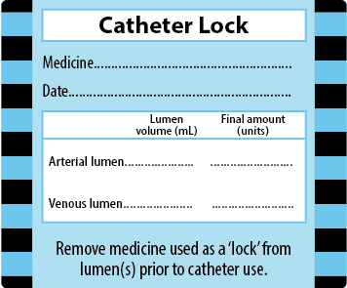

Label placement
Label to partially cover the catheter dressing. Place the label close to the catheter but leave part of a breathable dressing uncovered to allow the dressing to function as intended (see Section 7.2).

5.5 Other catheters and lines

5.5.1 Pulmonary artery catheters
Labelling pulmonary artery catheters is not necessary. It is important to differentiate between the central venous and pulmonary artery catheters and a label is provided for the central venous catheter. Pulmonary artery catheters are coloured yellow, and use of an additional label is not expected to improve patient safety (86).

5.5.2 Intracranial pressure monitoring lines
Labelling of the intracranial pressure (ICP) monitoring line is recommended. Although the ICP line is used for monitoring purposes and not for medicines administration, it should be labelled with a yellow intrathecal route label (86).

5.5.3 Extraventricular and lumbar drains
Labelling of the extraventricular drain and the lumbar drain lines is recommended. Health service organisations choosing to label these lines should use a yellow intrathecal route label.

5.5.4 Bladder irrigation lines
The bladder irrigation line may be labelled if there is any possibility that it could be confused with any other line. The pink miscellaneous line label should be used, and the words ‘Bladder irrigation’ written in the space for ‘Route’.

6 Labelling in perioperative areas
Two user-applied labelling standards apply in perioperative areas:
the Anaesthetic Labelling Standard (ISO 26825:2008) for labelling syringes containing medicines used during anaesthesia (63)
- this Labelling Standard, which applies to
- user-applied labelling of containers and conduits for any injectable medicine or fluid in the perioperative area where the Anaesthetic Labelling Standard (ISO 26825:2008) is not applicable
all non-injectable solutions, chemicals and reagents used in perioperative areas when these are removed from their original containers in a practice area where injectable medicines are used (see Section 7.6) (2, 54, 81).
Both of these standards should be applied as follows:
Use the Anaesthetic Labelling Standard (ISO 26825:2008) to identify medicines in syringes used for the purposes of anaesthesia.
Use the Labelling Standard for all other medicine containers and lines in perioperative areas.
Use container labels with full identification in all open-practice environments, including preparation and recovery areas.
Use abbreviated container labels on perioperative sterile fields (closed-practice environments).
The two standards complement each other and are used in parallel in the perioperative area (Figure 2).
Figure 2 User-applied labelling of medicines and fluids in the open- and closed-practice environments of the perioperative area
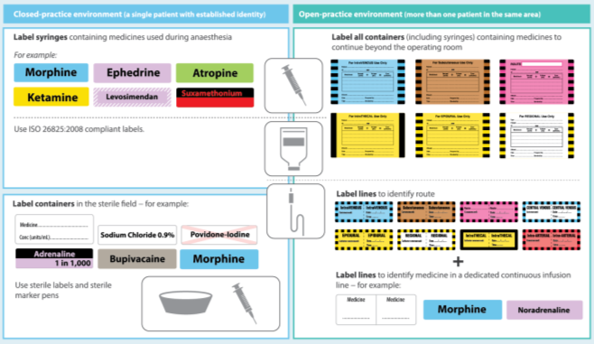

6.1 Open- and closed-practice environments
In an open-practice environment, full patient and user identification is required for user-applied labelling.
In a closed-practice environment, there is a single patient whose identity is beyond doubt, and the identity of the personnel responsible for preparing and checking medicines is recorded. The operating room in the perioperative area is a closed-practice environment. Here, both the Anaesthetic Labelling Standard (ISO 26825: 2008) and the Labelling Standard identify medicines drawn up into containers with no patient or user identification.
When the patient moves to an open-practice environment where other patients are in the same area (e.g. post-anaesthetic recovery unit), any containers and catheters remaining in place must be fully labelled, with patient and user identifiers, according to the Labelling Standard. This may include lines for continued delivery of infusion fluids with additives, administration and monitoring lines and drugs prepared in syringes to accompany the patient on transfer to another clinical area. Figure 2 demonstrates user-applied labelling in the open- and closed-practice environments of the perioperative area.

6.2 Containers on perioperative sterile fields
On perioperative sterile fields, abbreviated container labels without patient and user identification details, and preprinted with the name of the medicine or fluid, may be used (Figure 3).
Figure 3 Examples of preprinted abbreviated container labels for user-applied identification in the closed-practice environment
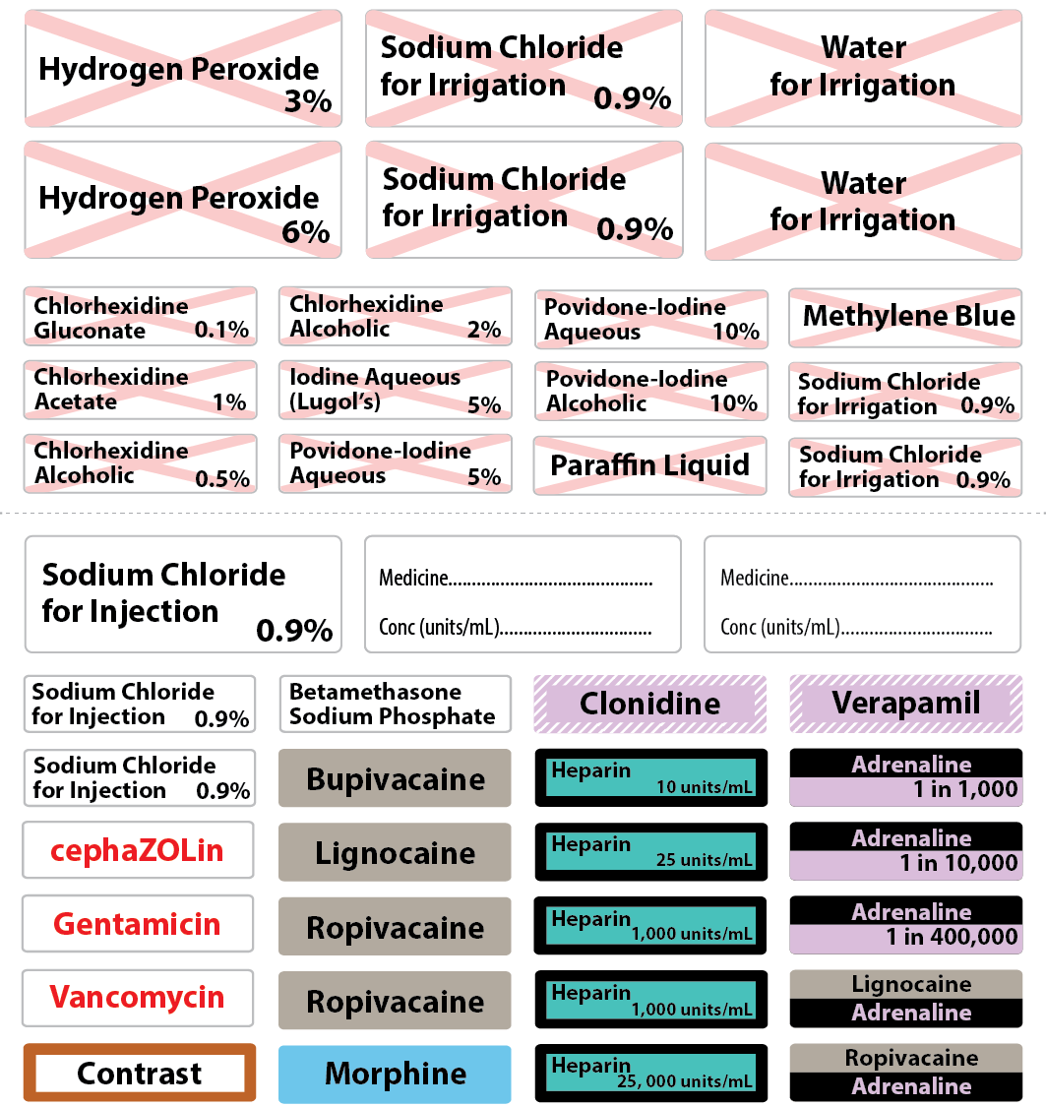
Figure notes:
1. Concentration is optional with the exception of adrenaline and when medicines are available in different concentrations.
2. The St Andrew’s Cross to facilitate recognition of non-injectable medicines is to be printed in 70% red behind the medicine name to ensure the name is legible.
3. High-risk medicines that are not associated with a specific colour may be printed in red text on a white background.
Sheets of preprinted labels for medicines and fluids that are frequently used in routine procedures offer the advantage of providing readily available labels that are efficient to select and easy to apply (4). Labels for injectable medicines should be in a separate section on the sheet from labels for non-injectable medicines (see Figure 3). In addition, non-injectable medicines should be printed with a red watermarked St Andrew’s Cross (87). The full specifications for preprinted abbreviated container labels are in Appendices 1 and 2.
Container or conduit labels for use on the sterile field must be supplied in a sterile package, suitable for aseptic use. Health services may opt to preprint and sterile-pack labels either individually or in sets to cover a procedure or a suite of operating rooms. For sterile label sheets, only labels that are required to be sterile should be included on the sheet.
Where a preprinted label is not available, the generic abbreviated container label should be used, with prompts for the medicine name and concentration (Figure 4).
Figure 4 Generic abbreviated container label for user-applied identification in the closed-practice environment
Sterile marker pens should be available to include concentration information if required and for completion of the generic abbreviated container label.
Do not preprint disposable containers with a medicine name because there is a possibility that the receptacle will be selected for another medicine if it is the only available container.
At the end of a procedure, all medicines prepared for use in the closed-practice environment, including partially used or unused medicines, must be discarded promptly.

6.3 Interventional cardiology, radiology and other low-light procedure areas
The Labelling Standard for user-applied labelling of containers and conduits in the perioperative area also applies to interventional cardiology, radiology and other perioperative settings with low light levels.
The specifications for preprinted abbreviated container labels also apply to labels used in interventional cardiology and radiology.
Catheters are frequently changed during the procedure and do not require labelling. However, all intravenous sheaths, intra-arterial sheaths, intravenous catheters and intra-arterial catheters should be labelled when the patient leaves the procedure room with the sheath or catheter in position. Moreover, the catheter position may vary, and the intra-arterial route label should be used for intra-arterial lines that also enter the intracoronary space.
The number of medicines labels required in interventional radiology is less than that required in cardiology, and some radiology centres may prefer a smaller label set to quicken the label selection process.
Figure 5 shows an example label sheet for interventional cardiology.
Figure 5 Examples of preprinted labels in cardiac catheter laboratories
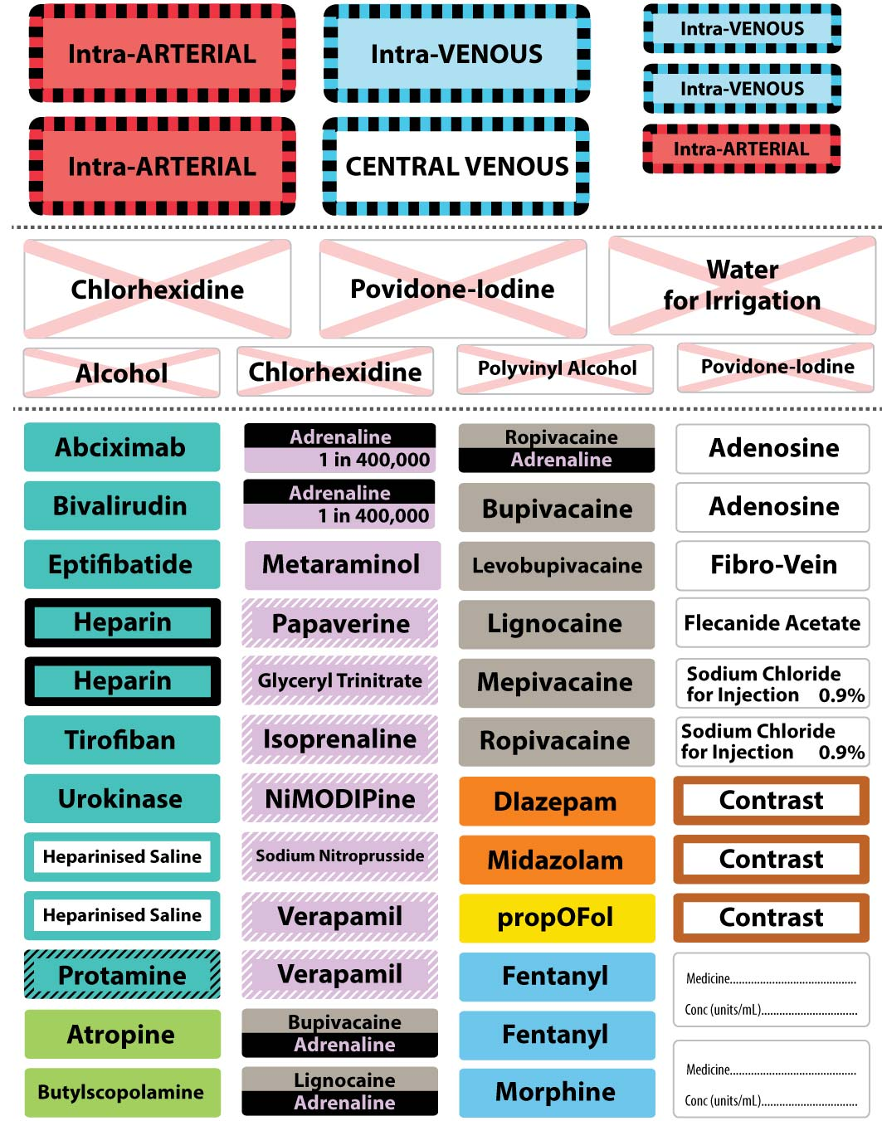

6.4 Contrast media
The minimum requirements of the Labelling Standard apply to contrast media. Contrast media labels should use the generic term ‘contrast’ in closed-practice environments, such as operating rooms. Use a brown (PMS 471) border to assist differentiation of contrast media (Figure 6). A prompt for concentration is not required.
Figure 6 Contrast media abbreviated container label

Combination products, including contrast with a medicine, should be labelled with black type on a white background. For example, phenol with iothalamate meglumine (Conray) should be labelled ‘phenol with iothalamate meglumine’ in black text on a white background.
Labelling is not required when contrast is decanted directly into a high-speed pump reserved solely for the purpose of contrast injection.

6.5 Reusable containers
Labels with adhesive that attaches throughout the procedure, but can be removed completely at the end of the procedure, should be used on reusable containers such as stainless steel hollowware. Label adhesion to reusable hollowware has been shown to be achievable (88, 89).
Solvents such as alcohol swabs/solutions and eucalyptus oil may be required to remove adhesive residue from reusable hollowware. These products are flammable and must be used in the cleaning area of the sterilising services unit, away from patients. Eucalyptus oil requires a warm temperature and detergent to remove any solvent residue.

6.6 Using preprinted labels
Composition of customised, preprinted label sheets should be determined according to local requirements and include some generic abbreviated container labels. The content may be determined by the health services or specialty within a service by identifying medicines that are used regularly:
across a suite of operating rooms
within one operating room
for a specific procedure.
Line labels and abbreviated container labels that are supplied in custom procedure packs used on the sterile field in perioperative areas (such as operating rooms and cardiac catheter laboratories) should comply with the Labelling Standard.

7 Specific considerations

7.1 Containers and lines on sterile fields outside the perioperative area
All medicine containers and lines used for medicines removed from their original container on any sterile field should be labelled according to the Labelling Standard (20, 29, 39, 43, 90). This includes sterile fields set up for procedures in clinical areas outside of perioperative areas, such as the administration of an intrathecal injection in a ward area.
Container and line labels applied on the sterile field must be supplied in sterile packaging. Sterile markers must be made available when labels require population at point of use (20, 29, 43).

7.2 Catheter lock
Central venous access devices may be ‘locked’ with a medicine – that is, a medicine is placed in situ in the portal. Dialysis catheters are one type of central venous access device and may be used for haemodialysis when a fistula for external haemodialysis is unsuitable. The dialysis catheter is generally locked with an anticoagulant such as heparin to maintain patency. In some cases, other medicines may be present (e.g. antibiotics). In general, it is usual to remove the medicine used as a ‘lock’ in the catheter before using the catheter, particularly in the case of heparin and other anticoagulants.
Catheters with a medicine in situ should be identified for route and medicine content using a blue (PMS 2985) catheter ‘lock’ line label (Figure 7).
Figure 7 Line label for medicine used to ‘lock’ a catheter
The suggested label size is 60 mm × 50 mm.
The label should be sited to partially cover the dialysis catheter dressing. In this way, the breathable dressing remains viable, and the label is situated close to the catheter to alert users to the medicine in situ. However, the label should not cover the catheter insertion site. The label should be removed after removing the medicine from the lock. The adhesive used on the label should be strong enough to adhere, but not so strong that it cannot be removed as required.

7.3 Cytotoxic medicines
This Labelling Standard applies to all medicines, including cytotoxic products. In practice, cytotoxics are likely to remain in the original container in which they were prepared for individual patient use. A purple label stating ‘cytotoxic’ may be used to highlight the presence of a cytotoxic medicine, in addition to the minimum requirements of the Labelling Standard and consistent with the Clinical Oncological Society of Australia’s Guidelines for the Safe Prescribing, Supply and Administration of Cancer Chemotherapy (91).

7.4 Radiopharmaceuticals
Labelling the medicine container is a minimum Labelling Standard requirement (see Section 4.6). The exception is radiopharmaceuticals, where the lead casing (secondary container) is labelled in preference to the syringe (primary container) holding the radiopharmaceutical. For the purposes of the Labelling Standard, the syringe containing radioactive material, with the whole unit enclosed in lead casing, constitutes the original container. This must be labelled with a full container label when the syringe is filled and placed in the lead casing.
There is the potential for a syringe to be removed from a labelled casing after manufacture and placed in a different casing when the final calculation of radioactivity is performed. Health service organisations should implement a policy that only one encased syringe is opened at any one time to reduce the risk of a syringe being inadvertently placed in a different (incorrectly labelled) casing.
Lines used for administering radiopharmaceuticals should be identified with route and medicine name labels in accordance with the Labelling Standard.

7.5 Blood products
The minimum requirements of the Labelling Standard apply to blood products. Although not specifically referenced in the Labelling Standards, blood products are injectable medicines and fluids, and should be identified if removed from their original container for patient administration.
Information on the administration of blood products is found in the Australian and New Zealand Society of Blood Transfusion’s Guidelines for the Administration of Blood Products (92).

7.6 Non-injectable medicines and fluids
The principles in the Labelling Standard apply to the identification of non-injectable medicines and fluids removed from their original container to be administered via non-injectable routes, such as inhalation, oral or enteral, and topical routes.
In all cases, syringes used for non-injectable solutions must NOT be compatible with parenteral entry portals (78, 93).

7.6.1 Oral and enteral route
Only syringes specifically designed for administration of medicines orally or via other enteral (e.g. nasogastric) routes should be used for these purposes. They should be clearly labelled with, for example, ‘For Oral Use Only’ or ‘For Enteral Use Only’ (Figure 8) (78, 93, 94).
Figure 8 Label for enteral use
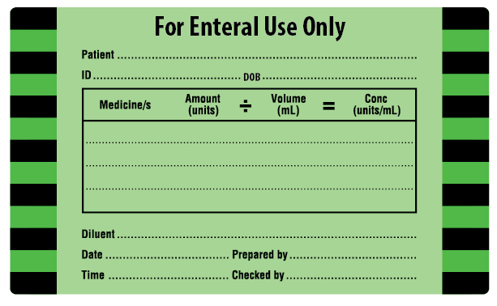

7.6.2 Inhalation route
Ideally, medicines for inhalation should be made available in single-use nebules to avoid measurement in a syringe. If a nebuliser solution is measured in a syringe, the syringe should be clearly labelled ‘For Inhalation Use Only’ (Figure 9).
Figure 9 Label for inhalation use
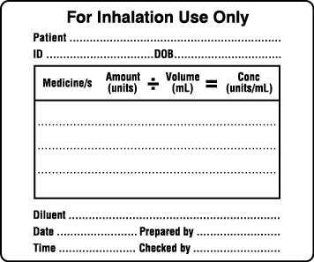

7.6.3 Topical route
Non-injectable medicines and fluids prepared in the same area as injectable products should be labelled, including solutions, chemicals and reagents used topically in perioperative units, interventional cardiology and radiology.
Best practice requires preparing the skin for a procedure and then removing skin preparation solutions from the sterile set-up before commencing the procedure (95-97).
Skin preparations should be labelled when they are removed from their original container, and labels should be provided for this purpose. Label sets should present injectable medicines, skin preparations and irrigation fluids in discrete areas on the same label sheet (see Section 6.2). Non-injectable medicines and fluids should also be identified with a red St Andrew’s Cross watermark behind the non-injectable medicine name.

7.7 Labelling at transitions of care
Particular attention should be given to compliance with the Labelling Standard at transitions of care – for example:
on transfer from a closed-practice to an open-practice environment
when a patient is transferred during or between shifts in a single clinical area
on transfer of patients from one clinical area to another
on preparation of injectable medicines for use en route when moving a patient from one clinical area to another.

7.8 Labelling in an emergency
When injectable medicines are drawn up in a syringe for immediate emergency use (e.g. during resuscitation), the principles in the Labelling Standard should be followed where possible – for example, where staff are available to label syringes without compromising the speed of emergency medicine delivery.
Optimally, use a standard container label in an open-practice environment, and use preprinted abbreviated medicine labels consistent with the Anaesthetic Labelling Standard (ISO 26825: 2008) (or a generic medicine label) in a closed-practice environment (80).

Glossary
Term | Definition
Anaesthesia | The practice of administering medicines or gases that block the feeling of pain and other sensations, permitting a range of medical and surgical procedures to be undertaken without causing undue distress or discomfort to the person being operated upon.
Blood products | Plasma derivatives and recombinant products (e.g. albumin, immunoglobulins and clotting factors).
Bolus | Administration of a small-volume, single-dose, sterile solution from a syringe directly into a tissue, organ or vein, for a short period (usually between 30 seconds and 10 minutes) (45).
Catheter | A tube inserted into a body cavity, sometimes to allow medicine administration, including (but not limited to):  angiographic catheter  arterial catheter  cardiac catheter  central venous access device  epidural catheter  implantable port (e.g. Port-a-Cath®)  intraperitoneal catheter or port  intrathecal catheter or port  midline catheter  peripheral intravenous catheter  peripherally inserted central venous catheter  subcutaneous catheter (e.g. soft winged infusion set)  tunnelled catheter (e.g. Hickmans®, Broviac®).
Catheter lock | Medicine is placed in the portal of a central venous access device.
Clinical area | Any area where injectable medicines and fluids are administered, including:  wards  outpatient areas  Hospital in the Home  procedure rooms (e.g. endoscopy rooms)  perioperative environments.
Closed-practice environment | An area where the identity of the patient is beyond doubt and identities of members of the patient care team are recorded.
Conduit | Any line or device through which injectable fluids could be administered.
Container | Any receptacle in which injectable fluids could be held.
Dedicated continuous infusion | A continuous, uninterrupted flow of a single medicine for a relatively long period of time via a conduit that is reserved for that medicine.
Emergency use | Administration of medicines in an emergency; that is, where an unpredicted situation involving the patient arises (e.g. during resuscitation).
Flag labels | A method of attaching labels to small syringes and containers where part of the label is applied to the syringe, leaving an exposed ‘flag’ portion to ensure that details on the labels can be read, and the syringe markings and contents of the syringe remain visible.
Flush | To purge access devices (e.g. cannulas) before and/or after injection of a medicine, or between injections of different medicines with a sterile solution of diluent such as 0.9% sodium chloride (45).
High-risk medicines | High-risk medicines include:  medicines with a low therapeutic index  medicines that present a high risk when administered by the wrong route or when other system errors occur.
Infusion | Administration (from a syringe, or other rigid or collapsible container, such as a plastic bag) of a volume of sterile solution containing an injectable medicine directly into a tissue, organ, vein or artery, at a constant rate, under gravity or by means of an electronic or mechanical pump or other means of rate control, for a defined period of at least 10 minutes (45).
Injectable medicine | Sterile medicine intended for administration by bolus injection, perfusion or infusion by any of the following routes (45):  epidural  intra-arterial  intradermal  intramuscular  intra-ocular  intraosseous  intrapleural  intrathecal  intravenous  intraventricular  intravesicular  intravitreal  subcutaneous.
Lines | This includes all intravenous giving sets, administration lines, invasive monitoring lines and catheters through which injectable medicines and fluids could be administered.
Open-practice environment | An area where more than one patient may be present and where there may be doubt regarding an intended medication that does not have patient identification.
Operating room | The room in which a surgical procedure is undertaken, with or without the administration of an anaesthetic (98).
Perioperative | The period before, during and after an anaesthetic, surgical or other procedure (98).
Perioperative environment | The service area where the provision of an anaesthetic, or a surgical or other procedure may be undertaken (98).
Post-anaesthetic recovery unit | An area set aside within the perioperative environment that is well planned, well equipped, well staffed and well managed for the safe, immediate management of patients who have recently undergone a surgical or other procedure, irrespective of the type of anaesthesia or sedation (98). Also known as ‘recovery’.
Skin preparation fluid | An antiseptic fluid used to cleanse the skin before surgery or venipuncture.
Sterile field | A specified area, such as within a tray or on a sterile towel, that is considered to be free from microorganisms. An area immediately around a patient that has been prepared for a surgical procedure. The sterile field includes the scrubbed team members, who are properly attired, and all furniture and fixtures in the area.

Acknowledgements

National Injectable Medicines Labelling Project
A project of the Australian Commission on Safety and Quality in Health Care
Details of the project team, advisory committee and pilot hospitals involved in development of the Labelling Recommendations can be found in the National Recommendations for User-applied Labelling of Injectable Medicines, Fluids and Lines (3).

Labelling Recommendations Reference Group
Chair – Ms Julianne Bryce, Senior Federal Professional Officer, Australian Nursing and Midwifery Federation, Federal Office, Melbourne, Victoria
Ms Jaclyn Baker, Deputy Director of Pharmacy, Ballarat Hospital, Ballarat, Victoria
A/Prof Lourens Bester, Australian and New Zealand College of Radiologists; former Head of Interventional Radiology, St Vincent’s Hospital, Darlinghurst, New South Wales
Ms Suzanne Colby, College of Emergency Nursing Australia; Nurse Unit Manager, Emergency Department, West Gippsland Healthcare Group, Warragul, Victoria
Ms Joy Jensen, Queensland Director, Australian College of Operating Room Nurses; Nurse Unit Manager, Operating Theatre, Redcliffe Hospital, Redcliffe, Queensland
Ms Fiona Bailey, Medication Safety and Quality Officer, Clinical Excellence Commission, Sydney, New South Wales
A/Prof Andrew MacIsaac, Chair of the Interventional Council, Cardiac Society of Australia and New Zealand; Director, Cardiology Services, Deputy Chief Medical Officer, St Vincent’s Health, Melbourne, Victoria
Ms Fiona McIver, Medication Safety Officer, Medicines Regulation and Quality, Queensland Health, Fortitude Valley, Queensland
A/Prof Jeffrey Presneill, Australian and New Zealand Intensive Care Society; Intensive Care Physician, Royal Brisbane Women’s Hospital, Herston, Queensland; A/Professor, School of Medicine, University of Queensland, Brisbane, Queensland
A/Prof David A Scott, Vice President, Australian and New Zealand College of Anaesthetists; Director, Department of Anaesthesia and Acute Pain Medicine, St Vincent’s Health, Melbourne, Victoria
Ms Diana Shipp, Senior Project Officer, eHealth and Medication Safety, Australian Commission on Safety and Quality in Health Care, Sydney, New South Wales
Mr Ralph Tramm, Australian College of Critical Care Nurses, Australian and New Zealand Intensive Care Research Centre, School of Public Health and Preventive Medicine, Monash University, Melbourne, Victoria
Mrs Leonie Weisbrodt, President, Australian College of Critical Care Nurses; Clinical Lecturer, Sydney Nursing School, University of Sydney; Clinical Nurse Consultant, Intensive Care Unit Research, Nepean Hospital, Kingswood, New South Wales
Ms Tiffany Whittington, Professional Officer, Renal Society of Australasia Federal Board; Clinical Services Coordinator, Noarlunga Dialysis Unit, Southern Local Health Network, Royal Adelaide Hospital, Adelaide, South Australia

Hospitals contributing to evaluation of user-applied labelling implementation
Clinical area | Hospital
Operating room | Calvary Wakefield Hospital, South Australia
Intensive care unit | Barwon Health, Victoria  Royal Prince Alfred Hospital, New South Wales  Southern Health (Monash), Victoria  Tweed Hospital, New South Wales
Perioperative sterile services | Prince of Wales Hospital, New South Wales  St Vincent’s Hospital, New South Wales
Cardiac catheter laboratory | Greenslopes Hospital, Queensland  Royal Adelaide Hospital, South Australia  St John of God Hospital, Perth, Western Australia  St Vincent’s Health Melbourne, Victoria  St Vincent’s Private Melbourne, Victoria
Interventional radiology | Prince of Wales Hospital, New South Wales  St Vincent’s Public Hospital, Darlinghurst, New South Wales
Renal dialysis unit | Royal Adelaide Hospital, South Australia

National contributions
The following stakeholders and national peak professional bodies contributed to the development of the Labelling Recommendations, the Labelling Standard, or both:
state and territory health departments
state and territory safer medicines groups or equivalents
Australian Association of Nuclear Medicine Specialists
Australian College of Critical Care Nurses
Australian College of Nursing
Australian College of Operating Room Nurses
Australian and New Zealand College of Anaesthetists, including the Faculty of Intensive Care Medicine
Australian and New Zealand Intensive Care Society
Australian and New Zealand Society for Nuclear Medicine
Australian Nursing and Midwifery Federation
Australian Pharmaceutical Healthcare Systems
Australian Private Hospitals Association
Cancer Council Australia
Cardiac Society of Australia and New Zealand
Catheter Laboratory Nursing Council
Clinical Oncological Society of Australia
College of Emergency Nursing Australia
Consumers Health Forum
Council of Australian Therapeutic Advisory Groups
Intensive Care Coordination and Monitoring Unit, New South Wales
Renal Society of Australasia
Royal Australian and New Zealand College of Radiologists
SESIAHS Sterilising Services, Randwick Hospitals Campus
Society of Hospital Pharmacists of Australia
Women’s & Children’s Hospitals Australasia.

Appendix 1 Label guide and specifications
Containers: injectable medicines and fluids – route labels
Route | Example | Background | Border | Size
Intrathecal | 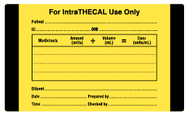 | Pantone Yellow with 70% stipple | Solid black | Small label: 60 mm × 50 mm  Large label: 100 mm × 60 mm
Intravenous | 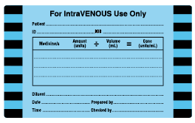 | Blue PMS 2985 with 70% stipple | Black/blue hatched | Small label: 60 mm × 50 mm  Large label: 100 mm × 60 mm
Epidural | 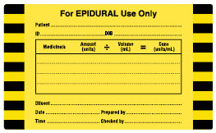 | Pantone Yellow with 70% stipple | Black/yellow hatched | Small label: 60 mm × 50 mm  Large label: 100 mm × 60 mm
Subcutaneous | 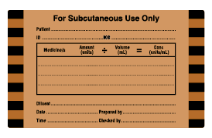 | Beige PMS 723 with 70% stipple | Black/beige hatched | Small label: 60 mm × 50 mm  Large label: 100 mm × 60 mm
Regional | 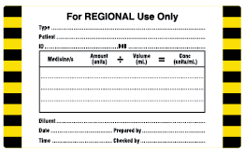 | White | Black/ Pantone Yellow hatched | Small label: 60 mm × 50 mm  Large label: 100 mm × 60 mm
Miscellaneous | 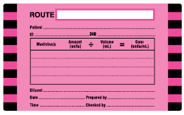 | Pink 806 with 70% stipple | Black/pink hatched | Small label: 60 mm × 50 mm  Large label: 100 mm × 60 mm
Intra-arterial | 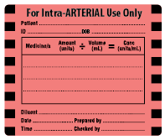 | Red PMS 1787 with 70% stipple | Black/red hatched | Small label: 60 mm × 50 mm
PMS = Pantone Matching System
Note: Containers include bags, bottles and syringes.
Containers: open-practice environment (abbreviated label) – flush label
Ingredients | Example | Background | Border | Size
0.9% sodium chloride flush only |  | White | Nil | 37 mm × 10 mm
Note: Containers include bags, bottles and syringes.
Containers: closed-practice environment (abbreviated medicine labels)
Medicine | Example | Background | Size
Perioperative sterile field | 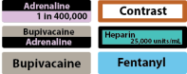 | Consistent with ISO 26825:2008 and extension to ISO 26825:2008 (see Section 3.3.2) | To be determined by health facility but sufficiently large to accommodate medicine name in legible font size (see Appendix 2)
Cardiac catheter laboratory | 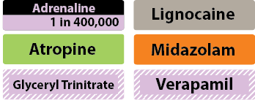 | Consistent with ISO 26825:2008 and extension to ISO 26825:2008 (see Section 3.3.2) | To be determined by health facility but sufficiently large to accommodate medicine name in legible font size (see Appendix 2)
Non-injectable fluids | 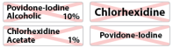 | Consistent with ISO 26825:2008 and extension to ISO 26825:2008 (see Section 3.3.2) | To be determined by health facility but sufficiently large to accommodate medicine name in legible font size (see Appendix 2)
Generic | 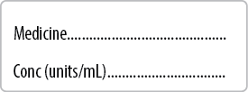 | White | 70 mm × 25 mm (‘peel-off’ for reusable containers)
Note: Containers include bags, bottles and syringes.
Containers: non-injectable medicines and fluids – route labels
Route | Example | Background | Border | Size
Enteral | 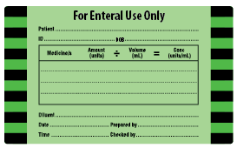 | Green PMS 361 with 70% stipple | Black/green hatched | Small label: 60 mm × 50 mm  Large label: 100 mm × 60 mm
Inhalational | 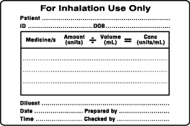 | White | None | Small label: 60 mm × 50 mm
PMS = Pantone Matching System
Note: Containers include bags, bottles and syringes.
Conduits: route label
Route | Example | Background | Border | Size
Intravenous: burette | 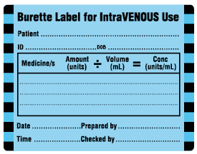 | Blue PMS 2985 with 70% stipple | Black/blue hatched | 76 mm × 59 mm (‘peel-off’)
PMS = Pantone Matching System
Lines and catheters: injectable medicines and fluids – route labels
Route | Example | Background | Border | Size
Intrathecal |  | Pantone Yellow with 70% stipple | Solid black | 70 mm × 25 mm
Intravenous | 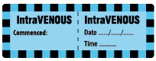 | Blue PMS 2985 with 70% stipple | Black/blue hatched | 70 mm × 25 mm
Epidural | 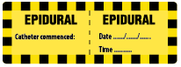 | Pantone Yellow with 70% stipple | Black/yellow hatched | 70 mm × 25 mm
Central venous |  | White | Black/blue PMS 2985 hatched | 70 mm × 25 mm
Regional |  | White | Black/Pantone Yellow hatched | 70 mm × 25 mm
Subcutaneous |  | Beige PMS 723 with 70% stipple | Black/beige hatched | 70 mm × 25 mm
Intra-arterial |  | Red PMS 1787 with 70% stipple | Black/red hatched | 70 mm × 25 mm
Miscellaneous |  | Pink PMS 806U with 70% stipple | Black/pink hatched | 70 mm × 25 mm
Dialysis |  | Blue PMS 2985 with 70% stipple | Black/blue hatched | 60 mm × 50 mm (‘peel-off’)*
PMS = Pantone Matching System
Lines and catheters: non-injectable medicines and fluids – route label
Route | Example | Background | Border | Size
Enteral |  | Green PMS 361 with 70% stipple | Black/green hatched | 70 mm × 25 mm
PMS = Pantone Matching System
Lines and catheters: medicine labels
Medicine | Example | Background | Border | Sizeª
Preprinted |  | Consistent with ISO 26825:2008 and extension to ISO 26825:2008 (see Section 3.3.2) | Consistent with ISO 26825:2008 and extension to ISO 26825:2008 (see Section 3.3.2) | To be determined by health facility
Generic |  | White | Nil | 70 mm × 25 mm
a Label stock used in evaluation was unplasticised PVC tape (see Section 5.2.2).

Appendix 2 Specifications for preprinted abbreviated container labels
Preprinted medicine labels should be printed with the full generic name of the medicine or fluid (with the exception of contrast media). Labels should be sufficiently large to retain font size and legibility of the medicine name.
- Concentration should be included where this can be specified:
- Concentration should be expressed as it appears on the original container.
- Concentration MUST be specified for adrenaline administered as a single medicine. For adrenaline mixed with a local anaesthetic, concentration for both adrenaline and the local anaesthetic may be omitted.
Concentration should be specified on label sheets with multiple labels for the same medicine available in different strengths (see Figures 3 and 5).
- Colour coding should comply with the Anaesthetic Labelling Standard (ISO 26825:2008). Exceptions are as follows
- Antiplatelet and anticoagulant medicines should be printed in black on a teal green background (see Section 3.3.2).
- Contrast media labels should be printed in black text on a white background with a brown border (PMS 471) (see Section 6.4).
Where two medicines are combined in the original container, such as a local anaesthetic and a vasopressor, the user-applied label will include both medicines and carry appropriate colour coding for both.
Non-injectable fluids (e.g. solutions for skin preparation) should have a red St Andrew’s Cross watermarked behind the fluid name.
A large, clear (sans serif) font should be used (69). Font size may be determined by the health service. It should be proportionate to the label size (e.g. 20 point for larger labels, 12 point for smaller labels and 11 point for small labels with two medicine names, such as bupivacaine/adrenaline).
Medicine names should have an initial capital letter and other letters lower case.
Tall Man lettering should be used for medicines on the National Tall Man Lettering List and presented consistent with the list (69). The National Tall Man Lettering convention should also be used to distinguish between other elements that look alike (78), such as routes of administration (e.g. IntraTHECAL, IntraVENOUS and IntraARTERIAL).
Label size should be determined by the perioperative facility. Larger labels (55 mm × 20 mm) are suitable for fluids such as water for irrigation and lactated ringers solution. Smaller labels (40 mm × 10 mm) are suitable for other medicines and fluids such as heparin and chlorhexidine.

Appendix 3 The Labelling Standard and other standards

Australian Standard
The Labelling Standard has been developed with consideration of the Australian Standard AS 4940:2002 User-applied identification labels for use on fluid bags, syringes and drug administration lines (67, 68).
AS 4940:2002 specifies dimensions, colour (to identify target tissue), borders, background, printing and adhesive qualities of the user-applied labels. The Labelling Standard expands on AS 4940:2002 and includes:
recommendations regarding label content and label placement
modifications to label dimensions, background colour and depth, borders, colour, lettering, and label adhesion to ensure its practicability in clinical settings.

Label dimensions
AS 4940:2002 (67, 68) defines dimensions of labels to be applied to bags and another set of dimensions for labels to be applied to syringes. However, these dimensions do not accommodate the range of the various sized bags and syringes used in clinical settings.
The Labelling Standard includes two sizes of labels for application to bags and syringes – small (60 mm × 50 mm) and large (100 mm × 60 mm). These labels contain the same information and are interchangeable. The label selected for use will depend on the container size. For example, the small label may be applied to both syringes and small-volume fluid bags (e.g. mini bags), and the large label may be applied to other fluid bags and larger-volume syringes (e.g. 50 mL).

Background and borders
Modifications to the AS 4940:2002 specifications for background and borders are listed in Table A.1.
Table A.1 Modifications to AS 4940 used in the Labelling Standard: background and borders
AS 4940 | Labelling Standard | Rationale for modification
Background colour to be white except for neural route, which is to be yellow | Background is coloured (70% of primary colour) | A coloured background was introduced to increase the visibility of labels applied to fluid bags in clinical settings. This was applied to both labels (small and large). To allow for readability of label content, 70% of the primary colour was chosen. A combination of coloured (70% of primary colour) and white backgrounds was applied to line labels to assist differentiating between similar routes (e.g. intravenous and central venous)
Background colour to be white except for neural route, which is to be yellow | Yellow background retained for intrathecal and epidural routes. Regional route background colour is white | The white background was applied to the regional route to differentiate between the two other neural routes – epidural and intrathecal
Border pattern to be of squares of alternating black and coloured squares | Alternating black and coloured square borders have been retained in all cases with the exception of the intrathecal route | Using the same border and background for intrathecal and epidural routes was judged to be a source of high-risk error and patient harm, due to similar label design. A solid black border has been introduced to assist in differentiating between intrathecal and epidural
Border to be at least 4 mm in width | Border at least 3 mm in width | The border width was reduced to maximise space for label content
Border to occupy at least 3 sides of the label | Border occupies 2 sides of the label | The border was applied to the lateral sides to retain the border feature and to maximise space available for label content
AS 4940 = Australian Standard AS 4940:2002 User-applied identification labels for use on fluid bags, syringes and drug administration lines (67, 68)

Use of colour to identify target tissue/route
Use of colour to identify target tissue/route is aligned with AS 4940:2002 (67, 68), with the exception of intravenous and miscellaneous routes (Table A.2).
Table A.2 Modifications to AS 4940 used in the Labelling Standard: colour for target tissue/route
Route | AS 4940 | Labelling Standard | Rationale for modification
Intravenous | PMS Process Blue | PMS Blue 2985 | PMS Blue 2985 was identified as the preferred colour compared with Process Blue both for superior visibility and for retaining legibility of label content
Miscellaneous | White | PMS Pink 806 | Pink was selected as a nonwhite background to highlight the presence of an additive
AS 4940 = Australian Standard AS 4940:2002 User-applied identification labels for use on fluid bags, syringes and drug administration lines (67, 68); PMS = Pantone Matching System
The Labelling Standard uses sans serif font, consistent with AS 4940:2002 (67, 68).
Tall Man lettering has been introduced for route labels to improve readability and differentiation between similar route names, such as intraVENOUS and intraTHECAL. This is consistent with (but not part of) the National Tall Man Lettering Standard (69).

International Standard
The International Standard ISO 26825:2008E: Anaesthetic and respiratory equipment – user-applied labels for syringes containing drugs used during anaesthesia – colours, design and performance (63) supersedes AS/NZS 4375:1996 User-applied labels for syringes containing drugs used during anaesthesia (80). The Labelling Standard complements but does not replace ISO 26825:2008.
The Labelling Standard has extended the use of Anaesthetic Labelling Standard (ISO 26825:2008) colour coding to medicine lines labels and abbreviated container labels used outside anaesthesia, with some modifications. See Table A.3.
Table A.3 Anaesthetic Labelling Standard colour coding to medicines lines labels and abbreviated container labels used outside anaesthesia
Medicine/ medicine class | Colour | Examples
Anticoagulant/ antiplatelet agents | Teal green (PMS 3255; CMYK 64.0.32.0; RGB 34.211.197) | abciximab, bivalirubin, eptifabatide, tirofiban, urokinase
Heparin | Teal green (PMS 3255; CMYK 64.0.32.0; RGB 34.211.197) with solid black border (1–2 mm)
Protamine | Teal green (PMS 3255; CMYK 64.0.32.0; RGB 34.211.197) with black diagonal-stripe border (1–2 mm)
Heparinised saline | White with teal green (PMS 3255; CMYK 64.0.32.0; RGB 34.211.197) border
Contrast media | White with brown (PMS 471; CMYK 20.70.100.7; RGB 188. 97.36) border

Appendix 4 Labelling Standard development and maintenance

National Injectable Medicines Labelling Project
The National Standard for User-applied Labelling of Injectable Medicines, Fluids and Lines (August 2010) originated from a concept initiated by the New South Wales Therapeutic Advisory Group (NSW TAG) Safer Medicines Group. An advisory committee representing the interests of key clinical groups was established in February 2009 by the Australian Commission on Safety and Quality in Health Care (the Commission) to oversee development of user-applied labelling recommendations for injectable medicines, fluids and lines for national implementation.
Following national consultation, draft labelling recommendations were piloted in public and private health services across Australia.

National Recommendations for User-applied Labelling of Injectable Medicines, Fluids and Lines, first edition, November 2010
The first edition of the National Recommendations for User-applied Labelling of Injectable Medicines, Fluids and Lines, November 2010 (the Labelling Recommendations) (6), reflected:
NSW TAG Safer Medicines Group work on standardised labelling
Australian Standard AS 4940:2002 User-applied identification labels for use on fluid bags, syringes and drug administration lines (67, 68)
work by national and international organisations
relevant peer-reviewed literature
published case reports
unpublished incidents
project advisory committee review
pilot testing.
Reasons supporting the final recommendations were provided in the supporting implementation and education materials. The development process raised a number of issues relating to labelling practice. These were addressed in sections outlining additional strategies to improve medicine administration safety and extending the Labelling Recommendations to improve practice.

National Recommendations for User-applied Labelling of Injectable Medicines, Fluids and Lines, second edition, February 2012
The second edition of the Labelling Recommendations in February 2012 (3) reflected the patient identification requirements in the National Safety and Quality Health Service Standards (5). Standard 5: Patient Identification and Procedure Matching requires that ‘at least three approved patient identifiers are used when providing care, therapy or services’ (5). To comply with the standards, the Labelling Recommendations container labels were revised to include patient date of birth as a third patient identifier. The revision was valid from November 2011.

National Standard for User-applied Labelling of Injectable Medicines, Fluids and Lines, 2015
The National Standard for User-applied Labelling of Injectable Medicines, Fluids and Lines (the Labelling Standard) incorporates issues identified and addressed during national implementation of the Labelling Recommendations.
The Labelling Recommendations Reference Group was established to advise the Commission on implementation and maintenance of the Labelling Recommendations. Decisions are recorded in the Labelling Recommendations Issues Register (86).
A series of evaluations has been undertaken to assist health services to design labels and address issues raised during implementation. The following resolutions were proposed during this process, which were then included in the Labelling Standard:
preprinted labels on perioperative sterile fields
label adhesion requirements for reusable hollowware containers in operating rooms
standardised medicine line labels for dedicated continuous infusions
preprinted container labels in cardiac catheter laboratories and radiography suites
segregation and differentiation of labels for non-injectable medicines and fluids.
Many health services contributed to piloting and evaluation, which resulted in these changes (see Acknowledgements).

Evaluation of preprinted labels for identification of medicines and fluids on the perioperative sterile field (reports 1 and 2)
Evaluation of preprinted label sheets on the perioperative sterile field at Calvary Wakefield Hospital in 2012 (4) found that preprinted labels were easy to use, provided they were manufactured with materials that were durable and fit for purpose.
Preprinted labels are well accepted in the perioperative sterile field. However, the Labelling Recommendations Reference Group (LRRG) acknowledged that injectable and non-injectable medicines and fluids could be more clearly differentiated within the same practice area. Ideally – and within best-practice guidelines, such as those described by the Australian and New Zealand College of Anaesthetists (99) – user-applied labelling of non-injectable fluids would take place before the patient enters the operating room or procedure area. However, it still may be necessary to identify non-injectable medicines and fluids in the operating or procedure room where injectable medicines are used, and a way of differentiating between them is necessary. The following methods were evaluated and endorsed:
use of a red St Andrew’s Cross applied as a watermark across the labels of non-injectable medicines and fluids
segregation of the two medicine and fluid types within the one label sheet.

Evaluation of label adherence to hollowware containers in operating rooms (reports 1 and 2)
Adhesive strength is dependent on the use of disposable or reusable containers in the operating room. Stronger adhesive is appropriate for disposable containers because there is no requirement to remove labels. Reusable containers (e.g. stainless steel) will require labels to adhere for the duration of the procedure and then be removed entirely for the container to be cleaned and sterilised for reuse (5, 6). Label stock and adhesives suitable for reusable hollowware containers have been evaluated in two bench-top trials.

Evaluation of standardised medicine line labels for dedicated continuous infusions
Preprinted, standardised medicine labels (using colours and formatting described in the Anaesthetic Labelling Standard [ISO 26825: 2008]) on dedicated continuous infusion lines for commonly used medicines were implemented in intensive care units at four sites and evaluated through a survey of clinical staff (85). The findings support the national standard requirement for identifying medicines in dedicated continuous infusion lines.

Evaluation of standardised medicine syringe labels in interventional cardiac catheter and radiology laboratories
Evaluation of preprinted labels was conducted within interventional cardiology and radiology. These specialist perioperative areas differ from operating rooms in two main respects:
The interventionist manages the majority of medicine administrations at the same time as performing a clinical procedure.
Both tasks are often required to be undertaken in low-light conditions to allow for simultaneous review of angiography or other radiology.
Preprinted medicine line labels were well accepted in interventional cardiology and radiology, and a series of recommendations was made for user-applied labelling based on trial outcomes. A full list is detailed in the trial report (100), but the following approach to colour coding was adopted across all medicine labels following consultation with the LRRG.
Colour of sterile preprinted medicine labels should be consistent with colour coding in the Anaesthetic Labelling Standard, with the following exceptions:
antiplatelet agents/anticoagulants to be labelled with teal green (Pantone Matching System [PMS] 3255)
heparin to be teal green with a black border
protamine to be teal green with a black diagonal-stripe border
heparinised saline to have a teal green border (PMS 3255)
contrast to have a brown border (PMS 471).

Labelling Standard maintenance
There is an agreed process for maintenance of the Labelling Standard, which involves states, territories and private health services.
The Labelling Standard Issues Register will continue to record issues reported by health service organisations on the Commission’s web site. These issues will be referred to the Commission’s advisory groups, including the Labelling Standard Reference Group, formerly the LRRG (see Acknowledgements).

References
1. Australian Government Department of Health and Ageing. The National Strategy for Quality Use of Medicines. Canberra: Commonwealth of Australia; 2002.
2. Institute for Safe Medication Practices. Medication Safety Alert: Acute care – loud wake-up call: unlabeled containers lead to patient’s death [web page]. Institute for Safe Medication Practices; 2004 [cited 2015 1 April].
3. Australian Commission on Safety and Quality in Health Care. National Recommendations for User-applied Labelling of Injectable Medicines, Fluids and Lines [web page]. Sydney: Australian Commission on Safety and Quality in Health Care; 2012 [cited 2015 1 April].
4. Australian Commission on Safety and Quality in Health Care. National Recommendations for User-applied Labelling of Injectable Medicines, Fluids and Lines: evaluation of preprinted labels for identification of medicines and fluids on the perioperative sterile field (report 1) [web page]. Sydney: Australian Commission on Safety and Quality in Health Care; 2012 [cited 2015 1 April].
5. Australian Commission on Safety and Quality in Health Care. National Safety and Quality Health Service Standards. Sydney: Australian Commission on Safety and Quality in Health Care 2011. Report No. 978-0-9870617-9-9 (paperback).
6. Australian Commission on Safety and Quality in Health Care. National Recommendations for User-applied Labelling of Injectable Medicines, Fluids and Lines. Sydney: Australian Commission on Safety and Quality in Health Care; 2010.
7. Australian Government Department of Health. National Medicines Policy [web page]. Canberra: Department of Health; 2014 [cited 2015 1 April].
8. Taxis K, Barber N. Ethnographic study of incidence and severity of intravenous drug errors. British Medical Journal. 2003;326:684–7.
9. Fraind D, Slagle J, Tubbesing V, Hughes S, Weinger M. Reengineering intravenous drug and fluid administration processes in the operating room: step one: task analysis of existing processes. Anesthesiology. 2002;97(1):139–47.
10. American Nurses Association. 2007 study of injectable medication errors [web page]. American Nurses Association and Inviro Medical Devices; 2007 [cited 2015 1 April]. Available from: http://psnet.ahrq.gov/resource.aspx?resourceID=5503.
11. American Nurses Association. Medication errors and syringe safety are top concerns for nurses according to a new national study [press release]. Silver Spring, MD: American Nurses Association, 18 June 2007.
12. Cohen M, Smetzer J. ISMP medication error report analysis: Errors with injectable medications: unlabeled syringes are surprisingly common! Hospital Pharmacy. 2007;43:81–4.
13. Cousins D, Sabatier B, Begue D, Schmitt C, Hoppe-Tichy T. Medication errors in intravenous drug preparation and administration: a multicentre audit in the UK, Germany and France. Quality and Safety in Health Care 2005;14:190–5.
14. Valentin A, Capuzzo M, Guidet B, Moreno R, Metnitz B, Bauer P, et al. Errors in administration of parenteral drugs in intensive care units: multinational prospective study. British Medical Journal. 2009;338:b814.
15. Bruce J, Wong I. Parenteral drug administration errors by nursing staff on an acute medical admissions ward during day duty. Drug Safety. 2001;24(11):855–62.
16. Thomas A, Panchagnula U. Medication-related patient safety incidents in critical care: a review of reports to the UK National Patient Safety Agency. Anaesthesia. 2008;63(7):726–33.
17. Paix A, Bullock M, Runciman W, Williamson J. Crisis management during anaesthesia: problems associated with drug administration during anaesthesia. Quality and Safety in Health Care 2005;14:e15.
18. Abeysekera A, Bergman I, Kluger M, Short T. Drug error in anaesthetic practice: a review of 896 reports from the Australian Incident Monitoring Study Database. Anaesthesia. 2005;60:220–7.
19. Institute for Safe Medication Practices Canada. ISMP Canada Safety Bulletin. ALERT: Fatal outcome after inadvertent injection of epinephrine intended for topical use [PDF, 426KB]. Institute for Safe Medication Practices Canada; 2009 [cited 2015 1 April].
20. Victorian Institute of Forensic Medicine. Medications: double checking at the bedside? Coronial Communiqué: Victorian Institute of Forensic Medicine. 2006;4(4):4.
21. National Patient Safety Agency. Rapid Response Report: risks with intravenous heparin flush solutions [web page]. National Patient Safety Agency. National Reporting and Learning Service; 2008 [updated April; cited 2015 1 April].
22. Kirschling TE (ed). The Handbook on Storing and Securing Medications. 2nd ed. Oakbrook Terrace, Illinois: Joint Commission Resources; 2009.
23. Anon. Be prepared is often not the best option for risk management. Australian Incident 46. Journal of Pharmacy Practice and Research. 2006;36(3):225.
24. National Patient Safety Agency. Rapid Response Report: Reducing risk of overdose with midazolam injection in adults. Supporting information [web page]. National Patient Safety Agency. National Reporting and Learning Service; 2008 [updated December; cited 2015 1 April].
25. Anon. Preventing errors with neuromuscular blockers. Journal of Pharmacy Practice and Research. 2005;35(4):3–5.
26. Gilbar P, Seger A. Deaths reported from the accidental intrathecal administration of bortezomib. Journal of Oncology Pharmacy Practice. 2012;18(3):377–8.
27. National Patient Safety Agency. Rapid Response Report: Problems with infusions and sampling from arterial lines. Supporting information [web page]. National Patient Safety Agency. National Reporting and Learning Service; 2008 [updated July; cited 2015 1 April].
28. Bogod D. The sting in the tail: antiseptics and the neuraxis revisited. Anaesthesia. 2012;67(12):1305–20.
29. Institute for Safe Medication Practices. Medication Safety Alert: Acute care – problems persist with life-threatening tubing misconnections [web page]. Institute for Safe Medication Practices; 2004 [cited 2015 1 April].
30. Institute for Safe Medication Practices. Medication Safety Alert: Acute care – preventing magnesium toxicity in obstetrics [web page]. Institute for Safe Medication Practices; 2005 [cited 2015 1 April].
31. Sheridan DJ. Labeling solutions and medications in sterile procedural settings. Joint Commission Journal on Quality and Patient Safety. 2006;32(5):276–82.
32. Hicks RW, Wanzer L, Goeckner B. Perioperative pharmacology: a framework for perioperative medication safety. AORN Journal. 2011;93(1):136–42.
33. National Patient Safety Agency. Reporting and learning system quarterly data summary. Patient safety incident reports in the NHS. England Issue 11. London: National Patient Safety Agency. National Reporting and Learning Service; 2009.
34. Burdeu G, Crawford R, van de Vreede M, McCann J. Taking aim at infusion confusion. Journal of Nursing Care Quarterly 2006;21:151–9.
35. Jennings J, Foster J. Medication safety just a label away. AORN Journal 2007;86:618–25.
36. Webster C, Merry A, Larsson L, McGrath K, Weller J. The frequency and nature of drug administration error during anaesthesia. Anaesthesia and Intensive Care. 2001;29:494–500.
37. Santell J. Medication errors involving neuromuscular blocking agents. Joint Commission Journal on Quality and Patient Safety. 2006;32:470–5.
38. Statler JD, Towbin RB, Ronsivalle JA, Oteham A, Miller DL, Grassi CJ, et al. Recommendations for the implementation of Joint Commission Guidelines for Labeling Medications. Journal of Radiology Nursing. 2009;28(3):77–82.
39. Erbe B. Safe medication administration in the operating room. Tar Heel Nurse. 2011;73(1):10–13; quiz 4.
40. Jensen L, Merry A, Webster C, Weller J, Larsson L. Evidence-based strategies for preventing drug administration errors during anaesthesia. Anaesthesia 2004;59:493–504.
41. Llewellyn R, Gordon P, Wheatcroft D, Lines D, Reed A, Butt A, et al. Drug administration errors: a prospective survey from three South African teaching hospitals. Anaesthesia and Intensive Care. 2009;37(1):93–8.
42. Hew C, Cyna A, Simmons S. Avoiding inadvertant epidural injection of drugs intended for non-epidural use. Anaesthesia and Intensive Care. 2003;31:44–9.
43. WHO Collaborating Centre for Patient Safety Solutions. Patient safety solutions: avoiding catheter and tubing mis-connections [PDF, 480KB]. WHO Collaborating Centre for Patient Safety Solutions; 2007 [cited 2015 1 April].
44. National Patient Safety Agency. Rapid Response Report: Reducing risk of overdose with midazolam injection in adults [web page]. National Patient Safety Agency. National Reporting and Learning Service; 2008 [updated December; cited 2015 1 April].
45. National Patient Safety Agency. Patient safety alert 20: Promoting safer use of injectable medicines [web page]. National Patient Safety Agency; 2007 [updated March; cited 2015 1 April].
46. National Patient Safety Agency. Patient safety alert 21: Safer practice with epidural injections and infusions [web page]. National Patient Safety Agency; 2007 [updated March; cited 2015 1 April].
47. National Patient Safety Agency. Rapid Response Report: Problems with infusions and sampling from arterial lines [web page]. National Patient Safety Agency. National Reporting and Learning Service; 2008 [updated July; cited 2015 1 April].
48. The Joint Commission. Hospital Accreditation Standards 2010. Medication Management Standards. Standard MM.05.01.09. Medications are labeled. The Joint Commission; 2009.
49. van Zundert A, Beckers A. How to avoid mistakes? Safety issues with epidurals. Spring 2010 Abstract Titles: ASRA 35th Annual Regional Anesthesia Meeting and Workshops; 22–25 April 2010; Toronto, Ontario, Canada. Regional Anesthesia and Pain Medicine. 2010;35(5):E42.
50. Cohen M. ISMP medication error report analysis: Do not use empty prelabeled syringes/bowls. Hospital Pharmacy. 2008;43:963.
51. Smetzer J, Cohen M. ISMP medication error report analysis: Epidural-intravenous route mix-ups: reducing the risk for deadly errors. Hospital Pharmacy. 2008;43:788–90.
52. Cohen M. ISMP medication error report analysis: Reuse of insulin pen for multiple patients risks transmission of blood-borne disease. Hospital Pharmacy. 2009;44(5):376–7.
53. Institute for Safe Medication Practices Canada. ISMP Canada Safety Bulletin. Tunneled intrathecal catheter mistaken as central venous line access [PDF, 250KB]. Institute for Safe Medication Practices Canada; 2005 [cited 2015 1 April].
54. Institute for Safe Medication Practices Canada. Operating room medication safety checklist. Version 2 [web page]. Toronto: Institute for Safe Medication Practices Canada; 2009 [cited 2015 1 April].
55. Merry AF, Shipp DH, Lowinger JS. The contribution of labelling to safe medication administration in anaesthetic practice. Best Practice and Research Clinical Anaesthesiology. 2011;25(2):145–59.
56. NHS Pharmaceutical Aseptic Services Group. Position statement regarding use of safer-connecting neuraxial devices [web page]. NHS Pharmaceutical Aseptic Services Group; 2012 [cited 2013 November].
57. NHS Pharmaceutical Aseptic Services Group. Guidance on use of safer-connecting neuraxial devices in pharmacy aseptic services [PDF, 127KB]. NHS Pharmaceutical Aseptic Services Group; 2013 [cited 2015 1 April].
58. Kinsella S, Goswami A, Laxton C, Kirkham L, Wharton N, Bowen M. Clinical evaluation of four non-Luer spinal needle and syringe systems. Anaesthesia. 2012;67(11):1217–24.
59. NHS Pharmaceutical Aseptic Services Group. Guidance on Use of Safer-connecting Neuraxial Devices in Pharmacy Aseptic Services. Replaces the PASG position statement on use of these devices, issued March 2013. NHS Pharmaceutical Aseptic Services Group; 2013 [cited 2013 December].
60. NHS Commissioning Board. Neuraxial Update. Issue 5, February 2013. London: NHS Commissioning Board; 2013.
61. Porat N, Bitan Y, Shefi D, Donchin Y, Rozenbaum H. Use of colour-coded labels for intravenous high-risk medications and lines to improve patient safety. Quality and Safety in Health Care. 2009;18(6):505–9.
62. Cho J, Chung HS, Hong SH. Improving the safety of continuously infused fluids in the emergency department. International Journal of Nursing Practice. 2013;19(1):95–100.
63. International Organization for Standardization. User-applied labels for syringes containing drugs used during anaesthesia – colours, design and performance. 1st edition. ISO 26825:2008(E). Geneva: ISO; 2008.
64. SHPA Manufacturing Working Party. SHPA guidelines for medicines prepared in Australian hospital pharmacy departments. Journal of Pharmacy Practice and Research. 2010;40(2):133–43.
65. Therapeutic Goods Administration. Therapeutic Goods Order No. 69: General requirements for labels for medicines. Canberra: Therapeutic Goods Administration; 2001.
66. Australian and New Zealand Association of Physicians in Nuclear Medicine (Inc). Standards for Accreditation of Nuclear Medicine Practices. Sydney: Australian and New Zealand Association of Physicians in Nuclear Medicine (Inc); 2005.
67. Standards Australia International Pty Ltd. User-applied identification labels for use on fluid bags, syringes and drug administration lines (AS 4940:2002). Sydney: Standards Australia International Pty Ltd; 2002.
68. Standards Australia International Pty Ltd. User-applied identification labels for use on fluid bags, syringes and drug administration lines (AS 4940:2002) Amendment 1(2003). Sydney: Standards Australia International Pty Ltd; 2003.
69. Australian Commission on Safety and Quality in Health Care. National Tall Man lettering [web page]. Sydney: Australian Commission on Safety and Quality in Health Care; 2011 [cited 2015 1 April].
70. National E-Health Transition Authority. Australian medicines terminology [web page]. Sydney: National E-Health Transition Authority; 2015 [cited 2015 1 April].
71. Institute for Safe Medication Practices. Medication Safety Alert: Acute care – a spectrum of problems with using color [web page]. Institute for Safe Medication Practices; 2003 [cited 2015 1 April].
72. American Psychological Association. APA statement on the use of color coding [PDF, 57KB]. American Psychological Association; 2007 [cited 2015 1 April].
73. Australian Commission on Safety and Quality in Health Care, Australian and New Zealand College of Anaesthetists. A Joint Statement Supporting User-applied Labelling Standardisation for All Injectable Medicines and Fluids by the Australian Commission on Safety and Quality in Health Care, and the Australian and New Zealand College of Anaesthetists. Sydney: Australian Commission on Safety and Quality in Health Care; 2013.
74. National Patient Safety Agency. Promoting safer use of injectable medicines: multi-professional safer practice standards for: prescribing, preparing and administering injectable medicines in clinical areas. National Patient Safety Agency; 2007.
75. Porto G. Safety by design: ten lessons from human factors research. Journal of Healthcare Risk Management. 2001;Fall:43–50.
76. Wheeler D, Carter J, Murray L, Degnan B, Dunling C, Salvador R, et al. The effect of drug concentration expression on epinephrine dosing errors: a randomized trial. Annals of Internal Medicine. 2008;148:11–14.
77. Institute for Safe Medication Practices. Medication Safety Alert: Acute care – it doesn’t pay to play the percentages [web page]. Institute for Safe Medication Practices; 2002 [updated October; cited 2015 1 April].
78. Cohen MR (ed). Medication Errors. 2nd edition. Washington DC: American Pharmacists Association; 2007.
79. National Patient Safety Agency. Work competence statement. Injectable medicines competence 2: Preparation of injectable medicines [web page]. National Patient Safety Agency; 2007 [cited 2015 1 April].
80. Standards Australia International Pty Ltd. User-applied labels for use on syringes containing drugs used during anaesthesia (AS/NZS 4375:1996). Sydney: Standards Australia International Pty Ltd; 1996.
81. The Joint Commission. Hospital Accreditation Standards 2010. National Patient Safety Goals. Standard NPSG.03.04.01. Label all medications, medication containers, and other solutions on and off the sterile field in perioperative and other procedural settings. The Joint Commission; 2009.
82. Lesar T. Medication prescribing errors involving the route of administration. Hospital Pharmacy. 2006;41:1053–66.
83. The Joint Commission. Tubing misconnections: a persistent and potentially deadly occurrence. Sentinel Event Alert Issue 36 [PDF, 61KB]. The Joint Commission; 2006 [updated April 3; cited 2015 1 April].
84. Australian Commission on Safety and Quality in Health Care. High risk medicines [web page]. Sydney: Australian Commission on Safety and Quality in Health Care; 2014 [cited 2015 1 April].
85. Australian Commission on Safety and Quality in Health Care. National Recommendations for User-applied Labelling of Injectable Medicines, Fluids and Lines: evaluation of standardised medicine line labels for medicines in dedicated continuous infusions [PDF, 1.5MB]. Sydney: Australian Commission on Safety and Quality in Health Care; 2013 [cited 2015 1 April].
86. Australian Commission on Safety and Quality in Health Care. National Recommendations for User-applied Labelling of Injectable Medicines, Fluids and Lines: Issues Register [web page]. Sydney: Australian Commission on Safety and Quality in Health Care; 2013 [cited 2015 1 April].
87. Australian Commission on Safety and Quality in Health Care. National Recommendations for User-applied Labelling of Injectable Medicines, Fluids and Lines: evaluation of preprinted labels for identification of medicines and fluids on the perioperative sterile field (Report 2). Sydney: Australian Commission on Safety and Quality in Health Care; 2015.
88. Australian Commission on Safety and Quality in Health Care. National Recommendations for User-applied Labelling of Injectable Medicines, Fluids and Lines: evaluation of label adherence to reusable hollowware containers used in the operating room [PDF, 328KB]. Sydney: Australian Commission on Safety and Quality in Health Care; 2012 [cited 2015 1 April].
89. Australian Commission on Safety and Quality in Health Care. National Recommendations for User-applied Labelling of Injectable Medicines, Fluids and Lines: evaluation of label adherence to reusable hollowware containers used in the operating room (2nd report) [PDF, 422KB]. Sydney: Australian Commission on Safety and Quality in Health Care; 2012 [cited 2015 1 April].
90. Victorian Consultative Council on Anaesthetic Mortality and Morbidity. Minimising drug errors in anaesthetic practice [PDF, 12KB]. Victorian Consultative Council on Anaesthetic Mortality and Morbidity; 2003 [cited 2015 1 April].
91. Clinical Oncological Society of Australasia. Guidelines for the Safe Prescribing, Supply and Administration of Cancer Chemotherapy. Sydney: Clinical Oncological Society of Australasia; 2008.
92. Australian and New Zealand Society of Blood Transfusion. Guidelines for the Administration of Blood Products. Sydney: Australian and New Zealand Society of Blood Transfusion; 2011.
93. National Patient Safety Agency. Patient Safety Alert 19: Promoting safer measurement and administration of liquid medicines via oral and other enteral routes [web page]. National Patient Safety Agency; 2007 [cited 2015 1 April].
94. Institute for Safe Medication Practices. Acute Care Newsletter: Oral syringes: a crucial and economical risk reduction strategy that has not been fully utilized [web page]. Institute for Safe Medication Practices; 2009 [cited 2015 1 April].
95. NSW Health. Safety Notice 010/10: Correct identification of medication and solutions for epidural anaesthesia and analgesia, issued 25 August 2010. Sydney: NSW Health; 2010.
96. Australian and New Zealand College of Anaesthetists. ANZCA Position Statement (PS03-2011): Guidelines for the Management of Major Regional Analgesia. Australian and New Zealand College of Anaesthetists; 2013.
97. Australian and New Zealand College of Anaesthetists. ANZCA Position Statement (PS28-2013): Guidelines on Infection Control in Anaesthesia. Australian and New Zealand College of Anaesthetists; 2013.
98. Australian College of Nursing Operating Room Nurses. ACORN Standards for Perioperative Nursing. Australian College of Nursing Operating Room Nurses; 2010.
99. Australian and New Zealand College of Anaesthetists. Guidelines for the Safe Administration of Injectable Drugs in Anaesthesia. Australian and New Zealand College of Anaesthetists; 2009.
100. Australian Commission on Safety and Quality in Health Care. National Recommendations for User-applied Labelling of Injectable Medicines, Fluids and Lines: evaluation of preprinted labels in the cardiac catheter laboratory and radiology [web page]. Sydney: Australian Commission on Safety and Quality in Health Care; 2013 [cited 2015 1 April].

Australian Commission on Safety and Quality in Health Care
Level 5, 255 Elizabeth Street SYDNEY NSW 2000
GPO Box 5480 SYDNEY NSW 2001
Telephone: (02) 9126 3600
Fax: (02) 9126 3613
mail@safetyandquality.gov.au
www.safetyandquality.gov.au

