DECISION AID
for consumers

Middle ear infection:
Should my child take antibiotics?

What is this decision aid for?
- This decision aid can help you decide whether to use antibiotics when your child has a middle ear infection.
- It is designed to be used with your doctor to help you make a shared decision about what is best for you or your child.

What causes middle ear infection?
- It can be caused by a viral or bacterial infection. It is hard for your doctor to tell which it is.
- It is also called ‘acute otitis media’. Acute means it is a short-term infection.

How long does the earache last?
Symptoms (such as earache) usually get better in 2–7 days, without taking antibiotics.

What are the treatment options?
There are two options that you can discuss with your doctor:
- Not taking antibiotics. This means letting the infection get better by itself.
- Taking antibiotics.
Symptoms, such as fever, can be treated with over-the-counter medicines which can be used with either option. See below for some examples.

What are the likely benefits and harms of each option?
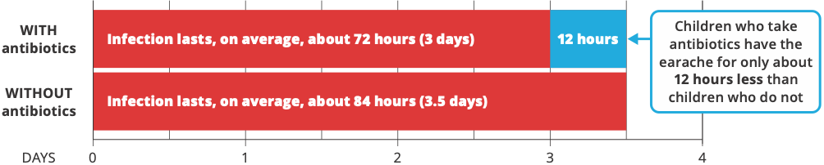

These figures show what is likely to happen to children with middle ear infection who do not take antibiotics and those who do. Each circle is one child. We cannot predict who will get better sooner or who will have problems.

Possible benefits

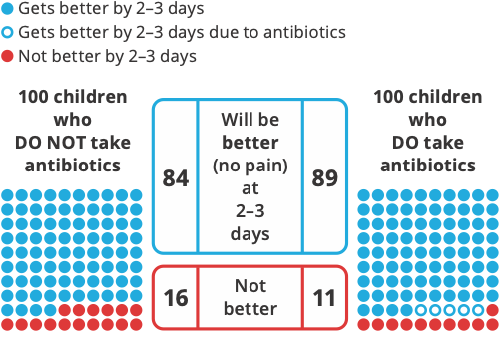
With antibiotics, 5 more children will be better after 2–3 days.
Without taking antibiotics, most children will be better after about four days anyway.

Possible harms
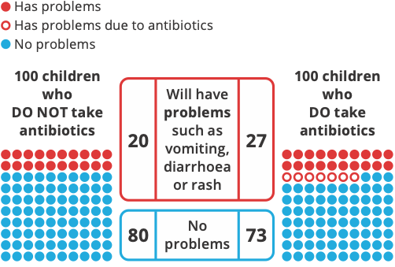
With antibiotics, 7 more children will have problems such as vomiting, diarrhoea or rash. Other antibiotic downsides are:
- The cost of buying them
- Remembering to take them
- The risk of antibiotic resistance (see below).

Where do these estimates of benefits and harms come from?
- They are from the most up-to-date medical evidence of benefits and harms about what works best.1 This is a review of 13 studies, and over 3,400 children, that looked at antibiotic use in children with middle ear infection.
- The quality of this research evidence is ranked as high. This means that further research is very unlikely to change these estimates.

Why might antibiotics be used?
Your doctor may suggest antibiotics if you are more likely to get complications, such as for Aboriginal and Torres Strait Islander children and children who are under two years of age.

What is antibiotic resistance?
- Using antibiotics means the bacteria, including the healthy ones in your body, can develop resistance to the antibiotic.
- This means that antibiotics may not work if your child needs them in the future to treat a bacterial infection.
- A person who has recently used antibiotics is more likely to have resistant bacteria in their body.

Are there other things I can do to manage a middle ear infection?
- Pain and fever are best treated with over-the-counter paracetamol or ibuprofen. Do not give more than the maximum recommended dose. Read the dose information on the packet.
- Aspirin should NOT be used with children who are younger than 16 years.

When should you see a doctor and get further help?
If your child with a middle ear infection has any of these signs:
- Very drowsy
- Fast or difficult breathing, wheezing, or shortness of breath
- Cold or discoloured hands and/or feet with a warm body
- A high fever (over 38.5 °C)
- Pain in the arms and/or legs
- Unusual skin colour (pale or blue) around the lips
- A rash that does not fade when the skin is pressed
- Pain and tenderness of the bone behind the ear
- Blood or discharge from the ear.

Questions to consider when talking with your doctor
- Does my child need antibiotics?
- What happens if my child does not take antibiotics?
- Do I know enough about the benefits and harms of:
  - taking antibiotics?
  - not taking antibiotics?
- Am I clear about which benefits and harms matter most to me?
- Do I have enough information and support to decide?

References
- Venekamp RP, Sanders S, Glasziou PP, Del Mar CB, Rovers MM. Antibiotics for acute otitis media in children. Cochrane Database Syst Rev 2015;1:CD000219. www.cochranelibrary.com
The information in this decision aid is provided for general information only. It is not intended as medical advice and should not be relied upon as a substitute for consultations with a qualified health professional who can determine you or your child’s individual medical needs.
Last reviewed: June 2023. Update due: July 2025. Decision Aids funded by the Australian Commission on Safety and Quality in Health Care and developed by Professor Tammy Hoffmann, Professor Chris Del Mar, and Mr Peter Coxeter – Institute for Evidence-Based Healthcare, Bond University.
safetyandquality.gov.au
© Australian Commission on
Safety and Quality in Health Care 2023

