DECISION AID
for consumers

Sore throat:
Should I take antibiotics?

What is this decision aid for?
- This decision aid can help you decide whether to use antibiotics when you or your child has a sore throat.
- It is designed to be used with your doctor to help you make a shared decision about what is best for you or your child.

What causes a sore throat?
It can be caused by a viral or bacterial infection. It is hard for your doctor to tell which it is.

How long does a sore throat last?
Symptoms will usually get better in 2–7 days, without taking antibiotics.

What are the treatment options?
There are two options that you can discuss with your doctor:
- Not taking antibiotics. This means letting the infection get better by itself.
- Taking antibiotics.
Symptoms, such as fever, can be treated with over-the-counter medicines which can be used with either option. See below for some examples.

What are the likely benefits and harms of each option?
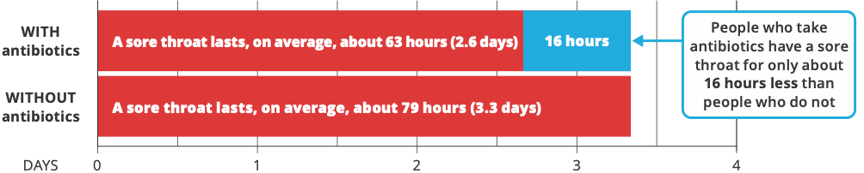

These figures show what is likely to happen to people with sore throats who do not take antibiotics and those who do. Each circle is one person. We cannot predict who will get better sooner or who will have problems.

Possible benefits
With antibiotics, 20 more people will be better by 3 days.
Without taking antibiotics, most people will be better after about 4–7 days anyway.

Possible harms
With antibiotics, 7 more people will have problems such as vomiting, diarrhoea or rash. Other antibiotic downsides are:
- The cost of buying them
- Remembering to take them
- The risk of antibiotic resistance (see below).

Where do these estimates of benefits and harms come from?
- They are from the most up-to-date medical evidence of benefits and harms about what works best.1-3 This is a review of 29 studies, and over 15,000 people, that looked at antibiotic use in people with sore throat.
- The quality of this research evidence is ranked as moderate. This means that further research may change these estimates.

Why might antibiotics be used?
There are a few special reasons why your doctor might suggest antibiotics. This might be if the sore throat is caused by a dangerous, but rare, type of bacterium, or in people who are at a high risk of complications, such as Aboriginal and Torres Strait Islander peoples.

What is antibiotic resistance?
- Using antibiotics means the bacteria, including the healthy ones in your body, can develop resistance to the antibiotic.
- This means that antibiotics may not work if you or your child needs them in the future to treat a bacterial infection.
- A person who has recently used antibiotics is more likely to have resistant bacteria in their body.

Are there other things I can do to manage a sore throat?
- Pain and fever are best treated with over-the-counter paracetamol or ibuprofen. Do not give more than the maximum recommended dose. Read the dose information on the packet.
- Aspirin should NOT be used with children who are younger than 16 years.
- Gargle with warm salty water.
- Suck an ice cube or throat lozenge.

When should you see a doctor and get further help?
If the person with the sore throat has any of these signs:
- Very drowsy
- Fast, noisy, or difficult breathing, or shortness of breath
- Cold or discoloured hands and/or feet with a warm body
- Pain in the arms and/or legs
- Unusual skin colour (pale or blue) around the lips
- A rash that does not fade when the skin is pressed.

Questions to consider when talking with your doctor
- Do I need antibiotics?
- What happens if I do not take antibiotics?
- Do I know enough about the benefits and harms of:
  - taking antibiotics?
  - not taking antibiotics?
- Am I clear about which benefits and harms matter most to me?
- Do I have enough information and support to decide?

References
- Spinks A, Glasziou P, & Del Mar C. Antibiotics for treatment of sore throat in children and adults. Cochrane Database of Systematic Reviews 2021. 12: CD000023. DOI: 10.1002/14651858.CD000023.pub5. www.cochranelibrary.com
- Spinks A, Glasziou P, & Del Mar C. Antibiotics for sore throat. Cochrane Database of Systematic Reviews, 2013. 11: CD000023.
- Gillies M, Ranakusuma A, Hoffmann T, Thorning S, McGuire T, Glasziou P, & Del Mar C. Common harms from amoxicillin: a systematic review and meta-analysis of randomized placebo-controlled trials for any indication. Canadian Medical Association Journal, 2015, 187; doi:10.1503/cmaj.140848.
The information in this decision aid is provided for general information only. It is not intended as medical advice and should not be relied upon as a substitute for consultations with a qualified health professional who can determine you or your child’s individual medical needs.
Last reviewed: June 2023. Update due: July 2025. Decision Aids funded by the Australian Commission on Safety and Quality in Health Care and developed by Professor Tammy Hoffmann, Professor Chris Del Mar, and Mr Peter Coxeter – Institute for Evidence-Based Healthcare, Bond University.
safetyandquality.gov.au
© Australian Commission on
Safety and Quality in Health Care 2023

