

National Standard for User-Applied Labelling of Injectable Medicines, Fluids and Lines

  - Issues register
  - May 2018

Contents
Introduction 3
Issues summary 4
Details of registered issues 6
IR 1a: Size of the catheter lock label – dialysis catheters 6
IR 1b: Central venous catheter lock label 7
IR 2: User-applied container labelling in EMM systems 9
IR 3: Variation of colour-coding in interventional cardiology 12
IR 4: International harmonisation of medicine names 15
IR 5: User-applied labelling oral and enteral liquid medicines 17

Introduction
The National Standard for User-applied Labelling of Injectable Medicines, Fluids and Lines (the Labelling Standard)¹ sets out the minimum requirements for labelling medicines and fluids that have been removed from their original packaging.
Implementing relevant action items in the National Safety and Quality Health Service (NSQHS) Standards² will assist clinicians to safely prescribe, dispense and administer injectable medicines. The Labelling Standard is part of the NSQHS Medication Safety Standard, and health service organisations seeking accreditation under the Australian Health Service Safety and Quality Accreditation Scheme are required to:
Provide evidence of Labelling Standard implementation
Regularly assess injectable medicines management procedures in all clinical areas
Identify risks and take action to reduce these risks.
The Australian Commission on Safety and Quality in Health Care (the Commission) is responsible for maintaining the Labelling Standard, and for identifying and reducing national barriers to implementation.
This Labelling Standard issues register records implementation issues that cannot be resolved by reference to the Labelling Standard or related support materials. Issues referred to the Commission are referred to the Commission’s Health Services Medication Expert Advisory Group for consideration. The recorded outcomes potentially change the way that organisations implement and use the Labelling Standard, so it is important that the issues and outcomes are publicly available. The Labelling Standard issues register is available on the Commission’s website, at: www.safetyandquality.gov.au/our-work/medication-safety/safer-naming-labelling-and-packaging-of-medicines/national-standard-for-user-applied-labelling-of-injectable-medicines-fluids-and-lines/labelling-standard-issues-register/.
Implementation of the Labelling Standard has been evolving since the introduction of the Labelling Recommendations in 2010.³ For the most part; issues encountered at the outset have been addressed. However, the Commission invites facilities with further implementation issues that cannot be answered by the Labelling Standard and implementation resources (including the frequently asked questions)⁴ to contact their state or territory representative in the first instance and, for organisations with no state or territory representative, to contact the Commission at accreditionACSQHC@safetyandquality.gov.au.

Issues summary
Table 1: Issues register summary
No. | Issue | Suggested change | Proponent | Date | Response | Reason | Action
1a | Size of the catheter lock line label | Reduce label size | Queensland | April 2016 | Evaluate smaller label | Allow clear view of catheter insertion site and avoid dressing compromise | Use either label size while awaiting results of evaluation
1b | CVC lock label | Remove arterial and venous lumen volumes  Preprint medicine name | Prince of Wales Hospital, Randwick, NSW | April 2018 | Evaluate preprinted CVC lock labels | Multiway CVC medicine locks are identified without compromising catheter insertion | Use either catheter lock label while awaiting results of evaluation
2 | User-applied container labels in EMM systems | Print medicines information for container labels | Victoria | April 2016 | Apply EMM-generated labels to a route container label | Increase readability of information, reduce transcription errors and introduce scanning capability | Populate route container labels either by hand or by EMM-generated labels
3 | Variation of colour-coding in interventional cardiology | Use existing non-standard labels | Queensland | May 2016 | Labelling Standard labels to be used in closed-practice environments, including interventional cardiology | To provide quality and safe use of injectable medicines through consistent and standardised processes | Ongoing use and evaluation of labels in interventional cardiology
4 | International harmonisation of medicine names | Preprinted medicine labels to carry dual labelling | Commission | June 2016 | Incorporate international name changes to user-applied labelling | To be consistent with manufacturers labelling and packaging | Preprinted medicine line labels and container labels for closed-practice environments to carry new medicine names or dual labelling according to TGA listing, at: www.tga.gov.au/updating-medicine-ingredient-names-list-affected-ingredients
5 | User-applied labelling oral liquid medicines | Create abbreviated oral syringe label | WCHN | April 2018 | Make available a label ‘For Oral Use Only’ | To ensure oral medicines removed from their original packaging can be identified where paediatric and neonatal services prepare oral syringes that may leave the hand. | Use the label ‘For Oral Use Only’, noting the label is under evaluation
CVC = central venous catheter; EMM = electronic medication management; HSMEAG = Health Service Medication Expert Advisory Group; TGA = Therapeutic Goods Administration; WCHN = Women’s and Children’s Hospital Network

Details of registered issues

IR 1a: Size of the catheter lock label – dialysis catheters
The Labelling Standard¹ sets out minimum requirements for line labelling, including the catheter lock, and provides a label template (Figure 1.1).
Figure 1.1: Labelling Standard line label for medicine used to ‘lock’ a catheter
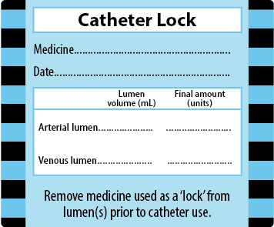

From the Labelling Standard
Central venous access devices may be ‘locked’ with a medicine – that is, a medicine is placed in situ in the portal. Dialysis catheters are one type of central venous access device and may be used for haemodialysis when a fistula for external haemodialysis is unsuitable. The dialysis catheter is generally locked with an anticoagulant such as heparin to maintain patency. In some cases, other medicines such as antibiotics may be present. In general, it is usual to remove the medicine used as a ‘lock’ in the catheter before using the catheter, especially in the case of heparin and other anticoagulants.
Catheters with a medicine in situ should be identified for route and medicine using a blue (PMS 2985) catheter lock line label (Figure 1.1). The suggested label size is 60 mm × 50 mm.
The label should be sited to partially cover the dialysis catheter dressing. In this way, the breathable dressing remains viable, and the label is situated close to the catheter to alert users to the medicine in situ. However, the label should not cover the catheter insertion site. The label should be removed after removing the medicine from the lock. The adhesive used on the label should be strong enough to adhere, but not so strong that it cannot be removed as required.

Issue
Continued implementation of the catheter lock label in Queensland suggested the size of the label is too large, and it covers and obscures the exit site of the catheter. Also, the label is being placed over the dressing ‘window’ to prevent the label adhering to skin. Regardless of the adhesive strength, this can loosen the dressing, especially with repeated label removal. This leads to concerns over the efficacy of the dressing itself.

Proposed response and action
Local hospital policy and best practice require the catheter exit site to be clearly viewed. Therefore, the two hospitals raising this issue proposed:
A smaller label with the same prompts
A larger dressing to allow sight of the exit site
Set procedures for viewing the exit site and dressing.
The smaller label (Figure 1.2) is the same size as the line label (that is, 70 mm × 25 mm), stock is synthetic, with mixed reviews on the adhesive to date.
Figure 1.2: Proposed alternative smaller catheter lock label
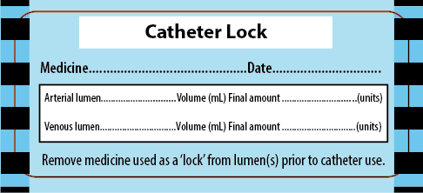
Evaluations of the proposed, smaller catheter lock label are ongoing in Queensland, and further advice from these evaluations will be available on the Labelling Standard issues register.
Response: Evaluate smaller label
Reason: Allow clear view of catheter insertion site and avoid dressing compromise
Action: Use either label size while awaiting results of evaluation

IR 1b: Central venous catheter lock label

Issues
The catheter lock label includes the volume and amount of medicine contained in the venous and arterial lumens (Figure 1.2). However, central venous catheters (CVC) do not have venous and arterial lumens, so these prompts are not required.
Application of a large catheter lock label across dressings raises similar issues to those seen with dialysis catheters. In addition, a large label may be adhered to skin, with potential to fall off and/or introduce infection around the insertion site.
CVCs are often multilumen with two or more lumens. Each lumen may contain an anticoagulant such as heparin to ‘lock’ the catheter. Therefore, each lumen requires a label identifying a medicine ‘lock’ in place.

Proposed response and action
An abbreviated, smaller label could be used to identify the medicine held in the lumen of a CVC. This would be suitable for application to each lumen of a multilumen CVC. Where heparin is exclusively used, a small label printed ‘heparin locked’ colour-coded teal green (PMS 3255) with a solid black border is proposed. This is consistent with colour-coding of the Labelling Standard (see Figure 1.3). Similarly, preprinted labels for other anticoagulants, such as urokinase, could be used (see Figure 1.4).
Labels should be placed adjacent to the portal, but not interfere or introduce infection risk.
The labels should be removed after removing the medicine from the lock. The preprinted label should be a ‘peel-off’ label. That is, the label adhesive should be strong enough to adhere but not so strong it cannot be removed as required.
Wording should be duplicated so it can be read from both sides when the label is wrapped around the lumen.
Figure 1.3: Proposed central venous catheter lock label for heparin
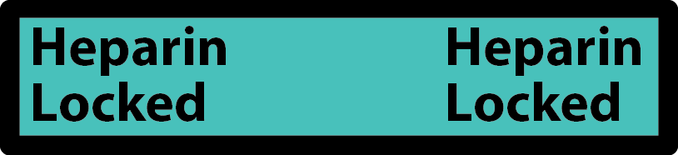
Figure 1.4: Proposed central venous catheter lock label for urokinase

Other anticoagulant agents may be used, such as urokinase. Antibiotics alone, or in combination with heparin, may be used as a lock. Specific labels printed with the medicine name and the wording ‘locked’ would be required for these circumstances.
Response: Evaluate abbreviated CVC lock label
Reason: Multilumen CVC medicine locks are identified with smaller labels to avoid compromising catheter insertion
Action: Use either catheter lock label while awaiting results of evaluation

IR 2: User-applied container labelling in EMM systems
The Labelling Standard¹ sets out the minimum requirements for information on a container label (Figure 2.1).
Figure 2.1: Labelling Standard container label example
Electronic medication management (EMM) systems provide further benefits in cross-checking and preventing medication errors. As these systems are introduced, health service organisations may be able to generate electronic labels. Below is a suggested method of pre-populating information from the electronic record to generate user-applied labels that meet the minimum requirements of the Labelling Standard.

Label preparation
The label is prepared as follows:
1. A pre-populated label is generated by the electronic prescription order (Figure 2.2) and includes:
- Route of administration
- Patient names (given and family names)
- Patient identifier (ID) (for example, a medical record number)
- Patient date of birth (DOB)
- Active ingredient (medicine/s) added to bag or syringe
- Amount of medicine/s added (including units)
- Total volume of fluid (mL) in bag or syringe
- Concentration (units/mL)
- Diluent (for syringes: optional for bags)
Figure 2.2: Example of pre-populated label for an intravenous infusion
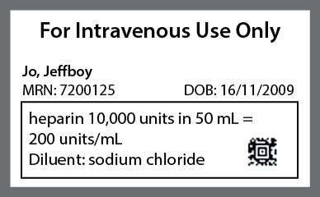
2. The label is printed and placed in the centre of the route container label (Figure 2.3), and the route populated with label printing is double checked against the route container label selected
Figure 2.3: Example of pre-populated section of label applied to the intravenous route container label
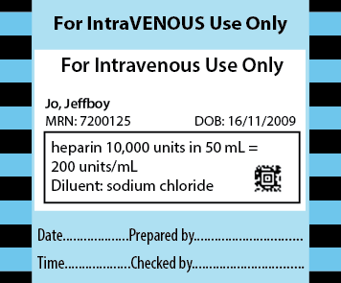
3. The medicine is drawn up from the original medicine container and cross-checked against the prescription order and the user-applied, pre-populated label, in the same way as if the label had been populated by hand
4. The label is applied to the syringe or bag
5. If scanning technology is available, the barcode(s) generated on the manufacturer’s original container and the user-applied label may be cross-checked against the electronic prescription order
6. The ‘Prepared by’ prompt on the route container label is hand signed and dated by the person preparing the medicine, and the electronic record is signed
7. The ‘Checked by’ prompt on the route container label is hand signed and dated by the person checking the preparation of the medicine, and the electronic record is signed
8. If scanning technology is available at the point of administration, the barcode generated on the electronic, user-applied label may be cross-checked against the patient’s identification band and the electronic prescription order.
Route labels with a white unpopulated centre area could be made available to fit label machines and the pre-populated information could be printed directly onto the route container label. However, this would require either several label machines that are loaded with labels for different routes, or changing of label rolls within a single machine.
Examples of other route container labels are shown in Figures 2.4 and 2.5.
Figure 2.4: Example of pre-populated section of label applied to the epidural route container label
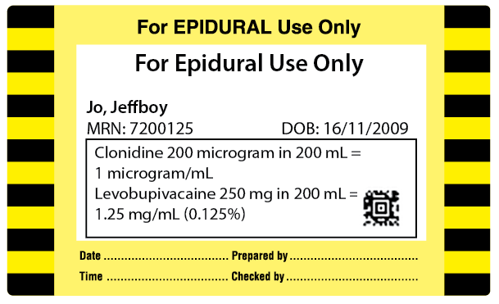
Figure 2.5: Example of pre-populated section of label applied to the enteral route container label
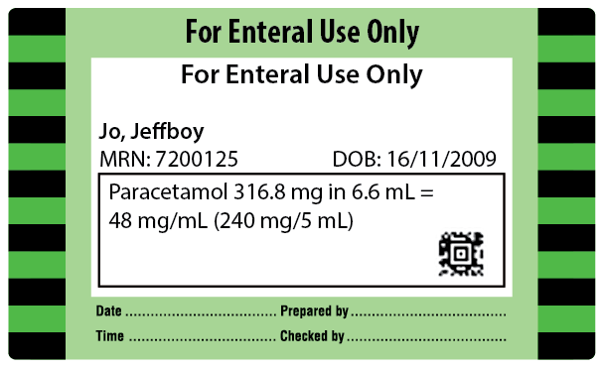
Response: Apply EMM-generated labels to a route container label.
Reason: Increase readability of information, reduce transcription errors and introduce scanning capability.
Action: Populate route container labels either by hand or by with EMM-generated labels.

IR 3: Variation of colour-coding in interventional cardiology
The Labelling Standard¹ sets out the minimum requirements for labelling containers in closed-practice environments, including interventional cardiology. An example is shown in Figure 3.1.
A cardiac catheter laboratory (CCL) has undertaken a local risk assessment and requested a deviation from the Labelling Standard. Before the introduction of the Labelling Standard, this CCL used colour-coding to identify syringes that were prepared and used in the CCL, but these colours were different to those specified in the Labelling Standard.
Two incidents occurred (Box 1) when the label manufacturer transitioned to the new labels with colour-coding, following the Labelling Standard for the sterile labels used within the CCL.
Box 1: Incidents occurring after a label manufacturer transitioned to new labels
Incident 1
Radial verapamil/glyceryl trinitrate combination was injected in error in place of glyceryl trinitrate only. The patient had chest pain, which was resolved quickly with fentanyl and T-wave inversion. No other adverse reactions were noted.
The labels were colour-coded violet with diagonal stripes for both glyceryl trinitrate and verapamil, and glyceryl trinitrate combination.
Response
Mixing medicines in the same syringe is beyond the scope of the Labelling Standard. Best practice is to administer medicines separately. Examples of labels for identifying medicines in the closed-practice environment are shown in the Labelling Standard (see Figure 3.1). The only labels that are provided with two medicines in combination are those with adrenaline and a local anaesthetic to be used where the two medicines are supplied in prefilled syringes.
Incident 2
Lignocaine 1% was drawn up from an open container and injected in the coronary artery instead of adenosine. The syringe and open container were labelled appropriately. Severe coronary artery spasm resolved with glyceryl trinitrate and the patient was admitted overnight on telemetry to ensure no adverse outcomes.
Response
The lignocaine and adenosine labels are different colours (lignocaine is grey and adenosine is green). The error appears to have occurred during process checking rather than labelling.
Figure 3.1: Examples of preprinted labels in cardiac catheter laboratories
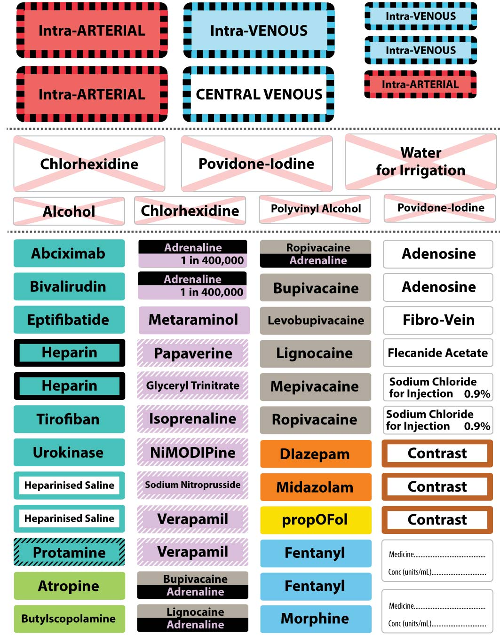

In summary
The main principle of the labelling convention is to provide quality and safe use of medicines through consistent and standardised processes, including applying standard colour labels for medicines from the same class.
Two evaluations of labels in interventional cardiology led to the inclusion of a standard set of labels for CCL and other closed-practice environments (see: www.safetyandquality.gov.au/our-work/medication-safety/safer-naming-labelling-and-packaging-of-medicines/national-standard-for-user-applied-labelling-of-injectable-medicines-fluids-and-lines/label-specifications-for-specialist-clinical-areas/
The introduction of standardised labels was a considerable change of practice for many interventional cardiology units, and errors more commonly occur when practice is changed. In both evaluations, education before introducing the labels and a period of increased vigilance around processes was necessary as the workforce became familiar with the new label sets.
However, after this period the labels were well accepted, and the benefits of using standard and consistent labels for the workforce members moving between areas and across facilities was an advantage.
The hospital that has raised the issues is further evaluating Labelling Standard–compliant labels. The Commission encourages other facilities to make regular assessments using the Labelling Standard audit tools on the Commission’s website:
Audit tool user guide (PDF 1MB) (Word 1MB)
Data collection form (Excel 126KB)
Data entry form (Excel 111KB).
Hospitals not implementing the Labelling Standard in interventional cardiology will need to show how:
The Labelling Standard risks patient safety in their organisation
The organisation will produce and maintain implementation, education and evaluation resources for the non-standard labelling substitute
The risk of not using the Labelling Standard will be mitigated, such as locum and agency workforce members moving from other organisations.
Response: Labelling Standard labels to be used in closed- practice environments, including interventional cardiology.
Reason: To provide quality and safe use of injectable medicines through consistent and standardised processes.
Action: Ongoing use and evaluation of labels in interventional cardiology.

IR 4: International harmonisation of medicine names
In different countries, different names are used to describe the same medicinal ingredient.
The Therapeutic Goods Administration (TGA) has issued guidance on the introduction of name changes in Australia, according to the program for international harmonisation of names (www.tga.gov.au/updating-medicine-ingredient-names). Similar harmonisation activities have previously occurred in the United Kingdom (2003) and New Zealand (2008).
The list of affected active ingredient names is available on the TGA website, at: www.tga.gov.au/updating-medicine-ingredient-names-list-affected-ingredients.
Some changes are minor (for example, changing a ‘y’ to an ‘i’) and will not affect how the ingredient name is pronounced. In some cases, the new names already appear on Australian medicine labels – for example, ‘amoxicillin (amoxycillin)’.
Some changes are more marked. For these products, medicine labels will need to use dual labelling to help consumers and clinicians become familiar with the new name. For example, medicines containing lignocaine will need to be dual labelled as ‘lidocaine (lignocaine)’. Adrenaline and noradrenaline will remain the approved active ingredient names and will include epinephrine or norepinephrine – for example, ‘adrenaline (epinephrine) hydrochloride’. Examples are shown in Table 2.
Table 2: Examples of dual-labelling requirements
Current label | Dual label
 | 
 | 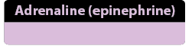
 | 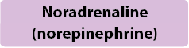

Pharmaceutical product manufacturers will be given four years (from April 2016 to April 2020) to introduce the new medicine names to their product labelling and packaging. For dual-labelled products, both names must be displayed for another three years after the transition period (until 2023), when the manufacturer may remove the old name. This gives a period of at least three years, and possibly more than seven years, when packaging will be available for dual-named products with both the old and new medicine name visible.
There will be a time lag between the start of the transition period and when new medicine labels start to appear on the market. During the transition period, these changes may be included in prescribing and dispensing software, clinical guidelines and other materials, including user-applied labelling.
Health service organisations should work with label manufacturers to ensure that preprinted labels for user-applied labelling according to the Labelling Standard are consistent with international naming.
The line label guide will be revised in line with international harmonisation of medicine names to cover changes to naming for adrenaline and lignocaine (www.safetyandquality.gov.au/wp-content/uploads/2015/10/Pre-printed-medicine-line-label-guide-Aug-2015.pdf) (PDF 2.1MB).
The following publications will be revised at the next edition:
Perioperative Labelling Poster (www.safetyandquality.gov.au/wp-content/uploads/2015/10/Perioperative-labelling-of-medicines-and-fluids-poster-December-2016.pdf)
Labelling Standard (www.safetyandquality.gov.au/publications/national-standard-for-user-applied-labelling/).
Response: Incorporate international name changes to user-applied labelling.
Reason: To be consistent with manufacturers labelling and packaging.
Action: Preprinted medicine line labels and container labels for closed-practice environments to carry new medicine names or dual labelling, according to TGA listing www.tga.gov.au/updating-medicine-ingredient-names-list-affected-ingredients.

IR 5: User-applied labelling oral and enteral liquid medicines

Issue
The Commission has been requested to provide further guidance on the user-applied labelling of syringes containing oral and enteral liquid medicines.
The Labelling Standard sets out the requirements for user-applied labelling of non-injectable fluids that can no longer be identified by their original packaging, including oral and enteral liquids (see Section 7.6 of the Labelling Standard, Non-injectable medicines and fluids).
A container label for enteral use is available (Figure 5.1). However, there is no label design artwork for oral syringe labels.
Figure 5.1: Container label for enteral use
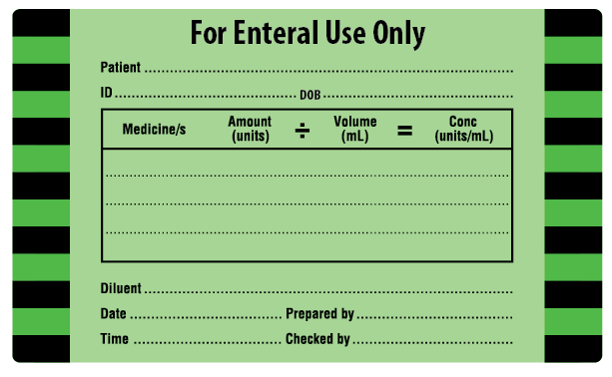
Best practice specifies oral liquids drawn up from the original container should be given immediately. Labelling is not required when the preparation and bolus administration of a SINGLE medicine are one uninterrupted process, the syringe DOES NOT leave the hands of the person who prepared it and that same person administers the medicine IMMEDIATELY.
There may be instances where the oral syringe is prepared but leaves the hand prior to use. Not labelling is a risk to patient safety. An abbreviated container label ‘For Oral Use Only’ may be used in these circumstances. Best practice principles still apply as follows:
Liquid medicines should not be stored in a syringe for later use
Medicines should be prepared and labelled before the preparation and labelling of a subsequent medicine
Multiple oral (liquid and crushed) medicines should not be drawn up in one syringe
An abbreviated container (syringe) label for oral medicines (Figure 5.2) is available to identify the oral medicine in a syringe when that medicine has been removed from its original packaging and the syringe may leave the hand. The label is based on a design by the Women’s & Children’s Hospital Network (WCHN), South Australia.
Figure 5.2: Abbreviated label for oral use
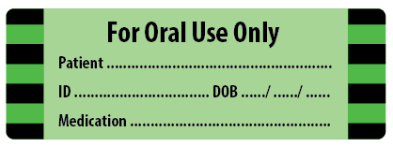
This label may aid identification and compliance in paediatric and neonatal health services where a number of oral medicines are prepared.
User-applied labelling of enteral medicines:
1. All non-injectable enteral liquid medicines are prepared in a clearly labelled enteral syringe, designed to administer medicines via the enteral route. Note: The international standard ISO 80369-3:2016 Small-bore Connectors for Liquids and Gases in Healthcare Applications specifies connectors for enteral applications². These connectors should be used to ensure syringes with enteral liquids are NOT compatible with parenteral entry portals.
2. A medicine for enteral administration via an enteral infusion device is labelled with the full container label (Figure 5.1). Prompts are completed for medicine, dose, volume route and time of preparation, including patient identification and the signatures of the two users
3. All administration lines for enteral medicines should be labelled and include route of administration (Figure 5.3).
Figure 5.3: Route label for enteral use

User-applied labelling of oral medicines:
1. All non-injectable oral liquid medicines are prepared in a clearly labelled syringe designed to administer medicines orally
2. The green oral/enteral abbreviated container label (Figure 5.2) is completed with the patient name and identifiers and the medicine in the syringe/container. Medicines prepared and administered in a single action, and that do not leave the hands of the person preparing/administering the medicine do not require labelling.
Colour coding
Colour remains a secondary identifier to the written word as the primary identifier. In Australia, some manufacturers have advised that purple colour will be used for enteral specific connectors and adaptors that comply with ISO80369-3:2016. For oral syringes, purple and orange colours are used depending on the manufacturer. The user-applied Labelling Standard uses green-coloured labels for enteral route containers and lines. The Health Services Medication Advisory Group notes that organisations are managing this variation at a local level and that no changes are required to the Labelling Standard. The standard specifies green (PMS 361) for enteral/oral route labels.
Response: Make available a label ‘For Oral Use Only’.
Reason: To ensure oral medicines removed from their original packaging can be identified where paediatric and neonatal services prepare oral syringes that may leave the hand.
Action: Use the label ‘For Oral Use Only’ noting the label is under evaluation.

References
1. Australian Commission on Safety and Quality in Health Care. National Standard for User-applied Labelling of Injectable Medicines, Fluids and Lines. Sydney: ACSQHC, 2015
2. International Organization for Standardization. Part 3: connectors for enteral applications. In ISO 80369-3:2016 Small-bore connectors for liquids and gases in healthcare applications. Geneva: ISO; 2016 [cited 2017 30 October]. Available at: www.iso.org/standard/50731.html
3. Cohen MR, editor. Medication errors, 2nd edition. Washington DC: American Pharmacists Association; 2007.
4. National Patient Safety Agency. Patient safety alert 19: promoting safer measurement and administration of liquid medicines via oral and other enteral routes. London, UK: National Patient Safety Agency; 2007 [cited 2017 30 October]. Available at: www.nrls.npsa.nhs.uk/resources/?EntryId45=59808

