

October 2017

User Guide to the National Subcutaneous Insulin Chart: Sub-acute Hospitals and Mental Health Facilities
For use in adult patients

Published by the Australian Commission on Safety and Quality in Health Care
Level 5, 255 Elizabeth Street, Sydney NSW 2000
Phone: (02) 9126 3600
Email: mail@safetyandquality.gov.au
Website: www.safetyandquality.gov.au
ISBN: 978-1-925224-97-9
© Australian Commission on Safety and Quality in Health Care 2017
All material and work produced by the Australian Commission on Safety and Quality in Health Care is protected by copyright. The Commission reserves the right to set out the terms and conditions for the use of such material.
As far as practicable, material for which the copyright is owned by a third party will be clearly labelled. The Commission has made all reasonable efforts to ensure that this material has been reproduced in this publication with the full consent of the copyright owners.
With the exception of any material protected by a trademark, any content provided by third parties, and where otherwise noted, all material presented in this publication is licensed under a Creative Commons Attribution-NonCommercial-NoDerivatives 4.0 International Licence.
Enquiries about the licence and any use of this publication are welcome and can be sent to communications@safetyandquality.gov.au.
The Commission’s preference is that you attribute this publication (and any material sourced from it) using the following citation:
Australian Commission on Safety and Quality in Health Care. User Guide to the National Subcutaneous Insulin Chart: Sub-acute facilities. Sydney: ACSQHC; 2017.

Disclaimer
The content of this document is published in good faith by the Australian Commission on Safety and Quality in Health Care for information purposes. The document is not intended to provide guidance on particular healthcare choices. You should contact your health care provider on particular healthcare choices.
This document includes the views or recommendations of its authors and third parties. Publication of this document by the Commission does not necessarily reflect the views of the Commission, or indicate a commitment to a particular course of action. The Commission does not accept any legal liability for any injury, loss or damage incurred by the use of, or reliance on, this document

Contents
Background and chart overview 4
The national subcutaneous insulin chart 5
General requirements and instructions 7
Preparing the chart for use 8
3.1 Patient Identification 8
3.2 Cross-referencing the national standard medication chart (NSMC) 9
3.3 Hospital details 10
3.4 Doctor to notify 10
3.5 Special instructions 10
3.6 Diabetes treatment prior to admission 11
Instructions for monitoring blood glucose levels 12
4.1 BGL frequency 12
4.2 Adjusting the chart to accommodate more than six BGLs for a single day 13
4.3 What to do if BGL readings fall out of alignment with routine insulin orders 14
4.4 Diet 15
Monitoring blood glucose levels and responding to alerts 16
5.1 Recording BGLs 16
5.2 Alerts 17
5.3 Modified BGL ranges 18
Ordering insulin 19
6.1 Routine insulin orders 19
6.2 Supplemental insulin orders 23
6.3 Stat/Phone insulin orders 26
6.3.1 Stat orders 26
6.3.2 Phone orders 26
6.3.3 What to do if there are too many phone orders to fit into the phone order section 28
6.4 Administration record 29
Administering insulin and documenting administration 30
7.1 Administration of a routine insulin dose 31
7.2 Administration of a supplemental insulin dose 32
7.3 Administration of a phone order 33
7.4 Examples 34
7.4.1 Routine insulin example 34
7.4.2 Supplemental insulin example 35
7.4.3 Phone order example 36
Comments section 37
Pharmacy review 37
Reviewing hyperglycaemia treatment 38
Treating hypoglycaemia and reviewing treatment 39
11.1 Treating hypoglycaemia 39

Background and chart overview
The purpose of this user guide is to explain how clinicians should use the National Subcutaneous Insulin Chart. Although some sections of this document may be more relevant for either prescribers or nurses, it is important to read the whole document sequentially to fully understand the chart – Insulin Subcutaneous Order and Blood Glucose Record – Adult. For further information on the design rationales behind the chart, as well as details of the development process and an initial evaluation, please refer to the following document, available from www.safetyandquality.gov.au:
Horswill MS, Hill A, Christofidis M, Francis S, Watson MO. Development and initial evaluation of a new subcutaneous insulin form: final report. Sydney: Australian Commission on Safety and Quality in Health Care; 2015.
Insulin is recognised internationally as a high-alert or high-risk medication in healthcare settings by the Institute for Safe Medication Practices (ISMP). Because of the risks associated with its use, several Australian hospitals contacted the Australian Commission on Safety and Quality in Health Care (the Commission) requesting a standardised national chart for the ordering and administration of insulin, and for the recording of blood glucose levels (BGLs). As a result, the current version of the chart was developed by the Commission in collaboration with human factors researchers from The University of Queensland.
The use of human factors design in the development of other charts has resulted in significant reductions in errors and improvements in clinical outcomes. In addition, standardising the communication of medical information between doctors, nurses and pharmacists can reduce harm to patients from medication errors.
For inpatients with diabetes, the National Subcutaneous Insulin Chart links together all the key information required to manage the treatment of their condition. This should enable clinical staff to care for these patients more effectively. For patients who are not currently being treated with insulin, the chart is used primarily for BGL monitoring.
The chart has been designed to reflect best practice and to promote consistent documentation, to assist with accurate interpretation of BGLs and subcutaneous insulin orders.
On the next page is a filled-in example of the chart. The Monitoring Record section is used for the recording and monitoring of BGLs, and provides prompts advising when a BGL should be acted upon if it is too low (for hypoglycaemia) or if it is elevated (for hyperglycaemia). Other specific areas of the chart are devoted to prescribing subcutaneous insulin (Routine Insulin Orders, Supplemental Insulin Orders and Stat/Phone Orders) and administering it (Administration Record). The remaining areas are used for additional communication among clinicians.
Later sections of this user guide explain the mechanics of how to use each area of the chart, and will include some rationales for the safety prompts and actions to be taken. Please note that this document is not intended to provide diabetes management advice.
Note: This chart is NOT intended to be used for children.

The national subcutaneous insulin chart
The subcutaneous insulin chart for sub-acute hospitals and mental health facilities is a two-sided chart. The two different surfaces of the chart are shown in Figure 1 and Figure 2.
Figure 1: Inner pages of the national subcutaneous insulin chart (pages 2 and 3 respectively)
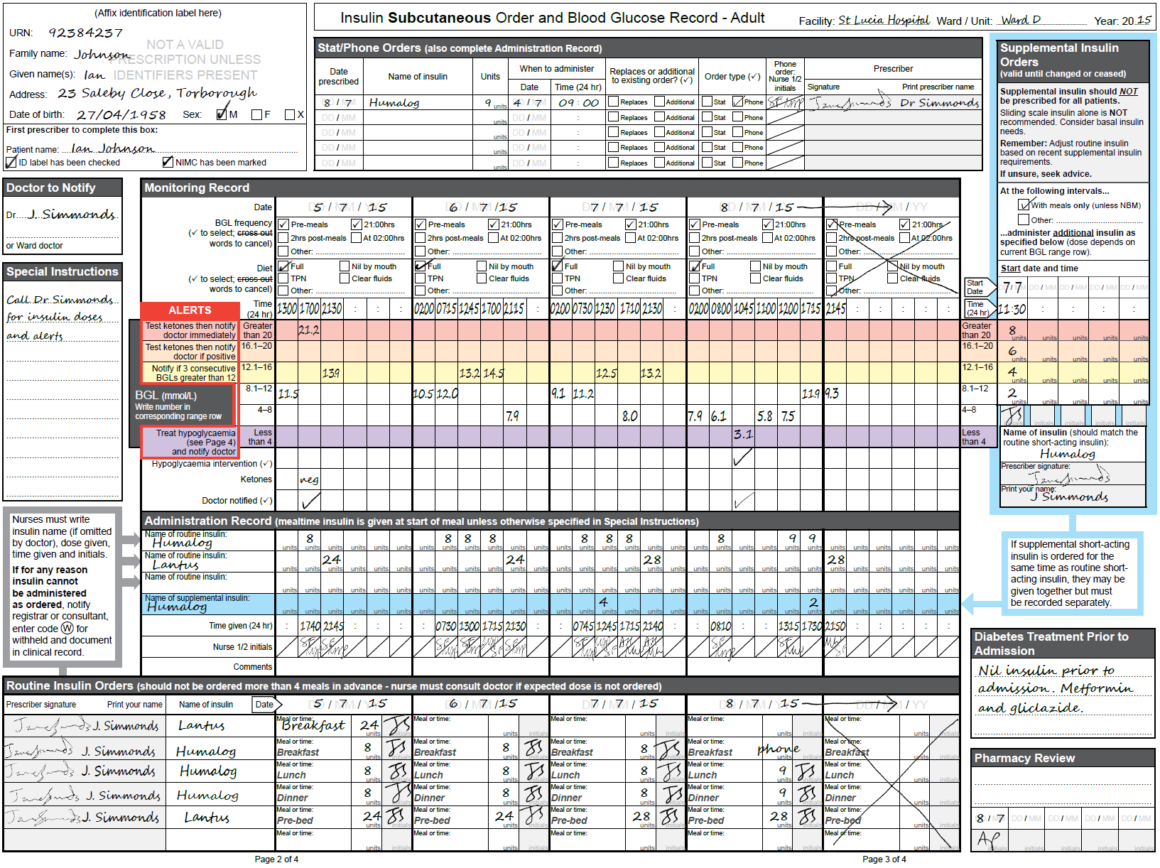
Figure 2: Outer pages of the national subcutaneous insulin chart (pages 1 and 4 respectively)

General requirements and instructions
The following are general requirements and instructions regarding the use of the National Subcutaneous Insulin Chart:
- All authorised prescribers must order medicines for inpatients in accordance with legislative requirements, according to the relevant state or territory drugs and poisons legislation
- Orders should be reviewed daily and when notifications of out-of-range BGLs occur, to ensure appropriate diabetes management and dosing of insulin
- The chart is to be used for all inpatients requiring subcutaneous insulin and/or BGL monitoring unless ward or unit procedures state otherwise
- A different insulin chart is required for the prescribing, administration and monitoring of intravenous insulin; the subcutaneous insulin chart should never be used for infusions or pumps
- All entries must be written legibly in ink; no matter how accurate or complete an order, it may be misinterpreted if it cannot be read clearly
- Water-soluble ink, such as a fountain pen, should not be used
- Black ink is preferred
- A medication order is valid only if the authorised prescriber enters all the required items
- All information should be printed
- Erasers or ‘whiteout’ should not be used
- The chart allows orders to be updated daily for five days, after which time the orders must be rewritten on a new chart
- The patient’s current hospital and ward location should be clearly marked on the chart (see section 3.3).

Preparing the chart for use
This section describes the steps required to prepare a national subcutaneous insulin chart for use.

3.1 Patient Identification
Before using the chart, prescribers must ensure that the patient identification (ID) details are correct. Patient identification on the National Subcutaneous Insulin Chart is consistent with the identification required when using the national standard medication chart (NSMC) which includes the national inpatient medication chart and the PBS hospital medication chart.
A watermark has been included in the patient identification sections on pages 1 and 2 as a reminder that a prescription is not valid unless the patient’s identifiers are present.
Patient identifiers may be added to the chart by one of two methods:
- Attach the current patient ID label in the spaces provided on pages 1 and 2, or
- At a minimum, write the following patient details in legible print
  - UR number
  - Name (family and given)
  - Address
  - Date of birth
  - Tick the relevant checkbox for the patient’s sex (M = male; F = female; X = indeterminate).
Once satisfied that all the ID details relate to the correct patient, the first prescriber to use the chart should attend to the area marked ‘First prescriber to complete this box’. Here, the first prescriber should print the patient’s name and tick the checkbox marked ‘ID label has been checked’. This will reduce the risk of the wrong patient receiving any insulin ordered on the chart. Figure 3 shows an example of a correctly completed patient ID section.
Figure 3: Patient identification section completed correctly
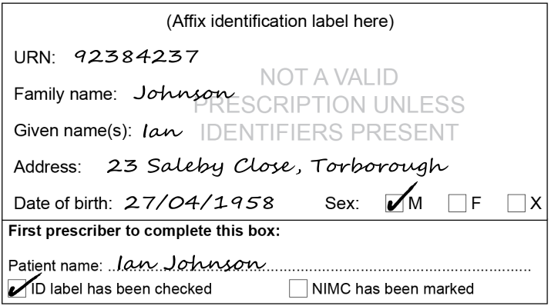


Insulin should not be administered if the prescriber has not completed and checked the patient identification details. If anything is missing, or if the label does not appear to have been checked, the nurse should:
- Contact the prescriber urgently to avoid insulin being withheld unnecessarily
- Contact the doctor on call if the original prescriber is not available.

3.2 Cross-referencing the national standard medication chart (NSMC)
Before using the chart, it is important for the first prescriber to cross-reference it on the NSMC. This is done by ticking the ‘BGL/Insulin’ box on page 1 of the NSMC. Figure 4 shows an example of how to cross-reference the insulin chart on the NSMC.
Figure 4: Additional medication charts section of the National Standard Medication Charts
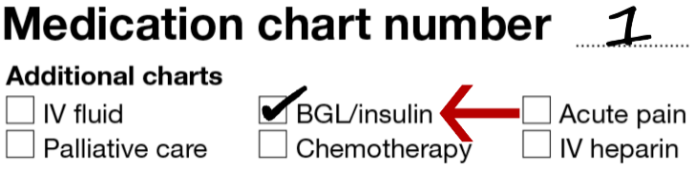
This action should also be recorded on the subcutaneous insulin chart, by ticking the checkbox labelled ‘NIMC (or NSMC) has been marked’. Figure 5 shows that the NSMC has been cross-referenced on the subcutaneous insulin chart.
Figure 5: Patient identification section marked to indicate that the NIMC has been cross-referenced
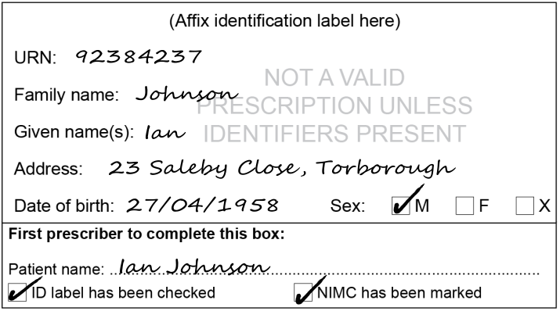


If insulin is to be ordered for the patient, the prescriber should also cross-reference the insulin order in the regular medications section of the NSMC. (Alternatively, a pharmacist or registered nurse may do the cross-referencing.) This will help to ensure insulin is not omitted during the patient’s hospital admission or from their discharge medications. This cross-referencing should be done by one of two methods:
- Attach a pre-printed sticker stating that ‘Insulin is ordered for this patient – see Insulin/BGL form’ as shown in Figure 6
Figure 6: National subcutaneous insulin chart cross-referenced on the NSMC
- Hand-write this information, as shown in Figure 7
Figure 7: Alternative method to cross reference the subcutaneous insulin chart on the NIMC
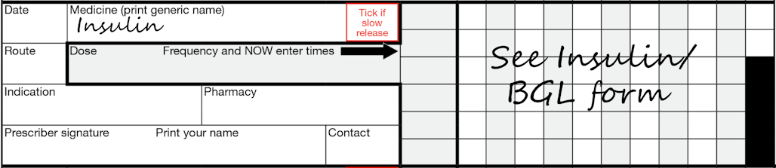

3.3 Hospital details
Prescribers should record the facility name, ward or unit, and year in this section (at the top right-hand side of page 3). Figure 8 shows how this information can be handwritten on the subcutaneous insulin chart. It is permissible to have some of this information pre-printed on the chart.
Figure 8: Hospital details section

3.4 Doctor to notify
The prescriber should document who is to be notified if any alerts are triggered on the chart, or if any other concerns arise regarding the patient’s diabetes management. If the ‘Doctor to Notify’ box (on the left side of page 2) is left blank, the resident medical officer for the treating team must usually be notified. The doctor on call should be notified after hours. An example of this section can be seen in Figure 9.
Figure 9: Doctor to notify in case of emergency or clinical change
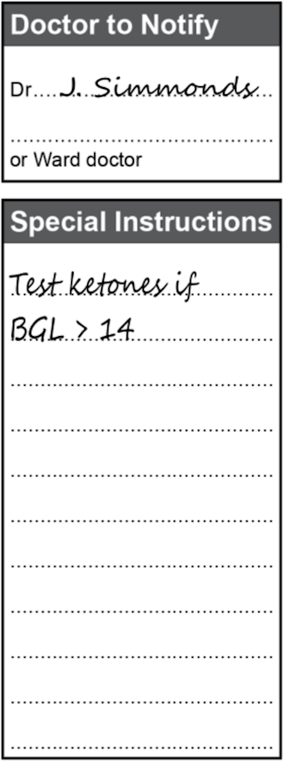

3.5 Special instructions
Clinicians may document any additional information related to the patient’s diabetes management in the ‘Special Instructions’ box (on the left side of page 2) as shown in Figure 10.
Figure 10: Special instructions panel

3.6 Diabetes treatment prior to admission
Clinicians should document the patient’s previous treatment in the ‘Diabetes Treatment Prior to Admission section of the chart’ (in the bottom right-hand corner of page 3).
This may include oral hypoglycaemic agents and/or insulin names and doses. Optional additional information may include the insulin device that the patient uses – for example, the type of insulin pen.
Subsequent prescribers should refer to this information when reviewing the patient’s response to treatment. A completed example is shown in Figure 11.
Figure 11: Diabetes treatment prior to admission section
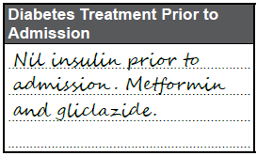

Instructions for monitoring blood glucose levels
This section describes how blood glucose levels should be ordered, recorded and monitored by clinicians.

4.1 BGL frequency
Before the BGL frequency can be specified for a particular day, the date should be documented at the top of the relevant ‘Date’ column in the ‘Monitoring Record’ section of the chart. This should be done by the first clinician to write in the ‘Monitoring Record’ column for that day, whether they are a prescriber or a nurse.
Beneath the date, the prescriber can specify the BGL frequency required for that day. Otherwise, the default option is for BGL to be recorded before each meal and at 21:00 hours, as indicated by the checkboxes that are pre-ticked on the chart. Prescribers can select other options by ticking the relevant checkbox. Note that more than one checkbox can be ticked, and unwanted options that have been ticked can be cancelled by crossing them out. Figure 12 shows an example of how to complete this section.
Figure 12: Blood glucose monitoring frequency section
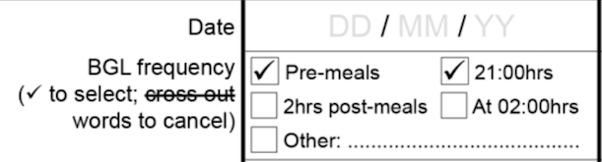
When making these choices, it is important for prescribers to consider whether the patient might require more frequent BGL monitoring than the default options. For example, an additional reading at 02:00 hours could be considered if there is a risk of nocturnal hypoglycaemia or the patient is fasting, or an additional reading two hours after meals might be useful if the patient is pregnant.

4.2 Adjusting the chart to accommodate more than six BGLs for a single day
The chart has space for up to six BGLs to be recorded each day for up to five days. If more than six BGLs are required for a single day, the prescriber should also make the following changes to the chart to facilitate this:
- When 7 to 12 BGLs are required, the prescriber should draw a large ‘X’ through the following day’s ‘BGL frequency’ and ‘Diet’ areas, and draw an arrow extending from the current date into the middle of the next day’s date label area as shown in Figure 13. The same procedure should also be used to modify the Routine Insulin Orders section
Figure 13: Diagram showing how to order 7-12 blood glucose levels per day
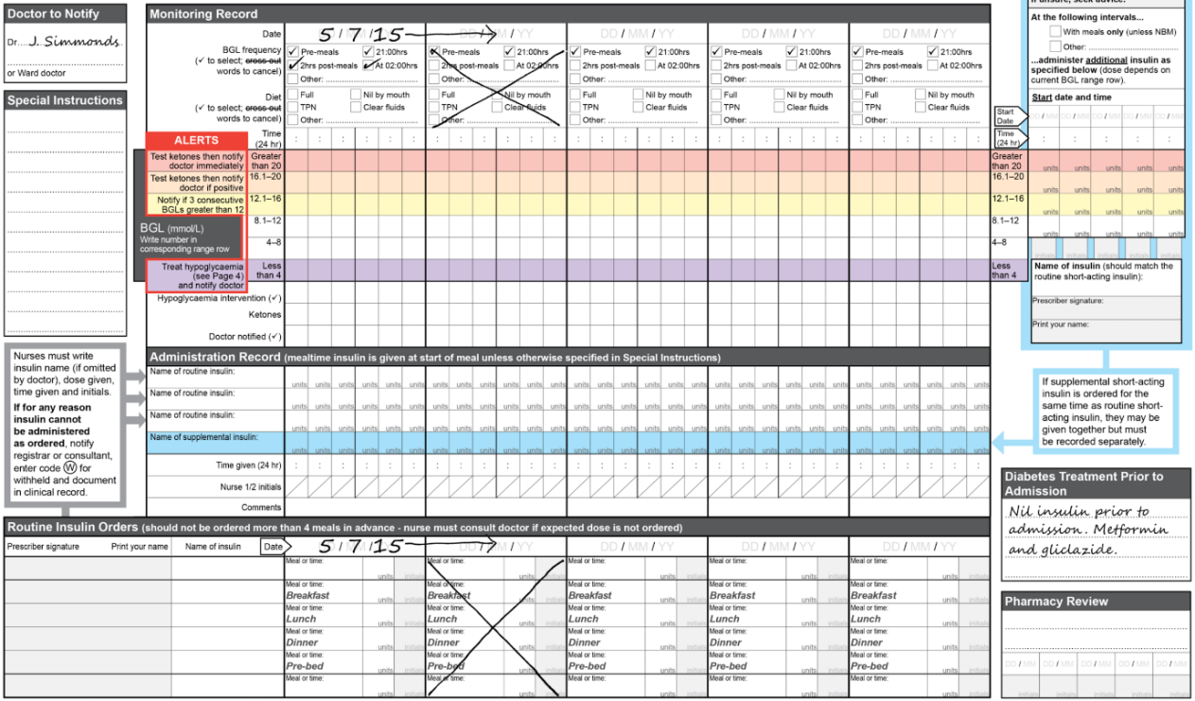
- If 13 to 18 BGLs are ordered, these ‘X’s’ should be placed in the next two date columns and the arrows extended further as seen in Figure 14.
Figure 14: Diagram showing how to order 13 to 18 blood glucose levels per day
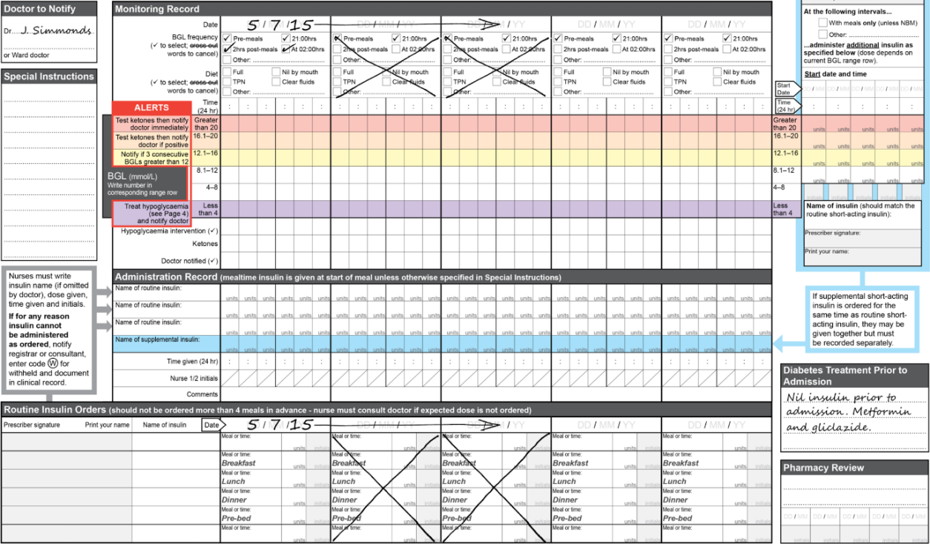
If these changes are not made by the prescriber, or if the patient’s monitoring requirements change at a later time, nurses may also make these alterations to the chart.

4.3 What to do if BGL readings fall out of alignment with routine insulin orders
In some hospitals, patients have their weekend insulin orders written up in advance. In these facilities, there is a risk that the BGLs recorded on the chart will fall out of alignment with the routine insulin orders below. This could happen if there is an unplanned increase in the frequency of BGL monitoring – for example, because of a hypoglycaemic event.
In such cases, nurses should still document all the BGL readings on the subcutaneous insulin chart, even if they spill over into columns provided for the following day(s), where routine orders have already been prescribed. When this happens, the nurse should cross out all the routine insulin doses that have not yet been administered, and contact the prescriber to review the orders. Figure 15 shows a detailed example of this scenario.
If the prescriber cannot attend the patient, a phone order should be taken and recorded in the ‘Stat/Phone Orders’ section and cross-referenced in the ‘Routine Insulin Orders’ section.
Figure 15: Diagram showing how to record additional telephone orders and how to record more blood glucose levels than ordered
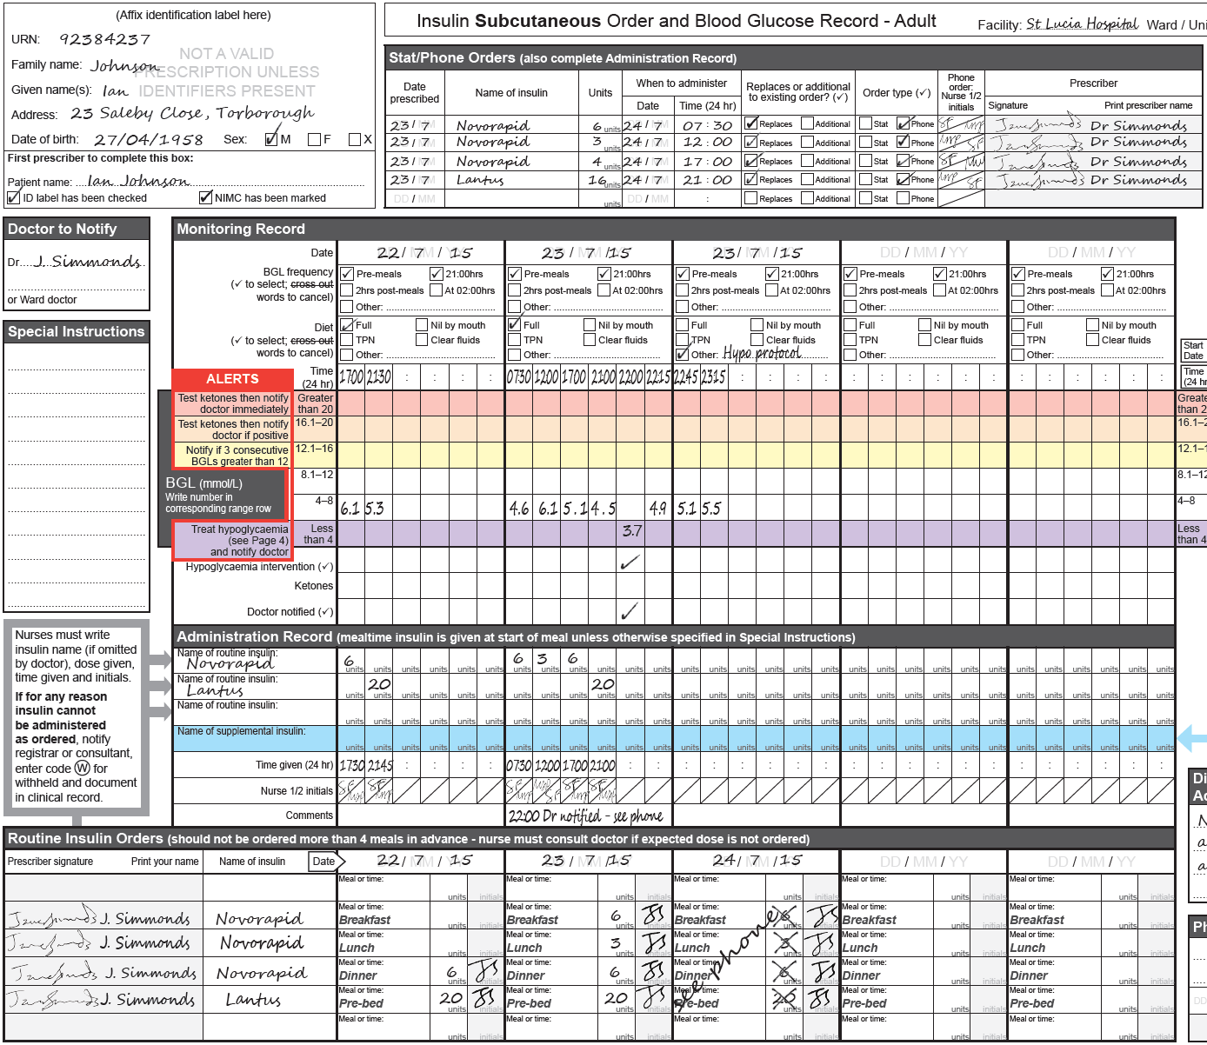

4.4 Diet
Underneath the ‘BGL frequency’ row is a separate ‘Diet’ row for documenting the diet that the patient is to receive for the day. This includes checkboxes for full diet, nil by mouth, total parenteral nutrition (TPN) and clear fluids. Either the prescriber or a nurse can record these details. It should be completed as shown in Figure 16.
As well as acting as a record, this information provides a prompt for reassessment of insulin needs should the patient be fasting for a procedure or have altered dietary requirements.
Figure 16: Daily diet section
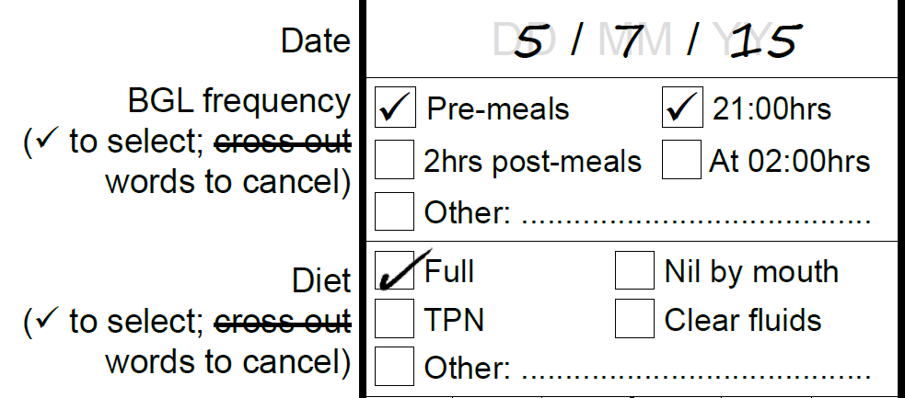

Monitoring blood glucose levels and responding to alerts
This section describes how to monitor blood glucose levels (BGLs) and how to respond appropriately when BGLs do not fall in the accepted range.

5.1 Recording BGLs
BGLs are recorded in the Monitoring Record section of the chart.
To record a BGL:
- Document the date at the top of the current ‘Date’ column (if blank)
- Document the diet that the patient is to receive for the day in the ‘Diet’ row (if blank)
- Document the time when the BGL is measured in the next available time cell for the current day; if it is the first BGL of the day, make sure that it is recorded under the correct date – that is, skip over any blank time columns left over from the previous day
- Measure the patient’s BGL according to local procedure and complete the record as shown in Figure 17
- Enter the BGL into the chart, taking care to record the BGL in the row that corresponds to its value (there are six rows in which to record BGLs, with ranges written on the left and right); act immediately on any instructions in the ALERTS section that align with that row (see section 5.2).
Figure 17: Diagram showing how blood glucose levels should be recorded on the monitoring record
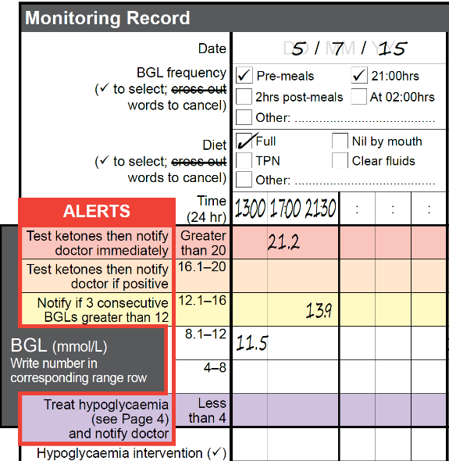
Two of the rows for recording BGLs do not have any coloured shading. Unless modified (see section 5.3), these rows correspond to the 4 to 8 and 8.1 to 12 mmol/L ranges. If the BGL falls within these ranges, a doctor does not need to be notified unless it has been requested in the Special Instructions, or if the nurse has specific concerns. This is because the target range for most inpatients on general wards who are receiving subcutaneous insulin and/or oral treatments is 4 to 10 mmol/L, with up to 12 mmol/L usually regarded as acceptable.

5.2 Alerts
The chart has a number of alerts embedded within it. If a BGL is recorded within a shaded row, consult the instructions in the ALERTS section that align with that row, and act on them immediately. This section outlines the standard actions and notifications required for each shaded row.

The purple row (hypoglycaemia)
If the patient’s BGL is less than 4 mmol/L, it will fall within the purple range row, which indicates hypoglycaemia and a potential emergency. If this occurs, several actions are required of the nurse:
- Initiate hypoglycaemia treatment as per the Guidelines for Treating Hypoglycaemia flow diagram (on page 4 of the chart), ensuring that the patient’s safety is maintained at all times; if the patient is unconscious or not cooperative, it is an emergency situation
- Notify the treating prescriber or doctor on call at the point specified in the flow diagram, and then place a tick in the ‘Doctor notified’ row in the Monitoring Record
- After following the flow diagram all the way to the end, place a tick in the ‘Hypoglycaemia intervention’ row in the Monitoring Record section
- Perform follow-up BGLs as specified in the treatment flow diagram and respond accordingly (see section 11.1)
- Document the hypoglycaemia treatment and response in the medical record, and in the ‘Comments’ section of the Administration Record as required.

The other coloured rows (hyperglycaemia)
The other coloured ranges indicate elevated BGLs, and each level of elevation requires a different response.

The red row
If the patient’s BGL is greater than 20 mmol/L, it will fall within the red range row. In this case, the nurse should:
- Perform a urine or blood ketone test (according to local procedure), and document the result in the ‘Ketones’ row
  - If a urine ketone test is performed, the result is documented as ‘neg’ if no ketones are present or as a ‘+’ or ‘++’ etc., as indicated on the urine ketone test strip bottle
  - If a blood ketone test is performed, the result is documented as a number – for example, ‘0.6’ or ‘1.4’
- Notify the treating prescriber or doctor on call immediately, regardless of the ketone result, and then place a tick in the ‘Doctor notified’ row in the Monitoring Record
- Document the actions taken and further relevant information in the ‘Comments’ section of the Administration Record, and in the medical record.

The orange row
If the patient’s BGL falls within the orange range row (usually 16.1 to 20 mmol/L unless modified), the nurse should:
- Perform a ketone test, and document the result in the ‘Ketones’ row (as above)
- If the ketone result is positive, notify the treating prescriber or doctor on call immediately, and then place a tick in the ‘Doctor notified’ row in the Monitoring Record
- Document the actions taken and further relevant information in the ‘Comments’ section of the Administration Record, and in the medical record.

The yellow row
If the patient’s BGL falls within the yellow range row (usually 12.1 to 16 mmol/L unless modified) the required response varies.
A single elevated BGL that falls in the yellow range row does not require any special action.
However, action is required if the patient has had three or more consecutive BGLs greater than 12 mmol/L, which may have fallen in any combination of the yellow, orange and red rows. In such cases, the nurse should:
- Notify the treating prescriber or doctor on call immediately, and then place a tick in the ‘Doctor notified’ row in the Monitoring Record
- Document the actions taken and further relevant information in the ‘Comments’ section of the Administration Record, and in the medical record.

5.3 Modified BGL ranges
Some conditions – for example, pregnancy – may require tighter control of BGL. For these patients, a senior doctor may choose to modify some of the ranges printed on the chart. They can do this by crossing out the relevant numbers on both the left and right, and replacing them with handwritten ranges. Such modifications effectively change the thresholds for both alerts (see section 5.2) and doses of supplemental insulin (see section 6.2). A worked example of this scenario is shown in Figure 18.
If handwritten modifications result in any ambiguity, the nurse must contact the doctor to correct the chart. This includes situations where:
- The handwritten range only appears on one side of the chart
- There is a mismatch between the handwritten ranges on the left and right
- Two ranges overlap
- There is a gap between two ranges
- BGLs had already been recorded on the chart prior to modification.
Note that these modifications should always be made before any BGLs have been recorded on the chart. If the chart has already been used, a new chart must be started instead.
Such modifications should not be common because only highly experienced insulin prescribers can make them safely.
Figure 18: Diagram showing how to modify blood glucose ranges if necessary
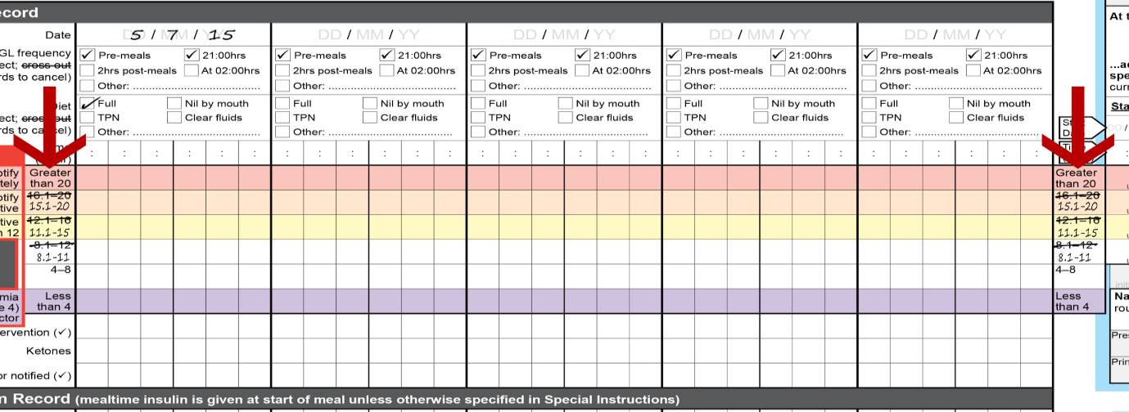

Ordering insulin
Insulin orders are divided into three sections on the chart: Routine Insulin Orders, Supplemental Insulin Orders and Stat/Phone Orders. The location of each section has been carefully chosen to reduce the risk of administration errors. Patients may require any combination of routine, supplemental and stat/phone orders.
If no insulin is prescribed for a patient with diabetes, the chart should still be used for BGL monitoring as the alerts and notification prompts will still apply.
Each hospital will have its own specific chart for intravenous insulin, and the subcutaneous insulin chart should never be used for insulin infusions or pumps.

6.1 Routine insulin orders
The Routine Insulin Orders section (at the bottom of pages 2 and 3) has been designed to align with the date columns used in the Monitoring Record and Administration Record.
Figure 19: Diagram showing a completed regular insulin orders section
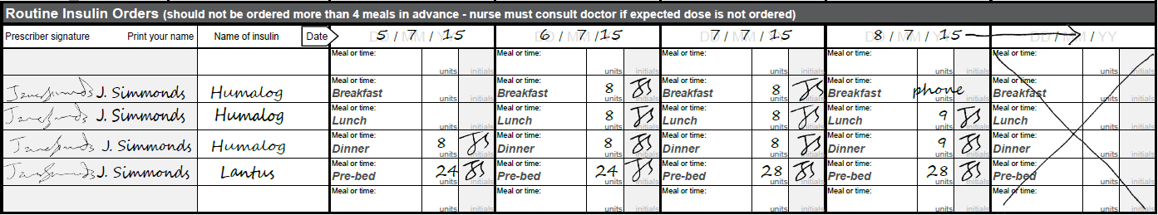
For each day, there are six rows in which routine insulin doses can be prescribed. Each dose is prescribed in a different row according to the time when it is to be administered. Figure 19 shows an example of a completed routine insulin orders section.
Note that routine insulin orders are not recurrent, so routine insulin must be ordered separately for each day. When writing up doses, it is appropriate to prescribe for up to four meals in advance – for example, for the rest of the present day plus the first dose(s) for the following day. In some circumstances, it may also be appropriate to write up insulin doses for several days, but only if the patient’s BGLs have been acceptable and stable in the range of 4 to 12 mmol/L.
Standard administration times are pre-printed in four of the six rows, namely:
- Breakfast
- Lunch
- Dinner
- Pre-bed.
When these standard administration times are used, all mealtime insulin doses are to be given immediately before the patient eats, when their meal is in front of them. This includes insulins with a 15–30 minute delay in onset of action.
Rationale: In the hospital setting, meal delivery times are variable and if a meal is delayed after insulin has been administered, hypoglycaemia may result.
Prescribers have the option of crossing out a standard administration time label and writing a specific 24-hour time in the adjacent space instead – see Figure 20.
Figure 20: Diagram showing how to amend standard meal times if required
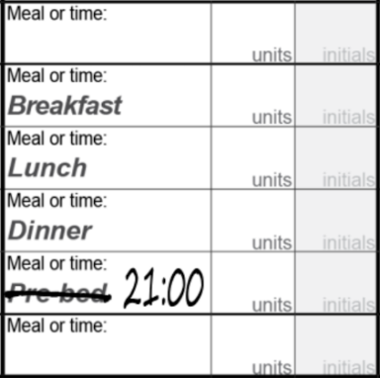
There are also two rows – at the top and bottom – that are not pre-labelled with standard administration times. These can be used when a patient requires two insulin types at a single meal or time – for example, if a patient receives both their basal insulin and mealtime insulin at breakfast.

Ordering routine insulin
To order routine insulin, the prescriber must:
- Consider whether any modifications to the patient’s BGL frequency are required, if not done already (see section 4.1), noting that the desired BGL frequency for each day must be specified if frequency deviates from the pre-ticked default options; if more than six BGLs are requested per day, it is important to adjust the chart accordingly before prescribing for the following day to ensure that the order is recorded in the correct column (see section 4.2)
- Write the date that the dose is to be administered at the top of the relevant column in the Routine Insulin Orders section; if the chart is already in use, take care to ensure that any dates in the Routine Insulin Orders section match those in the corresponding columns of the Monitoring Record
- Find the appropriate row for the order – for example, the second row if ordering a breakfast dose – and write the full trade/brand name of the insulin to be administered in the ‘Name of insulin’ column
  - For a premixed insulin, specify the insulin type in full – for example, ‘Mixtard 30/70’, ‘Humalog Mix 25’ and ‘NovoMix 30’
  - The use of truncations – for example, ‘Mixtard’ and ‘Humalog Mix’ – means that the order is incomplete and the nurse is not allowed to administer it.
  - Rationale: Trade names are preferred for insulin prescribing to avoid confusion, as there are many look-alike or sound-alike generic insulin names which are not interchangeable. Additionally, wherever possible, the patient should receive the brand of insulin that they use or will be using at home.
- Write the number of units ordered as a whole number in the cell immediately to the right of the relevant meal or time; the word ‘units’ is pre-printed
  - Do not write ‘U’ or ‘IU’ as these abbreviations can cause serious dose administration errors – for example, ‘5u’ may be interpreted as 50 units
  - For more information on this point, refer to the Australian Commission on Safety and Quality in Health Care document entitled Recommendations for Terminology, Abbreviations and Symbols Used in the Prescribing and Administration of Medicines
- Initial in the grey shaded cell to the right of the dose cell (where ‘initials’ is watermarked – see Figure 21)
- Sign each order in the leftmost column
- Print full name at least once per chart
- If not already done write the full trade or brand name, of each insulin to be administered, in one of the cells in the Administration Record containing the prompt ‘Name of routine insulin’ (see section 6.4).
Figure 21: How to prescribe the number of units of insulin to be administered
If the patient has been receiving insulin and an expected dose has not been ordered for the next meal or time, the nurse must call the treating prescriber or the doctor on call for a phone order (see section 6.3.2). If a phone order is placed, the nurse must document it in the Stat/Phone Orders section and write ‘phone’ in the appropriate dose box in the Routine Insulin Orders section as a cross-reference.
A new chart must be written by the prescriber after five days, or when there is no space left to order doses or record BGLs.

Ceasing routine insulin orders
If a prescriber decides to change a patient’s insulin regimen (not just a dose change, which can be facilitated on the chart), the prescriber must not overwrite the original order. Instead, the original order must be ceased and a new order written on a new subcutaneous insulin chart. See Figure 22 for a worked example.
To cease a routine insulin order for any reason, the prescriber must draw a clear line through the order, taking care that the line does not obliterate the original order or other orders. The prescriber must write the reason for changing the order – for example, ‘cease, change to insulin regimen’ – and the date the order was changed, then initial.
Note: The abbreviation ‘D/C’ (that is, discontinued) should not be used for ceased orders since this can be confused with ‘discharge’. Always use ‘cease’.
Figure 22: How to correctly cease and insulin order
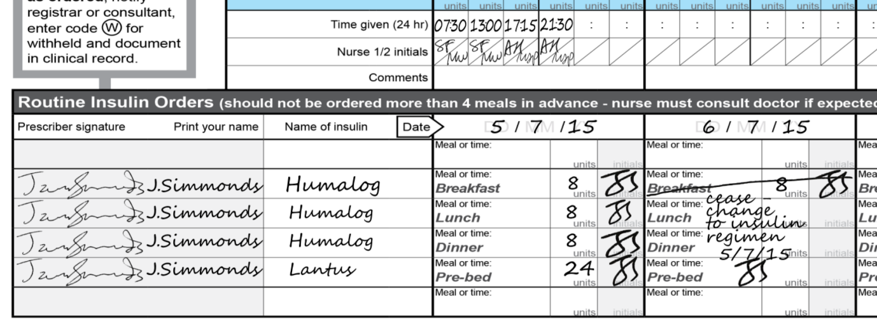

Patients who self-administer insulin
Some patients may calculate the amount of subcutaneous insulin that they require based on their carbohydrate intake, and then self-administer. This can be documented on the subcutaneous insulin chart as shown in Figure 23.
First, describe the procedure in the ‘Special Instructions’ box. Then, note it in the Routine Insulin Orders section, and cross-reference the ‘Special Instructions’ box as shown below.
Figure 23: Diagram showing how to provide instructions for patients who self-administer insulin based on their carbohydrate intake
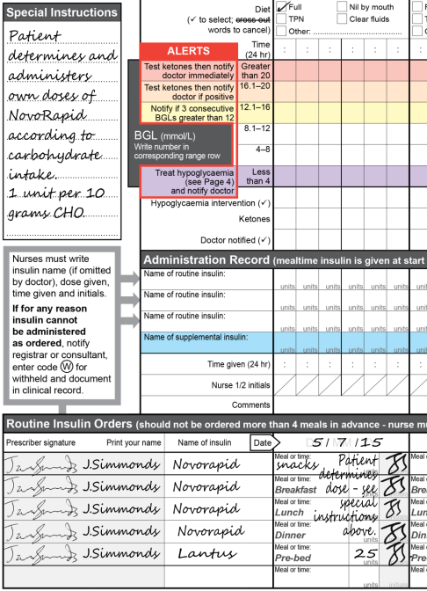

6.2 Supplemental insulin orders
The Supplemental Insulin Orders section (at the top right of page 3) has been designed to align with the BGL range rows used in the Monitoring Record. It allows prescribers to order different quantities of insulin for each range row, which will be administered in addition to the patient’s routine mealtime or basal insulin doses. Figure 24 shows how the Supplemental Insulin Orders section aligns with the alert rows.
Figure 24: Diagram showing how to order supplemental insulin
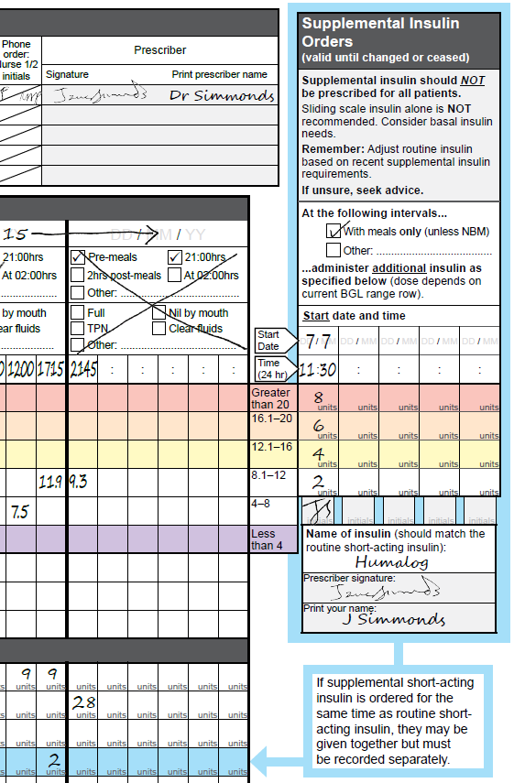
It is not necessary for all patients to have supplemental insulin prescribed. It may be considered if:
- Glycaemic control has been erratic and strict control is desirable
- The patient’s condition, dietary intake or a concurrent medication is altering their insulin requirements
- The patient has recently commenced subcutaneous insulin and optimal doses have not yet been determined.
A supplemental insulin order remains valid until changed or ceased. This contrasts with routine insulin orders, where doses must be ordered for each day.
Rationale: Routine doses should be adjusted daily in response to the BGLs and the amount of supplemental insulin required in the previous 24 hours. The patient’s requirement for supplemental insulin should reduce as routine insulin doses are adjusted.
However, supplemental orders are not valid beyond the life of the current chart. When a new chart is started, supplemental orders must be either:
- Ordered on the new chart, if supplemental insulin is to be continued, or
- Ceased on the expiring chart, to communicate the intention that the patient is no longer to receive supplemental insulin.
Box 1 Recommendation
Standalone sliding scale insulin is not recommended as sole insulin therapy. Basal insulin requirements should be considered.
It is important to note that supplemental insulin (or ‘correctional insulin’) is NOT a standalone sliding scale insulin strategy. Rather, it is a short-acting insulin given in addition to a patient’s routine insulin to cover unexpected hyperglycaemia which has occurred despite the patient’s regular basal or basal and mealtime insulin regimen. In contrast, standalone sliding scale strategies involve intermittent short-acting insulin given in response to BGLs without any background basal or mixed insulin.
Ordering supplemental insulin
To order supplemental insulin, the prescriber must:
- Tick the relevant checkbox to indicate the intervals at which the additional insulin is to be administered
- ‘With meals only’ if the patient is tolerating an oral diet, or
- ‘Other’, and specify the relevant times (24-hour) and/or meals
- Write the start date and start time (24-hour) for the order in the first available column
- Write the ‘Name of insulin’ to be administered in the space provided; usually, if the patient is receiving rapid or short-acting routine insulin with meals, the same type of insulin is prescribed as supplemental insulin
- Enter the number of units of supplemental insulin to be prescribed for each BGL range
  - Each dose should be written as a whole number; the word ‘units’ has been pre-printed in each dosage cell as shown in Figure 25
  - On page 1, there is a table containing suggested initial doses that vary according to the patient’s previous total daily dose or (if not previously on insulin) their weight (see section 10), colour-coded for ease of transcription; however, these suggested doses may not be appropriate if the BGL alert ranges have been modified in the Monitoring Record, which effectively changes the thresholds for both the BGL-related alerts and the administration of supplemental insulin
  - See section 5.3 for details of the modification procedure required, but note that it is strongly recommended that prescribers do not make these modifications unless they are highly experienced with managing insulin
- Initial beneath the column of doses
- Sign the order and print full name in the spaces provided.
Figure 25: Diagram showing prescribers how to complete the supplemental insulin section correctly
- If not already done, write the full trade or brand name of the supplemental insulin in the Administration Record cell containing the prompt ‘Name of supplemental insulin’ (see section 6.4); this row has been shaded blue to link it to the Supplemental Insulin Orders section. An example is shown in Figure 26
Figure 26: Diagram showing the addition of the supplemental insulin brand name to the administration record section
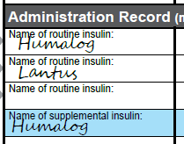
Note that supplemental doses can be amended as required by completing further columns. Changes are validated as of the start date by initialling at the bottom of the column.
Ceasing supplemental insulin orders
To cease a supplemental order, the prescriber should draw a diagonal line through the order, document the reason for change, sign and date. The correct way to annotate the chart when ceasing an order is shown in Figure 27.
Figure 27: Diagram showing the correct way to cease a supplemental insulin order
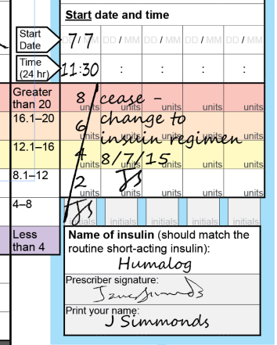

6.3 Stat/Phone insulin orders
All stat or phone orders for single doses of insulin are recorded in the Stat/Phone Orders section. It has been positioned at the top of pages 2 and 3 to reduce the risk that a stat or phone order will be missed. An example of a completed telephone order is shown in Figure 28.
Administration of the stat or phone insulin dose is documented in the Administration Record section along with routine doses (see sections 7.3 and 7.4).
Figure 28: Diagram showing how to record insulin orders in the telephone or stat order section
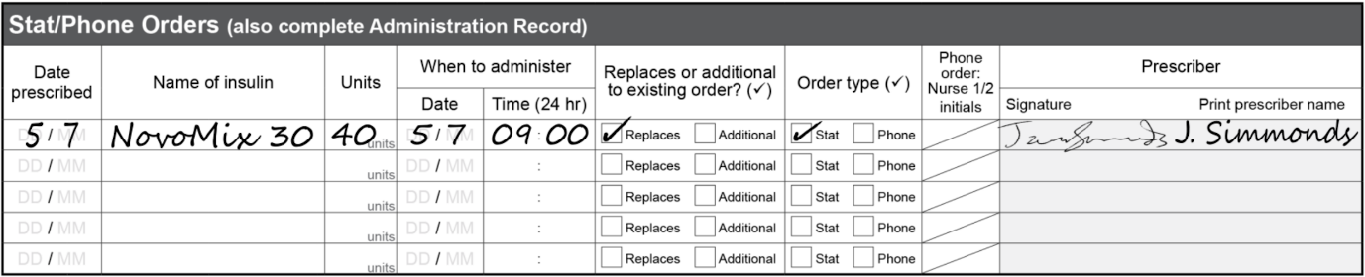

6.3.1 Stat orders
Stat doses of insulin may be ordered for several reasons, including out-of-range BGLs. They must always be documented on the subcutaneous insulin chart, not in the stat/phone order section of the NSMC, even if the patient has no other insulin orders.
To order a stat dose, the prescriber should:
- Enter the date prescribed, the insulin name and the number of units ordered (as a whole number) in the corresponding columns
- Enter the intended date and time of administration in the ‘When to administer’ column
- Tick the relevant checkbox to indicate whether the order replaces an existing order, or is additional to existing orders
- Tick the ‘Stat’ checkbox
- Sign and print full name
- Verbally inform the nurse responsible for the patient’s care so that the stat dose is not missed at the required administration time.

6.3.2 Phone orders
If a registered nurse takes a phone order for any insulin dose – that is, routine or due to an out-of-range BGL – they must document the order in the Stat/Phone Orders section. Phone orders should then be signed by the prescriber (or otherwise confirmed in writing) within 24 hours, in accordance with local procedure and state or territory legislation.
To record a phone order, the nurse should:
- Enter the date prescribed, the insulin name and the number of units ordered (as a whole number) in the corresponding columns
- Enter the intended date and time of administration in the ‘When to administer’ column
- Tick the relevant checkbox to indicate whether the order replaces an existing or expected order, or is additional to existing orders
- Tick the ‘Phone’ checkbox
- Print the prescribing doctor’s name
- Initial in the space provided for ‘Nurse 1’
- Get a second nurse to
- read the written order back to the prescriber to confirm that it is correct
- countersign in the space provided for ‘Nurse 2’.
A completed example of a telephone order including two signatures is shown in Figure 29.
Figure 29: Diagram showing how to correctly record a new insulin order given over the telephone to two nurses
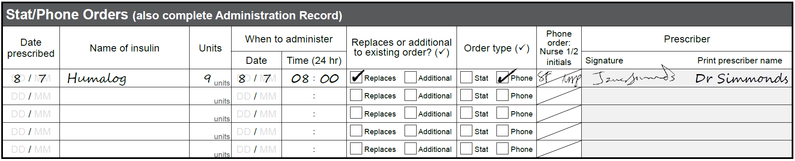
- If the phone order replaces an existing or expected routine insulin order, cross-reference it in the Routine Insulin Orders section as shown in Figure 30
  - In the case of an existing order, cross out the original dose and write the words ‘see phone’ in the adjacent box labelled ‘Meal or time’
Figure 30: Diagram showing how to correctly record an insulin order given over the telephone to two nurses that replaces an existing insulin order
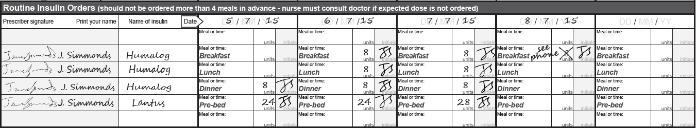


  - If the phone order replaces an expected routine insulin order, write the word ‘phone’ in the appropriate dose box as shown in Figure 31.
Figure 31: Diagram showing how to replace an expected routine insulin order with an order given by telephone to two nurses
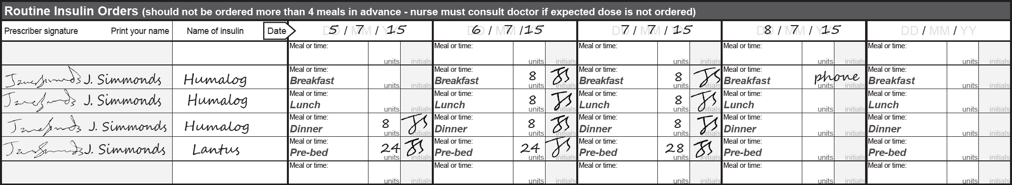


6.3.3 What to do if there are too many phone orders to fit into the phone order section
In some hospitals, a large number of insulin orders are given over the phone – often too many for the five spaces provided in the ‘Stat/Phone Orders’ section. As a result, these hospitals may choose to authorise nurses to record phone orders in the ‘Routine Insulin Orders’ section instead.
Figure 32: Diagram showing how two nurses may use the routine orders section to record additional telephone orders
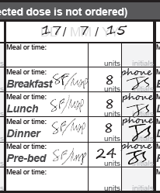
As with other phone orders, two nurses should document the order, with the second nurse reading it back to the prescriber to make sure that it has been recorded correctly. A completed example of such an order in the routine insulin order section is shown in Figure 32.
The first nurse should record the dose ordered in the box labelled ‘units’ and write the word ‘phone’ at the top of the ‘initials’ box provided for the prescriber. Both nurses should sign their initials in the box labelled ‘Meal or time’. When next attending the patient, the prescriber should initial underneath the word ‘phone’, ideally within 24 hours.
However, if there is already an order written in the ‘Routine Insulin Orders’ section, then the phone order should be recorded in the ‘Stat/Phone Orders’ section and cross-referenced in the ‘Routine Insulin Orders’ section, as explained above (see section 6.3.2). Otherwise, it would become unreadable.
Hospitals that allow phone orders to be recorded in the ‘Routine Insulin Orders’ section should have a policy in place outlining the required practice, and should ensure that nurses are adequately trained in it.

6.4 Administration record
Immediately after prescribing insulin, the prescriber should write the full trade or brand name of the insulin in one of the cells in the Administration Record section containing the prompt ‘Name of routine insulin’ or ‘Name of supplemental insulin’ (as appropriate), if this has not already been done as shown in Figure 33.
Trade names are preferred when prescribing insulin to avoid confusion (as discussed in section 6.1).
Figure 33: Trade or brand names of insulins prescribed are written in the Administration Record section
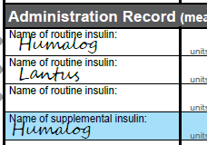
Box 2 Recommendation
A nurse or pharmacist may write the insulin trade name on the administration record.
If the prescriber has not written the insulin trade name and the patient requires an insulin dose, a registered nurse or pharmacist may write the full trade name in these rows. An example is shown in Figure 33.
.

Administering insulin and documenting administration
All insulin doses should be prepared and administered according to local procedure, and documented in the Administration Record.
Figure 34: A completed insulin administration section showing routine and supplemental doses administered
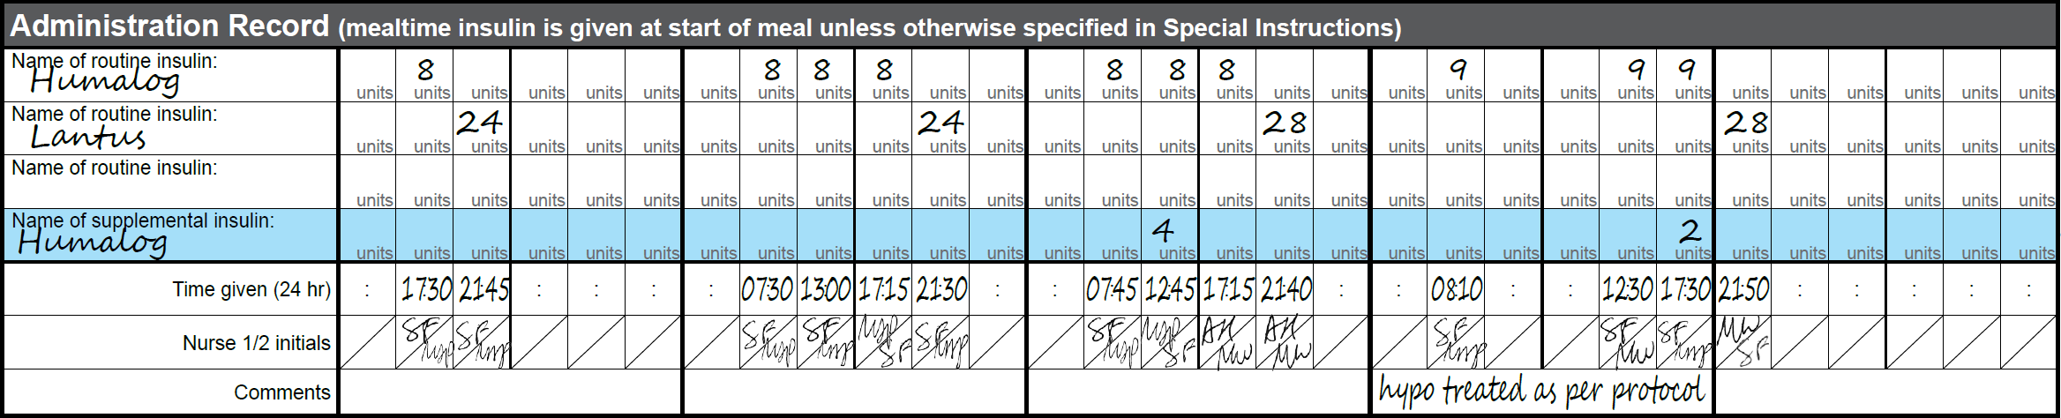

The Administration Record contains four rows in which to document administered doses, allowing for up to three types of routine insulin and one type of supplemental insulin to be recorded on the chart. An example showing how to record three types of insulin I shown in Figure 34.
General procedure for administering insulin and documenting administration
To administer insulin and document administration:
- Always check for orders in the Routine Insulin Orders, Supplemental Insulin Orders and Stat/Phone Orders sections before administering any insulin, because some patients may be prescribed more than one dose of insulin at a time
  - Insulin orders for the same type of insulin (for example, short-acting) may be administered together but must be documented separately in the Administration Record
  - Supplemental insulin doses should always be recorded in the blue row
- Calculate and prepare the total insulin dose (routine ± supplemental ± stat/phone); check local procedure to determine whether different types of insulin can be mixed in the same syringe
- Confirm that the insulin type and dose are correct with another appropriately trained nurse
- Find the Administration Record row that contains a handwritten label for the appropriate ‘Name of routine insulin’ or ‘Name of supplemental insulin’; stat and phone orders are recorded in the same rows that are used for documenting routine insulin
- If the insulin name has not already been recorded in the appropriate row, copy the full trade/brand name from the Routine Insulin Orders section
- Record the dose administered in the row that contains the corresponding ‘Name of routine insulin’ or ‘Name of supplemental insulin’; it is important that all administered doses are recorded in the correct row
- Administer the insulin
- Document the time of administration in the ‘Time given’ row (using 24-hour time) to accurately reflect the time of administration (which may be slightly different from the time at which the BGL was recorded)
- Initial in the top half of the ‘Nurse 1/2 initials’ box to acknowledge administration of the dose
- Ensure that the second nurse checking the dose initials in the bottom half of the ‘Nurse 1/2 initials’ box; the two sets of initials confirm the administration of each insulin dose.
Before administering insulin
For patients receiving routine insulin, BGL should be measured within the 30 minutes before an insulin dose. If left longer, the patient’s BGL may change significantly prior to insulin administration.
Insulin doses administered at mealtimes should be given immediately before the patient eats, when their meal is in front of them.
Rationale: In the hospital setting, meal delivery times are variable and if a meal is delayed after insulin has been administered, hypoglycaemia may result.
When insulin should NOT be administered
There are some circumstances in which a prescribed dose of insulin should not be administered:
- If the prescriber has not completed and verified the patient ID details – insulin should not be withheld unnecessarily, so the nurse should contact the prescriber urgently; if the original prescriber is not available, the nurse should contact the doctor on call instead.
- If clinical judgement indicates that a prescribed dose should not be administered – for example, if the patient is fasting or vomiting – the nurse should notify the prescriber to review the dose.
Documenting withheld insulin
If, for any reason, an insulin dose cannot be administered as ordered, the following steps should be completed by the nurse:

- Notify the prescriber
- Enter code for withheld in the Administration Record in place of the dose
- Document both the reason and the action taken in the clinical record.
Note: It would be unusual for a patient with type 1 diabetes to have their insulin dose withheld completely.

7.1 Administration of a routine insulin dose
After taking and recording a BGL, check if an insulin dose is to be administered. As noted above, some patients may be prescribed more than one dose of insulin at a time, so always check for orders in the Routine Insulin Orders, Supplemental Insulin Orders and Stat/Phone Orders sections before administering any insulin.
Figure 35: Diagram showing how a prescriber may order more than one type of regular insulin
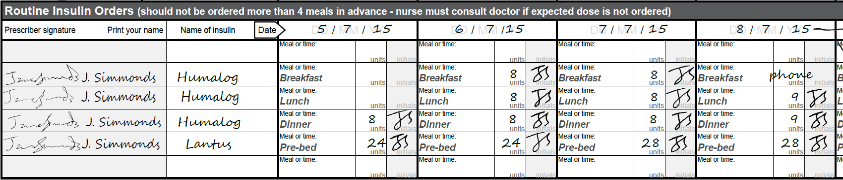
In the Routine Insulin Orders section, standard administration times – ‘Breakfast’, ‘Lunch’, ‘Dinner’, ‘Pre-bed’ – are pre-printed in four of the six rows, but prescribers also have the option of replacing them with a specific 24-hour time and/or ordering insulin in the other two rows. An example I shown in Figure 35
The dose is prescribed under the current ‘Date’ column. If there is no dose ordered where one would be expected, the nurse should contact the prescriber or doctor on call to determine if a dose is required and to provide a phone order if it is (see section 6.3.2).
The insulin should be administered and the administration documented as outlined in the general procedures on page 30. For an example, see section 7.5.1.

7.2 Administration of a supplemental insulin dose
If the patient has an elevated BGL– that is, recorded in one of the four highest rows of the BGL record – review the ‘Supplemental Insulin Orders’ and check whether there is a current supplemental order. An example is shown in Figure 36.
These orders are valid until changed or ceased, so the date and time recorded by the prescribing doctor indicate when the order started, not when the insulin is to be administered. As a result, the start date and start time for a current supplemental order can be up to five days in the past.
Figure 36: Supplemental insulin orders are written in lines that correspond to abnormal blood glucose level alerts
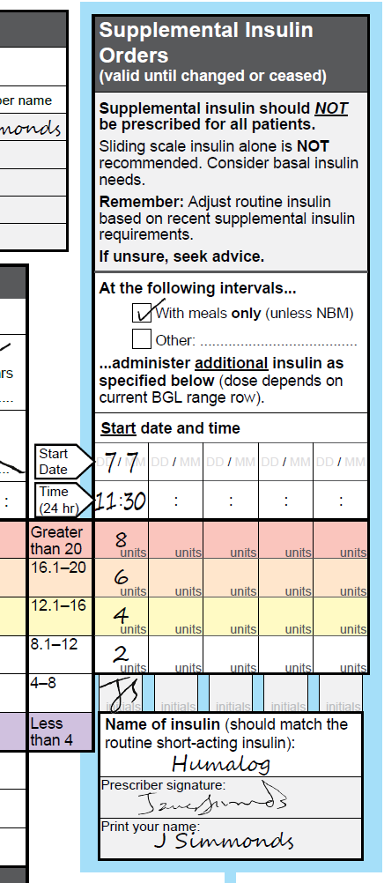
If there is a current order, check the administration interval to determine whether it should be administered at the present time. Most supplemental insulin orders will be for administration with meals only, but the prescribing doctor may have specified something different.
If it is appropriate to administer supplemental insulin, select the dose that corresponds to the patient’s current BGL range row. Note that this may be in addition to a routine dose of the same insulin type (for example, short-acting) due at the same time. If so, calculate the total insulin dose by adding together the routine and supplemental doses before preparing the total dose. Supplemental and routine insulin of the same type may be administered together but must be documented separately.
The insulin should be administered and the administration documented in the Administration Record as outlined in the general procedures on page 31. For an example, see section 7.5.2.

7.3 Administration of a phone order
If a registered nurse takes a phone order for any insulin dose – that is, routine or due to an out-of-range BGL – they must document the order in the Stat/Phone Orders section. A worked example is shown in Figure 37.
Figure 37: Insulin order received by two nurses by telephone intended to replace a routine order
If the prescriber attends the ward and prescribes a dose in the Stat/Phone Orders section, he/she must verbally inform the nurse responsible for the patient’s care.
As mentioned previously, it is important for the nurse administering the order to be aware of whether the dose replaces an existing or expected order, or is additional to existing orders.
Once the correct dose or doses to be administered have been determined, the insulin should be administered and the administration documented as outlined in the general procedures on page 30.

7.4 Examples
This section shows some worked examples of the subcutaneous insulin chart in use.

7.4.1 Routine insulin example
In this example, the nurse has measured and recorded the patient’s BGL, which is 12 mmol/L at breakfast on 6/7/15. There is a routine order for 8 units of rapid-acting insulin. The patient has no additional supplemental or stat/phone orders, so the dose to be administered remains 8 units of routine rapid-acting insulin.
This is administered and documented as ‘8’ in the relevant row in the Administration Record. The time of administration (07:30) is documented in the ‘Time given’ row. Then the nurses, who prepared, checked and administered the dose, initial the document after the administration. Figure 38 shows how routine insulin doses are prescribed and then recorded in the administration section.
Figure 38: Prescribing and administration sections completed to reflect insulin orders given as prescribed
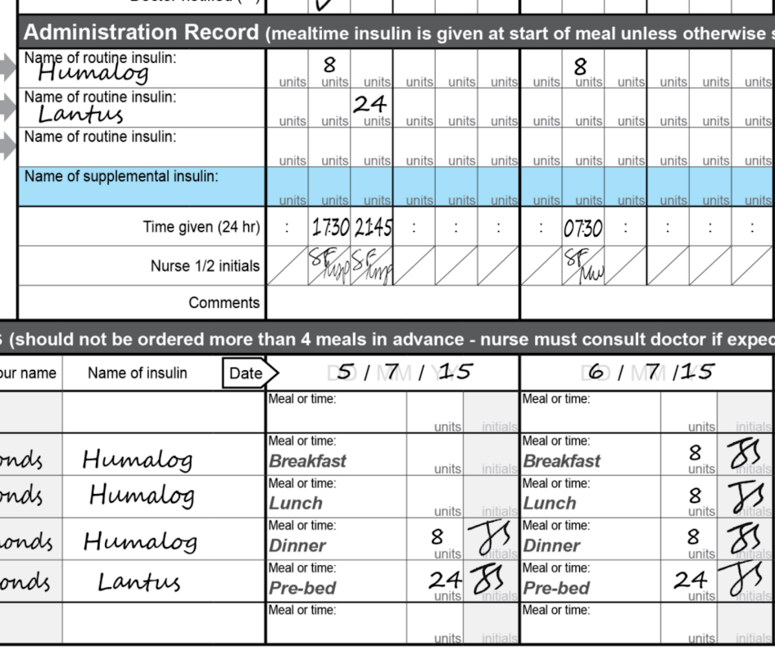
The same procedure is undertaken at each meal time with routine insulin. Before bed, when the basal insulin dose is often ordered, it is documented in a different row – that is, the one that corresponds with the basal insulin name.

7.4.2 Supplemental insulin example
In this example, the nurse has measured and recorded the patient’s BGL of 11.9 mmol/L at dinner time. The nurse then checks the Routine Insulin Orders, Supplemental Insulin Orders and Stat/Phone Orders sections.
Figure 39: Management of an abnormal blood glucose level using the appropriate supplemental insulin order
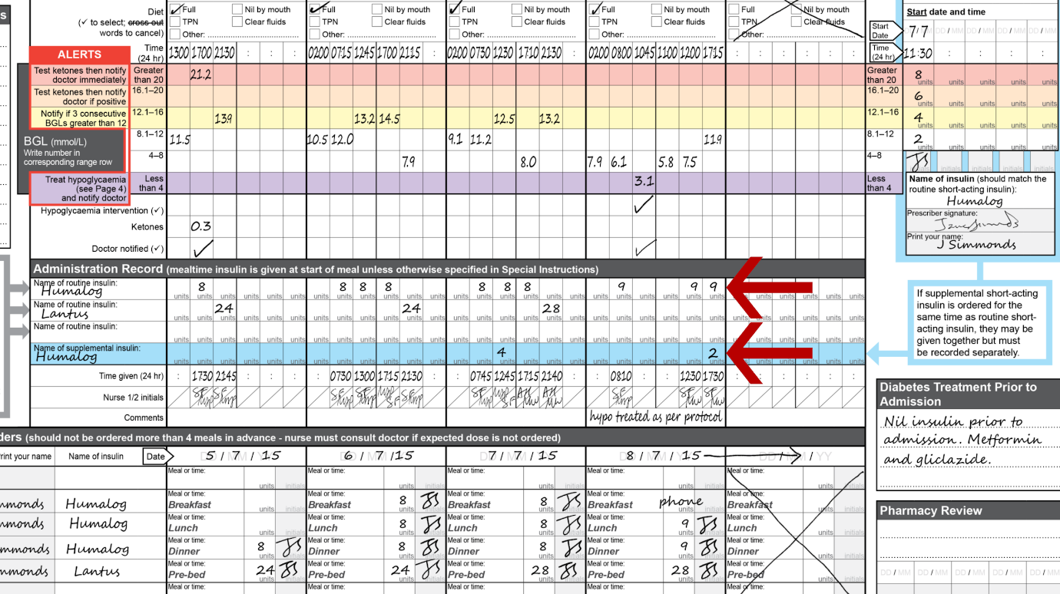
The patient has been prescribed 9 units of rapid-acting insulin as a routine insulin dose. The patient’s BGL is within the upper white row (8.1–12 mmol/L), and the supplemental order specifies that an additional 2 units of rapid-acting insulin are to be given for an elevated BGL within that range. There is no stat/phone order.
The nurse prepares the total insulin dose of 11 units of rapid-acting insulin – that is, 9 units of routine rapid-acting insulin plus 2 units of supplemental rapid-acting insulin – which is checked and administered according to facility procedure. The administration record is shown in Figure 39 and the red arrows point to the routine and supplemental insulin orders.
Although the total dose is administered as a single injection, the routine and supplemental doses are documented separately in the Administration Record, as 9 and 2 units respectively. This is to allow clinicians to reconcile the amount of insulin administered. The time of administration (17:30) is documented in the ‘Time given’ row. Then the nurses who prepared, checked and administered the dose initial to document the administration.

7.4.3 Phone order example
In this example, there is no insulin ordered for the patient at breakfast time on 8/7/15. As the patient has been receiving insulin routinely, the nurse contacts the prescriber to see if a phone order is required.
The nurse notifies the prescriber that the breakfast time BGL is 8 mmol/L. A phone order is made for 9 units of rapid-acting insulin. Since this replaces an existing or expected order (in this case, an expected order), the nurse ticks the checkbox marked ‘Replaces’ when recording the details of the order, as well as ticking the ‘Phone’ checkbox. The nurse then initials in the space provided for ‘Nurse 1’ to confirm receipt of the order.
A second nurse reads the written order back to the prescriber to confirm that the documentation is correct, and countersigns in the space provided for ‘Nurse 2’, to confirm receipt of the order. In addition, one of the nurses writes ‘phone’ in the relevant cell of the Routine Insulin Orders section as a cross-reference so that clinicians are aware that a phone order has been taken.
The nurses then prepare, check and administer the dose. They document it in the Administration Record, writing '9’ as the units administered, entering the time of administration (08:10) in the ‘Time given’ row, and both initialling below. Each step in the process is shown in Figure 40 and Figure 41.
Figure 40: Record of a phone order received by two nurses to replace a missing routine insulin order
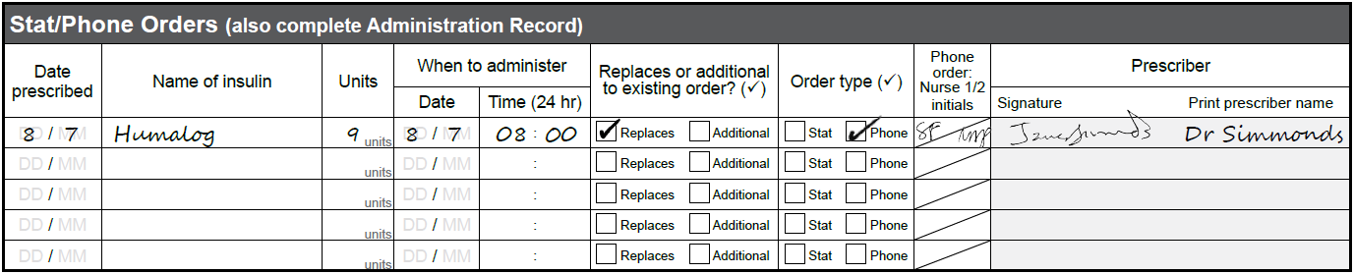
Figure 41: A worked example of how a telephone order received in Figure 40 is recorded in the prescribing and administration record sections
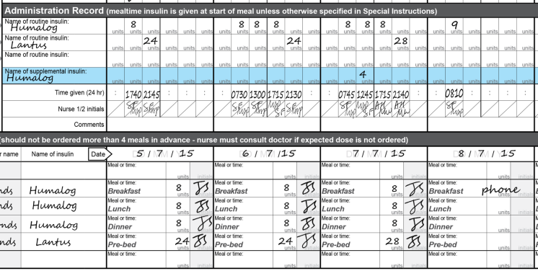

Comments section
There is a small comments section in each day column within the Administration Record. This is for documenting communication between members of the team caring for the patient with regard to the patient’s insulin therapy and diabetes management. An example of how to complete the section is shown in Figure 42.
Examples of what can be documented here include:
- That a hypoglycaemic event has been treated per protocol
- That the patient has been changed to intravenous insulin.
Figure 42: Clinical information can be recorded in the Comments section such as the management of an abnormal blood glucose level

Pharmacy review
In the bottom right-hand corner of the chart, there is also an area for the documentation of pharmacy review.
It has been clearly demonstrated that inpatients benefit from a clinical pharmacist review of their medication regimen. Figure 43 shows how the section might be annotated to indicate that a clinical chart review has been completed.
The pharmacist undertaking the pharmacy review should sign and date the Pharmacy Review section as a record that they have reviewed the subcutaneous insulin chart on the corresponding day. Their role is to ensure that all insulin orders are clear, safe and appropriate for that individual patient, thereby reducing the risk of an adverse drug event.
Associated activities – such as liaison with medical and nursing staff, clarification of orders, and supply and administration information – are necessary to ensure safe and effective outcomes for patients.
Figure 43: Annotated Pharmacy Review section indicating that a clinical chart review has taken place
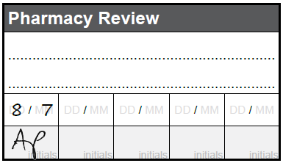

Reviewing hyperglycaemia treatment
Page 1 of the subcutaneous insulin chart includes Guidelines for Treatment Review Following Hyperglycaemia Alert as shown in Figure 44. These are intended to assist less experienced clinicians, non-frequent prescribers and other non-specialist clinicians. They are not designed to decrease autonomy or specialist input. If there are any clinical concerns, then advice should always be obtained from a senior medical officer.
The guidelines include:
- Recommendations for patient assessment following a hyperglycaemia alert
- A flow diagram providing advice on the initiation of basal and mealtime insulin and adjustment of insulin doses
- A table of suggested initial stat and supplemental doses based on the patient’s previous total daily dose or (if they were not previously on insulin) their weight.
Figure 44: Guidelines for the treatment of hyperglycaemia in sub-acute hospitals
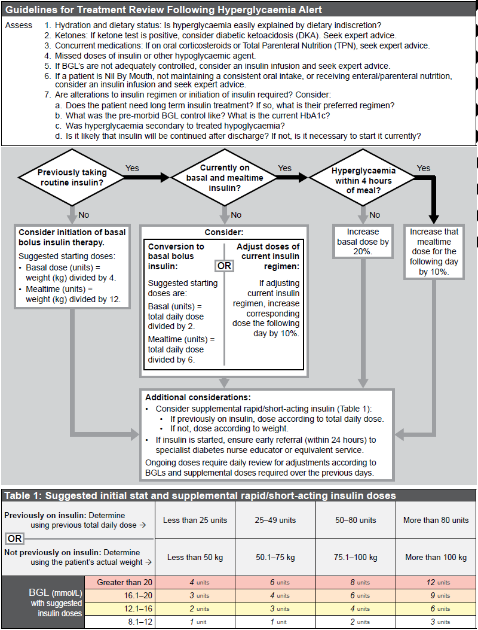

Treating hypoglycaemia and reviewing treatment
This section outlines the information contained on the chart to management blood glucose readings that are below the accepted range and the steps that should be taken to review the patient’s glycaemic management once they have been stabilised.

11.1 Treating hypoglycaemia
Page 4 of the subcutaneous insulin chart includes a flow diagram to guide carers’ actions in response to hypoglycaemia in adult patients. The diagram was designed specifically for sub-acute hospitals without access to an on-site emergency team and specialist diabetes advice. There is a different version of the diagram for acute care hospital settings.
The flow diagram must be used whenever a patient has a BGL reading of less than 4 mmol/L. The information box at the top of page 4 lists the signs and symptoms that may indicate a patient is experiencing hypoglycaemia. If hypoglycaemia is suspected, test the patient’s BGL immediately to determine if it is less than 4 mmol/L. If the patient’s BGL cannot be tested immediately, it is safer to assume that the patient is experiencing hypoglycaemia, and to respond as indicated on the flow diagram.
To use the flow diagram, start with the decision diamond at the top left. If the patient is conscious and cooperative and able to tolerate oral intake, follow the ‘yes’ arrow on the right. Being able to tolerate oral intake means that the patient can swallow safely, without coughing, spluttering or choking, and without nausea or vomiting afterwards.
If the three conditions in the initial decision diamond are not all met, follow the ‘no’ arrow down to the purple column below the arrow. This is an emergency situation that requires the fastest possible response.
Likewise, if the patient is initially conscious, cooperative and able to tolerate oral intake, but later becomes unconscious or uncooperative or unable to tolerate oral intake, return immediately to the decision diamond at the start of the diagram and work down the purple column.
Lists of appropriate food choices are included at several points in the flow diagram to guide the initial and follow-up treatment, but note the following points:
- Food choices are determined from the standard options available at each site
- Sites are encouraged to ensure that their hypoglycaemia treatment food options are available in a central location in each ward, unit and outpatient facility
- Each area should also ensure that they have access to in-date glucagon 1 milligram injections with a standing order to enable it to be used in emergency situations
- Glucose-based products are preferred as the initial treatment
- Diet (low kilojoule) products must not be used to treat hypoglycaemia.
If the episode of hypoglycaemia can be resolved locally, then the flow diagram specifies that the doctor must review both the patient’s diabetes treatment and their hypoglycaemia care plan, including instructions for ongoing BGL monitoring. If the patient is transferred to an acute care facility, then these reviews should be carried out when the patient returns to the sub-acute facility.
Figure 45: Guidelines for the treatment of hypoglycaemia in sub-acute hospitals and mental health facilities
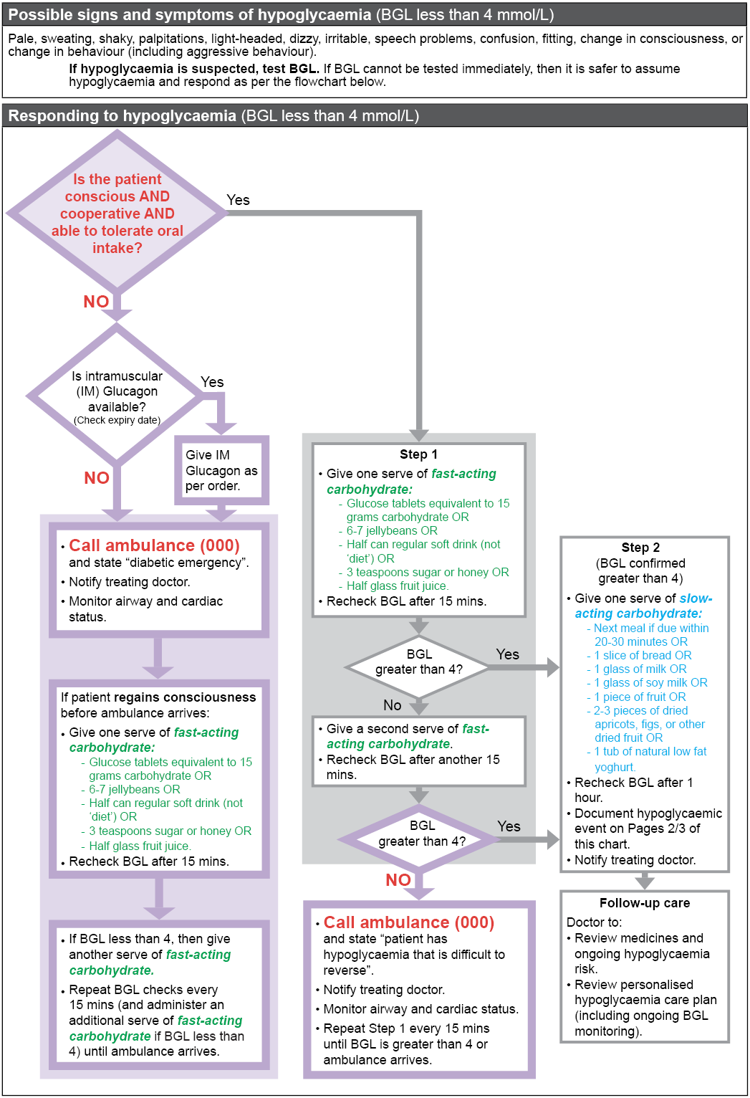
Level 5, 255 Elizabeth Street, Sydney NSW 2000
GPO Box 5480, Sydney NSW 2001
Phone: (02) 9126 3600
Email: mail@safetyandquality.gov.au
Website: www.safetyandquality.gov.au

