Using hospital mortality indicators to improve patient care:
A guide for Boards and Chief Executives

2014

ISBN:
Print: 978-1-921983-72-6
Electronic: 978-1-921983-73-3
Suggested citation: Australian Commission on Safety and Quality in Health Care. Using hospital mortality indicators to improve patient care: A guide for Boards and Chief Executives. Sydney. ACSQHC, 2014.
© Commonwealth of Australia 2014
This work is copyright. It may be reproduced in whole or in part for study or training purposes subject to the inclusion of an acknowledgement of the source. Requests and inquiries concerning reproduction and rights for purposes other than those indicated above requires the written permission of the Australian Commission on Safety and Quality in Health Care:
Australian Commission on Safety and Quality in Health Care
GPO Box 5480
Sydney NSW 2001
Email: mail@safetyandquality.gov.au
Acknowledgements
This document was prepared by the Australian Commission on Safety and Quality in Health Care in collaboration with numerous expert working groups, members of the Commission’s standing committees, and individuals who generously gave of their time and expertise.

Contents
Purpose 5
Introduction 6
Using hospital mortality indicators 7
Hospital-standardised mortality ratios (HSMRs) 9
Death in low mortality DRGs 11
In-hospital mortality for AMI, stroke, fractured neck of femur and pneumonia 13
Review 15
Other resources and companion documents 16
Appendix 1 – South Australia flowchart for mortality review 17
Appendix 2 – Example of a review pathway 19
Appendix 3 – Case Study 20
20
References 24

Purpose
This guide has been prepared for Chief Executives, and Boards, of public and private hospitals and Local Hospital Networks (LHNs). It provides information about how you can use hospital mortality indicators to screen for potential safety and quality issues through your existing clinical governance processes.
Hospital mortality indicators will usually be generated by your state or territory health department, or private hospital ownership group, and provided to your hospital. You should use this information, together with other safety and quality indicators, to monitor the delivery of care and patient outcomes in your hospital. This guide will help you to use hospital mortality indicators in this work.

Introduction
The Australian Commission on Safety and Quality in Health Care (the Commission) is supporting health service Boards and Chief Executives to understand their roles and responsibilities for clinical governance and the implementation of the National Safety and Quality Health Service (NSQHS) Standards1 through the development of supporting guides.
Standard 1: Governance for Safety and Quality in Health Service Organisations of the NSQHS Standards1,2 requires health service organisation leaders to implement governance systems to set, monitor and improve the performance of the organisation. Standard 1 also expects that the Chief Executive and Board of a health care organisation will create integrated governance systems that maintain and improve the reliability and quality of patient care.
Hospital mortality indicators (i.e. indicators about trends of death) are crucial elements of a hospital patient safety monitoring program. Some hospital mortality indicators, such as hospital-standardised mortality ratios (HSMRs), allow a comparison between the number of deaths that occurred in a hospital and the number of deaths that could have been expected, taking into account hospital and patient characteristics. Hospital mortality indicators are best used as safety and quality screening tools to support clinical governance by flagging potential areas of concern or best practice, not as measures of performance.
Australian Health Ministers agreed to ensure each state and territory’s hospital mortality data was gathered and presented to their respective hospitals for regular review, along with infection rates, readmission rates and patient experience survey results.
The hospital mortality indicators endorsed by Health Ministers are:
- hospital-standardised mortality ratios (HSMRs)
- death in low mortality diagnosis related groups (DRGs)
- in-hospital mortality for four specified conditions.

Using hospital mortality indicators
Information regarding the presentation and interpretation of hospital mortality indicators is included in this guide.
The three types of hospital mortality indicators included in this guide are as follows.
1. Hospital-standardised mortality ratios (HSMRs) compare your hospital’s mortality against its expected mortality based on the age and health status of patients with diagnoses that account for 80% of in-hospital mortality nationally, who are admitted to your hospital.
2. Deaths in low mortality diagnosis related groups (DRGs) report in-hospital deaths for DRGs where the national mortality rate is less than 0.5%.
3. In-hospital mortality for acute myocardial infarction (AMI), stroke, fractured neck of femur and pneumonia compares your hospital’s rate of deaths against the rate of deaths that would be expected based on the age and health of patients admitted to your hospital for management of these conditions.
These four conditions are monitored because:
- they are ‘high-morbidity’ conditions, which together account for 20% of all hospital deaths3
- they have known models of care for patients based on clinical evidence.

The Chief Executive, Board, and any higher level of governance within a health service organisation are responsible for patient safety and quality of care. Hospital mortality indicators support clinical governance processes. They provide an opportunity to review factors that may have an impact on the delivery of care and patient outcomes.
When a hospital’s mortality rate or ratio varies from the expected mortality rate for its patient population, it is the responsibility of the Chief Executive to ensure that:
- there is a governance process which specifies who is notified, who actions the review of the variation and reports back on this review, who implements actions identified from the review and who monitors the closure of the actions
- clinicians provide leadership to the review process
- coding staff are involved in the review
- reviews are triggered in a timely manner, and performed with due care
- reviews are thorough, meaning they consider potential data issues, the hospital’s case mix, hospital structure and resources, processes of care, and professional issues
- appropriate actions are nominated to address the issues identified from the review
- lessons from the reviews are disseminated to all appropriate groups
- quality improvements are actioned as identified
- information is provided to the Board or highest level of governance and assurance given that the issues identified are being dealt with appropriately.
It is the responsibility of the Board to ensure that:
- hospital mortality indicators are considered regularly, along with other indicators of safety and quality such as hospital-acquired infection, experience of patients, and readmission rates
- where a hospital’s mortality is higher than the expected rate, the hospital has undertaken a thorough review and, where actions have been identified, these are being progressed in a timely manner
- regular reports on safety and quality indicators and other safety data are monitored by the executive level of governance1,2
- action is taken to improve the safety and quality of patient care1,2
- organisation-wide risk management systems incorporate assessment, rating, controls and monitoring of patient safety and quality.1,2

Hospital-standardised mortality ratios (HSMRs)
HSMRs are used to screen for safety and quality issues in your hospital. The first report on Australian HSMRs was published in 2009.4 This report used admitted patient data from all hospitals to generate HSMRs, and established the Australian approach to HSMR generation and presentation.
HSMRs are not stand alone measures and should be interpreted as part of a suite of safety and quality metrics. They compare your hospital’s overall mortality# to other hospitals; either throughout Australia or with your hospital’s peer group, for a given period. HSMRs are calculated ratios of the number of actual deaths to the number of expected deaths, multiplied by 100. They are calculated from admitted patient data and the mortality ratios are adjusted for patient characteristics like age, sex and diagnosis.
The Commission recommends the use of funnel plots for hospitals monitoring this indicator. State and territory health departments can produce HSMR reports using funnel plots. An example of a funnel plot is shown in Figure 1 overleaf. Funnel plots display each hospital’s result as a ‘dot’ on a graph. The central line represents the national average ratio (100). If a hospital (dot) is above the central line, it has a higher mortality rate than the national rate.
If the hospital is below the line, it has a lower mortality rate than the national rate. The two curved lines above and below the central line represent 95% and 99% confidence intervals. These lines constitute the ‘funnels’, and identify if a hospital’s result varies significantly from the national average ratio (100). If the hospital is above one of the upper funnels, its mortality rate is considered to be significantly higher than the national rate. Alternatively, if the hospital is below one of the lower funnels, its mortality rate is significantly below the national rate.
In larger hospitals, HSMRs are best reviewed quarterly. In smaller hospitals, annual or ‘rolling HSMRs’ may be used to present 12 months of data in the funnel plots.
# for diagnoses associated with a high in-hospital death rate nationally

Figure 1: Sample funnel plot showing HSMR variation with 95% and 99.8% control limits5
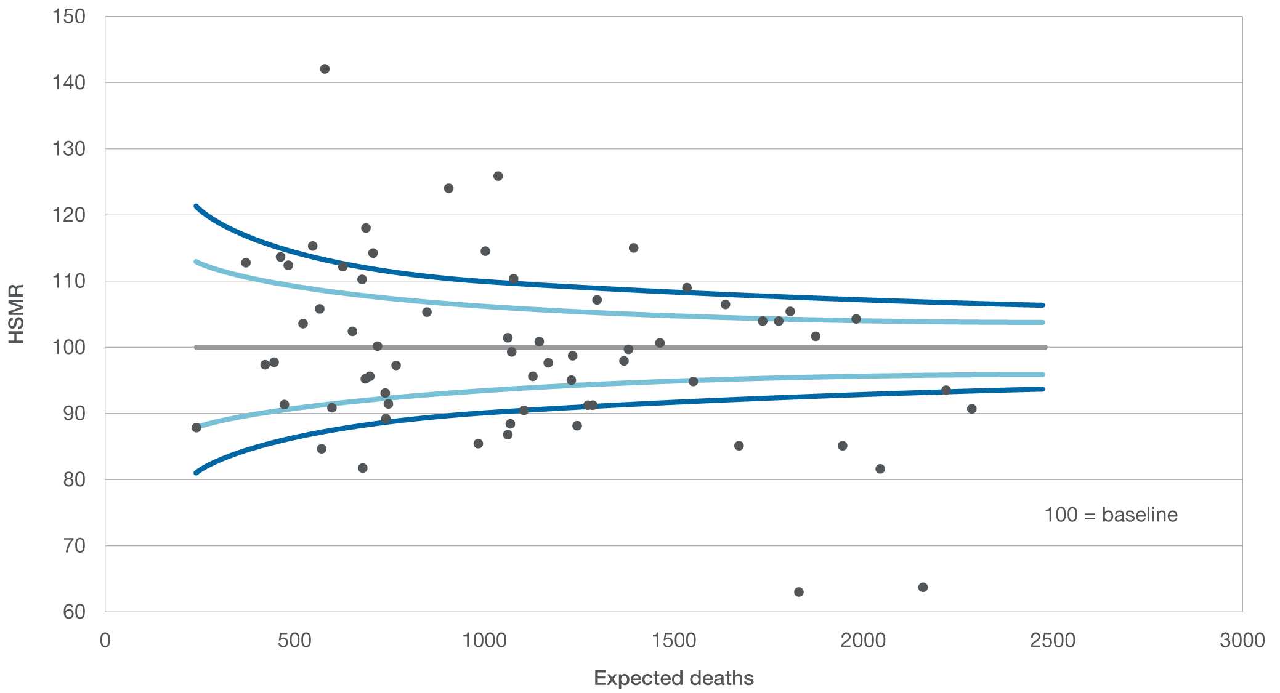
Actions
An elevated HSMR warrants review. If your hospital has a statistically higher mortality (where the HSMR is above the funnel) then the review should investigate the hypothesis that more patients are dying in your hospital than would be expected for their age and health profile.
If your hospital has a statistically lower mortality (where the HSMR is below the funnel), then the review should check the hypothesis that fewer patients are dying in your hospital than expected. It is important to confirm that inconsistent coding and classification processes are not distorting results.
Information on review processes is provided in the Review section of this guide on page 11.
‘A high HSMR is a trigger to ask hard questions. Good hospitals monitor their HSMRs actively and understand where performance may be falling short and action should not stop until clinical leaders and the Board at the hospital are satisfied that the issues have been effectively dealt with.’6

Death in low mortality DRGs
This indicator was developed by the Agency for Healthcare Research and Quality (AHRQ)8 in the United States. It identifies all in-hospital deaths for DRGs where the national mortality rate is less than 0.5%.
Examples of low mortality DRGs are:
- headache
- hand procedures
- arthroscopy.
The premise of this indicator is that a review is warranted when a patient is admitted with a low-risk condition or procedure and dies in hospital. The number of deaths in low mortality DRGs should, by definition, be small. Monthly review of these deaths is recommended.
Data about deaths in low mortality DRGs are easily generated from your hospital’s admitted patient data, and should be presented regularly using the simple tables shown as illustrated in Tables 1 and 2.
You may receive reports in a format similar to Table 1, which lists the hospital identifiers of those patients who died in DRGs where death is rare. Each of these deaths should be reviewed.
Table 1: Death in low mortality DRGs
Hospital patient identifier | Date of death | AR-DRG | Date of review
8569742 | 2 January 2011 | GO5C
1452879 | 22 February 2011 | KO1B
1234567 | 5 April 2011 | B73Z
9876543 | 2 May 2011 | D04B
234987 | 13 June 2011 | J60C
6358921 | 28 June 2011 | L04B

You may also choose to receive the report in a format similar to Table 2. This gives an indication of whether your hospital’s rate of deaths in the low mortality groups is elevated.
A list of the low mortality DRGs is available on the Commission’s website.
Table 2: Death in low mortality DRGs in your hospital
Reference period | Low mortality DRG separations | Number of deaths | Deaths as a % of eligible separations
2011–12 | 3000 | 8 | 0.3%
2012–13 | 2000 | 4 | 0.2%
Actions
Each hospital death of a patient whose admission was in the low mortality DRG group should be reviewed.
A review can indicate whether the actual grouping of that separation to a ‘low mortality DRG’ was appropriate, or whether there were concurrent conditions presenting a more complex case than that represented by the DRG.
The review can also highlight whether hospital resources or processes of care need investigation.

In-hospital mortality for AMI, stroke, fractured neck of femur and pneumonia
Queensland and Victoria pioneered routine reporting of risk-adjusted mortality rates for a set of high morbidity conditions in Australia. Hospital mortality rates for AMI, stroke, fractured neck of femur and pneumonia were calculated and provided to public hospitals in those states as part of the VLAD8 and AusPSI9 projects, respectively.
Like HSMRs, these mortality indicators are generated from admitted patient data for specific, high-morbidity populations in your hospital, and are adjusted for each patient’s health and characteristics.
Queensland Health developed a graphical presentation for regular reporting of in-hospital mortality called the VLAD (variable life-adjusted display).10 It presents the difference between the number of actual deaths and expected deaths over time, and uses cumulative sum (CUSUM) tests to determine if a further investigation is warranted. The Commission recommends the use of VLAD/CUSUM chart for hospitals monitoring this indicator, as they identify if an apparent change in the mortality rate occurs. These indicators can also be presented as funnel plots.
For your hospital, each VLAD/CUSUM will refer to deaths from AMI, stroke, fractured neck of femur or pneumonia for a given period. The VLAD/CUSUM presents your hospital’s results over time, and shows if the mortality rate for your hospital exceeds the expected mortality range for Australian hospitals. An example of a VLAD/CUSUM chart is shown in Figure 2.
Figure 2: Sample VLAD/CUSUM chart11
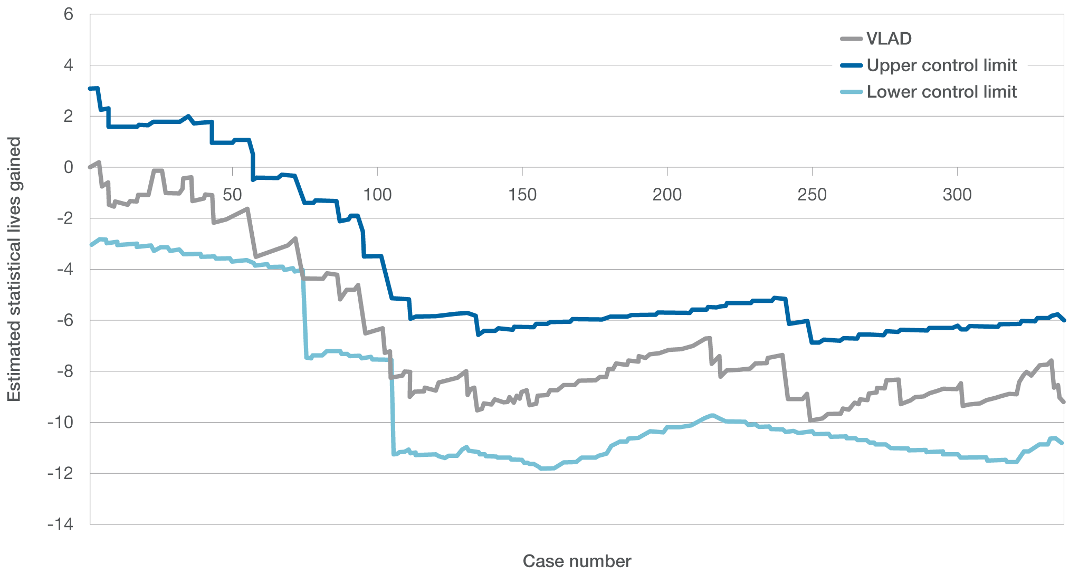
In Figure 2, the central grey line represents the deaths in your hospital, expressed as an estimate of statistical lives gained or lost above or below the national ‘expected rate’ for the patients treated for the condition monitored at your hospital.
Moving outwards above and below the central line are lines which are termed control limits. If the central grey line (your hospital result) crosses either of the control limits, it indicates a level of variation between your hospital and the state average.
There are three possible trends for VLAD/CUSUMs:
1. The central line remains broadly level, staying within the upper and lower control limits. This indicates your hospital’s mortality rate is similar to the national mortality rate.
2. The central line moves down and touches the control limit below (lower limit). This ‘flag’ indicates that your hospital has a higher mortality rate than the national average as shown at point A in figure 3.
3. The central line moves up and touches the control limit above (upper limit). This ‘flag’ indicates that your hospital has a lower mortality rate than the national average as shown at point B in figure 3.
Actions
A review is warranted if the central line falls over time and touches the lower control limit. This suggests your hospital has a higher mortality rate than is expected for its case mix.
By reviewing the patient charts associated with the downward trend, you may be able to identify contributing factors to the increase in deaths. Contributing factors may include coding issues or incorrect documentation. The review may identify resource, process of care or professional issues requiring the need to make systematic changes to address the increase in the hospital’s mortality for the referred condition.
There are potential lessons from both positive and negative trends. In 2008, Queensland Health produced VLADs for Dummies.12 This book provides a clear and methodical explanation of VLADs, and is recommended reading.
Figure 3: Sample VLAD/CUSUM showing ‘flags’
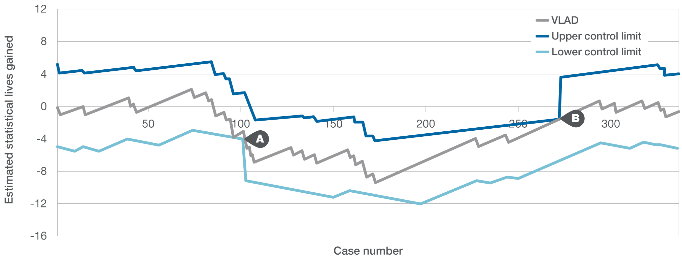
Review
By monitoring hospital mortality rates and ratios, significant variance in patient outcomes is able to be detected. The occurrence of a high or low result should not be immediately interpreted as good or bad performance, as there are many possible explanations for a hospital’s variation.
Elevated mortality rates or worsening trends should be reviewed by the hospital or local hospital network. Some states and territories have established review processes and governance arrangements where hospital mortality rates are elevated. An example is shown in Appendix 1. South Australia Health has developed a flowchart outlining the process for hospital mortality indicators review. It is a good example of how mortality indicators can be incorporated into clinical governance processes to effect system improvement.
In general, hospitals reviewing elevated mortality should work their way up the ‘Mohammed pyramid’ (see Figure 4) in looking for causes of variation.13
The first step is to consider the possibility that artefact, rather than quality of care, explains the variation. Data should be verified to confirm that the variation identified in the hospital mortality indicators is real, rather than due to different or inconsistent coding, classification practices, or chart documentation issues.
Further review will show whether this variation is either acceptable due to differences in patient characteristics or services delivered, or unacceptable due to issues associated with the safety and quality of care.
An example of a review pathway is shown in Appendix 2.
An example of a mortality review and process used to establish contributing factors is outlined in a case study in Appendix 3.
Figure 4: Pyramid of elements of investigation
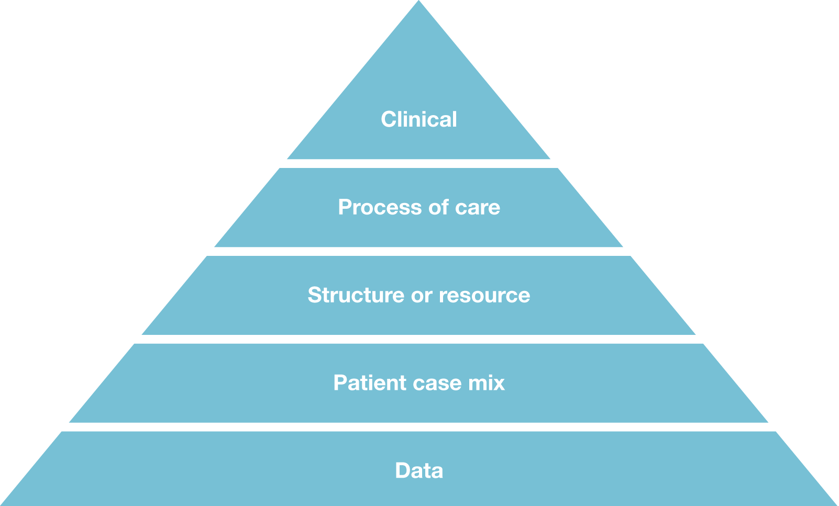

Other resources and companion documents
Companion documents to support the use of hospital mortality indicators include:
- a technical “toolkit” for generation of hospital mortality indicators including:
- indicator specification and workflow
- annotated statistical code
- national coefficients and reference sets.
The Commission is developing documents to support the understanding and use of hospital mortality indicators which will include:
- a technical guide to hospital mortality indicators
- hospital mortality indicators for clinicians and health service managers.
In addition to the South Australian guide shown in Appendix 1, the following publications are examples from working systems where routine review of hospital mortality indicators operates within a broader clinical governance framework.
VLADS for Dummies.12
Patient Safety Guideline for Variable Life Adjusted Display and other National Patient Safety Indicators.14
Using the HSMR to help improve patient care: A guide for NHS Boards.15
Dying to know: How to interpret and investigate hospital mortality measures.16

Appendix 1 –
South Australia flowchart for mortality review
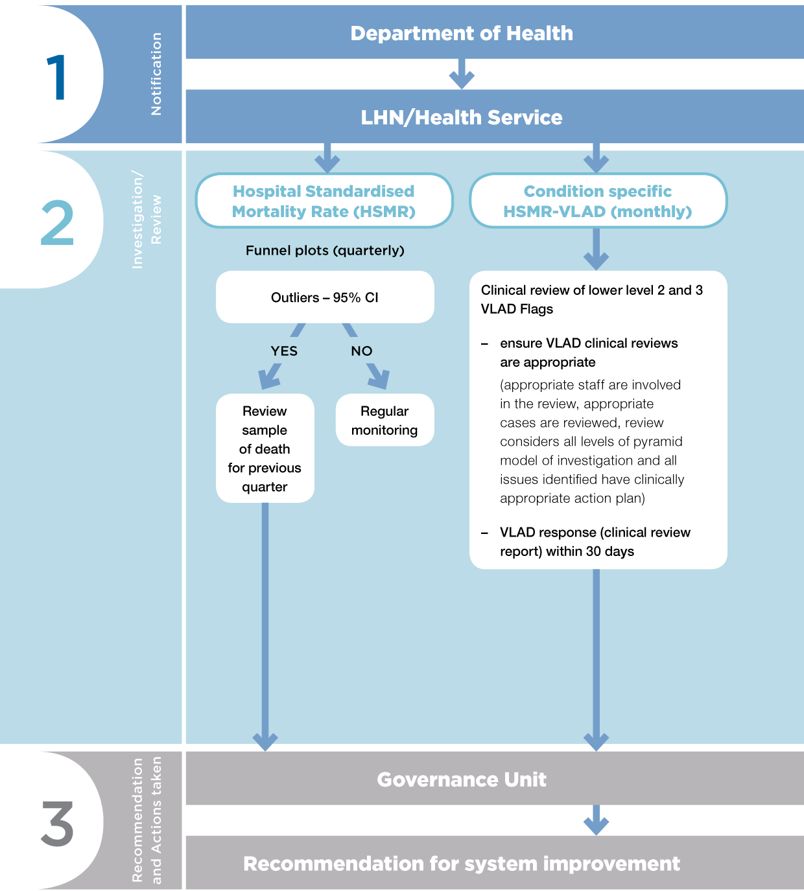
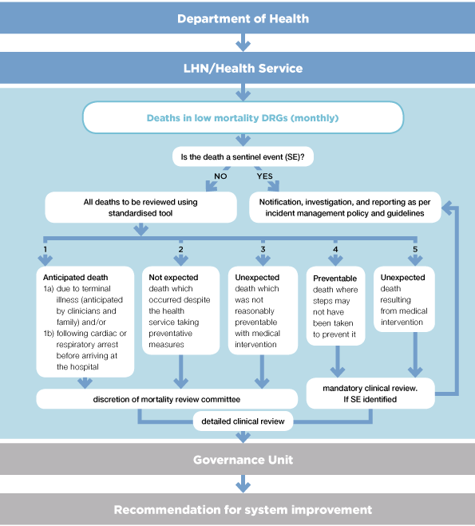
Appendix 2 –
Example of a review pathway
This example has been modified from the Dr Foster Intelligence Unit to suit Australian coding systems and processes. It outlines an example to reviewing elevated or worsening hospital mortality.17
Example of a review pathway
1. Coding and classification
Has the hospital submitted incorrect data or applied different data codes from other hospitals? Poor depth of coding can also affect the HSMR, that is when there are no, or few, secondary codes.
Hospital managers and executives can improve coding by encouraging coders and clinicians to work more closely together (some organisations have coders attached to specific specialties) so they can better understand each others’ roles and limitations. They could encourage clinicians to use medical record audit tools like the Körner Medical Records (KMR)* to determine the most appropriate primary diagnosis and procedure code. Managers and executives also need to ensure that staff entering data understand the importance of the work they are doing and its impact on the hospital.
2. Case mix
Has something extraordinary happened within the time frame, such as an abnormal run of severely ill patients in a short period of time?
Is co-morbidity coding correct? Check the co-morbidity coding to identify the true case mix of the patient.
3. Structure
Does the hospital work in a different way from others across the country? Do they have different care pathways, particularly for end-of-life care? Other structural differences such as no weekend discharges or nurse-led discharge teams should also be considered.
4. Process
At this point, start considering that there may be a potential safety and quality issue. Where service delivery needs to be reviewed, issues can be identified after monitoring and investigating alerts. Information systems can help with this.#
5. Individual or team
Very occasionally the investigation will lead you to an individual or team. Where there is a commonality of personnel involved, or a particular team, clinician, or department, see what extra support they need in order for them to deliver the best possible care.
Adapted from Dr Foster Intelligence. Understanding HSMRs: A toolkit on hospital standardised mortality ratios. Version 6: October 2011
* “The KMR is a record reflecting the number of patients admitted and discharged, the clinical problems encountered, lengths of stay and other relevant information.”18
# For example, the RTM: Rosetta Terminology Mapping supports the extraction of patient observations data from different health information systems. Incident reporting systems (IRS) are in use across Australian hospitals and provide valuable.
Appendix 3 –
Case Study
A hypothetical in-hospital mortality review is shown below. This example shows the processes used to identify contributing factors for a VLAD/CUSUM chart when it showed a lower level ‘flag’ for in-hospital mortality for stroke. An example of this is shown in Figure 3 on page 10.
The review process works through the levels of Mohammed’s Pyramid and evaluates each component to establish the management action plan. It examines a series of stroke patients within the VLAD/CUSUM cohort who died before the flag occurred.
Cases reviewed with Principal diagnosis (reason for admission)
Case A: Cause of death: Cerebral haemorrhage (lacunar infarcts)
Case B: Cause of death: Large, severe stroke likely hypertensive & secondary to warfarin (high INR 4.1)
Case C: Cause of death: Large intracerebral haemorrhage transferred to and died at another hospital.
Case D: Cause of death: Intracerebral haemorrhage, likely hypertensive & suspected bleed brain tumour, transferred to palliative care unit, another hospital
Case E: Cause of death: Large cerebral infarction
Case F: Cause of death: Large intracerebral haemorrhage
Case G: Cause of death: Large embolic cerebral infarction due to atrial fibrillation (AF) despite warfarin therapy
Case H: Cause of death: Extensive, deep seated (thalamus) intracerebral haemorrhage
Case I: Cause of death: Large cerebral infarction
Case J: Cause of death: Large cerebral infarction with likely extension of stroke
Case K: Cause of death: Aspiration pneumonia as consequence of cerebral infarction

Data
Investigation Description & Findings:
Data for all cases were reviewed and analysed. Overall, documentation was clear, complete and consistent within emergency department, ward and discharge summary documentation. However, in one case the code for ‘aspiration pneumonia’ was missing. In another, the relevant end of life care documentation within the medical record was missing.
These factors did not contribute to this indicator being flagged. It is unlikely that ‘Data’ factors contributed to the stroke mortality VLAD flagging.
Case mix
Investigation Description and Findings
As a part of the review, the characteristics and comorbidities of 11 stroke patients who died were considered.
- All patients were brought in via ambulance with a poor prognosis on arrival to the emergency department.
- Four patients had a delayed presentation and had been found unresponsive over an unknown period of time.
- All were frail, elderly patients with complex, multiple morbidities and medical histories which had a significant impact on their poor outcome.
- Six patients had a severe/large haemorrhage; the remaining five patients had large and/or embolic infarcts.
- All eleven cases had an acute resuscitation plan in place and of these; seven were for end of life care; two cases also had an enduring power of attorney in place.
- Nine of the 11 cases were reviewed by the Death Review Committee and all were deemed as non-reportable deaths under the relevant Coroners Act.
- Two cases were transferred out to other facilities where the patients subsequently died.
It is likely that ‘Case mix’ factors contributed to the stroke mortality VLAD flagging.

Structure or Resource
Investigation Description and Findings
There were no issues identified with structure or resources in these cases. Each patient was admitted and attended to by a well-resourced emergency department and medical treating team (consisting of medical consultants, specialist clinicians, registrars, stroke coordinator, allied health disciplines). Consultation was also held with the neurosurgeon at another tertiary hospital for a number of cases.
It is unlikely that ‘Resource’ factors contributed to the stroke mortality VLAD flagging.
Process of Care
Investigation Description and Findings
Appropriate care and services were administered to all patients. Clinicians undertook intensive clinical assessment taking into consideration the main condition, comorbidities and frailty of patients. Clinical care provided was consistent with current best practice (National Stroke Foundation Guidelines).
This hospital has a stroke unit. To support the treatment and management of stroke patients a multidisciplinary team meeting was formed for each case. In addition to this process, an acute stroke care coordinator role was established to aid in the smooth transition of patient care from admission to discharge. The implementation of the acute stroke clinical management pathways and end of life care processes were also put in place. Thrombolytic therapy and clinical resources are available for this hospital to handle potential bleeding complications.
The emergency department is able to work with specialist resources (medical consultant, stroke coordinator, intensive care unit (ICU) consultant) and have the capability to thrombolyse patients on admission.
It is unlikely that ‘Process of Care’ factors contributed to the stroke mortality VLAD flagging.
Professional
Investigation Description and Findings
Each patient was treated on an individual case-to-case basis and monitored by an experienced team of qualified medical registrars, consultants, stroke coordinator, allied health disciplines and nursing staff during the admission. The review considered all clinical care provided to be consistent with the clinical guidelines of the National Stroke Foundation Guidelines regarding investigations, treatment, medications and the management of comorbidities.
It is unlikely that ‘Professional’ factors contributed to the stroke mortality VLAD flagging.

Management Action Plan
The review determined that the factor likely to be responsible for the elevated stroke mortality (‘flag’) was the case mix of the patient population.
- six of the 11 deaths were patients with haemorrhagic stroke, which is known to have worse outcomes than ischaemic stroke
- seven of the 11 deaths were highly co-morbid patients with end of life care documentation.
Actions
The investigations and recommendations are reported back to relevant groups for discussion and information. The outcomes of VLAD investigations are to be tabled at the hospital:
- Patient Safety Committee
- Death Review Committee (all cases previously reviewed)
- Medical Service Improvement Group as scheduled
- Relevant forums as required (unit meetings, in-service sessions).

References
1. Australian Commission on Safety and Quality in Health Care. National Safety and Quality Health Service Standards (September 2012). Sydney. ACSQHC, 2012.
2. Australian Commission on Safety and Quality in Health Care. Safety and Quality Improvement Guide Standard 1: Governance for Safety and Quality in Health Service Organisations (October 2012). Sydney. ACSQHC, 2012.
3. Bureau of Health Information. The Insights Series: 30 day mortality for five clinical conditions, NSW, July 2009 – June 2012. Sydney. BHI, 2013.
4. Ben-Tovim D, Woodman R, Harrison J et al. Measuring and reporting mortality in hospital patients. Canberra. Australian Institute of Health and Welfare, 2009.
5. Jarman B, Pieter D, Van der Veen A et al. The hospital standarised mortality ratio: a powerful tool for Dutch hospital to assess their quality of care? BMJ Quality and Safety. 2010; 19:9–13.
6. National Review of HSMR ratio – Consensus statement 2011. Steering Group of the National Review of hospital standarised mortality ratio. (Accessed 19 May 2014 at https://www.gov.uk/government/publications/report-and-consensus-statement-from-the-steering-group-for-the-national-review-of-the-hospital-standardised-mortality-ratio).
7. Death in low-mortality DRGs: in-hospital deaths per 1,000 discharges. Agency for Healthcare Research and Quality. (Accessed 19 May 2014 at http://www.qualitymeasures.ahrq.gov/content.aspx?id=38512).
8. Variable life adjustment display (VLAD). Queensland Health. (Accessed 19 May 2014 at http://www.health.qld.gov.au/psu/vlad/default.asp).
9. Patient safety indicators: AusPSI. Victorian Government Health Information. (Accessed 19 May 2014 at http://www.health.vic.gov.au/psi/auspsi).
10. Sherlaw-Johnson C. A method for detecting runs of good and bad clinical outcomes on cariable life-adjusted display (VLAD) charts’. Health Care Management Science. 2005; 8:61–5.
11. Duckett S, Coory M, Sketcher-Baker K. Identifying variations in quality of care in Queensland hospitals. Medical Journal of Australia. 2007; 187 (10): 571–5.
12. Clinical Practice Improvement Centre. VLADs for Dummies. Milton. Wiley Publishing. Australia, 2008.
13. Mohammed A. An investigation into general practitioners associated with high patient mortality flagged up through the Shipman inquiry: retrospective analysis of routine data. British Medical Journal. 2004; 328(7454):1474–7.
14. Patient Safety Guideline for Variable Life Adjusted Display and other National Patient Safety Indicators. Queensland Government. (Accessed on 19 May 2014 at http://www.health.qld.gov.au/directives/docs/gdl/qh-hsdgdl-032-1.pdf).
15. NHS Scotland. Using the Hospital Standardised Mortality Ratio to help improve patient care: A guide for NHS Boards. (Accessed on 19 May 2014 at http://www.healthcareimprovementscotland.org/default.aspx?page=13997).
16. Association of Public Health Observers. Dying to know: How to interpret and investigate hospital mortality measures. (Accessed on 19 May at http://www.apho.org.uk/resource/view.aspx?RID=95780).
17. Dr Foster Intelligence. Understanging HSMRs: A toolkit on Hospital Mortality Ratios. Version 6. (Access on 19 May at drfosterintelligence.co.uk/wp-content/uploads/2011/10/HSMR-Toolkit-Version-6-October-2011.pdf).
18. Tewary K, N’Zoaka S, Jayatunga R. KMR: A clinical audit. Archives of Disease in Childhood. 2007; 92 (7): 652.


Australian Commission on Safety and Quality in Health Care
Level 5, 255 Elizabeth Street, Sydney NSW 2000
GPO Box 5480, Sydney NSW 2001
Phone: (02) 9126 3600 (international +61 2 9126 3600)
Fax: (02) 9126 3613 (international + 61 2 9126 3613)
Email: mail@safetyandquality.gov.au
www.safetyandquality.gov.au

