


Annual Report 2020–21

Published by the Australian Commission on Safety and Quality in Health Care
Level 5, 255 Elizabeth Street, Sydney NSW 2000
Phone: (02) 9126 3600
Email: mail@safetyandquality.gov.au
Website: www.safetyandquality.gov.au
ISBN (print): 978–1–922563–42–2
ISBN (online): 978–1–922563–41–5
© Australian Commission on Safety and Quality in Health Care 2021
All material and work produced by the Australian Commission on Safety and Quality in Health Care is protected by copyright. The Commission reserves the right to set out the terms and conditions for the use of such material.
As far as practicable, material for which the copyright is owned by a third party will be clearly labelled. The Commission has made all reasonable efforts to ensure that this material has been reproduced in this publication with the full consent of the copyright owners.
With the exception of any material protected by a trademark, any content provided by third parties, and where otherwise noted, all material presented in this publication is licensed under a Creative Commons Attribution-NonCommercial-NoDerivatives 4.0 International licence.

Enquiries about the licence and any use of this publication are welcome and can be sent to communications@safetyandquality.gov.au.
The Commission’s preference is that you attribute this publication (and any material sourced from it) using the following citation:
Australian Commission on Safety and Quality in Health Care. Annual Report 2020–21. Sydney; ACSQHC, 2021.
Cover image: REUTERS / POOL – stock.adobe.com
Disclaimer
The content of this document is published in good faith by the Australian Commission on Safety and Quality in Health Care for information purposes. The document is not intended to provide guidance on particular healthcare choices. You should contact your healthcare provider on particular healthcare choices.
The Commission does not accept any legal liability for any injury, loss or damage incurred by the use of, or reliance on, this document.

Letter of transmittal
The Honourable Greg Hunt MP
Minister for Health
Parliament House
Canberra ACT 2600
Dear Minister
On behalf of the Board of the Australian Commission on Safety and Quality in Health Care (the Commission), I am pleased to submit our Annual Report for the financial year ending 30 June 2021.
This report was prepared in accordance with the requirements of the National Health Reform Act 2011 and section 46 of the Public Governance, Performance and Accountability Act 2013.
The report includes the Commission’s audited Financial Statements, as required by section 42 of the Public Governance, Performance and Accountability Act 2013.
The Commission’s annual performance statements were prepared in accordance with the requirements of section 39 of the Public Governance, Performance Accountability Act 2013 and accurately present the Commission’s performance from 1 July 2020 to 30 June 2021.
As required by section 10 of the Public Governance, Performance and Accountability Rule 2014, I certify on behalf of the Board that:
- The Commission has prepared fraud risk assessments and fraud control plans
- The Commission has in place appropriate fraud control mechanisms that meet its specific needs
- All reasonable measures have been taken to appropriately deal with fraud relating to the Commission.
This report was approved for presentation to you in accordance with a resolution of the Board on 8 September 2021.
I commend this report to you as a record of our achievements and compliance.
Yours sincerely
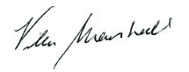
Professor Villis Marshall ac
Chair
Australian Commission on Safety and Quality in Health Care
8 September 2021
Contents
Letter of transmittal 1
Highlights 4
1. Overview 6
About the Commission 8
Our purpose 9
Our accountability 9
Strategic Intent 2020–2025 10
Report from the Chair 12
Report from the Chief Executive Officer 14
Supporting safety and quality during COVID–19 16
Cross-sectoral collaboration 18
2. Report on performance 20
Priority 1: Safe delivery of health care 23
Priority 2: Partnering with consumers 41
Priority 3: Partnering with healthcare professionals 45
Priority 4: Quality, value and outcomes 49
3. Corporate governance and accountability 62
Legislation and requirements 64
Commission’s Board 66
Committees 73
Internal governance arrangements 76
External scrutiny 78
4. Our organisation 82
Organisational structure 84
People management 86
Staff profile 87
Work health and safety 88
Learning and development 89
Workplace diversity 90
Aboriginal and Torres Strait Islander employment 90
5. Financial statements 92
Independent auditor’s report 94
Financial statements 96
Overview and notes to the financial statements 101
6. Appendices 120
Appendix A: Related-entity transactions 122
Appendix B: Freedom of information summary 123
Appendix C: Compliance with ecologically sustainable development 124
7. Indexes and references 126
Acronyms 128
Glossary 129
Index of figures 133
Index of tables 134
Compliance index 135
Index 140
References 152

Highlights
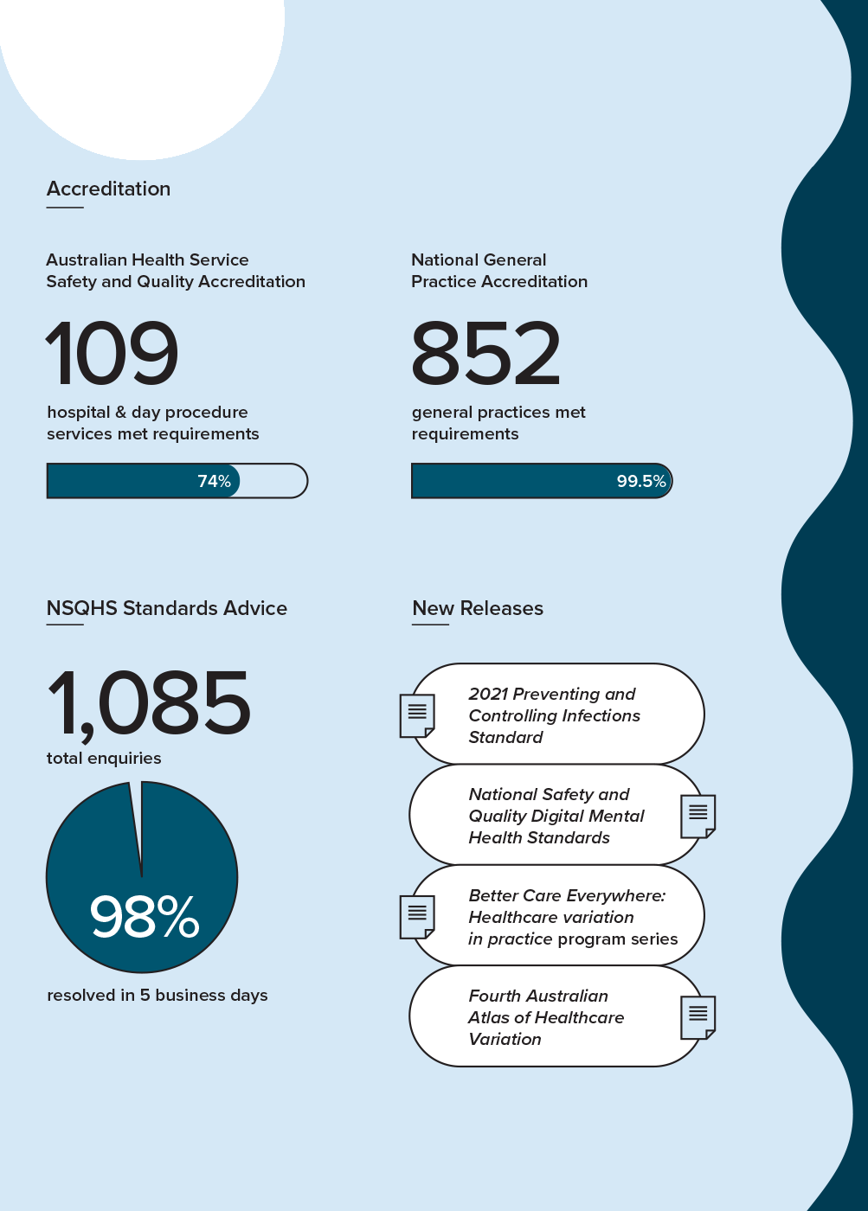
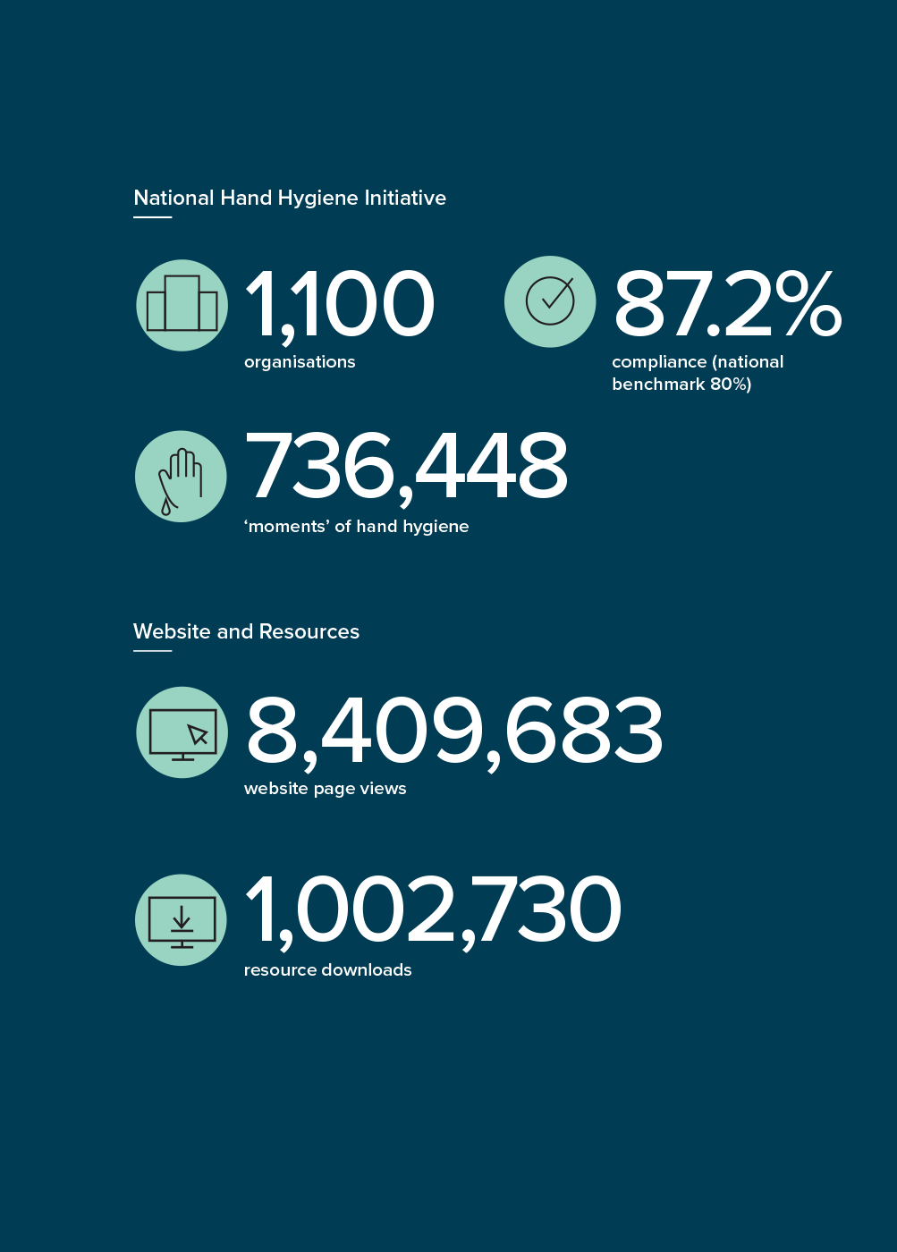

1. Overview

This section provides an overview of the Australian Commission on Safety and Quality in Health Care (the Commission) – including its mission, role, functions and accountability – and reports from the Commission’s Chair and Chief Executive Officer.
About the Commission 8
Our purpose 9
Our accountability 9
Strategic Intent 2020–2025 10
Report from the Chair 12
Report from the Chief Executive Officer 14
Supporting safety and quality during COVID–19 16
Cross-sectoral collaboration 18

About the Commission
In 2006, the Council of Australian Governments established the Commission to lead and coordinate national improvements in the safety and quality of health care. The Commission’s permanent status was confirmed with the passage of the National Health and Hospitals Network Act 2011, and its role was codified in the National Health Reform Act 2011. The Commission commenced as an independent statutory authority on 1 July 2011, funded jointly by the Australian Government and state and territory governments.

Our purpose
Our purpose is to contribute to better health outcomes and experiences for all patients and consumers, and improved value and sustainability in the health system by leading and coordinating national improvements in the safety and quality of health care. Within this overarching purpose, the Commission aims to ensure that people are kept safe when they receive health care and that they receive the care they should.
The functions of the Commission are specified in section 9 of the National Health Reform Act 2011, and include:
- Formulating standards, guidelines and indicators relating to healthcare safety and quality matters
- Advising health ministers on national clinical standards
- Promoting, supporting and encouraging the implementation of these standards, and related guidelines and indicators
- Monitoring the implementation and impact of the standards
- Promoting, supporting and encouraging the implementation of programs and initiatives relating to healthcare safety and quality
- Formulating model national schemes that provide for the accreditation of organisations that provide healthcare services, and relate to healthcare safety and quality
- Publishing reports and papers relating to healthcare safety and quality.

Our accountability
The Commission is a corporate Commonwealth entity and part of the Health portfolio of the Australian Government. As such, it is accountable to the Australian Parliament and the Minister for Health and Aged Care, the Honourable Greg Hunt MP.

Strategic Intent 2020–2025
In 2019–20, the Commission’s Board endorsed a new Strategic Intent 2020–2025. The functions described in section 9 of the National Health Reform Act 2011 guide the Commission’s work, and are expressed in the four priorities of the Commission’s Strategic Intent 2020–2025.
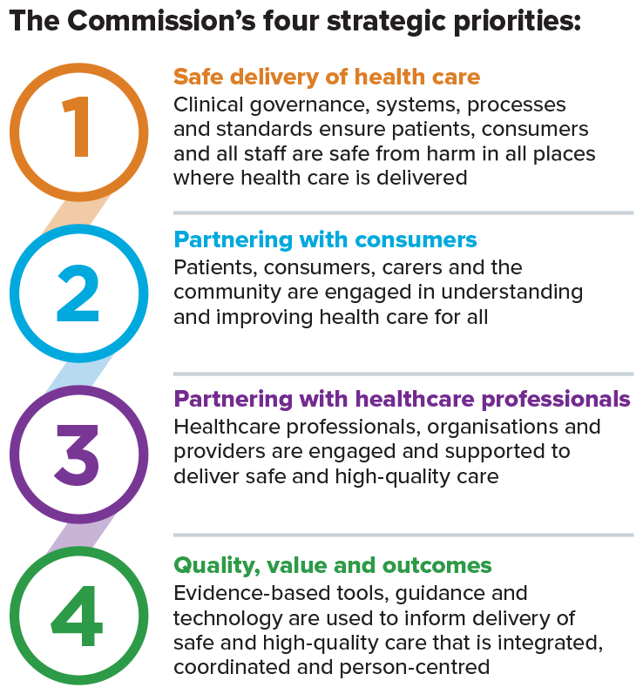
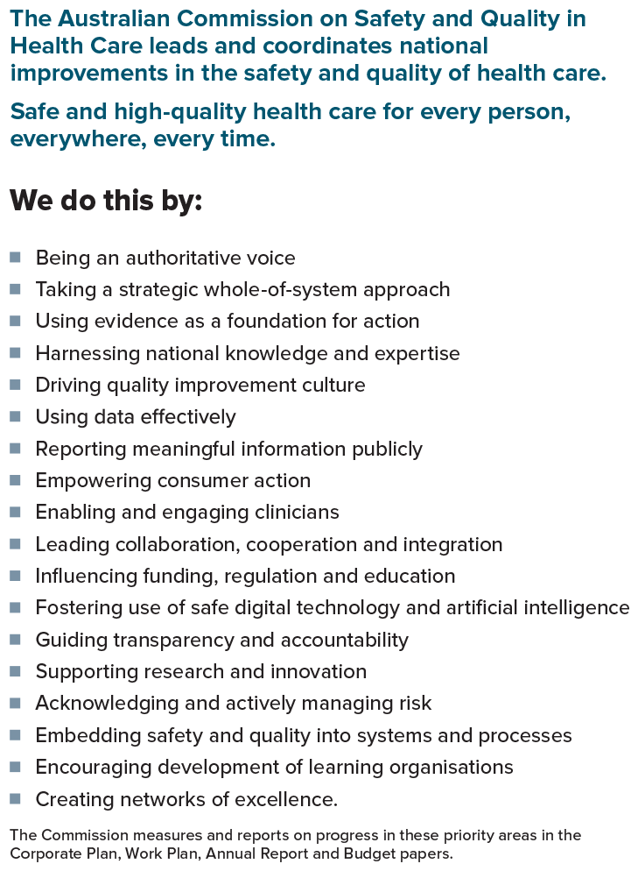

Report from the Chair
Professor Villis Marshall ac
“The human element will always be important for our partnerships. This year has shown that we can think and work differently, and continue to connect meaningfully.”

In 2020–21, health care remained a focus globally, as nations continued to respond to the ongoing COVID–19 pandemic. Our country’s strong response during this time was achieved through formation of a National Cabinet, listening to experts, and early international border closures and quarantine. Community acceptance of public health measures such as surveillance, contact tracing, handwashing, spatial distancing and lockdowns was also crucial. The combined efforts of healthcare providers, emergency responders, governments and the community have kept Australians safe.
Commission staff continued to assist with contact tracing for NSW Health up until the end of November 2020, contributing to an incredibly effective measure to limit the impacts of individual COVID–19 cases and local outbreaks in Australia.
The Commission continued to support the pandemic response in a number of ways. A clear priority was to support health service organisations to provide safe environments for staff, patients and visitors. Led by the Commission, the National Clinical Taskforce, comprising leading infection prevention and control experts from around the country, revised the National Safety and Quality Health Service (NSQHS) Standard on Preventing and Controlling Healthcare-Associated Infection to include emerging evidence on COVID–19 airborne transmission. Assessment to the revised standard began on 1 July 2021.
As well as this important work to support the national pandemic response, the Commission has needed to balance support for the pandemic response with maintaining a strong focus on other national priorities for the safety and quality of health care.
There have been many highlights, but I would like to mention one in particular.
In February 2021, the Commission hosted the online program Better Care Everywhere: Healthcare variation in practice. This was the first program of its kind dedicated to reducing unwarranted variation in clinical care in Australia. The series of live-streamed webinars was made freely available and attracted a larger and wider audience than a conference (originally planned for July 2020) could have. Thousands joined in to hear from healthcare leaders, and to discuss practical ways to reduce unwarranted healthcare variation and deliver better care.
Work has continued in digital healthcare delivery, with the release of Australia's first National Safety and Quality Digital Mental Health Standards in November 2020. The challenges of the past year have increased the focus on mental health and wellbeing, and this remains a priority for the Commission.
The human, face-to-face element will always be important for our partnerships. However, this year has shown that we can think and work differently, and continue to connect with one another meaningfully, regardless of the circumstances.
In presenting the 2020–21 annual report, I would like to thank our healthcare partners, including the Australian Government, state and territory partners, the private sector, clinicians and, of course, consumers – who will always be at the centre of everything we do. I extend my thanks to the Hon. Greg Hunt MP, Minister for Health and Aged Care, for his continuing leadership and support, and the members of the Commission’s Board for their advice and guidance over the past year.
On behalf of the Board, I would like to express my gratitude to the executive team and all of the staff of the Commission – your outstanding work continues to lead national efforts to improve the health care that Australians receive.

Report from the Chief Executive Officer
Adjunct Professor Debora Picone ao
“It is our role to highlight the areas needing improvement and to challenge status quo thinking.”
The COVID–19 pandemic continued to dominate the health news and place considerable demands on health systems worldwide in 2020–21.
However, our longstanding health challenges remained.
The Commission continued to address national health priorities throughout the year, while also supporting our health service organisations to respond rapidly and effectively to the ongoing pandemic. Our staff have demonstrated their adaptability and commitment to supporting safe and high-quality health care in this challenging environment. By coming together as a team, and finding new ways of working, we can continue our progress and achieve our goals.

On 28 April 2021, we released the Fourth Australian Atlas of Healthcare Variation. The findings are compelling, revealing some significant variations in care that we must act on. In particular, the latest Atlas draws attention to Australia’s high rates of unnecessary early caesarean section births. Rates remain high despite strong evidence that waiting until at least 39 weeks is usually best for the baby.
All Australians deserve access to high-quality, safe care – no matter where they live. The Atlas is a cornerstone of our work, highlighting opportunities to improve access to evidence-based care across Australia and reduce the use of low-value therapies.
The Atlas series has been a catalyst for change, with previous Atlas reports identifying issues and prompting the development of clinical care standards to support evidence-based care. This has led to more appropriate care and better patient outcomes in several areas, including heavy menstrual bleeding and knee osteoarthritis.
Meaningful collaboration is central to our work. It is our role to highlight the areas needing improvement and to challenge status quo thinking. However, change would not be possible without the support and commitment of all our healthcare partners.
In April and May 2021, we released Australia’s first clinical care standards on third and fourth degree perineal tears, and the management of peripheral intravenous catheters. I look forward to seeing local and national improvements in patient care in these areas.
As always, the NSQHS Standards and the Australian Health Service Safety and Quality Accreditation (AHSSQA) Scheme remain central to our work to improve the safety and quality of health care in Australia. In March 2020, the Commission announced that the accreditation status of healthcare organisations would be maintained during the response phase of the COVID–19 pandemic. Onsite accreditation assessments resumed from 26 October 2020, following the easing of COVID–19 pandemic restrictions.
The Commission provided briefings and submissions to inform the Royal Commission into Aged Care Quality and Safety and the Royal Commission into Violence, Abuse, Neglect and Exploitation of People with Disability. We are committed to further work in these areas to help deal with these issues and improve access to safe, high-quality care for older Australians and those with a disability.
Understanding the experiences of consumers, carers and the clinicians delivering care is extremely important to us. I am grateful to everyone who has been involved in our advisory groups, consultations and pilot programs. We could not do this work without you.
I would also like to acknowledge the Commission Board; our Board Chair, Professor Villis Marshall AC; the Hon. Greg Hunt MP, Minister for Health and Aged Care; health ministers; and health chief executive officers for their leadership in improving health care during the past year.
Finally, I would like to thank the Australian Government, our state and territory partners, private sector colleagues, clinical and consumer advisors, and, of course, our outstanding Commission staff. Thank you for all that you do – together we can make a difference and support our healthcare services in delivering high-quality, safe care to all Australians.

Supporting safety and quality during COVID–19
The COVID–19 pandemic is a public health emergency requiring an extraordinary response by the health system and society. The need to prepare for, and respond to, the threat of COVID–19 infection, including new and emerging variants, within Australia has placed unique pressures on healthcare systems.
In 2019–20 and 2020–21, Australia’s strong public health response and proactive action prevented Australia experiencing some of the dire circumstances other countries faced. Australia’s response to the COVID–19 pandemic has also evolved, as understanding of the virus increases and new variants emerge. As long as the risk of future COVID–19 outbreaks in Australia remains, the Commission must continue to support the health system to mitigate this risk and deliver safe, high-quality, evidence-based care.
The Commission has balanced the need to address national priorities in the safety and quality of health care with a flexible response to new and emerging needs in 2020–21.

Liaison and redeployment
The Commission continued staff deployments to support national and state-based COVID–19 response activities, in line with the Prime Minister’s direction regarding the redeployment of public servants on 26 March 2020. The Commission worked with NSW Health to establish a contact tracing team, which then provided support in response to a NSW COVID–19 outbreak until November 2020. In addition, Commission staff were redeployed to leadership roles in the NSW COVID–19 Public Health Response Branch, and led or participated in key national and specialist COVID–19 committees.

Rapid response unit
As part of its continuing support for Australia’s response to COVID–19, the Commission’s Rapid Response Unit developed tailored resources for new and emerging needs; collaborated with other agencies to support effective infection prevention and control practices; and disseminated resources and information for a range of health service organisations, aged care services and the community.
A number of guidance resources were developed to provide COVID–19 specific information on infection prevention and control risk assessment, hand hygiene and the use of personal protective equipment.

Strengthening infection control guidance
The Commission led the revision of the NSQHS Preventing and Controlling Healthcare-Associated Infection Standard, strengthening the requirements on transmission-based precautions, environmental and other controls in relation to COVID–19. The 2021 Preventing and Controlling Infections Standard is accompanied by the Australian Guidelines for the Prevention and Control of Infection in Healthcare to enhance implementation of the Standard, and uptake of evidence-based infection prevention and control practices, by health service organisations.

Medication guidance
The Commission developed the COVID–19 Medicines management: Position statements on medicine-related issues for clinicians and health service organisations. The statements provide guidance on the safe, appropriate use of certain medicines (for example, clozapine and oral anticoagulants) and on exposure to COVID–19.
A set of web resources on the management of medicines and health conditions and exposure to COVID–19 were published by the Commission. These resources for clinicians and health service organisations include clinical guidance from national and international health information providers.
In the early stages of COVID–19, the Commission published a summary of potential medicines to treat COVID–19 for clinicians.
This was archived following the establishment of the National COVID–19 Clinical Evidence Taskforce in October 2020.

Maintenance of accreditation
In March 2020, the Commission announced that the accreditation status of health service organisations under the AHSSQA Scheme and the National General Practice Accreditation Scheme would be maintained during the response phase of the COVID–19 pandemic. These arrangements were put in place to comply with social distancing requirements, and to support health service organisations in maximising their capacity to respond to the emerging COVID–19 pandemic. In response to the easing of COVID–19 pandemic restrictions, onsite assessments to the NSQHS Standards resumed from 26 October 2020.

Managing work plan activities
As the COVID–19 pandemic emerged, the Commission iteratively reviewed activities and timelines for individual projects under the work plan, including external contracts, for 2020–21. This involved prioritising tasks and activities to avoid placing undue pressure on health service organisations and clinicians occupied in responding to COVID–19, and reallocating staff to respond to health system needs. These changes meant that some consultation and engagement activities were delayed or undertaken virtually, and desktop activities such as project planning, resource drafting and literature reviews were brought forward.
The Commission took a risk management approach to balancing work plan activities with new requests and redeployment directions, and continually monitored the progress of deliverables under the work plan to ensure there were no significant delays.

Cross-sectoral collaboration
A number of Royal Commissions continued during 2020–21, highlighting a range of safety and quality issues highly relevant to the work of the Commission and the delivery of safe, high-quality and equitable health care in Australia. The Commission provided briefings and submissions to these Royal Commissions, and worked collaboratively with other government agencies to address some of the key cross-sectoral issues arising from hearings and evidence.

Royal Commission into Aged Care Quality and Safety
The Commission provided submissions to the Royal Commission into Aged Care Quality and Safety (Aged Care Royal Commission). These submissions emphasised that older people should receive safe and high-quality health care regardless of the setting in which it is delivered, and that mechanisms should be in place in all settings to protect older people from harm and enable access to the health care that they need. Strengthened clinical governance, infection control, medication safety, and reduction in the inappropriate use of antipsychotic medicines in older people are areas of particular interest to the Commission, with harmonisation of safety standards in these areas seen as an opportunity for future improvement.
The final recommendations of the Aged Care Royal Commission were released in March 2021, and the Government Response was released on 11 May 2021. The Commission is working with the Australian Government Department of Health and relevant agencies to support the Australian Government’s commitment to improving the provision of care for older Australians.

Royal Commission into Violence, Abuse, Neglect and Exploitation of People with Disability
The Royal Commission into Violence, Abuse, Neglect and Exploitation of People with Disability (Disability Royal Commission) held hearings throughout 2020–21 and will be continuing through to 2023. The Commission has provided briefings and submissions, with a particular focus on the inappropriate use of psychotropic medicines in response to behaviours of concern in people with disability.
The Commission noted that the Disability Royal Commission concluded in its interim report, published in October 2020, that people with cognitive disability have been, and continue to be, neglected by the Australian health system. In response, the Commission has expanded its Cognitive Impairment program of work to address the safety and quality issues faced by people with intellectual disability.

The work program is supported by an expert advisory group of clinicians and people with intellectual disability and cognitive impairment. Early work includes the development of fact sheets for health service organisations about the provision of safe and high-quality care for people with intellectual disability.

Joint action plan on inappropriate use of antipsychotics
In 2020–21, the Commission, the National Disability Insurance Scheme (NDIS) Quality and Safeguards Commission, and the Aged Care Quality and Safety Commission agreed to develop an action plan on inappropriate use of psychotropic medicines to manage behaviours of concern across the aged care, disability and health sectors. The agencies have established a joint senior officers group, undertaken preliminary scoping and are developing a plan that will focus on older people and people with disabilities, especially people with neuro-developmental conditions and dementia. The joint action plan is expected to be completed in 2021–22.

Clarifying complaints processes for consumers
The Commission commenced a joint project with the Australian Health Practitioner Regulation Agency (AHPRA) in 2020–21 to improve clarity, consumer awareness and understanding of health complaints processes nationally. The Commission and AHPRA have established a joint project plan and an advisory group, and started mapping complaints processes. In-depth consultation and engagement will occur in 2021–22, as well as development of guidance and communication materials to support improved understanding, both within the health system and by consumers, of the most appropriate complaints processes for different circumstances and issues.

National Disability Insurance Scheme Provider Practice Alerts
Many people with disability are at high risk of poor health, chronic disease and premature death from preventable illness. In 2020–21, the Commission worked collaboratively with the NDIS Quality and Safeguards Commission to develop a set of three Provider Practice Alerts that highlight some of the key health issues and concerns providers should be aware of when caring for people with disability. The alerts included information on comprehensive health assessments, lifestyle risks and oral health. These Provider Practice Alerts will be released in the second half of 2021.

2. Report on performance

This section details the Commission’s achievements against its four priority areas.
Priority 1: Safe delivery of health care 23
Priority 2: Partnering with consumers 41
Priority 3: Partnering with healthcare professionals 45
Priority 4: Quality, value and outcomes 49

“All Australians deserve access to high-quality, safe care – no matter where they live.”
— Chief Executive Officer, Adjunct Professor Debora Picone ao

Priority 1: Safe delivery of health care
This priority area aims to ensure that patients and consumers are kept safe from preventable harm.

Improving patient safety through National Safety and Quality Health Service Standards
The primary aim of the National Safety and Quality Health Service (NSQHS) Standards is to protect the public from harm and to improve the quality of health service provision. The NSQHS Standards outline safety and quality outcomes that a health service organisation must achieve, while giving organisations the flexibility to decide how to achieve these outcomes in a way that is appropriate for their context. Health service organisations began assessment against the second edition of the NSQHS Standards in January 2019.
All hospitals and day procedure services are required to implement the NSQHS Standards. They must implement organisation-wide safety and quality processes, and have a comprehensive clinical governance framework. With the NSQHS Standards and a clinical governance framework in place, health service organisations can reduce the risk of harm to patients from hospital-acquired infections, the wrong medicines and lapses in communication, and improve the provision of comprehensive care and management of an acutely deteriorating patient.

Key activities undertaken by the Commission in 2020–21 to support implementation of the NSQHS Standards include the following.

Assessment to the NSQHS Standards
Seven independent accrediting agencies were approved by the Commission to assess health service organisations to the NSQHS Standards. As at June 2021, 1,323 hospitals and day procedure services are required to be assessed to the NSQHS Standards. Health service organisations must demonstrate that they meet all of the requirements in the NSQHS Standards to achieve accreditation. In response to the easing of COVID–19 pandemic restrictions, onsite assessments to the NSQHS Standards resumed from 26 October 2020. Since July 2020, 148 hospitals and day procedure services in Australia have been assessed to the NSQHS Standards. Of these organisations, 74% (109 organisations) met all actions at the initial assessment.

Providing guidance and advice
A range of resources to support health service organisations implement the NSQHS Standards were published. These included fact sheets on preventing pressure injuries and wound management; reporting on safety and quality data; and consumer involvement in clinical governance. The User Guide for the Review of Clinical Variation in Health Care was released in August 2020 and an updated workforce immunisation risk matrix tool was published in March 2021.

NSQHS Advice Centre
The Commission also provides an advice centre to help health service organisations and approved accrediting agencies implement the NSQHS Standards. In 2020–21, the Commission’s advice centre responded to 1,805 email enquiries, which represents a 6% reduction on the previous financial year and includes four months in which assessments were not conducted. During the first wave of the COVID–19 pandemic, incoming calls were redirected as email enquiries. The Commission continues to meet its service targets for emails, resolving 98% within five business days.

Figure 1: Health service organisation accreditation, 2020–21
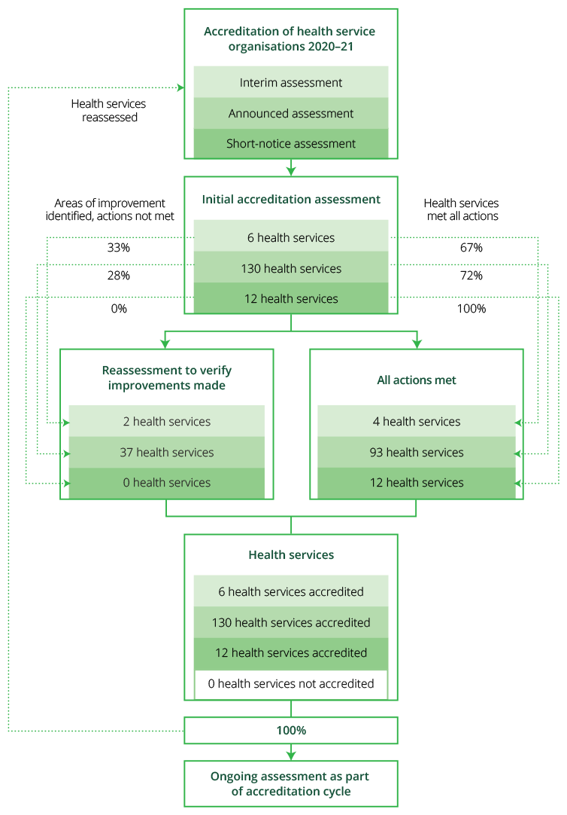

Improving the reliability of the accreditation processes
The Commission continues to respond to industry feedback and is implementing six strategies to improve the reliability of the accreditation process. Combined, these strategies will ensure that the accreditation process more accurately assesses a health service organisation’s implementation of the NSQHS Standards.
Key activities undertaken by the Commission in 2020–21 to improve the reliability of the accreditation process include the following.

Short-notice assessments
A voluntary option to undertake short-notice assessments, which are conducted with 48 hours of notice, was introduced for health service organisations in January 2019. A total of 25 health service organisations have undertaken short-notice assessments since then.
During 2021, the Commission worked with states and territories to broaden this program to include unannounced assessments for hospitals and day procedure services.

Governing body attestation statements
Health service organisations submit an annual attestation statement to their accrediting agency as evidence of their compliance with Actions 1.01 and 1.02 in the NSQHS Standards. These two actions specifically require governing bodies to ensure robust clinical governance systems and processes are in place. The attestation statement involves an organisation’s authorised officers, usually from governing bodies, confirming compliance with the NSQHS Standards.
At June 2021, 100% of health service organisations had complied with this requirement and submitted their attestation statements.

Public reporting of accreditation outcomes
In collaboration with states and territories, consumers and health service organisations, the Commission developed and tested a prototype for public reporting. Individual facilities will report on the outcomes of assessments and any areas where improvements were required to achieve accreditation. Public reporting on accreditation outcomes is anticipated to start in the second half of 2021.

Oversight and feedback on accrediting agency performance
The quality and timeliness of the data being collected on assessment outcomes has allowed comprehensive analysis of accrediting agency performance. Feedback is also collected on accrediting agencies through other key data sources, including observations by the Commission, post-assessment surveys from health service organisations, and information from enquiries to the NSQHS Standards Advice Centre. The Commission provides performance feedback to each of the accrediting agencies on a regular basis and monitors their compliance with the conditions of approval under the Australian Health Service Safety and Quality Accreditation (AHSSQA) Scheme.

Review of accreditation outcomes data
Accrediting agencies submit data on assessment outcomes through the Commission’s data collection portal. The portal automatically validates the data submitted to ensure that the information is consistent with the Commission’s requirements. The Commission analyses the data, and provides reports to state and territory regulators and various program administrators. In 2020–21 this included:
- Review of trends in compliance with NSQHS Standards and specific actions that require improvement
- Examination of the validity and consistency of not applicable actions awarded; these are actions from the NSQHS Standards that are not assessed because they do not apply in that service setting
- Identification of health service organisations that meet the criteria for mandatory reassessment
- Review of variation among accrediting agencies.

Assessor training
All assessors for the NSQHS Standards are required to undergo the NSQHS Standards Assessor Orientation Course. As of 30 June 2021, 384 assessors had completed this course. All assessors currently enrolled in the course have also been enrolled in the Core Cultural Learning Aboriginal and Torres Strait Islander Foundation Course, with 408 assessors completing this course. There are four intakes for the NSQHS Standards Assessor Orientation Course. The current course will be open until December 2021.

Post-assessment survey
A survey was sent to health service organisations after assessment to assist with monitoring the performance of accrediting agencies and assessors for the NSQHS Standards. The survey has had a 33.6% response rate.
Some of the key findings from the survey included: all assessments had a lead assessor, final reports were provided to health service organisations in a format that was easily understood, assessors had a comprehensive knowledge of the NSQHS Standards, assessors used the PICMoRS structured assessment method and referred to Commission resources when required.

Patient safety in primary health care
Primary health care is the setting where consumers most often receive health care, yet there are limited data on the frequency, causes and consequences of errors and adverse events in the sector. The Commission has been working to better understand the issues that affect patient safety in primary care settings, and to provide nationally consistent strategies, tools and resources for patient safety improvement.
Key activities undertaken by the Commission in 2020–21 on patient safety in primary care include the following.

National General Practice Accreditation Scheme
The National General Practice Accreditation (NGPA) Scheme commenced in January 2017 with the primary aim of supporting national consistency of accreditation of general practices. General practices participating in the NGPA Scheme are accredited to the Royal Australian College of General Practitioners (RACGP) Standards for general practices.
Five independent accrediting agencies were approved by the Commission to assess general practices to the RACGP Standards for general practices. A total of 856 general practices were assessed by these agencies, with almost all meeting the requirements of the standards and being awarded accreditation. Four general practices were not accredited.
Of the organisations assessed under the NGPA Scheme, 95% were general practices, and the remaining 5% were Aboriginal medical services. Of the general practices assessed, 557 were in metropolitan areas (65%), and more than half were in New South Wales or Victoria (51%).
In relation to the workforce of the general practices assessed, the NGPA Scheme found that:
- 83% employed five or fewer full-time equivalent (FTE) general practitioners
- 65% employed two or fewer FTE practice nurses.

Supporting general practices during the COVID–19 pandemic
The Commission worked extensively with the Australian Government Department of Health (the Department), Services Australia and accrediting agencies to support general practices during the COVID–19 pandemic. This included temporarily maintaining the accreditation status of all general practices between March and October 2020. During this period, the Commission provided advice and guidance to general practices and accrediting agencies, and implemented temporary arrangements for relocating general practices.
From October 2020, assessments resumed where there was a low risk of transmission of COVID–19. The Commission also provided general practices with a 12-month extension for assessments.

National Safety and Quality Primary and Community Healthcare Standards
Significant progress was made in the development of the National Safety and Quality Primary and Community Healthcare (NSQPCH) Standards. The NSQPCH Standards aim to protect the public from harm and improve the quality of care delivered by describing a nationally consistent framework that all primary and community healthcare services can apply when delivering care.
Following extensive input from the industry-based expert advisory committee, the Commission conducted a public consultation on the draft standards between October 2020 and January 2021. More than 360 consumers, healthcare providers and services, professional and peak bodies, Primary Health Networks and other representatives of the sector participated, and their feedback has been used to finalise the NSQPCH Standards, which are expected to be released in the second half of 2021.

Healthcare-associated infections, and infection prevention and control
Healthcare-associated infections are some of the most common and significant hospital-acquired complications, with almost 47,000 healthcare-associated infections per year. As well as causing unnecessary pain and suffering for patients and their families, a healthcare-associated infection can prolong a patient’s hospital stay and add considerably to the cost of delivering health care.
Effective infection prevention and control practices can minimise the risk of transmission of infection between patients, healthcare workers and other people in the healthcare environment and, in turn, reduces the risk of healthcare-associated infections.
Key infection prevention and control activities undertaken by the Commission in 2020–21 include the following.

Revision of the Infection Control Standard
The Commission convened the National Clinical Taskforce to support the review of the NSQHS Preventing and Controlling Healthcare-Associated Infection Standard. This review had a strong focus on transmission-based precautions, including aerosol-based transmission, environmental and other controls in relation to COVID–19.
This work resulted in the 2021 Preventing and Controlling Infections Standard, which was released for implementation in June 2021.
Major refinements included providing information about:
- Ensuring healthcare worker safety as part of patient safety objectives
- Managing members of the workforce with transmissible infections
- Managing the wellbeing of patients and healthcare workers who are required to isolate or quarantine due to infection.

The refinements also included requiring:
- Health service organisations to use the hierarchy of controls, in combination with infection prevention and control systems, to control for hazards such as aerosols
- Use of a precautionary approach to prevent transmission of infection, especially where evidence is emerging
- Consideration of ventilation and air management system issues, and emerging evidence in relation to these issues, as part of a precautionary approach to responding to the risk of airborne transmission of COVID–19.

Surveillance of healthcare-associated infections
From July 2020, the new national benchmark for Staphylococcus aureus bloodstream infection (SABSI) of 1.0 per 10,000 patient days came into effect. To support the implementation of this benchmark and local improvement activities, the Commission published an online compendium of SABSI prevention resources, developed jointly with the states and territories, and an information guide on SABSI data analysis. An updated implementation guide for SABSI surveillance, including an updated SABSI surveillance definition, has been published. The updated surveillance case definition for SABSI will take effect from 1 July 2021.
The Commission’s work on Clostridioides difficile infection (CDI) continued in 2020–21, with the publication of the 2018 CDI data snapshot report and the development of a three-year amalgam report on the national burden of CDI. Both reports highlighted the continued high prevalence of community-associated CDI cases presenting to Australian hospitals, indicating the need for greater effort to prevent and monitor CDI in the community.

National Hand Hygiene Initiative
The Commission continued its processes to enhance the National Hand Hygiene Initiative (NHHI), in collaboration with states and territories and the private sector. During 2020–21, improvements included automating validation of audit data, enabling access to auditor training resources via the NHHI learning management system, and the ongoing review and update of NHHI user guides.
More than 1,100 organisations submitted hand hygiene compliance data for Audit 1 2021 (1 November 2020 to 31 March 2021), which is the highest participation recorded since the NHHI began in 2008. Hospitals have continued to report hand hygiene compliance greater than the 80% national benchmark. Compliance for most healthcare worker groups also exceeded the national benchmark, and student doctors exceeded the benchmark for the first time in 2020.

Environmental cleaning resources
A suite of environmental cleaning resources was produced by the Commission. This included fact sheets on auditing environmental cleaning, product selection and new and emerging technologies. These resources emphasise the critical importance of maintaining clean and hygienic clinical environments for delivery of health care.

Updated guide on controlling carbapenemase-producing Enterobacterales
After an extensive review and consultation process, the Commission revised the guide on recommendations for the control of carbapenemase-producing Enterobacterales (CPE). CPE poses a significant risk to patient safety, because bacteria that produce carbapenemase enzymes are almost always resistant to other important antibiotic classes besides carbapenems. This means that effective treatment options for infections may be limited, and lengths of hospital admissions may increase.

Antimicrobial use and resistance in Australia
Antimicrobial resistance (AMR) reduces the range of antimicrobials available to treat infections, and increases morbidity and mortality associated with infections caused by multidrug-resistant organisms. AMR is well established as a priority area of action because of its serious and growing impact on human health.
Key AMR activities undertaken by the Commission in 2020–21 include the following.

Antimicrobial Use and Resistance in Australia Surveillance System
During 2020–21, the Commission continued the operation and enhancement of the Antimicrobial Use and Resistance in Australia (AURA) Surveillance System. As part of this, the Commission produced a range of reports, and supported transition of the overall coordination of AURA to the Department, as part of the expansion of AMR surveillance to a national One Health approach.
The Commission worked with the Australian Group on Antimicrobial Resistance (AGAR), the National Antimicrobial Prescribing Survey and the National Antimicrobial Surveillance Utilisation Program to finalise publications for their surveillance programs. The Commission also developed AURA 2021: Fourth Australian report on antimicrobial use and resistance in human health, which is finalised and expected to be formally released in the second half of 2021.
In 2020–21, the Commission continued to coordinate and operate other AMR surveillance systems, such as CARAlert and Australian Passive AMR Surveillance (APAS). APAS provides the largest volume of AMR data to AURA, and now includes more than 80 million individual susceptibility results from all states, the Australian Capital Territory, and a number of private sector laboratories. These data are readily accessible by the health service organisations that participate in APAS, and AURA reports include geographical and organism-related AMR trends to support states and territories, and clinicians.
Some of the key issues identified and reported on by the AURA Surveillance System in 2020–21, include:
- Ongoing inappropriate antimicrobial use in aged care; this included prolonged duration of use, high rates of PRN (as required) prescriptions, high rates of topical use, prolonged prophylaxis for conditions for which this is not recommended by guidelines, and poor documentation of indication, review and stop dates for antimicrobial prescriptions
- Resistance to ciprofloxacin and other fluoroquinolones has continued to rise in Escherichia coli isolates from community-onset infections, despite restricted access to these agents on the Pharmaceutical Benefits Scheme – these changes in resistance may mean increasing treatment failures and greater reliance on last-line treatments.

Participation in the WHO Global Antimicrobial Resistance and Use Surveillance System
In July 2020, the Commission worked with AGAR to analyse and submit AMR data to the WHO Global Antimicrobial Resistance and Use Surveillance System Program. Data were provided from the AGAR 2019 Sepsis Outcome Programs, and included five pathogens from blood (Staphylococcus aureus, Klebsiella pneumoniae, Escherichia coli, Acinetobacter species, Salmonella species). This is a significant achievement for AURA, and the first time data on these pathogens have been submitted by Australia to be included in this picture of international AMR.

Safety in digital health
The Commission contributes to improvements in digital health by optimising safety and quality in the rollout of clinical systems, including through development of tools, guidance and standards, and by undertaking reviews and research.
Key digital health activities undertaken by the Commission in 2020–21 include the following.

National Safety and Quality Digital Mental Health Standards
The National Safety and Quality Digital Mental Health (NSQDMH) Standards were launched in November 2020. The Commission developed the NSQDMH Standards with funding from the Department, and in collaboration with consumers, carers, families, clinicians, service providers and technical experts.
The NSQDMH Standards are a significant first step in providing safety and quality assurance for digital mental health service users, and best-practice guidance for service providers and developers. The Commission published resources to support digital mental health service providers implement the NSQDMH Standards.
In 2021, the Commission designed and piloted an accreditation scheme for the NSQDMH Standards. Accrediting agencies conducted assessments for a range of service providers to explore how the accreditation process works in the digital space. The findings from the pilot will inform the Commission’s recommendations to the Department for the implementation of the scheme in 2021–22.

My Health Record clinical safety program
The Australian Digital Health Agency (ADHA) engaged the Commission to undertake a clinical safety program for the My Health Record system and other national digital health infrastructure. In 2020–21, this included completing Clinical Safety Review 21, which examined the progress of health service organisations in implementing systems that can provide high-quality clinical information to My Health Record.

My Health Record in emergency departments
The ADHA also engaged the Commission to investigate requirements for emergency department clinicians to use the My Health Record system. In June 2021, the Commission finalised the My Health Record in Emergency Departments – Final Report and Adoption Model.
The report’s findings are based on a five-month study in four hospital emergency departments across Australia. Study activities included a staff survey, the collection of My Health Record ‘case studies’ from staff and patients, emergency department operational data, and My Health Record activity data.

Electronic Medication Management Self-Assessment Tool
The Commission developed the online Electronic Medication Management Self-Assessment Tool (EMM SAT) to support health service organisations to collect feedback about their system utility, and inform improvements to their EMM, as part of a continuous quality improvement program.
The online EMM SAT tool was released in late 2020 to a target group of health service organisations. Following positive feedback, it was rolled out more widely in 2021. Ongoing evaluation of the EMM SAT will continue throughout 2021 to better assess the tool’s effectiveness in supporting improvements in EMM systems.

Improving transitions of care between residential aged care facilities and hospitals
The Commission is undertaking a project to identify opportunities to improve transitions of care between residential aged care facilities (RACFs) and hospitals. Initially, the project is exploring the use of the My Health Record during transitions of care. This includes examining whether the My Health Record and the content contained within its current documents assists in the transition of information between health service organisations and RACFs. This project will support adjacent activities being undertaken by the Department as part of the Digital Economy Strategy, which includes a $301.8 million investment to enhance the My Health Record system.
Recruitment of up to four pilot sites began in 2020–21, including both RACFs and hospitals. The pilot will help inform an understanding of the role and effectiveness of My Health Record in transmitting accurate and timely information, and its impact on user workload, medication safety, and hospital readmission rates and incidents during transitions of care. The project started in 2020–21 and is due to be completed in 2021–22.

Medication safety
The Commission leads and coordinates a range of national initiatives to reduce medication errors and harm from medicines. Key medication safety activities undertaken by the Commission in 2020–21 include the following.

National baseline report on quality use of medicines
In November 2019, quality use of medicines and medicines safety was announced as Australia’s 10th National Health Priority Area. The Commission is leading work on a national baseline report on quality use of medicines and medicine safety, which will be used to inform new best-practice models, new national standards and better medication management.
Phase 1 of the report focuses on aged care and issues of polypharmacy, use of antipsychotic medicines and transitions of care. Phase 2 of the report focuses on investigating the broader issues of quality use of medicines and medicines safety, as well as issues of medication safety during transitions of care.
Informed by a discussion paper and public consultation in August 2020, phase 1 of the report will be released in the second half of 2021.

Review of quality use of medicines publications for aged care and community
In March 2021, the Commission was engaged by the Department to review and update three national quality use of medicines publications related to the National Medicines Policy:
- Guiding principles for medication management in residential aged care facilities
- Guiding principles for medication management in the community and reference guide
- Guiding principles to achieve continuity in medication management.
In 2020–21, a literature review and environmental scan were undertaken to inform the project, and a project advisory group provided technical and strategic advice. The revised guiding principles are due for completion and release in late 2021.

National standard for labelling dispensed medicines
Standardised labelling makes it easier for consumers to locate and understand the information about how to take their medicines safely and effectively. The Commission released the National Standard for Labelling Dispensed Medicines to guide the format and content of medicine-related information printed on dispensed medicines. The standard is for all health professionals who dispense medicines, including pharmacists, pharmacy technicians, nurse practitioners, general practitioners, optometrists and dentists.

Psychotropic medicines point prevalence study
The Commission is coordinating a psychotropic medicines point prevalence study involving 11 health service organisations across New South Wales, Queensland and South Australia to better understand the issue of inappropriate use of psychotropic medicines within residential aged care. The study began in May 2021, and aims to describe the prevalence and characteristics of psychotropic medicines initiated in hospitalised patients who are discharged to RACFs. A final report will be completed in 2021–22, and the study findings will inform future action by the Commission to support a reduction in inappropriate use of psychotropic medicines.

Active ingredient prescribing
National legislation on active ingredient prescribing was introduced in October 2019 with the aims of reducing consumer confusion, improving safe and quality use of medicines, and promoting the uptake of generic and biosimilar medicines. The Commission was engaged by the Department to develop guidance and resources for prescribers to support action to meet these new legislative requirements. These include:
- Active ingredient prescribing: User Guide for Australian prescribers and accompanying fact sheet
- Active ingredient prescribing: List of Medicines for Brand Consideration
- Active ingredient prescribing: List of Excluded Medicinal Items.

Education courses on high-risk medicines
The Commission has partnered with SA Health to develop an online suite of high-risk medicines eLearning modules. These modules promote the safe use of high-risk medicines, and each module focuses on a specific topic, medicine or medicine group.
There are currently five modules available, including one on opioid analgesics in acute settings that was released in February 2021. The final two modules – on psychotropic medicines and chemotherapy, and immune modulators – are in development and are expected to be released in 2021–22.

National Opioid Analgesic Stewardship Program
In May 2020, the Therapeutic Goods Administration (TGA) engaged the Commission to develop the National Opioid Analgesic Stewardship Program, including a clinical care standard.
A multidisciplinary topic working group was established to provide advice and guidance for the project. A discussion paper was distributed in April 2021 for consultation, and a framework for the National Opioid Analgesic Stewardship Program was provided to the TGA. The Commission will finalise the Opioid Analgesic Stewardship Clinical Care Standard in 2021–22.

Anticoagulant stewardship incident analysis
Inappropriate concomitant prescribing and administration of heparins and direct oral anticoagulants (DOACs) is a significant clinical issue. Clinicians not recognising anticoagulant medicines within the DOAC group has been identified as contributing to this problem.
In response to this issue, the Commission has developed the Anticoagulant Stewardship – Incident Analysis report. This report describes and quantifies anticoagulant-related incidents reported by hospitals and other healthcare services across Australia. The report also includes resources and initiatives that have been developed to support local anticoagulant stewardship efforts across Australia.

Mental health
The Commission has an ongoing commitment to support safety and quality in the delivery of mental health care. Key mental health activities undertaken by the Commission in 2020–21 include the following.

Recognising and responding to deterioration in a person’s mental state
The Commission released the Escalation Mapping template in August 2020, a quality improvement tool to assess the efficacy of health service organisations’ systems for recognising and responding to deterioration in a person’s mental state.
In May 2021, the Commission convened two webinars, bringing together stakeholders from a range of healthcare settings to share innovative and context-specific approaches to recognising and responding to deterioration in a person’s mental state.

Standards and guidance for community mental health services
The Commission developed a draft NSQHS Standards Guide for Acute and Community Mental Health Services. This guide provides information to support the implementation of the NSQHS Standards in mental health service organisations that are part of the AHSSQA Scheme. The guide will be finalised and released in late 2021.
In addition, in April 2021, the Commission began national consultation on the development of National Safety and Quality Mental Health Standards for Community Managed Organisations. These standards will complement existing standards, including the NSQHS Standards and the NSQDMH Standards, and provide consistent safety and quality standards across the continuum of care.

Cognitive impairment and intellectual disability
The Commission works collaboratively with agencies such as the NDIS Quality and Safeguards Commission and the Aged Care Quality and Safety Commission to increase the focus on safety and quality issues for people with cognitive impairment and intellectual disability.
Key activities undertaken by the Commission in 2020–21 on cognitive impairment and disability include the following.

Healthcare rights guide for people with cognitive impairment
The Commission released My Healthcare Rights: A guide for people with cognitive impairment for people with cognitive impairment and their families, along with translations into 10 languages and an easy-English guide.

Resource for intellectual disability
The Commission began development of resources for health service organisations on using the NSQHS Standards to improve care of people with intellectual disability. These resources will outline strategies for improvement, examples of good practice and helpful links, and will be completed in 2021–22.

Reducing inappropriate use of antipsychotic medicines
A web page of guidance and resources for reducing inappropriate use of antipsychotic medicines was published by the Commission. This web page includes links to relevant Commission work, including data from the Australian Atlas of Healthcare Variation series, the Delirium Clinical Care Standard, the NSQHS Standards and information on medication safety.
The Commission has also worked closely with the NDIS Quality and Safeguards Commission and the Aged Care Quality and Safety Commission in developing a coordinated action plan aimed at reducing inappropriate use of psychotropic medicines in response to behavioural and psychological symptoms of dementia and other conditions.

Communicating for safety
Communication is essential for safe, high-quality care. Failures in communication are commonly cited as a contributing factor in a range of preventable adverse events.
Key activities undertaken by the Commission in 2020–21 on communicating for safety include the following.

Open disclosure
A key recommendation of the 2020 review of the Australian Open Disclosure Framework was to update Commission resources to better support consistent implementation of the open disclosure process and increase consumer awareness of the purpose and value of open disclosure.
In March and April 2021, the Commission and the Consumers Health Forum of Australia facilitated consumer focus groups to co-design consumer fact sheets on open disclosure. A suite of consumer resources will be finalised in late 2021; they will include infographics, an easy-English version and translations of the fact sheets. Clinician open disclosure resources were also reviewed and updated in 2021.

Informed consent
In September 2020, new guidance was released on informed consent, the Informed Consent in Health Care fact sheet. The fact sheet sets out the importance of clear communication, discussion and shared decision making with the person receiving care, before obtaining informed consent. The fact sheet also provides information on key principles for informed consent, clinician ethical and legal responsibilities, consumer rights, and useful resources.

Comprehensive care
Comprehensive care describes the integration of screening, assessment and risk identification processes, with the aim of developing an individualised care plan. This individualised care plan should be developed through shared decision-making processes, be tailored to the needs and preferences of the patient, and prevent or minimise risk of harm.
Key comprehensive care activities undertaken by the Commission in 2020–21 include the following.

Guidance and resources
The Commission developed resources to support implementation of the Comprehensive Care Standard, including:
- Implementing the Comprehensive Care Standard: Deliver comprehensive care
- Implementing the Comprehensive Care Standard: Clinical assessment and diagnosis
- Setting Your Health Care Goals, an animation for consumers to support them setting their goals of care
- Set Goals for Your Care infographic
- A series of comprehensive care fact sheets.
The Commission also began evaluating implementation of the Standard to identify where further guidance and support may be needed. Assessed health service organisations were surveyed and assessment outcome data was reviewed, and findings will inform implementation of a targeted communication strategy for comprehensive care in 2021–22.

Sepsis program
The Department engaged the Commission to lead the National Sepsis Program in partnership with The George Institute for Global Health. The program consists of eight discrete projects aimed at improving outcomes for patients with sepsis in Australia.
A range of activities were completed in 2020–21, including:
- Development of a report on the epidemiology of sepsis in Australia
- Revision of the Antimicrobial Stewardship Clinical Care Standard
- Scoping the current state of sepsis survivorship services
- A systematic review of trigger tools that promote early detection of sepsis symptoms.
The findings from these activities will inform the development of the Sepsis Clinical Care Standard, and the review of the National Consensus Statement: Essential elements for recognising and responding to acute physiological deterioration, which will both start in 2021–22.

“Consumers will always be at the centre of everything we do.”
— Board Chair, Professor Villis Marshall ac

Priority 2: Partnering with consumers
This priority area aims to ensure that patients, consumers, carers and the community are engaged in understanding and improving health care for all.

Supporting consumer engagement and partnerships
Raising consumers’ awareness of their healthcare rights, the roles they play, and options available to foster healthcare improvement is a core focus of the Commission’s work.
Key activities undertaken by the Commission in 2020–21 to support consumer engagement and partnerships include the following.

Australian Charter of Healthcare Rights
The Australian Charter of Healthcare Rights (the Charter) aims to provide a shared understanding between consumers, clinicians and healthcare services about the rights of consumers accessing health care in Australia. As outlined in the NSQHS Standards, health service organisations are required to have a charter of rights that is consistent with the Charter, and to ensure that this information is easily accessible to patients, carers, families and consumers.
The Commission published two guides on the Charter for consumers, Understanding My Healthcare Rights: A guide for consumers and Understanding My Healthcare Rights: A summary booklet for consumers.
In addition, in response to requests from health service organisations, the Commission also published digital versions of the Charter poster, and infographics for display on television screens and patient rooms. These formats were developed to reduce the risk of infection associated with paper resources, and to provide options for consumers who may prefer non-written information.
The Commission began consultation and engagement with Aboriginal and Torres Strait Islander consumers to identify their needs and preferences for how to communicate information on the Charter in a meaningful way. Resources for Aboriginal and Torres Strait Islander communities will be developed in 2021–22.
The Commission also started work on three short resources to support health service organisations and clinicians apply the principles of the Charter in their day-to-day interactions with consumers. A national survey and workshops with clinicians and health service managers informed the development of the resources, which are expected to be released in late 2021.

Shared decision making and health information
The Commission reviewed and updated three patient decision aids, originally published in 2016, on the use of antibiotics for sore throats, middle ear infections and acute bronchitis. The approach involved an expert review of the evidence underpinning each of the resources, as well as design improvements to improve accessibility. Clinicians and consumers can use these aids during a consultation to weigh up the potential benefits and harms of using antibiotics, and make a decision together about the best treatment.
The Commission, in partnership with the Australian and New Zealand College of Anaesthetists, the Royal Australian and New Zealand College of Obstetricians and Gynaecologists, and the Royal Australasian College of Physicians, reviewed the online education module Helping Patients Make Informed Decisions: Communicating risks and benefits. The module, first published in 2016, aims to help clinicians develop and refine their skills in risk communication and shared decision making. The revised modules, based on best current evidence, will be released in late 2021.

End-of-life care
The Commission published Delivering and Supporting Comprehensive End-of-Life Care: A user guide for health service organisations and clinicians. This guide provides information for delivering end-of-life care that aligns with the NSQHS Standards and the National Consensus Statement: Essential elements for delivering safe and high-quality end-of-life care. Three complementary fact sheets for clinicians were also developed: clinical basics, planning and the last days of life.
A rapid literature review to update the evidence on safe and high-quality end-of-life care, and specific issues associated with end-of-life care during the COVID–19 pandemic, was also undertaken. The review will be used to inform the review and revision of the National Consensus Statement: Essential elements for delivering safe and high-quality end-of-life, which is to begin in 2021–22.

Measuring patient experience
Understanding patients’ experience of their care and outcomes is vital for identifying where improvements in the safety and quality of health care can be made. Key activities undertaken by the Commission in 2020–21 on measuring patient experience include the following.

Patient-reported experience measures
The Commission undertook an environment scan and literature review to understand how patient experience data are collected, measured and used in primary health care. The review provided insights into patient experience measurement in primary care in Australia, and will inform the Commission’s future action in this area.
The Commission continued to support health service organisations implementing the Australian Hospital Patient Experience Question Set (AHPEQS). AHPEQS is a non-proprietary 12-question survey instrument that assesses core aspects of patient experience. AHPEQS focuses on hospital patients and provides a mechanism for health service organisations to measure patient experience in a consistent manner.

Patient-reported outcome measures
Patient-reported outcome measures (PROMs) provide a systematic way to assess the effectiveness of healthcare interventions from the patient’s perspective. They complement and extend traditional measures, such as clinical indicators and measures of output or efficiency.
The Commission convened an expert advisory group and hip fracture expert panel to widen the use of PROMs in hip fracture care. The Commission is also working with experts to develop recommendations for the use of PROMs in low back pain and maternity care.
The Commission has been collaborating with the Organisation for Economic Co-operation and Development on a project to develop, pilot and report on PROMs internationally. In 2020–21, the Commission started managing Australia’s involvement in international work to develop a new survey on outcomes and experiences of patients over the age of 45 who have one or more chronic condition and receive primary or ambulatory care.

“Change would not be possible without the support and commitment of all our healthcare partners.”
— Chief Executive Officer, Adjunct Professor Debora Picone ao

Priority 3: Partnering with healthcare professionals
This priority area aims to ensure that healthcare professionals, organisations and providers are engaged and supported to deliver safe and high-quality care.

Indicators, measures and dataset specifications
Most health care in Australia is associated with good clinical outcomes; however, preventable adverse events and complications continue to occur across the healthcare system. To assist in identifying instances of harm, the Commission has developed three indicators for local monitoring of safety and quality: hospital-acquired complications, avoidable hospital readmissions and sentinel events.
In partnership with the Independent Hospital Pricing Authority (IHPA), and the state and territory health departments, the Commission developed specifications for hospital-acquired complications, avoidable hospital readmissions and sentinel events indicators under the National Health Reform Agreement. The 2020–25 Addendum to the National Health Reform Agreement includes these indicators, and promotes development of ways to reduce avoidable and preventable hospitalisations in collaboration with IHPA and the Administrator of the National Health Funding Pool.
Key indicator, measure and dataset specification activities undertaken by the Commission in 2020–21 include the following.

Sentinel Events and Hospital-acquired Complications list curation
The 2020–25 Addendum to the National Health Reform Agreement states that the Commission will curate the Australian Sentinel Events list and the Hospital-acquired Complications (HACs) list to ensure that they remain robust and relevant for clinical improvement purposes. The Commission continued curation of these lists in 2020–21, overseen by a clinical advisory group and with advice from relevant clinical specialty panels. Version 3.1 of the HACs list was published in March 2021, while work on mental health hospital-acquired complications continued in 2020–21.

Avoidable Hospital Readmissions list maintenance
The Commission developed the Avoidable Hospital Readmissions list (V1), including associated condition-specific timeframes. Under the 2020–25 Addendum to the National Health Reform Agreement, the Commission is also responsible for the ongoing maintenance and review of this list.
In late 2020, the Commission began a review of the Avoidable Hospital Readmissions list (V1), based on the process used for the curation of the HACs list. Version 2 of the Avoidable Hospital Readmissions list will be developed in 2021–22.

Avoidable and preventable hospitalisations
The 2020–25 Addendum to the National Health Reform Agreement requires the IHPA, the Commission and the Administrator of the National Health Funding Pool to ‘provide options for the further development of safety and quality-related reforms, including examining ways that avoidable and preventable hospitalisations can be reduced through changes to the National Health Reform Agreement’.
In 2020–21, the Commission developed its advice that avoidable and preventable hospitalisations can be reduced through evidence-based models of care for the management of certain conditions; the Commission has specified a list of these conditions. The Commission’s advice, along with advice from the IHPA and the Administrator of the National Health Funding Pool, on potential pricing and funding mechanisms will be included in a report for health ministers.

Clinical care standards indicators
The Commission has continued to develop and specify indicators to support the implementation of the clinical care standards. Indicators were developed for the Acute Anaphylaxis Clinical Care Standard, and the indicator set for the Antimicrobial Stewardship Clinical Care Standard was revised to ensure that the indicators remain fit for purpose, relevant and appropriate.
Work is under way to develop indicators for the new Sepsis Clinical Care Standard and the Low Back Pain Clinical Care Standard, and the revised Delirium Clinical Care Standard.

Patient safety culture measurement toolkit
Measuring staff perceptions of patient safety culture is invaluable. Healthcare staff are often the first to identify patterns of unsafe practice, and can often recognise risks or conditions that increase the likelihood of unsafe practices occurring.
The Commission finalised a patient safety culture measurement toolkit in 2020–21. The toolkit includes a validated survey to measure patient safety culture from the perspective of staff, information on other validated measures, and advice on implementation and improvement strategies.
The Commission will continue to work with the expert advisory group to promote the toolkit and support hospitals that are implementing projects to measure and improve patient safety culture.

Improving reporting of safety and quality data
Improving reporting of safety and quality data involves providing guidance, technical specifications and standards to support meaningful collection, analysis and use of data to measure and improve the safety and quality of health service delivery. Key activities to improve reporting of safety and quality data undertaken by the Commission in 2020–21 include the following.

Aligning public reporting for public and private hospitals
National public reporting of key safety and quality information will enable greater transparency of, and accountability for, the safety and quality of health care. It will contribute to quality improvement and quality assurance practices, and allow consumers to make better-informed choices about their care.
The Commission is undertaking the Patient Safety Reporting project to implement a health ministers’ agreement to align public reporting against standards of quality health care and patient safety across public and private hospitals nationally. The project aims to deliver standard national public reporting of five quality health care and patient safety measures across the hospital sector.
In 2020–21, the Commission finalised the technical specifications of indicators for the first four of these measures, and the requirements for the validation and public reporting platform.

Incident monitoring
A patient safety incident is an event or circumstance that could have resulted, or did result, in unnecessary harm to a patient. Incident monitoring systems are used to capture patient safety incidents and near misses.
The Commission developed a guide for incident monitoring, which provides a concise overview of the incident monitoring process and its underlying principles. The guide consolidates best-practice approaches based on literature reviews and state and territory incident monitoring policies.
The Commission also worked with an expert advisory committee to start development of a national approach to share analysis, reports and lessons learned from patient safety incidents. The aim is for the information to be shared across Australia to improve patient safety.

National Clinical Trials Governance Framework
The Commission conducted a pilot evaluation of the National Clinical Trials Governance Framework (the Governance Framework). The pilot included 33 health service organisations with clinical trial services. The pilot assessed the services against actions within the NSQHS Standards Clinical Governance Standard and Partnering with Consumers Standard, as provided in the Governance Framework.
As part of the pilot, the Commission engaged a mentoring team and an accrediting agency to conduct an accreditation assessment against a maturity scale. Overall, the Governance Framework was well received, and early insights indicate that health service organisations considered participation in the pilot valuable when navigating the changes required to embed clinical trial service provision into existing clinical and corporate governance systems.

“The Atlas is a cornerstone of our work, highlighting opportunities to improve access to evidence-based appropriate health care.”
— Chief Executive Officer, Adjunct Professor Debora Picone ao

Priority 4: Quality, value and outcomes
This priority area aims to ensure that evidence informs the delivery of safe, appropriate and high-quality care.

Identifying healthcare variation
Australia has one of the best health systems in the world, but there are large variations in the way health care is currently delivered across the country. Healthcare variation is not necessarily bad, and if it reflects differences in patients’ needs or preferences it is a good thing. But when a difference in use does not reflect these factors, it is unwarranted variation and represents an opportunity for the health system to improve.
This improvement may involve increasing access to treatment options that produce better outcomes for patients, or reducing treatment with little or uncertain benefit. Addressing unwarranted healthcare variation can therefore benefit patients and improve the value gained from the health budget.
Key activities undertaken by the Commission in 2020–21 to identify healthcare variation include the following.

The Fourth Australian Atlas of Healthcare Variation
The Commission published the Fourth Australian Atlas of Healthcare Variation (the fourth Atlas) in partnership with the Australian Institute of Health and Welfare. Covering 17 clinical items across six topic themes, the fourth Atlas was launched by the Minister for Health and Aged Care, the Hon. Greg Hunt MP on 28 April 2021.
Some key findings of the fourth Atlas included:
- Early planned birth
Around half (between 43% and 56%) of planned caesarean section births before 39 weeks in 2017 did not have a medical or obstetric reason, putting many newborns at avoidable risk. Birth before 39 weeks’ gestation is associated with a higher risk of breathing problems in newborns, and a higher risk of long-term learning and behavioural problems.
- Chronic disease and infection: potentially preventable hospitalisations
More than 330,000 potentially preventable hospitalisations in Australia in 2017–18 were due to five conditions: chronic obstructive pulmonary disease (COPD), kidney infections and urinary tract infections (UTIs), heart failure, cellulitis, and diabetes complications.
Rates of hospitalisation for these conditions varied substantially according to where people lived. Variation between lowest and highest rate areas was greatest for COPD (the highest rate was 18.5 times higher than the lowest), cellulitis (15.5 times) and diabetes complications (12.2 times).

Aboriginal and Torres Strait Islander people, people living in areas of socioeconomic disadvantage, and people living in remote areas had substantially higher rates of hospitalisation for the five conditions than other Australians. The rate of COPD hospitalisations for Aboriginal and Torres Strait Islander people was 4.8 times as high as the rate for other Australians.
Rates in 2017–18 were higher than in 2014–15 for all conditions, except for kidney infections and UTIs. There were large increases in hospitalisation rates for Aboriginal and Torres Strait Islander people, including a 17.8% increase for cellulitis and a 15.7% increase for COPD.

Resources for using healthcare variation data
In addition to online interactive Atlases, which allow data to be viewed, downloaded, compared and shared, the Commission has produced a range of resources to help health service organisations use and act on healthcare variation data. These resources feature case studies and interviews with clinicians and safety and quality experts, who share their practical advice on how to use healthcare variation data to make meaningful improvements in clinical care.
Key resources produced by the Commission in 2020–21 for using healthcare variation data include the following.

Better Care Everywhere online program series
In February 2021, the Commission held the online program series Better Care Everywhere: Healthcare variation in practice. The program series consisted of five webinars with keynote presentations from Australian healthcare leaders, followed by question-and-answer sessions:
- Same care everywhere? Far from it!
A discussion about the causes of healthcare variation, what variation means for health service leaders, clinicians, consumers and the health system, and how Atlas data can be used to improve health outcomes.
- Stopping the habit: Opioid prescribing in general practice
Advice on reducing inappropriate opioid prescribing, and the resulting harm, in primary care in Australia.
- Preventing a problem: Opioid prescribing in hospitals
Practical tips on how to change prescribing practices in hospitals, and work with primary care providers to prevent the problems of ongoing opioid use.
- Vanishing variation: Practical tips for doing more of the same
A discussion about managing change, and advice on how to make the investigation and management of healthcare variation part of your clinical governance framework. Recorded as an episode of the No Harm Done podcast.

- NSQHS Standards Action 1.28: Your roadmap to better care
Presentation of several case studies showing how to identify, investigate and address unwarranted variation, using the six steps to drive change and deliver better care in the NSQHS Standards User Guide for the Review of Clinical Variation in Health Care.

Development of further case studies for the NSQHS Standards User Guide for the Review of Clinical Variation in Health Care
The NSQHS Standards User Guide for the Review of Clinical Variation in Health Care provides step-by-step instructions for health service organisations on how to implement Action 1.28 of the NSQHS Standards. It includes several case studies, demonstrating how health service organisations can use data to identify and address potentially unwarranted clinical variation. More case studies are in development, using contributions from health service organisations that were prompted by consultation for the fourth Atlas.

Improving appropriateness of care
Appropriate care means offering patients care that optimises benefits and minimises harms, and is based on the best available evidence. At a health system level, it also needs to take into account whether the people with the greatest clinical need are receiving care.
Key activities by the Commission in 2020–21 to improve appropriateness of care include the following.

Clinical care standards
The Commission launched two new clinical care standards: the Third and Fourth Degree Perineal Tears Clinical Care Standard and the Management of Peripheral Intravenous Catheters Clinical Care Standard. In addition, the Commission began work on three new clinical care standards.

Acute Anaphylaxis Clinical Care Standard
The Commission drafted the Acute Anaphylaxis Clinical Care Standard, which aims to help improve the recognition of anaphylaxis and the provision of appropriate treatment and follow-up care. This standard is expected to be completed in 2021–22, and aligns with a recommendation in the 2020 Parliamentary Inquiry into Allergy and Anaphylaxis report Walking the Allergy Tightrope.

Low Back Pain Clinical Care Standard
The Commission drafted the Low Back Pain Clinical Care Standard, which aims to improve the early assessment and management of low back pain based on the best available evidence, and to reduce the use of investigations and treatment options that may be ineffective or unnecessary. This standard is expected to be consulted on and completed in 2021–22.

Sepsis Clinical Care Standard
As part of the National Sepsis Program, in 2020–21 the Commission drafted the Sepsis Clinical Care Standard. The purpose of the Sepsis Clinical Care Standard is to support evidence-based practices to improve early recognition, treatment and outcomes for patients with sepsis in Australia. This standard relates to neonatal, paediatric and adult patients in acute, non-acute and pre-hospital settings, and is expected to be completed in 2021–22.

Promotion of the Colonoscopy Clinical Care Standard
A range of resources were developed to support the implementation of the Colonoscopy Clinical Care Standard, including an educational webinar series, a checklist, a gap analysis tool and an indicator report. In addition, a consumer fact sheet about reducing the risk of bowel cancer, and a consumer fact sheet and video for Aboriginal and Torres Strait Islander peoples were developed in 2020–21.

Annual performance statements
As the accountable authority of the Commission, the Board presents the 2020–21 annual performance statements of the Commission, as required under subsection 39(1)(a) of the Public Governance, Performance and Accountability Act 2013. In the opinion of the Board, based on advice from Commission management and the Audit and Risk Committee, these annual performance statements accurately reflect the performance of the Commission and comply with subsection 39(2) of the Public Governance, Performance and Accountability Act 2013.
Professor Villis Marshall ac
Board Chair

Our purpose
Our purpose is to contribute to better health outcomes and experiences for all patients and consumers, and improve the value and sustainability of the health system, by leading and coordinating national improvements in the safety and quality of health care. Within this overarching purpose, the Commission aims to ensure that people are kept safe when they receive health care and that they receive care that is right for them.
The functions of the Commission are specified in section 9 of the National Health Reform Act 2011, and include:
- Formulating standards, guidelines and indicators relating to healthcare safety and quality matters
- Advising health ministers on national clinical standards
- Promoting, supporting and encouraging the implementation of these standards, and related guidelines and indicators
- Monitoring the implementation and impact of the standards
- Promoting, supporting and encouraging the implementation of programs and initiatives relating to healthcare safety and quality matters
- Formulating model national schemes that provide for the accreditation of organisations that provide healthcare services, and relate to healthcare safety and quality matters
- Publishing reports and papers relating to healthcare safety and quality matters.

Analysis of performance against purpose
In 2020–21, the Commission achieved a number of goals in line with the 2020–21 Health Portfolio Budget Statements and Corporate Plan 2020–21. The Commission continued to deliver consistently high-quality and valuable work in areas that can be improved through national coordination and action.
The Commission reviewed and refreshed its strategic priorities in 2019–20, and developed a Strategic Intent 2020–2025. The Strategic Intent guides the Commission in undertaking its work, and is expressed in four strategic priorities that aim to ensure that patients, consumers and communities have access to and receive safe and high-quality health care.
Key to the Commission’s strategic priorities are partnerships led at a national level, supported by local activities and implementation. To facilitate these national partnerships, the Commission works closely with patients, carers and clinicians; the Australian, state and territory health systems; the private sector; managers; and healthcare organisations to achieve a safe, high-quality and sustainable health system.
The Commission works with its partners to support the implementation of safety and quality initiatives by developing guidance, resources, tools and educational materials. The Commission also supports the evaluation of its activities, and measurement of the impact of initiatives to improve safety and quality of the health system. The Commission continually looks to identify new and emerging safety and quality issues, while being responsive to the evolving needs of its partners and the healthcare system.

In 2020–21, Australian and international healthcare systems continued to respond to the ongoing COVID–19 pandemic. The Commission continued to work flexibly to respond to changing needs and risks within the healthcare system. This included expanding and communicating national guidance on infection prevention and control; developing additional information and resources on COVID–19 for health services, clinicians and consumers; redeploying staff to support critical pandemic response activities, including contact tracing and investigations; and adjusting work plan activities to avoid placing undue pressure on the healthcare system.
The Commission has continued to work differently, both operationally and strategically, to support the health system in its response to the COVID–19 pandemic. The Commission has taken a risk management approach to balancing work plan activities with new requests and redeployment directions, and continually monitored the progress of deliverables. Consequently, the Commission has been able to progress its strategic priorities as planned and deliver the work plan, while at the same time responding and providing support to the health system to operate safely during the COVID–19 pandemic.
In 2020–21, some of the Commission’s key achievements include:
- Development of a range of resources to support health service organisations in understanding and meeting the requirements of the NSQHS Standards, including guides and fact sheets on topics such as consumer involvement in governance, preventing pressure injuries, wound management and reviewing clinical variation
- Implementation of reform strategies to the AHSSQA Scheme, including instituting attestation statements for governing bodies, voluntary short-notice assessments, recognition of exemplar practices and user testing a prototype for public reporting of accreditation outcomes
- Review of the NSQHS Preventing and Controlling Healthcare-Associated Infection Standard. This has a particular focus on transmission-based precautions, including aerosol-based transmission, environmental and other controls in relation to COVID–19. This work resulted in the release of the 2021 Preventing and Controlling Infections Standard
- Release of Australia’s first National Safety and Quality Digital Mental Health Standards
- Broadcast of the Better Care Everywhere: Healthcare variation in practice online seminar series. This seminar series focused on reducing unwarranted variation in clinical care in Australia through a series of five live-streamed webinars
- Publication of the Fourth Australian Atlas of Healthcare Variation. The Atlas highlights opportunities to improve access to evidence-based care across Australia and reduce the use of low-value therapies. This Atlas included topics such as early planned birth, chronic disease and infection, and medication use in older people
- Development and publication of detailed reports from the following AURA Surveillance System programs: the AGAR, the Hospital National Antimicrobial Prescribing Survey and the National Antimicrobial Utilisation Surveillance Program, in addition to the submission of antimicrobial resistance data to the World Health Organization Global Antimicrobial Resistance and Use Surveillance System Program

- Development and release of the Delivering and Supporting Comprehensive End-of-Life Care: a user guide for health service organisations and clinicians and accompanying fact sheets. This guide provides information for achieving end-of-life care that aligns with the NSQHS Standards and the National Consensus Statement
- Commencement of the National Sepsis Program, including completion of a literature review on sepsis trigger tools, and commencement of a Sepsis Clinical Care Standard and medical record review
- Ongoing management of a clinical safety program for the My Health Record system, and delivery of a clinical safety review on the implementation of systems by health service organisations that can provide high-quality clinical information to My Health Record
- Release of the Third and Fourth Degree Perineal Tears Clinical Care Standard and the Management of Peripheral Intravenous Catheters Clinical Care Standard. In addition, work commenced on the development of three new clinical care standards on acute anaphylaxis, low back pain and sepsis, to identify and define the care people should expect to receive or be offered, and support the delivery of appropriate care and reduce unwarranted variation.

Performance against the Corporate Plan 2020–21 and Health Portfolio Budget Statements
The Commission’s Corporate Plan 2020–21 was prepared under subsection 35(1)(a) of the Public Governance, Performance and Accountability Act 2013, and published in accordance with section 16E(3) of the Public Governance, Performance and Accountability Rule 2014.
The Corporate Plan 2020–21 identifies the strategic priorities that drive the Commission’s direction and work for the four-year period to 2023–24, and specifies how the Commission will measure its performance during that period. The Corporate Plan is informed by the Commission’s work plan, which is required under the National Health Reform Act 2011. The Corporate Plan can be accessed on the Commission’s website: www.safetyandquality.gov.au/about-us/corporate-plan
The Commission’s performance criteria for 2020–21 were published in the Corporate Plan and formed the basis of the Commission’s entry in the 2020–21 Health Portfolio Budget Statements. Table 1 provides a report against the performance measures set out in the Corporate Plan 2020–21 and Health Portfolio Budget Statements.

- Report against performance measures in the Corporate Plan 2020–21 and Health Portfolio Budget Statements
Performance criteria | Target 2020–21 | Result against performance criteria
Implement the National Safety and Quality Health Service (NSQHS) Standards and coordinate the Australian Health Service Safety and Quality Accreditation Scheme, whilst supporting health services, health professionals, patients and consumers to form effective partnerships. | Hospitals and day procedure services assessed against the NSQHS Standards. | Achieved and ongoing  A maintenance period was introduced because the COVID–19 pandemic interrupted assessments. The maintenance period ended on 26 October 2020; however, further lockdowns and border closures have delayed or postponed some assessments.  All hospitals and day procedure services have scheduled assessments to the NSQHS Standards. In 2020–21, 148 hospitals or day procedure services were assessed against the NSQHS Standards.
 | Provide guidance and resources to support health services to meet the second edition of the NSQHS Standards. In 2020–21, this will include a guide for community health services and a user guide for health services providing care to people from migrant and refugee backgrounds. | Achieved and ongoing  A community health services guide and a user guide for people from migrant and refugee backgrounds were finalised and will be released in 2021–22.  Multiple fact sheets, tools and advisories were released and updated during 2020–21.

Performance criteria | Target 2020–21 | Result against performance criteria
 | Accrediting agencies approved to assess health services to the NSQHS Standards. | Achieved and ongoing  Seven accrediting agencies held approval to assess to the NSQHS Standards in 2020–21.  The next approval process will be conducted in December 2021, before current approvals are due to expire.
 | Provide guidance, through publications and other resources, to health services, health professionals, patients and consumers about forming effective partnerships. | Achieved and ongoing  Guidance on forming effective partnerships was developed and provided to health services, health professionals, patients and consumers. This included the release of two consumer guides to support the use and understanding of the second edition of the Australian Charter of Healthcare Rights.
Examine healthcare variation and work to reduce unwarranted variation to improve quality and appropriateness of care. | Produce a rolling program of reports on healthcare variation in Australia, and release the Fourth Australian Atlas of Healthcare Variation. | Achieved and ongoing  The Fourth Australian Atlas of Healthcare Variation was released in April 2021. The fourth Atlas examined variation in 17 healthcare items across six clinical areas, and included changes in rates over time for 10 items.  In February 2021, the Commission broadcast the Better Care Everywhere: Healthcare variation in practice webinar series for policy makers, health service managers and clinicians. This was the first program of its kind dedicated to reducing unwarranted variation in clinical care in Australia.

Performance criteria | Target 2020–21 | Result against performance criteria
 |  | To support health service organisations reduce unwarranted variation, the NSQHS Standards User Guide for the Review of Variation in Health Care was published in August 2020.
 | Produce clinical care standards and other resources focusing on high impact, high burden and high variation areas of clinical care. In 2020–21, this will include clinical care standards on sepsis, lower back pain and acute management of anaphylaxis. | Achieved and ongoing  The Acute Anaphylaxis Clinical Care Standard has been finalised and will be released in 2021–22.  The Low Back Pain Clinical Care Standard is substantially complete and will be finalised in 2021–22.  The consultation draft Sepsis Clinical Care Standard has been completed for public consultation and will be finalised in 2021–22.  The Third and Fourth Degree Perineal Tears Clinical Care Standard and the Management of Peripheral Intravenous Catheters Clinical Care Standard were released in 2020–21.
 | Review and revise previously released clinical care standards. In 2020–21, this will include antimicrobial stewardship, delirium and hip fracture clinical care standards. | Achieved and ongoing  The Antimicrobial Stewardship Clinical Care Standard was revised and released in 2020–21.  Consultation on the revised Delirium Clinical Care Standard is complete and the standard will be released in 2021–22.  The review of the Hip Fracture Care Clinical Care Standard commenced in 2020–21, and will be finalised in 2021–22.

Performance criteria | Target 2020–21 | Result against performance criteria
Identify, specify and refine clinical and patient-reported measures and safety and quality indicators. | Provide and maintain nationally agreed health information standards, measures and indicators for safety and quality, such as:  - support and measure performance towards new clinical care standards; and  - support and measure performance towards an enhanced patient safety culture. | Achieved and ongoing  The Commission developed and maintained:  - core hospital-based outcome indicators  - indicators for the clinical care standards  - measures of hospital-acquired complications  - measures of avoidable hospital readmissions  - patient safety culture toolkit.
 | Provide further guidance and tools for health services to support the local use of data for safety and quality improvement. | Achieved and ongoing  In 2020–21, the Commission developed and maintained nationally agreed health information standards, measures and indicators for safety and quality. This included an update of hospital-acquired complications specifications (Version 3.1).

Performance criteria | Target 2020–21 | Result against performance criteria
 | Maintain guidance and tools for adverse patient safety events and hospital-acquired complications. | Achieved and ongoing  During 2020–21, the Commission continued its role in providing guidance and tools to support patient safety. These included:  - ongoing provision of the hospital-acquired complications grouper, to support health services identify these complications  - continued support for the implementation of local programs to improve hospital-acquired complications and avoidable hospital readmissions  - the Commission Sentinel Events Review Committee, to assist local services in assessing potential sentinel events.
Percentage of consumers and clinicians participating in the Commission’s consultation and advisory processes who report positively on the work of the Commission. | When surveyed, 80% of consumers and clinicians participating in consultation and advisory processes report positively on the work of the Commission. | Achieved  The Commission surveyed its committee members; 92% responded that they are either ‘very satisfied’ or ‘satisfied’ in their dealings with the Commission through their committee membership.

3. Corporate governance and accountability

This section outlines the Commission’s legislative requirements, corporate governance and accountability processes, including internal and external scrutiny arrangements, and procedures for risk management and fraud control. It also includes profiles of the Commission’s Board and committee members.
Legislation and requirements 64
Commission’s Board 66
Committees 73
Internal governance arrangements 76
External scrutiny 78

Legislation and requirements
The Commission is a corporate Commonwealth entity of the Australian Government, accountable to the Australian Parliament and the Australian Government Minister for Health and Aged Care.
The Commission’s principal legislative basis is the National Health Reform Act 2011, which sets out the Commission’s purpose, powers, functions, and administrative and operational arrangements. The National Health Reform Act 2011 also sets out the Commission’s Constitution, the process for appointing members of the Board and the Chief Executive Officer (CEO), and the operation of Board meetings.
The Commission must fulfil the requirements of the Public Governance, Performance and Accountability Act 2013, which regulates certain aspects of the financial affairs of Commonwealth entities; their obligations relating to financial and performance reporting, accountability, banking and investment; and the conduct of their accountable authorities and officials.

Compliance with legislation
The Commission has complied with the provisions and requirements of the:
- Public Governance, Performance and Accountability Act 2013
- Public Governance, Performance and Accountability Rule 2014
- Appropriation Acts
- Other instruments defined as ‘finance law’, including relevant ministerial directions.

Strategic planning
The Commission’s Strategic Intent 2020–2025 outlines four priority areas of focus for the Commission, and describes a range of mechanisms used to progress them. The four strategic priorities that guide the Commission in undertaking its work are:
- Priority 1: Safe delivery of health care – clinical governance, systems, processes and standards ensure that patients, consumers and staff are safe from harm in all places where health care is delivered
- Priority 2: Partnering with consumers – patients, consumers, carers and the community are engaged in understanding and improving health care for all
- Priority 3: Partnering with healthcare professionals – healthcare professionals, organisations and providers are engaged and supported to deliver safe and high-quality care
- Priority 4: Quality, value and outcomes – evidence-based tools, guidance and technology are used to inform delivery of safe and high-quality care that is integrated, coordinated and person-centred.

Ministerial directions
Section 16 of the National Health Reform Act 2011 empowers the Australian Government Minister for Health and Aged Care to make directions with which the Commission must comply. The Minister for Health and Aged Care made no such directions during the 2020–21 reporting period.

Related-entity transactions
In accordance with the requirements prescribed by section 17BE of the Public Governance, Performance and Accountability Rule 2014 and the Australian Government Department of Finance Resource Management Guide 136: Annual reports for corporate Commonwealth entities, related-entity transactions for 2020–21 are disclosed in Appendix A.

Indemnity and insurance
The Commission holds directors’ and officers’ liability insurance cover through Comcover, the Australian Government’s self-managed fund. As part of its annual insurance renewal process, the Commission reviewed its insurance coverage in 2020–21 to ensure that the coverage was still appropriate for its operations. During the year, no indemnity-related claims were made, and the Commission knows of no circumstances likely to lead to such claims. Many liability limits under the Commission’s schedule of cover are standard Australian Government limits, such as $100 million in cover for general liability and professional indemnity, as well as directors’ and officers’ liability. The Commission’s business interruption indemnity cover is for a period of up to 24 months. Motor vehicle, third-party property damage and expatriate cover have not been taken out, as they do not apply to the Commission.

Commission’s Board
The Commission’s Board governs the organisation, and is responsible for the proper and efficient performance of its functions. The Board establishes the Commission’s strategic direction, including directing and approving its strategic plan, and monitoring management’s implementation of the plan.
The Board also oversees the Commission’s operations. It ensures that appropriate systems and processes are in place so that the Commission operates in a safe, responsible and ethical manner, consistent with its regulatory requirements.
The Board is established and governed by the provisions of the National Health Reform Act 2011 and the Public Governance, Performance and Accountability Act 2013.

Board membership 2020–21
The Australian Government Minister for Health and Aged Care appoints the Commission’s Board in consultation with all state and territory health ministers. The Board includes members who have extensive experience and knowledge in the fields of healthcare administration, provision of health services, law, management, primary health care, corporate governance, and improvement of safety and quality.

Professor Villis Marshall ac (chair)
Professor Villis Marshall brings to the Board experience in providing healthcare services, managing public hospitals, and improving safety and quality. Professor Marshall has significant clinical experience as a urologist, and as Clinical Director (Surgical Specialties Service) for the Royal Adelaide Hospital and Clinical Professor of Surgery at the University of Adelaide.
Professor Marshall was awarded a Companion of the Order of Australia in 2006 for services to medicine, particularly urology and research into kidney disease; to the development of improved healthcare services in the Defence forces; and to

the community through distinguished contributions to the development of pre-hospital first aid care provided by St John Ambulance Australia.
His previous appointments include General Manager at Royal Adelaide Hospital, Senior Specialist in Urology and Director of Surgery at Repatriation General Hospital, and Professor and Chair of Surgical and Specialty Services at Flinders Medical Centre.
Qualifications: MD, MBBS, FRACS
Board membership: Appointed to Board on 1 April 2012; appointed as Chair on 1 April 2013; reappointed as Chair on 1 July 2017 and 8 April 2020.

Dr David Filby psm
Dr David Filby has worked extensively across the Australian healthcare landscape in several significant policy and executive roles. He has held senior national health policy roles and senior executive positions in Queensland and South Australia. In July 2016, he completed a term of six and a half years as Executive Consultant for SA Health and the Australian Health Ministers’ Advisory Council.
Dr Filby was a board member of the National Health Performance Authority until June 2016 and a board member of the Australian Institute of Health and Welfare for 14 years. In August 2016, he finished a nine-year term, including six as Chair, with Helping Hand Aged Care Inc. He is a member of the board of Pedare School. In 2008, he was awarded a Public Service Medal, and in 2007 was awarded the Sidney Sax Medal by the Australian Healthcare and Hospitals Association.
Previously, he was on the board of South Australia’s Child Health Research Institute Council.
Qualifications: PhD
Board membership: Appointed on 29 July 2016; term concluded on 31 March 2021.

Ms Christine Gee
Ms Christine Gee brings to the Board extensive experience in private hospital administration, having held executive management positions for more than 30 years. She has been the CEO of Toowong Private Hospital, a mental health service, since 1997 and is Chair of the Commission’s Private Hospital Sector Committee.
Ms Gee is involved in a number of state and national boards and committees, including the Australian Private Hospitals Association, the Private Hospitals Association of Queensland, the Australian Institute of Health and Welfare, and the Queensland Board of the Medical Board of Australia. She is the Chair of the Medical Board of Australia’s National Special Issues Committee and she was the private sector representative on the Safety and Quality Partnership Standing Committee of the Mental Health Principal Committee prior to its cessation in 2021.
Qualifications: MBA
Board membership: Appointed as a Commission member in March 2006; appointed to the Board on 1 July 2011 and reappointed on 1 July 2018.

Ms Wendy Harris qc
Ms Wendy Harris QC is a barrister who specialises in commercial law. She was admitted to the Victorian Bar in 1997 and was appointed Senior Counsel in 2010.
Between 2011 and 2015, she was Board Chair of the Peter MacCallum Cancer Centre, Australia’s only public hospital dedicated to cancer treatment, research and education. Other past directorships include 10 years on the Board of Barristers’ Chambers Limited, which is the repository of the substantial property assets of the Victorian Bar, and provider of chambers accommodation and ancillary services to its members.
Ms Harris is also immediate past President of the Victorian Bar Inc.
Qualifications: LLB (Hons)
Board membership: Appointed on 1 July 2015 and reappointed on 8 April 2020.

Dr Helena Williams
Dr Helena Williams brings to the Board active clinical expertise as a practising general practitioner and leadership experience as a previous Clinical Director of Southern Adelaide–Fleurieu–Kangaroo Island Medicare Local Ltd. She is also currently the Executive Medical Director, South Australia/East Coast, for the Silver Chain Group and a HealthPathways GP Clinical Editor in South Australia.
Dr Williams’s governance experience includes six years as the Presiding Member of the Southern Adelaide Local Health Network Governing Council. Past directorships include the Southern Adelaide Health Service, the Cancer Council South Australia, Noarlunga Health Services, the South Australian Divisions of General Practice, and the Australian General Practice Network.
Qualifications: MBBS, FRACGP
Board membership: Appointed as a Commission member in April 2008; appointed to the Board on 1 July 2011 (term concluded 30 June 2018) and reappointed on 1 April 2019.

Adjunct Professor Veronica Casey am
Adjunct Professor Veronica Casey has held nursing and midwifery executive leadership positions in Queensland Health since 1997. She worked in nursing and midwifery Executive Director roles at The Prince Charles Hospital, the Royal Brisbane Hospital and the Royal Women’s Hospital before her appointment as Executive Director, Nursing Services, Princess Alexandra Hospital; and Executive Director, Nursing and Midwifery Services, Metro South Health. At Princess Alexandra Hospital, she has been instrumental in helping the hospital achieve redesignation under the Magnet® credentialing program, and in introducing the Nurse Sensitive Indicator performance monitoring system. Professor Casey’s experience and expertise in the nursing profession extend to national and international platforms. She is current Chair of the Nursing and Midwifery Board of Australia, and served as an inaugural International Magnet Commissioner for the American Nurses Credentialing Center from 2010 to December 2017. She has been recognised for her contribution to the nursing and midwifery profession by being awarded the American Nursing Credentialing Center HRH Princess Muna Al-Hussein Award for international contribution to nursing in 2011; and the Queensland University of Technology Outstanding Alumni Award, Faculty of Health, 2018, for contribution to nursing and health care; and being appointed as a Member of the Order of Australia (General Division) in 2019.

Professor Casey’s special interests are workforce planning and development; change management – changing cultures within work environments that enhance a positive practice environment; providing mentorship to nurses and other disciplines; participating in the educational development of undergraduate and postgraduate students on an academic and practical level; governance structures that are inclusive for all levels of staff, establishing credentialing requirements within nursing, and quality and safety systems that support professional and clinical standards.
Qualifications: RN, RM, BN, MN-Leadership, GradDipNursing – Geriatrics, GradDip – Management (Dist), FCNA
Board membership: Appointed on 1 April 2019.

Ms Glenys Beauchamp psm
Ms Glenys Beauchamp was Secretary of the Australian Government Department of Health from 18 September 2017 to 28 February 2020. She has had an extensive career in the Australian Public Service at senior levels, with responsibility for a number of significant government programs covering economic and social policy areas. She has more than 25 years of experience in the public sector and began her career as a graduate in the Industry Commission.
Ms Beauchamp was Secretary of the Department of Industry, Innovation and Science (2013–2017), and Secretary of the Department of Regional Australia, Local Government, Arts and Sport (2010–2013). She has served as Deputy Secretary in the Department of the Prime Minister and Cabinet (2009–10), and the Department of Families, Housing, Community Services and Indigenous Affairs (2002–2009).
Ms Beauchamp has held a number of executive positions in the ACT Government, including Deputy Chief Executive, Department of Disability, Housing and Community Services; and Deputy Chief Executive Officer, Department of Health. She has also held senior positions in housing, energy and utilities functions with the ACT Government.
Ms Beauchamp was awarded a Public Service Medal in 2010 for coordinating Australian Government support during the 2009 Victorian bushfires.
Ms Beauchamp currently serves on a number of government and private sector boards, including not-for-profit boards.
Qualifications: BEcon, MBA
Board membership: Appointed on 1 July 2018.

Adjunct Professor Janet Weir-Phyland
Adjunct Professor Janet Weir-Phyland is the Executive Director Nursing Services and Chief Nursing Officer at Alfred Health. Professor Weir-Phyland is responsible for the professional leadership of nurses, allied health services, non-clinical support services, patient experience, community participation, population health and environmental sustainability. With more than 25 years of experience in health, she has worked in a number of management and senior management positions in both Canada and Australia in the areas of education; clinical governance; and acute, subacute and residential care services. Her particular interest is improving quality and safety, and enhancing patient experience.

Professor Weir-Phyland is an Adjunct Professor with the School of Nursing and Midwifery at Deakin University.
Qualifications: DipNrsg, BScN, MBA
Board membership: Appointed on 1 July 2019.

Ms Caroline Edwards psm
Ms Caroline Edwards PSM is the Associate Secretary at the Australian Department of Health. Caroline has responsibility for whole-of-portfolio strategic policy and relations, health economics and medical research, sport and the strategic and corporate operations of the department. She led the Health response to the COVID–19 pandemic in 2020 and currently has responsibility for the vaccine rollout program. Caroline holds a Bachelor of Laws with first class Honours from Monash University, Australia. She was previously District Registrar for the Federal Court of Australia and has held a range of legal and public administration roles.
Qualifications: LLB (Hons)
Board membership: Appointed on 1 February 2021.

Board meetings and attendance
Attendance at Board meetings, along with beginning and ending of terms, is outlined in Table 2.
- Attendance at Board meetings
 | Meeting date
Name | 8 September 2020 | 11 October 2020 | 25 March 2021 | 25 June 2021
Professor Villis Marshall AC (Chair) | a | a | a | a
Ms Glenys Beauchamp PSM | a | a | a | a
Adjunct Professor Veronica Casey AM | r | r | r | a
Ms Caroline Edwards PSM | – | – | a | r
Dr David Filby PSM | a | a | a | –
Ms Christine Gee | a | a | a | a
Ms Wendy Harris QC | r | a | a | a
Adjunct Professor Janet Weir-Phyland | a | a | a | a
Dr Helena Williams | a | a | a | a
a Present r Absent – Not applicable

Board developments and review
New Board members undertake a formal induction to their role, including a meeting with the Chair and CEO. They receive an induction manual that includes the Board Operating Guidelines, which informs the conduct of Board members, and describes their responsibilities and duties under legislation.
Board members are briefed on relevant topics at meetings, as appropriate. They are required to undertake ongoing professional development relevant to, and in line with, the Commission’s needs. The Commission supports Board members to pursue these activities.

Ethical standards
The Commission’s Board Operating Guidelines provide a Board Charter that outlines the function, duties and responsibilities of the Board, as well as a code of conduct that defines the standard of conduct required of Board members, and the ethics and values they are bound to uphold. The Duty to Disclose Interests Policy for Board Members requires Board members to recognise, declare, and take reasonable steps to avoid or appropriately manage any conflicts of interest. This includes the duty to disclose material personal interests, as required under section 29 of the Public Governance, Performance and Accountability Act 2013.

Committees
The Audit and Risk Committee helps the Board discharge its responsibilities under the National Health Reform Act 2011 and the Public Governance, Performance and Accountability Act 2013 with respect to financial reporting, performance reporting, risk oversight and management, and internal control.
The Inter-Jurisdictional Committee meets regularly to provide advice to the Commission and the Board on the Commission’s work, and safety and quality matters in the states and territories.
Additional standing committees and reference groups provide sector- and topic-specific advice on the Commission’s programs and projects.

Audit and Risk Committee
The Board established the Audit and Risk Committee in compliance with section 45 of the Public Governance, Performance and Accountability Act 2013 and section 17 of the Public Governance, Performance and Accountability Rule. The primary role of the committee is to help the Board discharge its responsibilities with respect to financial reporting, performance reporting, risk oversight and management, internal control, and compliance with relevant laws and policies.
The Committee’s responsibilities include:
- Reviewing the appropriateness of risk management frameworks, including identification and management of the Commission’s business and financial risks (including fraud)
- Monitoring the Commission’s compliance with legislation, including the Public Governance, Performance and Accountability Act 2013 and Rule
- Monitoring preparation of the Commission’s annual financial statements and recommending their acceptance by the Board
- Reviewing the appropriateness of the Commission’s performance measures, and how these are assessed and reported
- Assessing whether relevant policies are in place to maintain an effective internal control framework, including for security arrangements and business continuity
- Reviewing the work undertaken by the Commission’s outsourced internal auditors, including approving the internal audit plan, and reviewing all audit reports and issues identified in them.
The Audit and Risk Committee Charter is available online.

The Audit and Risk Committee met five times during 2020–21. Table 3 summarises members’ attendance at committee meetings.
In accordance with the Public Governance, Performance and Accountability Rule, although members of the Commission’s senior management attended meetings as advisors, they were not members of the Audit and Risk Committee and the majority of members are not officials of any Commonwealth entity.
- Audit and Risk Committee attendance and remuneration, 2020–21
Committee member | Meeting attendance | Remuneration (GST excl)
Jennifer Clark (Chair) | 5/5 | $40,425
Peter Achterstraat | 5/5 | $15,000
Dana Sutton | 5/5 | Nil

Ms Jennifer Clark (Chair)
Ms Jennifer Clark is the Chair of the Committee. Ms Clark has an extensive background in business, finance and governance through a career as an Investment Banker and as a Non-Executive Director.
She has been the chair or member of over 20 audit, risk and finance committees in the Commonwealth and private sectors over the past 30 years. Ms Clark is a Fellow of the Australian Institute of Company Directors and has substantial experience in financial and performance reporting, audit and risk management.

Mr Peter Achterstraat
Mr Peter Achterstraat AM, BCom, LLB, BEc (Hons), is currently Commissioner of the New South Wales (NSW) Productivity Commission and was Auditor-General of NSW (2006–2013) and NSW Chief Commissioner of State Revenue (1999–2006). He was President of the Australian Institute of Company Directors (NSW Division) from 2014 to 2020.
Peter is a fellow of Chartered Accountants Australia and New Zealand, as well as CPA Australia and the Governance Institute of Australia. He has more than 30 years’ experience in finance and governance.

Ms Dana Sutton
Ms Dana Sutton is a senior executive in the Australian Government Department of Finance (Finance) with more than 20 years’ experience working with government entities including 5 years in private practice as a solicitor. Ms Sutton was Head of Internal Audit in Finance for 5 years, including responsibility for Finance’s governance framework including the Audit Committee, Risk Sub-Committee, and a member of the Financial Statements Sub-Committee and Performance Framework Sub-Committee.
Ms Sutton was also a rotating member of Finance’s Executive Board between 2018 and 2019.

Inter-Jurisdictional Committee
The Inter-Jurisdictional Committee is made up of senior safety and quality managers from the Australian Government, and state and territory governments. It is responsible for advising the Commission on policy development, and facilitating engagement with state, territory and Australian Government health departments. The role of committee members is to:
- Advise the Commission on the adequacy of the policy development process, particularly policy implementation
- Ensure that health departments and ministries are aware of new policy directions and are able to review local systems accordingly
- Monitor national actions to improve patient safety, as approved by health ministers
- Help collect national data on safety and quality
- Build effective mechanisms in all jurisdictions to enable national public reporting.

Other committees and consultations
The Board has established two subcommittees that provide specific advice and support across all relevant areas of its work, and are chaired by members of the Board. These are the:
- Private Hospital Sector Committee
- Primary Care Committee.
The Private Hospital Sector Committee is chaired by Ms Christine Gee, and the Primary Care Committee is chaired by Dr Helena Williams.
The Commission works closely with a number of other expert committees, working parties and reference groups, established for limited periods, to inform and support its work. These groups allow the Commission to draw on expert knowledge, consult with relevant key individuals and organisations, and develop appropriate implementation strategies.
The Commission consults widely with subject-matter experts, peak bodies, states and territories, consumers, and other relevant organisations and individuals. This includes ongoing discussions with key national and other organisations, and with an extensive network of formal reference and advisory groups. The Commission also undertakes formal consultation on specific issues.

Internal governance arrangements
The CEO manages the Commission’s day-to-day administration, and is supported by an executive management team and internal management committees. The Commission’s internal governance arrangements include internal management, risk management, fraud control and internal audit.

Internal management
The Commission has two internal management groups and two committees.
The Leadership Group and the Business Group meet regularly to facilitate information sharing and help with decision-making.
The Workplace Consultative Committee facilitates regular consultation and employee participation in the development and review of human resources, and operational policies and procedures. The Information and Records Management Steering Committee assesses the Commission’s record keeping, promotes good record management practices across the Commission, and develops strategies to ensure that all records are digitised.

Risk management
Risk management is part of the Commission’s strategy to promote accountability through good governance and robust business practices. The Commission is committed to embedding risk management principles and practices, consistent with the Australian Standard Risk Management – Principles and Guidelines (ISO 31000:2018) and the Commonwealth Risk Management Policy, into its:
- Organisational culture
- Governance and accountability arrangements
- Reporting, performance review, business transformation and improvement processes.
Through the risk management framework and its supporting processes, the Commission formally establishes and communicates its approach to ongoing risk management, and guides employees in their actions, and their ability to accept and manage risks.

Fraud control
The Commission recognises the responsibility of all Australian Government entities to develop and implement sound financial, legal and ethical decision-making. The Commission’s Fraud Control and Anti-Corruption Plan complies with the Attorney-General’s Commonwealth Fraud Control Policy. The plan minimises the potential for instances of fraud within the Commission’s programs and activities by employees or people external to the Commission. Fraud risk assessments help the Commission understand fraud risks, identify internal control gaps or weaknesses, and develop strategies to mitigate the risks. These assessments are conducted regularly across the organisation, taking into consideration the Commission’s business activities, processes and accounts. The Commission also delivers regular fraud awareness training to staff.

Internal audit
Internal audit is a key component of the Commission’s governance framework, providing an independent, ongoing appraisal of the organisation’s internal control systems. The internal audit process provides assurance that the Commission’s financial and operational controls can manage the organisation’s risks, and are operating in an efficient, effective and ethical manner.
The Commission has appointed Crowe Australasia as its internal auditor. The firm provides assurance of the overall state of the Commission’s internal controls and advises on any systemic issues that require management’s attention.

External scrutiny

Freedom of information
Agencies subject to the Freedom of Information Act 1982 are required to publish information for the public as part of the Information Publication Scheme. In accordance with Part II of the Act, each agency must display on its website a plan showing what information it publishes in accordance with the requirements of the scheme. The Commission’s plan and freedom of information disclosure log are available on its website.
See Table 9 in Appendix B for a summary of freedom of information activities for 2020–21.

Judicial decisions and reviews by external bodies
No judicial decisions or external reviews significantly affected the Commission in 2020–21.
There were no reports on the operations of the Commission by the Auditor-General (other than the reports on financial statements), a parliamentary committee, the Commonwealth Ombudsman or the Office of the Australian Information Commissioner in 2020–21.

Parliamentary and ministerial oversight
The Commission is a corporate Commonwealth entity of the Australian Government and part of the Health portfolio. As such, it is accountable to the Australian Parliament and the Australian Government Minister for Health and Aged Care.

Executive remuneration
Remuneration and other benefits for the CEO and Board members are set by the Remuneration Tribunal. Employees are covered by either the Commission’s Enterprise Agreement 2019–2022 or other employment legislation (determinations). Any employee covered by the Enterprise Agreement may also have an individual flexibility agreement in operation.
- Remuneration paid to key management personnel, 2020–21
 |  | Short-term  benefits |  |  | Post-employment benefits | Long-term  benefits
Name | Position  title | Base  salary  ($) | Bonuses  ($) | Other benefits and  allowances  ($) | Superannuation contributions  ($) | Long service leave  ($) | Other long-term benefits  ($) | Termination  benefits  ($) | Total  remuneration  ($)
Debora Picone | Chief Executive Officer | 440,100 | – | 10,356 | 21,016 | 16,933 | – | – | 488,404
Michael Wallace | Chief Operating Officer | 273,494 | – | 37,269 | 44,522 | 11,196 | – | – | 366,481
Villis Marshall | Board Member | 77,372 | – | – | 7,350 | – | – | – | 84,723
Wendy Harris | Board Member | 25,767 | – | – | 2,448 | – | – | – | 28,215
Christine Gee | Board Member | 25,767 | – | – | 2,448 | – | – | – | 28,215
David Filby | Board Member | 19,821 | – | – | 1,883 | – | – | – | 21,704
Janet Weir-Phyland | Board Member | 25,767 | – | – | 2,448 | – | – | – | 28,215
Helena Williams | Board Member | 25,767 | – | – | 2,448 | – | – | – | 28,215
Glenys Beauchamp | Board Member | 25,767 | – | – | 2,448 | – | – | – | 28,215
Total |  | 939,623 | – | 47,625 | 87,011 | 28,129 | – | – | 1,102,388

- Remuneration paid to executives, 2020–21
 |  | Short-term  benefits |  |  | Post-employment benefits | Long-term  benefits
Remuneration band ($) | Number  of executives | Average base salary  ($) | Average bonuses ($) | Average other benefits and allowances ($) | Average superannuation contributions  ($) | Average long- service leave  ($) | Average other long-term benefits  ($) | Average termination benefits  ($) | Average total remuneration ($)
0–  220,000 | 1 | 40,621 | – | – | 3,254 | 10,443 | – | – | 54,318
245,001–270,000 | 1 | 188,224 | – | 31,132 | 28,871 | 9,512 | – | – | 257,739
270,001–295,000 | 1 | 239,549 | – | – | 37,657 | 8,584 | – | – | 285,790
- Remuneration paid to other highly paid staff, 2020–21
 |  | Short-term  benefits |  |  | Post-employment benefits | Long-term  benefits
Remuneration band ($) | Number  of highly paid staff | Average base salary  ($) | Average bonuses ($) | Average other benefits and allowances ($) | Average superannuation contributions  ($) | Average long- service leave  ($) | Average other long-term benefits  ($) | Average termination benefits  ($) | Average total remuneration ($)
230,001–245,000 | 2 | 196,283 | – | 5,178 | 31,841 | 7,124 | – | – | 240,426
245,001–270,000 | – | – | – | – | – | – | – | – | –
270,001–295,000 | 3 | 221,519 | – | 15,875 | 41,673 | 7,005 | – | – | 286,071
295,001–320,000 | 2 | 243,838 | – | 15,381 | 36,674 | 6,108 | – | – | 302,001
320,001–345,000 | – | – | – | – | – | – | – | – | –
345,001–370,000 | – | – | – | – | – | – | – | – | –
370,001–395,000 | – | – | – | – | – | – | – | – | –

Developments and significant events
The Commission is required under section 19(1) of the Public Governance, Performance and Accountability Act 2013 to keep the Minister for Health and Aged Care and the Minister for Finance informed of any significant decisions or issues that have affected, or may affect, its operations. In 2020–21, there were no such decisions or issues.

Environmental performance and ecologically sustainable development
Section 516A of the Environment Protection and Biodiversity Conservation Act 1999 requires Australian Government organisations and authorities to include information in their annual reports about their environmental performance and their contribution to ecologically sustainable development. The Commission is committed to making a positive contribution to ecological sustainability. The Commission’s ecologically sustainable activities are detailed in Appendix C.

Advertising and market research
Section 331A of the Commonwealth Electoral Act 1918 requires Australian Government departments and agencies to include particulars in their annual reports of amounts over $13,200 that were paid to advertising agencies, market research organisations, polling organisations, direct mail organisations or media advertising organisations. In 2020–21, the Commission did not make any payments over $13,200 to these types of organisations.

National Health Reform Act 2011 amendments
No amendments to the National Health Reform Act 2011 were made during 2020–21.

Government policy orders
No new government policy orders applicable to the Commission were issued in 2020–21.

4. Our organisation

The Commission employs a diverse range of highly skilled professionals with experience across the healthcare industry. Because of the nature of its work, the Commission has a strong national presence in safety and quality in both the public and private sectors.
The Commission is committed to managing and developing its employees to achieve the objectives and outcomes in its work plan.
Organisational structure 84
People management 86
Staff profile 87
Work health and safety 88
Learning and development 89
Workplace diversity 90
Aboriginal and Torres Strait Islander employment 90

Organisational structure
Figure 2: Organisational structure
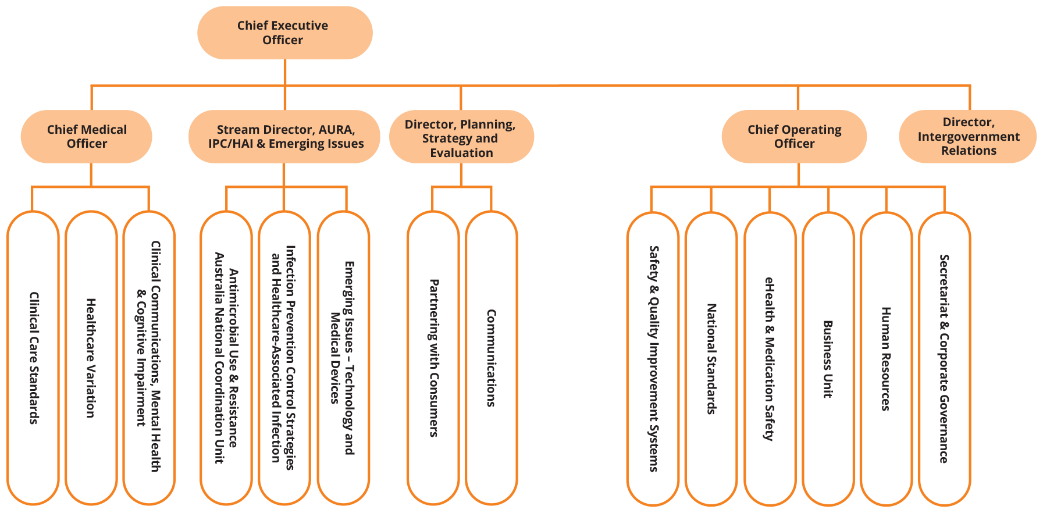

People management
The Commission continues to deliver high performance by providing ongoing support through its performance management systems and embedding a strong sense of direction across the organisation.
The Commission’s performance development scheme places emphasis on employees and managers having regular, meaningful performance discussions. All employees are required to have an individual performance and development plan in place. Managers and employees have joint accountability for capability and career development.
The Commission participates in the online induction program offered by the Australian Public Service Commission, giving new employees the opportunity to learn how the Australian Public Service operates and the behaviours expected of all staff members.
In May 2021, the Commission encouraged all staff members to participate in the Australian Public Service Commission’s employee census survey.

Staff profile
As of 30 June 2021, the Commission’s headcount was 89 employees. Most employees are located in Sydney. Table 7 provides a breakdown of the Commission’s employee profile by classification, gender, full-time or part-time status, and ongoing or non-ongoing status.
- Employee headcount profile as of 30 June 2021

Classification | Female |  |  |  | Male |  |  |  | Total
Classification | Ongoing |  | Non-ongoing |  | Ongoing |  | Non-ongoing |  | Total
Classification | Full-time | Part-time | Full-time | Part-time | Full-time | Part-time | Full-time | Part-time | Total
CEO | 0 | 0 | 1 | 0 | 0 | 0 | 0 | 0 | 1
MO6 | 1 | 0 | 0 | 0 | 0 | 0 | 0 | 1 | 2
EL2 | 14 | 5 | 0 | 0 | 8 | 0 | 0 | 0 | 27
EL1 | 16 | 11 | 0 | 2 | 5 | 0 | 2 | 0 | 36
APS6 | 7 | 2 | 5 | 2 | 3 | 0 | 0 | 0 | 19
APS5 | 0 | 0 | 2 | 0 | 1 | 0 | 0 | 0 | 3
APS4 | 0 | 1 | 0 | 0 | 0 | 0 | 0 | 0 | 1
Total | 38 | 19 | 8 | 4 | 17 | 0 | 2 | 1 | 89

Work health and safety
The Commission promotes a healthy and safe workplace, and is committed to meeting its obligations under the Work Health and Safety Act 2011 and the Safety, Rehabilitation and Compensation Act 1988. All new staff members are required to complete online work health and safety training as part of their induction.
The Commission undertook a number of activities during 2020–21 to encourage employees to adopt healthy work practices (see ‘Highlights’).

Keeping our staff safe and productive during COVID–19
In response to the COVID–19 pandemic, the Commission triggered its pandemic response under its Business Continuity Plan. This resulted in Commission staff working from home for most of 2020.
In line with the repeal of section 6 of the New South Wales Public Health Order on 14 December 2020, Commission staff began a hybrid arrangement of office- and home-based work. The Commission continues to operate in accordance with New South Wales Public Health Orders.
Highlights
- Ergonomic workstation assessments were conducted as required, and access to standing desks was provided
- Biannual workplace inspections were conducted; all staff members were encouraged to report incidents and hazards in the workplace
- Access was provided to an employee assistance program
- A ‘Looking out for your mates’ session and training in workplace mental health was offered on R U OK? day for all staff members
- Influenza vaccinations were made available to all staff members
- Access was provided to reimbursement of eyewear costs for use with screen-based equipment
There were no work health and safety incidents reported in 2020–21. There were no notifiable incidents in 2020–21. No notices were issued to the Commission, and no investigations were initiated under the Work Health and Safety Act 2011.

Learning and development
The Commission values the talents and contributions of its staff members, and recognises the importance of building expertise and capability within the organisation.
Learning and development needs and opportunities are primarily identified through the performance development scheme. The Commission promotes learning and development by delivering regular continuing professional development sessions and by providing access to online learning platforms to all staff members.
During 2020–21, the Commission’s study support and training arrangements ensured the ongoing development of staff members’ skills and capabilities. Ten staff members accessed study support assistance to study a range of tertiary courses. These included Master of Public Health, Executive Master of Public Administration and various graduate certificates in health-related fields. Thirty staff members completed external training courses, and internal training was provided to staff on workplace mental health, appropriate behaviour in the workplace and privacy.

Workplace diversity
The Commission’s workplace diversity program supports its ongoing commitment to recognising and fostering diversity in the workplace.
The Commission is committed to increasing opportunities for people with disability to participate in employment. The Commission complies with the Australian Government accessibility requirements for online access and publishing. Reasonable adjustments are provided to employees with disability, as required.
During 2020–21, the Commission participated in the Australian Public Service Disability Champions Network.

Aboriginal and Torres Strait Islander employment
The Commission currently has no staff members who have identified as being Aboriginal or Torres Strait Islander.
The Commission is committed to improving the recruitment, retention and career development of Indigenous employees. The Commission undertook a recruitment process to fill an Affirmative Measure – Indigenous position during 2020–21, and is still actively seeking to fill this vacancy.
The Commission also participated in the APS Indigenous Graduate Pathway program to recruit graduates to start in 2022.

“Our staff have demonstrated their adaptability and commitment to supporting safe and high-quality health care in this challenging environment.”
— Chief Executive Officer, Adjunct Professor Debora Picone ao

5. Financial statements

Independent auditor’s report 94
Financial statements 96
Overview and notes to the financial statements 101

Independent auditor’s report
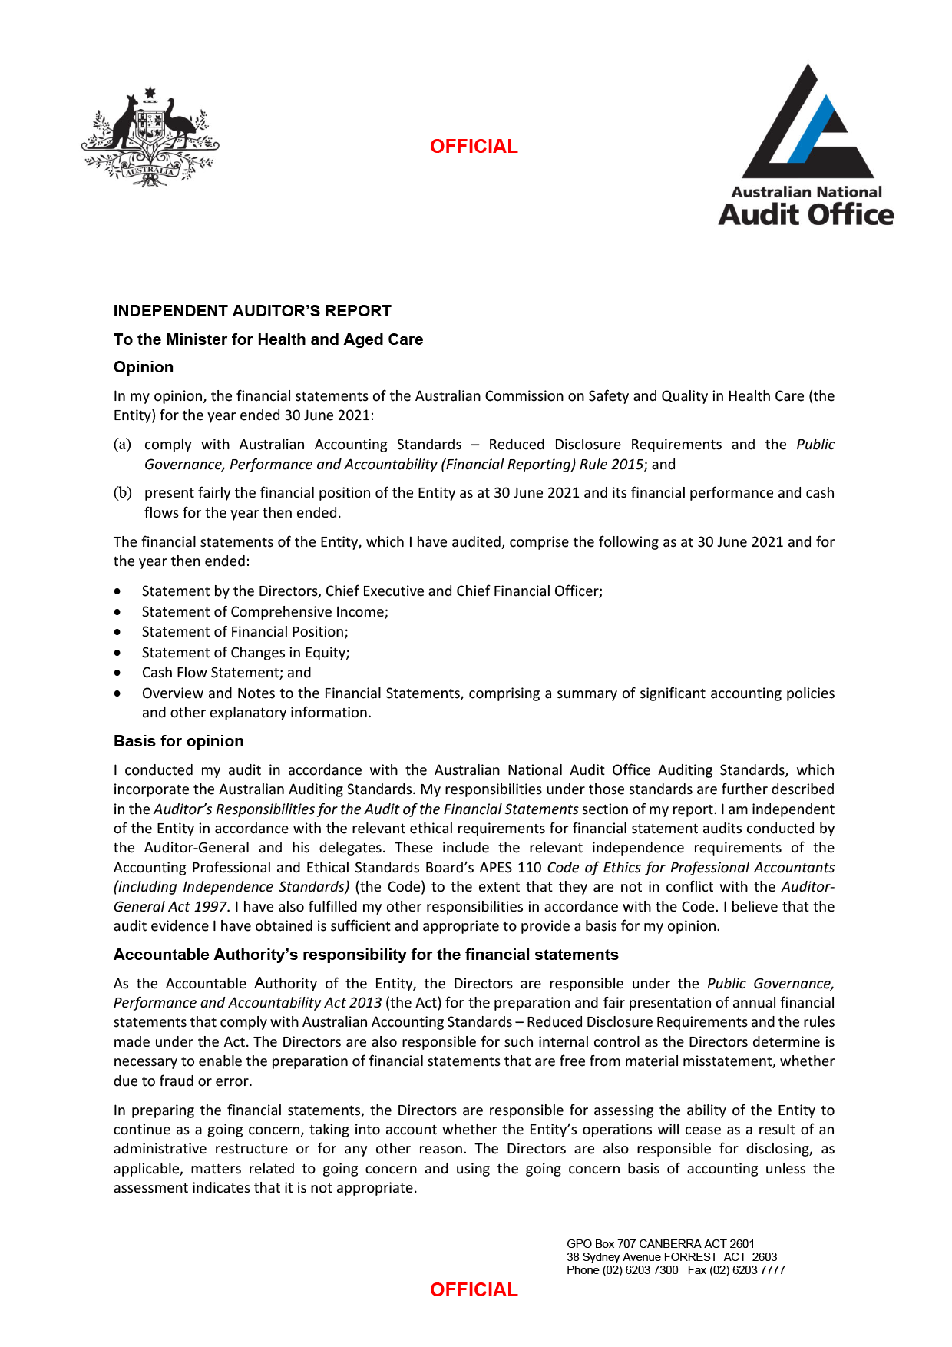
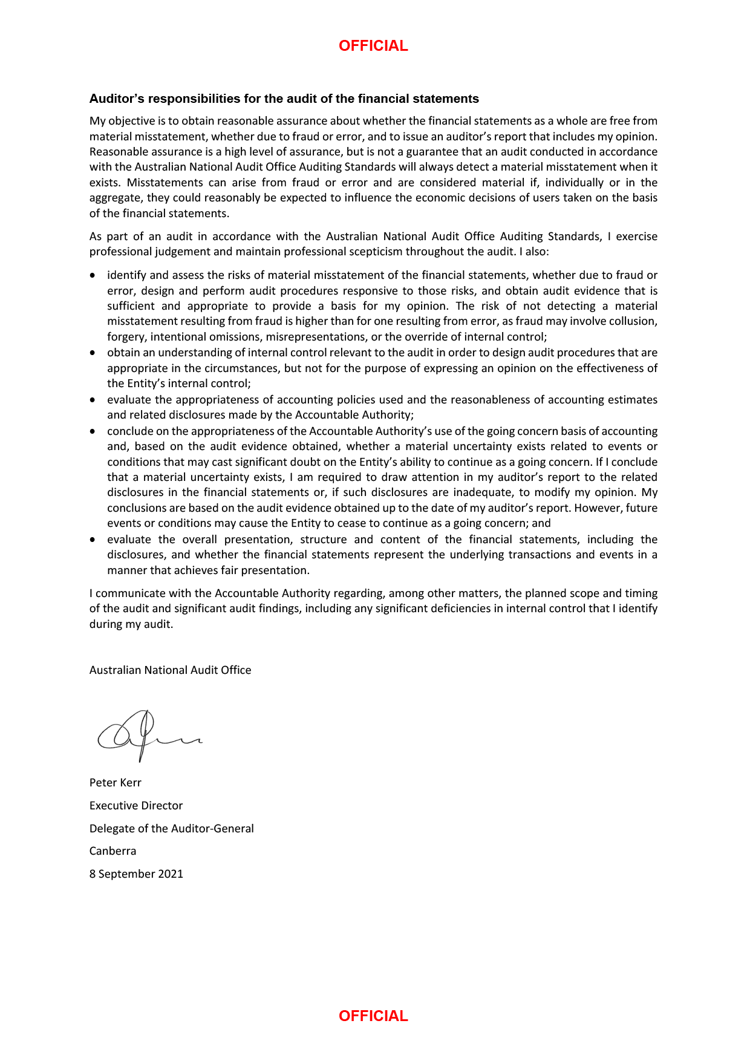

Financial statements
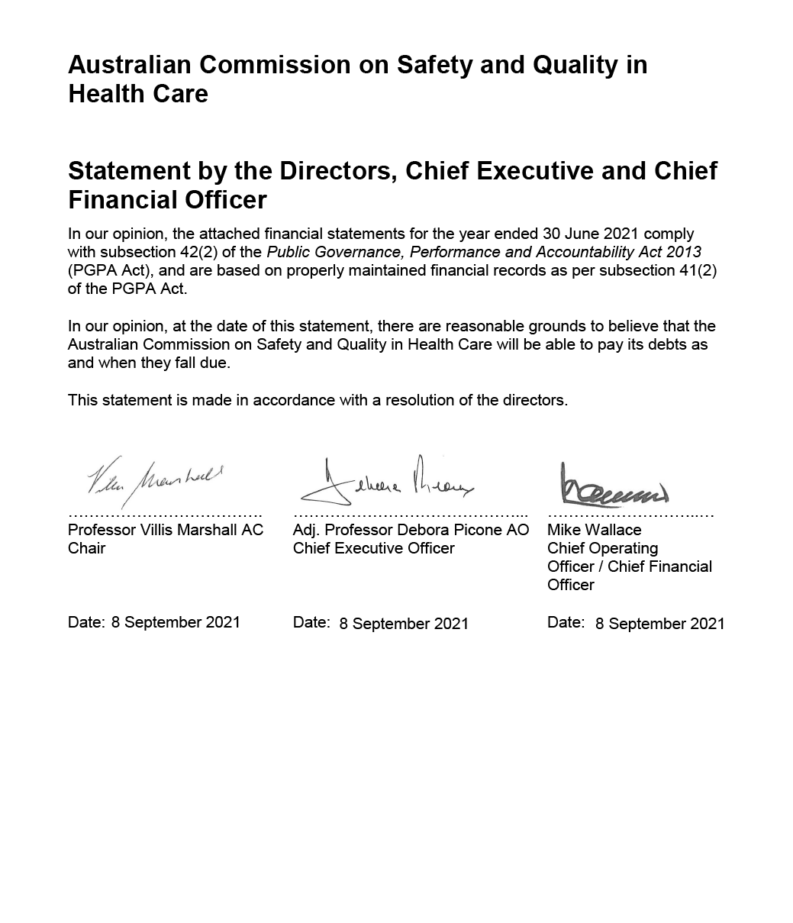
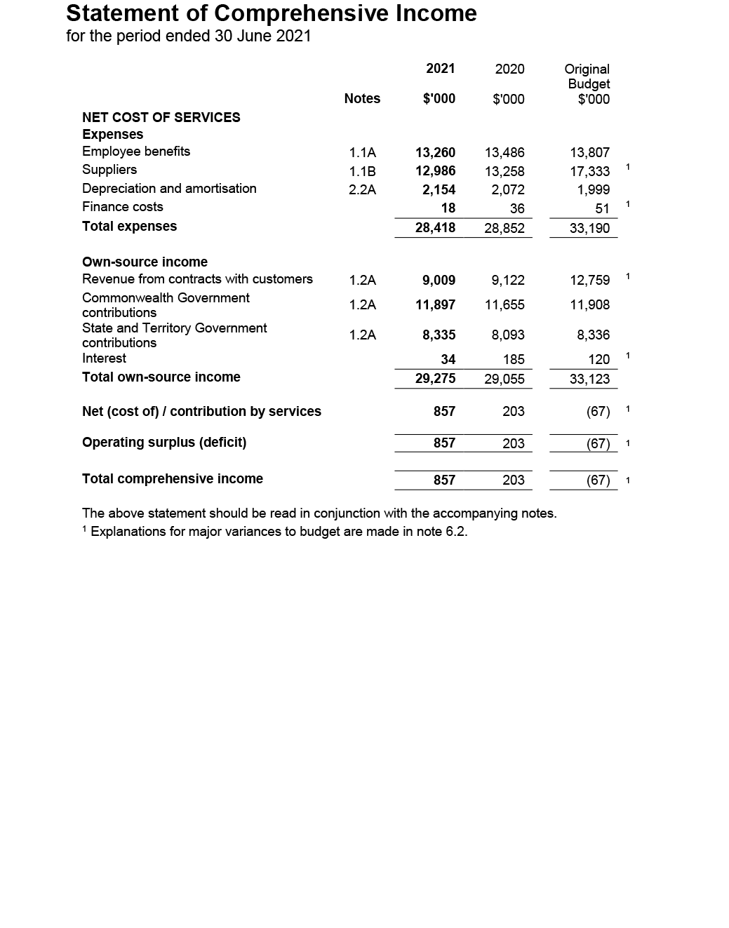
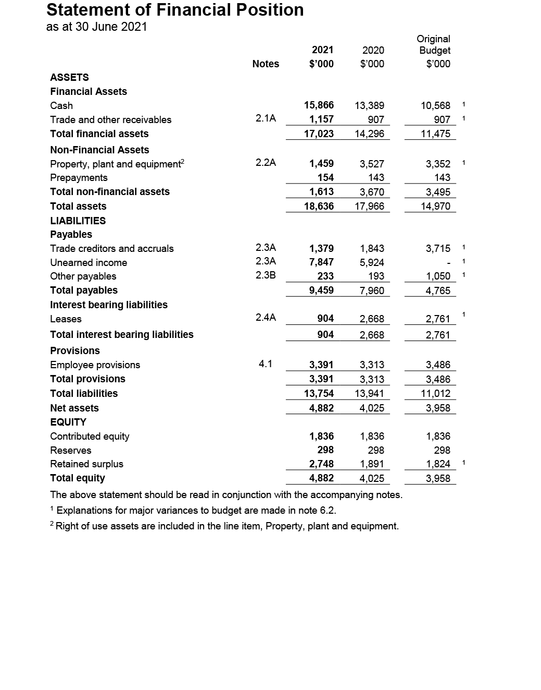
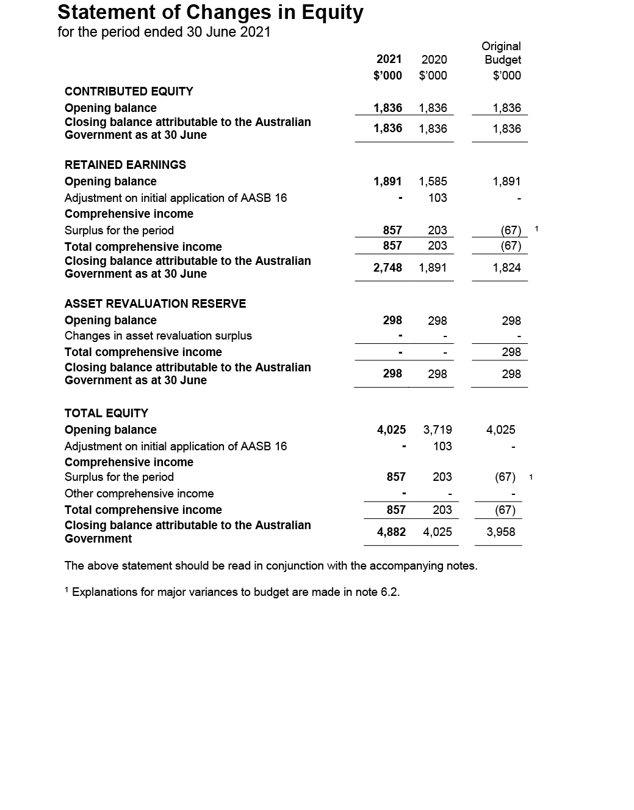
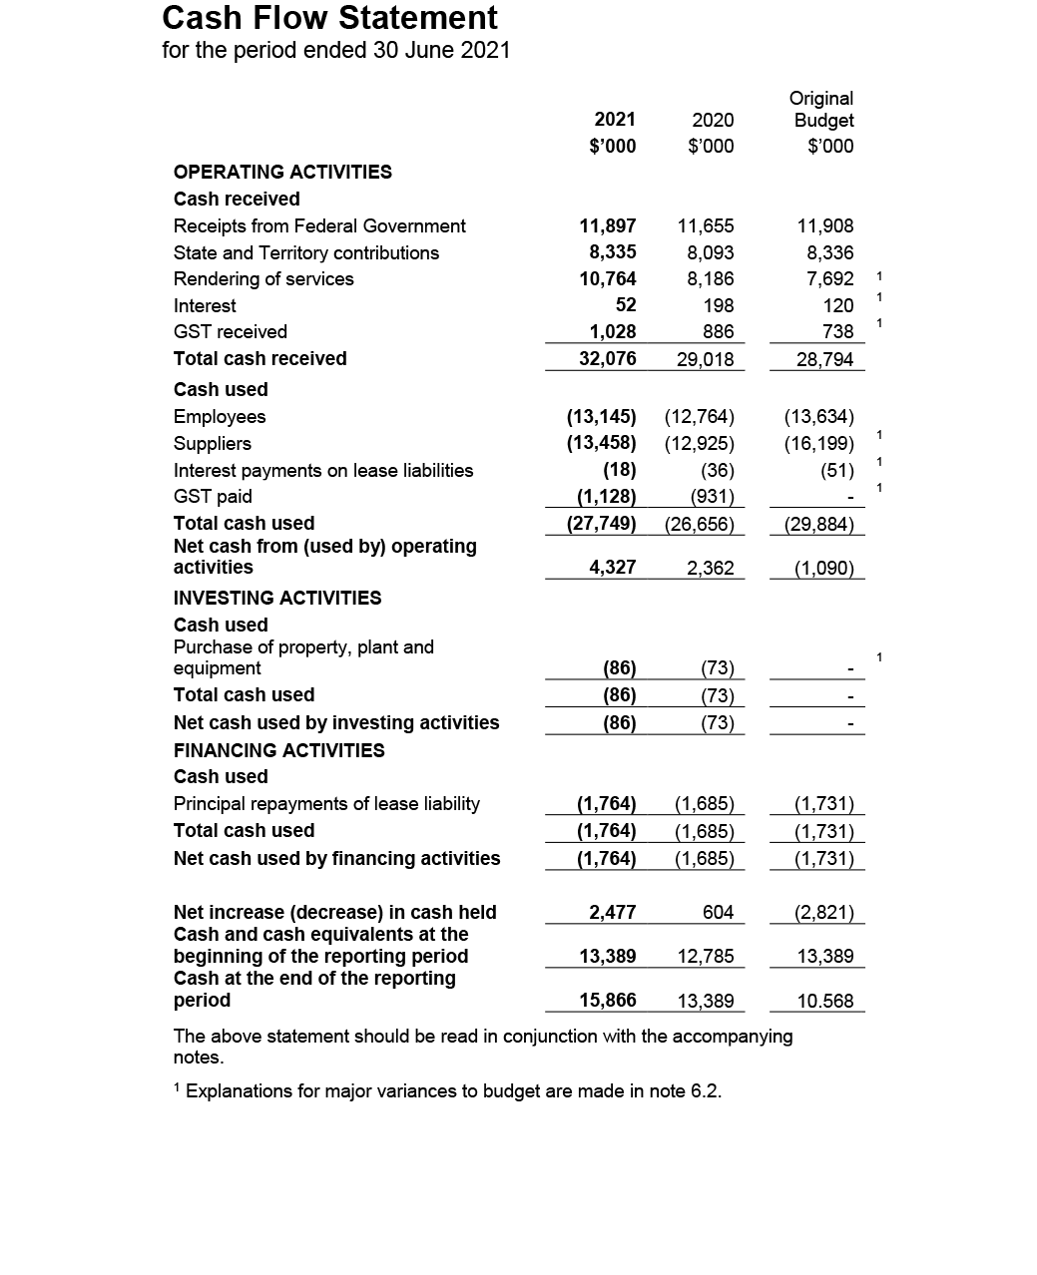

Overview and notes to the financial statements
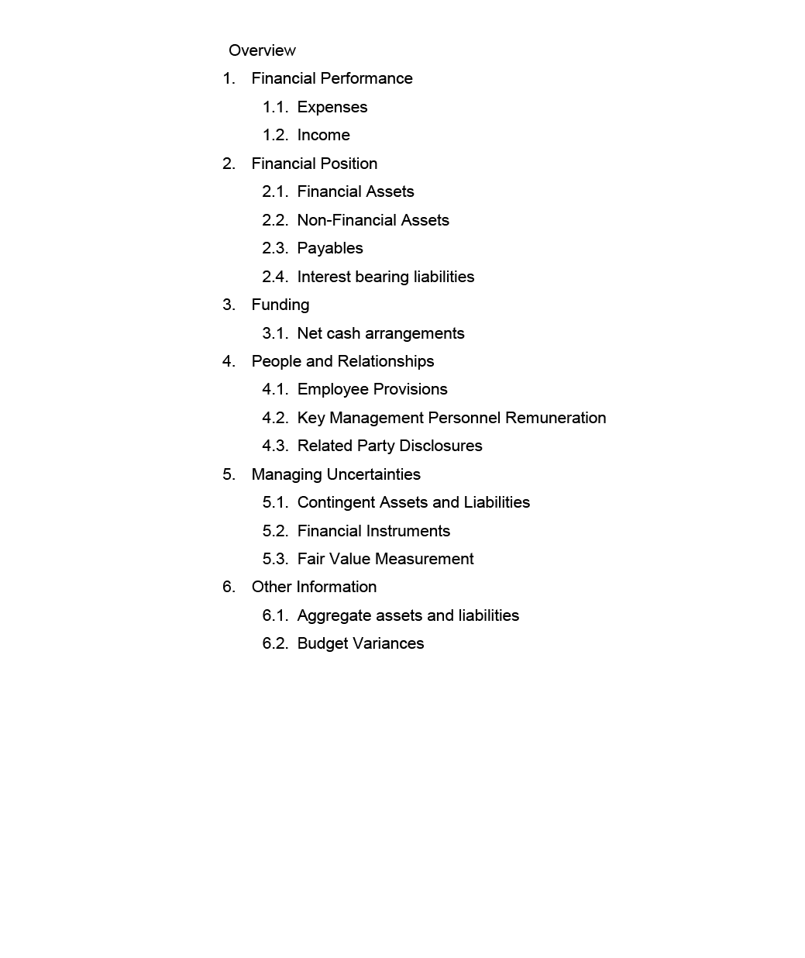
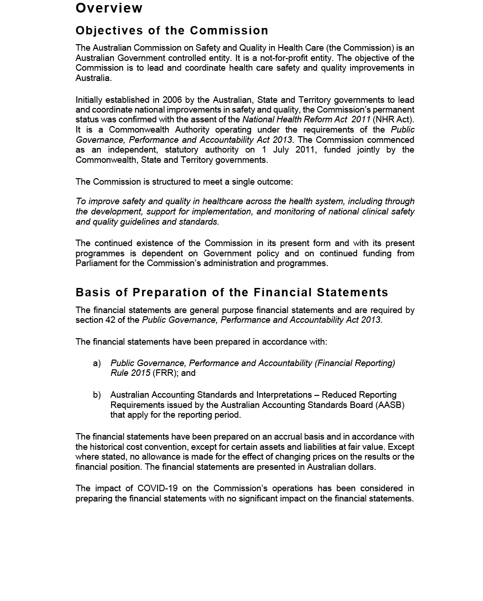

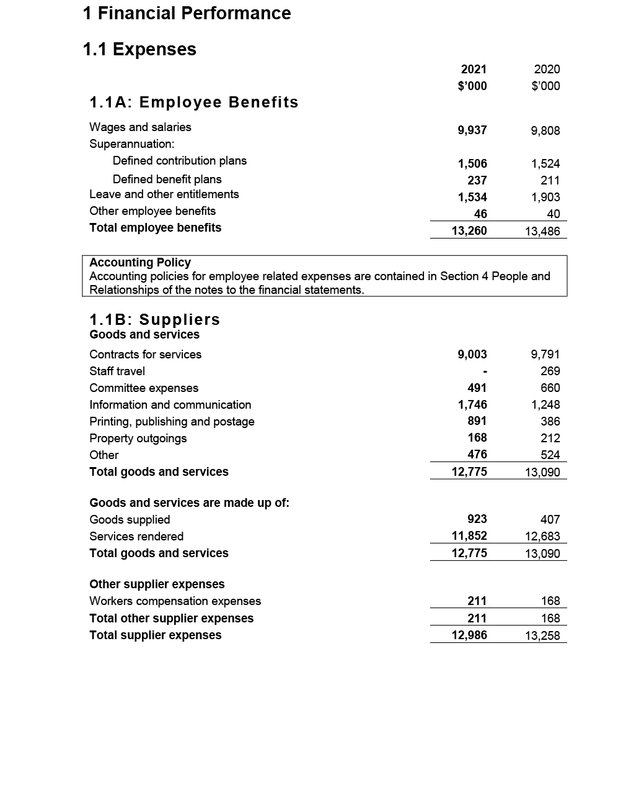
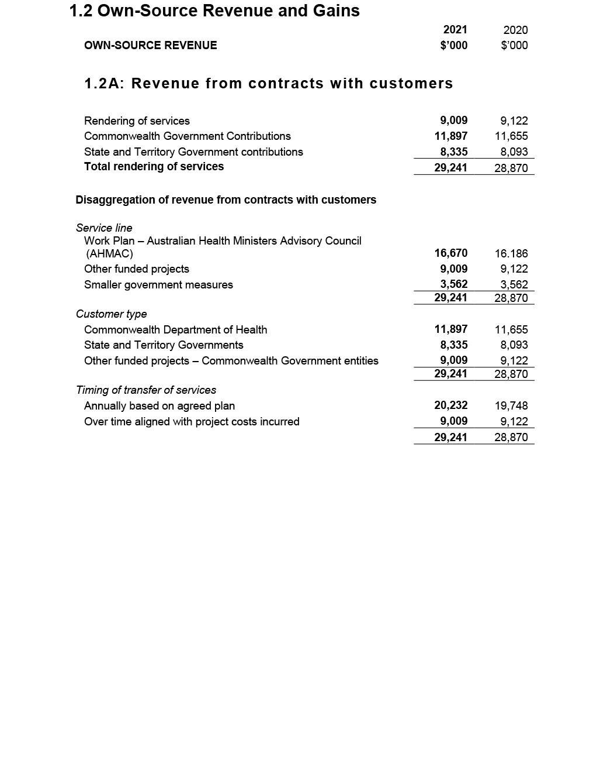
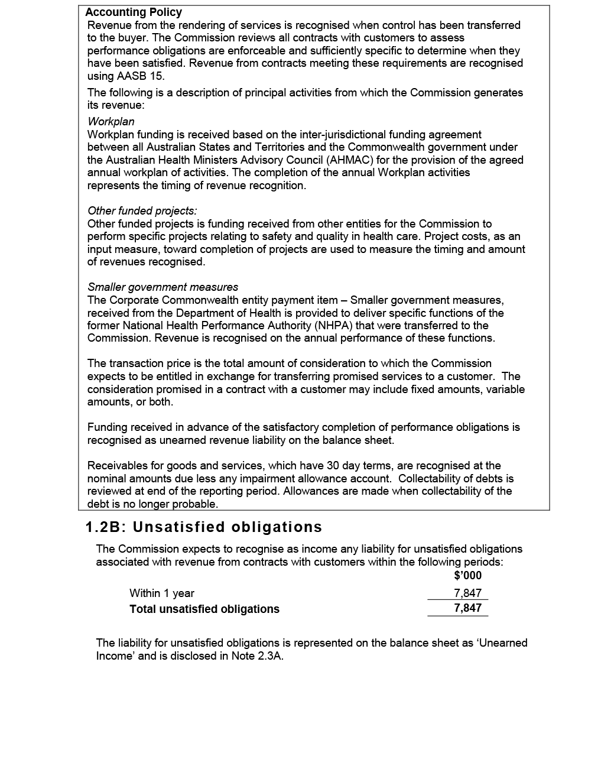
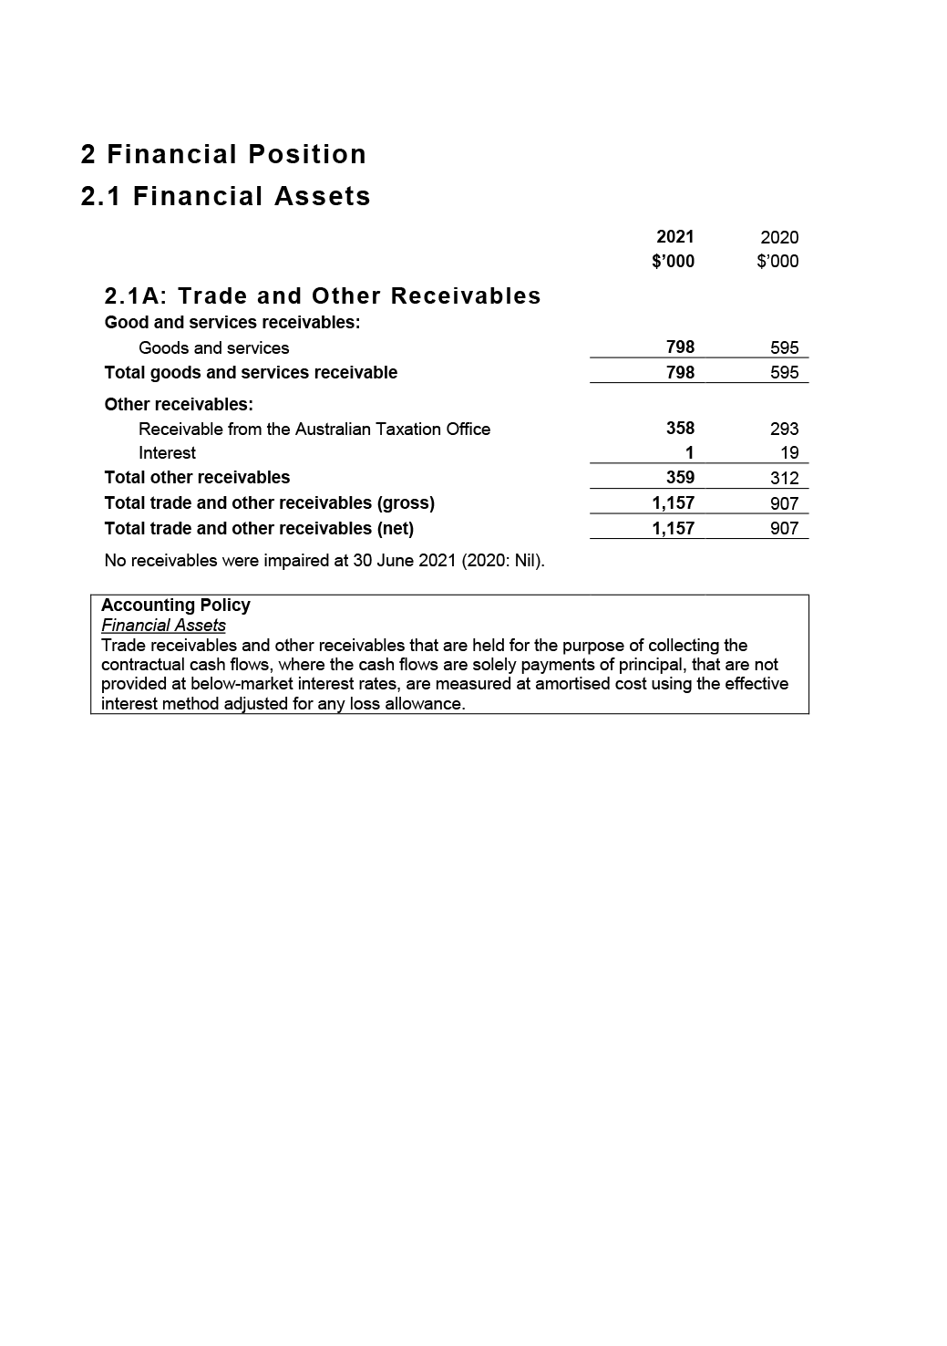
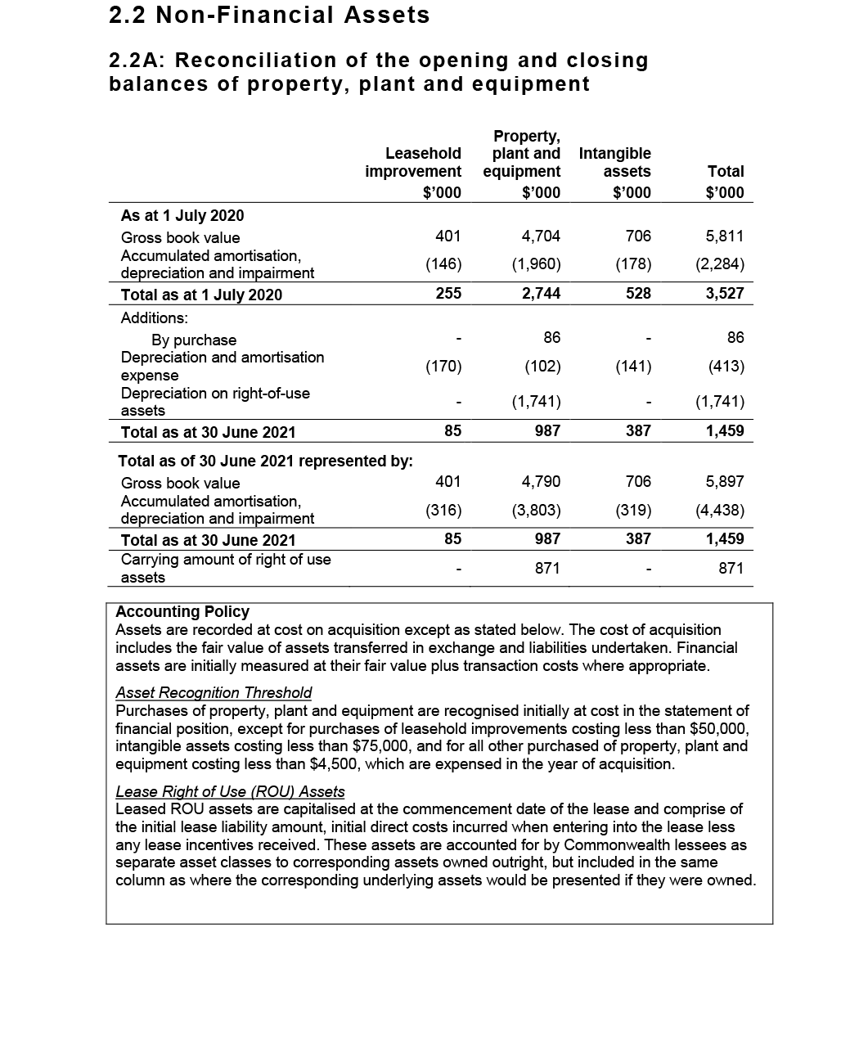
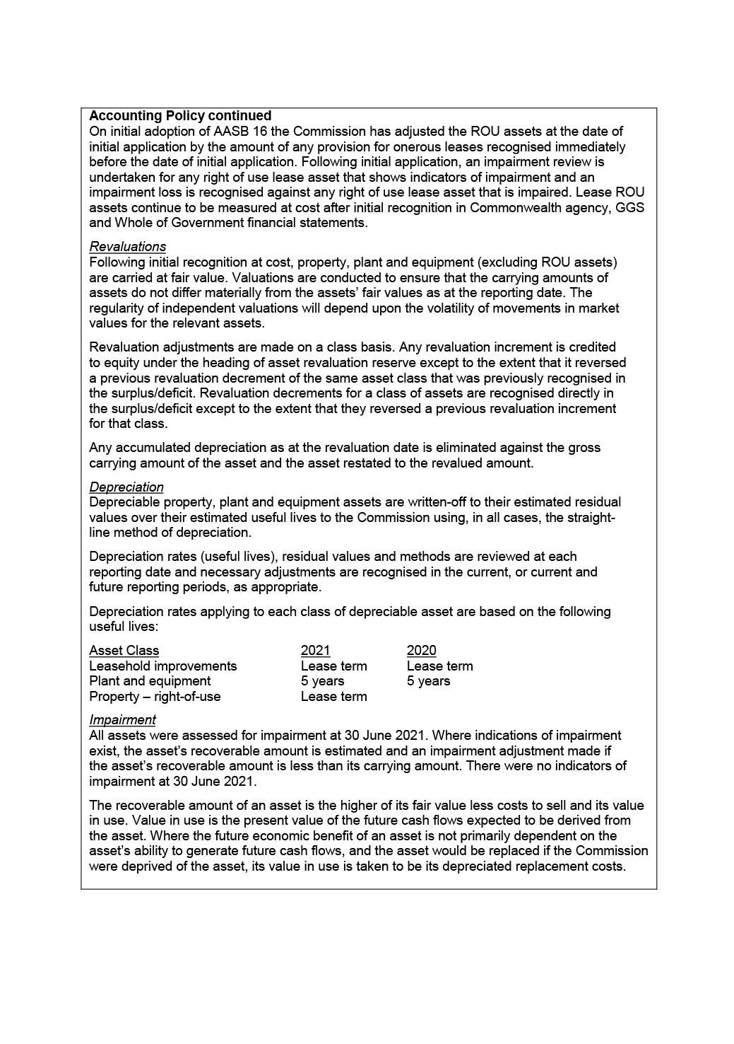
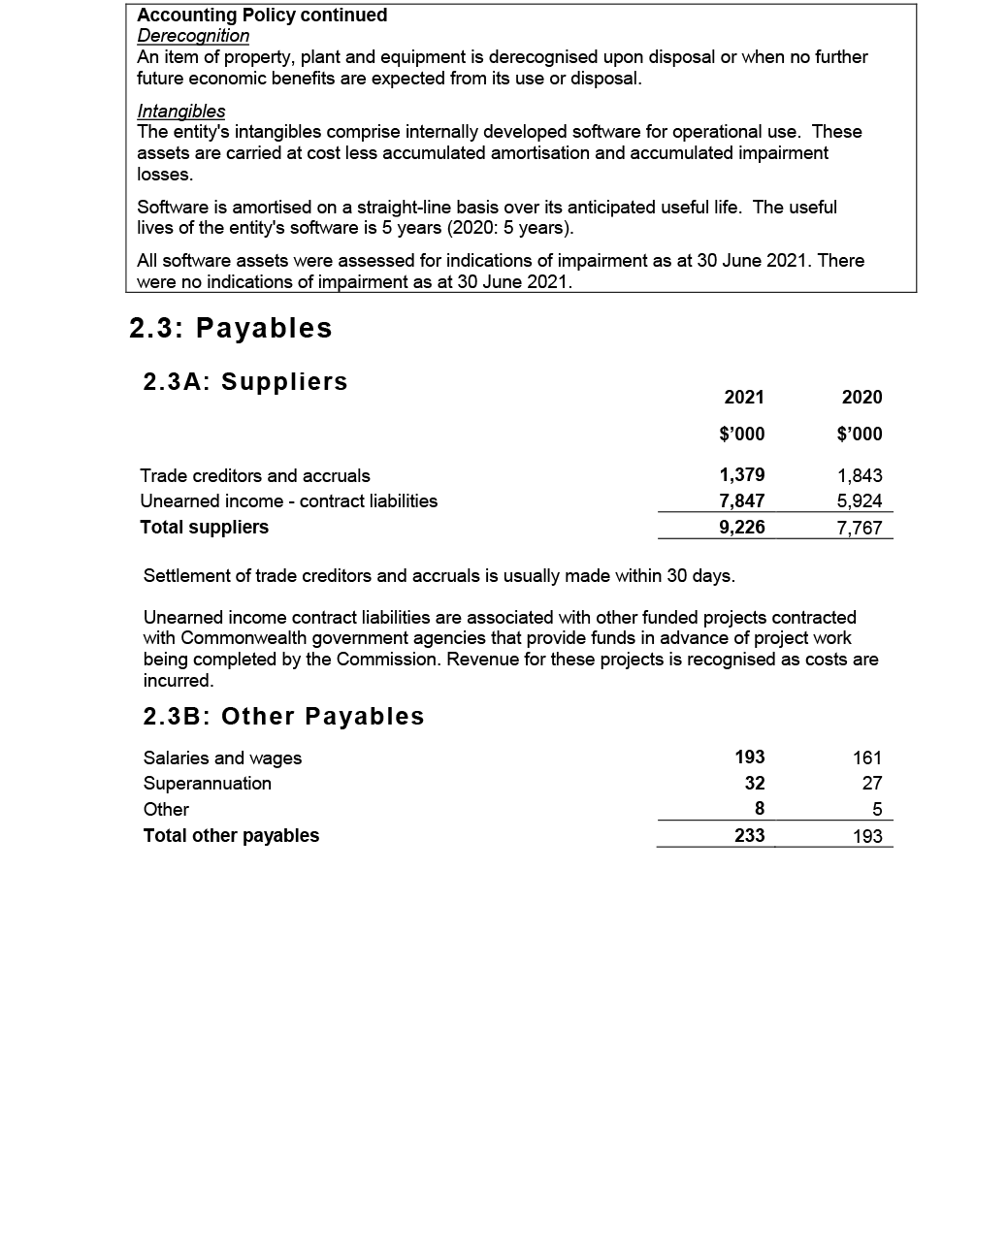
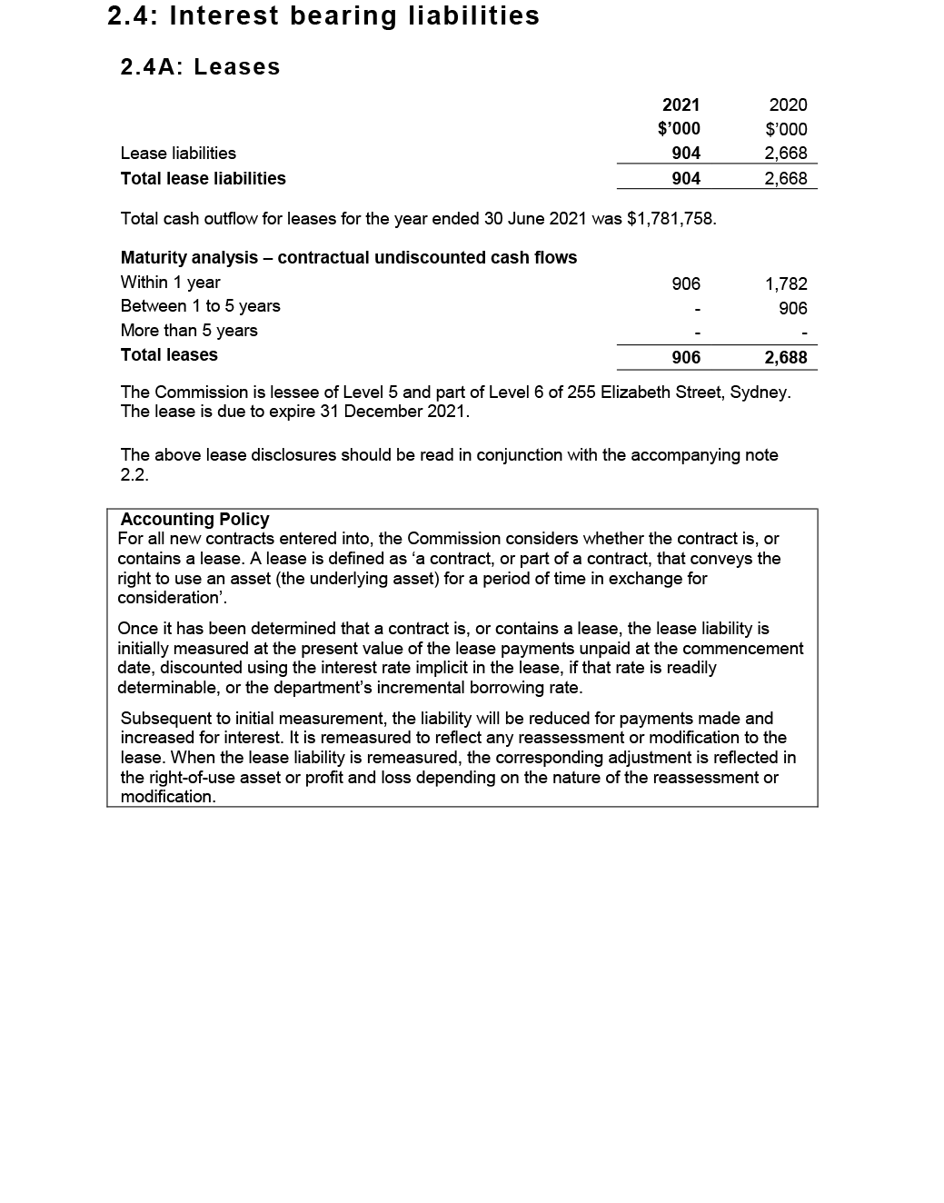
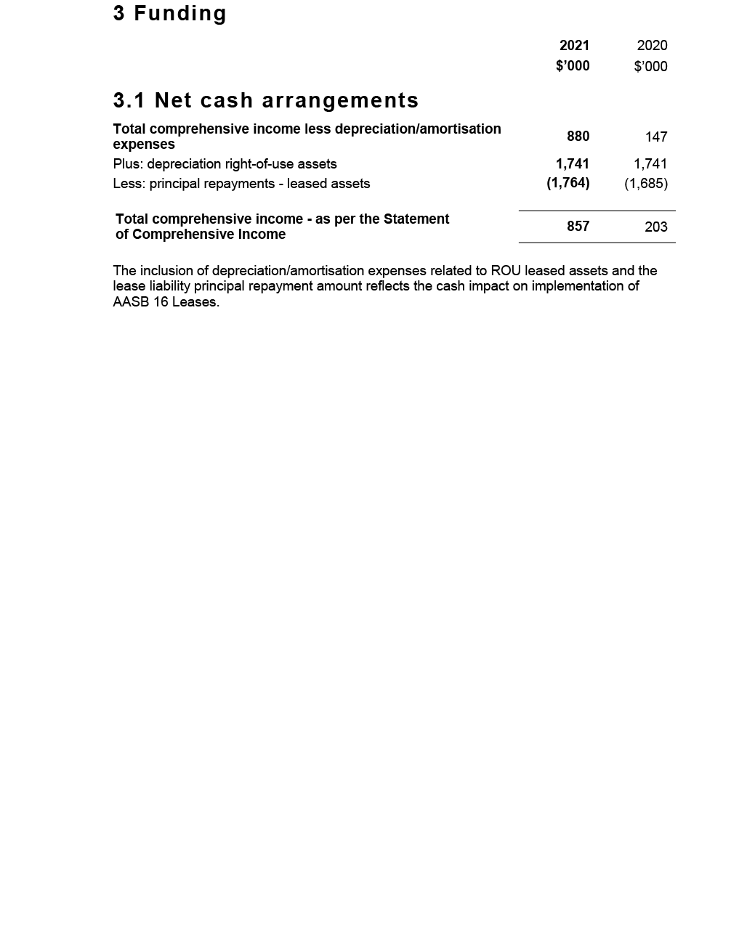
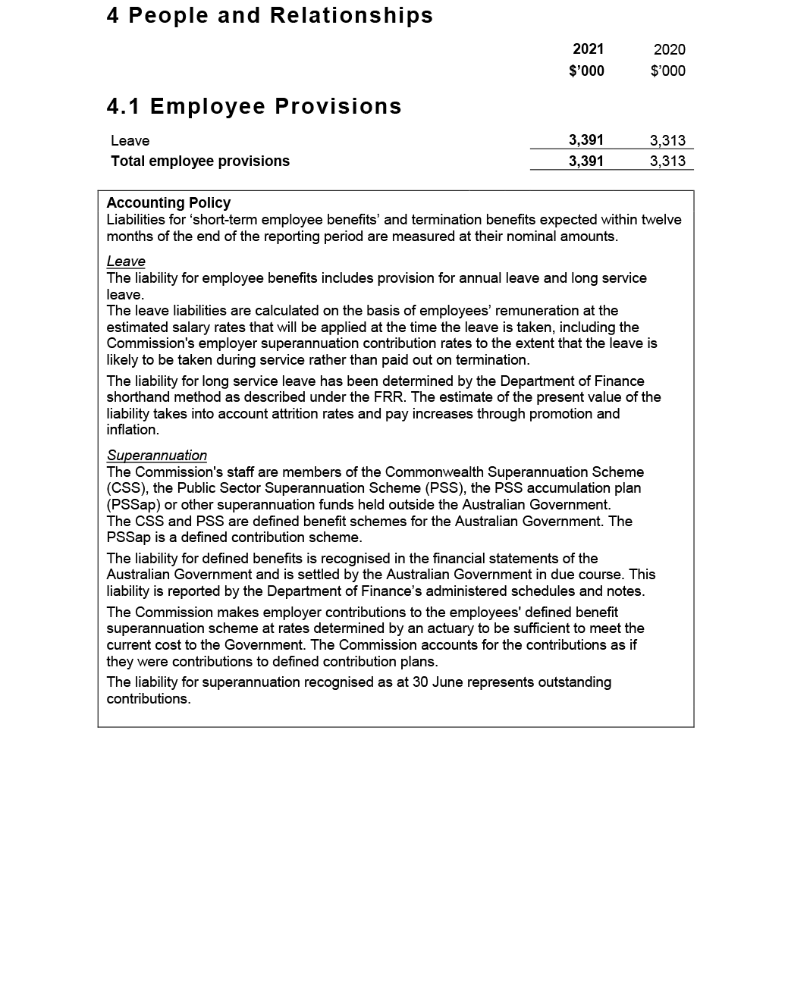
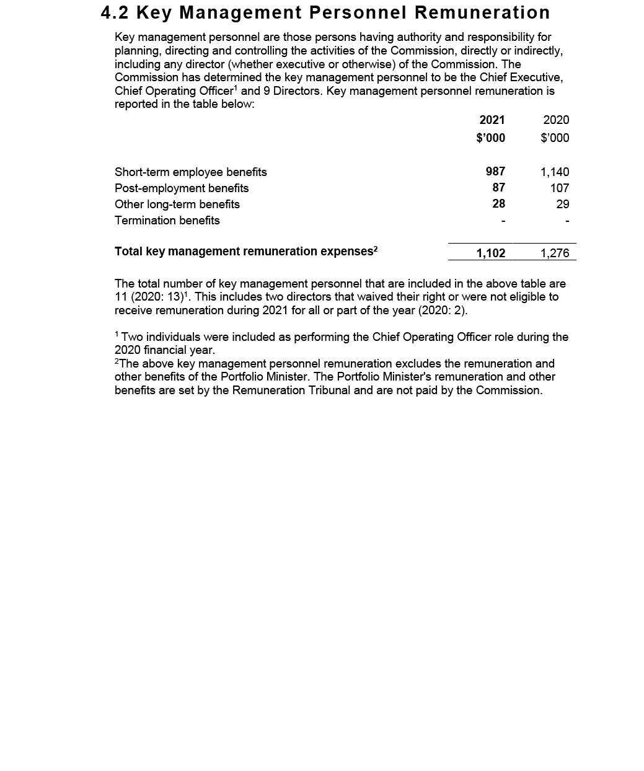
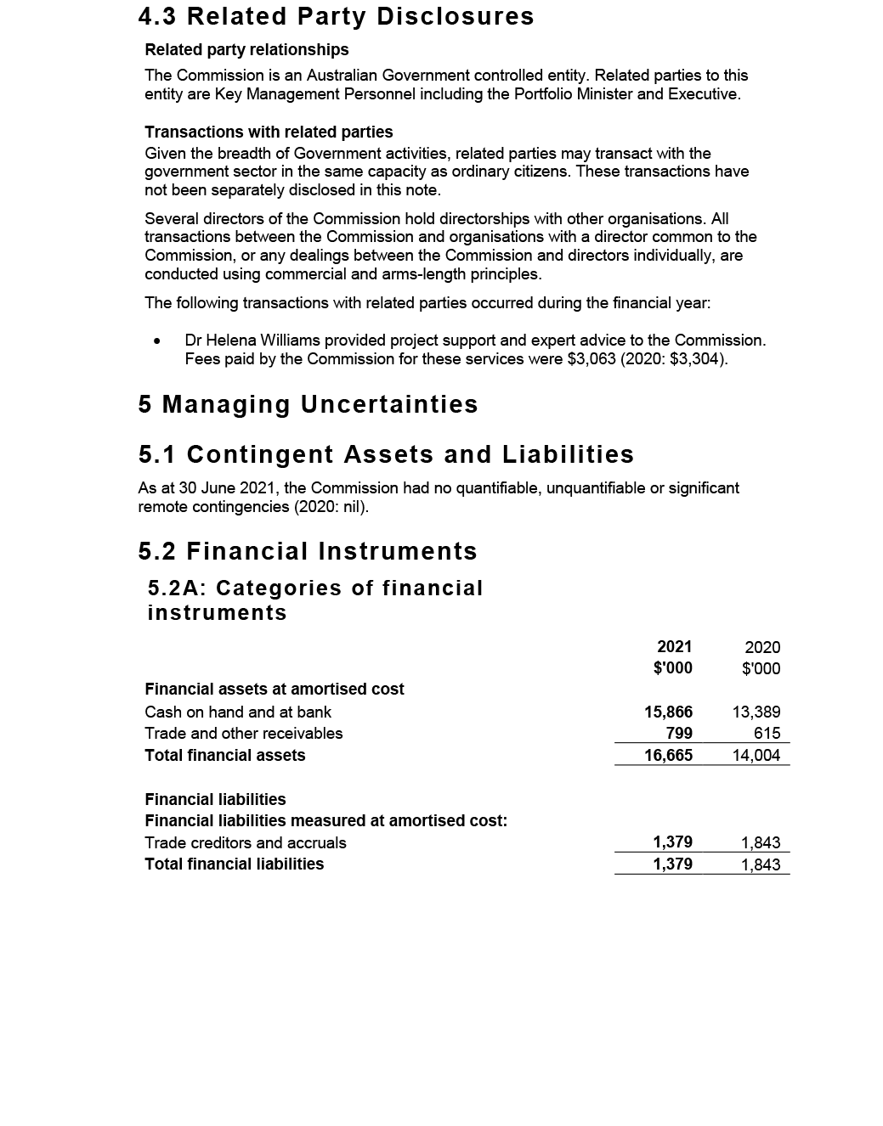
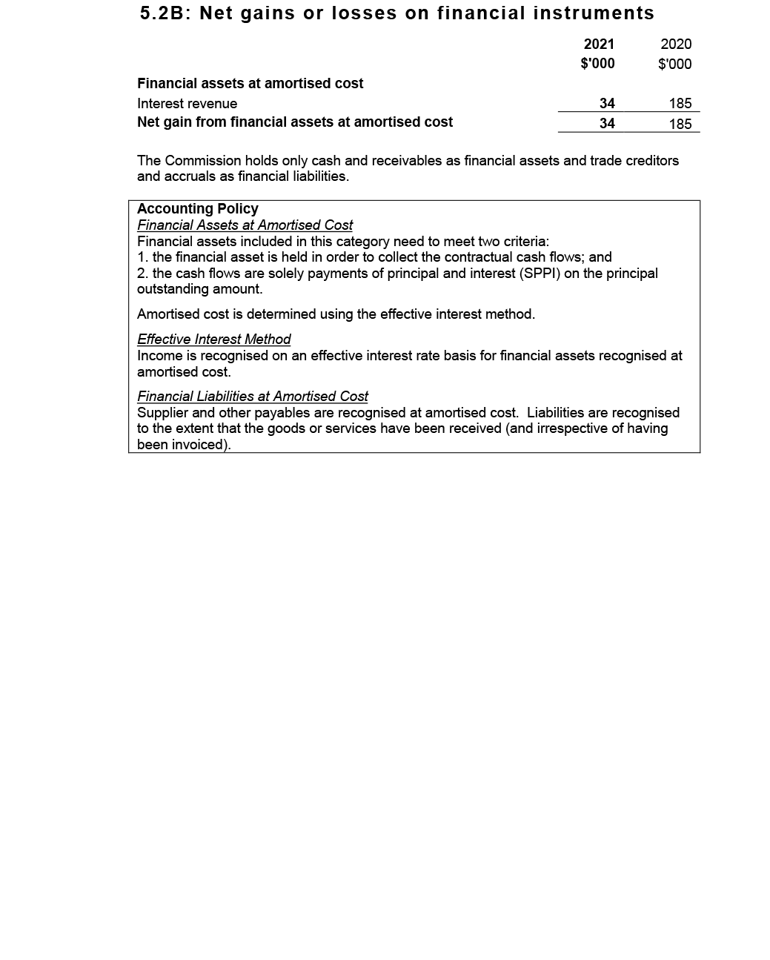
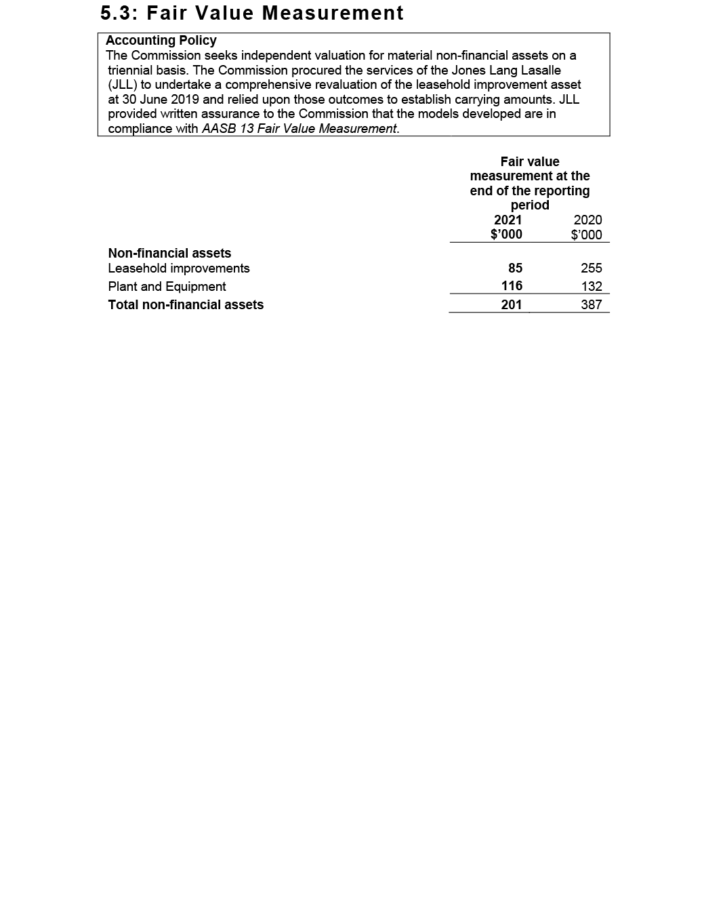
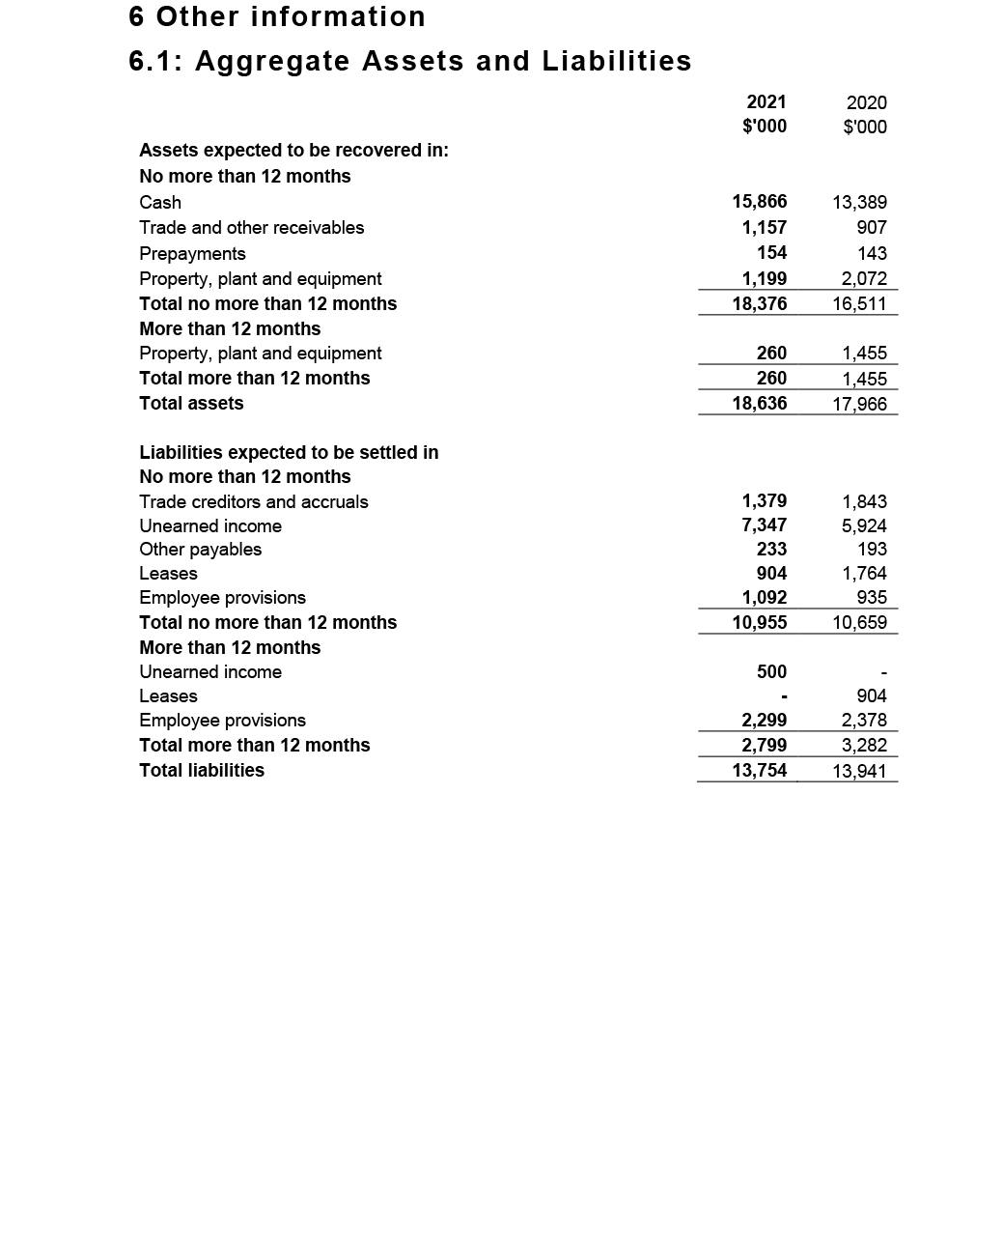
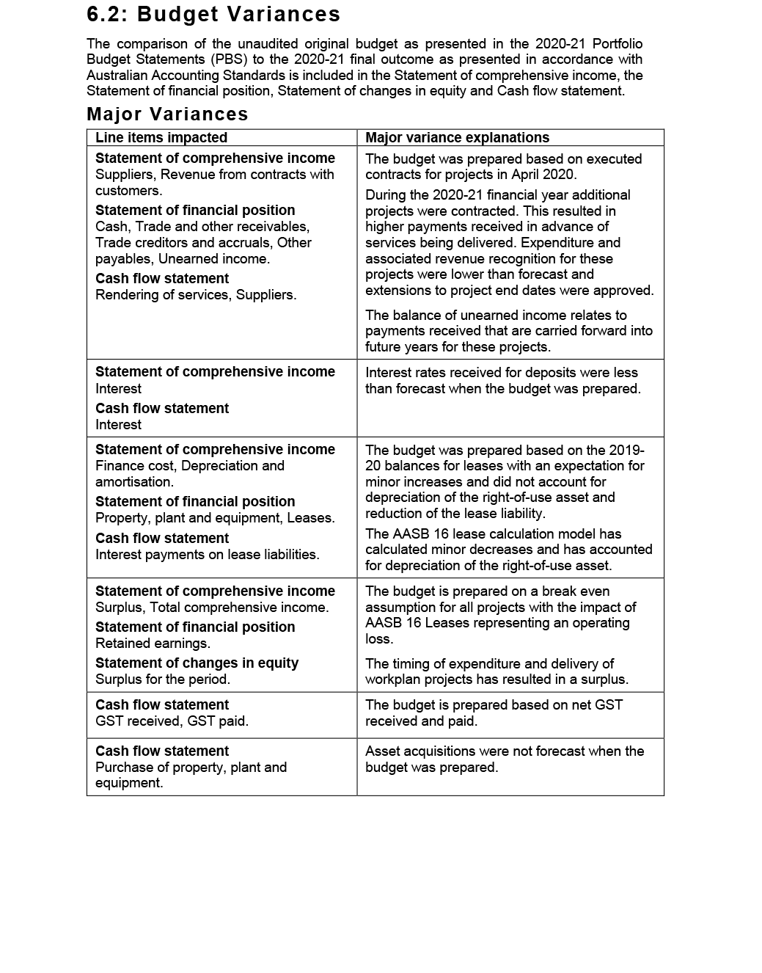

6. Appendices

Appendix A: Related-entity transactions 122
Appendix B: Freedom of information summary 123
Appendix C: Compliance with ecologically sustainable development 124

Appendix A: Related-entity transactions
- Related-entity transactions, 2020–21
Vendor no. | Commonwealth entity | Number of transactions | Transaction value | Description
100362 | Department of Health | 12 | $759,395.77 | Payments processed in 2020–21 for corporate services received from the Department of Health under a shared services agreement between the Commission and the Department.

Appendix B: Freedom of information summary
The following table summarises freedom of information requests and their outcomes for 2020–21, as discussed on page 78.
- Freedom of information summary, 2020–21
Activity | Number
Requests
On hand at 1 July 2020 | 0
New requests received | 1
Total requests handled | 1
Total requests completed as at 30 June 2021 | 0
Total requests on hand as at 30 June 2021 | 0
Action of request
Access granted in full | n/a
Access granted in part | n/a
Access refused | n/a
Access transferred in full | n/a
Request withdrawn | 1
No records | n/a
Response time
0–30 days | n/a
30–60 days | n/a

Appendix C: Compliance with ecologically sustainable development
The Commission is committed to making a positive contribution to ecological sustainability. Table 10 details the Commission’s activities in accordance with section 516A(6) of the Environment Protection and Biodiversity Conservation Act 1999.
- Summary of the Commission’s compliance with ecologically sustainable development
Environment Protection and Biodiversity Conservation Act 1999 requirement | Commission response
Activities of the Commission during 2020–21 accord with the principles of ecologically sustainable development | The Commission ensures that its decision-making and operational activities mitigate environmental impact. The principles of ecologically sustainable development are embedded in the Commission’s approach to its work plan, and corporate, purchasing and operational guidelines.
Outcomes specified for the Commission in an Appropriation Act for 2020–21 contribute to ecologically sustainable development | The Commission’s single appropriations outcome focuses on improving safety and quality in health care across the Australian health system. As such, the Commission does not directly contribute to ecologically sustainable development.
Effects of the Commission’s activities on the environment | The Commission’s offices are located in a 5-star building, and the Commission works proactively with building management to achieve energy savings, where possible. The Commission continues to improve its dissemination of publications, reports and written materials through electronic media to minimise printing.

Environment Protection and Biodiversity Conservation Act 1999 requirement | Commission response
Measures the Commission is taking to minimise its impact on the environment | To reduce its environmental impact, the Commission is improving its website functionality and increasing the use of multi-channel strategies to distribute information electronically.  To reduce travel, the Commission uses remote meeting attendance options, where feasible. Most staff have been working and attending meetings remotely during the pandemic.  Responsible use of materials, electricity and water, and disposal of waste are expected of all staff and visitors.
Mechanisms for reviewing and increasing the effectiveness of these measures | The Commission has established mechanisms to review current practices and policies. In addition, staff are encouraged to identify initiatives to adopt behaviours, procedures or policies that may minimise their environmental impact, and that of their team and the Commission more broadly.

7. Indexes and references

Acronyms 128
Glossary 129
Index of figures 133
Index of tables 134
Compliance index 135
Index 140
References 152

Acronyms
Acronym | Description
AC | Companion of the Order of Australia
AGAR | Australian Group on Antimicrobial Resistance
AHPEQS | Australian Hospital Patient Experience Question Set
AHSSQA Scheme | Australian Health Service Safety and Quality Accreditation Scheme
AM | Member of the Order of Australia
AMR | antimicrobial resistance
AO | Officer of the Order of Australia
AURA | Antimicrobial Use and Resistance in Australia
CARAlert | National Alert System for Critical Antimicrobial Resistances
CEO | Chief Executive Officer
FCNA | Fellow of the College of Nursing, Australia
FRACGP | Fellow of the Royal Australian College of General Practitioners
FRACS | Fellow of the Royal Australasian College of Surgeons
MD | Doctor of Medicine
NDIS | National Disability Insurance Scheme
NGPA Scheme | National General Practice Accreditation Scheme
NSQDMH Standards | National Safety and Quality Digital Mental Health Standards
NSQHS Standards | National Safety and Quality Health Service Standards
PSM | Public Service Medal
RACF | Residential Aged Care Facility

Glossary
Word | Description
Accreditation | A status that is conferred on an organisation or individual when they have been assessed as having met particular standards. The two conditions for accreditation are compliance with an explicit definition of quality (that is, a standard) and passing an independent review process aimed at identifying the level of congruence between practices and quality standards.
Adverse event | An incident that results in harm to a patient or consumer.
Antimicrobial | A chemical substance that inhibits or destroys bacteria, viruses or fungi, including yeasts and moulds.1
Antimicrobial resistance | A property of organisms – including bacteria, viruses, fungi and parasites – that allows them to grow or survive in the presence of antimicrobial levels that would normally suppress growth or kill susceptible organisms.
Antimicrobial stewardship | A program implemented in a health service organisation to reduce the risks associated with increasing antimicrobial resistance, and to extend the effectiveness of antimicrobial treatments. Antimicrobial stewardship may incorporate a broad range of strategies, including monitoring and reviewing antimicrobial use.
Clinical care standards | Standards developed by the Commission and endorsed by health ministers that identify and define the care people should expect to be offered or receive for specific clinical conditions or procedures. Clinical care standards highlight best-practice care and priority areas for quality improvement and include indicators to support quality improvement.
Clinical governance | The set of relationships and responsibilities established by a health service organisation between its department of health (for the public sector), governing body, executive, clinicians, patients, consumers and other stakeholders to ensure good clinical outcomes. It ensures that the community and health service organisations can be confident that systems are in place to deliver safe and high-quality health care and continuously improve services.
Clinical handover | The transfer of professional responsibility and accountability for some or all aspects of care for a patient, or group of patients, to another person or professional group on a temporary or permanent basis.2
Clinician | A healthcare provider, trained as a health professional. Clinicians include registered and non-registered practitioners, or teams of health professionals, who spend the majority of their time delivering direct clinical care.
Cognitive impairment | Deficits in one or more of the areas of memory, communication, attention, thinking and judgement. Cognitive impairment can be temporary or permanent, and can affect a person’s understanding, their ability to carry out tasks or follow instructions, their recognition of people or objects, how they relate to others and how they interpret the environment. Dementia and delirium are common forms of cognitive impairment seen in hospitalised older patients.3 Cognitive impairment can also be caused by other conditions, such as an acquired brain injury, a stroke, intellectual disability or drug use.
Consumer | A person who has used, or may potentially use, health services. A healthcare consumer may also act as a consumer representative to provide a consumer perspective, contribute consumer experiences, advocate for the interests of current and potential health service users, and take part in decision-making processes.4
Delirium | An acute disturbance of consciousness, attention, cognition and perception that tends to fluctuate during the course of the day. Delirium is a serious condition that can be prevented in 30–40% of cases, and should be treated promptly and appropriately. Hospitalised older people with existing dementia are at the greatest risk of developing delirium. Delirium can be hyperactive (the person has heightened arousal, or can be restless, agitated and aggressive) or hypoactive (the person is withdrawn, quiet and sleepy).5
Electronic medication management system | Enables medicines to be prescribed, dispensed, administered and reconciled electronically.
End of life | The period when a patient is living with, and impaired by, a fatal condition, even if the trajectory is ambiguous or unknown. This period may be years in the case of patients with chronic or malignant disease, or very brief in the case of patients who suffer acute and unexpected illnesses or events such as sepsis, stroke or trauma.6
Hand hygiene | A general term referring to any hand-cleansing action.
Healthcare-associated infections | Infections that are acquired in healthcare facilities (nosocomial infections) or that occur as a result of healthcare interventions (iatrogenic infections). Healthcare-associated infections may manifest after people leave healthcare facilities.7
Healthcare variation | This occurs when patients with the same condition receive different types of care. For example, among a group of patients with the same condition, some may have no active treatment, some may be treated in the community and others in hospital, and some may have surgery while others receive medication. Some variation in how health care is provided is desirable because of differences in patients’ needs, wants and preferences (see ‘unwarranted healthcare variation’).
Hospital-acquired complication | A complication for which clinical risk mitigation strategies may reduce (but not necessarily eliminate) the risk of that complication occurring.
My Health Record | A secure online summary of a consumer’s health information, managed by the System Operator of the national e-health record system (the Secretary of the Department of Health). Healthcare providers are able to share health records to a consumer’s My Health Record, in accordance with the consumer’s access controls. This may include information such as medical history and treatments, diagnoses, medications and allergies. Also known as a ‘Personally Controlled Electronic Health Record’.
National Safety and Quality Health Service (NSQHS) Standards | Standards developed by the Commission in consultation and collaboration with states and territories, technical experts, health service organisations and patients. The NSQHS Standards aim to protect the public from harm, and to improve the quality of health services. They provide a quality assurance mechanism that tests whether relevant systems are in place to ensure that minimum safety and quality standards are met, and a quality improvement mechanism that allows health service organisations to realise aspirational or developmental goals.
Partnering with consumers | Treating consumers and/or carers with dignity and respect, communicating and sharing information between consumers and/or carers and health service organisations, encouraging and supporting consumers’ participation in decision-making, and fostering collaboration between consumers and/or carers and health service organisations in planning, designing, delivering and evaluating health care. Other terms are used internationally, such as patient-based, consumer-centred, person-centred, relationship-based, patient-centred and patient‑and-family‑centred care.
Patient | A person receiving health care. Synonyms for ‘patient’ include ‘consumer’ and ‘client’.
Patient safety | Reducing the risk of unnecessary harm associated with health care to an acceptable minimum.
Patient safety incident | An event or circumstance that could have resulted, or did result, in unnecessary harm to a patient.
Person-centred care | Where patients, consumers and members of the community are treated as partners in all aspects of healthcare planning, design, delivery and evaluation; the foundation for achieving safe, high-quality care.
Shared decision making | The integration of a patient’s values, goals and concerns with the best available evidence about the benefits, risks and uncertainties of treatment to achieve appropriate healthcare decisions.8
Standard | Agreed attributes and processes designed to ensure that a product, service or method will perform consistently at a designated level.
Unwarranted healthcare variation | Variation not attributed to a patient’s needs, wants or preferences. It may reflect differences in clinicians’ practices, the organisation of health care or people’s access to services. It may also reflect poor-quality care that is not in accordance with evidence-based practice.

Index of figures
Figure | Title | Page no.
1 | Health service organisation accreditation, 2020–25 | 25
2 | Organisational structure | 84

Index of tables
Table | Title | Page no.
1 | Report against performance measures in the Corporate Plan 2020–21 and Health Portfolio Budget Statements | 57
2 | Attendance at Board meetings | 71
3 | Audit and Risk Committee attendance and remuneration, 2020–21 | 74
4 | Remuneration paid to key management personnel, 2020–21 | 79
5 | Remuneration paid to executives, 2020–21 | 80
6 | Remuneration paid to other highly paid staff, 2020–21 | 80
7 | Employee headcount profile as of 30 June 2021 | 87
8 | Related-entity transactions, 2020–21 | 122
9 | Freedom of information summary, 2020–21 | 123
10 | Summary of the Commission’s compliance with ecologically sustainable development | 124
11 | Mandatory reporting orders as required under legislation | 135

Compliance index
The Commission is bound by legislative requirements to disclose certain information in this annual report.
The operative provisions of the Public Governance, Performance and Accountability Act 2013 came into effect on 1 July 2014. The Public Governance, Performance and Accountability Amendment (Corporate Commonwealth Entity Annual Reporting) Rule 2016 prescribes the reporting requirements for the Commission (Table 11).
- Mandatory reporting orders as required under legislation
Requirement | Reference | Page listing of compliant information
Accountable authority | Public Governance, Performance and Accountability Amendment (Corporate Commonwealth Entity Annual Reporting) Rule 2016 subsection 17BE(j) | 66–72
Amendments to the Commission’s enabling legislation and to any other legislation directly relevant to its operation | Public Governance, Performance and Accountability Amendment (Corporate Commonwealth Entity Annual Reporting) Rule 2016 subsection 17BE(a) | 81
Approval by the accountable authority | Public Governance, Performance and Accountability Amendment (Corporate Commonwealth Entity Annual Reporting) Rule 2016 section 17BB | 1, 53, 96
Assessment of the impact of the performance of each of the Commission’s functions | National Health Reform Act 2011 subsection 53(a) | 23–61
Assessment of the safety of healthcare services provided | National Health Reform Act 2011 subsection 53(b)(i) | 23–39
Assessment of the quality of healthcare services provided | National Health Reform Act 2011 subsection 53(b)(ii) | 49–52
Audit committee | Public Governance, Performance and Accountability Amendment (Corporate Commonwealth Entity Annual Report) Rule 2016 subsection 17BA(taa) | 73–74
Board committees | Public Governance, Performance and Accountability Amendment (Corporate Commonwealth Entity Annual Reporting) Rule 2016 subsection 17BE(j) | 73–75
Ecologically sustainable development and environmental performance | Environment Protection and Biodiversity Conservation Act 1999, section 516A | 81, 124–125
Enabling legislation, functions and objectives | Public Governance, Performance and Accountability Amendment (Corporate Commonwealth Entity Annual Reporting) Rule 2016 subsection 17BE(a) | 8–9, 64
Financial statements | Public Governance, Performance and Accountability Act 2013 subsection 43(4) | 94–119
Financial statements certification: a statement, signed by the accountable authority | Public Governance, Performance and Accountability Act 2013 subsection 43(4) | 96
Financial statements certification: Auditor-General’s Report | Public Governance, Performance and Accountability Act 2013 subsection 43(4) | 94–95
Government policy orders | Public Governance, Performance and Accountability Amendment (Corporate Commonwealth Entity Annual Reporting) Rule 2016 subsection 17BE(e) | 81
Indemnities and insurance premiums for officers | Public Governance, Performance and Accountability Amendment (Corporate Commonwealth Entity Annual Reporting) Rule 2016 subsection 17BE(t) | 65
Information about remuneration for key management personnel | Public Governance, Performance and Accountability Amendment (Corporate Commonwealth Entity Annual Report) Rule 2016 subsection 17CA | 79, 114
Information about remuneration for senior executives | Public Governance, Performance and Accountability Amendment (Corporate Commonwealth Entity Annual Report) Rule 2016 subsection 17CB | 79–80
Information about remuneration for other highly paid staff | Public Governance, Performance and Accountability Amendment (Corporate Commonwealth Entity Annual Report) Rule 2016 subsection 17CC | 80
Judicial decisions and decisions by administrative tribunals | Public Governance, Performance and Accountability Amendment (Corporate Commonwealth Entity Annual Reporting) Rule 2016 subsection 17BE(q) | 78
Key activities and changes that have affected the Commission | Public Governance, Performance and Accountability Amendment (Corporate Commonwealth Entity Annual Reporting) Rule 2016 subsection 17BE(p) | 16–19, 81
Location of major activities and facilities | Public Governance, Performance and Accountability Amendment (Corporate Commonwealth Entity Annual Reporting) Rule 2016 subsection 17BE(l) | 87
Ministerial directions | Public Governance, Performance and Accountability Amendment (Corporate Commonwealth Entity Annual Reporting) Rule 2016 subsection 17BE(d) | 65
Organisational structure | Public Governance, Performance and Accountability Amendment (Corporate Commonwealth Entity Annual Reporting) Rule 2016 subsection 17BE(k) | 84–85
Related-entity transactions | Public Governance, Performance and Accountability Amendment (Corporate Commonwealth Entity Annual Reporting) Rule 2016 subsections 17BE(n) and (o) | 65, 122
Reporting of significant decisions or issues | Public Governance, Performance and Accountability Amendment (Corporate Commonwealth Entity Annual Reporting) Rule 2016 subsection 17BE(f) | 16–19, 81
Reports about the Commission by the Auditor-General, a parliamentary committee, the Commonwealth Ombudsman or the Office of the Australian Information Commissioner | Public Governance, Performance and Accountability Amendment (Corporate Commonwealth Entity Annual Reporting) Rule 2016 subsection 17BE(r) | 78
Responsible minister | Public Governance, Performance and Accountability Amendment (Corporate Commonwealth Entity Annual Reporting) Rule 2016 subsection 17BE(c) | 9, 64–65
Review of performance | Public Governance, Performance and Accountability Amendment (Corporate Commonwealth Entity Annual Reporting) Rule 2016 subsection 17BE(g) | 53–61
Statement on governance | Public Governance, Performance and Accountability Amendment (Corporate Commonwealth Entity Annual Reporting) Rule 2016 subsection 17BE(m) | 76–77

Index
Page range references in bold type refer to major discussions of a topic.

A
abbreviations, 128
Aboriginal and Torres Strait Islander people
rates of hospitalisation, 49–50
resources for, 41, 52
staff member, 90
Aboriginal medical services, 28
accountability of Commission, 9
accountable authority, 53, see also Board
accreditation, defined, 129
accreditation (digital mental health service providers), 32
accreditation (general practices), 17, 28
accreditation (health service organisations), 17, 24–27
AHSSQA Scheme, 15, 17, 26, 36, 55
attestation statements, 26
improving reliability, 26–27
post-assessment survey, 27
process and results, 24–25
public reporting of outcomes, 26
report against performance measures, 57–58
review of accreditation outcomes data, 27
short notice assessments, 26
status maintained during COVID–19 pandemic, 15, 17
see also National Safety and Quality Health Service (NSQHS) Standards
Achterstraat, Peter, 74
acronyms, 128
active ingredient prescribing, 35
Acute Anaphylaxis Clinical Care Standard, 46, 51, 56, 59
address and contact details, inside front cover
adverse events, defined, 129
advertising and market research, 81
Advice Centre, 24
aged care
My Health Record use, 33
residential aged care, 33, 34, 35
Royal Commission, 15, 18
transitions of care, 33, 34
Aged Care Quality and Safety Commission, 37
AHSSQA Scheme accreditation see accreditation (health service organisations)
anaphylaxis, 46, 51, 56, 59
annual performance statements see performance report
anticoagulant stewardship incident analysis, 36
antimicrobial use and resistance, 31, 46, 55–56, 129

Antimicrobial Use and Resistance in Australia (AURA) Surveillance System, 31, 55
antipsychotic medicines, 18, 19, 34, 37
attestation statements, 26
Audit and Risk Committee, 73–74
Auditor-General, 78
audits, 77, 94–95
Australian Atlas of Healthcare Variation (Fourth Atlas), 15, 49–50, 55, 58
Australian Charter of Healthcare Rights, 41, 58
Australian Commission on Safety and Quality in Health Care
accountable authority, 66–72, see also Board
address and contact details, inside front cover
establishment, 8
legislative framework, 64
performance see performance report
purpose and role, 8–9, 54
Strategic Intent, 10–11, 65
Australian Group on Antimicrobial Resistance (AGAR), 31, 55
Australian Guidelines for the Prevention and Control of Infection in Healthcare, 17
Australian Health Practitioner Regulation Agency (AHPRA), 19
Australian Health Service Safety and Quality Accreditation (AHSSQA) Scheme, 15, 17, 26, 36, 55, see also accreditation (health service organisations)
Australian Hospital Patient Experience Question Set (AHPEQS), 43
Australian Information Commissioner, 78
Australian Open Disclosure Framework, 38
Australian Passive AMR Surveillance, 31
Australian Public Service Commission induction program, 86
Australian Public Service Disability Champions Network, 90
Australian Public Service Indigenous Graduate Pathway program, 90
Australian Sentinel Events List, 45
avoidable and preventable hospitalisations, 46
Avoidable Hospital Readmissions list, 45–46

B
Beauchamp, Glenys, 69, 71, 79
Better Care Everywhere online program series, 13, 50–51, 55, 58
birth
early planned birth, 15, 49
Perineal Tears Clinical Care Standard, 15, 51, 56, 59
Board, 66–72
Chair’s report, 12–13
committees, 61, 73–75
ethical standards, 72
meeting attendance, 71
membership, 66–70
remuneration, 79
role and responsibilities, 66, 72
bowel cancer, 52
Business Continuity Plan, 88
Business Group, 76

C
caesarean section births, 15, 49
CARAlert, 31
carbapenemase-producing Enterobacterales control, 30
Casey, Adjunct Professor Veronica, 68–69, 71
catheters, peripheral intravenous, 15, 51, 56, 59
cellulitis, rates of hospitalisation for, 49–50
Chair of the Board, 66–67
report from, 12–13
charter see Australian Charter of Healthcare Rights
charters of rights, 41
Chief Executive Officer
remuneration, 79
report from, 14–15
role, 76
chronic obstructive pulmonary disease (COPD), rates of hospitalisation for, 49–50
Clark, Jennifer, 74
cleaning resources, 30
Clinical Care Standards, 15, 51, 56, 59, 129
indicators, 46, 60
clinical governance, 23, 26, 47, 65, 129
clinical handovers, 129, see also transitions of care
clinical incidents see incident monitoring and reporting
clinical trials governance framework, 47
clinician, defined, 130
Clostridioides difficile infection (CDI), 30
cognitive impairment, 18–19, 37, 130
collaboration, 18–19
Colonoscopy Clinical Care Standard, 52
committees
Board committees, 61, 73–75
internal committees, 76
Commonwealth Ombudsman, 78
communicating for safety, 38, see also informed consent
complaints processes, 19
comprehensive care, 39
conflicts of interest, 72
consultative processes (Board), 75, see also stakeholder consultation
consultative processes (staff), 76
consumer guidance, 38, 41–42, 52, see also patient experience
consumers, defined, 130, 132, see also partnering with consumers
Consumers Health Forum of Australia, 38
corporate governance, 64–81
Board see Board
committees, 73–75
external scrutiny, 78–81
internal governance arrangements, 76–77
legislation and requirements, 64–65
Corporate Plan 2020–21, 56
performance report, 53–61
corporate services, 125
COVID–19 pandemic, 16–17
Commission work practices, 13, 14–15, 16–17, 55–56, 88
contact tracing, 13, 16, 55
exposure and medication guidance, 17
general practice support, 28
health service organisation accreditation status, 15, 17
national response, 13
cross-sectoral collaboration, 18–19

D
definitions (glossary), 129–132
delirium, 46, 59, 130
dementia, 19, 37, 130
Department of Health, 18, 28, 125, see also Minister for Health and Aged Care (Greg Hunt)
developments and significant events, 81
diabetes complications, rates of hospitalisation for, 49–50
Digital Economy Strategy, 33
digital health, 32–33
mental health standards, 32, 55
My Health Record, 32, 33, 56, 131
Disability Royal Commission, 15, 18–19, see also people with disability
diversity see workplace diversity

E
early planned birth, 15, 49
ecologically sustainable development, 81, 124–125
education courses, 35, 42, see also webinars
Edwards, Caroline, 70, 71
electronic health records see digital health; My Health Record
electronic medication management, 33, 130
Electronic Medication Management Self-Assessment Tool (EMM SAT), 33
emergency department use of My Health Record system, 32
end-of-life care, 42, 56, 130
Enterprise Agreement 2019–2022, 79
environmental cleaning resources, 30
environmental performance, 81, 124–125
Escalation Mapping template (for mental health), 36
ethical standards, 72
expert advisory groups, 19, 29, 43, 46, 47
external scrutiny, 78–81

F
Filby, Dr David, 67, 71, 79
finance law compliance, 64
financial statements, 96–100
independent auditor’s report, 94–95
overview and notes, 101–119
Fourth Australian Atlas of Healthcare Variation, 15, 49–50, 55, 58
fraud control, 1, 77
freedom of information, 78
requests and outcomes, 123
functions of the Commission, 8, 11, 54

G
Gee, Christine, 67, 71, 75, 79
general practice, 28
George Institute for Global Health, 39
glossary, 129–132
governance
of clinical trials see clinical governance
corporate see corporate governance
government policy orders, 81

H
hand hygiene, 30, 130
Harris, Wendy, 68, 71, 79
health and safety at work see work health and safety
health care
appropriateness of, 51–52
patient safety in primary health care, 28–29
safe delivery of, 23–39
transitions of care, 33, 34
variation, 13, 15, 49–51, 55, 58–59, 131, 132
see also healthcare professionals; patient safety; Safe delivery of health care (Priority 1)
Health Portfolio Budget Statements performance report, 53–61
health records
My Health Record, 32, 33, 56, 131
health service organisation accreditation see accreditation
healthcare professionals, 45–47
indicators, measures and dataset specifications for, 45–46, 54, 60
healthcare standards see Clinical Care Standards; National Safety and Quality Health Service (NSQHS) Standards
healthcare variation, 13, 15, 49–51, 55, 58–59, 131, 132
healthcare-associated infections, 13, 17, 29–30, 55, 131
heart failure, rates of hospitalisation for, 49–50
highlights (summary), 4–5

high-risk medicines
education courses, 35
hip fracture care, 43, 59
Hospital National Antimicrobial Prescribing Survey, 55
hospital-acquired complications (HACs), 45, 60–61, 131
hospitalisations
avoidable and preventable, 46
potentially preventable, 49
hospitals
emergency departments, 32
NSQHS Standards implementation, 23–25
reporting on, 47
transitions of care, 33
Hunt, Greg see Minister for Health and Ageing (Greg Hunt)

I
incident monitoring and reporting, 47, see also public reporting
indemnity, 65
Independent Hospital Pricing Authority (IHPA), 45
indicator sets, 45–46, 60
individual flexibility agreements, 79
infection prevention and control, 13, 17, 29–30, 55, see also antimicrobial use and resistance
Information and Records Management Steering Committee, 76
Information Publication Scheme, 78
informed consent, 38, see also communicating for safety
insurance, 65
intellectual disability, 18–19, 37
Inter-Jurisdictional Committee, 73, 75
internal audit, 77
internal governance arrangements, 76–77
international engagement, 31, 43, 56

J
judicial decisions, 78

K
key management personnel, 79, 114
kidney infections, rates of hospitalisation for, 49–50

L
labelling of dispensed medicines, 34
Leadership Group, 76
learning and development (staff), 89
legislative framework, 8–9, 64
letter of transmittal, 1
Low Back Pain Clinical Care Standard, 46, 52, 56, 59

M
market research, 81
Marshall, Professor Villis (Chair), 40, 53, 66–67, 71, 79
report from the Chair, 12–13
letter of transmittal, 1
medication management, 33–34
medication safety, 34–36
medication guidance, 17
quality use of medicines, 34
at transitions of care, 33, 34
mental health, 13, 36, 55
Minister for Health and Aged Care (Greg Hunt), 9, 64, 65, 78
ministerial directions, 65
My Health Record, 32, 33, 56, 131

N
National Antimicrobial Prescribing Survey, 31
National Antimicrobial Surveillance Utilisation Program, 31, 55
National Clinical Taskforce, 13, 29
National Clinical Trials Governance Framework, 47
National COVID–19 Clinical Evidence Taskforce, 17
National Disability Insurance Scheme, 19, 128
National Disability Insurance Scheme Quality and Safeguards Commission, 19, 37
Provider Practice Alerts, 19
National General Practice Accreditation Scheme, 17, 28
National Hand Hygiene Initiative, 30
National Health and Hospitals Network Act 2011, 8
National Health Reform Act 2011, 1, 8, 10, 54, 56, 64, 65, 66, 73, 135, 136
amendments, 81
National Health Reform Agreement 2020–2025 Addendum, 45, 46
National Medicines Policy, 34
National Opioid Analgesic Stewardship Program, 35
National Safety and Quality Digital Mental Health (NSQDMH) Standards, 13, 32, 55, 128
National Safety and Quality Health Service (NSQHS) Standards, 23–25, 131

accreditation see accreditation
Advice Centre, 24
assessor training, 27
guidance, 24, 36, 37
implementation of, 23–25
infection control standards, 13, 17, 29–30, 55
mental health services, 36
report against performance measures, 53–61
user guides, 24, 42, 51, 55, 56
National Safety and Quality Mental Health Standards for Community Managed Organisations, 36
National Safety and Quality Primary and Community Healthcare (NSQPCH) Standards, 29
National Sepsis program, 39, 56
NSW Health COVID–19 response, 13, 16

O
Office of the Australian Information Commissioner, 78, 138
Ombudsman, Commonwealth, 78, 138
open disclosure, 38
opioid analgesics, 35, 50
Organisation for Economic Co-operation and Development (OECD), 43
organisational structure, 84–85

P
parliamentary and ministerial oversight, 78
partnering with consumers, defined, 132
Partnering with consumers (Priority 2)
performance report, 41–43
Partnering with healthcare professionals (Priority 3)
performance report, 45–47
pathogens, 31
patient experience, 43, see also consumer guidance
patient safety
antimicrobial use and resistance, 31
cognitive impairment, 37
communicating for safety, 38
comprehensive care, 39
defined, 132
incident monitoring, 47
infection prevention and control, 13, 16, 17, 29–30, 55
medication safety, 34–36
mental health, 36
in primary health care, 28–29
reporting, 47
staff perceptions of patient safety culture, 46
see also Clinical Care Standards; National Safety and Quality Health Service (NSQHS) Standards
patient-reported outcome measures (PROMs), 43

patients, defined, 132
people management, 86, see also staff
people with disability, 18–19, 37, 90, see also National Disability Insurance Scheme
performance report
analysis of performance against purpose, 54–56
annual performance statements, 53–61
highlights (summary), 4–5
key achievements, 55–56
performance against Corporate Plan 2020–21 and Health PBS, 56–61
Priority 1: Safe delivery of health care, 23–39
Priority 2: Partnering with consumers, 41–43
Priority 3: Partnering with healthcare professionals, 45–47
Priority 4: Quality, value and outcomes, 49–52
Perineal Tears Clinical Care Standard, 15, 51, 56, 59
Peripheral Intravenous Catheters Clinical Care Standard, 15, 51, 56, 59
person-centred care, defined, 132
Picone, Professor Debora (CEO), 14–15, 22, 44, 48, 79, 91, see also Chief Executive Officer
plans and planning
business continuity, 88
corporate see Corporate Plan 2020–21
fraud control, 77
strategic see Strategic Intent 2020–2025
work plan, 17, 56
policy orders, 81
polypharmacy, 34
Portfolio Budget Statements
performance report, 54–61
portfolio membership, 9, 64
preventable hospitalisations, 46
potentially preventable hospitalisations, 49
Primary Care Committee, 75
primary health care, patient safety in, 28–29
priorities see Strategic Intent 2020–2025
Private Hospital Sector Committee, 75
private hospitals
NSQHS standards implementation, 23–25
reporting framework, 47
psychotropic medicines, 18, 19, 35, 37
Public Governance, Performance and Accountability (PGPA) Act 2013, 1, 53, 56, 64, 66, 72, 73, 81, 96, 102, 136, 137
Public Governance, Performance and Accountability Rule 2014, 1, 56, 64, 65, 73, 74
public reporting
accreditation outcomes, 26
Commission annual performance statements, 53–61
of safety and quality data, 47
publications see Clinical Care Standards; communicating for safety; consumer guidance; National Safety and Quality Health Service (NSQHS) Standards
purpose and role, 8–9, 54

Q
Quality, value and outcomes (Priority 4)
performance report, 49–52

R
records management, 76
related-entity transactions, 65, 122
related party disclosures, 115
remuneration
Audit and Risk Committee members, 74
executives, 80
key management personnel, 79, 114
other highly paid staff, 80
reporting see performance report; public reporting
residential aged care
medication management, 34
psychotropic medication use, 19, 35, 37
transitions of care, 33
see also aged care
risk management, 17, 76
Royal Australian College of General Practitioners Standards for general practices, 28
Royal Commission into Aged Care Safety and Quality, 15, 18
Royal Commission into Violence, Abuse, Neglect and Exploitation of People with Disability, 15, 18–19

S
Safe delivery of health care (Priority 1)
performance report, 23–39
safety see medication safety; patient safety; work health and safety
senior executives
organisational structure, 84–85
remuneration, 80
see also Chief Executive Officer
sentinel events, 45, 61
Sepsis Clinical Care Standard, 39, 46, 52, 56, 59
shared decision making, 42, 132
significant decisions or issues, 81
staff
consultative arrangements, 76
diversity, 90
employment arrangements, 79
learning and development, 89
organisational structure, 84–85
people management, 86
profile, 87
work health and safety, 88
working from home, 88

stakeholder consultation, 15, 17, 29, 30, 34, 35, 36, 41, 51, 59, 61
standards
clinical care see Clinical Care Standards
comprehensive care, 39
defined, 132
labelling of dispensed medicines, 34
mental health services, 36
NSQHS see National Safety and Quality Health Service (NSQHS) Standards
NSQPCH see National Safety and Quality Primary and Community Healthcare (NSQPCH) Standards
sepsis, 39
Staphylococcus aureus bloodstream infection (SABSI), 30
Strategic Intent 2020–2025, 10–11, 65
Priority 1: Safe delivery of health care, 23–39
Priority 2: Partnering with consumers, 41–43
Priority 3: Partnering with healthcare professionals, 45–47
Priority 4: Quality, value and outcomes, 49–52
study support, 89
Sutton, Dana, 74

T
terminology (glossary), 129–132
Therapeutic Goods Administration (TGA), 35
Torres Strait Islanders see Aboriginal and Torres Strait Islander people
transitions of care, 33, 34

U
urinary tract infections (UTIs), rates of hospitalisation for, 49–50

V
variation in health care, 13, 15, 49–51, 55, 58–59, 131, 132

W
webinars, 13, 36, 50, 52, 55, 58
Weir-Phyland, Adjunct Professor Janet, 69–70, 71, 79
Williams, Dr Helena, 68, 71, 75, 79, 115
work health and safety, 88
work plan, 17, 56
workforce (Commission) see staff
workforce in general practices, 28
Workplace Consultative Committee, 76
workplace diversity, 90
World Health Organization (WHO) Global Antimicrobial Resistance and Use Surveillance System, 31, 56

References
- Australian Commission on Safety and Quality in Health Care. AURA 2016: first Australian report on antimicrobial use and resistance in human health. Sydney: ACSQHC; 2016.
- National Patient Safety Agency. Seven steps to patient safety. London: NPSA; 2004.
- Australian Commission on Safety and Quality in Health Care. A better way to care: safe and high-quality care for patients with cognitive impairment (dementia and delirium) in hospital. Sydney: ACSQHC; 2014.
- Consumers Health Forum of Australia. About consumer representation [Internet]. Australia: CHF; 220 [cited 2020 Sep 15]. Available from: www.chf.org.au/representation.
- National Institute for Health and Clinical Excellence. Delirium: diagnosis, prevention and management. London: NICE; 2010.
- General Medical Council. Treatment and care towards the end of life: good practice in decision making [Internet]. Manchester: GMC; 2010 [cited 2017 Jun 1]. Available from: www.gmc-uk.org/ethical-guidance/ethical-guidance-for-doctors/treatment-and-care-towards-the-end-of-life.
- Cruickshank M, Ferguson J, editors. Reducing harm to patients from health care associated infection: the role of surveillance. Sydney: ACSQHC; 2008.
- Hoffmann TC, Legare F, Simmons MB, McNamara K, McCaffery K, Trevena LJ, et al. Shared decision making: what do clinicians need to know and why should they bother? Med J Aust 2014;201:35–9.

Notes

Level 5, 255 Elizabeth Street
Sydney NSW 2000
GPO Box 5480
Sydney NSW 2001
Telephone: (02) 9126 3600
mail@safetyandquality.gov.au
safetyandquality.gov.au

Health service organisations include only hospitals and day procedure services, where accreditation to the NSQHS Standards is mandatory. Other services assessed to the NSQHS Standards are not included. These are finalised assessments between 1 July 2020 and 30 June 2021 to the second edition of the NSQHS Standards. Assessments resumed from 26 October 2020 with the easing of restrictions caused by the COVID-19 pandemic.
The NGPA Scheme defines FTE according to the number of hours worked by an employee or contractor in the practice. One FTE is equivalent to 38 hours per week.
Wording for the performance criteria and target reflect the Commission’s Corporate Plan 2020–21. This wording may vary slightly from the performance criteria and target within the 2020–21 Portfolio Budget Statement due to editing and timing of publications.
Appointed 1 February 2021
Term concluded 31 March 2021
Based on the National Australian Built Environment Rating System

