


Annual Report 2021–22

Published by the Australian Commission on Safety and Quality in Health Care
We, the Australian Commission on Safety and Quality in Health Care, acknowledge the Traditional Owners and Custodians of Country throughout Australia. We recognise the strength and resilience of Aboriginal and Torres Strait Islander people, and acknowledge and respect their continuing connections and relationships with Country, rivers, land and sea. We acknowledge the ongoing contribution Aboriginal and Torres Strait Islander people make across the health system and wider community. We also pay our respects to Elders past, present and future, and extend that respect to all Traditional Custodians of this land. We acknowledge and respect the Traditional Custodians of the ancestral lands on which our office is located.
Level 5, 255 Elizabeth Street, Sydney NSW 2000
Phone: (02) 9126 3600
Email: mail@safetyandquality.gov.au
Website: www.safetyandquality.gov.au
ISBN (print): 978–1–922880–02–4
ISBN (online): 978–1–922880–01–7
© Australian Commission on Safety and Quality in Health Care 2022
All material and work produced by the Australian Commission on Safety and Quality in Health Care is protected by copyright. The Commission reserves the right to set out the terms and conditions for the use of such material.
As far as practicable, material for which the copyright is owned by a third party will be clearly labelled. The Commission has made all reasonable efforts to ensure that this material has been reproduced in this publication with the full consent of the copyright owners.
With the exception of any material protected by a trademark, any content provided by third parties, and where otherwise noted, all material presented in this publication is licensed under a Creative Commons Attribution-NonCommercial-NoDerivatives 4.0 International licence.

Enquiries about the licence and any use of this publication are welcome and can be sent to communications@safetyandquality.gov.au.
The Commission’s preference is that you attribute this publication (and any material sourced from it) using the following citation:
Australian Commission on Safety and Quality in Health Care. Annual report 2021–22. Sydney; ACSQHC, 2022.
Disclaimer
The content of this document is published in good faith by the Australian Commission on Safety and Quality in Health Care for information purposes. The document is not intended to provide guidance on particular healthcare choices. You should contact your healthcare provider on particular healthcare choices.
The Commission does not accept any legal liability for any injury, loss or damage incurred by the use of, or reliance on, this document.

Letter of transmittal
The Honourable Mark Butler MP
Minister for Health and Aged Care
Parliament House
Canberra ACT 2600
Dear Minister
On behalf of the Board of the Australian Commission on Safety and Quality in Health Care (the Commission), I am pleased to submit our Annual Report for the financial year ending 30 June 2022.
This report was prepared in accordance with the requirements of the National Health Reform Act 2011 and section 46 of the Public Governance, Performance and Accountability Act 2013.
The report includes the Commission’s audited Financial Statements, as required by section 42 of the Public Governance, Performance and Accountability Act 2013.
The Commission’s annual performance statements were prepared in accordance with the requirements of section 39 of the Public Governance, Performance Accountability Act 2013 and accurately present the Commission’s performance from 1 July 2021 to 30 June 2022.
As required by section 10 of the Public Governance, Performance and Accountability Rule 2014, I certify on behalf of the Board that:
- the Commission has prepared fraud risk assessments and fraud control plans
- the Commission has in place appropriate fraud control mechanisms that meet its specific needs
- all reasonable measures have been taken to appropriately deal with fraud relating to the Commission.
This report was approved for presentation to you in accordance with a resolution of the Board on 7 September 2022.
I commend this report to you as a record of our achievements and compliance.
Yours sincerely
Professor Villis Marshall AC
Chair
Australian Commission on Safety and Quality in Health Care
7 September 2022

Contents
Letter of transmittal 3
Highlights 6
1. Overview 8
About the Commission 10
Strategic Intent 2020–2025 12
Report from the Chair 14
Report from the Chief Executive Officer 16
Supporting safety and quality during COVID–19 18
Cross-sectoral collaboration 20
2. Report on performance 22
Priority 1: Safe delivery of health care 25
Priority 2: Partnering with consumers 47
Priority 3: Partnering with healthcare professionals 51
Priority 4: Quality, value and outcomes 55
3. Corporate governance and accountability 68
Legislation and requirements 70
Commission’s Board 72
Committees 80
Internal governance arrangements 83
External scrutiny 85
4. Our organisation 90
Organisational structure 92
People management 94
Staff profile 95
Work health and safety 96
Learning and development 97
Workplace diversity 98
Aboriginal and Torres Strait Islander employment 98
5. Financial statements 100
Independent auditor’s report 102
Financial statements 104
Overview and notes to the financial statements 109
6. Appendices 128
Appendix A: Related-entity transactions 130
Appendix B: Freedom of information summary 131
Appendix C: Compliance with ecologically sustainable development 132
7. Indexes and references 134
Acronyms 136
Glossary 137
Index of figures 141
Index of tables 142
Compliance index 143
References 147
Index 148

Highlights
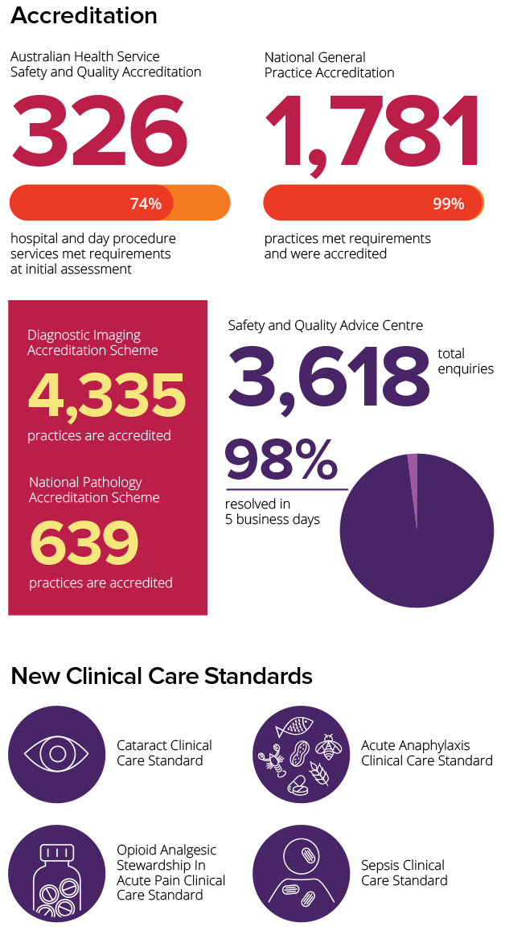
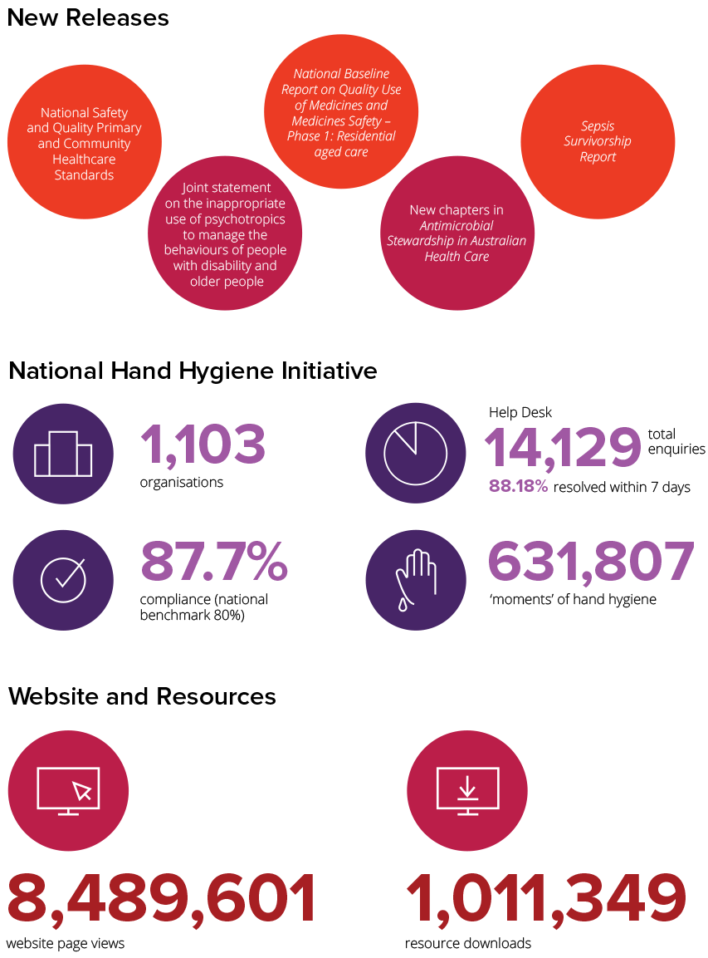
- Overview
This section provides an overview of the Australian Commission on Safety and Quality in Health Care (the Commission) – including its mission, role, functions and accountability – and reports from the Commission’s Chair and Chief Executive Officer.
About the Commission 10
Strategic Intent 2020–2025 12
Report from the Chair 14
Report from the Chief Executive Officer 16
Supporting safety and quality during COVID–19 18
Cross-sectoral collaboration 20

[This page has been intentionally left blank]

About the Commission
In 2006, the Council of Australian Governments established the Commission to lead and coordinate national improvements in the safety and quality of health care. The Commission’s permanent status was confirmed with the passage of the National Health and Hospitals Network Act 2011, and its role was codified in the National Health Reform Act 2011. The Commission commenced as an independent statutory authority on 1 July 2011, funded jointly by the Australian Government and state and territory governments.

Our purpose
Our purpose is to contribute to better health outcomes and experiences for all patients and consumers, and improve value and sustainability in the health system by leading and coordinating national improvements in the safety and quality of health care. Within this overarching purpose, the Commission aims to ensure that people are kept safe when they receive health care and that they receive the care they should.
The functions of the Commission are specified in section 9 of the National Health Reform Act 2011 and include:
- formulating standards, guidelines and indicators relating to healthcare safety and quality matters
- advising health ministers on national clinical standards
- promoting, supporting and encouraging the implementation of these standards, and related guidelines and indicators
- monitoring the implementation and impact of the standards
- promoting, supporting and encouraging the implementation of programs and initiatives relating to healthcare safety and quality
- formulating model national schemes that provide for the accreditation of organisations that provide healthcare services, and relate to healthcare safety and quality
- publishing reports and papers relating to healthcare safety and quality.

Our accountability
The Commission is a corporate Commonwealth entity and part of the Health portfolio of the Australian Government. As such, it is accountable to the Australian Parliament and the Minister for Health and Aged Care. During 2021–22, the Minister was the Hon. Greg Hunt MP until late May 2022 and the Hon. Mark Butler MP from June 2022.

Strategic Intent 2020–2025
In 2019–20, the Commission’s Board endorsed the Strategic Intent 2020–2025. The functions described in section 9 of the National Health Reform Act 2011 guide the Commission’s work, and are expressed in the four priorities of the Strategic Intent 2020–2025.
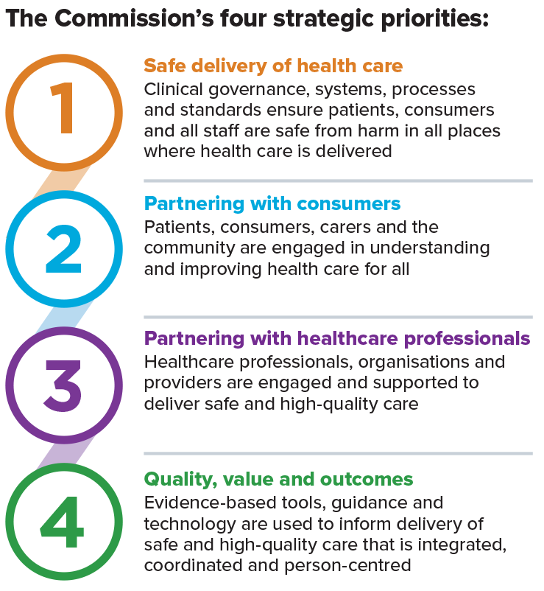

The Australian Commission on Safety and Quality in Health Care leads and coordinates national improvements in the safety and quality of health care.
Safe and high-quality health care for every person, everywhere, every time.
We do this by:
- being an authoritative voice
- taking a strategic whole-of-system approach
- using evidence as a foundation for action
- harnessing national knowledge and expertise
- driving a quality improvement culture
- using data effectively
- reporting meaningful information publicly
- empowering consumer action
- enabling and engaging clinicians
- leading collaboration, cooperation and integration
- influencing funding, regulation and education
- fostering use of safe digital technology and artificial intelligence
- guiding transparency and accountability
- supporting research and innovation
- acknowledging and actively managing risk
- embedding safety and quality into systems and processes
- encouraging development of learning organisations
- creating networks of excellence.
The Commission measures and reports on progress in these priority areas in the Corporate Plan, work plan, annual report and Budget papers.
The Commission works in partnership with patients; carers; clinicians; the Australian, state and territory health systems; the private sector managers; and healthcare organisations to achieve a safe, high-quality and sustainable health system. Key functions of the Commission include developing national safety and quality standards, developing clinical care standards to improve the implementation of evidence-based health care, coordinating work in specific areas to improve outcomes for patients, and providing information, publications and resources about safety and quality.


Report from the Chair
Professor Villis Marshall AC
“Protecting older people from harm and improving the quality of their health care are continuing priorities in our work. All Australians deserve access to high-quality, safe care.”
As the COVID–19 pandemic continued into a third year, our health systems remained under great pressure as new viral strains emerged and case numbers rose. The Commission has demonstrated the resolve and capability to continue its work to improve healthcare safety and quality while supporting healthcare providers to meet the greatest public health challenge of recent times.

In 2021–22, the Commission commenced significant new work to improve care for some of the most vulnerable in our community. The Commission is playing a key role in strengthening the protection of older people from harm in care settings by developing an Aged Care Clinical Standard that will form part of the Aged Care Quality Standards. This work is being undertaken in collaboration with the Australian Government Department of Health and the Aged Care Quality and Safety Commission (ACQSC). Protecting older people from harm and improving the quality of their health care are continuing priorities in our work. All Australians deserve access to high-quality, safe care.
The Commission has long recognised the detrimental impact of the inappropriate use of psychotropics for older people and people with disability, and has developed a range of resources on the topic. In further recognition of the need for collaborative efforts across the health, aged and disability care sectors, in March 2022 the Commission joined with the ACQSC and the National Disability Insurance Scheme Quality and Safeguards Commission to release a joint statement addressing the impact of the inappropriate use of psychotropics for older people and people with disability.
The achievement of a formal commitment by all three agencies to joint action not only shone a spotlight onto this area of concern but also demonstrated a way forward for cross-agency cooperation in the management of healthcare issues in aged care and disability services.
Following this commitment, the Commission began developing a clinical care standard to address the inappropriate use of psychotropic medicines for people with changed behaviours, which will be consulted on and released in 2022–23.
In presenting the 2021–22 annual report, I would like to thank our healthcare partners, including the Australian Government, state and territory partners, the private sector, clinicians, and, of course, our consumer advisory groups and consumers themselves who take time to share their experiences to make services better.
I extend my thanks to the members of the Commission’s Board for their advice and guidance over the past year, to the Hon. Greg Hunt MP, former Minister for Health and Aged Care, for his leadership and support and to the new Minister for Health and Aged Care, the Hon. Mark Butler MP. On behalf of the Board, I would like to express my sincere gratitude to Professor Debora Picone, who is retiring from her role as Chief Executive Officer in September 2022. Adjunct Professor Picone’s contribution has been truly outstanding – her strength and commitment to safety and quality in health care, and her insight, experience, skills and humour have been invaluable. Her legacy is a strong Commission with a clear vision and direction, which is highly regarded and has substantial influence on healthcare systems across the country.
Also on behalf of the Board, I would like to thank the executive team and all staff of the Commission – your outstanding work continues to strengthen our reputation and recognition as a national leader for improvement in health care for all Australians.


Report from the Chief Executive Officer
Adjunct Professor Debora Picone AO
“My time at the Commission has been an incredible journey. The opportunities to support and drive improvement, and the gains made have been substantial.”
Over the past year, I am pleased to report that, through the commitment of staff and the support of the Board, the Commission has again achieved progress against our work plan while dealing with the impact of the COVID–19 pandemic on both the health system and the Commission’s normal operational activities.
We have recognised the level of fatigue in health systems as they entered the third year of meeting the challenges of the COVID–19 pandemic, with new variants and rising cases. Conscious of our many interactions with clinicians and health agencies, the Commission has actively sought to be targeted in our engagement, and adaptable and responsive in interactions with stakeholders, to avoid placing undue pressure on people, systems and services responding to COVID–19 outbreaks.

Even in light of these adjustments to our normal practice, this year delivered some outstanding initiatives and achievements.
Among the many highlights from this year have been the outstanding efforts to raise awareness of the devastating impacts of sepsis. In 2021–22, the Commission led the National Sepsis Program, in partnership with the George Institute for Global Health, to deliver an awareness campaign, foundational research and a number of resources and reports, which will have continuing long-term value. As part of this work, the Commission also developed a clinical care standard.
In 2021–22, the Commission published four clinical care standards: the Sepsis Clinical Care Standard, the Cataract Clinical Care Standard, the Acute Anaphylaxis Clinical Care Standard and the Opioid Analgesic Stewardship in Acute Pain Clinical Care Standard. This is a remarkable achievement in delivering high-quality clinical advice to assist in provision of better care. These standards, relating to specific conditions, identify and define the care people should expect to receive, regardless of where they are treated in Australia. They are an important resource for both clinicians and consumers.
Another important achievement this year was the delivery of the National Safety and Quality Primary and Community Healthcare Standards, released in October 2021. These standards provide a clear framework for healthcare services across the sector to deliver safe, high-quality health care. Resources are currently being developed to support assessment against the standards.
In August 2021, the Commission released the fourth Australian report on antimicrobial resistance in human health – AURA 2021 – which shows that antimicrobial stewardship and antimicrobial resistance continue to be concerns for Australia. To support understanding and improvement in this area, the Commission also released three further chapters in Antimicrobial Stewardship in Australian Health Care, on antimicrobial stewardship in community and residential aged care, in rural and remote hospitals and health services, and in dental practice.
This is my last annual report as Chief Executive Officer of the Commission. My time at the Commission has been an incredible journey. At a national level, we have driven implementation and harmonisation of safety and quality standards, advocated for greater partnerships with consumers and clinicians, examined and explored healthcare variation, and fostered improvement in measurement across the healthcare system. The opportunities to support and drive improvement, and the gains made have been substantial.
I would like to acknowledge the Commission Board, including our Board Chair, Professor Villis Marshall AC; the Hon. Greg Hunt MP, former Minister for Health and Aged Care; and the Hon. Mark Butler MP, the new Minister for Health and Aged Care, for their leadership and contributions to improving health care over the past year.
I would also like to thank the Australian Government, our state and territory partners, private sector colleagues, clinical and consumer advisors, and, of course, our outstanding Commission staff. Together, we have made a difference and supported our healthcare services in delivering high-quality, safe care for all Australians. This work will continue.

Supporting safety and quality during COVID–19
The COVID–19 pandemic continued as a public health emergency requiring an extraordinary response by the health system and society. The need to prepare for, and respond to, the threat of COVID–19 infection, including new and emerging variants, within Australia placed unique pressures on healthcare systems.
Australia’s response to the COVID–19 pandemic continued to evolve in 2021–22 as our understanding of the virus increased and new variants emerged. While the risk of future COVID–19 outbreaks in Australia remained, the Commission continued to support the health system to mitigate this risk and deliver safe, high-quality, evidence-based care.
The Commission balanced the need to address national priorities in the safety and quality of health care with a flexible response to new and emerging needs in 2021–22.

Liaison and redeployment
The Commission continued staff deployments to support national and state-based COVID–19 response activities, in line with the Prime Minister’s direction regarding the redeployment of public servants on 26 March 2020. Commission staff who previously worked in health and whose registration and training allowed them to give vaccinations assisted in NSW Health vaccination centres during October 2021. In addition, senior staff were redeployed to the Public Health Response Branch of NSW Health and participated in the operations team of the Australian Defence Force’s response.

Strengthening infection control guidance
The Commission continued its work to develop and promote resources to support health service organisations in implementing the Preventing and Controlling Infections Standard of the National Safety and Quality Health Service (NSQHS) Standards, and to support Australia’s response to COVID–19.
The Commission monitored the need for new and updated guidance during the COVID–19 pandemic. It focused attention on risk management for infection prevention and control to support health service organisations in assessing risks related to COVID–19 and developing a comprehensive risk management plan.
In addition, the Commission revised tailored infection control resources for COVID–19, collaborated with other agencies to support infection control practices and improved

dissemination of relevant resources. Updated resources included the suite of posters for healthcare and aged care workers regarding putting on and removing personal protective equipment, the Break the Chain of Infection poster, and guidance on environmental cleaning practices for small health services and cleaners.

Accreditation arrangements in 2022
The COVID–19 pandemic continued to create challenges for the health system throughout 2021–22. In some instances, this affected the ability of health service organisations to participate in accreditation assessments.
To provide certainty for organisations, and facilitate accreditation assessments proceeding where possible, the Commission implemented provisions in February 2022 to enable hybrid and virtual accreditation assessments, for both acute and primary care service organisations, where on-site assessments were not possible. Criteria and information on processes for conducting hybrid and virtual assessments were developed and provided to the healthcare system. These arrangements were scheduled for review after June 2022.

Managing work plan activities
As the impact of the COVID–19 pandemic fluctuated, the Commission monitored and iteratively reviewed activities and timelines for individual projects under the work plan for 2021–22. This involved prioritising tasks and activities to avoid placing undue pressure on health service organisations and clinicians occupied in responding to COVID–19, and reallocating staff to respond to health system needs. These changes meant that some consultation and engagement activities were delayed or undertaken virtually, and desktop activities such as project planning, drafting of resources and literature reviews were brought forward.
The Commission took a risk management approach to balancing work plan activities with new requests and redeployment directions, and continually monitored the progress of deliverables under the work plan to ensure that there were no significant delays.

Cross-sectoral collaboration
A number of royal commissions highlighted safety and quality issues highly relevant to the work of the Commission and the delivery of safe, high-quality, equitable health care in Australia. The Commission worked collaboratively with government agencies to address some of the key cross-sectoral issues.

Supporting aged care reform
Following the Royal Commission into Aged Care Quality and Safety (Aged Care Royal Commission), the Australian Government announced in the 2020–21 Budget that the Commission would be responsible for leading formulation of a draft clinical standard for inclusion in the Aged Care Quality Standards. In October 2021, the Commission began a two-year project, funded by the Australian Government Department of Health (the Department) to draft the Aged Care Clinical Standard, in collaboration with the Department and the Aged Care Quality and Safety Commission. The draft clinical standard will be integrated with the revised Aged Care Quality Standards before a public consultation, expected to be completed in 2022–23.
The draft clinical standard will address key clinical safety and quality issues in aged care organisations where there are known gaps between current service provision and best-practice outcomes, as identified by the Aged Care Royal Commission, consumers and the aged care sector.
Once the revised Aged Care Quality Standards are finalised, the Commission will develop accompanying guidance, tools and resources for implementation. The aim is to protect older people from harm and improve the quality of health care delivered through Australian Government–subsidised aged care services.

Reducing inappropriate use of psychotropic medicines
In March 2022, the Commission joined with the Aged Care Quality and Safety Commission and the National Disability Insurance Scheme (NDIS) Quality and Safeguards Commission to release a joint statement on the inappropriate use of psychotropics to manage the behaviours of people with disability and older people.
This work highlighted the detrimental impact of the inappropriate use of psychotropic medicines (including antipsychotic medicines) for older people and people with disability, as well as the need to proactively seek alternatives such as positive behaviour support.

The Commission continued to progress work plan activities focusing on strategies to reduce the inappropriate use of psychotropic medicines, and has begun developing a clinical care standard on appropriate use of these medicines for behaviour management.

Improving health care for people with disability
The Royal Commission into Violence, Abuse, Neglect and Exploitation of People with Disability held hearings throughout 2021–22 and will be continuing through to September 2023. The Commission provided briefings and submissions, with a particular focus on the inappropriate use of psychotropic medicines in response to behaviours of concern in people with disability.
In October 2021, the Commission expanded its Cognitive Impairment Program to include safety and quality issues for people with disability. The initial focus is on improving health care for people with intellectual disability and supporting implementation of the NSQHS Standards.
The Commission and the NDIS Quality and Safeguards Commission are working together to increase engagement across the two sectors and identify shared goals in the health care of people with disability.

Complaints processes for consumers
The Commission is working with the Australian Health Practitioner Regulation Agency (Ahpra) on a project to improve consumer awareness, understanding and experience of health complaints processes nationally.
This year, the Commission and Ahpra consulted with professional associations, specialist colleges and health service management organisations to build an understanding of their experience of complaints, including how complaints are managed at the local level, and current referral pathways. In addition, the Commission worked with peak consumer health organisations to explore consumers’ experience of health complaints. These consultations, together with mapping of common complaints pathways, will be used to identify opportunities to support improvements in consumer understanding and experience of complaints in 2022–23.
- Report on performance
This section details the Commission’s achievements against its four priority areas.
Priority 1: Safe delivery of health care 25
Priority 2: Partnering with consumers 47
Priority 3: Partnering with healthcare professionals 51
Priority 4: Quality, value and outcomes 55

[This page has been intentionally left blank]

“The Commission continues to respond to industry feedback and is implementing six strategies to improve the reliability of the accreditation process.”

Priority 1: Safe delivery of health care
This priority area aims to ensure that patients and consumers are kept safe from preventable harm.

Improving patient safety through the National Safety and Quality Health Service Standards
The primary aim of the NSQHS Standards is to protect the public from harm and to improve the quality of health service provision. The NSQHS Standards outline safety and quality outcomes that a health service organisation must achieve, while giving organisations the flexibility to decide how to achieve these outcomes in a way that is appropriate for their context. Health service organisations began assessment against the second edition of the NSQHS Standards in January 2019.
All hospitals and day procedure services are required to implement the NSQHS Standards. They must implement organisation-wide safety and quality processes, and have a comprehensive clinical governance framework. With the NSQHS Standards and a clinical governance framework in place, health service organisations can reduce the risk of harm to patients from hospital-acquired infections, the wrong medicines and lapses in communication, and improve the provision of comprehensive care and management of an acutely deteriorating patient.
Key activities undertaken by the Commission in 2021–22 to support implementation of the NSQHS Standards included the following.

Assessment to the NSQHS Standards
In December 2021, seven independent accrediting agencies were approved by the Commission to assess health service organisations to the NSQHS Standards.
As of June 2022, 1,303 hospitals and day procedure services were required to be assessed to the NSQHS Standards. Health service organisations must demonstrate they meet all the requirements in the NSQHS Standards to achieve accreditation. The COVID–19 pandemic continued to impact on-site assessments to the NSQHS Standards. In the period July 2021 to June 2022, 440 hospitals and day procedure services in Australia were assessed to the NSQHS Standards. This is below the expect rate of 400 organisations that would normally be assessed each year. Of the 440 organisations assessed, 74% (326 organisations) met all actions at the initial assessment.
A summary of health services organisation assessment outcomes for 2021–22 is outlined in Figure 1.

From January 2021, eligible Multi-Purpose Services (MPS) can be accredited to the NSQHS Standards and the MPS Aged Care Module using a streamlined assessment process under the Australian Health Service Safety and Quality Accreditation (AHSSQA) Scheme. Forty MPS have been assessed to the MPS Aged Care Module as of June 2022.
One accrediting agency is yet to report on 13 assessments completed in 2021–22.

Providing guidance and advice
A number of resources to support health service organisations to implement the NSQHS Standards were published in 2021–22. These included fact sheets on risk screening for COVID–19 for accrediting agencies and health service organisations; updated workbooks, guides and monitoring tools to support implementation of the updated 2021 Preventing and Controlling Infections Standard; advice on implementing the updated Delirium Clinical Care Standard; guidance for accrediting agencies and health service organisations on conducting hybrid assessments to the NSQHS Standards; and a checklist for assessors on reviewing paper-based National Standard Medication Charts.
In September 2021, the Commission launched the NSQHS Standards User Guide for Health Service Organisations Providing Care for Patients from Migrant and Refugee Backgrounds. The Commission developed the resource in collaboration with the Migrant and Refugee Health Partnership.
Fact sheets were developed to provide consumers with an overview of the NSQHS Standards and the process of accreditation, and support a better understanding of the assessment outcome data that are not publicly reported.

Safety and Quality Advice Centre
The Commission’s Safety and Quality Advice Centre supports implementation of safety and quality standards developed or approved by the Commission, and provides advice to approved accrediting agencies on the performance of accreditation assessments under the requirements of the AHSSQA Scheme. In 2021–22, the advice centre responded to 3,618 enquiries, including 2,785 emails and 833 incoming calls. This is a 39% increase in email enquiries compared with the previous year. During the reporting year, the advice centre expanded to support coordination of additional accreditation schemes and implementation of new safety and quality standards developed by the Commission.

Figure 1 Health service organisation accreditation, 2021–22
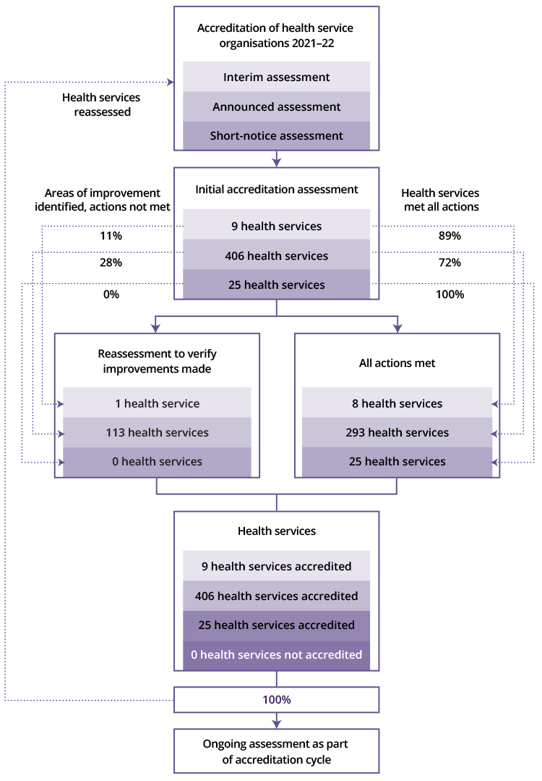
Note: Health service organisations includes only hospitals and day procedure services, where accreditation to the NSQHS Standards is mandatory. Other services assessed to the NSQHS Standards are not included. These are finalised assessments between 1 July 2021 and 30 June 2022 to the second edition of the NSQHS Standards.

Improving the reliability of the accreditation processes
The Commission continued to respond to industry feedback, implementing six strategies to improve the reliability of the accreditation process. Combined, these strategies ensure a more accurate assessment of a health service organisation’s implementation of the NSQHS Standards.
Key activities undertaken by the Commission in 2021–22 to improve the reliability of the accreditation process included the following.

Unannounced assessments
A voluntary option to undertake unannounced assessments, which are conducted with 48 hours notice, was introduced for health service organisations in January 2019. A total of 25 health service organisations have undertaken unannounced assessments since then. During 2022, the Commission worked with states and territories to broaden this program to include mandatory unannounced assessments for all hospitals and day procedure services; this is due to commence in 2023.

Governing body attestation statements
Health service organisations are required to submit an annual attestation statement to their accrediting agency between July and September each year. The Commission undertakes follow-up processes to identify organisations with an outstanding attestation statement.
At the beginning of January 2022, 13 health service organisations had not submitted an attestation statement. Most were small day procedure services that had not submitted an attestation statement because of closures associated with COVID–19. By February 2022, 100% of health service organisations had complied with this requirement.
In collaboration with accrediting agencies, the Commission continued to consider mechanisms to remind health service organisations of the intent and importance of annual attestation statements.

Public reporting of accreditation outcomes
Public reporting of accreditation outcomes commenced in December 2021. In collaboration with states and territories, consumers and health service organisations, the Commission developed a public reporting tool on the outcomes of assessments and any areas where improvements are required to achieve accreditation. Since its introduction, there have been 2,761 visitors to the tool online. Of those providing feedback on the public reporting tool, 55% (33 of 60) found the information helpful.

Oversight and feedback on accrediting agency performance
The Commission conducted a review of assessment outcome reports provided to health service organisations by approved agencies. This led to the development of a standardised reporting template that ensures that health service organisations receive information on an agreed minimum dataset following each assessment. Accrediting agencies piloted the template in the first half of 2022 and began using it in June 2022.
From July 2022, accrediting agencies are required to submit an annual declaration relating to any potential conflicts of interest.

Review of accreditation outcomes data
Accrediting agencies submit data on assessment outcomes through the Commission’s data collection portal. The portal automatically validates the data submitted to ensure that the information is consistent with the Commission’s requirements. The Commission analyses the data, and provides reports to state and territory regulators and various program administrators. In 2021–22, this included:
- review of trends in compliance with the NSQHS Standards and specific actions that require improvement
- examination of the validity and consistency of ‘not applicable’ actions awarded; these are actions from the NSQHS Standards that are not assessed because they do not apply in that service setting
- identification of health service organisations that meet the criteria for mandatory reassessment
- review of variation among accrediting agencies.

Assessor training
All assessors for the NSQHS Standards are required to undergo the NSQHS Standards Assessor Orientation Course. At 30 June 2022, 384 assessors had completed this course. There are four intakes for the course, and the current course will be open until December 2022. All assessors currently enrolled in the course have also been enrolled in the Core Cultural Learning Aboriginal and Torres Strait Islander Foundation Course, and 408 assessors had completed this course by 30 June 2022.
Assessors are required to complete a training module to support assessment under the NSQHS Standards Aged Care Module and User Guide for Multi-Purpose Services. As of 30 June 2022, 384 assessors had completed this course.
From mid–2022, all assessors will be required to participate in a one-day face-to-face cultural safety workshop, which relates to assessment of the Aboriginal and Torres Strait Islander–specific actions across the NSQHS Standards, the National Safety and Quality Primary and Community Healthcare Standards, (Primary and Community Healthcare Standards) and the National Safety and Quality Digital Mental Health (NSQDMH) Standards. Content for the course has been developed in partnership with the Congress of Aboriginal and Torres Strait Islander Nurses and Midwives. Training of all eligible assessors is expected by June 2023. The training is designed to increase assessors’ cultural safety when assessing the six Aboriginal and Torres Strait Islander–specific actions.

Post-assessment survey
A survey is sent to all health service organisations immediately following the completion of an assessment to the NSQHS Standards. Feedback is sought from organisations as part of monitoring of the performance of accrediting agencies and assessors for the NSQHS Standards. The survey has had a 34% (88 of 259) response rate. Almost all respondents (95%) found their lead assessor effective in coordinating the assessment.
Key findings included that:
- all assessments had a lead assessor
- final reports were provided to health service organisations in a format that was easily understood
- assessors had a comprehensive knowledge of the NSQHS Standards
- assessors used the PICMoRS (process, improvement, consumer participation, monitoring, reporting and systems) structured assessment method and referred to Commission resources when required.

Diagnostic Imaging Accreditation Scheme
On 1 July 2021, administration of the Diagnostic Imaging Accreditation Scheme was transferred to the Commission from the Department.
This scheme provides accreditation of diagnostic imaging practices to the Diagnostic Imaging Accreditation Scheme Standards. As of 30 June 2022, there are 4,335 diagnostic imaging practices with accreditation. The services provided by these practices range from single modality (62%) to five modalities (5%). A substantial majority (81%) of these practices offered ultrasound services.
In 2021–22, the Commission re-established the Diagnostic Imaging Accreditation Scheme Advisory Committee and Diagnostic Imaging Accrediting Agency Working Group under its governance systems. The Commission developed a webpage, engaged with stakeholder groups, collected data on diagnostic imaging assessments, and developed resources to support implementation of the standards and assessment to the standards.
The Commission commenced a review of the Diagnostic Imaging Accreditation Scheme Standards in 2021–22, which is expected to be finalised in 2022–23. As part of this process, the Commission conducted consumer and stakeholder consultations, and a literature review on safety and quality issues in diagnostic imaging.

National Pathology Accreditation Scheme
On 1 July 2021, the Commission assumed responsibility from the Department for administering the National Pathology Accreditation Scheme (NPAS), and supporting the National Pathology Accreditation Advisory Council (NPAAC) and its subcommittees.
NPAAC is responsible for developing and maintaining standards used to assess pathology laboratories in Australia. It is a longstanding statutory advisory committee of the Australian Government established under the National Health Act 1953.
At June 2022, there were 25 pathology standards listed in the Health Insurance (Accredited Pathology Laboratories – Approval) Principles 2017. Three pathology standards have been updated:
- requirements for the retention of laboratory records and diagnostic material
- requirements for medical testing of human nucleic acids
- requirements for the packaging and transport of pathology specimens and associated materials.
The Commission is working closely with the National Association of Testing Authorities to collate data on the assessment of pathology laboratories, and ensure that pathology standards are in line with current best-practice safety and quality requirements for pathology services.
The Commission has transitioned NPAAC, and its subcommittees and technical working groups under its governance systems, and developed an NPAS webpage. The Commission published resources to support the pathology sector and health system in addressing critical issues arising from the COVID–19 pandemic.

Patient safety in primary health care
Primary health care is the setting in which consumers most often receive health care, yet there are limited data on the frequency, causes and consequences of errors and adverse events in the sector. The Commission has been working to better understand the issues that affect patient safety in primary care settings, and to provide nationally consistent strategies, tools and resources for improving patient safety.
Key activities undertaken by the Commission in 2021–22 on patient safety in primary care included the following.

National General Practice Accreditation Scheme
The Department funds the Commission to coordinate the National General Practice Accreditation (NGPA) Scheme. The NGPA Scheme commenced in January 2017 with the primary aim of supporting national consistency of accreditation of general practices. General practices participating in the NGPA Scheme are accredited to the Royal Australian College of General Practitioners (RACGP) Standards for General Practices.
Five independent accrediting agencies were approved by the Commission to assess general practices to these standards. A total of 1,796 general practices were assessed, with 99% meeting the requirements of the standards and awarded accreditation. Twelve general practices were not accredited and three withdrew from the NGPA Scheme.
Of the practices assessed, 96% were categorised as general practices, and the remaining 4% were categorised as Aboriginal medical services. Of the 1,796 assessed practices, 1,152 were in metropolitan areas (64%); just over three-quarters were in Queensland, New South Wales and Victoria. The number and type of ‘not met’ indicators were largely similar between metropolitan and rural and remote locations.
In relation to the workforce of the general practices assessed:
- 76% employed five or fewer full-time equivalent (FTE) general practitioners
- 70% employed two or fewer FTE practice nurses.
From 1 November 2021, the Commission expanded the standards under the NGPA Scheme to include the RACGP Standards for Point-of-Care Testing. In 2021–22, no general practices have registered with an accrediting agency for assessment to these standards.

Supporting general practices during the 2022 floods
To support general practices affected by the extreme flooding events in New South Wales and Queensland in March 2022, the Commission allowed affected general practices to apply for extensions of their accreditation expiry date of up to 12 months. This was so that affected general practices could focus on rebuilding and providing the necessary support to their communities.

National Safety and Quality Primary and Community Healthcare Standards
In October 2021, the Commission launched Australia’s first Primary and Community Healthcare Standards. The Primary and Community Healthcare Standards were developed in consultation with a wide range of stakeholders, including the Australian Government, state and territory partners, primary and community healthcare services, consumers, peak bodies and interest groups. They provide a clear framework for healthcare services across the sector to deliver safe, high-quality health care.
Significant progress has been made in the development of comprehensive resources for healthcare services to implement the Primary and Community Healthcare Standards. Progress has also been made in establishing a flexible assessment model to support voluntary assessment and accreditation to the standards in 2022.

Healthcare-associated infections, and infection prevention and control
Healthcare-associated infections are some of the most common and significant hospital-acquired complications, with around 38,000 healthcare associated infections occurring in Australia per year. As well as causing unnecessary pain and suffering for patients and their families, a healthcare-associated infection can prolong a patient’s hospital stay and add considerably to the cost of delivering health care.
Effective infection prevention and control practices can minimise the risk of transmission of infection between patients, healthcare workers and other people in the healthcare environment. This reduces the risk of healthcare-associated infections.

Resources to support the new Preventing and Controlling Infections Standard
Accreditation against the 2021 Preventing and Controlling Infections Standard commenced in January 2022.
The Commission’s resources were updated to reflect the content of the new standard. New resources were also developed to support implementation of systems and strategies to meet the requirements of the standard, including:
- guidance on use of a hierarchy of controls, and infection prevention and control systems to identify hazards and develop risk mitigation strategies
- revision of the infection prevention and control online learning modules to reflect the actions and content of the new standard.
To provide additional support for implementation of the antimicrobial stewardship actions of the NSQHS Standards, three new chapters of Antimicrobial Stewardship in Australian Health Care were published in 2021–22. These focused on antimicrobial stewardship in community and residential aged care, in rural and remote hospitals and health services, and in dental practice.

An implementation guide was developed to assist health service organisations enhance patient care and meet the aseptic technique requirements of the NSQHS Standards. In addition, a clinician fact sheet, Principles of Aseptic Technique: Information for healthcare workers, was developed to specifically support clinicians in their use of aseptic technique.

Surveillance of healthcare-associated infections
To provide ongoing support for implementation of the revised benchmark for healthcare-associated Staphylococcus aureus bloodstream infection (SABSI), and to support further reductions in preventable cases, the Commission implemented an updated SABSI surveillance definition in July 2021 and published a surveillance implementation guide to support this change.
Infections caused by Clostridioides difficile (CDI) are often linked to prolonged and unnecessary use of antimicrobial therapy. CDI can be spread by direct or indirect contact, which can be prevented by frequent hand hygiene and effective environmental cleaning, as part of patient care. The Commission continued to monitor CDI in Australian public hospitals, releasing Clostridioides difficile Infection (CDI): 2019 data snapshot report in December 2021. This report highlighted the continued growth in prevalence of CDI in the community, with a 5% increase in CDI infections presenting to Australian public hospitals with symptoms emerging before hospitalisation.

National Hand Hygiene Initiative
Compliance with hand hygiene protocols for medical professionals has generally improved over the past five years. However, the national compliance rate for medical professionals remains below the national benchmark of 80% – one of the lowest rates across all healthcare worker types. Although student doctors have increased compliance rates over the same audit periods, this group has also frequently had compliance rates below the national benchmark.
In 2021–22, the Council of Presidents of Medical Colleges and the Commission released a joint statement to highlight the critical role of hand hygiene in reducing patient harm. This work was also promoted with various medical colleges, Medical Deans Australia and New Zealand, and the Australian Medical Association Council of Doctors in Training.
In 2021, the Commission commenced a major refresh of infection prevention and control e-learning modules to ensure currency of content and consistency with the NSQHS Standards, the Australian Guidelines for the Prevention and Control of Infection in Healthcare and the 2020 update of the World Health Organization’s Core Competencies for Infection Prevention and Control Professionals. The modules will provide a contemporary approach to learning across these vital areas of infection prevention and control. The first nine modules have been released.
In addition, the Commission has adapted its existing infection prevention and control e-learning resources to provide enhanced support to the aged care sector, to focus support for infection prevention and control in this setting, particularly during the COVID–19 pandemic.
Two new resources – the Basics of Infection Prevention and Control for Aged Care module and a train-the-trainer module – were published in July and October 2021. These aged care resources were developed in collaboration with the NSW Clinical Excellence Commission and the Aged Care Quality and Safety Commission.

Environmental cleaning resources
The Commission produced a suite of environmental cleaning resources to support reduction of harm through infection, and to support health service organisations to meet the clean and safe environment actions of the Preventing and Controlling Infections Standard. The resources also support implementation of the environmental cleaning requirements of the Australian Guidelines for the Prevention and Control of Infection in Healthcare.
The resources provide guidance on cleaning practices for small health service organisations, emerging environmental cleaning technologies, auditing and product selection. To better support the workforce directly undertaking environmental cleaning, specific information for cleaners was developed.

Updated guide on controlling carbapenemase-producing Enterobacterales
The 2021 Recommendations for the Control of Carbapenemase-Producing Enterobacterales (CPE): A guide for acute health service organisations (the CPE Guide) was published in November 2021. The updated CPE Guide follows an increasing prevalence of CPE across Australia, and strengthens strategies to prevent, detect and contain CPE. To support implementation of the 2021 CPE Guide and to promote greater recognition of CPE infections, the Commission also published an information sheet for patients and an infographic that illustrates the growing threat of CPE in Australia.

Antimicrobial use and resistance in Australia
Antimicrobial resistance (AMR) reduces the range of antimicrobials available to treat infections, and increases morbidity and mortality associated with infections caused by multidrug-resistant organisms.

Antimicrobial Use and Resistance in Australia Surveillance System
The Commission continued to undertake key AMR surveillance in Australia. The Department has contracted the Commission to continue its:
- coordination, support and enhancement of the functionality, coverage and reporting of the National Alert System for Critical Antimicrobial Resistances (CARAlert) and Australian Passive AMR Surveillance (APAS)
- collaboration with the Australian Group on Antimicrobial Resistance (AGAR) to report data on AMR in selected bacteria detected from blood cultures
- reporting on community antimicrobial use based on analyses of data from the Pharmaceutical Benefits Scheme (PBS) and Repatriation Pharmaceutical Benefits Scheme (RPBS), and the NPSMedicineWise MedicineInsight program.
APAS provides the largest volume of AMR data to AMR surveillance for human health in Australia, through AURA. In 2021, APAS included 16 pathology services nationally, comprising more than 85 million individual susceptibility results from all states, the Australian Capital Territory, and a number of private sector laboratories. These data are readily accessible by the health service

organisations that participate in APAS to inform local guidance on antimicrobial prescribing, infection prevention and control programs, and antimicrobial stewardship programs.
In August 2021, the Fourth Australian Report on Antimicrobial Use and Resistance in Human Health (AURA 2021) was released, which identified the following key issues:
- a continuing gradual decline in the rate of systemic antimicrobial prescribing via the PBS/RPBS and in MedicineInsight practices
- continuing high rates of patients from MedicineInsight practices prescribed antimicrobials for conditions for which there is no evidence of benefit, including acute bronchitis and sinusitis
- AGAR data showing that episodes of bacteraemia in Australia overwhelmingly had their onset in the community
- continuing increases in resistance to ciprofloxacin and other fluoroquinolones in Escherichia coli isolates from community-onset infections, and to key anti-gram-negative antimicrobial agents
- reductions in 2021 in reports of critical antimicrobial resistances that cause community-onset infections, such as multidrug-resistant Shigella and Neisseria gonorrhoeae, which corresponded with continuing lockdowns and travel restrictions associated with the COVID–19 pandemic and reduced social contact.

Safety in digital health
The Commission contributes to improvements in digital health by optimising safety and quality in the rollout of clinical systems, including through development of tools, guidance and standards, and by undertaking reviews and research.

Collaboration with the Australian Digital Health Agency
In December 2021, the Commission signed a new memorandum of understanding (MOU) with the Australian Digital Health Agency (ADHA). This builds on the Commission’s previous digital health and clinical safety program, which has been conducted on behalf of the My Health Record System Operator since 2012. The purpose of the MOU is to support clinical governance, and the clinical safety and quality of the national digital health work program. The Commission continues to support patient safety and digital health by:
- providing independent, expert advice to the ADHA on the clinical governance, clinical safety and quality of national digital health infrastructure, including the My Health Record system
- using the NSQHS Standards program and supporting resources to promote safe use of digital health national infrastructure, including the My Health Record system
- working collaboratively with the ADHA to promote clinical safety and quality in digital health through the Commission’s e-health safety work program and resources.
In January 2022, the Commission completed a review of the ADHA’s Clinical Governance Framework.

My Health Record in emergency departments
The Commission was engaged by the ADHA to investigate the needs of emergency department clinicians to support their use of the My Health Record system and how content can be applied to clinical decision-making. A five-month pilot study was performed in four public hospital emergency departments, which included almost 130,000 patients and 1,000 emergency department staff.

National Safety and Quality Digital Mental Health Standards
In December 2021, the Commission concluded a pilot that tested an accreditation model for the NSQDMH Standards. Following the pilot, it was recommended the accreditation model should operate under the Commission’s existing AHSSQA Scheme, which was accepted by the Department. The accreditation model is scheduled to commence by the end of 2022.
In addition, in March 2022, the Commission published National Safety and Quality Digital Mental Health Standards: Guide for service providers. This guide helps prepare service providers for accreditation by highlighting evidence they may use to address each of the actions in the NSQDMH Standards.

Electronic Medication Management Self-assessment Tool
In 2021, the Commission released a beta version of the Electronic Medication Management Self-Assessment Tool (EMM SAT online). This tool aims to support health service organisations to improve the use, scope, capacity and safety of their electronic medication management systems. This is achieved by simplifying the process of system assessment, reporting and planning for improvement. The tool was launched in June 2022.

Safer transitions of care for older Australians
The Commission commenced a project to identify opportunities to improve transitions of care between residential aged care facilities (RACFs) and hospitals. In 2021–22, the project focused on recruiting RACF pilot sites that have the capability to upload data to the My Health Record system. Recruitment efforts have resumed based on the availability of RACF pilot sites, subject to COVID–19. Once pilot sites are recruited, the project will examine how the My Health Record system transmits accurate and timely information, and its impact on user workload, medication safety and hospital readmission rates during transitions of care.

Medication safety
The Commission leads and coordinates a number of national initiatives to reduce medication errors and harm from medicines.

Electronic National Residential Medication Chart
In December 2021, the Commission published two resources to support the safe implementation and optimisation of electronic National Residential Medication Chart (eNRMC) medication management systems.
The first resource was aimed at RACFs looking to transition from paper-based or hybrid (electronic and paper) medication management systems to an eNRMC medication management system.
A second resource• was developed for software vendors looking to optimise or enhance their eNRMC medication management systems.

National baseline report on quality use of medicines
In November 2019, quality use of medicines and medicines safety was announced as Australia’s 10th National Health Priority Area. The Commission was subsequently engaged to develop a national baseline report on the quality use of medicines and medicines safety, with an initial focus on aged care and issues of polypharmacy, inappropriate use of antipsychotic medicines, and transitions of care.
Published in March 2022, the National Baseline Report on Quality Use of Medicines and Medicines Safety – Phase 1: Residential aged care aims to inform new best-practice models, new national standards and better medication management. The report presents 10 priority actions to be considered by government. Each priority action contributes to reductions in avoidable misuse of medicines and errors involving medicines, adverse drug events, and medication-related hospital admissions.

Review of publications on quality use of medicines
In March 2021, the Commission was engaged by the Department to review and update the following three national publications on quality use of medicines that underpin the National Medicines Policy:
- Guiding Principles for Medication Management in Residential Aged Care Facilities
- Guiding Principles for Medication Management in the Community and reference guide
- Guiding Principles to Achieve Continuity in Medication Management.
The quality use of medicines and medicines safety landscape has evolved since these guiding principles were originally published. The review and update of these documents considered contemporary quality use of medicines, medicines safety literature and the National Medicines Policy, which is also under review.
Each of the publications underwent an extensive consultation process, including focus groups held with practising nurses and doctors. The updated publications were provided to the Department in June 2022.

National standard for labelling of dispensed medicines
Standardising labels on dispensed medicines can assist consumers to easily locate and understand information on how to use their medicines safely and effectively. In July 2021, the Commission released the National Standard for Labelling Dispensed Medicines to guide the design and content of medicine-related information printed on dispensed medicine labels. The standard is for all health professionals who dispense medicines, including pharmacists, pharmacy technicians, nurse practitioners, general practitioners, optometrists and dentists.
The Commission continues to work with clinicians and software vendors to support implementation of the standard. In March 2022, a roundtable was convened to address barriers and formulate implementation advice.

Point prevalence study on psychotropic medicines
Since May 2021, the Commission has been undertaking a point prevalence study in relation to prescribing of psychotropic medicines. The study, in partnership with 15 health service organisations, aims to describe the prevalence and characteristics of psychotropic medicines initiated in hospitalised patients who are discharged to RACFs. A final report is due for completion in mid–2022–23, which will inform the Commission’s ongoing work to reduce inappropriate use of psychotropic medicines.

Active ingredient prescribing
Active ingredient prescribing aims to increase the health literacy of consumers in relation to the active ingredient name of medicines, thereby improving safe and quality use of medicines, and promoting the uptake of generic and biosimilar medicines.
As of February 2021, most prescriptions under the PBS/RPBS must describe the medicine by active ingredient name to be eligible for subsidy. However, the principles for active ingredient prescribing extend to medicines outside the PBS/RPBS and are applicable across all healthcare settings where medicines are prescribed.
From June 2019, the Commission has been engaged by the Department to develop and maintain resources to support active ingredient prescribing. These include:
- Active Ingredient Prescribing: User guide for Australian prescribers and accompanying fact sheet
- Active Ingredient Prescribing: List of medicines for brand consideration
- Active Ingredient Prescribing: List of excluded medicinal items.
In 2021–22, the Commission continued to maintain resources. Final versions will be provided to the Department in December 2022.

Education courses on high-risk medicines
The Commission partnered with the South Australian Department of Health to develop an online suite of e-learning modules on high-risk medicines. These modules promote the safe use of high-risk medicines. Each module focuses on a specific topic, medicine or medicine group. Five modules are currently available:
- an introduction to high-risk medicines
- insulin
- anticoagulants
- clozapine
- opioid analgesics.
Two further modules, on psychotropic medicines and anti-cancer medicines, were developed in 2021–22, and will be released in early 2022–23.
The module program was evaluated in late 2021. Participating jurisdictions were supportive of the Commission continuing to provide stewardship and maintenance of the modules.

Incident analysis for anticoagulant stewardship
In October 2021, the Commission published a National Anticoagulant Incident Analysis report. Members of the Commission’s Health Services Medication Expert Advisory Group and other stakeholders had raised concerns about the rising number of incidents involving anticoagulant medicines. Of particular concern was the inappropriate prescribing and administration of heparins and direct oral anticoagulants.
The report describes and quantifies incidents that have involved anticoagulants. Incidents have been captured from healthcare settings (primarily hospitals) in states and territories across Australia. Findings in the report confirm that duplicate anticoagulant therapy is the most frequently occurring prescribing issue for these types of medicines.

Neural connector devices
In 2019, the Commission developed and published guidelines, including a safety checklist on the implementation of neural connector devices that comply with the international standard ISO 80369–6.
In March 2022, the Commission published a fact sheet – Identification of Neural Route Medicines, Fluids and Lines – aimed at those implementing the changeover from Luer to ISO 80369–6 neural connector devices. The fact sheet has been endorsed by the Quality and Safety Committee of the Australian and New Zealand College of Anaesthetists.
The Commission continues to consult with clinicians, states and territories, procurement teams, the Therapeutic Goods Administration and the Medical Technology Association of Australia on progress and overcoming barriers to implementation.

Evidence briefings on interventions to improve medication safety
In July 2021, the Commission published updated evidence briefings on interventions to improve medication safety. The evidence briefings support health professionals by summarising the latest evidence, which covered six topics:
- double-checking medication administration
- reducing interruptions during medication prescribing, preparation and administration
- electronic medication administration records
- closed-loop medication management systems
- electronic prescribing systems and their impact on patient safety in hospitals
- scanning medication administration systems.

Mental health
The Commission has an ongoing commitment to supporting safety and quality in the delivery of mental health care.

Recognising and responding to deterioration in a person’s mental state
The Commission released the online Escalation Mapping Template in May 2022, a quality improvement tool that can be used to determine the effectiveness of a health service organisation’s processes for recognising and responding to deterioration in a person’s mental state.
The tool was initially released in 2020 in Microsoft Excel format and was then translated to an online application. The new version allows greater functionality, and improves the user experience and navigation of the tool.

Standards and guidance for community mental health services
In 2021–22, the Commission developed specific mental health support materials based on the NSQHS Standards to align national standards that apply in mental health services across all healthcare settings, including services provided by community managed organisations. This work was initiated in response to the Fifth National Mental Health and Suicide Prevention Plan.
The two documents developed from this project align with, and complement, other Commission work related to the NSQHS Standards.
- The National Safety and Quality Mental Health Standards for Community Managed Organisations build on the established concepts and principles from the NSQHS Standards to ensure high-quality and safe health outcomes from mental health care delivery; the standards were developed and consulted on in 2021–22 and will be released in mid–2022–23.
- The NSQHS Standards User Guide for Acute and Community Mental Health Services subject to the AHSSQA Scheme will be released in mid–2022–23; it provides interpretive material and helpful strategies to assist mental health services subject to the AHSSQA Scheme to implement their requirements under the NSQHS Standards.

Intellectual disability
The Commission works collaboratively with agencies such as the National Disability Insurance Scheme Quality and Safeguards Commission and the Aged Care Quality and Safety Commission to increase the focus on safety and quality issues for people with intellectual disability.

Resources to support people with intellectual disability
The Commission developed a fact sheet series on intellectual disability. The fact sheet series aims to support and provide guidance to health service organisations and clinicians to improve the safety and quality of health care for people with intellectual disability.
The Commission worked with its Cognitive Impairment Advisory Group to release the draft fact sheet series for public consultation in 2021. The Commission received feedback from people with intellectual disability, and health and disability clinicians and organisations.
The fact sheets provide comprehensive information about:
- intellectual disability
- the challenges people with intellectual disability face
- a wide range of safety and quality issues
- how and why implementation of the NSQHS Standards can improve health outcomes for people with intellectual disability.
The fact sheets will be released in mid–2022–23.

Communicating for safety
Communication is essential for safe, high-quality care. Failures in communication are commonly cited as a contributing factor in several preventable adverse events.

Open disclosure
A key recommendation of the 2020 review of the Australian Open Disclosure Framework was to update Commission resources to better support consistent implementation of the open disclosure process, and increase consumer awareness of the purpose and value of open disclosure.
In January 2022, the Commission released two new consumer fact sheets to increase understanding of the open disclosure process, and support communication between clinicians and consumers. The content, language and design of the fact sheets were informed by surveys and consumer focus groups facilitated with peak consumer health agencies. To promote accessibility, the fact sheets were released in easy-English versions and translated into 25 community languages and an Auslan video.

Informed consent
Consumers have the right to receive clear and easy-to-understand information about their care and treatment options, so they are supported to make informed decisions about their care. In 2022, consultation commenced with stakeholders to understand the need for additional guidance to support consumers in their understanding of, and engagement in, informed consent. This work aims to support a shared understanding of informed consent among consumers and clinicians. It will complement existing Commission resources and information about informed consent for health services and clinicians.

Comprehensive care
Comprehensive care describes the integration of screening, assessment and risk identification processes, with the aim of developing an individualised care plan. This individualised care plan should be developed through shared decision-making processes, be tailored to the needs and preferences of the patient, and prevent or minimise risk of harm.

Guidance and resources
An interim evaluation of implementation of the Comprehensive Care Standard was completed. An associated article by the Commission was published in the peer-reviewed journal Australian Health Review, based on a qualitative survey of accredited health service organisations.
The Commission participated in multiple external meetings on comprehensive care covering three jurisdictions, and provided support and guidance to quality improvement projects, including four statewide projects.

National Sepsis Program
The Department engaged the Commission to lead the National Sepsis Program, in partnership with the George Institute for Global Health. The program consists of eight discrete projects to improve outcomes for patients with sepsis in Australia.
In 2021–22, the Commission:
- delivered the National Sepsis Awareness Campaign to improve general community awareness and clinician recognition of sepsis
- published a report on a qualitative study that investigated the lived experience of sepsis survivors, their families and carers, and bereaved families
- published the third edition of the National Consensus Statement: Essential elements for recognising and responding to acute physiological deterioration
- conducted a pilot for a national retrospective review of sepsis patients’ medical records to identify how sepsis is recognised, managed and clinically coded.
A report detailing findings and recommendations from the national retrospective medical record review will be published in 2022–23.

Priority 2: Partnering with consumers
This priority area aims to ensure that patients, consumers, carers and the community are engaged in understanding and improving health care for all.

Supporting consumer engagement and partnerships
Raising consumers’ awareness of their healthcare rights, the roles they play and options available to foster healthcare improvement is a core focus of the Commission’s work.

Australian Charter of Healthcare Rights
The Australian Charter of Healthcare Rights (the Charter) aims to provide a shared understanding between consumers, clinicians and healthcare services about the rights of consumers accessing health care in Australia. As outlined in the NSQHS Standards, health service organisations are required to have a charter of rights that is consistent with the Charter, and to ensure that this information is easily accessible to patients, carers, families and consumers.
In 2022, the Commission released two new quick-reference guides about healthcare rights, one for consumers and one for health service organisations. These describe what to expect when receiving health care, and can help patients in conversations with their clinicians about healthcare rights. The consumer guide will also be translated into 20 community languages to support consumers who speak languages other than English.
To support health service organisations to implement the Charter, a new guide, Using the Charter in your Health Service, was developed in 2021–22 and will be published in mid–2022–23. The content of the guide was shaped through consultation with stakeholders. The guide shares practical strategies on how to implement the Charter in organisation-wide systems. This includes linking the Charter to clinical governance systems, and engaging consumers and staff in planning how to strengthen use of the Charter.

Shared decision making and health information
Navigating the online health information environment can be challenging for consumers.
In 2022, the Commission published a suite of resources with tips to help consumers find good health information online. The resources focus on finding reliable information from trusted sources. They explain what to look for and where consumers can get support.
The resources, including a poster, a booklet, an easy-English adaptation and an animation, were developed with the advice of consumers to ensure that they met needs,

and are easy to access and understand. The poster and booklet were translated into 20 community languages to support access by people from culturally and linguistically diverse backgrounds.

Resources to support consumers engaging in partnerships in their own health care
In 2021–22, the Commission worked with the Consumers Health Forum of Australia to develop a guide on partnerships for consumers. Partnering with Consumers: A guide for consumers will help both consumers and health service organisations better understand how to get the most from their partnerships so that there are better health outcomes. The guide will be published in mid–2022–23.

End-of-life care
In 2021–22, the Commission undertook two literature reviews to inform the development of the second edition of the National Consensus Statement: Essential elements for delivering safe and high-quality end-of-life care. The second edition has been drafted and expanded to be relevant to all settings where end-of-life care is provided by a health service organisation, including in the community, in RACFs and at home. Consultation, refinement and publication of the draft will occur in 2022–23.
An end-of-life care systems review tool was developed in 2021–22 to assist health service organisations to identify strengths and weaknesses in the provision of end-of-life care. Final testing and publication are scheduled for 2022–23.

Measuring patient experience
Understanding patients’ experience of their care and outcomes is vital for identifying opportunities for improvement in safety and quality of care.

Patient-reported experience measures
In 2021–22, the Commission continued to support health service organisations to implement the Australian Hospital Patient Experience Question Set (AHPEQS). The Commission assisted organisations in adapting AHPEQS for use in specialised areas, and consulted with stakeholders and identified priority patient populations, such as paediatric settings, for supplementary AHPEQS questions. Supplementary questions can further elicit the experiences of priority patient populations for quality improvement.
The Commission is also supporting a research project funded by the National Health and Medical Research Council to develop a patient-reported experience measure tool for Aboriginal and Torres Strait Islander people accessing primary health care.
The Commission commenced a project to understand how health service organisations use data collected from AHPEQS for local safety and quality improvement. Insights from this project will inform future initiatives to support implementation of AHPEQS.

Patient-reported outcome measures
Patient-reported outcome measures (PROMs) provide a systematic way to assess the effectiveness of healthcare interventions from the patient’s perspective. In 2021–22, the Commission continued to collaborate with the Organisation for Economic Co-operation and Development on a project to develop, pilot and report on PROMs internationally. The Commission is managing Australia’s involvement in this international work to develop a new survey on outcomes and experiences of patients over the age of 45 who have one or more chronic conditions and receive primary or ambulatory care. The pilot survey has been developed, and cognitive testing completed.
The Commission continued its ongoing work to support implementation of PROMs in Australia. In collaboration with expert panels, the Commission outlined recommendations for the use of PROMs in hip fracture and maternity care. A roundtable of senior PROMs implementers is planned for 2022–23.

“In 2021–22, the Commission finalised work on a nationally consistent definition of avoidable hospital readmissions, with all states and territories.”

Priority 3: Partnering with healthcare professionals
This priority area aims to ensure that healthcare professionals, organisations and providers are engaged and supported to deliver safe and high-quality care.

Indicators, measures and dataset specifications
Most health care in Australia is associated with good clinical outcomes; however, preventable adverse events and complications continue to occur across the healthcare system. To assist in identifying instances of harm, the Commission developed three indicators for local monitoring of safety and quality: hospital-acquired complications (HACs), avoidable hospital readmissions and sentinel events.
In partnership with the Independent Hospital Pricing Authority (IHPA), and the state and territory health departments, the Commission has developed specifications for these three indicators under the National Health Reform Agreement. The 2020–2025 Addendum to the National Health Reform Agreement includes these indicators, and promotes development of ways to reduce avoidable and preventable hospitalisations in collaboration with the IHPA and the Administrator of the National Health Funding Pool.

Hospital-acquired complications list
In 2021–22, the Commission continued its role of supporting local-level monitoring and improvement of patient care with the HACs list. In April 2022, the Commission updated the HACs list to align with coding changes that were to commence in July 2022.
In 2022, the Commission began updating the HACs fact sheets, initially published in mid–2018. The fact sheets support health service organisations by outlining governance structures and quality improvement processes needed to minimise occurrence of a HAC. A comprehensive literature review has been completed for all 16 HACs to ensure that the updated HACs fact sheets reflect contemporary practice.

Avoidable hospital readmissions list
In 2021–22, the Commission finalised work on a nationally consistent definition of avoidable hospital readmissions, with all states and territories. As tasked under the 2020–2025 Addendum to the National Health Reform Agreement, the Commission completed a clinician-focused process to review and refine the avoidable hospital readmissions list. This review informed the development and publication of the avoidable hospital readmissions list version 2.0, in May 2022.

Sentinel events
Sentinel events are a subset of adverse events that result in death or serious harm to a patient. In 2021–22, the Commission continued the engagement of an expert group, comprising senior clinical and executive staff, to review queries received relating to severe incidents and potential sentinel events. These queries were recorded in an issues log. This process serves to maintain and review the sentinel events list to ensure its currency and validity.

Clinical care standards indicators
The Commission continued to develop and specify indicators to support the implementation of clinical care standards published in 2021–22, including for:
- opioid analgesic stewardship in acute pain
- sepsis
- low back pain.
In September 2021, the indicator set for the Delirium Clinical Care Standard (first published in July 2016) was revised to ensure that the indicators remain fit for purpose, relevant and appropriate.
Work commenced to develop indicators for the new Stillbirth and Bereavement Care Clinical Care Standard and a clinical care standard to address the inappropriate use of psychotropic medicines for people with changed behaviours, scheduled for publication in 2022–23.

Patient Safety Culture Measurement Toolkit
The Commission released the Patient Safety Culture Measurement Toolkit in December 2021. The toolkit includes a validated survey, the Australian Hospital Survey on Patient Safety Culture 2.0, that measures patient safety culture from the perspective of staff, in addition to implementation and improvement strategies.
The Commission has begun work to develop a short set of questions for integration into annual staff surveys.

Improving reporting of safety and quality data
Improving reporting of safety and quality data involves providing guidance, technical specifications and standards to support meaningful collection, analysis and use of data that can be used to measure and improve the safety and quality of health service delivery.

Aligning public reporting for public and private hospitals
All Australian governments recognise the benefit and value of public reporting, such as improvements in provider quality of care and consumer empowerment, and are working to improve the transparency of public reporting.
The Commission commenced work in response to a request from all Australian health ministers to implement a simple, accessible national public reporting system that provides safety and quality information about individual hospitals.
The Safety in Healthcare Report will take the form of a website platform where people will be able to search for a relevant and reliable set of safety and quality information for each hospital in Australia. In 2021–22, the Commission, in conjunction with the public and private sector, finalised the initial indicators and completed specifications for the platform.
The website will be tested and completed in 2023. In the future, it is expected that the website will also contain patient-reported information on the outcomes of care.

Incident monitoring
In November 2021, the Commission published the Incident Management Guide, which provides a concise overview of incident management processes. It also includes links to state and territory incident management policies, and other national and international resources.
The Commission has commenced stakeholder consultations on a national mechanism to share lessons learned from patient safety incidents.

National Clinical Trials Governance Framework
In February 2022, all jurisdictions agreed to incorporate accreditation of health service organisations for the provision of clinical trial services under the AHSSQA Scheme. For the first three years, or one accreditation assessment cycle, health service organisations will be assessed against a maturity scale. A health service organisation will be assessed as having either established systems, growing systems or initial systems for provision of clinical trial services.

National One Stop Shop and National Clinical Trials Front Door
In 2021, the Commission began national consultation to develop requirements for the National One Stop Shop for health-related human research approvals and the National Clinical Trials Front Door project. The proposal for the National One Stop Shop was co-designed with all states and territories, building on key reforms and initiatives through the Clinical Trials Project Reference Group.

Consultations in 2021–22 revealed sector-wide support for a National One Stop Shop to cover the research life cycle, as well as support for incorporation of single national ethics and site-specific approvals.
There was also support for a National Clinical Trials Front Door that acts as a central access point to facilitate connectivity: not a point where consumers, clinicians and researchers can readily identify up-to-date information about clinical trials of relevance to them, and about each other. A proof of concept for the National One Stop Shop was approved by the Department and the Clinical Trials Project Reference Group in May 2022. A final report outlining recommended options for, and key components of, the proposed National One Stop Shop will be developed in 2022–23 for endorsement by the states and territories, and submission to the Department.

Expansion of the National Mutual Acceptance scheme and development of an ethics committee accreditation standard
The National Mutual Acceptance (NMA) scheme for single ethical and scientific review by public and private ethics committee providers that have been accredited in Australia has consistently been identified as a key enabler of clinical trials. States and territories agreed to expand the NMA Scheme through the Commission by developing a draft quality standard and scheme for accreditation of human research ethics committees.
In 2022, the Commission convened an expert advisory group to advise on consultations related to the NMA scheme. The Commission reviewed the international literature on quality standards and accreditation schemes for human research ethics committees to inform the development of the quality standard. Targeted consultations on a draft quality standard and accreditation scheme took place from May 2022. Endorsement from the states and territories of the recommended options for a scheme for accreditation of NMA ethics committees will be sought in 2022–23.

Revision of the Framework for Australian Clinical Quality Registries
In 2021–22, the Commission progressed the revision of the Framework for Australian Clinical Quality Registries. The revision aims to provide guidance in line with current best practice, relevant legislation and guidelines, and consideration of future-focused approaches for clinical quality data collections that align with the NSQHS Standards.

Priority 4: Quality, value and outcomes
This priority area aims to ensure that evidence informs the delivery of safe, appropriate and high-quality care.

Identifying healthcare variation
Australia has one of the best health systems in the world; however, there are large variations in the way health care is currently delivered across the country. Healthcare variation is not necessarily bad if it reflects differences in patients’ needs or preferences. When a difference in use of health care does not reflect these factors, it is unwarranted variation and represents an opportunity for the health system to improve.
This improvement may involve increasing access to treatment options that produce better outcomes for patients, or reducing treatment that has little or uncertain benefit. Addressing unwarranted healthcare variation benefits patients and improves the value gained from the health budget.

Time-series analysis of key data in the Australian Atlas of Healthcare Variation
The Australian Atlas of Healthcare Variation series illuminates variation by using data to map the use of health care according to where people live. Each Atlas identifies specific actions targeting inappropriate care. The first and third Atlases, released by the Commission in 2015 and 2018, respectively, included examination of dispensing rates of antipsychotic and opioid medicines. These two groups of medicines are commonly prescribed and are effective treatments when used for the right patient, at the right dose and duration, and for the right condition. When used outside these indications, antipsychotic medicines and opioid medicines can present serious risks. In early 2022–23, the Commission will publish time-series reports to assess the change over time in dispensing of these medicines.

Resources for using data on healthcare variation
In addition to online interactive atlases, which allow data to be viewed, downloaded, compared and shared, the Commission has produced several resources to help health service organisations use and act on healthcare variation data. These resources feature case studies and interviews with clinicians and safety and quality experts, who share their practice advice on how to use data on healthcare variation to make meaningful improvements in clinical care.

Development of case studies for the NSQHS Standards User Guide for the Review of Clinical Variation in Health Care
In 2021–22, the Commission developed additional case studies to support the NSQHS Standards User Guide for the Review of Clinical Variation in Health Care, covering high-priority topics:
- improving the quality of end-of-life care
- reducing third- and fourth-degree perineal tears during childbirth
- reducing preterm and early-term births
- reducing tonsillectomy readmissions.
The Commission also undertook user testing with key stakeholders to inform changes to the presentation of the user guide in 2022. Changes included transition from a PDF to an HTML format, and highlighting case studies and resources for projects on local-level variation.
The updated user guide will be published in early 2022–23.

Improving appropriateness of care
Appropriate care means offering patients care that optimises benefits and minimises harms, and is based on the best available evidence. At a health system level, takes into account whether the people with the greatest clinical need are receiving care.

Clinical care standards
The Commission launched four new clinical care standards in 2021–22:
- Cataract Clinical Care Standard
- Acute Anaphylaxis Clinical Care Standard
- Opioid Analgesic Stewardship in Acute Pain Clinical Care Standard
- Sepsis Clinical Care Standard.
In addition, the Commission launched a revised version of the Delirium Clinical Care Standard, and finished work on the Low Back Pain Clinical Care Standard, which is due for release in 2022–23.
During 2021–22, work also commenced on two new standards: the Stillbirth and Bereavement Care Clinical Care Standard and a clinical care standard to address the inappropriate use of psychotropic medicines for people with changed behaviours.

Cataract Clinical Care Standard
Cataract is the most common elective surgery diagnosis in Australia. The Cataract Clinical Care Standard was developed in response to the first Australian Atlas of Healthcare Variation, which identified up to seven-fold variation in Medicare Benefits Schedule–funded services for cataract surgery.
The standard covers appropriate primary care referral, decisions about cataract surgery and postoperative care. It recommends prioritisation of first clinic appointments and cataract surgery according to clinical need, based on criteria including visual impairment and the impact of vision loss on daily activities.
The standard was released in August 2021.

Acute Anaphylaxis Clinical Care Standard
Anaphylaxis is a severe form of allergic reaction that is potentially life-threatening, especially if not treated immediately.
The Acute Anaphylaxis Clinical Care Standard aims to improve the recognition of anaphylaxis, and the provision of appropriate treatment and follow-up care. The standard covers the care provided to adults and children when they are experiencing anaphylaxis – from initial presentation in a healthcare setting to discharge, including planning for follow-up care. The standard builds on the Safer Care Victoria clinical care standard and guidelines from the Australasian Society of Clinical Immunology and Allergy.
The standard was released in November 2021.

Opioid Analgesic Stewardship in Acute Pain Clinical Care Standard
In May 2020, the Therapeutic Goods Administration engaged the Commission to develop the National Opioid Analgesic Stewardship Program, including an Opioid Analgesic Stewardship in Acute Pain Clinical Care Standard.
The goal of the standard is to ensure the appropriate use and review of opioid analgesics for the management of acute pain in the hospital setting, to optimise patient outcomes and reduce the potential for opioid-related harm. The standard focuses on emergency departments and surgical services, identified as common areas of opioid analgesic prescriptions in hospitals.
The standard was released in April 2022.

Sepsis Clinical Care Standard
Sepsis is a life-threatening condition that arises when the body’s response to an infection damages its own tissues and organs. In 2017, there were about 55,251 cases of sepsis in Australia and 8,702 sepsis-related deaths in people of all ages. The direct hospital cost of sepsis to the Australian healthcare system is approximately $700 million per year, and indirect costs are more than $4 billion per year.
The Sepsis Clinical Care Standard has been developed by the Commission as part of the National Sepsis Program. The George Institute for Global Health has partnered with the Commission to develop and implement this work.
The goal of the standard is to ensure that a patient presenting with signs and symptoms of sepsis is recognised early and receives coordinated, best-practice care so the risk of death or ongoing morbidity is reduced. The standard relates to neonatal, paediatric and adult patients (including older people) in the primary and community care, acute and non-acute settings.
The standard was released in June 2022.

Low Back Pain Clinical Care Standard
In Australia, back problems affect approximately 16% of the population, and are the number one cause of early retirement and income poverty. Most episodes of low back pain will improve with primary care management, and without further investigations or referral to specialists.
The Low Back Pain Clinical Care Standard was developed in response to the first and second editions of the Australian Atlas of Healthcare Variation, which recommended that the Commission undertake activity in response to variation in computed tomography of the lumbar spine, lumbar spinal decompression surgery and lumbar spinal fusion surgery, in line with international evidence-based guidelines, including those from the National Institute for Health and Care Excellence in the United Kingdom.
The standard covers the early clinical assessment, non-surgical management, review and appropriate referral for secondary intervention of people with low back pain, with or without leg pain. It aims to improve the early assessment and management of low back pain based on the best available evidence, and to reduce the use of investigations and treatment options that may be ineffective or unnecessary.
The standard was completed in 2022 and will be released in 2022–23.

Review of published clinical care standards
The Commission has published 14 clinical care standards since 2014. The standards are regularly reviewed to ensure continued alignment with clinical practice guidelines and relevance to clinical practice.
In 2021–22, the Delirium Clinical Care Standard was revised and released. Review of the Osteoarthritis of the Knee Clinical Care Standard and the Heavy Menstrual Bleeding Clinical Care Standard has commenced, and the revised Hip Fracture Care Clinical Care Standard is being finalised for release.

Stillbirth and Bereavement Care Clinical Care Standard
Stillbirth is the most common form of infant death in Australia, with six babies stillborn every day. The experience has a profound and long-lasting impact on parents and families, and often their care providers.
The National Stillbirth Action and Implementation Plan was launched in December 2020. The plan aims to reduce rates of preventable stillbirth (after 28 weeks gestation) by 20% by December 2025. Development of a Stillbirth and Bereavement Care Clinical Care Standard is identified as a task under Action Area 7 of the plan.
The Stillbirth and Bereavement Care Clinical Care Standard describes the care that women who are pregnant, or planning a pregnancy, should expect to receive to reduce their risk of experiencing a stillbirth. It also aims to support best practice in bereavement care for parents (and their support people) who have experienced any form of perinatal loss.
The standard will be released in mid–2022–23.

Clinical care standard to address inappropriate use of psychotropic medicines
There is concern about the increasing use of psychotropic medicines as a form of restrictive practice – including for restraint, sedation and management of changed behaviour in the absence of a diagnosed mental illness – across the aged care, disability and healthcare sectors, in place of more appropriate behavioural or psychological treatment options. This has been highlighted by the Royal Commission into Violence, Abuse, Neglect and Exploitation of People with Disability, and the Royal Commission into Aged Care Quality and Safety (Aged Care Royal Commission).
The new clinical care standard aims to reduce the inappropriate use of psychotropic medicines for people with changed behaviours. It is intended that the standard be relevant to the care provided to people in RACFs, disability services (including residential facilities) and healthcare services (including acute care facilities).
The standard is scheduled to be finalised during 2023.

Reducing avoidable and preventable hospitalisations
In October 2021, the Commission, in collaboration with the IHPA and the National Health Funding Pool Administrator, provided options to health ministers for reducing avoidable and preventable hospitalisations. These options focused on strategies and mechanisms to reduce avoidable and preventable hospitalisations for patients with chronic disease through changes to the 2020–2025 Addendum to the National Health Reform Agreement.
The chief executives of the Commission and the IHPA presented these options to health ministers and health chief executives at their joint February 2022 meeting. Ministers were supportive of the options provided and asked the national Reform Implementation Group to guide the work of the national bodies to ensure alignment with long-term health reform, and bring together a plan to enable trials of innovative models of care for 2022–23.

Annual performance statements
As the accountable authority of the Commission, the Board presents the 2021–22 annual performance statements of the Commission, as required under subsection 39(1)(a) of the Public Governance, Performance and Accountability Act 2013. In the opinion of the Board, based on advice from Commission management and the Audit and Risk Committee, these annual performance statements accurately reflect the performance of the Commission and comply with subsection 39(2) of the Public Governance, Performance and Accountability Act 2013.
Professor Villis Marshall AC
Board Chair

Our purpose
Our purpose is to contribute to better health outcomes and experiences for all patients and consumers, and improve the value and sustainability of the health system, by leading and coordinating national improvements in the safety and quality of health care. Within this overarching purpose, the Commission aims to ensure that people are kept safe when they receive health care and that they receive care that is right for them.
The functions of the Commission are specified in section 9 of the National Health Reform Act 2011, and include:
- formulating standards, guidelines and indicators relating to healthcare safety and quality matters
- advising health ministers on national clinical standards
- promoting, supporting and encouraging the implementation of these standards, and related guidelines and indicators
- monitoring the implementation and impact of the standards
- promoting, supporting and encouraging the implementation of programs and initiatives relating to healthcare safety and quality matters
- formulating model national schemes that provide for the accreditation of organisations that provide healthcare services, and relate to healthcare safety and quality matters
- publishing reports and papers relating to healthcare safety and quality matters.

Analysis of performance against purpose
In 2021–22, the Commission achieved a number of deliverables in line with the 2021–22 Health Portfolio Budget Statements and Corporate Plan 2021–22. The Commission continued to deliver consistently high-quality and valuable work in areas that can be improved through national coordination and action.
The Commission’s Strategic Intent 2020–2025 guides the Commission in undertaking its work, and is expressed in four strategic priorities that aim to ensure that patients, consumers and communities have access to and receive safe and high-quality health care.
Key to the Commission’s strategic priorities are partnerships led at a national level, supported by local activities and implementation to improve quality, value and outcomes. To facilitate these national partnerships, the Commission works closely with patients, carers and clinicians; the Australian, state and territory health systems; the private sector; managers; and healthcare organisations to achieve a safe, high-quality and sustainable health system.
The Commission works with its partners to support the implementation of safety and quality initiatives by developing guidance, resources, tools and educational materials. The Commission also supports the evaluation of its activities, and measurement of the impact of initiatives to improve safety and quality of the health system. The Commission continually looks to identify new and emerging safety and quality issues, while being responsive to the evolving needs of its partners and the healthcare system.
In 2021–22, Australian and international healthcare systems continued to respond to the ongoing COVID–19 pandemic. The Commission worked flexibly to respond to changing needs and risks within the healthcare system, including redeploying staff to support critical pandemic response activities in vaccination centres and the Australian Defence Force’s response; and adjusting work plan activities to address emerging issues related to the pandemic, and avoid placing undue pressure on the healthcare system.
The Commission has continued to work differently, both operationally and strategically, to support the health system in its response to the COVID–19 pandemic. The Commission has taken a risk management approach to balancing work plan activities with new requests and redeployment directions, and continually monitored the progress of deliverables. Consequently, the Commission has been able to progress its strategic priorities as planned and deliver the work plan, while at the same time responding and providing support to the health system to operate safely during the COVID–19 pandemic.
In 2021–22 some of the Commission’s key achievements include:
- development of a range of resources to support health service organisations in understanding and meeting the requirements of the NSQHS Standards, including guides and fact sheets on topics such as the updated 2021 Preventing and Controlling Infections Standard, risk screening for COVID–19 and conducting hybrid assessments. The Commission also launched the NSQHS Standards User Guide for Health Service Organisations Providing Care for Patients from Migrant and Refugee Backgrounds

- implementation of reform strategies to the AHSSQA Scheme, including public reporting on accreditation outcomes, broadening unannounced assessments, validation of accreditation outcomes data through a data collection portal and increasing oversight of accreditation agencies
- release of Australia’s first Primary and Community Healthcare Standards
- provision of options to health ministers for reducing avoidable and preventable hospitalisations for patients with chronic disease, in collaboration with the IHPA and the National Health Funding Pool Administrator
- development and publication of detailed reports from the following Antimicrobial Use and Resistance Surveillance System programs: the Australian Group on Antimicrobial Resistance, the Hospital National Antimicrobial Prescribing Survey and the National Antimicrobial Utilisation Surveillance Program, in addition to the submission of antimicrobial resistance data to the World Health Organization Global Antimicrobial Resistance and Use Surveillance System Program
- release of three new chapters of Antimicrobial Stewardship in Australian Health care, which focus on antimicrobial stewardship in community and residential aged care, rural and remote hospitals and health services, and in dental practice
- release of a joint statement on the inappropriate use of psychotropics to manage the behaviours of people with disability and older people
- commencement of drafting a clinical standard, for inclusion in the Aged Care Quality Standards, to address key clinical safety and quality issues in aged care organisations as identified by the Aged Care Royal Commission, consumers and the aged care sector
- delivery of the National Sepsis Awareness Campaign to improve both general community awareness and clinician recognition of sepsis, and publication of a report on the lived experience of sepsis survivors, their families and carers, and bereaved families
- release of the National baseline report on Quality Use of Medicines and Medicines Safety – Phase 1: Residential aged care to inform new best-practice models, new national standards and better medication management
- release of the Cataract Clinical Care Standard, the Acute Anaphylaxis Clinical Care Standard, the Opioid Analgesic Stewardship in Acute Pain Clinical Care Standard, the Sepsis Clinical Care Standard and the revised Delirium Clinical Care Standard.

Performance against the Corporate Plan 2021–22 and Health Portfolio Budget Statements
The Commission’s Corporate Plan 2021–22 was prepared under subsection 35(1)(a) of the Public Governance, Performance and Accountability Act 2013, and published in accordance with section 16E(3) of the Public Governance, Performance and Accountability Rule 2014.
The Corporate Plan 2021–22 identifies the strategic priorities that drive the Commission’s direction and work for the four-year period to 2024–25, and specifies how the Commission will measure its performance during that period. The Corporate Plan is informed by the Commission’s work plan, which is required under the National Health Reform Act 2011. The Corporate Plan can be accessed on the Commission’s website: www.safetyandquality.gov.au/about-us/corporate-plan.
The Commission’s performance criteria for 2021–22 were published in the Corporate Plan and formed the basis of the Commission’s entry in the 2021–22 Health Portfolio Budget Statements. Table 1 provides a report against the performance measures set out in the Corporate Plan 2021–22 and the Health Portfolio Budget Statements.
Table 1 Report against performance measures in the Corporate Plan 2020–21 and Health Portfolio Budget Statements*
Performance criteria | Target 2021–22 | Result against performance criteria
Implement the National Safety and Quality Health Service (NSQHS) Standards and coordinate the Australian Health Service Safety and Quality Accreditation Scheme, whilst supporting health services, health professionals, patients and consumers to form effective partnerships. | Hospitals and day procedure services assessed against the NSQHS Standards. | Achieved and ongoing  Assessments continued throughout 2021–22; however, lockdowns and border closures associated with the COVID–19 pandemic delayed or postponed some assessments.  There are 1,303 hospitals and day procedure services that must implement the NSQHS Standards. In 2021–22, 440 of these hospitals and day procedure services were assessed to the NSQHS Standards.  Public reporting on the outcome of assessments to the NSQHS Standards commenced in December 2021. Reports on all health service organisations assessed to the NSQHS Standards were made available on the Commission’s website.
Implement the National Safety and Quality Health Service (NSQHS) Standards and coordinate the Australian Health Service Safety and Quality Accreditation Scheme, whilst supporting health services, health professionals, patients and consumers to form effective partnerships continued. | Five publications or other resources are developed to provide guidance to support health services in meeting the second edition of the NSQHS Standards. | Achieved and ongoing  Seven fact sheets were released during 2021–22.  Three new advisories and seven updated advisories were released during 2021–22.
 | Accrediting agencies approved to assess health services to the NSQHS Standards. | Achieved and ongoing  Eight accrediting agencies held approval to assess to the NSQHS Standards in 2021–22. This included one agency that was awarded approval in December 2021 and one agency that returned their approval on 30 June 2022.
 | Five publications or other resources are developed to provide guidance to health services, health professionals, patients and consumers about forming effective partnerships. | Achieved and ongoing  Publications on forming effective partnerships with consumers that were finalised and released in 2021–22 include:  - 20 translations of consumer resources about finding good health information online  - eight case studies on partnering with consumers and person-centred care, developed in consultation with health services organisations across Australia  - two flyers providing a quick guide to the Australian Charter of Healthcare Rights, one for consumers and one for health services.  Two additional resources were developed in 2021–22, and will be launched in 2022–23:  - a fact sheet to support health service organisations to better understand the Australian Charter of Healthcare Rights  - a guide for consumers about the Partnering with Consumers Standard that was developed in partnership with Consumers Health Forum of Australia.
Examine healthcare variation and work to reduce unwarranted variation to improve quality and appropriateness of care for all Australians. | Produce a rolling program of reports with time-series data on healthcare variation in Australia. | Achieved and ongoing  Two interactive times-series reports were finalised in 2021–22, and will be released online in 2022–23:  - Opioids Medicines Dispensing, All Ages  - Antipsychotics Medicines Dispensing, 65 Years and Over.
 | Produce clinical care standards and other resources focusing on high-impact, high-burden and high-variation areas of clinical care, including finalising standards on sepsis and lower back pain, and commencing a standard on stillbirth prevention and bereavement care. | Achieved and ongoing  In 2021–22 the Commission finalised and launched the:  - Cataract Clinical Care Standard in August 2021  - Acute Anaphylaxis Clinical Care Standard in November 2021  - Opioid Analgesic Stewardship in Acute Pain Clinical Care Standard in April 2022  - Sepsis Clinical Care Standard in June 2022.  The Commission finalised the following standards, which will be launched in 2022–23:  - Low Back Pain Clinical Care Standard  - Stillbirth and Bereavement Care Clinical Care Standard.  Development also commenced on a clinical care standard to address the inappropriate use of psychotropic medicines for managing changed behaviours in 2021–22.
 | Review and revise previously released clinical care standards. | Achieved and ongoing  The revised Delirium Clinical Care Standard was released in September 2021.  Reviews of the Hip Fracture Care Clinical Care Standard and the Osteoarthritis of the Knee Clinical Care Standard commenced in 2021–22, and will be completed in 2022–23.
Improve stakeholders’ experience of working with the Commission. | Use systems and processes to evaluate stakeholder consultation and advisory processes. | Achieved and ongoing  In 2021–22, the Commission designed and implemented a new system and processes to seek feedback directly from stakeholders about their experiences, and inform organisation-wide improvement. The first annual organisational workshop on stakeholder feedback and improving stakeholder experience was held in June 2022.
Support the delivery of safe and high-quality health care to all Australians by identifying, specifying and refining clinical and patient-reported measures and safety and quality indicators to enable health services to monitor and improve the safety and quality of care. | Provide and maintain nationally agreed health information standards, measures and indicators for safety and quality, including:  support and measure performance towards new clinical care standards  support and measure performance towards an enhanced patient safety culture. | Achieved and ongoing  In 2021–22, indicators were developed to support implementation of new clinical care standards on acute anaphylaxis, opioid analgesic stewardship in acute pain, low back pain, sepsis and stillbirth. Indicators were revised for the clinical care standard on delirium.  A toolkit to support the measurement of patient safety culture in Australian hospitals was released in December 2021.  Work commenced on the development of a short set of questions on patient safety culture for inclusion in organisational culture surveys in 2021–22.  In 2021–22, the Commission developed and maintained:  - classification of hospital-acquired diagnoses  - measures of hospital-acquired complications  - measures of avoidable hospital readmissions.
 | Provide further guidance and tools for health services to support the local use of data for safety and quality improvement. | Achieved and ongoing  In 2021–22, the Commission developed and maintained nationally agreed health information standards, measures and indicators for safety and quality. This included an update of hospital-acquired complications, avoidable hospital readmissions and classification of hospital acquired diagnoses specifications, to ICD–10-AM 12th edition.
Support the delivery of safe and high quality health care to all Australians by identifying, specifying and refining clinical and patient-reported measures and safety and quality indicators to enable health services to monitor and improve the safety and quality of care continued. | Maintain guidance and tools for adverse patient safety events and hospital-acquired complications. | Achieved and ongoing  Over 2021–22, the Commission continued its role in providing guidance and tools to support patient safety. These included:  - ongoing provision of the hospital-acquired complications list and relevant groups for version 3.1, to support health services to identify these complications  - continued support for the implementation of local programs to improve hospital-acquired complications and avoidable hospital readmissions  - release of the Incident Management Guide, which provides a concise overview of the incident management process and best-practice principles.
* Wording for the performance criteria and targets reflect the Commission’s Corporate Plan 2020–21. This wording may vary slightly from the performance criteria and target within the 2020–21 Portfolio Budget Statement due to editing and timing of publications.
- Corporate governance and accountability
This section outlines the Commission’s legislative requirements, corporate governance and accountability processes, including internal and external scrutiny arrangements, and procedures for risk management and fraud control. It also includes profiles of the Commission’s Board and committee members.
Legislation and requirements 70
Commission’s Board 72
Committees 80
Internal governance arrangements 83
External scrutiny 85

[This page has been intentionally left blank]

Legislation and requirements
The Commission is a corporate Commonwealth entity of the Australian Government, accountable to the Australian Parliament and the Australian Government Minister for Health and Aged Care.
The Commission’s principal legislative basis is the National Health Reform Act 2011, which sets out the Commission’s purpose, powers, functions, and administrative and operational arrangements. The National Health Reform Act 2011 also sets out the Commission’s Constitution, the process for appointing members of the Board and the Chief Executive Officer (CEO), and the operation of Board meetings.
The Commission must fulfil the requirements of the Public Governance, Performance and Accountability Act 2013, which regulates certain aspects of the financial affairs of Commonwealth entities; their obligations relating to financial and performance reporting, accountability, banking and investment; and the conduct of their accountable authorities and officials.

Compliance with legislation
The Commission has complied with the provisions and requirements of the:
- Public Governance, Performance and Accountability Act 2013
- Public Governance, Performance and Accountability Rule 2014
- appropriation Acts
- other instruments defined as ‘finance law’, including relevant ministerial directions.

Strategic planning
The Commission’s Strategic Intent 2020–2025 outlines four priority areas of focus for the Commission, and describes a range of mechanisms used to progress them. The four strategic priorities that guide the Commission in undertaking its work are:
- Priority 1: Safe delivery of health care – clinical governance, systems, processes and standards ensure that patients, consumers and staff are safe from harm in all places where health care is delivered
- Priority 2: Partnering with consumers – patients, consumers, carers and the community are engaged in understanding and improving health care for all
- Priority 3: Partnering with healthcare professionals – healthcare professionals, organisations and providers are engaged and supported to deliver safe and high-quality care
- Priority 4: Quality, value and outcomes – evidence-based tools, guidance and technology are used to inform delivery of safe and high-quality care that is integrated, coordinated and person-centred.

Ministerial directions
Section 16 of the National Health Reform Act 2011 empowers the Australian Government Minister for Health and Aged Care to make directions with which the Commission must comply. The Minister for Health and Aged Care made no such directions during the 2021–22 reporting period.

Related-entity transactions
In accordance with the requirements prescribed by section 17BE of the Public Governance, Performance and Accountability Rule 2014 and the Australian Government Department of Finance Resource Management Guide 136: Annual reports for corporate Commonwealth entities, related-entity transactions for 2021–22 are disclosed in Appendix A.

Indemnity and insurance
The Commission holds directors’ and officers’ liability insurance cover through Comcover, the Australian Government’s self-managed fund. As part of its annual insurance renewal process, the Commission reviewed its insurance coverage in 2021–22 to ensure coverage was still appropriate for its operations. During the year, no indemnity-related claims were made, and the Commission knows of no circumstances likely to lead to such claims. Many liability limits under the Commission’s schedule of cover are standard Australian Government limits, such as $100 million in cover for general liability and professional indemnity, as well as directors’ and officers’ liability. The Commission’s business interruption indemnity cover is for a period of up to 24 months. Motor vehicle, third-party property damage and expatriate cover have not been taken out, as they do not apply to the Commission.

Commission’s Board
The Commission’s Board governs the organisation, and is responsible for the proper and efficient performance of its functions. The Board establishes the Commission’s strategic direction, including directing and approving its strategic plan and monitoring management’s implementation of the plan.
The Board oversees the Commission’s operations. It ensures that appropriate systems and processes are in place so the Commission operates in a safe, responsible and ethical manner, consistent with its regulatory requirements.
The Board is established and governed by the provisions of the National Health Reform Act 2011 and the Public Governance, Performance and Accountability Act 2013.

Board membership 2021–22
The Australian Government Minister for Health and Aged Care appoints the Commission’s Board in consultation with all state and territory health ministers. The Board includes members who have extensive experience and knowledge in the fields of healthcare administration, provision of health services, law, management, primary health care, corporate governance, and improvement of safety and quality.

Professor Villis Marshall AC (Chair)
Professor Villis Marshall brings to the Board experience in providing healthcare services, managing public hospitals, and improving safety and quality. Professor Marshall has significant clinical experience as a urologist, and as Clinical Director (Surgical Specialties Service) for the Royal Adelaide Hospital and Clinical Professor of Surgery at the University of Adelaide.
Professor Marshall was awarded a Companion of the Order of Australia in 2006 for services to medicine, particularly urology and research into kidney disease; to the

development of improved healthcare services in the Defence forces; and to the community through distinguished contributions to the development of pre-hospital first aid care provided by St John Ambulance Australia.
His previous appointments include General Manager at Royal Adelaide Hospital, Senior Specialist in Urology and Director of Surgery at Repatriation General Hospital, and Professor and Chair of Surgical and Specialty Services at Flinders Medical Centre.
Qualifications: MD, MBBS, FRACS
Board membership: Appointed on 1 April 2012; appointed as Chair on 1 April 2013; reappointed as Chair on 1 July 2017 and 8 April 2020.

Ms Glenys Beauchamp PSM
Ms Glenys Beauchamp had an extensive career in the Australian Public Service, serving as Secretary of three Australian Government departments (including the Department of Health from 2017 to 2020; Department of Industry, Innovation and Science from 2013 to 2017; and Department of Regional Australia, Local Government, Arts and Sport from 2010 to 2013 ) and as Deputy Secretary of the Department of the Prime Minister and Cabinet (2009–10). She also has much experience at senior levels in the ACT Public Service across social and economic policy areas.
Ms Beauchamp also has extensive board experience. In addition to serving as a board member of the Commission, she is also a board member of the Australian Government’s Industry Innovation and Science Australia, and of the McGrath Foundation Ltd, and Chair of the Australian Building Codes Board and Food Standards Australia New Zealand. She is also on the Advisory Boards of Region Group Pty Ltd and Medicines Australia.
Qualifications: BEcon, MBA
Board membership: Appointed on 1 July 2018.

Adjunct Professor Veronica Casey AM
Adjunct Professor Veronica Casey has held nursing and midwifery executive leadership positions in Queensland Health since 1997. She worked in nursing and midwifery Executive Director roles at the Prince Charles Hospital, the Royal Brisbane Hospital and the Royal Women’s Hospital before her appointment as Executive Director, Nursing Services, Princess Alexandra Hospital; and Executive Director, Nursing and Midwifery Services, Metro South Health.
At Princess Alexandra Hospital, she has been instrumental in helping the hospital achieve redesignation under the Magnet® credentialing program, and in introducing the Nurse Sensitive Indicator performance monitoring system.
Professor Casey’s experience and expertise in the nursing profession extend to national and international platforms. She is current Chair of the Nursing and Midwifery Board of Australia, and served as an inaugural International Magnet Commissioner for the American Nurses Credentialing Center from 2010 to December 2017. She has been recognised for her contribution to the nursing and midwifery profession by being awarded the American Nursing Credentialing Center HRH Princess Muna Al-Hussein Award for international contribution to nursing in 2011; and the Queensland University of Technology Outstanding Alumni Award, Faculty of Health, for contribution to nursing and health care in 2018. She was appointed as a Member of the Order of Australia (General Division) in 2019.
Professor Casey’s special interests are workforce planning and development; change management – changing cultures within work environments that enhance a positive practice environment; mentorship of nurses and other disciplines; the educational development of undergraduate and postgraduate students on academic and practical levels; governance structures that are inclusive for all levels of staff; establishing credentialing requirements within nursing; and quality and safety systems that support professional and clinical standards.
Qualifications: RN, RM, BN, MN-Leadership, GradDipNursing – Geriatrics, GradDip – Management (Dist), FCNA
Board membership: Appointed on 1 April 2019.

Ms Caroline Edwards PSM
During the period of her appointment, Ms Caroline Edwards was the Associate Secretary at the Australian Government Department of Health. Ms Edwards had responsibility for whole-of-portfolio strategic policy and relations, health economics and medical research, sport, and the strategic and corporate operations of the department. She led the Department of Health response to the COVID–19 pandemic in 2020 and had responsibility for the vaccine rollout program. She was previously District Registrar for the Federal Court of Australia, and has held several legal and public administration roles.
Qualifications: LLB (Hons)
Board membership: Appointed on 1 February 2021.

Dr David Filby PSM
Dr David Filby has worked extensively across the Australian healthcare landscape in several significant policy and executive roles. He has held senior national health policy roles and senior executive positions in Queensland and South Australia. In July 2016, he completed a term of six and a half years as Executive Consultant for SA Health and the Australian Health Ministers’ Advisory Council.
Dr Filby was a board member of the National Health Performance Authority until June 2016 and a board member of the Australian Institute of Health and Welfare for 14 years. In August 2016, he finished a nine-year term, including six as Chair, with Helping Hand Aged Care. In 2008, he was awarded a Public Service Medal, and in 2007 was awarded the Sidney Sax Medal by the Australian Healthcare and Hospitals Association.
Previously, he was on the board of South Australia’s Child Health Research Institute Council.
Qualifications: PhD
Board membership: Appointed to the Board on 29 July 2016 (term concluded 31 March 2021); reappointed on 10 August 2021.

Ms Christine Gee
Ms Christine Gee brings to the Board extensive experience in private hospital administration, having held executive management positions for more than 30 years. She has been the CEO of Toowong Private Hospital, a mental health service, since 1997 and is Chair of the Commission’s Private Hospital Sector Committee.
Ms Gee is involved in a number of state and national boards and committees, including the Australian Private Hospitals Association, the Private Hospitals Association of Queensland, the Australian Institute of Health and Welfare, and the Queensland Board of the Medical Board of Australia. She is Chair of the Medical Board of Australia’s National Special Issues Committee. Ms Gee is the 2021 recipient of the Gold Medal of the Australian Council on Healthcare Standards.
Qualifications: MBA
Board membership: Appointed as a Commission member in March 2006; appointed to the Board on 1 July 2011; reappointed on 1 July 2018 and 31 March 2022

Ms Wendy Harris QC
Ms Wendy Harris is a barrister who specialises in commercial law. She was admitted to the Victorian Bar in 1997 and was appointed Senior Counsel in 2010.
Between 2011 and 2015, she was Board Chair of the Peter MacCallum Cancer Centre, Australia’s only public hospital dedicated to cancer treatment, research and education. Other past directorships include 10 years on the Board of Barristers’ Chambers Limited, which is the repository of the substantial property assets of the Victorian Bar, and provider of chambers accommodation and ancillary services to its members.
Ms Harris is also past President of the Victorian Bar.
Qualifications: LLB (Hons)
Board membership: Appointed on 1 July 2015; reappointed on 8 April 2020.

Professor Tony Lawler
Professor Tony Lawler is Chief Medical Officer and Deputy Secretary – Clinical Quality, Regulation and Accreditation with the Tasmanian Department of Health, and Professor in Health Services at the University of Tasmania.
Professor Lawler holds dual specialist qualifications in Emergency Medicine and Medical Administration. He is a past President of the Australasian College for Emergency Medicine. He has previously been a Medical Advisor to the Tasmanian Minister for Health, Deputy Head of the Tasmanian School of Medicine, and Tasmanian Branch President of the Australian Medical Association.
He is a member of the Australian Medical Council’s Special Education Accreditation Committee, the Medical Review Advisory Committee and the National Medical Workforce Reform Advisory Committee. He is a member of the National Health and Medical Research Council, the Audit Committee of the National Health and Medical Research Council, and a Director of the Postgraduate Medical Education Council of Tasmania.
Qualifications: BMedSci, MBBS, FACEM, GAICD, MBA, FIFEM, FRACMA
Board membership: Appointed on 10 August 2021.

Ms Susan Pearce
Ms Susan Pearce is Secretary, NSW Health, appointed in March 2022. In this role, she is responsible for management of the New South Wales health system – with more than 120,000 full-time-equivalent staff and a budget of more than $30 billion – to ensure the provision of world-class, patient-centred care to the people of New South Wales.
Before her recent appointment, Ms Pearce was Deputy Secretary, Patient Experience and System Performance Division, NSW Health, a position she held from November 2015. In that role, Ms Pearce had responsibility for oversight of front-end service delivery, and system performance and management across NSW Health, and improving patient experience.
Ms Pearce was the Controller of the State Health Emergency Operations Centre, responsible for directing and overseeing NSW Health’s operational response to the COVID–19 pandemic. From February 2021, she led the NSW Health vaccine rollout program, establishing more than 40 NSW Health vaccination clinics and more than 100 mobile, outreach and pop-up locations across the state to contribute to the high COVID–19 vaccination rates that have been achieved among the people of New South Wales.
Ms Pearce began her career as a registered nurse more than 30 years ago in Broken Hill. She has continually worked to serve the communities of New South Wales, including working in a number of Local Health Districts and subsequently as the New South Wales Chief Nurse. Ms Pearce has qualifications in law and was admitted to the Supreme Court of New South Wales as a solicitor in September 2019.
Qualifications: BAppSci (Nursing), DipLaw, GradDipLegalPractice
Board membership: Appointed on 10 August 2021.

Dr Hannah Seymour
Dr Hannah Seymour is a practising clinician in geriatrics at Fiona Stanley Hospital in Western Australia, where she looks after older people in partnership with orthopaedic surgeons. Dr Seymour has experience in using data to improve care, and has been involved with the Australian and New Zealand Hip Fracture Registry since its formation. Her passion is improving outcomes and experience for frail older people in hospitals.
Dr Seymour has extensive clinical leadership experience. She has held positions in the Western Australian Department of Health in falls prevention and aged care. She gained experience in transformation through the Four Hour Rule Program at Royal Perth Hospital and led the clinical commissioning of Fiona Stanley Hospital, where she was a Medical Director until recently. Dr Seymour was the clinical nominee on the Sustainable Health Review and is currently the clinical lead of the Western Australian Electronic Medical Records program.
Qualifications: BSc, MBBS (Hons), FRACP
Board membership: Appointed on 31 March 2022.

Adjunct Professor Kylie Ward
Professor Kylie Ward’s story is grounded in service to others, a vision for a greater future and a tenacity to get the job done. Professor Ward’s strengths lie in breaking down the walls, reframing the issue for fresh thinking and bringing people together to create long-lasting solutions.
Professor Ward currently serves as CEO of the Australian College of Nursing (ACN). She has led a program of transformation at the ACN, increasing revenue, tripling student numbers, raising awareness of the profession, and building a legacy of nursing leadership, policy, sponsorship and community.
Professor Ward is inspired to increase the recognition of nurses and women in society: articulating and amplifying the professional voice of nurses, and ensuring that they have a major seat at the table to develop health and social policy.
Professor Ward holds honorary academic appointments with five leading Australian universities.
Before joining the ACN, Professor Ward ran a successful consultancy specialising in transformation, executive coaching, leadership and change management. She is renowned for her business acumen, entrepreneurship and visionary style of leadership.
Qualifications: RN, MMgt, FACN, FCHSM (Hon), Wharton Fellow, MAICD
Board membership: Appointed on 31 March 2022.

Dr Helena Williams
Dr Helena Williams brings to the Board active clinical expertise as a practising general practitioner working at the South Australia Refugee Health Service, and leadership experience as a previous Clinical Director of Southern Adelaide–Fleurieu–Kangaroo Island Medicare Local. She is currently the Executive Medical Director, South Australia/East Coast, for the Silver Chain Group and a HealthPathways GP Clinical Editor in South Australia.
Dr Williams’ governance experience includes six years as the Presiding Member of the Southern Adelaide Local Health Network Governing Council. Past directorships include the Southern Adelaide Health Service, the Cancer Council South Australia, Noarlunga Health Services, the South Australian Divisions of General Practice, and the Australian General Practice Network.
Qualifications: MBBS, FRACGP
Board membership: Appointed as a Commission member in April 2008; appointed to the Board on 1 July 2011 (term concluded 30 June 2018); reappointed on 1 April 2019.

Board meetings and attendance
Attendance at Board meetings, along with the beginning and ending of terms, are outlined in Table 2.
Table 2 Attendance at Board meetings
Name | Meeting date
Name | 8 September 2020 | 21 October 2021 | 24 March 2022 | 23 June 2022
Professor Villis Marshall AC (Chair)
Ms Glenys Beauchamp PSM
Adjunct Professor Veronica Casey AM* |  |  |  | —
Ms Caroline Edwards PSM? | — | — | — | —
Dr David Filby PSM
Ms Christine Gee
Ms Wendy Harris QC
Professor Tony Lawler§
Ms Susan Pearce# |  |  | — | —
Dr Hannah Seymour** | — | — | —
Adjunct Professor Kylie Ward** | — | — | —
Dr Helena Williams
Present Absent — Not applicable
* Term concluded 31 March 2022.
† Term concluded 16 August 2021.
§ Term commenced 10 August 2021.
# Term concluded 16 March 2022.
** Term commenced 31 March 2022.

Board developments and review
New Board members undertake a formal induction to their role, including a meeting with the Chair and CEO. They receive an induction manual that includes the Board operating guidelines, which informs the conduct of Board members, and describes their responsibilities and duties under legislation.
Board members are briefed on relevant topics at meetings, as appropriate. They are required to undertake ongoing professional development relevant to, and in line with, the Commission’s needs. The Commission supports Board members to pursue these activities.

Ethical standards
The Commission’s Board operating guidelines provide a Board Charter that outlines the function, duties and responsibilities of the Board, as well as a code of conduct that defines the standard of conduct required of Board members, and the ethics and values they are bound to uphold. The Duty to Disclose Interests Policy for Board Members requires Board members to recognise, declare, and take reasonable steps to avoid or appropriately manage, any conflicts of interest. This includes the duty to disclose material personal interests, as required under section 29 of the Public Governance, Performance and Accountability Act 2013.

Committees
The Audit and Risk Committee helps the Board discharge its responsibilities under the National Health Reform Act 2011 and the Public Governance, Performance and Accountability Act 2013 with respect to financial reporting, performance reporting, risk oversight and management, and internal control.
The Inter-Jurisdictional Committee meets regularly to provide advice to the Commission and the Board on the Commission’s work and safety and quality matters in the states and territories.
Additional standing committees and reference groups provide sector- and topic-specific advice on the Commission’s programs and projects.

Audit and Risk Committee
The Board established the Audit and Risk Committee in compliance with section 45 of the Public Governance, Performance and Accountability Act 2013 and section 17 of the Public Governance, Performance and Accountability Rule 2014. The primary role of the committee is to help the Board discharge its responsibilities with respect to financial reporting, performance reporting, risk oversight and management, internal control, and compliance with relevant laws and policies.
The Committee’s responsibilities include:
- reviewing the appropriateness of risk management frameworks, including identification and management of the Commission’s business and financial risks (including fraud)
- monitoring the Commission’s compliance with legislation, including the Public Governance, Performance and Accountability Act 2013 and Rule
- monitoring preparation of the Commission’s annual financial statements and recommending their acceptance by the Board
- reviewing the appropriateness of the Commission’s performance measures, and how these are assessed and reported
- assessing whether relevant policies are in place to maintain an effective internal control framework, including for security arrangements and business continuity
- reviewing the work undertaken by the Commission’s outsourced internal auditors, including approving the internal audit plan, and reviewing all audit reports and issues identified in them.

The Audit and Risk Committee Charter is available online.
The Audit and Risk Committee met five times during 2020–21. Table 3 summarises members’ attendance at committee meetings.
Table 3 Audit and Risk Committee attendance and remuneration, 2021–22
Committee member | Meeting attendance | Remuneration (GST excl)
Jennifer Clark (Chair) | 5/5 | $40,425
Peter Achterstraat | 5/5 | $15,375
Dana Sutton | 5/5 | Nil
In accordance with the Public Governance, Performance and Accountability Rule, although members of the Commission’s senior management attended meetings as advisors, they were not members of the Audit and Risk Committee, and the majority of members are not officials of any Commonwealth entity.

Ms Jennifer Clark

Chair
Ms Jennifer Clark is the Chair of the Committee. Ms Clark has an extensive background in business, finance and governance through a career as an investment banker and as a non-executive director.
She has been the chair or member of more than 20 audit, risk and finance committees in the Australian Government and private sectors over the past 30 years. Ms Clark is a Fellow of the Australian Institute of Company Directors, and has substantial experience in financial and performance reporting, audit and risk management.

Mr Peter Achterstraat AM, BCom, LLB, BEc (Homs)
Mr Peter Achterstraat is currently Commissioner of the New South Wales Productivity Commission. He was Auditor-General of New South Wales (2006–2013) and the New South Wales Chief Commissioner of State Revenue (1999–2006). He was President of the Australian Institute of Company Directors (NSW Division) from 2014 to 2020.
Mr Achterstraat is a fellow of Chartered Accountants Australia and New Zealand, as well as CPA Australia and the Governance Institute of Australia. He has more than 30 years experience in finance and governance.

Ms Dana Sutton
Ms Dana Sutton is a senior executive in the Australian Government Department of Industry, Science, Energy and Resources, leading governance and ministerial liaison. Ms Sutton has more than 20 years experience working with government entities, including five years in private practice as a solicitor. She was Head of Internal Audit in the Australian Government Department

of Finance for five years, where she was responsible for the department’s governance framework, including the Audit Committee and the Risk Sub-Committee, and was a member of the Financial Statements Sub-Committee and Performance Framework Sub-Committee.
Ms Sutton was also a rotating member of the Department of Finance Executive Board between 2018 and 2019.

Inter-Jurisdictional Committee
The Inter-Jurisdictional Committee is made up of senior safety and quality managers from the Australian Government and state and territory governments. It is responsible for advising the Commission on policy development, and facilitating engagement with state, territory and Australian Government health departments. The role of the committee members is to:
- advise the Commission on the adequacy of the policy development process, particularly policy implementation
- ensure that health departments and ministries are aware of new policy directions and are able to review local systems accordingly
- monitor national actions to improve patient safety, as approved by health ministers
- help collect national data on safety and quality
- build effective mechanisms in all jurisdictions to enable national public reporting.

Other committees and consultations
The Board established two subcommittees, chaired by members of the Board, to provide specific advice and support across all relevant areas of its work. These are the:
- Private Hospital Sector Committee
- Primary Care Committee.
The Private Hospital Sector Committee is chaired by Ms Christine Gee, and the Primary Care Committee is chaired by Dr Helena Williams.
The Commission works closely with a number of other expert committees, working parties and reference groups, established for limited periods, to inform and support its work. These groups allow the Commission to draw on expert knowledge, consult with relevant key individuals and organisations, and develop appropriate implementation strategies.
The Commission consults widely with subject-matter experts, peak bodies, states and territories, consumers, and other relevant organisations and individuals. This includes ongoing discussions with key national and other organisations, and with an extensive network of formal reference and advisory groups. The Commission also undertakes formal consultation on specific issues.

Internal governance arrangements
The CEO manages the Commission’s day-to-day administration and is supported by an executive management team and internal management committees. The Commission’s internal governance arrangements include internal management, risk management, fraud control and internal audit.

Internal management
The Commission has two internal management groups and two committees.
The Leadership Group and the Business Group meet regularly to facilitate information sharing and help with decision-making.
The Workplace Consultative Committee facilitates regular consultation and employee participation in the development and review of human resources, and operational policies and procedures. The Information and Records Management Steering Committee assesses the Commission’s record keeping, promotes good record management practices across the Commission, and develops strategies to ensure that all records are digitised.

Risk management
Risk management is part of the Commission’s strategy to promote accountability through good governance and robust business practices. The Commission is committed to embedding risk management principles and practices, consistent with the Australian Standard Risk Management – Principles and Guidelines (ISO 31000:2018) and the Commonwealth Risk Management Policy, into its:
- organisational culture
- governance and accountability arrangements
- reporting, performance review, business transformation and improvement processes.
Through the risk management framework and its supporting processes, the Commission formally establishes and communicates its approach to ongoing risk management, and guides employees in their actions, and their ability to accept and manage risks.

Fraud control
The Commission recognises the responsibility of all Australian Government entities to develop and implement sound financial, legal and ethical decision-making. The Commission’s Fraud Control and Anti-Corruption Plan complies with the Attorney-General’s Commonwealth Fraud Control Policy. The plan minimises the potential for instances of fraud within the Commission’s programs and activities by employees or people external to the Commission. Fraud risk assessments help the Commission understand fraud risks, identify internal control gaps or weaknesses, and develop strategies to mitigate the risks. These assessments are conducted regularly across the organisation, taking into consideration the Commission’s business activities, processes and accounts. The Commission also delivers regular fraud awareness training to staff.

Internal audit
Internal audit is a key component of the Commission’s governance framework, providing an independent, ongoing appraisal of the organisation’s internal control systems. The internal audit process provides assurance that the Commission’s financial and operational controls can manage the organisation’s risks and are operating in an efficient, effective and ethical manner.
The Commission has appointed Crowe Australasia as its internal auditor. The firm provides assurance of the overall state of the Commission’s internal controls and advises on any systemic issues that require management’s attention.

External scrutiny

Freedom of information
Agencies subject to the Freedom of Information Act 1982 are required to publish information for the public as part of the Information Publication Scheme. In accordance with Part II of the Act, each agency must display on its website a plan showing what information it publishes in accordance with the requirements of the scheme. The Commission’s plan and freedom of information disclosure log are available on its website.
See Table 9 in Appendix B for a summary of freedom of information activities for 2021–22.

Judicial decisions and reviews by external bodies
No judicial decisions or external reviews significantly affected the Commission in 2021–22.
There were no reports on the operations of the Commission by the Auditor-General (other than the reports on financial statements), a parliamentary committee, the Commonwealth Ombudsman or the Office of the Australian Information Commissioner in 2021–22.

Parliamentary and ministerial oversight
The Commission is a corporate Commonwealth entity of the Australian Government and part of the Health portfolio. As such, it is accountable to the Australian Parliament and the Australian Government Minister for Health and Aged Care.

Executive remuneration
Remuneration and other benefits for the CEO and Board members (Table 4) are set by the Remuneration Tribunal. Employees see Table 5–6) are covered by either the Commission’s Enterprise Agreement 2019–2022 or other employment legislation (determinations). Any employee covered by the Enterprise Agreement may also have an individual flexibility agreement in operation.

Table 4 Remuneration paid to key management personnel, 2021–22
Name | Position title | Short-term benefits |  |  | Post-employment benefits | Long-term benefits |  | Termination benefits ($) | Total remuneration ($)
Name | Position title | Base salary ($) | Bonuses ($) | Other benefits and allowances ($) | Superannuation contributions ($) | Long service leave ($) | Other long-term benefits ($) | Termination benefits ($) | Total remuneration ($)
Debora Picone | Chief Executive Officer | 436,017 | – | 10,648 | 23,604 | 14,486 | – | – | 484,755
Michael Wallace | Chief Operating Officer (to 25 October 2021) | 95,956 | 5,613 | 11,945 | 15,962 | 3,594 | – | – | 133,070
Chris Leahy | Chief Operating Officer (from 25 October 2021) | 193,919 | 9,729 | 35,458 | 31,997 | 6,814 | – | – | 277,917
Villis Marshall | Board member | 77,372 | – | – | 6,547 | – | – | – | 83,919
Wendy Harris | Board member | 25,767 | – | – | 2,577 | – | – | – | 28,344
Christine Gee | Board member | 25,767 | – | – | 2,577 | – | – | – | 28,344
David Filby | Board member | 22,440 | – | – | 2,244 | – | – | – | 24,684
Helena Williams | Board member | 25,767 | – | – | 2,577 | – | – | – | 28,344
Glenys Beauchamp | Board member | 25,767 | – | – | 2,577 | – | – | – | 28,344
Total |  | 928,772 | 15,342 | 58,051 | 90,662 | 24,894 | – | – | 1,117,721

Table 5 Remuneration paid to executive staff, 2021–22
Remuneration band ($) | Number of executives | Short-term benefits |  |  | Post-employment benefits | Long-term benefits |  | Average termination benefits ($) | Average total remuneration ($)
Remuneration band ($) | Number of executives | Average base salary ($) | Average bonuses ($) | Average other benefits and allowances  ($) | Average superannuation contributions ($) | Average long service leave ($) | Average other long-term benefits ($) | Average termination benefits ($) | Average total remuneration ($)
0–220,000 | 1 | 117,012 | – | – | 15,877 | – | – | – | 132,889
220,001– 245,000 | 1 | 173,513 | 15,236 | – | 37,939 | 6,110 | – | – | 232,798
245,001– 270,000 | 1 | 188,400 | – | 26,396 | 31,914 | 3,335 | – | – | 250,045
Notes:
- Any employee who held a substantive senior executive or equivalent position during 2021–22 is represented as one. This excludes those executives who have been disclosed in Table 6.
- Excludes bond rate impact on long service leave.
- The table includes the part-year impact of senior executives who either commenced or separated during the year.

Table 6 Remuneration paid to other highly paid staff, 2021–22
Remuneration band ($) | Number of executives | Short-term benefits |  |  | Post-employment benefits | Long-term benefits |  | Average termination benefits ($) | Average total remuneration ($)
Remuneration band ($) | Number of executives | Average base salary ($) | Average bonuses ($) | Average other benefits and allowances ($) | Average superannuation contributions ($) | Average long service leave ($) | Average other long-term benefits ($) | Average termination benefits ($) | Average total remuneration ($)
235,001– 245,000 | 1 | 193,015 | 11,065 | – | 31,604 | 5,055 | – | – | 240,739
245,001– 270,000 | 2 | 220,238 | 6,322 | – | 33,535 | 5,301 | – | – | 265,396
270,001– 295,000 | 2 | 211,625 | 12,340 | 9,177 | 35,155 | 5,382 | – | – | 273,679
295,001– 320,000 | 1 | 240,438 | 14,016 | – | 44,672 | 6,791 | – | – | 305,917
320,001– 345,000 | 3 | 255,763 | 14,865 | 8,971 | 43,727 | 6,623 | – | – | 329,949
345,001– 370,000 | – | – | – | – | – | – | – | – | –
370,001– 395,000 | – | – | – | – | – | – | – | – | –
Notes:
- Excludes bond rate impact on long service leave.
- The table includes the part-year impact of some employees who have temporarily filled a senior executive position during 2021–22.

Developments and significant events
The Commission is required under section 19(1) of the Public Governance, Performance and Accountability Act 2013 to keep the Minister for Health and Aged Care and the Minister for Finance informed of any significant decisions or issues that have affected, or may affect, its operations. In 2021–22, there were no such decisions or issues.

Environmental performance and ecologically sustainable development
Section 516A of the Environment Protection and Biodiversity Conservation Act 1999 requires Australian Government organisations and authorities to include information in their annual reports about their environmental performance and their contribution to ecologically sustainable development. The Commission is committed to making a positive contribution to ecological sustainability. The Commission’s ecologically sustainable activities are detailed in Appendix C.

Advertising and market research
Section 331A of the Commonwealth Electoral Act 1918 requires Australian Government departments and agencies to include particulars in their annual reports of amounts over $13,200 paid to advertising agencies, market research organisations, polling organisations, direct mail organisations or media advertising organisations. In 2021–22, the Commission did not make any payments over $13,200 to these types of organisations.

National Health Reform Act 2011 amendments
No amendments to the National Health Reform Act 2011 were made during 2021–22.

Government policy orders
No new government policy orders applicable to the Commission were issued in 2021–22.
- Our organisation
The Commission employs a diverse range of highly skilled professionals with experience across the healthcare industry. Because of the nature of its work, the Commission has a strong national presence in safety and quality in both the public and private sectors.
The Commission is committed to managing and developing its staff members to achieve the objectives and outcomes in its work plan.
Organisational structure 92
People management 94
Staff profile 95
Work health and safety 96
Learning and development 97
Workplace diversity 98
Aboriginal and Torres Strait Islander employment 98

[This page has been intentionally left blank]

Organisational structure
Figure 2 Organisational structure
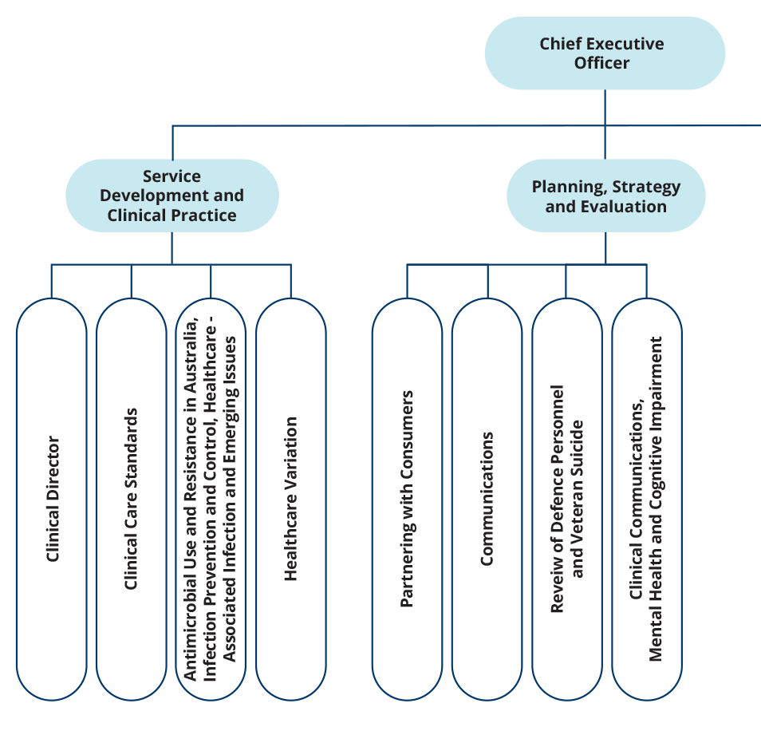

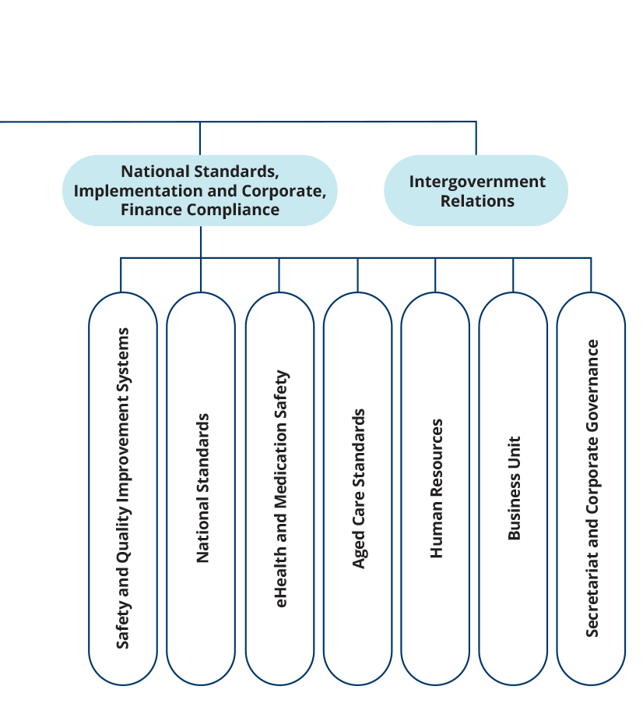

People management
The continuing commitment, flexibility and resilience of Commission staff, especially since the emergence of the COVID–19 pandemic, has allowed the Commission to continue to lead national efforts to improve the health care Australians receive.
The Commission continues to deliver high performance by providing ongoing support through its performance management systems and embedding a strong sense of direction across the organisation.
The Commission’s performance development scheme places emphasis on employees and managers having regular, meaningful performance discussions. All employees are required to have an individual performance and development plan in place. Managers and employees have joint accountability for capability and career development.
The Commission participates in the online induction program offered by the Australian Public Service Commission, giving new employees the opportunity to learn how the Australian Public Service operates and the behaviours expected of all staff members.
In May 2022, the Commission encouraged all staff members to participate in the Australian Public Service Commission’s employee census survey.

Staff profile
As of 30 June 2022, the Commission’s headcount was 81 employees. Most employees are located in Sydney. Table 7 provides a breakdown of the Commission’s employee profile by classification, gender, full-time or part-time status, and ongoing or non-ongoing status.
Table 7 Employee headcount profile as of 30 June 2022
Classification | Female |  |  |  | Male |  |  |  | Total
Classification | Non-ongoing |  | Ongoing |  | Non-ongoing |  | Ongoing |  | Total
Classification | Full-time | Part-time | Full-time | Part-time | Full-time | Part-time | Full-time | Part-time | Total
CEO | 1 | 0 | 0 | 0 | 0 | 0 | 0 | 0 | 1
MO6 | 0 | 0 | 0 | 2 | 0 | 0 | 0 | 0 | 2
EL2 | 0 | 0 | 14 | 2 | 1 | 0 | 6 | 0 | 23
EL1 | 0 | 0 | 21 | 11 | 0 | 0 | 5 | 0 | 37
APS6 | 3 | 1 | 6 | 1 | 0 | 0 | 3 | 0 | 14
APS5 | 1 | 0 | 1 | 0 | 0 | 0 | 1 | 0 | 3
APS4 | 0 | 0 | 0 | 1 | 0 | 0 | 0 | 0 | 1
Total | 5 | 1 | 42 | 17 | 1 | 0 | 15 | 0 | 81

Work health and safety
The Commission promotes a healthy and safe workplace, and is committed to meeting its obligations under the Work Health and Safety Act 2011 and the Safety, Rehabilitation and Compensation Act 1988. All new staff are required to complete online work health and safety training as part of their induction.

Highlights
The Commission undertook a number of activities during 2021–22 to encourage employees to adopt healthy work practices:
- ergonomic workstation assessments were conducted as required, and access to standing desks provided
- biannual workplace inspections were conducted; all staff members were encouraged to report incidents and hazards in the workplace
- access was provided to an Employee Assistance Program (EAP)
- regular online webinar sessions on wellbeing were conducted by the Commission’s EAP provider for all staff
- influenza vaccinations were made available to all staff
- access was provided to reimbursement of eyewear costs for use with screen-based equipment.
One work health and safety incident was reported in 2021–22. There were no notifiable incidents in 2021–22. No notices were issued to the Commission, and no investigations were initiated under the Work Health and Safety Act 2011.

Keeping our staff safe and productive during COVID–19
In response to the COVID–19 pandemic, the Commission triggered its pandemic response under its Business Continuity Plan. This resulted in Commission staff working from home from June 2021 to March 2022. Commission staff have returned to working a hybrid arrangement of office and home-based work. The Commission continues to operate in accordance with New South Wales Public Health Orders.

Learning and development
The Commission values the talents and contributions of its staff members, and recognises the importance of building expertise and capability within the organisation.
Learning and development needs and opportunities are primarily identified through a performance development scheme. The Commission promotes learning and development by delivering regular continuing professional development sessions and by providing all staff members with access to online learning platforms.
During 2021–22, the Commission’s study support and training arrangements ensured the ongoing development of staff members’ skills and capabilities. Thirteen staff accessed study support assistance for a range of tertiary courses. These included Master of Public Health, Master of Data Science Strategy and Leadership, and Graduate Certificate in Health Service Management (Safety and Quality). Twenty-eight staff completed external training courses. Internal training was provided to staff on integrity, work health and safety, and privacy.

Workplace diversity
The Commission’s workplace diversity program supports its ongoing commitment to creating a diverse and inclusive workplace that strongly values the skills, expertise and perspectives of all people.
The Commission’s Workplace Diversity Program was revised and implemented during 2021–22. The program aims to increase workplace representation of under-represented groups, retain and support emerging talent, and educate staff to facilitate an inclusive work environment.
The program is informed by whole-of-government diversity strategies, including:
- Aboriginal and Torres Strait Islander Workforce Strategy 2020–2024
- Disability Employment Strategy 2020–25
- Gender Equality Strategy 2021–26.

Aboriginal and Torres Strait Islander employment
The proportion of the Commission’s workforce who identified as being of Aboriginal and/or Torres Strait Islander origin during 2021–22 was 0.5%.
The Commission is committed to improving the recruitment, retention and career development of Aboriginal and Torres Strait Islander employees. The Commission undertook a recruitment process to fill an Affirmative Measure – Indigenous position during 2021–22, and is still actively seeking to fill this vacancy.
The Commission participates annually in the Australian Public Service Indigenous Graduate Pathway program and engaged a graduate who commenced in 2022.


The work by artist and designer Kylie Hill was commissioned for the production of the Commission’s Reconciliation Action Plan.
Elements in the artwork tell a story individually and are also key links in the Commission’s work and reconciliation journey. For example, the feet around the centre element represents the feet of those walking around our hospitals and healthcare systems, and the journey of the healthcare workers in their important roles protecting our community.
- Financial statements
Independent auditor’s report 102
Financial statements 104
Overview and notes to the financial statements 109

[This page has been intentionally left blank]

Independent auditor’s report
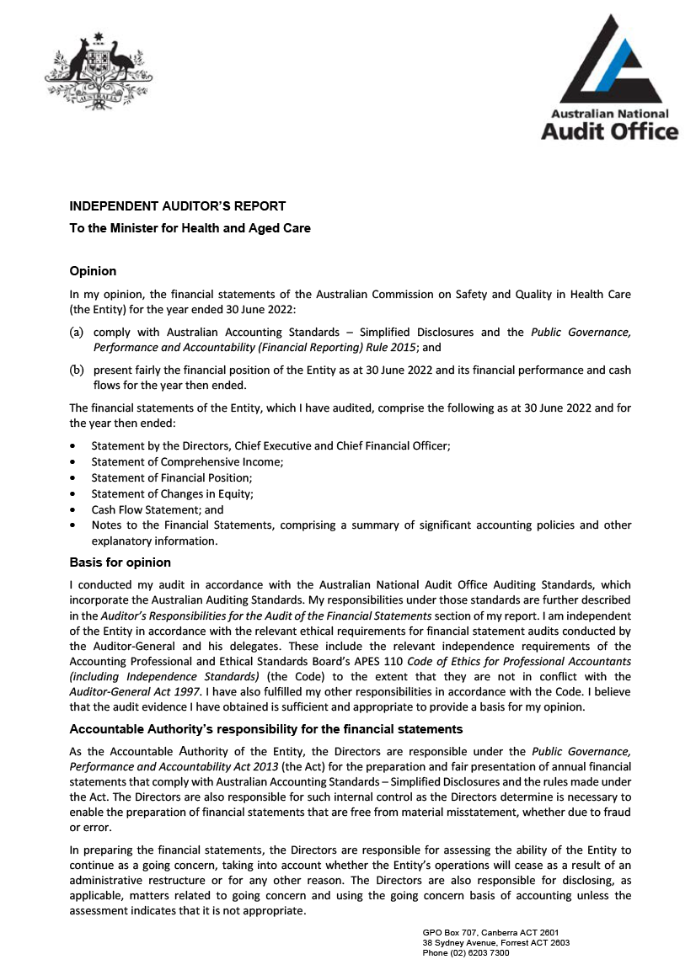
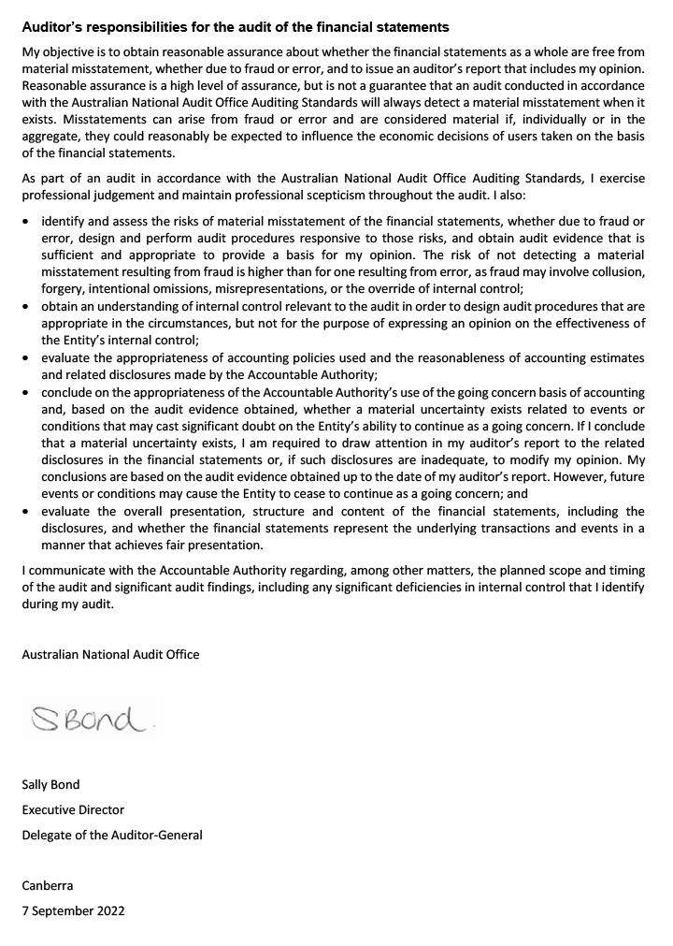

Financial statements
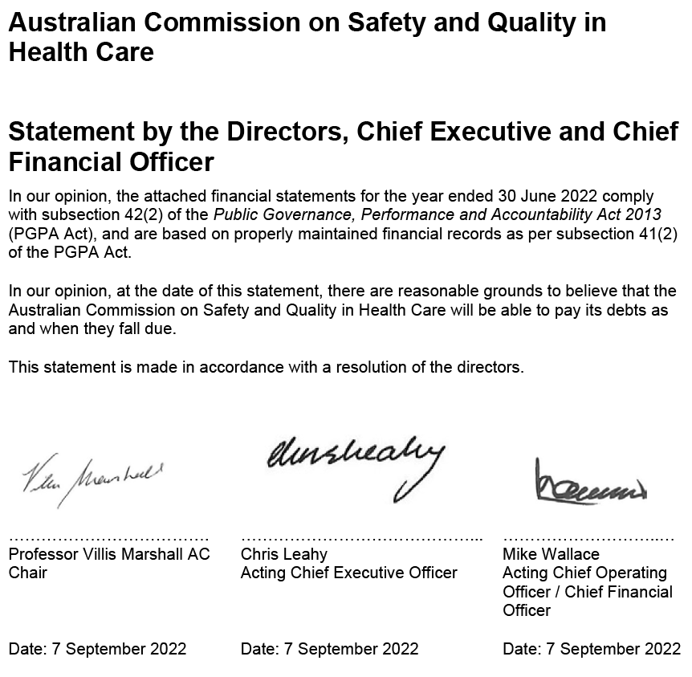
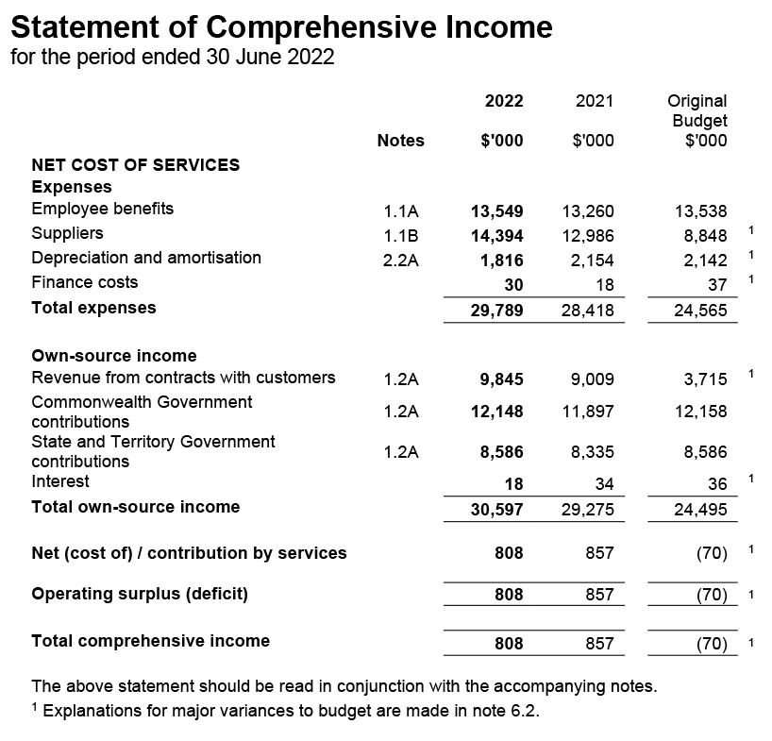
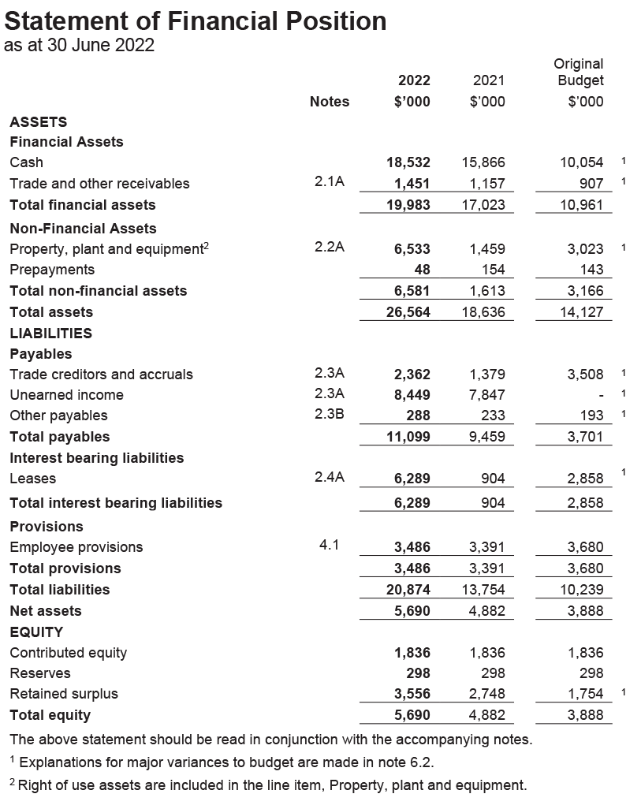
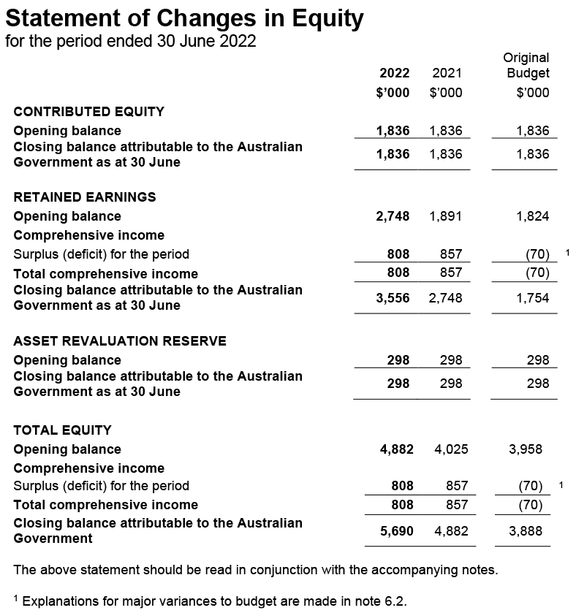
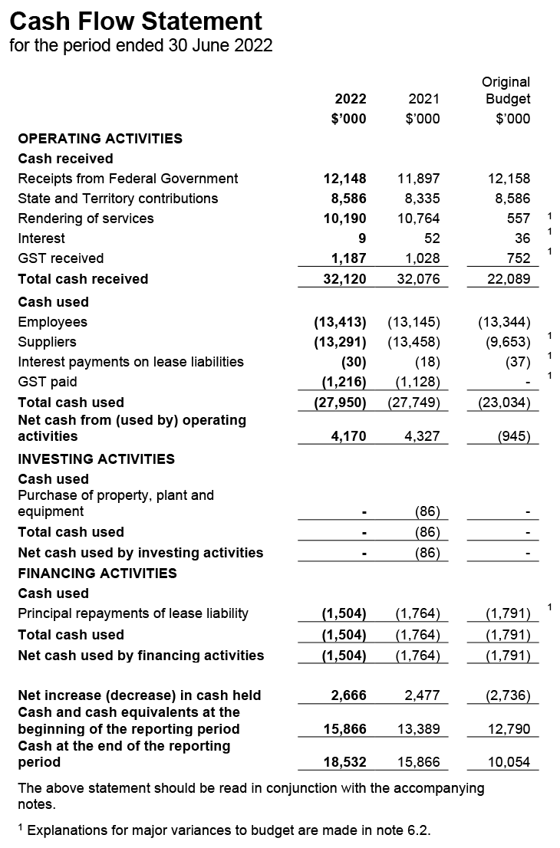

Overview and notes to the financial statements
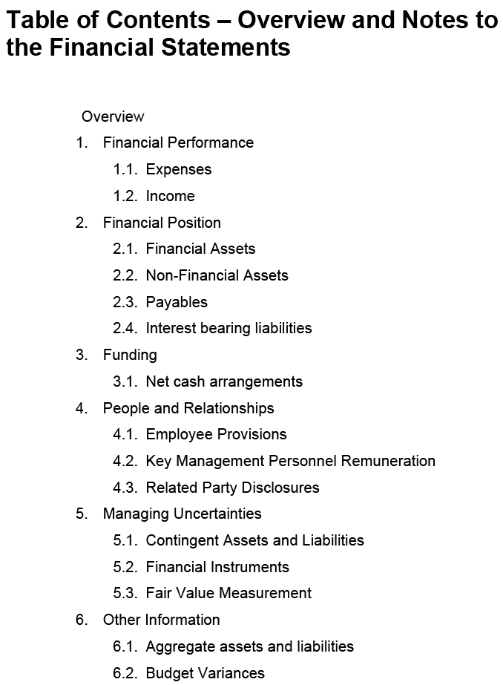
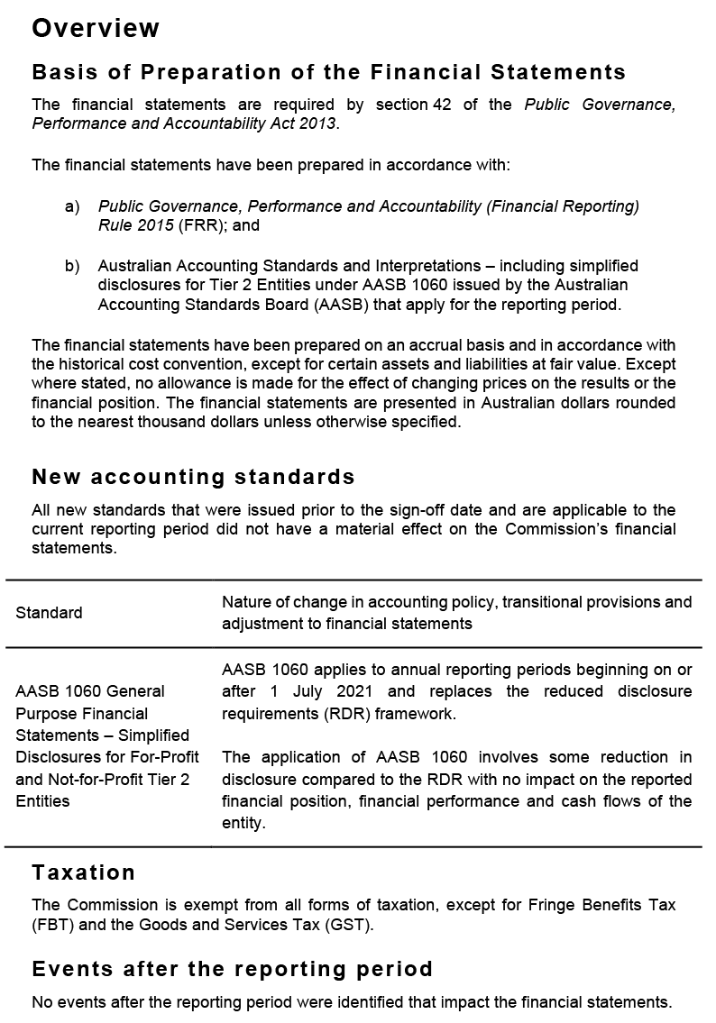
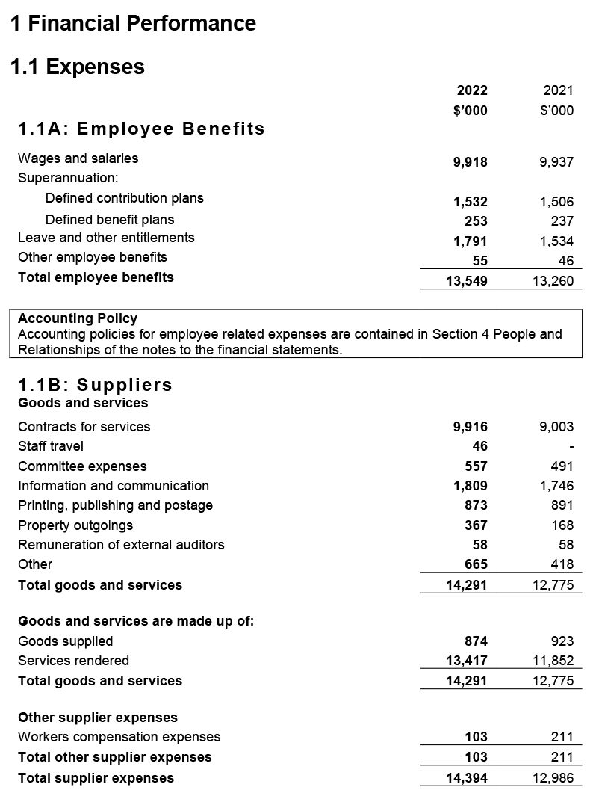
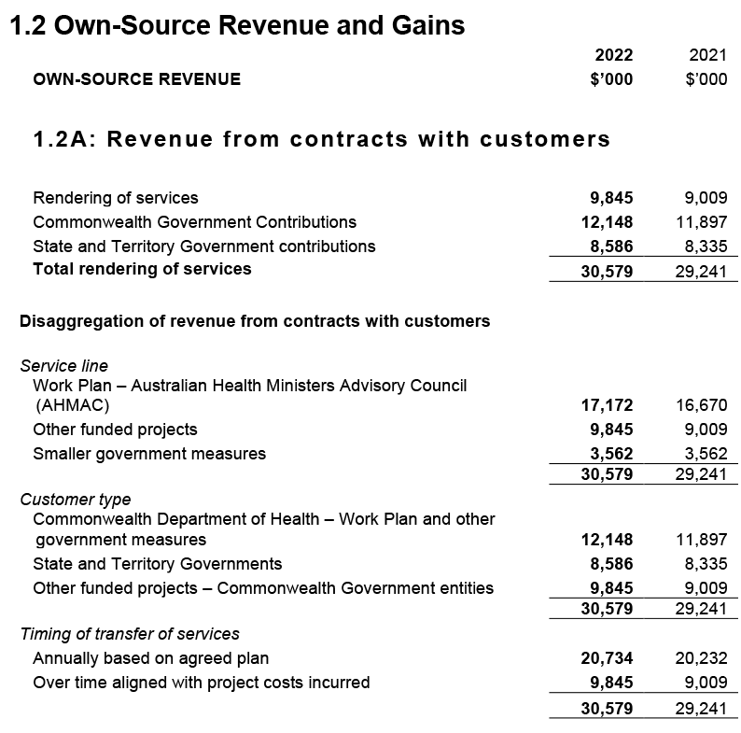
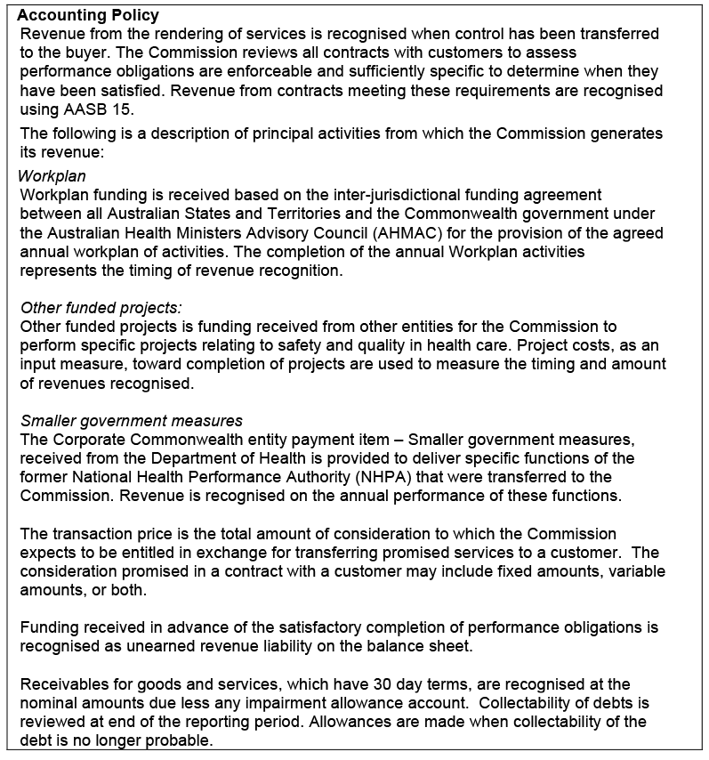
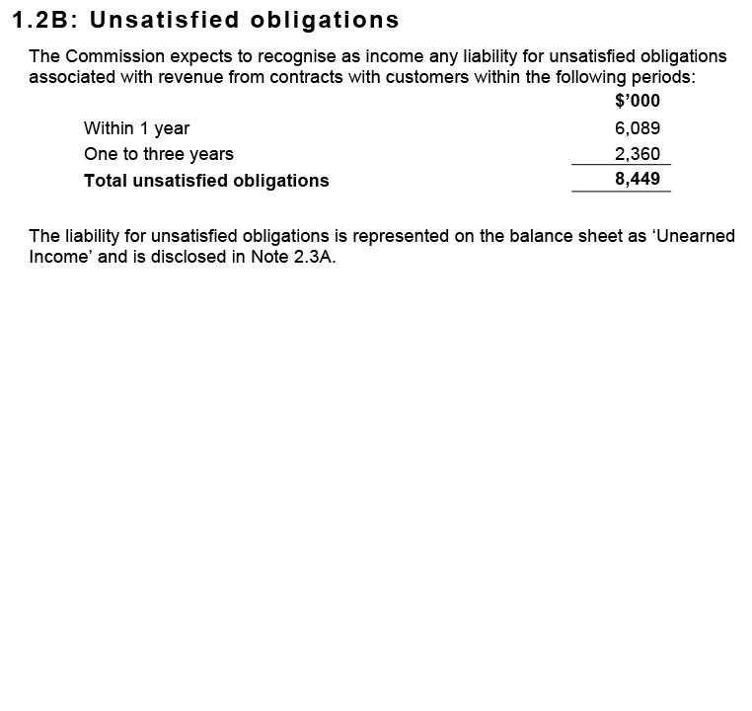
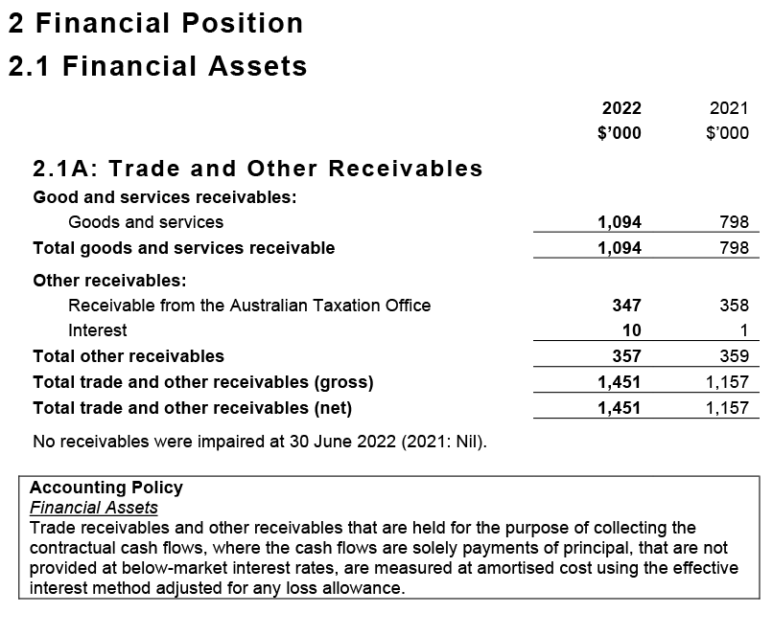
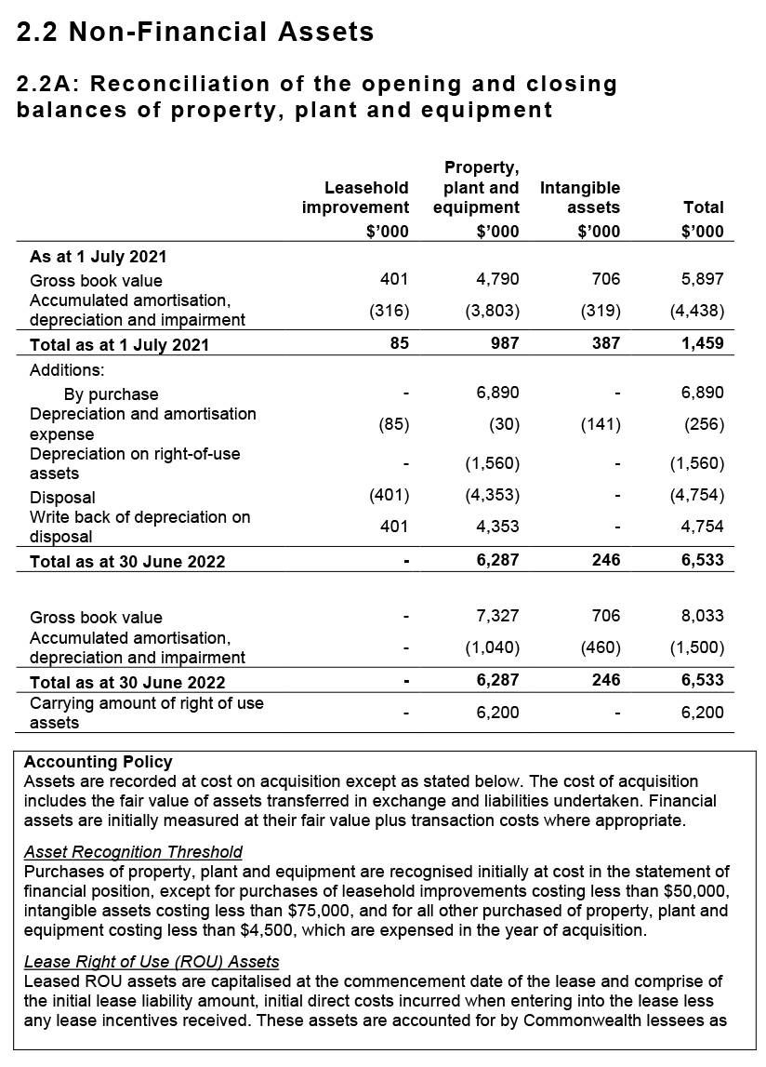
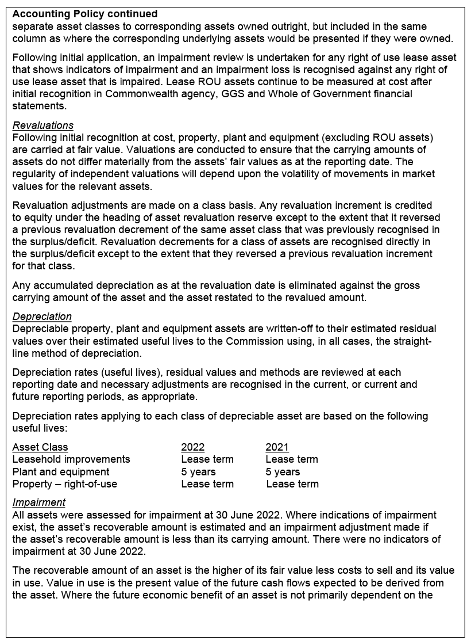
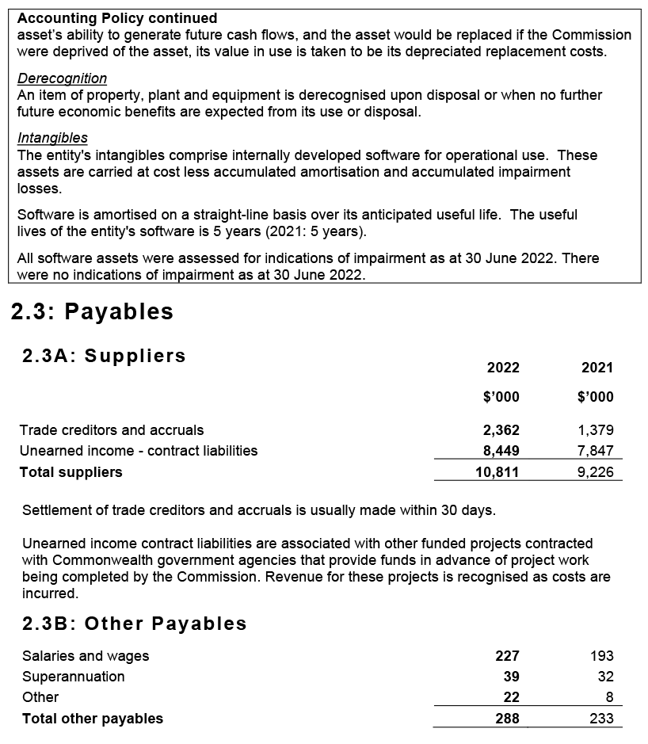
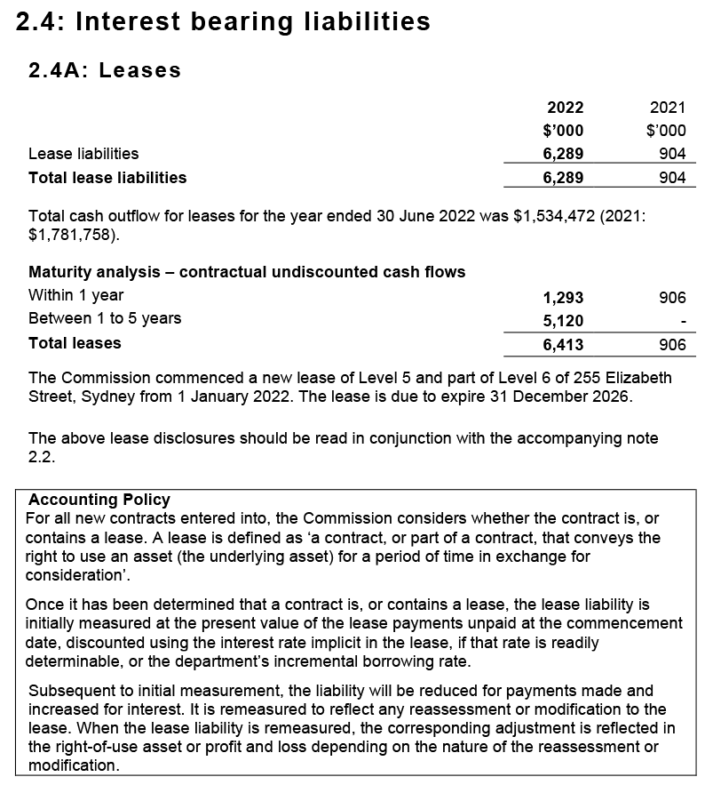
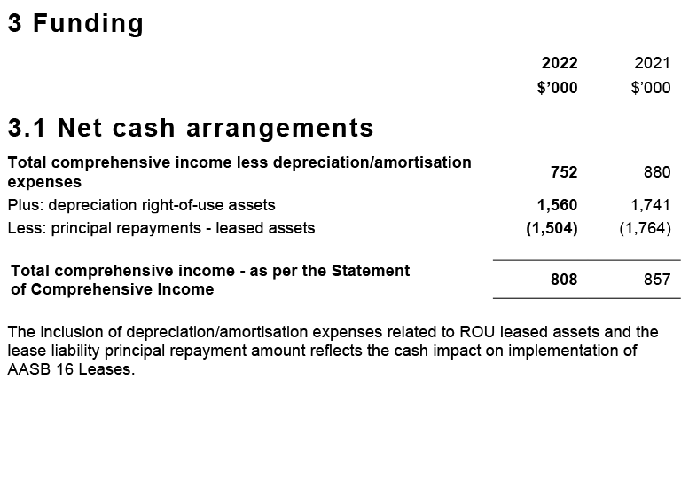
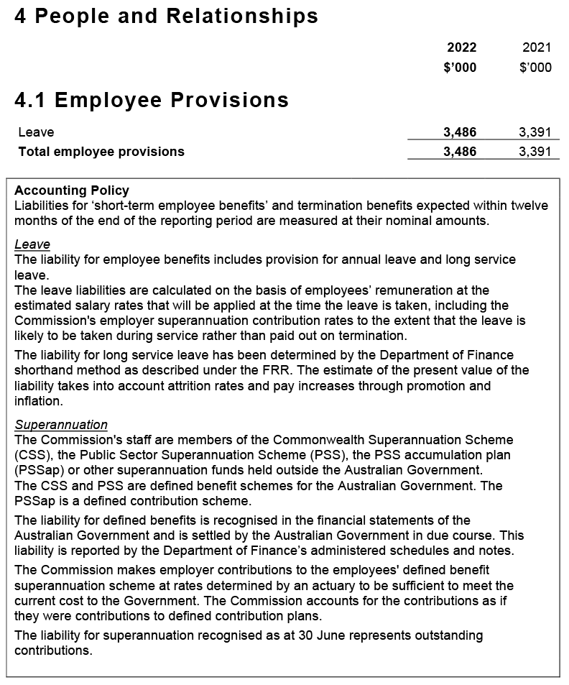
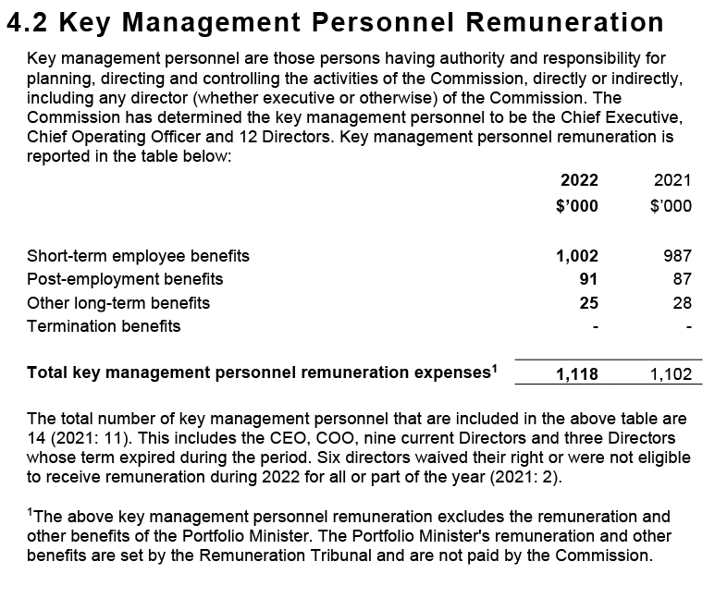
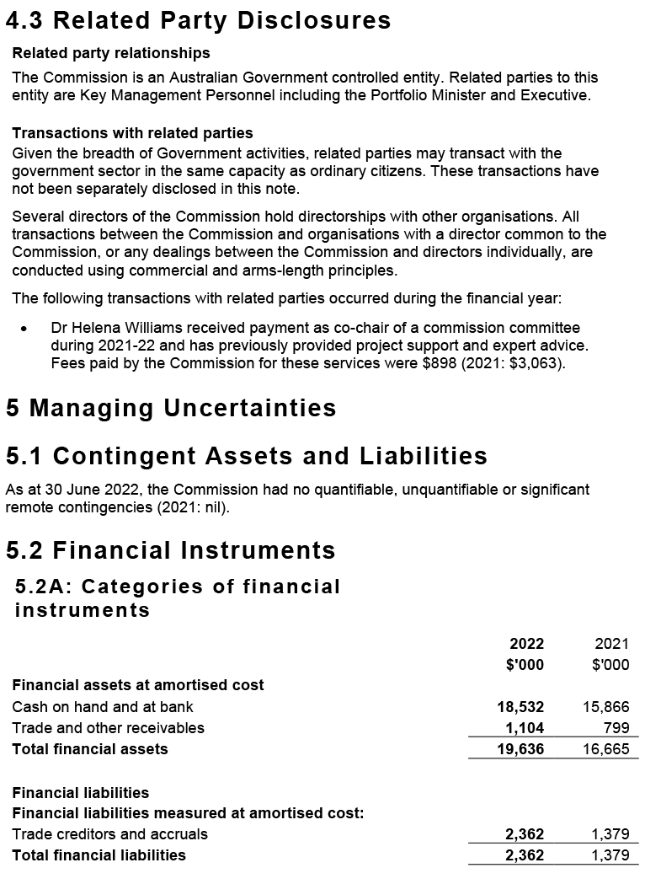
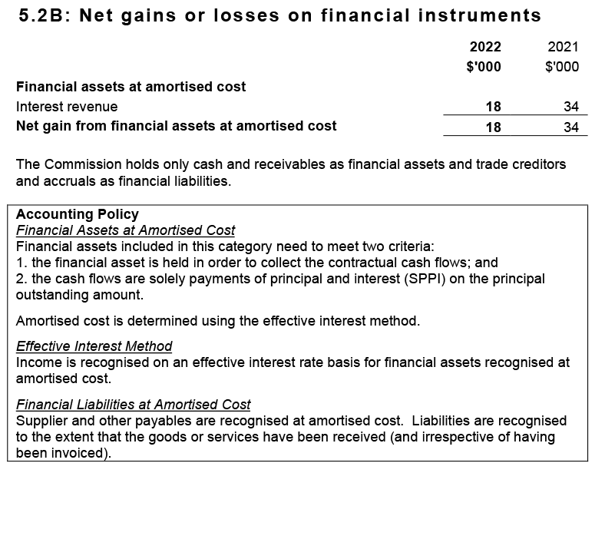
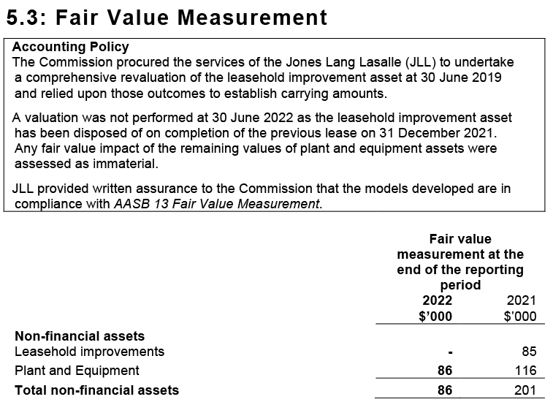
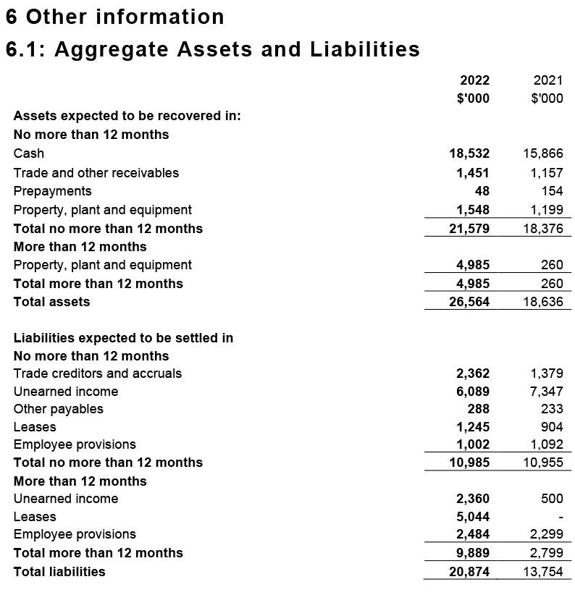
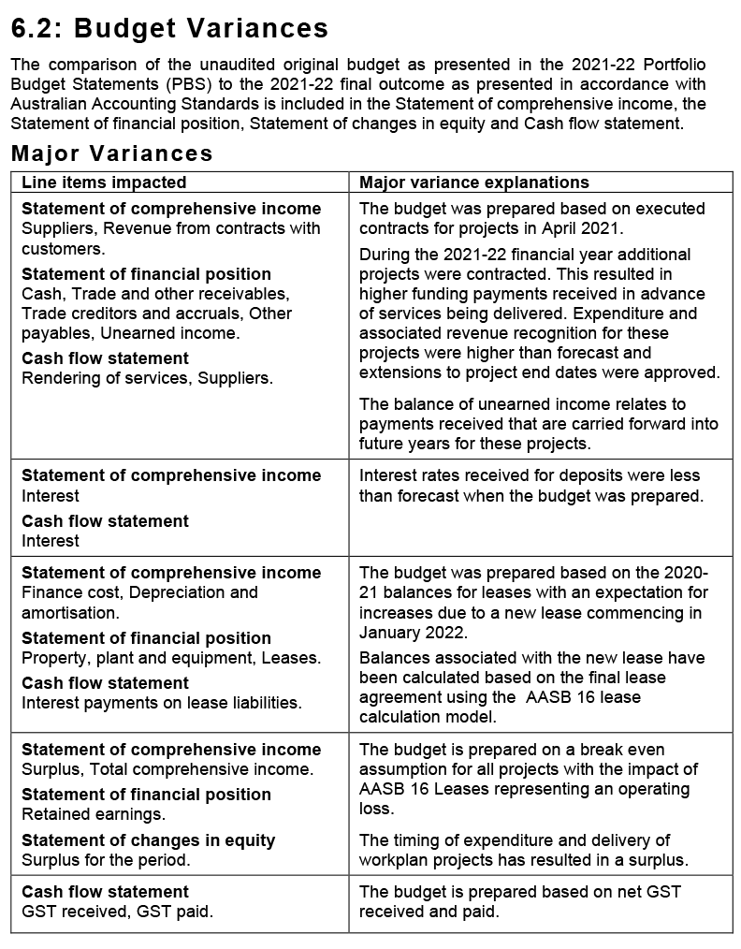
- Appendices
Appendix A: Related-entity transactions 130
Appendix B: Freedom of information summary 131
Appendix C: Compliance with ecologically sustainable development 132

[This page has been intentionally left blank]

Appendix A: Related-entity transactions
Table 8 Related-entity transactions, 2021–22
Vendor no. | Commonwealth entity | Number of transactions | Transaction value | Description
100362 | Department of Health | 12 | $857,345.89 | Payments processed in 2021–22 for corporate services received from the Department of Health under a shared services agreement between the Commission and the Department.

Appendix B: Freedom of information summary
Table 9 summarises freedom of information requests and their outcomes for 2021–22, as discussed on page 85.
Table 9 Freedom of information summary, 2021–22
Activity | Number
Requests
On hand at 1 July 2021 | 0
New requests received | 1
Total requests handled | 1
Total requests completed as at 30 June 2022 | 1
Total requests on hand as at 30 June 2022 | 0
Action of request
Access granted in full | 0
Access granted in part | 1
Access refused | 0
Access transferred in full | 0
Request withdrawn | 0
No records | 0
Response time
0–30 days | 0
30–60 days | 1

Appendix C: Compliance with ecologically sustainable development
The Commission is committed to making a positive contribution to ecological sustainability. Table 10 details the Commission’s activities in accordance with section 516A(6) of the Environment Protection and Biodiversity Conservation Act 1999.

Table 10 Summary of the Commission’s compliance with ecologically sustainable development
Environment Protection and Biodiversity Conservation Act 1999 requirements | Commission response
Activities of the Commission during 2021–22 accord with the principles of ecologically sustainable development | The Commission ensures that its decision-making and operational activities mitigate environmental impact. The principles of ecologically sustainable development are embedded in the Commission’s approach to its work plan, and corporate, purchasing and operational guidelines.
Outcomes specified for the Commission in an Appropriation Act for 2021–22 contribute to ecologically sustainable development | The Commission’s single appropriations outcome focuses on improving safety and quality in health care across the Australian health system. As such, the Commission does not directly contribute to ecologically sustainable development.
Effects of the Commission’s activities on the environment | The Commission’s offices are located in a 5-star building, and the Commission works proactively with building management to achieve energy savings, where possible. The Commission continues to improve its dissemination of publications, reports and written materials through electronic media to minimise printing.
Measures the Commission is taking to minimise its impact on the environment | To reduce its environmental impact, the Commission is improving its website functionality and increasing the use of multi-channel strategies to distribute information electronically.  To reduce travel, the Commission uses remote meeting attendance options, where feasible. Most staff have been working and attending meetings remotely during the pandemic.  The Commission advocates responsible use of materials, electricity and water, and disposal of waste is expected of all staff and visitors.
Mechanisms for reviewing and increasing the effectiveness of these measures | The Commission has established mechanisms to review current practices and policies. In addition, staff are encouraged to identify initiatives to adopt behaviours, procedures or policies that may minimise their environmental impact, and that of their team and the Commission more broadly.

- Indexes and references
Acronyms 136
Glossary 137
Index of figures 141
Index of tables 142
Compliance index 143
References 147
Index 148

[This page has been intentionally left blank]

Acronyms
Acronym | Description
AC | Companion of the Order of Australia
AGAR | Australian Group on Antimicrobial Resistance
AHSSQA Scheme | Australian Health Service Safety and Quality Accreditation Scheme
AM | Member of the Order of Australia
AO | Officer of the Order of Australia
AURA | Antimicrobial Use and Resistance in Australia
CEO | Chief Executive Officer
Department | Australian Government Department of Health
FCNA | Fellow of the College of Nursing, Australia
FRACGP | Fellow of the Royal Australian College of General Practitioners
FRACS | Fellow of the Royal Australasian College of Surgeons
IHPA | Independent Hospital Pricing Authority
MD | Doctor of Medicine
NSQDMH Standards | National Safety and Quality Digital Mental Health Standards
NSQHS Standards | National Safety and Quality Health Service Standards
PBS | Pharmaceutical Benefits Scheme
PSM | Public Service Medal
RACF | Residential Aged Care Facility
RPBS | Repatriation Pharmaceutical Benefits Scheme

Glossary
Word | Description
Accreditation | A status that is conferred on an organisation or individual when they have been assessed as having met particular standards. The two conditions for accreditation are compliance with an explicit definition of quality (that is, a standard) and passing an independent review process aimed at identifying the level of congruence between practices and quality standards.
Adverse event | An incident that results in harm to a patient or consumer.
Antimicrobial | A chemical substance that inhibits or destroys bacteria, viruses or fungi, including yeasts and moulds.1
Antimicrobial resistance | A property of organisms – including bacteria, viruses, fungi and parasites – that allows them to grow or survive in the presence of antimicrobial levels that would normally suppress growth or kill susceptible organisms.
Antimicrobial stewardship | A program implemented in a health service organisation to reduce the risks associated with increasing antimicrobial resistance, and to extend the effectiveness of antimicrobial treatments. Antimicrobial stewardship may incorporate a broad range of strategies, including monitoring and reviewing antimicrobial use.
Clinical care standards | Standards developed by the Commission and endorsed by health ministers that identify and define the care people should expect to be offered or receive for specific clinical conditions or procedures. Clinical care standards highlight best-practice care and priority areas for quality improvement, and include indicators to support quality improvement.
Clinical governance | The set of relationships and responsibilities established by a health service organisation between its department of health (for the public sector), governing body, executive, clinicians, patients, consumers and other stakeholders to ensure good clinical outcomes. It ensures that the community and health service organisations can be confident that systems are in place to deliver safe and high-quality health care and continuously improve services.
Clinician | A healthcare provider, trained as a health professional. Clinicians include registered and non-registered practitioners, or teams of health professionals, who spend the majority of their time delivering direct clinical care.
Cognitive impairment | Deficits in one or more of the areas of memory, communication, attention, thinking and judgement. Cognitive impairment can be temporary or permanent, and can affect a person’s understanding, their ability to carry out tasks or follow instructions, their recognition of people or objects, how they relate to others and how they interpret the environment. Dementia and delirium are common forms of cognitive impairment seen in hospitalised older patients.2 Cognitive impairment can also be caused by other conditions, such as an acquired brain injury, a stroke, intellectual disability or drug use.
Consumer | A person who has used, or may potentially use, health services. A healthcare consumer may also act as a consumer representative to provide a consumer perspective, contribute consumer experiences, advocate for the interests of current and potential health service users, and take part in decision-making processes.3
Delirium | An acute disturbance of consciousness, attention, cognition and perception that tends to fluctuate during the course of the day. Delirium is a serious condition that can be prevented in 30–40% of cases, and should be treated promptly and appropriately. Hospitalised older people with existing dementia are at the greatest risk of developing delirium. Delirium can be hyperactive (the person has heightened arousal, or is restless, agitated and aggressive) or hypoactive (the person is withdrawn, quiet and sleepy).4
Electronic medication management system | Enables medicines to be prescribed, dispensed, administered and reconciled electronically.
End of life | The period when a patient is living with, and impaired by, a fatal condition, even if the trajectory is ambiguous or unknown. This period may be years in the case of patients with chronic or malignant disease, or very brief in the case of patients who suffer acute and unexpected illnesses or events such as sepsis, stroke or trauma.5
Hand hygiene | A general term referring to any hand-cleansing action.
Healthcare- associated infections | Infections that are acquired in healthcare facilities (nosocomial infections) or that occur as a result of healthcare interventions (iatrogenic infections). Healthcare-associated infections may manifest after people leave healthcare facilities.6
Healthcare variation | This occurs when patients with the same condition receive different types of care. For example, among a group of patients with the same condition, some may have no active treatment, some may be treated in the community and others in hospital, and some may have surgery while others receive medication. Some variation in how health care is provided is desirable because of differences in patients’ needs, wants and preferences (see ‘unwarranted healthcare variation’).
Hospital-acquired complication | A complication for which clinical risk mitigation strategies may reduce (but not necessarily eliminate) the risk of that complication occurring.
My Health Record | A secure online summary of a consumer’s health information, managed by the System Operator of the national e-health record system (the Secretary of the Department of Health). Healthcare providers are able to share health records to a consumer’s My Health Record, in accordance with the consumer’s access controls. This may include information such as medical history and treatments, diagnoses, medications and allergies. Also known as a ‘Personally Controlled Electronic Health Record’.
National Safety and Quality Health Service (NSQHS) Standards | Standards developed by the Commission in consultation and collaboration with states and territories, technical experts, health service organisations and patients. The NSQHS Standards aim to protect the public from harm, and to improve the quality of health services. They provide a quality assurance mechanism that tests whether relevant systems are in place to ensure that minimum safety and quality standards are met, and a quality improvement mechanism that allows health service organisations to realise aspirational or developmental goals.
Partnering with consumers | Treating consumers and/or carers with dignity and respect, communicating and sharing information between consumers and/or carers and health service organisations, encouraging and supporting consumers’ participation in decision-making, and fostering collaboration between consumers and/or carers and health service organisations in planning, designing, delivering and evaluating health care. Other terms are used internationally, such as patient-based, consumer-centred, person-centred, relationship-based, patient-centred and patient‑and-family‑centred care.
Patient | A person receiving health care. Synonyms for ‘patient’ include ‘consumer’ and ‘client’.
Patient safety | Reducing the risk of unnecessary harm associated with health care to an acceptable minimum.
Patient safety incident | An event or circumstance that could have resulted, or did result, in unnecessary harm to a patient.
Person-centred care | Where patients, consumers and members of the community are treated as partners in all aspects of healthcare planning, design, delivery and evaluation; the foundation for achieving safe, high-quality care.
Shared decision making | The integration of a patient’s values, goals and concerns with the best available evidence about the benefits, risks and uncertainties of treatment to achieve appropriate healthcare decisions.7
Standard | Agreed attributes and processes designed to ensure that a product, service or method will perform consistently at a designated level.
Unwarranted healthcare variation | Variation not attributed to a patient’s needs, wants or preferences. It may reflect differences in clinicians’ practices, the organisation of health care or people’s access to services. It may also reflect poor-quality care that is not in accordance with evidence-based practice.

Index of figures
Figure | Title | Page no.
1 | Health service organisation accreditation, 2021–22 | 27
2 | Organisational structure | 92–93

Index of tables
Table | Title | Page no.
1 | Report against performance measures in the Corporate Plan 2021–22 and Health Portfolio Budget Statements | 63–67
2 | Attendance at Board meetings | 78
3 | Audit and Risk Committee attendance and remuneration, 2021–22 | 81
4 | Remuneration paid to key management personnel, 2021–22 | 86
5 | Remuneration paid to executive staff, 2021–22 | 87
6 | Remuneration paid to other highly paid staff, 2021–22 | 88
7 | Employee headcount profile as of 30 June 2022 | 95
8 | Related-entity transactions, 2021–22 | 130
9 | Freedom of information summary, 2021–22 | 131
10 | Summary of the Commission’s compliance with ecologically sustainable development | 133
11 | Mandatory reporting orders as required under legislation | 143–146

Compliance index
The Commission is bound by legislative requirements to disclose certain information in this annual report.
The operative provisions of the Public Governance, Performance and Accountability Act 2013 came into effect on 1 July 2014. The Public Governance, Performance and Accountability Amendment (Corporate Commonwealth Entity Annual Reporting) Rule 2016 prescribes the reporting requirements for the Commission (Table 11).
Table 11 Mandatory reporting orders as required under legislation
Requirement | Reference | Page listing of compliant information
Accountable authority | Public Governance, Performance and Accountability Amendment (Corporate Commonwealth Entity Annual Reporting) Rule 2016 subsection 17BE(j) | 60
Amendments to the Commission’s enabling legislation and to any other legislation directly relevant to its operation | Public Governance, Performance and Accountability Amendment (Corporate Commonwealth Entity Annual Reporting) Rule 2016 subsection 17BE(a) | 89
Approval by the accountable authority | Public Governance, Performance and Accountability Amendment (Corporate Commonwealth Entity Annual Reporting) Rule 2016 section 17BB | 3, 60, 104
Assessment of the impact of the performance of each of the Commission’s functions | National Health Reform Act 2011 subsection 53(a) | 22–67
Assessment of the safety of healthcare services provided | National Health Reform Act 2011 subsection 53(b)(i) | 25–46
Assessment of the quality of healthcare services provided | National Health Reform Act 2011 subsection 53(b)(ii) | 55–9
Audit committee | Public Governance, Performance and Accountability Amendment (Corporate Commonwealth Entity Annual Report) Rule 2016 subsection 17BA(taa) | 80–2
Board committees | Public Governance, Performance and Accountability Amendment (Corporate Commonwealth Entity Annual Reporting) Rule 2016 subsection 17BE(j) | 80–2
Ecologically sustainable development and environmental performance | Environment Protection and Biodiversity Conservation Act 1999, section 516A | 89, 132–3
Enabling legislation, functions and objectives | Public Governance, Performance and Accountability Amendment (Corporate Commonwealth Entity Annual Reporting) Rule 2016 subsection 17BE(a) | 10, 70
Financial statements | Public Governance, Performance and Accountability Act 2013 subsection 43(4) | 104–27
Financial statements certification: a statement, signed by the accountable authority | Public Governance, Performance and Accountability Act 2013 subsection 43(4) | 104
Financial statements certification: Auditor-General’s Report | Public Governance, Performance and Accountability Act 2013 subsection 43(4) | 102–3
Government policy orders | Public Governance, Performance and Accountability Amendment (Corporate Commonwealth Entity Annual Reporting) Rule 2016 subsection 17BE(e) | 89
Indemnities and insurance premiums for officers | Public Governance, Performance and Accountability Amendment (Corporate Commonwealth Entity Annual Reporting) Rule 2016 subsection 17BE(t) | 71
Information about remuneration for key management personnel | Public Governance, Performance and Accountability Amendment (Corporate Commonwealth Entity Annual Report) Rule 2016 subsection 17CA | 85, 86
Information about remuneration for senior executives | Public Governance, Performance and Accountability Amendment (Corporate Commonwealth Entity Annual Report) Rule 2016 subsection 17CB | 85, 87
Information about remuneration for other highly paid staff | Public Governance, Performance and Accountability Amendment (Corporate Commonwealth Entity Annual Report) Rule 2016 subsection 17CC | 88
Judicial decisions and decisions by administrative tribunals | Public Governance, Performance and Accountability Amendment (Corporate Commonwealth Entity Annual Reporting) Rule 2016 subsection 17BE(q) | 84
Key activities and changes that have affected the Commission | Public Governance, Performance and Accountability Amendment (Corporate Commonwealth Entity Annual Reporting) Rule 2016 subsection 17BE(p) | 14–19
Location of major activities and facilities | Public Governance, Performance and Accountability Amendment (Corporate Commonwealth Entity Annual Reporting) Rule 2016 subsection 17BE(l) | inside front page, 95
Ministerial directions | Public Governance, Performance and Accountability Amendment (Corporate Commonwealth Entity Annual Reporting) Rule 2016 subsection 17BE(d) | 71
Organisational structure | Public Governance, Performance and Accountability Amendment (Corporate Commonwealth Entity Annual Reporting) Rule 2016 subsection 17BE(k) | 92–3
Related-entity transactions | Public Governance, Performance and Accountability Amendment (Corporate Commonwealth Entity Annual Reporting) Rule 2016 subsections 17BE(n) and (o) | 71, 130
Reporting of significant decisions or issues | Public Governance, Performance and Accountability Amendment (Corporate Commonwealth Entity Annual Reporting) Rule 2016 subsection 17BE(f) | 89
Reports about the Commission by the Auditor-General, a parliamentary committee, the Commonwealth Ombudsman or the Office of the Australian Information Commissioner | Public Governance, Performance and Accountability Amendment (Corporate Commonwealth Entity Annual Reporting) Rule 2016 subsection 17BE(r) | 85
Responsible minister | Public Governance, Performance and Accountability Amendment (Corporate Commonwealth Entity Annual Reporting) Rule 2016 subsection 17BE(c) | 11, 70
Review of performance | Public Governance, Performance and Accountability Amendment (Corporate Commonwealth Entity Annual Reporting) Rule 2016 subsection 17BE(g) | 61–7
Statement on governance | Public Governance, Performance and Accountability Amendment (Corporate Commonwealth Entity Annual Reporting) Rule 2016 subsection 17BE(m) | 70–84

References
- Australian Commission on Safety and Quality in Health Care. AURA 2016: first Australian report on antimicrobial use and resistance in human health. Sydney: ACSQHC; 2016.
- Australian Commission on Safety and Quality in Health Care. A better way to care: safe and high-quality care for patients with cognitive impairment (dementia and delirium) in hospital. Sydney: ACSQHC; 2014.
- Consumers Health Forum of Australia. About consumer representation [Internet]. Australia: CHF; 2020 [cited 2020 Sep 15]. Available from: www.chf.org.au/representation
- National Institute for Health and Clinical Excellence. Delirium: diagnosis, prevention and management. London: NICE; 2010.
- General Medical Council. Treatment and care towards the end of life: good practice in decision making [Internet]. Manchester: GMC; 2010 [cited 2017 Jun 1]. Available from: www.gmc-uk.org/ethical-guidance/ethical-guidance-for-doctors/treatment-and-care-towards-the-end-of-life
- Cruickshank M, Ferguson J, editors. Reducing harm to patients from health care associated infection: the role of surveillance. Sydney: ACSQHC; 2008.
- Hoffmann TC, Legare F, Simmons MB, McNamara K, McCaffery K, Trevena LJ, et al. Shared decision making: what do clinicians need to know and why should they bother? Med J Aust 2014;201:35–9.

Index
Page range references in bold type refer to major discussions of a topic.

A
abbreviations, 136
Aboriginal and Torres Strait Islander people
employment, 98
patient-reported experience measurement tool, 49
accountability of Commission, 11
accountable authority, 60, see also Board
accreditation, defined, 137
accreditation (diagnostic imaging practices), 6, 31
accreditation (digital mental health service providers), 39
accreditation (general practices), 33
accreditation (health service organisations), 25–34
accrediting agency performance, 30
AHSSQA Scheme, 26, 39, 44, 53, 62
arrangements in 2022, 19
assessor training, 30
attestation statements, 28
improving reliability, 28
post-assessments surveys, 31
process and results, 27
public reporting of outcomes, 29
report against performance measures, 63–4
review of accreditation outcomes data, 30
statistics, 6, 27
unannounced assessments, 28
see also National Safety and Quality Health Service (NSQHS) Standards
accreditation (pathology laboratories), 32
Achterstraat, Peter, 81
ACQSC (Aged Care Quality and Safety Commission), 15, 20, 21, 36, 44
acronyms, 136
ACSQHC, see Australian Commission on Safety and Quality in Health Care (the Commission)
active ingredient prescribing, 41
Acute Anaphylaxis Clinical Care Standard, 6, 17, 57
acute pain, see low back pain; opioid analgesics
address and contact details, inside front cover
adverse events, defined, 137
advertising and market research, 89
aged care, 62
antimicrobial stewardship, 35
end-of-life care, 48
infection prevention and control, 36
reform, 20
royal commission, 20, 59, 62
transitions of care, 39
see also residential aged care
Aged Care Clinical Standard, 20
Aged Care Quality and Safety Commission (ACQSC), 15, 20, 21, 36, 44
Aged Care Quality Standards, 15, 20, 62
AHPEQS (Australian Hospital Patient Experience Question Set), 49
Ahpra (Australian Health Practitioner Regulation Agency), 21
AHSSQA Scheme, 26, 39, 44, 53, 62, see also accreditation (health service organisations)
analgesics, see opioid analgesics
anaphylaxis, 6, 17, 56, 57
annual performance statements, see performance report
anticoagulants, 42
antimicrobial stewardship, 35, 62
antimicrobial use and resistance, 17, 37–8, 62
definitions, 137
Antimicrobial Use and Resistance in Australia (AURA) Surveillance System, 37–8, 62
antipsychotic medicines, 15, 21, 55, see also psychotropic medication use
APAS (Australian Passive AMR Surveillance), 37–8
aseptic techniques, 35, see also sepsis
attestation statements, 28
Audit and Risk Committee, 80–2
Auditor-General, 85
audits
independent auditor’s report, 102–3
internal, 84
Australian Atlas of Healthcare Variation, 55–6, 58
Australian Charter of Healthcare Rights, 47
Australian Commission on Safety and Quality in Health Care (the Commission)
accountable authority, 60, see also Board
address and contact details, inside front cover
establishment, 10
functions, 11, 12, 60
legislative framework, 10, 70
new responsibilities, 31, 32, 38
organisational structure, 92–3
performance, see performance report
purpose and role, 10–13, 60
staff see staff
strategic priorities, see Strategic Intent 2020–2025
work plan, 19
Australian Defence Force role in pandemic response, 18, 61
Australian Digital Health Agency, 38–9
Australian Group on Antimicrobial Resistance (AGAR), 37, 38
Australian Guidelines for the Prevention and Control of Infection in Healthcare, 36, 37
Australian Health Practitioner Regulation Agency (Ahpra), 21
Australian Health Service Safety and Quality Accreditation (AHSSQA) Scheme, 26, 39, 44, 53, 62, see also accreditation (health service organisations)
Australian Hospital Patient Experience Question Set (AHPEQS), 49
Australian Hospital Survey on Patient Safety Culture, 52
Australian Information Commissioner, 85
Australian Open Disclosure Framework, 45
Australian Passive AMR Surveillance (APAS), 37–8
avoidable and preventable hospitalisations, 59, 62
avoidable hospital readmissions list, 52

B
bacteraemia, 38
Beauchamp, Glenys, 73, 78, 86
bereavement care, 58
birth
stillbirth, 52, 58
Board, 72–9
Chair’s report, 14–15
committees, 80–2
ethical standards, 79
induction and briefings, 79
meeting attendance, 78
membership, 72–7
remuneration, 85, 86
role and responsibilities, 72
Business Continuity Plan, 96
Business Group, 83
Butler, Hon. Mark, 15, 17

C
CARAlert, 37
carbapenemase-producing Enterobacterales (CPE), 37
Casey, Adjunct Professor Veronica, 73–4, 78
Cataract Clinical Care Standard, 6, 17, 56–7
CDI (Clostridioides difficile infection), 35
Chair of the Board
remuneration, 85, 86
report from, 14–15
charter of rights, 47
Chief Executive Officer
remuneration, 85, 86
report from, 16–17
retirement, 15, 17
chronic disease patients, preventable hospitalisations, see hospitalisations
ciprofloxacin resistance, 38, see also antimicrobial use and resistance
Clark, Jennifer, 81
cleaning resources, 37
clinical care standards, 137
indicators, 52
new, 6, 15, 17, 56–9, 62, 65
review of, 58, 65
clinical governance, 12, 25, 38, 47, 71, 137
clinical handovers, see transitions of care
clinical incidents, see incident monitoring and reporting
clinical quality registries, 54
clinical trials, 53–4
clinician, defined, 137
Clostridioides difficile infection (CDI), 35
clozapine, 42
cognitive impairment, 21, 44, 138
Cognitive Impairment Advisory Group, 44
collaboration, 15, 20–1, 44, 61
committees
Board committees, 80–2
internal committees, 83
see also expert advisory groups
Commonwealth Ombudsman, 84
communicating for safety, 45, see also informed consent
community healthcare standards, 7, 17, 34
complaints processes, 21
comprehensive care, 45
conflicts of interest, 30
consultative processes (Board), 82, see also stakeholder consultation
consultative processes (staff), 83
consumers, 47–9, 138
charter of rights, 47
experience and complaints, 21
informed consent, 45
patient experience, 49
resources for, 47–8
Consumers Health Forum of Australia, 48
corporate governance, 70–89
Board, see Board committees, 80–3
external scrutiny, 84–5
internal governance arrangements, 83–4
legislation and requirements, 70–1
Corporate Plan 2021–22, 61, 63
performance report, 63–7
corporate services, 130
Council of Presidents of Medical Colleges, 36
COVID–19 pandemic, 14, 16, 18–19
Commission work practices, 18–19, 61, 96
health service organisation accreditation arrangements, 19
infection prevention and control, 36
support for pathology sector, 32
CPE (carbapenemase-producing Enterobacterales), 37
cross-sectoral collaboration, 15, 20–1, 44
Crowe Australasia, 84

D
decision-making
resources for consumers, 47–8
shared, 45, 140
definitions (glossary), 137–40
delirium, defined, 138
Delirium Clinical Care Standard, 52, 56, 58
Department of Health, 15, 20, see also Minister for Health and Aged Care
developments and significant events, 89
Diagnostic Imaging Accreditation Scheme, 6, 31, 31
Advisory Committee, 31
Diagnostic Imaging Accreditation Scheme Standards, 31
Diagnostic Imaging Accrediting Agency Working Group, 31
digital health, 38–9
mental health standards, 39
My Health Record system, 38, 39, 139
disability services
psychotropic medication use, 15, 21, 59, 62
see also people with disability
dispensed medications, see medication management; medication safety
diversity, see workplace diversity

E
ecologically sustainable development, 89, 132–3
education courses, 35, 36, 42
Edwards, Caroline, 74, 78
electronic health records, see digital health; My Health Record system
electronic medication management, 39, 40, 138
emergency department use of My Health Record system, 39
enabling legislation, 10, 70
end-of-life care, 48, 138
Enterprise Agreement 2019–2022, 85
environmental cleaning resources, 37
environmental performance, 89, 89, 132–3
Escalation Mapping Template (for mental health), 43
ethical standards, 30, 79, 84
ethics committee accreditation standard, 54
expert advisory groups, 42, 49, 52, 54, 82
external scrutiny, 85

F
Filby, Dr David, 74, 78, 86
finance law compliance, 70
financial statements, 104–27
certification, 104
independent auditor’s report, 102–3
overview and notes, 109–27
floods and general practice accreditation expiry extensions, 33
fluoroquinolones, 38, see also antimicrobial use and resistance
Framework for Australian Clinical Quality Registries, 54
fraud control, 3, 84
freedom of information, 85
requests and outcomes, 131
functions of the Commission, 11, 12, 60

G
Gee, Christine, 74–5, 78, 82, 86
general practice, 33–4
George Institute for Global Health, 17, 46, 57
glossary, 137–40
governance
clinical, see clinical governance; clinical trials
corporate, see corporate governance
government policy orders, 89

H
hand hygiene, 7, 36, 138
Harris, Wendy, 75, 78, 86
health and safety at work, see work health and safety
health care
appropriateness of, 56–9
charter of rights, 47
end-of-life care, 48, 138
patient safety in primary healthcare, 33–4
safe delivery of, 25–46
transitions of care, 39
variations in, 55–6, 65, 139, 140
see also healthcare professionals; hospitalisations; National Safety and Quality Health Service (NSQHS) Standards; patient safety; Safe delivery of health care (Priority 1)
Health Insurance (Accredited Pathology Laboratories – Approval) Principles 2017, 32
Health Portfolio Budget Statements
performance report, 63–7
health records
My Health Record system, 38, 39, 139
retrospective review of records of sepsis management, 46
health service organisation accreditation, see accreditation (health service organisations)
Health Services Medication Expert Advisory Group, 42
healthcare professionals, 51–4
indicators, measures and dataset specifications for, 51–2
healthcare rights, 47
healthcare standards, see clinical care standards; National Safety and Quality Health Service (NSQHS) Standards
healthcare variation, 55–6, 65, 139, 140
healthcare-associated infections, 34–7, 138
Heavy Menstrual Bleeding Clinical Care Standard, 58
highlights (summary), 6–7
high-risk medicines
education courses, 42
Hill, Kylie, 99
Hip Fracture Care Clinical Care Standard, 58
Hospital National Antimicrobial Prescribing Survey, 62
hospital-acquired complications, 51, 139
hospitalisations
avoidable and preventable, 59, 62
avoidable readmissions, 52
hospitals
emergency department use of My Health Record system, 39
NSQHS Standards implementation, 25–6
reporting on, 53
transitions of care, 39
human research approvals and ethics, 53–4
Hunt, Hon. Greg, 15, 17

I
incident analysis for anticoagulant stewardship, 42
incident monitoring and reporting, 53, see also public reporting
indemnity, 71
Independent Hospital Pricing Authority, 51, 59, 62
indicators, measures and dataset specifications, 51–2
individual flexibility agreements, 85
infection prevention and control, 18–19,
34–7, see also antimicrobial use and resistance
Information and Records Management Steering Committee, 83
Information Publication Scheme, 85
informed consent, 45, see also communicating for safety
insulin, 42
insurance, 71
intellectual disability, 44
Inter-Jurisdictional Committee, 71, 82
internal audit, 84
internal governance arrangements, 83–9

J
judicial decisions, 85

K
key management personnel, 85–6

L
labelling of dispensed medicines, 41
Lawler, Professor Tony, 75, 78
Leadership Group, 83
Leahy, Chris, 86
learning and development (staff), 97
legislative framework, 10, 70
letter of transmittal, 3
low back pain, 52, 56, 58
Low Back Pain Clinical Care Standard, 58

M
market research, 89
Marshall, Professor Villis (Chair), 17, 72–3, 78, 86
accountable authority, 60
report from the Chair, 14–15
medical records, see health records
medication management, 39, 40, 138
medication safety, 40–3
active ingredient description, 41
education courses, 42
evidence briefings, 43
labelling of dispensed medicines, 41
medication guidance, 40, 42
quality use of medicines, 40, 55, 62
mental health, 39, 43–4
Minister for Health and Aged Care, 11, 15, 17, 70, 85
ministerial directions, 71
My Health Record system, 38, 39, 139

N
National Alert System for Critical Antimicrobial Resistances (CARAlert), 37
National Antimicrobial Prescribing Surveys, 62
National Antimicrobial Surveillance Utilisation Program, 62
National Association of Testing Authorities, 32
National Clinical Trials Front Door project, 53–4
National Clinical Trials Governance Framework, 53
National Disability Insurance Scheme Quality and Safeguards Commission, 15, 21, 44, 62
National General Practice Accreditation Scheme, 6, 33
National Hand Hygiene Initiative, 7, 36
National Health and Hospitals Network Act 2011, 10
National Health and Medical Research Council, 49
National Health Funding Pool Administrator, 51, 59
National Health Priority Areas, 40
National Health Reform Act 2011, 3, 10, 70, 71, 72, 80
amendments, 89
National Health Reform Agreement – 2020–2025 Addendum, 51, 59
National Medicines Policy, 40
National Mental Health and Suicide Prevention Plan, 44
National Mutual Acceptance Scheme for single ethical and scientific review, 54
National One Stop Shop for health-related human research approvals, 53–4
National Opioid Analgesic Stewardship Program, 57
National Pathology Accreditation Advisory Council, 32
National Pathology Accreditation Scheme, 6, 32
National Safety and Quality Digital Mental Health (NSQDMH) Standards, 39
National Safety and Quality Health Service (NSQHS) Standards, 25–31, 36, 139
accreditation, see accreditation (health service organisations)
assessor training, 30
guidance and advice, 26
implementation of, 25–6
infection control standards, 34–5
report against performance measures, 63–4
user guides, 26, 44, 56, 61
National Safety and Quality Mental Health Standards for Community Managed Organisations, 44
National Safety and Quality Primary and Community Healthcare Standards, 7, 17, 34, 62
National Sepsis Awareness Campaign, 46, 62
National Sepsis Program, 17, 46
National Standard for Labelling Dispensed Medicines, 41
National Stillbirth Action and Implementation Plan, 58
neural connector devices, 42

O
Office of the Australian Information Commissioner, 85
older people, see aged care
Ombudsman, 85
open disclosure, 45
Opioid Analgesic Stewardship in Acute Pain Clinical Care Standard, 6, 17, 52, 57
opioid analgesics, 6, 17, 42, 52, 55, 56, 57
Organisation for Economic Co-operation and Development, 49
organisational structure, 92–3
Osteoarthritis of the Knee Clinical Care Standard, 58

P
parliamentary and ministerial oversight, 85
parliamentary committees, 85
Partnering with consumers (Priority 2), 12, 71
partnering with consumers, defined, 139
performance report, 47–9
Partnering with healthcare professionals (Priority 3), 12, 71
performance report, 51–4
partnerships, see collaboration; stakeholder consultation
pathology laboratories
accreditation, 6
AMR surveillance, 37–8
pathology laboratory accreditation, 32
pathology standards, 32
patient, defined, 139, see also consumers
patient experience, 49
patient safety
antimicrobial use and resistance, 37–8
cognitive impairment, 44
communicating for safety, 45
comprehensive care, 45
defined, 140
in digital health, 38–9
guidance and tools, 26, 44, 56, 61, 67
incidents, 53, 140
infection prevention and control, 18–19, 34–7
medication safety, 40–3
mental health, 43–4
in primary health care, 33–4
reporting, 53
staff perceptions of patient safety culture, 52
see also clinical care standards; health care; National Safety and Quality Health Service (NSQHS) Standards
Patient Safety Culture Measurement Toolkit, 52
patient-reported outcome measures, 49
patients, defined, 139
Pearce, Susan, 76, 78
people management, 94, see also staff
people with disability, 15, 21, see also National Disability Insurance Scheme Quality and Safeguards Commission
performance report, 60–7
analysis of performance against purpose, 61–2
highlights (summary), 6–7
key achievements, 61–2
performance against Corporate Plan 2021–22 and Health Portfolio Budget Statements, 63–7
Priority 1: Safe delivery of health care, 25–46
Priority 2: Partnering with consumers, 47–9
Priority 3: Partnering with healthcare professionals, 51–4
Priority 4: Quality, value and outcomes, 55–9
person-centred care, 71, 140
Pharmaceuticals Benefit Scheme
active ingredient description, 41
Picone, Professor Debora, 15, 86
report from CEO, 16–17
see also Chief Executive Officer
plans and planning
business continuity, 96
corporate, see Corporate Plan 2021–22
fraud control, 3, 84
strategic, see Strategic Intent 2020–2025
work plan, 19
policy orders, 89
Portfolio Budget Statements
performance report, 63–7
portfolio membership, 11
prescribing, see medication management; medication safety
Preventing and Controlling Infections Standard, 34–5, see also infection prevention and control
Primary Care Committee, 82
primary healthcare patient safety, 33–4
priorities, see Strategic Intent 2020–2025
Private Hospital Sector Committee, 82
private hospitals
NSQHS standards implementation, 25–6
reporting framework, 53
psychotropic medication use, 15, 21, 41, 52, 56, 59, 62
Public Governance, Performance and Accountability Act 2013, 3, 60, 63, 70, 72, 79, 80, 89
Public Governance, Performance and Accountability Rule 2014, 63, 70, 71, 80
public reporting
accreditation outcomes, 29
Commission annual performance statements, see performance report
of safety and quality data, 53–4
publications, see clinical care standards; communicating for safety; consumers: resources for; medication management: guiding principles; National Safety and Quality Health Service (NSQHS) Standards
purpose and role, 10–13, 60
performance against purpose, 63–7

Q
Quality, value and outcomes (Priority 4), 12, 71
performance report, 55–9
quality use of medicines and medicines safety, see medication safety

R
records management, 83
related-entity transactions, 71, 130
related-party disclosures, 123
remuneration, 85–8
Audit and Risk Committee members, 81
executives, 87
key management personnel, 85–6
other highly paid staff, 88
Repatriation Pharmaceuticals Benefit Scheme
active ingredient description, 41
reporting, see performance report; public reporting
research approvals and ethics, 53–4
residential aged care
end-of-life care, 48, 138
medication management, 39, 40
psychotropic medication use, 41, 59
quality use of medicines, 62
transitions of care, 39
see also aged care
responsible minister, 11, 70
risk management, 19, 61, 83
Royal Australian College of General Practitioners Standards for point-of-care testing, 33
Royal Commission into Aged Care Safety and Quality, 20, 59, 62
Royal Commission into Violence, Abuse, Neglect and Exploitation of People with Disability, 21, 59

S
Safe delivery of health care (Priority 1), 12, 71
performance report, 25–46
see also medication safety; patient safety
safety at work, see work health and safety
Safety and Quality Advice Centre, 6, 26
senior executives
organisational structure, 92–3
remuneration, 85–7
see also Chief Executive Officer
sentinel events, 52
sepsis, 17, 46, 57, 62
Sepsis Clinical Care Standard, 6, 17, 52, 57
Seymour, Dr Hannah, 76, 78
significant decisions or issues, 89
staff
consultative arrangements, 83
diversity, 98
employment arrangements, 94
learning and development, 97
location, inside front cover, 95
organisational structure, 92–3
people management, 94
profile, 95
redeployments, 18
remuneration (executive and highly paid staff), 85–7
work health and safety, 96
working arrangements (office and home based), 96
stakeholder consultation, 31, 34, 42, 45, 47, 49, 53, 56, 66
standards
clinical care, see clinical care standards
comprehensive care, 45
defined, 140
labelling of dispensed medicines, 41
mental health services, 44
neural connector devices, 42
NSQHS, see National Safety and Quality Health Service (NSQHS) Standards
NSQPCH, see National Safety and Quality Primary and Community Healthcare Standards
Staphylococcus aureus bloodstream infection, 35
state and territory health departments, 13, 51, 53, 82
Stillbirth and Bereavement Care Clinical Care Standard, 52, 58
Strategic Intent 2020–2025, 12–13, 61, 71
Priority 1: Safe delivery of health care, 12, 25–46, 71
Priority 2: Partnering with consumers, 12, 47–9, 71
Priority 3: Partnering with healthcare professionals, 12, 51–4, 71
Priority 4: Quality, value and outcomes, 12, 55–9, 71
study support, 97
Sutton, Dana, 81–2

T
terminology (glossary), 137–40
Therapeutic Goods Administration, 57
Torres Strait Islanders, see Aboriginal and Torres Strait Islander people
training, see learning and development (staff)
transitions of care, 39

V
variation in health care, 55–6, 65, 139, 140

W
Wallace, Michael, 86
Ward, Adjunct Professor Kylie, 77, 78
websites
Safety in Healthcare Report website platform, 53
views and downloads, 7
Williams, Dr Helena, 77, 78, 82, 86
work health and safety, 96
work plan, 19
workforce (Commission), see staff
workforce in general practices, 33
Workplace Consultative Committee, 83
workplace diversity, 98
World Health Organization
Core Competencies for Infection Prevention and Control Professionals, 36
Global Antimicrobial Resistance and Use Surveillance System, 62

[This page has been intentionally left blank]

Level 5, 255 Elizabeth Street Sydney NSW 2000
GPO Box 5480
Sydney NSW 2001
Telephone: (02) 9126 3600
mail@safetyandquality.gov.au
safetyandquality.gov.au

The NGPA Scheme defines FTE according to the number of hours worked by an employee or contractor in the practice. One FTE is equivalent to 38 hours per week.

