



Annual Report
2022–23

Published by the Australian Commission on Safety and Quality in Health Care
Level 5, 255 Elizabeth Street, Sydney NSW 2000
Phone: (02) 9126 3600
Email: mail@safetyandquality.gov.au
Website: www.safetyandquality.gov.au
ISBN (print): 978-1-922880-35-2
ISBN (online): 978-1-922880-36-9
© Australian Commission on Safety and Quality in Health Care 2023
All material and work produced by the Australian Commission on Safety and Quality in Health Care is protected by copyright. The Commission reserves the right to set out the terms and conditions for the use of such material.
As far as practicable, material for which the copyright is owned by a third party will be clearly labelled. The Commission has made all reasonable efforts to ensure that this material has been reproduced in this publication with the full consent of the copyright owners.
With the exception of any material protected by a trademark, any content provided by third parties, and where otherwise noted, all material presented in this publication is licensed under a Creative Commons Attribution-NonCommercial-NoDerivatives 4.0 International Licence.

Enquiries about the licence and any use of this publication are welcome and can be sent to communications@safetyandquality.gov.au.
The Commission’s preference is that you attribute this publication (and any material sourced from it) using the following citation:
Australian Commission on Safety and Quality in Health Care. Annual report 2022–23. Sydney; ACSQHC, 2023.
Disclaimer
The content of this document is published in good faith by the Australian Commission on Safety and Quality in Health Care for information purposes. The document is not intended to provide guidance on particular healthcare choices. You should contact your healthcare provider on particular healthcare choices.
The Commission does not accept any legal liability for any injury, loss or damage incurred by the use of, or reliance on, this document.

Acknowledgement of Country
We, the Australian Commission on Safety and Quality in Health Care, acknowledge the Traditional Owners and Custodians of Country throughout Australia. We recognise the strength and resilience of First Nations people, and acknowledge and respect their continuing connections and relationships with country, rivers, land and sea.
We acknowledge the ongoing contribution First Nations people make across the health system and wider community. We also pay our respects to Elders past, present and future, and extend that respect to all Traditional Custodians of this land.
We acknowledge and respect the Traditional Custodians whose ancestral lands on which our office is located.

Letter of transmittal
The Honourable Mark Butler MP
Minister for Health and Aged Care Parliament House
PO Box 6022
Canberra ACT 2600
Dear Minister Butler
On behalf of the Board of the Australian Commission on Safety and Quality in Health Care (the Commission), I am pleased to submit our Annual Report for the financial year ending 30 June 2023.
This report was prepared in accordance with the requirements of the National Health Reform Act 2011 and section 46 of the Public Governance, Performance and Accountability Act 2013.
The report includes the Commission’s audited Financial Statements, as required by section 42 of the Public Governance, Performance and Accountability Act 2013.
The Commission’s annual performance statements were prepared in accordance with the requirements of section 39 of the Public Governance, Performance and Accountability Act 2013 and accurately present the Commission’s performance from 1 July 2022 to 30 June 2023.
As required by section 10 of the Public Governance, Performance and Accountability Rule 2014, I certify on behalf of the Board that:
- the Commission has prepared fraud risk assessments and fraud control plans
- the Commission has in place appropriate fraud control mechanisms that meet its specific needs
- all reasonable measures have been taken to appropriately deal with fraud relating to the Commission.
This report was approved for presentation to you in accordance with a resolution of the Board on 6 September 2023.
I commend this report to you as a record of our achievements and compliance.
Yours sincerely
Professor Villis Marshall ac
Chair
Australian Commission on Safety and Quality in Health Care
6 September 2023
Contents
Acknowledgement of Country 3
Letter of transmittal 5
Highlights 9
1. Overview 11
About the Commission 13
Strategic Intent 2020–2025 15
Report from the Chair 17
Report from the Chief Executive Officer 19
Vale Kathy Meleady 21
Cross-sectoral collaboration 22
2. Report on performance 25
Priority 1: Safe delivery of health care 28
Priority 2: Partnering with consumers 48
Priority 3: Partnering with healthcare professionals 52
Priority 4: Quality, value and outcomes 58
3. Corporate governance and accountability 71
Legislation and requirements 73
Commission’s Board 75
Committees 83
Internal governance arrangements 87
External scrutiny 89
4. Our organisation 95
Organisational structure 97
People management 99
Staff profile 100
Work health and safety 103
Learning and development 104
Workplace diversity 105
Aboriginal and Torres Strait Islander employment 106
5. Financial statements 107
Independent auditor’s report 109
Financial statements 111
Overview and notes to the financial statements 116
6. Appendices 137
Appendix A: Related-entity transactions 139
Appendix B: Freedom of information summary 140
Appendix C: Compliance with ecologically sustainable development 141
7. Indexes and references 145
Acronyms 147
Glossary 149
Index of figures 153
Index of tables 153
Compliance index 154
Index 159

Highlights
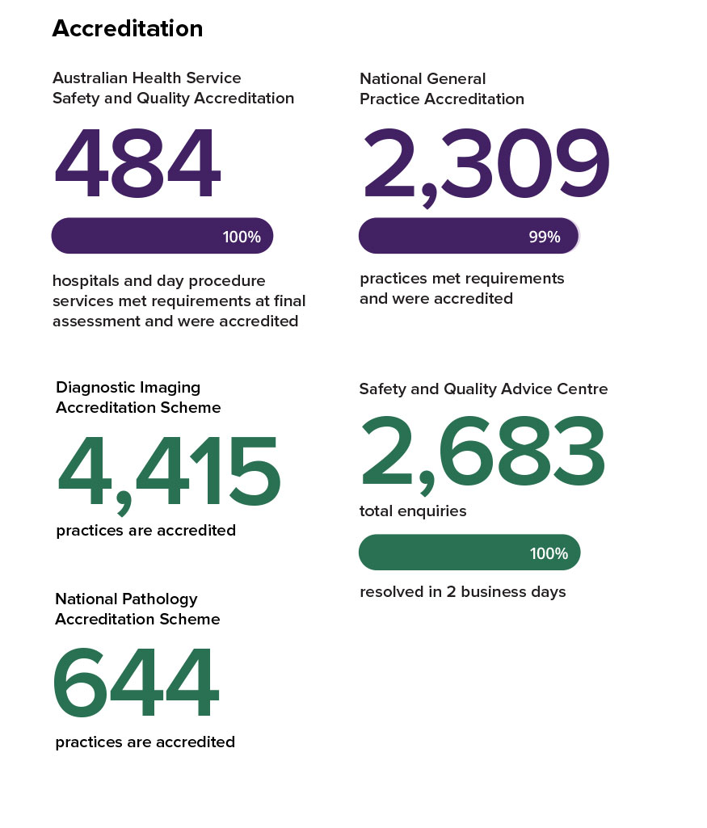
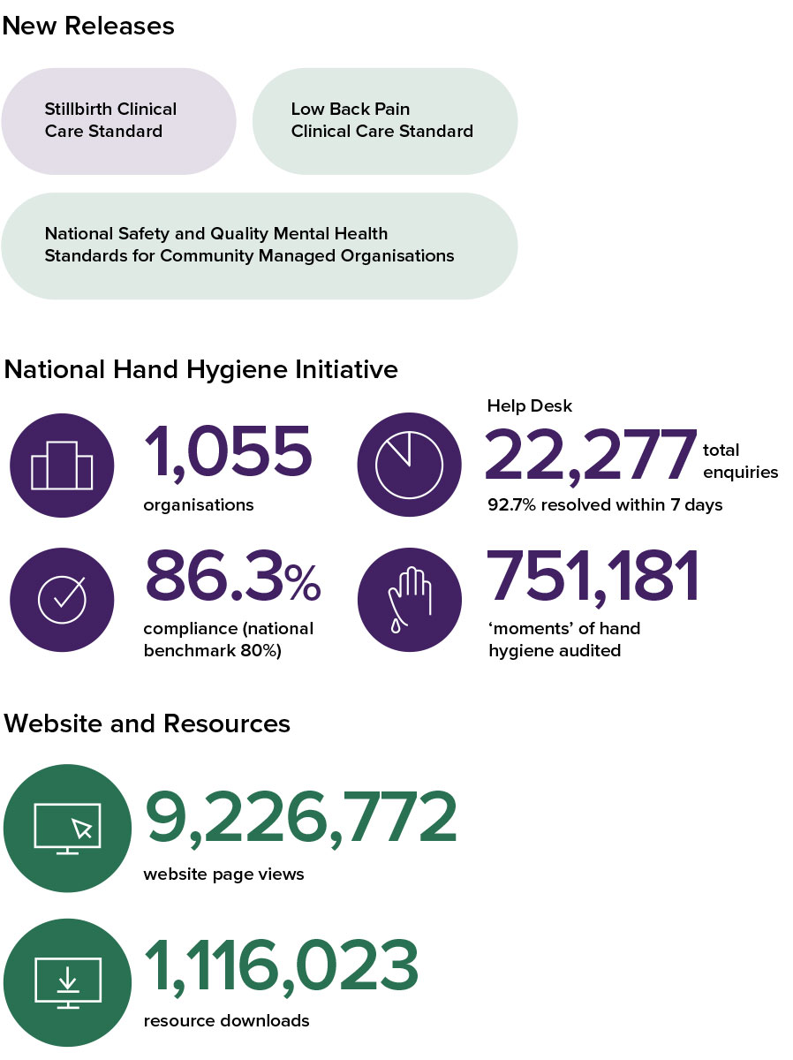

1. Overview
This section provides an overview of the Australian Commission on Safety and Quality in Health Care (the Commission) – including its mission, role, functions and accountability – and reports from the Commission’s Chair and Chief Executive Officer.
About the Commission 12
Strategic Intent 2020–2025 14
Report from the Chair 16
Report from the Chief Executive Officer 18
Vale Kathy Meleady 20
Cross-sectoral collaboration 21



About the Commission
In 2006, the Council of Australian Governments established the Commission to lead and coordinate national improvements in the safety and quality of health care. The Commission’s permanent status was confirmed with the passage of the National Health and Hospitals Network Act 2011, and its role was codified in the National Health Reform Act 2011. The Commission commenced as an independent statutory authority on 1 July 2011, funded jointly by the Australian Government and state and territory governments.

Our purpose
Our purpose is to contribute to better health outcomes and experiences for Australians, and improve value and sustainability in the health system by leading and coordinating national improvements in the safety and quality of health care. Within this overarching purpose, the Commission aims to ensure that people are kept safe when they receive health care and that they receive the care they should.
The functions of the Commission are specified in section 9 of the National Health Reform Act 2011 and include:
- formulating standards, guidelines and indicators relating to healthcare safety and quality matters
- advising health ministers on national clinical standards
- promoting, supporting and encouraging the implementation of these standards, and related guidelines and indicators
- monitoring the implementation and impact of the standards
- promoting, supporting and encouraging the implementation of programs and initiatives relating to healthcare safety and quality
- formulating model national schemes that provide for the accreditation of organisations that provide healthcare services, and relate to healthcare safety and quality
- Publishing reports and papers relating to healthcare safety and quality.

Our accountability
The Commission is a corporate Commonwealth entity and part of the Health and Aged Care portfolio of the Australian Government. As such, it is accountable to the Australian Parliament and the Minister for Health and Aged Care, the Hon. Mark Butler MP.

Strategic Intent 2020–2025
In 2019–20, the Commission’s Board endorsed the Strategic Intent 2020–2025. The functions described in section 9 of the National Health Reform Act 2011 guide the Commission’s work, and are expressed in the four priorities of the Strategic Intent 2020–2025.
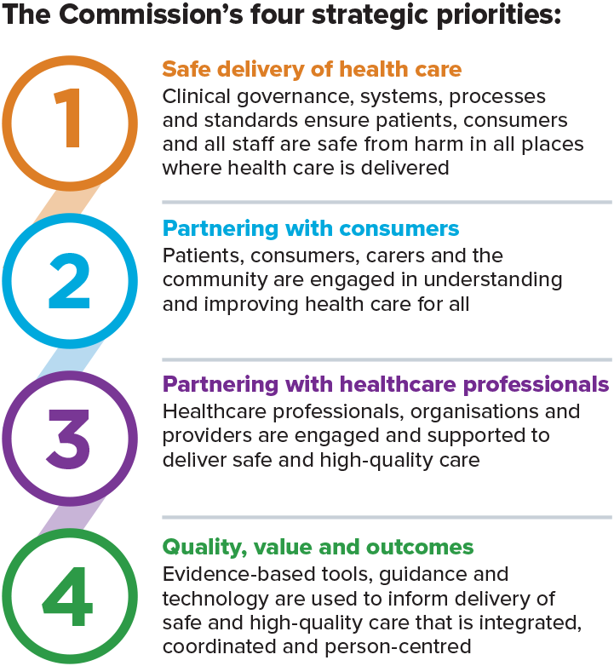

The Australian Commission on Safety and Quality in Health Care leads and coordinates national improvements in the safety and quality of health care.
We do this by:
- being an authoritative voice
- taking a strategic whole-of-system approach
- using evidence as a foundation for action
- harnessing national knowledge and expertise
- driving a quality improvement culture
- using data effectively
- reporting meaningful information publicly
- empowering consumer action
- enabling and engaging clinicians
- leading collaboration, cooperation and integration
- influencing funding, regulation and education
- fostering use of safe digital technology and artificial intelligence
- guiding transparency and accountability
- supporting research and innovation
- acknowledging and actively managing risk
- embedding safety and quality into systems and processes
- encouraging development of learning organisations
- creating networks of excellence.
The Commission works in partnership with patients, carers and clinicians; the Australian, state and territory health systems, private sector managers and healthcare organisations to achieve a safe, high-quality and sustainable health system.
The Commission works in partnership with patients; carers; clinicians; the Australian, state and territory health systems; the private sector; managers and healthcare organisations to achieve a safe, high-quality and sustainable health system. Key functions of the Commission include developing national safety and quality standards, developing clinical care standards to improve the implementation of evidence-based health care, coordinating work in specific areas to improve outcomes for patients, and providing information, publications and resources about safety and quality.

Report from the Chair
Professor Villis Marshall AC
"It is an honour to welcome Professor Anne Duggan to the role of Chief Executive Officer. I look forward to our work together."
This year, we saw the COVID-19 pandemic start to ease and our health systems begin a return to more normal operation – in many ways a new normal. One enduring effect of the pandemic has been a shift towards more digital services. COVID-19 restrictions both increased the demand for mental health services and necessitated the digital delivery of these services. Responding to this emerging need for a baseline standard of delivery, the Commission developed the National Safety and Quality Digital Mental Health Standards in 2022 and accreditation to the Standards began in November of that year.

The Commission once again delivered across a variety of programs during the year, including the development of standards. Two outstanding achievements were the Lower Back Pain Clinical Care Standard, which recommends new approaches to a common and widespread problem, and the Cosmetic Surgery Standards, which are part of wide-ranging reforms to protect consumers who are undergoing cosmetic procedures.
The Commission looked to expand and embed an inclusive and equitable approach to the development of and access to its resources. Resources published this year included information to assist clinicians to improve delivery of services to those with an intellectual disability, and an adaption of the design of the Australian Charter of Health Care Rights so that it relates to all community members.
I am extremely proud of the achievements of the Commission in this reporting year, in continuing the delivery of high-value services and programs during the transition of Quality Use of Medicines functions to the Commission from 1 January 2023.
On behalf of the Board, I would like to express my sincere gratitude to Professor Debora Picone, who retired from her role as Chief Executive Officer in September 2022. Adjunct Professor Picone’s contribution to the health sector has been truly invaluable.
My specific thanks to our Chief Operating Officer, Mr Chris Leahy, for ably taking up the Chief Executive Officer role over the interim period up to the appointment of our new Chief Executive Officer, Conjoint Professor Anne Duggan, in March 2023, and providing stable leadership that allowed Commission staff to continue their work without interruption.
It is an honour to welcome Professor Anne Duggan to the role of Chief Executive Officer. Professor Duggan’s leadership expertise, her understanding of the work of the Commission from her previous role as Chief Medical Officer, her breadth and depth of knowledge of the delivery of healthcare services, and especially her contemporary insight as a recently practising physician, give her the ideal background for leading and setting the strategic direction for the Commission in coming years. I look forward to our work together.
In presenting the 2022–23 Annual Report, I would like to thank our healthcare partners, including the Australian Government, state and territory partners, the private sector, clinicians and, of course, our consumer advisory groups and consumers themselves who take time to share their experiences to make services better.
I extend my sincere thanks to the members of the Commission’s Board for their advice and guidance over the past year and to the Hon. Mark Butler MP, Minister for Health and Aged Care, for his leadership and support. My sincere thanks to departing board members, Ms Glenys Beauchamp AO PSM and Ms Wendy Harris KC.
On behalf of the Board, I would like to thank the executive team and all staff of the Commission – your outstanding work continues to strengthen our reputation and recognition as a national leader for improvement in health care for all Australians.

Report from the Chief Executive Officer
Conjoint Professor Anne Duggan
“I look forward to collaborating with the state, territory and Commonwealth health departments to achieve safety and quality in health care and operationalising the strategic direction set by the Board.”
Australia is fortunate to have one of the best health systems in the world, but it is facing many challenges. The far-reaching effects of COVID-19, poor connectedness between system elements and a lack of equity in health outcomes are among these. Supporting the health system to provide consumers with safe and high quality health care in the context of these challenges is at the centre of the Commission’s work.
The extraordinary demands created by COVID-19 have put enormous strain on our health system – and on the people working within it. Although case numbers may be lower than in previous years, the effects are still very much being felt. The Commission recognises this changed environment and the need to provide support to a health system under pressure.

Along with COVID-19 came changes to the way we work, such as greater use of telehealth. A key challenge is ensuring the changes that have occurred are used in ways that benefit patients. The Commission’s work in this area includes the National Safety and Quality Digital Mental Health Standards.
An important part of supporting a health system under pressure is identifying how best to target our efforts to produce the greatest benefit to consumers. Reducing low-value care frees up resources for these endeavours and contributes to reducing the environmental impact of the health system. Data is key for identifying and reducing low-value care, and for monitoring whether we are getting the intended outcomes.
The maps and data in the Australian Atlas of Healthcare Variation series show some people may be missing out on health care they need, while others may be exposed to risks of low-value care. Drilling down to the local area level, these data can act as a signal to investigate whether differences reflect patient needs, or if other factors are at play.
We have a complex health system that needs to be better integrated to work more effectively. General Practitioners who have a holistic view of the consumer are at the centre of a better coordinated system. With greater emphasis on primary care, we may reduce the future human and financial costs of advanced chronic disease.
In 2022–23, through the commitment of staff and the support of the Board, I am pleased to report the Commission has again successfully progressed our Work Plan.
Among the many highlights from this year, the Commission began work on two very important clinical care standards: the Psychotropic Medicines in Cognitive Disability Standard and the Chronic Obstructive Pulmonary Disease Clinical Care Standard. The value of clinical care standards was seen this year in the results of an evaluation where 96% of health services surveyed reported that clinical care standards are improving quality of care.
Our work in the development of standards continues to expand into new areas of health services. In addition to our response to the priority of strengthening protection of consumers contemplating and undergoing cosmetic surgery, work is well under way in the areas of pathology and diagnostic imaging. In early 2023, accreditation started for the Clinical Trials Governance Framework, which, for the first time, sets national standards for this work and brings clinical trials into the established hospital accreditation process. Our work in this area is widely anticipated to increase efficiencies through standardisation of practices and boost Australia’s capacity and capability in research.
From 1 January 2023, the Commission took up new responsibilities as part of changes to the Department’s Quality Use of Diagnostics, Therapeutics and Pathology Program. This has required a dedicated program of transition involving research, analysis and review with the goal of moving towards integration of ongoing quality use of medicines functions. I thank everyone for their efforts in such a complex change process.
I am immensely proud to have been appointed as the Commission’s Chief Executive Officer from March 2023. I look forward to operationalising the strategic direction set by the Board and to collaborating with the state, territory and Commonwealth health departments to achieve our common goal of safety and quality in health care.

Vale Kathy Meleady
Sadly, 2022 saw the loss of one of the Commission’s trusted and longstanding staff members, Adjunct Professor Kathy Meleady PSM.
Kathy began work at the Commission in 2013 after a long and successful career at NSW Health, where she led statewide health system planning, capital and infrastructure investment, health technology planning and assessment, and development of super-specialty services. Kathy was awarded a Public Service Medal in 2015 for her outstanding public service and contribution to the NSW health system.
During her time at the Commission, Kathy led the establishment and implementation of a number of quality and safety programs, including the National Patient Blood Management Collaborative; reducing radiation exposure from CT scans for children and young people; the development and ongoing enhancement of the AURA Surveillance System, Australia’s first comprehensive system for monitoring and reporting on antimicrobial resistance and use; and infection prevention and control and the response to healthcare-associated infections. Kathy also led the development of resources for women and clinicians in relation to transvaginal mesh, the work on credentialling for sacrocolpopexy, and the Commission’s collaborative work with the Therapeutic Goods Administration and the Department of Health and Aged Care in relation to the safety of medical devices.
Kathy is greatly missed by the Commission and many people in the health system nationally.

Cross-sectoral collaboration
The Commission continues to work collaboratively with government agencies and other organisations to address key cross-sectoral healthcare safety and quality issues.

Improving healthcare safety in aged care
During 2022–23, the Commission continued its work to develop Quality Standard 5 – Clinical Care, which forms part of a consolidated set of revised Aged Care Quality Standards (Quality Standards). The Quality Standards aim to protect older people from harm and improve the quality of clinical care delivered through Australian Government subsidised aged care services.
In August 2022, following development and targeted consultation, the Commission delivered the draft Quality Standard 5 – Clinical Care. The Commission then supported a public consultation, led by the Australian Government Department of Health and Aged Care (the Department), on the set of revised Quality Standards.
The Aged Care Quality and Safety Commission (ACQSC) began a pilot of the revised Quality Standards in April 2023, which used a new audit methodology to test how the draft standards worked in practice. The Commission, in consultation with ACQSC, supported the pilot program with development of guidance material for implementation of Quality Standard 5. Further resources will be developed during 2023–24 to support Quality Standard 5 – Clinical Care.

Scoping study on national standards for Safe Spaces
Beginning in early 2023, the Commission, on behalf of the Department, engaged with stakeholders with lived and learned experience of suicide for a scoping study to explore options for national standards for Safe Spaces. Safe Spaces are places where people experiencing suicidal distress can seek support from peers with lived experience in a non-clinical environment.
The scoping study aims to understand the safety and quality expectations that people with lived experience of suicide, their carers and support people, and governments and the suicide prevention sector have of Safe Spaces, and whether options for new or existing safety and quality standards could be applied to Safe Spaces. This work will continue in 2023–24.

Improving health care for people with disability
In 2022–23, the Commission worked with the Department, the disability sector and the NDIS Quality and Safeguards Commission to improve consultation and cross-sector collaboration for people with cognitive impairment and disability. Projects included supporting the development and implementation of the National Roadmap to Improve Health Care of People with Intellectual Disability; the National Dementia Action Plan; and collaborative work relating to the reduction of the use of psychotropic medication for behaviour modification.

Improving the experience of people using complaints processes
The Commission continued to work with the Australian Health Practitioner Regulation Agency (Ahpra) to improve consumer awareness, understanding and experience of health complaints processes.
In 2022–23, the Commission worked with Health Consumers Queensland to better understand consumers’ experiences of making a health care complaint and explore the need to develop information or resources to better support consumers and improve their experience. Feedback from consumers identified the need for consistent advice about the best ways to approach health services and provision of information on how to make a health care complaint.
The Commission and Ahpra began work on a resource, for consumers, providing guidance on making a complaint or providing feedback to their health provider or local health service This resource will be finalised in 2023–24.

Supporting Quality Use of Medicines
The 2022–23 Budget included provision to redesign the Department’s Quality Use of Diagnostics, Therapeutics and Pathology (QUDTP) Program. Included in this announcement was the decision to transfer a range of Quality Use of Medicines (QUM) activities, developed under the QUDTP program, to the Commission.
From 1 January 2023, the Commission became responsible for QUM stewardship and the management of a range of QUM functions. This included the management of the MedicineInsight data collection, Choosing Wisely Australia; a number of medication safety applications; a suite of online learning modules on safe and appropriate medicines use; convening the National Medicines Symposium; and development and maintenance of guidance and resources on key medication issues.
Expansion of the QUM program is an extension of the Commission’s existing Medication Safety Program and complements previous work including the development of national indicators for QUM in Australian hospitals, guiding principles on medication management resources, and the National Baseline Report on Quality Use of Medicines and Medicines Safety – Phase 1: Residential aged care.
This expanded program of work on QUM will continue in 2023–24, and will involve the review, modification, alignment and further integration of these new functions across the Commission’s relevant program areas.

Reconciliation Action Plan
The Commission’s Reconciliation Action Plan (RAP) is a first step towards reconciliation and, importantly, improving the safety and quality of health care for Aboriginal and Torres Strait Islander people in Australia.
The Reflect-type RAP is the first of four stages – Reflect, Innovate, Stretch and Elevate. The Commission’s Reflect RAP, endorsed in August 2022, will increase the capability, resources and events across our organisation for staff to learn, form partnerships and innovate to improve the experience of health care for Aboriginal and Torres Strait Islander people across Australia. The Commission’s Aboriginal and Torres Strait Islander Health Advisory Group was involved in the development of the Reflect RAP.
The Commission has established internal groups and processes to review implementation and progress against its RAP objectives.

2. Report on performance
This section details the Commission’s achievements against its four priority areas.
Priority 1: Safe delivery of health care 27
Priority 2: Partnering with consumers 47
Priority 3: Partnering with healthcare professionals 51
Priority 4: Quality, value and outcomes 57



“The introduction of short notice assessments will ensure the assessment outcome reflects day-to-day practice, identifies gaps and supports health service organisations to improve safety and quality systems and processes.”

Priority 1: Safe delivery of health care
This priority is to keep patients and consumers safe from preventable harm.

Improving patient safety through the National Safety and Quality Health Service Standards
The National Safety and Quality Health Service (NSQHS) Standards have been applied in hospitals and day procedure services since 2013. They provide a framework for safety and quality services improvement and protect the public from harm. The NSQHS Standards outline safety and quality outcomes that a health service organisation must achieve, while giving organisations the flexibility to decide how to achieve these outcomes in a way that is relevant to their size, location and context. The NSQHS Standards (second edition) have been assessed in health service organisations since January 2019.
All hospitals and day procedure services in Australia are required to implement the NSQHS Standards. Most importantly, they provide a practical mechanism for implementing a comprehensive and robust clinical governance framework, which is the foundation for all other clinical safety and quality processes. With the NSQHS Standards and a clinical governance framework in place, health service organisations can reduce the risk of harm to patients from common risks such as hospital-acquired infections, the medication errors and lapses in communication, and improve the provision of comprehensive care and management of an acute deterioration.

Assessment to the NSQHS Standards
At 30 June 2023, 1,319 hospitals and day procedure services were routinely being assessed to the NSQHS Standards. Health service organisations must demonstrate they meet all the requirements in the NSQHS Standards to achieve accreditation. Of the 484 organisations assessed in the 2022–23 financial year, 58% (279 organisations) met all actions at the initial assessment.
From April 2022, organisations have begun their second round of assessments to the second edition of the NSQHS Standards. This provides an opportunity to monitor trends over time. As of 30 June 2023, 148 health service organisations have completed two assessments.
A summary of health service organisation assessment outcomes for 2022–23 and initial trend data is outlined in Figure 1.

Figure 1: Health service organisation accreditation, 2022–23*
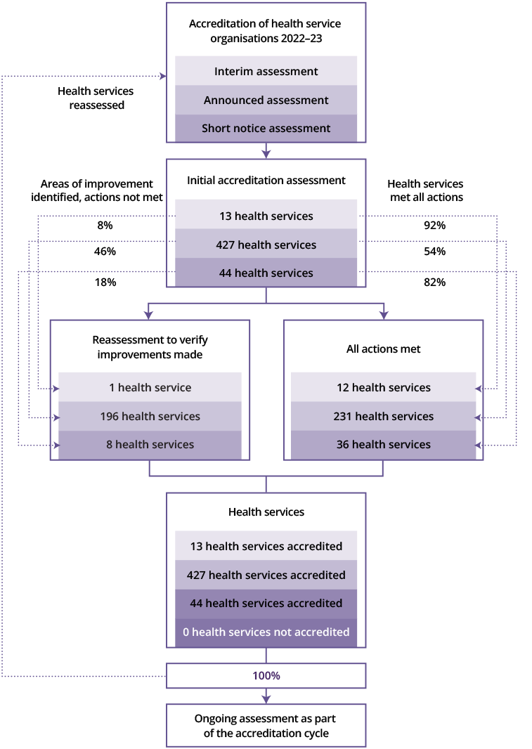
*Health service organisations include only hospitals and day procedure services, where accreditation to the NSQHS Standards is mandatory. Other services assessed to the NSQHS Standards are not included. These were finalised assessments between 1 July 2022 to 30 June 2023 to the second edition of the NSQHS Standards.

Providing guidance and advice
Many resources to support health service organisations to implement the NSQHS Standards were published in 2022–23. These included:
- fact sheets on the transition to short notice accreditation assessment, which commences on 1 July 2023
- a report on the outcomes of the National Survey on Cultural Safety Training
- advisories that describe non-applicable NSQHS actions for BreastScreen Australia Services
- fact sheets and a user guide to support implementation of the National Clinical Trials Governance Framework.
To support assessment of the six Aboriginal and Torres Strait Islander–specific actions in the NSQHS Standards, a cultural safety training program was developed in collaboration with the Council of Aboriginal and Torres Strait Islander Nurses and Midwives. An advisory regarding this training was released in December 2022, and all assessors were required to complete this training by 30 July 2023.

Safety and Quality Advice Centre
The Commission’s support of the Safety and Quality Advice Centre (the Advice Centre)ensures health service organisations, consumers, clinicians, accrediting agencies and others can readily find accurate information on the NSQHS Standards, supporting resources and information on the accreditation scheme.
In 2022–23, the Advice Centre responded to 2,683 email enquiries and met its key performance indicator of resolving enquiries within three business days, providing a first response within five hours and resolving enquires within two business days.

Improving the reliability of the accreditation processes
The Commission continued to work to improve the effectiveness of its accreditation processes in 2022–23. Standardised reporting on assessment outcomes has been fully implemented by accrediting agencies. The health system has been supported in the transition to short notice assessments from 1 July 2023, along with strengthening the application of the assessment rating scale and updating thresholds for triggering a mandatory reassessment. Together, these strategies deliver a more accurate assessment of the implementation of safety and quality standards in a health service organisation.

Short notice assessments
Mandatory short notice assessments to the NSQHS Standards begin July 2023. This change applies to all health service organisations where licensing requires accreditation to the NSQHS Standards.
The introduction of short notice assessments will ensure the assessment outcome reflects day-to-day practice, identifies gaps and supports health service organisations to improve safety and quality systems and processes.

Rating scale adjustments
From July 2023, changes to the rating scale for assessment were introduced. Where a health service organisation has a large number of actions rated ‘not met’ or ‘met with recommendations’ following initial assessment to the NSQHS Standards, and is subsequently awarded accreditation, a mandatory reassessment may be required.
The aim of the reassessment is to ensure the health service has fully embedded the necessary improvements in their safety and quality systems to maintain compliance with the NSQHS Standards.

Public reporting of accreditation outcomes
A national dashboard of hospital performance at assessment is published on the Commission’s website. This information is updated monthly to ensure its accuracy. It provides a high level overview of the number of assessments occurring, the overall performance by sector and by standards.
The public reporting tool provides information on individual hospitals which is updated monthly as assessments are finalised. It details outcomes of assessment and any areas where improvements are required to achieve accreditation. Since its introduction in 2021, there have been 5,046 visitors to the site.

Oversight and feedback on accrediting agency performance
The Commission annually provides a detailed performance report on approved accrediting agencies as part of its oversight of the Australian Health Service Safety and Quality Accreditation (AHSSQA) Scheme. This includes analysis of each agency’s assessment performance, feedback from observation of agency practice and collated data from health service organisation feedback. The aim is to ensure accrediting agencies’ processes are rigorous and effective. Eleven observation visits across five states and territories were conducted in 2022–23.

Review of accreditation outcomes data
Data on assessment outcomes is submitted though the Commission’s data collection portal monthly by accrediting agencies. The portal validates the data submitted to ensure accuracy, consistency and completeness of the data. The data is analysed in a variety of ways to report to state and territory regulators, program areas and program administrators. In 2022–23, specific reports were conducted on:
- validity and consistency of ‘met with recommendations’ awarded; these are actions from the NSQHS Standards where the action is mostly met, with some implementation still required
- assessment outcomes to identify health service organisations that meet the criteria for mandatory reassessment.

Assessor training
All assessors for the NSQHS Standards are required to undergo the NSQHS Standards Assessor Orientation Course. As of 30 June 2023, 387 assessors had completed this course. A total of 4,696 non-assessors are currently enrolled in the NSQHS Standards orientation course and there continues to be significant interest from members of the wider workforce in accreditation processes and implementation of safety and quality standards.
New training for assessors has been released to support assessment of the National Safety and Quality Digital Mental Health Standards (NSQDMH) and the National Clinical Trials Governance Framework.
Assessors were required to complete the updated Cultural Safety Training for Assessors by July 2023. The online Core Cultural Learning Aboriginal and Torres Strait Islander Foundation Course was unavailable from 1 January 2023 and new assessors were required to undertake face-to-face cultural safety training.

Post-assessment survey
Following the completion of an assessment to the NSQHS Standards, each health service organisation is sent a survey seeking feedback on the performance of its accrediting agency and assessors. The survey has had a 28% (93 of 293) response rate. Almost all respondents (95%) found their lead assessor effective in coordinating the assessment.
Key findings included:
- final reports were provided to health service organisations in a format that was easily understood
- assessors had a comprehensive knowledge of the NSQHS Standards.
Assessors used the PICMoRS (process, improvement, consumer participation, monitoring, reporting and systems) structured assessment method and referred to Commission resources when required.

Diagnostic Imaging Accreditation Scheme
The Diagnostic Imaging Accreditation Scheme provides the framework for assessment of medical imaging practices to the Diagnostic Imaging Accreditation Scheme Standards. As of 30 June 2023, there were 4,413 accredited imaging practices . The services provided by these practices range from a single service (61%) to multiple services (5%). Most (80%) of these practices offer ultrasound services.

In 2022–23, work by the Commission on the review of the Diagnostic Imaging Accreditation Scheme Standards progressed and revised standards were drafted. Activities informing the standards development included feedback from consumers and stakeholders on safety and quality issues, a literature review on diagnostic imaging safety and quality and a review of national and international imaging practice accreditation standards.
The renamed National Safety and Quality Medical Imaging Standards are scheduled for release and consultation in the second half of 2023. Work began in 2023 to improve the collection and reporting on assessment outcomes data.

National Pathology Accreditation Scheme
In 2022–23, the Commission, in collaboration with the National Pathology Accreditation Advisory Council (NPAAC), updated six pathology standards. Since the work of the NPAAC has transitioned to the Commission, the revision of pathology standards has aimed to align the structure and language to existing national safety and quality standards while maintaining safety and quality requirements for pathology services.
In 2023, the Commission continued the review of the following pathology standards:
- performance measures for Australian laboratories reporting cervical cytology
- requirements for laboratories reporting tests for the National Cervical Screening Program
- requirements for validation of self-collected vaginal swabs for use in the National Cervical Screening Program
- requirements for medical pathology services
- requirements for the estimation of measurement of uncertainty
- requirements for quality control, external quality assurance and method evaluation
- requirements for the communication of high-risk pathology results
- guidelines for approved pathology collection centres (requirements for medical pathology specimen collection)
- requirements for supervision in the clinical governance of medical pathology laboratories.
Key activities undertaken by the Commission in 2022–23 to improve the national pathology accreditation scheme include:
- scoping regulatory associated issues with the national pathology accreditation scheme
- working closely with the National Association of Testing Authorities to collate data on the assessment of pathology laboratories
- developing implementation resources to support consistency across the pathology sector in addressing safety and quality requirements.

Digital standards

National Safety and Quality Digital Mental Health Standards
In 2022, the Commission finalised and implemented an accreditation model for the NSQDMH Standards under the AHSSQA Scheme. Assessment to the NSQDMH Standards began on 1 November 2022, allowing digital mental health services to become formally accredited to these Standards. Additional resources were released in 2022–23, including guidance on the NSQDMH Standards accreditation badge, and a clinical and technical governance webinar was held in early 2023.

Patient safety in general practice
The Commission has an increasing focus on patient safety and quality in primary and community healthcare settings, as delivering health care close to where people live and work constitutes a large and essential part of the healthcare system.

National General Practice Accreditation Scheme
The Department funds the Commission to coordinate the non-compulsory National General Practice Accreditation (NGPA) Scheme. The NGPA Scheme began in January 2017 with the primary aim of supporting national consistency of accreditation of general practices. General practices participating in the NGPA Scheme are accredited to the Royal Australian College of General Practitioners (RACGP) Standards for general practices.
Five independent accrediting agencies were approved by the Commission to assess general practices to the RACGP Standards for general practices. A total of 2,309 general practices were assessed, with 99% meeting the requirements of the standards and awarded accreditation. Twenty-one general practices were not accredited and one withdrew from the NGPA Scheme.

Of the practices assessed, 97% were categorised as general practices, and the remaining 3% were categorised as Aboriginal medical services. Of the 2,309 assessed practices, 1,539 were in metropolitan areas (67%), and a substantial majority were in New South Wales, Victoria and Queensland. The number and type of ‘not met’ indicators were largely similar between metropolitan and rural and remote locations.
Regarding the workforce of the general practices assessed:
- 76% employed five or fewer full-time equivalent (FTE)? general practitioners
- 74% employed two or fewer FTE practice nurses.
The Commission continued to support general practices during the COVID-19 pandemic and natural disasters experienced throughout the country in 2022–23. To provide certainty for general practices, and facilitate accreditation assessments proceeding where possible, provisions for accreditation assessments were applied during 2022–23. Between July 1 2022 and 30 June 2023, the Commission supported 60 applications for extensions related to COVID-19. This figure is down on the 79 applications received in the previous year. Sixteen applications were due to floods – double the previous twelve months - and nine were to undertake a hybrid assessment.

Patient safety in primary health care

National Safety and Quality Primary and Community Healthcare Standards
Following the launch of Australia’s first nationally consistent safety and quality standards for the primary healthcare sector, the National Safety and Quality Primary and Community Healthcare Standards, the Commission has been working to support implementation through the development of a comprehensive resource to provide practical guidance and support. Healthcare services wishing to seek independent accreditation to the standards were able to do so from 1 May 2023. Depending on the service context and previous accreditation, assessment can be conducted as a desktop, virtual or onsite assessment to the standards.

Cosmetic surgery standards and licensing framework
As part of Australia-wide reforms to address poor practices and variation in cosmetic surgery regulation, Australian health ministers requested the Commission undertake two specific tasks: to develop National Safety and Quality Cosmetic Surgery (Cosmetic Surgery) Standards and to develop a national licensing framework for service providers performing cosmetic surgery.
The Cosmetic Surgery Standards and licensing framework were developed in 2022–23, with broad consultation and in close collaboration with key stakeholders including consumers, clinicians, service providers, peak professional organisations and regulators. The Cosmetic Surgery Standards aim to protect the public from harm by improving the safety and quality of cosmetic surgery performed. The Standards aim to achieve this by supporting service providers to embed clinical governance frameworks and address key safety issues such as informed consent and advertising of cosmetic surgery services.
The licensing framework provides a robust, nationally consistent approach to the licensing of service providers performing cosmetic surgery, which can then be implemented by states and territories. The Cosmetic Surgery Standards and licensing framework was provided to health ministers in July 2023.
The Commission worked with the Medical Board of Australia and Ahpra to ensure cosmetic surgery reforms were aligned.

Sustainability module
In 2022–23, the Commission developed and refined a Sustainable Healthcare Module. In mid-2022, the Commission engaged the Climate and Health Alliance and the Monash Sustainable Development Institute to prepare a report on current action being taken in health service organisations and across jurisdictions and the evidence base on the risks and opportunities for health service organisations in sustainable health care.
Between October 2022 and January 2023, the Commission undertook a public consultation process to determine the need for, and applicability of, the draft Sustainable Healthcare Module. The Commission received 45 written submissions and 756 online survey responses, with overwhelming support for the implementation of the module from respondents.
In late 2023, Board approval will be sought to finalise the module and steps will be taken to support implementation across all sectors of the health system. Resources to support implementation will be developed in 2023–24.

Healthcare-associated infections, and infection prevention and control
Healthcare-associated infections are some of the most common and significant hospital-acquired complications, with around 38,000 healthcare-associated infections occurring in Australia per year. As well as causing unnecessary pain and suffering for patients and their families, a healthcare-associated infection can prolong a patient’s hospital stay and add greatly to the cost of delivering health care. It is estimated that globally up to 1 in 10 patients with a healthcare-associated infection will die from the infection.

Effective infection prevention and control practices can minimise the risk of transmission of infection between patients, healthcare workers and other people in the healthcare environment. This reduces the risk of healthcare-associated infections.
The Commission continued to develop resources to support infection prevention and control in aged care in collaboration with the Aged Care Quality and Safety Commission. These resources support implementation of Quality Standard 5 – Clinical Care of the Aged Care Quality Standards.

National Hand Hygiene Initiative
In 2022–23, the Commission started collaborating with the Council of Presidents of Medical Colleges on a campaign to promote further improvement in medical practitioner compliance with hand hygiene protocols. This campaign culminated on Hand Hygiene Day on 5 May 2023.
A major refresh of infection prevention and control e-learning modules was completed to ensure currency of content and consistency with the NSQHS Standards and the Australian Guidelines for the Prevention and Control of Infection in Healthcare.
In collaboration with states, territories and the private health sector, the Commission implemented revised hand hygiene auditor training pathways and updated the hand hygiene e-learning modules for clinical and non-clinical healthcare workers. These changes increase access to hand hygiene auditor training through online modules and incorporate a contemporary approach to supporting healthcare worker competence in hand hygiene practice.

Antimicrobial use and resistance in Australia

AURA project
Antimicrobial resistance (AMR) reduces the range of antimicrobials available to treat infections, and increases morbidity and mortality associated with infections caused by multidrug-resistant organisms.

Antimicrobial Use and Resistance in Australia (AURA) project
The Commission continued to contribute to the response to AMR in Australia, with funding provided by the Department for:
- coordination, support and enhancement of the functionality, coverage and reporting of the National Alert System for Critical Antimicrobial Resistances and Australian Passive AMR Surveillance (APAS)
- collaboration with the Australian Group on Antimicrobial Resistance (AGAR) to report data on AMR in selected bacteria detected from blood cultures
- reporting on community antimicrobial use based on analyses of data from the Pharmaceutical Benefits Scheme (PBS) and Repatriation Pharmaceutical Benefits Scheme (RPBS), and the MedicineInsight program
- reporting AMR data from APAS and AGAR to the World Health Organization Global Antimicrobial Resistance and Use Surveillance System
- development of AURA 2023, the fifth Australian report on antimicrobial use and resistance in human health.
Analyses of 2021 data from these programs published by the Commission identified:
- more than doubling of non-PBS/RPBS (private) prescriptions for antimicrobials from 2.5% in 2015 to 5.3% in 2021
- prescribing rates for respiratory-related illnesses in primary care that were not consistent with national guidelines but showed improvement in appropriateness (this is compared with urinary tract infections and acute otitis media, for which appropriateness was not improved; prescribing rates for these conditions remained high)
- a dramatic decrease in antimicrobial use between 2019 and 2021 (25.3%) – during the response to COVID-19 – compared with the drop between 2015 and 2019 (8.9%)
- variation in patterns of resistance between states and territories
- variation between hospital and community settings in patterns of resistance – overwhelmingly, onset of episodes of bacteraemia was in the community.

The Commission uses these analyses to continue to support states and territories, and the private health sector, to refine and strengthen their approaches to infection prevention and control and antimicrobial stewardship and implementation of the NSQHS Standards.
The Commission also supported the Therapeutic Goods Administration (TGA) with the response to antimicrobial shortages by developing general information for prescribers and pharmacists on how to manage shortages of antimicrobials in acute and primary healthcare settings. A resource was developed for consumers on what to do if their antimicrobial is temporarily unavailable.

Safety in digital health

Collaboration with the Australian Digital Health Agency
The Commission has a memorandum of understanding (MoU) with the Australian Digital Health Agency (ADHA). This builds on the Commission’s previous digital health and clinical safety program, which has been conducted on behalf of the My Health Record System Operator since 2012. The purpose of the MoU is to support clinical governance, and the clinical safety and quality of the national digital health work program. The Commission continues to support patient safety and digital health by:
- providing independent, expert advice to the ADHA on the clinical governance, clinical safety and quality of national digital health infrastructure, including the My Health Record system
- using National Standards and supporting resources to promote the safe use of digital health national infrastructure, including the My Health Record system
- working collaboratively with the ADHA to promote clinical safety and quality in digital health through the Commission’s e-health safety work program and resources.
In early 2023, the Commission was engaged to provide further input into the ADHA’s Clinical Governance Framework, including development of implementation resources.

My Health Record in emergency departments
The Commission was engaged by the ADHA to investigate the needs of emergency department clinicians to support their use of the My Health Record system and examine how content can be applied to clinical decision-making. A five-month pilot study was conducted in four public hospital emergency departments, which included almost 130,000 patients and 1,000 emergency department staff. The final report on this project was published by the ADHA in August 2022.

Unique Device Identifiers
The Commission, in collaboration with the TGA and the Department, began a project to develop and pilot the Australian Unique Device Identifier Framework for Australian health service organisations (UDI4H Framework).
Implementation of the UDI4H Framework aims to improve patient safety by enhancing capability to effectively respond to adverse events, support recalls and build consumer confidence in Australia’s system for post-market surveillance. It will also improve efforts by jurisdictions and the private sector to identify safety or performance concerns.
In 2022–23, Queensland Health joined the Early Adopter Project for UDI4H and is working with the Commission and the TGA to develop the initial UDI4H Framework with resources that will allow other jurisdictions to pilot and implement the UDI4H Framework in future.

Medication safety

Electronic National Residential Medication Chart
In December 2021, the Commission published two resources to support the safe implementation and optimisation of electronic National Residential Medication Chart (eNRMC) medication management systems. The first resource was aimed at residential aged care facilities (RACF) looking to transition from paper-based or hybrid (electronic and paper) medication management systems to an eNRMC medication management system. A second resource was developed for software vendors looking to optimise or enhance their eNRMC medication management systems.
In 2023, the Commission began updating the eNRMC user guide and software vendor resource. The updated publications will address issues that have emerged since the national adoption and implementation of the eNRMC, reflecting feedback from RACFs, software vendors and other stakeholders.

Review of National Tall Man lettering list
In 2022–23, the Commission started to review its National Tall Man Lettering List (the List). The List, first published in 2017, and its 2019 supplementary list of specialised medicines ending in the suffix ‘mab’, ‘nib’ or ‘gib’, will be consolidated into an updated publication for release in 2023–24.

Terminology, abbreviations and symbols used in documentation
One of the major causes of medication errors is the use of error-prone abbreviations and dose expressions. To promote patient safety, the Recommendations for Terminology, Abbreviations and Symbols used in Medicines Documentation (2016) sets out principles for medicines governing safe, clear and consistent terminology, abbreviations and dose designations.
In 2023, the Commission initiated a rapid literature review and environmental scan to review and identify areas for updating the 2016 publication. Updated guidance on recommendations for terminology, abbreviations and symbols used in medicines and documentation will be published in 2023–24.

Review of publications on quality use of medicines
In March 2021, the Commission was engaged by the Department to review and update three national publications on QUM. The focus of these publications is residential aged care facilities, the community and support for continuity of care for individuals who move between different parts of the healthcare system. The review and update of these documents considered contemporary QUM, medicines safety literature and the National Medicines Policy.
The Commission led the review, collaborating closely with the ACQSC. Public consultation included more than 80 peak organisations and experts involved in medication management, individuals receiving care and healthcare professionals, including registered nurses, doctors and pharmacists.
In December 2022, the Department published the updated national guiding principles and their supplementary resources developed by the Commission to improve the quality and safety of medication management for all:
- Guiding Principles for Medication Management in Residential Aged Care Facilities, User Guide: Role of a Medication Advisory Committee and Fact sheet
- Guiding Principles for Medication Management in the Community and Fact sheet
- Guiding Principles to Achieve Continuity in Medication Management and Fact sheet
- Glossary for the Guiding Principles and User Guide.

Review of guidelines for on-screen display of medicines
In 2017, the Commission published the guidelines as a combined version of the National Guidelines for On-Screen Display of Clinical Medicines Information and National Guidelines for On-Screen Display of Consumer Medicines Information.
In late 2022, the Commission began a review into the uptake of the guidelines, and reviewed the presentation of medicines information in areas previously out of scope, such as mobile devices. Following this, in early 2023, the Commission began reviewing and revising these guidelines to ensure currency and address identified barriers to implementation. The revised guidelines will better support standardised presentation of medicines information across various systems and health settings.

Active ingredient prescribing
In December 2022, the Commission completed its program of work and returned stewardship of active ingredient prescribing to the Department.
In 2022–23, the Safer insulin prescribing fact sheet was developed for prescribers, highlighting the importance of including the brand name, in addition to the active ingredient name, on a prescription for insulin. This fact sheet outlines elements for safer insulin prescribing within the context of active ingredient prescribing and does not provide detailed guidance on all prescribing requirements.

Point prevalence study on psychotropic medicines
From May 2021 to November 2022, the Commission undertook a point prevalence study in relation to prescribing of psychotropic medicines in hospitalised patients over 65 years of age and discharged to a residential aged care facility. The study aimed to acquire a deeper understanding of the issues and advise on opportunities for improvement in the prescription and use of psychotropic medicines in acute and aged care settings.
The prevalence of psychotropic medicine use was 1.4 per patient on presentation, 2.4 per patient during admission, and 1.6 per patient on discharge. Examining antipsychotic medicines prescribing, 13% of patients were prescribed at least one pre-admission, 26% during admission, and 18% on discharge. An identified area of concern is the number of opioid analgesics prescribed during admission that were continued on discharge.
The snapshot report is being used to inform the development of the Commission’s Psychotropic Medicines in Cognitive Disability or Impairment Clinical Care Standard.

Online learning modules for high-risk medicines
The Commission partnered with the SA Health to develop an online suite of e-learning modules on high-risk medicines. These modules promote the safe use of high-risk medicines to healthcare professionals. Two further modules, on psychotropic medicines and anticancer medicines, were developed and are now available in participating jurisdictions. There was also interest in making the modules widely available across Australia to promote safe use South Australian Department of Health and Wellbeing of high-risk medicines in the private hospital sector and primary and aged care settings.

In response, the Women’s and Children’s Health Network in South Australia developed a new online platform to host the modules. This platform enables purchased access for all healthcare professionals and health service organisations in a not-for-profit model. Seven modules are currently available:
- An Introduction to High-Risk Medicines
- Insulin
- Anticoagulants
- Clozapine
- Opioid Analgesics
- Psychotropic Medicines
- Anticancer Medicines.
In 2022–23, the Commission began a review of the first two modules, an ‘An introduction to high-risk medicines’ and ‘Insulin’, to ensure currency of the content. The updated versions will be released in mid-to-late 2023. Work will start in late 2023 to review an additional two existing modules.

Neural connector devices
The Commission and the Australian and New Zealand College of Anaesthetists continue to support the introduction and use of neural connector devices compliant with ISO 80369-6. Using neural route devices with connectors compliant with ISO 80369-6 aims to reduce the risk of unintended connections when medicines are delivered via intrathecal, epidural and other neural routes.
In 2022–23, the Commission developed an advisory for all public and private health service organisations to transition to the use of neural route devices with connectors compliant with ISO 80369-6. Imposition of timelines for implementation through an advisory will not progress. Rather, health service organisations are encouraged to implement according to local requirements using the implementation guidance and safety checklist to inform the changeover.

National Standard Medication Chart audit
The Commission hosts the National Standard Medication Chart (NSMC) audit every two years via the online NSMC audit system. The NSMC audits aim to evaluate the compliance to the safety features of standardised medication charts and the safety and quality of prescribing and medication documentation, and identify further areas for improvement in medication management. In October 2022, a NSMC national audit was conducted, involving 317 public and private hospitals, with 9,441 individual patient charts audited with the report expected to be released in late 2023.

Real Time Prescription Monitoring
In 2022, the Commission reviewed implementation of the national Real Time Prescription Monitoring (RTPM) system to identify gaps and barriers to effective, safe and quality use of the system. In 2023, the Commission began development of national resources to support use of RTPM by prescribers and pharmacists. The resources aim to support stewardship of high-risk medicines through effective use of RTPM systems. Resources provide practical guidance for clinicians on how to use RTPM systems during clinical decision-making for patients on high-risk medicines.

Mental health

National safety and quality standards for community managed organisations
In November 2022, the Commission launched the National Safety and Quality Mental Health Standards for Community Managed Organisations (NSQMH CMO Standards). These standards provide a purpose designed, contemporary set of standards for community managed organisations providing mental health services.
The standards are designed to be interoperable with other relevant sets of standards including the NSQHS Standards, the NDIS practice standards and the National Standards for Mental Health Services, to reduce regulatory burden on service providers.
In 2022–23, the Commission developed supporting materials to assist community managed organisations to implement the new NSQMH CMO Standards. These include resources for consumers and carers, co-designed with Lived Experience Australia; a user guide to assist service providers preparing for accreditation; and mapping work to assist in identifying actions that community managed organisations may already have addressed during accreditation to other relevant sets of standards. This work will be completed in late 2023 for distribution to service providers to facilitate entry to the AHSSQA Scheme.
The NSQMH CMO Standards are being integrated in the AHSSQA Scheme and will be ready for implementation in early 2024.

Guidance for acute and community mental health services
In July 2022, the Commission released the NSQHS Standards User Guide for Acute and Community Mental Health Services. This user guide provides examples of strategies to support mental health services subject to the AHSSQA Scheme to implement actions in the NSQHS Standards. It includes a series of spotlights, which demonstrate how mental health services can use the NSQHS Standards to address key issues, such as working with carers and families, and delivering trauma-informed, recovery-oriented mental health care.

Cognitive impairment and intellectual disability

Resources to support people with intellectual disability
In March 2023, the Commission released a series of fact sheets to support health services to deliver safe and high-quality health care for people with disability. One of these fact sheets is an Easy Read resource designed with and for people with intellectual disability to help them and their support people to talk with health services about reasonable adjustments that will improve their access to equitable health care.
The Commission also began development of a NSQHS Standards User Guide for the health care of people with intellectual disability. These resources demonstrate how building reasonable adjustments into the delivery of health care will improve outcomes for people with intellectual disability.

Communicating for safety

Open disclosure
In November 2022, the Commission began an evaluation of the Australian Open Disclosure Framework. This is the first formal evaluation the Commission has conducted of the Framework since it was endorsed by Australian health ministers in 2011. It aims to ensure guidance relating to open disclosure remains relevant, meaningful and pertinent to the health services to which it applies.
The Commission is engaging with consumer and carer representative organisations, clinicians, health service managers and Health Care Complaints Commissioners to gain broad understanding about how Open Disclosure is currently being practised and experienced. The findings of this evaluation will inform a potential revision of the Australian Open Disclosure Framework by the Commission in 2023–24.

Informed consent
Consumers have the right to receive clear and easy-to-understand information about their care and treatment options so they are supported to make informed decisions about their care. The Commission has developed several resources to support a shared understanding between health service organisations, clinicians and consumers about requirements in relation to informed consent in health care. Consultation with stakeholders identified the need for more detailed consumer information.
In 2022–23, the Commission contracted the Health Care Consumers’ Association of the ACT to undertake consultation with consumers from diverse backgrounds to identify where more support was needed to help consumers understand what is meant by informed consent. The Commission subsequently began development of resources with a focus on the needs of culturally and linguistically diverse (CALD) populations and Aboriginal and Torres Strait Islander people.

Comprehensive care
During 2022–23, the Commission has focused on supporting the implementation of the Comprehensive Care Standard through participation in projects across states and territories and promotion of Commission resources on best-practice, person-centred care.
The Commission participated in a wide range of key stakeholder meetings and workshops on comprehensive care, and provided support and guidance to quality improvement projects, including four statewide projects.

Priority 2: Partnering with consumers
This priority is to ensure patients, consumers, carers and the community are engaged in understanding and improving health care for all.

Supporting consumer engagement and partnerships

Australian Charter of Healthcare Rights
In 2022–23, the Commission focused on increasing accessibility to the Australian Charter of Healthcare Rights (the Charter) for different population groups.
In 2022, the Commission worked with North Sydney Local Health District (NSLHD) to adapt the Charter, making it culturally appropriate and more accessible for Aboriginal and Torres Strait Islander people within their district. A development team consisting of the NSLHD Aboriginal and Torres Strait Islander team, supported by the NSLHD Governance Unit, developed a unique artwork to accompany the Charter. The story behind the artwork has been published alongside the adapted Charter on the Commission’s website as an exemplar for other health service organisations.
The Commission has also been working with the Northern Territory Top End Region to translate the Charter into six of the most common languages in the region: Yolngu Matha, Murrinh Patha, Anindilyakwa, Kunwinjku, Tiwi and Kriol. The project, which is led by local Aboriginal providers, includes development of an animation, co-designed with consumers, to explain the Charter in a culturally meaningful way.
The Commission has established a relationship with ACON (AIDS Council of NSW) and LGBTIQ+ Health Australia. An LGBTQI+ version of the Charter was released to coincide with Sydney World Pride 2023. This version is available for health services to display to reassure the LGBTQI+ community that their health care will be provided in a safe and inclusive environment that meets their needs. A supporting resource to provide clinicians and health services with more detailed information about effective ways to communicate with LGBTQI+ people, based on the seven rights in the Charter. The Commission began development of a supporting resource to provide clinicians and health services with more detailed information about effective ways to communicate with LGBTQI+ people, based on the seven rights in the Charter.

Supporting consumers to partner in their own health care
In collaboration with Health Consumers NSW, the Commission developed a series of videos on demand (vodcasts) for health consumers relating to partnering with health services. The vodcasts Patient Power: Healthcare Rights and Positive Change were available from June 2023 and feature four episodes:

- ‘The Australian Charter of Healthcare Rights’
- ‘Shared Decision Making in Health Care’
- ‘Feedback to Improve Health Care’
- ‘Community Representatives Improving Health Care’.
In 2022–23, the Commission worked with the Australian Institute of Health Innovation (AIHI) to develop resources to help health services communicate more effectively with CALD communities. The AIHI conducted a project on the development and validation of co-designed patient engagement practices to enhance patient safety among CALD consumers in Australian cancer services. This project has informed the development of a fact sheet by the Commission for health service organisations and clinicians, sharing strategies for engaging CALD consumers in planning and making decisions about their own care.
In 2022–23, three consumer resources – the Australian Charter of Healthcare Rights and two resources providing advice on how to find good health information online – were translated into 19 different languages.

Supporting consumers to engage with organisational design and governance
In 2022–23, the Commission developed a Person-Centred Care Resource Hub on the Commission’s website to provide access to range of resources, including best-practice tips for consumers and health services to improve engagement in organisational design and governance. As part of this work, the Commission has launched a webinar series, Person-Centred Care in Practice. The first two webinars received more than 1,000 registrations. A further four webinars will complete the series in 2023–24. A network to share resources and best practice in person-centred care has also been established and currently has 1,500 members.
In 2022–23, the Commission also worked with the Consumer Health Forum of Australia to develop a consumer-led project, Partnering with Consumers: A guide for consumers, to help consumers and health service organisations better understand how to get the most from their partnerships. This resource will be published as a package with a range of supporting materials, including case studies, in 2023–24.

End-of-life care
In 2022, the Commission started revising the National Consensus Statement: Essential elements for safe and high-quality end-of-life care. An open consultation was conducted between November 2022 and January 2023 and identified several themes that were incorporated to develop a new edition of the consensus statement. The new edition of the consensus statement will be published in 2023–24.

Measuring patient experience

Patient-reported experience measures
In 2022–23, the Commission continued to support health service organisations to implement the Australian Hospital Patient Experience Question Set (AHPEQS).
The Commission assisted organisations in adapting the AHPEQS for use in specialised areas. This included:

- a collaboration with Perth Children’s Hospital to adapt the AHPEQS for use by parents and carers of children
- support to adapt the AHPEQS for use by children and young people
- ongoing support to a National Health and Medical Research Council funded research project to develop a patient-reported experience measure for Aboriginal and Torres Strait Islander people using primary health care. In 2022–23, a study protocol for this project was published in a peer-reviewed journal and data collection through yarning circles is under way.
The Commission is continuing to expand its work in patient-reported experience measurement. In 2022–23, the Commission undertook a review of how health service organisations are using patient experience data for local safety and quality improvement. The review identified barriers and enablers of patient experience measurement, potential themes for future actions and suggestions on meaningful use of patient experience data for safety and quality improvement.
The Commission also released a literature review on patient-reported experience measurement in primary health care. The literature provided insights into the use of patient experience across different service providers in the primary health care sector. The literature review highlighted some of the challenges and identified best-practice principles for primary health care patient experience measurement.

Patient-reported outcome measures
Patient-reported outcome measures (PROMs) provide a systematic way of assessing a patient’s view of the impact of interventions on their clinical condition, wellbeing and quality of life. In 2022–23, the Commission continued its ongoing work to support the implementation of PROMs in Australia. The Commission has continued the development of evidence and consensus-based recommendations for the use of PROMs in low back pain and maternity care. The Commission also hosted a series of roundtables with senior PROMs implementers from state and territory health departments and consumers. Participants shared knowledge and experiences on engaging consumers and clinicians to use PROMs.

The PaRIS initiative
The Commission continued to collaborate with the Organisation for Economic Co-operation and Development on the Patient-Reported Indicator Survey (PaRIS) initiative. This initiative aims to strengthen the measurement of outcomes and experiences of health care that matter most to people. The Commission is managing Australia’s involvement in this international work and has been funded by the Department to develop and implement a new survey on outcomes and experiences of patients 45 years and over, with chronic conditions, who are managed in primary or ambulatory care (PaRIS survey). The PaRIS survey has been field tested and national rollout of the survey in Australia began in May 2023.

“The Governance Framework aims to reduce duplication and increase efficiency, cohesion and productivity of governance across the clinical trials sector.”

Priority 3: Partnering with healthcare professionals
This priority is to ensure healthcare professionals, organisations and providers are engaged and supported to deliver safe and high-quality care.

Indicators, measures and dataset specifications
While most health care in Australia is associated with good clinical outcomes, preventable adverse events and complications continue to occur across the healthcare system. To assist in identifying instances of harm, the Commission developed three indicators for local monitoring of safety and quality: hospital-acquired complications (HACs), avoidable hospital readmissions and sentinel events.
In partnership with the Independent Health and Aged Care Pricing Authority and the state and territory health departments, the Commission has maintained the specifications for these three sets of indicators under the National Health Reform Agreement in 2022–23. This maintenance process includes the consideration of stakeholder requests to amend the indicators, with clinician advice, as well as updates to ensure alignment with the latest data standards and definitions.

Hospital-acquired complications list
In 2022–23, the Commission continued its role of supporting local-level monitoring and improvement of patient care with the Hospital-acquired complications list (HACs list). In August 2022, the Commission began to update the resources provided to support the monitoring and reduction of HACs across the system. This work was finished in March 2023, with the publication of the HACs FAQs and Resources page, including a list of frequently asked questions, a searchable HACs resources and literature table and a set of goal HAC rates. The Commission will expand on this work and include more online interactive HACs data in 2023-24.

Avoidable hospital readmissions list
In 2022–23, the Commission continued its role under the 2020–2025 Addendum to the National Health Reform Agreement to review and maintain the avoidable hospital readmissions list. The Commission supported a number of health services and jurisdictions to understand and interpret this indicator, along with updating the specifications to align with the International Statistical Classification of Diseases and Related Health Problems (10th Revision, Australian Modification) 12th edition.

Sentinel events
Sentinel events are a subset of adverse events that result in death or serious harm to a patient. In 2022–2023, the Commission continued the engagement of an expert group, comprising senior clinical and executive staff, to review queries received relating to severe incidents and potential sentinel events. These queries were recorded in an issues log. This process serves to maintain and review the sentinel events list to ensure its currency and validity.

Clinical care standards indicators
The Commission continued to develop and specify indicators to support the implementation of clinical care standards. In 2022–23, indicators were published for the:
- Low Back Pain Clinical Care Standard
- Stillbirth Clinical Care Standard.
The indicator set for the Hip Fracture Care Standard was revised to ensure that the indicators remain fit for purpose, relevant and appropriate.
Work progressed on the new Psychotropic Medicines in Cognitive Disability or Impairment Clinical Care Standard indicators. Work began to develop indicators for the new Chronic Obstructive Pulmonary Disease Standard to review and revise the indicators in the Osteoarthritis of the Knee and Heavy Menstrual Bleeding Clinical Care Standards, scheduled for publication in 2023–24.

Patient Safety Culture Measurement Toolkit
The Commission has continued to support use of patient safety culture measurement for improvement over 2022–23. The Patient Safety Culture Measurement Toolkit, released in 2021, includes a validated survey, the Australian Hospital Survey on Patient Safety Culture 2.0, in addition to information on implementation and improvement strategies. The use of the toolkit and measurement of patient safety culture continues to expand in Australia.
In 2022–23, the Commission drafted a short set of questions for integration into annual staff surveys. These will be piloted over 2023–24.

Improving reporting of safety and quality data

Aligning public reporting for public and private hospitals
There is good academic and operational evidence that public reporting of safety and quality information stimulates safety and quality improvements, especially at a hospital and clinical department level, for the benefit of patient care and outcomes. All Australian governments recognise the benefit and value of public reporting and are working to improve the transparency of public reporting.
In response to a request by health ministers, the Commission started to implement a simple, accessible national public reporting system that provides standard safety and quality data about public and private hospitals. This will take the form of a Safety in Health Care web tool, where people can search for relevant and reliable safety and quality information about Australian hospitals. The tool will initially be released with three safety and quality indicators: meeting NSQHS Standards; hand hygiene; and rates of Staphylococcus aureus bloodstream infection.
In 2022–23, the Commission finalised the design of the Safety in Health Care web tool and undertook extensive user testing. The web tool will be released in late 2023. In the future, it is expected that additional indicators for safety and quality will be specified and added to the tool, including patient-reported information on the outcomes and experiences of care.

Incident management
In 2022–23, the Commission published information on methodologies used to investigate patient safety incidents. The Commission’s web page now includes information on methodologies such as root cause analysis, London protocol and failure mode and effect analysis. This complements the Commission’s Incident Management Guide published in 2021.
The Commission is working with states and territories to finalise a national approach to sharing lessons learned from patient safety incidents. It is also supporting a research project funded by the National Health and Medical Research Council on incident management primarily focused on improving the strategy and function of incident management systems and investigations.

National Clinical Trials Governance Framework
In 2022–23, the Commission delivered a number of fact sheets and webinars to support the implementation of, and assessment to, the National Clinical Trials Governance Framework (the Governance Framework).
The Governance Framework supports integration of clinical trials into routine health care and strengthening of clinical and corporate governance arrangements for governments, hospital administrators, health services, private companies, trial sponsors and trial investigators that deliver clinical trials. Importantly, it aims to reduce duplication and increase efficiency, cohesion and productivity of governance across the clinical trials sector.

The accreditation of health service organisations for the provision of clinical trial services has been incorporated into the AHSSQA Scheme. From May 2023, health service organisations commenced assessment against specific actions in the NSQHS Standards, as provided in the Governance Framework.
As clinical trial services are a new service type for assessment, health services will be assessed to the actions in the Governance Framework once in the first three years against a maturity scale. That is, health services will be assessed as having initial systems, growing systems or established systems in place to meet the actions in the NSQHS Clinical Governance Standard and the Partnering with Consumers Standard, as provided in the Governance Framework.

National One Stop Shop
The purpose of the National One Stop Shop is to streamline and harmonise the operating environment for the approval and management of clinical trials and health-related research to make it easier for patients, researchers, industry representatives and sponsors to find, conduct, participate in and invest in high-quality and ethical research in Australia.
Consultations in 2021–22 revealed sector-wide support for a National One Stop Shop to:
- cover the research life cycle, including a sophisticated national ethics, governance and research management system
- incorporate the Clinical Trials Notification and Clinical Trials Approvals schemes
- include requirements of the Office of the Gene Technology Regulator, in addition to an embedded next-generation national clinical trials registry and other modules, to enable accurate and real-time information.
The National One Stop Shop would enable and underpin the nationally consistent approach to accreditation for trial sites in public and private health service organisations. A proof of concept for the National One Stop Shop was developed and approved by the Department and the Clinical Trials Project Reference Group in May 2022. A final report outlining recommended options for, and key components of, the proposed National One Stop Shop has been provided to health ministers for their consideration.

Expansion of the National Mutual Acceptance scheme
The National Mutual Acceptance (NMA) scheme for single ethical and scientific review by public and private ethics committee providers that have been accredited in Australia has consistently been identified as a key enabler of clinical trials. States and territories agreed to expand the NMA scheme and, to support this in 2022–23, the Commission began developing a draft quality standard and scheme for accreditation of human research ethics committees.
Adherence to a quality standard for human research ethics committees (HRECs) under the NMA scheme will enhance the consistency and efficiency of the ethical review process and build reciprocal confidence in HREC approvals. In 2022, the Commission convened an expert advisory group to advise on consultations related to the NMA scheme. In May 2023, the Commission completed an international literature review on quality standards and accreditation schemes for HRECs to inform the development of the quality standard.
Targeted consultations on a draft quality standard and accreditation scheme will begin mid-2023. Endorsement from the states and territories of the recommended options for a scheme for accreditation of NMA ethics committees will be sought in 2023–24.

Revision of the Framework for Australian Clinical Quality Registries
During 2022–23, the Commission developed the second edition of the Framework for Australian Clinical Quality Registries (the Framework). The Framework aims to support national clinical quality registries operating under, or moving towards, national arrangements to meet their core purpose. That is, the Framework supports registries to work towards achieving national reporting and returning information to patients, clinicians, health service providers, health insurers, governments and the community on the appropriateness and effectiveness of health care in high-priority clinical conditions, medical devices, therapies and interventions.
From January to March 2023, the Commission led a national consultation process on the second edition of the Framework. This revised version will provide guidance in line with current best practice, relevant legislation and guidelines, and will consider future-focused approaches for clinical quality data collections that align with the NSQHS Standards. The revised Framework is expected to be published in 2023–24.

Quality Use of Medicines

Transition of functions and stewardship
Under the Department’s Quality Use of Diagnostics, Therapeutics and Pathology (QUDTP) Program, a range of Quality Use of Medicines (QUM) functions transitioned to the Commission on 1 January 2023. QUM functions that have transitioned to the Commission include:
- national stewardship of QUM
- management of the MedicineInsight data collection – a quality improvement program for primary care and post-market surveillance of medicines
- management of the MedicineWise and Doctor’s Bag apps – apps to support consumers, carers and health professionals
- hosting and coordinating of Choosing Wisely Australia – an initiative to support clinicians, consumers and healthcare stakeholders to reduce unnecessary tests, treatments and procedures
- convening of the National Medicines Symposium – a symposium that brings together organisations, individuals and decision-makers in the health sector to discuss and debate key issues around quality QUM and health technologies
- development of practice reviews – reviews of individual general practitioner data for dispensing of PBS medicines or ordering of Medicare Benefit Scheme tests related to specific clinical areas to support professional development and quality improvement
- curation of website materials and online learning platforms funded under the QUDTP Program – materials and education modules previously developed by NPS MedicineWise that provide clinicians, consumers and carers, health services and students with a range of QUM information and resources.
In 2022–23, the Commission transferred the functions, materials, resources and infrastructure and started a review process to identify opportunities for alignment and efficiency across programs and functions.

Priority 4: Quality, value and outcomes
This priority area is to ensure evidence informs the delivery of safe, appropriate and high-quality care.

Identifying healthcare variation
Identifying and reducing unnecessary or low-value care improves the appropriateness and sustainability of healthcare services. All levels of the health system need to focus on reducing unnecessary or low-value care. A robust governance framework provides the scaffold for sustainable and appropriate health care.
The Commission provides data, tools and resources to identify variation in healthcare use to inform the improvement of the appropriateness of care.
The Australian Atlas of Healthcare Variation series is one of these tools. It maps the use of health care according to where people live, providing data and direction for health services to identify and address unwarranted variation and improve the appropriateness of care. Improvement may involve increasing access to treatment options that have better outcomes or reducing treatment that has little or no benefit.

Healthcare variation reports
In 2022–23, the Commission reported trend data about the dispensing of two high-risk medicines and compared it to data in the third Atlas.
Using PBS data, the interactive reports examined dispensing of opioid medicines (all ages) and antipsychotic medicines (65 years and over) at national, state and territory, Primary Health Network (PHN) and local levels between 2016–17 and 2020–21.
The reports revealed a decline in dispensing of these medicines over five years but continuing variation. Dispensing rates fell nationally, and in all states and territories, in the five years to 2020–21. There was an 18% reduction nationally in opioids dispensing rates and an 11% reduction in antipsychotics dispensing rates. The data indicated some geographical areas had consistently high dispensing rates, indicating further investigation is required.
Health services, PHNs and clinicians can use the data to review rates of dispensing in their local area and benchmark with rates for similar areas.

Working across primary and acute care
In 2022–23, the Commission engaged with PHNs that had consistently high rates of dispensing of opioid and antipsychotic medicines for the five years to 2020–21. The Commission developed tailored data reports and met with each PHN to discuss local factors that may have contributed to high dispensing rates and ways to improve the use of the medicines.
All PHNs welcomed the Commission’s personal engagement approach, particularly the tailored reports, which had highlighted areas for quality improvement.
The Commission also engaged with healthcare organisations when updating the User Guide for Reviewing Clinical Variation. In 2022–23, the user guide was published as an interactive tool to make it easier for health services to use the guide’s six-step approach to improving care.
The guide includes practical case studies, which show how health services have addressed clinical variation, including clinician and policy makers’ insights. New case studies included improving end-of-life care, reducing unplanned readmissions after tonsillectomy and analgesic stewardship.

Improving appropriateness of care
Clinical care standards support appropriate care by describing how clinicians and healthcare services can provide care based on the best available evidence. Appropriate care reduces the risk of harm, maximises benefits and avoids the use of ineffective interventions.

Clinical care standards
The Commission launched two new clinical care standards in 2022–23:
- Low Back Pain Clinical Care Standard
- Stillbirth Clinical Care Standard.
- During 2022–23, work was undertaken on two new standards:
- Psychotropic Medicines in Cognitive Disability or Impairment Clinical Care Standard
- Chronic Obstructive Pulmonary Disease Clinical Care Standard.
Clinical care standards under review in 2022–23 included:
- Hip Fracture Care Clinical Care Standard
- Heavy Menstrual Bleeding Clinical Care Standard
- Osteoarthritis of the Knee Clinical Care Standard.
An evaluation of three clinical care standards found that clinical care standards are highly relevant and are improving the quality of care.

Low Back Pain Clinical Care Standard
In Australia, back problems affect approximately 16% of the population(1), and are the number one cause of early retirement(2) and income poverty(3). Most episodes of low back pain will improve with primary care management, and without further investigations or referral to specialists.
The Low Back Pain Clinical Care Standard was developed in response to the first and second Australian Atlases of Healthcare Variation, which recommended that the Commission undertake activity in response to variation in computed tomography of the lumbar spine, lumbar spinal decompression surgery and lumbar spinal fusion surgery, in line with international evidence-based guidelines, including those from the National Institute for Health and Care Excellence in the United Kingdom.
The standard covers the early clinical assessment, non-surgical management, review and appropriate referral for secondary intervention of people with low back pain, with or without leg pain. It aims to improve the early assessment and management of low back pain based on the best available evidence, and to reduce the use of investigations and treatment options that may be ineffective or unnecessary.
The standard was launched in September 2022 and was endorsed by 19 key professional and consumer organisations.

Stillbirth Clinical Care Standard
Stillbirth is the most common form of infant death in Australia, with six babies stillborn every day. The experience has a profound and long-lasting impact on parents and families, and often their care providers.
The Stillbirth Clinical Care Standard describes the care that women who are pregnant, or planning a pregnancy, should expect to receive to reduce their chance of experiencing a stillbirth. It also aims to support best practice in bereavement care for parents (and their support people) who have experienced any form of perinatal loss.
Funding was provided by the Department to support the development of the Stillbirth Clinical Care Standard, as part of the National Stillbirth Action and Implementation Plan. The plan aims to reduce rates of preventable stillbirth (after 28 weeks gestation) by 20% by December 2025.
The standard was launched at the Annual National Stillbirth Forum in November 2022 and was endorsed by 26 professional and consumer organisations.

Psychotropic Medicines in Cognitive Disability or Impairment Clinical Care Standard
The safe and appropriate use of psychotropic medicines is a national priority for people with cognitive impairment and disability, their families and carers, healthcare providers, and aged and disability care service providers. This was highlighted during the Royal Commission into Aged Care Quality and Safety and the Royal Commission into Violence, Abuse, Neglect and Exploitation of People with Disability.
This clinical care standard was developed following the release of a joint statement by the Australian Commission on Safety and Quality in Health Care, the Aged Care Quality and Safety Commission and the NDIS Quality and Safeguards Commission in March 2022, outlining a shared commitment to working together to reduce the inappropriate use of psychotropic medicines in older people and people with cognitive disability or impairment.
The clinical care standard aims to support the rights, dignity, health and quality of life of people with cognitive disability or impairment in all healthcare settings and to ensure the safe and appropriate use of psychotropic medicines. It relates to the health care that people of all ages with cognitive disability or impairment should receive to optimise the prescribing and use of psychotropic medicines and safeguard the person. This clinical care standard will be released in 2023–24.

Chronic Obstructive Pulmonary Disease Clinical Care Standard
Chronic obstructive pulmonary disease (COPD) is a serious chronic condition affecting an estimated 1 in 13 Australians over the age of 40. COPD is the leading cause of potentially preventable hospitalisations in Australia and is associated with significant healthcare costs. In 2018–2019, an estimated $935 million was spent on COPD, representing 21% of the disease expenditure on respiratory conditions in Australia. COPD exacerbations are associated with increased morbidity, mortality and healthcare costs, and are a major source of potentially preventable hospitalisations.
Despite the availability of clinical guidelines such as the COPD-X guidelines, there is significant variation in health care for COPD in Australia. The fourth Atlas identified up to 18-fold variation in hospitalisation rates for COPD between local areas. The rate for Aboriginal and Torres Strait Islander people was 4.8 times the rate for other Australians.
The clinical care standard will seek to address current gaps in clinical practice, providing a pathway of quality care for the management of COPD in acute and community settings and the transitions of care between them. The standard will describe best practice in the assessment and management of COPD, including exacerbations. This clinical care standard will be released in 2023–24.

Review of published clinical care standards
The Commission has published 17 clinical care standards since 2014. The standards are regularly reviewed to ensure continued alignment with clinical practice guidelines and relevance to clinical practice.
The Hip Fracture Care Clinical Care Standard (first published in 2016) was reviewed and updated for planned launch in September 2023.
Stakeholder surveys and evidence reviews were undertaken in preparation for the reviews of the Heavy Menstrual Bleeding Clinical Care Standard and the Osteoarthritis of the Knee Clinical Care Standard. Revisions of these standards began in 2022–23 with updated versions expected to be published in late 2023.

Evaluating clinical care standards
As part of their planned review, an evaluation of the Antimicrobial Stewardship, Delirium and Hip Fracture Care Clinical Care Standards was undertaken in 2022–23. The evaluation focused on four key areas:
- relevance and feasibility to implement
- adoption and use
- championing by stakeholder and interest groups
- improvements in quality of care.
The evaluation found that at least:
- 96% of health services surveyed found the clinical care standards relevant
- 92% of health services using the clinical care standards reported that they had improved the quality of care.
The evaluation involved 514 survey participants, some of whom responded about more than one clinical care standard. In total there were 590 responses about the relevance of the standard, and 454 responses about improvements in care.

Annual performance statements
As the accountable authority of the Commission, the Board presents the 2022–23 annual performance statements of the Commission, as required under subsection 39(1) of the Public Governance, Performance and Accountability Act 2013. In the opinion of the Board, based on advice from Commission management and the Audit and Risk Committee, these annual performance statements accurately reflect the performance of the Commission and comply with subsection 39(2) of the Public Governance, Performance and Accountability Act 2013.
Professor Villis Marshall AC
Board Chair

Our purpose
Our purpose is to contribute to better health outcomes and experiences for all patients and consumers, and improve the value and sustainability of the health system, by leading and coordinating national improvements in the safety and quality of health care.
Within this overarching purpose, the Commission aims to ensure that people are kept safe when they receive health care and that they receive care that is right for them.
The functions of the Commission are specified in section 9 of the National Health Reform Act 2011, and include:
- formulating standards, guidelines and indicators relating to healthcare safety and quality matters
- advising health ministers on national clinical standards
- promoting, supporting and encouraging the implementation of these standards, and related guidelines and indicators
- monitoring the implementation and impact of the standards
- promoting, supporting and encouraging the implementation of programs and initiatives relating to healthcare safety and quality matters
- formulating model national schemes that provide for the accreditation of organisations that provide healthcare services, and relate to healthcare safety and quality matters
- publishing reports and papers relating to healthcare safety and quality matters.

Analysis of performance against purpose
In 2022–23, the Commission achieved its deliverables in line with the Commission’s section of the 2022–23 Health Portfolio Budget Statements and Corporate Plan 2022–23. The Commission continued to deliver consistently high-quality and valuable work in areas that can be improved through national coordination and action.
The Commission’s Strategic Intent 2020–25 guides the Commission in undertaking its work, and is expressed in four strategic priorities that aim to ensure that patients, consumers and communities have access to and receive safe and high-quality health care.
Key to the Commission’s strategic priorities are partnerships led at a national level, supported by local activities and implementation to improve quality, value and outcomes. To facilitate these national partnerships, the Commission works closely with patients, carers and clinicians; the Australian, state and territory health systems; the private sector; managers; and healthcare organisations to achieve a safe, high-quality and sustainable health system.
The Commission works with its partners to support the implementation of safety and quality initiatives by developing guidance, resources, tools and educational materials. The Commission also supports the evaluation of its activities, and measurement of the impact of initiatives to improve safety and quality on the health system. The Commission continually looks to identify new and emerging safety and quality issues, while being responsive to the evolving needs of its partners and the healthcare system.
The Commission has continued to adjust operationally and strategically to support the health system as it managed ongoing pressures brought about by the COVID-19 pandemic. The Commission has taken a risk management approach to balancing work plan activities and continually monitored the progress of deliverables. Consequently, the Commission has been able to progress its strategic priorities as planned and deliver the work plan.
In 2022–23 some of the Commission’s key achievements included:
- development of a range of resources to support health service organisations in understanding and meeting the requirements of the National Safety and Quality Health Service (NSQHS) Standards including guides and fact sheets on topics such oral health, application of NSQHS Standards in ambulance health services, hand hygiene and the introduction of short notice assessments
- implementation of reform strategies to the Australian Health Service Safety and Quality Accreditation Scheme, preparation of accrediting agencies and health service organisations for the introduction of short notice assessments from 1 July 2023, refined public reporting on accreditation outcomes, validation of accreditation outcomes data through a data collection portal and ongoing oversight of accreditation agencies
- release of the National Safety and Quality Mental Health Standards for Community Managed Organisations, and commenced development of a clinician guide and a consumer guide to support implementation

- development and publication of detailed reports from the following Antimicrobial Use and Resistance Surveillance System programs: National Alert System for Critical Antimicrobial Resistances, Australian Passive Antimicrobial Resistance Surveillance, the Australian Group on Antimicrobial Resistance; development of AURA 2023: Fifth Australian report on antimicrobial use and resistance in Australia; and submission of antimicrobial resistance data to the World Health Organization Global Antimicrobial Resistance and Use Surveillance System Program
- national consultation on the Framework for Australian Clinical Quality Registries (second edition)
- publication of two time series reports as part of the Australian Atlas of Healthcare Variation series on opioid and antipsychotic medicines dispensing
- publication of an expanded online version in an interactive format of the User Guide for Reviewing Clinical Variation, including seven new case studies about identifying unwarranted variation and improving the appropriateness of health care
- development, and support for piloting, of a clinical standard for inclusion in the Aged Care Quality Standards, to address key clinical safety and quality issues in aged care organisations as identified by the Aged Care Royal Commission, consumers, and the aged care sector
- launch of the Low Back Pain Clinical Care Standard and the Stillbirth Clinical Care Standard and accompanying resources
- establishment of the person-centred care resource hub, which includes a network of more than 3,000 people, and delivery of four webinars for health professionals with examples of best-practice approaches to designing and delivering person-centred care.

Performance against the Corporate Plan 2022–23 and Health Portfolio Budget Statements
The Commission’s Corporate Plan 2022–23 was prepared under subsection 35(1) (a) of the Public Governance, Performance and Accountability Act 2013, and published in accordance with section 16E(3) of the Public Governance, Performance and Accountability Rule 2014.
The Corporate Plan 2022–23 identifies the strategic priorities that drive the Commission’s direction and work for the four-year period to 2025–26, and specifies how the Commission will measure its performance during that period. The Corporate Plan is informed by the Commission’s work plan, which is required under the National Health Reform Act 2011. The Corporate Plan can be accessed on the Commission’s website:
www.safetyandquality.gov.au/about-us/corporate-plan.
The Commission’s performance criteria for 2022–23 were published in the Corporate Plan and formed the basis of the Commission’s entry in the 2022–23 Health Portfolio Budget Statements. Table 1 provides a report against the performance measures set out in the Corporate Plan 2022–23 and the Health Portfolio Budget Statements.
Table 1: Report against performance measures in the 2022–23 Corporate Plan and Health Portfolio Budget Statements*
Performance criteria | Target 2022–23 | Result against performance criteria
Implement National Safety and Quality Health Service (NSQHS) Standards and coordinate the Australian Health Service Safety and Quality Accreditation Scheme, whilst supporting health services, health professionals, patients and consumers to form effective partnerships. | Hospitals and day procedure services assessed against the NSQHS Standards. | Achieved and ongoing  By 30 June 2023, 98.3% of the 1,319 hospitals and day procedure services that are required to be assessed to the NSQHS Standards have completed assessments.
 | Develop five publications or other resources to provide guidance to support implementation of the second edition of the NSQHS Standards. | Achieved and ongoing  Published resources include:  - fact sheet and booklet on oral health  - an advisory for Ambulance Health Services implementing the NSQHS Standards  - an advisory on the application of the Hand Hygiene program  - fact sheets on the introduction of short notice assessment for hospitals and day procedure services  - fact sheet on cultural safety training.
Continues

Table 1 continued
Performance criteria | Target 2022–23 | Result against performance criteria
Implement National Safety and Quality Health Service (NSQHS) Standards and coordinate the Australian Health Service Safety and Quality Accreditation Scheme, whilst supporting health services, health professionals, patients and consumers to form effective partnerships.  Continued. | Accrediting agencies are approved to assess health services to the NSQHS Standards. | Achieved and ongoing  Six accrediting agencies held approval to assess to the NSQHS Standards in 2022–23.  Approvals were granted for five agencies in 2021 for three years. The approval for one agency with conditions was reviewed in 2022 and brought in line with other agencies following compliance with conditions.
 | Develop five publications or other resources to provide guidance to health services, health professionals and consumers about forming effective partnerships. | Achieved and ongoing  Published resources on forming effective partnerships with consumers include:  - four webinars for health professionals providing examples of best-practice approaches to delivering person-centred care  - a newsletter sent to a newly established person-centred care network linking members with local initiatives in partnering with consumers  - a resource to support health service organisations’ engagement with LGBTQI+ communities.  A number of additional resources were developed in 2022–23, and will be launched in 2023–24:  - four podcasts in partnership with Health Consumers NSW with information on health care rights shared decision-making, how to provide feedback and becoming a consumer representative  - two fact sheets for health professionals about approaches to communicating with culturally and linguistically diverse communities  - six co-designed resources with Top End Services providing culturally appropriate formats of the Australian Charter of Healthcare Rights in Aboriginal and Torres Strait Islander languages.

Table 1 continued
Performance criteria | Target 2022–23 | Result against performance criteria
Examine healthcare variation and work to reduce unwarranted variation to improve quality and appropriateness of care for all Australians. | Produce a rolling program of reports with time-series data on healthcare variation in Australia. | Achieved and ongoing  Published two time series reports as part of the Australian Atlas of Healthcare Variation series:  - Antipsychotic medicines dispensing (65 years and over)  - Opioid medicines (all ages).  Work has commenced on the next report examining rates of hysterectomy and endometrial ablation over an eight-year period.
 | Produce clinical care standards and other resources, focusing on high-impact, high-burden and high-variation areas of clinical care. | Achieved and ongoing  Launched two clinical care standards and accompanying resources for consumers, clinicians and healthcare services:  - Low Back Pain Clinical Care Standard  - Stillbirth Clinical Care Standard.  Commenced development of clinical care standards on:  - Chronic Obstructive Pulmonary Disease  - Psychotropic Medicines in Cognitive Disability or Impairment.
 | Review and revise previously released clinical care standards. | Achieved and ongoing  Finalised the revised Hip Fracture Clinical Care Standard.  Continued work on the revised Heavy Menstrual Bleeding Clinical Care Standard and the revised Osteoarthritis of the Knee Clinical Care Standard.

Table 1 continued
Performance criteria | Target 2022–23 | Result against performance criteria
Evaluate to improve stakeholders’ experience of working with the Commission. | Use/maintain systems and processes to evaluate and improve stakeholder consultation and advisory mechanisms. | Achieved and ongoing  Met with teams during November-December to provide guidance and review progress in implementing the new process.  Teams designed processes to seek feedback tailored to their committees and stakeholders. Processes include conducting surveys of committee members or adding it as a meeting agenda item for discussion.  The annual organisation-wide workshop to review stakeholder feedback and identify opportunities for improvement was held on 22 March 2023. Staff shared feedback and suggestions on the process used to seek feedback, and discussed feedback received.  Following the workshop, staff have used feedback received to further improve stakeholder experience.
Identify, specify and refine clinical and patient reported measures and safety and quality indicators to enable health services to monitor and improve the safety and quality of care. | Provide and maintain nationally agreed health information standards, measures and indicators for safety and quality, including:  - support and measure performance towards new clinical care standards  - support and measure performance towards an enhanced patient safety culture. | Achieved and ongoing  Indicators were developed and released for the Low Back Pain Clinical Care Standard and the Stillbirth Clinical Care Standard.  Revised indicators for the Hip Fracture Care Clinical Care Standard which will be released in 2023–24.  Continued to develop indicators for the new Psychotropic Medicines in Cognitive Disability or Impairment Clinical Care Standard.  Commenced work on the review of the Osteoarthritis of the Knee and Heavy Menstrual Bleeding Clinical Care Standard indicators.  Continued engagement with services and jurisdictions implementing patient safety culture surveys. Continued to develop a short set of questions that can be included in broader annual organisational culture surveys.  Continued work to develop PROMs recommendations including:  - engagement with stakeholders implementing PROMs in low back pain to develop recommendations – consensus-building panels to beheld in 2023–24  - engagement with stakeholders implementing PROMs in maternity care to develop recommendations.

Table 1 continued
Performance criteria | Target 2022–23 | Result against performance criteria
Identify, specify and refine clinical and patient reported measures and safety and quality indicators to enable health services to monitor and improve the safety and quality of care  Continued. | Provide further guidance and tools for health services to support the local use of data for safety and quality improvement. | Achieved and ongoing  Engaged an external provider to undertake a literature review, environmental scan and gap analysis on primary care and acute care measurement. This work will include an issues paper on the readiness to support incident management systems in the primary sector.
 | Maintain guidance and tools for adverse patient safety events and hospital-acquired complications. | Achieved and ongoing  Maintain the hospital-acquired complications (HACs) and avoidable hospital readmissions (AHRs) lists and considered queries and suggested revisions with the Independent Health and Aged Care Pricing Authority on pricing models.  Updated the HACs resources page, to include frequently asked questions, searchable resource table and updated HAC goal rates.  Supported sharing of resources related to incident management published by states and territories, and on methodologies used to investigate patient safety incidents.  Continued to support a research project funded by the National Health and Medical Research Council on incident management.
*Wording for the performance criteria and target reflect the Commission’s Corporate Plan 2022–23. This wording may vary slightly from the performance criteria and target within the 2022–23 Portfolio Budget Statement due to editing and timing of publications.
The Commission’s performance criteria are on pages.15–17 of the Corporate Plan 2022–23 and pages.164–166 of the 2022–23 Portfolio Budget Statements.

3. Corporate governance and accountability
This section outlines the Commission’s legislative requirements, corporate governance and accountability processes, including internal and external scrutiny arrangements, and procedures for risk management and fraud control. It also includes profiles of the Commission’s Board and committee members.
Legislation and requirements 72
Commission’s Board 74
Committees 82
Internal governance arrangements 86
External scrutiny 88



Legislation and requirements
The Commission is a corporate Commonwealth entity of the Australian Government, accountable to the Australian Parliament and the Australian Government Minister for Health and Aged Care.
The Commission’s principal legislative basis is the National Health Reform Act 2011, which sets out the Commission’s purpose, powers, functions, and administrative and operational arrangements. The National Health Reform Act 2011 also sets out the Commission’s Constitution, the process for appointing members of the Board and the Chief Executive Officer (CEO), and the operation of Board meetings.
The Commission must fulfil the requirements of the Public Governance, Performance and Accountability Act 2013, which regulates certain aspects of the financial affairs of Commonwealth entities; their obligations relating to financial and performance reporting, accountability, banking and investment; and the conduct of their accountable authorities and officials.

Compliance with legislation
The Commission has complied with the provisions and requirements of the:
- Public Governance, Performance and Accountability Act 2013
- Public Governance, Performance and Accountability Rule 2014
- appropriation Acts
- other instruments defined as ‘finance law’, including relevant ministerial directions.

Strategic planning
The Commission’s Strategic Intent 2020–2025 outlines four priority areas of focus for the Commission, and describes a range of mechanisms used to progress them. The four strategic priorities that guide the Commission in undertaking its work are:
- Priority 1: Safe delivery of health care – clinical governance, systems, processes and standards ensure that patients, consumers and staff are safe from harm in all places where health care is delivered
- Priority 2: Partnering with consumers – patients, consumers, carers and the community are engaged in understanding and improving health care for all
- Priority 3: Partnering with healthcare professionals – healthcare professionals, organisations and providers are engaged and supported to deliver safe and high-quality care
- Priority 4: Quality, value and outcomes – evidence-based tools, guidance and technology are used to inform delivery of safe and high-quality care that is integrated, coordinated and person-centred.

Ministerial directions
Section 16 of the National Health Reform Act 2011 empowers the Australian Government Minister for Health and Aged Care to make directions with which the Commission must comply. The Minister for Health and Aged Care made no such directions during the 2022–23 reporting period.

Related-entity transactions
In accordance with the requirements prescribed by section 17BE of the Public Governance, Performance and Accountability Rule 2014 and the Australian Government Department of Finance Resource Management Guide 136: Annual reports for corporate Commonwealth entities, related-entity transactions for 2022–23 are disclosed in Appendix A.

Indemnity and insurance
The Commission holds directors’ and officers’ liability insurance cover through Comcover, the Australian Government’s self-managed fund. As part of its annual insurance renewal process, the Commission reviewed its insurance coverage in 2021–22 to ensure coverage was still appropriate for its operations. During the year, no indemnity-related claims were made, and the Commission knows of no circumstances likely to lead to such claims. Many liability limits under the Commission’s schedule of cover are standard Australian Government limits, such as $100 million in cover for general liability and professional indemnity, as well as directors’ and officers’ liability. The Commission’s business interruption indemnity cover is for a period of up to 24 months. Motor vehicle, third-party property damage and expatriate cover have not been taken out, as they do not apply to the Commission.

Commission’s Board
The Commission’s Board governs the organisation, and is responsible for the proper and efficient performance of its functions. The Board establishes the Commission’s strategic direction, including directing and approving its strategic plan, and monitoring management’s implementation of the plan.
The Board also oversees the Commission’s operations. It ensures that appropriate systems and processes are in place so the Commission operates in a safe, responsible and ethical manner, consistent with its regulatory requirements.
The Board is established and governed by the provisions of the National Health Reform Act 2011 and the Public Governance, Performance and Accountability Act 2013.

Board membership 2022–23
The Australian Government Minister for Health and Aged Care appoints the Commission’s Board in consultation with all state and territory health ministers. The Board includes members who have extensive experience and knowledge in the fields of healthcare administration, provision of health services, law, management, primary health care, corporate governance, and improvement of safety and quality.

Professor Villis Marshall AC (Chair)
Professor Villis Marshall brings to the Board experience in providing healthcare services, managing public hospitals, and improving safety and quality. Professor Marshall has significant clinical experience as a urologist, and as Clinical Director (Surgical Specialties Service) for the Royal Adelaide Hospital and Clinical Professor of Surgery at the University of Adelaide.
Professor Marshall was awarded a Companion of the Order of Australia in 2006 for services to medicine, especially urology and research into kidney disease; to the development of improved healthcare services in the Defence forces; and to the community through distinguished contributions to the development of pre-hospital first aid care provided by St John Ambulance Australia.
His previous appointments include General Manager at Royal Adelaide Hospital, Senior Specialist in Urology and Director of Surgery at Repatriation General Hospital, and Professor and Chair of Surgical and Specialty Services at Flinders Medical Centre.
Qualifications: MD, MBBS, FRACS
Board membership: Appointed on 1 April 2012; appointed as Chair on 1 April 2013; reappointed as Chair on 1 July 2017 and 8 April 2020.

Ms Glenys Beauchamp AO PSM
Ms Glenys Beauchamp had an extensive career in the Australian Public Service, serving as Secretary of three Commonwealth Government departments including the Department of Health from 2017 to 2020; Department of Industry, Innovation and Science from 2013 to 2017 and Department of Regional Australia, Local Government, Arts and Sport from 2010–2013. She had much experience at senior levels in the Australian Public Service and ACT Public Service across social and economic policy areas and the Department of the Prime Minister and Cabinet.
Ms Beauchamp also has extensive board experience – in addition to serving as a board member of the Commission, she is also a board member of the Australian Government’s Industry Innovation and Science Australia; non-executive director of Health Metrics Pty Ltd; board member of the McGrath Foundation Ltd; and Chair of the Australian Building Codes Board and Food Standards Australia New Zealand. She is also on the advisory boards of Region Group Pty Ltd and Medicines Australia Limited.
Qualifications: BEcon, MBA
Board membership: Appointed on 1 July 2018 and concluded 31 March 2023.

Dr David Filby PSM
Dr David Filby has worked extensively across the Australian healthcare landscape in several significant policy and executive roles. He has held senior national health policy roles and senior executive positions in Queensland and South Australia. In July 2016, he completed a term of six and a half years as Executive Consultant for SA Health and the Australian Health Ministers’ Advisory Council.
Dr Filby was a board member of the National Health Performance Authority until June 2016 and a board member of the Australian Institute of Health and Welfare for 14 years. In August 2016, he finished a nine-year term, including six as Chair, with Helping Hand Aged Care. In 2008, he was awarded a Public Service Medal, and in 2007 was awarded the Sidney Sax Medal by the Australian Healthcare and Hospitals Association.
Previously, he was on the board of South Australia’s Child Health Research Institute Council.
Qualifications: PhD
Board membership: Appointed to the Board on 29 July 2016 (term concluded 31 March 2021); reappointed on 10 August 2021.

Ms Christine Gee AM
Ms Christine Gee brings to the Board extensive experience in private hospital administration, having held executive management positions for more than 30 years. She has been the CEO of Toowong Private Hospital, a mental health service, since 1997 and is Chair of the Commission’s Private Hospital Sector Committee.
Ms Gee is involved in a number of state and national boards and committees, including the Australian Private Hospitals Association, the Private Hospitals Association of Queensland, the Australian Institute of Health and Welfare, and the Queensland Board of the Medical Board of Australia. She is the Chair of the Medical Board of Australia’s National Special Issues Committee. Ms Gee is the 2021 recipient of the Gold Medal of the Australian Council on Healthcare Standards. She was appointed as a Member (AM) of the Order of Australia (General Division) on 12 June 2023.
Qualifications: MBA
Board membership: Appointed as a Commission member in March 2006; appointed to the Board on 1 July 2011; reappointed on 1 July 2018 and 31 March 2022.

Ms Wendy Harris KC
Ms Wendy Harris is a barrister who specialises in commercial law. She was admitted to the Victorian Bar in 1997 and was appointed Senior Counsel in 2010.
Between 2011 and 2015, she was Board Chair of the Peter MacCallum Cancer Centre, Australia’s only public hospital dedicated to cancer treatment, research and education. Other past directorships include 10 years on the Board of Barristers’ Chambers Limited, which is the repository of the substantial property assets of the Victorian Bar, and provider of chambers accommodation and ancillary services to its members.
Ms Harris is also past President of the Victorian Bar.
Qualifications: LLB (Hons)
Board membership: Appointed on 1 July 2015; reappointed on 8 April 2020 and concluded 31 March 2023.

Professor Anthony Lawler
Until 23 June 2023, Professor Anthony Lawler was Chief Medical Officer and Deputy Secretary – Clinical Quality, Regulation and Accreditation with the Tasmanian Department of Health. He was a member of the Australian Medical Council’s Special Education Accreditation Committee, the MBS Review Advisory Committee and the National Medical Workforce Reform Advisory Committee, and the National Health and Medical Research Council.
On 26 June 2023, Professor Lawler assumed the role of Deputy Secretary Health Products Regulation Group with the Australian Government Department of Health and Aged Care. He continues as a Professor in Health Services at the University of Tasmania, and as a member of the Audit Committee of the National Health and Medical Research Council and a Director of the Royal Australasian College of Medical Administrators.
Professor Lawler holds dual specialist qualifications in Emergency Medicine and Medical Administration. He is a past President of the Australasian College for Emergency Medicine. He has previously been a Medical Advisor to the Tasmanian Minister for Health, Deputy Head of the Tasmanian School of Medicine, and Tasmanian Branch President of the Australian Medical Association.
Qualifications: BMedSci, MBBS, FACEM, FRACMA, MBA (Health Mgmt), GAICD, FIFEM
Board membership: Appointed on 10 August 2021.

The Hon Peter McClellan AM KC
The Hon Peter McClellan was admitted to the New South Wales Bar in 1975 and appointed Queen’s Counsel in 1985. He practised in many areas of the law, in particular, environmental law. He was Counsel Assisting the Royal Commission into British Nuclear Tests in Australia ('Maralinga') and was an Assistant Commissioner of the New South Wales Independent Commission Against Corruption. He also appeared in and conducted a number of other government inquiries, including the Sydney Water Inquiry which examined the safety of Sydney’s water supply.
Justice McClellan was appointed a judge of the NSW Supreme Court in 2001. In 2003 he was appointed Chief Judge of the NSW Land and Environment Court. In 2005 he was appointed as the Chief Judge of the Common Law Division of The Supreme Court of NSW. In that role he was responsible for the management of major criminal trials and appeals. He also had oversight of major civil cases including medical negligence.
In 2013 he was appointed a Judge of Appeal.
In his various judicial roles, Justice McClellan has been responsible for bringing many changes to court procedures. He was responsible for the introduction of the process which allows experts to give evidence concurrently.
Justice McClellan was the Chair of the Royal Commission into Institutional Responses To Child Sexual Abuse which completed its work in December 2017.
He is presently the Chair of the NSW Sentencing Council.
Qualifications: BA, LLB
Board membership: Appointed on 1 April 2023.

Dr Hannah Seymour
Dr Hannah Seymour is a practising geriatrician at Fiona Stanley Hospital in Western Australia, where she looks after older people in partnership with orthopaedic surgeons. Dr Seymour has experience in using data to improve care, and has been involved with the Australian and New Zealand Hip Fracture Registry since its formation. Her passion is improving outcomes and experience for frail older people in hospitals.
Dr Seymour has extensive clinical leadership experience. She has held positions in the Western Australian Department of Health in falls prevention and aged care. She gained experience in transformation through the Four Hour Rule Program at Royal Perth Hospital and led the clinical commissioning of Fiona Stanley Hospital, where she was a Medical Director until 2020. Dr Seymour was the clinical nominee on the Sustainable Health Review and is currently the clinical director of the Western Australian Electronic Medical Records program. Dr Seymour recently graduated from the Australian Institute of Company Directors Course.
Qualifications: BSc, MBBS (Hons), FRACP, GAICD
Board membership: Appointed on 31 March 2022.

Adjunct Professor Kylie Ward
Professor Ward currently serves as CEO of the Australian College of Nursing (ACN) and CEO of the Australian College of Nursing Foundation. She has led a program of transformation, including raising awareness of the profession and building a legacy of nursing leadership, policy, advocacy, and social impact, as well as creating hundreds of leadership and representation positions for nurses Australia wide. As such, ACN is now Australia’s beacon for Nurse Leadership.
Professor Ward holds honorary professorships with seven leading Australian universities, and has been awarded several fellowships, including a Wharton Fellow, USA.
In 2023, Professor Ward was awarded a Commendation from the Chief of the Defence Force, for her exceptional devotion to military nurses and for raising the statue of Lieutenant Colonel Vivian Bullwinkel at the Australian War Memorial.
Professor Ward is a multi-award winner. In 2022, Professor Ward was named National Winner of Executive / Team Leader of the Year and Overall National Winner at the Outstanding Leadership Awards. In the same year, Professor Ward was named the ACT Winner of the Excellence in Women’s Leadership Awards by Women and Leadership Australia and was a National Finalist for two of CEO Magazine’s prestigious awards, CEO of the Year and Not-For-Profit Executive of the Year. She was previously named Telstra ACT Businesswoman of the Year for Purpose and Social Enterprise.
Qualifications: RN, MMgt, FACN, FCHSM (Hon), Wharton Fellow, GAICD
Board membership: Appointed on 31 March 2022.

Dr Helena Williams
Dr Helena Williams brings to the Board active clinical expertise as a practising general practitioner, most recently at the South Australia Refugee Health Service. She is currently the Executive Medical Director, South Australia/East Coast, for the Silverchain Group and has just completed five years as a HealthPathways GP Clinical Editor in South Australia. She is a Member of the Clinical Advisory Group of the SA Commission on Excellence and Innovation.
Dr Williams is currently a Director on the Barossa Hills Fleurieu Local Health Network Board and previous governance experience includes six years as the Presiding Member of the Southern Adelaide Local Health Network Governing Council. Past directorships include the Southern Adelaide Health Service, the Cancer Council South Australia, Noarlunga Health Services, the South Australian Divisions of General Practice, and the Australian General Practice Network.
Qualifications: MBBS, FRACGP
Board membership: Appointed as a Commission member in April 2008; appointed to the Board on 1 July 2011 (term concluded 30 June 2018); reappointed on 1 April 2019.

Board meetings and attendance
Attendance at Board meetings, along with the beginning and ending of terms, are outlined in Table 2.
Table 2: Attendance at Board meetings
Name | Meeting date
Name | 7 September 2022 | 27 October 2022 | 4 April 2023 | 22 June 2023
Professor Villis Marshall AC (Chair) | P | P | P | P
Ms Glenys Beauchamp AO PSM* | P | P | – | –
Dr David Filby PSM | P | P | P | P
Ms Christine Gee AM | P | P | P | P
Ms Wendy Harris KC* | P | P | – | –
Professor Anthony Lawler | P | P | P | P
The Hon Peter McClellan AM KC? | – | – | P | P
Dr Hannah Seymour | P | P | P | P
Adjunct Professor Kylie Ward | P | P | O | P
Dr Helena Williams | P | P | P | P
P Present O Absent – Not applicable
* Term concluded 31 March 2023.
† Term commenced 1 April 2023.

Board developments and review
New Board members undertake a formal induction to their role, including a meeting with the Chair and CEO. They receive an induction manual that includes the Board operating guidelines, which informs the conduct of Board members, and describes their responsibilities and duties under legislation.
Board members are briefed on relevant topics at meetings, as appropriate. They are required to undertake ongoing professional development relevant to, and in line with, the Commission’s needs. The Commission supports Board members to pursue these activities.

Ethical standards
The Commission’s Board operating guidelines provide a Board Charter that outlines the function, duties and responsibilities of the Board, as well as a code of conduct that defines the standard of conduct required of Board members, and the ethics and values they are bound to uphold. The Duty to Disclose Interests Policy for Board Members requires Board members to recognise, declare, and take reasonable steps to avoid or appropriately manage, any conflicts of interest. This includes the duty to disclose material personal interests, as required under section 29 of the Public Governance, Performance and Accountability Act 2013.

Committees
The Audit and Risk Committee helps the Board discharge its responsibilities under the National Health Reform Act 2011 and the Public Governance, Performance and Accountability Act 2013 with respect to financial reporting, performance reporting, risk oversight and management, and internal control.
The Inter-Jurisdictional Committee, Private Hospital Sector Committee and Primary Care Committee meet regularly to provide advice to the Commission and the Board on the Commission’s work, and safety and quality matters in the states and territories.
Additional sector, expert and topic-specific committees and reference groups provide specialised advice on the Commission’s programs and projects.

Audit and Risk Committee
The Board established the Audit and Risk Committee in compliance with section 45 of the Public Governance, Performance and Accountability Act 2013 and section 17 of the Public Governance, Performance and Accountability Rule. The primary role of the committee is to help the Board discharge its responsibilities with respect to financial reporting, performance reporting, risk oversight and management, internal control, and compliance with relevant laws and policies.
The Committee’s responsibilities include:
- reviewing the appropriateness of risk management frameworks, including identification and management of the Commission’s business and financial risks (including fraud)
- monitoring the Commission’s compliance with legislation, including the Public Governance, Performance and Accountability Act 2013 and the Public Governance, Performance and Accountability Rule
- monitoring preparation of the Commission’s annual financial statements and recommending their acceptance by the Board
- reviewing the appropriateness of the Commission’s performance measures, and how these are assessed and reported
- assessing whether relevant policies are in place to maintain an effective internal control framework, including for security arrangements and business continuity
- reviewing the work undertaken by the Commission’s outsourced internal auditors, including approving the internal audit plan, and reviewing all audit reports and issues identified in them.

The Audit and Risk Committee Charter is available online.
The Audit and Risk Committee met five times during 2022–23. Table 3 summarises members’ attendance at Committee meetings.
In accordance with the Public Governance, Performance and Accountability Rule, although members of the Commission’s senior management attended meetings as advisors, they were not members of the Audit and Risk Committee, and the majority of members are not officials of any Commonwealth entity.
Table 3: Audit and Risk Committee attendance and remuneration, 2022–23
Committee member | Meeting attendance | Remuneration (GST excl)
Ms Jennifer Clark (Chair) | 5/5 | $40,425
Mr Peter Achterstraat | 5/5 | $16,500
Ms Dana Sutton | 4/4 (Member concluded in March 2023) | Nil (Senior Official of Commonwealth entity not entitled to sitting fee)
Ms Lily Viertmann | 1/1 (Member commenced in April 2023) | Nil (Senior Official of Commonwealth entity not entitled to sitting fee)

Ms Jennifer Clark (Chair)
Ms Jennifer Clark is the Chair of the Committee. Ms Clark has an extensive background in business, finance and governance through a career as an investment banker and as a non-executive director.
She has been the chair or member of more than 20 audit, risk and finance committees in the Australian Government and private sectors over the past 30 years. Ms Clark is a Fellow of the Australian Institute of Company Directors, and has substantial experience in financial and performance reporting, audit and risk management.

Mr Peter Achterstraat AM, BCom, LLB, BEc (Hons)
Mr Peter Achterstraat is currently Commissioner of the New South Wales Productivity Commission. He was Auditor-General of New South Wales (2006–2013) and the New South Wales Chief Commissioner of State Revenue (1999–2006). He was President of the Australian Institute of Company Directors (NSW Division) from 2014 to 2020.
Mr Achterstraat is a fellow of Chartered Accountants Australia and New Zealand, as well as CPA Australia and the Governance Institute of Australia. He has more than 30 years' experience in finance and governance.

Ms Dana Sutton
Ms Dana Sutton is a senior executive in the Australian Government Department of Industry, Science, Energy and Resources, leading governance and ministerial liaison. Ms Sutton has more than 20 years’ experience working with government entities, including five years in private practice as a solicitor. She was Head of Internal Audit in the Australian Government Department of Finance for five years, where she was responsible for the department’s governance framework, including the Audit Committee, Risk Sub-Committee, and was a member of the Financial Statements Sub-Committee and Performance Framework Sub-Committee. Ms Sutton was also a rotating member of the Department of Finance Executive Board between 2018 and 2019.
Ms Sutton’s membership of the Audit and Risk Committee concluded in March 2023.

Ms Lily Viertmann
Ms Lily Viertmann is currently the Chief Audit Executive and General Manager of Corporate and Cross Government Services in Services Australia. Ms Viertmann has been in the Senior Executive Service for over 18 years and has worked in both the Commonwealth and the Queensland public sector in various roles, including membership of Audit Committees and Executive Boards.
Ms Viertmann is a Fellow of CPA Australia, a graduate of the Australian Institute of Company Directors, a finalist in the 2012 ACT Telstra Business Women’s Awards and a recipient of Chartered Accountants Australia and New Zealand's Leadership in Government Awards, for Outstanding Contribution in Public Administration 2018. She has over 20 years’ experience in financial management, 13 of these as Chief Finance Officer.
Ms Viertmann commenced as a member of the Audit and Risk Committee in April 2023.

Inter-Jurisdictional Committee
The Inter-Jurisdictional Committee is made up of senior safety and quality managers from the Australian Government, and state and territory governments. It is responsible for advising the Commission on policy development, and facilitating engagement with state, territory and Australian Government health departments. Until March 2023, the committee was chaired by Ms Kirstine Sketcher-Baker, Executive Director, Patient Safety and Quality, Clinical Excellence Queensland, Queensland Health. In March 2023, Dr Audrey Koay, Executive Director, Patient Safety and Clinical Quality Directorate, Department of Health Western Australia was appointed as Chair. The role of the committee members is to:
- advise the Commission on the adequacy of the policy development process, particularly policy implementation
- ensure that health departments and ministries are aware of new policy directions and are able to review local systems accordingly
- monitor national actions to improve patient safety, as approved by health ministers
- help collect national data on safety and quality
- build effective mechanisms in all jurisdictions to enable national public reporting.

Other committees and consultations
The Board has established two subcommittees that provide specific advice and support across all relevant areas of its work, and are chaired by members of the Board. These are the:
- Private Hospital Sector Committee
- Primary Care Committee.
The Private Hospital Sector Committee is chaired by Ms Christine Gee, and the Primary Care Committee is chaired by Dr Helena Williams.
The Commission works closely with a number of other expert committees, working parties and reference groups, established for limited periods, to inform and support its work. These groups allow the Commission to draw on expert knowledge, consult with relevant key individuals and organisations, and develop appropriate implementation strategies.
The Commission consults widely with subject-matter experts, peak bodies, states and territories, consumers, and other relevant organisations and individuals. This includes ongoing discussions with key national and other organisations, and with an extensive network of formal reference and advisory groups. The Commission also undertakes formal consultation on specific issues.

Internal governance arrangements
The CEO manages the Commission’s day-to-day administration, and is supported by an executive management team and internal management committees. The Commission’s internal governance arrangements include internal management, risk management, fraud control and internal audit.

Internal management
The Commission has two internal management groups and two committees.
The Leadership Group and the Business Group meet regularly to facilitate information sharing and help with decision-making.
The Workplace Consultative Committee facilitates regular consultation and employee participation in the development and review of human resources, and operational policies and procedures. The Information and Records Management Steering Committee assesses the Commission’s record keeping, promotes good record management practices across the Commission, and develops strategies to ensure that all records are digitised.

Risk management
Risk management is part of the Commission’s strategy to promote accountability through good governance and robust business practices. The Commission is committed to embedding risk management principles and practices, consistent with the AS ISO 31000:2018 Risk Management Guidelines and the Commonwealth Risk Management Policy, into its:
- organisational culture
- governance and accountability arrangements
- reporting, performance review, business transformation and improvement processes.
Through the risk management framework and its supporting processes, the Commission formally establishes and communicates its approach to ongoing risk management, and guides employees in their actions, and their ability to accept and manage risks.

Fraud control
The Commission recognises the responsibility of all Australian Government entities to develop and implement sound financial, legal and ethical decision-making. The Commission’s Fraud Control and Anti-Corruption Plan complies with the Attorney-General’s Commonwealth Fraud Control Policy. The plan minimises the potential for instances of fraud within the Commission’s programs and activities by employees or people external to the Commission. Fraud risk assessments help the Commission understand fraud risks, identify internal control gaps or weaknesses, and develop strategies to mitigate the risks. These assessments are conducted regularly across the organisation, taking into consideration the Commission’s business activities, processes and accounts. The Commission also delivers regular fraud awareness training to staff.

Internal audit
Internal audit is a key component of the Commission’s governance framework, providing an independent, ongoing appraisal of the organisation’s internal control systems. The internal audit process provides assurance that the Commission’s financial and operational controls can manage the organisation’s risks and are operating in an efficient, effective and ethical manner.
The Commission has appointed Crowe Australasia as its internal auditor. The firm provides assurance of the overall state of the Commission’s internal controls and advises on any systemic issues that require management’s attention.

External scrutiny

Freedom of information
Agencies subject to the Freedom of Information Act 1982 are required to publish information for the public as part of the Information Publication Scheme. In accordance with Part II of the Act, each agency must display on its website a plan showing what information it publishes in accordance with the requirements of the scheme. The Commission’s plan and freedom of information disclosure log are available on its website.
See Table 9 in Appendix B for a summary of freedom of information activities for 2022–23.

Judicial decisions and reviews by external bodies
No judicial decisions or external reviews significantly affected the Commission in 2022–23.
There were no reports on the operations of the Commission by the Auditor-General (other than the reports on financial statements), a parliamentary committee, the Commonwealth Ombudsman or the Office of the Australian Information Commissioner in 2022–23.

Parliamentary and ministerial oversight
The Commission is a corporate Commonwealth entity of the Australian Government and part of the Health portfolio. As such, it is accountable to the Australian Parliament and the Australian Government Minister for Health and Aged Care.

Executive remuneration
Remuneration and other benefits for the CEO and Board members are set by the Remuneration Tribunal. Employees are covered by either the Commission’s Enterprise Agreement 2019–2022 or other employment legislation (determinations). Any employee covered by the Enterprise Agreement may also have an individual flexibility agreement in operation.

Table 4: Remuneration paid to key management personnel, 2022–23
Name | Position title | Short-term benefits |  |  | Post-employment benefits | Long-term benefits |  | Termination benefits  ($) | Total remuneration ($)
Name | Position title | Base salary ($) | Bonuses ($) | Other benefits and allowances ($) | Superannuation contributions  ($) | Long service leave  ($) | Other long-term benefits ($) | Termination benefits  ($) | Total remuneration ($)
Debora Picone | CEO (to 4 September 2022) | 81,556 | – | 1,946 | 4,488 | 2,551 | – | – | 90,541
Anne Duggan | CEO (from 5 March 2023) | 151,594 | – | 3,596 | 8,242 | 5,116 | – | – | 168,548
Chris Leahy | Acting CEO (from 5 September 2022 to 26 March 2023) COO for other period | 393,997 | – | 28,052 | 36,031 | 12,988 | – | – | 471,068
Naomi Poole | Acting COO (from 5 October 2022 to 26 March 2023) | 130,917 | – | 6,028 | 23,456 | 4,364 | – | – | 164,765
Villis Marshall | Board Chair | 79,458 | – | – | 9,534 | – | – | – | 88,992
Wendy Harris | Board member | 20,323 | – | – | 2,134 | – | – | – | 22,457
Christine Gee | Board member | 26,235 | – | – | 2,755 | – | – | – | 28,990
David Filby | Board member | 26,235 | – | – | 2,755 | – | – | – | 28,990
Helena Williams | Board member | 26,235 | – | – | 2,755 | – | – | – | 28,990
Glenys Beauchamp | Board member | 20,323 | – | – | 2,134 | – | – | – | 22,457
Kylie Ward | Board member | 32,182 | – | – | 3,379 | – | – | – | 35,561
Peter McClellan | Board member | 5,913 | – | – | 621 | – | – | – | 6,534
Total |  | 994,968 | – | 39,622 | 98,284 | 25,019 | – | – | 1,157,892

Table 5: Remuneration paid to executive staff, 2022–23
Remuneration band ($) | Number of executives | Short-term benefits |  |  | Post-employment benefits | Long-term benefits |  | Average termination benefits  ($) | Average total remuneration ($)
Remuneration band ($) | Number of executives | Average base salary ($) | Average bonuses ($) | Average other benefits and allowances ($) | Average superannuation contributions  ($) | Average long service leave  ($) | Average other long-term benefits ($) | Average termination benefits  ($) | Average total remuneration ($)
0–220,000 | 2 | 152,584 | – | 13,114 | 24,494 | 8,162 | – | – | 198,354
220,001– 245,000 | – | – | – | – | – | – | – | – | –
245,001– 270,000 | – | – | – | – | – | – | – | – | –
Notes:
- Any employee who held a substantive senior executive or equivalent position during 2022–23 is represented as one. This excludes those executives who have been disclosed in Table 6.
- Excludes bond rate impact on long service leave
- No termination payments were made to senior executives or equivalent employees during 2022–23.
- The table includes the part year impact of senior executives who either commenced or separated during the year, including 1 senior executives who were partially reported in Table 4.

Table 6: Remuneration paid to other highly paid staff, 2022–23
Remuneration band ($) | Number of executives | Short-term benefits |  |  | Post-employment benefits | Long-term benefits |  | Average termination benefits  ($) | Average total remuneration ($)
Remuneration band ($) | Number of executives | Average base salary ($) | Average bonuses ($) | Average other benefits and allowances ($) | Average superannuation contributions  ($) | Average long service leave  ($) | Average other long-term benefits ($) | Average termination benefits  ($) | Average total remuneration ($)
240,001– 245,000 | – | – | – | – | – | – | – | – | –
245,001– 270,000 | 3 | 216,915 | – | – | 33,554 | 7,721 | – | – | 258,190
270,001– 295,000 | 1 | 232,658 | – | – | 37,334 | 8,084 | – | – | 278,076
295,001– 320,000 | 1 | 244,642 | – | 11,043 | 48,096 | 8,962 | – | – | 312,743
320,001– 345,000 | 1 | 246,745 | – | 37,957 | 43,122 | 8,868 | – | – | 336,692
345,001– 370,000 | – | – | – | – | – | – | – | – | –
370,001– 395,000 | – | – | – | – | – | – | – | – | –
395,001– 420,000 | – | – | – | – | – | – | – | – | –
Notes:
- Excludes bond rate impact on long service leave.
- No termination payments were paid to employees who terminated during 2022–23.
- The table includes the part year impact of some employees who have temporarily filled a senior executive position during 2022-23.

Developments and significant events
The Commission is required under section 19(1) of the Public Governance, Performance and Accountability Act 2013 to keep the Minister for Health and Aged Care and the Minister for Finance informed of any significant decisions or issues that have affected, or may affect, its operations. In 2022–23, there were no such decisions or issues.

Environmental performance and ecologically sustainable development
Section 516A of the Environment Protection and Biodiversity Conservation Act 1999 requires Australian Government organisations and authorities to include information in their annual reports about their environmental performance and their contribution to ecologically sustainable development. The Commission is committed to making a positive contribution to ecological sustainability. The Commission’s ecologically sustainable activities are detailed in Appendix C.

Advertising and market research
Section 331A of the Commonwealth Electoral Act 1918 requires Australian Government departments and agencies to include particulars in their annual reports of amounts over $13,200 paid to advertising agencies, market research organisations, polling organisations, direct mail organisations or media advertising organisations. In 2022–23, the Commission did not make any payments over $13,200 to these types of organisations.

National Health Reform Act 2011 amendments
No amendments to the National Health Reform Act 2011 were made during 2022–23.

Government policy orders
No new government policy orders applicable to the Commission were issued in 2022–23.

4. Our organisation
The Commission employs a diverse range of highly skilled professionals with experience across the healthcare industry. Because of the nature of its work, the Commission has a strong national presence in safety and quality in both the public and private sectors.
The Commission is committed to managing and developing its staff members to achieve the objectives and outcomes in its work plan.
Organisational structure 96
People management 98
Staff profile 99
Work health and safety 102
Learning and development 103
Workplace diversity 104
Aboriginal and Torres Strait Islander employment 105



Organisational structure
The Commission's organisational structure is shown in Figure 2.
Figure 2: Organisational structure
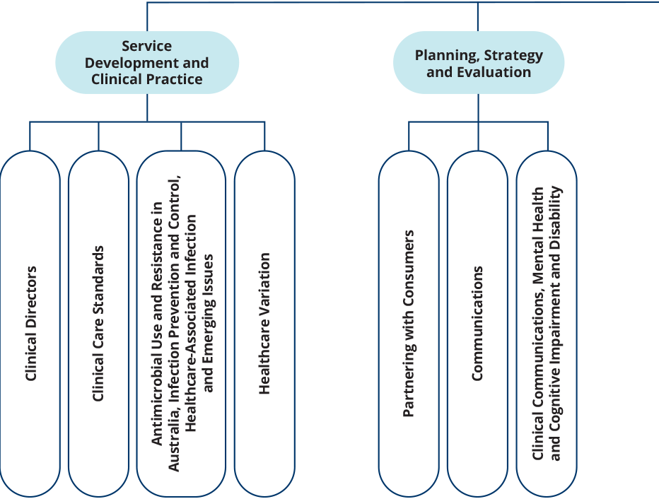
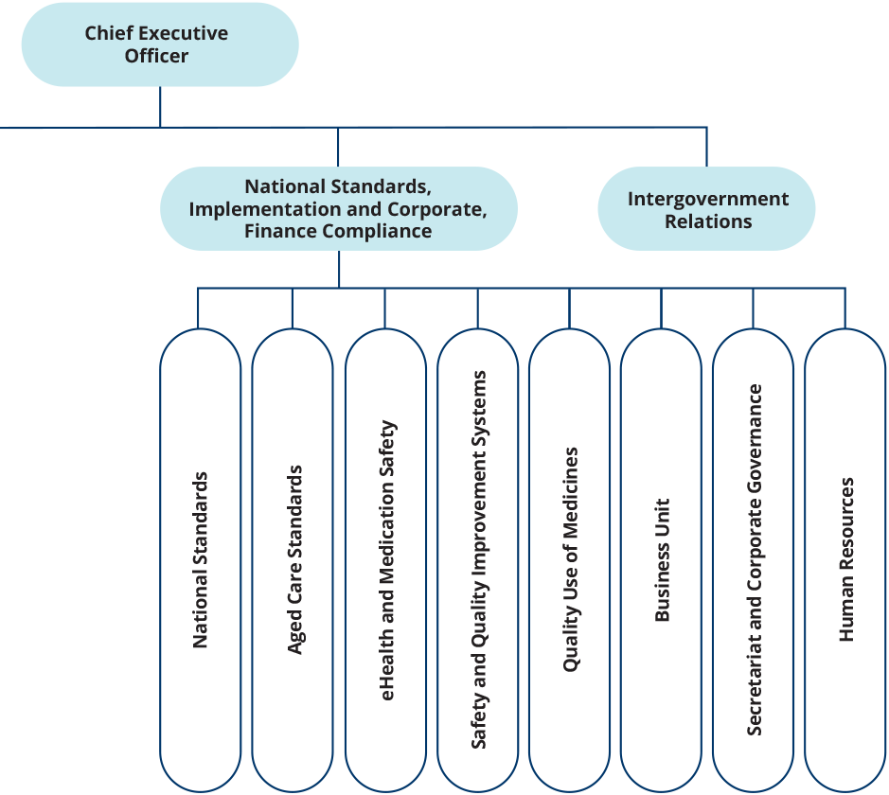

People management
The continuing commitment, flexibility and resilience of Commission staff, especially since the emergence of the COVID-19 pandemic, has allowed the Commission to continue to lead national efforts to improve the health care that Australians receive.
The Commission continues to deliver high performance by providing ongoing support through its performance management systems and embedding a strong sense of direction across the organisation.
The Commission’s performance development scheme places emphasis on employees and managers having regular, meaningful performance discussions. All employees are required to have an individual performance and development plan in place. Managers and employees have joint accountability for capability and career development.
The Commission participates in the online induction program offered by the Australian Public Service Commission, giving new employees the opportunity to learn how the Australian Public Service operates and the behaviours expected of all staff members.
In May 2023, the Commission encouraged all staff members to participate in the Australian Public Service Commission’s employee census survey.

Staff profile
As of 30 June 2023, the Commission’s headcount was 100 employees. Most employees are located in Sydney. Table 7 provides a breakdown of the Commission’s employee profile by classification, gender, full-time or part-time status, and ongoing or non-ongoing status.
Table 7: Employee headcount profile as of 30 June 2023
Classification | Female |  |  |  | Male |  |  |  | Non-Binary |  |  |  | Total
Classification | Non-ongoing |  | Ongoing |  | Non-ongoing |  | Ongoing |  | Non-ongoing |  | Ongoing |  | Total
Classification | Full-time | Part-time | Full-time | Part-time | Full-time | Part-time | Full-time | Part-time | Full-time | Part-time | Full-time | Part-time | Total
CEO | 1 | 0 | 0 | 0 | 0 | 0 | 0 | 0 | 0 | 0 | 0 | 0 | 1
MO6 | 0 | 0 | 0 | 1 | 0 | 0 | 0 | 0 | 0 | 0 | 0 | 0 | 1
EL2 | 1 | 1 | 13 | 3 | 2 | 0 | 8 | 0 | 0 | 0 | 0 | 0 | 28
EL1 | 3 | 2 | 24 | 11 | 2 | 0 | 4 | 0 | 0 | 0 | 0 | 0 | 46
APS6 | 4 | 0 | 8 | 1 | 4 | 0 | 4 | 0 | 0 | 0 | 0 | 0 | 21
APS5 | 1 | 0 | 2 | 0 | 0 | 0 | 0 | 0 | 0 | 0 | 0 | 0 | 2
APS4 | 0 | 0 | 0 | 1 | 0 | 0 | 0 | 0 | 0 | 0 | 0 | 0 | 1
Total | 9 | 3 | 47 | 17 | 8 | 0 | 16 | 0 | 0 | 0 | 0 | 0 | 100
Continues

Table 7 continued
Female
Classification | Non-ongoing |  |  | Ongoing |  |  | Total
Classification | Full-time | Part-time | Total | Full-time | Part-time | Total | Total
NSW | 9 | 3 | 12 | 47 | 16 | 63 | 75
Qld | 0 | 0 | 0 | 0 | 0 | 0 | 0
SA | 0 | 0 | 0 | 0 | 0 | 0 | 0
Tas | 0 | 0 | 0 | 0 | 0 | 0 | 0
Vic | 0 | 0 | 0 | 0 | 1 | 1 | 1
WA | 0 | 0 | 0 | 0 | 0 | 0 | 0
ACT | 0 | 0 | 0 | 0 | 0 | 0 | 0
External territories | 0 | 0 | 0 | 0 | 0 | 0 | 0
Overseas | 0 | 0 | 0 | 0 | 0 | 0 | 0
Total | 9 | 3 | 12 | 47 | 17 | 64 | 76

Male
Classification | Non-ongoing |  |  | Ongoing |  |  | Total
Classification | Full-time | Part-time | Total | Full-time | Part-time | Total | Total
NSW | 8 | 0 | 8 | 16 | 0 | 16 | 24
Qld | 0 | 0 | 0 | 0 | 0 | 0 | 0
SA | 0 | 0 | 0 | 0 | 0 | 0 | 0
Tas | 0 | 0 | 0 | 0 | 0 | 0 | 0
Vic | 0 | 0 | 0 | 0 | 0 | 0 | 0
WA | 0 | 0 | 0 | 0 | 0 | 0 | 0
ACT | 0 | 0 | 0 | 0 | 0 | 0 | 0
External territories | 0 | 0 | 0 | 0 | 0 | 0 | 0
Overseas | 0 | 0 | 0 | 0 | 0 | 0 | 0
Total | 8 | 0 | 8 | 16 | 0 | 16 | 24

Table 7 continued
Non-binary
Classification | Non-ongoing |  |  | Ongoing |  |  | Total
Classification | Full-time | Part-time | Total | Full-time | Part-time | Total | Total
NSW | 0 | 0 | 0 | 0 | 0 | 0 | 0
Qld | 0 | 0 | 0 | 0 | 0 | 0 | 0
SA | 0 | 0 | 0 | 0 | 0 | 0 | 0
Tas | 0 | 0 | 0 | 0 | 0 | 0 | 0
Vic | 0 | 0 | 0 | 0 | 0 | 0 | 0
WA | 0 | 0 | 0 | 0 | 0 | 0 | 0
ACT | 0 | 0 | 0 | 0 | 0 | 0 | 0
External territories | 0 | 0 | 0 | 0 | 0 | 0 | 0
Overseas | 0 | 0 | 0 | 0 | 0 | 0 | 0
Total | 0 | 0 | 0 | 0 | 0 | 0 | 0

Work health and safety
The Commission promotes a healthy and safe workplace, and is committed to meeting its obligations under the Work Health and Safety Act 2011 and the Safety, Rehabilitation and Compensation Act 1988. All new staff are required to complete online work health and safety training as part of their induction.

Highlights
The Commission undertook a number of activities during 2022–23 to encourage employees to adopt healthy work practices, including:
- conducting ergonomic workstation assessments for all new staff and as required, as well as providing access to standing desks
- conducting biannual workplace inspections; all staff members were encouraged to report incidents and hazards in the workplace
- providing access to an Employee Assistance Program (EAP)
- providing regular online webinar sessions on wellbeing, conducted by the Commission’s EAP provider for all staff, including for R U OK? Day
- influenza vaccinations available to all staff
- providing flexibility to obtain COVID-19 vaccinations during work hours
- providing access to reimbursement of eyewear costs for use with screen-based equipment.
One work health and safety incident was reported in 2022–23. There were no notifiable incidents in 2022–23. No notices were issued to the Commission, and no investigations were initiated under the Work Health and Safety Act 2011.

Learning and development
The Commission values the talents and contributions of its staff members, and recognises the importance of building expertise and capability within the organisation.
Learning and development needs and opportunities are primarily identified through the performance development scheme. The Commission promotes learning and development by delivering regular continuing professional development sessions and by providing all staff members with access to online learning platforms.
During 2022–23, the Commission’s study support and training arrangements ensured the ongoing development of staff members’ skills and capabilities. Eleven staff accessed study support assistance to study a range of tertiary courses. These included Master of Public Health, Master of Data Science Strategy and Leadership, and Graduate Certificate in Strategic Management. Thirty staff completed external training courses. Internal training was provided to staff on family and domestic violence, leading and managing in a hybrid environment, and privacy.

Workplace diversity
The Commission’s workplace diversity program supports its ongoing commitment to creating a diverse and inclusive workplace that strongly values the skills, expertise and perspectives of all people.
The Commission’s Workplace Diversity Program aims to increase workplace representation of under-represented groups, retain and support emerging talent, and educate staff to facilitate an inclusive work environment.
During 2022–23, program initiatives continued to be implemented to broaden diversity in the workplace and support a wide range of diversity dimensions. The Commission renewed its membership with ACON Pride in Health + Wellbeing and became a member of the Diversity Council Australia. As part of NAIDOC Week, the Commission’s Reconciliation Action Plan artwork was unveiled and staff met the artist, Kylie Hill. During 2023 all Commission staff will complete the Australian Institute of Aboriginal and Torres Strait Islander Studies (AIATSIS) online Core Cultural Learning: Aboriginal and Torres Strait Islander Australia (CORE) Foundation Course.
Commission staff have access to the Department of Health and Aged Care’s staff diversity networks which provide networking opportunities, information, and valuable workplace and peer support, and include:
- Culturally and Linguistically Diverse Network
- Disability and Carers Network
- Gender Equality Network
- Health Pride (LGBTQIA+) Network
- National Aboriginal and Torres Strait Islander Network, including Friends of the National Aboriginal and Torres Strait Islander Network.

Aboriginal and Torres Strait Islander employment
The proportion of the Commission’s workforce who identified as being of Aboriginal and/or Torres Strait Islander origin during 2022–23 was 0.15%.
The Commission is committed to improving the recruitment, retention and career development of Aboriginal and Torres Strait Islander employees. The Commission undertook a number of recruitment processes to fill Affirmative Measure – Indigenous positions during 2022–23, and was successful in filing one of these positions.
During 2022–23 the Commission participated in the Australian Public Service Indigenous Graduate Pathway Program and Indigenous Apprenticeship Program.

5. Financial statements
Independent auditor’s report 108
Financial statements 110
Overview and notes to the financial statements 115



Independent auditor’s report
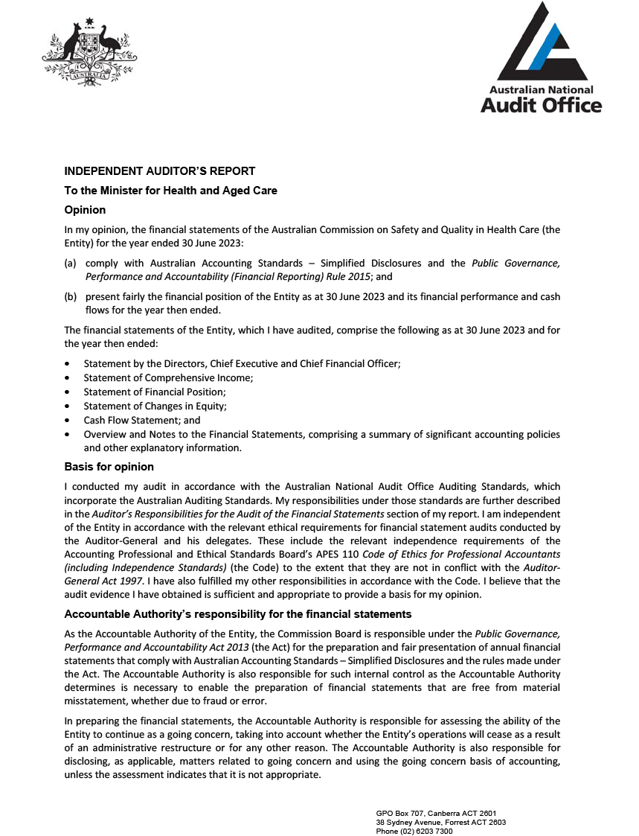
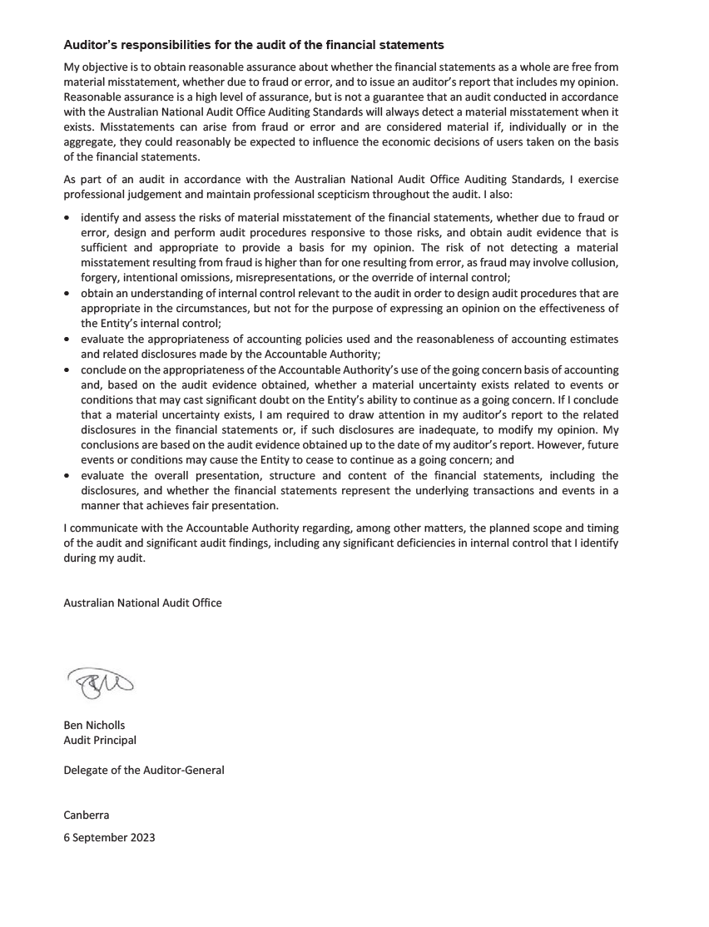

Financial statements

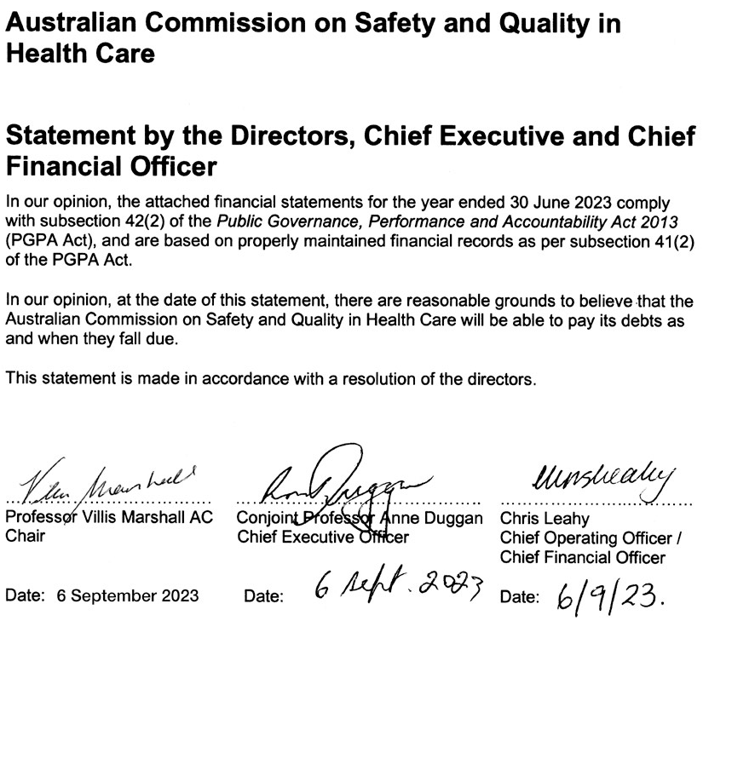
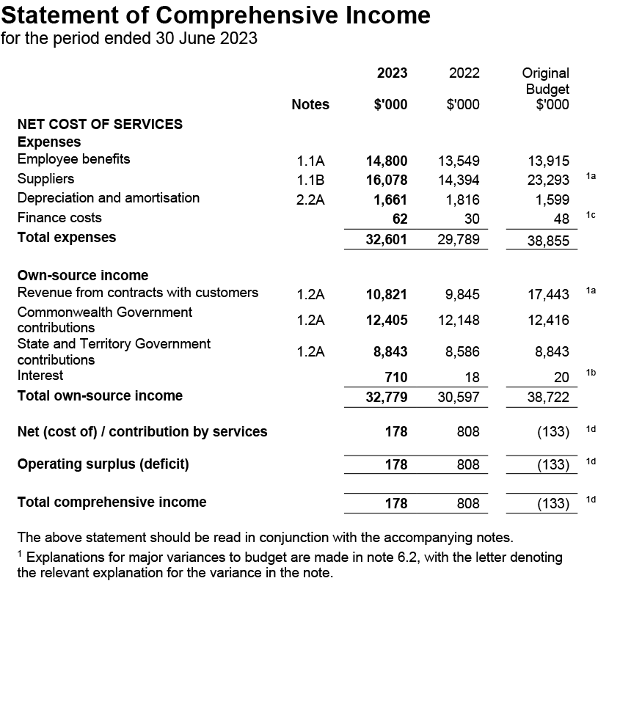
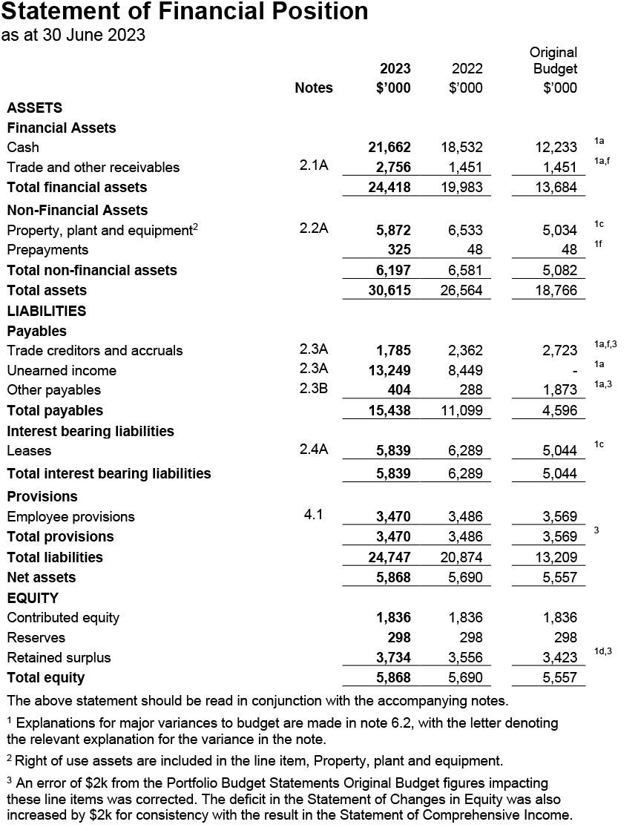
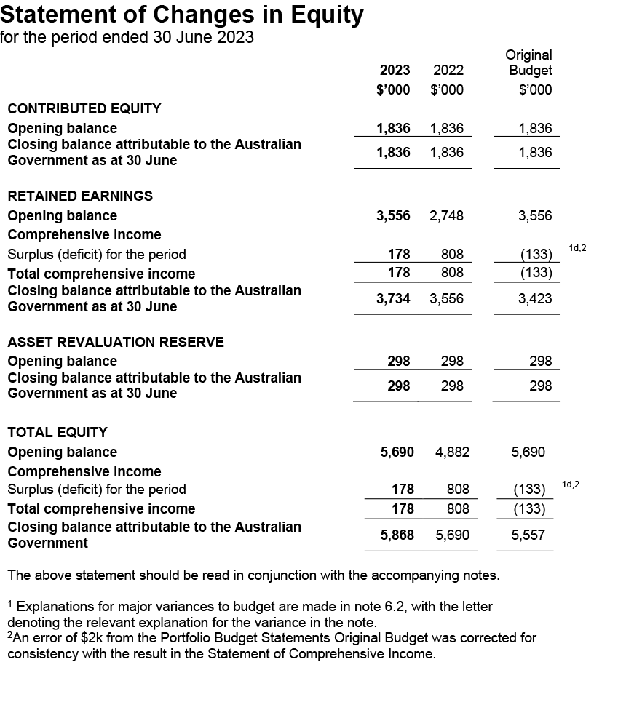
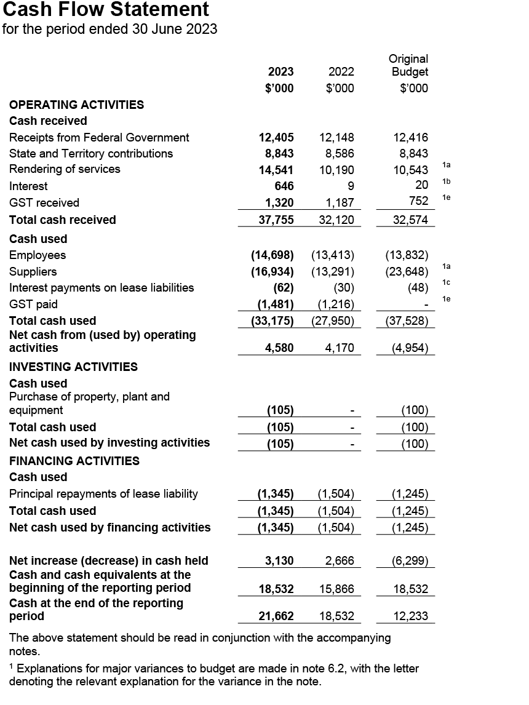

Overview and notes to the financial statements

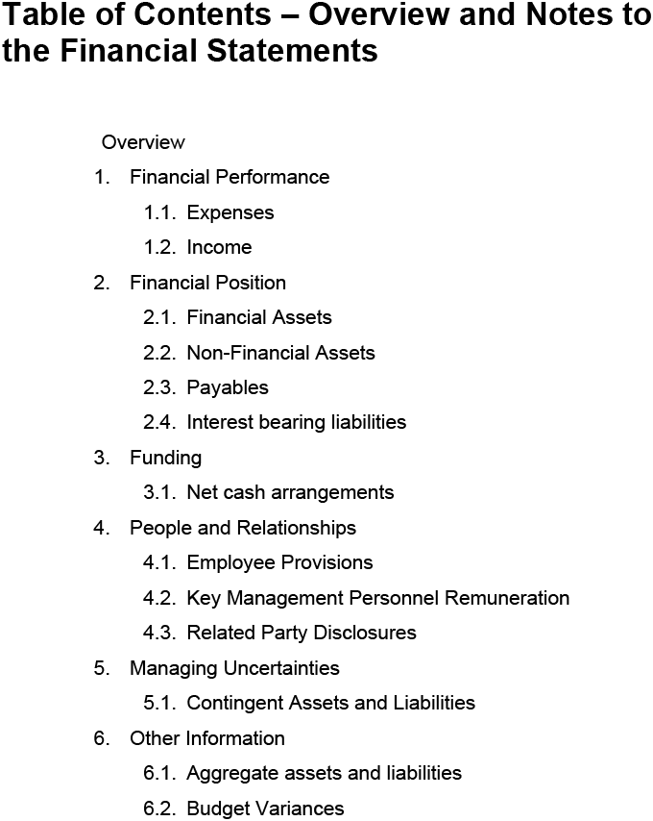
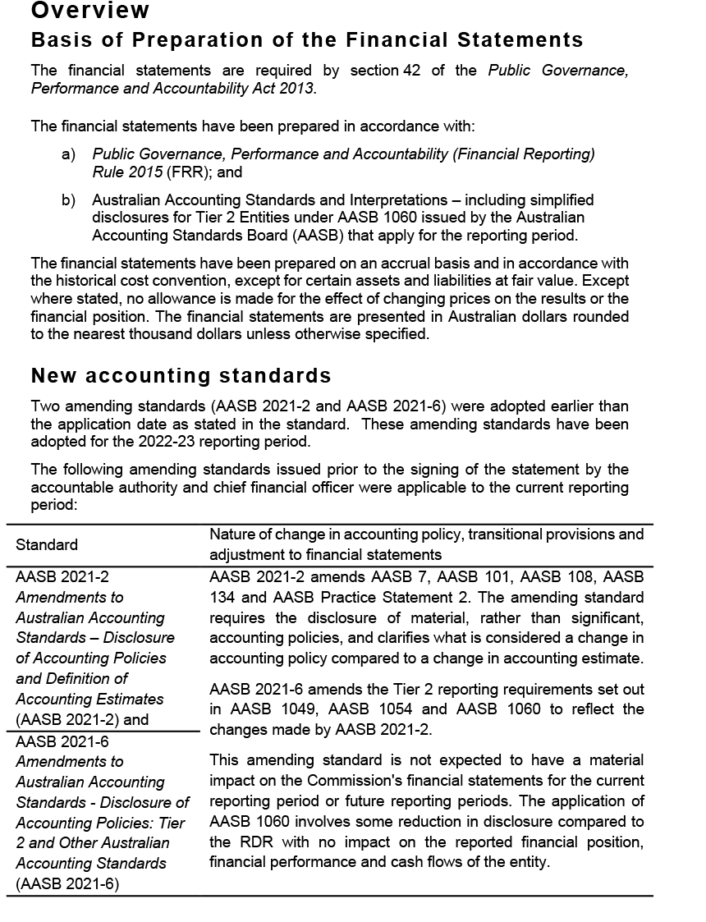

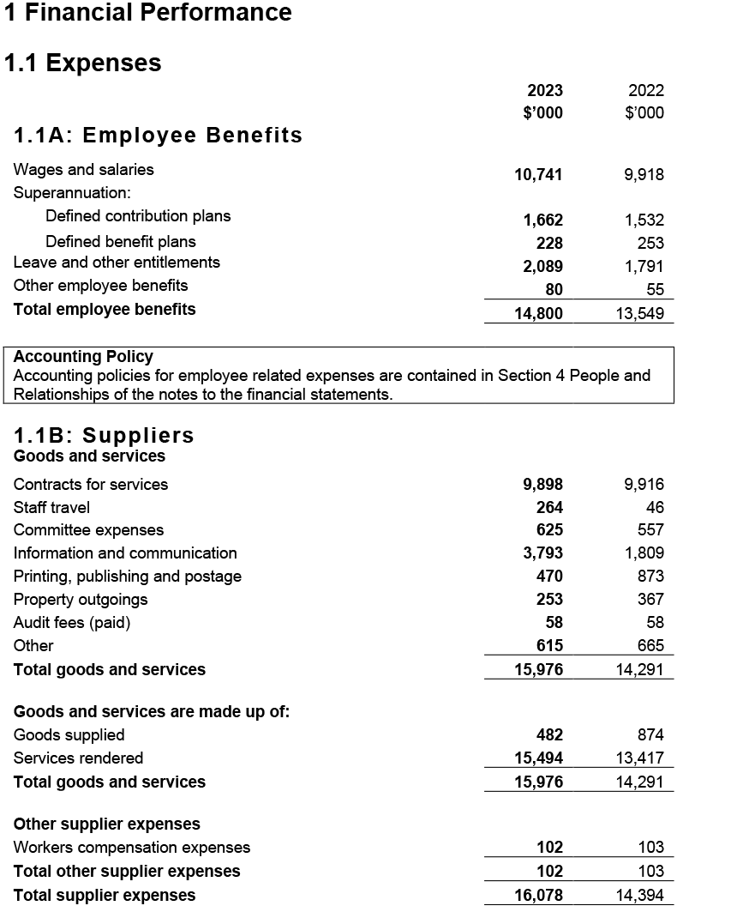
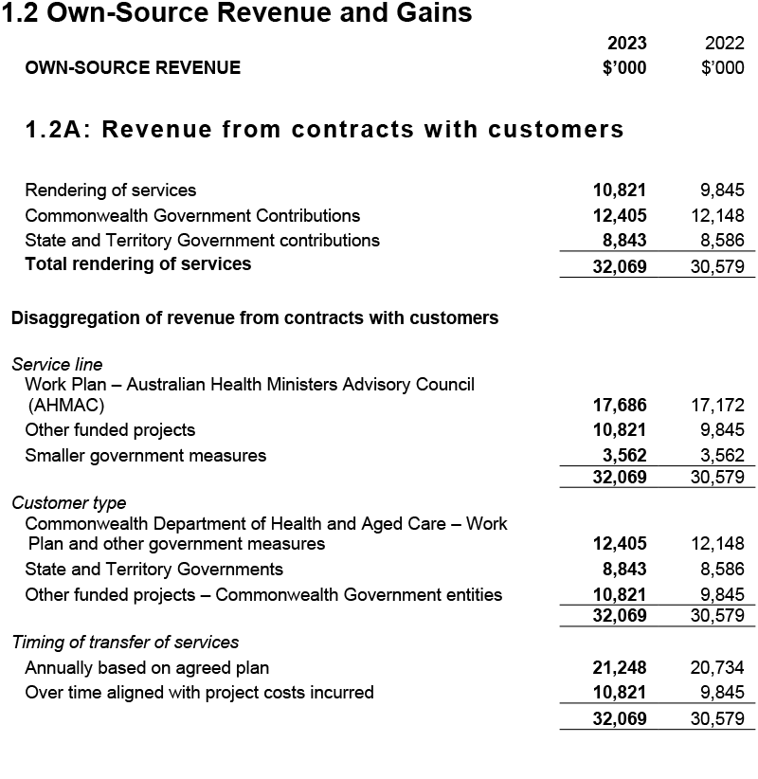
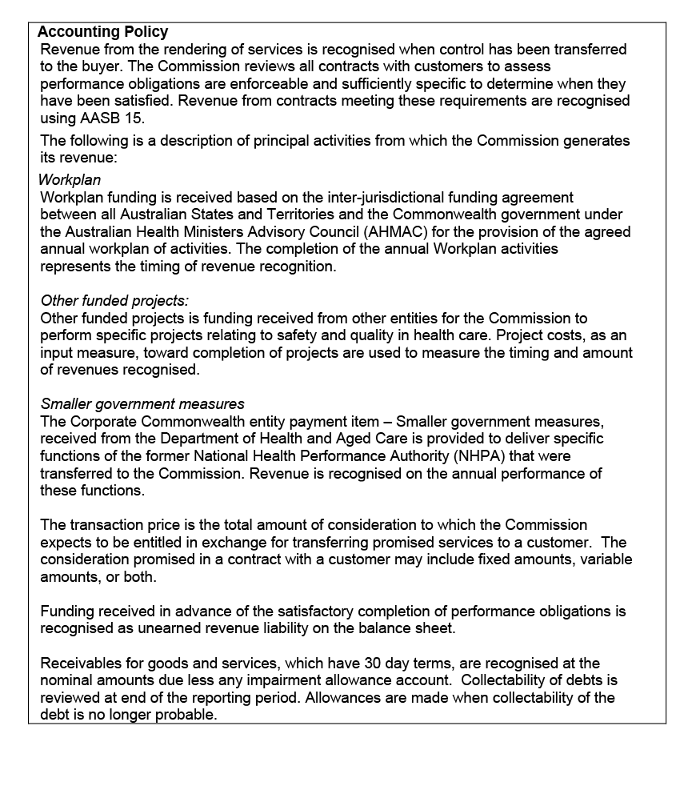
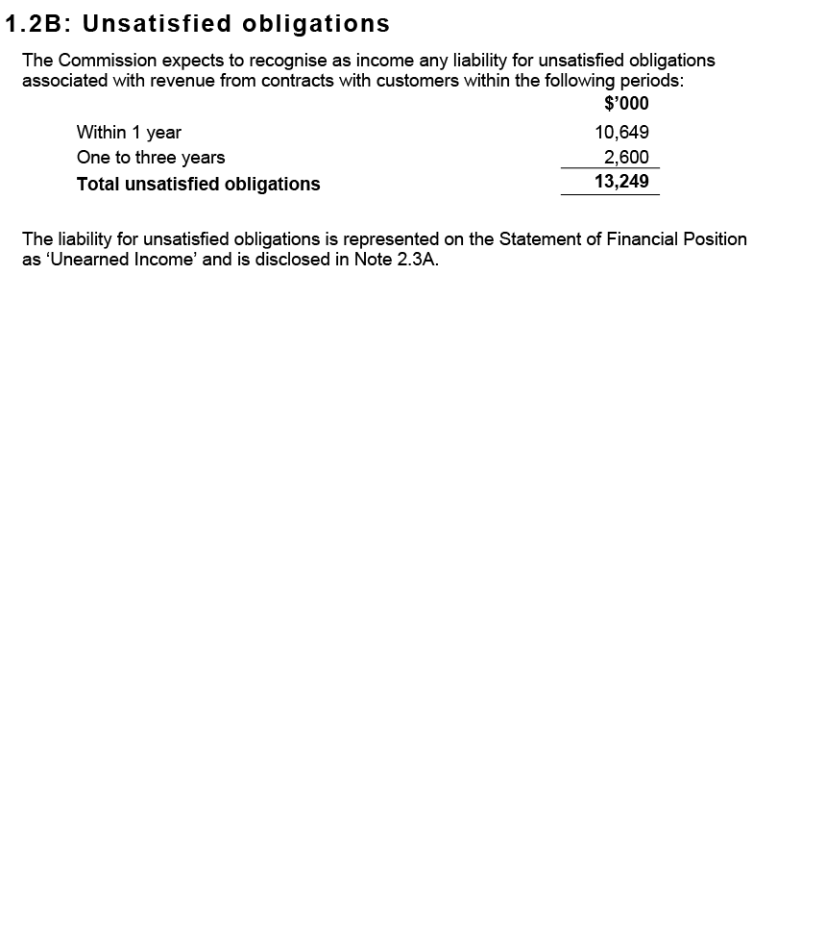
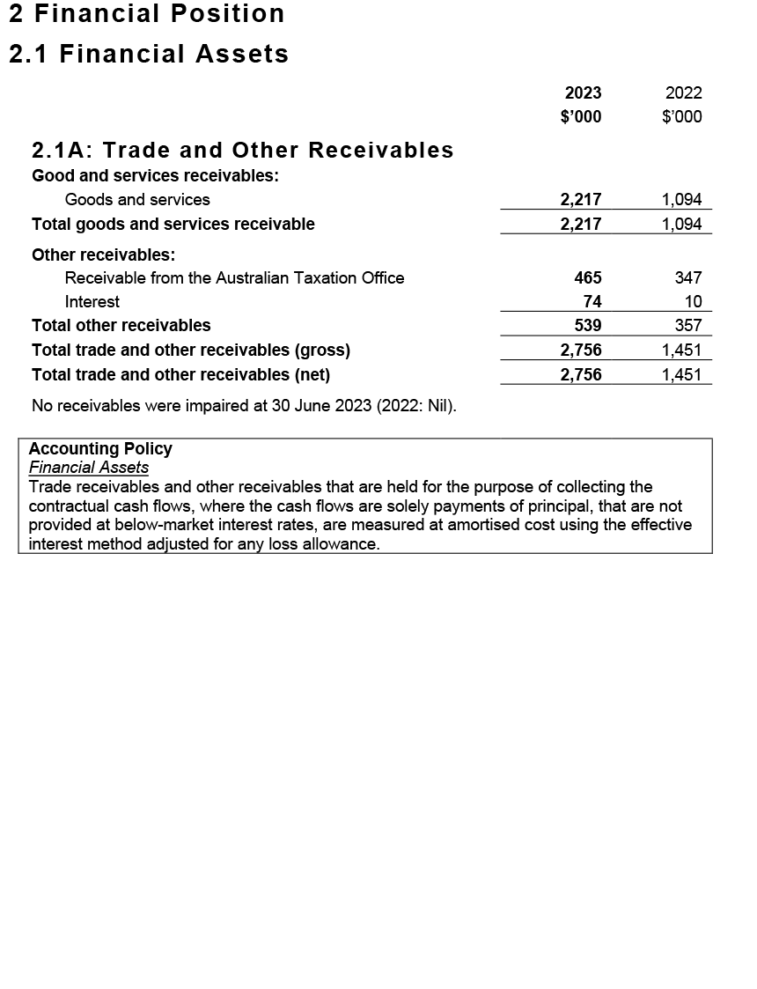
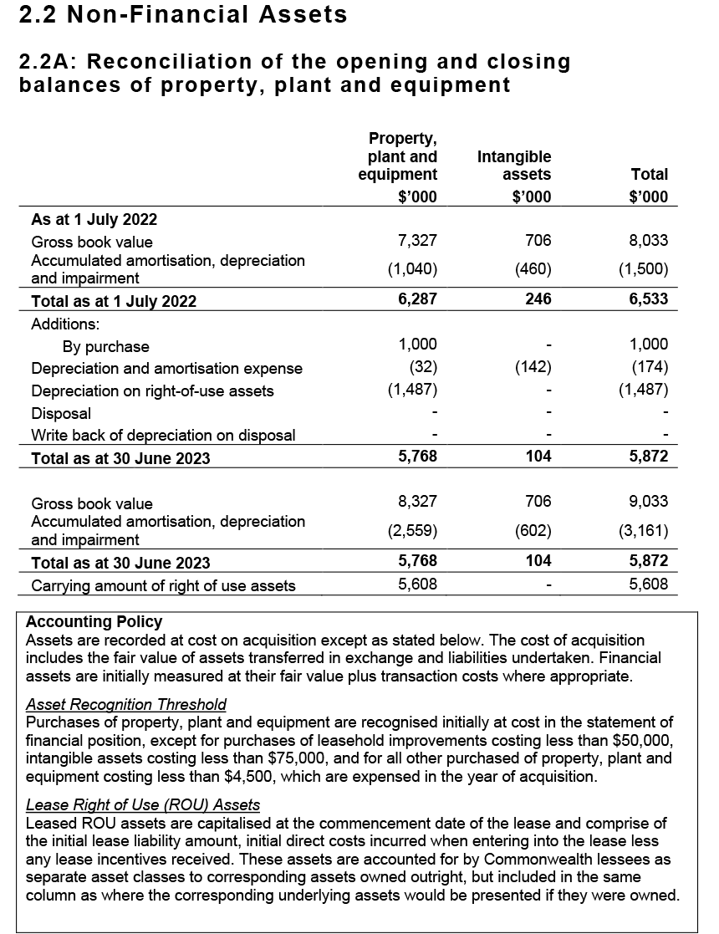
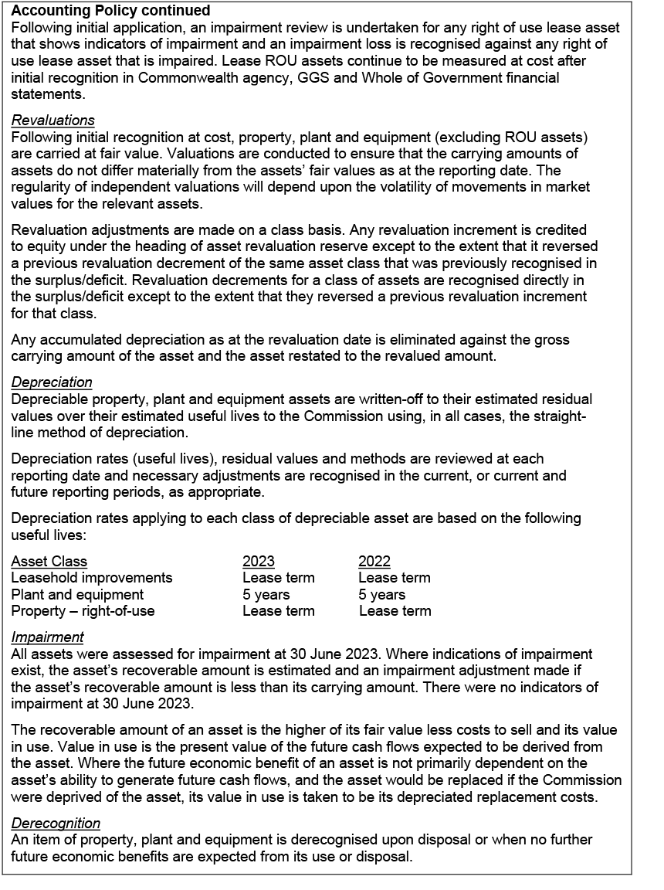
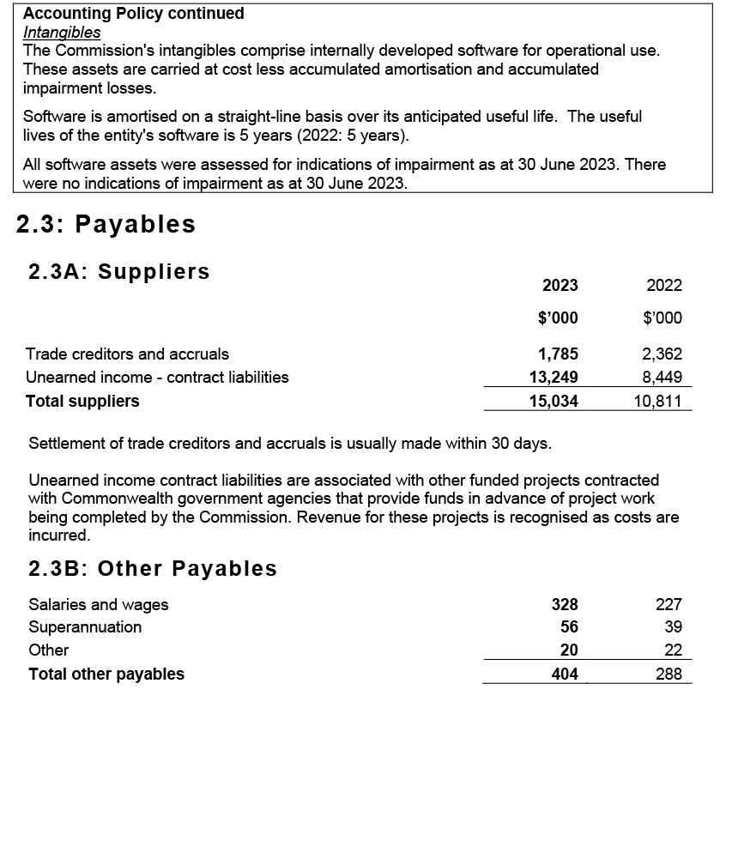
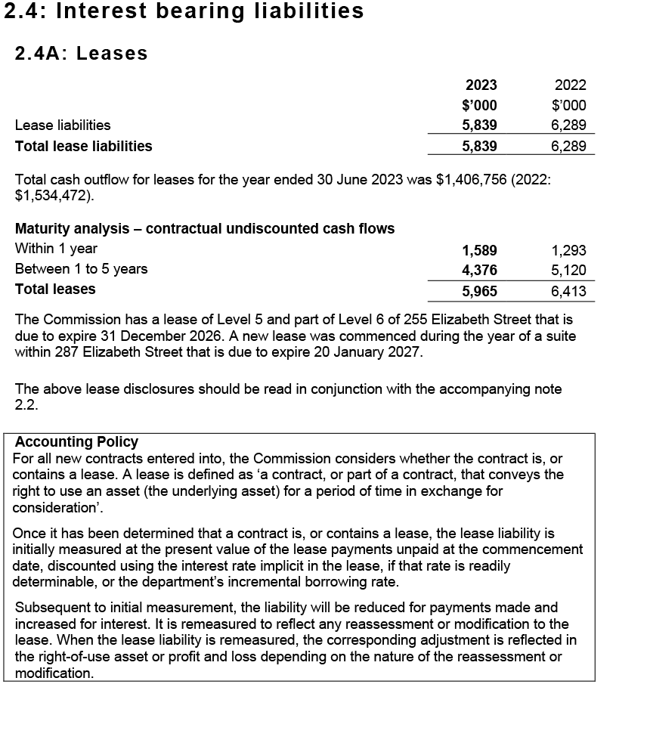
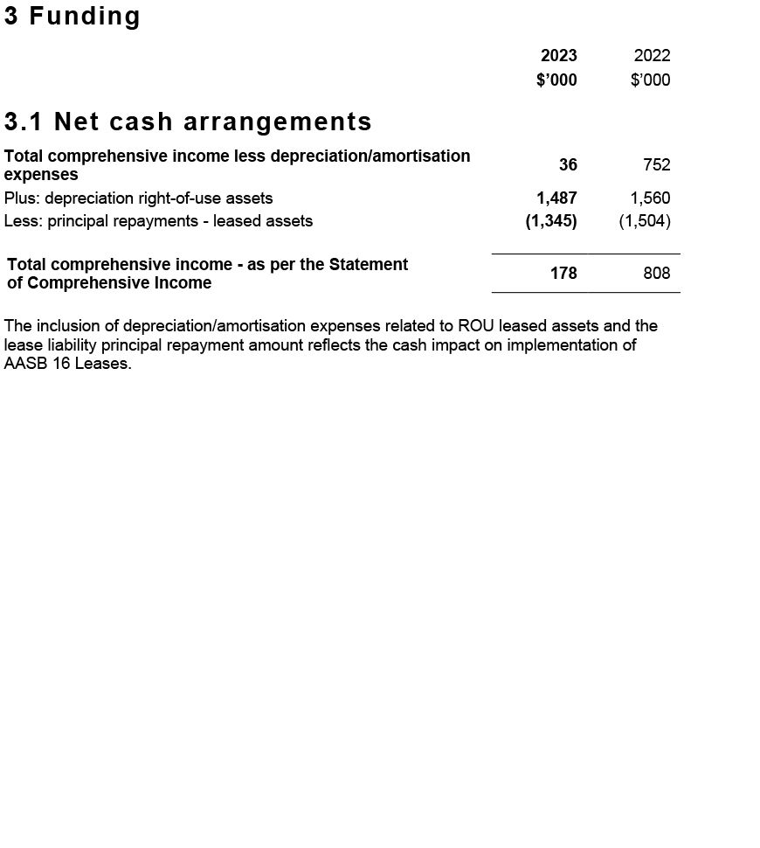
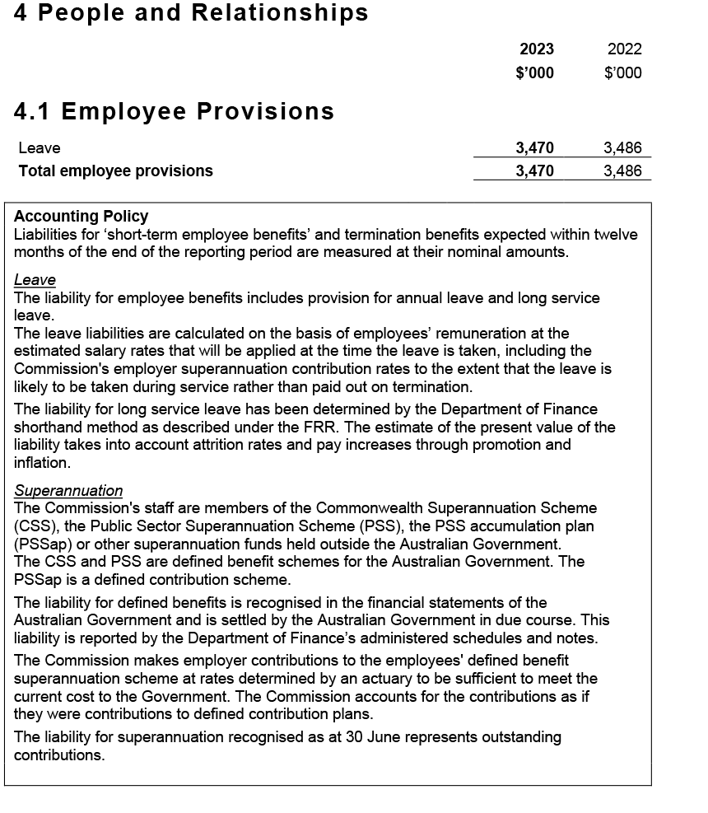
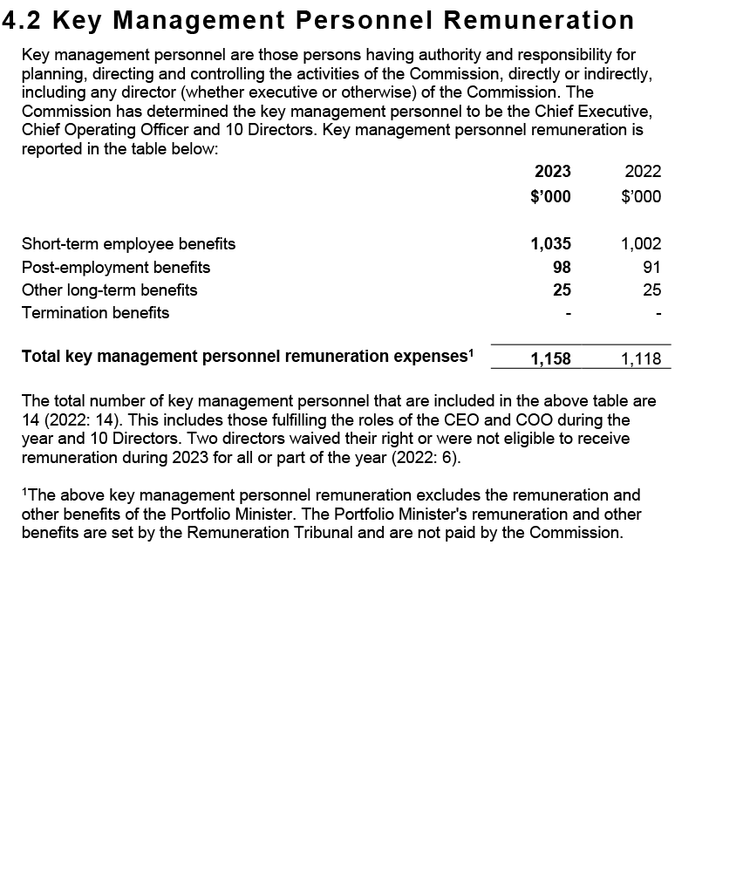
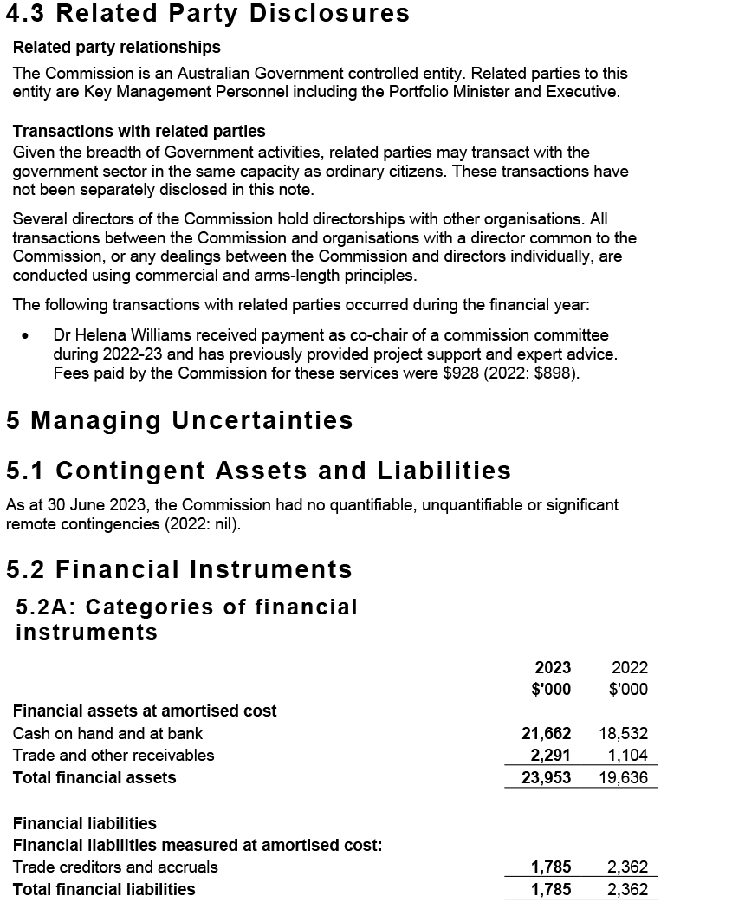
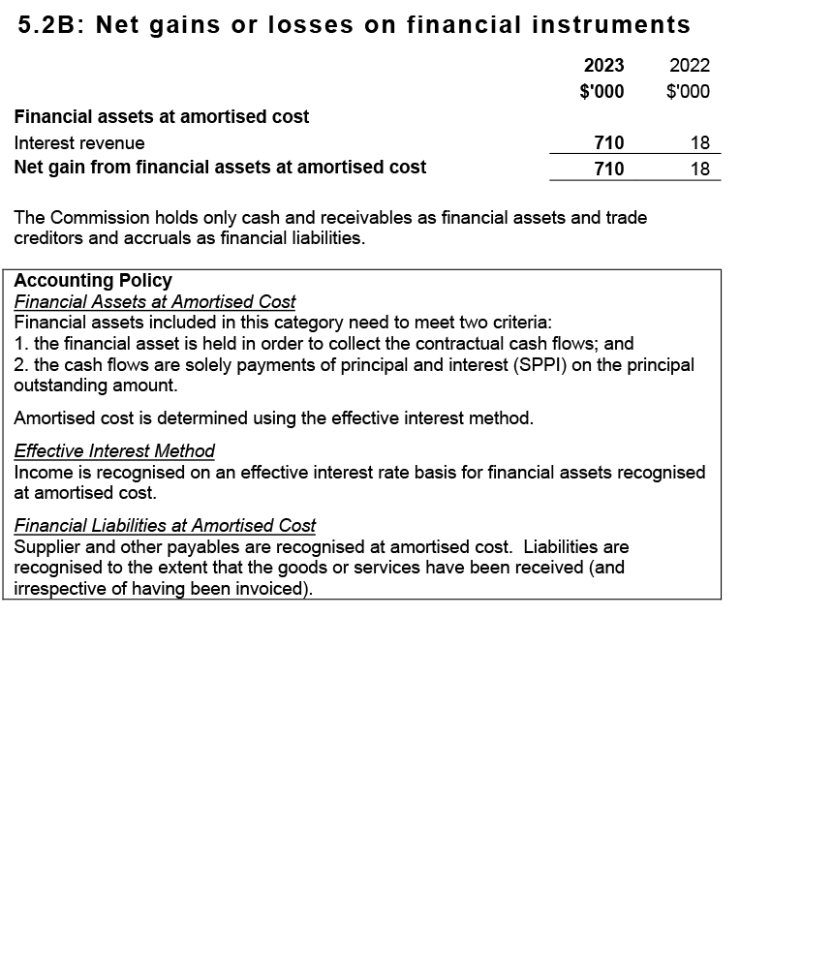
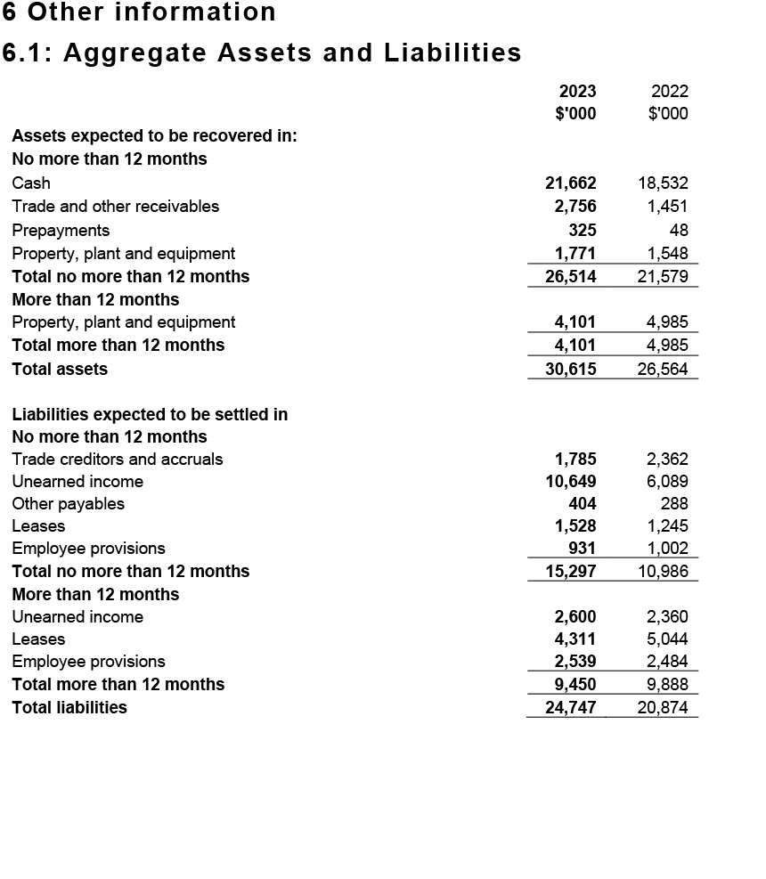
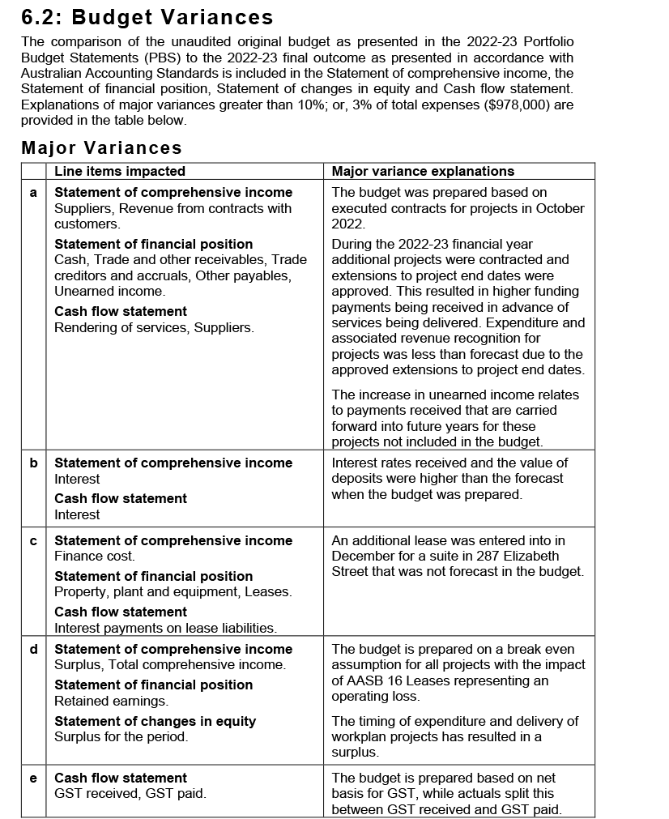

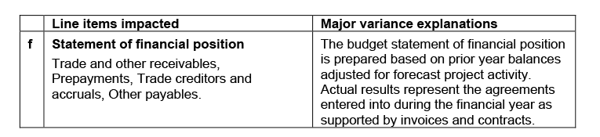

6. Appendices
Appendix A: Related-entity transactions 138
Appendix B: Freedom of information summary 139
Appendix C: Compliance with ecologically sustainable development 140



Appendix A: Related-entity transactions
Table 8: Related-entity transactions, 2022–23
Vendor no. | Commonwealth entity | Number of transactions | Transaction value | Description
100362 | Department of Health and Aged Care | 12 | $1,110,105.55 | Payments processed in 2022–23 for corporate services received from the Department of Health and Aged Care under a shared services agreement between the Commission and the Department.

Appendix B: Freedom of information summary
Table 9 summarises freedom of information requests and their outcomes for 2022–23, as discussed on page 88.
Table 9: Freedom of information summary, 2022–23
Activity | Number
Requests
On hand at 1 July 2022 | 0
New requests received | 3
Total requests handled | 3
Total requests completed as at 30 June 2023 | 3
Total requests on hand as at 30 June 2023 | 0
Action of request
Access granted in full | 2
Access granted in part | 0
Access refused | 1
Access transferred in full | 0
Request withdrawn | 0
No records | 0
Response time
0–30 days | 2
30–60 days | 1

Appendix C: Compliance with ecologically sustainable development
The Commission is committed to making a positive contribution to ecological sustainability. Table 10 details the Commission’s activities in accordance with section 516A(6) of the Environment Protection and Biodiversity Conservation Act 1999.

Table 10: Summary of the Commission’s compliance with ecologically sustainable development
Environment Protection and Biodiversity Conservation Act 1999 requirements | Commission response
Activities of the Commission during 2022–23 accord with the principles of ecologically sustainable development | The Commission ensures that its decision-making and operational activities mitigate environmental impact. The principles of ecologically sustainable development are embedded in the Commission’s approach to its work plan, and corporate, purchasing and operational guidelines.
Outcomes specified for the Commission in an Appropriation Act for 2022–23 contribute to ecologically sustainable development | The Commission’s single appropriations outcome focuses on improving safety and quality in health care across the Australian health system. As such, the Commission does not directly contribute to ecologically sustainable development.
Effects of the Commission’s activities on the environment | The Commission’s offices are located in a 5-star* building, and the Commission works proactively with building management to achieve energy savings, where possible. The Commission continues to improve its dissemination of publications, reports and written materials through electronic media to minimise printing.
Measures the Commission is taking to minimise its impact on the environment | To reduce its environmental impact, the Commission is improving its website functionality and increasing the use of multichannel strategies to distribute information electronically.  To reduce travel, the Commission uses remote meeting attendance options, where feasible. Most staff have been working and attending meetings remotely during the pandemic.  The Commission advocates and expected responsible use of materials, electricity and water, and disposal of waste by all staff and visitors.
Mechanisms for reviewing and increasing the effectiveness of these measures | The Commission has established mechanisms to review current practices and policies. In addition, staff are encouraged to identify initiatives to adopt behaviours, procedures or policies that may minimise their environmental impact, and that of their team and the Commission more broadly.
*Based on the National Australian Built Environment Rating System

Table 11 details the Commission’s activities in accordance with section 516A(6) of the Environment Protection and Biodiversity Conservation Act 1999 and the Australian Government’s APS Net Zero 2030 policy. Greenhouse gas emissions reporting has been developed with methodology that is consistent with the whole-of-government approach as part of the APS Net Zero 2030 policy.

Table 11: Summary of the Commission's greenhouse gas emissions
Report year | Portfolio | Entity Name
2022–23 | Health and Aged Care | Australian Commission on Safety and Quality in Health Care

Emission source | Scope 1 kg CO2-e* | Scope 2 kg CO2-e | Scope 3 kg CO2-e | Total kg CO2-e
Electricity (location-based approach) | – | 126,277 | 10,379 | 136,656
Natural gas | – | – | – | –
Fleet vehicles | – | – | – | –
Domestic flights | – | – | 143,261 | 143,261
Other energy | – | – | – | –
Total kg CO2-e | – | 126,277 | 153,640 | 279,917
The electricity emissions reported above are calculated using the location-based approach. When applying the market-based approach, which accounts for activities such as GreenPower, purchased large-scale generation certificates and/or being located in the ACT, the total emissions for electricity are as shown below.
Emission source | Scope 1 kg CO2-e | Scope 2 kg CO2-e | Scope 3 kg CO2-e | Total kg CO2-e
Electricity (market-based approach) | – | 118,461 | 15,679 | 134,140
Natural gas | – | – | – | –
Fleet vehicles | – | – | – | –
Domestic flights | – | – | 143,261 | 143,261
Other energy | – | – | – | –
Total kg CO2-e | – | 118,461 | 158,940 | 277,401
*CO2-e = carbon dioxide equivalent, a measure of the climate effect of all greenhouse gas emissions expressed in terms of the climate effect of carbon dioxide emissions

7. Indexes and references
Acronyms 146
Glossary 148
Index of figures 152
Index of tables 152
Compliance index 153
Index 158



Acronyms
Acronym | Description
AC | Companion of the Order of Australia
ACN | Australian College of Nursing
ACON | AIDS Council of NSW
ACQSC | Aged Care Quality and Safety Commission
ADHA | Australian Digital Health Agency
AGAR | Australian Group on Antimicrobial Resistance
AHPEQS | Australian Hospital Patient Experience Question Set
AHSSQA Scheme | Australian Health Service Safety and Quality Accreditation Scheme
AIHI | Australian Institute of Health Innovation
AIATSIS | Australian Institute of Aboriginal and Torres Strait Islander Studies
AM | Member of the Order of Australia
AMR | Antimicrobial resistance
AO | Officer of the Order of Australia
APAS | Australian Passive AMR Surveillance
AURA | Antimicrobial Use and Resistance in Australia
CALD | culturally and linguistically diverse
CEO | Chief Executive Officer
COPD | chronic obstructive pulmonary disease
EAP | Employee Assistance Program
FRACGP | Fellow of the Royal Australian College of General Practitioners
FRACS | Fellow of the Royal Australasian College of Surgeons
FTE | full-time equivalent
HAC | hospital-acquired complications
HREC | human research ethics committees
IHPA | Independent Hospital Pricing Authority
MD | Doctor of Medicine
MoU | memorandum of understanding
NDIS | National Disability Insurance Scheme
NGPA | National General Practice Accreditation
NMA | National Mutual Acceptance
NPAAC | National Pathology Accreditation Advisory Council
NSLHD | North Sydney Local Health District
NSMC | National Standard Medication Chart
NSQDMH Standards | National Safety and Quality Digital Mental Health Standards
NSQHS Standards | National Safety and Quality Health Service Standards
NSQMH CMO Standards | National Safety and Quality Mental Health Standards for Community Managed Organisations
PaRIS | Patient-Reported Indicator Survey
PHN | Primary Health Network
PICMoRS | Process, improvement, consumer participation, monitoring, reporting and systems
PROM | patient-reported outcome measures
PBS | Pharmaceutical Benefits Scheme
PSM | Public Service Medal
QUDTP Program | Quality Use of Diagnostics, Therapeutics and Pathology Program
QUM | Quality Use of Medicines
RACGP | Royal Australian College of General Practitioners
RAP | Reconciliation Action Plan
RPBS | Repatriation Pharmaceutical Benefits Scheme
RTPM | Real Time Prescription Monitoring
TGA | Therapeutic Goods Administration
UDI | unique device identifier

Glossary
Word | Description
Accreditation | A status that is conferred on an organisation or individual when they have been assessed as having met particular standards. The two conditions for accreditation are compliance with an explicit definition of quality (that is, a standard) and passing an independent review process aimed at identifying the level of congruence between practices and quality standards.
Adverse event | An incident that results in harm to a patient or consumer.
Antimicrobial | A chemical substance that inhibits or destroys bacteria, viruses or fungi, including yeasts and moulds.1
Antimicrobial resistance | A property of organisms – including bacteria, viruses, fungi and parasites – that allows them to grow or survive in the presence of antimicrobial levels that would normally suppress growth or kill susceptible organisms.
Antimicrobial stewardship | A program implemented in a health service organisation to reduce the risks associated with increasing antimicrobial resistance, and to extend the effectiveness of antimicrobial treatments. Antimicrobial stewardship may incorporate a broad range of strategies, including monitoring and reviewing antimicrobial use.
Clinical care standards | Standards developed by the Commission and endorsed by health ministers that identify and define the care people should expect to be offered or receive for specific clinical conditions or procedures. Clinical care standards highlight best-practice care and priority areas for quality improvement, and include indicators to support quality improvement.
Clinical governance | The set of relationships and responsibilities established by a health service organisation between its department of health (for the public sector), governing body, executive, clinicians, patients, consumers and other stakeholders to ensure good clinical outcomes. It ensures that the community and health service organisations can be confident that systems are in place to deliver safe and high-quality health care and continuously improve services.
Clinician | A healthcare provider, trained as a health professional. Clinicians include registered and non-registered practitioners, or teams of health professionals, who spend the majority of their time delivering direct clinical care.
Cognitive impairment | Deficits in one or more of the areas of memory, communication, attention, thinking and judgement. Cognitive impairment can be temporary or permanent, and can affect a person’s understanding, their ability to carry out tasks or follow instructions, their recognition of people or objects, how they relate to others and how they interpret the environment. Dementia and delirium are common forms of cognitive impairment seen in hospitalised older patients.2 Cognitive impairment can also be caused by other conditions, such as an acquired brain injury, a stroke, intellectual disability or drug use.
Consumer | A person who has used, or may potentially use, health services. A healthcare consumer may also act as a consumer representative to provide a consumer perspective, contribute consumer experiences, advocate for the interests of current and potential health service users, and take part in decision-making processes.3
Delirium | An acute disturbance of consciousness, attention, cognition and perception that tends to fluctuate during the course of the day. Delirium is a serious condition that can be prevented in 30–40% of cases, and should be treated promptly and appropriately. Hospitalised older people with existing dementia are at the greatest risk of developing delirium. Delirium can be hyperactive (the person has heightened arousal, or is restless, agitated and aggressive) or hypoactive (the person is withdrawn, quiet and sleepy).4
Digital health | Technology designed to improve the healthcare system for providers and patients, including telehealth, electronic health records and electronic prescriptions.
Evidence based | Using the best current clinical evidence in making decisions or designing policy.
Hand hygiene | A general term referring to any hand-cleansing action.
Healthcare- associated infections | Infections that are acquired in healthcare facilities (nosocomial infections) or that occur as a result of healthcare interventions (iatrogenic infections). Healthcare-associated infections may manifest after people leave healthcare facilities.6
Healthcare variation | This occurs when patients with the same condition receive different types of care. For example, among a group of patients with the same condition, some may have no active treatment, some may be treated in the community and others in hospital, and some may have surgery while others receive medication. Some variation in how health care is provided is desirable because of differences in patients’ needs, wants and preferences (see ‘unwarranted healthcare variation’).
Hospital-acquired complication | A complication for which clinical risk mitigation strategies may reduce (but not necessarily eliminate) the risk of that complication occurring.
My Health Record | A secure online summary of a consumer’s health information, managed by the System Operator of the national e-health record system (the Secretary of the Department of Health). Healthcare providers are able to share health records to a consumer’s My Health Record, in accordance with the consumer’s access controls. This may include information such as medical history and treatments, diagnoses, medications and allergies. Also known as a ‘Personally Controlled Electronic Health Record’.
National Safety and Quality Health Service (NSQHS) Standards | Standards developed by the Commission in consultation and collaboration with states and territories, technical experts, health service organisations and patients. The NSQHS Standards aim to protect the public from harm, and to improve the quality of health services. They provide a quality assurance mechanism that tests whether relevant systems are in place to ensure that minimum safety and quality standards are met, and a quality improvement mechanism that allows health service organisations to realise aspirational or developmental goals.
Partnering with consumers | Treating consumers and/or carers with dignity and respect, communicating and sharing information between consumers and/or carers and health service organisations, encouraging and supporting consumers’ participation in decision-making, and fostering collaboration between consumers and/or carers and health service organisations in planning, designing, delivering and evaluating health care. Other terms are used internationally, such as patient-based, consumer-centred, person-centred, relationship-based, patient-centred and patient‑and-family‑centred care.
Patient | A person receiving health care. Synonyms for ‘patient’ include ‘consumer’ and ‘client’.
Patient safety | Reducing the risk of unnecessary harm associated with health care to an acceptable minimum.
Patient safety incident | An event or circumstance that could have resulted, or did result, in unnecessary harm to a patient.
Person-centred care | Where patients, consumers and members of the community are treated as partners in all aspects of healthcare planning, design, delivery and evaluation; the foundation for achieving safe, high-quality care.
Shared decision making | The integration of a patient’s values, goals and concerns with the best available evidence about the benefits, risks and uncertainties of treatment to achieve appropriate healthcare decisions.7
Standard | Agreed attributes and processes designed to ensure that a product, service or method will perform consistently at a designated level.
Unwarranted healthcare variation | Variation not attributed to a patient’s needs, wants or preferences. It may reflect differences in clinicians’ practices, the organisation of health care or people’s access to services. It may also reflect poor-quality care that is not in accordance with evidence-based practice.

Index of figures
Figure | Title | Page no.
1 | Health service organisation accreditation, 2022–23 | 28
2 | Organisational structure | 96

Index of tables
Table | Title | Page no.
1 | Report against performance measures in the 2022–23 Corporate Plan and Health Portfolio Budget Statements | 65
2 | Attendance at Board meetings | 80
3 | Audit and Risk Committee attendance and remuneration, 2022–23 | 83
4 | Remuneration paid to key management personnel, 2022–23 | 89
5 | Remuneration paid to executive staff, 2022–23 | 90
6 | Remuneration paid to other highly paid staff, 2022–23 | 91
7 | Employee headcount profile as of 30 June 2023 | 99
8 | Related-entity transactions, 2022–23 | 138
9 | Freedom of information summary, 2022–23 | 139
10 | Summary of the Commission’s compliance with ecologically sustainable development | 141
11 | Summary of the Commission's greenhouse gas emissions | 143
12 | Mandatory reporting orders as required under legislation | 153

Compliance index
The Commission is bound by legislative requirements to disclose certain information in this annual report.
The operative provisions of the Public Governance, Performance and Accountability Act 2013 came into effect on 1 July 2014. The Public Governance, Performance and Accountability Amendment (Corporate Commonwealth Entity Annual Reporting) Rule 2016 prescribes the reporting requirements for the Commission (Table 12).
Table 12: Mandatory reporting orders as required under legislation
Requirement | Reference | Page listing of compliant information
Accountable authority | Public Governance, Performance and Accountability Amendment (Corporate Commonwealth Entity Annual Reporting) Rule 2016 subsection 17BE(j) | 62
Amendments to the Commission’s enabling legislation and to any other legislation directly relevant to its operation | Public Governance, Performance and Accountability Amendment (Corporate Commonwealth Entity Annual Reporting) Rule 2016 subsection 17BE(a) | 92
Approval by the accountable authority | Public Governance, Performance and Accountability Amendment (Corporate Commonwealth Entity Annual Reporting) Rule 2016 section 17BB | 3, 62, 110
Assessment of the impact of the performance of each of the Commission’s functions | National Health Reform Act 2011 subsection 53(a) | 27–69
Assessment of the safety of healthcare services provided | National Health Reform Act 2011 subsection 53(b)(i) | 27–46
Assessment of the quality of healthcare services provided | National Health Reform Act 2011 subsection 53(b)(ii) | 57–61
Audit committee | Public Governance, Performance and Accountability Amendment (Corporate Commonwealth Entity Annual Report) Rule 2016 subsection 17BA(taa) | 82–84
Board committees | Public Governance, Performance and Accountability Amendment (Corporate Commonwealth Entity Annual Reporting) Rule 2016 subsection 17BE(j) | 82–85
Ecologically sustainable development and environmental performance | Environment Protection and Biodiversity Conservation Act 1999, section 516A | 92, 138–141
Enabling legislation, functions and objectives | Public Governance, Performance and Accountability Amendment (Corporate Commonwealth Entity Annual Reporting) Rule 2016 subsection 17BE(a) | 12, 72
Financial statements | Public Governance, Performance and Accountability Act 2013 subsection 43(4) | 111–133
Financial statements certification: a statement, signed by the accountable authority | Public Governance, Performance and Accountability Act 2013 subsection 43(4) | 110
Financial statementscertification: Auditor-General’s Report | Public Governance, Performance and Accountability Act 2013 subsection 43(4) | 108–109
Government policy orders | Public Governance, Performance and Accountability Amendment (Corporate Commonwealth Entity Annual Reporting) Rule 2016 subsection 17BE(e) | 92
Indemnities and insurance premiums for officers | Public Governance, Performance and Accountability Amendment (Corporate Commonwealth Entity Annual Reporting) Rule 2016 subsection 17BE(t) | 74
Information about remuneration for key management personnel | Public Governance, Performance and Accountability Amendment (Corporate Commonwealth Entity Annual Report) Rule 2016 subsection 17CA | 89
Information about remuneration for senior executives | Public Governance, Performance and Accountability Amendment (Corporate Commonwealth Entity Annual Report) Rule 2016 subsection 17CB | 90
Information about remuneration for other highly paid staff | Public Governance, Performance and Accountability Amendment (Corporate Commonwealth Entity Annual Report) Rule 2016 subsection 17CC | 91
Judicial decisions and decisions by administrative tribunals | Public Governance, Performance and Accountability Amendment (Corporate Commonwealth Entity Annual Reporting) Rule 2016 subsection 17BE(q) | 88
Key activities and changes that have affected the Commission | Public Governance, Performance and Accountability Amendment (Corporate Commonwealth Entity Annual Reporting) Rule 2016 subsection 17BE(p) | 16–20
Location of major activities and facilities | Public Governance, Performance and Accountability Amendment (Corporate Commonwealth Entity Annual Reporting) Rule 2016 subsection 17BE(l) | Inside front cover, 99
Ministerial directions | Public Governance, Performance and Accountability Amendment (Corporate Commonwealth Entity Annual Reporting) Rule 2016 subsection 17BE(d) | 73
Organisational structure | Public Governance, Performance and Accountability Amendment (Corporate Commonwealth Entity Annual Reporting) Rule 2016 subsection 17BE(k) | 96–97
Related-entity transactions | Public Governance, Performance and Accountability Amendment (Corporate Commonwealth Entity Annual Reporting) Rule 2016 subsections 17BE(n) and (o) | 73
Reporting of significant decisions or issues | Public Governance, Performance and Accountability Amendment (Corporate Commonwealth Entity Annual Reporting) Rule 2016 subsection 17BE(f) | 92
Reports about the Commission by the Auditor-General, a parliamentary committee, the Commonwealth Ombudsman or the Office of the Australian Information Commissioner | Public Governance, Performance and Accountability Amendment (Corporate Commonwealth Entity Annual Reporting) Rule 2016 subsection 17BE(r) | 88
Responsible minister | Public Governance, Performance and Accountability Amendment (Corporate Commonwealth Entity Annual Reporting) Rule 2016 subsection 17BE(c) | 72
Review of performance | Public Governance, Performance and Accountability Amendment (Corporate Commonwealth Entity Annual Reporting) Rule 2016 subsection 17BE(g) | 65–69
Statement on governance | Public Governance, Performance and Accountability Amendment (Corporate Commonwealth Entity Annual Reporting) Rule 2016 subsection 17BE(m) | 72–92

References
- Australian Commission on Safety and Quality in Health Care. AURA 2016: first Australian report on antimicrobial use and resistance in human health. Sydney: ACSQHC; 2016.
- Australian Commission on Safety and Quality in Health Care. A better way to care: safe and high-quality care for patients with cognitive impairment (dementia and delirium) in hospital. Sydney: ACSQHC; 2014.
- Consumers Health Forum of Australia. About consumer representation [Internet]. Australia: CHF; 2020 [cited 2020 Sep 15]. Available from: www.chf.org.au/representation
- National Institute for Health and Clinical Excellence. Delirium: diagnosis, prevention and management. London: NICE; 2010.
- General Medical Council. Treatment and care towards the end of life: good practice in decision making [Internet]. Manchester: GMC; 2010 [cited 2017 Jun 1]. Available from: www.gmc-uk.org/ethical-guidance/ethical-guidance-for-doctors/treatment-and-care-towards-the-end-of-life
- Cruickshank M, Ferguson J, editors. Reducing harm to patients from health care associated infection: the role of surveillance. Sydney: ACSQHC; 2008.
- Hoffmann TC, Legare F, Simmons MB, McNamara K, McCaffery K, Trevena LJ, et al. Shared decision making: what do clinicians need to know and why should they bother? Med J Aust 2014;201:35–9.

Index

A
abbreviations, 144
Aboriginal and Torres Strait Islander Health Advisory Group, 23
Aboriginal and Torres Strait Islander Foundation Course, 32, 104
Aboriginal and Torres Strait Islander people, 23, 29, 46, 47, 49, 60, 66
employment, 105
accessibility, 17, 47, 53
accountability, 13, 70, 71; see also external scrutiny; ministerial oversight
accountable authority, see Chair of Board
accreditation, 8, 13, 17, 19, 27-35, 44, 54, 55, 62-66
accrediting agencies, 31, 32, 63, 66
assessor training, 32
Diagnostic Imaging Accreditation Scheme, 8, 30
National General Practice Accreditation Scheme, 34-35
National Pathology Accreditation Scheme, 8, 31
post-assessment surveys, 30
public reporting on, 30, 63
reliability of, 30, 63
short notice assessment, 29, 30
acronyms, 144
acute care, 58, 69
address and contact details, inside cover
advertising and market research, 92
advisories, see resources, publications
advisory groups, 17, 23, 55, 85
aged care
healthcare safety in, 21, 22, 37, 41, 42, 43, 64
residential facilities, 41, 42
Aged Care Quality and Safety Commission, 21, 37
Aged Care Quality Standards, 64
AIDS Council of NSW, 47, 104
ambulance health services, 63, 65
Annual National Stillbirth Forum, 59
antimicrobial resistance, 20, 38-39, 64
Antimicrobial Stewardship Clinical Care Standard, 61
Antimicrobial Use and Resistance in Australia (AURA) project, 38
Antimicrobial Use and Resistance Surveillance System, 64
antipsychotic medicines, 42, 57, 58, 64, 67
annual performance statements, 3, 62-69
analysis of performance, 63-64
key achievements, 63-64
Attorney-General, 87
Audit and Risk Committee, see committees
Auditor-General, 88, 109, 154
audits
financial statements, 3, 108-09
internal, 82, 86, 87
of standards and programs, 21, 37, 44
AURA Surveillance System, see Antimicrobial Use and Resistance Surveillance System
Australian and New Zealand College of Anaesthetists, 43
Australian Atlas of Healthcare Variation, 19, 57, 59, 60, 64, 67
Australian Charter of Health Care Rights, 17, 47-48, 66
Australian Clinical Quality Registries, 55
Australian Commission on Safety and Quality in Health Care
structure, 96-97
purpose, 13, 62, 72
functions, 13, 62
Australian Digital Health Agency, 39, 40, 64
Clinical Governance Framework, 64
memorandum of understanding, 39
Australian Group on Antimicrobial Resistance, 38
Australian Guidelines for the Prevention and Control of Infection in Healthcare, 37
Australian Health Practitioner Regulation Agency (Ahpra), 22, 36
Australian Health Service Safety and Quality Accreditation Scheme, 31, 65-66
Australian Hospital Survey on Patient Safety Culture 2.0, 52
Australian Hospital Patient Experience Question Set, 48
Australian Institute of Aboriginal and Torres Strait Islander Studies, 104
Australian Institute of Health Innovation, 48
Australian Open Disclosure Framework, 46
Australian Passive AMR Surveillance, 38
Australian Public Service Commission, 98
Australian Public Service Employee Census, 98
avoidable hospital readmissions, 51-52

B
Board, 14, 17, 19, 36, 62, 72-81, 82, 85
operating guidelines, 72, 81
code of conduct, 81
Chair, 3, 62, 89
Chair’s report, 16-17
Charter, 81
ethical standards, 81
meetings and attendance, 80
members, 74-79
remuneration, see Key Management Personnel – remuneration
role and responsibilities, 74
see also committees
business continuity planning, 82
BreastScreen Australia Services, 29
Butler, the Hon Mark MP (Minister for Health and Aged Care), 3, 13, 17

C
Chair of the Board, 3, 62, 89
remuneration, see Key Management Personnel – remuneration
report, 16-17
Chief Executive Officer, 17, 18-19, 72, 97
remuneration, see Key Management Personnel – remuneration
report from, 18-19
Choosing Wisely Australia (dataset), 56
chronic disease, 19, 49
Chronic Obstructive Pulmonary Disease Clinical Care Standard, 19, 60
Climate and Health Alliance, 36
Clinical Care Standards, 9, 13, 15, 19, 42, 52, 58-61, 67, 68
Antimicrobial Stewardship, 61
Chronic Obstructive Pulmonary Disease, 19, 60
Delirium, 61
evaluation and review of, 61
Heavy Menstrual Bleeding, 52, 58, 61, 67, 68
Hip Fracture Care, 52, 58, 61, 67, 68
Low Back Pain, 9, 52, 58, 59, 67, 68
Opioid Analgesic Stewardship in Acute Pain,
Osteoarthritis of the Knee, 52, 58, 61, 67, 68
Psychotropic Medicines in Cognitive Disability or Impairment, 19, 42, 52, 60, 68
Stillbirth, 9, 52, 58, 59, 67, 68
Clinical Governance Framework, see Australian Digital Health Agency
clinical quality, see Framework for Australian Clinical Quality Registries, 55
clinical trials, 19, 53-55
Clinical Trials Project Reference Group, 54
Clinical Trials Notification scheme, 54
Clinical Trials Approvals scheme, 54
consultation, 21, 33, 36, 41, 46, 48, 54, 55, 64, 67-68, 85
Public, 21, 41, 46
cognitive disability, 21, 45, 60
collaboration, see partnerships
committees, internal, 82, 86
Audit and Risk Committee, 62, 82-84
Information and Records Management Steering Committee, 86
Inter-Jurisdictional Committee, 82, 85
Private Hospital Sector Committee, 82, 85
Primary Care Committee, 82, 85
Workplace Consultative Committee, 86
Commonwealth Fraud Control Policy, 87
Commonwealth Ombudsman, 88
complaints processes, 22
Comprehensive Care Standard, 46
Consumer Health Forum of Australia, 48
consumers, 16, 17, 19
experience, 17, 22, 48-49
informed consent, 36, 46
partnering with (Priority 2), 14, 33, 36, 47-49, 65-67, 73, 85
resources for, 29, 39, 44, 48, 56, 67
rights see Australian Charter of Health Care Rights
contracts, 46
expenditure, 117
COPD-X guidelines, 60
Core Cultural Learning Aboriginal and Torres Strait Islander Foundation Course, 32, 104
corporate governance, see governance
Corporate Plan 2022–23, 63, 65-69
performance reporting, 65-69
Cosmetic Surgery Project, 17, 36
National Licensing Framework, 36
National Safety and Quality Cosmetic Surgery Standards, draft, 17, 36
Council of Aboriginal and Torres Strait Islander Nurses and Midwives, 29
Council of Australian Governments, 12
Council of Presidents of Medical Colleges, 37
COVID-19, 16, 18, 19, 35, 38, 63, 98, 102
Crowe Australasia, 87
cultural safety training, 29, 32, 65
culturally and linguistically diverse (CALD) populations, 66, 104

D
definitions (glossary), 145-48
Delirium Care Clinical Care Standard, 61
Department of Finance, 73
Department of Health and Aged Care, 19, 20, 21, 22, 34, 38, 40, 41, 42, 49, 54, 59, 104,
Digital health, 16-17, 39
Digital Mental Health Standards, 17, 19, 32, 34
Australian Unique Device Identifier Framework (UDI4H), 40
electronic National Residential Medication Chart (eNRMC), 40
see also My Health Record
Disability and Carers Network, 104
diversity, see workforce – diversity
Diversity Council Australia, 104
Doctor’s Bag app, 56

E
e-health see digital health
e-learning modules, 37, 42
ecologically sustainable development, 92, 138-41
electronic medication management, 40
Employee Assistance Program, 102
employees see workforce
enabling legislation see legislation – National Health Reform Act 2011
end-of-life care, 48, 58
Enterprise Agreement 2019–2022, 88
environmental performance, 92, 138-41
ethics
ethics committees, 55
ethical standards. 74, 81, 87
research ethics, 54-55
executive, see Board; Key Management Personnel
external reviews, 88
external scrutiny, 88; see also accountability; ministerial oversight

F
failure mode and effect analysis, 53, 69
finance law compliance, 72, 82
financial statements, 110-33
fraud prevention and control, 3, 82, 87
Fraud Control and Anti-Corruption Plan, 87
Framework for Australian Clinical Quality Registries, 55, 64
freedom of information, 88, 137
Information Publication Scheme, 88
functions see Australian Commission on Safety and Quality in Health Care – functions
funding, see financial statements

G
Gender Equity Network, 104
general practitioners, 19, 35, 56, 79
glossary, 145-48
governance, 74, 86-87
See also audits; Board; committees
government policy orders, 92
guidance and advice, see resources
Guiding Principles for Medication Management in Residential Aged Care Facilities, 41
Guiding Principles for Medication Management in the Community, 41
Guiding Principles to Achieve Continuity in Medication Management, 41

H
Hand Hygiene Day, 37
Health and Aged Care portfolio, 13, 141
See also Portfolio Budget Statements
health care
appropriateness of, 22, 38, 55, 57-60, 64, 66
Charter of Health Care Rights, 17, 47, 48, 66
end-of-life care, 48, 58
primary healthcare, 35, 39, 49, 74
transitions of care, 60
variations in, 36, 57-60, 64, 66, 67
see also Clinical Care Standards; hospitalisation; National Safety and Quality Health Service Standards; patient safety
Health Care Complaints Commissioners, 46
Health Consumers NSW, 47, 66
Health Consumers Queensland, 22
Health Care Consumers’ Association (ACT), 46
health records, see My Health Record
health and safety see work health and safety
healthcare professionals, 41, 42, 43
indicators, measures and dataset specifications for, 51-56
partnering with (Priority 3), 51
healthcare standards see clinical care standards; National Safety and Quality Health Service (NSQHS) Standards
healthcare variation, see health care – variation in
healthcare-associated infections, 27, 36-37
high-risk medicines, 42-43, 44, 57
education courses, 43
Hip Fracture Care Clinical Care Standard, 52, 58, 61, 67, 68
hospital-acquired complications, 36, 51, 69
hospitals, 22, 38, 40, 43, 44, 53, 65
accreditation, 19
use of My Health Record system, 40
NSQHS Standards implementation, 27
reporting on, 30
hospitalisation
avoidable/preventable, 51, 52, 60, 69
human research, 55
human research ethics committees (HRECs), 55
human resources see workforce

I
inclusion see diversity
incident management, 53, 69
Incident Management Guide, 53
indemnity and insurance, 73
Independent Health and Aged Care Pricing Authority, 51, 69
individual flexibility agreements, 88
informed consent, 36, 46
integrity see ethical standards; fraud prevention and control
internal audit, see audits
internal governance arrangements, see governance
International Statistical Classification of Diseases and Related Health Problems, 52
Indigenous Apprenticeship Program, 105
Indigenous Graduate Pathway Program, 105

J
judicial decisions, 88

K–L
Key Management Personnel
remuneration, 88, 128; see also Chief Executive Officer
learning and development see workforce – learning and development
legislation
National Health and Hospitals Network Act 2011, 12
National Health Reform Act 2011, 12, 13, 14, 62, 65, 72, 73, 74, 82, 92, 151, 152
Environment Protection and Biodiversity Conservation Act 1999, 92, 138, 140
Work Health and Safety Act 2011, 102
Safety, Rehabilitation and Compensation Act 1988, 102
Commonwealth Electoral Act 1918, 92
Freedom of Information Act 1982, 88
Public Governance, Performance and Accountability Act 2013, 3, 62, 65, 72, 74, 81, 82, 92, 108, 110, 116
letter of transmissal, 3
Lived Experience Australia, 44
London protocol, 53, 69
Low Back Pain Clinical Care Standard, 9, 17, 52, 59, 64, 67, 68,

M
market research, 92
maternity care, 68
Medical Board of Australia, 36, 76
medical records see health records
Medicare Benefit Scheme, 56
medication management, 22, 40, 41, 44
guiding principles for, 41
systems, 40
medication safety, 40, 22
medication guidance, 41
quality use of medicines, 41; see also Quality Use of medicines
MedicineInsight program, 38, 56
MedicineWise app, 56
mental health services, 16, 34, 44-45; see also National Safety and Quality Standards – Digital Mental Health Standards; National Safety and Quality Mental Health Standards for Community Managed Organisations
Minister for Health and Aged Care, 13, 17, 72, 73, 88, 92
Minister for Finance, 92
ministerial directions, 72, 73, 153
ministerial oversight, 88; see also accountability
Medication Safety Program, 22
Monash Sustainable Development Institute, 36
My Health Record, 39, 40

N
NAIDOC Week, 104
National Alert System for Critical Antimicrobial Resistances, see AURA Project
National Association of Testing Authorities, 33
National Baseline Report on Quality Use of Medicines and Medicines Safety, 22
National Cervical Screening Program, 33
National Clinical Trials Governance Framework, 19, 29, 32, 53
National Consensus Statement: Essential elements for safe and high-quality end-of-life care, 48
National Dementia Action Plan, 22
National Disability Insurance Scheme, 125
practice standards, 44
Quality and Safeguards Commission, 21, 60
National General Practice Accreditation Scheme, 34
National Hand Hygiene Initiative, 9, 37, 65
National Health Reform Agreement, 51, 52
National Health and Medical Research Council, 49, 53, 69
National Institute for Health and Care Excellence, 59
National Medicines Policy, 41
National Medicines Symposium, 22, 56
National Mutual Acceptance scheme, 55
National Pathology Accreditation Advisory Council, 33
National Pathology Accreditation Scheme, 9, 33
National Roadmap to Improve Health Care of People with Intellectual Disability, 22
National Safety and Quality Health Service Standards, 9, 15, 17, 19, 21, 27-29, 33, 39, 44, 45, 53, 55, 62, 65-66
Clinical Governance Standard, 54
Communicating for Safety Standard,
Comprehensive Care Standard, 46
Digital Mental Health Standards, 17, 19, 34
Medical Imaging Standards, 33
Medication Safety Standard,
Mental Health Standards for Community Managed Organisations, 9, 44, 63
Partnering with Consumers Standard, 54
Preventing and Controlling Infections Standard,
Primary and Community Healthcare Standards, 35
User Guide for Acute and Community Mental Health Services, 45
National Standard Medication Chart audit, 44
National Stillbirth Action and Implementation Plan, 59
National Survey on Cultural Safety Training, 29
National Tall Man Lettering List, 40
NDIS see National Disability Insurance Scheme
neural connector devices, 43
North Sydney Local Health District, 47
Northern Territory, 47
NSQHS Standards User Guide for Acute and Community Mental Health Services, 45

O
observation visits, 31
Office of the Australian Information Commissioner, 88
Office of the Gene Technology Regulator, 54
opioid medicines, 42, 43, 57, 58, 64, 67
Organisation for Economic Co-operation and Development, 49
organisational structure see Australian Commission on Safety and Quality in Health Care – structure
oversight, see accountability; external scrutiny; ministerial oversight

P
partnerships , 63, 65-66; see also consumers – partnering with; strategic priorities (Strategic Priority 1); strategic priorities (Strategic Priority 2)
Partnering with Consumers: A guide for consumers, 48
pathology laboratories, 19, 33
accreditation, see National Pathology Accreditation Scheme
see also Quality Use of Diagnostics, Therapeutics and Pathology (QUDTP) Program
patient safety, 15, 21, 27, 34-53, 63, 68, 69, 85
communicating for safety,
incident investigation, 53, 69
infection prevention and control,
measurement, 52
medication safety, 40
in general practice, 34
in primary health care, 35
staff perceptions of patient safety culture,
see also clinical care standards; health care; National Safety and Quality Health Service (NSQHS) Standards
patient-reported measures, 48-49, 53, 68, 69
Patient-Reported Indicator Survey (PaRIS), 49
Patient Safety Culture Measurement Toolkit, 52
people management, see workforce
people with disability, 17, 21-22, 60
resources for, 45
performance reporting, see annual performance statements
Perth Children’s Hospital, 49
Pharmaceutical Benefits Scheme, 38
planning
business continuity, 82
corporate see Corporate Plan 2022–23; Strategic Intent 2020-2025
fraud control, see fraud prevention and control
strategic see Strategic Intent 2020–2025
Portfolio Budget Statements, 63, 65, 69n, 89, 133
prescribing see medication management; medication safety
Primary Care Committee, 82, 85
Primary Health Network, 57
professional development, see workforce – learning and development
psychotropic medicines, 22, 42-43, 60
Psychotropic Medicines in Cognitive Disability Standard, 19, 42, 52, 58, 60, 68
public reporting system – Safety in Health Care web tool
publications see Clinical Care Standards; communicating for safety; consumers – resources for; medication management: guiding principles; National Safety and Quality Health Service (NSQHS) Standards

Q
Quality Use of Diagnostics, Therapeutics and Pathology Program, 19, 22, 56
Quality Use of Medicines (QUM), 17, 19, 22, 41, 56, 64
Queensland Health, 40

R
Real Time Prescription Monitoring, 44
Recommendations for Terminology, Abbreviations and Symbols used in Medicines Documentation, 41
Reconciliation Action Plan, 23, 104
record keeping, 86
related-entity transactions, 73, 136
remuneration, see Key Management Personnel; Senior Executive Service; workforce
Repatriation Pharmaceutical Benefits Scheme, 38
reporting see annual performance report; financial statements; public reporting
resources and guidance
Safety and Quality Advice Centre, 8, 29
Fact sheets, 29, 41, 42, 45, 48, 53, 63, 65
advisories and user guides, 29, 40, 41, 45, 58, 64, 65
vodcasts (videos on demand), 47
Person-Centred Care Resource Hub, 48, 64
webinars, 34, 48, 53, 64, 66, 103
See also website – online resources
responsible minister see Minister for Health and Aged Care
risk management, 63, 87
see also Audit and Risk Committee; fraud prevention and control
role and functions see Australian Commission on Safety and Quality in Health Care – functions
Royal Commissions
Aged Care Quality and Safety, 60, 64
Violence, Abuse, Neglect and Exploitation of People with Disability, 60

S
Safe Spaces scoping study, 21
safety see work health and safety
Senior Executive Service
remuneration, 90-91
statistics, 99
see also Key Management Personnel
sentinel events, 51, 52
short notice accreditation assessment, 29, 30
South Australian Department of Health and Wellbeing, 43
staff, see workforce
Standards, 13, 14, 17, 37, 62, 73
Aged Care Quality Standards – Clinical Care, 21, 35
Diagnostic Imaging Accreditation Scheme Standards, 33
For Safe Spaces, 21
Pathology Accreditation Standards, 33
Quality Standard 5 – Clinical Care, 21, 37
Royal Australian College of General Practitioners Standards, 35
see also Clinical Care Standards; Cosmetic Surgery Project; National Safety and Quality Health Service Standards
state and territory health systems, 49, 51, 57, 63
Strategic Intent 2020–2025, 14, 63, 73
Strategic priorities, 14, 63, 65, 73
Priority 1: Safe delivery of health care, 27-46
Priority 2: Partnering with consumers, 47-49
Priority 3: Partnering with healthcare professionals, 51-56
Priority 4: Quality, value and outcomes, 57-61
Stillbirth, 59
Stillbirth Clinical Care Standard, 9, 52, 58, 59, 64, 67, 68
sustainability , 92, 138-39
Sustainable Healthcare Module, 36
study assistance, 103

T
telehealth, 19
Therapeutic Goods Administration (TGA), 20, 39
Top End Services, 66
training, see workforce – learning and development

U–V
User Guide for Reviewing Clinical Variation, 58
User Guide: Role of a Medication Advisory Committee, 41
vaccinations, 102
variation in healthcare, see health care – variation in

W–Z
webinars, see resources – webinars
website, 30, 47, 48, 53, 56, 65, 88, 139
address, inside front cover
online resources, 9, 53, 56, 69
views, 9
workforce
Aboriginal and Torres Strait Islander staff, 102, 105
diversity, 104
employment arrangements, 102
people management, 98
learning and development, 103
staffing profile, 99
see also Key Management Personnel; Senior Executive Service
World Health Organization Global Antimicrobial Resistance and Use Surveillance System, 38, 64
work health and safety, 102
notifiable incidents, 201
workplace diversity, see workforce – diversity
Workplace Diversity Program, 104
Women’s and Children’s Health Network, 43



Level 5, 255 Elizabeth Street
Sydney NSW 2000
GPO Box 5480
Sydney NSW 2001
Telephone: (02) 9126 3600
mail@safetyandquality.gov.au
safetyandquality.gov.au

World Health Organization. The declaration of Alma-Ata. Geneva: WHO;1988 [cited 2023 Jun 27]. Available from: apps.
The NGPA Scheme defines FTE according to the number of hours worked by an employee or contractor in the practice. One FTE is equivalent to 38 hours per week.

