


Annual Report
2019–20

Published by the Australian Commission on Safety and Quality in Health Care
Level 5, 255 Elizabeth Street, Sydney NSW 2000
Phone: (02) 9126 3600
Email: mail@safetyandquality.gov.au
Website: www.safetyandquality.gov.au
ISBN (print): 978-1-925948-80-6
ISBN (online): 978-1-925948-81-3
© Australian Commission on Safety and Quality in Health Care 2020
All material and work produced by the Australian Commission on Safety and Quality in Health Care is protected by copyright. The Commission reserves the right to set out the terms and conditions for the use of such material.
As far as practicable, material for which the copyright is owned by a third party will be clearly labelled. The Commission has made all reasonable efforts to ensure that this material has been reproduced in this publication with the full consent of the copyright owners.
With the exception of any material protected by a trademark, any content provided by third parties, and where otherwise noted, all material presented in this publication is licensed under a Creative Commons Attribution-NonCommercial-NoDerivatives 4.0 International licence.

Enquiries about the licence and any use of this publication are welcome and can be sent to communications@safetyandquality.gov.au.
The Commission’s preference is that you attribute this publication (and any material sourced from it) using the following citation:
Australian Commission on Safety and Quality in Health Care. Annual Report 2019–20. Sydney; ACSQHC; 2020.
Disclaimer
The content of this document is published in good faith by the Australian Commission on Safety and Quality in Health Care for information purposes. The document is not intended to provide guidance on particular healthcare choices. You should contact your healthcare provider on particular healthcare choices.
The Commission does not accept any legal liability for any injury, loss or damage incurred by the use of, or reliance on, this document.

Letter of transmittal
The Honourable Greg Hunt MP
Minister for Health
Parliament House
Canberra ACT 2600
Dear Minister
On behalf of the Board of the Australian Commission on Safety and Quality in Health Care (the Commission), I am pleased to submit our Annual Report for the financial year ending 30 June 2020.
This report was prepared in accordance with the requirements of the National Health Reform Act 2011 and section 46 of the Public Governance, Performance and Accountability Act 2013.
The report includes the Commission’s audited Financial Statements, as required by section 42 of the Public Governance, Performance and Accountability Act 2013.
The Commission’s annual performance statements were prepared in accordance with the requirements of section 39 of the Public Governance, Performance and Accountability Act 2013 and accurately present the Commission’s performance from 1 July 2019 to 30 June 2020.
As required by section 10 of the Public Governance, Performance and Accountability Rule 2014, I certify on behalf of the Board that:
- The Commission has prepared fraud risk assessments and fraud control plans
- The Commission has in place appropriate fraud control mechanisms that meet its specific needs
- All reasonable measures have been taken to appropriately deal with fraud relating to the Commission.
This report was approved for presentation to you in accordance with a resolution of the Board on 8 September 2020.
I commend this report to you as a record of our achievements and compliance.

Professor Villis Marshall AC
Chair
Australian Commission on Safety and Quality in Health Care
8 September 2020
Contents
Letter of transmittal 1
Highlights 4
1. Overview 6
About the Commission 8
Our purpose 9
Our accountability 9
Strategic Intent 2020–2025 10
Report from the Chair 12
Report from the Chief Executive Officer 14
2. Supporting safety and quality during COVID-19 17
Liaison and redeployment 18
Establishment of rapid response unit 18
Communication of infection control guidance 18
Medication management in COVID-19 18
Maintenance of accreditation 19
Managing work plan activities 19
3. Report on performance 21
Priority 1: Safe delivery of health care 23
Priority 2: Partnering with consumers 46
Priority 3: Partnering with healthcare professionals 52
Priority 4: Quality, value and outcomes 59
Annual performance statements 63
4. Corporate governance and accountability 73
Legislation and requirements 74
Commission’s Board 76
Committees 83
Internal governance arrangements 86
External scrutiny 88
5. Our organisation 93
Organisational structure 94
People management 96
Staff profile 97
Work health and safety 98
Learning and development 99
Workplace diversity 99
Aboriginal and Torres Strait Islander employment 99
6. Financial statements 101
Independent auditor’s report 102
Financial statements 104
Overview and notes to the financial statements 109
7. Appendices 133
Appendix A: Freedom of information summary 134
Appendix B: Compliance with ecologically sustainable development 135
Appendix C: Related-entity transactions 137
8. Indexes and references 139
Acronyms 140
Glossary 142
Index of figures 146
Index of tables 147
Compliance index 148
Index 153
References 164

Highlights
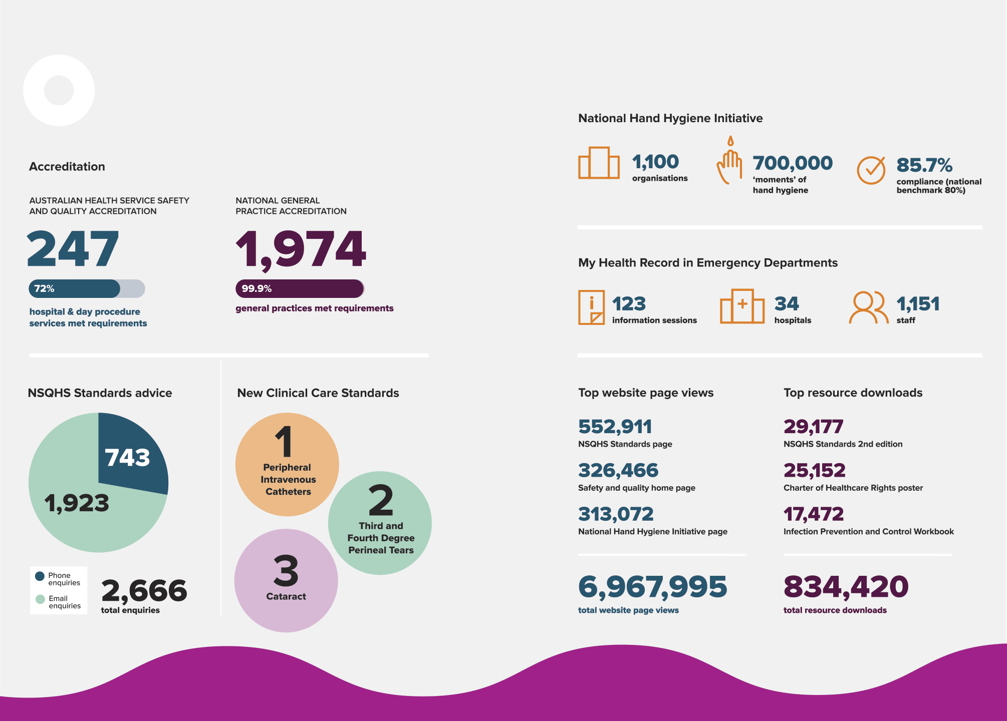

This page is intentionally left blank.

1. Overview
This section provides an overview of the Australian Commission on Safety and Quality in Health Care (the Commission) – including its mission, role, functions and accountability – and reports from the Commission’s Chair and Chief Executive Officer.
About the Commission 8
Our purpose 9
Our accountability 9
Strategic Intent 2020–2025 10
Report from the Chair 12
Report from the Chief Executive Officer 14

About the Commission
In 2006, the Council of Australian Governments established the Commission to lead and coordinate national improvements in the safety and quality of health care. The Commission’s permanent status was confirmed with the passage of the National Health and Hospitals Network Act 2011, and its role was codified in the National Health Reform Act 2011. The Commission commenced as an independent statutory authority on 1 July 2011, funded jointly by the Australian Government and state and territory governments.

Our purpose
Our purpose is to contribute to better health outcomes and experiences for all patients and consumers, and improved value and sustainability in the health system by leading and coordinating national improvements in the safety and quality of health care. Within this overarching purpose, the Commission aims to ensure that people are kept safe when they receive health care and that they receive the care they should.
The functions of the Commission are specified in section 9 of the National Health Reform Act 2011, and include:
- Formulating standards, guidelines and indicators relating to healthcare safety and quality
- Advising health ministers on national clinical standards
- Promoting, supporting and encouraging the implementation of these standards, and related guidelines and indicators
- Monitoring the implementation and impact of the standards
- Promoting, supporting and encouraging the implementation of programs and initiatives relating to healthcare safety and quality
- Formulating model national schemes that provide for the accreditation of organisations that provide healthcare services, and relate to healthcare safety and quality
- Publishing reports and papers relating to healthcare safety and quality.

Our accountability
The Commission is a corporate Commonwealth entity and part of the Health portfolio of the Australian Government. As such, it is accountable to the Australian Parliament and the Minister for Health, the Honourable Greg Hunt MP.

Strategic Intent 2020–2025
In 2019–20, the Commission’s Board developed a new Strategic Intent 2020–2025. The functions described in section 9 of the National Health Reform Act 2011 guide the Commission’s work, and are expressed in the four priorities of the Commission’s Strategic Intent 2020–2025.
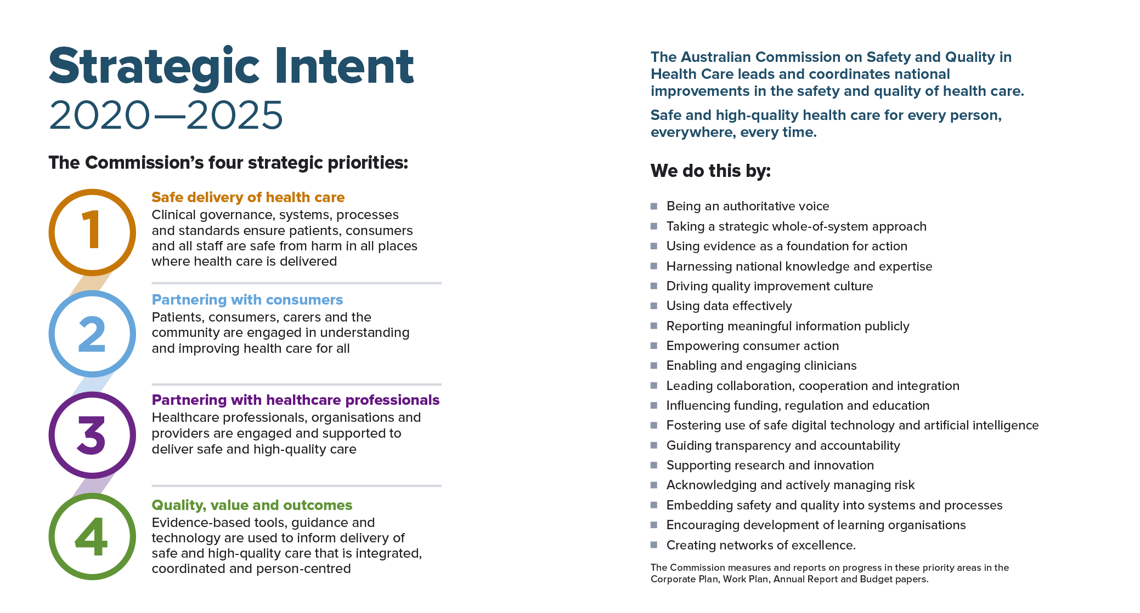

Report from the Chair
Professor Villis Marshall AC
“Together with our healthcare partners, the Commission has contributed to a strong national response to the COVID-19 pandemic.”


The past year has been an exceptional one for the Australian healthcare system, requiring adaptability and decisive leadership. Together with our healthcare partners, the Commission has contributed to a strong national response to the COVID-19 pandemic.
Many of the Commission’s staff have redirected their focus and worked tirelessly to support our healthcare providers in responding rapidly – and safely – to the emerging public health emergency. In March 2020, the Prime Minister called on the Australian Public Service to assist with the response. Some of the Commission’s teams have been redeployed and made valuable contributions in the areas of close contact tracing, investigations, infection prevention and control, and national and state planning to minimise the impact of the pandemic.
In addition, the Commission has continued with key business activities, focusing on priority areas for improving the quality and safety of health care in Australia.
This year, I was extremely proud to be present at the launch of the Australian Charter of Healthcare Rights. Developed in partnership with consumers, this is an incredibly important piece of work to support awareness and understanding of consumer rights. Empowering consumers to participate in their care, and to advocate for themselves and others is essential for improving health care, and I would like to thank staff and consumers who contributed to these valuable resources.
Ensuring safety in the digital delivery of health services is a priority, as we use telehealth and digital communication platforms more than ever. The timely work of the Commission in developing national standards for digital mental health services, and a My Health Record guide for emergency department clinicians, will continue to be pertinent post pandemic. The Commission has also developed new clinical care standards for several areas, including cataract, peripheral intravenous catheters and third and fourth degree perineal tears.
There are many more achievements, some of which are included in these pages. Meaningful collaboration continues to be central to our work. In presenting the 2019–20 annual report, I would like to thank our healthcare partners, including the Australian Government, states and territories, the private sector, clinicians and, of course, consumers.
I extend my thanks to Minister Greg Hunt for his continuing leadership and support, and the members of the Commission’s Board for their advice and guidance over the past year. In particular, I would like to acknowledge the inspiring leadership of Professor John Walsh AM as Board member since July 2016. John has been an exceptional advocate for better care, support and access to services, particularly for those with disability. As one of Australia’s leading actuaries, he has been instrumental in system and policy change in Australia, helping to shape Australia’s first national scheme for people with disability, the National Disability Insurance Scheme. While John’s regular contributions will be greatly missed by the Board, he continues to inspire each of us to keep the consumer and their experience at the heart of all we do.
Finally, on behalf of the Board, I would like to express my gratitude to the executive team and staff of the Commission – you have responded to a challenging year with astute leadership, and great commitment and compassion.

Report from the Chief Executive Officer
Adjunct Professor Debora Picone AO
“Together we can make a difference and support our healthcare services in delivering high-quality, safe care to all Australians.”

In 2019–20, the Commission and its partners continued to provide leadership and support to healthcare services to drive safety and quality. The COVID-19 pandemic has dominated the latter half of the financial year, and tested the safety and quality systems of healthcare services in Australia and across the world in many ways.
Health service organisations have had to respond rapidly to changing circumstances. The Commission has provided support to enable services to respond effectively to COVID-19, while continuing to deliver high-quality and safe care. We have provided a range of resources to help protect the safety of clinicians and consumers, including resources on infection control and personal protective equipment, and guidance for the safe reintroduction of elective surgery.

The National Safety and Quality Health Service Standards and the Australian Health Service Safety and Quality Accreditation Scheme remain central to our work to improve the quality and safety of health care in Australia. The Commission has worked to improve the reliability of the accreditation process, and released several resources to assist healthcare organisations in implementing the standards and improving their services. In March 2020, the Commission announced the decision to maintain healthcare organisations’ accreditation status during the COVID-19 pandemic to allow the organisations to focus on the immediate needs of their communities. In the meantime, we have begun work to develop and align standards for primary health care, community mental health and other services across the sector.
The COVID-19 pandemic has highlighted the importance of developing national standards for digital mental health services. In the past few months, there has been an unprecedented increase in the online delivery of mental health services. The Digital Mental Health Standards that the Commission has developed will support healthcare providers in delivering these services effectively online, to provide the best possible care and health outcomes.
Infection prevention and control has naturally been an important focus during the pandemic, creating high public awareness of hand hygiene. On 1 November 2019, we transitioned the National Hand Hygiene Initiative from Hand Hygiene Australia to the Commission. Providing guidance in this area will remain a priority for us.
I also welcomed the announcement of medicine safety as a national priority area in 2019. The Commission has started developing a national baseline report on medicine safety, and will continue to lead improvements in this area. This builds on the important work we have done to develop Australia’s response to the World Health Organization Global Patient Safety Challenge.
Information underpins everything we do – it is important for us to understand what happens when things go wrong to inform improvements in the safety and quality of health care. We are currently developing a patient safety reporting framework using a range of indicators, including patient and staff experience, to obtain comprehensive, meaningful data. We are also contributing to the Royal Commission into Aged Care Safety and Quality, and the Royal Commission into Violence, Abuse, Neglect and Exploitation of People with Disability, which are both expected to make recommendations for healthcare reform.
Our understanding of the experience of patients, carers and clinicians is so important, as are our close relationships with all of our healthcare partners. I would like to acknowledge the Commission Board; our Board Chair, Professor Villis Marshall AC; the Hon Greg Hunt MP, Minister for Health; health ministers; Glenys Beauchamp PSM, Secretary of the Australian Government Department of Health (18 September 2017 to 23 February 2020); and health chief executive officers for their leadership and contributions to improving health care over the past year. I would also like to thank the Australian Government, our state and territory partners, private sector colleagues, clinical and consumer advisors, and, of course, our outstanding Commission staff. Together we can make a difference and support our healthcare services in delivering high-quality, safe care to all Australians.
This page is intentionally left blank.

2. Supporting safety and quality during COVID-19
The COVID-19 pandemic is a public health emergency requiring an extraordinary response by the health system and society. The need to prepare for, and respond to, the emerging threat of potentially widespread COVID-19 infection within Australia has placed unique pressures on healthcare systems. Priorities have shifted, usual practice has been diverted, but innovation has flourished as Australia has sought to predict and meet health system need, and minimise the impact on the population. During this time, the Commission responded by adapting the way it worked, seeking new solutions, and supporting the health system to deliver safe, high-quality, evidence-based care.
The sections below describe some of the ways that the Commission has balanced the maintenance of usual business with a flexible response to new and emerging needs within the healthcare system in 2019–20.
Liaison and redeployment 18
Establishment of rapid response unit 18
Communication of infection control guidance 18
Medication management in COVID-19 18
Maintenance of accreditation 19
Managing work plan activities 19

Liaison and redeployment
Following the Prime Minister’s direction regarding the redeployment of public servants on 26 March 2020, a number of Commission staff assisted other agencies in managing COVID-19 response activities. For example, from March to June 2020, Commission staff were redeployed to the National Incident Room, the NSW Close Contact Tracing Team and the NSW Public Health Emergency Operations Centre, and led or participated in key national and specialist COVID-19 committees.

Establishment of rapid response unit
In April 2020, the Australian Deputy Chief Medical Officer Dr Nick Coatsworth approached the Commission requesting the establishment of a rapid response unit that could focus on developing, coordinating and better integrating communication of guidance on COVID-19 for health service organisations and clinicians. The establishment of the unit was endorsed by the Australian Health Protection Principal Committee and the Australian Health Ministers’ Advisory Council in May 2020.

Communication of infection control guidance
To support Australia’s response to COVID-19, the Commission has promoted existing guidance and standards on infection control, including the Australian Infection Prevention and Control Guidelines for Healthcare (2019) and Standard 3 of the National Safety and Quality Health Service Standards. In addition, the Commission developed new tailored infection control resources for COVID-19, collaborated with other agencies to support infection control practices, and improved dissemination of relevant resources.
The overall aim of infection control measures is to minimise the risk of exposure, thereby reducing transmission, infections and illness. Effective infection control is best achieved by applying a combination of:
- Individual measures
- Appropriate personal protective equipment
- Organisational and environmental measures.

Medication management in COVID-19
To support the response of the Australian Government Department of Health to COVID-19, the Commission developed medicines resources, including Potential Medicines to Treat COVID-19 and a series of position statements including Managing Intranasal Medicines in COVID-19 and Management of Patients on Oral Anticoagulants in COVID-19. These resources are revised regularly with input from the Commission’s Health Services Medication Expert Advisory Group and peak professional bodies.

Maintenance of accreditation
In March 2020, the Commission announced that the accreditation status of health service organisations under the Australian Health Service Safety and Quality Accreditation Scheme and the National General Practice Accreditation Scheme would be maintained during the response phase of the COVID-19 pandemic. These arrangements were put in place to comply with social distancing requirements, and to support health service organisations in maximising their capacity to respond to the emerging COVID-19 pandemic. These arrangements are being monitored; changes are anticipated in the recovery phase of the pandemic.

Managing work plan activities
As the COVID-19 pandemic emerged, the Commission iteratively reviewed activities and timelines for individual projects under the work plan, and external contracts for 2019–20. This involved prioritising tasks and activities to avoid placing undue pressure on health service organisations and clinicians occupied in responding to COVID-19, and reallocating staff to respond to health system need. As a result of these changes, some consultation and engagement activities were deferred to 2020–21, and desktop activities such as project planning, resource drafting and literature reviews were brought forward.
The Commission took a risk management approach to balancing the work plan activities with new requests and redeployment directions, and continually monitored the progress of deliverables under the work plan to ensure there were no significant delays.

This page is intentionally left blank.

3. Report on performance
This section details the Commission’s achievements against its four priority areas.
Priority 1: Safe delivery of health care 23
Priority 2: Partnering with consumers 46
Priority 3: Partnering with healthcare professionals 52
Priority 4: Quality, value and outcomes 59
Annual performance statements 63

“Ensuring safety in the digital delivery of health services is a priority, as we use telehealth and digital communication platforms more than ever.”
– Board Chair, Professor Villis Marshall AC

Priority 1: Safe delivery of health care
This priority area aims to ensure that patients and consumers are kept safe from preventable harm.

Implementing the National Safety and Quality Health Service Standards
The primary aim of the National Safety and Quality Health Service (NSQHS) Standards is to protect the public from harm and to improve the quality of health service provision. The NSQHS Standards outline safety and quality outcomes that a health service organisation must achieve, while giving organisations the flexibility to decide how to achieve these outcomes in a way that is appropriate for their context. The second edition of the NSQHS Standards was approved by health ministers in 2017, and assessment against this edition started from January 2019.
All hospitals and day procedure services are required to implement the NSQHS Standards. They must implement organisation-wide safety and quality processes, and a comprehensive clinical governance framework. With the NSQHS Standards and a clinical governance framework in place, health service organisations can reduce the risk of harm to patients from hospital-acquired infections, the wrong medicines and errors associated with lapses in communication, and improve the provision of comprehensive care and management of an acutely deteriorating patient.

Assessment to the NSQHS Standards
In 2019–20, eight independent accrediting agencies were approved by the Commission to assess health service organisations to the NSQHS Standards. One accrediting agency ceased operation in March 2020. As at June 2020, 1,321 hospitals and day procedure services are required to be assessed to the NSQHS Standards. Health service organisations have to demonstrate that they meet all of the requirements in the NSQHS Standards to achieve accreditation. In response to the COVID-19 pandemic, accreditation status was maintained from 25 March 2020. Since July 2019, 343 hospitals and day procedure services in Australia have been assessed to the NSQHS Standards. Of these organisations, 72% (247 organisations) met all actions at the initial assessment.

Providing guidance and advice
The Commission supports health service organisations by providing evidence-based information, education and guidance for policy, strategy and action to improve safety and quality in high-risk areas. Areas addressed include infection prevention and control, antimicrobial stewardship and medication safety, management and prevention of deterioration in physical and mental state, management of cognitive impairment, prevention of falls and pressure injuries, and open disclosure and clinical communication.
The Commission provides an advice centre to support health service organisations and approved accrediting agencies with the implementation of the NSQHS Standards. During 2019, a quality assurance evaluation of the NSQHS Standards advice centre was undertaken, including review of processes, data collection tools, data reporting and email responses. In addition, a user satisfaction survey was conducted to help to evaluate and inform the service.
In 2019–20, the Commission’s advice centre responded to 2,666 enquiries, comprising 743 phone enquiries and 1,923 email enquiries. The Commission continues to meet its service targets, responding to 98% of email enquiries within five business days.
Highlights
343 hospitals and day procedure services have been assessed to the NSQHS Standards
72% (247 organisations) met all actions at the initial assessment
The Commission’s advice centre responded to 2,666 enquiries.
Figure 1: Health service organisation accreditation, 2019–20
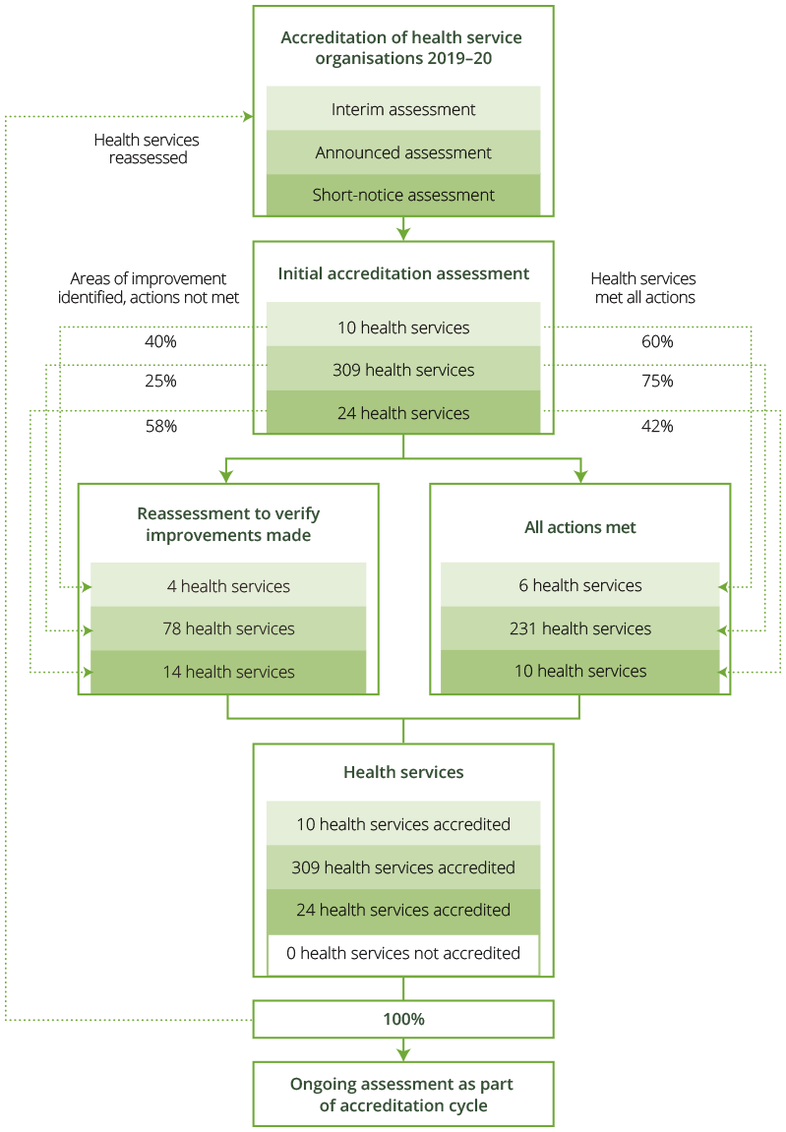

Improving the Australian Health Service Safety and Quality Accreditation Scheme
In 2019–20, the Commission continued implementing updates to the Australian Health Service Safety and Quality Accreditation (AHSSQA) Scheme, including the following activities.

Repeat assessment of health service organisations
A Process for Organisations Requiring Repeat Assessment was developed to guide repeat assessments for health service organisations that had to remediate a large number of actions to meet the NSQHS Standards. In 2019–20, 13 organisations were notified of the need to undertake a repeat assessment.

Short-notice assessments
A voluntary option to undertake short-notice assessments, which are conducted with 48 hours of notice, was introduced for health service organisations in January 2019. A total of 24 health service organisations have undertaken short-notice assessments. A network group of organisations that have opted to undergo short-notice assessments was convened from September 2019. The group met periodically to share experiences and approaches to evaluating short-notice assessment processes.

Governing body attestation statements
Health service organisations are required to submit an annual attestation statement to their accrediting agency. This involves their authorised officers, generally governing bodies, confirming compliance with the NSQHS Standards. Transition requirements allowed health service organisations to submit attestation statements up to 31 December 2019. At June 2020, 100% of health service organisations had submitted their attestation statements.

Recognition of exemplar practice in health service organisations
The Commission released the Policy for Recognising Exemplar Practice in Health Service Organisations in September 2019. Six nominations have been received from accrediting agencies for health service organisations that demonstrated exemplar practice. To date, one nomination has been awarded exemplar practice – the Royal Children’s Hospital Melbourne’s Transition Support Services. This submission was published on the Commission’s website.

Standardised assessment reporting and public reporting of accreditation outcomes
In 2019–20, the Commission consulted widely with stakeholders, including accrediting agencies and regulators, to standardise reporting of assessment outcomes and consider next steps for public reporting of assessment outcomes. The Commission will continue work towards introducing standardised public reporting of accreditation outcomes in 2020–21.
In addition, implementation of the updates to the AHSSQA Scheme is being monitored through review of:
- Accreditation outcome data
- Post-assessment surveys of health service organisations
- Observation visits of assessments by accrediting agencies
- Advice centre enquiries
- Feedback provided through the Accrediting Agencies and Regulators working group.
Highlights
A network group was established to support organisations undertaking short‑notice assessments
100% of attestation statements were received
The Royal Children’s Hospital Melbourne’s Transition Support Services was recognised for exemplar practice.

Improving reliability of the accreditation assessment process
In addition to the work described above, in 2019–20 the Commission continued work to improve the reliability of the accreditation assessment process through the following activities.

Oversight and feedback for accrediting agency performance
The Commission continued to improve oversight of, and feedback on, the performance of accrediting agencies in 2019–20. Feedback is collected through a number of key data sources, including data submitted from accrediting agencies, observations by the Commission, post-assessment surveys from health service organisations and information from enquiries to the NSQHS Standards advice centre. The Commission provides performance feedback to each of the accrediting agencies on a regular basis and monitors their compliance with the conditions of approval under the AHSSQA Scheme.

Review of accreditation outcomes data
In 2019–20, accrediting agencies continued to submit data on assessment outcomes through the Commission’s data collection portal. The portal automatically validates the data submitted to ensure that the information is consistent with the Commission’s requirements. The Commission analyses the data, and provides reports to state and territory regulators and various program administrators. Reports include:
- Review of trends in actions that require improvement
- Examination of the validity of not applicable actions awarded; these are actions from the NSQHS Standards that are not assessed because they do not apply in that service setting
- Identification of health service organisations that meet the criteria for mandatory reassessment
- Review of variation among accrediting agencies.

Assessor training
All assessors for the NSQHS Standards are required to undergo the NSQHS Standards Assessor Orientation Course. As of 29 February 2020, 367 assessors had completed this course. All assessors currently enrolled in the course have also been enrolled in the Core Cultural Learning Aboriginal and Torres Strait Islander Foundation Course, with 366 assessors completing this course. Four intakes for the NSQHS Standards Assessor Orientation Course have been made available. The current course will be open until 31 December 2020.

PICMoRS
PICMoRS is a mnemonic and framework designed to guide assessors in their assessment of health service organisations for accreditation to the NSQHS Standards. PICMoRS stands for Process, Improvement, Consumer participation, Monitoring, Reporting and Systems. In 2019–20, a new fact sheet was developed for health service organisations to support them in using PICMoRS to prepare for quality improvement and assessment.
All assessors are required to use PICMoRS for assessments. This is monitored via the post-assessment survey distributed to all health service organisations undergoing assessment, and feedback from accrediting agencies.

Post-assessment survey
A post-assessment survey was sent to health service organisations after assessment to assist with monitoring the performance of accrediting agencies and assessors for the NSQHS Standards. The survey has had a 40.5% response rate. Some of the key findings from the survey included: all assessments had a lead assessor, final reports were provided to health service organisations on time and in a format that was easily understood, and assessors were not spending 60% or more time in operational areas during an assessment.
Highlights
Seven accrediting agencies were provided with feedback on their performance
Reports on accreditation outcome data were sent to state and territory regulators
367 assessors have completed the NSQHS Standards Assessor Orientation Course.

Patient safety in primary health care
Primary health care is the first level of contact with the national health system for individuals, families and communities. The primary healthcare system brings health care as close as possible to where people live and work, and constitutes the first element of a continuing healthcare process.
Primary health includes health promotion, prevention, early intervention, treatment of acute and other conditions, management of chronic conditions, and end-of-life care. In Australia, primary health care is delivered across several settings by a diverse range of healthcare providers. These include registered health practitioners such as Aboriginal and Torres Strait Islander health workers, dentists, general practitioners, optometrists, pharmacists, physiotherapists, practice nurses and psychologists, and self-regulated practitioners such as audiologists, dietitians and exercise physiologists.
Although the current primary healthcare system performs well and most care is associated with good clinical outcomes, some people do not receive the care that is recommended to them, and others are inadvertently harmed by the care they receive.
As part of the Commission’s focus on supporting the safe delivery of care wherever care is delivered, several projects are under way to develop nationally consistent strategies, tools and resources to support improvements in primary health care. In 2019–20, the Commission undertook work in the following areas.

National General Practice Accreditation Scheme
The National General Practice Accreditation (NGPA) Scheme commenced on 1 January 2017 with the primary aim of supporting national consistency of accreditation of general practices. Under the NGPA Scheme, participating general practices are accredited to the Royal Australian College of General Practitioners’ Standards for General Practices.
In 2019–20, five independent accrediting agencies were approved by the Commission to assess general practices to the Standards for General Practices. A total of 1,976 general practices were assessed by these agencies with almost all meeting the requirements of the standards and being awarded accreditation. Two general practices were not accredited.
Of the organisations assessed under the NGPA Scheme, 96% were general practices, and the remaining 4% were Aboriginal medical services. Just over two-thirds of all general practices assessed were in metropolitan areas (69%), and more than half were in New South Wales and Victoria (58%).
In relation to the workforce of the general practices assessed, the NGPA Scheme found that:
- A little over two-thirds employed five or fewer full-time equivalent (FTE) general practitioners
- Two-thirds employed two or fewer FTE practice nurses.

Supporting general practices during the COVID-19 pandemic
The Commission has worked extensively with the Australian Government Department of Health, Services Australia and accrediting agencies to support general practices during the COVID-19 pandemic. This included announcing that the accreditation status of all general practices would be temporarily maintained during the response phase and no assessments commenced, providing advice and guidance to general practices and approved accrediting agencies, and implementing temporary arrangements for relocating general practices.

National Safety and Quality Primary Healthcare Standards
In 2019–20, following an intensive consultation process with providers, services and consumers in 2018–19, the Commission developed an initial draft set of National Safety and Quality Primary Healthcare Standards. The draft standards were reviewed by the industry-based expert National Safety and Quality Primary Healthcare Standards Advisory Committee. A full consultation process on the draft will occur in 2020–21.

National patient safety reporting and learning for primary health care
In 2019–20, the Commission undertook a scoping study on key elements for a national patient safety incident reporting and learning system for Australian primary healthcare services. The scoping study reviewed international incident reporting systems in primary health care, and is informing the Commission’s future work on incident reporting in primary care.
Highlights
1,976 general practices were assessed in 2019–20
The National Safety and Quality Primary Healthcare Standards Advisory Committee was convened
The Commission developed the draft National Safety and Quality Primary Healthcare Standards for consultation.

Antimicrobial use and resistance in Australia
Antimicrobial resistance (AMR) reduces the range of antimicrobials available to treat infections, and increases morbidity and mortality associated with infections caused by multidrug-resistant organisms. AMR is well established as a priority action because of its serious and growing impact on human health.

Antimicrobial Use and Resistance in Australia Surveillance System
During 2019–20, the Commission continued operating the Antimicrobial Use and Resistance in Australia (AURA) Surveillance System, which provides vital data and information to support Australia’s response to AMR. The Australian Government Department of Health has contracted the Commission since 2013 to establish and operate the AURA Surveillance System.
The AURA Surveillance System provides valuable data and reports to the public and private health systems, across the acute sector and community-based services, including aged care. This information provides an increasingly strong foundation for informed policy and clinical practice to prevent and contain AMR. Patient safety issues that were identified and reported in 2019–20 through the AURA Surveillance System include the following:
- Community-associated multidrug-resistant Staphylococcus aureus is increasing, and is now the dominant cause of multidrug-resistant S. aureus bacteraemia reported to the Australian Group on Antimicrobial Resistance
- Continuing increases in other AMRs were reported to the Australian Group on Antimicrobial Resistance; these reduce the effectiveness of common antibiotics for severe and multidrug-resistant infections, particularly non-susceptibility to ceftriaxone and fluoroquinolones in Escherichia coli, and vancomycin non-susceptibility in Enterococcus faecium
- Overall low, but increasing, numbers of the critical AMRs were reported to the National Alert System for Critical Antimicrobial Resistances (CARAlert) during 2019, particularly carbapenemase-producing Enterobacterales
- Reports of multidrug-resistant Shigella species to CARAlert increased by 218% in 2019 compared with 2018, which is concerning because empirical antimicrobial therapy choices for shigellosis may not be reliable
- Minimal improvement in overall appropriateness of antimicrobial prescribing was reported to the Hospital National Antimicrobial Prescribing Survey (NAPS) between 2013 and 2018 – approximately one-quarter of prescriptions were inappropriate
- Overall, compliance with national or local antimicrobial prescribing guidelines reported to the Hospital NAPS declined between 2013 and 2018
- Although the appropriateness of surgical prophylaxis reported to the Hospital NAPS improved between 2013 and 2018, a little under one-third (28%) of surgical prophylaxis was inappropriately given for longer than 24 hours
- The highest proportions of prescriptions assessed as inappropriate in the Hospital NAPS were for chronic obstructive pulmonary disease (COPD), surgical prophylaxis, non-surgical wound infections, community-acquired pneumonia and cystitis

- Use of many broad-spectrum antibacterials reported to the National Antimicrobial Utilisation Surveillance Program (NAUSP) increased from 2016 to 2018, which is concerning because of the proportion of inappropriate prescribing of these agents in hospitals
- The Aged Care NAPS found that
  - almost 10% of aged care home residents were prescribed an antimicrobial in 2018; only 35.4% of these prescriptions were for residents with documented signs and/or symptoms of a suspected infection
  - more than one-third of all prescriptions were for topical antimicrobials
  - more than one-fifth were for prn (‘as needed’) administration
  - there was poor compliance with documentation of indication for prescribing, and review and stop dates
  - the majority of antimicrobials prescribed for prophylaxis were for urinary tract conditions, including asymptomatic bacteriuria, for which antimicrobial treatment is not recommended.
These findings mean that careful assessment of patients is required as they transfer between hospitals and the community, including aged care homes, to ensure that appropriate infection prevention and control measures and treatments are used. The Commission will continue to work with states, territories, the private hospital and aged care sectors, and relevant colleges and specialty societies to respond to these patient safety issues, with particular focus on guidance and support for improved prescribing in regard to COPD, inappropriate prescribing in aged care homes, and continued monitoring of surgical prophylaxis prescribing.
Highlights
Detailed reports were published for each of the AURA Surveillance System programs: the Australian Group on Antimicrobial Resistance, the Hospital NAPS, the Aged Care NAPS, NAUSP and CARAlert
The Priority Antibacterial List for Antimicrobial Resistance Containment was published. This is an antimicrobial stewardship tool to assess use of antibacterials that are recommended as first-line treatments for common prescribing indications and/or agents, where the potential to promote AMR is considered to be low.

Healthcare-associated infections, and infection prevention and control
Healthcare-associated infections are one of the most common complications affecting patients in hospital. As well as causing unnecessary pain and suffering for patients and their families, a healthcare-associated infection can prolong a patient’s hospital stay and add considerably to the cost of delivering health care.
Effective infection prevention and control practices can minimise the risk of transmission of infection between patients, healthcare workers and other people in the healthcare environment and, in turn, reduce the risk of healthcare-associated infections.

National Hand Hygiene Initiative
In 2019–20, the Commission resumed direct responsibility for the coordination, support and management of the National Hand Hygiene Initiative. Good hand hygiene practice is one of the most important ways to reduce healthcare-associated infections. This work includes data validation for the national audits, national reporting of hand hygiene compliance, support for learning management systems for infection prevention and hand hygiene, and support for the health workforce through the operation of the National Hand Hygiene Initiative helpdesk.
More than 1,100 organisations participate in the National Hand Hygiene Initiative and provide more than 700,000 ‘moments’ of hand hygiene each audit period. The most recent completed audit of national hand hygiene compliance indicated an overall compliance of 85.7%, exceeding the national benchmark of 80%.
The Commission continues to work closely with the states and territories, and the private sector to identify opportunities to refine the National Hand Hygiene Initiative, to support better integration with other infection prevention and control strategies, to support clinicians in their continual learning about infection prevention and control, and to enable further automation and efficiencies in the auditing process for hand hygiene compliance.

Supporting infection prevention and control
The Commission’s online learning management system for delivering content on infection prevention and control and hand hygiene has been enhanced. All infection control modules were reviewed and rebuilt in 2019–20 to ensure consistency with current national infection control guidelines. As part of the Commission’s comprehensive support for healthcare workers and others interested in infection prevention and control, the team responded to more than 6,000 enquiries received by email or phone between October 2019 and June 2020.

Australian Guidelines for the Prevention and Control of Infection in Health Care
The Commission continues to support the implementation of the Australian Guidelines for the Prevention and Control of Infection in Health Care, working in partnership with the National Health and Medical Research Council. Consumer brochures on healthcare-associated methicillin-resistant Staphylococcus aureus, Clostridioides difficile and vancomycin-resistant enterococci infections have been updated and published. In addition, a guide has been developed to support clinical educators in their promotion and dissemination of the guidelines.
The Commission has also developed additional resources on the prevention and management of vancomycin-resistant enterococci, and environmental cleaning to further support implementation of the guidelines.

Surveillance of healthcare-associated infections
Surveillance of healthcare-associated infections remains a priority aspect of the Commission’s work to prevent these infections. Surveillance implementation guides for central line–associated bloodstream infections and Clostridioides difficile infection have been updated after wide consultation with key stakeholder groups. The surveillance implementation guide for Staphylococcus aureus bacteraemia is currently under review, and an updated edition will be published early in 2020–21 to coincide with the rollout of the revised national S. aureus bacteraemia reporting benchmark on 1 July 2020. The Commission published an online resource compendium to support the implementation of the revised benchmark; this will be updated as new resources become available.
Highlights
The National Hand Hygiene Audit 3 (2019) was published
The 2018 Clostridioides difficile infection snapshot report was published, including identification of possible linkages between infection trends and antimicrobial shortages
Updated consumer brochures were published on healthcare-associated methicillin-resistant Staphylococcus aureus, Clostridioides difficile and vancomycin-resistant enterococci infections
Updated surveillance implementation guides were published for central line–associated bloodstream infections and Clostridioides difficile infection.

Safety in digital health
Digital health programs can improve the quality of health care. The Commission contributes to safety in digital health by optimising safety and quality in the rollout of clinical systems. It focuses on hospital medication management programs and discharge summaries, and using digital health initiatives to improve the safety and quality of health care, including antimicrobial stewardship.

My Health Record Clinical Safety Program
The Australian Digital Health Agency appointed the Commission to undertake a clinical safety program for the My Health Record system and other national digital health infrastructure for 2016–2020. In 2019–20, this included two clinical safety reviews:
- Clinical safety review 19 – Determining the safety and quality benefits of secure messaging
- Clinical safety review 20 – Reviewing the benefit modelling process to determine the value proposition of My Health Record use in residential aged care facilities, with a focus on safety and quality benefits.

My Health Record in emergency departments
The Commission was engaged by the Australian Digital Health Agency to investigate the barriers and enablers to the My Health Record system in emergency departments. In November 2019, the Commission published the Emergency Department Clinician’s Guide to My Health Record, in partnership with the Australasian College for Emergency Medicine, peak bodies, and states and territories. The guide and supplementary support material will aid the continued adoption and use of the My Health Record system in emergency departments.
In addition, the Commission’s project team continued information sessions for public and private emergency departments across the country. The sessions were conducted in partnership with the Australian Digital Health Agency, and state and territory e-health representatives, and were delivered in 25–30-minute sessions or via peer-to-peer communication on the emergency department floor. In 2019–20, 123 sessions across 34 hospitals reaching 1,151 staff were held to discuss how My Health Record can be integrated into clinical workflows.

National Safety and Quality Digital Mental Health Standards
The Commission developed the National Safety and Quality Digital Mental Health (NSQDMH) Standards in collaboration with consumers, carers, clinicians, service providers and technical experts. The NSQDMH Standards aim to address key clinical and technical safety and quality risks for users of digital mental health services.
In developing the NSQDMH Standards, the Commission drew on the NSQHS Standards, adding actions and terminology for the digital environment that relate to privacy, cybersecurity, usability and accessibility. The NSQDMH Standards were developed using an iterative process, supported by a Digital Mental Health Advisory Group and a Technical Working Group.

In March–May 2020, the Commission consulted broadly with stakeholders across Australia and pilot tested the NSQDMH Standards with selected service providers. Planned in-person consultation forums were moved online following the introduction of travel restrictions and social distancing requirements due to the COVID-19 pandemic.
In response to the increased demand for digital mental health services during the COVID-19 pandemic, the Commission also developed tip sheets for consumers, carers and clinicians to help them choose a service to use or recommend.
The Commission submitted the NSQDMH Standards to the Australian Government Department of Health for approval in June 2020.
Highlights
Two clinical safety reviews were completed for the My Health Record system
123 information sessions were provided on the Emergency Department Clinician’s Guide to My Health Record
The Commission developed the NSQDMH Standards, which address key safety and quality risks for digital mental health service users.

Medication safety
The Commission leads and coordinates a range of national initiatives to reduce medication errors and harm from medicines. Key medication safety projects undertaken by the Commission in 2019–20 include the following.

Electronic medication management self-assessment tool
To support hospitals to optimise their systems and deliver medication safety improvements, the Commission has developed an electronic medication management self-assessment tool. The tool was successfully piloted by 10 Australian hospitals and evaluated during 2019–20. Feedback received from the evaluation will support further development of this online tool in 2020–21.

Guidelines for a new standard on neural connectors
In 2019–20, the Commission collaborated with the Australian and New Zealand College of Anaesthetists to produce guidelines, including a safety checklist, to support health service organisations in planning the introduction of ISO 80369-6-compliant neural devices which convey liquids or gases for clinical practice in Australia.

Safety statement for metered dose inhalers
Recent changes to medicine naming, description of doses and labelling for some inhalers have caused confusion for consumers, prescribers, and nursing and pharmacy staff at some health facilities. In response to these issues, in October 2019, the Commission published a safety statement on metered dose inhalers.

Review of medicine name similarity
In 2019–20, the Commission undertook a review of medicine name similarity for two specialised classes of medicines: monoclonal antibodies (with the suffix ‘mab’) and tyrosine kinase inhibitors (with the suffix ‘nib’). This review also considered any other medicines registered in Australia that had the potential to be confused. In December 2019, the Commission published the results of this work, along with a fact sheet containing a supplementary list of specialised medicines ending in the suffix ‘mab’, ‘nib’ or ‘gib’.

User guide on active ingredient prescribing
Legislation on active ingredient prescribing was introduced by the Australian Government Department of Health in October 2019 to increase consumers’ understanding of their own medicines, and increase the uptake of generic and biosimilar medicines. In 2019–20, the Commission developed a user guide for prescribers that includes principles for when to specify a brand name in addition to the active ingredient.

National baseline report on quality use of medicines and medicines safety
In October 2019, the Council of Australian Governments (COAG) Health Council approved the Australian Health Ministers’ Advisory Council to prepare a national baseline report on quality use of medicines and medicines safety, to identify areas for action to reduce medication-related harm. These areas include improvement of current frameworks, new best-practice models and new national standards.

The Australian Government Department of Health contracted the Commission to draft the national baseline report, focusing initially on polypharmacy, transitions of care, and the use of antipsychotic medicines associated with aged care homes. Development of the report began in 2019–20, and the report will be completed in 2020–21.

Electronic National Residential Medication Chart resources
The Commission has been engaged by the Australian Government Department of Health to support residential aged care facilities that wish to implement an electronic version of the National Residential Medication Chart. In 2019–20, the Commission began developing resources to support the safe and effective implementation of the electronic medication chart in residential aged care facilities.

Classifying adverse events and incidents related to electronic medication management
Development of standardised taxonomies to describe clinical incidents related to electronic medication management systems continues to be a challenge in Australia and internationally; many classifications are available for implementation.
In 2019–20, the Commission developed and released guidance for hospitals on classifying adverse events and incidents related to electronic medication management, including a fact sheet and three tools. Hospitals will be able to use this information to guide investigation of adverse events and incidents related to electronic medication management, and prioritise system improvement for health information technology.

Reducing the risk of look-alike and sound-alike medicines
In 2019–20, the Commission conducted a pilot survey on a set of principles for the safe selection and storage of medicines. These principles include a focus on look-alike, sound-alike medicines and are accompanied by a range of risk reduction strategies. To inform development of the principles, Australian and international tools, guidelines and literature were evaluated to support the recommended strategies.

Education courses on high-risk medicines
In partnership with SA Health, the Commission continues to coordinate the intergovernmental deed of agreement supporting the development of online courses for early-career health professionals to increase their knowledge and awareness of errors and incidents associated with high-risk medicines. The Commission will release the next topic in the series, ‘Opioid analgesics’, in late 2020.

Australia’s response to World Health Organization’s Global Patient Safety Challenge
The Commission was tasked by the Australian Government Department of Health to develop Australia’s response to the World Health Organization’s Global Patient Safety Challenge on medication safety. In Australia, the goal is to reduce avoidable medication errors, adverse drug events and medication-related hospital admissions by 50% by 2025.
The three flagship areas of the challenge are inappropriate polypharmacy, medication safety at transitions of care and misuse of high-risk medicines.
In April 2020, the Commission published Australia’s response, highlighting Australia’s goal and proposing 12 priority actions across the flagship areas. Each priority area has a suggested metric for measuring change over the duration of the challenge.
Highlights
Inappropriate polypharmacy is being addressed through implementation of evidence-based primary care programs for medication reconciliation and review, by using standardised templates, ensuring multidisciplinary collaboration to reduce risk of fragmented care, and using well-defined eligibility criteria targeting patients with greatest clinical need to ensure appropriate frequency of review
Harm from high-risk medicines is being reduced by increasing early-career prescriber competency and expanding cost-effective pharmacist-led stewardship programs for high-risk medicines in hospitals
Medication safety at transitions of care is being improved, with a focus on a discharge summary for all clinical handovers, the provision of a shared medicines list, and improved use of the My Health Record system.

Mental health
The Commission has an ongoing commitment to support safety and quality in the delivery of mental health care. In 2019–20, the Commission’s mental health team focused on reducing restrictive practices, supporting health services to implement both the NSQHS Standards and actions in the Fifth National Mental Health and Suicide Prevention Plan (the Fifth Plan), and developing standards for digital mental health services.

Reducing restrictive practices
In 2019–20, the Commission maintained its focus on reducing and, where possible, eliminating the use of restrictive practices, including restraint and seclusion, in health care. To support implementation of actions in the second edition of the NSQHS Standards, the Commission engaged with its partners to better understand how restraint is defined and practised across different healthcare settings.

Recognising deterioration in a person’s mental state
Based on consultation with stakeholders, in 2019–20 the Commission modified an Escalation Mapping Tool so that it could be used by health services to map their local processes for escalating care when a person’s mental state deteriorates. The template identifies potential gaps, or processes that could be improved, and includes links to resources.

Developing national standards for mental health settings
The Commission is working with partners to implement actions in the Fifth Plan. In 2019–20, the Commission began a project to develop national safety and quality community mental health standards. The standards will provide clarity for regulators and health service organisations by delivering contemporary, evidence-based standards suitable for implementation in all sectors, including in the community. They have the potential to operate as an adjunct module to the existing NSQHS Standards. These standards will continue to be developed in consultation with key stakeholders in 2020–21.
Highlight
An updated Escalation Mapping Tool was finalised to support health service organisations to describe their local processes for recognising and responding to deterioration in a person’s mental state.

Cognitive impairment
During 2019–20, the Commission transitioned the Caring for Cognitive Impairment campaign to an implementation support site to continue to assist health service organisations to improve care and prepare for assessment of the new cognitive impairment items in the NSQHS Standards.

Guide for consumers
Following the publication of resources for clinicians and health service organisations, a consumer guide, My Healthcare Rights: A guide for people with cognitive impairment, was developed with Dementia Australia and finalised in June 2020. An Easy English version of the consumer guide was also developed.

Cognitive impairment and intellectual disability
Dementia and delirium are common forms of cognitive impairment seen in hospitalised older patients. However, cognitive impairment can also result from other conditions, such as intellectual disability. In 2019–20, the Commission worked with stakeholders to promote the NSQHS Standards as a tool to support improvements in the response to the needs of people with intellectual disability in health care.

Restraint and cognitive impairment
In addition to focusing on eliminating the use of restraint for people with mental illness, in 2019–20 the Commission focused on minimising restraint for people with cognitive impairment. Options for supporting health service organisations to minimise and, where possible, eliminate the use of chemical, physical and mechanical restraint were further explored in 2019–20. The Commission also continued to provide representatives and expert advice to the Ministerial Aged Care Clinical Advisory Committee, which is examining regulations to reduce chemical and physical restraint.

Royal Commission into Aged Care Quality and Safety
In 2019–20, the Commission contributed to the Royal Commission into Aged Care Quality and Safety by providing a witness statement, an organisational submission, and a submission in response to the consultation paper Aged Care Program Redesign: Services for the future.
Highlights
The Commission published a consumer guide for cognitive impairment following consultation with people living with cognitive impairment and carers
The Commission continued to support health service organisations to implement cognitive impairment actions in the NSQHS Standards
The Commission made submissions to the Royal Commission into Aged Care Quality and Safety.

Communicating for safety
Communication plays a vital role in ensuring delivery of safe, high-quality care. Failures in communication underpin a substantial proportion of preventable adverse events in health care. Risks to patient safety increase when clinical information about care is not adequately communicated, documented or shared between healthcare teams, the person receiving care and their support people. In 2019–20, the Commission continued work to support improvement in clinical communication, and implementation of the second edition of the NSQHS Standards.

Communication and teamwork
In June 2020, the Commission completed a scoping study to improve understanding about what is currently in place to support clinical communication, collaboration and teamwork in Australian health services. The scoping study also addressed best practice in relation to acquisition of effective clinical communication and teamwork skills.

Communication at transitions of care
In 2019–20, the Commission began a project to scope and identify safety and quality risks relating to transitions of care between primary, acute and aged care. In particular, the project focused on system issues and population groups who are at increased risk of harm. Objectives of the project are to inform and provide background information to support the coordination of several Commission projects that aim to improve transitions of care across health settings.

Communicating for Safety resource portal
Information, guidance and resources to support effective clinical communication across a person’s healthcare journey continue to be shared and updated on the online Communicating for Safety resource portal. The portal provides clinicians and health service managers with an easily navigable repository of resources to support improvements in clinical communication.

Open disclosure
Open disclosure is the open discussion of adverse events that result in harm to a person while receiving health care, with that person and/or their support people. Open disclosure is part of a person’s healthcare right to information. It is anchored in professional ethics and professional codes of conduct, and is part of good clinical practice, effective clinical communication and the care continuum.
In March 2020, the Commission completed a review to assess implementation of the Australian Open Disclosure Framework in health services. Findings of the review illustrated that state and territory health departments and health service organisations have undertaken considerable work to implement open disclosure. However, levels of maturity across the system differ with respect to implementation of open disclosure, and inconsistencies were found in how the Australian Open Disclosure Framework was translated into practice.

Highlights
A scoping study was completed to improve understanding of the current landscape in relation to clinical communication, collaboration and teamwork in Australian health services
Work began to scope and identify safety and quality risks relating to transitions of care between primary, acute and aged care
The online Communicating for Safety resource portal was updated and enhanced
The Commission completed a review to assess implementation of the Australian Open Disclosure Framework in Australian health services.

Comprehensive care
Delivering comprehensive care is about the coordinated delivery of the total health care required or requested by a patient. It means ensuring that care is aligned with the patient’s expressed goals of care and healthcare needs, considering the impact of the patient’s health issues on their life and wellbeing, and ensuring clinically appropriate care.
The Comprehensive Care Standard in the NSQHS Standards was developed to address the cross-cutting issues that underlie many adverse events, and to optimise each person’s health care, while considering how risk and harm can be minimised along each patient journey.
In 2019–20, the Commission continued to develop resources to support implementation of the Comprehensive Care Standard. It released:
- Implementing the Comprehensive Care Standard: Review and improve comprehensive care delivery
- Implementing the Comprehensive Care Standard: Clinical assessment and diagnosis
- Implementing the Comprehensive Care Standard: Delivery of comprehensive care
- Eight fact sheets supporting the Comprehensive Care Standard, including an Easy English guide to goal setting.
In 2019–20, the Commission gave presentations on the Comprehensive Care Standard at approximately 15 conferences, seminars and training sessions for clinicians, managers and consumers.
Highlights
Three guides, a series of fact sheets and an updated advisory were published to support implementation of the Comprehensive Care Standard
The Commission gave presentations on the Comprehensive Care Standard at approximately 15 events.

“This year, I was extremely proud to be present at the launch of the Australian Charter of Healthcare Rights. Empowering consumers to participate in their care, and to advocate for themselves and others is essential for improving health care.”
– Board Chair, Professor Villis Marshall AC

Priority 2: Partnering with consumers
This priority area aims to ensure that patients, consumers, carers and the community are engaged in understanding and improving health care for all.

Australian Charter of Healthcare Rights
The Australian Charter of Healthcare Rights (the Charter) describes the rights of consumers accessing health care in Australia. It aims to provide a shared understanding between consumers, clinicians and healthcare services about these rights. As outlined in the NSQHS Standards, healthcare services are required to have a charter of rights that is consistent with the Charter, and to ensure that this information is easily accessible to patients, carers, families and consumers.
The Commission released the second edition of the Charter in August 2019 following an extensive review process that included two phases of online public consultation, workshops in three states, and review by key experts and advisory groups. The second edition has an increased focus on person-centred care and empowers consumers to take an active role in their health care.
To support implementation of the Charter, the Commission released a number of resources in 2019, including translations of the Charter into 19 community languages and braille, and AUSLAN and Easy English versions. A second tranche of supporting resources was developed in 2020, including a consumer guide, an animated video and several audio resources.
Additional supporting materials, including a guide for clinicians and healthcare services, are expected to be released in late 2020.
During 2019–20, the Commission gave presentations on the Charter at 10 conferences, seminars and training sessions for clinicians, managers and consumers.
Highlights
The Commission released the second edition of the Charter and a range of supportive resources, including translations into 19 community languages and braille, and AUSLAN and Easy English versions
A second tranche of resources was released, including a consumer guide, an animated video and audio resources
Presentations on the Charter were given at 10 events.

Shared decision making and health information
Health decisions often have no single ‘best choice’ and may require a choice to be made from several options. For patients (and carers) to understand risks and have the opportunity to be actively involved in sharing decisions, clinicians need to provide clear and relevant information about treatment options, and the potential benefits, risks, trade-offs and uncertainties of each. This information should reflect the best available evidence, and take into account the patient’s personal opinions, preferences, values and priorities.
This exchange of information, and discussion of preferences and options provides the basis for informed consent. In 2019–20, the Commission reviewed current guidance, including legal requirements and key principles, for informed consent, and developed a fact sheet for clinicians describing best practice in informed consent.
The Commission completed a structured review of consumer information on birth options, focused on caesarean section and vaginal birth. The review identified high-quality information resources that can be used to support consumers’ decision-making. The findings of this review were published in a report developed in June 2020.
The Commission recognises that some populations may have different requirements, expectations and preferences for information about health and health care. To help address these differences, consumer resources developed by the Commission are provided in languages other than English, and in formats such as braille, audio and Easy English.
In 2019–20, the Commission began a project to help guide future development of consumer resources for Aboriginal and Torres Strait Islander audiences. As part of this work, the Commission engaged the Cultural and Indigenous Research Centre Australia to undertake a review of health resources developed for Aboriginal and Torres Strait Islander people. The findings of this research were published in 2019–20 and will inform the Commission’s approach to developing or adapting consumer resources for this group.
During 2019–20, the Commission gave presentations on health literacy and shared decision making at five conferences, seminars and training sessions for clinicians, managers and consumers.
Highlights
Consumer information on birth options was reviewed, and a report identifying a range of high-quality resources was released
A fact sheet was developed for clinicians on informed consent in health care
The Commission gave presentations on health literacy at five events.

Measuring patient experience
Consistent and routine measurement of the patient experience is important because patients can offer a unique perspective on the quality of health care. Health service organisations can identify specific areas for improvement from patient views.
The Commission developed the Australian Hospital Patient Experience Question Set (AHPEQS) to assess patient experience in Australian health service organisations. AHPEQS is a non-proprietary, short and generic 12-question survey instrument that assesses core aspects of patient experience, without placing undue time burdens on the consumer. The questions address issues that are meaningful to Australian patients regardless of their health condition, type of care or treatment setting.
In 2019–20, the Commission developed several resources to support the implementation of AHPEQS. AHPEQS is now available in 20 languages, braille, large text and Easy English. These resources will help health services to collect patient experience information from a broader range of patients to improve person-centred care.
The Commission will continue to support the implementation of AHPEQS and its expanded use in different patient cohorts.
Highlights
AHPEQS and introductory text were translated into 20 languages
The AHPEQS braille and large text versions were released to enable measurement of patient experience of consumers with vision impairment
The AHPEQS Easy English version was developed to make AHPEQS more accessible to patients with intellectual disability and low health literacy.

Patient-reported outcome measures
Patient-reported outcome measures (PROMs) provide a systematic way to assess the effectiveness of healthcare interventions from the patient’s perspective. They complement and extend traditional measures, such as clinical indicators and measures of output or efficiency.
In 2019–20, the Commission continued to expand on the information and evidence on PROMs hosted on its website. The Commission established an expert advisory group that will support the development of advice on which PROMs are recommended for use in Australia.
The Commission has also been involved in developing, piloting and reporting on PROMs internationally through the Organisation for Economic Co-operation and Development (OECD). This year, the OECD reported on PROMs for the first time in Health at a Glance 20191, for a range of OECD member countries including Australia. The Commission has also contributed to work to develop a new survey on outcomes and experiences of patients over the age of 45 years who have one or more chronic conditions and receive primary and ambulatory care.
Highlights
Australian pilot sites were included in international reporting of PROMs on breast cancer care, and elective hip and knee replacement (OECD Health at a Glance 2019)
An expert advisory group was established to develop recommendations on PROMs.

End-of-life care
Safe and high-quality end-of-life care considers the needs, preferences and wishes of the patient. The health care that people receive in the last years, months and weeks of their lives can help to minimise the distress and grief associated with death and dying for the individual and their family, friends and carers.
The Commission provides guidance and tools for health service organisations, clinicians and consumers to help identify where improvement can be made to the delivery of safe and high-quality end-of-life care. Core elements of these have been incorporated into the Comprehensive Care Standard in the second edition of the NSQHS Standards.
In 2019–20, the Commission developed a guide for health service organisations and clinicians for achieving end-of-life care that aligns with both the NSQHS Standards and the National Consensus Statement: Essential elements for delivering safe and high-quality end-of-life care. This guide is expected to be released in 2020–21.
In partnership with the Australian Government Department of Health, the Commission developed a healthcare workforce survey to determine the extent of use of clinical tools to identify people approaching the end of life. Data from this national survey will support the identification of patients at the end of life.
During 2019–20, the Commission gave presentations on end-of-life care at six events, produced three new fact sheets, and participated in the development of end-of-life guidelines and frameworks initiated by partner organisations.
Highlights
A guide was developed for achieving high-quality end-of-life care that aligns with the NSQHS Standards and the National Consensus Statement
The Commission undertook work to support identification of patients at the end of life, in collaboration with the Australian Government Department of Health
The Commission gave presentations on delivering safe and high-quality end-of-life care at six events.

“Meaningful collaboration with healthcare professionals continues to be central to our work.”
– Board Chair, Professor Villis Marshall AC

Priority 3: Partnering with healthcare professionals
This priority area aims to ensure that healthcare professionals, organisations and providers are engaged and supported to deliver safe and high-quality care.

Indicators, measures and dataset specifications
Measurement of indicators aims to support the feedback of safety and quality data to several levels of the health system, including consumers, clinicians, administrators and funders. Meaningful metrics are required to understand what the major safety issues are across the care continuum, proactively mitigate patient safety risks and stimulate improvement.
Evidence demonstrates that safety and quality improve when clinicians and managers are provided with relevant and timely clinical information.
In 2019–20, the Commission continued to develop and maintain indicators and dataset specifications that help to improve the safety and quality of health care.

Clinical care standard indicators
The Commission has continued to develop and specify indicators to support the implementation of the clinical care standards. Indicators have been developed for the Colonoscopy, Cataract, Peripheral Intravenous Catheters, and Third and Fourth Degree Perineal Tears Clinical Care Standards. Where possible, the indicators align with existing quality measures and data collections. The Commission also reviewed the indicator sets for the Acute Coronary Syndromes and Acute Stroke Clinical Care Standards to ensure that they remain fit for purpose, relevant and appropriate.
Highlights
Indicator sets were developed for Cataract, Colonoscopy, Peripheral Intravenous Catheters, and Third and Fourth Degree Perineal Tears Clinical Care Standards
Indicator sets were reviewed for the Acute Coronary Syndromes and Acute Stroke Clinical Care Standards.

Indicators to help minimise harm
Although most health care in Australia is associated with good clinical outcomes, preventable adverse events and complications continue to occur across the Australian healthcare system. To assist in identifying instances of harm, the Commission has developed the following indicators for local monitoring of safety and quality: hospital-acquired complications, avoidable hospital readmissions, sentinel events, and avoidable and preventable hospitalisations.
In partnership with the Independent Hospital Pricing Authority (IHPA), and the state and territory health departments, the Commission has developed specifications for the hospital-acquired complications, sentinel events and avoidable hospital readmission indicators that are suitable for the National Health Reform Agreement. The 2020–2025 National Health Reform Agreement includes these indicators, and promotes development of options to reduce avoidable and preventable hospitalisations in collaboration with IHPA and the National Health Funding Pool Administrator.

Hospital-acquired complications list
The National Health Reform Agreement Addendum states that the Commission will ‘curate the sentinel events and hospital-acquired complications lists for the purposes of ensuring they remain robust and relevant for clinical improvement purposes’. The Commission continued this process in 2019–20, which was overseen by the Hospital-Acquired Complications Curation Clinical Advisory Group, with advice from relevant clinical specialty panels. Following the review process, the Commission released Version 2.0 of the hospital-acquired complications list in July 2019 and Version 3.0 in January 2020.
The work to expand monitoring of mental health hospital-acquired complications continued in 2019–20 through an environmental scan, a literature review, and state and territory health department interviews. A review of findings began with clinical experts in April 2020; completion is expected in late 2020.

Avoidable hospital readmissions
The Commission has developed a list of avoidable hospital readmissions and associated condition-specific timeframes. In early 2020, the Commission started reviewing the avoidable hospital readmissions list, and aims to update the list in early 2021.
In late 2019, following a roundtable with representation from clinicians, state and territory health departments, the private sector, and safety and quality experts, the Commission provided a nationally consistent definition and prioritisation criteria for avoidable hospital readmissions to the Australian Health Ministers’ Advisory Council. The council is expected to consider the proposed definition in late 2020.

Avoidable and preventable hospitalisations
The Commission, in conjunction with the IHPA and the National Health Funding Pool Administrator, is working closely with state and territory representatives to provide advice by December 2020 to the COAG Health Council (at its request) on ‘options for the further development of safety and quality-related reforms, including examining ways that avoidable and preventable hospitalisations can be reduced through changes to the [National Health Reform] Agreement’.
In 2019–20, the Commission progressed a literature review and environmental scan to identify current programs, care pathways and mechanisms used to reduce preventable hospitalisations.

Highlights
Versions 2.0 and 3.0 of the hospital-acquired complications list were released
The Commission reviewed the list of avoidable hospital readmissions and associated condition-specific timeframes
A nationally consistent definition and prioritisation criteria for avoidable hospital readmissions were developed
Development of measures for avoidable and preventable hospitalisations began.

Patient safety culture measurement
Measuring patient safety culture from the perspective of staff can provide insights that lead to improvements in care. Hospital staff are often the first to identify concerning patterns of unsafe practice and conditions that increase or decrease the likelihood of unsafe practice.
Patient safety culture can be measured through surveys of hospital staff, qualitative measurement, ethnographic investigation or a combination of these. To support local monitoring and improvement of patient safety culture in Australian hospitals, the Commission is developing a measurement toolkit. The toolkit will include a validated survey to measure patient safety culture, information on other validated measures, and advice on implementation and improvement strategies.
In 2019–20, the Commission, with support from the Safety Culture Measurement Expert Advisory Group, identified, modified and tested a short survey for inclusion in the patient safety culture measurement toolkit. The Commission will continue to work with the expert advisory group to finalise the toolkit and support measurement of patient safety culture in Australian hospitals.
Highlights
A short survey on patient safety culture in hospitals was identified, modified and tested
The survey was piloted in nine public and private hospitals.

Aligning public reporting of public and private hospitals
Little information on health service quality and patient safety is publicly available. As well, reporting standards and measures differ across states and territories, and between the private and public sectors. Consumers, carers and patients find such information difficult to interpret and often not relevant to their needs.
In 2018–19, at the request of the COAG Health Council, the Commission identified options to align public reporting standards for safety and quality of health care across public and private hospitals nationally. This involved an environmental scan and literature review, and expert interviews and focus groups of clinicians and consumers. The process was guided by a steering committee of consumer and carer representatives, clinical experts, representatives from state and territory health departments, and representatives of the private sector and private health insurance sector.
In 2019–20, the Commission submitted an options paper on aligning reporting on quality health care and patient safety to the COAG Health Council. The Commission recommended implementation of a simple national reporting framework for safety and quality, with the information accessible through a national portal. The framework will initially focus on five aspects of safety and quality in health care across public and private hospitals: the NSQHS Standards, patient outcomes, adverse events, patient-reported measures and patient safety culture.
This work is reinforced by the Commission’s focus on patient safety measurement and learning. The COAG Health Council endorsed the Commission’s recommended approach in March 2020, and the Commission has continued to progress this work.
Highlight
The development of safety and quality measures to align public reporting on quality health care and patient safety was endorsed nationally.

Severe incident management
A ‘patient safety incident’ is an event or circumstance that could have resulted, or did result, in unnecessary harm to a patient. Incident monitoring systems are used to capture patient safety incidents and near misses. The critical function of an incident monitoring system is to learn from serious incidents and near misses, and to develop actions for safety and quality improvement initiatives.
In 2019–20, the Commission completed an environmental scan, literature review and stakeholder consultation to understand current incident monitoring processes in hospitals across Australia. Based on stakeholder consultation and the literature review, the Commission established an Incident Monitoring Expert Advisory Committee, drafted a guide to support best-practice incident monitoring and identified options to share lessons learned at the national level.
In 2020–21, the Commission will work with the expert advisory committee, state and territory health departments, and the private hospital sector to finalise the incident monitoring guide and develop additional mechanisms to improve learning from incident monitoring systems in Australia.

Highlights
The Commission completed an environmental scan, literature review and stakeholder consultation to understand current incident monitoring processes
The Incident Monitoring Expert Advisory Committee was established.

National clinical quality registries
Clinical quality registries collect, analyse and report back essential risk-adjusted clinical information to patients, consumers, frontline clinicians and government, with a focus on quality improvement.
In 2019–20, the Commission, with expert advice, drafted A Quality Standard: Guidance on governance arrangements for national clinical quality registries. It is intended that this standard will be incorporated into the national Framework for Australian Clinical Quality Registries. National consultation is scheduled for late 2020.
In May 2020, the Commission released the Australian Register of Clinical Registries to facilitate collaboration on, and awareness of, clinical registry activity across Australia. To date, details of more than 90 registries have been submitted. Following curation, these are progressively published on the Commission website: www.safetyandquality.gov.au/australian-register-clinical-registries.
In 2019–20, a review of national, state and territory legislation and other regulation relevant to clinical quality registries was undertaken, to update the National Health Information Arrangements within the Framework for Australian Clinical Quality Registries.
Highlights
Evidence Check: Governance, accreditation, and quality assurance of clinical quality registries was completed
A Quality Standard: Guidance on governance arrangements for national clinical quality registries was drafted
The Australian Register of Clinical Registries was released
The National Health Information Arrangements were reviewed.

National clinical trials governance framework
The Commission has developed the draft National Clinical Trials Governance Framework (Governance Framework), on behalf of all states and territories, as a first step towards accreditation of health services to conduct clinical trials.
The Governance Framework is a key element of the COAG Health Council’s revitalised clinical trials agenda. It also aligns with the Commission’s existing NSQHS Standards, particularly the Clinical Governance and Partnering with Consumers standards.
In November 2019, the COAG Health Council endorsed the draft Governance Framework, and agreed for the Commission to undertake a pilot in health service organisations currently accredited to the NSQHS Standards. The pilot of the Governance Framework was announced on 25 February 2020. Twelve pilot sites were selected to provide voluntary feedback on the Governance Framework, and supporting tools and resources. The pilot is anticipated to be completed in late 2020.
Highlight
A draft National Clinical Trials Governance Framework was endorsed by the COAG Health Council for use in a pilot in 2020.

“Information underpins everything we do – it is important for us to understand what happens when things go wrong to inform improvements in the safety and quality of health care.”
– Chief Executive Officer, Adjunct Professor Debora Picone AO

Priority 4: Quality, value and outcomes
This priority area aims to ensure that evidence informs the delivery of safe, appropriate and high-quality care.

Identifying healthcare variation
Across Australia, there are significant variations in the use of different types of health care for many conditions. Variation in healthcare use that reflects differences in the health of specific populations or patient preferences is expected and appropriate. However, substantially higher or lower rates of an intervention in different places can highlight areas where variation is unwarranted, raising concerns about equity and appropriateness of care.
The Healthcare Variation program includes work to identify variation in healthcare use nationally through publication of the Australian Atlas of Healthcare Variation series. Maps of variation in care, derived from information routinely gathered by the health system, show how healthcare use differs across the country and raise important questions about why this variation might be occurring. The aim is to prompt further investigation into whether the observed variation reflects differences in people’s healthcare needs or in their informed choices, or whether it is unwarranted variation and represents an opportunity for the health system to improve.

Development of the Fourth Australian Atlas of Healthcare Variation
The Fourth Australian Atlas of Healthcare Variation is due for release in early 2021. Extensive work is under way to analyse and interpret the data, with topic experts and state and territory advisors consulted on each of the topic areas.
The fourth Atlas will focus on 17 clinical items across six topic areas: early planned birth; children’s ear, nose and throat surgery; potentially preventable hospitalisations for chronic disease and infection; polypharmacy and medication management reviews; gastrointestinal investigations and treatments; and lumbar spinal surgery hospitalisations.

Development of the NSQHS Standards User Guide for the Review of Clinical Variation in Health Care
The value of monitoring variation in clinical practice is now reflected in the NSQHS Standards. Action 1.28 (variation in clinical practice) of the Clinical Governance Standard requires health service organisations to have systems that use data to monitor variation in clinical practice and identify potentially unwarranted variation. Clinicians working in health service organisations must also regularly review and, where required, take action to improve the appropriateness of care. The User Guide for the Review of Clinical Variation in Health Care was completed in June 2020 and will be published on the Commission’s website.
The user guide explains how health service organisations can implement Action 1.28 of the Clinical Governance Standard. Practical steps and case studies assist clinicians and managers to select clinical priority areas for analysing data, investigate the causes of any variation and take action to improve appropriateness of care within their organisations.

Highlights
The online Atlas supplement Antimicrobial Medicines Dispensing Report was completed in June 2020, with time-series data showing changes in variation across Australia from 2013–14 to 2017–18 and analysis of the observed patterns
Interactive graphs were published by local area, state and territory, remoteness and socioeconomic status on the Commission’s website for data in the Third Australian Atlas of Healthcare Variation
The NSQHS Standards User Guide for the Review of Clinical Variation in Health Care was completed
Topics have been selected, and data analyses are under way, for the Fourth Australian Atlas of Healthcare Variation.

Improving appropriateness of care
Clinical care standards aim to support the delivery of appropriate care, reduce unwarranted variation in care, and promote shared decision making between patients, carers and clinicians.
Clinical care standards target key areas where opportunities exist to better align clinical practice with the best available evidence. They identify and define the care people can expect to be offered or receive, regardless of where they are treated in Australia. Each clinical care standard includes up to 10 quality statements outlining best-practice care. Clinical care standard indicators are developed to help health service organisations and clinicians monitor the care they provide, as part of their quality improvement processes.
In 2019–20, the Commission completed development of three clinical care standards: the Peripheral Intravenous Catheters Clinical Care Standard, the Third and Fourth Degree Perineal Tears Clinical Care Standard, and the Cataract Clinical Care Standard. These standards will be released in 2020–21.

Peripheral Intravenous Catheters Clinical Care Standard
Up to 70% of patients require a peripheral intravenous catheter (also known as a cannula or ‘drip’) during their hospital stay. However, complications occur frequently, including device failure for at least 30–40% of devices inserted. The clinical care standard will support the delivery of high-quality care to reduce the complications associated with the insertion, management and removal of peripheral intravenous catheters.

Third and Fourth Degree Perineal Tears Clinical Care Standard
Perineal tears are common during vaginal birth. Most involve minor lacerations to the area between the vagina and the anus (the perineum). Third and fourth degree perineal tears are the most severe form of tear, affecting 3% of Australian women having a vaginal birth. Associated complications can include faecal and urinary incontinence, pain and reduced quality of life. Australian rates are higher than the average for similar countries in the OECD, and the Second Australian Atlas of Healthcare Variation identified up to 12-fold variation across Australia. The clinical care standard aims to reduce the risk of third and fourth degree tears, and improve the care provided to women who do experience them.

Cataract Clinical Care Standard
With increasing demand for cataract surgery, it is important that care pathways are optimised so that surgery is provided according to clinical need, when appropriate, and in a transparent and consistent way. This clinical care standard aims to support clinicians and health service organisations to improve their pathways of care and access for people with clinically significant cataract.

Reviews of published clinical care standards
Since 2014, the Commission has published nine clinical care standards. The standards are reviewed at least every three years, and maintained or updated as required, to ensure continued alignment with clinical practice guidelines and relevance to clinical practice. In 2019, updated versions of the Acute Stroke Clinical Care Standard and the Acute Coronary Syndromes Clinical Care Standard were released.

Colonoscopy Clinical Care Standard
Work on implementation of the Colonoscopy Clinical Care Standard continued in 2019–20, with the development of resources to support health services in delivering the care described in the standard as part of the requirements of the NSQHS Standards. Videos for assessors and consumers, referral templates for general practice, and reporting templates for colonoscopists are among the resources available.

Development of new clinical care standards
During 2019–20, work began on scoping of two new clinical care standards for acute management of anaphylaxis – based on the Safer Care Victoria Anaphylaxis Standard – and low back pain. A literature review on the use of antipsychotics for management of behavioural and psychological symptoms in dementia was commissioned.
Highlights
Tools, templates and videos for health services and clinicians implementing the Colonoscopy Clinical Care Standard were developed, and a pilot of the standard took place across four sites
The Commission completed the development of the Peripheral Intravenous Catheters Clinical Care Standard, the Third and Fourth Degree Perineal Tears Clinical Care Standard, and the Cataract Clinical Care Standard
The Acute Stroke Clinical Care Standard and the Acute Coronary Syndromes Clinical Care Standard, and related indicators were updated.

Annual performance statements
As the accountable authority of the Commission, the Board presents the 2019–20 annual performance statements of the Commission, as required under subsection 39(1)(a) of the Public Governance, Performance and Accountability Act 2013. In the opinion of the Board, based on advice from Commission management and the Audit and Risk Committee, these annual performance statements accurately reflect the performance of the Commission and comply with subsection 39(2) of the Public Governance, Performance and Accountability Act 2013.
Professor Villis Marshall AC
Board Chair

Our purpose
Our purpose is to contribute to better health outcomes and experiences for all patients and consumers, and improved value and sustainability in the health system by leading and coordinating national improvements in the safety and quality of health care. Within this overarching purpose, the Commission aims to ensure that people are kept safe when they receive health care and that they receive the care they should.
The functions of the Commission are specified in section 9 of the National Health Reform Act 2011, and include:
- Formulating standards, guidelines and indicators relating to healthcare safety and quality
- Advising health ministers on national clinical standards
- Promoting, supporting and encouraging the implementation of these standards, and related guidelines and indicators
- Monitoring the implementation and impact of the standards
- Promoting, supporting and encouraging the implementation of programs and initiatives relating to healthcare safety and quality
- Formulating model national schemes that provide for the accreditation of organisations that provide healthcare services, and relate to healthcare safety and quality
- Publishing reports and papers relating to healthcare safety and quality.

Analysis of performance against purpose
In 2019–20, the Commission achieved a number of goals in line with the 2019–20 Health Portfolio Budget Statements and Corporate Plan 2019–20. The Commission continued to deliver consistently high-quality and valuable work in areas that can be improved through national coordination and action.
The Commission reviewed and refreshed its strategic priorities in 2019–20, and developed a Strategic Intent 2020–2025. The new Strategic Intent reflects a revitalised agenda for the next five years that aligns with, and builds on, the Commission’s strategic direction to date.
Key to the Commission’s strategic priorities are partnerships led at a national level, supported by local activities and implementation. To facilitate these national partnerships, the Commission works closely with patients, carers and clinicians; the Australian, state and territory health systems; the private sector; managers; and health service organisations to achieve a safe, high‑quality and sustainable health system.
The Commission works with its partners to support the implementation of safety and quality initiatives by developing guidance, resources, tools and educational materials. The Commission also supports the evaluation of its activities, and measurement of the impact of initiatives to improve safety and quality on the health system. The Commission continually looks to identify new and emerging safety and quality issues, while being responsive to the evolving needs of its partners and the healthcare system.
In 2019–20, Australian and international healthcare systems faced new challenges from the COVID-19 pandemic. During this period, the Commission worked flexibly to respond to changing needs and risks within the healthcare system. This included expanding on and communicating national

guidance on infection prevention and control; developing new information and resources on COVID-19 for health services, clinicians and consumers; redeploying staff to support critical pandemic response activities including contact tracing and investigations; and adjusting work plan activities to avoid placing undue pressure on the healthcare system.
The need to support the health system to respond to the COVID-19 pandemic has required the Commission to work differently, both operationally and strategically. The Commission has taken a risk management approach to balancing work plan activities with new requests and redeployment directions, and continually monitored the progress of deliverables. Consequently, the Commission has been able to progress its strategic priorities as planned and deliver the work plan, while at the same time responding and providing support to the health system to operate safely during the COVID-19 pandemic.
In 2019–20 some of the Commission’s key achievements include:
- Development of a range of resources to support health service organisations in understanding and meeting the requirements of the second edition of the National Safety and Quality Health Service (NSQHS) Standards, including guides, fact sheet, tools and case studies
- Implementation of reform strategies to the Australian Health Service Safety and Quality Accreditation Scheme, including instituting repeat assessments for health services that are required to remediate a large number of actions, introducing voluntary short-notice assessments, recognising exemplar practices and commencing work on public reporting of accreditation outcomes
- Development and piloting of the National Safety and Quality Digital Mental Health Standards, and in response to the increased demand for digital mental health services during the COVID-19 pandemic, the development of tip sheets for consumers, carers and clinicians to help them choose a digital mental health service to use or recommend
- Development and publication of detailed reports for each of the Antimicrobial Use and Resistance Surveillance System programs including the Australian Group on Antimicrobial Resistance, the Hospital National Antimicrobial Prescribing Survey, the Aged Care National Antimicrobial Prescribing Survey, National Antimicrobial Utilisation Surveillance Program and CARAlert
- Development and release of the second edition of the Australian Charter of Healthcare Rights, which describes what consumers, or someone they care for, can expect when receiving health care
- Ongoing management of a clinical safety program for the My Health Record system, and delivery of two clinical safety reviews on secure messaging and the use of the My Health Record in residential aged care services
- Development of three clinical care standards on third and fourth degree perineal tears, cataract, and peripheral intravenous catheters, which identify and define the care people should expect to receive or be offered, and can support the delivery of appropriate care and reduction of unwarranted variation
- Development and publication of guidance to support the delivery of safe care during the COVID-19 pandemic, including guidance on the use of masks, reintroduction of elective surgery, appropriate use of personal protective equipment, medication use for COVID-19, and infection control and prevention.

Performance against the 2019–20 Corporate Plan and Health Portfolio Budget Statements
The Commission’s Corporate Plan 2019–20 was prepared under subsection 35(1)(a) of the Public Governance, Performance and Accountability Act 2013, and published in accordance with section 16E(3) of the Public Governance, Performance and Accountability Rule 2014.
The Corporate Plan 2019–20 identifies the strategic priorities that drive the Commission’s direction and work for the four-year period to 2022–23, and specifies how the Commission will measure its performance during that period. The Corporate Plan is informed by the Commission’s work plan, which is required under the National Health Reform Act. The Corporate Plan can be accessed on the Commission’s website: www.safetyandquality.gov.au/about-us/corporate-plan
The Commission’s performance criteria for 2019–20 were published in the Corporate Plan and formed the basis of the Commission’s entry in the 2019–20 Health Portfolio Budget Statements. Table 1 provides a report against the performance measures set out in the 2019–20 Corporate Plan and Health Portfolio Budget Statements.

Table 1: Report against performance measures in the 2019–20 Corporate Plan and Health Portfolio Budget Statements
Performance criteria | Target 2019–20 | Result against performance criteria
Implement NSQHS Standards and coordinate the Australian Health Service Safety and Quality Accreditation Scheme, while supporting health services, health professionals, patients and consumers to form effective partnerships | Hospitals and day procedure services assessed against the NSQHS Standards | Achieved and ongoing  Health service organisations are implementing the second edition of the NSQHS Standards. Assessment to the second edition began on 1 January 2019. Percentage of health services assessed against the NSQHS Standards: 25%.  Note: The Commission provided advice to the health system on 25 March 2020 that the accreditation status of health service organisations would be maintained during the response phase of the COVID-19 pandemic. Organisations that have been assessed and found to meet the criteria for reassessment will be assessed. However, assessments will be conducted remotely during the response phase.

Table 1 continued
Performance criteria | Target 2019–20 | Result against performance criteria
 | Guidance and resources provided to support health services to meet the second edition of the NSQHS Standards | Achieved and ongoing  There is an ongoing process of development and release of guides and resources to support health services to meet the second edition of the NSQHS Standards. In 2019–20, resources released included user guides for cognitive impairment, guidance on comprehensive care and a suite of resources for medication management in cancer care. In addition, a Guide for Community Health Services, and a User Guide for Migrants and Refugees have been released for consultation. Fact sheets, case studies and tools to support implementation of the NSQHS Standards have also been released.
 | Accrediting agencies approved to assess health services against the NSQHS Standards | Achieved  Eight accrediting agencies were approved to assess against the second edition of the NSQHS Standards from January 2019. One agency ceased operation in March 2020.

Table 1 continued
Performance criteria | Target 2019–20 | Result against performance criteria
 | Guidance provided to health services, health professionals, patients and consumers about forming effective partnerships | Achieved and ongoing  Guidance on forming effective partnerships was developed and provided to health services, health professionals, patients and consumers. This included release of the second edition of the Australian Charter of Healthcare Rights and supporting resources on 8 August 2019.
Examine healthcare variation and work to reduce unwarranted variation to improve quality and appropriateness of care | Rolling program of reports on healthcare variation in Australia produced | Achieved and ongoing  The Fourth Australian Atlas of Healthcare Variation is under development and will be released in early 2021.
 | Clinical care standards and other resources produced focusing on high-impact, high-burden and high-variation areas of clinical care | Achieved and ongoing  In 2019–20, clinical care standards were finalised for cataract, third and fourth degree perineal tears, and peripheral intravenous catheters. Reviews of the Antimicrobial Stewardship (Version 1, 2014) and Delirium (Version 1, 2016) Clinical Care Standards have begun and will be completed in 2020–21.

Table 1 continued
Performance criteria | Target 2019–20 | Result against performance criteria
Identify, specify and refine clinical and patient-reported measures and safety and quality indicators | Nationally agreed health information standards, measures and indicators for safety and quality provided | Achieved and ongoing  The Commission developed and maintained:  - Core hospital-based outcome indicators  - Indicators for the clinical care standards  - Measures of hospital-acquired complications  - Measures of avoidable hospital readmissions  - Submission portals and supporting information for national accreditation processes.
 | Guidance and tools provided for health services to support local use of data for safety and quality improvement | Achieved and ongoing  In 2019–20, the Commission developed and maintained nationally agreed health information standards, measures and indicators for safety and quality (ISO-compliant METEOR metadata registry) including for hospital-acquired complications (Version 3).

Table 1 continued
Performance criteria | Target 2019–20 | Result against performance criteria
Percentage of consumers participating in the Commission’s consultation and advisory processes who report positively on the work of the Commission | 70% | Deferred until recovery phase  The Commission’s surveys of stakeholders were deferred, as the Commission wanted to avoid distracting key stakeholders working clinically, managing health services or otherwise engaged in managing Australia’s response to COVID-19. The surveys will be conducted once Australia reaches the recovery phase of the COVID-19 pandemic.
Percentage of clinicians participating in the Commission’s consultation and advisory processes who report positively on the work of the Commission* | 70% | Deferred until recovery phase  The Commission’s surveys of stakeholders were deferred, as the Commission wanted to avoid distracting key stakeholders working clinically, managing health services or otherwise engaged in managing Australia’s response to COVID-19. The surveys will be conducted once Australia reaches the recovery phase of the COVID-19 pandemic.

This page is intentionally left blank.

4. Corporate governance and accountability
This section outlines the Commission’s legislative requirements, corporate governance and accountability processes, including internal and external scrutiny arrangements, and procedures for risk management and fraud control. It also includes profiles of the Commission’s Board and committee members.
Legislation and requirements 74
Commission’s Board 76
Committees 83
Internal governance arrangements 86
External scrutiny 88

Legislation and requirements
The Commission is a corporate Commonwealth entity of the Australian Government, accountable to the Australian Parliament and the Australian Government Minister for Health. The Commission’s principal legislative basis is the National Health Reform Act 2011, which sets out the Commission’s purpose, powers, functions, and administrative and operational arrangements. The National Health Reform Act 2011 also sets out the Commission’s Constitution, the process for appointing members of the Board and the Chief Executive Officer (CEO), and the operation of Board meetings.
The Commission must fulfil the requirements of the Public Governance, Performance and Accountability Act 2013, which regulates certain aspects of the financial affairs of Commonwealth entities; their obligations relating to financial and performance reporting, accountability, banking and investment; and the conduct of their accountable authorities and officials.

Compliance with legislation
The Commission has complied with the provisions and requirements of the:
- Public Governance, Performance and Accountability Act 2013
- Public Governance, Performance and Accountability Rule 2014
- Appropriation Acts
- Other instruments defined as ‘finance law’, including relevant ministerial directions.

Strategic planning
The Commission’s Strategic Intent 2020–2025 outlines four priority areas of focus for the Commission, and describes a range of mechanisms used to progress them. The four strategic priorities that guide the Commission in undertaking its work are:
- Priority 1: Safe delivery of health care – clinical governance, systems, processes and standards ensure that patients, consumers and staff are safe from harm in all places where health care is delivered
- Priority 2: Partnering with consumers – patients, consumers, carers and the community are engaged in understanding and improving health care for all
- Priority 3: Partnering with healthcare professionals – healthcare professionals, organisations and providers are engaged and supported to deliver safe and high-quality care
- Priority 4: Quality, value and outcomes – evidence-based tools, guidance and technology are used to inform delivery of safe and high-quality care that is integrated, coordinated and person-centred.

Ministerial directions
Section 16 of the National Health Reform Act 2011 empowers the Australian Government Minister for Health to make directions with which the Commission must comply. The Minister for Health made no such directions during the 2019–20 reporting period.

Related-entity transactions
In accordance with the requirements prescribed by section 17BE of the Public Governance, Performance and Accountability Rule 2014 and the Australian Government Department of Finance Resource Management Guide 136: Annual reports for corporate Commonwealth entities, related-entity transactions for 2019–20 are disclosed in Appendix C.

Indemnity and insurance
The Commission holds directors’ and officers’ liability insurance cover through Comcover, the Australian Government’s self-managed fund. As part of its annual insurance renewal process, the Commission reviewed its insurance coverage in 2019–20 to ensure that the coverage was still appropriate for its operations. During the year, no indemnity-related claims were made, and the Commission knows of no circumstances likely to lead to such claims. Many liability limits under the Commission’s schedule of cover are standard Australian Government limits, such as $100 million in cover for general liability and professional indemnity, as well as directors’ and officers’ liability. The Commission’s business interruption indemnity cover is for a period of up to 24 months. Motor vehicle, third-party property damage and expatriate cover have not been taken out, as they do not apply to the Commission.

Commission’s Board
The Commission’s Board governs the organisation, and is responsible for the proper and efficient performance of its functions. The Board establishes the Commission’s strategic direction, including directing and approving its strategic plan, and monitoring management’s implementation of the plan.
The Board also oversees the Commission’s operations. It ensures that appropriate systems and processes are in place so that the Commission operates in a safe, responsible and ethical manner, consistent with its regulatory requirements.
The Board is established and governed by the provisions of the National Health Reform Act 2011 and the Public Governance, Performance and Accountability Act 2013.

Board membership 2019–20
The Australian Government Minister for Health appoints the Commission’s Board in consultation with all state and territory health ministers. The Board includes members who have extensive experience and knowledge in the fields of healthcare administration, provision of health services, law, management, primary health care, corporate governance, and improvement of safety and quality.

Professor Villis Marshall
AC (Chair)
Professor Villis Marshall brings to the Board experience in providing healthcare services, managing public hospitals, and improving safety and quality. Professor Marshall has significant clinical experience as a urologist, and as Clinical Director (Surgical Specialties Service) for the Royal Adelaide Hospital and Clinical Professor of Surgery at the University of Adelaide.
Professor Marshall was awarded a Companion of the Order of Australia in 2006 for services to medicine, particularly urology and research into kidney disease; to the development of improved healthcare services in the Defence forces; and to the community through distinguished contributions to the development of pre-hospital first aid care provided by St John Ambulance Australia.
His previous appointments include General Manager at Royal Adelaide Hospital, Senior Specialist in Urology and Director of Surgery at Repatriation General Hospital, and Professor and Chair of Surgical and Specialty Services at Flinders Medical Centre.
Qualifications: MD, MBBS, FRACS
Board membership: Appointed to Board on 1 April 2012; appointed as Chair on 1 April 2013; reappointed as Chair on 1 July 2017 and 8 April 2020.

Mr Martin Bowles
AO PSM
Mr Martin Bowles is the National CEO at Calvary Health Care. Before this appointment, Mr Bowles was Secretary of the Australian Government Department of Health and of the Australian Government Department of Immigration and Border Protection. Before this, he held the positions of Deputy Secretary in the Australian Government Department of Climate Change and Energy Efficiency, and the Australian Government Department of Defence. In 2012, he was awarded a Public Service Medal for delivering highly successful energy efficiency policies and remediation programs for the Home Insulation and Green Loans programs. In 2019, he was awarded an Officer of the Order of Australia for his distinguished service to public administration at the senior level, and to policy development and program implementation.
Before joining the Australian Government, Mr Bowles held senior executive positions in the education and health portfolios in the Queensland and New South Wales public sectors. He is a Fellow of the Australian Society of Certified Practising Accountants.
Qualifications: BBus, GCPubSecMgmnt
Board membership: Appointed on 14 May 2015; term concluded on 31 March 2020.

Dr David Filby
PSM
Dr David Filby has worked extensively across the Australian healthcare landscape in several significant policy and executive roles. He has held senior national health policy roles and senior executive positions in Queensland and South Australia. In July 2016, he completed a term of six and a half years as Executive Consultant for South Australia Health and the Australian Health Ministers’ Advisory Council.
Dr Filby was a board member of the National Health Performance Authority until June 2016 and a board member of the Australian Institute of Health and Welfare for 14 years. In August 2016, he finished a nine-year term, including six as Chair, with Helping Hand Aged Care Inc. He is a member of the board of Pedare School and holds an Adjunct Professorship in the Faculty of Health Sciences at Flinders University. In 2008, he was awarded a Public Service Medal, and in 2007 was awarded the Sidney Sax Medal by the Australian Healthcare and Hospitals Association. Previously, he was on the board of South Australia’s Child Health Research Institute Council.
Qualifications: PhD
Board membership: Appointed on 29 July 2016.

Adjunct Professor John Walsh
AM
Adjunct Professor John Walsh was a partner at PricewaterhouseCoopers, where he worked for 20 years. He has expertise in the areas of social policy and funding across accident compensation, health and disability, and has an Adjunct Professor appointment at the University of Sydney.
Professor Walsh is a board member of the National Disability Insurance Agency, having previously been a Productivity Commissioner and part of the reference group that recommended a National Disability Insurance Scheme in 2011.
Professor Walsh was also the Deputy Chair of the Board of the National Health Performance Authority until June 2016. He chaired the independent panel overseeing Caring Together: A Health Action Plan for NSW. He has held memberships on several boards, including the NSW Motor Accidents Authority and the NSW Home Care Service.
Qualifications: BSc, FIAA, FRACP(Hon)
Board membership: Appointed on 29 July 2016; resigned from Board on 24 February 2020.

Ms Christine Gee
Ms Christine Gee brings to the Board extensive experience in private hospital administration, having held executive management positions for more than 30 years. She has been the CEO of Toowong Private Hospital, a mental health service, since 1997 and is Chair of the Commission’s Private Hospital Sector Committee.
Ms Gee is involved in a number of state and national boards and committees, including the Australian Private Hospitals Association, the Australian Institute of Health and Welfare, the Safety and Quality Partnership Standing Committee of the Mental Health Principal Committee, the Queensland Board of the Medical Board of Australia, and the Private Hospitals Association of Queensland. She is the Chair of the Sexual Boundaries Notifications Committee of the Medical Board of Australia.
Qualifications: MBA
Board membership: Appointed as a Commission member in March 2006; appointed to the Board on 1 July 2011; reappointed on 1 July 2018.

Ms Wendy Harris
QC
Ms Wendy Harris QC is a barrister who specialises in commercial law. She was admitted to the Victorian Bar in 1997 and was appointed Senior Counsel in 2010.
Between 2011 and 2015, she was Board Chair of the Peter MacCallum Cancer Centre, Australia’s only public hospital dedicated to cancer treatment, research and education. Other past directorships include 10 years on the Board of Barristers’ Chambers Limited, which is the repository of the substantial property assets of the Victorian Bar, and provider of chambers accommodation and ancillary services to its members.
Ms Harris is also President of the Victorian Bar Inc.
Qualifications: LLB (Hons)
Board membership: Appointed on 1 July 2015; reappointed on 8 April 2020.

Dr Helena Williams
Dr Helena Williams brings to the Board active clinical expertise as a general practitioner and leadership experience as a previous Clinical Director of the Southern Adelaide–Fleurieu–Kangaroo Island Medicare Local Ltd. She is also currently the Medical Director SA for the Royal District Nursing Service South Australia and a General Practice Adviser for Return to Work South Australia.
Dr Williams’s governance experience includes six years as the Presiding Member of the Southern Adelaide Local Health Network Governing Council. Past directorships include the Southern Adelaide Health Service, the Cancer Council South Australia, Noarlunga Health Services, the South Australian Divisions of General Practice, and the Australian General Practice Network.
Qualifications: MBBS, FRACGP
Board membership: Appointed as a Commission member in April 2008; appointed to the Board on 1 July 2011 (term concluded 30 June 2018); reappointed on 1 April 2019.

Adjunct Professor Veronica Casey
AM
Adjunct Professor Veronica Casey has held nursing and midwifery executive leadership positions in Queensland Health since 1997. She worked in nursing and midwifery director roles at The Prince Charles Hospital, the Royal Brisbane Hospital and the Royal Women’s Hospital before her appointment as Executive Director, Nursing Services, Princess Alexandra Hospital; and Executive Director, Nursing and Midwifery Services, Metro South Health. At Princess Alexandra Hospital, she has been instrumental in helping the hospital achieve redesignation under the Magnet® credentialing program, and in introducing the Nurse Sensitive Indicator performance monitoring system. All nurses and midwives in Metro South Health have achieved Pathways to Excellence. Professor Casey’s experience and expertise in the nursing profession extend to national and international platforms: she is a member of the National Nursing and Midwifery Board of Australia, and served as an inaugural International Magnet Commissioner for the American Nurses Credentialing Center from 2010 to December 2017. She has been recognised for her contribution to the nursing and midwifery profession by being awarded the American Nursing Credentialing Center HRH Princess Muna Al-Hussein Award for international contribution to nursing in 2011; the Queensland University of Technology Outstanding Alumni Award, Faculty of Health, 2018, for contribution to nursing and health care; and appointment as a Member of the Order of Australia (General Division) in 2019.
Professor Casey’s special interests are workforce planning and development; change management – changing cultures within work environments that enhance a positive practice environment; providing mentorship to nurses and other disciplines; participating in the educational development of undergraduate and post-graduate students on an academic and practical level; governance structures that are inclusive for all levels of staff; establishing credentialing requirements within nursing; and quality and safety systems that support professional and clinical standards.
Qualifications: RN, RM, BN, MN-Leadership, GradDipNursing – Geriatrics, GradDip – Management (Dist), FCNA
Board membership: Appointed on 1 April 2019.

Ms Glenys Beauchamp
PSM
Ms Glenys Beauchamp was Secretary of the Australian Government Department of Health from 18 September 2017 to 28 February 2020. She has had an extensive career in the Australian Public Service at senior levels, with responsibility for significant government programs in economic and social policy areas. She began her career as a graduate in the Industry Commission and has more than 25 years of experience in the public sector.
Ms Beauchamp was Secretary of the Australian Government Department of Industry, Innovation and Science (2013–2017), and Secretary of the Australian Government Department of Regional Australia, Local Government, Arts and Sport (2010–2013). She has served as Deputy Secretary in the Australian Government Department of the Prime Minister and Cabinet (2009–2010), and the Australian Government Department of Families, Housing, Community Services and Indigenous Affairs (2002–2009).
Ms Beauchamp has held a number of executive positions in the ACT Government, including Deputy Chief Executive, Department of Disability, Housing and Community Services; and Deputy CEO,

Department of Health. She has also held senior positions in housing, energy and utilities functions with the ACT Government.
Ms Beauchamp was awarded a Public Service Medal in 2010 for coordinating Australian Government support during the 2009 Victorian bushfires.
Qualifications: BEcon, MBA
Board membership: Appointed on 1 July 2018.

Adjunct Professor Janet Weir-Phyland
Adjunct Professor Janet Weir-Phyland is the Executive Director Nursing Services and Chief Nursing Officer at Alfred Health. Professor Weir-Phyland is responsible for the professional leadership of nurses, allied health services, non-clinical support services, patient experience, community participation, population health and environmental sustainability. With more than 25 years of experience in health, she has worked in a number of management and senior management positions in both Canada and Australia in the areas of education; clinical governance; and acute, subacute and residential care services. Her particular interest is improving quality and safety, and enhancing patient experience.
Professor Weir-Phyland is an Adjunct Professor with the School of Nursing and Midwifery at Deakin University.
Qualifications: DipNrsg, BScN, MBA
Board membership: Appointed on 1 July 2019.

Table 2: Board meetings and attendance
Name | Meeting date
 | 10 September 2019 | 11 October 2019 | 20 March 2020 | 25 June 2020
Professor Villis Marshall AC (Chair) | a | a | a | a
Ms Glenys Beauchamp PSM | a | a | r | a
Mr Martin Bowles AO PSM | a | a | a | –
Adjunct Professor Veronica Casey AM | a | a | a | a
Dr David Filby PSM | r | a | r | a
Ms Christine Gee | a | a | a | a
Ms Wendy Harris QC | r | a | r | a
Adjunct Professor John Walsh AM | a | a | – | –
Adjunct Professor Janet Weir-Phyland | a | a | r | a
Dr Helena Williams | a | a | a | a
a Present r Absent – Not applicable

Board developments and review
New Board members undertake a formal induction to their role, including a meeting with the Chair and CEO. They receive an induction manual that includes the Board Operating Guidelines, which informs the conduct of Board members, and describes their responsibilities and duties under legislation.
Board members are briefed on relevant topics at meetings, as appropriate. They are required to undertake ongoing professional development relevant to, and in line with, the Commission’s needs. The Commission supports Board members to pursue these activities.

Ethical standards
The Commission’s Board Operating Guidelines provide a Board Charter that outlines the function, duties and responsibilities of the Board, as well as a code of conduct that defines the standard of conduct required of Board members, and the ethics and values they are bound to uphold. The Duty to Disclose Interests Policy for Board Members requires Board members to recognise, declare, and take reasonable steps to avoid or appropriately manage any conflicts of interest. This includes the duty to disclose material personal interests, as required under section 29 of the Public Governance, Performance and Accountability Act 2013.

Committees
The Audit and Risk Committee helps the Board discharge its responsibilities under the National Health Reform Act 2011 and the Public Governance, Performance and Accountability Act 2013 with respect to financial reporting, performance reporting, risk oversight and management, and internal control.
The Inter-Jurisdictional Committee meets regularly to provide advice to the Commission and the Board on the Commission’s work, and safety and quality matters in the states and territories.
Additional standing committees and reference groups provide sector- and topic-specific advice on the Commission’s programs and projects.

Audit and Risk Committee
The Board established the Audit and Risk Committee in compliance with section 45 of the Public Governance, Performance and Accountability Act 2013 and section 17 of the Public Governance, Performance and Accountability Rule. The primary role of the committee is to help the Board discharge its responsibilities with respect to financial reporting, performance reporting, risk oversight and management, internal control, and compliance with relevant laws and policies.
The Committee’s responsibilities include:
- Reviewing the appropriateness of risk management frameworks, including identification and management of the Commission’s business and financial risks (including fraud)
- Monitoring the Commission’s compliance with legislation, including the Public Governance, Performance and Accountability Act 2013 and Rule
- Monitoring preparation of the Commission’s annual financial statements and recommending their acceptance by the Board
- Reviewing the appropriateness of the Commission’s performance measures, and how these are assessed and reported
- Assessing whether relevant policies are in place to maintain an effective internal control framework, including for security arrangements and business continuity
- Reviewing the work undertaken by the Commission’s outsourced internal auditors, including approving the internal audit plan, and reviewing all audit reports and issues identified in them.
The Audit and Risk Committee Charter is available at: www.safetyandquality.gov.au/publications-and-resources/resource-library/audit-and-risk-committee-charter.

The Audit and Risk Committee met four times during 2019–20. Table 3 summarises members’ attendance at committee meetings.
In accordance with the Public Governance, Performance and Accountability Rule, although members of the Commission’s senior management attended meetings as advisors, they were not members of the Audit and Risk Committee.
Table 3: Audit and Risk Committee attendance and remuneration, 2019–20
Committee member | Meeting attendance | Remuneration (GST excl)
Jennifer Clark (Chair) | 4/4 | $40,424.98
Peter Achterstraat | 4/4 | $15,000
Dana Sutton | 4/4 | –
John Walsh (resigned) | 3/3 | –

Ms Jennifer Clark (Chair)
Ms Jennifer Clark is the Chair of the Committee. Ms Clark has an extensive background in business, finance and governance through a career as an Investment Banker and as a Non-Executive Director.
She has been the chair or member of more than 20 audit, risk and finance committees in the Commonwealth and private sectors over the past 30 years. Ms Clark is a Fellow of the Australian Institute of Company Directors and has substantial experience in financial and performance reporting, audit and risk management.

Mr Peter Achterstraat
Mr Peter Achterstraat AM, BCom, LLB, BEc (Hons), is currently Commissioner of the NSW Productivity Commission and was Auditor-General of NSW (2006–2013) and NSW Chief Commissioner of State Revenue (1999–2006). He has been President of the Australian Institute of Company Directors (NSW Division) since 2014. Peter is a fellow of Chartered Accountants Australia and New Zealand, as well as CPA Australia and the Governance Institute of Australia. He has more than 30 years of experience in finance and governance.

Ms Dana Sutton
Ms Dana Sutton is a senior executive in the Australian Government Department of Finance (Finance) with more than 20 years of experience working with government entities including 5 years in private practice as a solicitor. Ms Sutton was Head of Internal Audit in Finance for 5 years, involving responsibility for Finance’s governance framework including the Audit Committee, Risk Sub Committee, and a member of the Financial Statements Sub-Committee and Performance Framework Sub-Committee.
Ms Sutton was also a rotating member of Finance’s Executive Board between 2018 and 2019.

Adjunct Professor John Walsh
Adjunct Professor John Walsh was a member of the Audit and Risk Committee representing the Board. Professor Walsh resigned from Board membership in February 2020. Professor Walsh’s skills, qualifications and experiences are included under ‘Commission’s Board’.

Inter-Jurisdictional Committee
The Inter-Jurisdictional Committee is made up of senior safety and quality managers from the Australian Government, and state and territory governments. It is responsible for advising the Commission on policy development, and facilitating engagement with state, territory and Australian Government health departments. The role of committee members is to:
- Advise the Commission on the adequacy of the policy development process, particularly policy implementation
- Ensure that health departments and ministries are aware of new policy directions and are able to review local systems accordingly
- Monitor national actions to improve patient safety, as approved by health ministers
- Help collect national data on safety and quality
- Build effective mechanisms in all jurisdictions to enable national public reporting.

Other committees and consultations
The Board has established two subcommittees that provide specific advice and support across all relevant areas of its work, and are chaired by members of the Board. These are the:
- Private Hospital Sector Committee
- Primary Care Committee.
The Private Hospital Sector Committee is chaired by Ms Christine Gee, and the Primary Care Committee is chaired by Dr Helena Williams.
The Commission works closely with a number of other expert committees, working parties and reference groups, established for limited periods, to inform and support its work. These groups allow the Commission to draw on expert knowledge, consult with relevant key individuals and organisations, and develop appropriate implementation strategies.
The Commission consults widely with subject-matter experts, peak bodies, states and territories, consumers, and other relevant organisations and individuals. This includes ongoing discussions with key national and other organisations, and with an extensive network for formal reference and advisory groups. The Commission also undertakes formal consultation on specific issues.

Internal governance arrangements
The CEO manages the Commission’s day-to-day administration, and is supported by an executive management team and internal management committees. The Commission’s internal governance arrangements include internal management, risk management, fraud control and internal audit.

Internal management
The Commission has two internal management groups and two committees.
The Leadership Group and the Business Group meet regularly to facilitate information sharing and help with decision‑making.
The Workplace Consultative Committee facilitates regular consultation and employee participation in the development and review of human resources, and operational policies and procedures. The Information and Records Management Steering Committee assesses the Commission’s record-keeping, promotes good record management practices across the Commission, and develops strategies to ensure that all records are digitised.

Risk management
Risk management is part of the Commission’s strategy to promote accountability through good governance and robust business practices. The Commission is committed to embedding risk management principles and practices, consistent with the Australian Standard Risk Management – Principles and Guidelines (ISO 31000:2018) and the Commonwealth Risk Management Policy, into its:
- Organisational culture
- Governance and accountability arrangements
- Reporting, performance review, business transformation and improvement processes.
Through the risk management framework and its supporting processes, the Commission formally establishes and communicates its approach to ongoing risk management, and guides employees in their actions, and their ability to accept and manage risks.

Fraud control
The Commission recognises the responsibility of all Australian Government entities to develop and implement sound financial, legal and ethical decision-making. The Commission’s Fraud Control and Anti-Corruption Plan complies with the Attorney-General’s Commonwealth Fraud Control Policy. The plan minimises the potential for instances of fraud within the Commission’s programs and activities by employees or people external to the Commission. Fraud risk assessments help the Commission understand fraud risks, identify internal control gaps or weaknesses, and develop strategies to mitigate the risks. These assessments are conducted regularly across the organisation, taking into consideration the Commission’s business activities, processes and accounts. The Commission also delivers regular fraud awareness training to staff.

Internal audit
Internal audit is a key component of the Commission’s governance framework, providing an independent, ongoing appraisal of the organisation’s internal control systems. The internal audit process provides assurance that the Commission’s financial and operational controls can manage the organisation’s risks, and are operating in an efficient, effective and ethical manner.
The Commission has appointed Crowe Horwath as its internal auditor. The firm provides assurance of the overall state of the Commission’s internal controls and advises on any systemic issues that require management attention.

External scrutiny

Freedom of information
Agencies subject to the Freedom of Information Act 1982 are required to publish information for the public as part of the Information Publication Scheme. In accordance with Part II of the Act, each agency must display on its website a plan showing what information it publishes in accordance with the requirements of the scheme. The Commission’s plan and freedom of information disclosure log are available on its website.
See Table 8 in Appendix A for a summary of freedom of information activities for 2019–20.

Judicial decisions and reviews by external bodies
No judicial decisions or external reviews significantly affected the Commission in 2019–20.
There were no reports on the operations of the Commission by the Auditor-General (other than the reports on financial statements), a parliamentary committee, the Commonwealth Ombudsman or the Office of the Australian Information Commissioner in 2019–20.

Parliamentary and ministerial oversight
The Commission is a corporate Commonwealth entity of the Australian Government and part of the Health portfolio. As such, it is accountable to the Australian Parliament and the Australian Government Minister for Health.

Executive remuneration
Remuneration and other benefits for the CEO and Board members are set by the Remuneration Tribunal. Employees are covered by either the Commission’s Enterprise Agreement 2019–2022 or other employment legislation (determinations). Employees covered by the Enterprise Agreement may also have an individual flexibility agreement in operation.
Table 4: Remuneration paid to key management personnel, 2019–20
Name | Position Title | Short-term benefits |  |  | Post-employment benefits | Long-term benefits |  | Termination benefits  ($) | Total remuneration  ($)
Name | Position Title | Base salary ($) | Bonuses ($) | Other benefits and allowances  ($) | Superannuation contributions  ($) | Long-term service leave  ($) | Other long-term benefits  ($) | Termination benefits  ($) | Total remuneration  ($)
Debora Picone | Chief Executive Officer | 442,979 | – | 9,987 | 21,097 | 15,848 | – | – | 489,911
Michael Wallace | Chief Operating Officer | 281,072 | 36,892 | 36,900 | 49,916 | 11,019 | – | – | 415,799
Christopher Leahy | Chief Operating Officer (acting) | 66,772 | 8,618 | 2,897 | 11,473 | 2,389 | – | – | 92,149
Villis Marshall | Board Member | 77,355 | – | – | 7,349 | – | – | – | 84,704
Wendy Harris | Board Member | 25,762 | – | – | 2,447 | – | – | – | 28,209
Christine Gee | Board Member | 25,762 | – | – | 2,447 | – | – | – | 28,209
David Filby | Board Member | 25,762 | – | – | 2,447 | – | – | – | 28,209
John Walsh | Board Member | 19,815 | – | – | 1,882 | – | – | – | 21,698
Martin Bowles | Board Member | 19,745 | – | – | 1,876 | – | – | – | 21,620
Janet Weir-Phyland | Board Member | 25,484 | – | – | 2,421 | – | – | – | 27,905
Helena Williams | Board Member | 25,762 | – | – | 2,447 | – | – | – | 28,209
Glenys Beauchamp | Board Member | 8,282 | – | – | 787 | – | – | – | 9,069
Total |  | 1,044,553 | 45,510 | 49,784 | 106,590 | 29,256 | – | – | 1,275,693

Table 5: Remuneration paid to executives, 2019–20
Remuneration band ($) | Number  of executives | Short-term benefits |  |  | Post-employment benefits | Long-term benefits |  | Average termination benefits  ($) | Average total remuneration ($)
Remuneration band ($) | Number  of executives | Average base salary  ($) | Average bonuses ($) | Average other benefits and allowances ($) | Average superannuation contributions  ($) | Average long- service leave  ($) | Average other long-term benefits  ($) | Average termination benefits  ($) | Average total remuneration ($)
270,001–295,000 | 0 | – | – | – | – | – | – | – | –
295,001–320,000 | 1 | 242,252 | 19,525 | – | 41,081 | 6,912 | – | – | 309,770
320,001–345,000 | 1 | 221,621 | 31,634 | 26,914 | 42,870 | 6,597 | – | – | 329,635
345,001–370,000 | 0 | – | – | – | – | – | – | – | –
Table 6: Remuneration paid to other highly paid staff, 2019–20
Remuneration band ($) | Number  of highly paid staff | Short-term benefits |  |  | Post-employment benefits | Long-term benefits |  | Average termination benefits  ($) | Average total remuneration ($)
Remuneration band ($) | Number  of highly paid staff | Average base salary  ($) | Average bonuses ($) | Average other benefits and allowances ($) | Average superannuation contributions  ($) | Average long- service leave  ($) | Average other long-term benefits  ($) | Average termination benefits  ($) | Average total remuneration ($)
225,001–250,000 | 1 | 187,358 | 23,044 | – | 31,201 | 4,101 | – | – | 245,704
250,001–275,000 | 4 | 202,848 | 20,580 | 3,343 | 35,522 | 6,470 | – | – | 268,763
275,001–300,000 | – | – | – | – | – | – | – | – | –
300,001–325,000 | 3 | 230,714 | 30,846 | 8,971 | 42,773 | 4,831 | – | – | 318,134
325,001–350,000 | – | – | – | – | – | – | – | – | –
350,001–375,000 | – | – | – | – | – | – | – | – | –
375,001–400,000 | – | – | – | – | – | – | – | – | –

Developments and significant events
The Commission is required under section 19(1) of the Public Governance, Performance and Accountability Act 2013 to keep the Health Minister and the Finance Minister informed of any significant decisions or issues that have affected, or may affect, its operations. In 2019–20, there were no such decisions or issues.

Environmental performance and ecologically sustainable development
Section 516A of the Environment Protection and Biodiversity Conservation Act 1999 requires Australian Government organisations and authorities to include information in their annual reports about their environmental performance and their contribution to ecologically sustainable development. The Commission is committed to making a positive contribution to ecological sustainability. The Commission’s ecologically sustainable activities are detailed in Appendix B.

Advertising and market research
Section 331A of the Commonwealth Electoral Act 1918 requires Australian Government departments and agencies to include particulars in their annual reports of amounts over $13,200 that were paid to advertising agencies, market research organisations, polling organisations, direct mail organisations or media advertising organisations. In 2019–20, the Commission did not make any payments over $13,200 to these types of organisations.

National Health Reform Act 2011 amendments
No amendments to the National Health Reform Act 2011 were made during 2019–20.

Government policy orders
No new government policy orders applicable to the Commission were issued in 2019–20.

This page is intentionally left blank.

5. Our organisation
The Commission employs a diverse range of highly skilled professionals with experience across the healthcare industry. Because of the nature of its work, the Commission has a strong national presence in safety and quality in both the public and private sectors.
The Commission is committed to managing and developing its employees to achieve the objectives and outcomes in its work plan.
Organisational structure 94
People management 96
Staff profile 97
Work health and safety 98
Learning and development 99
Workplace diversity 99
Aboriginal and Torres Strait Islander employment 99

Organisational structure
Figure 2: Organisational structure
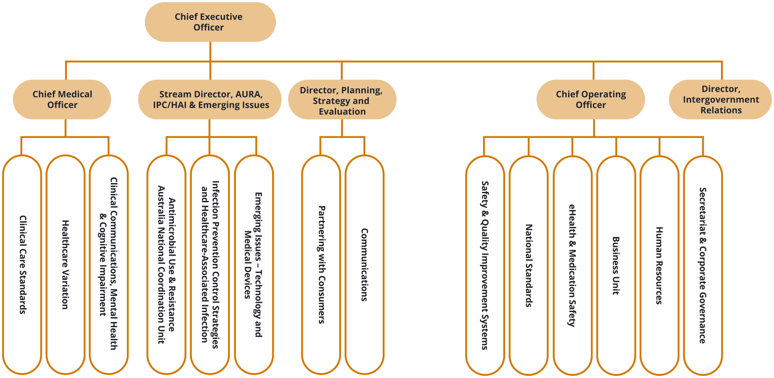

People management
The Commission continues to deliver high performance by providing ongoing support through its performance management systems and embedding a strong sense of direction across the organisation.
The Commission’s performance development scheme places emphasis on employees and managers having regular, meaningful performance discussions. All employees are required to have an individual performance and development plan in place. Managers and employees have joint accountability for capability and career development.
The Commission participates in the online induction program offered by the Australian Public Service Commission, giving new employees the opportunity to learn how the Australian Public Service operates and the behaviours expected of all staff members.

Staff profile
As of 30 June 2020, the Commission’s headcount was 94 employees. Most employees are located in Sydney. Table 7 provides a breakdown of the Commission’s employee profile by classification, gender, full-time or part-time status, and ongoing or non-ongoing status.
Table 7: Employee headcount profile as of 30 June 2020
Classification | Female |  |  |  | Male |  |  |  | Total
Classification | Ongoing |  | Non-ongoing |  | Ongoing |  | Non-ongoing |  | Total
Classification | Full-time | Part-time | Full-time | Part-time | Full-time | Part-time | Full-time | Part-time | Total
CEO |  |  | 1 |  |  |  |  |  | 1
MO6 | 1 |  |  |  |  | 1 |  |  | 2
EL2 | 14 | 5 |  |  | 7 |  |  |  | 26
EL1 | 12 | 12 | 3 | 2 | 6 |  | 2 |  | 37
APS6 | 9 | 4 | 6 | 1 | 2 |  |  |  | 22
APS5 |  |  | 3 |  | 1 |  |  |  | 4
APS4 |  | 1 | 1 |  |  |  |  |  | 2
Total | 36 | 22 | 14 | 3 | 16 | 1 | 2 | 0 | 94

Work health and safety
The Commission promotes a healthy and safe workplace, and is committed to meeting its obligations under the Work Health and Safety Act 2011 and the Safety, Rehabilitation and Compensation Act 1988. All new staff members are required to complete online work health and safety training as part of their induction.
The Commission undertook a number of activities during 2019–20 to encourage employees to adopt healthy work practices (see ‘Highlights’).

Keeping our staff safe and productive during COVID-19
In response to the COVID-19 pandemic, the Commission triggered its pandemic response under its Business Continuity Plan. This resulted in Commission staff working from home. Management met weekly by videoconference to oversee the Commission’s operations, and to ensure that the Commission accomplished its core businesses.
Highlights
Ergonomic workstation assessments were conducted as required, and access to standing desks was provided
Biannual workplace inspections were conducted; all staff members were encouraged to report incidents and hazards in the workplace
Access was provided to an employee assistance program
Influenza vaccinations were made available to all staff members
Access was provided to reimbursement of eyewear costs for use with screen-based equipment.
Five minor incidents were reported in 2019–20. There were no notifiable incidents in 2019–20. No notices were issued to the Commission, and no investigations were initiated under the Work Health and Safety Act 2011.

Learning and development
The Commission values the talents and contributions of its staff members, and recognises the importance of building expertise and capability within the organisation.
Learning and development needs and opportunities are mainly identified through the performance development scheme. The Commission promotes learning and development by delivering regular continuing professional development sessions and by providing access to online learning platforms to all staff members.
During 2019–20, the Commission’s study support and training arrangements ensured the ongoing development of staff members’ skills and capabilities. Eleven staff members accessed study support assistance to study a range of tertiary courses. These included Master of Public Health, Graduate Certificate in Health Service Management and Executive Master of Public Administration. Twenty-eight staff members completed external training courses, and internal training was provided to staff on managing underperformance, privacy and security.

Workplace diversity
The Commission’s workplace diversity program supports its ongoing commitment to recognising and fostering diversity in the workplace.
Commission staff participated in National Aborigines and Islanders Day Observance Committee week activities in July 2019.
The Commission is committed to increasing opportunities for people with disability to participate in employment. The Commission complies with the Australian Government accessibility requirements for online access and publishing. Reasonable adjustments are provided to employees with disability, as required.
During 2019–20, the Commission participated in the Australian Public Service Disability Champions Network.

Aboriginal and Torres Strait Islander employment
The Commission currently has no staff members who have identified as being Aboriginal or Torres Strait Islander.

This page is intentionally left blank.

6. Financial statements
Independent auditor’s report 102
Financial statements 104
Overview and notes to the financial statements 109

Independent auditor’s report
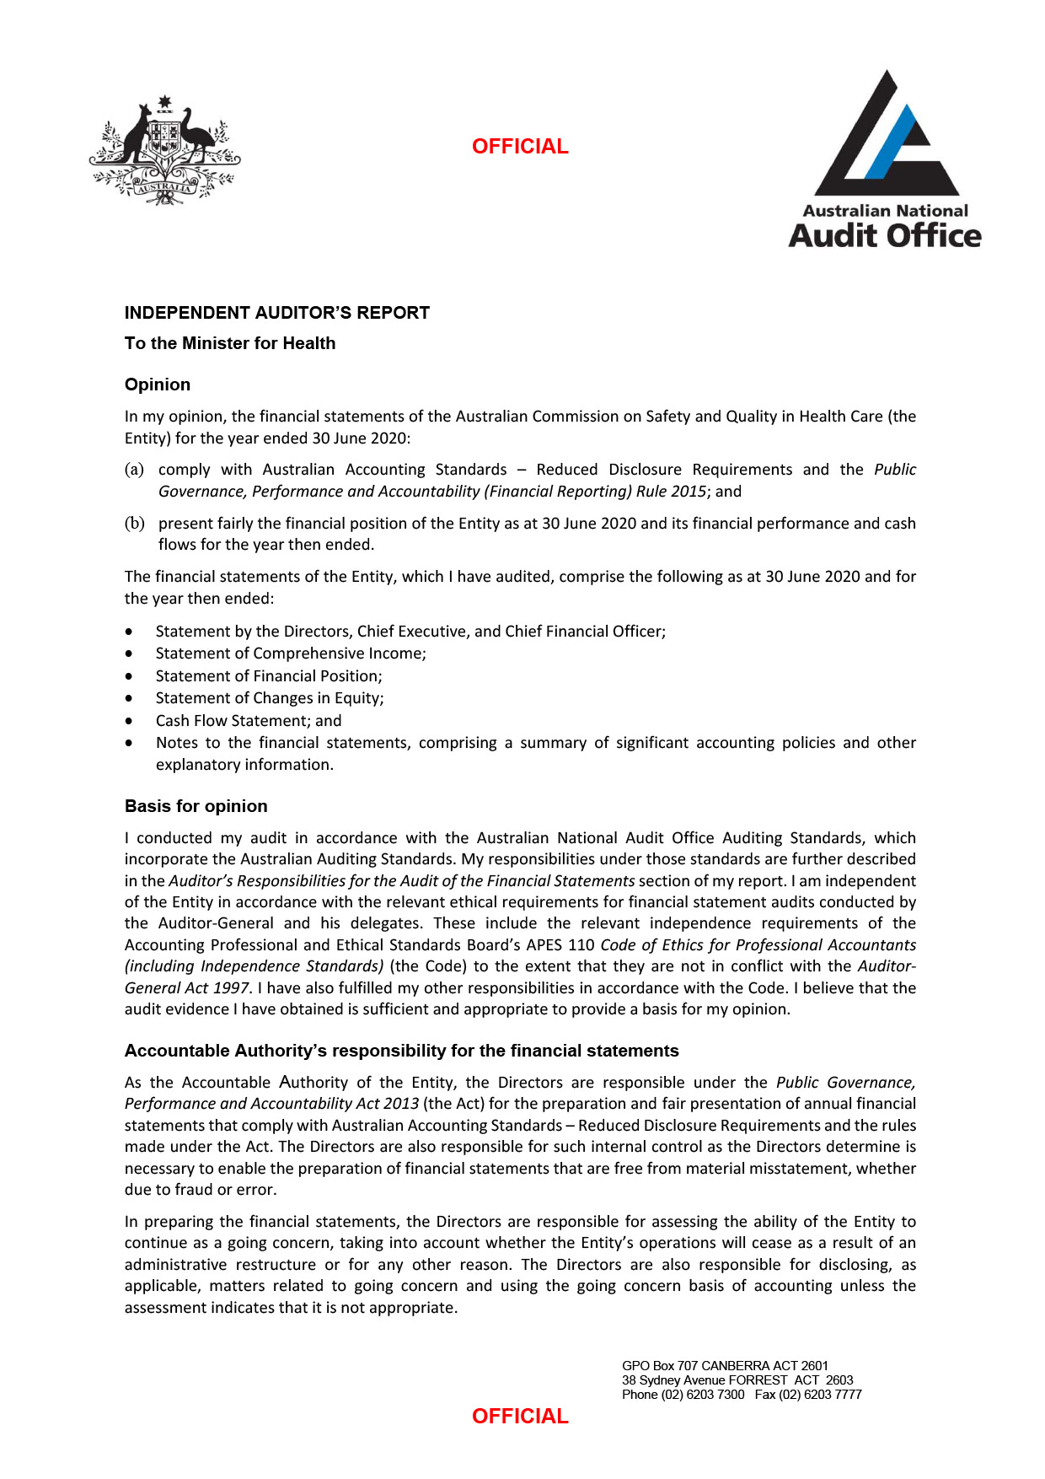
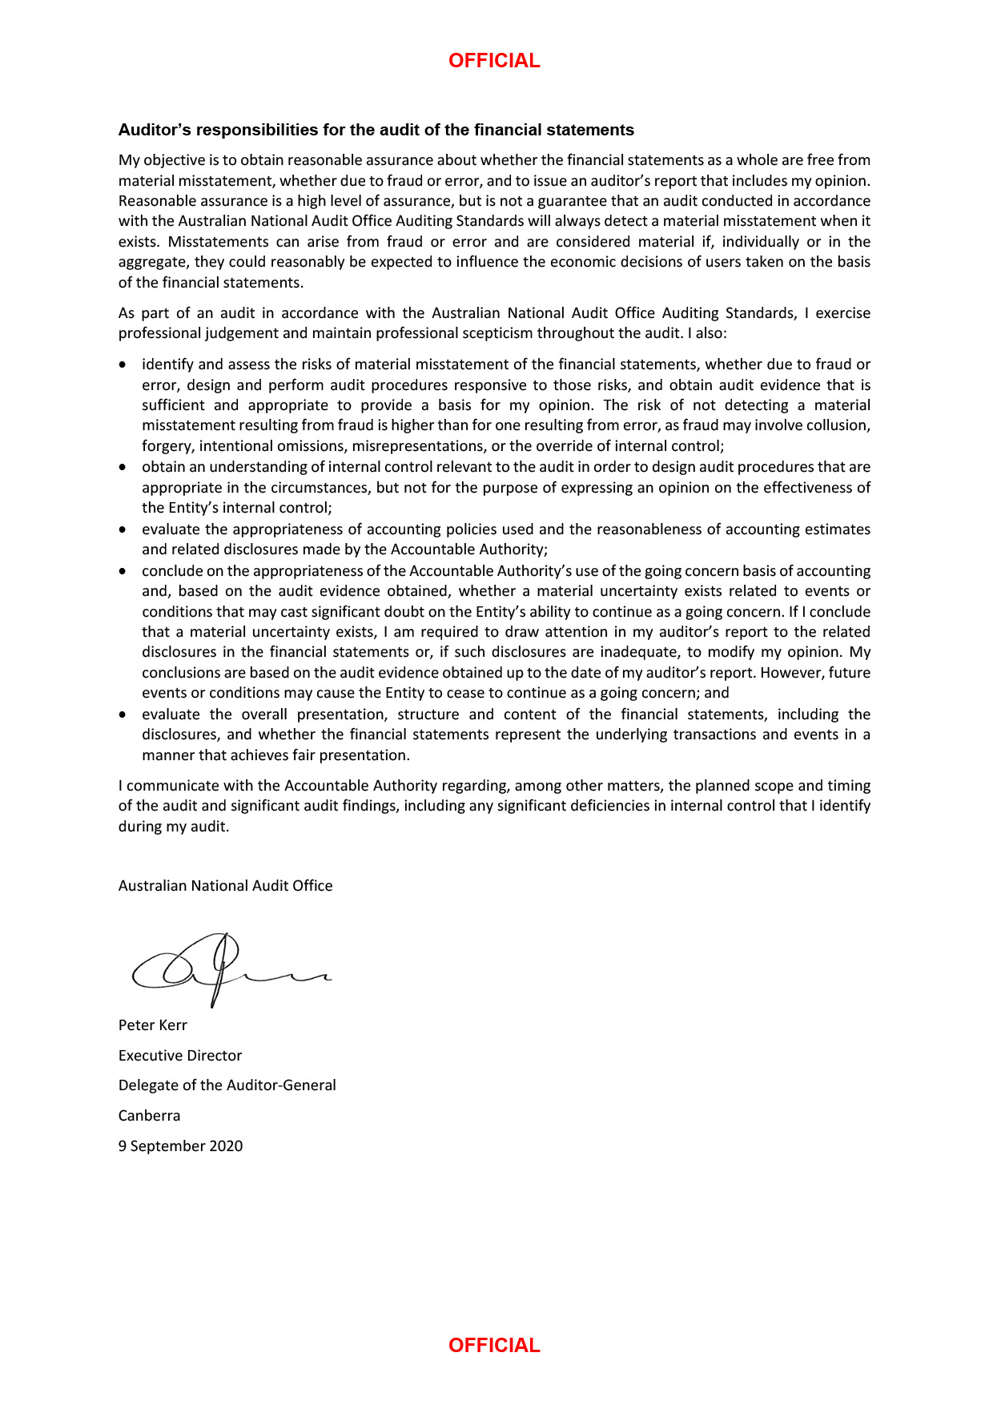

Financial statements
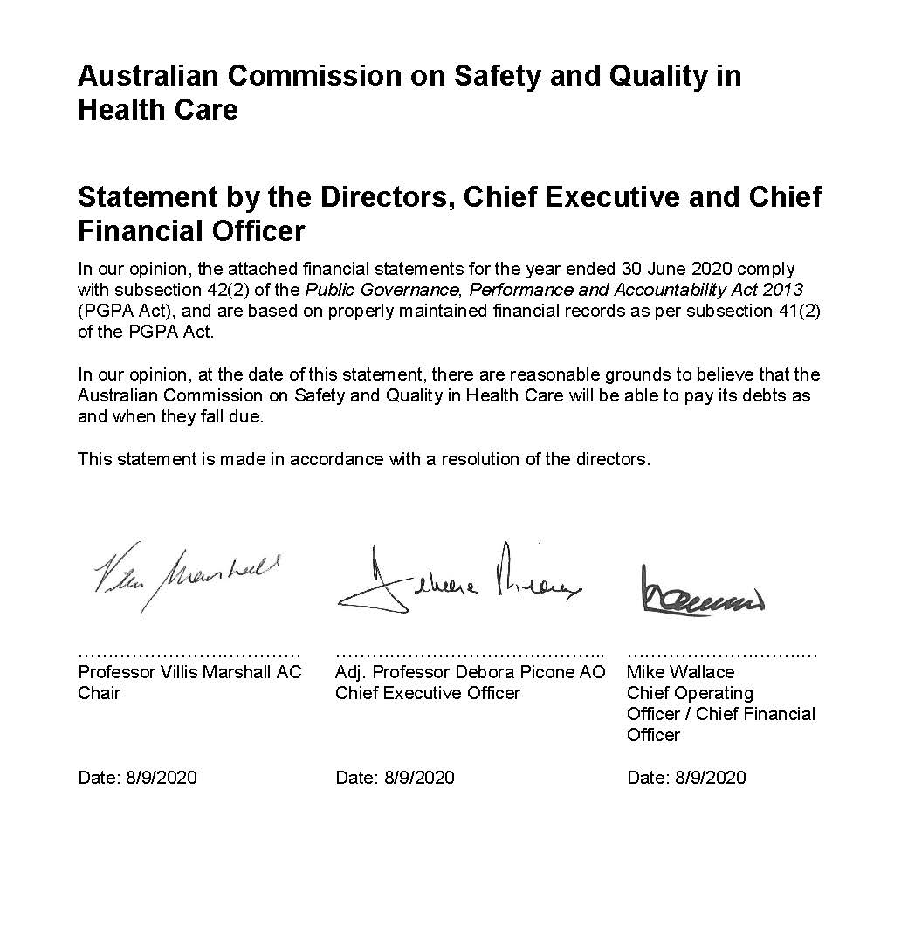
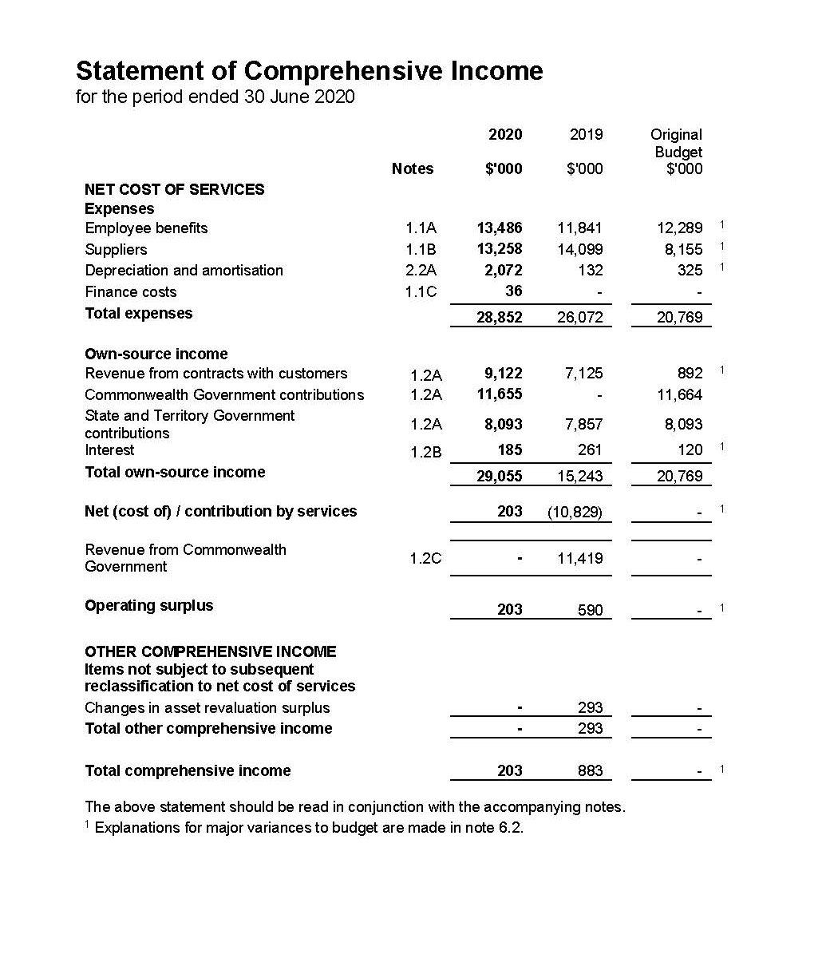
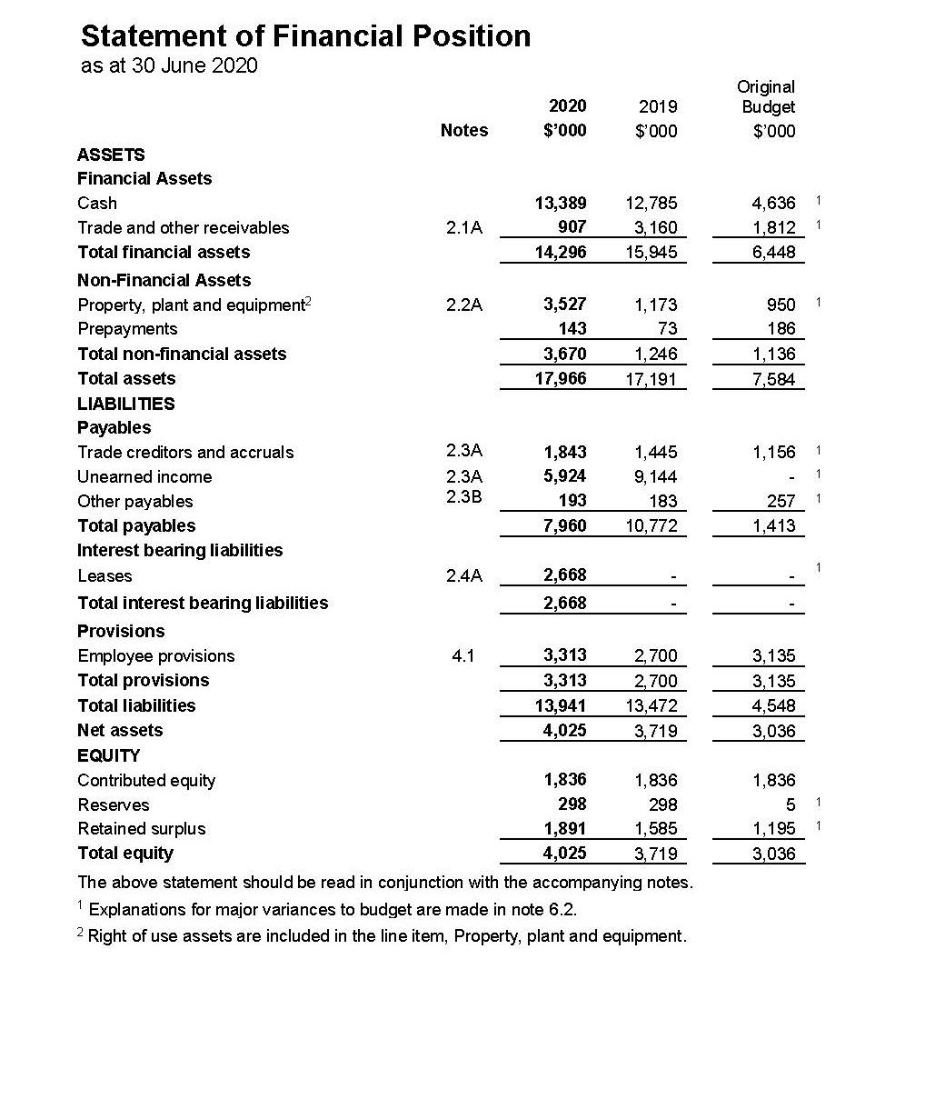
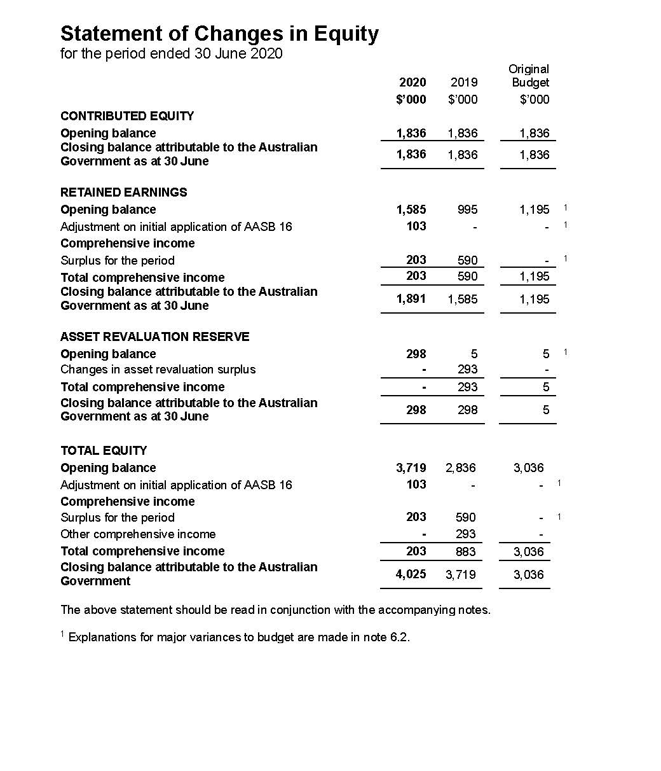
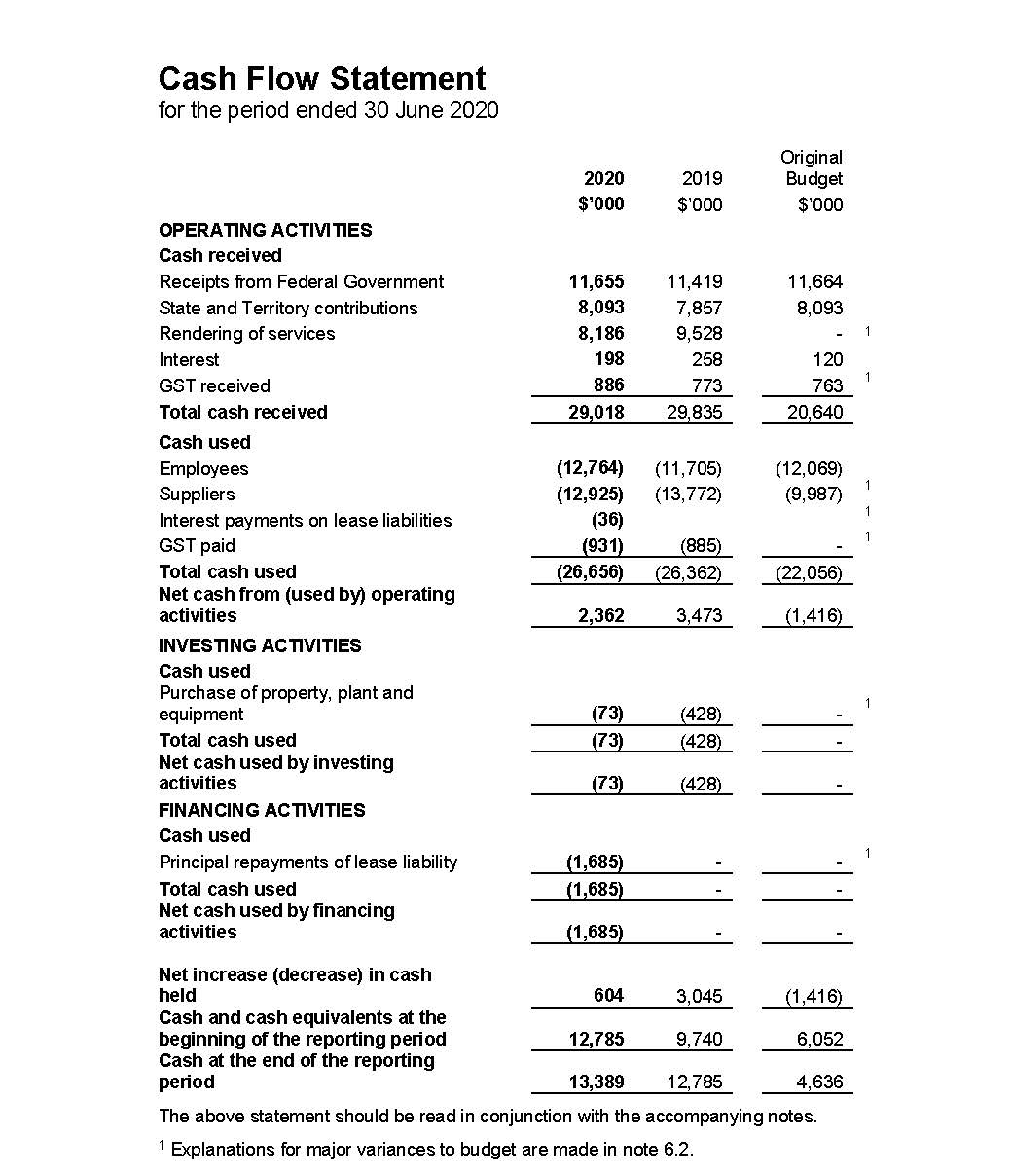

Overview and notes to the financial statements
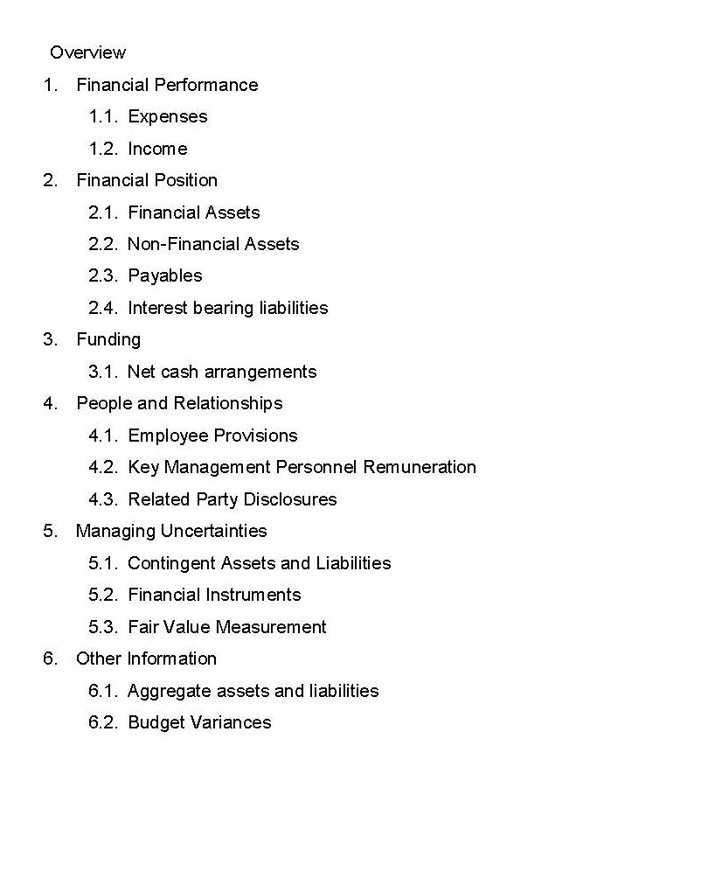
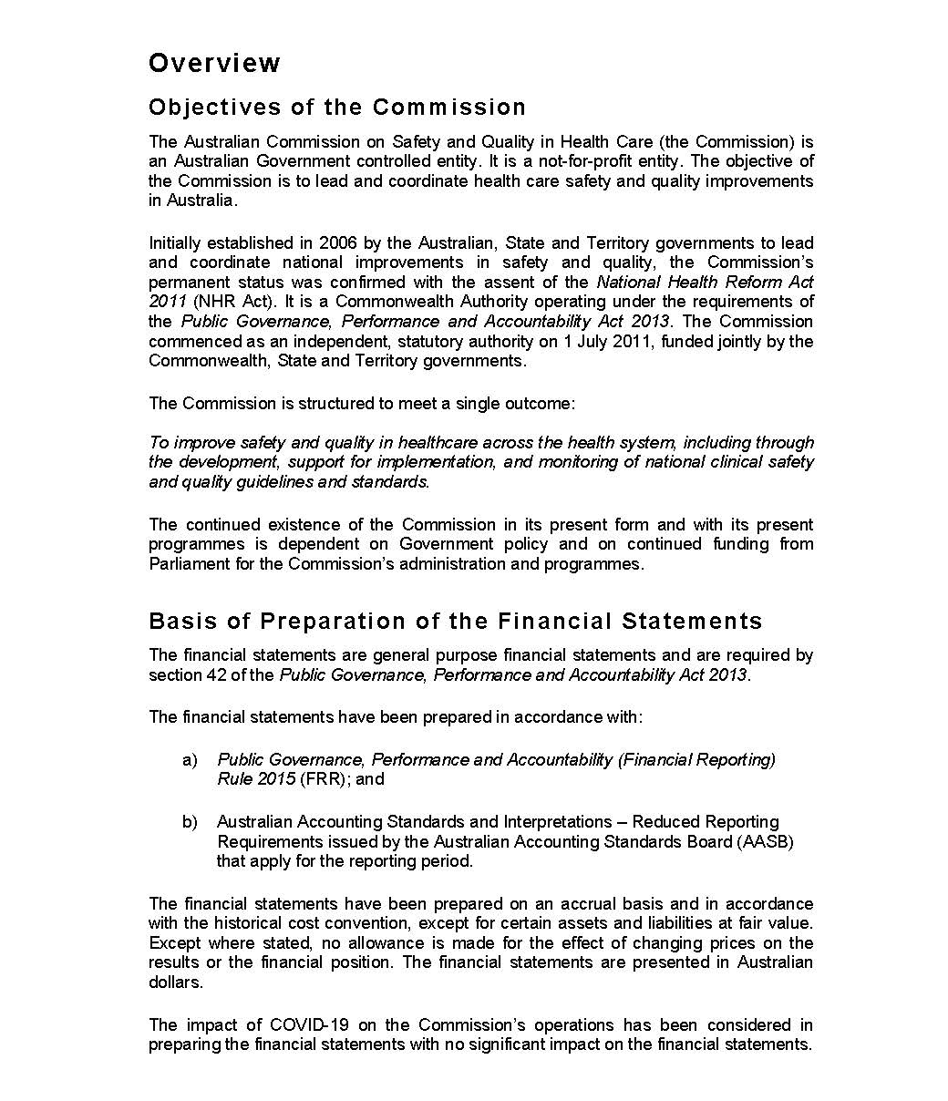
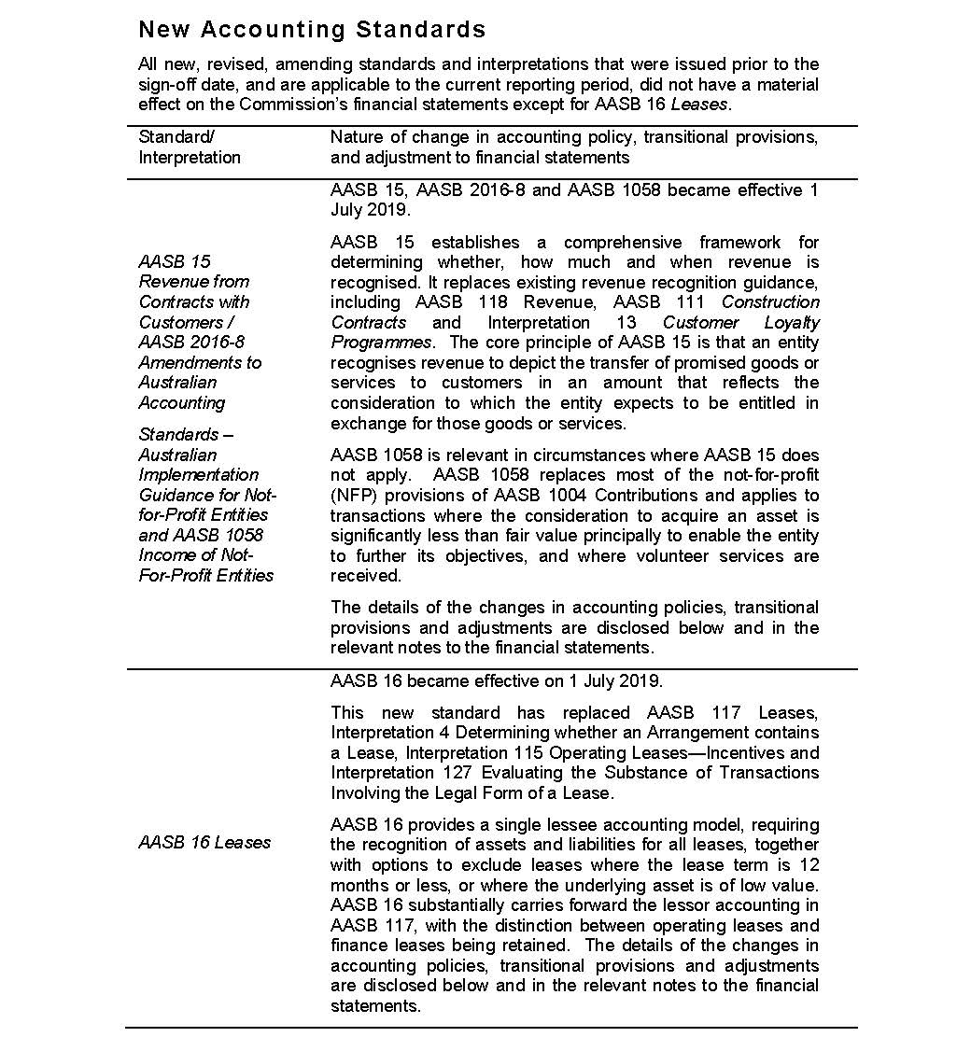
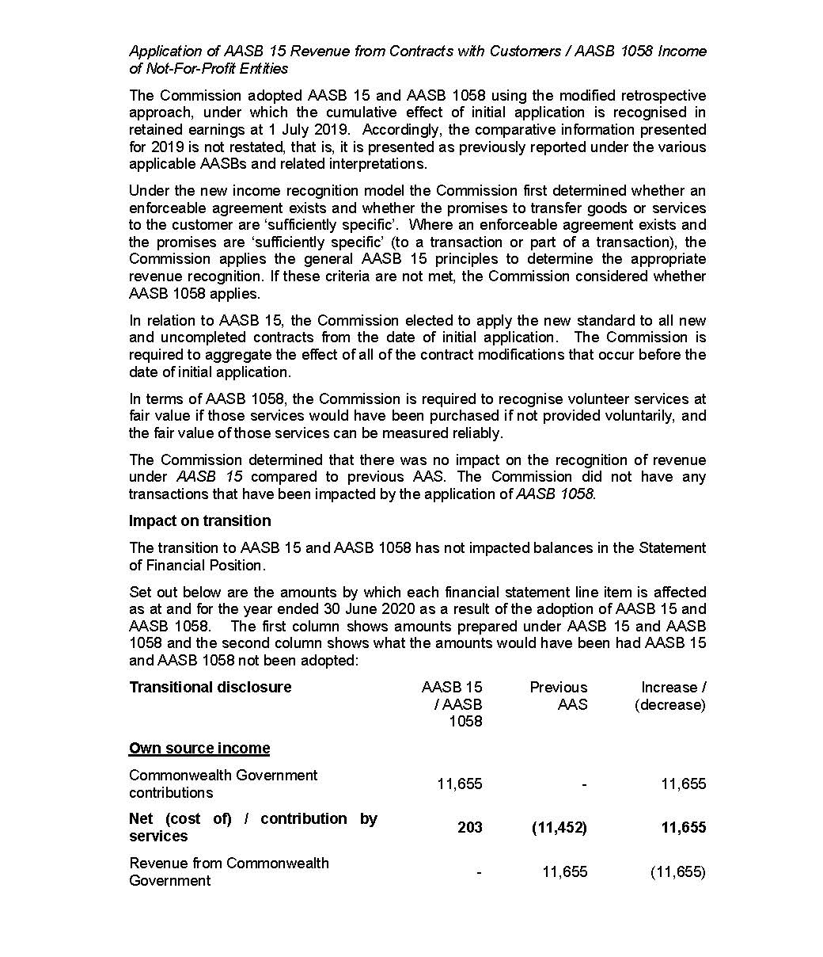
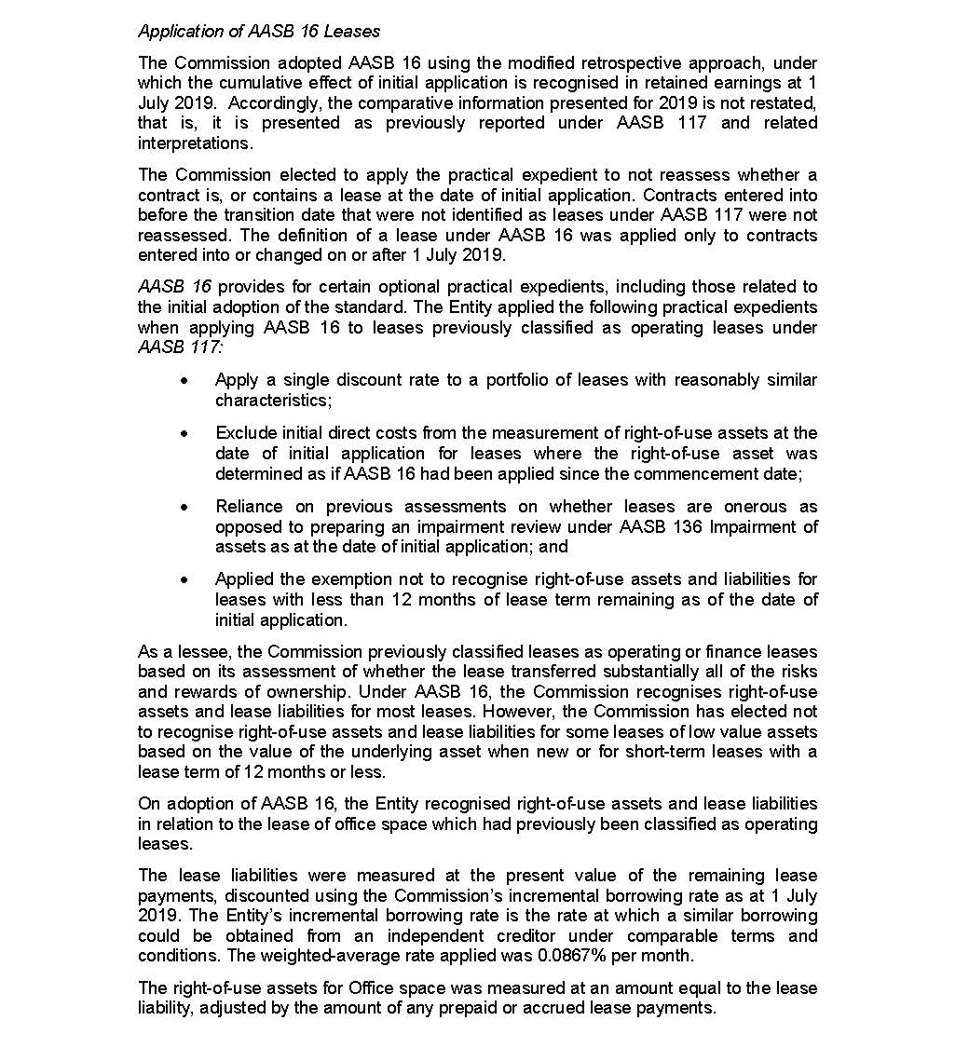
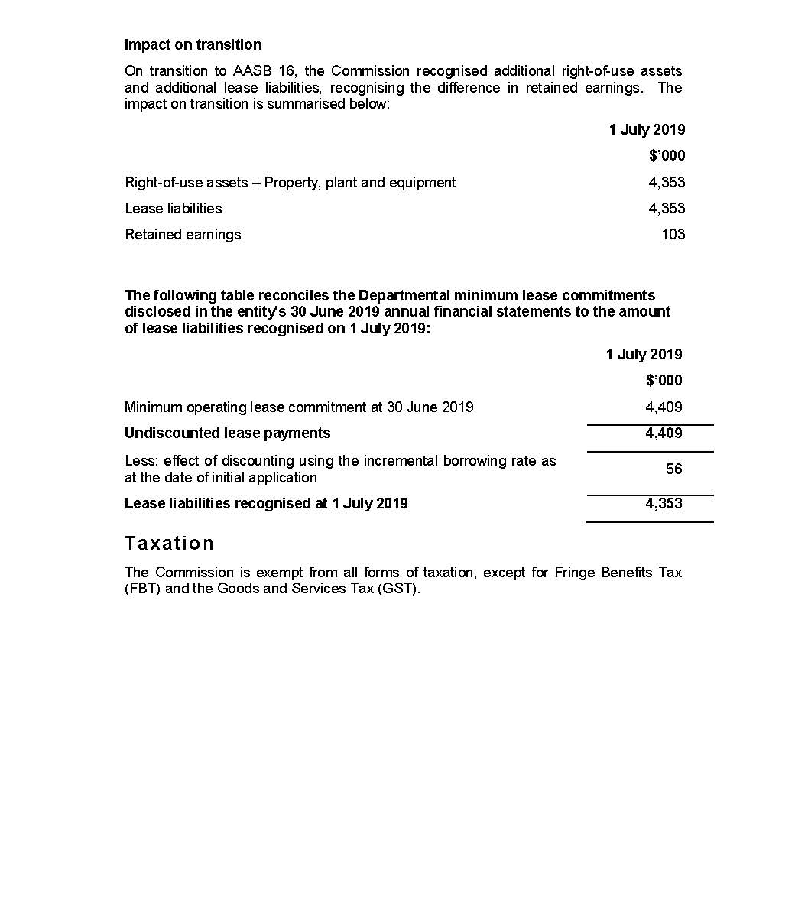
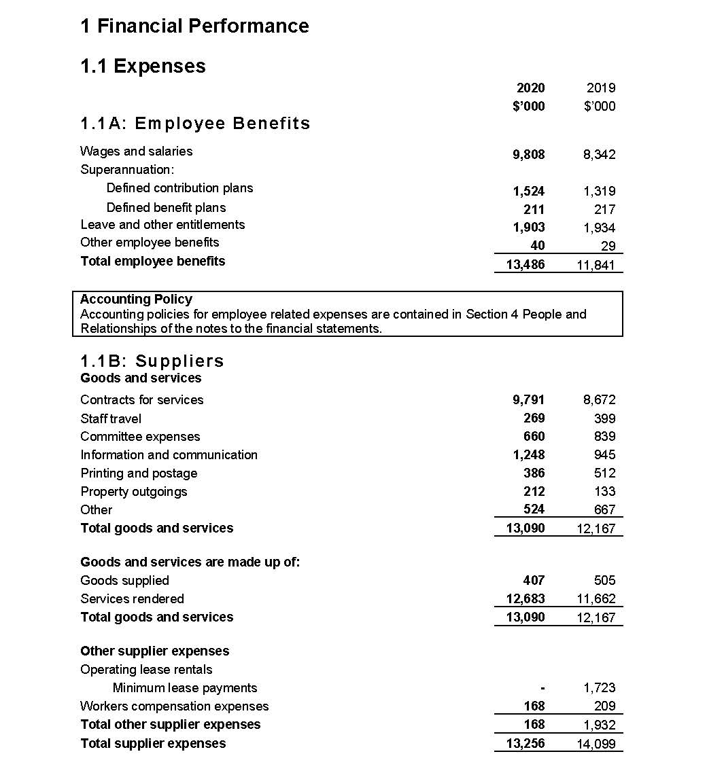
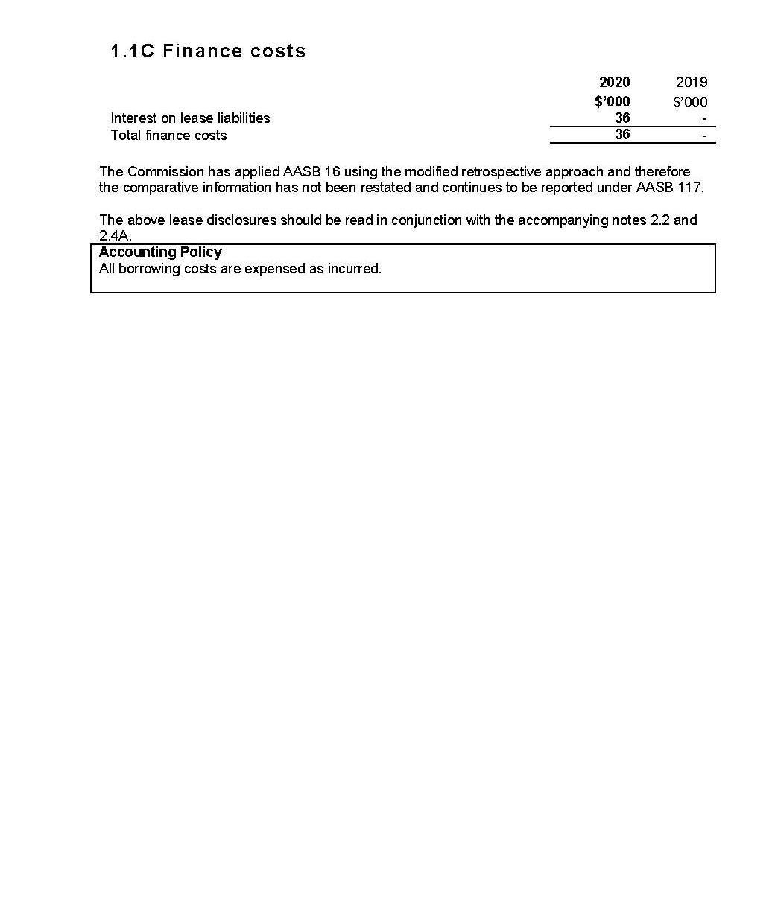
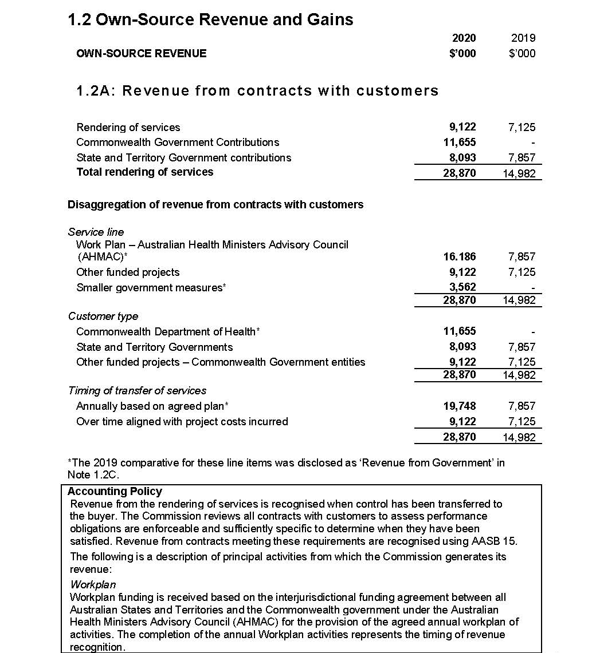
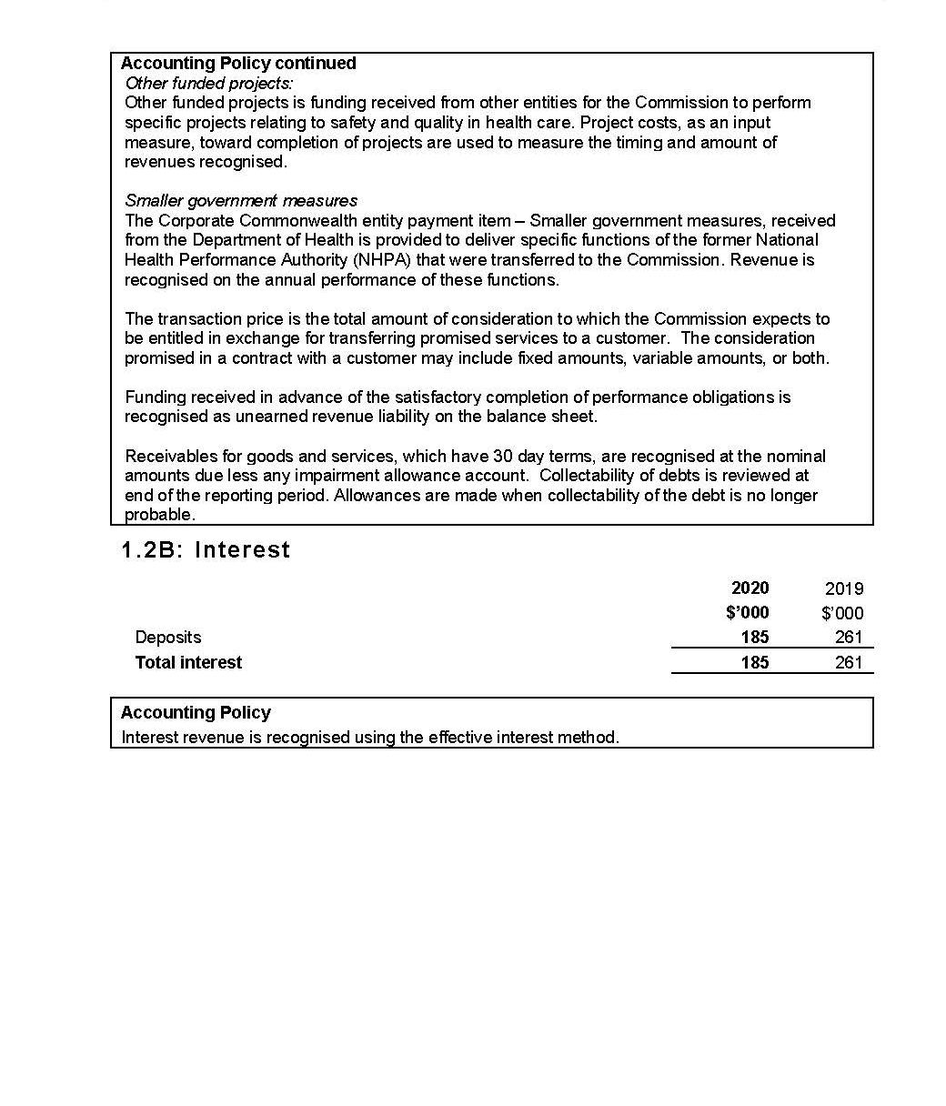
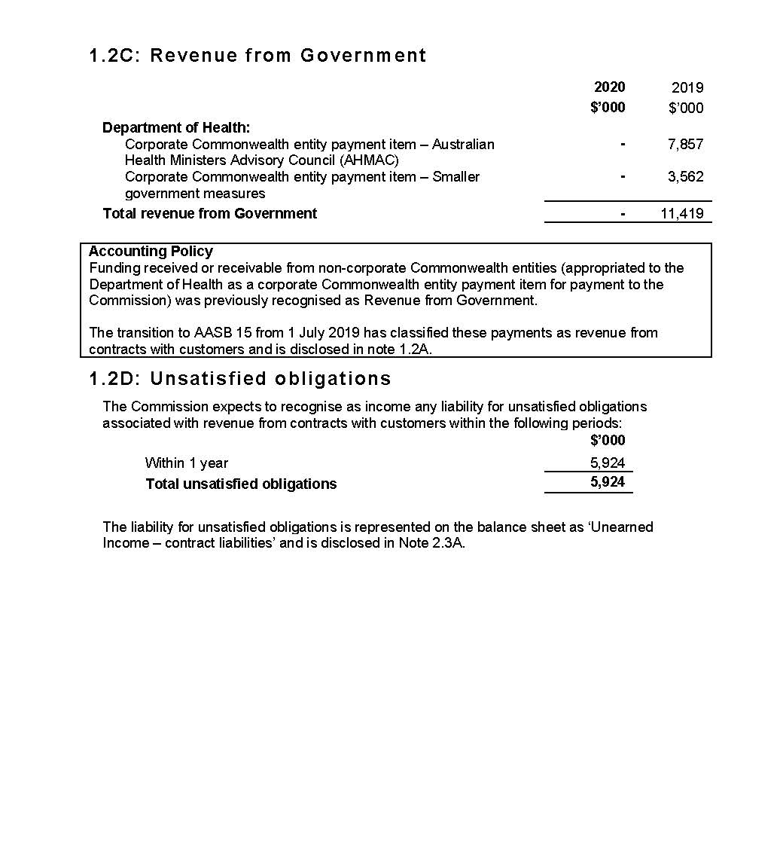
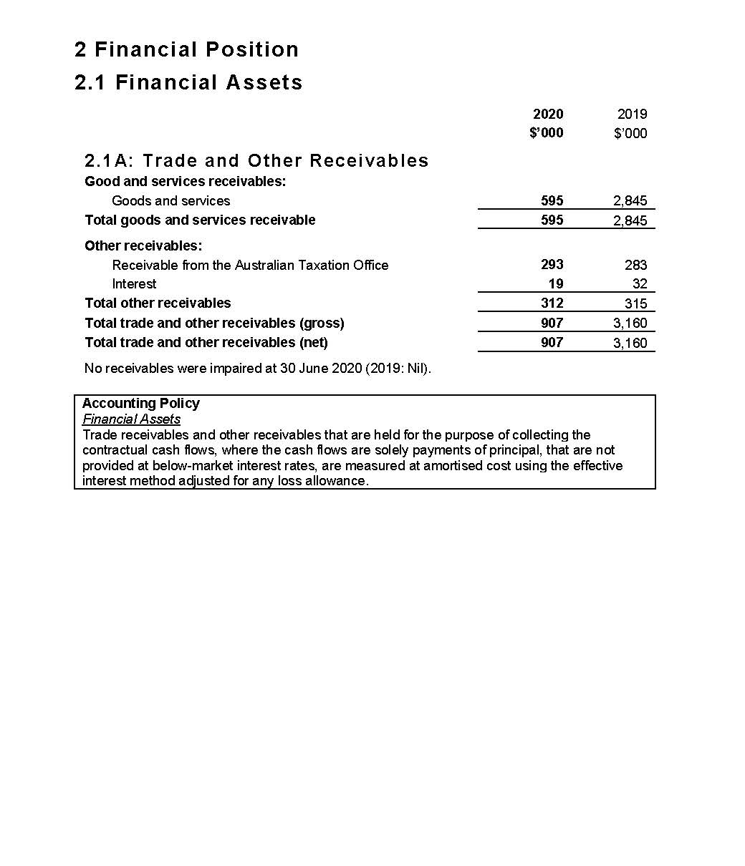
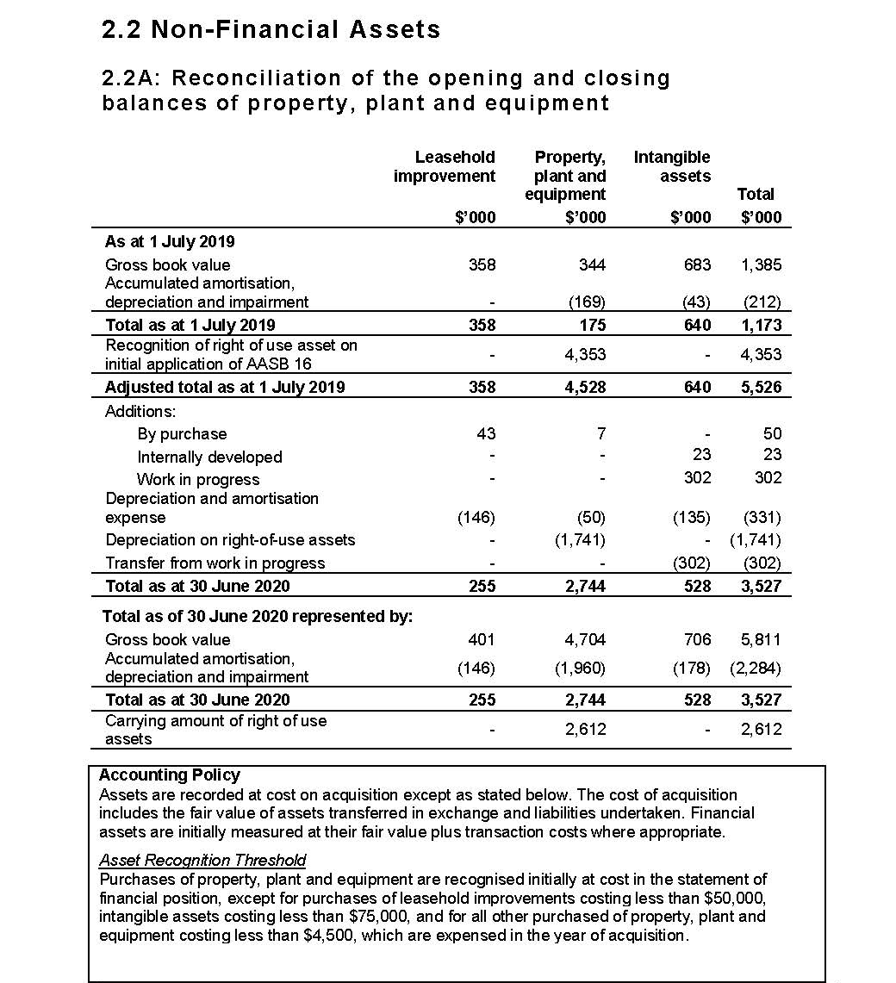
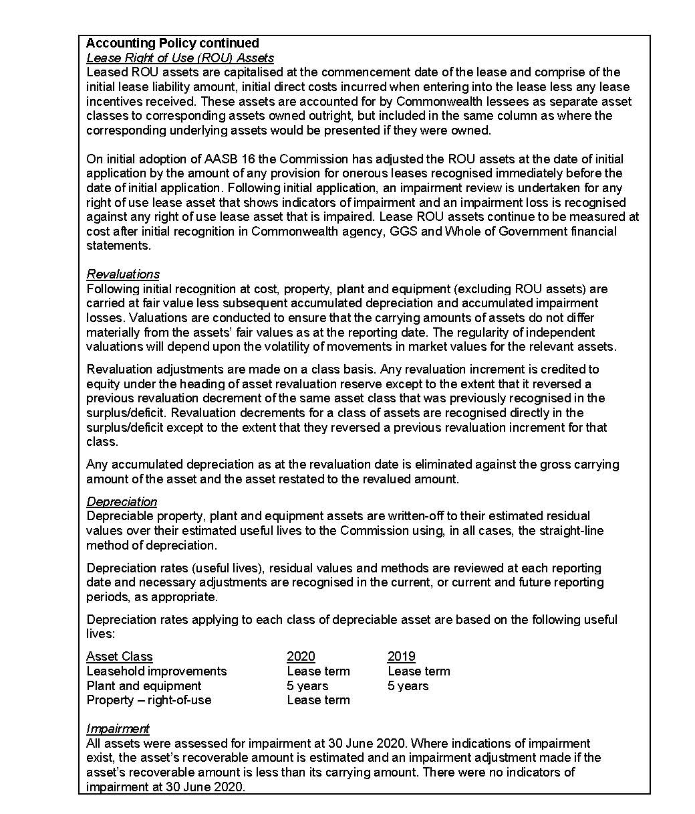
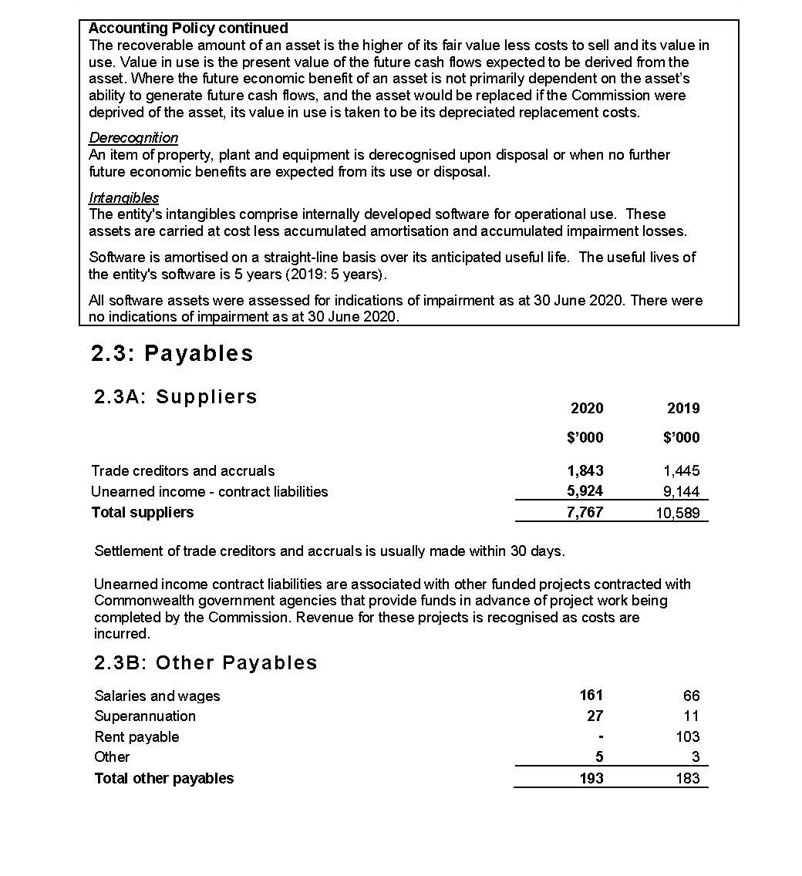
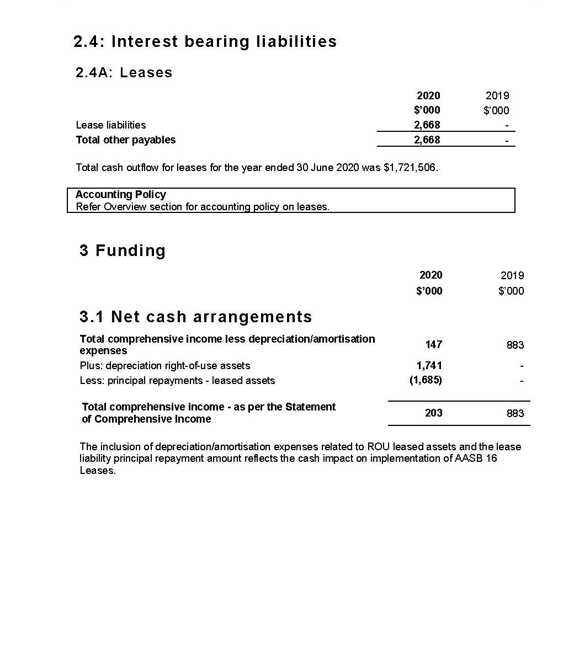
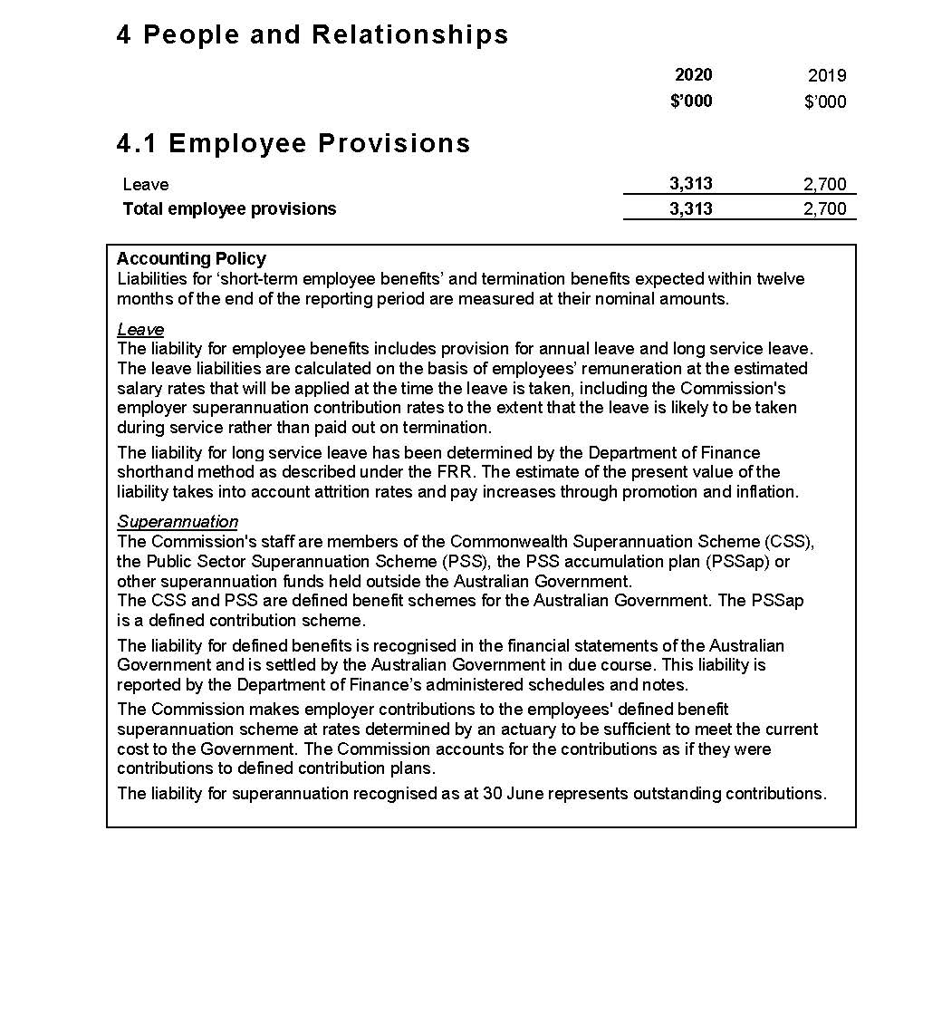
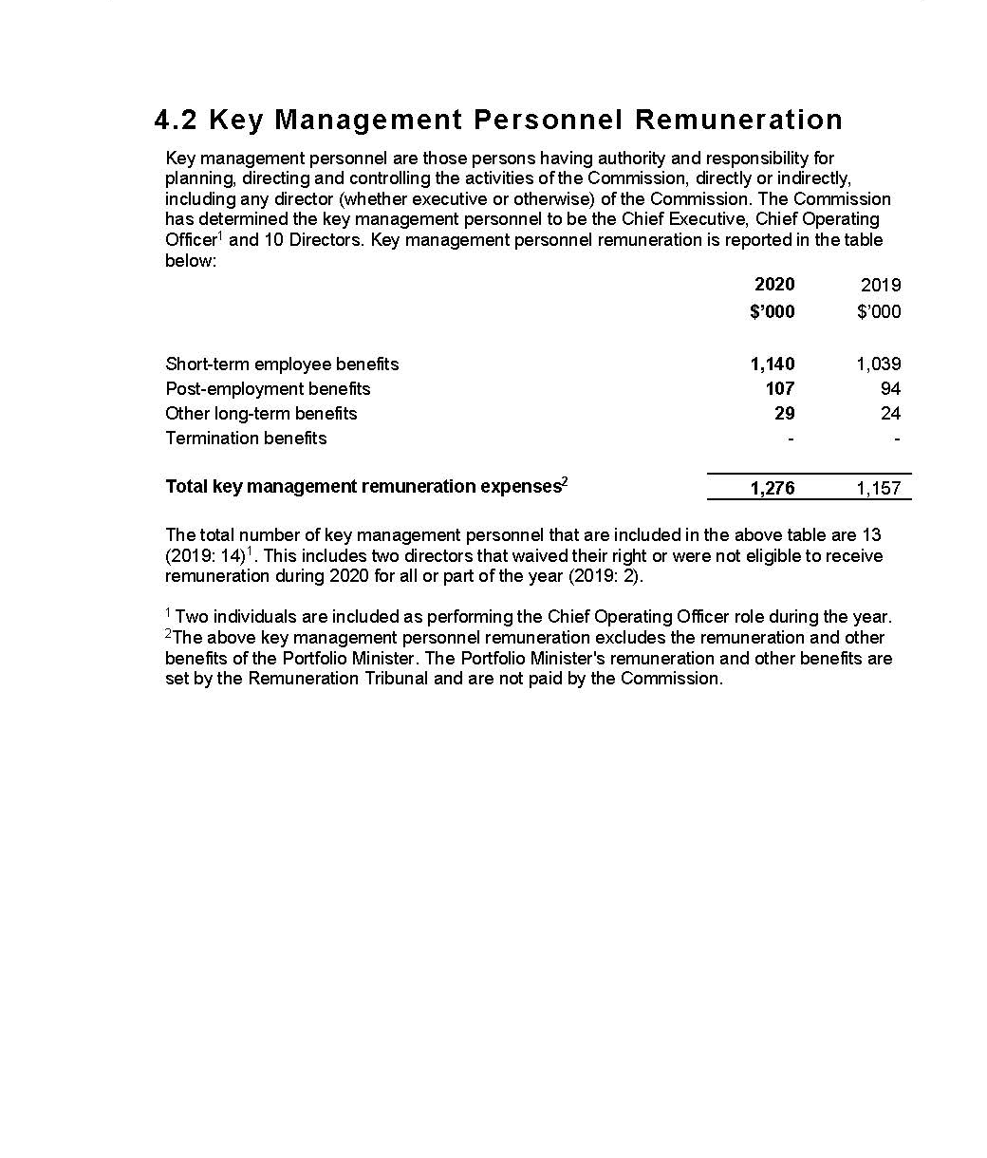
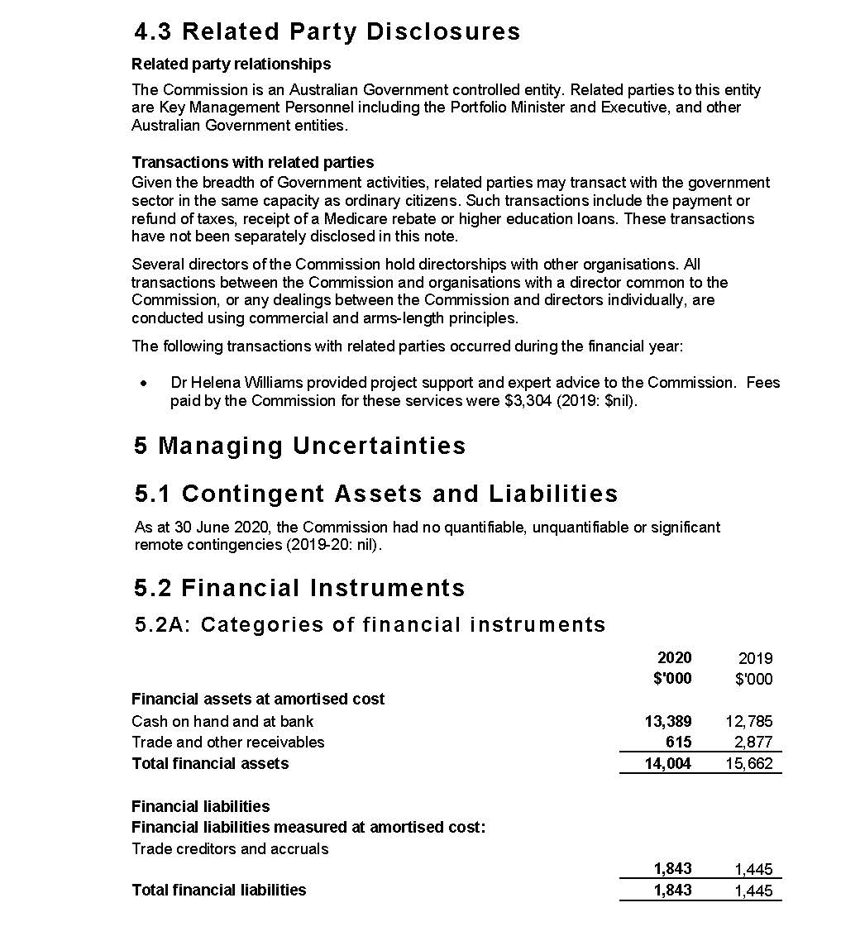
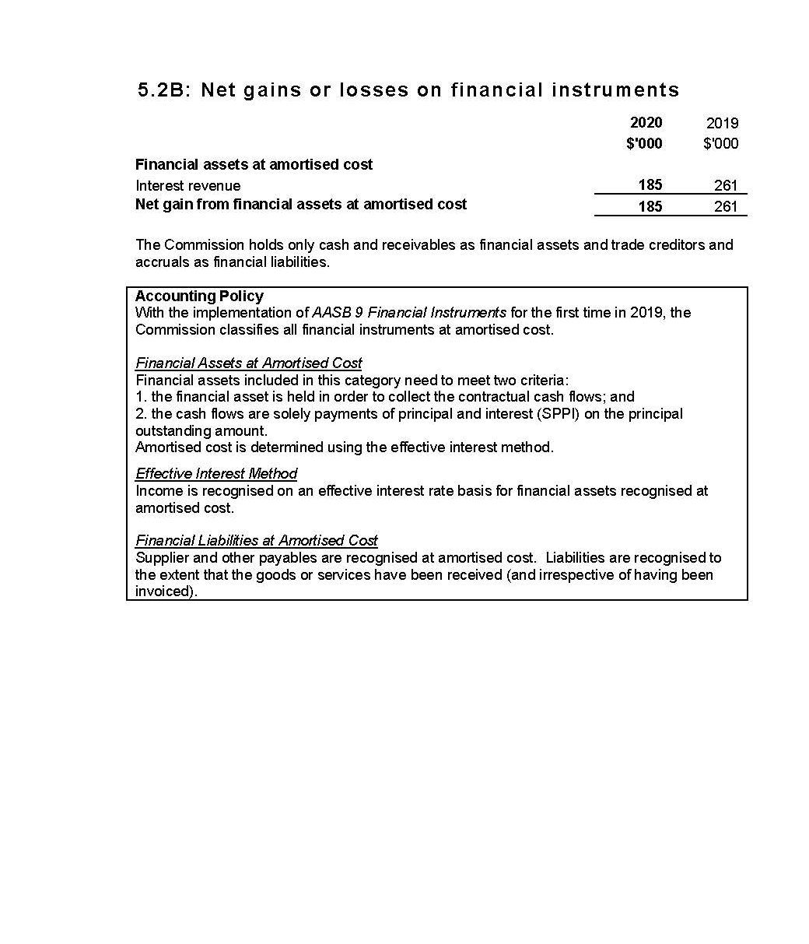
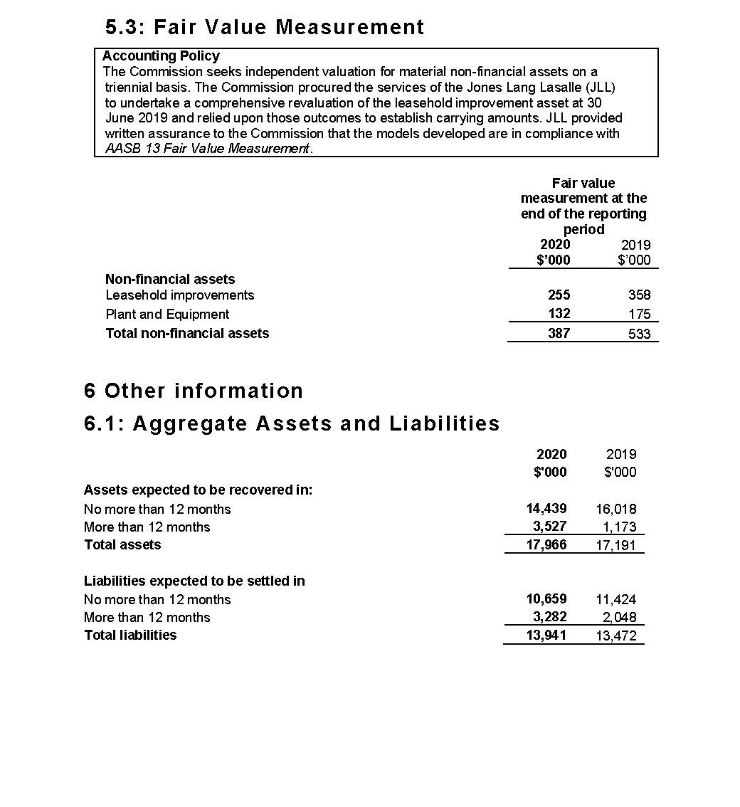
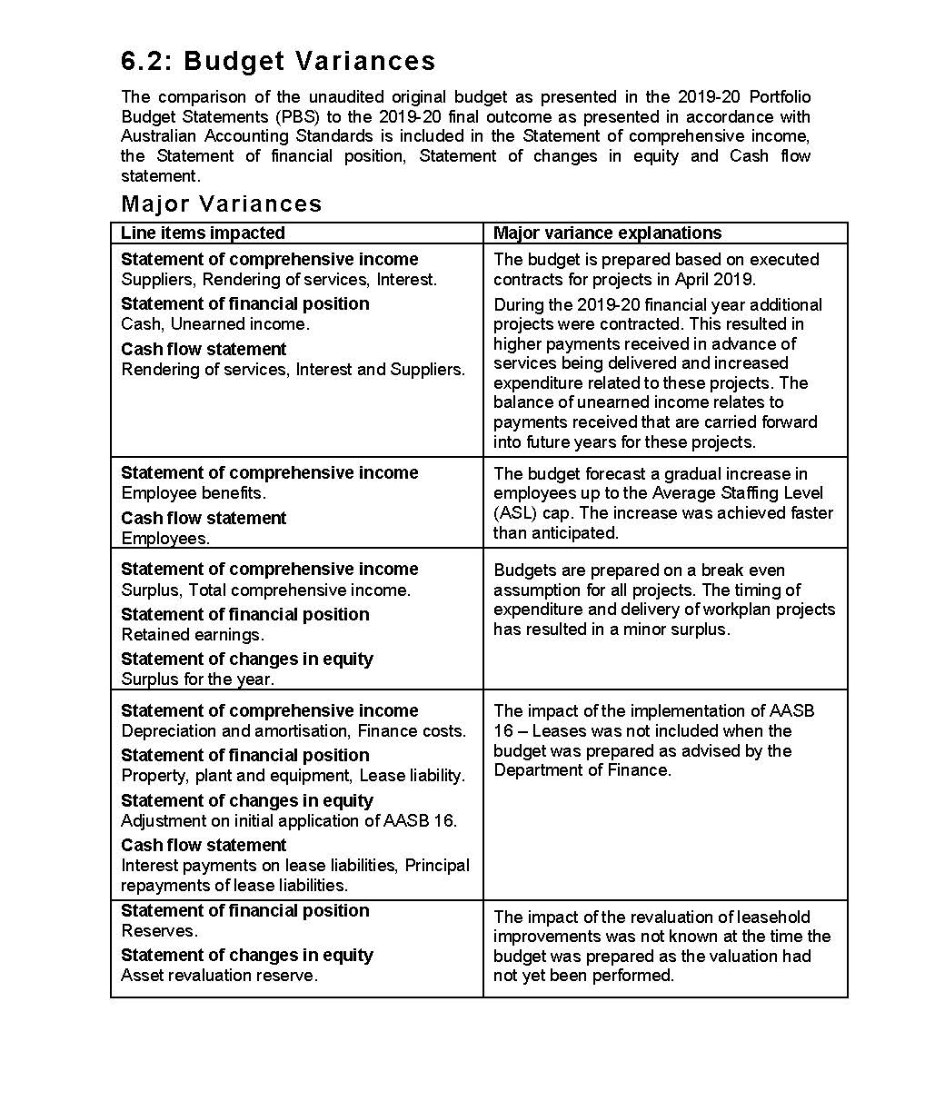

“The Commission and its partners continue to provide leadership and support to healthcare services to drive safety and quality.”
– Chief Executive Officer, Adjunct Professor Debora Picone AO

This page is intentionally left blank.

7. Appendices
Appendix A: Freedom of information summary 134
Appendix B: Compliance with ecologically sustainable development 135
Appendix C: Related-entity transactions 137

Appendix A: Freedom of information summary
The following table summarises freedom of information requests and their outcomes for 2019–20, as discussed on page 88.
Table 8: Freedom of information summary, 2019–20
Activity | Number
Requests
On hand at 1 July 2019 | 0
New requests received | 1
Total requests handled | 1
Total requests completed as at 30 June 2020 | 1
Total requests on hand as at 30 June 2020 | 0
Action of request
Access granted in full | 1
Access granted in part | N/A
Access refused | N/A
Access transferred in full | N/A
Request withdrawn | N/A
No records | N/A
Response time
0–30 days | 1
30–60 days | N/A

Appendix B: Compliance with ecologically sustainable development
The Commission is committed to making a positive contribution to ecological sustainability. Table 9 details the Commission’s activities in accordance with section 516A(6) of the Environment Protection and Biodiversity Conservation Act 1999.
Table 9: Summary of the Commission’s compliance with ecologically sustainable development, 2019–20
Environment Protection and Biodiversity Conservation Act 1999 requirement | Commission response
Activities of the Commission during 2019–20 accord with the principles of ecologically sustainable development | The Commission ensures that its decision-making and operational activities mitigate environmental impact. The principles of ecologically sustainable development are embedded in the Commission’s approach to its work plan, and corporate, purchasing and operational guidelines.
Outcomes specified for the Commission in an Appropriation Act for 2019–20 contribute to ecologically sustainable development | The Commission’s single appropriations outcome focuses on improving safety and quality in health care across the Australian health system. As such, the Commission does not directly contribute to ecologically sustainable development.
Effects of the Commission’s activities on the environment | The Commission’s offices are located in a 5-star building, and the Commission works proactively with building management to achieve energy savings, where possible. The Commission continues to improve its dissemination of publications, reports and written materials through electronic media to minimise printing output.

Table 9 continued
Environment Protection and Biodiversity Conservation Act 1999 requirement | Commission response
Measures the Commission is taking to minimise its impact on the environment | To reduce its environmental impact, the Commission is improving its website functionality and increasing the use of multi-channel strategies to distribute information electronically.  To reduce travel, the Commission uses remote meeting attendance options, where feasible. Most staff have been working and attending meetings remotely during the pandemic.  Responsible use of materials, electricity and water, and disposal of waste are expected of all staff and visitors.
Mechanisms for reviewing and increasing the effectiveness of these measures | The Commission has established mechanisms to review current practices and policies. In addition, staff are encouraged to identify initiatives to adopt behaviours, procedures or policies that may minimise their environmental impact, and that of their team and the Commission more broadly.

Appendix C: Related-entity transactions
Table 10: Related-entity transactions, 2019–20
Vendor no. | Commonwealth entity | Number of transactions | Transaction value | Description
100362 | Department of Health | 12 | $611,425.10 | Payments processed in 2019–20 for corporate services received from the Department of Health under a shared services agreement between the Commission and the Department.

This page is intentionally left blank.

8. Indexes and references
Acronyms 140
Glossary 142
Index of figures 146
Index of tables 147
Compliance index 148
Index 153
References 164

Acronyms
Term | Definition
AC | Companion of the Order of Australia
AHPEQS | Australian Hospital Patient Experience Question Set
AHSSQA Scheme | Australian Health Service Safety and Quality Accreditation Scheme
AM | Member of the Order of Australia
AMR | antimicrobial resistance
AO | Officer of the Order of Australia
AURA | Antimicrobial Use and Resistance in Australia
CARAlert | National Alert System for Critical Antimicrobial Resistances
CEO | Chief Executive Officer
COAG | Council of Australian Governments
FCNA | Fellow of the College of Nursing, Australia
FIAA | Fellow of the Institute of Actuaries of Australia
FRACGP | Fellow of the Royal Australian College of General Practitioners
FRACP | Fellow of the Royal Australiasian College of Physicians
FRACS | Fellow of the Royal Australasian College of Surgeons
MD | Doctor of Medicine
NAPS | National Antimicrobial Prescribing Survey
NAUSP | National Antimicrobial Utilisation Surveillance Program
NGPA Scheme | National General Practice Accreditation Scheme
NSQDMH Standards | National Safety and Quality Digital Mental Health Standards
NSQHS Standards | National Safety and Quality Health Service Standards

Term | Definition
OECD | Organisation for Economic Co-operation and Development
PROM | patient-reported outcome measure
PSM | Public Service Medal

Glossary
Term | Definition
Accreditation | A status that is conferred on an organisation or individual when they have been assessed as having met particular standards. The two conditions for accreditation are compliance with an explicit definition of quality (that is, a standard) and passing an independent review process aimed at identifying the level of congruence between practices and quality standards.
Adverse event | An incident that results in harm to a patient or consumer.
Antimicrobial | A chemical substance that inhibits or destroys bacteria, viruses or fungi, including yeasts and moulds.2
Antimicrobial resistance | A property of organisms – including bacteria, viruses, fungi and parasites – that allows them to grow or survive in the presence of antimicrobial levels that would normally suppress growth or kill susceptible organisms.
Antimicrobial stewardship | A program implemented in a health service organisation to reduce the risks associated with increasing antimicrobial resistance, and to extend the effectiveness of antimicrobial treatments. Antimicrobial stewardship may incorporate a broad range of strategies, including monitoring and reviewing antimicrobial use.
Clinical care standards | Standards developed by the Commission and endorsed by health ministers that identify and define the care people should expect to be offered or receive for specific conditions.
Clinical communication | The exchange of information about a person’s care that occurs between treating clinicians, the patient and members of a multidisciplinary team. Communication can take different forms, including face-to-face or electronic communication, and communication via telephone, written notes or other documentation.
Clinical governance | The set of relationships and responsibilities established by a health service organisation between its department of health (for the public sector), governing body, executive, clinicians, patients, consumers and other stakeholders to ensure good clinical outcomes. It ensures that the community and health service organisations can be confident that systems are in place to deliver safe and high-quality health care, and continuously improve services.

Term | Definition
Clinical handover | The transfer of professional responsibility and accountability for some or all aspects of care for a patient, or group of patients, to another person or professional group on a temporary or permanent basis.3
Clinician | A healthcare provider, trained as a health professional. Clinicians include registered and non-registered practitioners, or teams of health professionals, who spend the majority of their time delivering direct clinical care.
Cognitive impairment | Deficits in one or more of the areas of memory, communication, attention, thinking and judgement. Cognitive impairment can be temporary or permanent, and can affect a person’s understanding, their ability to carry out tasks or follow instructions, their recognition of people or objects, how they relate to others and how they interpret the environment. Dementia and delirium are common forms of cognitive impairment seen in hospitalised older patients.4 Cognitive impairment can also be caused by other conditions, such as an acquired brain injury, a stroke, intellectual disability or drug use.
Consumer | A person who has used, or may potentially use, health services. A healthcare consumer may also act as a consumer representative to provide a consumer perspective, contribute consumer experiences, advocate for the interests of current and potential health service users, and take part in decision-making processes.5
Delirium | An acute disturbance of consciousness, attention, cognition and perception that tends to fluctuate during the course of the day. Delirium is a serious condition that can be prevented in 30–40% of cases, and should be treated promptly and appropriately. Hospitalised older people with existing dementia are at the greatest risk of developing delirium. Delirium can be hyperactive (the person has heightened arousal, or can be restless, agitated and aggressive) or hypoactive (the person is withdrawn, quiet and sleepy).6
Electronic medication management system | Enables medicines to be prescribed, dispensed, administered and reconciled electronically.

Term | Definition
End of life | The period when a patient is living with, and impaired by, a fatal condition, even if the trajectory is ambiguous or unknown. This period may be years in the case of patients with chronic or malignant disease, or very brief in the case of patients who suffer acute and unexpected illnesses or events such as sepsis, stroke or trauma.7
Hand hygiene | A general term referring to any hand-cleansing action.
Healthcare-associated infections | Infections that are acquired in healthcare facilities (nosocomial infections) or that occur as a result of healthcare interventions (iatrogenic infections). Healthcare-associated infections may manifest after people leave healthcare facilities.8
Healthcare variation | This occurs when patients with the same condition receive different types of care. For example, among a group of patients with the same condition, some may have no active treatment, some may be treated in the community and others in hospital, and some may have surgery while others receive medication. Some variation in how health care is provided is desirable because of differences in patients’ needs, wants and preferences (see ‘unwarranted healthcare variation’).
Hospital-acquired complication | A complication for which clinical risk mitigation strategies may reduce (but not necessarily eliminate) the risk of that complication occurring.
Medication chart | A chart used by an authorised prescriber to record medication and treatment orders, as well as by nursing staff to record and monitor the administration of medicines and treatment.
My Health Record | A secure online summary of a consumer’s health information, managed by the System Operator of the national e-health record system (the Secretary to the Department of Health). Healthcare providers are able to share health records to a consumer’s My Health Record, in accordance with the consumer’s access controls. This may include information such as medical history and treatments, diagnoses, medications and allergies. Also known as a ‘Personally Controlled Electronic Health Record’.

Term | Definition
National Safety and Quality Health Service (NSQHS) Standards | Standards developed by the Commission in consultation and collaboration with states and territories, technical experts, health service organisations and patients. The NSQHS Standards aim to protect the public from harm, and to improve the quality of health services. They provide a quality assurance mechanism that tests whether relevant systems are in place to ensure that minimum safety and quality standards are met, and a quality improvement mechanism that allows health service organisations to realise aspirational or developmental goals.
Partnering with consumers | Treating consumers and/or carers with dignity and respect, communicating and sharing information between consumers and/or carers and health service organisations, encouraging and supporting consumers’ participation in decision-making, and fostering collaboration between consumers and/or carers and health service organisations in planning, designing, delivering and evaluating health care. Other terms are used internationally, such as patient-based, consumer-centred, person-centred, relationship-based, patient-centred and patient‑and-family‑centred care.
Patient | A person receiving health care. Synonyms for ‘patient’ include ‘consumer’ and ‘client’.
Patient safety | Reducing the risk of unnecessary harm associated with health care to an acceptable minimum.
Patient safety incident | An event or circumstance that could have resulted, or did result, in unnecessary harm to a patient.
Person-centred care | Where patients, consumers and members of the community are treated as partners in all aspects of healthcare planning, design, delivery and evaluation; the foundation for achieving safe, high-quality care.
Shared decision making | The integration of a patient’s values, goals and concerns with the best available evidence about the benefits, risks and uncertainties of treatment to achieve appropriate healthcare decisions.9
Standard | Agreed attributes and processes designed to ensure that a product, service or method will perform consistently at a designated level.
Unwarranted healthcare variation | Variation not attributed to a patient’s needs, wants or preferences. It may reflect differences in clinicians’ practices, the organisation of health care or people’s access to services. It may also reflect poor-quality care that is not in accordance with evidence-based practice.

Index of figures
Figure | Title | Page no.
1 | Health service organisation accreditation, 2019–20 | 25
2 | Organisational structure | 94

Index of tables
Table | Title | Page no.
1 | Report against performance measures in the 2019–20 Corporate Plan and Health Portfolio Budget Statements | 67
2 | Board meetings and attendance | 81
3 | Audit and Risk Committee attendance and remuneration, 2019–20 | 84
4 | Remuneration paid to key management personnel, 2019–20 | 89
5 | Remuneration paid to executives, 2019–20 | 90
6 | Remuneration paid to other highly paid staff, 2019–20 | 90
7 | Employee headcount profile as of 30 June 2020 | 97
8 | Freedom of information summary, 2019–20 | 134
9 | Summary of the Commission’s compliance with ecologically sustainable development, 2019–20 | 135
10 | Related-entity transactions, 2019–20 | 137
11 | Mandatory reporting orders as required under legislation | 148

Compliance index
The Commission is bound by legislative requirements to disclose certain information in this annual report. The operative provisions of the Public Governance, Performance and Accountability Act 2013 came into effect on 1 July 2014. The Public Governance, Performance and Accountability Amendment (Corporate Commonwealth Entity Annual Reporting) Rule 2016 prescribes the reporting requirements for the Commission (Table 11).
Table 11: Mandatory reporting orders as required under legislation
Requirement | Reference | Page listing of compliant information
Accountable authority | Public Governance, Performance and Accountability Amendment (Corporate Commonwealth Entity Annual Reporting) Rule 2016 subsection 17BE(j) | 76–82
Amendments to the Commission’s enabling legislation and to any other legislation directly relevant to its operation | Public Governance, Performance and Accountability Amendment (Corporate Commonwealth Entity Annual Reporting) Rule 2016 subsection 17BE(a) | 91
Approval by the accountable authority | Public Governance, Performance and Accountability Amendment (Corporate Commonwealth Entity Annual Reporting) Rule 2016 section 17BB | 1, 63, 104
Assessment of the impact of the performance of each of the Commission’s functions | National Health Reform Act 2011 subsection 53(a) | 21–71

Table 11 continued
Requirement | Reference | Page listing of compliant information
Assessment of the safety of healthcare services provided | National Health Reform Act 2011 subsection 53(b)(i) | 23–44
Assessment of the quality of healthcare services provided | National Health Reform Act 2011 subsection 53(b)(ii) | 59–62
Audit committee | Public Governance, Performance and Accountability Amendment (Corporate Commonwealth Entity Annual Reporting) Rule 2016 subsection 17BE(taa) | 83–84
Board committees | Public Governance, Performance and Accountability Amendment (Corporate Commonwealth Entity Annual Reporting) Rule 2016 subsection 17BE(j) | 83–85
Ecologically sustainable development and environmental performance | Environment Protection and Biodiversity Conservation Act 1999, section 516A | 91, 135–136
Enabling legislation, functions and objectives | Public Governance, Performance and Accountability Amendment (Corporate Commonwealth Entity Annual Reporting) Rule 2016 subsection 17BE(a) | 8–9, 74
Financial statements | Public Governance, Performance and Accountability Act 2013 subsection 43(4) | 100–130
Financial statements certification: a statement, signed by the accountable authority | Public Governance, Performance and Accountability Act 2013 subsection 43(4) | 104

Table 11 continued
Requirement | Reference | Page listing of compliant information
Financial statements certification: Auditor-General’s Report | Public Governance, Performance and Accountability Act 2013 subsection 43(4) | 102–103
Government policy orders | Public Governance, Performance and Accountability Amendment (Corporate Commonwealth Entity Annual Reporting) Rule 2016 subsection 17BE(e) | 91
Indemnities and insurance premiums for officers | Public Governance, Performance and Accountability Amendment (Corporate Commonwealth Entity Annual Reporting) Rule 2016 subsection 17BE(t) | 75
Information about remuneration for key management personnel | Public Governance, Performance and Accountability Amendment (Corporate Commonwealth Entity Annual Reporting) Rule 2016 subsection 17CA | 89, 126
Information about remuneration for senior executives | Public Governance, Performance and Accountability Amendment (Corporate Commonwealth Entity Annual Reporting) Rule 2016 subsection 17CB | 89–90
Information about remuneration for other highly paid staff | Public Governance, Performance and Accountability Amendment (Corporate Commonwealth Entity Annual Reporting) Rule 2016 subsection 17CC | 90
Judicial decisions and decisions by administrative tribunals | Public Governance, Performance and Accountability Amendment (Corporate Commonwealth Entity Annual Reporting) Rule 2016 subsection 17BE(q) | 88

Table 11 continued
Requirement | Reference | Page listing of compliant information
Key activities and changes that have affected the Commission | Public Governance, Performance and Accountability Amendment (Corporate Commonwealth Entity Annual Reporting) Rule 2016 subsection 17BE(p) | 17–19, 91
Location of major activities and facilities | Public Governance, Performance and Accountability Amendment (Corporate Commonwealth Entity Annual Reporting) Rule 2016 subsection 17BE(l) | 97
Ministerial directions | Public Governance, Performance and Accountability Amendment (Corporate Commonwealth Entity Annual Reporting) Rule 2016 subsection 17BE(d) | 75
Organisational structure | Public Governance, Performance and Accountability Amendment (Corporate Commonwealth Entity Annual Reporting) Rule 2016 subsection 17BE(k) | 94–95
Related-entity transactions | Public Governance, Performance and Accountability Amendment (Corporate Commonwealth Entity Annual Reporting) Rule 2016 subsections 17BE(n) and (o) | 75, 137
Reporting of significant decisions or issues | Public Governance, Performance and Accountability Amendment (Corporate Commonwealth Entity Annual Reporting) Rule 2016 subsection 17BE(f) | 17–19, 91
Reports about the Commission by the Auditor-General, a parliamentary committee, the Commonwealth Ombudsman or the Office of the Australian Information Commissioner | Public Governance, Performance and Accountability Amendment (Corporate Commonwealth Entity Annual Reporting) Rule 2016 subsection 17BE(r) | 88

Table 11 continued
Requirement | Reference | Page listing of compliant information
Responsible minister | Public Governance, Performance and Accountability Amendment (Corporate Commonwealth Entity Annual Reporting) Rule 2016 subsection 17BE(c) | 9, 74
Review of performance | Public Governance, Performance and Accountability Amendment (Corporate Commonwealth Entity Annual Reporting) Rule 2016 subsection 17BE(g) | 63–71
Statement on governance | Public Governance, Performance and Accountability Amendment (Corporate Commonwealth Entity Annual Reporting) Rule 2016 subsection 17BE(m) | 86–87

Index
Page range references in bold type refer to major discussions of a topic.

A
abbreviations, 140
Aboriginal and Torres Strait Islander people, 47, 99
accountability, 9, see also Board
accreditation, 23–25, 142
accrediting agencies, 23, 27, 28, 68
AHSSQA Scheme, 15, 19, 26–27, 65, 67
exemplar practice, 26, 65
general practice, 19, 29, 30
improving reliability, 27–28
public reporting of outcomes, 26, 65
repeat assessments, 26, 65
short-notice assessments, 26, 65
status maintained during COVID-19 pandemic, 15, 19, 23, 30, 67
see also National Safety and Quality Health Service (NSQHS) Standards
Achterstraat, Peter, 84
acronyms, 140
Acute Coronary Syndromes Clinical Care Standard, 52, 61
Acute Stroke Clinical Care Standard, 52, 61
address and contact details, inside front cover
adverse events, 38, 42, 44, 53, 55, 142
advertising and market research, 91
Advice Centre, 24, 27
aged care
medication use, 32, 38, 65
My Health Record use, 65
National Residential Medication Chart, 38
restraint minimisation, 40, 41
Royal Commission, 15, 41
Aged Care National Antimicrobial Prescribing Survey, 65
anaphylaxis, 62
annual performance statements, 63–71
analysis of performance against purpose, 64–65
performance against 2019–20 Health Portfolio Budget Statements and Corporate Plan, 66–71
Antimicrobial Medicines Dispensing Report, 60
antimicrobial resistance (AMR), 31–32, 142
Antimicrobial Use and Resistance in Australia (AURA) Surveillance System, 31–32, 65, 94
Priority Antibacterial List for Antimicrobial Resistance Containment, 32
resources, 33–34
antimicrobial stewardship, 32, 69, 142
antipsychotic medicines, 38, 62
attestation statements, 26
Audit and Risk Committee, 83–84
Auditor-General, 88
audits, 83, 102–103
Australasian College for Emergency Medicine, 35
Australian and New Zealand College of Anaesthetists, 37

Australian Atlas of Healthcare Variation series, 59, 60, 61, 69
Australian Charter of Healthcare Rights, 13, 45, 46, 65, 69
Australian Commission on Safety and Quality in Health Care
Board see Board
performance see performance report
purpose and role, 8–9, 24, 64
Strategic Intent, 10–11, 64, 75
Australian Digital Health Agency, 35
Australian Group on Antimicrobial Resistance, 65
Australian Guidelines for the Prevention and Control of Infection in Health Care, 33
Australian Health Ministers Advisory Council, 18, 37, 53
Australian Health Protection Principal Committee, 18
Australian Health Service Safety and Quality Accreditation (AHSSQA) Scheme, 15, 19, 26–27, 65, 67, see also accreditation
Australian Hospital Patient Experience Question Set (AHPEQS), 48
Australian Infection Prevention and Control Guidelines for Healthcare, 18
Australian Open Disclosure Framework, 42
Australian Public Service Commission, 96
Australian Public Service Disability Champions Network, 99
Australian Register of Clinical Registries, 56
avoidable hospital readmissions, 53, 70

B
Beauchamp, Glenys, 15, 79–80, 81
birth
options (information resources), 47
perineal tears clinical care standard, 52, 61, 65, 69
Board, 76–82
accountable authority, 63
Chair’s report, 12–13
committees, 83–85
membership, 13, 76–80
remuneration, 89
Bowles, Martin, 77, 81
breast cancer care, 49
Business Continuity Plan, 98
Business Group, 86

C
CARAlert, 31, 65
Caring for Cognitive Impairment campaign, 41
Casey, Professor Veronica, 79, 81
Cataract Clinical Care Standard, 52, 61, 65, 69
catheters, peripheral intravenous, 52, 61, 65, 69
Chair, report from, 12–13
charter see Australian Charter of Healthcare Rights
chemical and physical restraint see restrictive practices
Chief Executive Officer
remuneration, 89
report from, 14–15
role, 86

chronic obstructive pulmonary disease (COPD), 31, 32
Clark, Jennifer, 84
Clinical Care Standards, 142
Acute Coronary Syndromes, 52, 61
Acute Stroke, 52, 61
Antimicrobial Stewardship, 69
Cataract, 52, 61, 65
Colonoscopy, 52, 62
Delirium, 69
indicators, 52–53
Peripheral Intravenous Catheters, 52, 61, 65
review schedule, 61, 69
Third and Fourth Degree Perineal Tears, 52, 61, 65
clinical communication, 42–43, 142
clinical governance, 57, 59, 142
clinical handovers see transitions of care
clinical incidents see incident monitoring and reporting
clinical quality registries, 56
clinical trials governance framework, 57
COAG see Council of Australian Governments
Coatsworth, Dr Nick, 18
cognitive impairment, 41, 143
Colonoscopy Clinical Care Standard, 52, 62
committees, 83–85, 86, see also expert advisory groups
Commonwealth Ombudsman, 88
communicating for safety, 42–43, see also informed consent
compliance with legislation, 74–75
compliance index, 148–152
Comprehensive Care Standard, 44, 50
conflicts of interest, 82
consultation see staff, consultation; stakeholder consultation
consumer, defined, 143
consumer guidance, 33, 37, 41, 46–50, see also partnering with consumers
Core Cultural Learning Aboriginal and Torres Strait Islander Foundation Course, 28
coronary syndromes, 52, 61
corporate governance, 73–91
Board see Board
committees, 83–85
external scrutiny, 88–91
internal governance arrangements, 86–87
legislation and requirements, 74–75
Corporate Plan 2019–20, 64, 66
performance report, 66–71
Council of Australian Governments (COAG), 8
Health Council, 37, 53, 55, 57
COVID-19 pandemic, 17–19
and accreditation status, 15, 19, 23, 30, 67
Commission work practices during, 13, 17–19, 64–65, 98
digital mental health services, 36
guidance on delivery of safe care, 13, 14, 18, 65
stakeholder consultation deferred, 71
Cultural and Indigenous Research Centre Australia, 47
cultural diversity, 99

D
data collection and review, 15, 27
data sets, 52–54
day procedure services, NSQHS Standards and, 23–25
definitions (glossary), 142–145
delirium, 41, 69, 143
dementia, 41, 62
Department of Health, 15, 30, 31, 37, 38, 50, 137
digital health, 35–36
mental health records, 13
mental health standards, 15, 35–36
My Health Record, 13, 35, 35, 39, 65, 144
National Residential Medication Chart, 38
Digital Mental Health Advisory Group, 35
Digital Mental Health Technical Working Group, 35
disability strategy see people with disability
diversity see workplace diversity
Duty to Disclose Interests Policy for Board Members, 82

E
ecologically sustainable development, 91, 135–136
elective surgery, 14, 49
electronic health records see digital health; My Health Record
electronic medication management, 37, 38, 143
Emergency Department Clinician’s Guide to My Health Record, 35
end-of-life care, 50, 144
enquiries dealt with, 24, 33
Enterprise Agreement 2019–2022, 89
environmental performance, 91, 135–136
ethical standards, 82
Evidence Check: Governance, accreditation, and quality assurance of clinical quality registries, 56
executive remuneration, 89–90
exemplar practice, 26, 65
expert advisory groups, 18, 30, 49, 53, 54, 55
external scrutiny, 88–91

F
Fifth National Mental Health and Suicide Prevention Plan, 40
Filby, Dr David, 77, 81
finance law compliance, 74, 148–152
financial statements, 104–130
independent auditor’s report, 102–103
preparation of, 83
Fourth Australian Atlas of Healthcare Variation, 59, 69
Framework for Australian Clinical Quality Registries, 56
fraud control, 1, 83, 87
freedom of information, 88, 134

G
Gee, Christine, 78, 81, 85
general practice, 19, 29, 30
glossary, 142–145
governance
of clinical trials, 57
corporate see corporate governance
government policy orders, 91

H
hand hygiene, 5, 15, 33, 144
Harris, Wendy, 78, 81
health and safety at work see work health and safety
Health at a Glance 2019 (OECD), 49
health care, 15, 40
appropriateness of, 59, 61–62, 69
patient safety in primary healthcare, 29–30
variation, 59–60, 61, 69, 143, 144
see also healthcare professionals; patient safety; Safe delivery of health care (Priority 1)
health literacy, 47
Health Portfolio Budget Statements, 64
performance report, 66–71
health records
digital mental health records, 13
My Health Record, 13, 35, 35, 39, 65, 144
health service organisation accreditation see accreditation
Health Services Medication Expert Advisory Group, 18
healthcare-associated infections, 33–34, 144
healthcare professionals, 52–57
indicators, measures and dataset specifications for, 52–54
reporting framework, 55
severe incident management, 55
see also information resources; Partnering with healthcare professionals (Priority 3)
healthcare standards see Clinical Care Standards; National Safety and Quality Health Service (NSQHS) Standards
healthcare variation, 59–60, 61, 69, 144, 145
high-risk medicines, 38, 39
hip replacement, elective, 49
hospital-acquired complications, 53, 53, 70, 144
Hospital-Acquired Complications Curation Clinical Advisory Group, 53
Hospital National Antimicrobial Prescribing Survey, 31, 65
hospital readmissions, avoidable, 53, 70
hospitalisations, avoidable and preventable, 53
hospitals
emergency departments, 35
NSQHS Standards implementation, 23–25
reporting on, 55
Hunt, Greg see Minister for Health (Greg Hunt)

I
incident monitoring and reporting
clinical incident classification, 38
in primary care, 30
severe incident management, 55
Incident Monitoring Expert Advisory Committee, 55
indemnity, 75
independent auditor’s report, 102–103
Independent Hospital Pricing Authority, 53
indicator sets, 52–54, 70
individual flexibility agreements, 89
infection prevention and control, 14, 18, 33–34, 144
hand hygiene, 5, 15, 33, 144
see also antimicrobial resistance (AMR)
Information and Records Management Steering Committee, 86
Information Publication Scheme, 88
information resources, 14–15, 18, 33–34, 42, 44, 46–57, 65, 68–70, see also Clinical Care Standards; consumer guidance; National Safety and Quality Health Service (NSQHS) Standards
informed consent, 47, see also communicating for safety
inhalers, safety statement, 37
insurance, 75
intellectual disability, 41
Inter-Jurisdictional Committee, 85
internal governance arrangements, 83, 86–87
risk management, 19, 65, 83, 86

J
judicial decisions, 88

K
key management personnel, 89, 126
knee replacement, elective, 49

L
Leadership Group, 86
learning and development, 87, 99
learning systems, 33, 38
legislation, compliance with, 74–75
compliance index, 148–152
letter of transmittal, 1
liability insurance, 75

M
Management of Patients on Oral Anticoagulants in COVID-19, 18
Managing Intranasal Medicines in COVID-19, 18
market research, 91
Marshall, Professor Villis (Chair), 1, 12–13, 63, 76, 81
medication charts, 38, 144
Medication Expert Advisory Group, 18
medication management, 18, 37, 38, 143
medication safety, 15, 37–39
prescribing practices, 31–32, 37
quality use of medicines, 37–38
at transitions of care, 38, 39
WHO Global Patient Safety Challenge, 15, 38
mental health, 15, 40
digital records, 13
Escalation Mapping Tool, 40
hospital-acquired complications, 53
standards, 15, 35–36, 40, 65
METEOR metadata registry, 70
metered dose inhalers, safety statement, 37
Minister for Finance, 91
Minister for Health (Greg Hunt), 9, 13, 15, 76, 88, 91
Ministerial Aged Care Clinical Advisory Committee, 41
ministerial directions, 75
My Health Record, 39, 65, 144
clinical safety program, 35, 65
in emergency departments, 13, 35
in residential aged care, 65
My Healthcare Rights: A guide for people with cognitive impairment, 41

N
National Alert System for Critical Antimicrobial Resistances (CARAlert), 31, 65
National Antimicrobial Utilisation Surveillance Program, 32, 65
National Clinical Trials Governance Framework, 57
National Consensus Statement: Essential elements for delivering safe and high-quality end-of-life care, 50
National Disability Insurance Scheme, 13
National General Practice Accreditation Scheme, 19, 29, 30
National Hand Hygiene Initiative, 5, 15, 33, 34
National Health and Hospitals Network Act 2011, 8
National Health and Medical Research Council, 33
National Health Funding Pool Administrator, 53
National Health Reform Act 2011, 8, 64, 66, 74, 75, 76, 91
National Health Reform Agreement 2020–2025, 53
National Incident Room, 18
National Residential Medication Chart, 38
National Safety and Quality Digital Mental Health Standards (NSQDMH), 35–36, 65
National Safety and Quality Health Service (NSQHS) Standards, 15, 18, 23–25, 65, 145
accreditation see accreditation
Advice Centre, 24, 27
assessor training, 28
Clinical Governance Standard, 57, 59
community mental health standards, 40
Comprehensive Care Standard, 44, 50
implementation of, 23–25, 40, 67–68
Partnering with Consumers Standard, 57
Primary Health Care Standards, 30
use of restrictive practices, 40
user guides, 59, 68
National Safety and Quality Primary Health Care Standards Advisory Committee, 30

neural connectors, 37
NSW Close Contact Tracing Team, 18
NSW Public Health Emergency Operations Centre, 18

O
Office of the Australian Information Commissioner, 88
Ombudsman, 88
open disclosure, 42
Organisation for Economic Co-operation and Development (OECD), 49
organisational structure, 94–95

P
pain management, 62
parliamentary and ministerial oversight, 88
partnering with consumers, defined, 145
Partnering with consumers (Priority 2), 10, 75
performance report, 46–50
Partnering with Consumers Standard, 57
Partnering with healthcare professionals (Priority 3), 10, 75
performance report, 52–57
patient, defined, 145
patient experience, 48
patient-reported outcome measures (PROMs), 49, 70
patient safety, 23–44, 145
antimicrobial resistance, 31–32, 33, 34, 65, 142
cognitive impairment, 41
communicating for safety, 42–43
comprehensive care, 44
culture, 54
digital health, 35–36
incidents, 30, 55, 145
mental health, 40
in primary healthcare, 29–30, 39
reporting framework, 15, 55
see also Clinical Care Standards; infection prevention and control; medication safety; National Safety and Quality Health Service (NSQHS) Standards
people management, 96, see also staff
people with disability, 13, 15, 41, 99
performance report
annual performance statements, 63–71
highlights (summary), 4–5
key achievements, 65
Priority 1: Safe delivery of health care, 23–44
Priority 2: Partnering with consumers, 46–50
Priority 3: Partnering with healthcare professionals, 52–57
Priority 4: Quality, value and outcomes, 59–62
perineal tears clinical care standard, 52, 61, 65, 69
Peripheral Intravenous Catheters Clinical Care Standard, 52, 61, 65, 69
person-centred care, 46, 48, 75, 145
physical and chemical restraint see restrictive practices
PICMoRS (Process, Improvement, Consumer participation, Monitoring, Reporting and Systems), 28

Picone, Professor Debora (CEO), 14–15, see also Chief Executive Officer
plans and planning
business continuity, 98
corporate see Corporate Plan 2019–20
fraud control, 87
strategic see Strategic Intent 2020–2025
work plan, 19, 65, 66
Policy for Recognising Exemplar Practice in Health Service Organisations, 26
polypharmacy, 38, 39, 59
Portfolio Budget Statements, 64
performance report, 66–71
portfolio membership, 9
Primary Care Committee, 85
primary healthcare, patient safety in, 29–30, 39
Priority Antibacterial List for Antimicrobial Resistance Containment, 32
Private Hospital Sector Committee, 85
private hospitals
NSQHS standards implementation, 23–25
reporting framework, 55
A Process for Organisations Requiring Repeat Assessment, 26
Public Governance, Performance and Accountability (PGPA) Act 2013, 1, 66, 74, 76, 82, 83, 91
Public Governance, Performance and Accountability Rule 2014, 1, 66, 74, 75, 83, 84
public hospitals
NSQHS standards implementation, 23–25
reporting framework, 55
public reporting
accreditation outcomes, 26, 65
Commission annual performance statements, 63–71
mandatory reporting orders, 148–152
on public and private hospitals, 55
see also incident monitoring and reporting
publications see Clinical Care Standards; communicating for safety; consumer guidance; information resources; National Safety and Quality Health Service (NSQHS) Standards; website
purpose and role, 8–9, 64

Q
A Quality Standard: Guidance on governance arrangements for national clinical quality registries, 56
Quality, value and outcomes (Priority 4), 10, 75
performance report, 59–62

R
related-entity transactions, 75, 137
related-party disclosures, 127
remuneration
Audit and Risk Committee members, 84
executives, 90
key management personnel, 89, 126
other highly paid staff, 90
reporting see incident monitoring and reporting; performance report; public reporting
residential aged care see aged care

restrictive practices, 40, 41
risk management
corporate, 19, 65, 83, 86
in transitions of care, 42
Royal Australian College of General Practitioners Standards for General Practices, 29
Royal Children’s Hospital Melbourne Transition Support Services, 26
Royal Commission into Aged Care Safety and Quality, 15, 40
Royal Commission into Violence, Abuse, Neglect and Exploitation of People with Disability, 15

S
SA Health, 38
Safe delivery of health care (Priority 1), 10, 75
performance report, 23–44
safety see medication safety; patient safety; work health and safety
Safety Culture Measurement Expert Advisory Group, 54
Second Australian Atlas of Healthcare Variation, 61
senior executives, 86, 89, 90, 94–95, 97, see also Chief Executive Officer
sentinel events, 53
Services Australia, 30
severe incident management, 55
shared decision making, 46, 61, 145
significant decisions or issues, 91
staff
consultation, 86
diversity, 99
employment arrangements, 89
learning and development, 87, 99
organisational structure, 94–95
people management, 96
profile, 97
redeployment, 18
remuneration of executives, 89, 90
work health and safety, 98
working from home, 98, 136
see also Board
stakeholder consultation, 26, 36, 71, 85
standards
clinical care see Clinical Care Standards
defined, 145
for neural connectors, 37
NSQHS see National Safety and Quality Health Service (NSQHS) Standards
Strategic Intent 2020–2025, 10–11, 64, 75
Priority 1: Safe delivery of health care, 23–44, 75
Priority 2: Partnering with consumers, 46–50, 75
Priority 3: Partnering with healthcare professionals, 52–57, 75
Priority 4: Quality, value and outcomes, 59–62, 75
stroke, 52, 61
surgery, elective, 14, 49
surgical prophylaxis, 31, 32
sustainability
environment, 91, 135–136
health system, 9, 64
Sutton, Dana, 84

T
terminology (glossary), 142–145
Third and Fourth Degree Perineal Tears Clinical Care Standard, 52, 61, 65, 69
Torres Strait Islanders see Aboriginal and Torres Strait Islander people
transitions of care, 38, 39, 42

U
User Guide for the Review of Clinical Variation in Health Care, 59

V
variation in healthcare, 59–60, 61, 69, 144, 145

W
Walsh, Professor John, 13, 77–78, 81, 84
website, 5, 136
Weir-Phyland, Professor Janet, 80, 81
Williams, Dr Helena, 78, 81, 85
work health and safety, 98, 127
work plan, 19, 65, 66
working from home, 98, 136
Workplace Consultative Committee, 86
workplace diversity, 99
World Health Organization Global Patient Safety Challenge, 15, 38

References
- Organisation for Economic Co-operation and Development. Health at a glance 2019: OECD indicators. Paris: OECD Publishing; 2019.
- Australian Commission on Safety and Quality in Health Care. AURA 2016: first Australian report on antimicrobial use and resistance in human health. Sydney: ACSQHC; 2016.
- National Patient Safety Agency. Seven steps to patient safety. London: NPSA; 2004.
- Australian Commission on Safety and Quality in Health Care. A better way to care: safe and high-quality care for patients with cognitive impairment (dementia and delirium) in hospital. Sydney: ACSQHC; 2014.
- Consumers Health Forum of Australia. About consumer representation [Internet]. Australia: CHF; 220 [cited 2020 Sep 15]. Available from: www.chf.org.au/representation.
- National Institute for Health and Clinical Excellence. Delirium: diagnosis, prevention and management. London: NICE; 2010.
- General Medical Council. Treatment and care towards the end of life: good practice in decision making [Internet]. Manchester: GMC; 2010 [cited 2017 Jun 1]. Available from: www.gmc-uk.org/ethical-guidance/ethical-guidance-for-doctors/treatment-and-care-towards-the-end-of-life.
- Cruickshank M, Ferguson J, editors. Reducing harm to patients from health care associated infection: the role of surveillance. Sydney: ACSQHC; 2008.
- Hoffmann TC, Legare F, Simmons MB, McNamara K, McCaffery K, Trevena LJ, et al. Shared decision making: what do clinicians need to know and why should they bother? Med J Aust 2014;201:35–9.

Level 5, 255 Elizabeth Street
Sydney NSW 2000
GPO Box 5480
Sydney NSW 2001
Telephone: (02) 9126 3600
mail@safetyandquality.gov.au
safetyandquality.gov.au

Health service organisations include only hospitals and day procedure services, where accreditation to the NSQHS Standards is mandatory. Other services assessed to the NSQHS Standards are not included. These are finalised assessments between 1 July 2019 and 30 June 2020 to the second edition of the NSQHS Standards. In response to the COVID-19 pandemic, accreditation status was maintained from 25 March 2020.
The NGPA Scheme defines FTE according to the number of hours worked by an employee or contractor in the practice. One FTE is equivalent to 38 hours per week.
These measures were only included in the 2019–20 Corporate Plan.
Term concluded 31 March 2020.
Resigned from the Board 24 February 2020.
Based on the National Australian Built Environment Rating System

