

National Systems Survey Report

Addendum 1 – National One Stop Shop and National Clinical Trials Front Door Consultation Report
March 2023
Published by the Australian Commission on Safety and Quality in Health Care
Level 5, 255 Elizabeth Street, Sydney NSW 2000
Phone: (02) 9126 3600
Email: mail@safetyandquality.gov.au
Website: www.safetyandquality.gov.au
ISBN: 978-1-922563-85-9
© Australian Commission on Safety and Quality in Health Care 2022
All material and work produced by the Australian Commission on Safety and Quality in Health Care (the Commission) is protected by copyright. The Commission reserves the right to set out the terms and conditions for the use of such material.
As far as practicable, material for which the copyright is owned by a third party will be clearly labelled. The Commission has made all reasonable efforts to ensure that this material has been reproduced in this publication with the full consent of the copyright owners.
With the exception of any material protected by a trademark, any content provided by third parties, and where otherwise noted, all material presented in this publication is licensed under a Creative Commons Attribution-NonCommercial-NoDerivatives 4.0 International licence.

Enquiries about the licence and any use of this publication are welcome and can be sent to communications@safetyandquality.gov.au.
The Commission’s preference is that you attribute this publication (and any material sourced from it) using the following citation:
Australian Commission on Safety and Quality in Health Care. Addendum 1 – National One Stop Shop and National Clinical Trials Front Door Consultation Report. Sydney: ACSQHC; 2022.
Disclaimer
The content of this document is published in good faith by the Commission for information purposes. The document is not intended to provide guidance on particular healthcare choices. You should contact your healthcare provider for information or advice on particular healthcare choices.
The Commission does not accept any legal liability for any injury, loss or damage incurred by the use of, or reliance on, this document.

Contents
Executive summary 5
Introduction 5
Methodology 5
Scope and functionality 5
Development and implementation 6
Key findings 6
Methodology 7
Sample overview 8
Stakeholder groups 8
Respondents, by organisation 9
Respondents, by experience in the sector 10
Respondents, by state and territory 10
Evaluation of existing ethics workflow platforms 11
Usage of systems 11
Issues with existing systems 12
Existing ethics workflow platforms – likes 12
Existing ethics workflow platforms – dislikes 15
Opportunities for improving ethics workflows 18
Site-Specific Assessment processes 19
Jurisdictions 19
Site-Specific Assessment workflow functionality 20
Functionality to improve the Site‑Specific Assessment workflow 20
Support for the integration of workflows 21
Functionality for more timely reviews and approvals 22
Workflows to meet National Clinical Trials Governance Framework accreditation requirements 22
Minimising data-entry duplication 23
Common responses 24
Filtering functionality 26
Information-sharing – internal 26
Information-sharing needs, by category 26
Information-sharing needs, by mode of sharing 27
Health and human research registry 28
Access to information 28
Information and resource needs 30
Embedded resources 30
Reporting requirements 31
Metrics and other information 31
Report dissemination 31
Blue sky thinking 33
Optimal functionality 33
Functionality to meet safety and regulatory obligations 33
Future-proofing functionality 34
Potential remaining barriers 34
Open comment 35

List of figures
Figure 1: Survey respondents, by stakeholder groups (n=593) 9
Figure 2: Number of years respondents have worked in the health and human research sector (n=590) 10
Figure 3: Survey respondents, by state or territory (n=588) 10
Figure 4: Respondents’ experience across all ethics application systems (n=542) 11
Figure 5: Ethics application systems used most regularly by respondents (n=477) 11
Figure 6: Issues commonly faced by respondents (n=555) 12
Figure 7: Jurisdictions in which respondents had obtained SSA (n=440) 19
Figure 8: Jurisdictions in which respondents operate most regularly (n=454) 19
Figure 9: Suggestions for functionality to support more timely reviews and approvals (n=273) 22
Figure 10: Categories of information shared with internal and external stakeholders (n=309) 27
Figure 11: Methods used to share information with internal and external stakeholders (n=300) 27
Figure 12: Reporting metrics of most value to survey respondents (n=257) 31
Figure 13: Preferred methods for report dissemination (n=275) 32

List of tables
Table 1: Most cited organisations, institutions, agencies to which respondents belong (n=133) 9
Table 2: Positive aspects of existing systems (n=338) 13
Table 3: Aspects of existing systems which don’t work well or could be improved (n=355) 15

Executive summary

Introduction
The Australian Commission on Safety and Quality in Health Care (the Commission) is delivering national consultations to inform the development of a National One Stop Shop for health-related human research approvals (the One Stop Shop). Options for improving research participation through a related National Clinical Trials Front Door are also being considered. This includes mechanisms that facilitate access to third party participant recruitment providers.
The National Systems Survey Report collected information from the sector during the first phase of national consultations. Its intent was to engage with a broad range of stakeholders across all jurisdictions to scope the requirements for a platform that could provide a national research workflow system, inclusive of ethics and local site approvals, with functionality for a national health-related human research registry, that also enabled notification to the Therapeutic Goods Administration (TGA) and business requirements of the Office of The Gene Technology Regulator. The survey received responses from 599 stakeholders.
This survey was conducted by the Friday Collective on behalf of the Commission.

Methodology
The survey’s intent was best met by an exploratory design. Questions were unforced, flexible, and predominantly qualitative. Most questions were open-ended, and no Likert scales were applied. This approach made it possible to investigate underlying issues of existing systems and generate ideas and recommendations that could inform the development of the proposed National One Stop Shop and National Clinical Trials Front Door.

Scope and functionality
A large part of the survey was focussed on understanding current challenges and possible solutions for improving the performance of specific workflows, and integrating them into a single, centralised One Stop Shop. These included the workflows for ethics approvals, Site‑Specific Assessment (SSA) and authorisations, and notifications to the TGA. Although the survey was structured to look at each of these areas individually, common themes emerged and, taken collectively, these gave a clear and consistent overview of the scope and functionality that respondents are seeking in a national platform. There was a high level of agreement on functionality that provides:
- A centralised and standardised system used by all jurisdictions, including universities, for the conduct of all categories of health-related human research, including but not limited to clinical trials
- A system that permits users to enter data and upload documents once, and have information automatically shared across all parts of an application
- A system that is user-friendly, including better navigation, more intuitive functionality, and instructions that are clear, simple and easy to understand, backed by a reliable technical support system or ‘helpdesk’
- The ability to have multiple users contributing to an application, and to be able to assign roles to those users, including sign-off roles
- The ability to track the status of an application as it moves through various stages of review and approval, with various agencies and/or stakeholders
- Reporting capabilities built to meet the needs of various users, that meet relevant legal, safety and regulatory requirements.

Development and implementation
Throughout the survey, respondents took the opportunity to express their views relating to how the platform will be developed, implemented and supported, long-term. The sensitivity of respondents to these issues was often linked to negative experiences with existing systems. Common themes included:
- The need for the platform to be developed with extensive input from end-users
- The need for an iterative approach to the roll‑out of the National One Stop Shop, including extensive user testing, followed by a staged introduction of the platform, or a series of pilot programs
- The need for the platform, and any related standardisation of processes and requirements, to be mandated across all jurisdictions to ensure that the national, centralised and integrated system takes precedence over any other systems
- The need for a commitment to ongoing improvements, with regular reviews and updates, again involving extensive input from users.

Key findings
The National One Stop Shop project is viewed as a once in a generation opportunity to develop a technologically advanced platform to transform the conduct of all health and human research in Australia. In open-ended responses, respondents identified other areas in which the National One Stop Shop could trigger improvements in processes, and drive innovations that set up the Australian research sector for future global success:
- The need to improve HREC processes, ensure reviewers have the knowledge and experience required to assess research applications and provide greater transparency and accountability of the process
- The need to standardise the requirements related to the various approval and authorisation processes across all jurisdictions and, to review these with the intent of streamlining and rationalising requirements to reduce the administrative burden on research teams
- The need to consider scaling requirements to match the risk of individual projects and build these risk-specific pathways into the National One Stop Shop platform
- The opportunity to develop the infrastructure for data-sharing and secondary-data use among researchers, including the implementation of associated data standards and regulatory requirements
- The National One Stop Shop would include progress bar, multi-user access, on-screen support, enable pre-populated fields, secure document storage, and notifications.

Methodology
The National One Stop Shop Survey was built to collect input from stakeholders across a range of states, roles and organisations, on the needs, challenges and requirements of health and human research approvals, and how they might best be addressed by a national, digital platform.
An exploratory design was applied with the intent of investigating existing issues and eliciting ideas and recommendations for the development of the proposed One Stop Shop. The survey included 21 open-ended questions to aid the exploratory approach.
Time in the field | Average time spent to complete the survey | Survey completion rate | Completed surveys submitted
14 weeks  25 October 2021 to 31 January 2022 | 17 minutes | 66%* | 599
* Respondents were not required to answer every question and the verbatim responses provided have not been edited.

Sample overview

Stakeholder groups
As shown in Figure 1, respondents were asked to assign themselves to one of the following stakeholder groups:
- ANZCTR officer
- Clinical registry
- Clinical society
- Clinician investigator as sponsor
- Commercial trial sponsor
- Commonwealth officer
- Contract research organisation
- Data and infrastructure (patient registries/recruitment platforms, system developers)
- Health service organisation administrator
- HREC secretariat/manager
- Industry representative
- Jurisdictional health departmental officer
- Medical research institute
- Patient support organisation
- Private sector HREC secretariat
- Research coordinator
- Research investigator
- Research network
- Research officer undertaking local Site‑Specific Assessments
- Research pharmacist
- Research support (pharmacy, pathology, radiology)
- Researcher
- TGA staff member
- University governance board
- University HREC secretariat/manager
- University researcher
- Other.
As shown below, 593 responded and the most common responses were:
- Research coordinator (130 of 593; 22%)
- Researcher (130 of 593; 18%)
- University researcher (15%)
- Research investigator (13%).
Within the ‘other’ category (18%), descriptions provided by respondents included ‘Clinician’, ‘HREC member’, ‘Patient’, ‘Clinical trial manager’, and ‘Research manager’.
Figure 1: Survey respondents, by stakeholder groups (n=593)
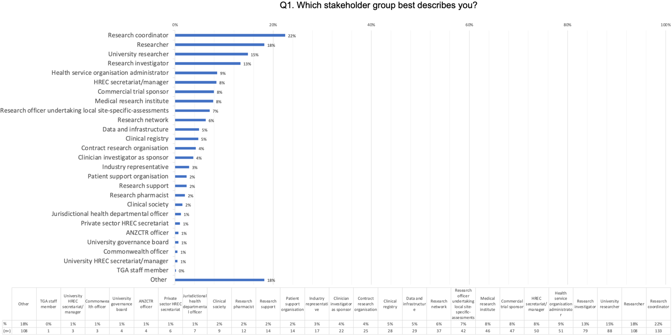

Respondents, by organisation
Respondents were asked to nominate which organisation, agency or institution they worked for. Of the 549 responses received, 133 identified as belonging to a broad range of employers across government, universities and private organisations (Table 1).
Table 1: Most cited organisations, institutions, agencies to which respondents belong (n=133)
Organisations/agencies/institutions | Total (n=133)
Queensland Department of Health | 27
New South Wales Department of Health | 20
Monash University | 19
MSD | 12
University of Queensland | 11
Monash Health | 11
Peter MacCallum Cancer Centre | 10
University of Sydney | 8
University of Newcastle | 8
Austin Health | 7

Respondents, by experience in the sector
Of the 590 responses received, 389 (66%) respondents reported having been involved in the sector for more than 10 years (Figure 2).
Figure 2: Number of years respondents have worked in the health and human research sector (n=590)
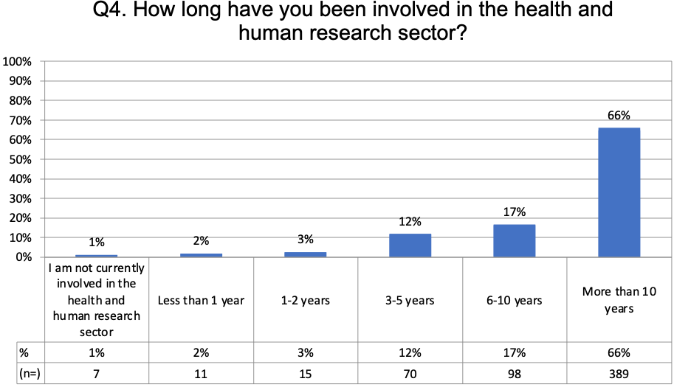

Respondents, by state and territory
The largest group of respondents are based in NSW (39%), followed by Victoria (25%), Queensland (19%), SA (6%), and WA (5%) (Figure 3).
Figure 3: Survey respondents, by state or territory (n=588)
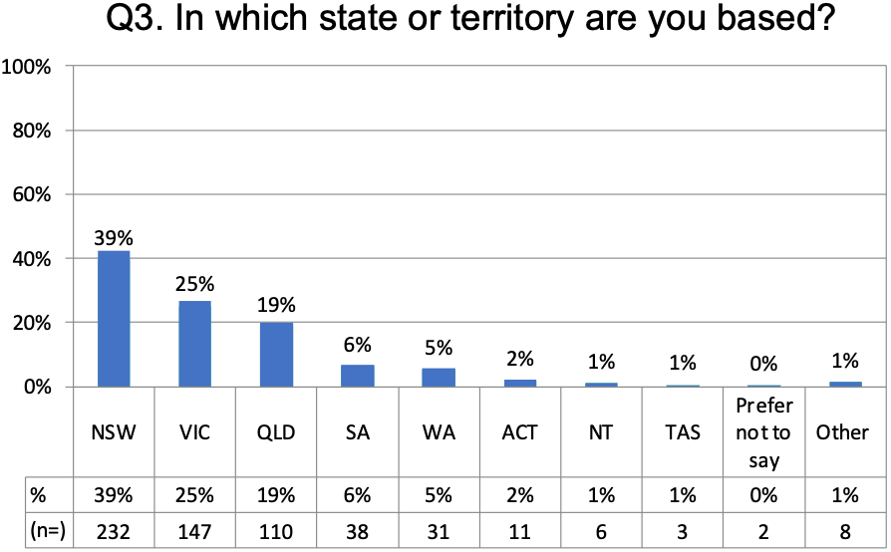

Evaluation of existing ethics workflow platforms

Usage of systems
Respondents were asked to share their experience of existing ethics workflow platforms. On average, respondents had experience with at least two systems (average = 2.3). Among these, the systems most commonly cited by the 542 respondents were ‘Ethics RM’ (53%), ‘REGIS’ (51%) followed by the ‘NHMRC’ (40%) (Figure 4).
Figure 4: Respondents’ experience across all ethics application systems (n=542)
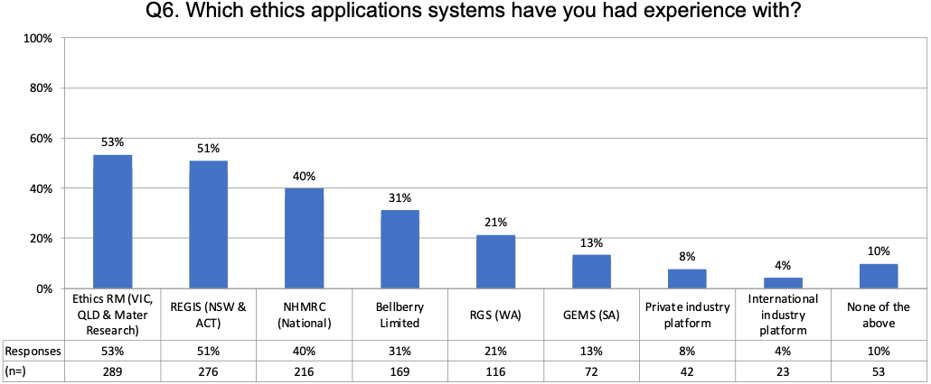
When asked which system they use most regularly, ‘Ethics RM’ and ‘REGIS’ were again the top responses from among the 477 responses received (Figure 5).
Figure 5: Ethics application systems used most regularly by respondents (n=477)
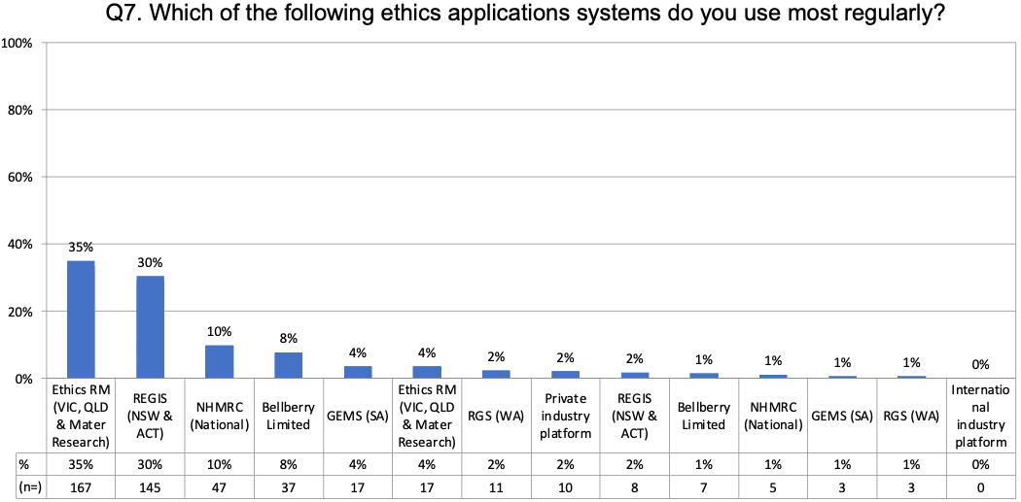

Issues with existing systems
The proposed platform aims to address some of the systemic issues that have been seen as barriers to the efficient and effective conduct of research in the past (Figure 6). The top issues identified by 555 respondents included:
- Navigating the various approval processes and systems (70%)
- Duplicative manual data entry into multiple systems (62%)
- Ethical review and approval process and systems (61%)
- Comparative timeliness of research start up (50%)
- Local site research authorisation (50%).
Figure 6: Issues commonly faced by respondents (n=555)
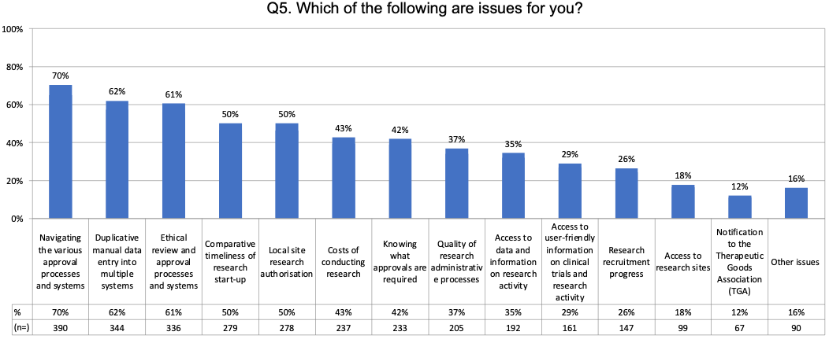

Existing ethics workflow platforms – likes
Respondents were asked to identify the positive aspects of the ethics workflow platforms they use most regularly (Table 2). More than half of the respondents offered a response (n=338; 56%).
Responses included fundamental system characteristics, including that the system:
- Provided a centralised platform for approvals (15%)
- Was online and did not generate paperwork (11%)
- Was familiar to the respondent (1%).
Other key functionalities that were endorsed included:
- Having an overview of application status/progress (9%)
- Ability to share with multiple users (8%)
- Access to support/helpdesk (6%)
- Pre-populated text (5%).
Based on the responses received, key functionality for consideration in the development of the One Stop Shop would include progress bar, multi-user access, on-screen support, pre-populating text, secure document storage, and notifications.
Table 2: Positive aspects of existing systems (n=338)
Total (n=338) | (n=) | %
Ease of use | 74 | 22%
Centralised | 52 | 15%
Online paperless | 36 | 11%
Application overview/status/progress | 30 | 9%
Sharing multiple users | 27 | 8%
Support/helpdesk | 21 | 6%
Quick turnaround | 17 | 5%
Auto-populated text | 16 | 5%
Secure storage of information | 16 | 5%
Notifications/alerts/reminders/feedback | 9 | 3%
Design | 6 | 2%
Automated templated letters | 5 | 1%
Communications | 4 | 1%
Customisable | 4 | 1%
Downloads | 3 | 1%
Familiarity | 4 | 1%
Dynamic/smart | 3 | 1%
Quality assurance | 1 | 0.3%
Other | 3 | 1%
Below are some representative verbatims from respondents in answer to the question: ‘As a user, are there any aspects that you particularly like about the system you use most regularly?’
Most used system: Ethics RM
‘Although it takes some time to get used to, once a project is created, it is fairly easy to see how many amendments, annual reports etc have been made. The sharing function to colleagues also works very well.’
‘I do like being able to receive, process and review research applications digitally, removing the need to have large volumes of paper. Being able to track the journey through the approval process for an application via a dashboard is very useful and also allows easier reporting on workload to management.’
One: that other research offices within the NSW Health system have access to the same documents, and don’t need to [have them] emailed separately, etc. Two: that it is a records repository. Three: being able to view/search by other IDs associated with the project (for example, Local ID).’
‘The ERM has a good layout: [it] is easy to see where, and what, the parent project is, and to see the sites listed under that lead approved project. Sub-forms are easy to generate.’
‘Questions are based on answers provided in previous sections thus avoiding sections not relevant to project.’
‘The ability to copy addresses and other data between different fields. Being able to download a copy of the information provided after submission.’
‘Email notification for documents that need my attention/review with a hyperlink straight to the site.’
Most used system: REGIS
‘Workflow combining SSA and central ethics is a step up.’
Most used system: NHMRC
‘Dynamic HREA form, completion online at website, can be downloaded to computer, guides along the way to assist researcher to complete questions. Similarly, SJGHC dynamic forms with guides along the way to complete submission with accompanying HREA.’
‘That the platform is accepted nationally and is relatively easy to navigate and share with team members.’
Most used system: Bellberry
‘Self-evident, good [standard operating procedures] SOPS, plenty of staff who turn around information in timely accurate accountable and traceable manner. Easy filing of documents. Plenty of dates for HREC review, good process on cycle queries, timely follow up. Professional educators that are directly accessible.’
‘Knowledgeable staff, streamlined processes, lots of information accessible from their website, the fact that applications are checked upon receipt and if something is missing or wrong [the] application is returned pretty fast for correction which avoids wasting the time of the reviewing committee and wasting time in cycle of comments.’
Although the question asked respondents to identify what they ‘liked’ about the system they use most regularly, a significant number of responses reflected negatively on the system commonly used in New South Wales and the Australian Capital Territory (REGIS), describing it as ‘clunky’, slow, non-intuitive, lacking functionality and being affected by glitches. Some representative verbatims are included below:
‘Systems like REGIS make the process even more complicated [such] that I would prefer paper forms over REGIS at the moment.’
‘A plethora. REGIS is difficult to navigate, and it can be very hard to locate simple tasks like submitting an amendment, for which you need to enter the project, click the application, open the original ethics submission, go to ‘Forms’ and then create a new form, which you can then class as an amendment. There’s also limited capacity to combine changes into a single amendment, such as changing a [Participant Information Statement and Consent Form] PISCF. [Also] adding a new site can’t be done currently …’
‘There is little to like. REGIS is clunky, poorly documented, and designed for researchers from another universe.’
‘I have been using REGIS weekly since the beginning, doing every kind of submission on it, and I still get lost and confused about where functions are located.’
‘I don’t like using REGIS at all.’
‘Very hard to comment here as the system (REGIS) has caused me a lot of grief (and I’d say some level of harm to be perfectly frank) given it’s tremendously poor implementation and lack of functionality.’
‘No REGIS is not user-friendly and has many glitches.’

Existing ethics workflow platforms – dislikes
Respondents were asked to identify aspects of the ethics workflow platforms they use most regularly that don’t work well or could be improved. More than half (n=355; 59%) offered a response (Table 3).
In answer to this question respondents identified wants and needs, including:
- Having approval processes centralised in a single system (29%)
- Having a more user-friendly interface (21%)
- Being able to enter text once and have it pre‑populate in relevant fields (12%)
- Standardising the requirements (11%)
- Having better navigation (11%)
- Having better reporting capabilities (10%).
Respondents also mentioned frustrations including:
- Having to upload documents one by one
- Confusing instructions
- Having to duplicate text responses
- Difficulties/complications in amending or editing submissions
- Slow page-loading speeds
- Problems storing and archiving documents within the system
- No oversight on the progress of their submission.
Table 3: Aspects of existing systems which don’t work well or could be improved (n=355)
Total (n=355) | (n=) | %
Centralised | 103 | 29%
More user friendly | 76 | 21%
Auto-populated text | 42 | 12%
Standardised | 39 | 11%
Better navigation | 39 | 11%
Better reporting capabilities | 35 | 10%
Better sharing capabilities | 31 | 9%
Transparency of review timelines | 30 | 8%
Better ability to amend/edit | 30 | 8%
Greater clarity of instructions requirements | 24 | 7%
Customisable option | 24 | 7%
Better communications/correspondence | 24 | 7%
Better support/guidelines/training | 20 | 6%
System speed (e.g. page loading) | 16 | 5%
Better document storage management | 14 | 4%
Everything | 13 | 4%
Targeted notifications alerts/reminders/feedback | 12 | 3%
Better design | 11 | 3%
Bulk document uploads | 9 | 3%
Below are some representative verbatims from respondents in answer to the question: ‘In your opinion, are there any aspects of the system you use most regularly that don’t work well or could be improved?’
Most used system: Ethics RM
‘Reminders and notifications to multiple users, not just the PI, so queries and issues can be actioned in a timely manner.’
‘The biggest thing is different HRECs use the system slightly differently. One hospital HREC insists email-only for correspondence (for example, notifying of approval). [Another] hospital HREC insists on using correspondence in ERM only. When you work [in] different collaborations across jurisdictions the inconsistencies quickly become apparent, and waste everyone’s precious time (not just the research team, but the HREC/RGO admin, etc). The bug that [you] have to put a period in [the] 2nd address line – it’s a small thing but one of those annoyances that catch out both myself and people I mentor.’
‘Although the ERM is intuitive, it doesn’t allow for much room when applications have exceptions to the rule/are not straightforward. Also, given the amount of data entered when completing an application there should be a reliable reporting function for research office staff (and other research administrative staff) to use. The ability to extract reports from the platform will be particularly useful and relevant to meeting the requirements of the National Clinical Trial Governance Framework.’
‘Reporting functionality is too complex for practical use in generating reports to answer different questions. Every other week someone asks a different question, and so data fields to answer the question are different. Poor formatting of system generated communications/letters.’
‘Reporting is terrible as the data comes from user-completed forms with minimum validations. Each site has a slightly different process flow which also contributes to poor reporting. It doesn’t link with existing email systems so all messages need to be sent twice: once within the system and once from Outlook.’
‘The reporting function is almost non-existent and, from a researcher’s view, signatures disappear [inconveniencing] both the researcher and others involved.’
‘Reporting is very difficult. Often reports don’t include [the] fields needed to filter details down. Administrators can build special reports if needed, however it is difficult. ERM can assign applications to reviewers such as governance officer, ethics chair, ethics committee members or other administrators. However it retains [all] this information, so when a sub-form is assigned for review it is sent to [all] the original reviewers as well as any new reviewers added. More often than not, this is not appropriate and limits our ability to use the review function in ERM. Reminders for applicants are not automated, rather these have to be manually produced in a very labour intensive process. It is difficult to track when annual reports are overdue for research projects – again this is a manual reporting process only available through the system administrator. When uploading documents for inclusion in their application, applicants are required to tick each applicable document type before they have an option or ability to upload that document. It’s counterintuitive and usually means many documents are missing in a submission to ethics and governance. Reviewers who have access to the sub-forms don’t automatically receive access to other form submissions, so if a reviewer needs to refer to an earlier document or submission, they often can’t open it.’
‘Reporting functionality, in its current form, is quite complicated and hard to navigate. Some of the data extracted in the reports is not always correct, despite the correct information being captured in the system.’
Most used system: REGIS
‘User interface is unacceptable, the terminology is not user-friendly, navigation is impossible, way too many study numbers, no email notifications from the system when stuff is due. The assumption that the PI will complete most of the actions and admin within REGIS is ridiculous and slows the whole process. The inability to edit and review documents in one step [needed].’
‘They should only collect the information needed to make an assessment against the National Statement. They are not intuitive. They were not co-designed by end users. They do not issue reminders for annual reports (except for Tasmania HREC).’
‘It is inflexible – you can’t alter the order of projects and submissions in the document ‘tree’. There is no facility to complete one annual governance report and then send this to all sites in the study.’
‘Difficult for multi-centre trials that cross state borders.’
‘Not intuitive, does not flow well, is difficult for the researcher, does not identify documents well, cannot easily run reports on the data input, cannot replicate metric reporting used by Ministry of Health (MoH), agendas and minutes are of poor quality and require significant editing, correspondence requires editing, does not talk to any other systems and has hard barriers between jurisdictions, help desk support is very sub‑standard.’
‘Amendments are cumbersome, annual reports make no sense to research that is not a clinical trial, [or] surveys.’
Most used system: Bellberry
‘Changes/updates to requirements/policies/application form design aren’t well communicated.’
‘Some questions can be very vague and bureaucratic; reporting requirements are unclear. There are types of documents/events that DO NOT require reporting/submission and [are] not outlined anywhere.’
Most used system: GEMS
‘The convoluted numbering system of the HREA questions is difficult in terms of quoting back to researchers when HREC queries arise about the submission.’

Opportunities for improving ethics workflows
Respondents were asked to offer their suggestions on how ethics workflow could be improved in the future. Seven key themes emerged:

1. Centralise
A system that integrates and supports the requirements of all jurisdictions and therefore supports multi-site submissions. This endorses the National One Stop Shop concept.

2. Standardise
Consistency across all jurisdictions for definitions, requirements, processes and policies relating to ethics approvals.

3. Change policy or process
New approaches to how ethics committees function and how approvals are managed (for example, a single national HREC to manage all applications).

4. Clarify requirements
Communicating requirements clearly and in plain English, and simplifying and scaling down requirements overall.

5. Support transparency
A clear view of the status of the application as it progresses through the workflow, with timely communication around deadlines, next steps, and anticipated timeframes.

6. Enable pre-populating text
Reducing data-entry duplication by enabling text to be carried across to relevant sections (for example, where information is common to the applications required for multiple sites).

7. Provide HREC education
Ensure that the HREC workforce have the skills and qualifications necessary to assess applications and oversee their approval in a timely and consistent manner.

Site-Specific Assessment processes

Jurisdictions
Respondents were asked in which jurisdictions they had sought Site-Specific Assessments (SSA) in the past. On average, the 440 respondents had obtained SSA in at least two different jurisdictions (average = 2.3). Among these, the jurisdictions most commonly cited were New South Wales (55%), Victoria (42%) and Queensland (40%) (Figure 7).
Figure 7: Jurisdictions in which respondents had obtained SSA (n=440)
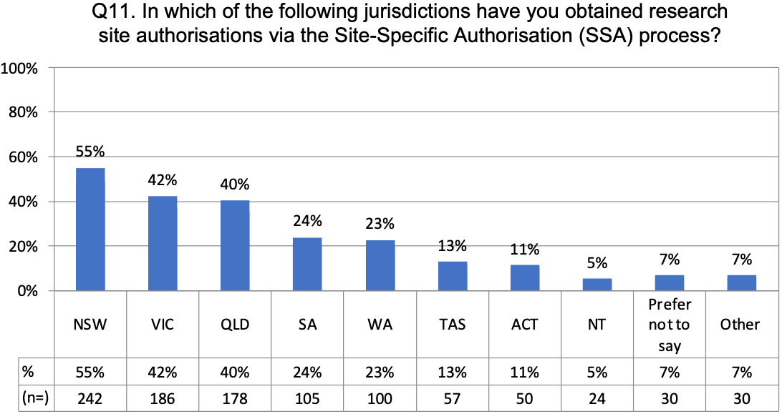
When asked which jurisdiction they operate in most regularly, the most commonly cited jurisdictions from the 454 respondents were New South Wales (37%), Victoria (24%) and Queensland (19%) (Figure 8).
Figure 8: Jurisdictions in which respondents operate most regularly (n=454)
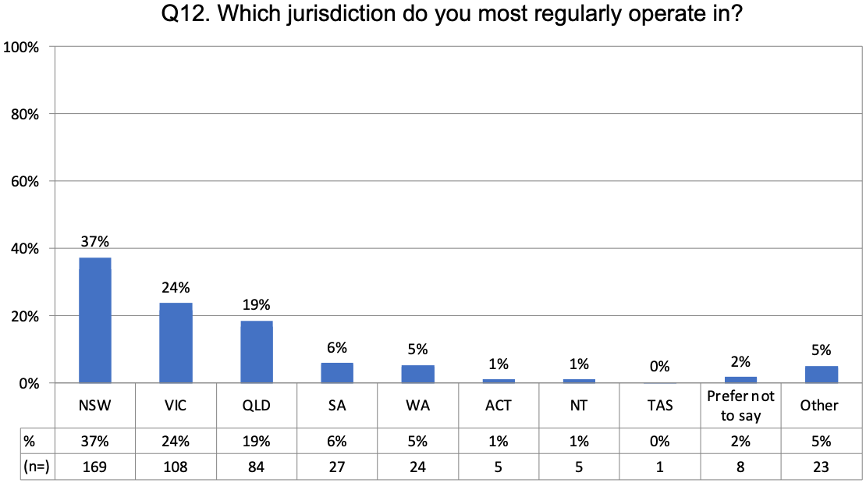

Site-Specific Assessment workflow functionality
The National One Stop Shop is an opportunity to optimise and integrate the workflows for reviews and authorisations. Respondents were asked for their suggestions on how to improve aspects of workflows, and how to support the integration of workflows into a single platform.

Functionality to improve the Site‑Specific Assessment workflow
Respondents were asked to offer their suggestions on functionality that could improve Site-Specific Assessments (SSA) workflows in the future. Respondents proposed functionality and other aspects of platform design which can be grouped into five key categories:

1. ​​Simplifying and consolidating
- Pre-populated text
- Simultaneous application process
- Simultaneous review process
- Eliminate executive summaries

2. Consistency and centralisation
- Centralised approval process
- Centralised approval registry
- One reference number for government and ethics
- National standards
- Standardised agreements

3. Platform/process responsiveness
- Real-time submission and approval status
- Direct sponsor submissions

4. Other functionality requests
- Electronic signature
- Automated approval notification
- Consent form template
- Multiple user access
- Pop-up instruction guides
- Critical information summary
- User profiles
- Document requirement checklist
- Roles and responsibilities guides
- Templated checklists

5. Standardisation
- Templates for contracts; participant information sheet and consent form and HREC approval letters
- Anticipated approval timelines

Support for the integration of workflows
Respondents were asked to offer their suggestions on how to support the integration of ethics approvals, regulatory approvals and SSA authorisations into a single platform. Responses from 298 respondents fell into six categories, illustrated below with representative verbatims:

1. Multi-site access to data and documents
- ‘HREC approval letters to be visible in the ‘system’ so that new sites have access to previous approvals.’
- ‘Allowing the system to add new sites and new site will be able to see previous approved documents and letters.’

2. Reduction of duplicate data entry
- ‘Only require documents to be uploaded once, but accessible through all forms. Auto-complete forms, to remove duplicate data entry.’

3. Consistent and standardised requirements
- ‘It is so hard when you do cross-jurisdictional research and have to spend hours working out exactly how each jurisdiction wants the forms completed.’
- ‘Clear understanding of the site authorisation workflow, seems to be different at every site and not transparent.’

4. National portal
- ‘One central system used across Australia and the ability to perhaps just submit to one authorisation office per organisation.’

5. Ethics and governance integration
- ‘A truly integrated application process that would incorporate ethics & governance for all sites in one step.’

6. Visibility of timelines
- ‘Timeline of SSA submission relative to ethics submission if both at the same site can be unclear.’

Functionality for more timely reviews and approvals
Respondents were asked to offer their suggestions for functionality that could be embedded into the platform to support more timely reviews and approvals. Responses from 273 respondents were aligned with themes and suggestions raised in previous workflow questions (Figure 9). Apart from the key recommendation of having a single, centralised system, the top time-saving suggestions included:
- Automated reminders
- Transparency of review
- Benchmarks for review timelines
- Transparency of review timelines
- Standardisation of requirements.
Figure 9: Suggestions for functionality to support more timely reviews and approvals (n=273)
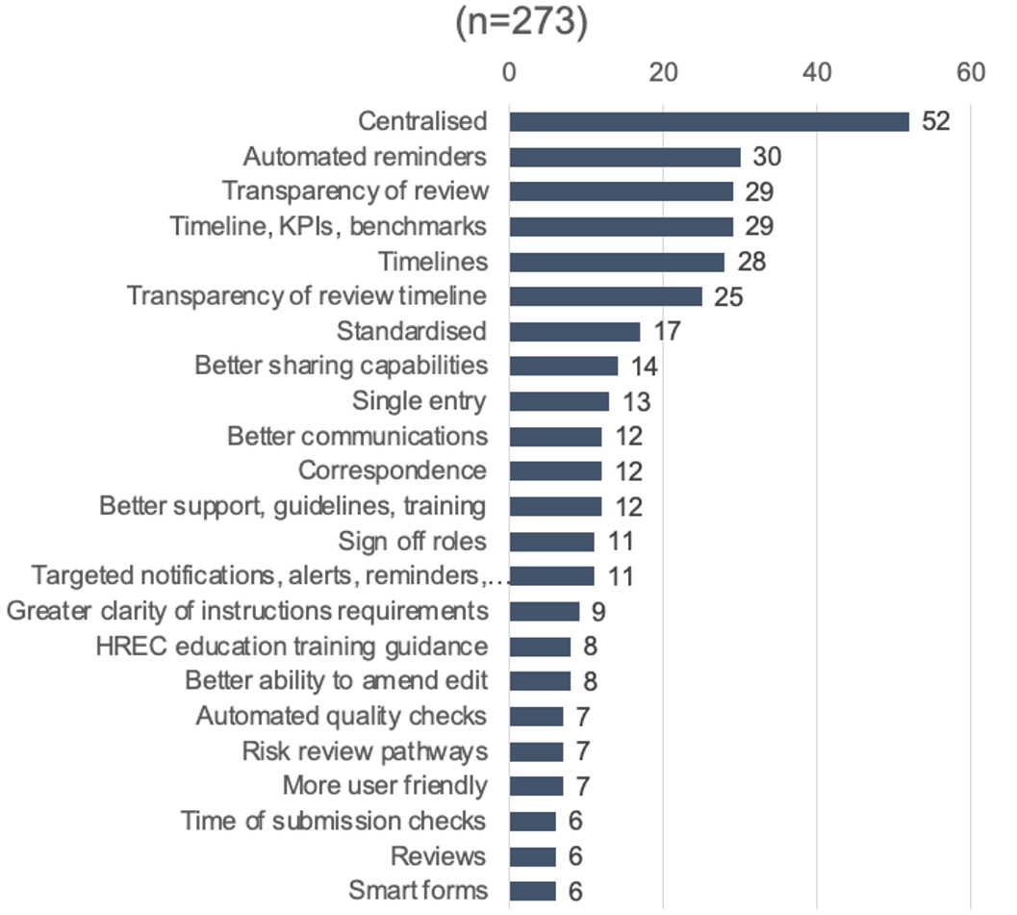

Workflows to meet National Clinical Trials Governance Framework accreditation requirements
Respondents were asked what information workflows might help them to meet their requirements for accreditation under the National Clinical Trials Governance Framework (Governance Framework). Although 216 respondents answered the question, many felt that this was not their area of expertise and/or that they were not able to comment. The key themes that emerged among those that did respond included:
- A need for greater clarity on the Governance Framework definitions
- More guidance on the requirements of accreditation
- More clinical trial governance training for research teams
- Functionality to track and report on CTGF requirements.
Below are some representative verbatims from respondents:
‘Be very clear what qualifies as a clinical trial. In WA there are so-called ‘cluster trials’ in ‘public health which are actually ‘clinical trials’ and described as such when researchers don’t appreciate the difference. HRECs need to make this much more distinct.’
‘The use of checklists throughout so that everyone is aware of what is needed for all approval processes.’
‘Easy access to good clinical practice (GCP) training for medical officers. Task-specific GCP training. For example, if a registrar is only involved in data entry for a specific clinical research project, it may not be necessary for them to complete a full GCP course.’
‘Able to add sponsor to oversight the progress of submission/approval.’
‘Ability to generate the required reports – we currently don’t have that functionality with ERM in Victoria and need to purchase other systems to generate those reports.’
‘Researchers [should] be provided [with] education and information on what study design/category their research project falls under.’
‘Better explanations nationally about the types of research. High-risk is easy, but the other non-conventional types [such as] registries, laboratory, etc are less clear.’
‘Much clearer information about the framework and what is expected.’
‘The ethics system should be able to provide timelines automatically and in a format that can be provided to your institute for the National Clinical Trails Governance Framework.’
‘A platform that includes and can report on as many of the elements of the National Clinical Trails Governance Framework as possible so that organisations don’t need to run duplicate tracking systems.’
‘Build the system to match accreditation requirements with real-time reporting.’

Minimising data-entry duplication
Duplicative data entry was identified as a significant barrier to the conduct of efficient and effective research. When asked to specify the fields that required repeat input on applications for multi-site research, respondents named fields that fell into five key categories:

1. Project summary
- Study details/project details
- Study title
- ID numbers
- Research category type
- Project summary
- Cover letter
- Study objectives

2. Team contacts
- Investigator/PI details
- Contact details/Researcher details
- Team details

3. Finance
- Finance details
- Funding details

4. Project details
- Site details
- Protocol details
- Sponsor details
- Consent details

5. Submission data/requirements
- Ethics approval submissions (multi-site)/ethics requirements
- SSA details
- Recruitment data
- Submission data
- Document uploads
- Governance requirements
- Legal requirements

Common responses
The most common individual responses were ‘investigator details’ (17 mentions), ‘study details’ (15 mentions), ‘site details’ (6 mentions), and ‘protocol details’ (6 mentions).
When asked for suggestions on how to minimise data duplication, respondents cited a variety of solutions, all of which support the development of a fit-for-purpose, fully integrated platform featuring a seamless, consistent and intuitive user experience across all agencies, institutions and processes. Below are some representative verbatims from respondents.
Regarding developing a single, centralised hub for all reviews, approvals and authorisations:
‘One system should be used throughout Australia and the next steps should be automatic.’
‘A truly national system which includes site-specific assessments – it all pre-populates from the one entry’
‘A single application that goes to all relevant sites.’
Regarding applying the research protocol to other workflow-specific requirements:
‘I have NEVER understood why it needs to be broken down and sliced up both for ethics, then again for governance, then again for the Clinical Trials Research Agreements (CTRA) and then again for the Risk Assessment Office, then again for the multi-institutional agreements. It is one endless process after another which is just driving researchers away from doing really valuable work. There’s the protocol and there is the budget. All the information is in there.’
‘Allow references to page and sections of protocol.’
‘Reduce the overlap between the protocol and the platform data entry – for example, allowing ‘See protocol section XX’ in the platform data entry. [Alternatively] using a shorter protocol that simply describes the study methods, and [then] including project background, risks, risk management etc in the platform.’
Regarding enabling pre-population/auto-population of text across relevant fields:
‘Have a cohort of information, such as ‘title’, ‘PIs’, ‘sponsor’, that is automatically pre-populated in all future documents.’
‘Allow the system to migrate data over from one form to another for instance ‘title’, ‘recruitment process’, ‘documents’ etc.’
Regarding enabling document and data sharing across workflows:
‘HREC approval letters within the system should be visible by governance without site submission.’
‘Having one upload option for documents to be sent to ethics and Research Governance Officers (RGOs) for site-specific assessments (SSA). The ability to copy, for example, ‘investigator details’ and/or ‘contact details’ would be helpful.’
‘If you could upload all your study documents on to the platform ONCE. If you absolutely need something very specific for only one site, there could be a site-specific folder for uploading a new document [for that] one site.’
Regarding co-designing and testing the platform with representative users:
‘More user acceptance testing (UAT). Have actual study coordinators or ethics submission people try out the systems first, and give users an opportunity to point out areas that don’t work/are repetitive/could be improved etc.’
‘Can we please have genuine co-design between users (ethics, regulatory and researchers/coordinators) in the design rather than having ethics and regulators design things that work for their purpose.’
‘Conduct data-mapping exercises for a range of different types of research; co-design new systems with users.’

Filtering functionality
The National One Stop Shop is expected to include functionality to enable users to choose and limit the information they share with stakeholders about health and human research.

Information-sharing – internal
Respondents were asked to identify the stakeholder groups that they commonly needed to share information with, self-allocating these to either internal or external categories. There was some crossover between stakeholders identified as ‘internal’ and those identified as ‘external’.
Among those that identified internal shareholders (n=252), responses included:
- Investigators (21 mentions)
- HREC (18 mentions)
- Researchers (18 mentions)
- RGO (16 mentions)
- Finance (10 mentions)
- Pharmacy (9 mentions)
- Pathology (9 mentions)
- Supporting departments (8 mentions)
- Governance (8 mentions)
- Executives (8 mentions).
Among those that identified external shareholders (n=254), responses included:
- The research sponsor (58 mentions)
- The Therapeutic Goods Administration or TGA (29 mentions)
- The relevant contract research organisation or CRO (20 mentions)
- NHMRC (17 mentions)
- HREC (14 mentions), sites (13 mentions)
- Funding bodies (9 mentions)
- Universities (7 mentions)
- Funders (7 mentions).

Information-sharing needs, by category
‘HREC reporting’, ‘Approvals needs’, ‘Adverse event reporting’, ‘Regulatory needs’, ‘Medical and patient care needs’, and ‘Business needs’ were the categories of information most commonly identified by the 309 respondents as the ones they needed to share with stakeholders. Other unprompted responses included the ‘Sharing of KPIs, outcomes and/or project impact’, ‘Governance reporting’, ‘Community reporting’, ‘Recruitment numbers’, and ‘Financial information (expenditure, insurance, billing, funding)’. (Figure 10)
Figure 10: Categories of information shared with internal and external stakeholders (n=309)
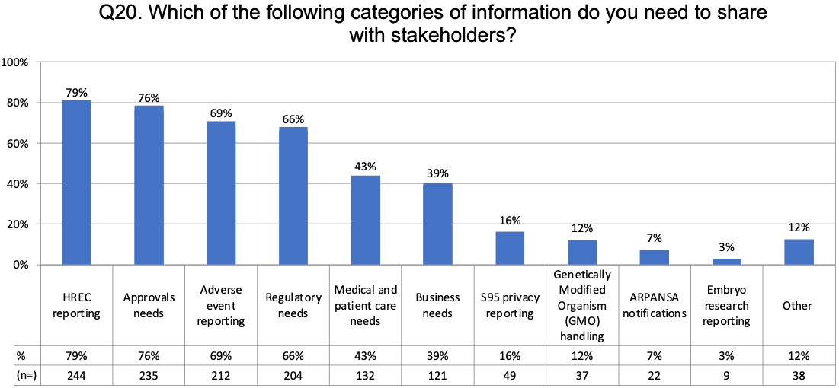

Information-sharing needs, by mode of sharing
‘Email’ (90%) was by far the most common method used to share information with shareholders according to the 300 respondents, followed by ‘Online portals’ (47%), ‘Internal systems’ (42%) and ‘Phone’ (40%) (Figure 11).
Figure 11: Methods used to share information with internal and external stakeholders (n=300)
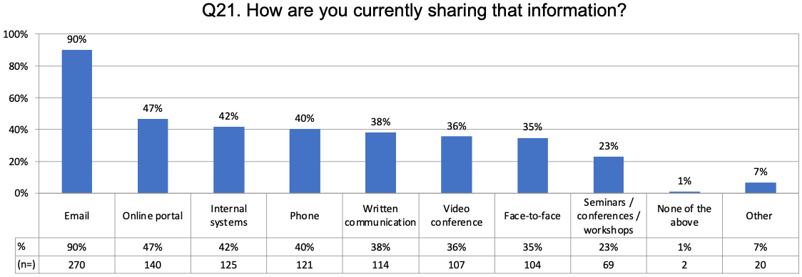

Health and human research registry

Access to information
Respondents were asked what sort of information they would like to have access to, via a health and human research registry. Their responses fell into six categories:

1. Directories
- Comprehensive clinical trials directory (inc. objectives, outcomes and status)
- Researcher by location
- Investigator directory
- Approvals registry
- Recruitment registry
- Site directory

2. Project data
- Clinical trials data
- Clinical trials executive summaries
- Submissions information
- Performance metrics
- Disease-specific data
- Site-specific data
- Funding breakdown
- HREC approvals
- RGO approvals

3. Guidance
- Submission guidance
- Training
- Approvals submissions
- Regulatory best practice
- Privacy and ethics interpretation support
- FAQs
- Schedule of fees

4. Health data
- Real-time data
- Disease-specific data
- Medicare data

5. Patient
- De-identified patient data
- Patient feedback
- Patient/volunteer registry
- Patient drop-out/retention data

6. Opportunities
- Funding opportunities
- Collaborator availability
- Collaboration opportunities
- Future trials

Information and resource needs

Embedded resources
Respondents were asked to consider what other sorts of information could be embedded into the National One Stop Shop platform to support them in their role. Information that respondents said they would find helpful and relevant fell into three main categories:

1. Application support materials
- Submission guidelines
- Submission flowcharts
- Submission checklist
- Exemplar submissions
- Document templates (for example, Patient Information Consent Form)
- Standard approval timelines
- Budgeting tool

2. Research support materials
- Training (especially Good Clinical Practice)
- Project-planning guidelines
- Research-design/co-design guidelines
- Standard operating procedures
- Reporting guidelines (including adverse-event reporting)
- Participant resources
- Case studies

3. National requirements
- Legislative and regulatory requirements
- TGA notifications
- Privacy principles
- Definitions

Reporting requirements

Metrics and other information
More than half (56%) of 274 respondents reported that they received some information about research activity.
Respondents were then asked about the reporting measures that were of most use to them in their role, and 257 replied. From a list of options, information about ‘HREC and Local site authorisation approval timelines’ was the most commonly cited measure (82%). Also mentioned by more than half of respondents were measures relating to ‘Site recruitment’ (65%), ‘Trial recruitment’ (61%) and ‘Overall study start-up timeline’ (57%) (Figure 12).
Figure 12: Reporting metrics of most value to survey respondents (n=257)
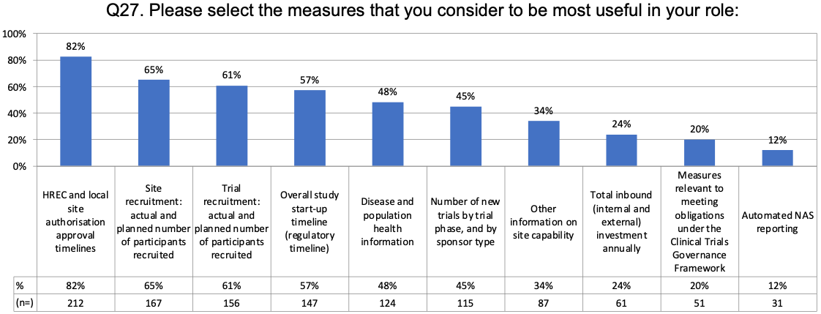
Respondents were also prompted to identify other operational measures of value to them in their role. The 149 responses included:
- Start-up metrics
- Schedule of fees/costs/financial
- Clinical trial participation metrics/recruitment progress
- Clinical trial outcomes
- Approval timelines/timelines
- Reporting
- Clinical trial status
- Clinical trial resourcing/staff availability
- Benchmarking
- Regulatory requirements
- Publication metrics
- FTE modelling
- Research reports
- Department data
- Site capability.

Report dissemination
Respondents also indicated they would need this information reported primarily at the research site level for research staff including research coordinator, followed by service department, institute/organisation.
The majority of the 275 respondents expressed a preference to receive reports via an ‘Online dashboard’ (41%). The second most preferred option was ‘Email’ (27%) (Figure 13).
Figure 13: Preferred methods for report dissemination (n=275)
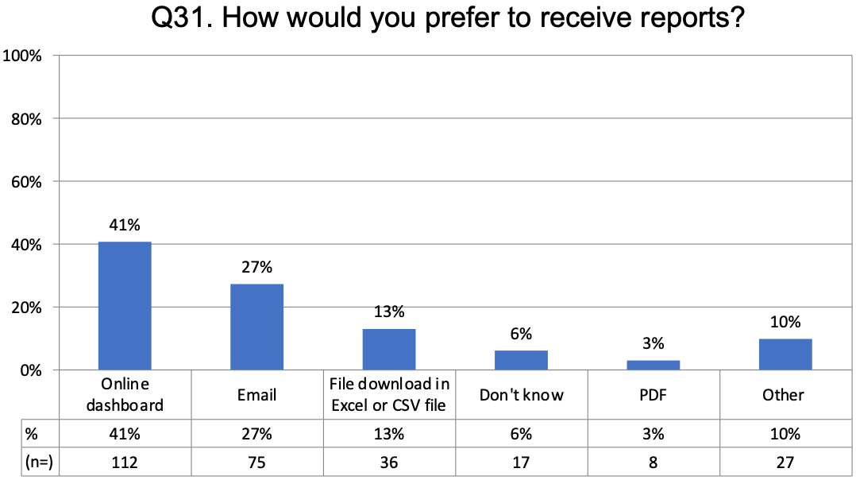

Blue sky thinking
The National One Stop Shop survey was an opportunity to consult with a broad range of stakeholders to establish a scope of requirements for the proposed National One Stop shop. It was also a rare opportunity to tap into the community for some more innovative thinking.

Optimal functionality
Respondents were encouraged to think about an attribute or item of functionality that they personally would like to see in the proposed National One Stop Shop. Predominantly, responses focussed on features that would help make research start-up processes more efficient, in line with themes discussed elsewhere in this report, specifically:
- Enabling the pre-population of text
- Sharing documents and data across workflows
- Providing a pre-submission checklist
- Enabling electronic signatures
- Supporting online HREC reviews.
This open-ended question also attracted multiple responses relating to the potential for the National One Stop Shop to support data-sharing among Australian researchers, and warning that the opportunity could either be lost or mismanaged if not developed with input from data specialists:
- One respondent cautioned that a platform that was focussed on supporting clinical trials may not have the scope to support data linkage.
- Another suggested the potential benefits of the platform designed as a Research Data Management System, rather than solely an approvals system, specifically noting the value of handling data relating to contracts, finance, reporting, and competencies, as well as pre- and post-approval data.
- It was also signalled in one response that the Australian Research Data Commons (ARDC) would have an interest in collaborating with the Commission on the development of data-sharing infrastructure.

Functionality to meet safety and regulatory obligations
Respondents were encouraged to consider functionality that would allow them to meet safety and regulatory obligations as easily as possible.
Many saw the proposed National One Stop Shop as the underlying solution, calling out specific functionalities such as automated reminders to prompt team members about their obligations, and better reporting capabilities that could be tailored to meet safety and regulatory requirements.
A significant number of responses raised the issue that researchers’ capacity to meet these obligations and requirements was limited. Issues included a perceived lack of time and money for teams to undertake these tasks, as well as a suggestion that the requirements are overly complicated and/or that some researchers may not currently have the skills or knowledge required to deal with them. The solutions proposed included:
- More funding
- Better resourcing
- Clearer instructions regarding obligations and requirements
- Case studies/benchmarking
- Training.

Future-proofing functionality
Looking ahead, respondents were asked to consider functionality that could futureproof the National One Stop Shop in response to impending challenges and opportunities. A total of 158 respondents offered suggestions which can be grouped into four key categories:

1. Centralisation
- A single centralised platform that is mandated to be used across jurisdictions
- Centralising all relevant data and registries
- National metrics register
- Setting national standards
- Aligning ethics review processes

2. Resourcing and infrastructure
- Dedicated funding and IT resources for system upgrades and back-end updates
- State-of-the-art IT system
- Dedicated resources to support adoption and training of the platform

3. Ongoing user consultation and buy-in
- Co-designed platform with input from end users
- Process for ongoing input, design and testing
- Collaboration, support and buy-in from territories

4. Functionality and seamless experience
- Real time data updates
- Data linkages and true integration across processes and other systems
- Simplifying the process
- Flexible and adaptable platform to allow for changes in governance
- Multisite sharing functionality
- Strong data and cyber security measures
- Allow for mobile device functionality

Potential remaining barriers
The National One Stop Shop is intended to address some of the barriers identified by the research community as inhibiting the efficient conduct of quality health and human research in Australia. Respondents were asked to consider what other barriers might still be in place, even after the successful implementation of the National One Stop Shop. This question prompted respondents to air concerns about both the development, and the roll‑out of the National One Stop Shop. Specific issues raised included:
- The importance of taking a co-design approach to the development of the platform, possibly through the involvement of a Working Party with representatives from key user groups
- The need to ensure that the scope of the platform is genuinely national and comprehensive, and specifically that it include universities
- The importance of an iterative roll-out, characterised as ‘user testing’, ‘beta testing’ and/or ‘pilot programs’, and a commitment to the continuous improvement of the platform in the years ahead
- The need for a holistic change management plan to ensure that all jurisdictions and all stakeholders are informed about the platform, and supported for a successful transition to the platform
- The need to ensure that all jurisdictions comply with the new system and any standardisation of requirements that come along with it, possibly through the mechanism of mandates.
Respondents also expressed concern that the research community be supported and encouraged to be competitive in a global marketplace. Within these topics, respondents referred to:
- The need to foster a highly skilled workforce
- The need to support medium- and long-term career development among researchers
- The need to ensure that those responsible for approving research have the knowledge and experience necessary to make informed assessments
- The opportunity presented to build data-sharing infrastructure into the National One Stop Shop.
Additionally, some respondents took the opportunity to advocate for minority groups within the research community, specifically:
- To guarantee support and equity of opportunity for rural and regional researchers
- To emphasise the importance of collaborating and consulting with First Nations communities to ensure that research meets their needs and acknowledges their lived experiences.

Open comment
The final question of the National One Stop Shop gave respondents an opportunity to share any additional thoughts and suggestions around the integration of clinical trial and research workflows.
Again, there was considerable commentary around the need to ensure that the scope of the National One Stop Shop is adequate, and that its implementation is successful. Specific issues raised included:
- Universities must be included in the scope
- The platform must support all types of health and human research, not just clinical trials
- The system, and the standardisation accompanying it, must be taken up by all jurisdictions, without exception
- The platform must undergo iterative implementation via extensive user-testing and/or pilot programs.
Additional comments included:
- The value of embedding risk pathways into the platform to ease requirements and speed approvals for low-risk research activity
- The importance of co-designing research with patients/consumers
- The opportunity, as noted above, for building data-sharing infrastructure into the National One Stop Shop.
In particular, the response from the ARDC proposed further discussion and collaboration to ensure alignment between the National One Stop Shop and their own ‘ARDC health data asset initiative’.


Level 5, 255 Elizabeth Street, Sydney NSW 2000
GPO Box 5480, Sydney NSW 2001
Phone: (02) 9126 3600
Email: mail@safetyandquality.gov.au
Website: www.safetyandquality.gov.au

