

Community Perspectives Survey Report

Addendum 3 – National One Stop Shop and National Clinical Trials Front Door Consultation Report
May 2022
Published by the Australian Commission on Safety and Quality in Health Care
Level 5, 255 Elizabeth Street, Sydney NSW 2000
Phone: (02) 9126 3600
Email: mail@safetyandquality.gov.au
Website: www.safetyandquality.gov.au
ISBN: 978-1-922880-07-9
© Australian Commission on Safety and Quality in Health Care 2022
All material and work produced by the Australian Commission on Safety and Quality in Health Care (the Commission) is protected by copyright. The Commission reserves the right to set out the terms and conditions for the use of such material.
As far as practicable, material for which the copyright is owned by a third party will be clearly labelled. The Commission has made all reasonable efforts to ensure that this material has been reproduced in this publication with the full consent of the copyright owners.
With the exception of any material protected by a trademark, any content provided by third parties, and where otherwise noted, all material presented in this publication is licensed under a Creative Commons Attribution-NonCommercial-NoDerivatives 4.0 International licence.

Enquiries about the licence and any use of this publication are welcome and can be sent to communications@safetyandquality.gov.au.
The Commission’s preference is that you attribute this publication (and any material sourced from it) using the following citation:
Australian Commission on Safety and Quality in Health Care. Community Perspectives Survey Report. Addendum 3 – National One Stop Shop and National Clinical Trials Front Door Consultation Report. Sydney: ACSQHC; 2022.
Disclaimer
The content of this document is published in good faith by the Commission for information purposes. The document is not intended to provide guidance on particular healthcare choices. You should contact your healthcare provider for information or advice on particular healthcare choices.
The Commission does not accept any legal liability for any injury, loss or damage incurred by the use of, or reliance on, this document.

Contents
Statement by the Chair 3
Purpose of this project 3
Initiation of this project 3
The reason 4
Why would we care? 4
The outcome 5
The benefit of getting it right 5
A brief history of clinical trials 5
Why a One Stop Shop? 6
Support for a One Stop Shop 7
Governance 8
Conclusion 8
Executive summary 10
Overview 11
Consultation summary 12
Findings 14
Recommendations 22
Consultation report 25
Introduction 25
The Commission 25
Background to the project 26
Policy context 29
Consultation method 30
Consultation insights 39
System gap analysis and development of the Proof of Concept 58
Summary of business requirements 68
Recommendations for implementation 76
Appendices 87
Appendix 1: Project Governance 87
Appendix 2: Stakeholder engagement strategy and consultation schedule 92
Appendix 3: Phase I consultation insights – Current system issues and future sector requirements by platform components 102
Appendix 4: Frequently asked questions 108
Acronyms and abbreviations 112
List of addenda 115

List of figures
Figure 1: Respondents’ participation in a clinical trial or other health‑related human research (n=475) 8
Figure 2: Respondents’ support of someone else to participate in a clinical trial or other health-related human research (n=473) 9
Figure 3: Respondents’ likelihood to recommend participation in health‑related human research (n=172) 10
Figure 4: Respondents’ likelihood to participate in health-related human research in the future (n=157) 11
Figure 5: Respondents’ sources for finding out about trial/research projects (n=173) 13
Figure 6: Respondents’ recall of consent process (n=153) 16
Figure 7: Respondents’ understanding of consent process (n=153) 16
Figure 8: Respondents’ comfortable with having details stored securely in a national volunteer patient registry (n=314) 24
Figure 9: Respondents’ preference to have control of contact requests (n=304) 25

Executive summary

Introduction
The Australian Commission on Safety and Quality in Health Care (the Commission) is delivering national consultations to inform the development of a National One Stop Shop for health-related human research approvals (the One Stop Shop). Options for improving research participation through a related National Clinical Trials Front Door are also being considered. This includes mechanisms that facilitate access to third party participant recruitment providers.
The Community Perspectives Survey Report collected input from community members on their experience of participating in or, supporting someone else to participate in a clinical trial or other health related research project.
This survey was conducted by the Friday Collective on behalf of the Commission.

Methodology
The survey was developed using an exploratory design to capture the experience of research participants and/or a participant’s carer to generate ideas and recommendations to inform the development of the proposed National Clinical Trials Front Door.
Two pathways were built into the survey: one for those who participated directly in a trial, and one for those who had supported others to participate a trial, such as a child.
The exploratory design supported unforced responses across 11 open-ended questions on topics including the pathways by which individual respondents became involved in clinical trials, the consent processes they experienced, their information needs, and their personal feelings about the experience. A set of quantitative questions captured baseline data regarding past participation in clinical trials, willingness to participate in clinical trials in the future, and likelihood to recommend clinical trials to others.
This approach captured a high-level view of the community experience and generated ideas and recommendations to inform the development of the proposed National Clinical Trials Front Door.
The survey received 477 responses.

Key themes

Motivations
Two motivating factors for research participation emerged:
- The idea that a person was contributing to a broader social good
- The hope that, as a participant, they received a better treatment (with the investigational product) and/or may have a better personal health outcome through increased medical oversight.
These motivating factors were evident among those who had not yet participated in a trial or research, as well as those that had.

Enablers to recruitment
Community members expressed appreciation for enrolment processes that were simple and comprehensive in the information they provided. Community members highlighted experiences where there was a notable absence of pressure, and sufficient time for them to ask questions about the trial and consider options for their care.

Barriers to recruitment
Large volumes of information, particularly information that was dense with medical jargon and terminology, were regarded as disincentives to participation.

Elements of positive experiences
Characteristics of the team and the engagement process that were associated with positive experiences of participating in a trial or research project included, friendly, respectful relationships with members of the research team, ongoing communication and updates throughout the trial or research project and sharing trial results at the end of the project. The inverse characteristics – unfriendly, impersonal staff, poor communication and lack of follow-up – were associated with a negative experience.

Considerations for national volunteer registry
Community members were also asked how they would feel about having their data stored on a national volunteer registry for the purpose of making themselves available for clinical trials or research projects. Support for the proposition was high if respondents retained the right to determine how their information was shared with third parties. Respondents were less likely to be supportive of sharing their data with private providers including, private hospitals and/or private research organisations.

Methodology
The Community Perspectives Survey Report was built to collect input from community members on their experience of human – related health research and clinical trials.
Time in the field | Average time spent to complete the survey | Survey completion rate | Completed surveys submitted
26 weeks  25 November 2021 to 13 May 2022 | 5 minutes | 62%* | 477
* Respondents were not required to answer every question and the verbatim responses provided have not been edited.

Past experience of participation
Of the 477 people who responded to the survey, just over half (255 of 475; 54%) had previously participated in a clinical trial or in some other form of health‑related human research (Figure 1).
Figure 1: Respondents’ participation in a clinical trial or other health‑related human research (n=475)
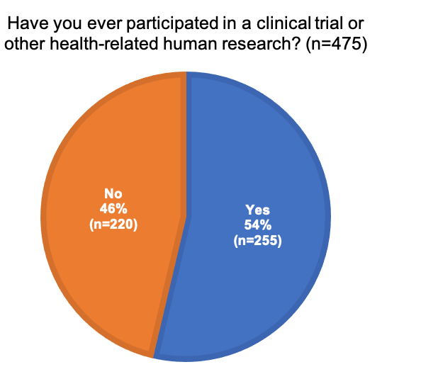
Approximately one third of respondents (160 of 473; 34%) said they had supported someone else, such as a child to participate in a clinical trial or health‑related human research (Figure 2).
Figure 2: Respondents’ support of someone else to participate in a clinical trial or other health-related human research (n=473)
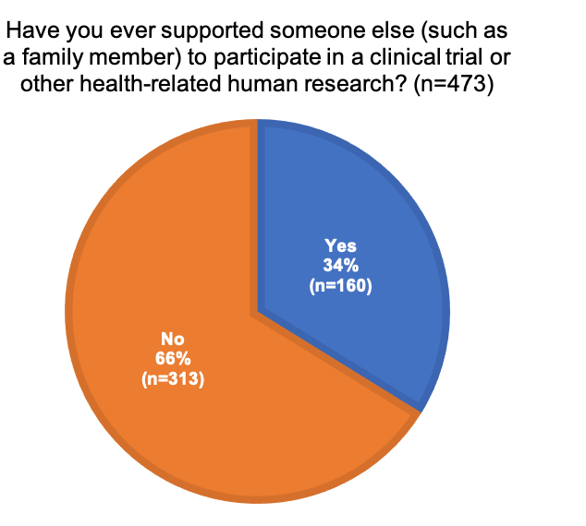

Motivations
Respondents were asked to provide reasons for their decision to participate in a clinical trial or health-related human research. Among those who chose to respond to this question, the 70% (126 of 180) cited altruistic motivations including contribution to the expansion of scientific knowledge, or to the greater good of humanity. Reasons commonly cited included:
Altruistic reasons
Personal benefits through access to latest treatments
Personal background in research and awareness of the need for research participation
A clear and uncomplicated care process
Personal invitation to participate
Financial incentives
Previous experience with clinical trials
Appeal of co-design.
Below are representative verbatims from respondents.
‘I like to contribute to research, also I work in social science research so know how hard it can be to get participants.’
‘So that I could do my bit in making the treatment process easier and better for anyone else who may unfortunately need the same treatment I underwent. To help improve in any possible way.’
‘Because I had a condition that at the time was not well understood and the research looked like it would contribute to the body of knowledge about the condition.’
‘Best chance of surviving leukaemia.’
‘I’ve always felt giving back a little is a very little inconvenience for the benefit of all. Like pay it forward. Some trials and studies may have offered me personally an opportunity to access new types of care currently not mainstream so while potential for negative overall benefit did offer a chance at greater than standard.’
‘To introduce true co-design principles from the ground up. To meet new people and learn to be part of a team. I have been a principal investigator and an associate. I want to see codesigned change and research. I am on research and grant approvals too. I want to help design change. I want to aid research. I don’t want to be a token afterthought. From start principles to knowledge translation, I want to be part of the team. Satisfaction that the research has consumer perspective and innovation.’
‘Interest in topic area; notion of contributing to wider knowledge; ‘paying back’ as I am a researcher who often relies on the goodwill of participants to contribute to research. Research karma.’
‘Only way to get the medication.’
‘GP asked to help identify if a certain medication will improve pain threshold.’
‘Because I was asked and thought it was an interesting study.’
‘My cancer treatment was the result of clinical trials. Without it I would not be here’.
‘Being a researcher myself, I wanted to contribute to knowledge that could potentially benefit other patients. There is also a generalised sense that there is a higher level of care/follow up when on a clinical trial in comparison to standard of care.’

Likelihood to recommend
Respondents who had previously participated in a trial or health-related human research were asked if they would recommend the experience to others. The majority indicated that they would recommend participation in a trial or research to others (166 of 172; 97%), suggesting an overall positive experience (Figure 3).
Figure 3: Respondents’ likelihood to recommend participation in health‑related human research (n=172)
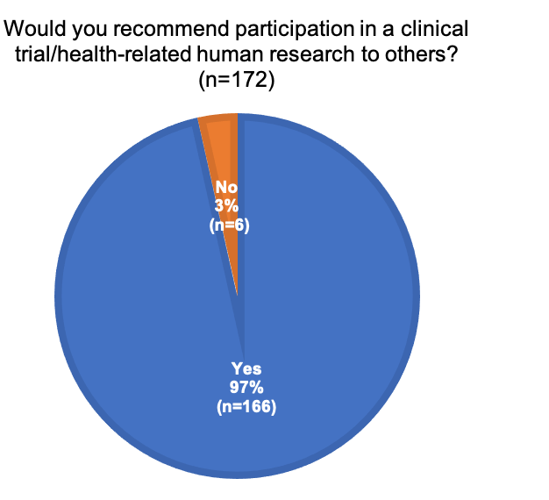

No past experience of participation
Of the 477 people who responded to the survey, 46% (220 of 477) had not previously participated in a clinical trial or some other form of health-related human research.
When prompted, those who volunteered an explanation responded that they were healthy and therefore had no need to participate; they had not been invited to participate or they were not aware of any opportunities to participate. Only a few respondents (4 of 220) responded they had not met the eligibility criteria for trials or in health-related human research.

Future intentions
Respondents who had not participated in a clinical trial or health-related human research in the past, were asked if they would be prepared to do so in the future. Of those who chose to respond 77% (120 of 157) indicated they would be prepared to participate in a clinical trial or in health-related human research in the future (Figure 4).
Figure 4: Respondents’ likelihood to participate in health-related human research in the future (n=157)
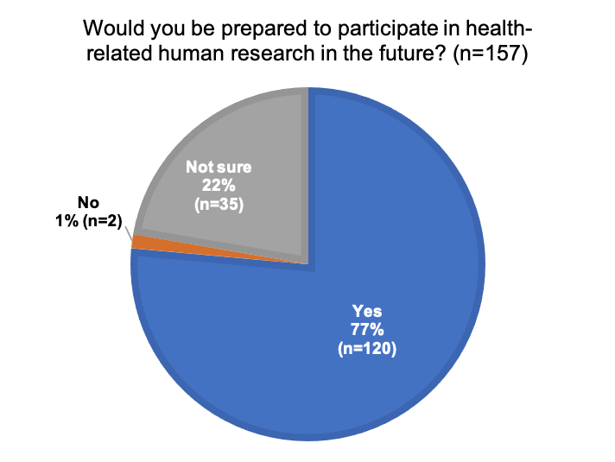

Decision enablers
Respondents who had not participated in a clinical trial or in health-related human research in the past were asked to nominate what would help them decide to participate in clinical trials or health-related human research in the future. Among those who chose to respond (n=145) the most commonly cited inputs were:
Clear information about all facets of the trial or research project
Being well informed by a GP or specialist
Clearly outlined benefits/efficacy of treatments
Understanding of health risks/safety issues
Greater awareness of relevant trials
Remuneration
Altruistic motives: helping find a cure/advance health outcomes/clear research goals
Relevancy/appropriateness
Ease of participation.

Information for decision-making
Respondents who had not participated in a clinical trial or in health-related human research in the past, were also asked to comment on the information they would need in order to make a decision about participating in clinical trials or health-related human research in the future. Among those who chose to respond to this non-mandatory question (n=146), the most commonly cited inputs were:
Information about the risks and benefits of the trial
A Patient Information Sheet including information about purpose, aims and objectives
Information about time and travel commitments
Information about how data will be stored, used and protected
Information about the cost of involvement, or about remuneration
Information about safeguards and safety procedures
Transparent information about trial sponsors and beneficiaries
Eligibility criteria
Information about benefits to the participant.

Recruitment, enrolment and consent

Triggers for participation
Respondents who had previously participated in a trial or research project were asked how they first found out about the opportunity to participate. They were asked to select from a closed set of options which included social media, google/internet search, website, healthcare professional, friend or family member, support group, direct contact from researcher(s), or a trial recruitment app (such as HealthMatch, ClinTrial Refer or Join Us). Respondents were also offered an ‘other’ option.
Over half of those who had previously participated in a trial or research indicated that they had found out about it through a ‘Healthcare professional’ (87 of 173; 50%). Twenty-four per cent (41 of 173) were ‘Actively approached by researchers’. Other common sources included ‘Social media’ (23 of 173; 13%); ‘Support groups’ (19 of 173; 11%), ‘Friend or family member’ (18 of 173; 10%) and ‘Website’ (17 of 173; 10%).
Twenty-five per cent of respondents (43 of 173) selected the ‘Other’ option. In response to the request to provide more detail, commonly cited triggers were print materials (such as posters or flyers in health settings) and newsletters, either from health organisations or special interest groups (Figure 5).
Figure 5: Respondents’ sources for finding out about trial/research projects (n=173)
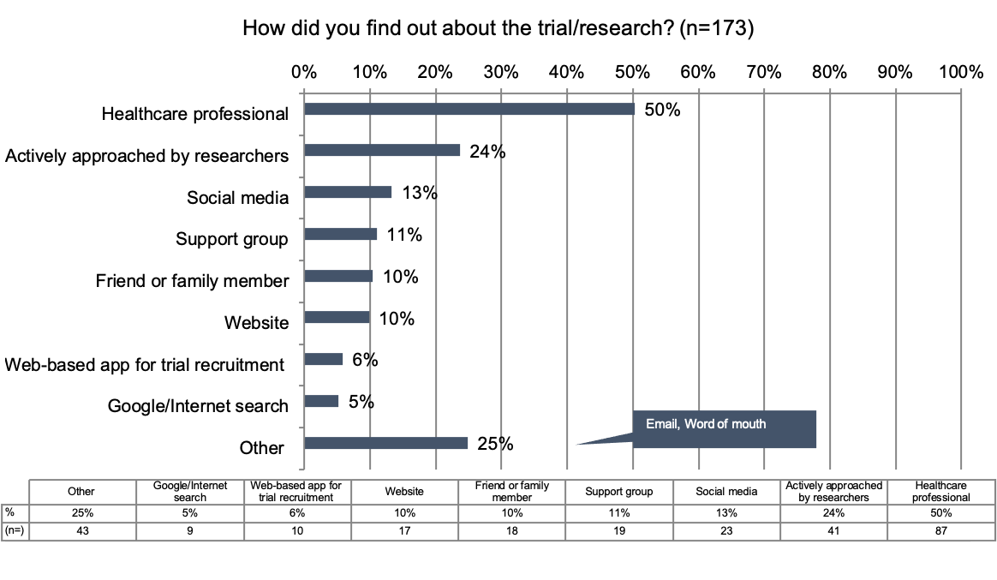

Enrolment and recruitment processes
Respondents were asked to share their recruitment experiences, specifically what they did and didn’t like about the process.
Of those who responded regarding what they liked about the experience (n=171) commonly cited points included:
A quick, easy and simple enrolment process, typically online
Contact with attentive, helpful staff who were able to explain and answer questions
Comprehensive information about aims, processes, risks and benefits of trial/research
A respectful approach with no pressure to join.
Below are some representative verbatims from respondents.
‘Clear communication and explanation. Listing of contacts for questions about the research.’
‘Easy, friendly staff who understood what the study was about and were able to clearly explain everything and knew the answers to my questions.’
‘Factual pitch with a clear purpose. Easy to register and answer questions, i.e. no time‑wasting.’
‘The people explaining what would happen clearly in everyday language.’
‘No pressure to participate.’
‘Via email and you just registered if interested. No pressure.’
‘Someone to contact if I had questions.’
Of those who responded regarding what they did not like about the experience (n=156), commonly cited points included:
Overly complicated information and processes
Sub-standard information that did not answer all questions
Inconvenience of having to appear in person for enrolment
Perception of disrespectful attitude or questions.
Below are some representative verbatims from respondents.
‘There was a lot of paperwork to read, I understood it, but others may have struggled.’
‘Long consent document, which I know put another person off participating in the trial.’
‘I had to attend the site to receive the information rather than it being provided to me in advance by email.’
‘I don’t think the people delivering the message realised the importance of allowing time for consideration.’
‘Insufficient information about how data would be handled, including naïve assumptions about ‘deidentification’ of data’.’
‘The PICF used such simple language that it treated me like an idiot.’
‘Invasive questions from the questionnaire.’
‘Onerous and time-consuming.’
‘They tried to get me to sign that they could use my DNA for other research. I said no. I was quite offended by this and wonder if other people may have been misled.’
‘We were not advised that we could say we didn’t want to take part.’

Quality of information provided
Respondents who had previously participated in a trial or research project were asked to provide feedback on the information they received as part of the recruitment process. Specifically, they were asked to indicate how much they agreed with the following statements:
The information was hard to understand
The information was relevant to my situation
The information was comprehensive
There was too much information.
The majority of respondents who had previously participated in a trial/research project felt that the information they received was both relevant and comprehensive.
A smaller number of respondents agreed either ‘somewhat’ (16 of 255; 6%) or ‘strongly’ (9 of 255; 4%) that the information was too hard to understand. Similarly, more than a quarter agreed either ‘somewhat’ (29 of 255: 11%) or ‘strongly’ (19 of 255; 8%) that they received too much information. Respondents were prompted to provide more information about what they had found hard to understand. The points most commonly cited included:
Unfamiliar medical or technical terminology
Confusing consent processes
Confusing information about all the risks and side effects.
Below are some representative verbatims from respondents.
‘There was lots of medical terminology that was difficult to understand before I entered into the healthcare profession.’
‘The document was complex and used a lot of medical terminology I was unaware of.’
‘… when an update occurred I was handed the 25‑page document and the only way I could ascertain the changes was to go through each document word for word. The changes were explained, but trying to remember all the changes required word-by-word comparison.’
‘Consent and how to withdraw consent.’
‘… time commitments to trial participation are not clear – often there’s an approximation of ‘1 hour’ for the visit but then you end up spending say 3–4 hours when you factor in the wait times; movement amongst departments etc. etc. …’
‘It was more about the consequences of participating in the trial on future treatments and the conditions of my 2 week hospital stay that were not clearly described.’

Consent
Respondents who had previously participated in a trial or research project were asked whether they fully understood the purpose of the trial or research, and the risks involved, before taking part. Of those who responded (n=153), a clear majority indicated that they had fully understood the purpose and the risks (141 of 153; 92%) (Figures 6 and 7).
Figure 6: Respondents’ recall of consent process (n=153)
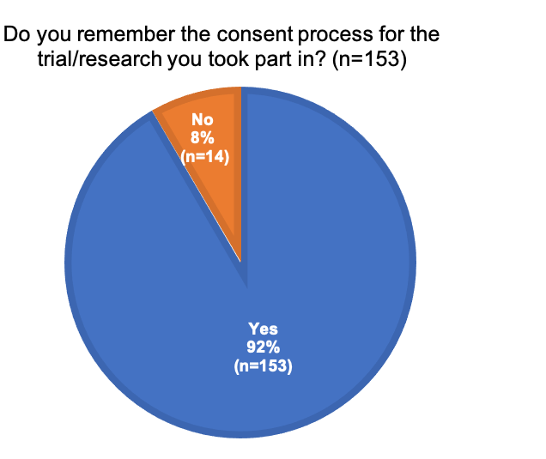
Figure 7: Respondents’ understanding of consent process (n=153)
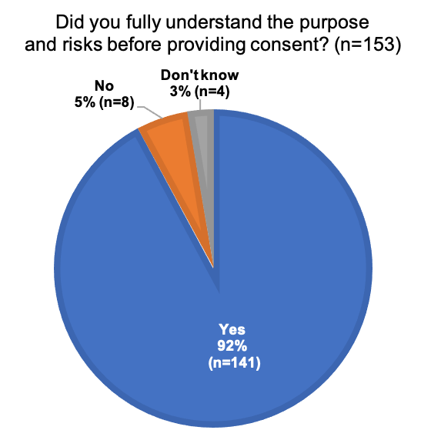

Lived experience of trial or research

Communication and support
Respondents who had previously participated in a trial or research project were asked to indicate how much they agreed with the following statements:
I was properly informed and supported during enrolment
I was properly informed and supported during the conduct of the trial
I found the experience worthwhile
I felt safe during the research
I was treated with dignity and respect
There was no conflict between the research experience and my own cultural needs
I found the whole experience worthwhile.
The majority of respondents agreed with ‘somewhat’ or ‘strongly’ that they felt safe during the research (144 of 157; 92%), that they were treated with dignity and respect (141 of 154; 91%), that there was no conflict between their research experience and their cultural needs (132 of 151; 87%), that they were properly informed and supported during enrolment (135 of 156; 86%), that the experience was worthwhile (134 of 155; 87%) and that they were properly informed and supported throughout the experience (135 of 156; 84%).
The statement that respondents were most likely to disagree with, either ‘somewhat’ or ‘strongly’ was that they were properly informed and supported throughout the experience (14 of 154; 9%).

Likes, dislikes and areas for improvement
Respondents who had previously participated in a trial or research project were asked to reflect on their experiences, and to offer thoughts on what they liked and disliked, and what could be improved.
Among those who responded regarding what they liked about the experience (n=157) the most commonly cited points included:
Feeling like they were contributing to the greater good
Feeling supported and included
Personal benefits of participation
A chance to have views and experiences heard
An approachable and knowledgeable team
Ease of participation.
Below are some representative verbatims from respondents.
‘The feeling of contributing to a worthwhile research project.’
‘I liked that it was catered to me, it was very personal. I was very well kept up-to date about all the progress and results were communicated very well.’
‘Thinking that I had contributed to understanding of cancer and development of treatments.’
‘Sharing my story to help others.’
‘Friendly, knowledgeable staff, lots of appointment time choices.’
‘Got the best treatment and was cured.’
‘Getting an alternative treatment for my condition.’
‘Supportive health workers and the hope that it may have health benefits for me or at least be beneficial as a basis for further research.’
‘Care taken by clinicians during period of trial and my subsequent post trial improvement.’
‘I got to try a new drug that helped control my condition – it was blinded but the impact was clear.’
‘I enjoyed working with the study team, who were kind and thoughtful, patient and calm, and who treated me as a partner in the research.’
Among those who responded regarding their dislikes about the experience (n=143) the most commonly cited points included:
Impersonal/non-inclusive processes
No follow-up on results or impacts
Too much bureaucracy and paperwork
Too time-consuming
Unfriendly staff.
Below are some representative verbatims from respondents.
‘I didn’t like that I never heard back about results of the research.’
‘Never hearing back from the researchers about the study’s findings or impact.’
‘Sometimes the questionnaires are repetitive, but that is part of the research.’
‘Can be time-consuming.’
‘Was terminated by sponsor without explanation.’
‘The feedback was very slow and disjointed.’
‘Technician dismissing a concern and not having someone else to contact at the time.’
‘I have no idea where my results are or whether it was used in research.’
‘Often too many appointments and it cost me money in driving and parking.’
‘Very impersonal.’
‘Felt like a number at times.’
‘Felt repetitive, and like ‘extra’ questionnaires had been added for someone else’s research.’
‘The manager of facility was not very friendly or kind … ran it as a business.’
Among those who responded regarding how their experience could have been improved (n=137) the most commonly cited points included:
Better communication, including updates and final outcomes
Better relationships with staff, more inclusive approaches
Greater transparency around commitments, and timelines.
Below are some representative verbatims from respondents.
‘More regular updates on findings.’
‘Receiving updates about the research would be useful.’
‘Good estimate of any time burden or other burdens involved important so can anticipate what is involved in participation.’
‘Touch bases with all the participants at the end to advise of the outcome.’
‘More personalised – I am making an important contribution so I want that to be recognised.’
‘Clear time frames and expectations, sharing the celebrated outcomes and knowledge transformation.’
‘Better use of communication technology at every stage – video based or visual consent or e-consent to ensure a better understanding. Better communication between visits, sending reminders and follow up messages to check I was OK.’
‘More honesty provided about the timeframes involved.’
‘People are volunteering their time and info, treat us well and kindly not as a business.’
‘To be treated like a part of the research team, to be given information relating to my case.’

Results and feedback
Respondents who had previously participated in a trial or research were asked if the results or outcomes of the trial or research project had been shared with them. Of those who responded, around two thirds (102 of 159; 64%) indicated that results had not been shared with them.
Just over a third (57 of 159; 36%) indicated that the results or outcomes of the trial or research project had been shared with them. Almost half of this group (27 of 57; 49%) had the results shared with them in an email. Those who had results shared with them were asked about the feedback they received form the research team. The most commonly cited points were:
Overall results of the trial or research, or updates if still in progress
Personal results, sometimes shared with care team
Expressions of gratitude
Opportunities for future participation.
Below are some representative verbatims from respondents.
‘Email thanking me, feedback directly after recording my interview praising me and talking through how immediately helpful it will be for others.’
‘They were very happy with the information given to them, and appreciated the time given for the research.’
‘The outcomes, what they meant, and how they would be disseminated.’
‘Comparison of my results to others on the trial by participant number, own and trial results against benchmarks.’
‘When the drug went to market as well as well as when study finished. Also new opportunities for more research.’
‘What they had identified, what areas require further investigation and the need for a further trial – which I will definitely put my hand up for.’
‘I was always informed of all the progress. They loved having me part of the trial.’

Support experiences
Almost a third of all respondents (160 of 477; 34%) said they had experience of supporting someone else, such as a child to participate in a clinical trial or health-related human research.

Consent
Respondents who had supported another person to participate in trials or health-related human research were asked to share their experiences of the consent process. In their responses, they referred to supporting not just children but parents, partners and siblings. Several themes emerged:
Some respondents referred to the balance of respectfully acknowledging the central role of the participant, while also involving the support person. Most were happy with the way things were handles
Some respondents specifically recalled being given time to take information away and discuss options before providing consent. This was appreciated
Several respondents noted that their ‘support’ was mainly centred on reading and explaining the complex consent documents to a loved one or family member
A handful of respondents related their negative experiences of feeling rushed or manipulated into providing consent.
Below are some representative verbatims from respondents.
‘It was my brother. He was able to do all his own consent but just wanted someone with him. The staff acknowledged me but addressed everything to him which was great.’
‘I helped a family member by reviewing the Participant Information Sheet and Consent Form and answering their questions and explaining what they would be required to do as part of their participation.’
‘I didn’t really support someone else to take part in a trial through the consent process. I received information about a study that was relevant to a family member, explained the consent process to them and explained the different section of a ten-page participant information statement and consent form to them.’
‘Unfortunately, my mother was in ICU and was intubated therefore I gave consent on her behalf for a study looking septicaemia. Unfortunately. she passed away but i feel that she would have wanted to help if she could.’
‘The clinical trial coordinator talked us through the patient information sheet and consent process. It was a lengthy process. We were able to take the information away and consider it before agreeing to participate. We understood the commitment required.’
‘Information was given to my mother by her oncologist. A nurses sat down with us and discussed the study and provided us with written information. We went away for a few days to decide. Mum signed the consent for with her doctor and treatment started a week later.’
‘It was a discussion with a family member about the pros and cons and I was asked what I thought.’
‘My child … information explained to both of us and my child was engaged in the process.’
‘In a prior to surgery meeting with the PI – we had said NO to participation. On being wheeled into surgery my family member was asked to sign a document (which later was disclosed to us as a consent form to the research).’
‘I was the person’s appointed medical power of attorney. I suggested she enrol in a trial and I found appropriate trials for her to participate in. We changed oncologists to ensure she could participate in the trial we found. I remember consent being done thoughtfully and slowly as she had neurological difficulties associated with her condition. I was involved in consent, to help her understand.’
‘Not really. Not genuine informed consent. Rushed and pressured into signing.’

Likes, dislikes and areas for improvement
Respondents who had supported someone else to participate in a trial or research project were asked to reflect on their experiences, and to offer thoughts on what they liked and disliked, and what could be improved.
Among those who responded regarding what they liked about the experience (n=87) some key themes emerged, including:
The opportunity to be actively involved in the support of a loved one
The opportunity to contribute to a greater good
The prospect of a higher standard of care, or better result, for the person participating
Being able to take the time to ask questions and discuss options.
Below are some representative verbatims from respondents.
‘For Mum the amount of information was overwhelming but I appreciated understanding what I needed to be aware of as her primary carer.’
‘The advancement of knowledge and the hope that the trial may produce information to help others.’
‘My loved one didn’t have to journey on her own.’
‘Supporting someone dear to me.’
‘I was cc’ed in on all correspondence to my child.’
‘Clear information provided and plenty of time available to discuss and consider that information.’
‘I felt my child was being closely monitored so their disease control was much better during the course of the trial.’
‘Inclusivity, warmth, caring attitude of trial staff.’
‘Two heads are better than one. We spent more time discussing and asking questions because there were two of us in the conversation.’
‘Hope in a positive outcome.’
‘I felt supportive of my mother’s care, and was able to get her a treatment she really needed.’
Among those who responded regarding what they disliked about the experience (n=81) the common themes included:
Not feeling fully included or informed
Impersonal or insensitive treatment by research team
Personal feelings of grief, discomfort, worry
Frustration with bureaucracy.
Below are some representative verbatims from respondents.
‘I didn’t have as much information about the trial, it was just what info I had [passed on] from the family member.’
‘Not enough thought had been given to young children participating in research. The study called for breakfast to be delayed until after the appointment, but the earliest appointment was 8.30am and children generally have breakfast at 6am. My daughter was placed in an enclosed device to measure body mass – I was not aware that she would be closed-in and she became very distressed which also distressed me. Despite her distress the researchers wanted me to calm her and for her to continue in the study. After that experience I decided I would never volunteer my children to participate in research; that they should be old enough to determine whether they wanted to participate; I felt like I had betrayed her trust. This experience occurred 19 years ago and it still makes me sad when I think of it.’
‘Occasional doctors lacking in empathy for patients with chronic disease.’
‘Some clinicians were not able to communicate well with non-medical trained participants.’
‘The patients were not treated with much sensitivity, and that was distressing to see.’
‘Sometimes the way we were spoken to like we were idiots.’
‘I felt the burden of knowing the research process would not help us directly but others; the burden of knowing that the ICU research would not be completed as my husband was dying.’
‘The paperwork is mind numbing and because of the detail it made the participant somewhat nervous.’
‘It was confusing and very scientific for them. Hard to find a trial in Australia. Hard to see there were option overseas but not here.’
‘Lack of information that was clearly not given to the participant, also at the end of the study there was no follow-up when my mother found out she had received the placebo.’
‘Tissue samples taken, that we had zero control of, or access to.’
‘The commitment required from a supporting person (post /in between visits) was not clearly explained prior to her participation on the study (e.g. transport; waiting periods for the study visits; technology understanding for devices provided, etc.).’
Among those who responded regarding how their experience could have been improved (n=80) the most commonly cited themes included:
The need for follow-up or ongoing contact after the trial or research has ended
Better understanding of the needs of child participants
More information and support for those in a supporting role
More empathy/better relationships with researchers and clinical teams.
Below are some representative verbatims from respondents.
‘Once the trial was finished it is sad that the same level of support is not able to be maintained.’
‘Far better understanding of children’s needs in participating in research and of pre-warning about claustrophobia; better awareness of the need to stop the experiment as the child and mother were clearly distressed.’
‘If the staff in the Clinical Trial could reassure the participant better.’
‘More attention paid to the patients’ feelings and perceptions of the trial.’
‘Instead of going from one clinician to the other that the same clinician explained the study and went through the consent process.’
‘Being treated with more respect by the lead researcher.’
‘More information and other supports are needed for people who are supporting persons with intellectual disability to participate in clinical trials, for these groups even simple things such as blood tests can be significant events that may be impossible to do at all or on a regular basis and more support is needed to guide people supporting persons with ID to think through the implications and whether a trial is right for them.’
‘Electronic and video based e-consent. My friend also had trouble signing her name as she was at an advanced stage of her disease.’
‘Less information. Opportunity to ask questions instead. Links could be provided if something was needed from a legal point of view.’
‘More detailed information and follow-up after the end of the study.’
‘Further information provided about the results of the trial.’

National volunteer registry proposition

Privacy and data
Respondents were asked if they would be comfortable having their data stored securely in a national volunteer registry, for the purpose of being contacted about future opportunities to participate in clinical trials or health-related human research.
More than three quarters of those who responded, indicated that they would feel comfortable having their data stored in this way, for this purpose (239 of 314; 76%) (Figure 8).
Figure 8: Respondents’ comfortable with having details stored securely in a national volunteer patient registry (n=314)
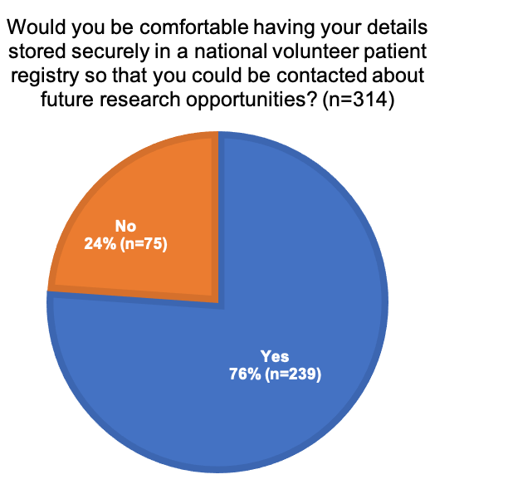
When asked whether they would prefer to have control over how their information was shared within the national volunteer registry, and what sort of contact requests they received, a majority of respondents (274 of 304; 90%) agreed that they would prefer that level of control (Figure 9).
Figure 9: Respondents’ preference to have control of contact requests (n=304)
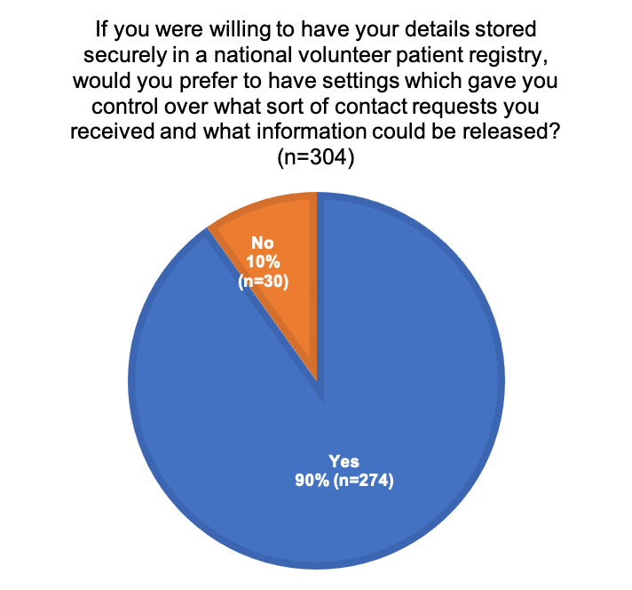
Respondents were then presented with a list of potential organisations/groups and asked if they would feel comfortable with any or all of these groups having access to their information within a national volunteer registry.
Approximately three quarters of respondents (216 of 307; 70%) felt comfortable with medical research institutes/organisations having access to their contact information. This was closely followed by clinicians (202 of 307; 66%), government funded organisations (188 of 307; 61%), public hospitals (179 of 307; 58%) and universities (173 of 307; 56%).
There was less support for private hospitals (122 of 307; 40%) and private research organisations (106 of 307; 35%) to hold their data than for the groups described above.
Approximately 16% (50 of 307) were not comfortable with any of these groups having access to their information within a national volunteer registry.


Level 5, 255 Elizabeth Street, Sydney NSW 2000
GPO Box 5480, Sydney NSW 2001
Phone: (02) 9126 3600
Email: mail@safetyandquality.gov.au
Website: www.safetyandquality.gov.au

