
TRIM: D17-37675
The infrastructure for Australian Passive AMR Surveillance (APAS) is provided by Queensland Health’s OrgTRx system using a data cube approach (Queensland Health’s Business Intelligence System – Panorama). OrgTRx accepts extracts of surveillance data from laboratory information management systems (LIS) that are incorporated as part of APAS.
All participating laboratories have access to the OrgTRx data cube for the preparation of regular reports and antibiograms to support antimicrobial stewardship programs in participating services. The following document provides answers to a number of questions frequently asked by users of the OrgTRx system.

My laboratory has been integrated into APAS. How do I access OrgTRx system support post ‘Go-Live’?
Post Go-Live support for the datacube is available via email to orgtrx-support@health.qld.gov.au.

How do I receive access for a new OrgTRx user?
The laboratory director or manager sends an email titled “New OrgTRx User Request” to orgtrx-support@health.qld.gov.au. This email needs to contain the following details of the new user:

- User first name
- User surname
- Phone number
- Email address
- Laboratory name
- IP address.

For sites using a fixed (static) IP address, the local site IT support staff will need to configure user access first. This also applies to accessing OrgTRx outside your usual work station (e.g. laptop). The sites using static IP address are listed below. If you are at one of those sites, please contact your local IT support staff to request access to the Queensland Health OrgTRx application and reference that access already exists for other users in your laboratory:
- ACT Pathology
- Monash Pathology
- NSWHP Hunter New England, Mid North Coast and North Coast, NSW
- NSWHP South Eastern Sydney and Illawarra Shoalhaven
- Royal Hobart Hospital
- South Australia Pathology

How do I terminate user access?
To advise that a user’s access should be terminated, an email should be sent from the laboratory director, or manager, to orgtrx-support@health.qld.gov.au, indicating which user’s access is required to be terminated and the date.

I have been denied access to the OrgTRx system. How do I re-establish my access?
The following steps should be followed if a user is unable to get access to the QH DSS data cube website:
- Contact your local IT support to check if there are problems with the local network
- Contact orgtrx-support@health.qld.gov.au and this will be escalated with the QH IT system processes.

How do I reset my password?
Users can change their own password by:
- Clicking on their name in the Application Bar at the top of the page
- Select Edit password
- Follow the prompts to change their password.
If users have forgotten their password and need it to be reset they need to contact the OrgTRx support email at orgtrx-support@health.qld.gov.au.

What do I do if my access has been archived?
The Queensland DSS Archive Process will suspend the access of users if their account is not used for three months. The email message users will receive if their account is about to be archived is shown below.

Subject: DSS ARCHIVE PROCESS – Log into DSS within the next 7 days to prevent your DSS account from being archived
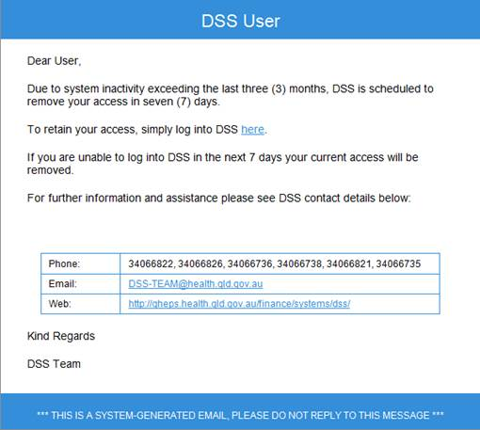

If users login within 7 days as requested they will not be archived.
Users outside Queensland Health have their own site-specific web URL. If they have lost the web URL, in the first instance, they should contact their local Super User. If they have been archived they should contact orgtrx-support@health.qld.gov.au and provide their name, user login, phone number and email address to be unarchived.

What do I do if my session has timed out?
If the DSS window remains inactive for one hour, the application ‘times out’ and users receive the message below. To re-establish, their session, users just need to refresh that window on their web browser.

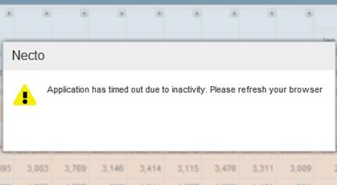

How do I log off OrgTRx?
To log off the DSS OrgTRx module, users need to close their browser window. If a user does not log off via this method, the system will time out. When the user next logs on, they will need to refresh their screen.

How do I let the Commission know about upcoming changes to my service’s laboratory information system?
A systemised approach to IT processes are required to ensure the APAS data as captured in the OrgTRx system is complete and provided in a timely manner. This is particularly important when sites upgrade or change their laboratory information system, or other systems, that provide supporting infrastructure to, or connect with, OrgTRx. These may include:

- A pathology/laboratory information system version upgrade
- Migration to a new pathology/laboratory information system
- Changes to geographical location of the laboratory service, including change of building and staff locations
- Changes to laboratory infrastructure: applications/hardware; NBN rollout; etc

- Change of communications service providers: Telstra, VoIP, etc
- Changes to laboratory business practices.
Such changes may impact upon the technical feeds into the OrgTRx system or the data being sent, and therefore impact on the reliability of reports.

It is essential that any site undertaking changes or upgrades to its systems promptly notify the Commission when such a change is planned. To facilitate smooth transition and avoid disruption to data transfer and access to reporting, the notification should be emailed to the Commission (AURA@safetyandquality.gov.au) using the Notification to Commission of Upgrade/Change to Site System(s) Form.
On receiving the form, the Commission team will:
- Confirm detail on the form and discuss any questions arising out of any project plan provided by the site;
- Complete an assessment of the time, resource and potential cost impacts on the system, where relevant); and,
- Plan the system work to accommodate the site changes and liaise with the site to ensure that the work between the sites and the OrgTRx team is coordinated.
A standing agenda item for the APAS User Advisory Group (UAG) also provides a means by which sites can advise the Project Team of upcoming system changes. All participating laboratories are invited to participate in the UAG.
- How do I request changes and/or improvements to the OrgTRx system?
When a site identifies an enhancement to the functionality of OrgTRx is required, they should first contact the Commission APAS team (AURA@safetyandquality.gov.au) – the Commission will liaise with the OrgTRx Team to advise if the functionality already exists and how to utilise these attributes. Additional training may be required to ensure awareness of, and familiarity with all the capabilities of the system.

If the functionality does not currently exist, the site should complete the OrgTrx Proposed Enhancement Request Form.

In completing the Proposed Enhancement Form, the site is asked to provide:
- The contact details of the senior person to respond on-site and best placed to influence the implementation of the enhancement
- A full description of the proposed enhancement (attach supporting information). For example this might be:
  - new data fields (which should be named)
  - a new antibiogram
  - a proposed change for benchmarking antibiogram functionality i.e. the capability to compare VRE across other de-identified laboratory services or perhaps across facilities of a similar size
- A description of the benefits to be achieved by this enhancement for the national system and relate to the national AURA objectives, particularly indicating where the enhancement provides potential national benefit.
Following receipt of a request, an analysis is required to establish the necessary work to be undertaken each party to develop, incorporate and test any changes to ensure the continued successful operation of the system.
A standing agenda item for the APAS UAG also provides a means by which sites can ask about the possibility of enhancements to the existing OrgTRx system.
- How do I export data to Excel?
The OrgTRx User Guide provides instructions for exporting in a variety of formats, including Excel and PDF.
- Are there standard reports available through OrgTRx?
Within OrgTRx, there are pre-prepared standard views that are used as the starting point for users to interrogate their own data.

- How are organisms mapped within OrgTRx?

In OrgTRx, all previously encountered organisms are in a reference table and have an organism code.

Below are examples of how organisms are categorised and allocated a code.

Organism Type | Description | Code
New genus | Genusname spp. | GENSPP
Un-speciated members of that genus | Genusname sp. | GENSP
New organism | Genus newone | GENNEW

If available, the organism code is usually the first three letters of the Genus followed by the first three letters of the species e.g. Staphylococcus aureus is STAAUR.

Process of mapping organisms
Mapping is an operation that associates each element of a given set (e.g. the OrgTRx Reference Table) with one or more elements of a second set (the unique code or codes from each Pathology Service)

While the organism nomenclature is the same, each LIS has different codes for these organisms. It is these codes that are sent to OrgTRx. When a pathology service sends their susceptibility data to be included in OrgTRx there are a number of scenarios for the organism code:

- If the organism code from the Pathology Service is new to OrgTRx, it may be necessary to contact the laboratory for the code’s description
- If the organism already exists in the OrgTRx organism reference table then the new code from that pathology service is mapped to the existing OrgTRx organism code
- When new codes are received the taxonomy/nomenclature is checked and it may be necessary to map that code to the new genus. For example, if a new code is received that has a laboratory description of ‘Actinobacillus actinomycetemcomitans’ it will be mapped to ‘Aggregatibacter (Actinobacillus) actinomycetemcomitans’. The old genus is in brackets.
- If an organism is sub-speciated in a specific laboratory service, but does not exist in the OrgTRx reference table, the laboratory would be contacted to check if it is acceptable to map this organism to the Genus and species group instead. If the sub-species are required, then it is possible to create a new organism in the OrgTRx reference table.

