


July 2024

Australian Passive AMR Surveillance
An update of resistance trends in

multidrug-resistant organisms – 2006 to 2023

Published by the Australian Commission on Safety and Quality in Health Care
Level 5, 255 Elizabeth Street, Sydney NSW 2000
Phone: (02) 9126 3600
Email: mail@safetyandquality.gov.au Website: www.safetyandquality.gov.au
ISBN: 978-1-922880-79-6
© Australian Commission on Safety and Quality in Health Care 2024
All material and work produced by the Australian Commission on Safety and Quality in Health Care is protected by copyright. The Commission reserves the right to set out the terms and conditions for the use of such material.
As far as practicable, material for which the copyright is owned by a third party will be clearly labelled. The Commission has made all reasonable efforts to ensure that this material has been reproduced in this publication with the full consent of the copyright owners.
With the exception of any material protected by a trademark, any content provided by third parties, and where otherwise noted, all material presented in this publication is licensed under a Creative Commons Attribution-NonCommercial-NoDerivatives 4.0 International licence.


Enquiries about the licence and any use of this publication are welcome and can be sent to communications@safetyandquality.gov.au.
The Commission’s preference is that you attribute this publication (and any material sourced from it) using the following citation:
Australian Commission on Safety and Quality in Health Care. Australian Passive AMR Surveillance: An update of resistance trends in multidrug-resistant organisms – 2006 to 2023. Sydney; ACSQHC, 2024.
Disclaimer
The content of this document is published in good faith by the Australian Commission on Safety and Quality in Health Care for information purposes. The document is not intended to provide guidance on particular healthcare choices. You should contact your healthcare provider on particular healthcare choices.
The Commission does not accept any legal liability for any injury, loss or damage incurred by the use of, or reliance on, this document.
Note regarding alternative descriptions
No alternative descriptions have been provided. If you need assistance with the structure of any graphs or charts, please email the Australian Commission on Safety and Quality in Health Care at APAS@safetyandquality.gov.au.

Contents
Executive Summary 4
Key findings and trends: 2015 to 2023 4
Implications for patient safety 5
What will be done to improve patient safety? 6
Vancomycin resistance in Enterococcus faecium 7
Vancomycin resistance in Enterococcus faecium by specimen type 8
Vancomycin resistance in Enterococcus faecium by setting 9
Vancomycin resistance in Enterococcus faecium by age group 10
Vancomycin resistance in Enterococcus faecium by state and territory 11
Vancomycin resistance in Enterococcus faecium by remoteness area 14
Fluoroquinolone resistance in Escherichia coli 15
Fluoroquinolone resistance in Escherichia coli by specimen type 16
Fluoroquinolone resistance in Escherichia coli by setting 17
Fluoroquinolone resistance in Escherichia coli by age group 18
Fluoroquinolone resistance in Escherichia coli by state and territory 19
Fluoroquinolone resistance in Escherichia coli by remoteness area 23
Methicillin resistance in Staphylococcus aureus 24
Methicillin resistance in Staphylococcus aureus by specimen type 25
Methicillin resistance in Staphylococcus aureus by setting 26
Methicillin resistance in Staphylococcus aureus by age group 27
Methicillin resistance in Staphylococcus aureus by state and territory 28
Methicillin resistance in Staphylococcus aureus by remoteness area 31
Conclusions 32
References 33
Appendix 1: About APAS 35
Appendix 2: Methodology 36

Executive Summary
Antimicrobial-resistant microorganisms, including bacteria, and the resistance genes they carry, can spread readily between people in the community as well as those receiving care in hospitals, aged care homes and primary care services. The spread of antimicrobial resistance (AMR) can occur rapidly and significantly affect patients, the community, health services and the health system. Effective surveillance and monitoring are essential to determine the burden of AMR, and to inform response, infection prevention and control and antimicrobial stewardship (AMS) strategies, and prescribing guidelines.
This report provides analyses of data from Australian Passive AMR Surveillance (APAS). APAS data on antimicrobial susceptibility testing results are contributed by public and private pathology services across Australia. These data are sourced from hospitals, the community and aged care homes. APAS was established by the Australian Commission on Safety and Quality in Health Care (the Commission) as a key component of the Antimicrobial Use and Resistance in Australia (AURA) surveillance program, which is coordinated by the Australian Government Department of Health and Aged Care (the Department).
Detailed information about APAS is included in Appendix 1. The methodology for the analyses and considerations for interpretation of data and analyses are included in Appendix 2.
The focus of this report is trends in multidrug-resistant organisms (MROs), primarily for 2015 to 2023, with some analyses from 2006. The MROs included are:
- Vancomycin resistance in Enterococcus faecium (VRE)
- Fluoroquinolone resistance in Escherichia coli
- Methicillin resistance in Staphylococcus aureus (MRSA).
VRE and MRSA are included in the high priority group in the World Health Organization Bacterial Priority Pathogen List¹ and these bacteria were selected along with fluoroquinolone resistance in
E. coli because analyses show that resistance rates are trending up. There are opportunities to improve the safety of care provided to Australians through infection prevention and control and AMS programs and antimicrobial prescribing guidelines. This report provides an update of APAS data analyses included in the series of national AURA reports since 2016²⁻⁶ and the previous APAS report on these MROs (2006 to 2017).⁷

Key findings and trends: 2015 to 2023
Vancomycin resistance in Enterococcus faecium
- Vancomycin resistance in E. faecium remained high in 2023 (42.5% of isolates). Resistance was highest in 2015 (51.9%) then trended downward until 2020 (33.2%) and rose steeply again in 2022. There has been an overall dramatic increase from 5.3% in 2006.
- Vancomycin resistance was generally higher in hospitals (43.5% in 2023) than the community (24.4% in 2023).
- The prevalence of VRE varied amongst states and territories but was highest in Victoria (62.6% in 2023), whereas trends were lower but similar across remoteness areas of Australia.
Fluoroquinolone resistance in Escherichia coli
- Fluoroquinolone resistance in E. coli has increased from 1.9% in 2006 to 13.4% in 2023.
- Resistance was similar in hospitals and the community (both 13.4% in 2023).
- The prevalence of resistance varied amongst states and territories but was highest in Victoria (21.7% in 2023). High levels of resistance were also observed amongst the very small number of isolates from the Northern Territory (NT).
- Despite low numbers of isolates, the proportion of fluoroquinolone-resistant E. coli was highest in very remote Australia (19.4% in 2023).

Methicillin resistance in Staphylococcus aureus
- MRSA rates remained relatively steady from 2006 to 2023; ranging from 19.8% in 2006, 2022
and 2023, respectively, to 22.8% in 2010 and 2017, respectively.
- There was a downward trend in MRSA rates from aged care homes from 2016 (35.0%) to 2023 (21.9%). Despite a comparatively very small number of isolates, MRSA remains more prevalent in aged care homes than in hospitals and the community (2023: 19.0% and 21.5%, respectively).
- MRSA was considerably more prevalent in the small number of isolates from the NT (36.4% in 2023) than other jurisdictions. In other jurisdictions, proportions ranged from 10.2% in Tasmania to 26.1% in Western Australia in 2023.
- The prevalence of MRSA was highest in remote and very remote Australia (2023: 31.5% and 33.5%, respectively); this was compared to major cities (19.4% in 2023) where the greatest number of S. aureus isolates were collected.

Implications for patient safety
Vancomycin resistance in Enterococcus faecium
Prevalence of VRE remains high and concerning, particularly in acute healthcare settings. Optimising infection prevention and control mechanisms to decrease spread, is essential to effectively respond to and better manage VRE in Australia.
Fluoroquinolone resistance in Escherichia coli
Increasing resistance in E. coli is concerning given it is not the anticipated effect of marked restrictions for prescribing fluoroquinolones in hospitals under AMS programs and also in the community under the Pharmaceutical Benefits Scheme (PBS) and the Repatriation Pharmaceutical Benefits Scheme (RPBS) restrictions. It is possible that high community use of antimicrobials to which these strains are co-resistant, such as amoxicillin and cefalexin, is fuelling this increase. This will likely cause a greater reliance on last-line antimicrobials such as carbapenems to treat serious infections caused by these resistant strains. The resumption of international travel following eased restrictions associated with the COVID-19 pandemic is also likely contributing to increasing resistance patterns. This is a particular concern for travel to and from Asian countries with high levels of resistance to fluoroquinolones and third-generation cephalosporins.^{8,} ⁹
Methicillin resistance in Staphylococcus aureus
MRSA remains common across Australia in the community and in hospitals. Strategies for prevention and control of MRSA in all settings continue to be a priority. This is especially where resistance rates are high and MRSA poses a risk to vulnerable populations, including those across remote and very remote regions and northern Australia, where there is a high population of Aboriginal and Torres Strait Islander peoples. The concern for residents of aged care homes, with the increased vulnerability of older people, is compounded by the high volume of antimicrobial prescribing in this setting, much of which appears to be inconsistent with prescribing guidelines.¹⁰

What will be done to improve patient safety?
In response to the issues identified in analyses in this report, the Commission will continue to:
- Work with developers of prescribing guidelines, including Therapeutic Guidelines Limited, to ensure AMR data informs guidelines, including Therapeutic Guidelines: Antibiotic¹¹; and for these to be promoted to prescribers through clear communications
- Work with states and territories and the private laboratory sector to encourage consideration of geographic variation of AMR through the use of local antibiograms produced by APAS contributors
- Promote adaptation of national prescribing practices to local resistance patterns and regular review of prescribing guidance by local AMS programs; this will support the use of broad- spectrum antimicrobials only where necessary and limit inappropriate prescribing
- Promote incorporation of concepts of geographical variation in AMR into clinical practice; particularly to support clinicians who regularly work in a range of settings
- Promote use of the Priority Antibacterial List for Antimicrobial Resistance Containment¹² as a tool to support AMS services to analyse antimicrobial usage in terms of preferred or optimal prescribing choices
- Use APAS and other AURA data to refine and strengthen guidance for surveillance, prevention and control of specific organisms and resistances, and AMS programs
- Support collaboration and coordination between states and territories, and between hospital and community care settings to explore the drivers of variation and improve local prevention and control efforts to help limit progression of AMR
- Continue to work with the Department, state and territory health authorities, and private pathology services, to achieve nationwide participation in APAS and enhance national surveillance coverage
- Continue to promote infection prevention and control practices in health and aged care settings consistent with the Australian Guidelines for the Prevention and Control of Infection in Healthcare¹³ and the National and Safety and Quality Standards for acute, primary and community and aged care¹⁴⁻¹⁶
- Continue to promote AMS programs and compliance with evidence-based prescribing guidelines in health and aged care settings consistent with the National and Safety and Quality Standards for acute, primary and community and aged care.¹⁴⁻¹⁶

Vancomycin resistance in Enterococcus faecium
Enterococcus species, including E. faecium, are opportunistic pathogens that cause a variety of infections in people whose physical barriers are compromised through surgery or invasive devices. This species often causes urinary tract, biliary tract and other intra-abdominal infections, and bloodstream infections, and commonly in vulnerable populations, such as the very elderly or those who are immunosuppressed.
Enterococci are naturally resistant to several common antimicrobial classes, including anti- staphylococcal penicillins, cephalosporins, macrolides and lincosamides. Oral amoxicillin is the most common treatment for minor infections. More serious infections are treated with intravenous ampicillin or amoxicillin. Vancomycin is used for serious infections in people who are allergic to penicillins.
The other main Enterococcus species is E. faecalis, which is commonly susceptible to both ampicillin and vancomycin. In contrast, high levels of ampicillin resistance have emerged in
E. faecium worldwide, including in Australia.¹⁷ This has led to the increased use of vancomycin for treatment.
More recently, vancomycin-resistant E. faecium (VRE) have also emerged. The two main gene complexes responsible for VRE are vanA and vanB.^{18,19} VRE require treatment with antimicrobials that are usually reserved, such as teicoplanin or daptomycin.
Between 2006 and 2023, there were 28,716 E. faecium isolates from the four long-term APAS contributor pathology services. Across all pathology services that contribute to APAS, including the four long-term contributors, data were available for 61,605 isolates over this period. See Appendices 1 and 2 for information about the pathology services that contribute to APAS.
Figure 1 shows the 18-year trend in vancomycin resistance in E. faecium reported by all APAS contributors between 2006 and 2023. There was a sharp increase in the proportion of vancomycin- resistant E. faecium isolates from 5.3% in 2006 to 51.9% in 2015. There was a steady decreasing trend until 2020 (33.2%) before increasing to over 42% in 2022 and 2023.
Figure 1: Percentage of Enterococcus faecium with vancomycin resistance, APAS contributors, 2006–2023
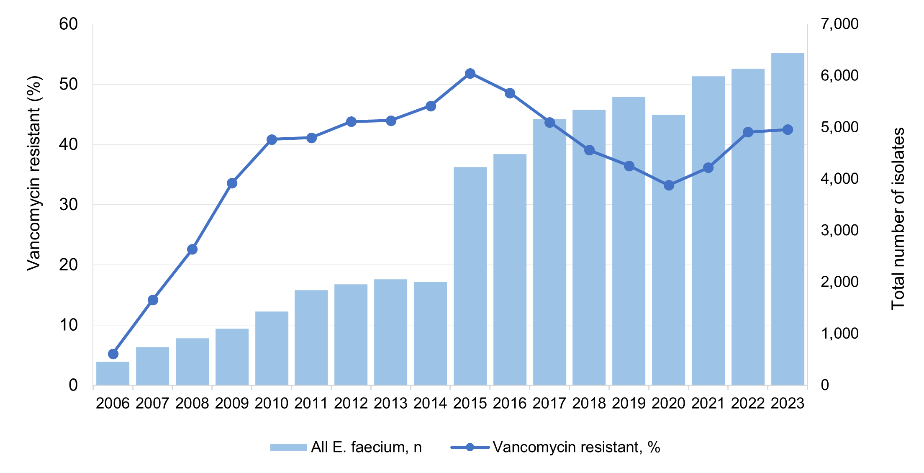
n = denominator for total number of isolates
Source: APAS (NSW, Vic, Qld, SA, WA, Tas, ACT) – see Table A1

For analyses of 2015 to 2023 data for this report, there were 48,961 E. faecium isolates from all APAS contributors.

Vancomycin resistance in Enterococcus faecium by specimen type
A little over one-half (57.9%) of E. faecium isolates reported by APAS contributors for 2015 to 2023 were from urine. Isolates were next most reported from tissue/fluid/pus/prosthesis (27.3%) and blood (13.3%). Rates of vancomycin resistance in E. faecium were high. While the overall proportion of isolates that were vancomycin-resistant decreased from 51.9% in 2015 to 33.2% in 2020, it increased to over 42% in 2022 and 2023. Apart from other specimen types (cerebrospinal fluid, ear nose and throat, enteric, genital, and respiratory), of which there were low numbers, the specimen source did not substantially influence resistance (Figure 2). For more information on specimen types, see Appendix 2.
Figure 2: Percentage of vancomycin-resistant Enterococcus faecium by specimen source, APAS contributors, 2015–2023
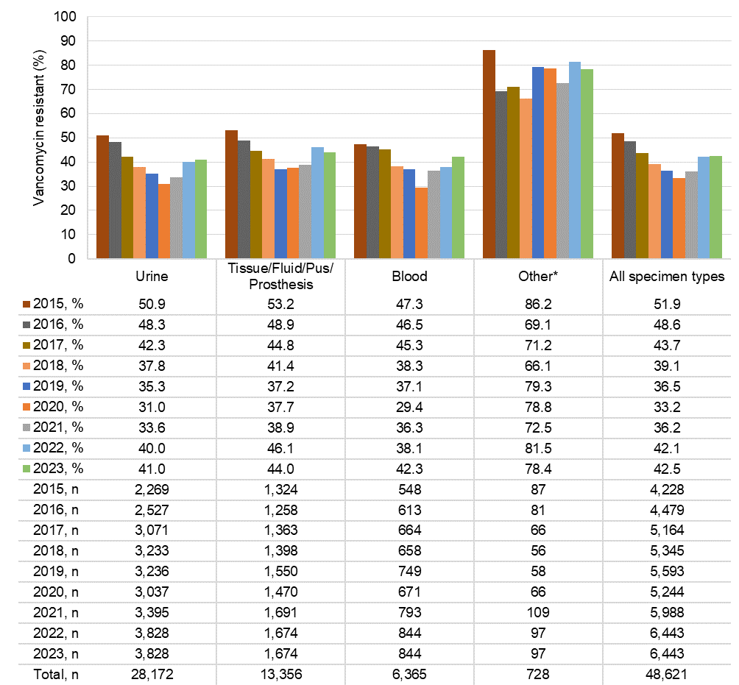
n = denominator for total number of isolates
* Other specimen types include cerebrospinal fluid, ear nose and throat, enteric, genital, and respiratory specimens Source: APAS (NSW, Vic, Qld, SA, WA, Tas, ACT) – see Table A1

Vancomycin resistance in Enterococcus faecium by setting
The vast majority (94.2%) of E. faecium isolates reported by APAS contributors for 2015 to 2023 were from hospitals (public and private). There was a steady decline in the proportion of VRE from hospital settings, falling from 51.6% in 2015 to 34.2% in 2020, although there was an increase to greater than 43% in 2022 and 2023.
Resistance in E. faecium isolates from the community was generally lower than those from hospital settings, falling from 56.2% to 10.7% in 2019 and 13.4% in 2020; in 2023, it was 24.4% (Figure 3). It is important to note that it cannot be determined from APAS data whether isolates collected from community settings were associated with prior healthcare exposure to VRE.
Figure 3: Percentage of vancomycin-resistant Enterococcus faecium by setting, APAS contributors, 2015–2023
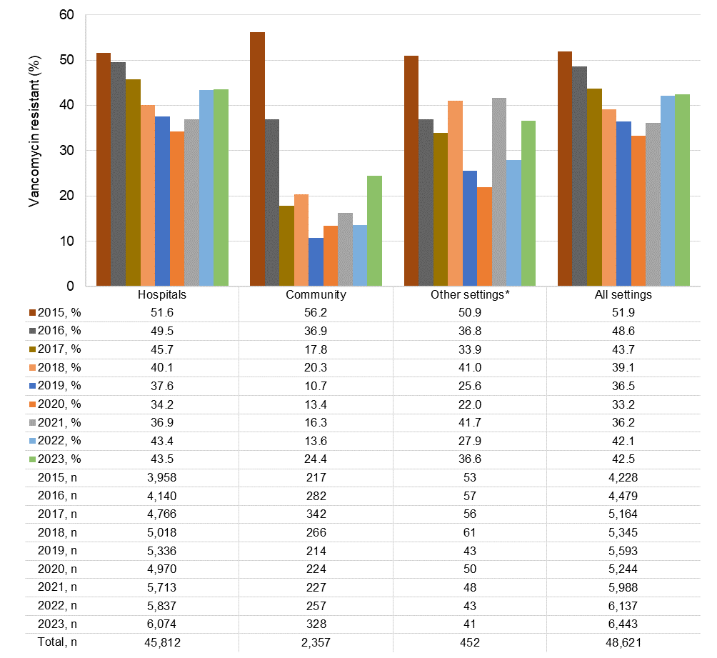
n = denominator for total number of isolates
* Other refers to settings other than hospital or community, including multi-purpose service and aged care homes Note: Hospitals = public and private.
Source: APAS (NSW, Vic, Qld, SA, WA, Tas, ACT) – see Table A1

Vancomycin resistance in Enterococcus faecium by age group
The vast majority of E. faecium isolates reported by APAS contributors for 2015 to 2023 were from adults (18–64 years, 31.8%; greater than 65 years, 67.0%); just 1.2% were reported from children (aged less than 18 years) (Figure 4). The proportion of vancomycin resistance in E. faecium was lower in children than adults in each year over this period. The resistance trends were similar across all age groups.
Figure 4: Percentage of vancomycin-resistant Enterococcus faecium by age group, APAS contributors, 2015–2023
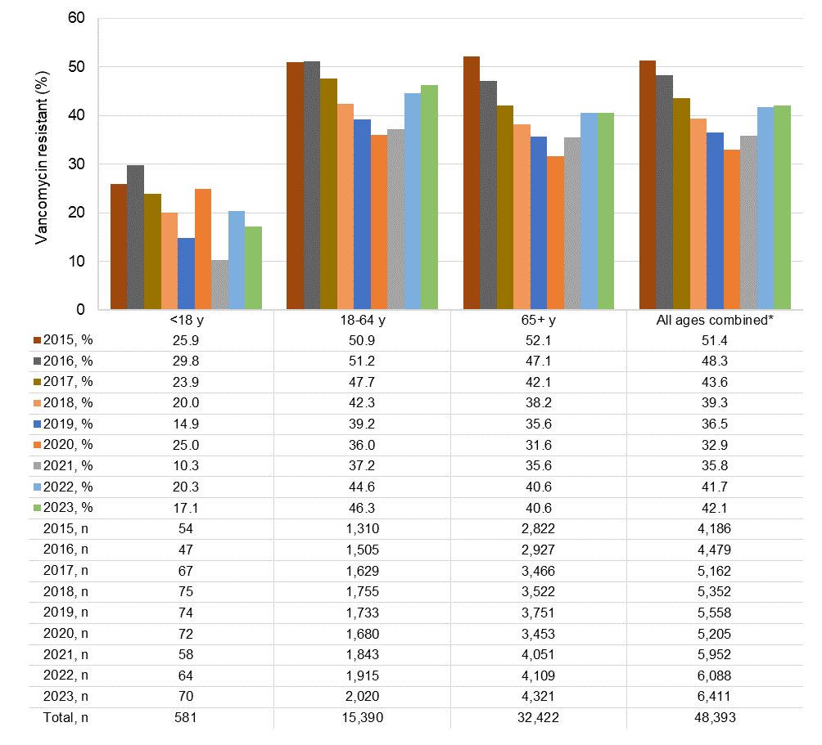
n = denominator for total number of isolates; y = years of age
* Where patient’s age was known
Source: APAS (NSW, Vic, Qld, SA, WA, Tas, ACT) – see Table A1

Vancomycin resistance in Enterococcus faecium by state and territory
Figures 5–7 show the trends in VRE isolates by state and territory reported from all APAS contributors from 2015 to 2023, with 2023 data mapped to Australian Statistical Area Level 4 (SA4) (Figure 7). Data were analysed based on the known postcode of residence of the person from whom the specimen was taken (see Appendix 2).
There was considerable variation across the states and territories in the number of E. faecium isolates and proportion of vancomycin resistance reported by APAS contributors from 2015 to 2023. In 2023, the overall proportion of vancomycin-resistant E. faecium isolates ranged from 12.8% in Western Australia (WA) to 62.6% in Victoria (Figure 5). Whilst the number of contributing APAS sites was lower and there were lower numbers of isolates submitted from Victoria, the rates of resistance were the highest nationally. For WA, the proportion of vancomycin-resistant blood isolates (23.0%) was more than double that of urine isolates (10.4%) (Figure 6).
Figure 5: Percentage of vancomycin-resistant Enterococcus faecium by state and territory, APAS contributors, 2015–2023
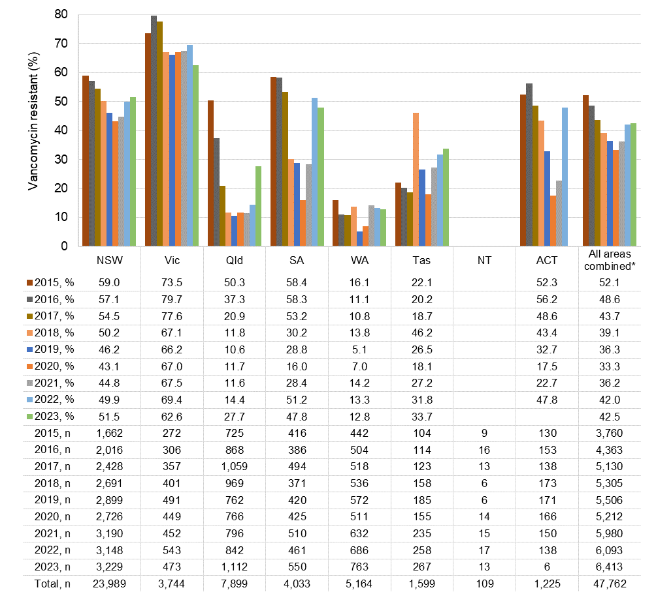
n = denominator for total number of isolates
* Where postcode of residence was known Notes:
- State and territory based on postcode of residence. Data available from the NT were from NT residents who received pathology services interstate. Data from ACT pathology services were not available for 2023, except where ACT residents received pathology services interstate.
- Postcode of residence was not available in 2015 for NSW Health Pathology South Eastern Sydney Local Health District.
- Blank cell indicate insufficient number of isolates (<30) to calculate percentage. Source: APAS (NSW, Vic, Qld, SA, WA, Tas, ACT) – see Table A1

Figure 6: Vancomycin resistance in Enterococcus faecium, by state and territory and specimen source, APAS contributors, 2023

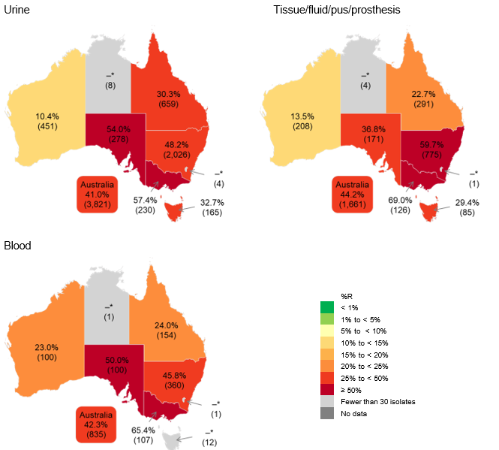

R = resistant
* Insufficient number of isolates (<30) to calculate percentage
Note: State and territory based on postcode of residence (where known). Data available from the NT were from NT residents who received pathology services interstate. Data from ACT pathology services were not available for 2023, except where ACT residents received pathology services interstate.
Source: APAS (NSW, Vic, Qld, SA, WA, Tas, ACT) – see Table A1

Figure 7: Vancomycin resistance in Enterococcus faecium, mapped to Australian SA4 areas, APAS contributors, 2023

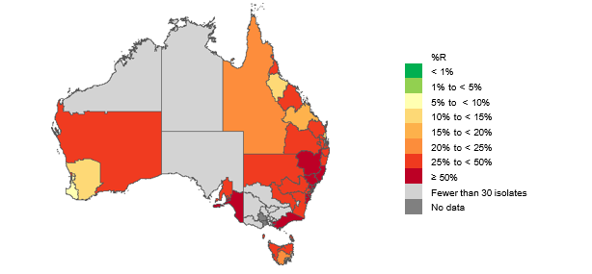

R = resistant; SA4 = Statistical Area Level 4
Note: SA4 based on postcode of residence (where known). Data available from the NT were from NT residents who received pathology services interstate. Data from ACT pathology services were not available for 2023, except where ACT residents received pathology services interstate.
Source: APAS (NSW, Vic, Qld, SA, WA, Tas, ACT) – see Table A1

Vancomycin resistance in Enterococcus faecium by remoteness area
Figure 8 shows the trends in VRE by remoteness area reported from all APAS contributors from 2015 to 2023. Data were analysed based on the known postcode of residence of the person from whom the specimen was taken (see Appendix 2).
A little over two-thirds (70.1%) of E. faecium isolates reported by APAS contributors for 2015 to 2023 were from patients residing in major cities of Australia. There were similar trends in vancomycin resistance in all remoteness areas during this period (Figure 8). It is important to note that there were low numbers of isolates from remote and very remote areas.
Figure 8: Percentage of Enterococcus faecium with vancomycin resistance by remoteness area,
APAS contributors, 2015–2023
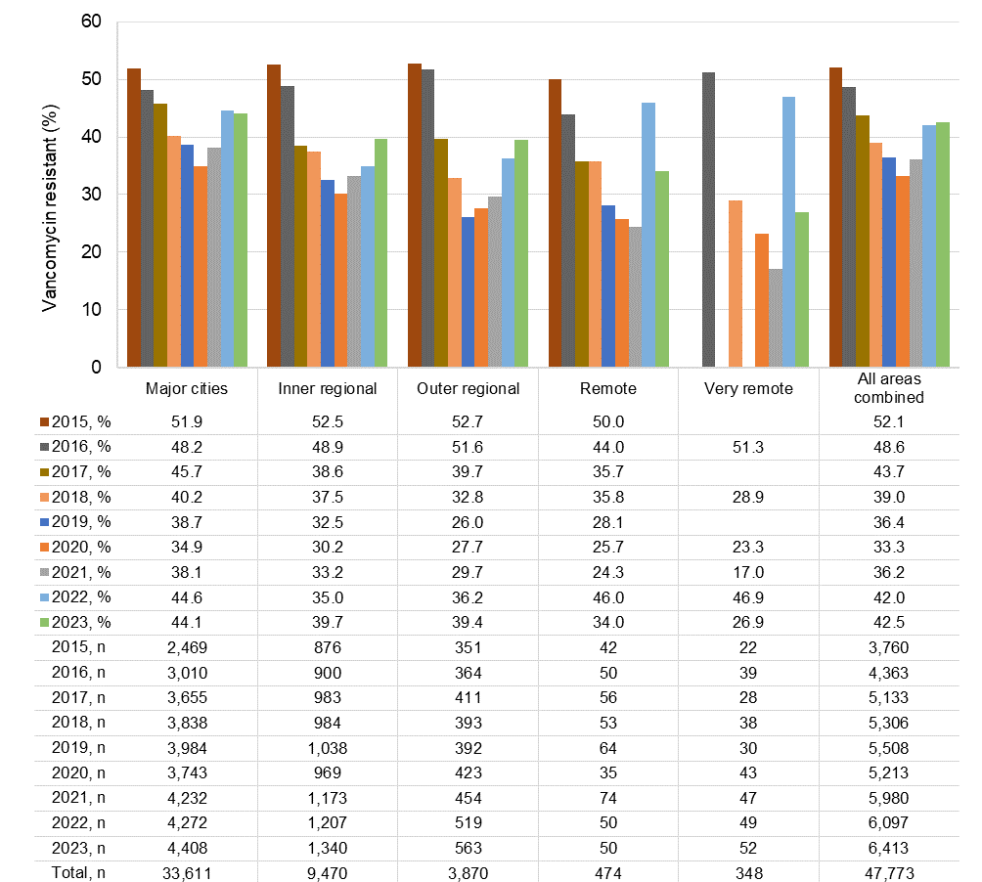
n = denominator for total number of isolates Notes:
- Remoteness area based on postcode of residence (where known).
- Blank cell indicate insufficient number of isolates (<30) to calculate percentage. Source: APAS (NSW, Vic, Qld, SA, WA, Tas, ACT) – see Table A1

Fluoroquinolone resistance in Escherichia coli
The order Enterobacterales encompasses a large group of related bacteria including
Escherichia coli, which is a common pathogen that causes both community- and hospital- associated infections. E. coli is the most common cause of urinary tract infection and bacteraemia in the community and in otherwise healthy people. It is also associated with a variety of infections, including biliary tract and other intra-abdominal infections (including those following surgery, and often mixed with other pathogens), as well as meningitis, and bacteraemia from intravascular lines.
The aminoglycosides (especially gentamicin) are recommended as part of empirical use, pending the results of culture and susceptibility testing. Β-lactam antimicrobials, including those combined with β-lactamase inhibitors, are preferred for the treatment of infections caused by E. coli when prolonged treatment or a switch from parenteral to oral therapy is considered. In addition to β- lactams, trimethoprim is currently recommended for the oral treatment of lower urinary tract infections.¹¹
In Australia, fluoroquinolones are usually only recommended for strains that are likely to be resistant to other classes of antimicrobials. They are also available in a range of formulations, such as oral, intravenous and topical (eye and ear).
E. coli has the capacity to acquire and transmit resistance genes among themselves and to some other genera through horizontal gene transfer. In addition, it has specialised mechanisms to become multidrug-resistant by capturing and accumulating resistance genes (integrons). Few antimicrobials are available for the treatment of highly multidrug-resistant strains, and all are more toxic than β-lactams.
Between 2006 and 2023, there were 1,233,211 E. coli isolates from the four long-term APAS contributor pathology services. Across all pathology services that contribute to APAS, including the four long-term contributors, data were available for 1,956,779 isolates over this period. See Appendices 1 and 2 for information about the pathology services that contribute to APAS.
Prevalence of fluoroquinolone resistance was examined using available antimicrobial susceptibility test data for ciprofloxacin (non-urine specimens) and norfloxacin (urine specimens).
Figure 9 shows the 18-year trend in fluoroquinolone resistance in E. coli reported by all APAS contributors between 2006 and 2023. The decrease in the number of E. coli isolates reported to APAS was attributed to a change to selective reporting practices for isolates from urinary tract infections by three of the four long-term contributors.
There was an increasing trend in the proportion of fluoroquinolone resistant E. coli isolates from 1.9% in 2006, peaking at 13.3% in 2020 and decreasing to 12.4% in 2022, but increasing again to
13.4% in 2023 (Figure 9).

Figure 9: Percentage of Escherichia coli with fluoroquinolone resistance, APAS contributors, 2006–2023
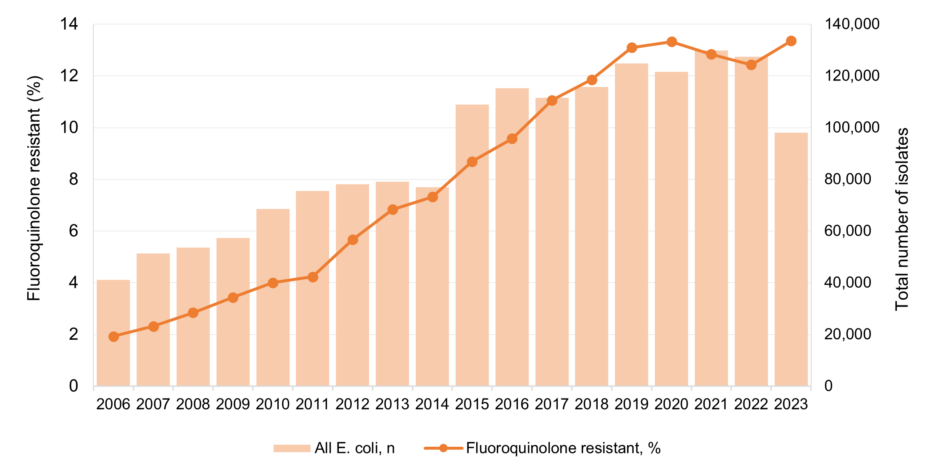
n = denominator for total number of isolates
Note: Selective testing/reporting of fluoroquinolone susceptibility of isolates from urine specimens was implemented in SA Pathology metropolitan (2015) and regional laboratories (2017), Mater Pathology (2020) and Pathology Queensland (2023).
Source: APAS (NSW, Vic, Qld, SA, WA, Tas, ACT) – see Table A1

For analyses of 2015 to 2023 data for this report, there were 1,342,721 E. coli isolates from all APAS contributors.

Fluoroquinolone resistance in Escherichia coli by specimen type
The majority (86.3%) of E. coli isolates reported by APAS contributors for 2015 to 2023 were from urine. Despite low numbers, resistance was generally higher among E. coli isolates from other specimens (cerebrospinal fluid, ear nose and throat, and enteric specimens), followed by tissue/pus/pus/prosthesis and respiratory specimens. Fluoroquinolone resistance was lowest in genital tract isolates. The number of isolates across specimen types varied substantially. In 2023, there was an increase in resistance across all specimen types (Figure 10). For more information on specimen types, see Appendix 2.

Figure 10: Percentage of Escherichia coli with fluoroquinolone resistance by specimen source,
APAS contributors, 2015–2023
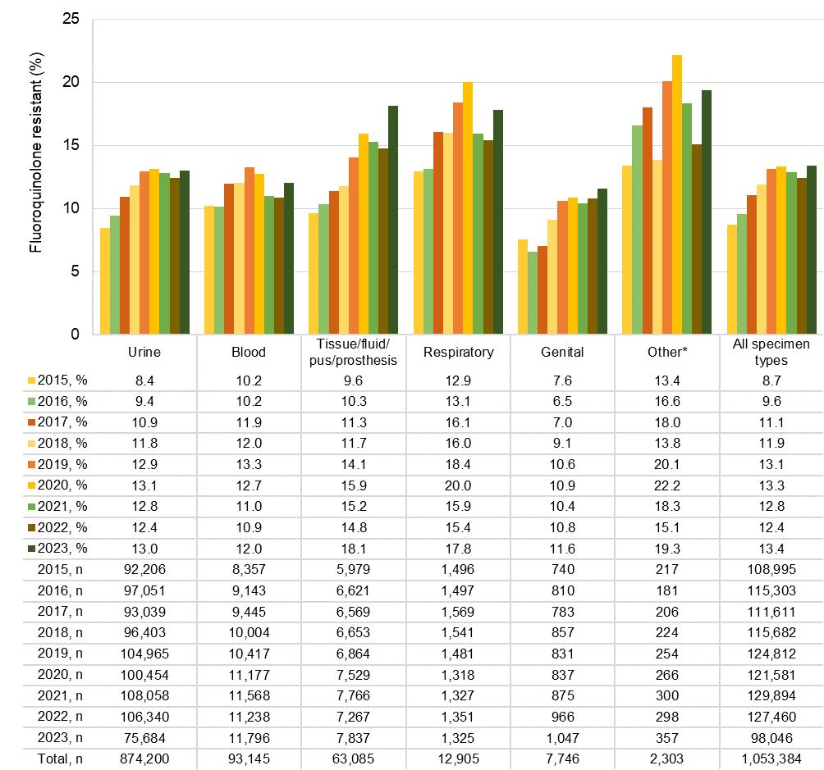
n = denominator for total number of isolates
* Other refers to cerebrospinal fluid, ear nose and throat, and enteric specimens
Note: Fluoroquinolone resistance was examined using available antimicrobial susceptibility test data for ciprofloxacin (non-urine specimens) and norfloxacin (urine specimens).
Source: APAS (NSW, Vic, Qld, SA, WA, Tas, ACT) – see Table A1

Fluoroquinolone resistance in Escherichia coli by setting
Almost all E. coli isolates reported by APAS contributors for 2015 to 2023 were from hospitals (84.8%) (public and private) and community settings (13.0%) (Figure 11). There was little difference in the proportion of fluoroquinolone-resistant E. coli isolates from hospitals compared to the community. E. coli isolates from multi-purpose service settings had the overall lowest fluoroquinolone resistance in this period, while isolates from aged care homes showed greater year-on-year variation.

Figure 11: Percentage of Escherichia coli with fluoroquinolone resistance by setting, APAS contributors, 2015–2023
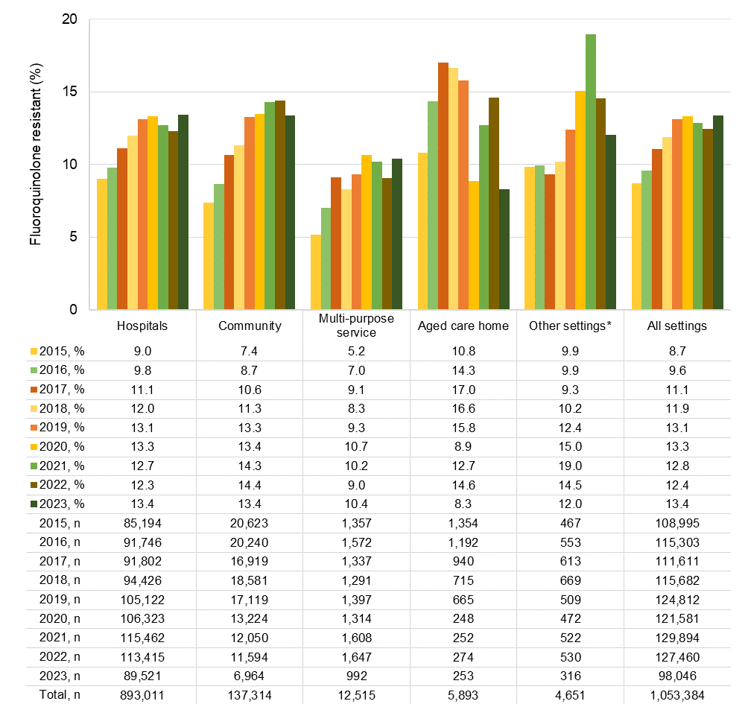
n = denominator for total number of isolates
* Other settings were predominantly corrective services Note: Hospitals = public and private.
Source: APAS (NSW, Vic, Qld, SA, WA, Tas, ACT) – see Table A1

Fluoroquinolone resistance in Escherichia coli by age group
Of E. coli isolates from APAS contributors for 2015 to 2023, 90.7% were from adults and 9.3% from paediatric patients (less than 18 years). The highest proportion of fluoroquinolone resistance was seen in tissue/fluid/pus/prosthesis isolates from adults. The proportion of fluoroquinolone- resistant E. coli was slightly lower among paediatric patients with urinary tract infections
(Figure 12).
Little difference was observed in the proportion of fluoroquinolone resistance across the three age groups for E. coli isolated from blood infections (Figure 12).

Figure 12: Percentage of Escherichia coli with fluoroquinolone resistance, by specimen source and age group, APAS contributors, 2015–2023
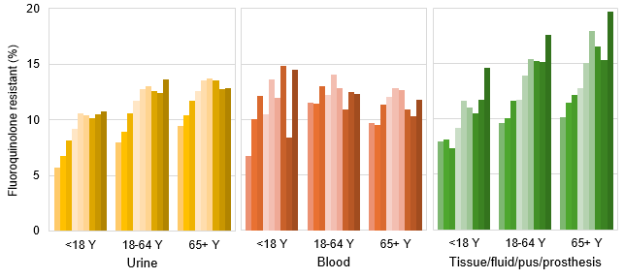

2015, % | 5.7 | 8.0 | 9.4 | 6.7 | 11.5 | 9.7 | 8.0 | 9.6 | 10.1
2016, % | 6.8 | 9.0 | 10.4 | 10.0 | 11.4 | 9.5 | 8.1 | 10.0 | 11.5
2017, % | 8.2 | 10.6 | 11.7 | 12.1 | 13.0 | 11.4 | 7.3 | 11.6 | 12.1
2018, % | 9.2 | 11.7 | 12.6 | 10.5 | 12.2 | 12.0 | 9.2 | 11.7 | 12.7
2019, % | 10.5 | 12.8 | 13.6 | 13.6 | 14.1 | 12.8 | 11.6 | 13.9 | 15.0
2020, % | 10.3 | 13.0 | 13.7 | 12.0 | 12.9 | 12.7 | 11.1 | 15.4 | 17.9
2021, % | 10.1 | 12.6 | 13.6 | 14.8 | 10.9 | 10.9 | 10.5 | 15.2 | 16.5
2022, % | 10.4 | 12.4 | 12.8 | 8.4 | 12.5 | 10.3 | 11.8 | 15.1 | 15.3
2023, % | 10.8 | 13.6 | 12.9 | 14.5 | 12.3 | 11.8 | 14.6 | 17.5 | 19.7
2015, n | 9,054 | 41,239 | 41,812 | 239 | 2,713 | 5,398 | 700 | 3,267 | 2,005
2016, n | 9,365 | 42,994 | 44,509 | 249 | 2,947 | 5,954 | 765 | 3,616 | 2,258
2017, n | 9,012 | 40,260 | 43,602 | 264 | 3,016 | 6,211 | 711 | 3,615 | 2,247
2018, n | 9,117 | 40,849 | 43,434 | 286 | 3,088 | 6,624 | 741 | 3,629 | 2,267
2019, n | 10,149 | 46,464 | 49,985 | 257 | 3,279 | 6,932 | 731 | 3,757 | 2,378
2020, n | 9,779 | 43,769 | 48,591 | 242 | 3,398 | 7,538 | 769 | 4,005 | 2,749
2021, n | 10,905 | 45,759 | 52,812 | 277 | 3,413 | 7,868 | 754 | 4,080 | 2,929
2022, n | 10,785 | 44,088 | 52,949 | 299 | 3,316 | 7,639 | 706 | 3,802 | 2,677
2023, n | 7,394 | 31,134 | 38,806 | 317 | 3,519 | 7,958 | 713 | 4,217 | 2,908
Total, n | 85,117 | 372,922 | 412,478 | 2,430 | 28,689 | 62,122 | 5,877 | 29,771 | 19,510
n = denominator for total number of isolates; y = years of age
Note: Fluoroquinolone resistance was examined using available antimicrobial susceptibility test data for ciprofloxacin (non-urine specimens) and norfloxacin (urine specimens).
Source: APAS (NSW, Vic, Qld, SA, WA, Tas, ACT) – see Table A1

Fluoroquinolone resistance in Escherichia coli by state and territory
Figures 13–15 show the trends in fluoroquinolone resistance in E. coli by state and territory reported from all APAS contributors from 2015 to 2023, with 2023 data mapped to Australian SA4 and Statistical Area Level 3 (SA3) (Figure 15). Data were analysed based on the known postcode of residence of the person from whom the specimen was taken (see Appendix 2).
There was considerable variation in the proportion of fluoroquinolone-resistant E. coli across Australia (Figure 13). There was an increasing trend observed across all states and territories from 2015 to 2019, which began to stabilise from 2020. The highest proportion of fluoroquinolone

resistance was in patients who resided in Victoria where resistance ranged from 13.2% in 2015 to 21.7% in 2023. The highest yearly proportion of resistance was observed in the Northern Territory (NT) in 2020 (29.1%) but this was attributed to a comparatively small number of isolates in comparison to other jurisdictions.
In Queensland, there was a marked decrease in the number of E. coli from urine specimens tested against norfloxacin in 2023, which was associated with a statewide change of antimicrobial susceptibility test panels which include ciprofloxacin but not norfloxacin. In South Australia from 2017, there was a change to a selective antimicrobial susceptibility testing protocol for urinary tract isolates.
With consideration to specimen type, the highest proportion of E. coli with fluoroquinolone resistance in 2023 was isolated from tissue/fluid/pus/prosthesis specimens in New South Wales (Figure 14).

Figure 13: Percentage of Escherichia coli with fluoroquinolone resistance by state and territory, APAS contributors, 2015–2023
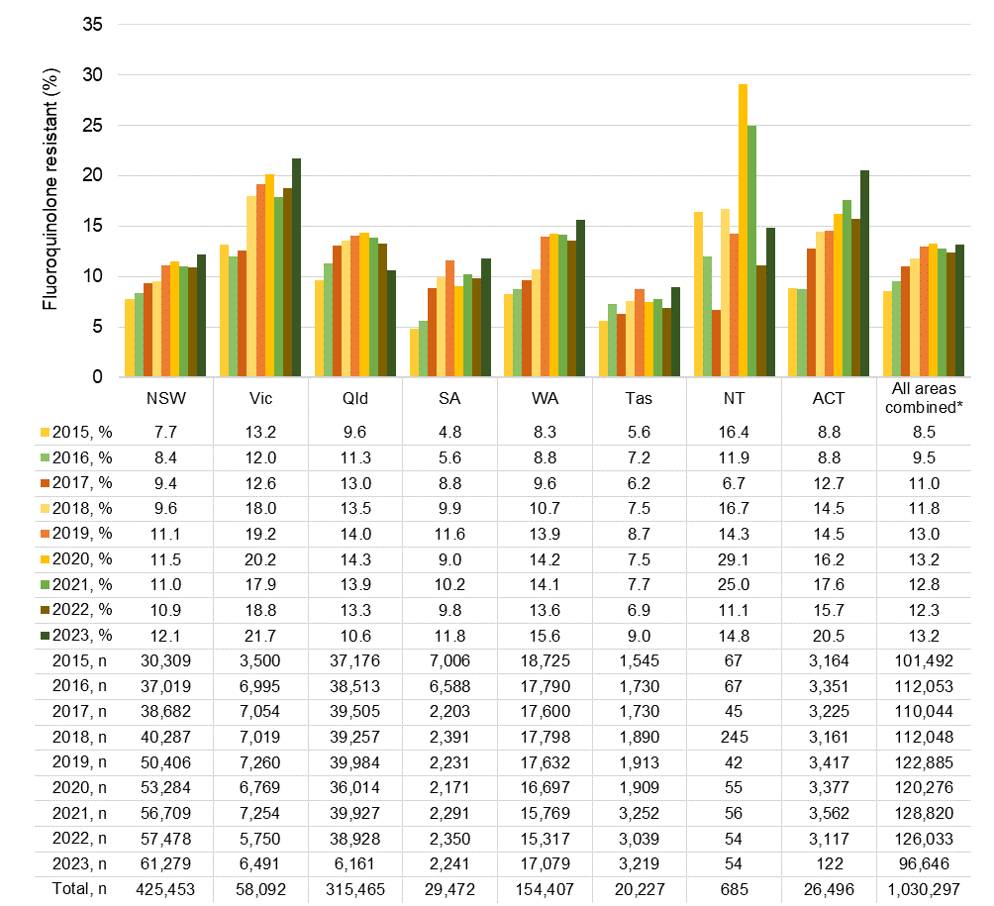
n = denominator for total number of isolates
* Where of residence was known Notes:
- State and territory based on postcode of residence. Data available from the NT were from NT residents who received pathology services interstate. Data from ACT pathology services were not available for 2023, except where ACT residents received pathology services interstate.
- Postcode of residence was not available in 2015 for NSW Health Pathology South Eastern Sydney Local Health District. Source: APAS (NSW, Vic, Qld, SA, WA, Tas, ACT) – see Table A1

Figure 14: Fluoroquinolone resistance in Escherichia coli, by state and territory and specimen source, APAS contributors, 2023
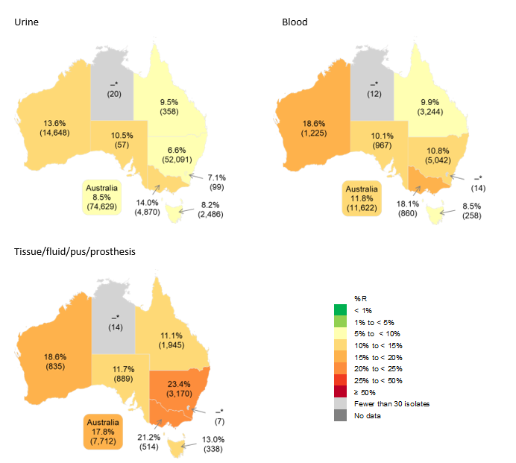
R = resistant
* Insufficient number of isolates (<30) to calculate percentage Notes:
- State and territory based on postcode of residence (where known). Data available from the NT were from NT residents who received pathology services interstate. Data from ACT pathology services were not available for 2023, except where ACT residents received pathology services interstate.
- Fluoroquinolone resistance was examined using available antimicrobial susceptibility test data for ciprofloxacin (non-urine specimens) and norfloxacin (urine specimens).
- Norfloxacin not available on the EUCAST Vitek® 2 antimicrobial susceptibility test panel commonly used by some laboratories. Source: APAS (NSW, Vic, Qld, SA, WA, Tas, ACT) – see Table A1

Figure 15: Ciprofloxacin resistance in Escherichia coli, mapped to Australian SA4 and SA3 areas, APAS contributors, 2023
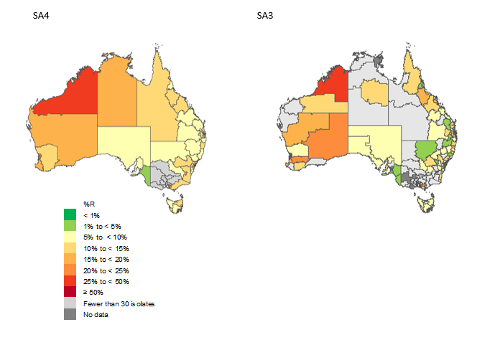
R = resistant; SA4 = Statistical Area Level 4; SA3 = Statistical Area Level 3 Notes:
- SA4 and SA3 based on postcode of residence (where known). Data available from the NT were from NT residents who received pathology services interstate. Data from ACT pathology services were not available for 2023, except where ACT residents received pathology services interstate.
- Fluoroquinolone resistance was examined using available antimicrobial susceptibility test data for ciprofloxacin (non-urine specimens) and norfloxacin (urine specimens).
- Norfloxacin not available on the EUCAST Vitek® 2 antimicrobial susceptibility test panel commonly used by some laboratories. Source: APAS (NSW, Vic, Qld, SA, WA, Tas, ACT) – see Table A1

Fluoroquinolone resistance in Escherichia coli by remoteness area
Figure 16 shows the trends in fluoroquinolone resistance in E. coli by remoteness area reported from all APAS contributors from 2015 to 2023. Data were analysed based on the known postcode of residence of the person from whom the specimen was taken (see Appendix 2).
A little under two-thirds (61.8%) of E. coli were isolated from patients residing in major Australian cities. Fluoroquinolone resistance was generally lower in inner and outer regional areas, and highest in very remote Australia. Proportions increased across all remoteness areas from 2015 to 2019 and stabilised from 2020. In E. coli isolates from patients residing in very remote Australia the proportion of fluoroquinolone resistance increased from 8.0% in 2015 to 19.4% in 2023 (Figure 16).
Figure 16: Percentage of Escherichia coli with fluoroquinolone resistance by remoteness area, APAS contributors, 2015–2023

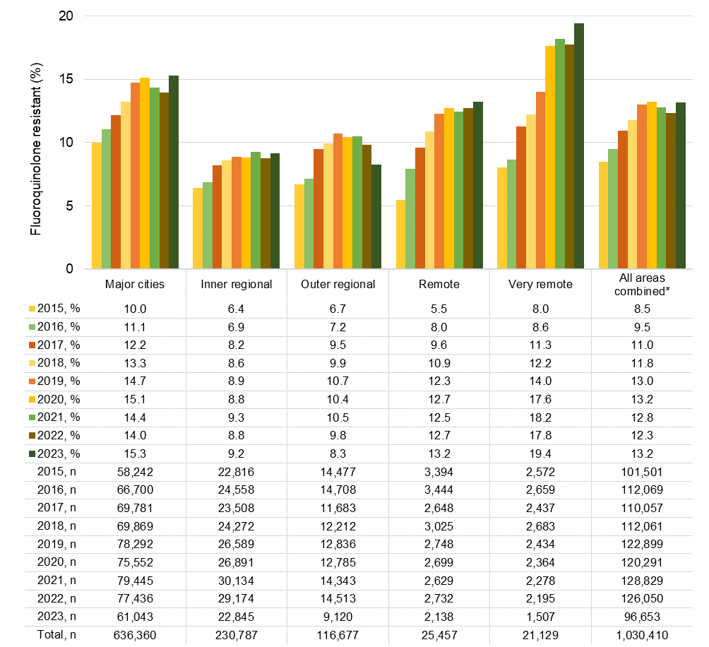
n = denominator for total number of isolates
Note: Remoteness area based on postcode of residence (where known). Source: APAS (NSW, Vic, Qld, SA, WA, Tas, ACT) – see Table A1

Methicillin resistance in Staphylococcus aureus
Staphylococcus aureus is a common pathogen that causes a wide variety of infections. Infections may be minor, such as boils, impetigo and wound infections; moderate, such as cellulitis; or serious, such as bone and joint infections, pneumonia, endocarditis and bacteraemia. S. aureus is also a common cause of healthcare-associated infection (HAI), especially surgical site infections, intravascular line infections with bacteraemia, and infections of prosthetic devices. Resistance to methicillin, referred to as methicillin-resistant S. aureus (MRSA), confers resistance to all β-lactam antimicrobials in community practice and almost all in hospital settings.
Many staphylococcal skin infections can be managed without antimicrobial therapy, but moderate and serious infections require treatment. First-line treatment is flucloxacillin (or dicloxacillin), or first-generation cephalosporins such as cefazolin or cefalexin for penicillin-allergic patients.
Between 2006 and 2023, there were 1,041,304 S. aureus isolates from the four long-term APAS contributor pathology services. Across all pathology services that contribute to APAS, including the four long-term contributors, data were available for 1,665,101 isolates over this period. See Appendices 1 and 2 for information about the pathology services that contribute to APAS.
Figure 17 shows the 18-year trend in methicillin resistance in S. aureus reported by all APAS contributors between 2006 and 2023. Methicillin resistance has remained stable between 20–23% during this period.
Figure 17: Percentage of Staphylococcus aureus with methicillin resistance, APAS contributors, 2006–2023
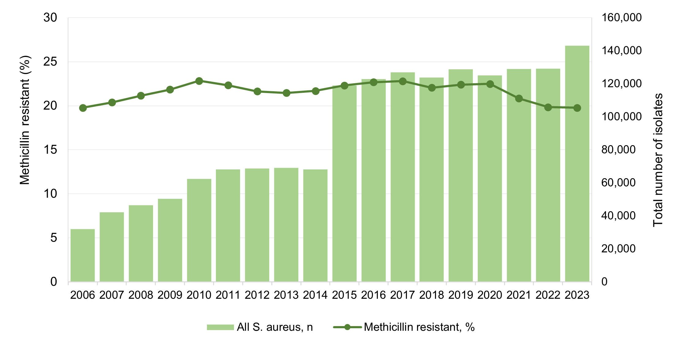

n = denominator for total number of isolates
Source: APAS (NSW, Vic, Qld, SA, WA, Tas, ACT) – see Table A1

For analyses of 2015 to 2023 data for this report, there were 1,149,190 S. aureus isolates from all APAS contributors.

Methicillin resistance in Staphylococcus aureus by specimen type
A substantial majority (80.9%) of S. aureus isolates were from tissue/fluid/pus/prosthesis specimens, for which the highest proportion of MRSA was observed. Isolates from the ear nose and throat had the lowest proportion of MRSA (Figure 18). For more information on specimen types, see Appendix 2.
Across all specimen types, methicillin resistance was stable at around 22% from 2015 to 2020. There was a slight downward trend to 19.8% in 2022 and 2023. There was a decreasing trend in MRSA isolated from blood specimens from 2016.
Figure 18: Percentage of methicillin-resistant Staphylococcus aureus by specimen source, APAS contributors, 2015–2023

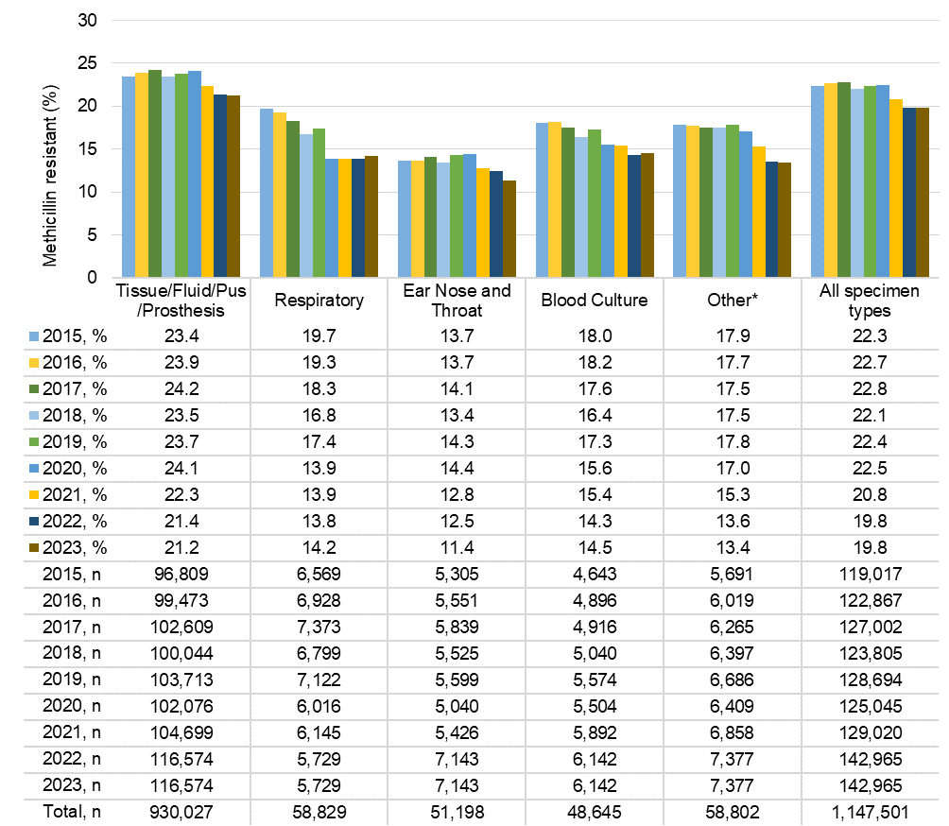
n = denominator for total number of isolates
* Other refers to cerebrospinal fluid, ear nose and throat, enteric, and genital specimens Source: APAS (NSW, Vic, Qld, SA, WA, Tas, ACT) – see Table A1

Methicillin resistance in Staphylococcus aureus by setting
Almost all S. aureus isolates reported by APAS contributors from 2015 to 2023 were from hospitals (public and private) (76.0%) and community settings (19.8%) (Figure 19).
The proportion of MRSA from hospital settings was stable between 2015 and 2020 (range 21.3% to 22.2%). From 2021, there was a slight downward trend to 19.1% in 2023. (Figure 19). The proportion of MRSA in isolates from the community setting increased slightly from 21.4% in 2015 to 24.9% in 2020 and decreased to 21.5% in 2023.
MRSA rates were highest in isolates from other settings (mostly corrective services) across all years, and in aged care homes until 2021. Despite these settings contributing only 2.3% of all
S. aureus isolates captured by APAS, it suggests that these settings are important reservoirs for MRSA. In aged care homes, both the total number of isolates and proportion of MRSA declined from 2016 (Figure 19).
Figure 19: Percentage of methicillin-resistant Staphylococcus aureus by setting, APAS contributors, 2015–2023

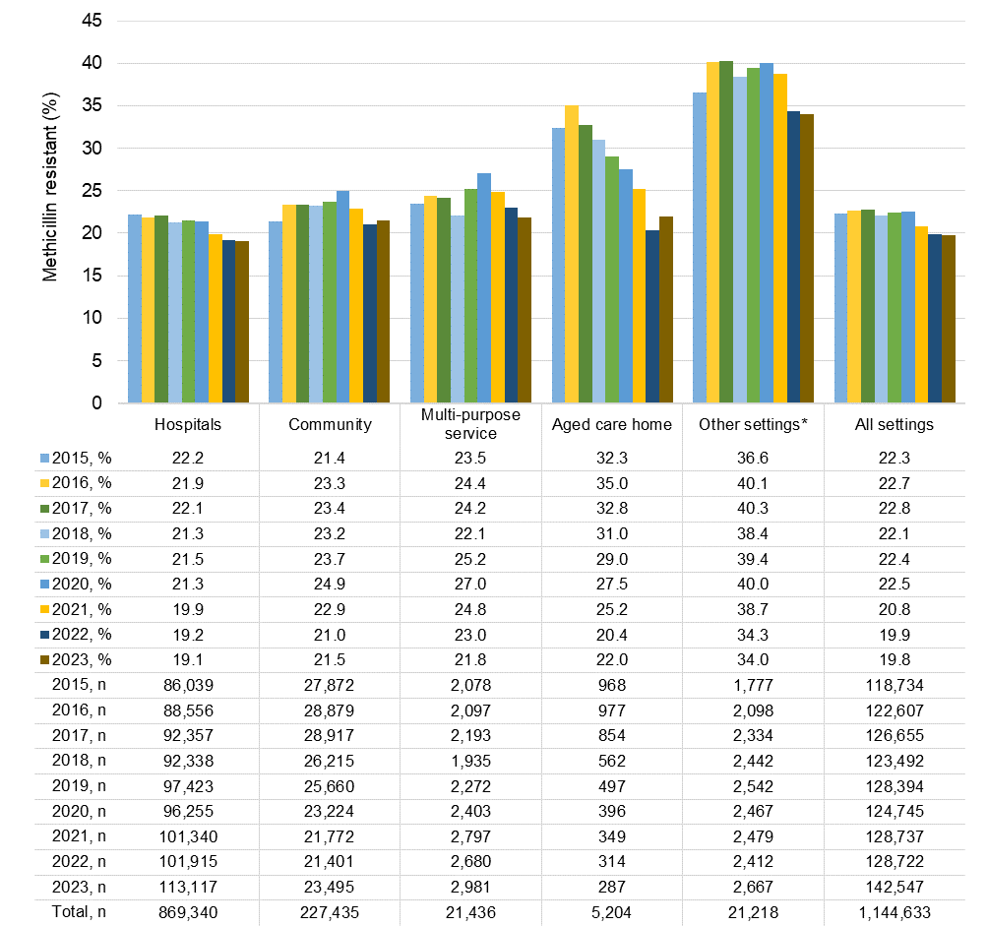

n = denominator for total number of isolates
* Other settings were predominantly corrective services Note: Hospitals = public and private.
Source: APAS (NSW, Vic, Qld, SA, WA, Tas, ACT) – see Table A1

Methicillin resistance in Staphylococcus aureus by age group
Of S. aureus isolates collected from all APAS contributors from 2015 to 2023, a slim majority (51.4%) were from the 18–64 years age group and a small proportion (18.5%) were from paediatric patients (aged less than 18 years).
The proportion of S. aureus with methicillin resistance was lowest among paediatric patients with respiratory infections (Figure 20). A decreasing trend in the MRSA rate was observed in patients aged 65 years and over across all specimen types. There was little difference in the proportion of MRSA observed in the three age groups for S. aureus isolated from blood. However, in 2023, the MRSA rate was 1.6-fold lower in paediatric patients (9.1%) compared to adults (14.9%).
Figure 20: Methicillin-resistant Staphylococcus aureus, by specimen source and age group, APAS contributors, 2015–2023
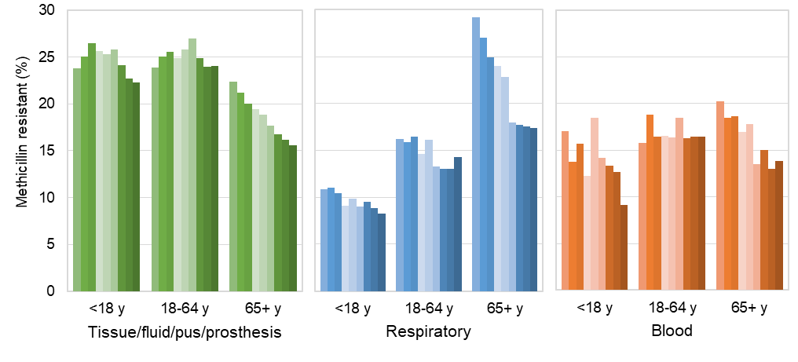
2015, % | 23.8 | 23.9 | 22.3 |  | 10.8 | 16.3 | 29.2 |  | 17.1 | 15.8 | 20.3
2016, % | 25.0 | 25.0 | 21.1 |  | 11.0 | 15.8 | 27.0 |  | 13.8 | 18.8 | 18.4
2017, % | 26.5 | 25.6 | 20.0 |  | 10.4 | 16.5 | 24.9 |  | 15.7 | 16.4 | 18.7
2018, % | 25.6 | 24.8 | 19.4 |  | 9.1 | 14.6 | 24.0 |  | 12.3 | 16.5 | 17.0
2019, % | 25.3 | 25.8 | 18.9 |  | 9.9 | 16.1 | 22.8 |  | 18.4 | 16.4 | 17.8
2020, % | 25.8 | 27.0 | 17.7 |  | 9.0 | 13.3 | 18.0 |  | 14.2 | 18.4 | 13.5
2021, % | 24.2 | 24.9 | 16.7 |  | 9.6 | 13.0 | 17.8 |  | 13.3 | 16.3 | 15.1
2022, % | 22.7 | 23.9 | 16.1 |  | 8.9 | 13.0 | 17.6 |  | 12.7 | 16.4 | 13.0
2023, % | 22.3 | 24.1 | 15.6 |  | 8.2 | 14.3 | 17.4 |  | 9.1 | 16.4 | 13.9
2015, n | 19,391 | 49,679 | 27,689 |  | 1,062 | 3,272 | 2,222 |  | 346 | 2,062 | 2,235
2016, n | 19,495 | 52,334 | 27,605 |  | 1,009 | 3,414 | 2,491 |  | 363 | 2,105 | 2,426
2017, n | 20,178 | 54,109 | 28,264 |  | 1,267 | 3,580 | 2,504 |  | 351 | 2,038 | 2,528
2018, n | 18,917 | 53,228 | 27,844 |  | 1,161 | 3,347 | 2,270 |  | 359 | 2,194 | 2,483
2019, n | 18,955 | 55,296 | 29,398 |  | 1,137 | 3,543 | 2,431 |  | 380 | 2,347 | 2,844
2020, n | 17,843 | 55,008 | 29,186 |  | 1,102 | 3,048 | 1,859 |  | 387 | 2,228 | 2,881
2021, n | 18,647 | 54,895 | 31,120 |  | 1,088 | 3,119 | 1,932 |  | 405 | 2,347 | 3,136
2022, n | 18,330 | 54,183 | 31,474 |  | 1,028 | 3,059 | 2,053 |  | 403 | 2,310 | 3,322
2023, n | 21,865 | 60,539 | 34,143 |  | 1,021 | 2,837 | 1,864 |  | 396 | 2,269 | 3,478
Total, n | 173,621 | 489,271 | 266,723 |  | 8,854 | 26,382 | 17,762 |  | 3,390 | 19,900 | 25,333
n = denominator for total number of isolates; y = years of age
Source: APAS (NSW, Vic, Qld, SA, WA, Tas, ACT) – see Table A1

Methicillin resistance in Staphylococcus aureus by state and territory
Figures 21–23 show the trends in MRSA isolates by state and territory reported from all APAS contributors from 2015 to 2023, with 2023 data mapped to Australian SA3 areas (Figure 23). Data were analysed based on the known postcode of residence of the person from whom the specimen was taken (see Appendix 2).
The number of S. aureus isolates and the prevalence of MRSA differs substantially between states and territories. In 2023, overall MRSA rates ranged from 10.2% in Tasmania to 36.4% in the NT.
There was a downward trend in MRSA rates across all states except Tasmania since 2015 (Figure 21).
With consideration to specimen type in 2023, the highest proportions of methicillin resistance were observed in S. aureus isolates from tissue/fluid/pus/prosthesis in patients residing in the NT followed by WA. However, there was vast difference between the number of isolates analysed (Figure 22).
Figure 21: Percentage of methicillin-resistant Staphylococcus aureus by state and territory, APAS contributors, 2015–2023
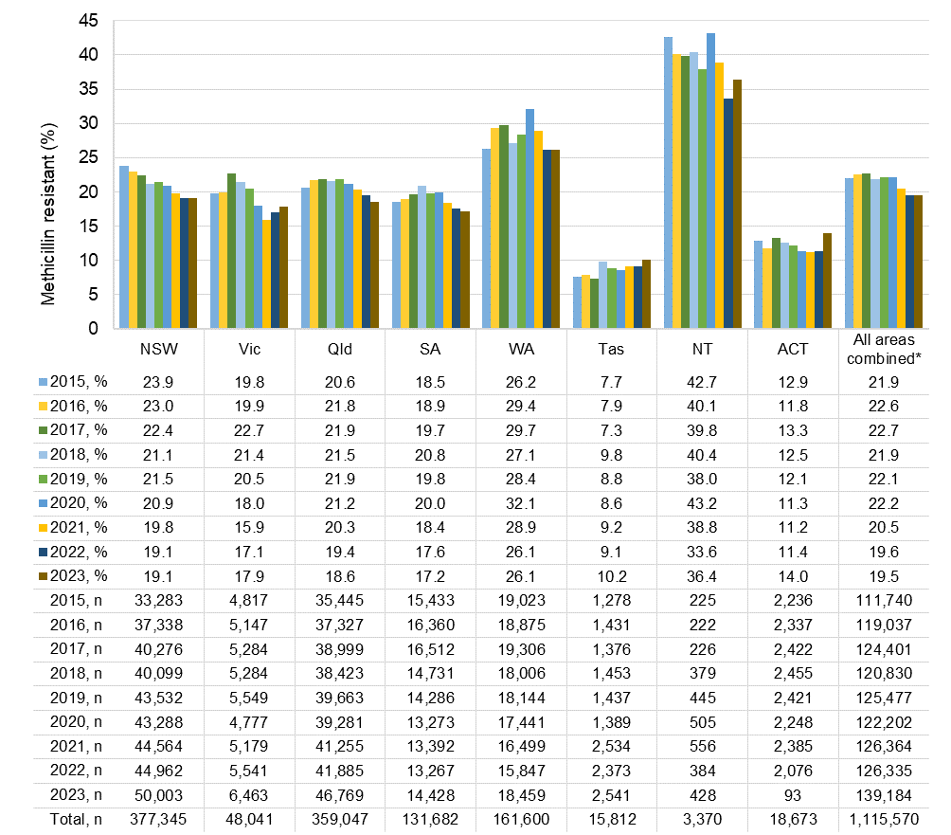
n = denominator for total number of isolates
* Where postcode of residence was known Notes:
- State and territory based on postcode of residence. Data available from the NT were from NT residents who received pathology services interstate. Data from ACT pathology services were not available for 2023, except where ACT residents received pathology services interstate.
- Postcode of residence was not available in 2015 for NSW Health Pathology South Eastern Sydney Local Health District.
Source: APAS (NSW, Vic, Qld, SA, WA, Tas, ACT) – see Table A1

Figure 22: Methicillin resistance in Staphylococcus aureus, by state and territory and specimen source, APAS contributors, 2023
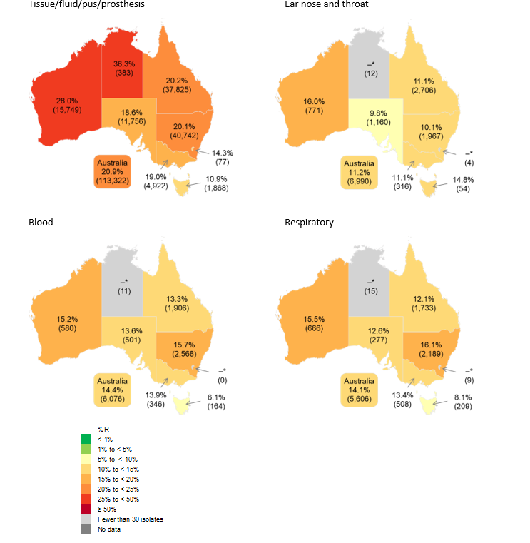
R = resistant
* Insufficient number of isolates (<30) to calculate percentage
Note: State and territory based on postcode of residence (where known). Data available from the NT were from NT residents who received pathology services interstate. Data from ACT pathology services were not available for 2023, except where ACT residents received pathology services interstate.
Source: APAS (NSW, Vic, Qld, SA, WA, Tas, ACT) – see Table A1

In 2023, the highest rates of MRSA were observed in WA and the NT: Kimberly (44.1%), Alice Springs (39.3%), West Pilbara (39.0%), Gascoyne (38.4%), and East Pilbara (37.5%). The lowest rate was observed in Tasmania in Hobart Inner (4.9%) (Figure 23).
Figure 23: Methicillin resistance in Staphylococcus aureus, mapped to Australian SA3 areas, APAS contributors, 2023

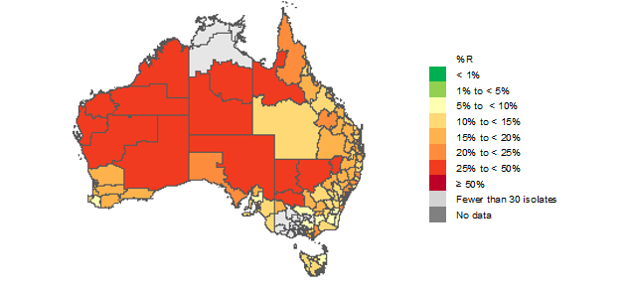

R = resistant; SA3 = Statistical Area Level 3
Note: SA3 based on postcode of residence (where known). Data available from the NT were from NT residents who received pathology services interstate. Data from ACT pathology services were not available for 2023, except where ACT residents received pathology services interstate.
Source: APAS (NSW, Vic, Qld, SA, WA, Tas, ACT) – see Table A1

Methicillin resistance in Staphylococcus aureus by remoteness area
Figure 24 shows the trends in MRSA by remoteness area as reported from all APAS contributors from 2015 to 2023. Data were analysed based on the known postcode of residence of the person from whom the specimen was taken (see Appendix 2).
Just over one-half (52.5%) of S. aureus isolates were from people residing in major Australian cities. However, methicillin resistance was more prevalent in remote and very remote areas of Australia than in major cities and inner regional areas (Figure 19). MRSA rates have declined slightly in isolates from patients residing in outer regional Australia since 2017. There has also been an overall downward trend in MRSA rates in isolates from people residing in remote (since 2020) and very remote Australia (since 2017).
Figure 24: Percentage of methicillin resistant Staphylococcus aureus by remoteness area, APAS contributors, 2015–2023
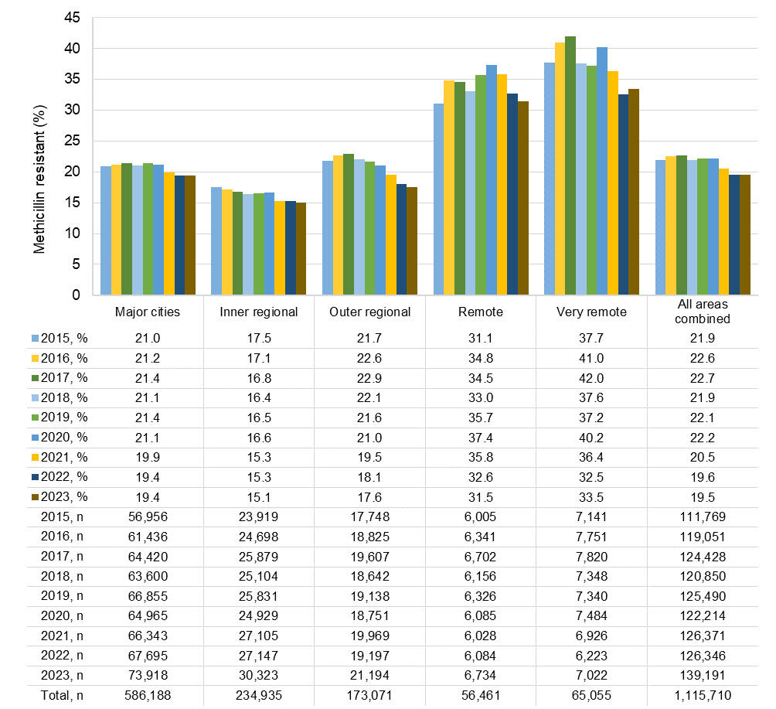

n = denominator for total number of isolates
Note: Remoteness area based on postcode of residence (where known). Source: APAS (NSW, Vic, Qld, SA, WA, Tas, ACT) – see Table A1

Conclusions
Antimicrobials are an integral component of healthcare delivery and need to be readily available and effective. The emergence of antimicrobial resistance (AMR) and consequent reduction in the efficacy of antimicrobials continues to be one of the biggest challenges to the provision of safe, high-quality health services in Australia and internationally. AMR is a critical risk to patient safety as it reduces the number of antimicrobials available to treat and prevent infections. There are also cost implications and risks associated with adverse effects from antimicrobial use, including side effects.
Multidrug-resistant organisms (MROs), including VRE, fluoroquinolone-resistant E. coli and MRSA, pose a greater risk given these infections are associated with increased morbidity and mortality.
This report provides some insight to the epidemiology of each MRO included in the analyses. There are opportunities to control the upward trend of AMR and improve the safety of care provided to Australians across acute, primary and community, and aged care settings. Strategies to achieve this include the implementation and improvement of antimicrobial prescribing guidelines, and antimicrobial stewardship (AMS) and infection prevention and control programs. This is especially important for vulnerable Australians including hospitalised patients, aged care home residents and First Nations communities.
The Commission will continue to work with developers of antimicrobial prescribing guidelines, including Therapeutic Guidelines and other expert groups, to ensure they are evidence-based and informed by current Australian AMR data. Development of local prescribing recommendations may become important in view of the variation in AMR patterns across different geographical and service delivery settings.
APAS contributors have ready access to data and functionality to produce antibiograms, which provide an overview of antimicrobial susceptibilities for specific microorganisms. Antibiograms can inform local empiric antimicrobial recommendations and the appropriate adaptation of national guidelines. Local and national guidelines also inform the management of antimicrobial formularies and their associated restriction rules and approval processes. These interventions are key actions for AMS programs and support the implementation of National Safety and Quality Standards for acute and primary and community healthcare services and aged care services.
The report findings also highlight the importance of effective infection prevention and control strategies. Appropriate infection prevention and control programs support the safe delivery of care provided across healthcare settings, within the framework of National Safety and Quality Standards and the Australian Guidelines for the Prevention and Control of Infections in Healthcare. In addition to protecting consumers, these programs also work to protect clinicians and visitors in healthcare settings by minimising the risk of transmission of infections and AMR, and by reducing infections so that fewer antimicrobials are used and there is less pressure on AMR.
This report highlights the importance of ongoing surveillance of AMR and infections, and the value of APAS and the Antimicrobial Use and Resistance in Australia (AURA) surveillance program in monitoring the emergence of, and trends in, AMR. The Commission will continue to collaborate with the Australian Government Department of Health and Aged Care, state and territory health departments, and private pathology services to enhance national surveillance of AMR and increase utility of AMR data to inform strategies for its prevention and containment.

References
- World Health Organisation. WHO Bacterial Priority Pathogens List, 2024: bacterial pathogens of public health importance to guide research, development and strategies to prevent and control antimicrobial resistance. Geneva: WHO, 2024.
- Australian Commission on Safety and Quality in Health Care. AURA 2016: first Australian report on antimicrobial use and resistance in human health. Sydney: ACSQHC, 2016.
- Australian Commission on Safety and Quality in Health Care. AURA 2017: second Australian report on antimicrobial use and resistance in human health. Sydney: ACSQHC, 2017.
- Australian Commission on Safety and Quality in Health Care. AURA 2019: third Australian report on antimicrobial use and resistance in human health. Sydney: ACSQHC, 2019.
- Australian Commission on Safety and Quality in Health Care. AURA 2021: fourth Australian report on antimicrobial use and resistance in human health. Sydney: ACSQHC; 2021.
- Australian Commission on Safety and Quality in Health Care. AURA 2023: fifth Australian report on antimicrobial use and resistance in human health. Sydney: ACSQHC; 2023.
- Australian Commission on Safety and Quality in Health Care. Australian Passive Antimicrobial Resistance Surveillance. First report: multi-resistant organisms. Sydney: ACSQHC, 2018.
- Furuya-Kanamori L, Mills DJ, Trembizki E, Robson JM, Jennison AV, Whiley DM, et al. High rate of asymptomatic colonization with antimicrobial-resistant Escherichia coli in Australian returned travellers. J Travel Med. 2022;29(1).
- Furuya-Kanamori L, Stone J, Yakob L, Kirk M, Collignon P, Mills DJ, et al. Risk factors for acquisition of multidrug-resistant Enterobacterales among international travellers: a synthesis of cumulative evidence. J Travel Med. 2020;27(1).
- Australian Government Department of Health and Aged Care. Royal Melbourne Hospital and the National Centre for Antimicrobial Stewardship. Infections and antimicrobial prescribing in Australian residential aged care facilities. Results of the 2022 Aged Care National Antimicrobial Prescribing Survey. Canberra: 2024.
- Antibiotic Expert Groups. Antibiotic. 2023. In: Therapeutic Guidelines [Internet]. Melbourne: Therapeutic Guidelines Limited. Available from: https://tgldcdp.tg.org.au/etgcomplete.
- Australian Commission on Safety and Quality in Health Care. Priority Antibacterial List for antimicrobial resistance containment: a stewardship resource for human health. [Internet] Sydney: ACSQHC; 2020 [cited 2024 May 5] Available from: https://www.safetyandquality.gov.au/publications-and-resources/resource-library/priority- antibacterial-list-antimicrobial-resistance-containment.
- National Health and Medical Research Council. Australian guidelines for the prevention and control of infection in healthcare. Canberra: Commonwealth of Australia; 2019.
- Australian Commission on Safety and Quality in Health Care. National safety and quality health service standards. 2nd ed. - version 2. [Internet] Sydney: ACSQHC; 2021 Available from: https://www.safetyandquality.gov.au/publications-and-resources/resource- library/national-safety-and-quality-health-service-standards-second-edition.
- Australian Commission on Safety and Quality in Health Care. National safety and quality primary and community healthcare standards. [Internet] Sydney: ACSQHC; 2021 Available from: https://www.health.gov.au/resources/publications/the-strengthened-aged-care-quality- standards-final-draft?language=en.
- Australian Commission on Safety and Quality in Health Care. The strengthened aged care quality standards - Final draft (November 2023). [Internet] Sydney: ACSQHC; 2023 Available from: https://www.health.gov.au/sites/default/files/2023-12/the-strengthened- aged-care-quality-standards-final-draft-november-2023.pdf.
- Coombs GW, Pearson JC, Christiansen K, Gottlieb T, Bell JM, George N, et al. Australian Group on Antimicrobial Resistance Enterococcus Surveillance Programme annual report, 2010. Commun Dis Intell Q Rep. 2013;37(3):E199-209.
- Coombs G, Bell JM, Daley D, Collignon P, Cooley L, Gottlieb T, et al. Australian Group on Antimicrobial Resistance: Sepsis Outcome Programs: 2021 report. Sydney: Australian Commission on Safety and Quality in Health Care, 2022.

- Coombs G, Bell JM, Blyth CC, Daley D, Collignon P, Cooley L, et al. Australian group on Antimicrobial Resistance Surveillance Outcomes Programs. Bloodstream infections: 2022 Report. Sydney: ACSQHC, 2023.
- European Committee on Antimicrobial Susceptibility Testing. Antimicrobial susceptibility testing. [Internet]: EUCAST; 2024 [cited May 2024] Available from: https://www.eucast.org/ast_of_bacteria/.
- CLSI. Methods for dilution antimicrobial susceptibility tests for bacteria that grow aerobically, 12th Edition. CLSI standard M07. [Internet] Wayne, PA: Clinical and Laboratory Standards Institute; 2024 [cited May 2024] Available from: https://clsi.org/standards/products/microbiology/documents/m07/.
- CLSI. Performance Standards for antimicrobial disk susceptibility tests, 14th edition. CLSI standard M02. [Internet] Wayne, PA: Clinical and Laboratory Standards Institute; 2024 [cited May 2024] Available from: https://clsi.org/standards/products/microbiology/documents/m02/.
- Bell SM, Pham JN, Rafferty DL, Allerton JK, James PM. Antibiotic Susceptibility Testing by the CDS Method. A Manual for medical and veterinary laboratories 2018. 9th edition (revised September 2019). [Internet]: NSW Health Pathology, South Eastern Area Laboratory Services; 2019 [cited Mar 2022] Available from: http://cdstest.net.
- Australian Bureau of Statistics. Australian Statistical Geography Standard (ASGS): Edition 3 - Remoteness Structure, July 2021. [Internet] Canberra: ABS; 2021 [updated 20/07/2021] Available from: https://www.abs.gov.au/statistics/standards/australian-statistical-geography- standard-asgs-edition-3/jul2021-jun2026/remoteness-structure.
- Australian Bureau of Statistics. Main structure and greater capital city statistical areas. Australian Statistical Geographical Standard (ASGS) Edition 3. July 2021. [Internet] Canberra: ABS; 2021 [updated 20/07/2021] Available from: https://www.abs.gov.au/statistics/standards/australian-statistical-geography-standard-asgs- edition-3/jul2021-jun2026/main-structure-and-greater-capital-city-statistical-areas.

Appendix 1: About APAS
Australian Passive AMR Surveillance (APAS) was established by the Commission in collaboration with Queensland Health in 2015 as a component of the Antimicrobial Use and Resistance in Australia (AURA) surveillance program.
Funding for APAS is provided by the Australian Government Department of Health and Aged Care, with contributions from the states and territories as part of the collection and analysis of their data.
Passive antimicrobial resistance (AMR) surveillance involves the extraction of routine susceptibility testing results from laboratory information systems. APAS uses the Queensland Health OrgTRx information technology infrastructure to collect, analyse and report on de-identified patient-level AMR data contributed by 10 public and private pathology services across Australia. The laboratories that are part of these pathology services detect AMR in isolates referred from public and private hospitals, aged care homes and community settings. Initially, data were captured from January 2015 from all contributing laboratories. Subsequently, historical data have been uploaded by several pathology services. APAS now includes more than 115 million records from 2005
to May 2024.
In addition to national reporting by the Commission, APAS participants have timely access to their own data, which enables comprehensive reporting of local AMR in the form of:
- Longitudinal datasets for specified organism–antimicrobial combinations
- Cumulative antibiograms showing rates of resistance for a range of organisms from a specified specimen type in a selected time period
- Tabulations showing the resistance profiles of organism strains isolated during a selected time period
- Reporting for individual units within hospitals or health services, or at a statewide level.
The Commission thanks the pathology services listed in Table A1 that currently contribute data to APAS.
Table A1: APAS contributor pathology services, July 2024

State/Territory | Pathology service | Notes
New South Wales | NSW Health Pathology*† | All NSW Health Pathology public laboratory services.
Victoria | Alfred Health | Public health service catchment for Alfred Health.
Victoria | Monash Health | Public health service catchment for Monash Health.
Queensland | Mater Pathology Brisbane* | Queensland public and private patients.
Queensland | Pathology Queensland* | All Queensland Health public hospitals and health services.
South Australia | SA Pathology* | Public health catchments for South Australia.
Western Australia | PathWest Laboratory Medicine | All Western Australia public hospitals.
Tasmania | Launceston General Hospital§ | Combined data from these two contributing laboratories capture most public patient data for Tasmania.
Tasmania | Royal Hobart Hospital
Australian Capital Territory | ACT Pathology# | All public and some private ACT health services.
* NSW Health Pathology (South Western Sydney and Sydney Local Health Districts), Mater Pathology Brisbane, Pathology Queensland and SA Pathology since 2006
† NSW Health Pathology West since 2010
§ Launceston General Hospital since 2021 # No data from ACT Pathology for 2023
Note: Data are only available from the Northern Territory for residents who received pathology services interstate.

Appendix 2: Methodology

Data extraction
Data were extracted from the Australian Passive AMR Surveillance (APAS) system on 1 May 2024. All data analyses for this report were performed using Microsoft Excel 365.
Results from isolates detected in infection control and environmental sampling were excluded because they were not representative of isolates from clinical infections.

Pathology services
At the time of data extraction, the 10 pathology services listed in Table A1 were contributing data to APAS.
APAS data report on antimicrobials tested using European Committee on Antimicrobial Susceptibility Testing (EUCAST)²⁰, Clinical and Laboratory Standards Institute (CLSI)^{21,} ²², or Calibrated Dichotomous Sensitivity (CDS)²³ methods. Pathology services in Victoria, Queensland, South Australia (SA), Tasmania, and the Australian Capital Territory (ACT) use EUCAST; PathWest uses CLSI; NSW Health Pathology services use CLSI, CDS, and EUCAST.
APAS provides categorical data (susceptible, intermediate, resistant) based on interpretive criteria. It is acknowledged that there are differences in the interpretation of results obtained by each method, and the Commission is working with stakeholders to promote alignment with a single method in Australia.

Representativeness
Historical data were available from 2006 for the four pathology services that have continuously contributed to APAS: NSW Health Pathology (South Western Sydney and Sydney Local Health Districts), Mater Pathology Brisbane, Pathology Queensland and SA Pathology. All pathology services that contribute to APAS are listed in Table A1.
Data from ACT Pathology were not available since November 2022 for the analyses for this report, pending re-integration of the service with APAS following implementation of a new laboratory information system in late 2022. The data for 2023 will be available when the re-integration project is completed.
It is important to note that, for historical data, there may have been changes since 2006 in the number of facilities from which the pathology services have received isolates, and numbers are likely to have varied from year to year, along with laboratory criteria and methods. There have also been breakpoint changes over time.
In addition, several public laboratories have been reconfigured or renamed during the period to which the analyses relate; these changes were not addressed in detail in this report.
Jurisdictions with state- or territory-wide public pathology services (Queensland, SA, Western Australia, New South Wales [NSW] and the ACT) were most representative. Queensland was comprehensively represented due to the participation in APAS by Mater Pathology Brisbane. NSW has transitioned all public laboratories to the statewide NSW Health Pathology service; the laboratory names used in this report reflect current naming conventions, and all NSW Health Pathology laboratories contributed data, including historical data from 2010 to APAS from May 2024.
Data from Victoria were limited as there were only two contributing sites. Data were not available from the Northern Territory.
Some public laboratories undertake testing for private facilities and in the community.

Isolates and specimen types
Data were only included where there were at least 30 isolates for each analysis. Analyses were conducted only when the proportion of isolates that were tested against a single antimicrobial was at least 75%.

The results of duplicate testing were included in the data collected for APAS. Duplicate testing means that the same bacterial strain was tested and reported from repeated specimens and similar specimens from a single infection episode. This was appropriate clinical laboratory practice from a patient management perspective. The impact of these duplicates was minimised for analyses of APAS data by using algorithms based on resistance patterns, and selected time periods for which duplicates were not counted. Only the first isolate for the first specimen of each specimen type per year was included in the dataset for analyses. A repeat isolate from the same specimen type was not included.
For APAS analysis, specimen types are allocated into nine categories: acid fast bacilli, blood culture, cerebrospinal fluid, ear, nose and throat, enteric, genital, respiratory, tissue/fluid/pus/prosthesis, and urine. Respiratory specimens include sputum, lung aspirates, tracheal aspirates and endotracheal aspirates as well other unknown primary sites, and some pathology services do not provide the primary site from which the respiratory specimen was taken.
For Escherichia coli, prevalence of fluoroquinolone resistance was examined using available antimicrobial susceptibility test data for ciprofloxacin (non-urine specimens) and norfloxacin (urine specimens).

Setting
Where available, the settings from which the isolates were obtained were included in the analyses. These were assigned by the pathology service that contributed the data for the specimen and include aged care, community, multi-purpose service, public hospital, and private hospital.
Facilities may also be categorised as other, such as correctional services.
It is important to note that, for historical data, there may have been changes since 2006 in the range and acuity of services offered in some settings, particularly those categorised as multi- purpose services. Information about each of these changes is not routinely available.
In this report, aged care home and multi-purpose service data were sometimes combined with data from settings other than hospitals or community due to a smaller sample size and limited representativeness across states and territories and the potential impact of a change in referral patterns for one large pathology service for this setting from mid-2018.

Location
The postcode of residence of the person from whom the specimen was taken, where known, was used to stratify the data in terms of location by state or territory, and local area and remoteness using the ABS Australian Statistical Geography Standard (ASGS).^{24,25}
Main Structure and Greater Capital City Statistical Areas has seven hierarchical levels including states and territories and Statistical Area Levels 4 and 3 (SA4 and SA3). SA4 and SA3 create a standard framework for the analysis of geographical data at a regional level through clustering groups that have similar regional characteristics. SA4s are the largest sub-state regions, which are formed by aggregated SA3s.
The Remoteness Areas Structure within the ASGS divides Australia into five categories of remoteness on the basis of a measure of relative access to services. The five Remoteness Areas for Australia are major cities, inner regional, outer regional, remote and very remote.

Data characteristics
APAS data differ from targeted antimicrobial resistance surveillance data in that a smaller range of agents are tested, there are varied antimicrobial testing and reporting practices, and three different testing systems are used in Australia.




Level 5, 255 Elizabeth Street, Sydney NSW 2000
GPO Box 5480, Sydney NSW 2001
Phone: (02) 9126 3600
Email: mail@safetyandquality.gov.au Website: www.safetyandquality.gov.au

