May 2024
Australian Passive AMR Surveillance
  - Trends in macrolide resistance in Streptococcus agalactiae and
Streptococcus pyogenes – 2006 to 2023
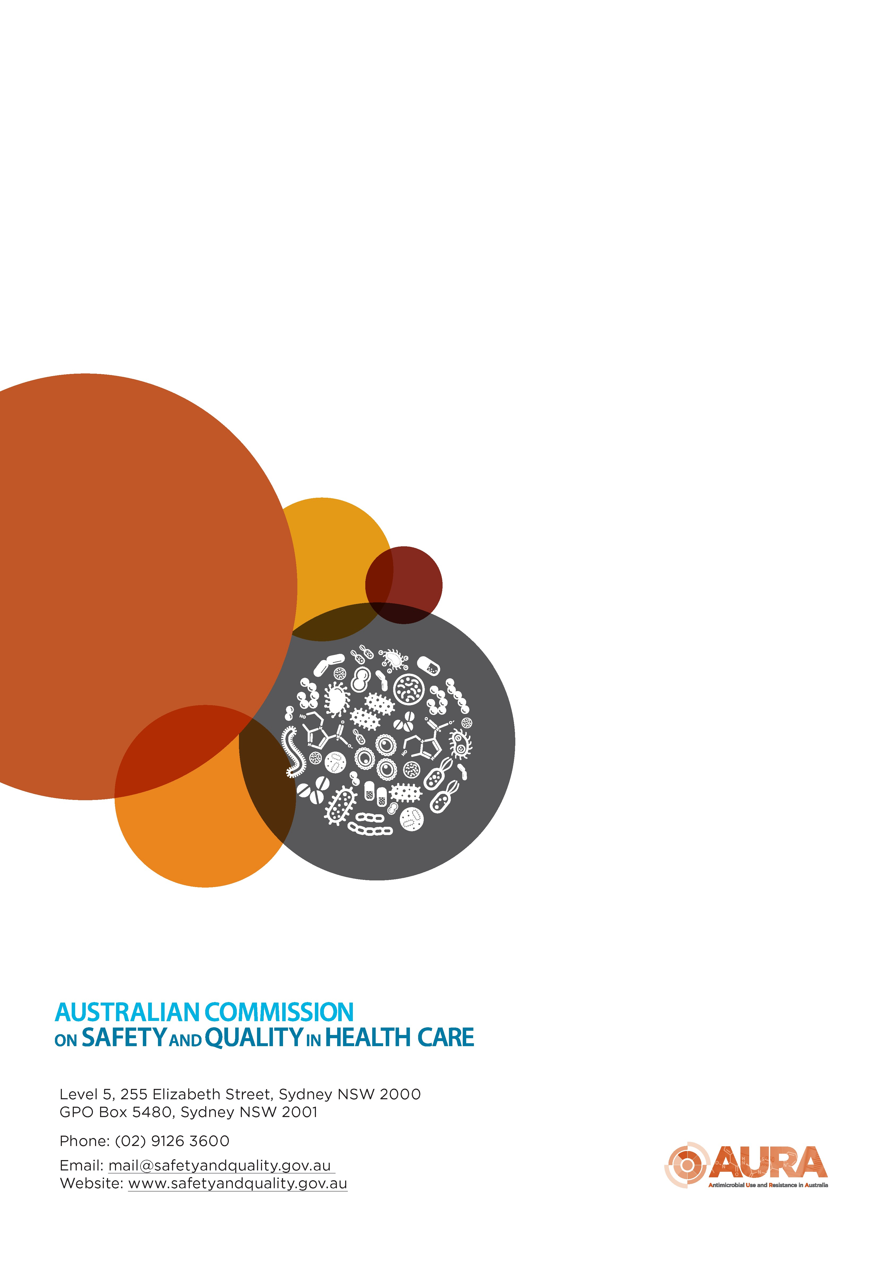

Published by the Australian Commission on Safety and Quality in Health Care
Level 5, 255 Elizabeth Street, Sydney NSW 2000
Phone: (02) 9126 3600
Email: mail@safetyandquality.gov.au
Website: www.safetyandquality.gov.au
ISBN: 978-1-922880-78-9
© Australian Commission on Safety and Quality in Health Care 2024
All material and work produced by the Australian Commission on Safety and Quality in Health Care is protected by copyright. The Commission reserves the right to set out the terms and conditions for the use of such material.
As far as practicable, material for which the copyright is owned by a third party will be clearly labelled. The Commission has made all reasonable efforts to ensure that this material has been reproduced in this publication with the full consent of the copyright owners.
With the exception of any material protected by a trademark, any content provided by third parties, and where otherwise noted, all material presented in this publication is licensed under a Creative Commons Attribution-NonCommercial-NoDerivatives 4.0 International licence.

Enquiries about the licence and any use of this publication are welcome and can be sent to communications@safetyandquality.gov.au.
The Commission’s preference is that you attribute this publication (and any material sourced from it) using the following citation:
Australian Commission on Safety and Quality in Health Care. Australian Passive AMR Surveillance: Trends in macrolide resistance in Streptococcus agalactiae and Streptococcus pyogenes – 2006 to 2023. Sydney; ACSQHC, 2024.
Disclaimer
The content of this document is published in good faith by the Australian Commission on Safety and Quality in Health Care for information purposes. The document is not intended to provide guidance on particular healthcare choices. You should contact your healthcare provider on particular healthcare choices.
The Commission does not accept any legal liability for any injury, loss or damage incurred by the use of, or reliance on, this document.
Note regarding alternative descriptions
No alternative descriptions have been provided. If you need assistance with the structure of any graphs or charts, please email the Australian Commission on Safety and Quality in Health Care at APAS@safetyandquality.gov.au.

Contents
Executive summary 4
Key findings and trends: 2006 to 2023 4
Implications for patient safety 5
What will be done to improve patient safety? 5
Introduction 6
Results 7
Macrolide resistance by specimen type 8
Macrolide resistance by setting 10
Macrolide resistance by state and territory 12
Macrolide resistance by remoteness area 15
Macrolide resistance by age group 16
Macrolide-lincosamide-streptogramin B (MLS_{B}) resistance phenotypes 19
Conclusions 22
References 23
Appendix 1: About APAS 25
Appendix 2: Methodology 26

Executive summary
Antimicrobial-resistant microorganisms, including bacteria, and the resistance genes they carry can spread readily between people in the community as well as those receiving care in hospitals, aged care homes and primary care services. The spread of antimicrobial resistance (AMR) can occur rapidly and significantly affect patients, the community, health services and the health system. Effective surveillance and monitoring are essential to determine the burden of AMR, and to inform response, infection prevention and control and antimicrobial stewardship (AMS) strategies, and prescribing guidelines.
This report provides analyses of data on AMR in Streptococcus agalactiae (also called group B Streptococcus [GBS]) and S. pyogenes (also called group A Streptococcus [GAS]) from Australian Passive AMR Surveillance (APAS). APAS data on antimicrobial susceptibility testing results are contributed by public and private pathology services across Australia. These data are sourced from hospitals, aged care homes and the community. APAS was established by the Australian Commission on Safety and Quality in Health Care (the Commission) as a key component of the Antimicrobial Use and Resistance in Australia (AURA) surveillance program, which is coordinated by the Australian Government Department of Health and Aged Care (the Department).
Detailed information about APAS is included in Appendix 1. The methodology for the analyses and considerations for interpretation of data and analyses are included in Appendix 2.
The focus of this report is trends for resistance to the macrolide group of antibiotics (represented by erythromycin) in S. agalactiae and in S. pyogenes, primarily for 2015 to 2023, with some analyses from 2006. Macrolide-lincosamide-streptogramin B (MLS_{B}) resistance phenotypes are also explored; with the lincosamide group of antibiotics represented by clindamycin. This report builds on analyses presented in the series of national AURA reports since 2016.¹⁻⁵

Key findings and trends: 2006 to 2023

Overall
- Erythromycin resistance was much more common in S. agalactiae than S. pyogenes.
- Increasing erythromycin resistance in both organisms was consistent with a MLS_{B} phenotype, which usually displays cross resistance to both erythromycin and clindamycin.

Streptococcus agalactiae (Group B Streptococcus)
- Erythromycin and clindamycin resistance in S. agalactiae increased between 2006 and 2023, from 8.4% and 6.5% respectively, to 37.5% and 35.4% respectively.
- Increasing erythromycin resistance was consistent across all specimen types and was most commonly isolated from tissue/fluid/pus/prosthesis and the genital tract.
- The proportion of erythromycin resistance was highest in remote and very remote Australia, despite the majority of isolates being collected from major cities.

Streptococcus pyogenes (Group A Streptococcus)
- Erythromycin resistance in S. pyogenes isolates remained low and stable at less than 4% from 2006 to 2016. Resistance increased to 4.2% in 2017 and was 9.5% in 2021 and 9.3% in 2022, before decreasing to 6.1% in 2023. These changes occurred in the context of a 1.6-fold increase in the total number of S. pyogenes isolates reported to APAS from 2022 to 2023.
- Erythromycin resistance was approximately 3–4-fold higher in isolates from the genital tract than blood and tissue/fluid/pus/prosthesis over this period. There was an increasing percentage of erythromycin resistance in isolates from all specimen types, peaking around 2021 to 2022 and sharply decreasing in 2023.
- Analyses indicate that S. pyogenes isolates with erythromycin resistance were more prevalent from major Australian cities. There was an increasing trend in erythromycin resistance across major cities, inner regional and outer regional Australia from 2015 to 2021, and a sharp fall in both 2022 and 2023. In remote Australia, resistance peaked in 2022.

Implications for patient safety
- High and increasing rates of clindamycin resistance in S. agalactiae mean that empirical use of clindamycin cannot be relied upon for the prevention or treatment of GBS in penicillin-allergic women, and it should only be used when the strain is known to be susceptible.
- There is a risk of infection and invasive disease for neonates if screening of women in late pregnancy for carriage of S. agalactiae is not conducted in accordance with state, territory and relevant college and specialty society guidelines⁶ to determine the need for intrapartum prophylaxis.
- There is a risk of transmission of both S. agalactiae and S. pyogenes in admitted and community healthcare settings, particularly given both organisms, but notably S. pyogenes, cause skin and soft tissue infections, especially in the lower limbs of those with damaged skin.
- Limited treatment options for infections caused by S. agalactiae and S. pyogenes and post-streptococcal syndromes are a risk of invasive disease due to increasing AMR.

What will be done to improve patient safety?
In response to the issues identified in analyses in this report, the Australian Commission on Safety and Quality in Health Care will:
- Communicate the findings about macrolide resistance in GBS and the implications for care of pregnant women and their neonates to the Royal Australian and New Zealand College of Obstetricians and Gynaecologists, the Royal Australasian College of Physicians, the Royal Australian College of General Practitioners, the Australian College of Rural and Remote Medicine, the Australasian Society for Infectious Diseases, the Australian College of Midwives and the Australian College of Nursing
- Promote multi-locus sequence typing and/or whole genome sequencing, particularly for invasive GAS (iGAS) to identify strains and enhance surveillance of GAS clones to increase understanding of the clinical impact of new variants
- Promote screening and assessment of individuals at risk of GAS and GBS, consistent with evidence-based guidelines and in collaboration with states and territories and relevant specialty societies and colleges. This will support effective treatment and management of infections and of people who carry these organisms
- Continue to work with the Department, state and territory health authorities, and private pathology services, to achieve nationwide participation in APAS and enhance recommended national surveillance coverage
- Continue to promote infection prevention and control practices in health and aged care settings consistent with the Australian Guidelines for the Prevention and Control of Infection in Healthcare⁷ and the National and Safety and Quality Standards for acute, primary and community and aged care⁸⁻¹⁰
- Continue to promote antimicrobial stewardship programs and compliance with evidence-based treatment guidelines in health and aged care settings consistent with the National and Safety and Quality Standards for acute, primary and community and aged care.⁸⁻¹⁰

Introduction

Streptococcus agalactiae
Streptococcus agalactiae, also called group B Streptococcus (GBS), is an important cause of maternally-acquired neonatal septicaemia and meningitis, and is associated with high rates of morbidity and mortality.^{11, 12} Antimicrobial prophylaxis during delivery for GBS carrier mothers is recommended in selected circumstances in Therapeutic Guidelines: Antibiotic, and clindamycin is recommended for mothers with immediate hypersensitivity to β-lactams.¹³ In older adults, S. agalactiae, is also a frequent cause of skin and soft tissue infections, often involving the lower limbs of people with skin damage or ulcers.¹⁴
Resistance to benzylpenicillin and cefazolin is emerging but still rare in Australia; however, resistance to erythromycin, lincomycin and clindamycin is now common, at around 30%.⁵ Lincosamide (lincomycin/clindamycin) resistance is strongly linked to resistance to macrolides, such as erythromycin, which is often used in the laboratory as the test agent to predict resistance to lincomycin/clindamycin. Mothers who carry GBS that is resistant to erythromycin, lincomycin and clindamycin, but who would otherwise be treated with lincomycin or clindamycin, require prophylaxis with vancomycin.

Streptococcus pyogenes
S. pyogenes, also called group A Streptococcus (GAS), is an important human pathogen. It most commonly causes skin and soft tissue infections, and acute pharyngitis, but can cause serious and life-threatening infections such as scarlet fever, bacteraemia, bone and joint infections, toxic shock syndrome, necrotising fasciitis and pneumonia. This organism is also associated with two ‘post-streptococcal’ syndromes: acute glomerulonephritis and rheumatic fever. These syndromes are rare in most parts of Australia but are typically only seen in remote Aboriginal and Torres Strait Islander communities, contributing to substantial long-term morbidity in these populations.¹⁵
Typically, transmission of S. pyogenes occurs through respiratory droplets from patients or carriers, but transmission can also occur through contact with secretions (such as saliva, wound discharge, or nasal secretions) from an infected person, or through skin-to-skin contact.¹⁶
Invasive group A Streptococcal Disease (iGAS) became nationally notifiable in Australia from 1 July 2021. While some jurisdictions had been collecting data on iGAS for up to a decade prior to this time, iGAS did not become notifiable in all jurisdictions until September 2022. All states and territories provided data to the National Notifiable Diseases Surveillance System (NNDSS) in 2023.^{16, 17}
Benzylpenicillin remains the treatment of choice for S. pyogenes infections. In people who are allergic to penicillins, macrolides such as erythromycin and first-generation cephalosporins are treatment options. People who have experienced one episode of acute rheumatic fever are prone to further episodes and worsening organ damage; consequently, they are administered long-term prophylaxis (usually over decades) with benzathine penicillin (intramuscularly) or phenoxymethylpenicillin (orally).
Confirmed resistance to benzylpenicillin is rare¹⁸ and has never been reported in Australia. However, the consequences of its emergence would be substantial. Based on observations of other species of Streptococcus, it is expected that resistance to benzylpenicillin would also affect susceptibility to first-generation cephalosporins. In contrast, acquired resistance to macrolide antibiotics has been present in S. pyogenes for many years, and levels of resistance appear to fluctuate in line with changes in circulating clones.^{5, 19}
In Australia, resistance to the primary therapeutic agents in S. pyogenes has generally been low. There was a dramatic but temporary increase in macrolide resistance reported in 1985 in Fremantle, Western Australia, which coincided with the America’s Cup competition in Fremantle and the arrival of large numbers of visitors from elsewhere in Australia and overseas.²⁰

Surveillance of Streptococcus agalactiae and Streptococcus pyogenes
In 2024, both penicillin-resistant S. agalactiae and macrolide-resistant S. pyogenes were added to the World Health Organization (WHO) Bacterial Priority Pathogen List.²¹ With the exception of iGAS, there is no mandatory national surveillance in Australia of either S. agalactiae or S. pyogenes or of antimicrobial resistance (AMR) in these organisms.
Data on AMR in S. agalactiae and S. pyogenes were available from Australian Passive AMR Surveillance (APAS). Data submitted to APAS were contributed by public and private pathology services across Australia that voluntarily participate in the system. These data, which were used for the analyses presented in this report, were sourced from hospitals, aged care homes and the community. APAS is a key component of the Antimicrobial Use and Resistance in Australia (AURA) surveillance program, which is coordinated by the Australian Government Department of Health and Aged Care. Detailed information about APAS is included in Appendix 1. The methodology for the analyses and considerations for interpretation of data and analyses are included in Appendix 2.

Results
Between 2006 and 2023, there were 80,573 S. agalactiae isolates from the four long-term APAS contributor pathology services. Across all pathology services that contribute to APAS, including the four long-term contributors, data were available for 105,655 S. agalactiae isolates over this period. See Appendices 1 and 2 for information about the pathology services that contribute to APAS.
For S. pyogenes, there were 184,005 isolates from the four long-term APAS contributor pathology services between 2006 and 2023. From all pathology services that contribute to APAS, there were 196,776 isolates from 2006 to 2023.
Figure 1 shows the 18-year trends in erythromycin resistance in both S. agalactiae and S. pyogenes reported by all APAS contributors between 2006 and 2023.
The total number of S. agalactiae isolates was lower than for S. pyogenes, with less variation in the total numbers between 2006 to 2023 from the long-term APAS contributors. Overtime, the variability in S. pyogenes may reflect expansion of the patient bases served by the APAS contributor laboratories, changes in specimen sampling practices, or both. The decline in 2020 and 2021 may also have been associated with the public health response to the COVID-19 pandemic, including social distancing measures. The increase in 2022 and 2023 may be associated with the removal of these restrictions.
Erythromycin resistance was more common in S. agalactiae than S. pyogenes and the proportion of resistant S. agalactiae isolates increased from 8.4% in 2006 to 37.5% in 2023.
Erythromycin resistance in S. pyogenes isolates remained stable at less than 4% from 2006 to 2016. Resistance increased from 4.2% in 2017 to a peak of 9.5% in 2021, then decreased to 6.1% in 2023.
Figure 1: Percentage of Streptococcus agalactiae and Streptococcus pyogenes with macrolide resistance, APAS contributors, 2006–2023
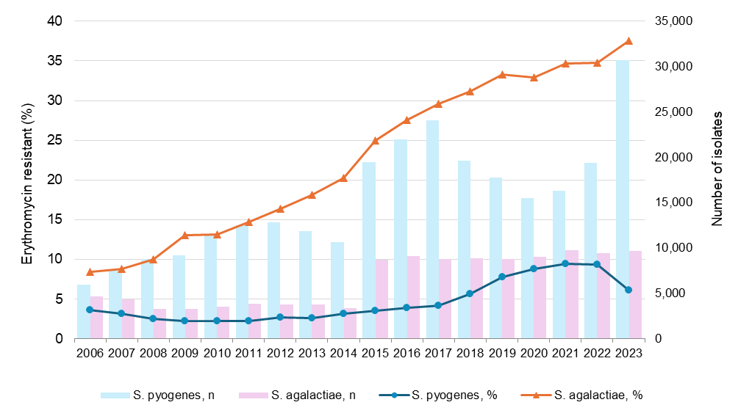
n = denominator for total number of isolates
Source: APAS (NSW, Vic, Qld, SA, WA, Tas, ACT) – see Table A1

Macrolide resistance by specimen type
Figures 2 and 3 show the trends in macrolide resistance in S. agalactiae and S. pyogenes by specimen type reported from all APAS contributors from 2015 to 2023.
S. agalactiae was isolated from a wide variety of specimen types, with tissue/fluid/pus/prosthesis being the most common. Isolates were also frequently collected from the genital tract and urine (Figure 2). S. pyogenes was also largely isolated from tissue/fluid/pus/prosthesis specimens (Figure 3).
S. agalactiae showed a higher proportion of resistance than S. pyogenes. There was an increasing percentage of erythromycin resistance in S. agalactiae isolates from all specimen sources, and the percentage of resistance was similar in all specimen types in any given year (Figure 2).
For S. pyogenes, erythromycin resistance was approximately 3–4-fold higher among isolates from the genital tract than from blood and tissue/fluid/pus/prosthesis (Figure 3), noting that isolates from the genital tract only contribute 2.4% of all isolates. There was an increasing percentage of erythromycin resistance in isolates from all specimen types, peaking around 2021 to 2022. In 2023, there was a sharp decrease in resistance across all specimen types.
Figure 2: Percentage of Streptococcus agalactiae with erythromycin resistance by specimen type, APAS contributors, 2015–2023
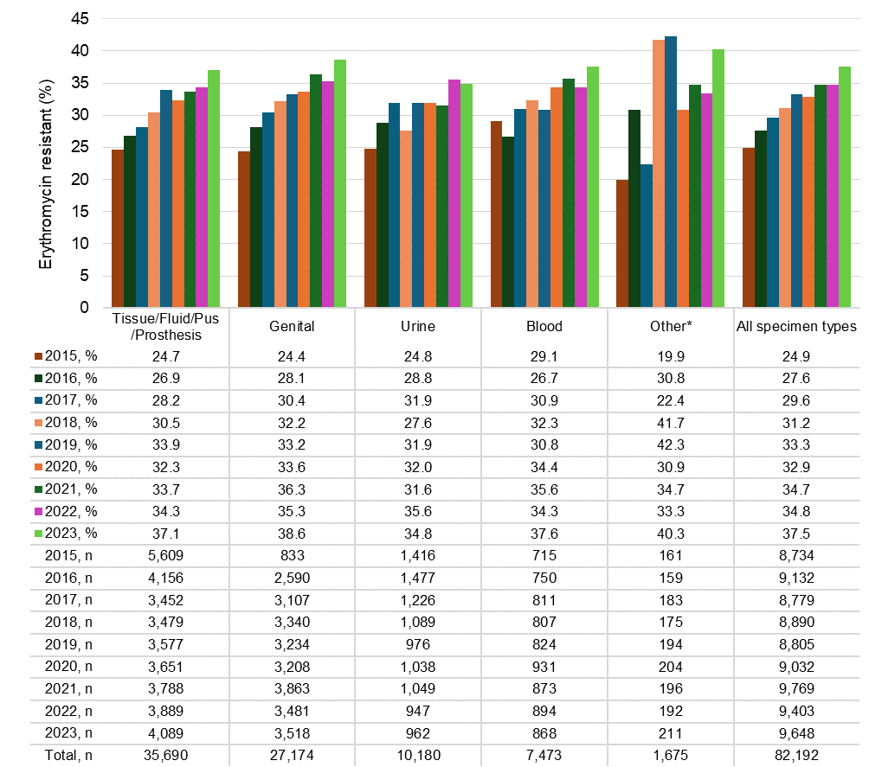
n = denominator for total number of isolates
* Other refers to cerebrospinal fluid, enteric, and urine specimens
Source: APAS (NSW, Vic, Qld, SA, WA, Tas, ACT) – see Table A1
Figure 3: Percentage of Streptococcus pyogenes with erythromycin resistance by specimen type, APAS contributors, 2015–2023
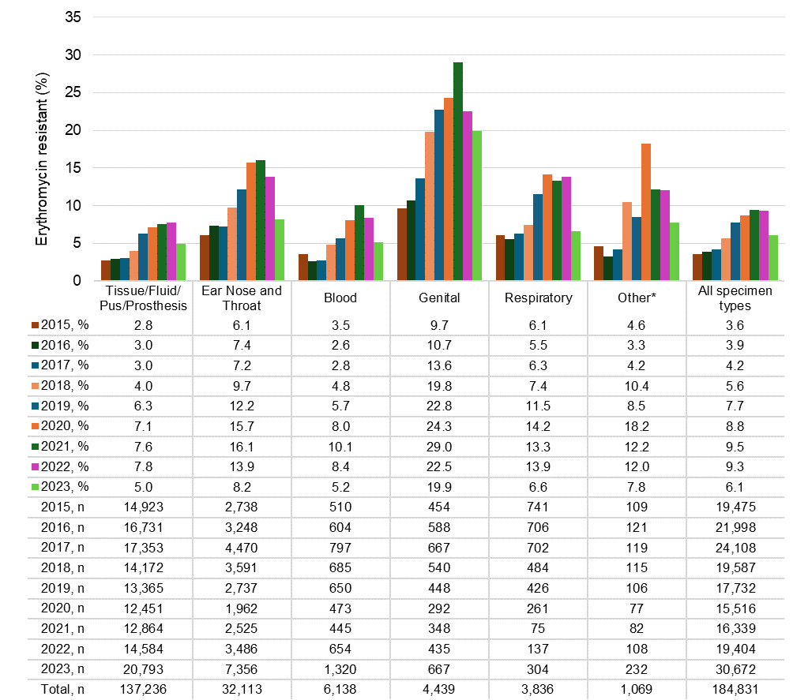
n = denominator for total number of isolates
* Other refers to cerebrospinal fluid, enteric, and urine specimens
Source: APAS (NSW, Vic, Qld, SA, WA, Tas, ACT) – see Table A1

Macrolide resistance by setting
Figures 4 and 5 show the trends in macrolide resistance in S. agalactiae and S. pyogenes by setting reported from all APAS contributors from 2015 to 2023. Data relating to aged care homes were combined with data from settings other than hospitals or community, including multi-purpose services, due to the smaller numbers and limited representativeness nationally (see Appendix 2).
A substantial majority (83.6%) of S. agalactiae isolates were from hospitals (public and private), and 15.0% were from community settings (Figure 4). There was little difference in the proportion of erythromycin-resistant S. agalactiae isolates from hospitals compared with those from community settings.
A little over one-half (60.3%) of S. pyogenes isolates were from hospitals (public and private), and 35.0% from community settings (Figure 5). The highest proportion of erythromycin resistance in S. pyogenes was observed in hospitals, followed by community settings. There was an upward trend in erythromycin resistance in S. pyogenes from all settings between 2015 (3.6%) and 2021 (9.5%); it stabilised in 2022 (9.3%) then declined in 2023 (6.1%).

Figure 4: Percentage of Streptococcus agalactiae with erythromycin resistance by setting, APAS contributors, 2015–2023
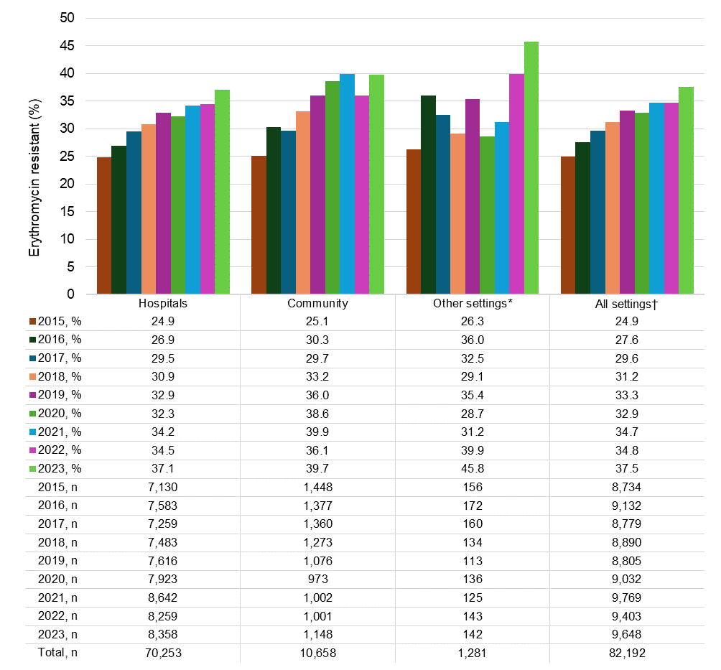
n = denominator for total number of isolates
* Settings other than hospitals or community, including multi-purpose services and aged care homes
† Where setting was known
Note: Hospitals = public and private.
Source: APAS (NSW, Vic, Qld, SA, WA, Tas, ACT) – see Table A1
Figure 5: Percentage of Streptococcus pyogenes with erythromycin resistance by setting, APAS contributors, 2015–2023
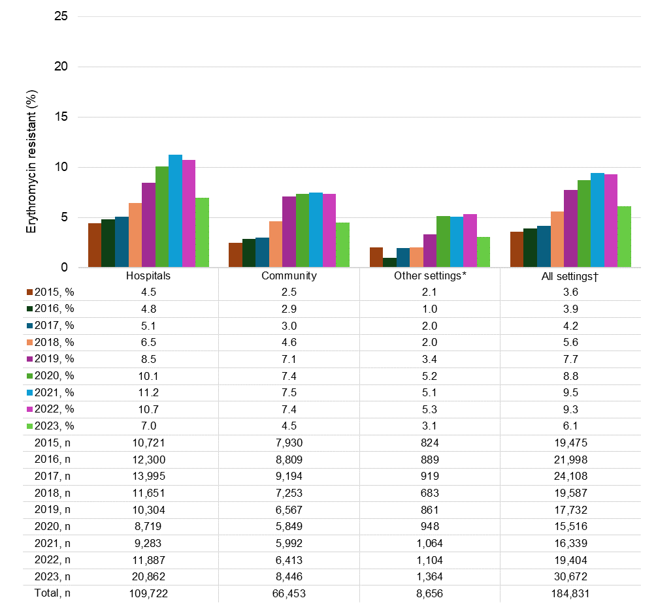
n = denominator for total number of isolates
* Settings other than hospitals or community, including multi-purpose services and aged care homes
† Where setting was known
Note: Hospitals = public and private.
Source: APAS (NSW, Vic, Qld, SA, WA, Tas, ACT) – see Table A1

Macrolide resistance by state and territory
Figures 6 and 7 show the trends in macrolide resistance in S. agalactiae and S. pyogenes by state and territory reported from all APAS contributors from 2015 to 2023. Data were analysed based on the known postcode of residence of the person from whom the specimen was taken (see Appendix 2).
Erythromycin resistance in S. agalactiae increased across all states and territories from 2015 to 2023. Since 2017 resistance was highest in patients residing in South Australia, reaching 45.8% in 2023 (Figure 6).
In S. pyogenes, the proportion of isolates with erythromycin resistance was lower than that seen in S. agalactiae. For S. pyogenes, erythromycin resistance was slightly higher in isolates from people who resided in the Australian Capital Territory (Figure 7). In 2023, a decline in erythromycin-resistant S. pyogenes was observed across all states and territories.

Figure 6: Percentage of Streptococcus agalactiae with erythromycin resistance by state and territory, APAS contributors, 2015–2023
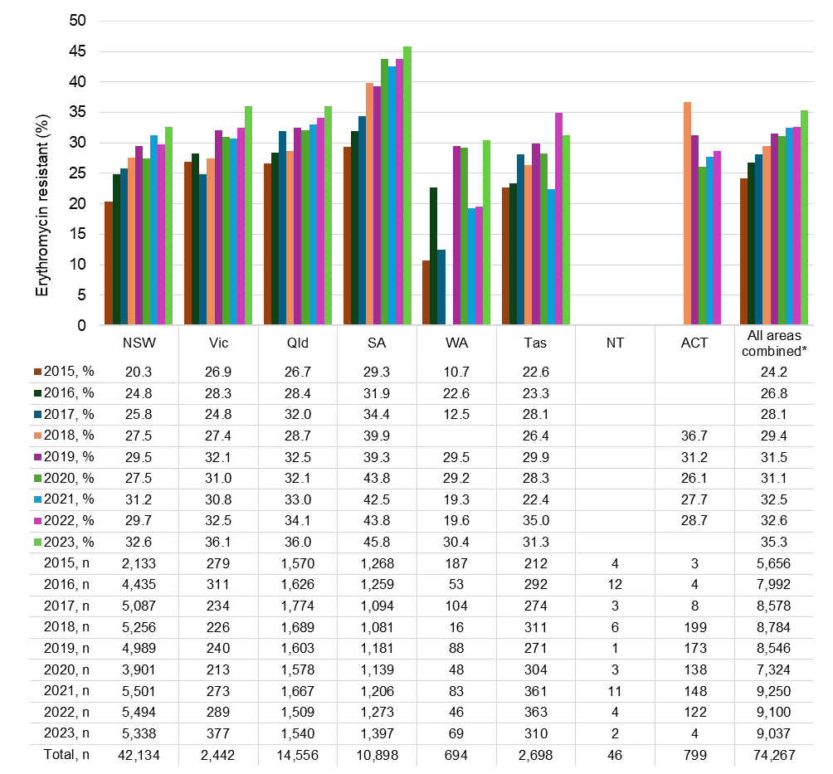
n = denominator for total number of isolates
* Where postcode of residence was known
Notes:
- State and territory based on postcode of residence. Data available from the NT were from NT residents who received pathology services interstate. Data from ACT pathology services were not available for 2023, except where ACT residents received pathology services interstate.
- Postcode of residence was not available in 2015 for NSW Health Pathology South Eastern Sydney Local Health District.
- Blank cell indicate insufficient number of isolates (<30) to calculate percentage.
Source: APAS (NSW, Vic, Qld, SA, WA, Tas, ACT) – see Table A1
Figure 7: Percentage of Streptococcus pyogenes with erythromycin resistance by state and territory, APAS contributors, 2015–2023
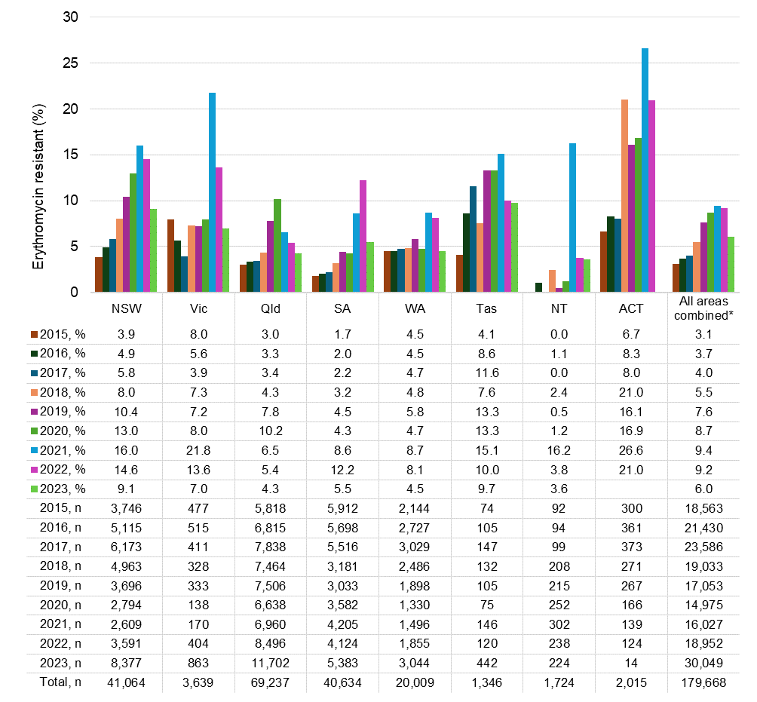
n = denominator for total number of isolates
* Where patient’s postcode of residence was known
Notes:
- State and territory based on postcode of residence. Data available from the NT were from NT residents who received pathology services interstate. Data from ACT pathology services were not available in 2023, except where ACT residents received pathology services interstate.
- Postcode of residence was not available in 2015 for NSW Health Pathology South Eastern Sydney Local Health District.
- Blank cell indicate insufficient number of isolates (<30) to calculate percentage.
Source: APAS (NSW, Vic, Qld, SA, WA, Tas, ACT) – see Table A1

Macrolide resistance by remoteness area
Figures 8 and 9 show the trends in macrolide resistance in S. agalactiae and S. pyogenes by remoteness area reported from all APAS contributors from 2015 to 2023. Data were analysed based on the known postcode of residence of the person from whom the specimen was taken (see Appendix 2).
For both S. agalactiae and S. pyogenes, most isolates were collected from people who reside in major Australian cities (Figures 8 and 9). However, for S. agalactiae, the proportion of erythromycin resistance was highest in patients residing in remote and very remote Australia (Figure 8).
In comparison, erythromycin-resistant S. pyogenes were most prevalent in major cities. There was an increasing trend in erythromycin resistance across major cities, inner regional and outer regional Australia from 2015 to 2021, and a sharp fall in both 2022 and 2023. In remote Australia, resistance peaked in 2022 (Figure 9).
Figure 8: Percentage of Streptococcus agalactiae with erythromycin resistance by remoteness area, APAS contributors, 2015–2023
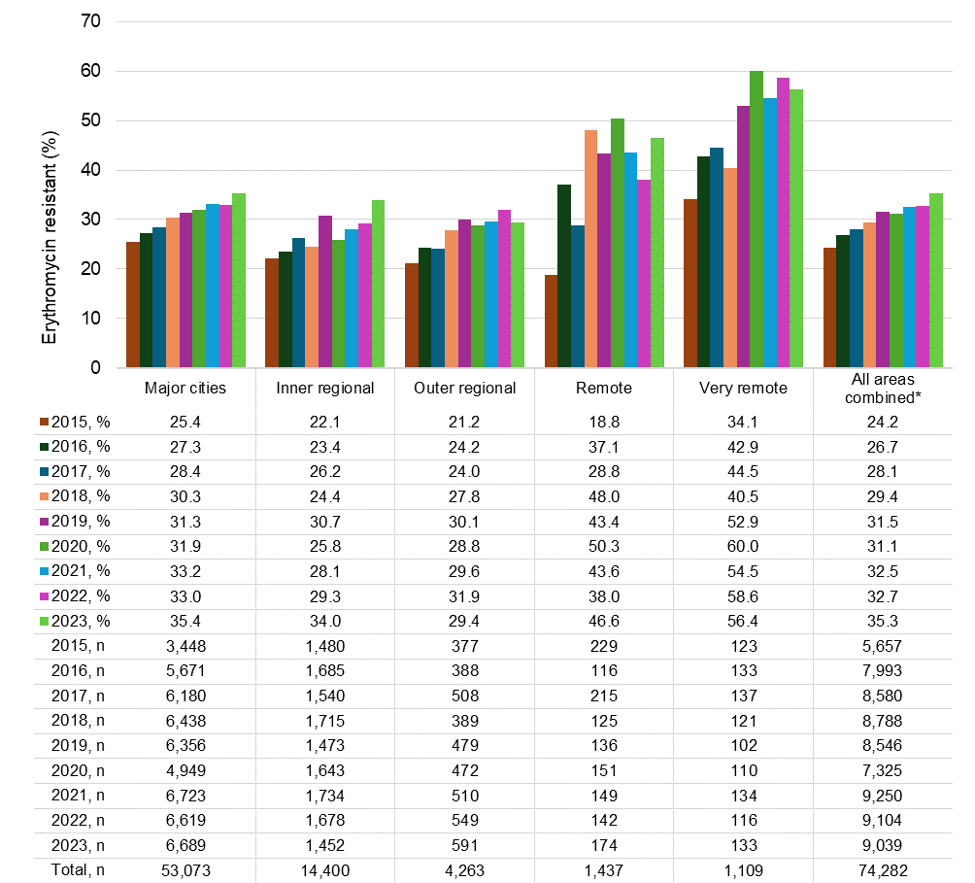
n = denominator for total number of isolates
* Where remoteness area of Australia was known
Note: Remoteness area was based on postcode of residence.
Source: APAS (NSW, Vic, Qld, SA, WA, Tas, ACT) – see Table A1
Figure 9: Percentage of Streptococcus pyogenes with erythromycin resistance by remoteness area, APAS contributors, 2015–2023
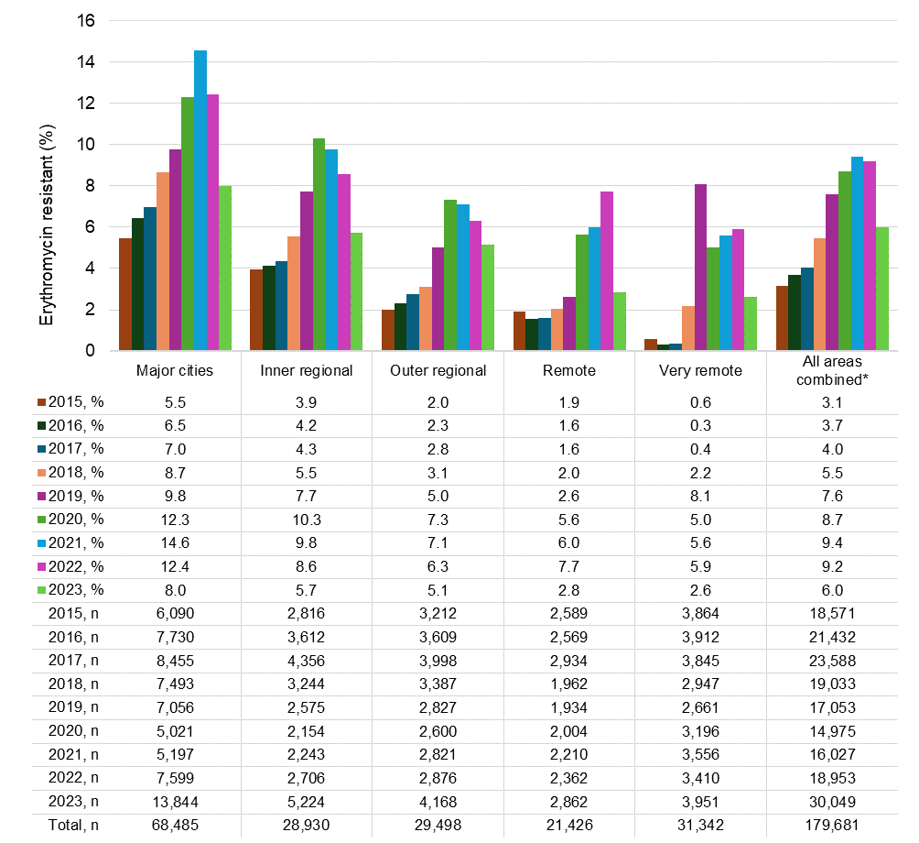
n = denominator for total number of isolates
* Where remoteness area of Australia was known
Note: Remoteness area was based on postcode of residence.
Source: APAS (NSW, Vic, Qld, SA, WA, Tas, ACT) – see Table A1

Macrolide resistance by age group
Figures 10 and 11 show the trends in macrolide resistance in S. agalactiae and S. pyogenes by age group reported from all APAS contributors from 2015 to 2023. The age groups selected to highlight trends in neonates and people of reproductive age.
Just over one-half (53.1%) of S. agalactiae isolates were from the 15–44 age group and 38.8% of S. pyogenes isolates were collected from paediatric patients (aged less than 18 years). In S. agalactiae, there was little difference in the proportion of erythromycin resistance observed across age groups examined (Figure 10). The highest rate was seen in isolates from blood in patients aged less than 1 year.
For S. pyogenes, the proportion of erythromycin resistance was lowest among tissue/fluid/pus/prothesis isolates from paediatric patients (Figure 11). The highest proportion of erythromycin-resistant S. pyogenes was in ear/nose/throat isolates in the 18–64 age group. There was little difference in the proportion of erythromycin resistance observed across groups for S. pyogenes isolated from blood or cerebrospinal fluid.
Figure 10: Percentage of Streptococcus agalactiae with erythromycin resistance, by specimen type and age group, APAS contributors, 2015–2023
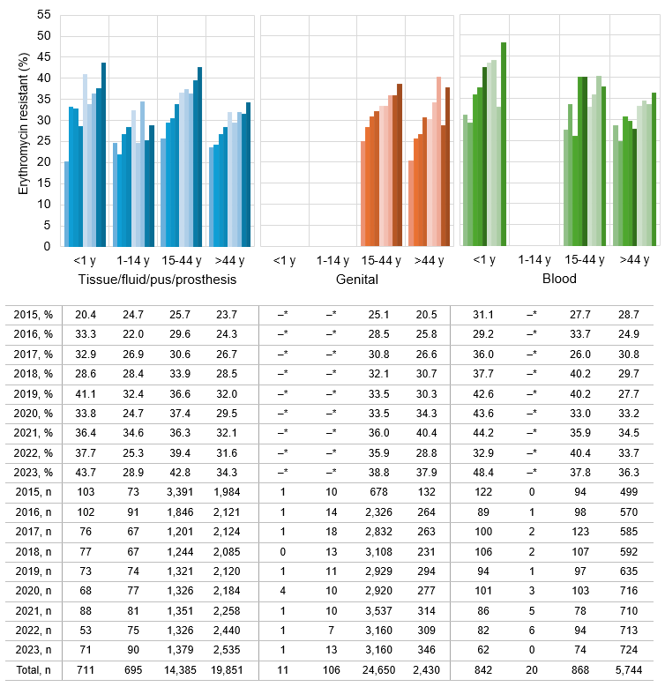
n = denominator for total number of isolates; y = years of age
* insufficient number of isolates (<30) to calculate percentage
Note: Age group selected to reflect neonates (< 1 year) and the reproductive age (15 to 44 years).²²
Source: APAS (NSW, Vic, Qld, SA, WA, Tas, ACT) – see Table A1
Figure 11: Percentage of Streptococcus pyogenes with erythromycin resistance, by specimen type and age group, APAS contributors, 2015–2023
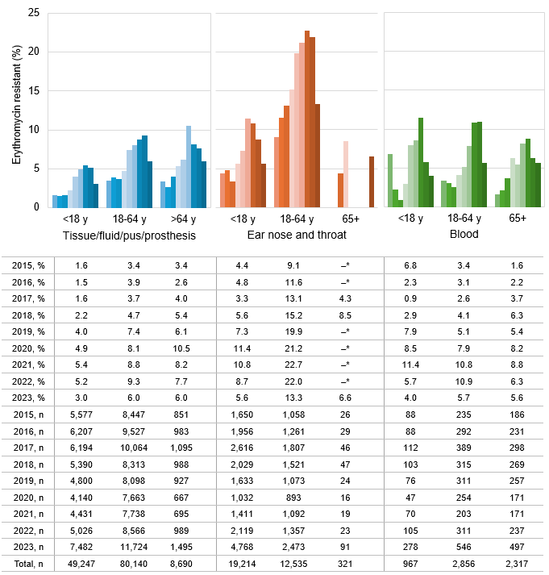
n = denominator for total number of isolates; y = years of age
* Insufficient number of isolates (<30) to calculate percentage
Source: APAS (NSW, Vic, Qld, SA, WA, Tas, ACT) – see Table A1

Macrolide-lincosamide-streptogramin B (MLS_{B}) resistance phenotypes
Figures 12 and 13 show the trends in macrolide (erythromycin) resistance and lincosamide (clindamycin) resistance in S. agalactiae and S. pyogenes reported from all APAS contributors from 2006 to 2023.
In S. agalactiae, erythromycin resistance increased from 8.4% in 2006 to 37.5% in 2023.In a similar pattern, resistance to clindamycin increased from 6.5% to 35.4% over this period (Figure 12).
In S. pyogenes, erythromycin resistance increased from 3.6% in 2006 to over 9% in 2021 and 2022, before falling to 6.1% in 2023. Similarly, resistance to clindamycin increased from 4.5% to 11.1% in 2022, before also falling to 6.1% in 2023 (Figure 13). However, the pattern of increasing resistance in S. pyogenes does not mirror S. agalactiae. Figure 13 shows year-on-year variability in resistance to erythromycin compared to clindamycin. The prevalence of clindamycin resistance was notably lower than that for erythromycin in 2019 and 2020. This may reflect changes in testing and reporting of inducible clindamycin resistance.
The increasing macrolide (erythromycin) resistance in both S. agalactiae and S. pyogenes was consistent with a MLS_{B} phenotype, which usually displays cross-resistance to lincosamides, such as clindamycin (Figures 14 and 15).²³ Clindamycin is the recommended treatment option for penicillin-allergic pregnant women who require intrapartum prophylaxis for S. agalactiae when the causative strain is known to be susceptible.
Figure 12: Streptococcus agalactiae, erythromycin and clindamycin resistance, APAS contributors, 2006–2023
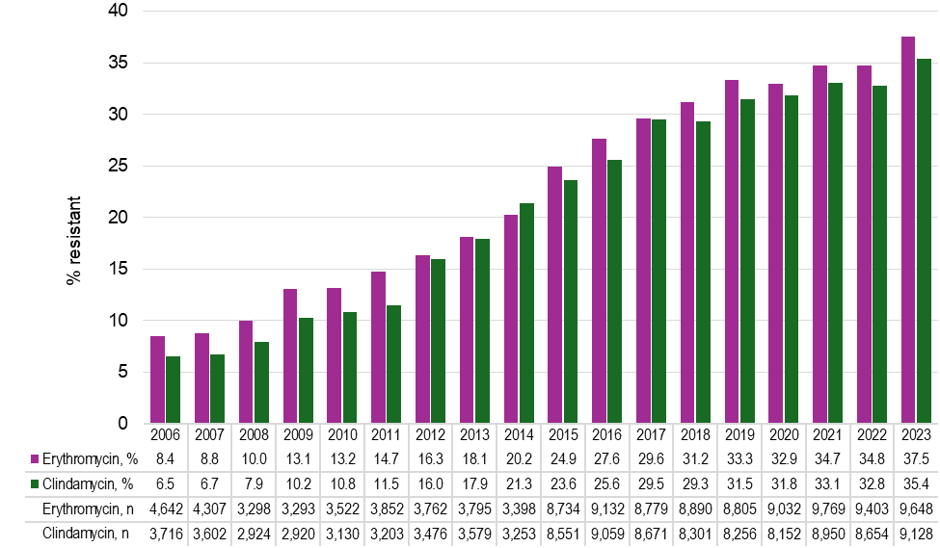
n = denominator for total number of isolates
Source: APAS (NSW, Vic, Qld, SA, WA, Tas, ACT) – see Table A1

Figure 13: Streptococcus pyogenes, erythromycin and clindamycin resistance, APAS contributors, 2006–2023
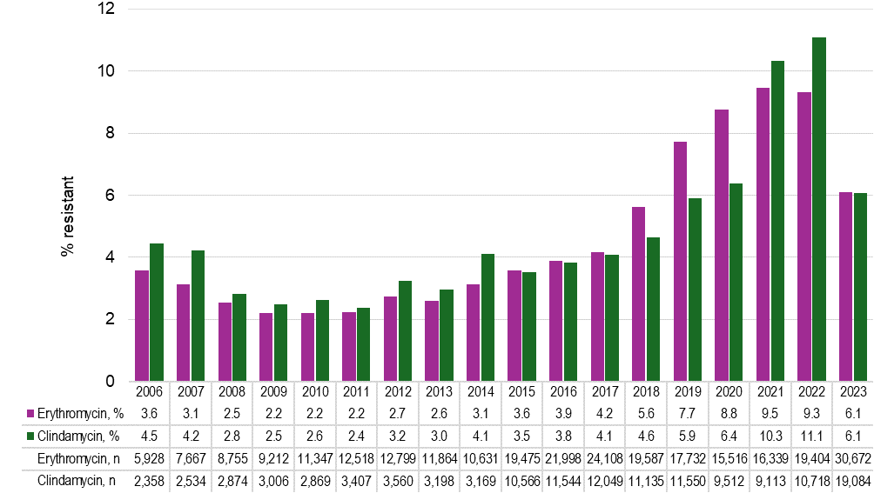
n = denominator for total number of isolates
Source: APAS (NSW, Vic, Qld, SA, WA, Tas, ACT) – see Table A1
Figure 14: Streptococcus agalactiae, erythromycin and clindamycin resistance phenotypes, APAS contributors, 2006–2023
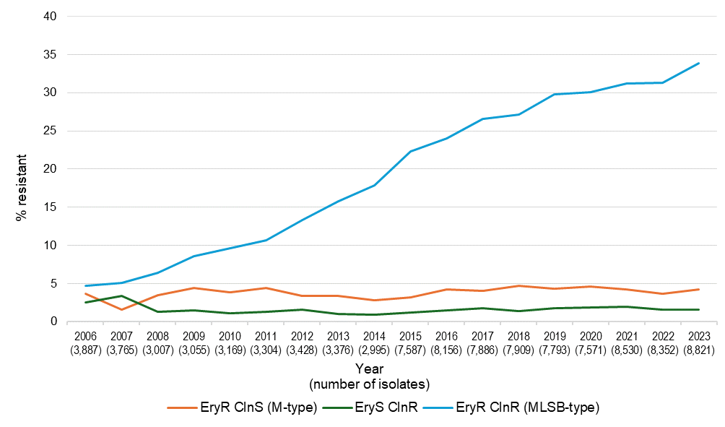
Cln = clindamycin; Ery = erythromycin; R = resistance; S = susceptible
Note: Phenotype was determined when both agents were tested.
Source: APAS (NSW, Vic, Qld, SA, WA, Tas, ACT) – see Table A1
Figure 15: Streptococcus pyogenes, erythromycin and clindamycin resistance phenotypes, APAS contributors, 2006–2023
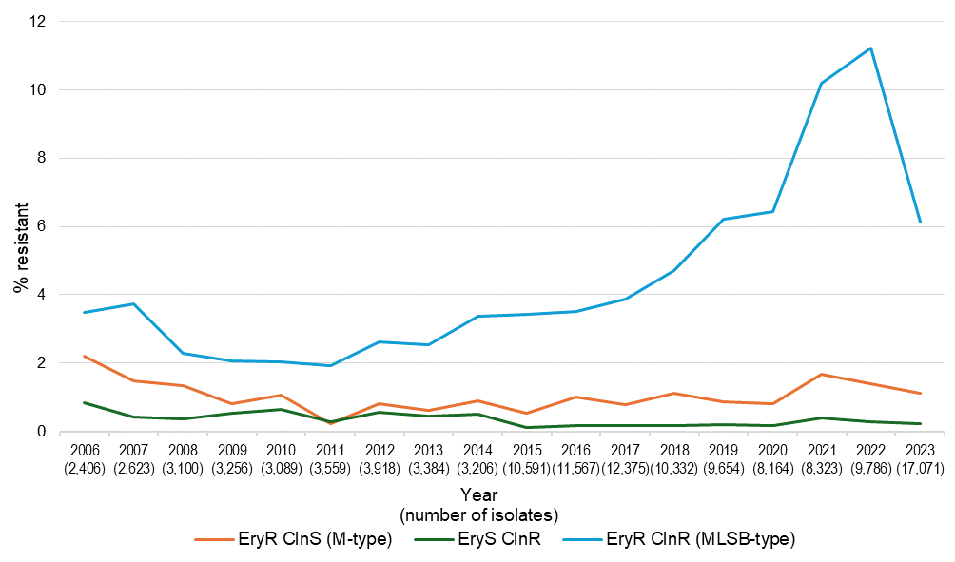
Cln = clindamycin; Ery = erythromycin; R = resistance; S = susceptible
Note: Phenotype was determined when both agents were tested.
Source: APAS (NSW, Vic, Qld, SA, WA, Tas, ACT) – see Table A1

Conclusions
S. agalactiae and S. pyogenes are important human pathogens that can cause significant morbidity and mortality if not appropriately detected and treated. Capacity to effectively treat and prevent these infections is impacted by AMR.
Analyses of APAS data from 2006 to 2023 have identified that erythromycin resistance was much more common in S. agalactiae than S. pyogenes.
Macrolide and lincosamide resistance in S. agalactiae increased steadily between 2006 and 2023, and there was variability in the geographic distribution of erythromycin resistance.
The year-on-year pattern of macrolide and lincosamide resistance in S. pyogenes was more variable than S. agalactiae but has also increased between 2006 and 2023. Geographic variability was also identified for S. pyogenes. Erythromycin resistance was most prevalent in S. pyogenes isolates from major cities of Australia. Erythromycin resistance increased across major cities, inner regional and outer regional Australia between 2015 to 2021 and fell sharply in both 2022 and 2023. In remote Australia, resistance peaked in 2022. It is important to note that variability between states and territories may reflect differences in routine laboratory susceptibility testing practices; some laboratories may not test all isolates for erythromycin susceptibility. In addition, data were only included in the analyses if 75% of isolates were tested for erythromycin susceptibility.
Erythromycin resistance was almost 3-fold higher in S. pyogenes isolates from genital tract infections compared to other sites. There was an increasing percentage of erythromycin resistance in S. pyogenes isolates from all specimen types, peaking around 2021 to 2022. In 2023 there was a sharp decrease in resistance across all specimen sources. The highest rate of erythromycin resistance in S. pyogenes was seen in isolates from hospitals, followed by community settings.
Acquired resistance to macrolide antimicrobials has been present in S. pyogenes for many years, and levels of resistance appear to fluctuate in line with changes in circulating clones.
The emergence of the new variant of S. pyogenes serotype M1 (designated ‘M1UK’ linage) has been reported in the United Kingdom and has been epidemiologically linked to increases in invasive disease and seasonal surges of scarlet fever. This clone has also been shown to have rapidly replaced the ‘M1global’ clone Australia.²⁴
Although the number of S. pyogenes isolates reported to APAS has increased, it is not clear if this increase in reports was due to increases in GAS infections or more susceptibility tested being performed due to increased awareness of the recently described M1UK clone. The observed decline in the MLS_{B} phenotype in 2023 is consistent with the rapid replacement of the M1 global clone.
Whilst the future clinical impact of this new variant is not yet understood, changes in AMR in S. agalactiae and S. pyogenes have implications for patient safety. This is particularly relevant for screening and treatment of mothers with a penicillin allergy to prevent GBS sepsis in neonates. Strategies to prevent and control the development of these infections and AMR in these organisms include ongoing maintenance of infection prevention and control and antimicrobial stewardship programs, surveillance and monitoring programs, and disease screening programs (e.g., antenatal GBS screening), where they are available, and early detection of clinical disease.

References
1. Australian Commission on Safety and Quality in Health Care. AURA 2016: first Australian report on antimicrobial use and resistance in human health. Sydney: ACSQHC, 2016.
2. Australian Commission on Safety and Quality in Health Care. AURA 2017: second Australian report on antimicrobial use and resistance in human health. Sydney: ACSQHC, 2017.
3. Australian Commission on Safety and Quality in Health Care. AURA 2019: third Australian report on antimicrobial use and resistance in human health. Sydney: ACSQHC, 2019.
4. Australian Commission on Safety and Quality in Health Care. AURA 2021: fourth Australian report on antimicrobial use and resistance in human health. Sydney: ACSQHC; 2021.
5. Australian Commission on Safety and Quality in Health Care. AURA 2023: fifth Australian report on antimicrobial use and resistance in human health. Sydney: ACSQHC; 2023.
6. Australian Society for Infectious Diseases. Group B Streptococcus. In: Palasanthiran P, Starr M, Jones C, Giles M, editors. Management of perinatal infections. 3rd ed. Sydney: ASID; 2022.
7. National Health and Medical Research Council. Australian guidelines for the prevention and control of infection in healthcare. Canberra: Commonwealth of Australia; 2019.
8. Australian Commission on Safety and Quality in Health Care. National safety and quality health service standards. 2nd ed. - version 2. [Internet] Sydney: ACSQHC; 2021 Available from: https://www.safetyandquality.gov.au/publications-and-resources/resource-library/national-safety-and-quality-health-service-standards-second-edition.
9. Australian Commission on Safety and Quality in Health Care. National safety and quality primary and community healthcare standards. [Internet] Sydney: ACSQHC; 2021 Available from: https://www.health.gov.au/resources/publications/the-strengthened-aged-care-quality-standards-final-draft?language=en.
10. Australian Commission on Safety and Quality in Health Care. The strengthened aged care quality standards - Final draft (November 2023). [Internet] Sydney: ACSQHC; 2023 Available from: https://www.health.gov.au/sites/default/files/2023-12/the-strengthened-aged-care-quality-standards-final-draft-november-2023.pdf.
11. Garland SM. Early onset neonatal group B streptococcus (GBS) infection: associated obstetric risk factors. Aust N Z J Obstet Gynaecol. 1991;31(2):117-118.
12. Garland SM, Cottrill E, Markowski L, Pearce C, Clifford V, Ndisang D, et al. Antimicrobial resistance in group B streptococcus: the Australian experience. J Med Microbiol. 2011;60(Pt 2):230-235.
13. Antibiotic Expert Groups. Antibiotic. 2023. In: Therapeutic Guidelines [Internet]. Melbourne: Therapeutic Guidelines Limited. Available from: https://tgldcdp.tg.org.au/etgcomplete.
14. Edwards MS, Baker CJ. Streptococcus agalactiae (Group B Streptococci). In: Bennett JE, Dolin R, Blaser MJ, editors. Mandell, Douglas, and Bennett's Principles and practice of Infectious Disease (9th Ed.): Elsevier Health Services; 2019.
15. Chong HC, Hung TY, Hohls A, Francis JR, Chaturvedi S. Clinical characteristics of hospitalised children with acute post-streptococcal glomerulonephritis in the Top End of Australia. J Paediatr Child Health. 2023;59(5):735-742.
16. Communicable Diseases Network Australia. Invasive Group A Streptococcal (iGAS) Disease - CDNA Series of National Guidelines. CDNA, 2024.
17. Australian Government Department of Health and Aged Care. National Notifiable Diseases Surveillance Dashboard. [Internet] Canberra: Australian Government; 2024 [cited 2 May 2024] Available from: https://nindss.health.gov.au/pbi-dashboard/.
18. Hayes A, Lacey JA, Morris JM, Davies MR, Tong SYC. Restricted sequence variation in Streptococcus pyogenes penicillin binding proteins. mSphere. 2020;5(2).
19. Brouwer S, Rivera-Hernandez T, Curren BF, Harbison-Price N, De Oliveira DMP, Jespersen MG, et al. Pathogenesis, epidemiology and control of Group A Streptococcus infection. Nat Rev Microbiol. 2023;21(7):431-447.
20. Stingemore N, Francis GR, Toohey M, McGechie DB. The emergence of erythromycin resistance in Streptococcus pyogenes in Fremantle, Western Australia. Med J Aust. 1989;150(11):626-627, 630-621.
21. World Health Organisation. WHO Bacterial Priority Pathogens List, 2024: bacterial pathogens of public health importance to guide research, development and strategies to prevent and control antimicrobial resistance. Geneva: WHO, 2024.
22. Australian Institute of Health and Welfare. Australia’s mothers and babies. [Internet] Canberra: AIHW; 2023 [updated 17 Aug 2023; cited 02 May 2024] Available from: https://www.aihw.gov.au/reports/mothers-babies/australias-mothers-babies/contents/overview-and-demographics/state-and-territory.
23. Simner PJ, Humphries, R. M. Special Phenotypic Methods for Detecting Antibacterial Resistance. In: Carroll KC, Pfaller, M. A., editor. Manual of Clinical Microbiology. Washington, D.C.: ASM Press; 2023.
24. Davies MR, Keller N, Brouwer S, Jespersen MG, Cork AJ, Hayes AJ, et al. Detection of Streptococcus pyogenes M1(UK) in Australia and characterization of the mutation driving enhanced expression of superantigen SpeA. Nat Commun. 2023;14(1):1051.
25. European Committee on Antimicrobial Susceptibility Testing. Antimicrobial susceptibility testing. [Internet]: EUCAST; 2024 [cited May 2024] Available from: https://www.eucast.org/ast_of_bacteria/.
26. CLSI. Methods for dilution antimicrobial susceptibility tests for bacteria that grow aerobically, 12th Edition. CLSI standard M07. [Internet] Wayne, PA: Clinical and Laboratory Standards Institute; 2024 [cited May 2024] Available from: https://clsi.org/standards/products/microbiology/documents/m07/.
27. CLSI. Performance Standards for antimicrobial disk susceptibility tests, 14th edition. CLSI standard M02. [Internet] Wayne, PA: Clinical and Laboratory Standards Institute; 2024 [cited May 2024] Available from: https://clsi.org/standards/products/microbiology/documents/m02/.
28. Bell SM, Pham JN, Rafferty DL, Allerton JK, James PM. Antibiotic Susceptibility Testing by the CDS Method. A Manual for medical and veterinary laboratories 2018. 9th edition (revised September 2019). [Internet]: NSW Health Pathology, South Eastern Area Laboratory Services; 2019 [cited Mar 2022] Available from: http://cdstest.net.
29. Australian Bureau of Statistics. Australian Statistical Geography Standard (ASGS): Volume 5 - Remoteness Structure, July 2016 (ABS Cat No. 1270.0.55.005). [Internet] Canberra: ABS; 2016 [updated 16/03/2018] Available from: https://www.abs.gov.au/ausstats/abs@.nsf/mf/1270.0.55.005.

Appendix 1: About APAS
Australian Passive AMR Surveillance (APAS) was established by the Commission in collaboration with Queensland Health in 2015 as a component of the Antimicrobial Use and Resistance in Australia (AURA) surveillance program.
Funding for APAS is provided by the Australian Government Department of Health and Aged Care, with contributions from the states and territories as part of the collection and analysis of their data.
Passive antimicrobial resistance (AMR) surveillance involves the extraction of routine susceptibility testing results from laboratory information systems. APAS uses the Queensland Health OrgTRx information technology infrastructure to collect, analyse and report on de-identified patient-level AMR data contributed by 10 public and private pathology services across Australia. The laboratories that are part of these pathology services detect AMR in isolates referred from public and private hospitals, aged care homes and community settings. Initially, data were captured from January 2015 from all contributing laboratories. Subsequently, historical data have been uploaded by several pathology services. APAS now includes more than 115 million records from 2005 to May 2024.
In addition to national reporting by the Commission, APAS participants have timely access to their own data, which enables comprehensive reporting of local AMR in the form of:
- Longitudinal datasets for specified organism–antimicrobial combinations
- Cumulative antibiograms showing rates of resistance for a range of organisms from a specified specimen type in a selected time period
- Tabulations showing the resistance profiles of organism strains isolated during a selected time period
- Reporting for individual units within hospitals or health services, or at a statewide level.
The Commission thanks the pathology services listed in Table A1 that currently contribute data to APAS.
Table A1: APAS contributor pathology services, June 2024
State/Territory | Pathology service | Notes
New South Wales | NSW Health Pathology*† | All NSW Health Pathology public hospitals.
Victoria | Alfred Health | Public health catchment for Alfred Health.
Victoria | Monash Health | Public health catchment for Monash Health.
Queensland | Mater Pathology Brisbane* | Queensland public and private patients.
Queensland | Pathology Queensland* | All Queensland Health public hospitals and health services.
South Australia | SA Pathology* | Public health catchments for South Australia.
Western Australia | PathWest Laboratory Medicine | All Western Australia public hospitals.
Tasmania | Launceston General Hospital§ | Combined data from these two contributing laboratories capture most public patient data for Tasmania.
Tasmania | Royal Hobart Hospital
Australian Capital Territory | ACT Pathology# | All public and some private ACT health services.
* NSW Health Pathology (South Western Sydney and Sydney Local Health Districts), Mater Pathology Brisbane, Pathology Queensland and SA Pathology since 2006
† NSW Health Pathology West since 2010
§ Launceston General Hospital since 2021
# No data from ACT Pathology for 2023
Note: Data are not available from the Northern Territory.

Appendix 2: Methodology

Data extraction
Data were extracted from the Australian Passive AMR Surveillance (APAS) system on 1 May 2024. All data analyses for this report were performed using Microsoft Excel 365.
Results from isolates detected in infection control and environmental sampling were excluded because they were not representative of isolates from clinical infections.

Pathology services
At the time of data extraction, the 10 pathology services listed in Table A1 were contributing data to APAS.
APAS data report on antimicrobials tested using European Committee on Antimicrobial Susceptibility Testing (EUCAST)²⁵, Clinical and Laboratory Standards Institute (CLSI)^{26, 27}, or Calibrated Dichotomous Sensitivity (CDS)²⁸ methods. Pathology services in Victoria, Queensland, South Australia (SA), Tasmania, and the Australian Capital Territory (ACT) use EUCAST; PathWest uses CLSI; NSW Health Pathology services use CLSI, CDS, and EUCAST.
APAS provides categorical data (susceptible, intermediate, resistant) based on interpretive criteria. It is acknowledged that there are differences in the interpretation of results obtained by each method, and the Commission is working with stakeholders to promote alignment with a single method in Australia.

Representativeness
Historical data were available from 2006 for the four pathology services that have continuously contributed to APAS: NSW Health Pathology (South Western Sydney and Sydney Local Health Districts), Mater Pathology Brisbane, Pathology Queensland and SA Pathology. All pathology services that contribute to APAS are listed in Table A1.
Data from ACT Pathology were not available since November 2022 for the analyses for this report, pending re-integration of the service with APAS following implementation of a new laboratory information system in late 2022. The data for 2023 will be available when the re-integration project is completed.
It is important to note that, for historical data, there may have been changes since 2006 in the number of facilities from which the pathology services have received isolates, and numbers are likely to have varied from year to year, along with laboratory criteria and methods. There have also been breakpoint changes over time and some pathology services may not routinely test for macrolide resistance.
In addition, several public laboratories have been reconfigured or renamed during the period to which the analyses relate; these changes were not addressed in detail in this report.
Jurisdictions with state- or territory-wide public pathology services (Queensland, SA, Western Australia, New South Wales [NSW] and the ACT) were most representative. Queensland was comprehensively represented due to the participation in APAS by Mater Pathology Brisbane. NSW has transitioned all public laboratories to the statewide NSW Health Pathology service; the laboratory names used in this report reflect current naming conventions, and all NSW Health Pathology laboratories contributed data, including historical data from 2010 to APAS from May 2024.
Data from Victoria were limited as there were only two contributing sites. Data were not available from the Northern Territory.
Some public laboratories undertake testing for private facilities and in the community.

Isolates and specimen types
Data were only included where there were at least 30 isolates for each analysis. Analyses were conducted only when the proportion of isolates that were tested against a single antimicrobial was at least 75%.
The results of duplicate testing were included in the data collected for APAS. Duplicate testing means that the same bacterial strain was tested and reported from repeated specimens and similar specimens from a single infection episode. This was appropriate clinical laboratory practice from a patient management perspective. The impact of these duplicates was minimised for analyses of APAS data by using algorithms based on resistance patterns, and selected time periods for which duplicates were not counted. Only the first isolate for the first specimen of each specimen type per year was included in the dataset for analyses. A repeat isolate from the same specimen type was not included.
For APAS analysis, specimen types are allocated into nine categories: acid fast bacilli, blood culture, cerebrospinal fluid, ear, nose and throat, enteric, genital, respiratory, tissue/fluid/pus/prosthesis, and urine.

Setting
Where available, the settings from which the isolates were obtained were included in the analyses. These were assigned by APAS and include aged care, community, multi-purpose service, public hospital, and private hospital. Facilities may also be categorised as other, such as correctional services.
It is important to note that, for historical data, there may have been changes since 2006 in the range and acuity of services offered in some settings, particularly those categorised as multi-purpose services. Information about each of these changes is not routinely available.
In this report, aged care data were combined with data from settings other than hospitals or community, including multi-purpose services, in figures and tables due to a smaller sample size, limited representativeness across states and territories, and the potential impact of a change in referral patterns for one large pathology service for this setting from mid-2018.

Location
The postcode of residence of the person from whom the specimen was taken, where known, was used to stratify the data in terms of location by state or territory and remoteness using the ABS Australian Statistical Geography Standard (ASGS).²⁹
The Remoteness Areas Structure within the ASGS divides Australia into five categories of remoteness on the basis of a measure of relative access to services. The five Remoteness Areas for Australia are major cities, inner regional, outer regional, remote and very remote.

Data characteristics
APAS data differ from targeted antimicrobial resistance surveillance data in that a smaller range of agents are tested, there are varied antimicrobial testing and reporting practices, and three different testing systems are used in Australia.



Level 5, 255 Elizabeth Street, Sydney NSW 2000
GPO Box 5480, Sydney NSW 2001
Phone: (02) 9126 3600
Email: mail@safetyandquality.gov.au
Website: www.safetyandquality.gov.au

