INFORMATION
for clinicians

Effective communication
for knee osteoarthritis
A person-centred approach supports self-management and improved wellbeing for people with knee osteoarthritis. Language can empower people to proactively self-manage in collaboration with clinicians and address any unhelpful beliefs.
Tailor communication about knee osteoarthritis to the person’s unique needs, preferences, and priorities. This means considering self-management in the context of their:
- Physical health and function
- Psychological and emotional wellbeing
- Social and economic situation
- Cultural identity and practices
- Health literacy
- Beliefs and concerns about their knee osteoarthritis
- Preferred activities
- Readiness to adopt self-management behaviours.

Addressing unhelpful beliefs
Misconceptions about diagnosis, treatment, pain, and movement are common amongst people with knee osteoarthritis, and can be unintentionally fostered by clinicians.
Figure 1: Helpful and unhelpful beliefs about knee osteoarthritis
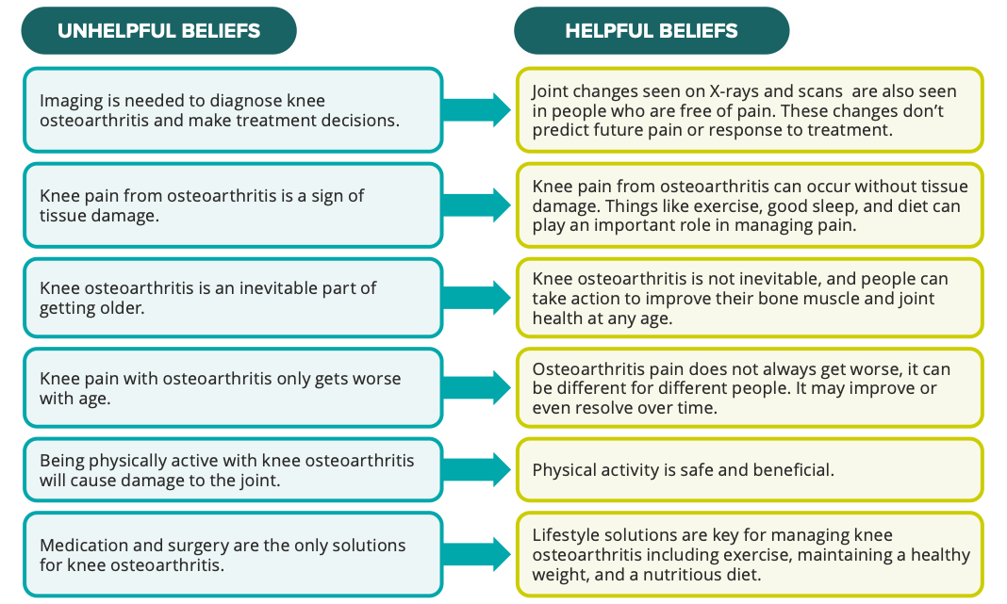

Positive conversations
Below are some examples of ways to frame more positive conversations – and some messages to avoid.

Express understanding
Recognise the impact of the person’s physical symptoms on their life and general wellbeing
‘Joint stiffness and pain can interfere with the activities you enjoy. This can affect you emotionally too. It’s important to know that osteoarthritis does not always get worse with time. With the right management, you can get back to doing the things you enjoy.’

Promote active self-management
Provide information that is individualised to the patient’s condition and empowers them to manage their osteoarthritis proactively, using terms like ‘healthy’, ‘strong’, and ‘active’
‘Based on your story, we can see a range of factors that influence what you can work on – things like weight around the belly, muscle weakness, lack of confidence to use your knee, and not enough sleep. The good news is that these things can be changed.’
‘We can work on a plan together for you to be active, strong, and healthy so you can participate in the activities you enjoy doing.’

Identify and address any unhelpful beliefs
Listen to the person’s concerns and address any misconceptions, especially those about the safety of weight-bearing activities and exercise
‘Knee osteoarthritis is a complex condition of the knee joint and the muscles around it, which can make your knees feel stiff and sore. It’s often described as joint ‘wear and tear’, but using your joints won’t wear them away – movement is good for your joints.’
Avoid descriptions of osteoarthritis that may reinforce unhelpful beliefs about activity causing more damage to the joint, or that cause concern about exercising.
Avoid using terms like ‘degenerative’, ‘wear and tear’, and ‘bone-on-bone’.

Emphasise the benefits of being active and exercising
Use positive terms to communicate the benefits of movement and of building and maintaining strength
‘Knee joints are strong – they stay healthy through movement and are designed to be loaded. It’s safe to be active, even if it’s a bit sore at the start. The key is to find the right amount of activity based on what you can do now and what you want to do in the future.’
‘Staying active is the best way to look after your osteoarthritis. It keeps your bones, joints, and muscles healthy. It is also good for your body and mind.’
‘If you meet the criteria for surgery, being healthy and strong before surgery will help you recover afterwards.’

Use supportive and non-stigmatising language to talk about weight management
Approach conversations about any excess weight sensitively and non-judgementally with the patient
‘What goals would you like to focus on in relation to your diet and exercise?’
‘Losing even a small amount of excess weight can improve your symptoms. Is that something you would like to consider?’
Avoid using terms like ‘fat’, ‘obese’, or ‘reducing load on the knee’ to talk about excess weight.

Clarify the role of medicines
Explain that medicines aren’t the only effective way to manage pain and work best when used together with self-management strategies
‘Medicines can help to reduce pain so that you can exercise and do your usual activities. But medicines should not replace moving your body, doing exercises to strengthen your knee, or losing any excess weight.’
Consider numeric literacy when talking about risks and benefits
Statements like ‘Nine out of 10 people with knee osteoarthritis self‑manage their condition without joint replacement surgery’ are often easier to understand than percentages or rates.

Offer hope and reassurance
Convey hope and reassurance that the patient can improve their symptoms and general wellbeing
‘There is good evidence that most people who are physically active and maintain a healthy weight can be healthy and strong and participate in the activities they enjoy without ever needing surgery.’
‘Within a few months you should find you are able to do more. Most people can look after knee osteoarthritis without surgery. For a small number of people, surgery can help.’
Avoid using language that suggests it is likely they will need surgery at some time in the future – this may support a belief that non-surgical management is futile.

Explain why imaging is not needed for diagnosis
‘Two people can have the same changes on X-ray but experience the effects on their joints very differently. This tells us that other factors play a role in your knee osteoarthritis experience.’
Avoid saying things like ‘It’s normal for adults to have joint changes on X-ray, but most won’t experience symptoms.’ as people who do experience symptoms can perceive this as stigmatising and judgemental.

Questions?

See the Commission’s Osteoarthritis of the Knee Clinical Care Standard webpage for more information and links to useful resources.
safetyandquality.gov.au
© Australian Commission on Safety and Quality in Health Care 2024

