

I am a Peer Worker. How do the National Safety and Quality Mental Health Standards for Community Managed Organisations affect me?
SCAN ME

FOR MORE INFO

As a peer worker in a Community Managed Organisation, you should feel:
- Confident that you are receiving the support you need;
- Comfortable in delivering non-clinical recovery-oriented supports; and
- Supported in all areas of the workplace so that you can do your best work.
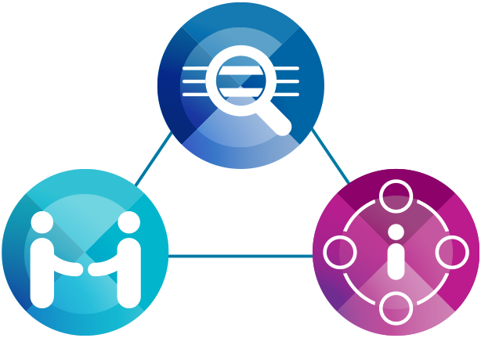

Will I be interviewed?
As a peer worker, you may be invited to be interviewed during the accreditation process of the Community Managed Organisation. Should you accept to be interviewed, you may be asked to speak about your experiences as a lived experience advocate or policy advisor where these roles overlap.

What if a consumer or carer asks for information about accreditation?
- Listen to their concerns
- Reassure that you have heard them
- Clarify what information they need to know
- Share consumer, family, and carer resources with them

Can I support someone during an interview with the assessors?
Yes. If a consumer or carer is being interviewed as part of the accreditation process, you can offer to support them and attend the interview with them if they ask. Please see factsheet “I have been asked to be part of the accreditation process. What next?” for further information on what to expect from the interview.

What about my needs?
Accreditation can be a complicated process. As someone who uses their lived experience as a staff member of an accredited service this can be a stressful time. Part of peer workers’ roles is acting as culture change agents within mental health services and this can create tensions, especially when the service is being evaluated.
Remember that:
- You can opt in or opt out at any stage
- You can request reasonable adjustments
- You can arrange for someone to support you
- You can talk to your supervisor
You may want to view the NSQMHCMO Standards: Guide for Service Providers to help you feel prepared.

Scan the QR code to view the NSQMHCMO Standards: Guide for Service Providers
For more information please call the Australian Commission on Safety and Quality in Health Care Advice Centre on 1800 304 056 or send an email to advicecentre@safetyandquality.gov.au


This Fact Sheet has been informed by the valued perspectives of consumers, families, carers and kin. We acknowledge the Traditional Owners and Custodians of Country throughout Australia, and their continuing connection to land, waters and community. We pay our respects to them and their cultures, and to elders both past and present.

