
February 2020

Review: Implementation
of the Australian
Open Disclosure Framework
  - Final consultation report


Published by the Australian Commission on Safety and Quality in Health Care
Level 5, 255 Elizabeth Street, Sydney NSW 2000
Phone: (02) 9126 3600
Email: mail@safetyandquality.gov.au
Website: www.safetyandquality.gov.au
ISBN: 978-1-925948-94-3
© Australian Commission on Safety and Quality in Health Care 2020
All material and work produced by the Australian Commission on Safety and Quality in Health Care (the Commission) is protected by copyright. The Commission reserves the right to set out the terms and conditions for the use of such material.
As far as practicable, material for which the copyright is owned by a third party will be clearly labelled. The Commission has made all reasonable efforts to ensure that this material has been reproduced in this publication with the full consent of the copyright owners.
With the exception of any material protected by a trademark, any content provided by third parties and where otherwise noted, all material presented in this publication is licensed under a Creative Commons Attribution–NonCommercial–NoDerivatives 4.0 International licence.

Enquiries about the licence and any use of this publication are welcome and can be sent to communications@safetyandquality.gov.au.
The Commission’s preference is that you attribute this publication (and any material sourced from it) using the following citation:
Australian Commission on Safety and Quality in Health Care. Review: Implementation of
the Australian Open Disclosure Framework – Final consultation report – February 2020.
Sydney; ACSQHC, 2020.
Disclaimer
The content of this document is published in good faith by the Australian Commission on Safety and Quality in Health Care for information purposes. The document is not intended to provide guidance on particular healthcare choices. You should contact your healthcare provider on particular healthcare choices.
The Commission does not accept any legal liability for any injury, loss or damage incurred by the use of, or reliance on, this document.

Table of Contents
Executive summary 5
Aim of the review 6
Overview of findings 6
Implementation gaps and priority areas for improvement 7
Enablers and barriers to open disclosure implementation 7
Strategies 8
Conclusion 9
1. Introduction 10
2. Background 11
2.1 Benefits of open disclosure 11
2.2 Supporting open disclosure in practice: culture and communication 12
2.3 Open disclosure in Australia 12
3. Aim and scope of the review 15
4. Project governance 16
5. Purpose and structure of this report 17
6. Methodology 18
6.1 Activity 1 – Analysis of accreditation data for the NSQHS Standards (first edition) 18
6.2 Activity 2 – Targeted interviews, desktop review and consultation with the Open Disclosure Advisory Group 19
6.3 Activity 3 – National online targeted survey 19
6.4 Activity 4 – Consumer focus groups 21
6.5 Activity 5 – Consultation with Complaints Commissioners 21
7. Findings 22
7.1 Number and demographics of survey responses 22
7.2 Thematic findings 26
8. Discussion 79
8.1 Activities and mechanisms to implement the Framework 79
8.2 Extent to which the Framework has been, or is being, implemented in practice 79
8.3 Implementation gaps and priority areas for improvement 80
8.4 Enablers and barriers to open disclosure implementation 80
8.5 Resources to support open disclosure implementation 81
9. Limitations 82
10. Strategies for next steps 84
At a national level 84
At a state and territory level 84
At a health service organisation level 84
11. Conclusion 86
12. Appendices 87
Appendix A: Guiding principles for open disclosure 87
Appendix B: Elements of an open disclosure process – key considerations and actions 89
Appendix C: Flow charts for open disclosure responses 91
Appendix D: Overview of open disclosure policy, training, resources and data collection at a state and territory level (current at April 2019) 93
Appendix E: Open disclosure resources and tools by the Commission, states and territories 101
Appendix F – Open Disclosure Advisory Group Member list 104
Acronyms and abbreviations 105
Glossary 106
References 107

Executive summary
People receiving health care, their carers and families, and the community trust healthcare providers and health service organisations to provide safe, high quality care; and most Australians have access to such care. Although most health care in Australia leads to good outcomes, people do not always receive the care that is most appropriate to them, and preventable adverse events occur.
When adverse events occur, the health service organisation and healthcare provider has a responsibility to tell the person who has experienced the adverse event. For the person, and their carers and families, this admission can allay feelings of anxiety and abandonment after harm. It has also been shown to influence whether people take legal action, because sometimes such action can be motivated because a person or their next of kin wishes to discover what happened if they are faced with evasion and a lack of communication following an incident.
Open disclosure is the open discussion of adverse events that resulted in harm to a person while receiving health care, with that person and/or their support people. It is not a one-way or one-off provision of information, but an ongoing discussion that may take place over a period of time. Open disclosure is part of a person’s healthcare right to information and is anchored in professional ethics and professional Codes of Conduct. Open disclosure is part of good clinical practice, effective clinical communication, and the care continuum.
The Australian Open Disclosure Framework (the Framework) provides a nationally consistent basis for communication following unexpected health outcomes and harm. The Framework was developed by the Australian Commission on Safety and Quality in Health Care (the Commission), in consultation with the health sector, and endorsed by Australian Health Ministers in 2013. Elements of open disclosure in the Framework are:
- An apology or expression of regret, which should include the words ‘I am sorry’ or ‘we are sorry’
- A factual explanation of what happened
- An opportunity for the person who has experienced harm or an unexpected event, and/or their support people to relate their experience
- A discussion of the potential consequences of the adverse event
- An explanation of the steps being taken to manage the adverse event and prevent recurrence.
In the first edition of the NSQHS Standards (released in 2011), actions on open disclosure required health service organisations to implement an open disclosure program consistent with the Open Disclosure Standard (2003), which was replaced by the Framework in 2013; and have a clinical workforce trained in open disclosure processes. These actions were ‘developmental’ and while health services were required to demonstrate that they were working towards implementing these actions, developmental actions did not need to be fully met to achieve accreditation against the first edition of the NSQHS Standards.
In the second edition of the NSQHS Standards, actions on open disclosure are strengthened. The NSQHS Standards (2nd ed.) require health service organisations to use an open disclosure program that is consistent with the Framework; and monitor and act to improve the effectiveness of open disclosure processes. From 1 January 2019 all actions in the NSQHS Standards (2nd ed.) are mandatory and have to be met to achieve accreditation.
It has been seventeen years since open disclosure was formally adopted by the Australian health system as a fundamental patient right and an attribute of a safe, high-quality health service organisation.
This review found that implementation of open disclosure is at various levels of maturation and there were inconsistencies with how the Framework is being translated operationally across the health system. This means that a person who has experienced an adverse event may never be told about the event, which may have had a significant impact on their health outcomes.
Open disclosure is a core professional requirement and an institutional obligation. There is no excuse for a health service organisation or healthcare provider to fail to communicate with the person and/or their support people following unexpected healthcare outcomes and harm.
The ethical and good practice challenge for the health system is to embed open disclosure as part of routine health care. Best practising healthcare providers have always done this.

Aim of the review
The Commission has undertaken this review to assess the implementation of the Framework in Australian health services. Project aims were to review and consult on:
- The activities and mechanisms undertaken by Australian health services, jurisdictions and the private hospital sector to implement the Framework, including state, territory and organisational policies, processes, training and strategies
- The extent to which the Framework has been, or is being, implemented in practice.
To meet these objectives, the Commission undertook a mixed method approach. This included an analysis of available accreditation data from the first edition of the NSQHS Standards; a review of state and territory open disclosure policies; targeted interviews and consultations; consumer focus groups; and a national online survey. From this approach, the Commission was able to gain a national view of the current landscape of open disclosure implementation, and an understanding of the perceived key issues, implementation gaps and potential areas to focus improvement activities.

Overview of findings
Findings show that state and territory health departments and health service organisations have undertaken considerable work to implement open disclosure; with many having policies directing open disclosure implementation, and systems and processes to support open disclosure practice. There were positive examples of open disclosure processes in place; however, challenges remain in relation to the consistent implementation of the Framework across the Australian health system.
Analysis of quantitative and qualitative data suggests that health service organisations are at different levels of maturity with respect to implementation of open disclosure, and there were inconsistencies with how the Framework was translated into practice. Key issues related to:
- Ensuring there is a just culture; where open disclosure is valued by the health service and healthcare providers as part of routine clinical practice. Concerns about medico-legal and reputational consequences were also raised as key issues
- Integration of open disclosure into governance systems and local clinical processes related to supporting the workforce to detect, assess and report incidents; and ensure that the appropriate level of open disclosure response occurs (lower-level/higher-level)
- Ongoing training and education that is focused on effective, respectful and compassionate communication, and ensures that the workforce are equipped with the knowledge and skills to undertake all levels of open disclosure responses
- Support for people who have experienced harm, their support people, and the health workforce, and ensuring that this is provided at the right time and that it meets their needs and expectations.

Implementation gaps and priority areas for improvement
Specific issues identified in the review affecting successful open disclosure implementation, are grouped into the following themes:
- Leadership and culture: Improving engagement at the clinical level and fostering a culture where open disclosure is viewed as an ethical requirement and part of effective communication and good clinical care; not viewed as one-off process that is separate to everyday clinical practice.
- Integration of open disclosure into local clinical governance: Ensuring clinical governance, risk management and quality improvement systems supports the workforce to detect, assess and report incidents; and that the appropriate level of open disclosure response occurs (i.e. lower-level/higher-level). This includes ensuring clear and formalised local processes for all levels of open disclosure responses.
- Measurement and evaluation: Ensuring consistent monitoring of open disclosure through multiple systems (incident, complaints, patient reported experience and outcome measures and escalation processes); and that appropriate feedback mechanisms are in place for the workforce, the people who have experienced harm, and their support people, to help facilitate learning, quality improvement and closure. This includes improving the consistency and quality of open disclosure documentation.
- Meeting the needs and expectations of the workforce (including training and development): Addressing perceived medico-legal, reputational and media concerns; supporting the workforce through provision of appropriate training and support to prepare for, and conduct open disclosure processes; and support after an open disclosure process has occurred.
- Meeting the needs and expectations of people who have experience harm and their support people: Ensuring there is genuine engagement and involvement of the person and/or their support people in open disclosure processes, including understanding a person’s cultural and communication needs and providing appropriate support. This includes ensuring there is an open discussion and an opportunity to ask questions, tell their story of the event, and be heard.
A number of additional issues were also consistently raised as having an impact on the extent to which the Framework could be implemented into practice. These included the need to adapt approaches to open disclosure for different settings and for different patient groups and issues related to the timing and timeliness of open disclosure.

Enablers and barriers to open disclosure implementation
Review findings identified a number of key enablers and barriers to open disclosure implementation; which related to both organisational and individual factors. These are grouped into similar themes:
- Culture and leadership
- Systems, policies and processes
- Training and support
- Resources (time and cost)
- Evaluation
- Awareness of open disclosure.
Key enablers identified included a supportive and just culture; robust clinical governance, risk management and quality improvement systems; and clear formalised local open disclosure processes. Ongoing education and training focused on effective, respectful and compassionate communication, and provision of appropriate information and guidance on open disclosure at the right time to all parties involved in the open disclosure were also identified as key enablers.
Conversely, findings suggested that implementation issues, as noted above, could be amplified if the health service culture, environment and leadership is unsupportive of genuine open disclosure practises. This included having unclear organisational policies, processes, and expectations (on behalf of the person, their support people and the healthcare workforce); and if the workforce is not appropriately equipped or supported to develop the knowledge and skills required to undertake open disclosures. Other key barriers identified included medico-legal concerns, fear of reputation damage, limited resources (time and cost), lack of awareness (consumer and healthcare providers), and difficulties and practicalities of monitoring, evaluating and documenting open disclosure (particularly lower-level responses).

Strategies
To support consistent implementation of the NSQHS Standards (2nd ed.) and translation of the Framework into practice, a coordinated, multi-level and multi-faceted approach is recommended. This will require different implementation strategies at a national, state and territory, and health service organisation level.

At a national level
Continue to assist health care organisations and healthcare providers to meet the NSQHS Standards, which require health service organisations to implement open disclosure processes aligned with the Framework; and monitor and act to improve the effectiveness of open disclosure processes. Areas of focus include:
- Further resources to support consistent implementation aligned with the principles of the Framework, including: tailored resources for different patient groups; development of national education; consideration of national indicators or guidance to support consistent data collection and monitoring; and further advice to support consistent assessment of the open disclosure actions in the NSQHS Standards
- Collaborating with key partners in the health system to promote open disclosure training, education and awareness.

At a state and territory level
Monitor and evaluate open disclosure implementation at a health service organisation level and continue to support consistent open disclosure practice at the clinical level. Areas of focus include:
- Provision of open disclosure training, with consumers
- Consistent monitoring of open disclosure implementation at the local level, and identifying areas where further resources and/or guidance would be helpful
- Sharing lessons learned on open disclosure implementation across the state/territory
- Clarifying and addressing medico-legal concerns specific to state or territory laws
- Considering support and additional resources needed for rural and remote areas and specific patient groups, specific to the state or territory.

At a health service organisation level
Support open disclosure implementation as part of routine practice; ensuring open disclosure processes are integrated into the organisation’s local clinical governance and quality improvement systems; and that the workforce is supported and skilled to conduct open disclosure. Areas of focus include:
- Fostering a culture that supports and prioritises open disclosure processes as part of good clinical care
- Assessing how open disclosure processes are implemented in the organisation, taking into consideration the principles and elements of the Framework
- Supporting and providing open disclosure training, peer support and mentorship, including communications skills training that support empathetic and respectful communication
- Ensuring access to appropriate support for the workforce, people who have experienced harm and their support people
- Continuous evaluation of open disclosure processes and feedback of results to the workforce, people who have experienced harm and their support people, and governing bodies for quality improvement
- Endeavouring to communicate lessons learned throughout the broader health system through existing mechanisms and relevant authorities.

Conclusion
Open disclosure is a fundamental patient right.
There is an ethical responsibility to communicate with a person, and their carers and families when health care has not been delivered as expected.
This review has found that routine practice of open disclosure is variable, and that challenges to implementation remain. After seventeen years there can be no more excuses. Health service organisations and health care providers who are not practising open disclosure as part of routine health care need to do so immediately.
Findings of this review show that considerable work has been undertaken to support open disclosure implementation, and there is sufficient support materials available at a national, state, territory and health service organisation level to support open disclosure implementation and practice.



Introduction
The Australian Commission on Safety and Quality in Health Care (the Commission) is a government agency created under the provisions of the National Health Reform Act 2011.
The Commission leads and coordinates national improvements in safety and quality in health care across Australia. The Commission’s key functions include: developing national standards; providing advice on best practice; coordinating work in specific areas to improve outcomes for consumers; and providing information and resources about safety and quality.
One of the key drivers in Australia for safety and quality improvement are the National Safety and Quality Health Service (NSQHS) Standards.1,2 The Commission developed the NSQHS Standards in collaboration with the Australian Government, state and territories, the private sector, clinical experts, consumer organisations, people who receive health care and their support people. The primary aims of the NSQHS Standards are to protect the public from harm and improve the quality of health care provision. They provide a quality assurance mechanism that test whether relevant systems are in place to ensure expected standards of safety and quality are met.
The NSQHS Standards are mandatory for all Australian hospitals and day procedure services, with assessment to the second edition of the NSQHS Standards commencing from January 2019.
Open disclosure is recognised as an important part of safe, high-quality care in the NSQHS Standards (2nd ed.); and Action 1.12 in the Clinical Governance Standard requires that health service organisations:
- Use an open disclosure program that is consistent with the Australian Open Disclosure Framework (the Framework)
- Monitor and acts to improve the effectiveness of open disclosure processes.2
This action is closely linked to the requirement that health service organisations have organisation-wide incident management and investigation systems (Action 1.11).
To support health services meet their open disclosure requirements under the NSQHS Standards, the Commission has undertaken a review in order to better understand the extent to which the Framework is being implemented in Australian health services, and identify where there may be implementation gaps or areas for improvement. The findings of this review will help to inform improvements in the implementation of open disclosure policy, processes and practice in Australia.



Background
Every day across Australia, many thousands of healthcare interventions occur. These interventions are often complex, delivered in high-pressure environments using highly advanced equipment, and involve multiple healthcare providers working together in teams and across organisations. Such interventions usually result in excellent clinical outcomes, but can also carry significant risks. Sometimes incidents occur, and some result in harm.
Open disclosure is the open discussion of adverse events that result in harm to a person while receiving health care, with that person and/or their support people.3
An adverse event is an incident in which results in harm to a person receiving health care. Harm is defined as an impairment of structure or function of the body and/or any deleterious effect arising from an incident, including disease, injury, suffering, disability and death. Harm may be physical, social or psychological.3,6
Open disclosure is not a one-way or one-off provision of information, but a discussion and exchange of information that may take place over a period of time. Open disclosure can be conducted through multiple modes, including face-to-face meetings, by tele/videoconference, by phone or via email. It is the health service organisation’s responsibility to work with the person and/or their support people to determine the best form of communication, and how the open disclosure process will occur.
Open disclosure is part of a person’s healthcare right to information and is anchored in professional ethics and professional Codes of Conduct. It is part of good clinical practice, effective clinical communication, and the care continuum.

2.1 Benefits of open disclosure
Open disclosure can have a direct benefit for the individuals involved, as well as system-wide benefits. These include:

For people where a harm has occurred and/or their support people
- Gaining an understanding of what happened and why, including an opportunity to ask questions and have concerns addressed
- Restoring trust in health care
- Ameliorating feelings of anger, guilt, grief or helplessness
- Encouraging the person and/or their support people to participate in health care quality improvement processes.

For healthcare providers
- Enabling the mitigation of ongoing consequences of harmful incidents
- Enabling healthcare providers to manage the stress and affective consequences of a harmful incident or complaint
- Ameliorating feelings of guilt and shame
- Facilitating full and frank incident investigations that can be used to improve the safety and quality
- Fulfilling professional, ethical and moral obligations to truthfully disclose information about harmful incidents.

At the system-wide level
- Facilitating a safer health system
- Improving system responsiveness to the person’s and community’s needs
- Strengthening public trust in healthcare institutions, including relationships between the healthcare provider and the person receiving health care
- Increasing and improving notification, reporting and investigation of incidents, resulting in more targeted quality improvement activity
- Improving workforce morale and retention
- Embedding transparency and openness into healthcare services.4

2.2 Supporting open disclosure in practice: culture and communication
Open disclosure is inherently complex, and is challenging and difficult for all participants. To support open disclosure practice within a health service organisation, there needs to be an environment where:
- There is a safe and just culture
- Effective communication is fostered
- Open disclosure is integrated into the local governance systems, such as incident management and complaints systems, patient experience and reported outcome measures, escalation processes and quality improvement processes.
Health service organisations need to foster a culture where people feel supported and are encouraged to identify and report adverse events, so that opportunities for systems improvements can be identified and acted on. Effective communication should commence from the beginning of an episode of care and continue throughout a person’s care.
There is also an ethical responsibility for healthcare providers to maintain honest and open communication with the person they are caring for and/or their support people, especially if care does not go to plan. Therefore, it is important that healthcare providers are equipped with the appropriate communication skills and support to undertake open disclosure processes.

2.3 Open disclosure in Australia

2.3.1 Open Disclosure Standard
Over the past 17 years the Commission has led work on open disclosure. In 2003, the Open Disclosure Standard (the OD Standard)4 was endorsed by Australian Health Ministers. The OD Standard was Australia’s first national open disclosure policy, and provided a framework for communication with a person and/or their support people following an adverse event.
Since its release in 2003, there has been considerable research resulting in an improvement in implementation guidance for open disclosure. This included Commission funded independent research evaluating the National Open Disclosure Standard Pilot, investigation of the disclosure experiences of people who have experienced harm, their support people and healthcare providers, and information about the legal aspects of open disclosure in Australia.

2.3.2 Review of the Open Disclosure Standard
In 2011–2012, the Commission undertook a formal review of the OD Standard. The purpose of the review was to ensure that the OD Standard was still meeting the needs of people who had experienced harm and/or their support people, healthcare providers and health services. The review of the OD Standard identified where it did and did not reflect current evidence, and recommended changes accordingly. There were four main review findings:
- Open disclosure is often conducted as a process of information provision from the service to the person who has experienced harm and/or their support people, but they would prefer open disclosure to be an open dialogue
- Health professionals support disclosure but barriers remain to its practice, including
  - perceived medico-legal consequences of disclosure
  - concerns about preparedness for involvement in open disclosure process
  - tensions between the principles of openness and timely acknowledgement, and the requirement for providers to take early advice from their insurers following a harmful incident
- International evidence and Australian experience suggest that disclosure is more effective as an ethical practice that prioritises organisational and individual learning from error, rather than solely as an organisational risk management strategy
- Open disclosure has been found to create larger benefits for the health system and people receiving health care by fostering cultures of openness and trust.
The review found that while the OD Standard remained mostly relevant, it could benefit from further refinement. Recommended changes to the OD Standard intended to encourage healthcare providers to prepare for open disclosure through awareness and training; and increase the involvement of people who have experienced harm and/or their support people in the open disclosure process.4

2.3.3 The Australian Open Disclosure Framework
As a result of the review, the Framework3 was developed. The Framework incorporates recommendations from the review and replaces the OD Standard. Implementation of the Framework was formally endorsed by Australian Health Ministers in December 2013, and officially endorsed by a number of professional organisations.
The Framework is designed to enable health service organisations and healthcare providers to communicate openly with patients when health care does not go to plan. While the Framework acknowledges that healthcare settings are varied, and that open disclosure is an inherently complex and difficult process; its aim is to provide a nationally consistent basis for communication following unexpected healthcare outcomes or harm. Consistent and systematic practice of open disclosure can assist health service organisations to manage adverse events compassionately and also provide broader benefits through improved clinical communication and system improvement.
The Framework describes the elements of open disclosure as:
- An apology or expression of regret, which should include the words ‘I am sorry’ or ‘we are sorry’
- A factual explanation of what happened
- An opportunity for the patient, their family and carers to relate their experience
- A discussion of the potential consequences of the adverse event
- An explanation of the steps being taken to manage the adverse event and prevent recurrence.

Eight guiding principles for open disclosure are also described as:
- Open and timely communication
- Acknowledgement
- Apology or expression of regret
- Supporting and meeting the needs and expectations of patients, their families and carers
- Supporting and meeting the needs and expectations of those providing health care
- Integrated clinical risk management and systems improvement
- Good governance
- Confidentiality.
These are further described in Appendix A. The Framework also provides guidance on the key considerations and actions of an open disclosure process. These were developed as a result of the review to the OD Standard, and provides key consistent actions that should be considered. These are:
- Detecting and assessing incidents
- Signalling the need for open disclosure (noting a lower-level response can conclude at this stage)
- Preparing for open disclosure
- Engaging in open disclosure discussions
- Providing follow-up
- Completing the process
- Maintaining documentation.
More detail on the actions is at Appendix B.
The Framework recognises that the appropriate open disclosure response will be determined by the effect, severity or consequences of the incident. Guidance is provided on the potential responses to various situations and incidents, outlining higher-level and lower-level responses (also known as formal open disclosure and clinician disclosure). Two flow charts outlining the key steps of open disclosure is at Appendix C.
To support implementation of the Framework, the Commission has also developed a number of resources for consumers, healthcare providers and health service organisations. These are listed in Appendix E, along with other resources available across states and territories.

2.3.4 The Framework and the NSQHS Standards
As noted above, open disclosure is required under the NSQHS Standards. In the first edition of the NSQHS Standards (released in 2011), actions on open disclosure required health service organisations to implement an open disclosure consistent with the Open Disclosure Standard (which was replaced by the Framework in 2013); and have a clinical workforce trained in open disclosure processes. These actions were ‘developmental’ and while health services were advised that they should be working towards implementing these actions, developmental actions did not need to be fully met to achieve accreditation.
In the second edition of the NSQHS Standards, actions on open disclosure are strengthened. The NSQHS Standards (2nd ed.) requires that health service organisations use an open disclosure program that is consistent with the Framework; and monitor and acts to improve the effectiveness of open disclosure processes. From 1 January 2019 all actions have to be met to achieve accreditation.



Aim and scope of the review
The Commission has undertaken a project to review implementation of the Framework in Australian health services. The project’s objectives are to review and consult on:
- The activities and mechanisms undertaken by Australian health services, jurisdictions and the private hospital sector to implement the Framework, including jurisdictional and organisational policies, processes, training and strategies; and
- The extent to which the Framework has been, or is being, implemented in practice.
Through the review process the Commission sought to identify and understand:
- Any implementation gaps, or priority areas in which the Commission and/or state and territory health departments and health services should focus on
- Lessons learned, including what is working well and what could be improved (barriers and enablers to implementation)
- If there is a need for additional resources or adaptions to existing resources to support consumer awareness of, and participation in, open disclosure; and to support health service organisations and healthcare providers to effectively undertake open disclosure processes that align with the Framework.



Project governance
The Commission has overall governance of the project and established an Open Disclosure Advisory Group (ODAG) to provide advice, expertise and consumer and carer input to inform the project. The ODAG’s term is from February 2019 to 30 June 2020.
Members were appointed as representatives of specific sectors, or in their individual capacity. The group includes representation from state and territory health departments, the private hospital sector, day procedure services, consumer and carers, the legal and indemnity insurance sector, and a Complaints Commissioner. A list of the members is at Appendix F. Members key roles are to provide advice on:
- The review and consultation process for the project, including development of a consultation survey, consultation activities, and strategies to connect, communication and engage with relevant stakeholders
- The findings of the review and consultation process, including input on possible recommendations from the review
- Potential next steps for the project and strategies on how best to progress next steps.
Based on their experience, members provided insights into the extent to which open disclosure processes are occurring in health services, and their views on the current challenges and barriers faced by people receiving health care, healthcare providers and health service organisations. Many of the issues raised by members were supported by the review findings. Members’ advice, comments and feedback have informed this report.
Members also provided their vision and hope for future open disclosure implementation, this included:
- Open disclosure is normalised and embedded as part of good clinical practice and effective communication with people who have experienced harm and/or their support people
- Open disclosure discussions take place that have a foundation of trust, respect, dignity, partnership, openness and learning
- Open disclosure practices occur across the care continuum, at all times, not just when a harmful incident occurs
- Encouragement of health services to provide a compassionate approach and support for the healthcare workforce, people accessing healthcare services and/or their support people; acknowledging that the open disclosure process is difficult for the person, their support people, and healthcare providers
- Open disclosure practice consistently aligned with what is described in the Framework, across all Australian health settings
- An understanding of the value and benefits of open disclosure throughout healthcare organisations and in the community
- A shift from open disclosure processes being viewed as compliance, to an opportunity to partner with people receiving health care, their support people and the healthcare workforce to improve the safety of the healthcare system
- Health service organisations fostering effective communication and a safe and just culture that supports open disclosure practice.



Purpose and structure of this report
The purpose of this report is to provide details of review findings and suggested strategies to support successful implementation of open disclosure that is aligned with the Framework at a national, state and territory, and health service organisation level.
Findings are reported against each of the activities described in the Methodology in section 6. Findings are grouped thematically based on the structure of the survey, with consideration of the principles and elements of the Framework. These themes are:
- Open disclosure is a priority (leadership and culture)
- Integration of open disclosure into local clinical governance
- Measurement and evaluation
- Meeting the needs and expectations of the workforce (including training and development)
- Meeting the needs and expectations of people who have experience harm and their support people
- Documentation.
Not all themes were raised in each activity.
Feedback and responses on ‘experience of open disclosure practice’ were reported for respondents to Section B of the survey only (as described in the Methodology). This is because respondents specifically identified as having participated in open disclosure. Survey questions related to preparation for open disclosure, open disclosure process and open disclosure outcomes.
Additional issues relating to implementation of the Framework, which were consistently raised throughout the review, have been collated from the survey free text responses and feedback from the target interviews and consultations and consumer focus groups. These are reported separately in section 7.2.9. Feedback on enablers and barriers to implementation, and suggested resources and strategies are reported separately in section 7.2.10.
This report will be presented to members of the Commission’s Inter-Jurisdictional Committee, Primary Care Committee, Private Hospital Sector Committee and Board.



Methodology
To gain a comprehensive understanding of how the Framework is being implemented in Australian health services, a mixed method approach was undertaken. This involved:
- Undertaking a state and territory policy review, to determine the policy levers influencing open disclosure implementation in each state and territory
- Identifying the resources, education and training available in each state and territory to support open disclosure
- Identifying how open disclosure is monitored, reported and evaluated in each state and territory
- Reviewing existing accreditation data from the first edition of the NSQHS Standards for evidence of health services meeting actions related to open disclosure
- Gathering quantitative and qualitative data from a national online survey on how key aspects of the Framework are being implemented
- Gathering qualitative data through target interviews, consultations and consumer focus groups to better understand the context and extent to which the Framework is being implemented, including feedback on enablers, barriers and implementation gaps.
A more detailed description of the above activities follows.

6.1 Activity 1 – Analysis of accreditation data for the NSQHS Standards (first edition)
Accreditation data on open disclosure actions in the first edition of the NSQHS Standards (Actions 1.16.1 and 1.16.2) were analysed from January 2013 to November 2018 (inclusive). This was to gain an initial snapshot of whether health service organisations had undertaken work towards implementing the open disclosure actions in the NSQHS Standards (1st ed.). Data included public hospitals, private hospitals and day procedure services across Australia that had at least two assessments (1,339), and at least three assessments (781). Types of assessments included interim, organisation-wide and mid-cycle assessments.
It is noted that the data was only able to provide a high-level view of open disclosure implementation, and it was difficult to draw any conclusions from the data about the extent to which the Framework was being implemented into practice.

6.2 Activity 2 – Targeted interviews, desktop review and consultation with the Open Disclosure Advisory Group
In February to March 2019, the Commission conducted eight targeted interviews with state and territory representatives to gain a better understanding of the different policy drivers, activities and mechanisms that direct open disclosure implementation in each jurisdiction. Representatives were nominated by members of the IJC as people who had responsibility for implementation of open disclosure policy and/or programs in their respective state or territory. Interviews focused on:
- Whether there was a state or territory-wide policy that mandated or guided implementation
- Availability and implementation of education and training on open disclosure
- How data and information about open disclosure is monitored, collected and used.
Representatives were also asked to provide feedback on the extent to which open disclosure processes are currently implemented in their respective state or territory; and their views on the main challenges, barriers and enablers to effective open disclosure implementation and practice. Additional key stakeholders were interviewed based on referrals from the representatives. This included a discussion with a group of health service executives from one jurisdiction and organisations involved in open disclosure education and training.
A desktop review of state and territory health websites and documents was conducted to support the jurisdictional interviews. This involved reviewing state and territory open disclosure policies to identify the policy levers directing open disclosure implementation; the type of education, training and resources available to support open disclosure processes; and identifying the resources available at a state and territory level to monitor and evaluate open disclosure implementation.
The Commission also consulted with members of its ODAG in April, October and November 2019. Members provided their views on the extent to which the Framework is being implemented in health services, and the current challenges, barriers and enablers faced by people who have experienced harm, their support people, healthcare providers and health services. Given the membership of the ODAG, members also provided advice on open disclosure policy, training and data collection.

6.3 Activity 3 – National online targeted survey
An online national survey was conducted from 5 August to 6 September 2019, and re-opened from 8 October to 28 October 2019 on advice from the ODAG for an additional two weeks, in order to gain a more representative national picture of open disclosure practice across health services.
The purpose of the survey was to gain a national overview of open disclosure practice in Australia; including qualitative data to help inform the Commission of the perceived barriers and enablers to implementation, and where there may be implementation gaps.
The survey was voluntary to complete and targeted at healthcare executives, managers and healthcare providers who have oversight or a role in open disclosure implementation, and/or those who have participated in an open disclosure process. The survey was distributed via nominated representatives of the Commission’s IJC, PHSC and the Australian Private Hospitals Association, on advice from the Commission’s IJC and PHSC. Representatives distributed the survey to relevant members of the healthcare workforce in their respective state or territory, and health services. Due to limitations in the method of distribution, and voluntary completion of the survey, it was not possible for the Commission to get a national representative sample. However, completed responses received after extending the survey timeframes did provide a more widespread response across states, territories, service-types and roles.
Survey questions were based on the Commission’s open disclosure patient, family, carer and support person evaluation survey, the staff evaluation survey, and the open disclosure organisational readiness assessment tool. These are existing resources available to support the Framework, and are aligned with the principles and elements of the Framework. The length of the survey was also considered to facilitate higher completion rates (i.e. not too long). Survey questions were tested with members of the ODAG and feedback incorporated.
SurveyMonkey® was the platform used to collect responses, and questions were structured based on the role and experience of the respondent. These were as follows:
- Section A: was targeted at respondents who had a role in the implementation of open disclosure policies and processes in their organisation, and included questions on
  - if open disclosure is a priority in their organisation
  - integration of open disclosure into local governance systems
  - measurement and evaluation
  - staff training and development
  - supporting and meeting the needs and expectations of staff
  - supporting and meeting the needs and expectations of patients, families, carers and support people
  - documentation
- Section B: was targeted at respondents who had participated in open disclosure processes, and included questions on
  - preparation for open disclosure
  - open disclosure process
  - open disclosure outcomes
- Section C: was for all respondents to complete and included questions on whether patients or their support people had raised any issues in relation to open disclosure; identifying enablers and barriers, and feedback on resources.
Survey questions were targeted based on the respondent’s role and experience, with all respondents answering questions on open disclosure barriers, enablers and resources. For example, respondents who answered that they had both a role in open disclosure implementation and have participated in open disclosure would be directed to answer questions in Section A, B and C. Respondents who only identified as having a role in open disclosure completed Section A and C. Respondents who only identified as having participated in open disclosure completed Section B and C. All survey responses were anonymous.
Most questions were assessed against a six-point rating scale of ‘strongly disagree, slightly disagree, neutral, slightly agree, strongly agree and N/A or unknown’. Responses were weighted as:
- Generally agreeing or disagreeing: if responses for ‘strongly agree/disagree’ were over 50%, and/or the sum of ‘strongly and slightly agree/disagree’ responses was over 70%
- Mostly agreeing or disagreeing: if responses for ‘strongly agree/disagree’ were over 70%
- Majority of respondents: if responses were equal to or over 80% strongly agree/disagree.
Percentages are rounded to the nearest whole number and have been presented for each question. Other questions allowed respondents to select from a range of choices or answer yes/no/unsure, where appropriate.
Free text questions were included at the end of each section of the survey to enable respondents to provide comments. Answers to questions were mandatory, however free text questions in each section were optional. Quotes provided in the report are drawn from the free text responses, representing the views and opinions of survey respondents. All responses reflected the respondents perceptions of how open disclosure was being implemented in their organisation.
There were 85 survey questions, which included 15 free text questions in the survey.

6.4 Activity 4 – Consumer focus groups
The original scope of the project was to undertake consultations with jurisdictional representatives, healthcare executives, managers and healthcare providers. The importance of including consumer experience and perspective in the project was recognised, however the best approach to identify and recruit consumers with open disclosure experience was constrained by the scope and timeframes of the project. On advice from the ODAG, the Commission conducted two consumer focus groups in July 2019. It was also agreed that it would be important for the Commission to partner with consumers in any subsequent development of resources that may arise from this review.
The Commission partnered with Health Consumers Alliance South Australia (HCASA) and Dementia Australia (DA) to recruit and host the focus groups. This method was chosen, as both organisations had strong networks and relationships with their consumers. There were also limited options to identify and recruit participants via other methods.
HCASA and DA recruited participants via an ‘Expression of Interest’ process, followed by short interviews to select participants. Selection criteria requested people who in the last four years had an experience in hospital where there was an unexpected outcome in their care, or the care of a family member, and where they had a planned conversation with the hospital (or no conversation). Recruitment aimed to sample experiences from a range of consumers, including those with specific needs such as people who have cognitive impairment or diminished capacity.
A total of 23 participants were involved in the focus groups. Participants’ experiences were varied, and represented family members, carers, consumer advocates and consumer organisation representatives. While some participants spoke about their communication (or lack of communication) with hospital staff about the harm that had occurred, it is noted that not all participants had experienced an open disclosure. Additionally, it is acknowledged that the focus groups had limited participation from people who were from culturally and linguistically diverse backgrounds, people who identified as Aboriginal and Torres Strait Islander, and people with a disability.
Focus groups were facilitated by the Commission and focused on similar themes to the survey, including experience of open disclosure processes, barriers and enablers and resources. The Commission also provided information to focus group participants on open disclosure as a patient right under the second edition of the Australian Charter of Health Care Rights.

6.5 Activity 5 – Consultation with Complaints Commissioners
On advice from the Commission’s IJC and PHSC, the Commission consulted with four Complaints Commissioners, and three staff members who had experience with resolving complaints. Commissioners had roles in dealing with complaints for health and community services, mental health and disability services, services for older people and services for children and young people.
As complaints often follow a situation where open disclosure has not occurred, or when a person and/or their support people are not satisfied with an open disclosure process, discussions with Complaints Commissioners were conducted to gain insights into where open disclosure improvements could be made, and advice on useful resources to support open disclosure implementation and practice.
The Commission was unable to consult with all state and territory Complaints Commissioners. Therefore, it is recognised that feedback from these activities may not be reflective of the experience of state/territory Commissioners that were not consulted.



Findings
Details of the review findings are presented in this section. This includes an overview of the survey respondents’ demographics, the current landscape in relation to open disclosure policy levers, training and data collection, and key issues raised in the review. Perceived enablers and barriers to open disclosure implementation and translation of the Framework into practice are also reported.

7.1 Number and demographics of survey responses

7.1.1 Number of survey responses
The survey received 503 responses overall with 373 completed responses. Analysis of quantitative data was undertaken on completed responses only.
There were 1,314 responses to the free text questions. Analysis of qualitative data was carried out for all free text responses provided. Table 1 lists the number of responses to the free text questions for each section.
Table 1: Free text questions in the survey and the number of responses
Free text question – comments regarding: | Number of responses
Priority of open disclosure in your organisation | 105
Integration of open disclosure into organisation’s clinical governance framework | 61
Measurement and evaluation of open disclosure in your organisation | 62
Staff training and development | 116
Patient, family and carer support systems | 47
Staff support systems | 49
Documentation | 44
Further comments about your open disclosure experience | 36
Different between open disclosure implementation and/or practice in the public versus private sector | 50
Issues raised by patients or their support person/s about the open disclosure process | 56
Enablers | 203
Barriers | 244
Existing resources and why they are useful | 174
Existing resources and why they are not useful | 5
Suggestions on resources to support open disclosure practice | 62
Total number of free text responses | 1,314

7.1.2 Demographics of survey responses

7.1.2.1 Service-type
Of the 373 completed responses, the majority of respondents identified public health service as their primary place of work (72%); with approximately 17% from private health services; 3% both public and private health services; 6% from day procedure services and 2% as other (Figure 1). Other included ambulance, not-for-profit and clinical trials cancer organisations.
Figure 1: Respondents’ primary place of work (service-type)

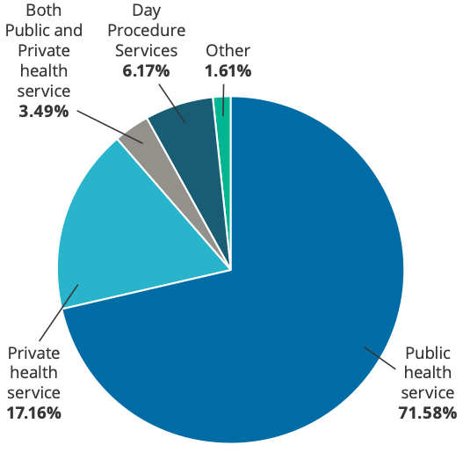
Answer choices | Responses
Public health service | 71.58%
Private health service | 17.16%
Both Public and Private health service | 3.49%
Day Procedure Services | 6.17%
Other | 1.61%

7.1.2.2 State and territory
Of the completed responses approximately 40% were from New South Wales, followed by Western Australia (16%), Queensland (11%), Victoria (11%) and South Australia (10%). Fewer responses were received from smaller state and territories, reflecting the smaller number of health services in those states and territories (see Figure 2).
Figure 2: Respondents’ primary location (state/territory)

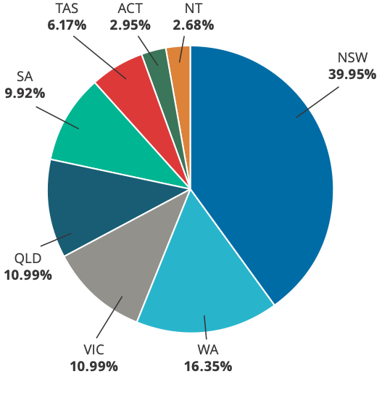
Answer choices | Responses
NSW | 39.95%
WA | 16.35%
VIC | 10.99%
QLD | 10.99%
SA | 9.92%
TAS | 6.17%
ACT | 2.95%
NT | 2.68%

7.1.2.3 Primary role
Survey respondents predominately identified as healthcare providers (27%), Safety and Quality Managers or Directors of Clinical Governance (25%) and health service executives (21%). Approximately 11% of respondents identified as ‘other’. Other, included Patient Safety or Safety and Quality Officers, Health Service Managers, Directors of Nursing, Quality Improvement Coordinators, and education providers (see Figure 3).
Figure 3: Respondents’ primary role

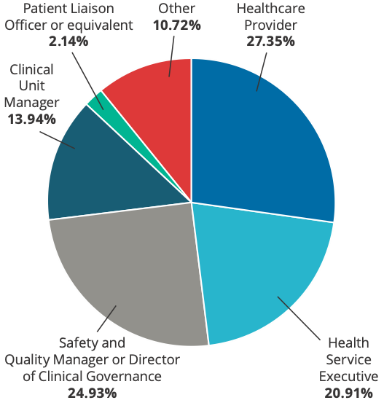
Answer choices | Responses
Healthcare Provider | 27.35%
Health Service Executive | 20.91%
Safety and Quality Manager or Director of Clinical Governance | 24.93%
Clinical Unit Manager | 13.94%
Patient Liaison Officer or equivalent | 2.14%
Other | 10.72%

7.1.4 Role in open disclosure implementation and experience of open disclosure
Of the completed responses, 277 respondents identified as having a role in the implementation of open disclosure policy and procedures in their organisation. They completed Section A of the survey (see Q4).
Q4: Do you have a role in the implementation of open disclosure policy and procedures in your organisation?
Answered: 373 Skipped: 0

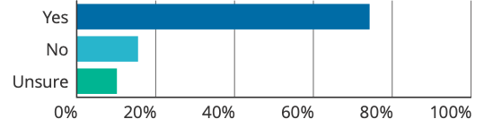

Answer choices | Responses
Yes | 74.26% | 277
No | 15.55% | 58
Unsure | 10.19% | 38
Total |  | 373

Of the completed responses, 266 respondents identified as having participated in an open disclosure process. They completed Section B of the survey (see Q51).
Q51: Have you participated in open disclosure
Answered: 373 Skipped: 0

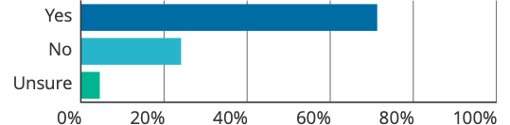

Answer choices | Responses
Yes | 71.31% | 266
No | 24.13% | 90
Unsure | 4.56% | 17
Total |  | 373

Some respondents identified as having both a role in implementing open disclosure policies and procedures, and as having participated in the open disclosure process. They completed Section A and B of the survey.

7.2 Thematic findings
Findings presented in this section provide details of the policy levers, training and data collection available for open disclosure in the public and private health sectors; key issues identified as affecting successful open disclosure implementation; and perceived barriers and enablers. Suggested resources and strategies identified by review respondents as helpful to supporting open disclosure implementation are also reported.

Key issues are grouped thematically based on the structure of the survey, with consideration of the principles and elements of the Framework. These themes are:
- Open disclosure is a priority (leadership and culture)
- Integration of open disclosure into local clinical governance
- Measurement and evaluation
- Meeting the needs and expectations of the workforce (including training and development)
- Meeting the needs and expectations of people who have experience harm and their support people
- Documentation.

7.2.1 Policy levers, training and data collection of open disclosure in Australia

7.2.1.1 Accreditation data on the NSQHS Standards (1st ed.)
The findings reflect data for two different health service groups, as described in the Methodology in section 6.
Table 2 shows an upward trend in the number of health services who have had at least two assessments for both open disclosure actions in the NSQHS Standards (1st ed.).

Table 2: Health services with at least two assessments (1,339 health services)
Action | Met the action  (1st assessment) | Met the action (2nd assessment)
Open disclosure program consistent with the national open disclosure [Framework] (Action 1.16.1) | 1,208 (90%) | 1,306 (98%)
The clinical workforce are trained in open disclosure processes (Action 1.16.2) | 1,007 (75%) | 1,213 (91%)
Table 3 shows an upward trend in the number of health services who have had at least three assessments for both open disclosure actions in the NSQHS Standards (1st ed.).
Table 3: Health services with at least three assessments (781 health services)
Action | Met the action  (1st assessment) | Met the action (2nd assessment) | Met the action (3rd assessment)
Open disclosure program consistent with the national open disclosure [Framework] (Action 1.16.1) | 689 (88%) | 753 (96%) | 771 (99%)
The clinical workforce are trained in open disclosure processes (Action 1.16.2) | 579 (74%) | 697 (89%) | 753 (96%)
While this data provides a high-level initial view that health service organisations have been working towards implementing open disclosure actions in the NSQHS Standards (1st ed.), it was difficult to draw conclusions about the extent to which the Framework has been implemented into practice. It also does not reflect how health service organisations are meeting the open disclosure actions required in the second edition of the NSQHS Standards.

7.2.1.2 Targeted interviews, desktop review and consultation with the Open Disclosure Advisory Group
To gain a better understanding of the policy, governance and training directing and informing open disclosure implementation and practice, targeted interviews, consultations and a desktop review were undertaken.

State and territory policy, training and data collection on open disclosure
An overview of the open disclosure policy, training and data was collected for each state and territory is provided at Appendix D.
Interviews with state and territory representatives found that policies, programs and protocols, education and training, and how data on open disclosure is collected varied between states and territories. In some jurisdictions, coordination of open disclosure implementation is more centralised with mandatory state or territory-wide policies and guidance. In other jurisdictions, policies are set at the health service level. All jurisdictions have education and training on open disclosure available to clinicians, ranging from introductory online education; face-to-face experiential training; to a train the trainer model. In most jurisdictions, open disclosure training forms part of orientation and workplace induction; however subsequent training (including online introductory courses) are often not mandatory.
Data collection on open disclosure, through the state or territory incident management systems also varies. For the majority of jurisdictions, data is collected on whether open disclosure has or has not occurred (yes or no option) for significant incidents (e.g. sentinel events, Severity Assessment Code (SAC) 1 and SAC 2 incidents). Some jurisdictions however, have incident management systems that allow for more detailed information to be collected. This includes reasons why an open disclosure has not occurred, or details about the open disclosure process. In some jurisdictions this data is collected and reported centrally to the state/territory health department.

Private health service policy, training and data collection on open disclosure
Advice from the private sector ODAG members noted that it was difficult to assess what is specifically in place for open disclosure implementation in the private health sector, as services vary in size, service-type, and governance structures. Regulation and licensing of private hospitals also varies between states and territories, with different reporting requirements determined by the license. While many states and territories require private hospitals to report sentinel events to the relevant state or territory Department of Health, there is no requirement to report information about open disclosure processes or outcomes. However, it is not uncommon for private hospitals to include information about open disclosure processes as part of root cause analysis reports to relevant state or territory departments where these are required/provided.
ODAG members also noted specific issues related to how health practitioners work in the private health sector. In many cases, health practitioners are self-employed, are not engaged on an employment or contractual basis, and provide their services to patients as private practitioners. The provision of their services is therefore governed solely through the credentialing process. This may impact how health services are able to engage and train these practitioners, and the way in which private health services and private health practitioners are responsible for open disclosure implementation in practice. For example, when open disclosure relates to the private health practitioner’s individual care/treatment/management of the patient, and does not involve the services provided by the private health service. Similarly when the open disclosure relates to the care/services provided by the private health service, and does not involve the care/treatment provided by the private health practitioner. Members however noted that there are various mechanisms, such as facility rules and by-laws, which cover the credentialing of health practitioners in the private health sector, which can include requirements related to open disclosure practice. Professional Codes of Conduct, which stipulate responsibilities in relation to open disclosure, also apply and these cut across professions.
Additionally, all private health services are required to meet the NSQHS Standards. This includes actions on open disclosure, as well as clinical performance and effectiveness.

7.2.2 Open disclosure is a priority (leadership and culture)

7.2.2.1 Targeted interviews and consultation with the Open Disclosure Advisory Group
Culture was raised as an important key issue in all target interviews and in consultation with the ODAG. Key elements of culture were identified as including:
- A supportive environment
- Open communication
- Confidence and trust in the open disclosure process
- Open and trusting relationships
- Valuing a person-centred approach.
Respondents acknowledged the importance of embedding open disclosure into an organisation’s culture, as part of routine practice, however noted that this could be challenging. Culture was described as varying across health services, as well as within a health service itself.

7.2.2.2 National online targeted survey
277 respondents identified as having a role in the implementation of open disclosure policy and procedures in their organisation. Of these responses, most respondents agreed that open disclosure is a priority within their organisation (78% strongly agree; 15% slightly agree); and that their open disclosure policy reflects, or is based on, the principles of the Framework (84% strongly agree; 10% slightly agree) (see Q5 and Q7).
Q5: Open disclosure is a priority in your organisation
Answered: 277 Skipped: 96

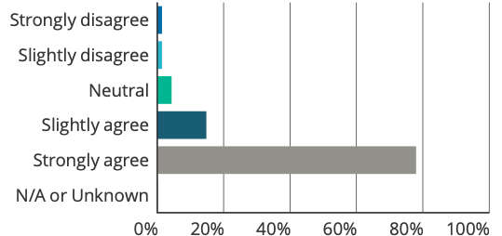

Answer choices | Responses
Strongly disagree | 1.44% | 4
Slightly disagree | 1.44% | 4
Neutral | 4.33% | 12
Slightly agree | 14.80% | 41
Strongly agree | 77.98% | 216
N/A or Unknown | 0.00% | 0
Total |  | 277
Weighted average |  | 4.66

Q7: The open disclosure policy reflects, and is based on, the principles detailed in the Australian Open Disclosure Framework
Answered: 277 Skipped: 96

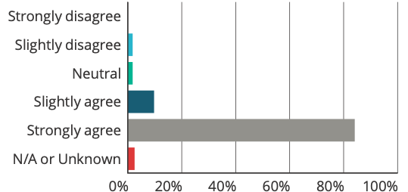

Answer choices | Responses
Strongly disagree | 0.00% | 0
Slightly disagree | 1.81% | 5
Neutral | 1.81% | 5
Slightly agree | 9.75% | 27
Strongly agree | 84.12% | 233
N/A or Unknown | 2.53% | 7
Total |  | 277
Weighted average |  | 4.81

Approximately 59% of the respondents strongly agreed their open disclosure policy is fully implemented in their organisation, with 30% of respondents who slightly agreed (see Q6).
Q6: An open disclosure policy is fully implemented
Answered: 277 Skipped: 96

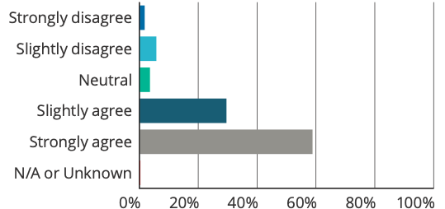

Answer choices | Responses
Strongly disagree | 1.81% | 5
Slightly disagree | 5.78% | 16
Neutral | 3.61% | 10
Slightly agree | 29.60% | 82
Strongly agree | 58.84% | 163
N/A or Unknown | 0.36% | 1
Total |  | 277
Weighted average |  | 4.38

Free text comments identified that some organisations strongly supported, prioritised and regularly discussed open disclosure at the Executive and Senior leadership level. However, the difficulty in making open disclosure a priority at the clinician level was acknowledged, for example it was noted:
At the executive governance level it is seen as a priority. This has been difficult to spread to the clinical coal face.
It is a priority for the organisation but not necessarily for the staff on the floor who are doing it. There is plenty of resources for training but it is not mandatory for medical staff and therefore there is poor compliance with completing it.
While respondents generally agreed that their organisation provided resources to train, develop and support staff (45% strongly agree; 30% slightly agree) (see Q9); a number of respondents in the free text identified that priority at the clinical governance level did not necessarily translate to adequate resources for open disclosure, particularly in terms of face-to-face training and staff support:
Whilst the implementation is strong amongst [clinical governance] staff, knowledge and understanding of this is definitely more patchy amongst clinical staff. There is a significant lack of resources dedicated to training and an over-reliance on e-learning as a replacement for face-to-face.
A lack of knowledge, consistent training, and difficulties in engaging visiting medical officers (VMOs) with open disclosure policies and processes was also raised. It was noted by a respondent that in some cases this resulted in VMOs being unwilling to participate in open disclosure, or an uncoordinated approach between VMOs and the hospital. This could give rise to difficulties for the ongoing management of the adverse event and discussions with the person and/or their support people.
Q9: The organisation provides resources to train, develop and support staff to undertake open disclosure
Answered: 277 Skipped: 96

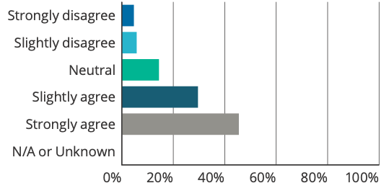

Answer choices | Responses
Strongly disagree | 4.69% | 13
Slightly disagree | 5.78% | 16
Neutral | 14.44% | 40
Slightly agree | 29.60% | 82
Strongly agree | 45.49% | 126
N/A or Unknown | 0.00% | 0
Total |  | 277
Weighted average |  | 4.05

The majority of respondents agreed their open disclosure policy requires an apology or expression of regret, including the words ‘I am/we are sorry’ as part of the open disclosure process (87% strongly agree; 8% slightly agree) (see Q8).
Q8: The open disclosure policy requires there to be an apology or expression of regret, including the words I am / we are sorry as part of the open disclosure process
Answered: 277 Skipped: 96

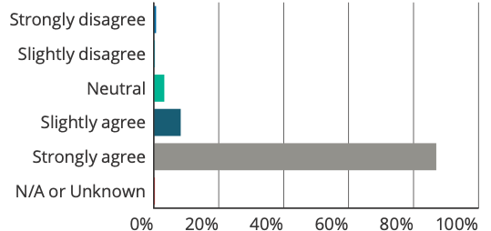

Answer choices | Responses
Strongly disagree | 0.72% | 2
Slightly disagree | 0.36% | 1
Neutral | 3.25% | 9
Slightly agree | 8.30% | 23
Strongly agree | 87.00% | 241
N/A or Unknown | 0.36% | 1
Total |  | 277
Weighted average |  | 4.81

Generally respondents agreed their organisational culture supported and encouraged staff to identify and report adverse events to support system improvement (68% strongly agree; 21% slightly agree) (see Q43).
Q43: There is a culture where staff are supported and encouraged to identify and report adverse events, so that system improvements can be made
Answered: 277 Skipped: 96

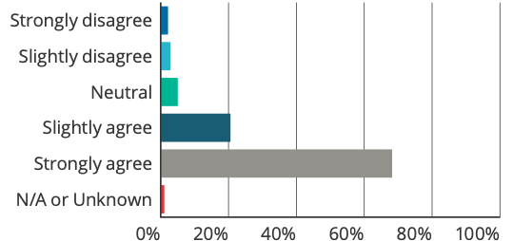

Answer choices | Responses
Strongly disagree | 2.17% | 6
Slightly disagree | 2.89% | 8
Neutral | 5.05% | 14
Slightly agree | 20.58% | 57
Strongly agree | 68.23% | 189
N/A or Unknown | 1.08% | 3
Total |  | 277
Weighted average |  | 4.51

Culture was a recurring theme raised in the free text responses across many aspects of the survey, with many respondents acknowledged the significant role culture plays as a key enabler and barrier to open disclosure implementation.
The importance of ensuring healthcare managers, executives and clinicians are not only trained in policies and procedures, but are also trained on how to communicate and build open and respectful relationships was also identified. This is reflected in the following response:
We are trained to know what the policy says, we [are] not trained to build open and respectful and trusting relationships.
Leadership, particularly support from the leadership team, was recognised as a key element of culture. One survey respondent provided an example of what good senior leadership looks like in their organisation, noting that for open disclosures the Director of Clinical Governance was always available to discuss issues with staff and provide advice and support. This included helping to prepare and plan the steps of the open disclosure process, and an opportunity to debrief. Another respondent noted:
Incident reporting and Open Disclosure culture varies widely from service to service across our organisation based largely on the leadership of individual services.

7.2.2.3 Consultation with Complaints Commissioners
Feedback from the Complaints Commissioners (Commissioners) recognised that organisational culture played a critical role in how open disclosure was implemented in practice. Leadership, management and the legal unit within an organisation were identified as key influencers of culture and the approach taken to the implementation of open disclosure.
The issue of paternalism was raised in the discussions, and it was identified that in some circumstances there remained a culture where disclosure (or saying sorry) was considered as not required, or not in the best interest of the person and/or their support people as it would cause further harm. Examples provided included situations where there is a ‘near miss’, or if the potential harm has not yet (or may never) present itself (e.g. under-dosing medication). It was recognised that in some cases the person and/or their support people may not want open disclosure however, healthcare providers/managers should not presume that this is the case.
This comment was supported by the ODAG members, who noted that managers and healthcare providers sometimes consider causation, ‘did we do something wrong’ as the trigger for the open disclosure process. Rather than ‘something unexpected has happened to the patient, and we need to disclose and provide them with information.’

7.2.3 Integration of open disclosure into local clinical governance

7.2.3.1 Targeted interviews and consultation with the Open Disclosure Advisory Group
All state and territory representatives interviewed described ways in which the open disclosure process was integrated into their governance systems, such as within their incident management, complaints and executive reporting systems.
Issues and uncertainty around when open disclosure processes should occur and the appropriate level of response required were raised by a number of respondents. While most state and territories have policies that specify the criteria for initiating an open disclosure process, particularly for high-level responses, lower-level responses seemed to not be as well articulated. It was noted that what happens in practice may therefore not align with the organisation’s policy (or the Framework).
Some respondents noted that open disclosure may not be appropriate in all cases, and there was a need to apply the Framework flexibly. This includes weighing up the person’s right to know, if the disclosure was going to cause additional harm, or when is the best time for open disclosure to take place. It was noted that in some cases (for example in mental health), it was a clinician’s decision to determine if open disclosure is appropriate (or not).
Feedback recognised that improvements could be made to better involve and partner with people and/or their support people in incident investigation processes. Not feeling as though they were adequately involved in investigations was a key issue raised by consumers in consultations conducted in one jurisdiction.

7.2.3.2 National online targeted survey
The majority of survey respondents (94%) identified that open disclosure policies and procedures were integrated into their organisation’s clinical governance framework.
The open disclosure process was triggered by number of mechanisms, with the main mechanisms identified as clinical incident reporting and complaints (99% and 95% respectively), followed by patient, family or visitors, internal clinical reviews and individual staff. Other mechanisms identified as triggering the open disclosure process included pharmacy checks, ministerials, external notifications (for example coroners and complaints commissions) and death audits (see Q12).

Q12: Open disclosure is triggered by a number of mechanisms including: (select all that apply)
Answered: 277 Skipped: 96

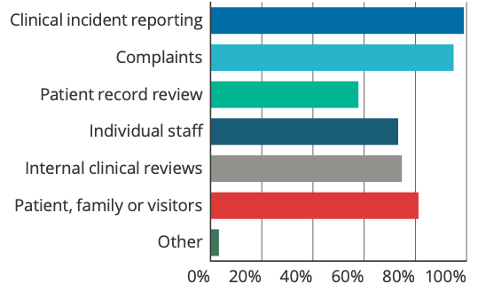

Answer choices | Responses
Clinical incident reporting | 98.92% | 274
Complaints | 94.95% | 263
Patient record review | 57.76% | 160
Individual staff | 73.29% | 203
Internal clinical reviews | 74.73% | 207
Patient, family or visitors | 81.23% | 225
Other | 3.25% | 9
Total respondents |  | 277

Respondents generally agreed their organisation’s policies described the level of response required when an open disclosure process is triggered (64% strongly agree; 18% slightly agree) (see Q13); however, the language used to describe the response differed across state and territories. For example, a higher-level response could be referred to as executive level or formal open disclosure; and a lower-level response could be referred to as clinician disclosure. It was noted in the free text comments that while the open disclosure process was integrated into systems and their clinical governance framework, there were still challenges in relation to clinical practice:
… it is well integrated. However sometimes clinicians do not understand the process or include documentation re the process.
OD is definitely embedded in the [Clinical Governance] Framework. There is still a lot of progress yet to be achieved in clinical practice.

Q13: When open disclosure is triggered, the open disclosure policy describes the level of open disclosure required (e.g. higher vs. lower-level response)
Answered: 277 Skipped: 96

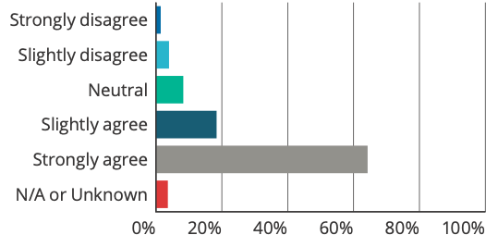

Answer choices | Responses
Strongly disagree | 1.44% | 4
Slightly disagree | 3.97% | 11
Neutral | 8.30% | 23
Slightly agree | 18.41% | 51
Strongly agree | 64.26% | 178
N/A or Unknown | 3.61% | 10
Total |  | 277
Weighted average |  | 4.45

Most respondents agreed that adverse events are acknowledged as soon as practicable after the event in their organisations (73% strongly agree; 22% slightly agree) (see Q14).
Q14: Adverse event are acknowledged as soon as practicable after the event
Answered: 277 Skipped: 96

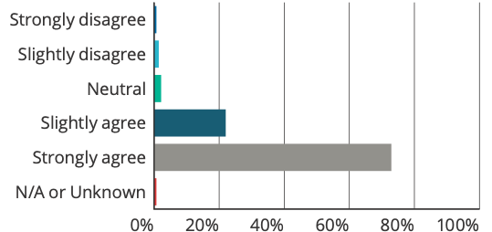

Answer choices | Responses
Strongly disagree | 0.72% | 2
Slightly disagree | 1.44% | 4
Neutral | 2.17% | 6
Slightly agree | 22.02% | 61
Strongly agree | 72.92% | 202
N/A or Unknown | 0.72% | 2
Total |  | 277
Weighted average |  | 4.66

Respondents generally agreed that information provided by the person and/or their support people, during an open disclosure, was used to inform incident investigations and systems review (64% strongly agree; 22% slightly agree) (see Q15). However, fewer respondents agreed that the person and/or their support people would be offered involvement in incident investigations and systems review, where appropriate (41% strongly agree; 29% slightly agree) (see Q16).
A number of respondents recognised the importance of involving the person and/or their support people in investigations, and noted that improvements could be made in this area:
… there is a lot to be gained by involving patient and family more formally during the investigation stage.
Some respondents indicated that ongoing work is being undertaken to improve engagement and involvement with people who had experienced harm and their support people; and in some services engagement with the person and/or their support people in formal investigations appeared to be part of routine practice:
For any formal incident investigation, the patient/family/carer are always provided with an opportunity to be interviewed as part of the investigation process. We routinely provide a copy of the recommendations following the investigation.
Q15: Information provided by patients and support persons about the adverse event during open disclosure is used in clinical incident investigations and systems review
Answered: 277 Skipped: 96

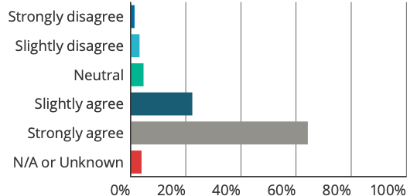

Answer choices | Responses
Strongly disagree | 1.44% | 4
Slightly disagree | 3.25% | 9
Neutral | 4.69% | 13
Slightly agree | 22.38% | 62
Strongly agree | 64.26% | 178
N/A or Unknown | 3.97% | 11
Total |  | 277
Weighted average |  | 4.51

Q16: Patients and support persons are offered involvement in clinical incident investigations and system review, when this is appropriate
Answered: 277 Skipped: 96

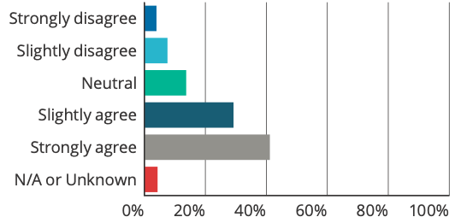

Answer choices | Responses
Strongly disagree | 3.97% | 11
Slightly disagree | 7.58% | 21
Neutral | 13.72% | 38
Slightly agree | 29.24% | 81
Strongly agree | 41.16% | 114
N/A or Unknown | 4.33% | 12
Total |  | 277
Weighted average |  | 4.00

7.2.3.3 Consumer focus groups
Issues and uncertainty around when open disclosure processes should take place, and the types of incidents that would warrant an open disclosure process were raised. Examples provided in the focus groups also identified that while there may have been an initial acknowledgement of an incident (and an apology may or may not have occurred) other elements of open disclosure were not being met. This included the ability to ask questions, the opportunity to find out why an incident happened, and what action was undertaken to prevent it from happening again.
One participant commented that their experience of the initial conversation felt rushed and tokenistic. With no opportunity to plan further conversations, it was then left up to them to initiate further discussions.
It was also felt that in some cases, the onus was on the person and/or their support people to identify and report incidents, and that staff may be too busy, or reluctant, to respond. Reporting an incident also relies on the person and/or their support person feeling comfortable and safe, without fear that it may affect their quality of care.

7.2.3.4 Consultation with Complaints Commissioners
Feedback identified that there can be a mismatch between what healthcare providers and managers perceive and assess as harm, and what a person and/or their support people may view as harm. Therefore, the level of response by the healthcare provider may not align with what is expected by the person and/or their support people. Near misses and psychological harm were specifically identified as situations where this may occur.
Commissioners noted that in some cases received by their office, a discussion had occurred (lower-level response) with some information provided. However, this was not sufficient in addressing the person’s and/or their support person’s concerns. While the organisation may have considered the process to be finalised, it left the person with unanswered questions and a feeling that the process was not as transparent as they would have liked.
Commissioners also raised the issue that disclosure often relies on the incident being reported, and assessed as serious enough for an open disclosure process to occur. In particular, there was concern that junior clinicians, who may detect the incident, may not recognise the severity or seriousness of the event and conduct a lower-level response without input from a senior clinician. This may result in an inappropriate response, further harm to the person and/or their support people, and the incident not being appropriately escalated.
In the mental health context there were particular issues raised around what is defined as a serious harm. It was identified that psychological harm and issues around sexual safety were not necessarily considered in policies or by healthcare providers as part of the definition of serious harm. This affected whether open disclosure processes occurred for these events, and the subsequent actions taken to support the person.
Additionally, it was noted that the Victorian Chief Psychiatrist Practice Direction 2019/015 requires that ‘where there is a failure to comply with the (Mental Health) Act, designated mental services should report it to the Chief Psychiatrist’. As part of this report, information about whether an open disclosure process has been completed with the person and/or their support people, including supports provided to the person, and any remedial action to prevent future occurrence of such incidents, should be included. It was noted that open disclosure discussions for breaches of the Act are likely to be different, and that there are currently no resources or training for these types of discussions.

7.2.4 Measurement and evaluation

7.2.4.1 Targeted interviews and consultation with the Open Disclosure Advisory Group
Feedback from interviews with state and territory representatives identified that monitoring, measurement and evaluation of open disclosure processes varies between services and jurisdictions.
For some health services, monitoring and evaluation of formalised open disclosure (higher-level response) appeared to occur well. This included information about open disclosure processes and outcomes being documented and collected, and regularly reported to the health service’s executive team. Most respondents however identified difficulties of measuring and evaluating lower-level responses due to its increased variability and because it usually occurs in isolation.
At a jurisdictional level, variation in how states, territories and private hospitals collect data on open disclosure was also identified. It was noted that data on open disclosure is usually collected through incident management systems, however the level of information collected is dependent on the capability of the incident management system. This varies from a tick-box that open disclosure has been initiated, to recording details of the open disclosure. This can include information or reasons why open disclosure has not occurred. It was highlighted that to enable a more systematic and meaningful collection of information about open disclosure, it would be helpful to have reporting of consistent open disclosure data embedded into incident management policies and processes, as well as IT systems that support the collection of more detailed data.
Feedback also noted that it could be difficult to measure outcomes for the person and/or their support people, as open disclosure occurs in the context of where harm has occurred. This can mean that while the open disclosure process may have been conducted in accordance with the policy and process, the outcome may still not meet the person’s or their support person’s expectations.

7.2.4.2 National online targeted survey
Respondents generally agreed that a person and/or their support people are given the opportunity to provide feedback on the open disclosure process (55% strongly agree; 23% slightly agree) (see Q18).
Free text comments identified there could be difficulty in asking for feedback from a person and/or their support people after the process is completed. It was noted that open disclosure needed to be considered as a:
… continuing conversation rather than a single event, and monitoring and evaluation can happen through reflective listening and feedback, which can become apparent throughout the process [not just at the end].
Q18: Patients and support persons are given the opportunity during and after the completion of an open disclosure process to provide their feedback or comments
Answered: 277 Skipped: 96

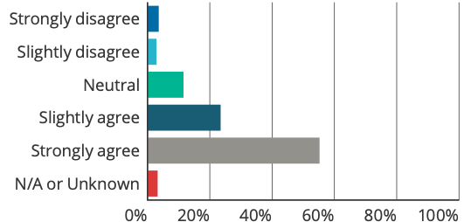

Answer choices | Responses
Strongly disagree | 3.61% | 10
Slightly disagree | 2.89% | 8
Neutral | 11.55% | 32
Slightly agree | 23.47% | 65
Strongly agree | 55.23% | 153
N/A or Unknown | 3.25% | 9
Total |  | 277
Weighted average |  | 4.28

Staff surveys did not appear to be routinely provided after completion of an open disclosure process (see Q19), and it is noted that surveys may not be appropriate for lower-level responses. Free text comments also identified that staff feedback could be collected in different ways. For example, one respondent noted:
Staff are not ‘surveyed’ following an OD but rather the team hold an appropriate debrief. Changes or improvements are immediately implemented based on that debrief rather than waiting for survey results.

Q19: Staff are surveyed after completion of an open disclosure process
Answered: 277 Skipped: 96

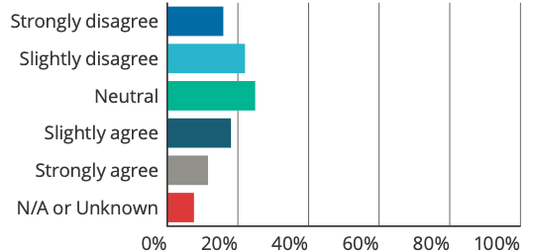

Answer choices | Responses
Strongly disagree | 15.88% | 44
Slightly disagree | 22.02% | 61
Neutral | 24.91% | 69
Slightly agree | 18.05% | 50
Strongly agree | 11.55% | 32
N/A or Unknown | 7.58% | 21
Total |  | 277
Weighted average |  | 2.86

In relation to whether staff survey results and patient and/or their support people feedback were fed back to staff for quality improvement, there was variation in responses with 24% strongly agree; 20% slightly agree; 17% neutral; 18% slightly disagree; 13% strong disagree and 8% unknown or N/A (see Q20).
Q20: Staff survey results and patient and support person feedback are collated, analysed and fed back to relevant staff for quality improvement purposes
Answered: 277 Skipped: 96

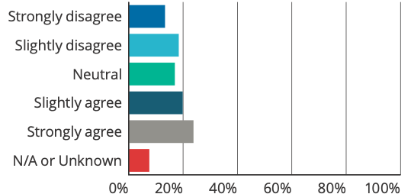

Answer choices | Responses
Strongly disagree | 13.36% | 37
Slightly disagree | 18.41% | 51
Neutral | 16.97% | 47
Slightly agree | 19.86% | 55
Strongly agree | 23.83% | 66
N/A or Unknown | 7.58% | 21
Total |  | 277
Weighted average |  | 3.24

In relation to regular reporting of open disclosure outcomes and measures to management and the governing body occurs, 38% of respondents strongly agreed; and 24% slightly agreed (see Q21). Similarly, 39% of respondents strongly agreed, and 28% of respondents slightly agreed that open disclosure report findings and recommendations are fed back to the person and/or their support person (see Q23).
Q21: There is regular reporting of open disclosure process and outcome measures to management and the governing body (such as the Board)
Answered: 277 Skipped: 96

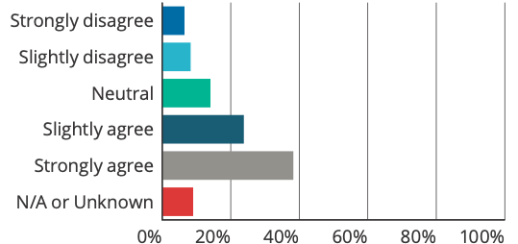

Answer choices | Responses
Strongly disagree | 6.50% | 18
Slightly disagree | 8.30% | 23
Neutral | 14.08% | 39
Slightly agree | 23.83% | 66
Strongly agree | 38.27% | 106
N/A or Unknown | 9.03% | 25
Total |  | 277
Weighted average |  | 3.87

Q23: Report findings and recommendations from an open disclosure process are tracked and fed back to the patient and/or support person/s
Answered: 277 Skipped: 96

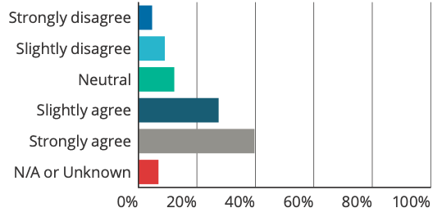

Answer choices | Responses
Strongly disagree | 4.69% | 13
Slightly disagree | 9.03% | 25
Neutral | 12.27% | 34
Slightly agree | 27.44% | 76
Strongly agree | 39.71% | 110
N/A or Unknown | 6.86% | 19
Total |  | 277
Weighted average |  | 3.95

There was also some variation in responses about open disclosure report findings and recommendations being tracked and feedback provided to staff (28% strongly agree; 28% slightly agree; 13% neutral; 12% slightly disagree; 13% strong disagree and 7% unknown or N/A (see Q22).
Q22: Report findings and recommendations from an open disclosure process are tracked and fed back to the staff
Answered: 277 Skipped: 96

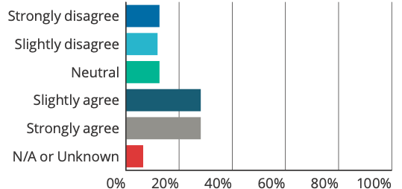

Answer choices | Responses
Strongly disagree | 12.64% | 35
Slightly disagree | 11.91% | 33
Neutral | 12.64% | 35
Slightly agree | 28.16% | 78
Strongly agree | 28.16% | 78
N/A or Unknown | 6.50% | 18
Total |  | 277
Weighted average |  | 3.51

These findings were supported in the free text comments, which noted:
Feedback to staff has been informal via the manager of the area or via Head of Dept/Senior Consultant for Patient Safety. Not a regular or robust system. Reports are made at governance and Safety Committee (includes Executive) on pooled data and cases of note, but not circulated to staff.
I know that results of these processes are fed back to the patient and support persons, but I have not seen feedback to staff. Staff should have greater involvement in the process …
Comments in the free text also identified a number of challenges in monitoring, measuring and evaluating open disclosure. Challenges included:
- Difficulty in monitoring and evaluating lower-level responses that can be variable depending on the healthcare provider, and usually performed in isolation
- Lower-level responses are frequently an informal process and are often not well documented, or not documented at all
- Lack of clarity about what measures should be used to evaluate ‘effectiveness’, particularly for lower-level responses
- Difficulty in evaluating outcomes of open disclosure processes, as the process itself may have been done in accordance with the policy or Framework, but the person and/or their support people may still be distressed or not happy with the process
- The need to ensure evaluation is conducted in a sensitive way
- Ad hoc, rather than systematic collection of information about open disclosure processes and the unavailability of systems to support this collection (for example, recording open disclosure is not adequately built into the incident management system).

One respondent also said:
Our evaluation processes are currently being reviewed to work out how best to approach staff and particularly patients/families in a sensitive way.
Respondents acknowledged the importance of evaluation to improve processes and practices, and many respondents identified the need for their organisation to make improvements in this area. It was also noted that there was a lack of opportunity to share learnings about open disclosure processes and practices with other services:
Open Disclosures are done at a local facility level, where a gap occurs is the translation of any learning across facilities in an LHD.

7.2.5 Meeting the needs and expectations of the workforce (including training and development)

7.2.5.1 Targeted interviews and consultation with the Open Disclosure Advisory Group
Feedback identified the importance of providing the workforce with support and recognising the emotional toll involved in open disclosure processes. This can significantly impact the healthcare providers and managers involved. This includes:
- Psychological harm and managing burnout
- Feeling comfortable to report incidents without fear of reputational damage, or that they’re ‘telling on’ colleagues
- Feeling comfortable to say sorry and not have legal consequences
- Having the support of senior management.
The importance of emphasising that the open disclosure process is not about blame (or litigation), but is a restorative healing process for all parties and a way to learn and improve was highlighted. One jurisdiction, identified this as a gap in their open disclosure program, and is currently developing a staff support program called Care for the Caregiver.
In terms of education and training, resources and workforce turnover were identified as challenges in ensuring the health service’s workforce are adequately trained in open disclosure processes. Resources related to the cost of face-to-face training, healthcare providers having the time to undertake training, and access to training for rural and remote services. One jurisdiction identified that it is currently undertaking work to address the issue of access through the delivery of training using online video simulation. Respondents noted that while training is available, it could be difficult to engage healthcare providers in training (if not mandatory). Managing conflict and discussions with angry and/or aggressive patients and/or their support people was also raised as an issue that could be addressed as part of open disclosure training.

7.2.5.2 National online targeted survey

Training and development
84% of respondents answered that open disclosure training is provided or available to relevant staff; with 16% of respondents selecting that no training is provided or available.
Of the respondents who answered that training is provided or available (233 responses), 54% of respondents strongly agreed and 33% slightly agreed that relevant staff are provided with basic open disclosure awareness training (see Q26). This training was mainly identified as being provided once at orientation only (60% of respondents); with 26% respondents identifying that training is provided once a year; and 14% of respondents reporting that training is provided more than once a year.
Q26: All relevant staff are provided with basic open disclosure awareness training
Answered: 233 Skipped: 140

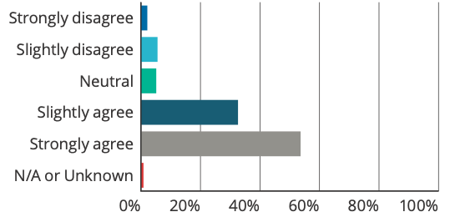

Answer choices | Responses
Strongly disagree | 2.15% | 5
Slightly disagree | 5.58% | 13
Neutral | 5.15% | 12
Slightly agree | 32.62% | 76
Strongly agree | 53.65% | 125
N/A or Unknown | 0.86% | 2
Total |  | 233
Weighted average |  | 4.31

‘Just in time’ information for relevant staff about to participate in open disclosure appeared to be
provided in some services, however approximately 40% respondents answered neutral or N/A or
unknown (see Q28).

Q28: ‘Just in time’ information, or education package, is available to relevant staff about to participate in open disclosure
Answered: 233 Skipped: 140

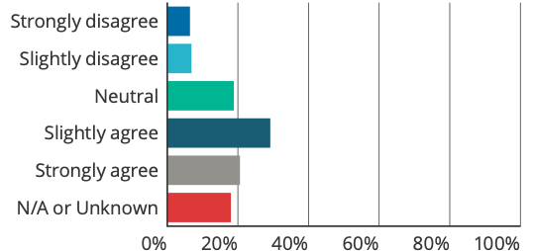

Answer choices | Responses
Strongly disagree | 6.44% | 15
Slightly disagree | 6.87% | 16
Neutral | 18.88% | 44
Slightly agree | 29.18% | 68
Strongly agree | 20.60% | 48
N/A or Unknown | 18.03% | 42
Total |  | 233
Weighted average |  | 3.62

64% of respondents indicated that their organisation had a smaller group of trained experts who are available to provide support to colleagues involved in open disclosure (15% of respondents did not have trained experts, and 21% of respondents were unsure).
The majority of experts were identified as clinical executive, senior staff (including managers, nurses and medical officers) or clinical governance staff. Some services had open disclosure consultants, and some services trained their Patient Liaison Officers and Directors of Patient and Family Experience to be open disclosure experts. Where an organisation had experts, approximately half of the respondents noted that their training involved role-play and feedback, however approximately a third of respondents were unsure (see Q31).
Q31: If experts are trained, does the training involve role-playing and feedback
Answered: 149 Skipped: 224

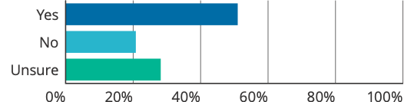

Answer choices | Responses
Yes | 51.01% | 76
No | 20.81% | 31
Unsure | 28.19% | 42
Total |  | 149

Many free text comments noted the importance of having interactive, experiential, face-to-face training in addition to online learning. Many respondents also noted the importance of mentorship, peer support, and ensuring staff are supported throughout the process, in addition to training. This is reflected in the following comments:
You learn through experience and with guidance from others with experience.
Online learning cannot fully replace face-to-face learning. Agree that role-playing/simulation is an important learning tool which could be utilised much more in many aspects of communication within Health.
Training is good however no amount of training can genuinely prepare someone for OD. It comes with experience and time. Training could be improved to be more structured and conducted in model that sees those who are new to the process only performing OD with someone who is more experienced. Most organisations would support this but it’s not always the case and the impact of OD on some staff can be greatly underestimated.
High costs associated with interactive and face-to-face training, limited resources (time and cost), and limited access to training were seen as barriers. It was also noted that for smaller services, where serious harmful incidents may be rare, training might be out of date when this type of incident arises. It was suggested that training should focus more on lower-level responses, which are more common:
Limited scenarios and role play available – but highly valued when offered.
The health service in my state feels that face to face training is the best but cost is prohibitive.

Support for the healthcare workforce
Most respondents identified that their organisation provides access to a counsellor or employee assistance program (71% strongly agree; 17% slightly agree) (see Q42); however, the opportunity to debrief was identified as less likely (47% strongly agree; 28% slightly agree) (see Q41).
Q42: Access is provided to a counsellor or employee assistance program
Answered: 277 Skipped: 96

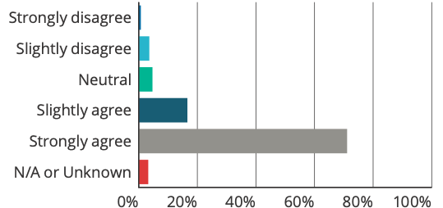

Answer choices | Responses
Strongly disagree | 0.72% | 2
Slightly disagree | 3.61% | 10
Neutral | 4.69% | 13
Slightly agree | 16.61% | 46
Strongly agree | 71.12% | 197
N/A or Unknown | 3.25% | 9
Total |  | 277
Weighted average |  | 4.59

Q41: Staff are given the opportunity to debrief when they have been involved in an open disclosure process (e.g. after their first open disclosure)
Answered: 277 Skipped: 96

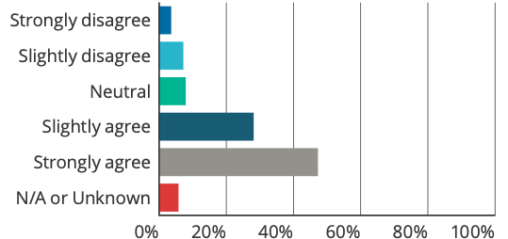

Answer choices | Responses
Strongly disagree | 3.61% | 10
Slightly disagree | 7.22% | 20
Neutral | 7.94% | 22
Slightly agree | 28.16% | 78
Strongly agree | 47.29% | 131
N/A or Unknown | 5.78% | 16
Total |  | 277
Weighted average |  | 4.15

While respondents identified that a number of processes and structures are in place to support staff, the culture of the organisation was identified as a key factor in staff feeling supported to report adverse events, and to conduct the open disclosure process. In particular, a common theme raised in free text responses was the importance of a just culture, where staff felt comfortable to speak up or report an adverse event, without fear that they would be ‘telling on’ colleagues. This is reflected in the following comments:
Staff are encouraged to report events however there is still an element of hesitancy and a fear of getting a person in trouble – we are working on a culture change.
I think I am lucky where I work we support each other but I think [Drs] in general are not supported properly and acknowledged the level of stress that an incident (open disclosure) creates for us all. We are kept in the dark whether if we report a problem how that [Dr] or system will be treated and I think sometimes things are not reported for fear of whistleblowing.
Staff support is spoken of and action may be taken. There is no protection against informal adverse consequences for those who report an adverse event.

7.2.5.3 Consumer focus groups
Participants acknowledged that when harm occurs, it could also be difficult emotionally for the healthcare provider involved. Participants noted that healthcare providers are often time poor and under a lot of pressure. Fear of liability, reputational damage and blame were also raised as issues, and participants felt this could act as a barrier, and may deter healthcare providers from saying sorry, or having open conversations with the people they are caring for if an incident occurs. Participants also raised that they felt some healthcare providers were worried about reporting incidents to their direct manager, and asked whether there were other mechanisms that allowed healthcare providers to report to an appropriate alternative co-worker.
In relation to training and education, one suggestion was to include consumers in open disclosure training, recognising the mutual benefits that could be gained from understanding each other’s perspectives.

7.2.5.4 Consultation with Complaints Commissioners
Commissioners’ feedback recognised the importance of effective communication skills. It was emphasised that poor communication skills and subsequent poor open disclosure practice can lead to unintended consequences, and cause further harm to the person and/or their support people. For example, poor communication (including use of jargon or inappropriately tailored language) can result in the person/support people not understanding what is happening, becoming more concerned or stressed, and/or feeling as though they have not been heard.
The importance of considering which healthcare provider has the appropriate skills to conduct the open disclosure process, and ensuring they have adequate training and support was identified. In a situation where a healthcare provider or manager does not have the adequate skills, but still needs to be involved (for example at the request of the person/support people, or they are the primary care provider), it was suggested that another healthcare provider or manager, who has the appropriate skill-set, should be involved.
It was noted that when open disclosure was done poorly, it often made later conciliation between the health service/healthcare provider and the person/support people more difficult. Commissioners agreed that if communication regarding the open disclosure was done well, it would likely lead to less complaints received by their office.
The Commissioners also recognised the important role of staff support, as the open disclosure process can be emotional and stressful for the healthcare providers and managers involved. For the healthcare provider this can become more stressful if they are referred to Australian Health Practitioner Regulation Agency (AHPRA).
Medico-legal concerns and fear of reputational damage on behalf of the healthcare provider and the health service organisation were also raised as key issues. It was noted that some healthcare providers will only deal with the complaints bodies through their lawyer, and there is a real concern about saying the wrong thing, and/or being unsure about what (and how much) to say. This could result in an offer of apology not being given well, or in a legalistic rather than genuine way.
Feedback identified that there can be a lack of legal expertise or assistance to support healthcare providers through an open disclosure process, or to provide guidance on what their options are, and what to do if they are involved in an incident. It was noted that support from jurisdictional lawyers (or the health service’s legal team) is usually only available for higher-level responses; and this can be challenging if they take a risk-averse approach to disclosure. It was recognised that healthcare providers can obtain information from their indemnity insurers, however this appeared to vary between insurers.

7.2.6 Meeting the needs and expectations of the person who has experienced harm and their support people

7.2.6.1 Targeted interviews and consultation with the Open Disclosure Advisory Group
Feedback acknowledged that the process of open disclosure should be person and/or their support people focused, and led by the priorities of the person who has experienced the harm and/or their support people.
Cultural considerations were identified as an area where improvements could be made, in particular in the planning of, and engaging in, open disclosure with people who identify as Aboriginal or Torres Strait Islander, or people from culturally and linguistically diverse backgrounds. This involves acknowledging that open disclosure may not be well understood in the cultural context of the person and/or their support people, as well as addressing specific needs in relation to conducting the open disclosure process itself. For example, providing additional support to assist with effective communication, and facilitating the open disclosure process in a way that is meaningful to the person and/or their support people.
It was noted that some health services had dedicated resources and well-organised support systems to meet the needs of the person and/or their support people. This usually related to higher-level responses. These support systems identified a dedicated contact person to help the person and/or their support people through the process; the provision of continuous follow-up with the person and/or their support people through multiple meetings and/or communication channels; and allowing time for the person and/or their support people to reflect and ask questions. It was acknowledged that difficulties could arise when there are multiple or concurrent processes occurring in addition to the open disclosure process. This is further discussed in section 7.2.9 – Additional issues raised.

7.2.6.2 National online targeted survey
Survey results indicate that generally health services have in place different mechanisms to support the needs of the person and/or their support people in the open disclosure process. This includes facilitating access to support services (53% strongly agreed; 26% slightly agreed), mechanisms to support culturally appropriate open disclosure practices (43% strongly agreed; 26% slightly agreed) and support for people with additional needs (53% strongly agreed; 30% slightly agreed) (see Q34–36). However, respondents were less certain about whether these mechanisms were utilised (36% strongly agreed; 34% slightly agreed) (see Q37). This was supported in the free text comments:
… whilst the procedures and mechanisms are in place there is not always use of them due to lack of staff knowledge in the clinical environment.
Mechanisms are in place but are utilised more on an ‘ad hoc’ basis – not formal structure for these things.
Q34: There are mechanisms for patients and support persons to access support services (e.g. counsellors, social workers and patient advocates) before, during and after an open disclosure process
Answered: 277 Skipped: 96

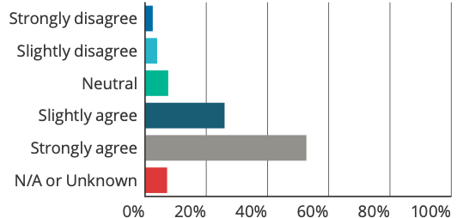

Answer choices | Responses
Strongly disagree | 2.53% | 7
Slightly disagree | 3.97% | 11
Neutral | 7.58% | 21
Slightly agree | 25.99% | 72
Strongly agree | 52.71% | 146
N/A or Unknown | 7.22% | 20
Total |  | 277
Weighted average |  | 4.32

Q35: There are mechanisms to facilitate culturally appropriate open dosclosure with patients/support persons who are Aboriginal or Torres Strait Islander or form culturally linguistically diverse groups
Answered: 277 Skipped: 96

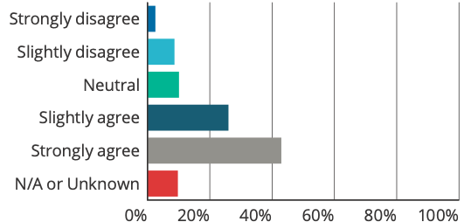

Answer choices | Responses
Strongly disagree | 2.53% | 7
Slightly disagree | 8.66% | 24
Neutral | 10.11% | 28
Slightly agree | 25.99% | 72
Strongly agree | 42.96% | 119
N/A or Unknown | 9.75% | 27
Total |  | 277
Weighted average |  | 4.09

Q36: There are mechanisms to facilitate open disclosure with patients/support persons who require additional support (e.g. interpreters and communication aids to support visual or hearing impairments)
Answered: 277 Skipped: 96

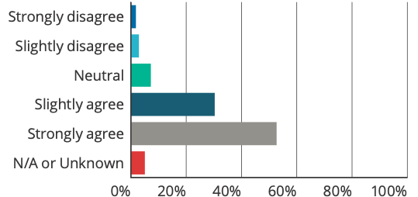

Answer choices | Responses
Strongly disagree | 1.81% | 5
Slightly disagree | 2.89% | 8
Neutral | 7.22% | 20
Slightly agree | 30.32% | 84
Strongly agree | 52.71% | 146
N/A or Unknown | 5.05% | 14
Total |  | 277
Weighted average |  | 4.36

Q37: Mechanisms to support patients/support person are utilised
Answered: 277 Skipped: 96

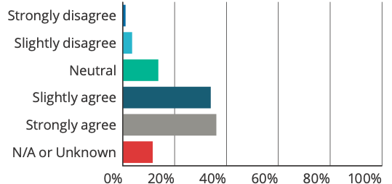

Answer choices | Responses
Strongly disagree | 1.08% | 3
Slightly disagree | 3.61% | 10
Neutral | 13.72% | 38
Slightly agree | 33.94% | 94
Strongly agree | 36.10% | 100
N/A or Unknown | 11.55% | 32
Total |  | 277
Weighted average |  | 4.13

Respondents also identified situations where support for the person and/or their support people is part of their organisation’s processes and facilitated by the organisation. This is reflected in the following comments:
Allocated single point of contact is someone who is most likely to be able to engage patient/family/carer and understand their needs including information and practical needs.
Assertive/Proactive follow up is expected from Single Point of Contact. Managers have funds available in such cases. In rural areas such support may be related to transport accommodation and meals and counselling if needed.
Patient liaison officers, social work, interpreter services, Aboriginal liaison officers are available. If costs are involved e.g. transport we would generally try to provide vouchers etc. We are happy to facilitate ongoing care/ second opinion here or external if required.
Respondents however also identified challenges to providing this support, including having the resources to provide this support, and access to support services:
Services that are well resourced do this well. I previously worked in a patient safety role in a
small health service where this was not done well and part of this was due to the lack of resources and staff to carry out these roles/tasks.
Majority [Aboriginal and Torres Strait Islander people] have poor access to and uptake of interpreter services.
Respondents generally agreed that information is provided to the relevant primary care providers following an adverse event, with the patient’s consent (48% strongly agreed; 26% slightly agreed) (see Q33).

Q33: Information is provided to relevant primary care providers following an adverse event with the patient’s consent
Answered: 277 Skipped: 96

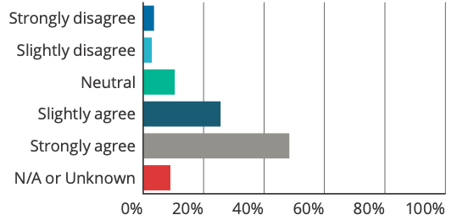

Answer choices | Responses
Strongly disagree | 3.61% | 10
Slightly disagree | 2.89% | 8
Neutral | 10.47% | 29
Slightly agree | 25.63% | 71
Strongly agree | 48.38% | 134
N/A or Unknown | 9.03% | 25
Total |  | 277
Weighted average |  | 4.23

Practical support (such as reimbursements or compensation for out-of-pocket expenses), appeared to be available in some services (31% strongly agreed; 18% slightly agreed), however a number of responses were neutral (17%), or N/A/unknown (21%) (see Q38).
Q38: Procedures are in place to offer practical support such as reimbursement for out-of-pocket expenses
Answered: 277 Skipped: 96

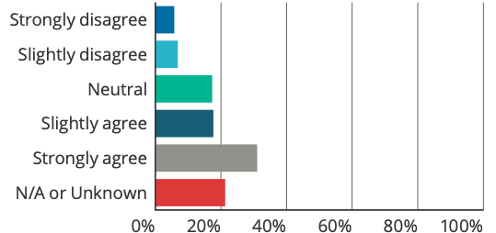

Answer choices | Responses
Strongly disagree | 5.78% | 16
Slightly disagree | 6.86% | 19
Neutral | 17.33% | 48
Slightly agree | 17.69% | 49
Strongly agree | 31.05% | 86
N/A or Unknown | 21.30% | 59
Total |  | 277
Weighted average |  | 3.78

Free text comments identified that some services appeared to have reimbursements or compensation for out-of-pocket expenses as a normal part of their open disclosure process, whereas in other services this was rarely communicated, or the process was unclear or unknown. One respondent also raised the need to have separate processes when discussing compensation and open disclosure, as having them part of the same discussion can lead to confusion and stress for the person and/or their support people and the healthcare provider involved.
In relation to having procedures that ensure a person who has experienced harm has appropriate ongoing care, respondents generally agreed that these are in place (65% strongly agreed; 20% slightly agreed) (see Q39).
Q39: Procedures are in place to ensure that a patient who has experienced harm has appropriate ongoing care
Answered: 277 Skipped: 96

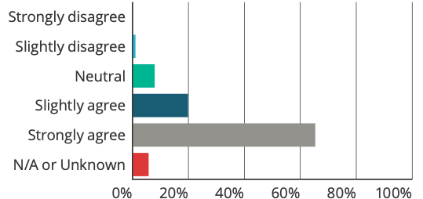

Answer choices | Responses
Strongly disagree | 0.00% | 0
Slightly disagree | 1.08% | 3
Neutral | 7.94% | 22
Slightly agree | 19.86% | 55
Strongly agree | 65.34% | 181
N/A or Unknown | 5.78% | 16
Total |  | 277
Weighted average |  | 4.59

7.2.6.3 Consumer focus groups
Feedback identified a lack of awareness and understanding amongst participants regarding open disclosure, including:
- Their right to open disclosure
- What they can expect in relation to the different types of open disclosure
- When the open disclosure process should take place
- How open disclosure relates to other processes (for example incident investigations)
- Who to contact if an incident has occurred when a person and/or their support people feels that open disclosure should take place.
Participants identified that more could be done to inform a person and/or their support people on the open disclosure process when they first enter a service (or beforehand). It was noted that there seemed to be more information provided about the complaints process (including information about external complaints bodies), than information on the open disclosure process. This included some participants noting that there appeared to be dedicated staff for complaints, however they did not know if there were staff dedicated to supporting people through the open disclosure process.
Terminology and language to describe what an open disclosure process is, as well as language used in open disclosure processes, were also raised as issues. It was identified that the term ‘open disclosure’ is not well understood. In the focus groups there was some confusion between open disclosure, informed consent and informed financial consent.
Feedback from participants identified that in some cases it was very difficult to acquire further information from the health service about what the service was doing, or would be doing to address the incident, or outcomes of an investigation if one had taken place. It was noted that this lack of communication had made them feel that the health service was not being open, transparent or taking their case seriously. This included information about expected timeframes, particularly if there was a delay due to concurrent processes being undertaken.
How information was communicated was also raised as an important consideration. This included providing information in a way that could be understood, in a genuine manner. For example, one participant reported that they received an impersonal apology letter from the service from someone who they did not know. This felt tokenistic and that the service did not respect or take their case seriously.

7.2.6.4 Consultation with Complaints Commissioners
Feedback emphasised that an essential component of an open disclosure process is for the person and/or their support people to be able to tell their story and be heard. This includes ensuring the person/support people has a say about who they want as part of the process; when and where discussions should take place; if they need support throughout the process (for examples, an advocate or interpreter), and understanding what matters most to them. The opportunity to ask questions and feel comfortable to ask questions or seek clarification was also identified. It was noted that complaints are often the end point of where there is poor communication between the healthcare provider/health service and the person and/or their support people. In many cases, complaints are received because the open disclosure process has not occurred, or if it has, the person is not satisfied with the process.
Commissioners’ feedback also identified the importance of considering the specific cultural or communication needs of people who identify as Aboriginal and Torres Strait Islanders; people from culturally and linguistic diverse backgrounds; and people with disabilities (intellectual and physical). Ensuring that additional support is available and provided was highlighted. This is further described in section 7.2.9 – Additional issues raised.

7.2.7 Documentation

7.2.7.1 Targeted interviews and consultation with the Open Disclosure Advisory Group
Open disclosure documentation was identified as being varied in detail and quality. It was noted that documentation was usually linked to incident monitoring and reporting, and that documentation could be improved in these systems for quality improvement purposes.
Uncertainty around whether documentation about findings of the relevant review or investigation should (or could) be shared with the person and/or their support people was also raised. It is noted that the legal framework in relation to qualified privilege varies across states and territories, and that this uncertainty could present a barrier to the open disclosure process. It was suggested that more guidance would be helpful in this area.

7.2.7.2 National online targeted survey
Most respondents reported that their service has an open disclosure documentation management policy in place (74% strongly agree; 19% slightly agree) (see Q45). Open disclosure documentation appeared to be kept in a number of places. These were mainly identified as in the incident management system and the patient healthcare record (see Q46).
Q45: An open disclosure document management policy/protocol is in place
Answered: 277 Skipped: 96

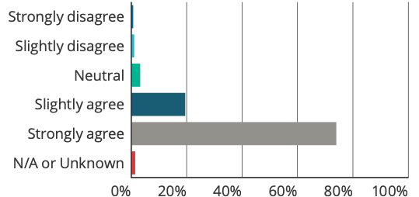

Answer choices | Responses
Strongly disagree | 0.72% | 2
Slightly disagree | 1.08% | 3
Neutral | 3.25% | 9
Slightly agree | 19.49% | 54
Strongly agree | 74.01% | 205
N/A or Unknown | 1.44% | 4
Total |  | 277
Weighted average |  | 4.67

Q46: Information relating to an open disclosure process is documented: (select all that apply)
Answered: 277 Skipped: 96

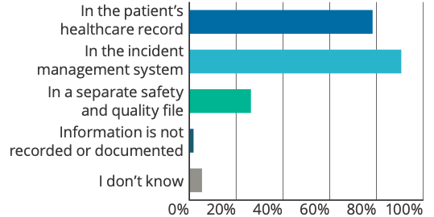

Answer choices | Responses
In the patient’s healthcare record | 78.34% | 217
In the incident management system | 90.61% | 251
In a separate safety and quality file | 26.35% | 73
Information is not recorded or documented | 1.81% | 5
I don’t know | 5.42% | 15
Total respondents |  | 277

Free text comments identified that the level of detail documented about an open disclosure can differ depending on where documentation is kept; and can also vary in quality and consistency. Respondents noted:
[Incident management system] only has yes/no question regarding whether it has been undertaken. Documentation in the patient record is variable in quality and consistency (especially for lower-level, clinical team discussions). Formal OD meeting summaries are kept separately, however this has pitfalls if subsequent treating teams are therefore unaware of history/discussions/undertakings that may have been made.
[Documentation] is spasmodic and not routine – however the current systems are not designed to collect well – this is under review.
Respondents generally agreed that documentation on report findings is provided to the person and/or their support people (52% strongly agreed; 28% slightly agreed) (see Q47). However, analysis of the free text comments identified that in practice there is still some hesitation in this area:
Documentation provided is usually decided by the Health Service following a specific request. The organisation is often reluctant to release Patient Safety Reports or review documents to families/ patients perhaps due to medico-legal issues … It is rare that these documents are openly shared and provided by the organisation itself.
Q47: Documentation about the findings of the relevant review or investigation is provided to the patient, family or support person/s. This includes: details of the adverse event, the patient or support person’s concerns or complaints, an apology, a summary of factors contributing to the adverse event information about what has been and will be done to avoid this adverse event from happening again, and how improvements will be monitored
Answered: 277 Skipped: 96

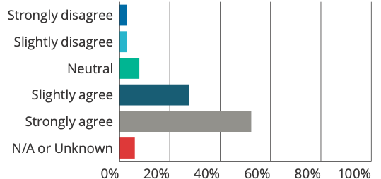

Answer choices | Responses
Strongly disagree | 2.89% | 8
Slightly disagree | 2.89% | 8
Neutral | 7.94% | 22
Slightly agree | 27.80% | 77
Strongly agree | 52.35% | 145
N/A or Unknown | 6.14% | 17
Total |  | 277
Weighted average |  | 4.32

7.2.7.3 Consumer focus groups
Feedback identified issues in relation to the timely transfer of documentation about a person’s care to other providers (for example, their GP). Delayed transfer of this information made it difficult for their ongoing and continuity of care. It was noted that a written summary provided to the person, and/or their support people and their GP (with the person’s consent) about their ongoing treatment plan and details about what had happened would be useful.

7.2.7.4 Consultation with Complaints Commissioners
How information is provided to the person and/or their support people was raised as an issue. One example provided was where an open disclosure process had gone well; but when the family received the report on the investigation findings and outcomes of the open disclosure process, it was very legalistic and did not reflect their experience or what had been discussed. This caused further harm to the family, and undermined their trust in the process.

7.2.8 Experience of open disclosure practice (national online survey results only)
266 respondents identified as having participated in open disclosure. Approximately 50% of respondents participated in both higher-level and lower-level responses; 30% in lower-level responses only; and 19% in higher-level responses only. 1% of respondents were unsure (see Q52).

Q52: I have participated in the following types of open disclosure: Higher-level response is usually in response to an incident resulting in death or major permanent loss of function, significant escalation of care or major change in clinical management, or major psychological or emotional distress. A higher-level response may also be instigated at the request of the patient even if the outcome of the event is not as severe. Low-level response is a briefer process usually in response to incidents resulting in no permanent injury, requiring no increased level of care, and resulting in no, or minor, psychological or emotional distress (e.g. near misses or no-harm incidents)
Answered: 266 Skipped: 107

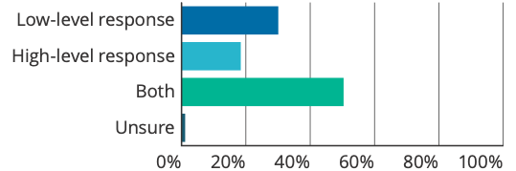

Answer choices | Responses
Low-level response | 30.08% | 80
High-level response | 18.42% | 49
Both | 50.38% | 134
Unsure | 1.13% | 3
Total |  | 266

Respondents mainly participated in initial discussions with the person and/or their support people, pre-meeting discussions (before an open disclosure meeting), and the open disclosure discussion itself. Respondents that selected ‘other’, identified participating in open disclosure discussions as a support person; as part of a Health Complaints Commissioner process; to gather information from staff members involved in or associated with the incident; and while conducting a follow-up meeting after an incident investigation to discuss findings and recommendations (see Q53).

Q53: I have participated in the following types of open disclosure discussions: (select all that apply)
Answered: 266 Skipped: 107

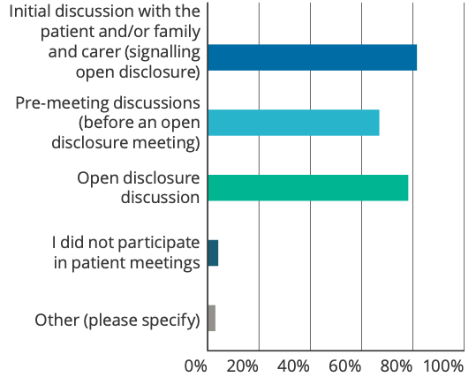

Answer choices | Responses
Initial discussion with the patient and/or family and carer (signalling open disclosure) | 81.58% | 217
Pre-meeting discussions (before an open disclosure meeting) | 66.92% | 178
Open disclosure discussion | 78.20% | 208
I did not participate in patient meetings | 4.14% | 11
Other (please specify) | 3.01% | 8
Total respondents |  | 266

Of the respondents who have participated in the open disclosure process, 76% strongly agreed and 18% slightly agreed their organisation encourages open disclosure (see Q57).
Q57: The organisation encourages open disclosure
Answered: 266 Skipped: 107

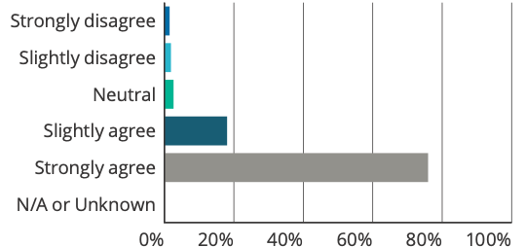

Answer choices | Responses
Strongly disagree | 1.50% | 4
Slightly disagree | 1.88% | 5
Neutral | 2.63% | 7
Slightly agree | 18.05% | 48
Strongly agree | 75.94% | 202
N/A or Unknown | 0.00% | 0
Total |  | 266
Weighted average |  | 4.65

7.2.8.1 Preparation for open disclosure
Most respondents identified as having participated in a variety of training, including online and audio-visual training; seminars and presentations; interactive workshops and independent studies. Approximately 9% of respondents noted that they received no training (see Q54). 5% of respondents selected ‘other’ and this included policy reviews, receiving advice from mentors and providing open disclosure education and training.
Q54: I have participated in the following forms of open disclosure education: (select all that apply)
Answered: 266 Skipped: 107

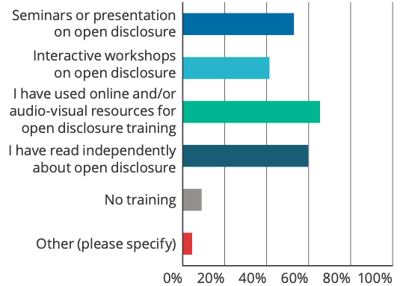

Answer choices | Responses
Seminars or presentation on open disclosure | 53.01% | 141
Interactive workshops on open disclosure | 41.35% | 110
I have used online and/or audio-visual resources for open disclosure training | 65.41% | 174
I have read independently about open disclosure | 59.77% | 159
No training | 9.02% | 24
Other (please specify) | 4.51% | 12
Total |  | 266

83% of respondents identified that they were provided with basic open disclosure awareness training. Most respondents reported that this was delivered only once at orientation/induction (65% of respondents) (see Q56).
Q56: I receive basic open disclosure awareness training
Answered: 221 Skipped: 152

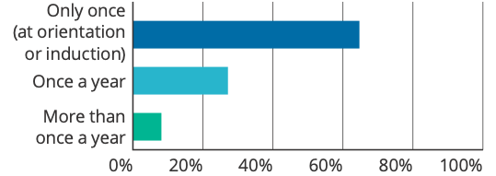
Answer choices | Responses
Only once (at orientation or induction) | 64.71% | 143
Once a year | 27.15% | 60
More than once a year | 8.14% | 18
Total |  | 221

When asked if they had received adequate training, respondents generally agreed (50% strongly agreed; 22% slightly agreed) (see Q58).
Q58: I have received adequate training in open disclosure
Answered: 266 Skipped: 107

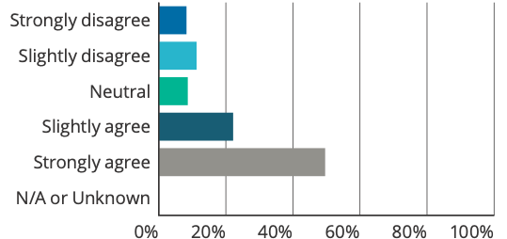

Answer choices | Responses
Strongly disagree | 8.27% | 22
Slightly disagree | 11.28% | 30
Neutral | 8.65% | 23
Slightly agree | 22.18% | 59
Strongly agree | 49.62% | 132
N/A or Unknown | 0.00% | 0
Total |  | 266
Weighted average |  | 3.94

When asked if they were confident about participating in the open disclosure process, respondents generally agreed (53% strongly agreed; 30% slightly agreed) (see Q59).
Q59: I was confident about participating in open disclosure
Answered: 266 Skipped: 107

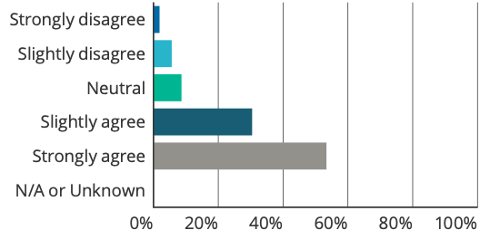

Answer choices | Responses
Strongly disagree | 1.88% | 5
Slightly disagree | 5.64% | 15
Neutral | 8.65% | 23
Slightly agree | 30.45% | 81
Strongly agree | 53.38% | 142
N/A or Unknown | 0.00% | 0
Total |  | 266
Weighted average |  | 4.28

In relation to whether a pre-meeting took place to prepare for the open disclosure process, 48% of respondents strongly agreed and 20% slightly agreed (see Q60); however it is noted that for lower-level responses, a pre-meeting may not be required.
Q60: There was pre-meeting to prepare for the open disclosure process
Answered: 266 Skipped: 107

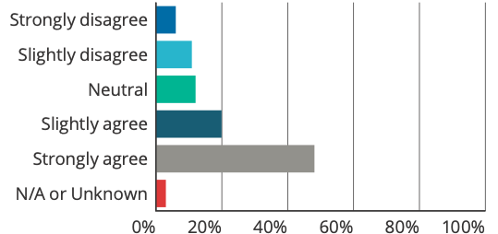

Answer choices | Responses
Strongly disagree | 6.02% | 16
Slightly disagree | 10.90% | 29
Neutral | 12.03% | 32
Slightly agree | 19.92% | 53
Strongly agree | 48.12% | 128
N/A or Unknown | 3.01% | 8
Total |  | 266
Weighted average |  | 3.96

7.2.8.2 Open disclosure process
Respondents generally agreed that the open disclosure process in their organisation is an ongoing discussion, rather than a one-off provision of information (53% strongly agreed; 27% slightly agreed) (see Q61).
Q61: In my organisation, open disclosure discussion is an ongoing process, rather than a one-off discussion
Answered: 266 Skipped: 107

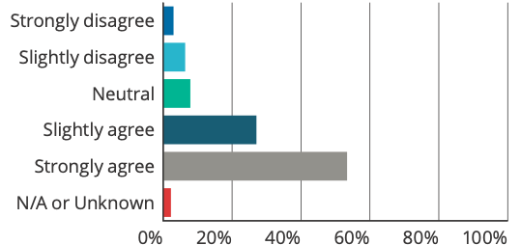

Answer choices | Responses
Strongly disagree | 3.01% | 8
Slightly disagree | 6.39% | 17
Neutral | 7.89% | 21
Slightly agree | 27.07% | 72
Strongly agree | 53.38% | 142
N/A or Unknown | 2.26% | 6
Total |  | 266
Weighted average |  | 4.24

In relation to support for the person and/or their support people, respondents generally agreed that they were provided with:
- A point of contact from the organisation throughout the open disclosure process (66% strongly agree; 18% slightly agree) (see Q62)
- Options about the time and place of open disclosure meetings and a choice about who is at the meeting (58% strongly agree; 21% slightly agree) (see Q63)
- Adequate time to talk about their experience of the incident (68% strongly agree; 17% slightly agree) (see Q64)
- The opportunity to ask questions (76% strongly agree; 14% slightly agree) (see Q65).
Q62: The patient/support person is given an organisation point of contact throughout the
open disclosure process
Answered: 266 Skipped: 107

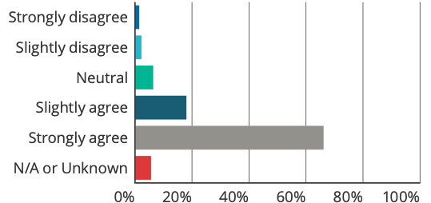

Answer choices | Responses
Strongly disagree | 1.50% | 4
Slightly disagree | 2.26% | 6
Neutral | 6.39% | 17
Slightly agree | 18.05% | 48
Strongly agree | 66.17% | 176
N/A or Unknown | 5.64% | 15
Total |  | 266
Weighted average |  | 4.54

Q63: The patient/support person is given options about the time and place of the open disclosure meeting/s and a choice about who is at the meeting
Answered: 266 Skipped: 107

Answer choices | Responses
Strongly disagree | 1.13% | 3
Slightly disagree | 6.02% | 16
Neutral | 6.02% | 16
Slightly agree | 21.05% | 56
Strongly agree | 57.89% | 154
N/A or Unknown | 7.89% | 21
Total |  | 266
Weighted average |  | 4.40

Q64: The patient/support person is given adequate time to talk about their experience of the harmful incident
Answered: 266 Skipped: 107

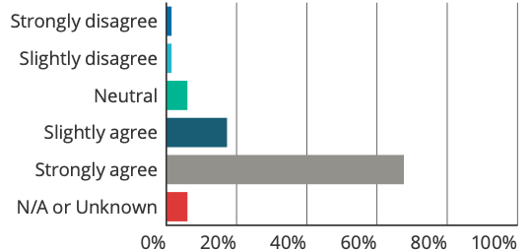

Answer choices | Responses
Strongly disagree | 1.50% | 4
Slightly disagree | 1.50% | 4
Neutral | 6.02% | 16
Slightly agree | 17.29% | 46
Strongly agree | 67.67% | 180
N/A or Unknown | 6.02% | 16
Total |  | 266
Weighted average |  | 4.58

Q65: The patient/support person is given the opportunity to ask questions
Answered: 266 Skipped: 107

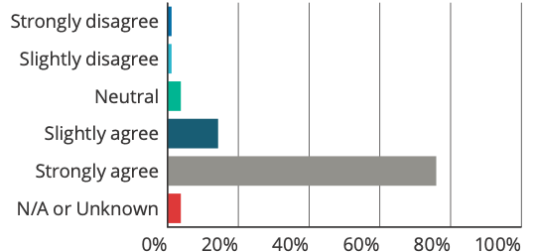

Answer choices | Responses
Strongly disagree | 1.13% | 3
Slightly disagree | 1.13% | 3
Neutral | 3.76% | 10
Slightly agree | 14.29% | 38
Strongly agree | 75.94% | 202
N/A or Unknown | 3.76% | 10
Total |  | 266
Weighted average |  | 4.69

Respondents also generally agreed that the person’s and/or their support person’s cultural and communication needs were met, where relevant (61% strongly agree; 23% slightly agree) (see Q66).
Q66: Where relevant, the person/support person’s cultural and communication needs are met
Answered: 266 Skipped: 107

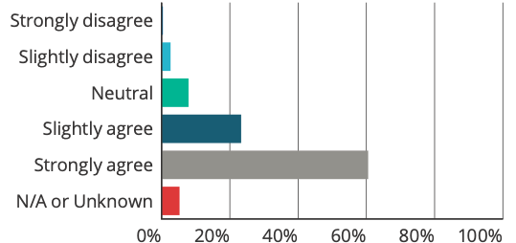

Answer choices | Responses
Strongly disagree | 0.38% | 1
Slightly disagree | 2.63% | 7
Neutral | 7.89% | 21
Slightly agree | 23.31% | 62
Strongly agree | 60.53% | 161
N/A or Unknown | 5.26% | 14
Total |  | 266
Weighted average |  | 4.49

However, it is important to note the limitations of these findings, given the survey questions were answered from the viewpoint of the healthcare provider/or manager conducting the open disclosure process. Therefore, it may not reflect the experience of the person and/or their support people involved.

7.2.8.3 Open disclosure outcomes
The majority of respondents strongly agreed (80%) that the open disclosure process involves an apology or expression of regret, which includes the words I am/we are sorry; and most agreed that where appropriate the organisation and staff recognised and acknowledged the severity of harm experienced by the person (79% strongly agree) (see Q67 and Q68 respectively).
Q67: Open disclosure involves an apology or expression of regret, including the words I am/we are sorry
Answered: 266 Skipped: 107

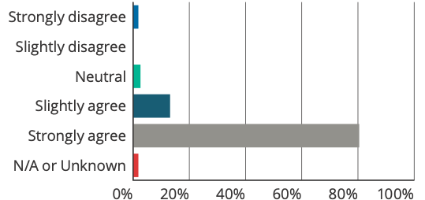

Answer choices | Responses
Strongly disagree | 1.88% | 5
Slightly disagree | 0.00% | 0
Neutral | 2.63% | 7
Slightly agree | 13.16% | 35
Strongly agree | 80.45% | 214
N/A or Unknown | 1.88% | 5
Total |  | 266
Weighted average |  | 4.74

Q68: Where appropriate, the organisation and staff recognise and acknowledge the severity of harm experienced by the patient
Answered: 266 Skipped: 107

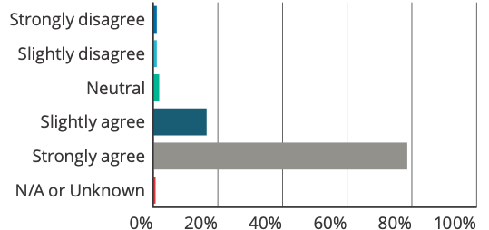

Answer choices | Responses
Strongly disagree | 1.13% | 3
Slightly disagree | 1.13% | 3
Neutral | 1.88% | 5
Slightly agree | 16.54% | 44
Strongly agree | 78.57% | 209
N/A or Unknown | 0.75% | 2
Total |  | 266
Weighted average |  | 4.72

In relation to providing an apology, some respondents identified the positive experience that people and their support people had, with one respondent noting that the family was ‘ … pleased with response and surprised that staff were so open.’
However, it was also identified in the free text that in some situations it was felt that saying sorry was unhelpful. For example, one respondent noted:
I have found it difficult and unhelpful to be having to “apologise” within open disclosure conversation about service contacts where the person’s adverse outcome actually had nothing to do with the service.
For appropriate ongoing support being offered to the person and/or their support people, respondents generally agreed that this was done by their organisation (65% strongly agree; 22% slightly agree) (see Q69).
Q69: Appropriate ongoing support is offered to the patient/support person
Answered: 266 Skipped: 107

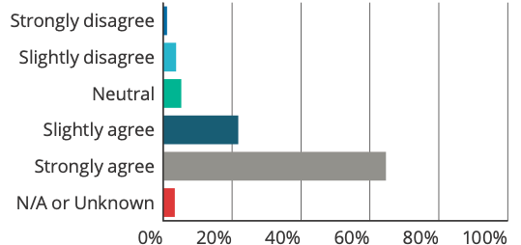

Answer choices | Responses
Strongly disagree | 1.13% | 3
Slightly disagree | 3.76% | 10
Neutral | 5.26% | 14
Slightly agree | 21.80% | 58
Strongly agree | 64.66% | 172
N/A or Unknown | 3.38% | 9
Total |  | 266
Weighted average |  | 4.50

Respondents generally agreed that the conclusion of an open disclosure process is mutually agreed between the person and/or their support people and health service (56% strongly agree; 24% slightly agree) (see Q70); however, the free text comments identified that what this meant in practice was sometimes difficult. For example:
[T]he question about mutual agreement is difficult to answer because on occasion the patient or carer may be requesting something that is not mutually agreed e.g. staff dismissal, large compensation payout and wish to keep going until their request is met.
Several of the Open Disclosure I have been involved in, have not resulted in any agreed plan. Even though one there was no harm, they both wanted monetary compensation. Or did not agree with our explanation/investigation.

Q70: The conclusion of the open disclosure process is mutually agreed between the patient/support person and staff
Answered: 266 Skipped: 107

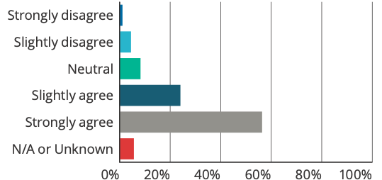

Answer choices | Responses
Strongly disagree | 1.13% | 3
Slightly disagree | 4.51% | 12
Neutral | 8.27% | 22
Slightly agree | 24.06% | 64
Strongly agree | 56.39% | 150
N/A or Unknown | 5.64% | 15
Total |  | 266
Weighted average |  | 4.38

In relation to whether the organisation met its responsibility to the person and/or their support people, respondents generally felt this happened (60% strongly agree; 25% slightly agree) (see Q71). However as above, it is important to note the limitations of these responses, as they are not from the perspective of the person and/or support people involved in the open disclosure process.
Q71: The organisation met its responsibility to the patient/support person
Answered: 266 Skipped: 107

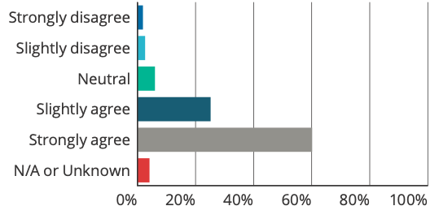

Answer choices | Responses
Strongly disagree | 1.88% | 5
Slightly disagree | 2.63% | 7
Neutral | 6.02% | 16
Slightly agree | 25.19% | 67
Strongly agree | 60.15% | 160
N/A or Unknown | 4.14% | 11
Total |  | 266
Weighted average |  | 4.45

Survey respondents were also asked if the person and/or their support people had raised any issues about the open disclosure process, and if so what issues were raised. Key issues that were consistently raised were:
- The timeliness and timing of the open disclosure process
- Dissatisfaction in the quality and consistency of information provided, including a lack of information or updates about investigations or information from medical officers about the provision or plan for care
- Defensive attitude of staff, rather than listening to the person’s and/or their support person’s concerns, and feeling that the organisation was only doing what was legally required
- Difficulty in knowing who to speak to and what to expect from the process, as well as issues with accessing information and locating contact information
- Having to speak to multiple people, and feeling overwhelmed by the number of people involved
- Inconsistent, delayed and/or poor communication.
In relation to whether the organisation met its responsibility to the staff involved, respondents generally agreed (50% strongly agree; 24% slightly agree) (see Q72).
Q72: The organisation met its responsibility to the staff involved, including providing appropriate support

Answered: 266 Skipped: 107
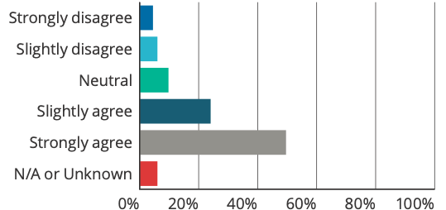

Answer choices | Responses
Strongly disagree | 4.51% | 12
Slightly disagree | 6.02% | 16
Neutral | 9.77% | 26
Slightly agree | 24.06% | 64
Strongly agree | 49.62% | 132
N/A or Unknown | 6.02% | 16
Total |  | 266
Weighted average |  | 4.15

Respondents identified that in some organisations support for staff could be improved, and emphasised the importance of a supportive culture and having support for staff (particularly junior clinicians) following incidents throughout the open disclosure process. Resultant burnout and the emotional burden that open disclosure processes can have were also identified. One respondent noted:
I’ve done over 50 by now – it can burn one out after a while.
Respondents however also identified positive experiences of open disclosure, noting:
It was a very positive experience for surgeon, nursing staff and the patient.
[The patient] found it both positive and constructive.

7.2.9 Additional issues raised
A number of additional issues that influence open disclosure implementation and practice were raised throughout the course of this review. These issues arose from the quantitative data analysis from the free text comments in the survey and consultation activities 2 to 5, as described in the Methodology at section 6. Quotes provided are drawn from the free text survey responses. Additional issues are outlined as follows.
Specific barriers and enablers are described in section 7.2.10.

7.2.9.1 Open disclosure in different service types
Feedback from the survey and consultation activities identified the need to acknowledge the variability across health services and the different issues, challenges and organisational complexities that can arise and impact the implementation of the open disclosure process. This includes how healthcare providers are employed (for example, as members or staff or visiting medical officers); the different governance structures; the diverse operational environments across states and territories; the type of service provided; and the environment or context of health service delivery.
In particular, specific issues influencing implementation of the open disclosure process were identified for rural and remote services, lower acuity services, and specific speciality services.

Rural and remote services
A number of barriers to open disclosure implementation relate to the small and locum nature of the workforce; the limited number of staff to support the open disclosure process and provide ongoing clinical support; and often limited options for people who have experienced harm to access other services or providers due to geographic location or availability of services. Specific issues that were raised included:
- Providing training to improve skills to a small and locum workforce
- The transitory nature of a locum workforce presents challenges for the continuity of the open disclosure process
- Sole practitioners, who were the healthcare provider involved in the incident, may be the only healthcare provider available to provide ongoing care to the person, and this may be traumatic for both the person and the provider. A person may also feel unable to return to the health service (or provider) where the incident occurred
- Limited resources in remote locations may result in limited mechanisms and services to support both the person and/or their support people and staff
- The open disclosure process may be slowed or may not take place at all when a person and/or their support people are required to travel large distances back to the health service to attend face-to-face meetings.
One suggestion to address the barrier of travelling large distances to attend face-to-face meetings is by facilitating open disclosure meetings via videoconference, which also enables the person to have multiple support people involved in the discussions. Challenges however with conversations via videoconference were identified, such as technical issues and ability to interact with multiple participants. It was noted that these would need to be considered when preparing for the meeting.

Lower acuity health services
Some responses noted that for smaller health services and day procedure services with lower acuity, the need to conduct higher-level responses were rare. It was suggested that guidance and training should be tailored so that it is meaningful and suited the context of the service.

Other specialty health services
Unique challenges for open disclosure implementation were identified for custodial services and in the mental health context. Issues identified related to the environment (for example, the custodial environment was noted as being litigious), and the different dynamics (in particular, the different power dynamics) and relationships these services have with the person and/or their support people.
For the mental health context, feedback from consultation activities identified areas where open disclosure implementation remained challenging. These included:
- Open disclosure for a breach of the Mental Health Act 2014 (in Victoria)
- Open disclosure where there are issues related to sexual safety
- Open disclosure for psychological harm. It was noted that as harm is usually not observed in the physical sense, open disclosure may not be triggered and/or the appropriate level of open disclosure may not be conducted
- Open disclosure where a person is under a Treatment Order. This is a mandatory legal order for a person to take medication and/or engage in therapy or other treatments without their consent. In this case, the timing of the open disclosure process may be an issue, and the power imbalance of being under a legal order may impact on how a person (and/or their support people) participates in an open disclosure process.

7.2.9.2 Specific issues for different patient groups
Variability in the patient population and the importance of ensuring the open disclosure process considers the needs and expectations for different population groups were acknowledged in consultation feedback and in the survey free text comments. Specific groups identified included: people who identify as Aboriginal and Torres Strait Islanders; people from culturally and linguistically diverse backgrounds; people with disabilities; people who have low health literacy; people with cognitive impairment, and people who have experience with mental health issues.
Feedback identified the need to ensure that:
- A person’s communication and other support needs are met before any open disclosure discussion takes place. This may include having an interpreter, advocate or support person present (for example, this could include Aboriginal or Torres Strait Islander Liaison Officers)
- Cultural sensitivities and preferences of the person and/or their support people are taken into account before undertaking the open disclosure process
- Language and terminology is tailored to the person and/or their support people to ensure information is easily understood, relevant and meaningful. For example, for some Aboriginal and Torres Strait Islander people the importance of ‘yarning’ or being able to tell your story and be heard should be acknowledged and facilitated.
It was noted that open disclosure can be viewed as a ‘western’ or ‘anglosaxon-white’ framework, and therefore the process and concept of open disclosure may be extremely daunting, uncomfortable and alienating for some people who are from culturally and linguistic diverse backgrounds, or people who identify as Aboriginal and Torres Strait Islanders. Having an understanding of the person’s cultural background, and their goals and preferences in relation to the open disclosure process was identified as critical to ensuring that they are genuinely involved in the process; that the process is culturally appropriate; and that it meets their needs. One respondent identified this as a gap in their organisation’s open disclosure policy:
Culturally appropriateness of discussing death to Aboriginal [and Torres Strait Islander] families and their belief systems with death and dying are not recognised in the Policy.

7.2.9.3 Timing of the open disclosure discussion
The timing of open disclosure discussions was an issue consistently raised throughout the review. Feedback identified the following issues:
- Poor timing of the open disclosure conversation. For example, when a person is unwell or lacking capacity, or the person and/or their support people are distressed. It was noted the importance for the healthcare provider to follow-up with the person and/or their support people when they are ready, and let them know that there will be opportunities for them to ask questions
- The classification of incidents, and the potential for this to change as a result of an investigation or review, or where facts relating to the incident become apparent months later. This is particularly challenging when this differs to what was said in initial discussions with the person and/or their support people; and can diminish their trust in the process
- Raising an incident identified retrospectively with the person and/or their support people. There may also be workforce changes, resulting in a different healthcare provider or manager being involved in the open disclosure process to who was originally involved when the incident took place.

7.2.9.4 Concurrent and/or ongoing processes
Processes that may overlap with, or stop an open disclosure process, include coronial investigations, incident investigations, complaints, legal and AHPRA processes.
Feedback from the survey and consultation activities noted the complexity that comes with multiple processes could impact on the timeliness of the open disclosure process, and be emotional and exhaustive for the person and/or their support people and staff involved. Feedback from participants in consumer focus groups also identified that these processes can be confusing, difficult to navigate, and that there can be a lack of information about what to expect, how long processes can be expected to take, and limited updates on what stage the process is at. It was identified that delays in receiving information were often exacerbated when multiple processes were happening at once.
Feedback from the Commissioners identified the need to distinguish and provide clarity on the purpose of each process. This includes being clear that open disclosure processes are separate from complaints processes; and that conciliation processes (through their offices) should not be a means for the open disclosure process to occur.

7.2.9.5 Roles and responsibilities for open disclosure
Clarity around the roles and responsibilities that healthcare providers have in relation to conducting open disclosure was raised as an issue in the survey and other consultation activities. In particular, issues experienced with visiting medical officers, or other healthcare practitioners who are not employed by the service (for example in some private health services). Issues included perceptions around engagement of these medical officers and ensuring they are knowledgeable and appropriately trained in the service’s open disclosure policies and processes.
The importance of ensuring GPs and other private healthcare providers (such as community pharmacists) understand their role and responsibilities in relation to the open disclosure process was also identified. In particular, where attendance at open disclosure meetings are required given their role in an incident.

7.2.9.6 Cross-jurisdictional issues
Targeted interviews with state and territory representatives and consultation with the ODAG identified that when a person moves from one health district (or state or territory) to another, or when a person moves between the public and private healthcare system, there can be complexities and uncertainty around who is the person responsible to undertake the open disclosure process. This uncertainty can adversely affect and delay the open disclosure process, cause confusion, and may result in inconsistent information being provided to the person and/or their support people. It was also raised that in some cases a service may not be aware that an incident has occurred in their service, until after the person has left the service or transferred to another service or healthcare provider. This sometimes resulted in an inability for a service to conduct an open disclosure process, if the subsequent service does not support or allow contact with the person and/or their support people.

7.2.9.7 More focus on lower-level responses and integrating all levels of open disclosure as part of routine clinical practice
Feedback from consultation activities and the survey identified that the main focus of guidance and resources appeared to be dedicated to incidents that required higher-level responses. It was suggested that there is a need to increase the focus of guidance and resources to support an organisational culture and workforce that is also confident, skilled and comfortable to conduct day to day lower-level responses. This may include conducting lower-level responses for a near-miss, if there is minor (or no) psychological or emotional distress, or if there is an unexpected outcome for the person and/or their support people, even if there is no or minor harm.
Respondents emphasised the importance of effective communication, building trusting relationships and good rapport with people receiving care and/or their support people at all times, not just when an incident occurs. The importance of ensuring the open disclosure process (all level responses) is built into routine incident management, complaints, monitoring and evaluation, and quality improvement was also reiterated.

7.2.9.8 Large-scale open disclosures
One jurisdiction raised challenges in relation to undertaking large-scale open disclosure where multiple people are affected by the same adverse event. For example, recall of an implant device or contamination of sterilised equipment. While large-scale open disclosures are currently outside the scope of the Framework, the principles outlined in the Framework still apply and it is noted that further guidance for the open disclosure process in these situations may be required.

7.2.10 Enablers and barriers to implementation
Key enablers and barriers consistently raised throughout the review have been collated from the free text survey responses and feedback from the consultation activities 2 to 5 as described in the Methodology at section 6. Generally, these relate to the following themes:
- Culture and leadership
- Systems, policies and processes
- Training and support
- Resources (time and cost)
- Evaluation of processes
- Awareness of open disclosure.
Many of the barriers and enablers identified, are linked to the findings described above and reflect the perceptions of respondents who participated in the consultation. A number of the themes are identified as both a barrier and an enabler. Medico-legal concerns and reputational damage however were raised as barriers only. More detail is provided as follows.

7.2.10.1 Culture and leadership
Culture was identified as a key enabler for open disclosure implementation. The following characteristics were described as important:
- Leadership/Executive support and priority
- Appointed clinical and/or open disclosure champions who are able to educate, advocate, mentor, build relationships and navigate between professions, units and/or organisational levels on open disclosure issues and practice
- A focus on the person and their support people (person-centred)
- Transparency and honesty
- A just culture, where the workforce feel able to speak up and proactively identify and report incidents or situations where open disclosure may be necessary and act accordingly
- A supportive environment for the healthcare workforce, the person receiving care and/or their support people
- Open disclosure as part of routine/normal practice and care delivery
- Open and trusting relationships, based on empathy and respect.
In contrast, a culture of blame and an unsupportive Executive or management were perceived to be key barriers. Factors identified by respondents as influencing a culture that is not supportive of open disclosure included:
- Executive, management and the service’s legal unit being risk averse and reluctant to disclose. This may be a result of anxiety around reputational damage, legal consequences and/or media concerns, and issues of paternalism
- A perception that reporting or disclosing an incident will get the others into trouble
- A relationship between health services, healthcare providers, the person and/or their support people that is not open or trusting, and where quality of care is not priority within the organisation
- Executive, management and/or healthcare providers not taking responsibility or wanting to be involved in open disclosure discussions.

7.2.10.2 Systems, policies and processes
The importance of robust clinical governance, risk management systems, and clear and formalised local processes in place for open disclosure were identified as enablers. This includes:
- Encouraging and integrating open disclosure processes into existing systems, including linking open disclosure tools, templates and flow charts into incident management and complaint systems
- Clearly communicating expectations, roles and responsibilities for conducting open disclosure processes across the organisation
- Ensuring correct, timely and up to date documentation on open disclosure processes, including communication to relevant healthcare providers involved in a person care, for example the person’s GP.
Key barriers were identified as:
- Ambiguous policies and processes, where it is unclear when and how open disclosure processes occur. This includes when lower-level and higher-level responses are not clearly distinguished and/or not fully understood by healthcare providers
- Legalistic or bureaucratic processes that do not support authentic engagements with the person and/or their support people
- Time lapses or delays in the finalisation of other processes (for example, coroner’s investigations) that results in the open disclosure process not being completed within appropriate time frames
- Poor documentation.

7.2.10.3 Training and support
The importance of ongoing training and education that includes building effective communication and active listening skills, establishing rapport with the person and/or their support people, and a focus on improvement were identified as key enablers. This included providing opportunities:
- To learn and practise open disclosure in a safe environment (mentoring)
- To debrief and learn from others’ experiences, such as staff who are experienced in open disclosure processes, as well as trained social workers (peer support).
Just in time training, and ensuring that the right information is provided at the right time to support healthcare providers and managers to conduct open disclosure was emphasised.
Not having access to, or time to, undertake training were identified as key barriers. This contributes to healthcare providers and managers being ill equipped with the appropriate skill-set to undertake open disclosure, and as a result not confident or competent to have difficult conversations, to apologise, or manage conflicts (which they may then avoid). This was particularly identified for healthcare providers or managers that have limited or no experience in the open disclosure process. Limited mentoring and support for the workforce were also identified as barriers to effective open disclosure implementation.

7.2.10.4 Resources (time and cost)
The provision of resources for open disclosure was consistently raised as a key enabler. This included:
- Access to appropriate places or areas for open disclosure discussions to occur, to create privacy and limit interruptions (for example private
meeting rooms)
- Protected time for healthcare providers and managers to prepare for open disclosure
- Protected and adequate time to undertake the open disclosure process, including allocated time for the healthcare provider to spend with the person and/or their support people as they process the information and ask questions
- A dedicated contact person for people receiving care and/or their support people and the workforce, to gain more information or support during the open disclosure process
- Protected time to debrief and access external support mechanisms
- Funding to support the person and/or their support people to participate in the open disclosure process (for example, reimbursement of parking, transport and other out-of-pocket costs)
- Administrative support to help with the logistics of an open disclosure process (for example, support to help set meeting times, organise attendees and take notes)
- Resources to train and build workforce capacity, particularly effective communication skills.
The number of resources required to support ongoing training, including the high costs associated with face-to-face and interactive training, and the reality that healthcare providers are often time poor and may choose to not attend open disclosure training, were identified as barriers.
Some respondents also identified that for higher-level responses there can be a high administrative burden in relation to the planning, execution, and follow-up with the person and/or their support people, managers and the governing bodies.
Competing priorities and limited resources was also identified as a barrier, which can result in limited or a lack of access to resources, training and support services for staff, the person who has experienced harm, and/or their support people.

7.2.10.5 Evaluation
Evaluation of incident management, open disclosure processes, and the experience of the person and/or their support people, and the workforce were identified as mechanisms that can inform improvement in open disclosure implementation. Review participants identified the importance of openness and transparency, which includes sharing findings and lessons learned from reviews and investigations. Feedback emphasised the importance of a just culture focused on learning and systems improvement, particularly when sharing this information.
Key barriers included poor documentation of incidents, particularly in relation to lower-level responses and limited evidence of evaluations to understand how open disclosure processes are taking place and where improvements can be made.

7.2.10.6 Awareness of open disclosure
Raising awareness of the open disclosure process was identified as important. This includes increasing awareness of the value and benefits of open disclosure; when open disclosure should occur, and what to expect.
Key barriers identified included:
- People may not be aware that they have a right to open disclosure, the purpose of open disclosure, and what can be expected from an open disclosure process
- A person who has experienced harm or an unexpected event may not raise concerns, for fear that it will affect the quality of care they will receive or not wanting to ‘make a fuss’
- A person and/or their support people not knowing who to raise the concern with.
Additionally, awareness of the importance and value and principles of the open disclosure process among healthcare providers, and their related roles and responsibilities, were raised as contributing factors as to why healthcare providers may not be engaged in open disclosure implementation (also linked to training).
One respondent noted:
These more “soft” aspects of clinical care are perceived by very time poor staff as something “extra” or just “nice to have”. The benefits have not been sold. The moral case for Open Disclosure hasn’t been sold well enough. Also no one likes having more difficult conversations than they need to. Also despite the availability of training staff do not understand when and where Open Disclosure is appropriate. The general understanding is that if the patient/family/carers know something has happened (i.e. a witnessed fall) then Open Disclosure is completely unnecessary.
The importance of managing expectations was also noted. Unrealistic expectations of the open disclosure process may lead to a person and/or their support people to become angry and/or aggressive. This may hinder the open disclosure process.
Partnering with other key stakeholders, for example with professional colleges, consumer groups and insurers, was suggested as a way to raise awareness of the importance of open disclosure implementation.

7.2.10.7 Medico-legal concerns
Linked to culture, medico-legal concerns were consistently raised as key barriers. Key issues included:
- Uncertainty about the legal requirements of open disclosure
- Fear of admitting fault, and the implications in relation to qualified privilege, privacy, confidentiality, litigation, and professional misconduct.

7.2.10.8 Reputational damage
The issue of reputational damage was noted as a significant barrier for healthcare providers identifying incidents and undertaking the open disclosure process. This included a fear of:
- How the person and/or support people will respond
- Being viewed as incompetent
- Being viewed as ‘telling on’ colleagues and the repercussions of being a whistle blower
- Repercussions that may follow an open disclosure, for example, this may be heightened in the context of small towns, where clinicians have close personal relationships with community members.

7.2.11 Resources and strategies to support implementation

7.2.11.1 Existing Commission resources
In the survey, of the completed responses (373), 58% were aware of the Commission’s existing resources on open disclosure. 35% were not aware, and 7% were unsure. Of the respondents that were aware, 82% found them useful (see Q82).
Q82: Did you find these resources useful?
Answered: 217 Skipped: 156

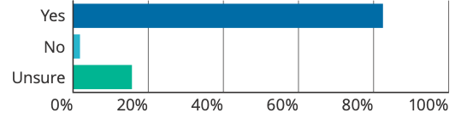

Answer choices | Responses
Yes | 82.49% | 179
No | 1.84% | 4
Unsure | 15.67% | 34
Total |  | 217

Comments regarding the usefulness of the Commission’s resources included that:
- They were readily available and online
- They outlined clear processes (particularly the flow chart) and step-by-step guidance
- Information for consumers was helpful.
Respondents who did not find the resources useful commented that simple, shorter resources would be more helpful and that the current resources weren’t targeted to their specific state (which used different terminology).

7.2.11.2 Suggested new resources and strategies
Additional consumer, healthcare provider and health service organisation resources and strategies were suggested in the survey and consultation feedback. These related to raising awareness and advocacy for open disclosure, and strategies to support open disclosure implementation. These are further described as follows:

Suggested consumer resources and strategies
- Update consumer brochure on open disclosure and link to the Australian Charter of Healthcare Rights. This could be included in a hospital’s health information pack, which contains specific information on the hospital’s open disclosure process and contact details for people if they have further questions or feel an open disclosure process should have taken place
- Multi-media resources to increase awareness of open disclosure, when it should occur and what to expect
- Tailored culturally appropriate resources for people who identify as Aboriginal and Torres Strait Islanders and people from culturally and linguistically diverse backgrounds
- Just in time information that can be provided to a person and/or their support people to guide and support them through the open disclosure process
- Resources clarifying the different processes that may occur when an incident happens, how different processes can interact (e.g. incidents, complaints), and where open disclosure fits within this bigger picture
- Guidance on phrases and/or questions a person and/or their support people may ask if they are concerned or feel that something has happened that should trigger the open disclosure process
- Access to a designated person who is independent of the organisation where the harm has occurred. For example, this could include an advocacy service that is able to guide a person and/or their support people through an open disclosure process.
It was noted that resources should meet health literacy principles and be developed in partnership with consumers.

Suggested healthcare provider resources and strategies
- Shorter, targeted resources promoting the value and importance of open disclosure processes
- Multi-media resources, which could include consumer perspectives on positive and negative experiences of the open disclosure process
- Clarity around roles and responsibilities for disclosing
- Clarity around qualified privilege in relation to open disclosure and investigations
- Free open access e-learning training that could include role play scenarios and interactive assessments
- Multi-media resources on when and how to signal that open disclosure should take place, and how to conduct lower-level responses, whilst accounting for concerns about liability and reputational damage
- Guidance and training on potential responses a person and/or their support people may have when notified of an incident, or during an open disclosure process
- Dedicated time to complete the open disclosure process and communication skills training
- Further just in time information and training to support healthcare providers prepare and conduct all levels of open disclosure
- Templates, prompts and scripts to support open disclosure communication, including guidance and examples on what should and should not be said
- Dedicated point of contact who is an expert in open disclosure, to help support and guide healthcare providers through the process
- Confidential phone line for clinicians to forward concerns raised by patients and/or their support people.

Suggested health service organisation resources and strategies
- Clear policies and communication to the service’s workforce around qualified privilege in relation to the open disclosure process and investigations, consistent with relevant state and territory legislation and policy
- Guidance on the type of information/data that should be collected about open disclosure to support quality improvement
- Guidance on how the open disclosure process might be managed in the context of smaller organisations
- Case studies or examples of the different levels of open disclosure response and how it may occur in different services and/or for different situations
- Guidance on the different modalities for open disclosure (for example, via videoconference, phone and email)
- Further guidance on situations where open disclosure should take place, including key considerations when determining when the open disclosure process is appropriate (or not)
- Consumer involvement in open disclosure education and training
- Appointment of experts, clinical and open disclosure champions.



Discussion
Over the past 17 years, open disclosure in Australia has been increasingly recognised as a key component of good clinical practice, part of what a person can expect when receiving health care, and essential for a safe, high-quality healthcare system. This has resulted in policy reforms and the implementation of systems, processes and training programs nationally and across states, territories and health service organisations to support and promote open disclosure implementation.
Given the national requirement for open disclosure implementation across health service organisations, the Commission has undertaken this review to assess the implementation of the Framework in Australian health services; and to identify any implementation gaps or priority areas in which the Commission can provide additional support or guidance. This includes identifying areas in which states, territories and health service organisations should focus improvement activities.
The following section will discuss findings in relation to the key focus areas of the review.

8.1 Activities and mechanisms to implement the Framework
The review found that state and territory health departments and health service organisations have undertaken considerable work to implement open disclosure.
Available accreditation data from the first edition of the NSQHS Standards indicate that many of the health service organisations who were assessed, were working towards implementing programs and training to support open disclosure. Targeted interviews, the desk-top review and national survey also identified the presence of open disclosure policies, activities and mechanisms to support implementation of the Framework. These however varied between states, territories and health service organisations.

8.2 Extent to which the Framework has been, or is being, implemented in practice
The extent to which the Framework has been, or is being, implemented into practice was more difficult to assess. Whilst open disclosure policies, systems, processes and training programs are often in place, and examples of positive open disclosure processes and implementation were identified; the review found that challenges remain. Analysis of quantitative and qualitative data suggests that health service organisations are at different levels of maturity with respect to implementation, and that there were inconsistencies with how the Framework was translated into practice. Findings suggested that there is more work to be done to improve open disclosure implementation and practice that is consistently aligned with principles of the Framework, across all Australian health settings.

8.3 Implementation gaps and priority areas for improvement
Findings provided insights into the key areas where health service organisations and healthcare providers identified challenges to implementation. These are grouped into the following themes:
- Leadership and culture: Improving engagement at the clinical level and fostering a culture where open disclosure is viewed as an ethical requirement and part of effective communication and good clinical care; not viewed as one-off process that is separate to everyday clinical practice.
- Integration of open disclosure into local clinical governance: Ensuring clinical governance, risk management and quality improvement systems supports the workforce to detect, assess and report incidents; and that the appropriate level of open disclosure response occurs (i.e. lower-level/higher-level). This includes ensuring clear and formalised local processes for all levels of open disclosure responses.
- Measurement and evaluation: Ensuring consistent monitoring of open disclosure through multiple systems (incident, complaints, patient reported experience and outcome measures and escalation processes); and that appropriate feedback mechanisms are in place for the workforce, the people who have experienced harm, and their support people, to help facilitate learning, quality improvement and closure. This includes improving the consistency and quality of open disclosure documentation.
- Meeting the needs and expectations of the workforce (including training and development): Addressing perceived medico-legal, reputational and media concerns; supporting the workforce through provision of appropriate training and support to prepare for, and conduct open disclosure processes; and support after an open disclosure process has occurred.
- Meeting the needs and expectations of people who have experience harm and their support people: Ensuring there is genuine engagement and involvement of the person and/or their support people in open disclosure processes, including understanding a person’s cultural and communication needs and providing appropriate support. This includes ensuring there is an open discussion and an opportunity to ask questions, tell their story of the event, and be heard.
A number of additional issues were also consistently raised as affecting successful open disclosure implementation aligned with the Framework. These included the need to adapt approaches to open disclosure for different settings and for different patient populations and issues related to the timing of the open disclosure discussions.
Respondents also noted the importance of embedding open disclosure as part of routine practice, whether it is a higher-level or lower-level response. As most resources and support focus on higher-level responses, this was identified by review participants as a perceived gap. The need for resources that support lower-level responses was highlighted by some services, as lower-level responses were often more appropriate for the types of incidents that occurred within their service. It was suggested that there was a need to also focus and support the implementation and skill development of clinicians to undertake lower-level open disclosure responses.
Consumer awareness of open disclosure, including when open disclosure may occur, what can be expected from an open disclosure process, and open disclosure being part of their healthcare right to information were also raised as priority areas to focus on.

8.4 Enablers and barriers to open disclosure implementation
Review findings identified a number of key enablers and barriers to open disclosure implementation; with the highest number of survey free text comments relating to these questions (203 response on enablers and 244 responses on barriers). Enablers and barriers related to both organisational and individual factors and are grouped into similar themes:
- Culture and leadership
- Systems, policies and processes
- Training and support
- Resources (time and cost)
- Evaluation
- Awareness of open disclosure.
Many of the barriers and enablers identified were linked to the review findings, reflecting the perceptions of respondents who participated in the consultation. Additional key barriers related to medico-legal concerns and fear of reputational damage. This can be linked to organisational culture, and were identified as significant barriers for healthcare providers potentially identifying incidents, as well as undertaking the open disclosure process.
It is acknowledged that there are many factors that influence implementation and open disclosure practice. The process of open disclosure can be an emotional and difficult process for all parties involved. It is recognised that healthcare providers often work in complex, high-pressured environments and this can result in healthcare providers and managers having competing priorities, limited time and limited resources. While these can present as barriers to open disclosure implementation, findings of the review indicate that there are a number of enablers that can help support open disclosure implementation at the health service level, and individual level (healthcare providers and consumers).
Enablers identified included a supportive and just culture, robust clinical governance, risk management and quality improvement systems, and clear formalised local open disclosure processes. Ongoing education and training focused on effective, respectful and compassionate communication, and provision of appropriate information and guidance on open disclosure at the right time to all parties involved in the open disclosure were also identified as key enablers.

8.5 Resources to support open disclosure implementation
While the Commission has a number of existing resources to support open disclosure implementation aligned with the Framework (see Appendix E); survey findings showed that only 58% of the respondents were aware of these resources. Of these respondents, the majority found them useful. Therefore, it may be worthwhile for the Commission to consider raising awareness of these resources.
Review respondents also made a number of suggestions for additional resources for consumers, healthcare providers and health service organisations. These suggestions were focused on raising awareness and advocacy for open disclosure, and resources or strategies to support open disclosure implementation. This included healthcare provider training, tailored resources and guidance for different health settings and patient groups, short multi-media resources, case studies, and templates.



Limitations
There are a number of design limitations of the review that need to be acknowledged.
In relation to the national survey, the process of distribution was to targeted key stakeholders nominated by the Commission’s IJC and PHSC, however completion of the survey was voluntary.
This led to an initial significant variation in response rates across participant groups, states and territories and across sectors (public and private). This was addressed by extending the survey completion date and distributing a second request to nominated representatives to encourage participation in the survey. While extending the survey timeframes did provide a more widespread response across states, territories, service-types and roles, there was still a disproportionate number of responses across states and territories and service-type. Also, in terms of respondent’s primary role, some states and territories had low or no responses from healthcare providers. The review does not provide a national representative sample.
The survey was limited by the inability to determine if respondents were representing their organisation when completing the survey or completing it as an individual. Furthermore, it is acknowledged that the survey questions did not cover every element of the Framework. This was due to considerations about length of, and time to, complete the survey.
Quantitative survey data analysis was conducted for completed survey responses only (373 responses). It is noted that 503 people started the survey, which is approximately a 25% dropout rate. This dropout may have been a result of the length of the survey, or the number of mandatory questions. Analysis of qualitative data provided in free text responses was conducted for all free text responses received. This may have included responses from respondents who did not fully complete the survey. It is noted that free text responses reflect the respondents perceptions of how open disclosure is occurring in their organisation.
There were questions included in the survey that focused on supporting the person who had experienced the harm, and whether there were particular issues raised by that person and/or their support people. It is acknowledged that responses to these questions are from the perspective of the health service organisation or healthcare provider completing the question. Therefore, it may not reflect the experience of the person and/or their support people.
Accreditation data analysed was only for open disclosure actions in the first edition of the NSQHS Standards, for health services assessed between January 2013 and November 2018. Some of the data therefore precedes the release of the Framework, and does not provide insight into how health services are meeting open disclosure actions required in the second edition of the NSQHS Standards.
In terms of participation in consumer focus groups, only a small number of consumers were involved (23 participants). There was difficulty in recruiting people who had been involved in open disclosure processes, and not all participants involved in the focus groups had an open disclosure experience. Therefore, it is acknowledged that the findings are limited in relation to direct feedback from consumers about their experience of open disclosure. Additionally, while there were participants with cognitive impairment in the focus groups, there was limited participation from people who were from culturally and linguistically diverse backgrounds, people who identify as Aboriginal and Torres Strait Islanders, and people with disability.
The Commission also only had the opportunity to consult with a group of people who had a role in clinical governance from one jurisdiction. Not all state and territory Complaints Commissioners participated in the review. It is therefore recognised that feedback from these activities may not be reflective of other states or territories, or the experience of state/territory Commissioners that were not consulted.



Strategies for next steps
To support successful implementation of open disclosure that is aligned with the Framework, a coordinated, multi-level and multi-faceted approach is required. This will require different implementation strategies at a national, state and territory, and health service organisation level.

At a national level
Continue to assist health care organisations and healthcare providers to meet the NSQHS Standards, which require health service organisations to implement open disclosure processes aligned with the Framework; and monitor and act to improve the effectiveness of open disclosure processes. Areas of focus include:
- Further resources to support consistent implementation aligned with the principles of the Framework, including: tailored resources for different patient groups; development of national education; consideration of national indicators or guidance to support consistent data collection and monitoring; and further advice to support consistent assessment of the open disclosure actions in the NSQHS Standards
- Collaborating with key partners in the health system to promote open disclosure training, education and awareness.

At a state and territory level
Monitor and evaluate open disclosure implementation at a health service organisation level and continue to support consistent open disclosure practice at the clinical level. Areas of focus include:
- Provision of open disclosure training, with consumers
- Consistent monitoring of open disclosure implementation at the local level, and identifying areas where further resources and/or guidance would be helpful
- Sharing lessons learned on open disclosure implementation across the state/territory
- Clarifying and addressing medico-legal concerns specific to state or territory laws
- Considering support and additional resources needed for rural and remote areas and specific patient groups, specific to the state or territory.

At a health service organisation level
Support open disclosure implementation as part of routine practice; ensuring open disclosure processes are integrated into the organisation’s local clinical governance and quality improvement systems; and that the workforce is supported and skilled to conduct open disclosure. Areas of focus include:
- Fostering a culture that supports and prioritises open disclosure processes as part of good clinical care
- Assessing how open disclosure processes are implemented in the organisation, taking into consideration the principles and elements of the Framework
- Supporting and providing open disclosure training, peer support and mentorship, including communications skills training that support empathetic and respectful communication
- Ensuring access to appropriate support for the workforce, people who have experienced harm and their support people
- Continuous evaluation of open disclosure processes and feedback of results to the workforce, people who have experienced harm and their support people, and governing bodies for quality improvement
- Endeavouring to communicate lessons learned throughout the broader health system through existing mechanisms and relevant authorities.



Conclusion
Open disclosure is a fundamental patient right.
There is an ethical responsibility to communicate with a person, their carers and families when health care has not been delivered as expected.
This review has found that routine practice of open disclosure is variable, and that challenges to implementation remain. After seventeen years there can be no more excuses. Health service organisations and health care providers who are not practising open disclosure as part of routine health care, need to do so immediately.
Findings of this review show that considerable work has been undertaken to support open disclosure implementation, and there is sufficient support materials available at a national, state, territory and health service organisation level to support open disclosure implementation and practice.
While barriers and issues were identified in the review, findings also identified key enablers and areas to focus improvement. These included:
- Fostering and building a just culture that values open disclosure as part of routine practice
- Ensuring robust clinical governance, risk management and quality improvement systems, in which open disclosure processes are integrated
- Ensuring clear and formalised local processes for open disclosure
- Providing ongoing education and training to the healthcare workforce focused on effective, respectful and compassionate communication, and ensuring they are appropriately equip with the knowledge and skills to undertake open disclosure
- Support for people who have experienced harm and/or their support people and the healthcare workforce. This includes ensuring appropriate information and support is provided at the right time, and that it meets their needs and expectations.
To support consistent implementation and translation of the Framework into practice, a coordinated, multi-level and multi-faceted approach is recommended. This will require different implementation strategies at a national, state and territory, health service organisation and individual level.



Appendices

Appendix A: Guiding principles for open disclosure

1. Open and timely communication
If things go wrong, the patient, their family and carers should be provided with information about what happened in a timely, open and honest manner. The open disclosure process is fluid and will often involve the provision of ongoing information.

2. Acknowledgement
All adverse events should be acknowledged to the patient, their family and carers as soon as practicable. Health service organisations should acknowledge when an adverse event has occurred and initiate open disclosure.

3. Apology or expression of regret
As early as possible, the patient, their family and carers should receive an apology or expression of regret for any harm that resulted from an adverse event. An apology or expression of regret should include the words ‘I am sorry’ or ‘we are sorry’, but must not contain speculative statements, admission of liability or apportioning of blame.

4. Supporting, and meeting the needs and expectations of patients, their families and carers
The patient, their family and carers can expect to be:
- Fully informed of the facts surrounding the adverse event and its consequences
- Treated with empathy, respect and consideration
- Supported in a manner appropriate to their needs.

5. Supporting, and meeting the needs and expectations of those providing care
Health service organisations should create an environment in which all staff are:
- Encouraged and able to recognise and report adverse events
- Prepared through training and education to participate in open disclosure
- Supported through the open disclosure process.

6. Integrated clinical risk management and systems improvement
Thorough clinical review and investigation of adverse events and adverse outcomes should be conducted through processes that focus on the management of clinical risk and quality improvement. Findings of these reviews should focus on improving systems of care and be reviewed for their effectiveness. The information obtained about incidents from the open disclosure process should be incorporated into quality improvement activity.

7. Good governance
Open disclosure requires good governance frameworks, and clinical risk and quality improvement processes. Through these systems, adverse events should be investigated and analysed to prevent them from recurring. Good governance involves a system of accountability through a health service organisation’s senior management, executive or governing body to ensure that appropriate changes are implemented and their effectiveness is reviewed. Good governance should include internal performance monitoring and reporting.

8. Confidentiality
Policies and procedures should be developed by health service organisations with full consideration for patient and clinician privacy and confidentiality, in compliance with relevant law (including Commonwealth, state and territory privacy and health records legislation). However, this principle needs to be considered in the context of Principle 1: Open and timely communication.

Appendix B: Elements of an open disclosure process
– key considerations and actions
Element | Key considerations and actions
1. Detecting and assessing incidents | - Detect adverse event through a variety of mechanisms  - Provide prompt clinical care to the patient to prevent further harm  - Assess the incident for severity of harm and level of response  - Provide support for staff  - Initiate a response, ranging from lower to higher levels  - Notify relevant personnel and authorities  - Ensure privacy and confidentiality of patients and clinicians are observed
2. Signalling the need for open disclosure | - Acknowledge the adverse event to the patient, their family and carers including an apology or expression of regret  - A lower-level response can conclude at this stage  - Signal the need for open disclosure  - Negotiate with the patient, their family and carers or nominated contact person  - the formality of open disclosure required  - the time and place for open disclosure  - who should be there during open disclosure  - Provide written confirmation  - Provide a health service contact for the patient, their family and carers  - Avoid speculation and blame  - Maintain good verbal and written communication throughout the open disclosure process
3. Preparing for open disclosure | - Hold a multidisciplinary team discussion to prepare for open disclosure  - Consider who will participate in open disclosure  - Appoint an individual to lead the open disclosure based on previous discussion with the patient, their family and carers  - Gather all the necessary information  - Identify the health service contact for the patient, their family and carers (if this is not done already)
4. Engaging in open disclosure discussions | - Provide the patient, their family and carers with the names and roles of all attendees  - Provide a sincere and unprompted apology or expression of regret including the words ‘I am sorry’ or ‘we are sorry’  - Clearly explain the incident  - Give the patient, their family and carers the opportunity to tell their story, exchange views and observations about the incident and ask questions  - Encourage the patient, their family and carers to describe the personal effects of the adverse event  - Agree on, record and sign an open disclosure plan  - Assure the patient, their family and carers that they will be informed of further investigation findings and recommendations for system improvement  - Offer practical and emotional support to the patient, their family and carers  - Support staff members throughout the process  - If the adverse event took place in another health service organisation, include relevant staff if possible.  - If necessary, hold several meetings or discussions to achieve these aims
5. Providing follow-up | - Ensure follow-up by senior clinicians or management, where appropriate  - Agree on future care  - Share the findings of investigations and the resulting practice changes  - Offer the patient, their family and carers the opportunity to discuss the process with another clinician (e.g. a general practitioner)
6. Completing the process | - Reach an agreement between the patient, their family and carers and the clinician, or provide an alternative course of action  - Provide the patient, their family and carers with final written and verbal communication, including investigation findings  - Communicate the details of the adverse event, and outcomes of the open disclosure process, to other relevant clinicians  - Complete the evaluation surveys
7. Maintaining documentation | - Keep the patient record up to date  - Maintain a record of the open disclosure process  - File documents relating to the open disclosure process in the patient record  - Provide the patient with documentation throughout the process

Appendix C: Flow charts for open disclosure responses
Figure 1: Flow chart outlining the key steps of a higher-level response
S = Section in the Australian Open Disclosure Framework
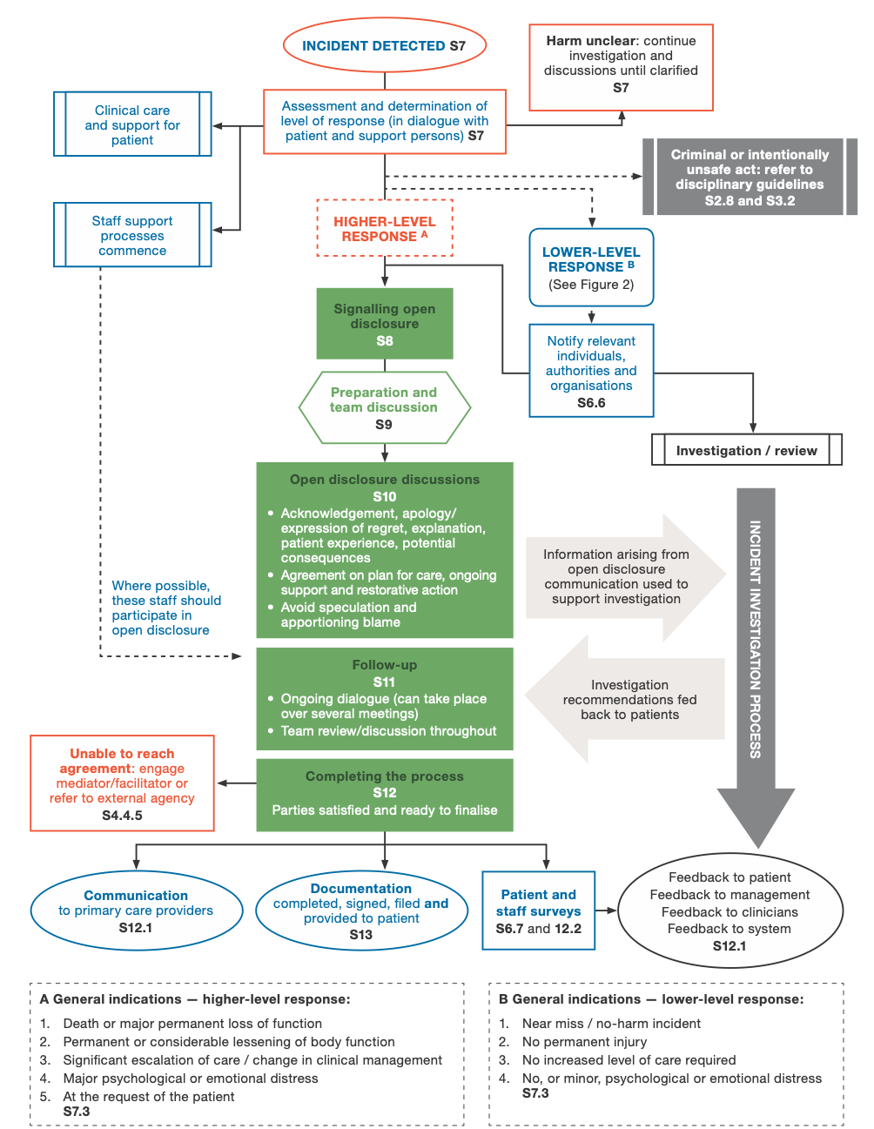

Figure 2: Flow chart outlining a lower-level response
S = Section in the Australian Open Disclosure Framework
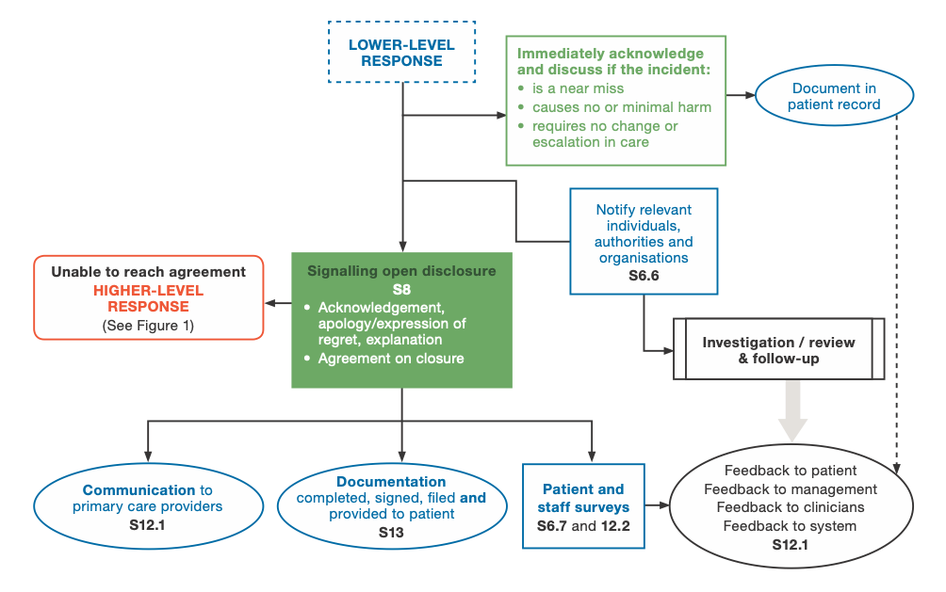

Appendix D: Overview of open disclosure policy, training, resources
and data collection at a state and territory level (current at April 2019)
Available links to policies and resources for each state and territory is provided at Appendix E.
State/territory | Policy/legislation | Level/type | Mandatory  (if state-wide) | Consistent with Framework | Education, training and resources | Data collection/indicators
New South Wales | Open Disclosure Policy (September 2014) – Policy Directive.  This mandatory policy sets out the minimum requirements for implementing open disclosure in NSW Health facilities, and describes when open disclosure is required.  Review date:  30 December 2019.  Open disclosure is also part of Incident Management Policy (February 2014), which describes the mandatory requirements for the management of both clinical and corporate incidents. | State-wide policy | Mandatory | Yes | Online eLearning modules are available for NSW Health staff through the Health Education and Training Institute (HETI). Modules include Clinician disclosure, Open Disclosure and Open Disclosure Advisors.  The open disclosure module is mandatory for all clinical staff.  Open disclosure resources, including a handbook, flowchart and checklists are available on the NSW Clinical Excellence Commission. | NSW public health systems use the Incident Information Management System (IIMS) to report incidents. St Vincent’s Health Network uses RiskMan as their incident reporting system.  Specific health care incidents are reported to the NSW Ministry of Health through the Reportable Incident Brief (RIB) system. These incidents are defined in the Incident Management Policy. In these cases the RIB is to indicate if initial open disclosure has occurred.  The Open Disclosure policy provides suggested measures to evaluate and report on open disclosure at a local level. This includes governance measures, education and training, process measures and outcome measures.
Victoria | Open disclosure is a legal obligation under Victorian Charter of Human Rights and Responsibilities Act 2006 – which requires public health services to discuss an adverse event with the affected patient.  Open disclosure is also included in the Victorian Health Incident Management Policy (2011). All Victorian publicly funded health services and agencies that provide health services on behalf of Victorian Department of Health are subject to this Policy.  Review date of incident management policy: March 2019 (expected to be completed 2020). | Legislation  Also included in state-wide incident management policy | Mandatory | Incident Management Policy refers to the old Open Disclosure Standard – however it does appear to align with the principles of the Framework | Department of Health and Human Services (DHHS) host online training programs (last updated July 2010; however does reference the Framework).  Safer Care Victoria assumed responsibility from the DHHS for open disclosure training as of June 2018. Some initial training sessions were supplied by the Cognitive Institute and they are in the process of procuring a learning management system to replace the DHHS online training, as well as review how online training can best be complimented by a face to face offering.  Open disclosure for Victorian health services – A guidebook (2008) is available on the website however this does not reflect the Framework.  Other resources on open disclosure, including checklist and questionnaires are available on the Victorian State Government website. | Open disclosure completion is captured through the sentinel event notification process, which is mandatory for public and private hospitals and requires them to report sentinel events to Safer Care Victoria.  This notification process is used more as a prompt for health services rather than a data item for monitoring. In regards to central monitoring, the information is captured as a tick box in the local VHIMS system (incident management system) at the health service, but it is not a subset of data that is collected centrally.
Queensland | There is no state-wide open disclosure policy, and it is the responsibility of each hospital and health service to implement own policy and procedure according to NSQHS Standards.  Review date: Unable to comment.  Queensland Health Best Practice Guide to Clinical Incident Management refers to clinician and formal open disclosure. | Health-service level policy/procedure | n/a | Unable to comment | Queensland Health provides online training through iLearn@QHealth on Open Disclosure for Health Professionals and Consultants (updated January 2019). Self-paced module; approx. 1 hour.  Open disclosure simulation training on formal open disclosure available to nominated senior open disclosure consultants (senior clinicians nominated by their hospital or health service). Two-day face to face training that includes role play with actors.  Each hospital and health service determines mandatory training for their workforce, so this may vary in relation to open disclosure. Resources on open disclosure available including how to prepare and plan for open disclosure (available on intranet). | Data is collected at the health-service level by each hospital and health service, and collection of data is not centralised.  RiskMan (Queensland incident management system) does collect data on SAC 1, however was not able to confirm that open disclosure is recorded as part of this incident reporting.
Northern Territory | There is a territory-wide open disclosure policy and guidelines.  Health services are responsible for implementing open disclosure at a local level.  Review date: Unable to comment. | Territory-wide policy | Mandatory | Yes | The NT Department of Health is providing training through the Cognitive Institute (face to face training). It is a ‘train the trainer’ model and targeted at clinicians who will be undertaking /coordinating open disclosure in their service.  All staff at both health services are trained on incident reporting and open disclosure during orientation and workplace induction. | Clinical incidents, near misses and events with the potential to cause harm are reported in the NT-wide RiskMan incident management system.  Data is collected on open disclosure is whether open disclosure has or has not occurred. This is reported back to the Department of Health.
South Australia | Patient incident management and open disclosure Policy Directive (14 July 2016).  All SA Health employees or persons who provide health services on behalf of SA Health must comply with this policy directive.  Review date: August 2020.  Open disclosure is also a patient and consumer right and legal obligation – Part 3 of Health and Community Services Complaints Act 2004, which includes a Charter of Health and Community Services Rights. | State-wide policy | Mandatory | Yes | Online eLearning course on Patient Incident Management and Open Disclosure (available on the SA intranet). There is an expectation that all staff will complete this course, however not mandatory.  In 2016, the open disclosure toolkit was released comprising of 16 tools to assist staff to conduct and participate in open disclosure process for level 1 (SAC 1 and 2) and level 2 (SAC 3 and 4) incidents. These are available on the SA Health website.  In 2017, level 1 – Open disclosure training was provided by the Cognitive Institute to 20 groups of senior managers.  Consumer information and resources on open disclosure are also available. | Patient incidents and open disclosure are reported on through the Safety Learning System (incident management system). The number of open disclosures that have occurred for all incidents is reported publicly in the South Australian Patient Safety Report. In 2016–2017, open disclosure was reported as having occurred for 58.2% of all incidents reported.  The Safety Learning System also allows the recording of details about the open disclosure process; and if open disclosure has not occurred, reasons why it has not occurred. This information can be viewed by all Local Health Districts in SA and are able to drill down to their service data.  The policy also requires health services to evaluate effectiveness of open disclosure processes, and provides a number of indicators and measures that could be used. For example, proportion of all SAC 1 and 2 incidents openly disclosed (target 95%); number of staff with open disclosure training; and survey results of staff and consumer experience of open disclosure.
Western Australia | WA Open Disclosure Policy – OD0592/15 (February 2015).  Under s.26 Health Services Act 2016 the Director General may issue mandatory policy frameworks. Under the Clinical Governance, Safety and Quality Policy Framework, all health service providers must comply with the WA Open Disclosure Policy.  Review date: Currently under review.  Open disclosure processes are also linked with incident management, and referred to in the Clinical Incident Management Policy OD0611/15 v 2.0. The WA Department of Health is working to align the terminology and guidance on open disclosure in this policy with the Australian Open Disclosure Framework. | State-wide policy (currently under review) | Mandatory | Yes | Online open disclosure learning package and Open disclosure toolkit available through WA Health intranet. The eLearning package is licences from the NSW Clinical Excellence Commission.  Training includes 3 modules, which are not mandatory but is strongly encouraged.  The toolkit has practice resources and templates and is available to all WA Health employees (available on WA Health intranet). | There is mandatory reporting of SAC 1 (including sentinel events) and SAC 2 clinical incidents into WA’s Clinical Incident Management System (Datix CIMS). All SAC 1 clinical incidents require the initiation of an open disclosure process that is in accordance with WA’s Open Disclosure Policy (ideally within 24 hours of clinical incident occurring).  Data is collected from public, private and other health service providers.  Data on open disclosure is solely around the initiation of open disclosure and where an open disclosure process is not initiated, reasons must be recorded.  Open disclosure related CIMS data is reported quarterly.
Tasmania | State-wide policy is in the process of development, currently working to bring four separate open disclosure policies together.  Review date: Currently under development. | State-wide policy/procedure | Will be mandatory | Unable to comment | Online introductory training available on open disclosure, however not mandatory.  Education through Cognitive Institute to provide face to face training has been available – unclear on the numbers trained.  Clinicians also receive open disclosure training from their professional colleges. | Incident data from public Tasmanian health services is collected through the Safety Reporting Learning System.  Reporting of significant incidents include a dropdown box to indicate if the event has been discussed with the patient or family. No other documentation is required.
Australian Capital Territory | No territory-wide open disclosure policy, however the ACT Health Policy – Incident Management requires all staff to participate in open disclosure procedures. Policy applies to all ACT Health staff, including contractors (except for incidents that occur at Calvary Public Hospital).  Review date: March 2020.  There is available a Canberra Hospital and Health Services Operational Procedure – Open Disclosure (August 2017) – a health service level procedure.  Review date: November 2020. | Health-service level procedure | n/a | Yes | Online education on open disclosure training available on Capabiliti – available to all clinical staff.  Open disclosure is included in manager’s orientation and executive and senior clinical staff, directors and Open Disclosure Champions (any staff may elect to be an open disclosure champion) should complete online training and face-to-face experiential training.  Templates and flowchart for Open Disclosure in ACT are provided, including prompts and scripts to assist with undertaking an open disclosure and an open disclosure brochure for patients and families. | Actions and outcomes of a formal open disclosure should be noted in RiskMan (ACT clinical incident management system).  Policy also describes process to gain feedback from consumers and staff on open disclosure once the process is completed, and there appears to be a dedicated team to coordinate obtaining this feedback.

Appendix E: Open disclosure resources and tools by the Commission, states and territories
Following is a list of available resources on open disclosure in Australia (current as of 31 October 2019). Please check your organisation’s intranet, policies and procedures and online training for more information and guidance on open disclosure in your state and territory.

Australian Commission on Safety and Quality in Health Care
Resources are accessed through the Commission’s website or through the Commission’s Communicating for Safety resource portal.

Guides and tools
- Australian Open Disclosure Framework (76 pages)
- Open disclosure checklist template (4 pages)
- Open disclosure principles, elements and process (11 pages)
- Saying Sorry: A guide to apologising and expressing regret during open disclosure (10 pages)
- Implementing the Australian Open Disclosure Framework in small practices (39 pages)
- Open disclosure resources for health service managers
- Open disclosure resources for clinicians and healthcare providers.

Resources for consumers and their families/carers
- Open disclosure FAQs for consumers (3 pages)
- Open disclosure of things that don’t go to plan in health care – A guide for patients (24 pages)
- Open disclosure: A guide for patient’s fact sheet (2 pages)
- Open disclosure flowchart for consumers (2 pages)
- Short guide to Open Disclosure Standard review report (22 pages).

Further resources
- Medical Journal of Australia article – Open disclosure: ethical, professional and legal obligations, and the way forward for regulation
- Views and experience of patients, families, carers on open disclosure
- Supporting healthcare professionals
- Legal aspects of open disclosure
- Evaluation of the National Open Disclosure Standard (161 pages).

New South Wales
Resources can be accessed through the NSW Government Clinical Excellence Commission website.

Guides and tools
- Open Disclosure Policy (30 pages)
- Open Disclosure Handbook (92 pages)
- Flowchart of open disclosure process (1 page)
- Checklist A: Clinician disclosure – steps for the initial discussion (1 page)
- Checklist B: Formal open disclosure – preparation (1 page)
- Checklist C: Formal open disclosure – team meeting (1 page)
- Checklist D: Formal open disclosure – during the disclosure (1 page)
- Checklist E: Formal open disclosure – completion (1 page).

Victoria
Resources can be accessed through the Victoria State Government, Clinical risk management, Open disclosure page.

Guides and tools
- Open disclosure for Victorian health services – A guidebook (34 pages)
- Open disclosure checklist and plan (3 pages)
- Open disclosure – Patient Questionnaire (1 page)
- Open disclosure – Staff Questionnaire (1 page)
- Open disclosure – Communication with patient/family following adverse event (27 slides).
Videos from the 2016 open disclosure forum held by the Department of Health and Human Services and the Victorian Managed Insurance Authority:
- Medico-legal perspective on open disclosure (5:09)
- Managing open disclosure in public healthcare (5:07)
- Open disclosure: the importance of transparency and honesty (2:32).

Queensland

Guides and tools
- Best practice guide to clinical incident management (key pages 37–40, 155 pages).

South Australia
Resources can be accessed through the Government of South Australia, Clinical resources, Safety and Quality page.

Patient incident management and open disclosure
- Patient incident management and open disclosure policy directive (31 pages)
- Patient incident management and open disclosure diagram (1 page).

Clinician resources
- Tool 1: Quick guide to the open disclosure process (18 pages)
- Tool 2: Saying sorry – A guide to expressing regret during open disclosure (10 pages)
- Tool 3: Comprehensive guide on open disclosure for clinical leads/facilitators (40 pages)
- Tool 8: Safety Learning System topic guide for open disclosure processes (2 pages)
- Tool 9: Open disclosure process checklist (3 pages)
- Tool 10: Patient considerations (7 pages)
- Tool 11: Staff considerations (3 pages)
- Tool 12: Open disclosure meeting checklist (2 pages)
- Tool 13: Open disclosure meeting planning and preparation tool (5 pages)
- Tool 14: Documentation and discussion summary (5 pages)
- Tool 16: Staff evaluation survey (6 pages).

Resources for consumer and their families/carers
- Tool 4: Open disclosure patients/consumer brochure (2 pages)
- Tool 5: A guide for patients/consumers beginning an open disclosure process (18 pages)
- Tool 6: Open disclosure flowchart for patients/consumers – incident resulting in harm and near miss/no harm (2 pages)
- Tool 7: Frequently asked questions about open disclosure for patients/consumers, families, carers and/or support persons (2 pages)
- Tool 15: Patient/consumer, family, carer and/or support person evaluation survey (6 pages).

Western Australia

Clinician resources
Resources for clinicians can be accessed through the Government of Western Australia website:
- WA Open Disclosure Policy: Communication and Disclosure Requirements for Health Professionals Working in Western Australia (38 pages).
- WA Open Disclosure Policy Statement (6 pages)
- Health professionals lanyard (2 pages).

Resources for consumers and their families/carers
Resources for consumers can be accessed through the Health Consumers’ Council website:
- Open disclosure chart.

Northern Territory

Guides and tools
- Governance of complaint handling and implementation of open disclosure at Royal Darwin Hospital (16 pages).

Australian Capital Territory
- Canberra Hospital and Health Services Operational Procedure – Open disclosure
(33 pages).

Appendix F – Open Disclosure Advisory Group Member list
Name | Position | Organisation
Chair – Chriss Gee | Chief Executive Officer | Toowong Private Hospital (Qld)
Dr Charles Pain | Executive Director Medical Services | Top End Health Service (NT)
Ms Toni Rice | Consumer representative
Ms Sarah Michael | Group Manager Clinical Governance and Safety | St Vincent’s Health Australia (NSW)
Ms Anna MacLeod (member from March–August 2019) | Head of Medical Defence and Service | Avant Insurers (Vic and ACT)
Mr Shane Evans | Partner and Leader of National Health Industry Group | Minter Ellison (Qld)
Dr Kim Hill | A/Executive Director Medical Services | Sydney Local Health District (NSW)
Mrs Kylie Downs | Director Clinical Safety, Quality and Governance | Central Coast Local Health District (NSW)
Dr David Rosengren | Deputy Executive Director Operations and Chief Digital Health Officer | Metro North Hospital and Health Service (Qld)
Dr Debra O’Brien | Director Medical Services | Epworth Richmond (Vic)
Dr Bernadette Eather | National Manager of Clinical Quality and Patient Safety | Ramsay Health Care (NSW)
Ms Bronwyn St Clair | Director of Nursing Services/Business Manager | The Skin Hospital (NSW)
Ms Joan Jackman | Consumer and Carer Representative
A/Prof Grant Davies | Health & Community Services Complaints Commissioner | Health and Community Services Complaints Commission (SA)
Mrs Stephanie Penney (member from September 2019) | Practice Manager Claims, NSW | Avant Insurers (NSW)
Mr Nathan Farrow (member from November 2019) | Manager, Incident Response Team | Safer Care Victoria (Vic)

Acronyms and abbreviations
AHPRA: Australian Health Practitioner Regulation Agency
DA: Dementia Australia
GP: General Practitioner
HCASA: Health Consumers Alliance South Australia
IJC: Inter-Jurisdictional Committee
NSQHS Standards: National Safety and Quality Health Service Standards
OD Standard: Open Disclosure Standard
ODAG: Open Disclosure Advisory Group
PHSC: Private Hospital Sector Committee
PCC: Primary Care Committee
SAC: Severity Assessment Code
The Commission: Australian Commission on Safety and Quality in Health Care
The Framework: Australian Open Disclosure Framework
The Scheme: Australian Health Service Safety and Quality Accreditation Scheme
VMO: Visiting Medical Officer

Glossary
Open disclosure: Open disclosure is the open discussion of adverse events that result in harm to a person while receiving health care, with that person and/or their support people.
The elements of open disclosure are an apology or expression of regret (including the word sorry), a factual explanation of what happened, an opportunity for the person and/or their support people to relate their experience, and an explanation of the steps being taken to manage the event and prevent recurrence.
Open disclosure is not a one-off process, but an ongoing discussion and exchange of information that may take place over time.3
Higher-level response: A comprehensive open disclosure process usually in response to an incident resulting in death or major permanent loss of function, permanent or considerable lessening of function, significant escalation of care or major change in clinical management, and major psychological or emotional distress. The criteria should be determined in consultation with the person who has experienced harm, and/or their support people.
A high-level response may also be instigated at the request of the person who has experienced harm, even if the outcome of the adverse event is not as severe.3 See also Lower-level response.
Lower-level response: A briefer open disclosure process usually in response to incidents resulting in no permanent injury, requiring no increased level of care, and resulting in no, or minor, psychological or emotional distress (e.g. near misses and no-harm incidents).
The criteria should be determined in consultation with the person who has experienced harm, and/or their support people.3 See also Higher-level response
Healthcare provider: A person trained as a health professional, including registered and non-registered practitioners. They may provide care within a health service organisation as an employee, contractor or a credentialed healthcare provider, or under other working arrangements. They include nurses, midwives, medical practitioners and allied health practitioners. Includes the term clinician.
Adverse event or harmful incident: An incident that results, or could have resulted, in harm to a person. Such incidents can either be part of the healthcare process, or occur in the healthcare setting.
The term adverse event or harmful incident is used interchangeably.3
Harm: An impairment of structure or function of the body and/or any deleterious effect arising from an incident, including disease, injury, suffering, disability and death. Harm may be physical, social or psychological.6
Near-miss: An incident that did not cause harm but had the potential to do so.7
Just culture: A culture where people feel supported and are encouraged to identify and report adverse events, so that opportunities for systems improvement can be identified and acted on.8
Support people: Can include family members, carers, partners, friends, guardians, substitute decision makers, social workers, and trained patient advocates (where available).
Person: For the purposes of this report, a person is someone who has experienced an adverse event while receiving health care. It includes the term patient.
Workforce: Anyone working within a health service organisation, including healthcare providers, self-employed professionals such as visiting medical officers, and credentialed medical officers. Includes the term staff.

References
1. Australian Commission on Safety and Quality in Health Care. National Safety and Quality Health Service Standards (first edition). Sydney: ACSQHC; 2012.
2. Australian Commission on Safety and Quality in Health Care. National Safety and Quality Health Service Standards (second edition). Sydney: ACSQHC; 2017.
3. Australian Commission on Safety and Quality in Health Care. Australian Open Disclosure Framework. Sydney ACSQHC; 2013.
4. Australian Commission on Safety and Quality in Health Care. Open Disclosure Standard Review Report. Sydney: ACSQHC; 2012.
5. Chief Psychiatrist Victorian State Government Department of Health and Human Services. Victorian Chief Psychiatrist Practice Direction 2019/01 – Reporting of incidents where there is a failure to comply with the Mental Health Act (the Act) – May 2019. Melbourne: State of Victoria, Department of Health and Human Services 2019.
6. World Health Organization. The International Classification for Patient Safety. WHO; 2009.
7. Barach P, Small SD. Reporting and preventing medical mishaps: lessons from non-medical near miss reporting systems. BMJ. 2000; 320(7237):759–63.
8. Australian Commission on Safety and Quality in Health Care. Implementing and practising open disclosure: Guide for health service managers. Sydney: ACSQHC; 2013.

