

Incident Management Guide
November 2021

Published by the Australian Commission on Safety and Quality in Health Care
Level 5, 255 Elizabeth Street, Sydney NSW 2000
Phone: (02) 9126 3600
Email: mail@safetyandquality.gov.au
Website: www.safetyandquality.gov.au
ISBN: 978-1-922563-30-9
© Australian Commission on Safety and Quality in Health Care 2021
All material and work produced by the Australian Commission on Safety and Quality in Health Care (the Commission) is protected by copyright. The Commission reserves the right to set out the terms and conditions for the use of such material.
As far as practicable, material for which the copyright is owned by a third party will be clearly labelled. The Commission has made all reasonable efforts to ensure that this material has been reproduced in this publication with the full consent of the copyright owners.
With the exception of any material protected by a trademark, any content provided by third parties, and where otherwise noted, all material presented in this publication is licensed under a Creative Commons Attribution-NonCommercial-NoDerivatives 4.0 International licence.

Enquiries about the licence and any use of this publication are welcome and can be sent to communications@safetyandquality.gov.au.
The Commission’s preference is that you attribute this publication (and any material sourced from it) using the following citation:
Australian Commission on Safety and Quality in Health Care. Incident Management Guide. Sydney: ACSQHC; 2021.
Disclaimer
The content of this document is published in good faith by the Commission for information purposes. The document is not intended to provide guidance on particular healthcare choices. You should contact your health care provider on particular healthcare choices.
The Commission does not accept any legal liability for any injury, loss or damage incurred by the use of, or reliance on, this document.

Contents
Contents 3
Introduction 4
What is an incident? 4
Why do we manage incidents? 4
What is in this guide? 4
Which settings? 4
Incident management in Australia 5
Best practice principles of incident management 6
Phases of incident management 7
1. Identification 8
2. Immediate action to reduce risk and harm to the patient 8
3. Notification 9
4. Initial assessment and prioritisation 9
5. Analysis, investigation and classification 10
6. Action – implementation of recommendations and action plan 12
7. Feedback 13
8. System-wide learning and sharing 13
Roles and responsibilities and governance arrangements 15
Comprehensive view of patient safety 16
Improving safety: What else do we need to do? 16
Best practice case study 17
1. Identification 17
2. Immediate action to reduce risk and harm to the patient 17
3. Notification 17
4. Initial assessment and prioritisation 17
5. Analysis, investigation and classification 18
6. Action – implementation of recommendations and action plan 18
7. Feedback 19
8. System-wide learning and sharing 19
Glossary 20
Resources 22
Acknowledgements 23
Incident Monitoring Expert Advisory Committee 23
Commission staff 23
References 24

Introduction

What is an incident?
An incident is an event or circumstance that resulted, or could have resulted, in unintended or unnecessary harm to a patient or consumer; or a complaint, loss or damage. An incident may be a near miss. Incidents may also be associated with omissions where patients are not provided with a medical intervention from which they would have likely benefited.
In Australia, there are over 11 million hospital admissions each year. Most of these results in a good outcome for the patient, but occasionally things go wrong. There are approximately 500,000 incidents reported each year in public health care systems; over 2,000 of these have a serious outcome for the patient involved.

Why do we manage incidents?
Incident management can improve safety, improve care processes, change the way patients, carers, families and the workforce think about risk and raise awareness of good practice. A well-designed incident management system will assist patients, carers, families and the workforce to identify, report, manage and learn from incidents.

What is in this guide?
This guide provides the healthcare workforce a concise overview of the incident management process and its underlying principles. It consolidates best practice approaches based on literature reviews and the Australian states’ and territories’ incident management policies.

Which settings?
The principles in this incident management guide can be applied in health service organisations which are delivering clinical services to patients in primary, secondary and community care settings, and others such as ambulance services. The guide applies only to clinical incidents and not to staff or work health and safety incidents.

Incident management in Australia
Australia has a strong foundation for incident management. The National Safety and Quality Health Service (NSQHS) Standards require health service organisations to have an organisation-wide incident management system, and outline the key elements of a robust incident management system.
Each state and territory has policies and programs to ensure that incidents are monitored and improvements are made. The Australian interactive map (Figure A) contains links to the relevant state and territory incident management policies.
Figure A: Australian interactive map of incident management policies
Click on each state or territory to link to its relevant incident management policy

ACT
Tas
Vic
NSW
Qld
SA
WA
NT

Best practice principles of incident management
Incidents managed under these principles are more likely to be resolved with an acceptable outcome for all involved and will reduce the risk of similar incidents occurring in the future.
Principle | Description
Transparency | Health service organisations will provide patients, carers, families and members of the workforce who are involved in an incident with an honest and open explanation of what happened, why it happened and what actions have, and will be taken, as a result (see the Australian Open Disclosure Framework and the NSQHS Standards).
Accountability | Health service organisations have a duty to take reasonable care to avoid harm to patients, the workforce, contractors and visitors.  When a patient is harmed, health service organisations will undertake an investigation and actions to remedy problems in a timely manner.
Partnering with consumers | Health service organisations facilitate and support patients, carers and families as partners in incident investigations and reviews.
Open, fair and just culture | Health service organisations create a culture where the workforce, patients, carers and families feel safe to report incidents.  During an incident investigation, health service organisations will treat everyone fairly, according to just culture, using a systems-based approach.
Act in a timely way | Health service organisations take action to remedy problems in a timely manner; the allocation of responsibility for action is explicit.
Prioritisation of action | Health service organisations prioritise action to address problems and direct resources to the areas of highest clinical risk and where the greatest improvements are possible.
Shared learning | The health system shares the lessons learnt from incidents across the healthcare sector to prevent further patient harm and to take collective remedial action.

Phases of incident management
Incident management generally includes the following phases. At each health service organisation, the order may be slightly different or different terms may be used. Importantly, the phases should support the implementation of the best practice principles of incident management.
Figure B: Phases of incident management
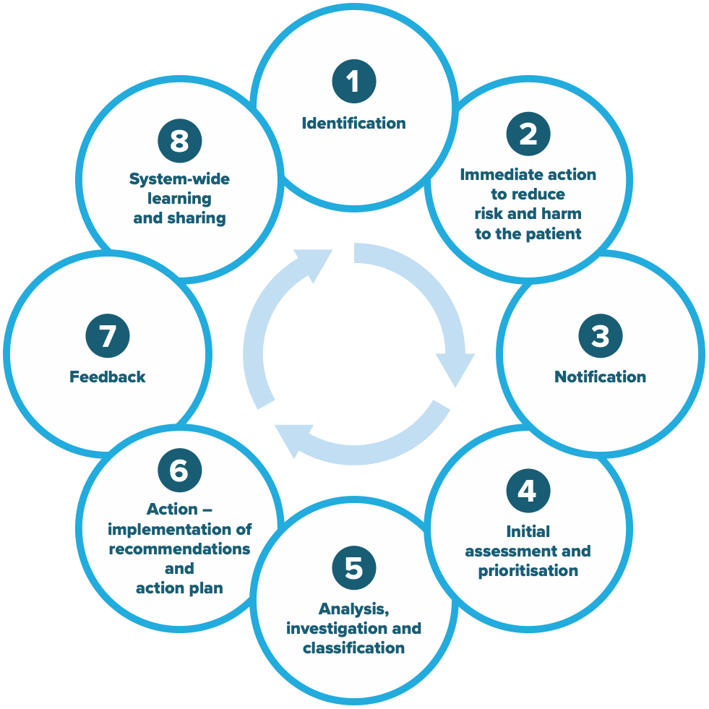

1. Identification
How do we recognise that things have gone wrong?
The workforce should recognise when things have gone wrong. Organisations should define the purpose of their incident management system and what must be reported and their expectations of the workforce. This should include incident definitions which can be communicated to the workforce. Incidents can be identified from a number of sources, which may include:
- Direct observation
- Team discussion
- Coroner’s reports
- Clinical review meetings
- Death review processes
- Staff meeting discussions
- Complaints
- Patient, carer and family input (for example, questions, concerns, information)
- Monitoring variation in clinical practice
- Audits
- Chart reviews.
Pro-active approaches such as direct observation of clinical workplaces, briefing and debriefing, and patient, carer and family escalation processes can detect errors early or prevent them.
Explore the different resources available in your state or territory here.

2. Immediate action to reduce risk and harm to the patient
How do we minimise the immediate risk?
When an incident is identified, immediate action must be taken to reduce the risk to the patient and anyone else who may be affected. These actions include:
- Providing immediate care to the individuals involved – this includes the patients, carers, families, and members of the workforce
- Making a situation/scene safe
- Notifying the responsible manager and medical team as necessary
- Notifying security and the police (as relevant to the incident)
- Removing or managing malfunctioning equipment or supplies
- Gathering information about the chain of events and objectively document these
- Commencing the Open Disclosure process.
Ongoing support should be offered to patients, carers, families and members of the workforce who are involved in the incident. The incident should be acknowledged and explained to the patient, carer and family including an apology or expression of regret in line with the Australian Open Disclosure Framework.
Explore the different resources available in your state or territory here.

3. Notification
How do we report the incident?
Notification of the incident should be simple and the time required to report should be minimal. An option for undertaking reporting anonymously should be available. Patients, carers or visitors should also be given the opportunity to easily notify incidents. Near misses should be recognised as opportunities for improvement and their reporting should be encouraged.
When reporting, ensure the accuracy, quality, and completeness of the report to support the follow-up incident review. Important considerations for notifiers include:
- Provide as much detail as possible
- Provide objective and factual information
- Report the incident within the prescribed timeline (for example, within 24 hours or by the end of the day)
- Where possible, avoid identifiable details such as staff names
- Document relevant facts and the incident ID number in the patient’s medical record.
Some incidents may require notification to other authorities such as the coroner.

4. Initial assessment and prioritisation
Do we have all the information we need?
How serious is the incident?
As part of the initial assessment, the manager should:
- Review the incident within the set time prescribed by the organisation (for example, within two days)
- Ensure accuracy, quality and completeness of the notification and update any additional information
- Allocate a risk or severity rating
- Consider whether the identified risk needs to be on the organisation’s risk register
- Decide the level of Open Disclosure that is necessary
- Ensure that the Chief Executive or equivalent is notified of all incidents with the highest severity rating.
A standardised, objective measure of severity (or degree of harm) should be allocated to each incident. The purpose of this is to determine the level of investigation and action required. Use of likelihood or frequency to rate incidents, in addition to severity is becoming less common as inter-rater reliability is relatively low.

5. Analysis, investigation and classification
What happened?
How and why it happened?
What actions can be taken to prevent similar incidents?
The type and level of investigation is determined by the severity or harm rating. All incidents with the highest severity rating should undergo an in-depth and detailed investigation. The main goal of the investigation is to assess the system, not to blame people involved. The investigation should:
- Be conducted within the principles of fair procedures and natural justice
- Be documented in accordance with policy and procedures
- Be free of value judgements
- Be undertaken by a multi-disciplinary team
- Involve an independent or external investigator (for complex incidents)
- Result in recommendations for approval and actioning by the organisation.
The patient and their carer and family should be partners in the investigation. Time and care should be taken to:
- Facilitate and support the patient, carer and family to recount their experience(s)
- Ensure that the expectations and concerns of the patient, carer and family are considered
- Discuss the nature of the investigation, time frame and how feedback will be provided on the findings and recommendations.
Where a question of professional misconduct or unsatisfactory professional conduct arises, this should be managed in accordance with local performance management processes, state-based legislation and registration requirements. Some state and territory health departments have guides to help determine whether incidents are primarily system- or individual‑based.
All health service organisations should:
- Assign appropriate levels of responsibility for investigation and action on all incidents
- Have procedures in place for the investigation of incidents using validated methodologies
- Provide access to training programs for the investigation of incidents
- Have appropriately trained staff to support those involved in investigations
- Assign appropriate levels of resourcing to enable effective investigations
- Ensure that the Clinical Governance Unit (or equivalent) provides appropriate oversight of the quality of investigation processes and outcomes and actions taken to address the identified problems.
Classification is the process of capturing relevant information from a range of perspectives about an incident to ensure that the complete nature of the incident, including contributory factors, is documented and understood. A classification system allows data to be compared within the organisation and over time.
Explore the different resources available in your state or territory here.

Figure C: Hierarchy of effectiveness
Strategies that are system-based such as forcing functions have high leverage and are more effective in preventing errors. However, these strategies may require more planning and effort to implement. Medium leverage strategies are moderately effective but may require periodic updating and reinforcement. Strategies that are person-based are easier to implement but have low leverage and are least effective in preventing errors.
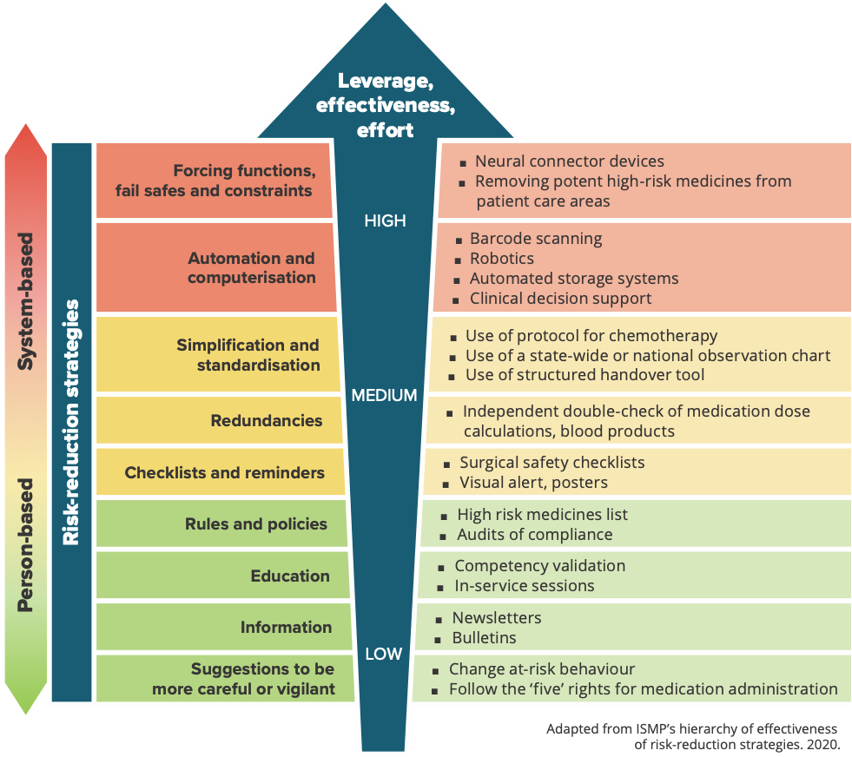

6. Action – implementation of recommendations and action plan
How do we improve?
How will we know we have improved?
Recommendations arising from investigations and analysis should:
- Address the contributing factors found in the investigation or analysis
- Consider their strength using the hierarchy of effectiveness (see Figure C)
- Consider patient perspective and include suggestions for improvements from patients, carers and families
- Consider suggestions for improvement from the workforce, including frontline clinicians
- Be written in a SMART (Specific, Measurable, Achievable, Realistic, Time-bound) format
- Each be assigned to a senior manager responsible for the implementation
- Have a stipulated timeframe for each recommendation
- Be approved by the executive of the organisation.
When a recommendation from a serious incident investigation is not supported, the Chief Executive must be able to document the reason and propose an alternative recommendation.
The health service organisation should:
- Have a register of recommendations
- Consider whether the incident and recommendations have relevance for other areas of the organisation
- Link the recommendations and actions to address the risk to the organisation’s risk register (where applicable)
- Develop a strategy to implement recommendations across the organisation (where applicable)
- Undertake ongoing monitoring to ensure the recommendations are addressed within the agreed time frame
- Evaluate the success of any action taken to achieve improvement.
The register of recommendations should be reviewed by the board and executive.
Explore the different resources available in your state or territory here.

7. Feedback
How do we tell people what happened and what we did to improve safety?
A key success factor of an incident management system is timely and meaningful feedback to stakeholders. Feedback should be provided to:
- Patients, carers and families
- Members of the workforce who notified and were involved in the incident
- Safety and quality committees
- Other members of the workforce and the organisation, potentially at multiple levels (see Figure D).
Communicating the improvements in safety resulting from the incident will encourage the workforce to report future safety concerns. Invite patients, carers and families to discuss the findings of the investigation. Information should be factual and presented in a manner that is appropriate for the audience. The workforce, patients, carers and families should be involved in designing how and when they receive feedback. Lessons learnt can be shared through forums such as ward meetings, clinical review meetings and Grand Rounds.
Regular reports on individual incidents and their outcomes, trended and aggregated data, should be provided to:
- The executive and board
- Safety and quality committees
- NSQHS Standards committees
- The workforce and management.

8. System-wide learning and sharing
How do we learn from incidents?
How do we share what we learnt?
System-wide learning encompasses a number of different activities including implementing recommendations more broadly in other similar and applicable contexts, monitoring their effectiveness and providing feedback to the workforce, executive, board and the wider community.
Another important activity is undertaking aggregated themed analysis of all safety data, not just incidents, and using these to inform improvement plans and projects in a strategic way (see Comprehensive view of patient safety). These analyses may be undertaken at a ward, organisational or state and territory level.
Explore the different resources available in your state or territory here.

Figure D: Feedback to stakeholders
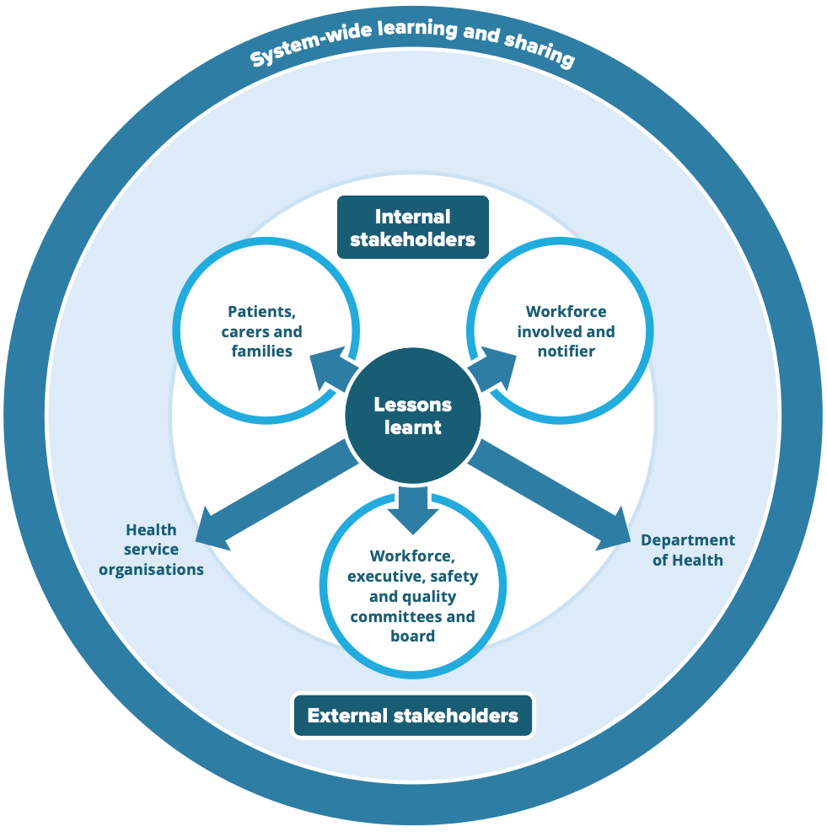

Roles and responsibilities and governance arrangements
Governing bodies (for example, boards) and executive are ultimately responsible for responding to incidents in a just and fair manner. Their roles include monitoring the recommendations from investigations and their implementation and using feedback on incident and other safety and quality data to improve the care delivered to patients.
Health service organisations should put in place the fundamental governance requirements for effective incident management, which include:
- Developing and monitoring policies and procedures
- Providing oversight of incident management systems
- Supporting and assuring that notifiers, managers, investigation teams, data analysts, and executive and the board can undertake their respective functions
- Supporting statutory obligations such as medico-legal, coroners, and other notifications
- Undertaking aggregated analysis of data and inform stakeholders including the executive and board
- Ensuring that the workforce has the necessary skills and knowledge in safety and quality.
See the NSQHS Standards Action 1.11 and the National Model Clinical Governance Framework, for more details.

Comprehensive view of patient safety

Improving safety: What else do we need to do?
Incident management systems are not the sole source of safety data. Organisations should use a range of indicators to understand the care being provided and identify areas where they are doing well and areas for improvement. Key areas of measurement include:
- Complications
- Compliance with standards
- Patient experience
- Patient outcomes – clinical and patient-reported including complaints
- Patient safety culture.
The Commission has developed indicators and tools to support measurement in these areas.
Safety II approach
As well as understanding why things go wrong, managing safety also includes trying to understand why things go right, despite the health service being uncertain, complex and busy. This is the Safety II approach – see the Resources list for further details.
Figure E: Comprehensive view of patient safety
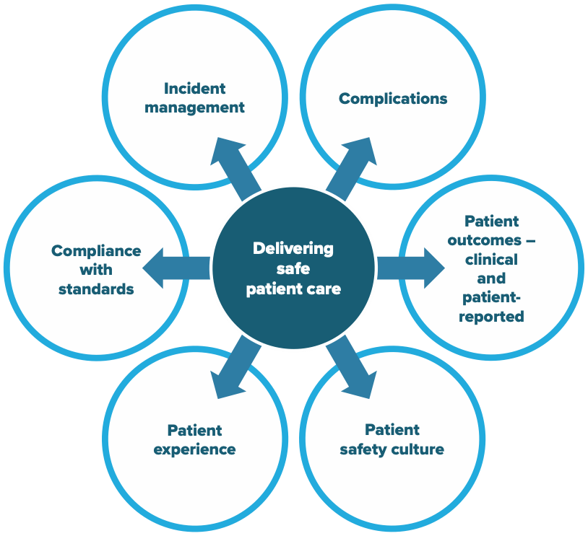

Best practice case study
This case study has been developed to illustrate the best practice principles outlined in this guide.

1. Identification
A nurse, Cameron, working on a surgical ward, administered a post-surgical patient, Ms Judith Griffiths, a 10-fold dose of morphine. This was despite a double check being done with another nurse, Julie. Shortly afterwards, Ms Griffiths became drowsy with slurred speech, and had an acute respiratory depression followed by an arrest.

2. Immediate action to reduce risk and harm to the patient
Cameron assessed Ms Griffiths airway, provided oxygen via a mask, supported her jaw, and called for help, and the rapid response team. While the team was managing Ms Griffiths, Cameron realised that a dosing error had occurred. A reversing agent was administered and Ms Griffiths made a full recovery. The nurse unit manager, Joanna, and home medical team were informed.
Joanna offered support to Cameron and Julie and gave both of them information on the hospital’s staff counselling service in case they needed it. Joanna also held a debriefing session with all clinicians involved.

3. Notification
Once Cameron was sure that Ms Griffiths was safe, he self-reported the incident into the hospital’s electronic incident management system (EIMS). He also updated Ms Griffiths’s medical record with a summary of the incident.

4. Initial assessment and prioritisation
Joanna was alerted that the incident had been reported as the EIMS automatically sent her an email. Given that Ms Griffiths made a full recovery but required resuscitation, Joanna assessed the incident as the second highest level of severity or harm.
Joanna and a medical consultant, Michael, had an initial discussion with Ms Griffiths on the day of the incident. Joanna and Michael informed Ms Griffiths that she was inadvertently given a higher than prescribed dose of morphine. Ms Griffiths was assured that she would not have any effects or complications from the overdose. Joanna apologised and informed her that an investigation will be undertaken to identify measures that can be put in place to prevent a similar occurrence. They discussed the nature of the investigation and asked Ms Griffiths about her expectations.
Joanna and Michael checked whether Ms Griffiths had any unanswered questions or concerns and whether she would be willing to be involved in the investigation. Ms Griffiths agreed to be interviewed as part of the investigation. Joanna and Michael also told her that she would be informed of the results of the investigation which were expected in four to six weeks.

5. Analysis, investigation and classification
Joanne interviewed Cameron and Julie separately the next day with a support person present at their request. Cameron described how he was asked to stay late due to a staff member being called in sick. He had just been asked to do a ward round with a doctor, was behind in his medication duties, and was quite tired. He misread the dosage on the computer on wheels. Julie also described how busy the ward was and that she was receiving a handover from the emergency department for two new admissions.
Joanna interviewed Ms Griffiths by telephone one week after her discharge from the hospital. Ms Griffiths said that she felt that the staff were very busy that day and were trying to catch-up all the time. Despite noticing how busy they were, she appreciated that the staff remained professional and caring at all times.
Joanna asked the Safety and Quality Director who she knew had human factors expertise to review the incident. The Director noted that trailing zeros are displayed in the electronic medication chart. According to the National Guidelines for On-screen Display of Clinical Medicines Information, trailing zeros are a known risk for 10-fold dosage errors. Joanna also sought advice from the Pharmacy Department, and Information Technology Department on the types of recommendations that would be more likely to be effective and sustainable over time.
In the EIMS, Joanna recorded the incident type:
- Medication type –› overdose
- Contributing factors –› fatigue, staff shortages, electronic medication management (EMM) system design issue.

6. Action – implementation of recommendations and action plan
Joanna updated the findings from the investigation in the EIMS, including the recommendations with dates of completion, and owners.
Joanna requested that the trailing zeros in the EMM system be placed on the organisational risk register as it was likely to lead to further incidents. One recommendation was that the Safety and Quality Director was to write to the EMM system vendor within two weeks to request a formal change to the software within 12 weeks.
As an interim step, the Pharmacy Department highlighted the inherent risk in the EMM system in their newsletter, and the Director sent an email to all clinicians.
The EMM system vendor developed and tested a fix and included it in their scheduled upgrade which was 12 weeks after the incident. They verified that the trailing zero problem was now no longer appearing for any medications. The risk was removed from the risk register at the hospital’s next organisational risk committee meeting. The findings were also fed back to the relevant quality and safety committee. The committee recommended that the Director of Pharmacy and Information Technology Department review the national guidelines and ensure that all of the recommendations were appropriately implemented.

7. Feedback
Joanne and Michael met Ms Griffiths after the investigation was completed when she was attending the hospital for an outpatient appointment. They broadly outlined the investigation’s findings and a summary of recommendations. Ms Griffiths was satisfied that the hospital had taken the matter seriously, had investigated thoroughly, and that the recommendations were being put in place so that a similar incident was unlikely to happen again.
Joanna also met with Cameron and Julie to update them on the actions arising from the investigation and their progress. Joanna also asked if they were experiencing any distress and required any further psychological support. Cameron and Julie appreciated the offer of help but did not require any intervention or further support.
Joanna used the staff meeting six months later to remind staff of the changes to the EMM system and that no further incidents have been recorded. Joanna also continues to reinforce to staff on a regular basis the importance of notifying incidents.
In the hospital’s bi-monthly safety and quality newsletter the change in the EMM system was explained with a de-identified summary of the incident.

8. System-wide learning and sharing
The Safety and Quality Director informed the Department of Health about the incident and the follow-up action. The Department of Health wrote to all hospitals in the state to review their EMM systems for similar trailing zero issues. Hospitals were also asked to ensure that their systems were consistent with the national guidelines.

Glossary
Term | Description
Adverse event | An incident that results, or could have resulted, in harm to a patient or consumer. A near miss is a type of adverse event. See also near miss.1
Clinical governance | An integrated component of corporate governance of health service organisations. It ensures that everyone – from frontline clinicians to managers and members of governing bodies, such as boards – is accountable to patients and the community for assuring the delivery of safe, effective and high-quality services. Clinical governance systems provide confidence to the community and the health service organisation that systems are in place to deliver safe and high-quality health care.1
Clinician | A healthcare provider, trained as a health professional, including registered and nonregistered practitioners. Clinicians may provide care within a health service organisation as an employee, a contractor or a credentialed healthcare provider, or under other working arrangements. They include nurses, midwives, medical practitioners, allied health practitioners, technicians, scientists and other clinicians who provide health care, and students who provide health care under supervision.1
Contributory factors | A circumstance, action or influence which is thought to have played a part in the origin or development of an incident or to increase the risk of an incident. Also known as causation or causative factors.2
Degree of harm | The severity and duration of harm, and any treatment implications, that result from an incident.2
Governing body | A board, chief executive officer, organisation owner, partnership or other highest level of governance (individual or group of individuals) that has ultimate responsibility for strategic and operational decisions affecting safety and quality in a health service organisation.1
Health service organisation | A separately constituted health service that is responsible for implementing clinical governance, administration and financial management of a service unit or service units providing health care at the direction of the governing body. A service unit involves a group of clinicians and others working in a systematic way to deliver health care to patients. It can be in any location or setting, including pharmacies, clinics, outpatient facilities, hospitals, patients’ homes, community settings, practices and clinicians’ rooms.1
Human factors | The study of how interactions between organisations, tasks, and the individual worker, impact on human behaviour and affect systems performance.3
Incident (clinical) | An event or circumstance that resulted, or could have resulted, in unintended or unnecessary harm to a patient or consumer; or a complaint, loss or damage. An incident may also be a near miss.1
Incident analysis | A structured process that aims to identify what happened, how and why it happened, what can be done to reduce the risk of recurrence and make care safer, and what was learned.4
Incident management | The various actions and processes required to conduct the immediate and ongoing activities following an incident. Incident analysis is part of incident management.4
Investigation | A systems review of what happened and why to determine how a similar incident can be prevented. Methodologies include root Cause Analysis (RCA), London Protocol, Failure Modes and Effects Analysis (FMEA), Human Error and Patient Safety (HEAPS) or Clinical Record Review.
Just culture | Emphasises that errors are generally a product of faulty organisational cultures, rather than solely brought about by the person or persons directly involved. It is a collective understanding of where the line should be drawn between blameless and blameworthy actions.5,6
Near miss | Near miss: an incident or potential incident that was averted and did not cause harm, but had the potential to do so.7
Omissions | Failing to provide the patient with a medical intervention from which the patient would have likely benefited.8
Open disclosure | An open discussion with a patient and carer about an incident that resulted in harm to the patient while receiving health care. The criteria of open disclosure are an expression of regret, and a factual explanation of what happened, the potential consequences, and the steps taken to manage the event and prevent recurrence.1
Patient | A person who is receiving care in a health service organisation. Synonyms for patient include ‘consumer’ and ‘client’.1
Patient safety | The reduction of risk of unnecessary harm associated with health care to an acceptable minimum. An acceptable minimum refers to the collective notions of current knowledge, resources available and the context in which care was delivered, weighed against the risk of non-treatment or other treatment.9
System approach | A systems approach concentrates on the conditions under which individuals work and tries to build defences to avert errors or mitigate their effects. It contrasts with a person approach which focuses on the errors of individuals, blaming them for forgetfulness, inattention, or moral weakness.6
Workforce | All people working in a health service organisation, including clinicians and any other employed or contracted, locum, agency, student, volunteer or peer workers. The workforce can be members of the health service organisation or medical company representatives providing technical support who have assigned roles and responsibilities for care of, administration of, support of, or involvement with patients in the health service organisation.1

Resources
- A HUMAN FACTORS RESOURCE for Health Professionals and Health Services Staff. 2019. Human Factors and Ergonomics Society of Australia, the Australian Institute of Health Innovation, Macquarie University, The University of Sydney and the NSW Clinical Excellence Commission.
- Canadian Incident Analysis Framework. 2012. Canadian Patient Safety Institute.
- Healthcare Failure Modes and Affects Analysis (HFMEA): Guidebook. 2021. Veterans Affairs National Center for Patient Safety.
- Literature review and environmental scan on approaches to the review and investigation of Health-IT related patient safety incidents. 2017. Australian Commission on Safety and Quality in Health Care.
- Patient Safety Learning Systems: A Systematic Review and Qualitative Synthesis. Ontario health technology assessment series. 2017. Health Quality Ontario.
- Patient safety reporting systems: A literature review of international practice. 2016. Health Quality & Safety Commission New Zealand.
- Systems Analysis of Clinical Incidents: The London Protocol. 2004. Imperial College, London.
- From Safety-I to Safety-II: A White Paper. 2015. The Resilient Health Care Net. University of Southern Denmark, University of Florida, USA, and Macquarie University, Australia.
- WHO draft guidelines for adverse event reporting and learning systems: from information to action. 2005. World Health Organization: Geneva, Switzerland.

Acknowledgements
The Commission wishes to thank Associate Professor Peter Hibbert for his contribution in the development of this document.
The Commission also wishes to thank members of the Incident Monitoring Expert Advisory Committee who have given their time and advice. The involvement and willingness of all concerned to share their experience and expertise is greatly appreciated.

Incident Monitoring Expert Advisory Committee
- Dr Patricia Bradd
- Ms Kathryn Briant
- Ms Jenny Broome
- Dr Amanda Craig
- Ms Deanne Day
- Dr Bernadette Eather
- Ms Wendy Fennah
- Ms Jennifer Garden
- Mr Cameron Hussey
- Mr James Kemp
- Ms Karen Lennon
- Ms Louise McKinlay
- Ms Joanne Miller
- Mr Andrew Modra
- Ms Stephanie Newell.

Commission staff
A number of Commission staff were also involved in the writing and review of this publication, and the Commission wishes to acknowledge:
- Conjoint Professor Anne Duggan
- Ms Suzanna Henderson
- Mr Chris Leahy
- Mr Girish Swaminathan.

References
1. Australian Commission on Safety and Quality in Health Care. National Safety and Quality Health Service Standards. 2nd ed. – version 2. Sydney: ACSQHC; 2021.
2. Runciman W, Hibbert P, Thomson R, Van Der Schaaf T, Sherman H, Lewalle P. Towards an International Classification for Patient Safety: key concepts and terms. International journal for quality in health care. 2009;21(1):18–26.
3. Bion JF, Abrusci T, Hibbert P. Human factors in the management of the critically ill patient. British journal of anaesthesia. 2010;105(1):26–33.
4. Incident Analysis Collaborating Parties. Canadian incident analysis framework. Edmonton, AB: Canada Patient Safety Institute. 2012.
5. Reason J. Managing the Risks of Organizational Accidents, 1er éd. Ashgate Publishing Company; 1997.
6. Reason J. Human error: models and management. BMJ. 2000;320(7237):768–770.
7. Barach P, Small SD. Reporting and preventing medical mishaps: lessons from non-medical near miss reporting systems. Bmj. 2000;320(7237): 759–763.
8. Aspden P, Corrigan JM, Wolcott J, Erickson SM. Institute of Medicine Committee on Data Standards for Patient Safety. Patient Safety: Achieving a New Standard for Care. Washington (DC): National Academies Press (US); 2004.
9. World Health Organization. The international classification for patient safety. WHO, 2009.


Level 5, 255 Elizabeth Street, Sydney NSW 2000
GPO Box 5480, Sydney NSW 2001
Phone: (02) 9126 3600
Email: mail@safetyandquality.gov.au
Website: www.safetyandquality.gov.au

