KEY ACTIONS
for health service organisations

‘Mixed‑case lettering’: Principles for application
  - Formerly known as ‘Tall Man lettering’

Background
The Australian Commission on Safety and Quality in Health Care (the Commission) is responsible for the development and stewardship of the National Mixed‑Case Lettering List (the List).1 The List compiles look-alike sound-alike (LASA) medicine names (generic and brand names) that have been predicted to pose the greatest risks to patient safety. The List shows LASA medicine names in pairs or groups (trios).
This fact sheet has been developed to assist health service organisations (HSOs) and clinicians involved in medication management, including the prescribing, dispensing and administration of medicines.

How to use this fact sheet
The fact sheet can be used by HSOs to assist in the understanding of the application of ‘mixed‑case lettering’ as a risk-reduction strategy. Its implementation should include educating clinicians about the risks associated with LASA medicine names and the purpose of ‘mixed‑case lettering’.

What is ‘mixed‑case lettering’?
‘Mixed‑case lettering’ (also referred to as ‘Tall Man lettering’) is a typographic technique that uses selective capitalisation to help make similar looking medicine names more easily distinguishable.2,3,4 It uses a combination of lower- and upper-case letters to highlight differences. For example:
- proGRAF and proZAC
- oBINUTUZumab and oFATUMumab.

Why is it used?
Medication errors are one of the most reported clinical incidents in acute healthcare settings. The prevalence of medication errors is a concern, particularly as many are preventable. Medication incidents related to LASA medicine names are one of the most common type of medication error. 5,6,7
Research based on experimental psychology suggests that ‘mixed‑case lettering’ purposely disrupts the reading of a medicine name, drawing attention to one or more differentiating syllables, and potentially preventing erroneous selection of a medicine with a similar name.

How is ‘mixed‑case lettering’ applied?
The medicine names on the List have ‘mixed‑case lettering’ applied to them consistent with a national convention. This is a systematic process to reserve the strategy for those medicine name pairs that would most benefit. ‘Mixed‑case lettering’ is only one of several risk-mitigation strategies used to differentiate LASA medicines names. Some principles for the application of ‘mixed‑case lettering’ are provided in Table 1.
Table 2 provides guidance on how to risk assess and apply ‘mixed‑case lettering’. Figure 1 provides a flowchart/decision tree with a worked example in Figure 2 on how to apply ‘mixed‑case lettering’ to medicine names.

Where else is ‘mixed‑case lettering’ used?
Internationally, the Institute for Safe Medication Practices (ISMP) and ISMP Canada, the International Medication Safety Network (IMSN), the World Health Organization (WHO) and many other organisations recommend ‘mixed‑case (or Tall Man) lettering’ as a strategy to minimise risk associated with LASA medicine names.8-20

Questions?
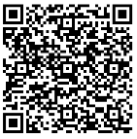
For more information, please visit: www.safetyandquality.gov.au/our-work/medication-safety/safer-naming-and-labelling-medicines/national-mixed-case-lettering-list
You can also contact the eHealth and Medication Safety team at: medsafety@safetyandquality.gov.au
Table 1: Principles for the application of ‘mixed‑case lettering’
Principle | Rationale
Use as part of a multi‑faceted approach to medication safety to differentiate LASA medicine names | ‘Mixed‑case lettering’ is one of several risk-mitigation strategies that can be used to differentiate LASA medicine names.  The Commission supports the use of ‘mixed‑case lettering’ as part of a multi‑faceted approach to reduce the risk of selection errors by clinicians associated with LASA medicines names. For instance, reducing the risk of selecting an incorrect medicine from a computerised drop-down list when a doctor is prescribing, or a pharmacist is dispensing against a medication order.  However, complementary or alternative strategies should be considered alongside the application of this technique. The Principles for safe selection and storage of medicines21 provide further advice and examples of risk-reduction strategies with a focus on LASA medicines.
Consider the medication management systems used within the HSO and assess the benefit(s) of the application of ‘mixed‑case lettering’ | Medication management systems used by HSOs can include:  - Electronic systems, including those used for prescribing, dispensing and administration of medicines  - Printed labels used for inpatient dispensing, shelving in pharmacies and in ward medicines’ storage cupboards  - Drug libraries for smart pumps  - Automated medicines storage and distribution systems.
Educate clinicians about the risks associated with LASA medicine names and the purpose of ‘mixed‑case lettering’ | Providing education to end-users, such as healthcare clinicians, about the hazards associated with LASA medicine names and the purpose of ‘mixed‑case lettering’ is a key implementation strategy.  Awareness of the purpose of ‘mixed‑case lettering’ can help users to differentiate between similar medicine names when this approach has been applied.  The Commission has developed an education resource for HSOs to use/adapt for their local education on LASA medicines and ‘mixed‑case lettering’.
Continue to be alert to new medicines or changes to medicine packaging | Given that this List is not exhaustive, it is recommended that HSOs conduct their own assessment of LASA risk with medicine names.  HSOs and clinicians should continue to be alert to new medicines that are registered in Australia and changes to the labelling and packaging of existing medicines.  With new medicines entering the market each year and in the absence of an effective pre-marketing screening method, LASA medicine names continue to pose a risk to patient safety.  HSOs and clinicians may identify some additional medicine names, via local reporting of adverse events and near misses, that could benefit from the use of ‘mixed‑case lettering’ to avoid confusion and error through mis-selection.
Conduct a local risk assessment before applying ‘mixed‑case lettering’ consistent with the Commission’s National Mixed-Case Lettering List1 | Root causes for medicine name confusion should be understood before ‘mixed‑case lettering’ is considered as a potential solution. Alternative and/or complementary differentiation strategies may be required. See the Principles for safe selection and storage of medicines.21  Risk assessment should consider:  - The likelihood that the medicine names will be confused  - The potential severity (consequence) of this confusion.  The Commission’s LASA search tool22 can assist HSOs with their local risk assessment to determine which LASA medicine names, that have been locally identified, would most benefit from ‘mixed‑case lettering’.  Information on how to use this tool, including assessment of the clinical risk(s), and apply ‘mixed‑case lettering’ to local medicine formularies, is also available:  - Information sheet on using the LASA search tool22  - Table 2: Guidance on how to risk assess and apply ‘mixed‑case lettering’ to medicine names  - Figure 1: Flowchart/decision tree for the application of ‘mixed-case lettering’  - Figure 2: Flowchart/decision tree for the application of ‘mixed-case lettering’ – worked example for ‘cyclonex’ and ‘cyclizine’
Limit the use of ‘mixed‑case lettering’ | ‘Mixed‑case lettering’ should be limited to LASA medicine name pairs or groups associated with a high risk to patient safety.  Its application will have the greatest impact on the differentiation of LASA medicine names if it is applied consistently locally and nationally (as well as internationally).  However, overuse of this technique may reduce its effectiveness. Unless additional LASA medicine names are identified locally, limit the application of ‘mixed‑case lettering’ to those medicines listed in the National Mixed-Case Lettering List.1
Alert the Commission to local medication errors, incidents or near misses involving medicine name or LASA confusion | Reporting errors, incidents and near misses allows the Commission to share this information and alert other medication safety stakeholders, and to review and consider whether additions to the List are warranted and so that national consistency in the application of ‘mixed‑case lettering’ can be maintained. Reports can be made to the Commission via medsafety@safetyandquality.gov.au.
Table 2: Guidance on how to risk assess and apply ‘mixed‑case lettering’ to medicine names
Risk assessment steps |  | Guidance
1 | CHECK the National Mixed-Case Lettering List1 | Whilst the National Mixed-Case Lettering List1 is not exhaustive, it is recommended that HSOs check if the LASA medicine names are already listed before conducting a local risk assessment.
2 | Review the associated clinical safety risk(s) along with the environmental factors related to the medicine names being risk assessed | Consideration of the context in which medicine name pairs or groups may be encountered represents a proactive attempt to reduce confusion that presents a risk of prescribing, dispensing or administration errors. Associated clinical/other factors likely to influence the likelihood of confusion in medicine selection include:  - Indication  - Available strength(s); formulation(s); route(s) of administration  - Similarity in packaging  - Shelf/storage location  - Proximity in an EMM system drop-down list.  When assessing the potential for confusion between two or more medicines, the decision‑making process might include:  - Similarity score (extreme, high, or moderate), plus  - Duplication of prefix or suffix letters, plus  - Similarity in word length, plus  - Potential for confusion based on strength(s); and/or formulation(s); and/or route(s) of administration, plus  - Proximity in a digital drop-down list or menu, plus  - Storage proximity, plus  - Potential severity, clinical consequence, or risk of harm.
3 | Use the LASA search tool22 | LASA medicines are a well-recognised cause of medication errors that are due to the appearance or orthographic (look-alike) and phonetic (sound-alike) similarities between medicines that can potentially be confused.  Usually, look-alike medicines appear visually the same with respect to packaging, shape, colour and/or size, while sound-alike medicines are similar in the phonetics of their names, doses and/or strengths. Look-alike medicine names are similar in word length or number of syllables and/or duplication of a string of letters (e.g. the same prefix or suffix).  The LASA search tool22 can assist in the identification of medicine name pairs or groups in Australia with higher orthographic and/or phonetic similarity. The result can present as an extreme, high or moderate LASA risk.
4 | Check or benchmark locally and/or against international ‘mixed‑case (or Tall Man) lettering’ lists | Other Australian states or territories may have already assessed the risk of the same LASA medicine name(s). Contact medsafety@safetyandquality.gov.au and lodge a request for state and territory feedback.  Internationally, the Institute for Safe Medication Practices (ISMP) routinely updates its list of Look-alike Drug Names with Recommended Tall Man (Mixed Case) Letters.9
5 | Seek local DTC endorsement of the rationale for application of ‘mixed‑case lettering’ | Healthcare clinicians should be involved in the process of identifying LASA medicine names, relevant to their respective practice settings. They should also participate in the review and approval process when determining the rationale for ‘mixed‑case lettering’ and/or other risk-reduction strategies to be implemented.  A user’s subjective perception of medicine name similarity is an important consideration when capitalising letters to differentiate LASA medicine names.
6 | Apply ‘mixed‑case lettering’ consistent with the Commission’s National Mixed-Case Lettering List1 | The Commission’s methodology is referred to as ‘Mid-type mixed‑case (Tall Man) lettering rule’ (‘Mid rule’).23 The ‘Mid rule’ was created by taking two or more LASA medicine names and applying a stepwise or systematic approach to the capitalisation of letters, noting that capitalisation should not be applied to:  - Common prefixes or suffixes  - The letter ‘i’ to avoid confusion with the letter ‘l’  - Letters or sections of medicine names that are phonetically similar. The number of syllables, pronunciation stresses, and placement of vowel and consonant sounds are attributes that should be considered when determining the degree of medicine name similarity.  In general, apply capitalisation by considering the following:  - Highlight three to five letters that are different  - If possible, choose letters that form a syllable  - Highlight letters closer to the beginning of the word that are different, to facilitate correct selection when electronic drop-down lists or menus are used.  Direct application of the ‘Mid rule’ may inadvertently make two medicine names appear more similar to one another or more similar to a medicine name outside a particular pair or group. In these instances, no capitalisation or an alternative capitalisation approach may need to be considered.  For groups of three or more confusable medicine names, attempts should be made to apply a capitalisation scheme that maximises distinctiveness across all possible pairings.  See to Figure 1 and Figure 2 for additional guidance and example(s) on how to risk assess and apply ‘mixed‑case lettering’.

Figure 1: Flowchart/decision tree for the application of ‘mixed-case lettering’
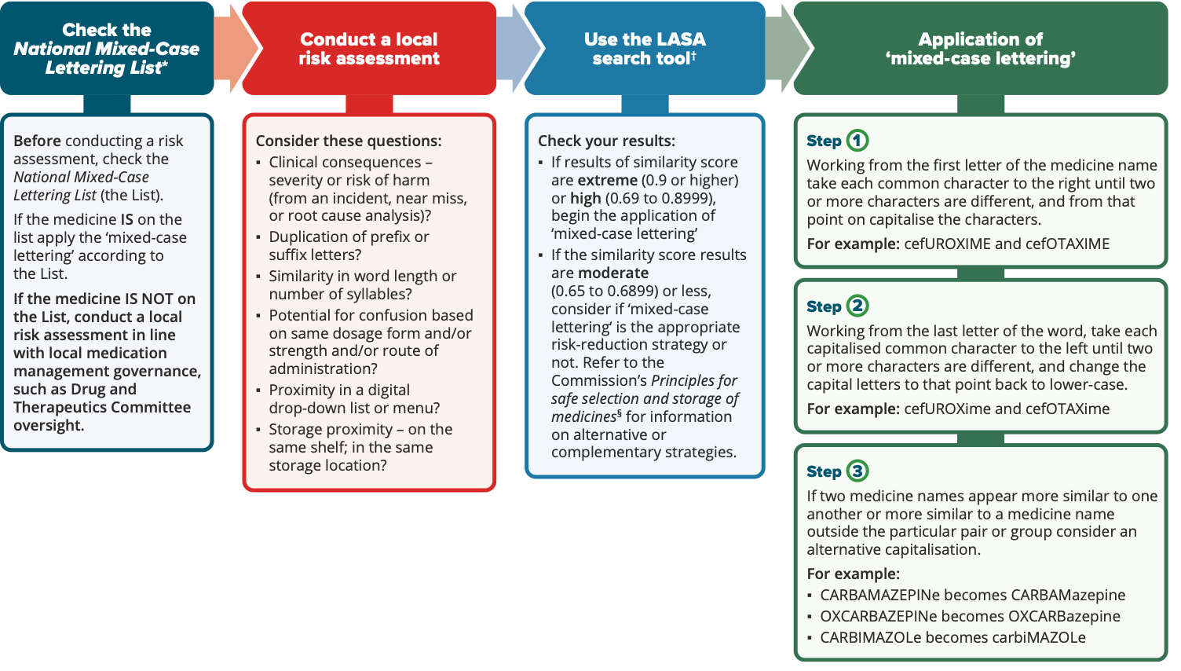
* National Mixed-Case Lettering List1 † LASA search tool22 § Principles for safe selection and storage of medicines21

Figure 2: Flowchart/decision tree for the application of ‘mixed-case lettering’ – worked example for ‘cyclonex’ and ‘cyclizine’
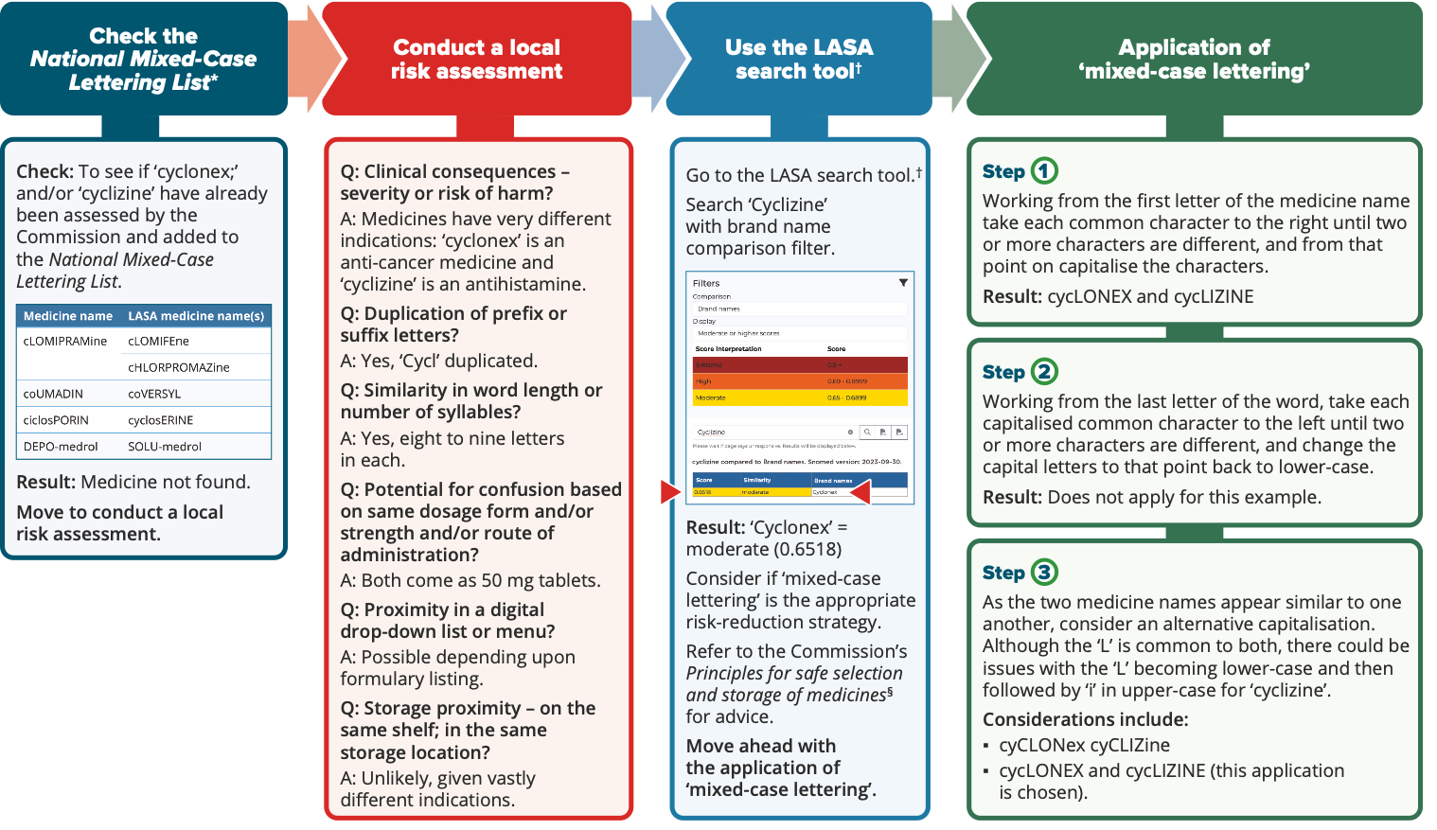
* National Mixed-Case Lettering List1 † LASA search tool22 § Principles for safe selection and storage of medicines21

References
- Australian Commission on Safety and Quality in Health Care. National Mixed-Case Lettering List. Sydney, Australia: ACSQHC; 2024. Available from: www.safetyandquality.gov.au/publications-and-resources/resource-library/national-mixed-case-lettering-list
- Filik R, Purdy K, Gale A, Gerrett D. Drug name confusion: evaluating the effectiveness of capital (‘Tall Man’) letters using eye movement data. Social science & medicine. 2004;59(12):2597–601.
- Filik R, Purdy K, Gale A, Gerrett D. Labeling of medicines and patient safety: evaluating methods of reducing drug name confusion. Human Factors. 2006;48(1):39–47.
- Gabriele S. The role of typography in differentiating look-alike/sound-alike drug names. Healthc Q. 2006;9:88–95.
- DeHenau C, Becker MW, Bello NM, Liu S, Bix L. Tallman lettering as a strategy for differentiation in look-alike, sound-alike drug names: the role of familiarity in differentiating drug doppelgangers. Applied ergonomics. 2016;52:77–84.
- Lambert BL, Lin S-J, Chang K-Y, Gandhi SK. Similarity as a risk factor in drug-name confusion errors: the look-alike (orthographic) and sound-alike (phonetic) model. Medical care. 1999;37(12):1214–25.
- Phatak HM, Cady PS, Heyneman CA, Culbertson VL. Retrospective detection of potential medication errors involving drugs with similar names. Journal of the American Pharmacists Association. 2005;45(5):616–24.
- Institute for Safe Medication Practices. ISMP Updates Its List of Drug Names with Tall Man (Mixed Case) Letters Based on Survey Results. [Internet]: Institute for Safe Medication Practices (ISMP); 2023 [cited 2023 Sep 29]. Available from: www.ismp.org/acute-care/medication-safety-alert-january-26-2023
- US Food and Drug Administration and Institute for Safe Medication Practices. FDA and ISMP Lists of Look-Alike Drug Names with Recommended Tall Man (Mixed Case) Letters. FDA and ISMP; 2023. Available from: www.ismp.org/recommendations/tall-man-letters-list
- Institute for Safe Medication Practices. List of Confused Drug Names. [Internet]: ISMP; 2023. Available from: www.ismp.org/recommendations/confused-drug-names-list
- The Institute for Safe Medication Practices Canada. Principles for the Application of TALLman Lettering in Canada. 2016. Available from: www.ismp-canada.org/download/TALLman/PrinciplesApplication-TALLmanLettering-Mar2016.pdf
- The Institute for Safe Medication Practices Canada. Application of TALLman lettering for drugs used in oncology. ISMP Can Saf Bull. 2010;10(8):1–4.
- Institute for Safe Medication Practices Canada. TALLman Lettering for Look-Alike/Sound-Alike Drug Names in Canada. [Internet]: ISMP Canada; 2015. Available from: ismpcanada.ca/wp-content/uploads/2022/02/TALLman-lettering.pdf
- Institute for Safe Medication Practices Canada. Application of TALLman Lettering for Selected High-Alert Drugs in Canada. [Internet]: ISMP Canada; 2015. Available from: ismpcanada.ca/wp-content/uploads/2021/11/Application-of-TALLman-Lettering-for-Selected-High-Alert-Drugs-in-Canada.pdf
- Institute for Safe Medication Practices Canada. Drug Labelling and the Application of TALLman Lettering Project Report. [Internet]: ISMP Canada; 2016. Available from: ismpcanada.ca/wp-content/uploads/2022/02/TALLmanLettering-ProjectReport.pdf
- The National Pharmacy Association. Look-alike sound-alike (LASA) items. October 2018. Available from: www.npa.co.uk/wp-content/uploads/2018/10/Look-alike-sound-alike-items.pdf
- World Health Organization. Patient Safety Solutions: Look-Alike, Sound-Alike Medication Names 2007 [cited 2019 Nov 9]; 1 (Solution 1). Available from: www.who.int/patientsafety/solutions/patientsafety/PS-Solution1.pdf?ua=1
- World Health Organization. Medication safety for look-alike, sound-alike medicines. Geneva: WHO; 2023. Available from: iris.who.int/bitstream/handle/10665/373495/9789240058897-eng.pdf?sequence=1
- Health Quality & Safety Commission New Zealand. Aotearoa New Zealand Tall Man lettering list: Review report. [Internet] New Zealand: HQSCNZ; 2023. Available from: www.hqsc.govt.nz/assets/Our-work/System-safety/Reducing-harm/Medicines/Publications-resources/Aotearoa_New_Zealand_Tall_Man_lettering_list_review_report_April_2020.pdf
- Health Quality & Safety Commission New Zealand. Tall Man lettering. [Internet] New Zealand: HQSCNZ; 2023. Available from: www.hqsc.govt.nz/our-work/system-safety/reducing-harm/medicines/projects/tall-man-lettering
- Australian Commission on Safety and Quality in Health Care. Principles for the safe selection and storage of medicines: Guidance on the principles and survey tool. Sydney, Australia: ACSQHC; 2020. Available from: www.safetyandquality.gov.au/publications-and-resources/resource-library/principles-safe-selection-and-storage-medicines-guidance-principles-and-survey-tool
- Australian Commission on Safety and Quality in Health Care. LASA search tool. [Internet] Sydney, Australia: ACSQHC; 2023. Available from: lasa.azureedge.net
- Australian Commission on Safety and Quality in Health Care. National Standard for the Application of Tall Man Lettering: Project Report. Sydney, Australia: ACSQHC; 2011. Available from: www.safetyandquality.gov.au/publications-and-resources/resource-library/national-standard-application-tall-man-lettering-project-report

safetyandquality.gov.au
© Australian Commission on Safety and Quality in Health Care 2024

EMM = Electronic Medication Management
Orthographic factors that increase visual similarity include similar length of the medicine names and number of groups of characters in the names
DTC = Drug and Therapeutics Committee

