

TRIM 24380

NIMC User Guide

July 2019

© Commonwealth of Australia 2019

This work is copyright. It may be reproduced in whole or in part for study or training purposes subject to the inclusion of an acknowledgement of the source. Requests and inquiries concerning reproduction and rights for purposes other than those indicated above requires the written permission of the Australian Commission on Safety and Quality in Health Care, GPO Box 5480 Sydney NSW 2001 or mail@safetyandquality.gov.au

Suggested citation

Australian Commission on Safety and Quality in Health Care (2019), National Inpatient Medication Chart User Guide. ACSQHC, Sydney.

Acknowledgment

Many individuals and organisations have freely given their time, expertise and documentation to develop the NIMC User Guide. In particular, the Commission wishes to acknowledge the work of Queensland Health for its original work in medication chart standardisation. The Commission wishes to acknowledge members of its Health Services Medication Advisory Group (formerly the National Inpatient Medication Chart Oversight Committee) for their significant contribution to this document. Finally, the Commission acknowledges all the users of the NIMC that suggest improvements and participate in audits, all of which contribute to maintenance of the NIMC User Guide. The involvement and willingness of all concerned to share their experience and expertise is greatly appreciated.

Table of contents
Introduction 4
Purpose of the NIMC 5
NIMC versions 7
General instructions 9
3.1 General requirements 9
3.2 Writing orders 9
3.3 Abbreviations, symbols and terminology 9
3.4 Essential prescribing requirements 9
3.5 Essential administration requirements 10
3.6 Pharmacy 11
4. Establishing patient ID, previous ADRs and other clinical information 11
4.1 Patient identification 11
4.2 Patient weight and height 11
4.3 Patient location 12
4.4 NIMC numbering 12
4.5 Additional charts 13
4.6 Allergies and ADR alert 13
4.7 ADR alert sticker 14
5. Recording medication history 15
5.1 Medicines taken prior to presentation to hospital 15
6. Medicine orders 17
6.1 Once only and nurse initiated medicines and pre-medications 17
6.2 Telephone orders 18
6.3 Variable dose medicines 19
6.4 Venous thromboembolism prophylaxis 20
6.5 Warfarin 22
6.6 Anticoagulant education record 23
6.7 Regular medicine order 24
6.8 Pharmaceutical review 25
6.9 Discharge supply 25
7. Medicine Orders: PRN (as required) 30
7.1 PRN order 30
8. Paediatric NIMC: Additional safety features 32
Patient weight, date, height, and body surface area 32
Gestational age at birth 32
Dose calculation 32
Administration of medicines 32
Additional reason for not administering medicine code 32
Appendices 33
Appendix A: NIMC resources 33
Appendix B: Guidelines for administering and withholding medicines 34
Appendix C: Ordering oral and enteral nutrition supplements on the NIMC 35
Appendix D: Ordering and administering medical gases on the NIMC 36
Appendix E: NIMC (GP e-version) User Guide 37
Appendix F: Summary Rationale for the National Inpatient Medication Chart 38

Introduction

The National Inpatient Medication Chart (NIMC) is a standardised tool for communicating patient medication information consistently between health professionals. It is based on standardised processes for medicines prescribing, dispensing, administering and reconciling in health service organisations. A national, standard medication chart ensures that health professionals are familiar with the layout of the chart and the safe medication management principles on which it is based no matter where they practice. Use of the NIMC is mandatory for all Australian public and private health service organisations including day procedure services. The evidence-based principles that guided development of the NIMC are applicable to all healthcare settings. Because it is national standard, the NIMC is incorporated into health professional under-graduate curricula and into safe medication management competency frameworks and materials. Health professionals are familiar with the NIMC from their first day in practice. The NIMC reflects best practice and is evidence-based. It is designed to assist health professionals improve the safety and quality of medication management. It is also intended as a tool to minimise the risk of adverse medication events.
Consistent documentation allows accurate interpretation of orders
Research shows that many adverse events reported in Australian health service organisations are associated with medicines. Research also demonstrates that standardisation and improvements to medication chart design can improve the safety of medication processes. The NIMC was developed by a group of health care professionals (including public and private sector nursing, medical and pharmacy staff) from states and territories across Australia and who were often involved in similar medication chart standardising projects within their own health service organisations.
Australian Health Ministers required a common inpatient medication chart to reduce the incidence of preventable patient harm by standardising and consistently documenting medicines. As demonstrated in the Commission’s 2008 NIMC Quality Improvement Project and subsequent NIMC national audits, the NIMC is used widely in healthcare facilities nationally and reduces key risks of prescribing and administration error.
Nationally maintained support materials
The NIMC is supported by a large range of nationally consistent and maintained resources. These include resources for health professional education, guidance on use of the NIMC and NIMC auditing resources.
A full list of the NIMC supporting resources is available at Attachment A of this document.
Use exceptions
The NIMC is not designed for charting and recording administration of:
- enteral nutritional supplements or
- medical gases
See Appendices C and D for additional information on these issues.
Electronic medication management systems
The NIMC represents national agreement on standardised presentation and communication of medication information and the processes which underpin them. It is a sound basis for future electronic medication management initiatives. The Commission encourages safe implementation of electronic systems to improve medication safety and quality and works with other national organisations to achieve a nationally consistent approach to it.

Electronic Medication Management Systems: A Guide to Safe Implementation (3nd Edition) has been produced by the Commission to assist health service organisations to safely implement electronic medication management systems.

Purpose of the NIMC

The NIMC is a suite of nationally standard medication charts, both paper and electronic, that present and communicate information consistently between healthcare professionals providing care to patients on the intended use of medicines for an individual patient.

Its purpose is to reduce the risk of prescribing, dispensing and administration error by health professionals through standardised presentation of information on the intended use of medicines for an individual patient, and through standardised presentation of medicines information in all high risk healthcare settings.

NIMC use mandated requirement for accreditation
Use of the NIMC is a mandatory requirement for health service organisations seeking accreditation against National Safety and Quality Health Service (NSQHS) Standard 4 Medication Safety.

Medication management in health service organisations should also accord with other NSQHS Standards including NSQHS Standard 5, Patient Identification and Procedure Matching.
The requirement on health service organisations is to use relevant NIMCs which have been agreed nationally and which incorporate the NIMC elements and layouts.

Electronic medication management systems are required to incorporate the full range of NIMC safety features as a minimum.
Non-conforming medication charts:
- will not be verifiable for accreditation purposes
- cannot be audited through use of the NIMC Audit System
- are not reflected in any nationally maintained support materials including education resources
- may create medico-legal risks for health service organisations in the event of patient harm related to medication misadventure.

Managing the NIMC locally
The NIMC can be managed locally by health service organisations. The NIMC Local Management Guidelines provide detailed guidance on the scope of changes to the NIMC which can be authorised at local levels (i.e. state / territory, private health service chain / local hospital network and individual health service organisation). It describes the process for managing NIMC issues which cannot be managed locally and which need to be referred to the national level for consideration. The NIMC Local Management Guidelines are available at: http://www.safetyandquality.gov.au/wp-content/uploads/2014/01/NIMC-Local-Management-Guidelines.pdf

Application of adhesive labels to the NIMC
There may be circumstances where use of an adhesive label to alert staff to a medicine or medicine(s) are appropriate. However, use of adhesive labels as a mechanism to alert should be used judiciously and considered within the health service organisation’s context. There should be a process around their application, ensuring they do not obscure a pre-existing medicine order. There is no guarantee that labels will be applied consistently and health services considering the use of such labels should undertake an assessment of their effectiveness prior to broader implementation.

Application of adhesive labels to constitute a medicine order is generally not advised. Health services considering use of adhesive labels in this way should contact the relevant Pharmaceutical Services Branch for their jurisdiction in the first instance to determine whether the practice is permitted. Where use of labels is accepted, a risk assessment approach must be used to determine the safety and effectiveness of their use. Any risks identified must be addressed prior to implementation.

Limitations of this guide
The NIMC User Guide provides guidance and best practice advice to health service organisations on use of the national inpatient medication chart.

The Commission recognises that some jurisdictions have made state-wide modifications to the standard national chart. For information regarding these changes, the relevant representative from the Health Services Medication Expert Advisory Group or health department should be contacted.

Legislative requirements for prescribing, administering and dispensing medicines vary between jurisdictions.

While every effort has been made to incorporate relevant legislative information in this guide, some of the more specific requirements or limitations may not be discussed. It is the responsibility of each health service organisation to know and comply with legislation relevant to their jurisdiction.

NIMC versions

The NIMC is a suite of standard medication charts. Use of the NIMC is mandatory and can be demonstrated by implementation and use of one, or more, of the following NIMC versions. Charts are available in formats designed for private health services.

All versions of the NIMC are available from the Commission web site in low and high resolution PDF files. Design files can be requested by contacting the Commission directly on mail@safetyandquality.gov.au

1. NIMC (acute)
The NIMC (acute) is a medication chart designed for patients in acute care. It is used across health service organisations in medical and surgical wards, emergency departments and intensive care units. The NIMC (acute) available on the Commission web site has 10.5 days of administration.

2. NIMC (long-stay)
The NIMC (long-stay) is designed for long-term, stable adult patients in acute care. For example, the NIMC (long-stay) may be suitable for patients in spinal units and rehabilitation units. The NIMC (long-stay) available on the Commission web site has 28.5 days of administration.

3. NIMC (paediatric) and NIMC (paediatric long stay)
In 2008, Australian Health Ministers endorsed paediatric versions of the NIMC (acute) and NIMC (long stay). The paediatric NIMCs have additional features to improve prescribing safety for paediatric inpatients including neonates. These charts should be used for all children aged 12 years and less.
Use of the safety features specific to the paediatric NIMCs is outlined in Section 8 of this guide. Unless otherwise indicated, all other guidance in this document is relevant to the paediatric NIMCs.

4. NIMC (paediatric) and NIMC (paediatric long-stay) in private health service organisations
Private health service organisations often face a unique challenge in relation to safe medication charting. The Pharmaceutical Benefits Scheme requires separate, signed prescriptions for each medication order and pharmacy arrangements may require separate paper-based orders for dispensing. The NIMC paediatric for private health service organisations includes the same design and safety features of the NIMC paediatric for public hospitals (see above) but incorporates tear away sections for pharmacy orders and Medicare Australia claiming purposes.
See also Pharmaceutical Benefits Scheme Hospital Medication Chart (PBS HMC) short-stay and long-stay versions for adult patients.

5. NIMC (GP e-version)
General practitioners who prescribe for inpatients (usually in rural and remote health service organisations) need to issue medicine orders in NIMC compliant formats. To accommodate this requirement, the NIMC (GP e-version), a four A4 page version, was developed for incorporation in general practice electronic prescribing software. This allows general practitioners to print out medicine orders for inpatients in the NIMC (acute) format and permits recording of inpatient medicines administration using the standard NIMC process. Additional advice on use of the NIMC (e-version) forms Appendix E to this guide.

6. NIMC (day surgery)
The NIMC (day surgery) is a two-side A4 medication chart which has no regular medicine order spaces. It incorporates standard NIMC features as well as features suitable for day procedure services:
- IV fluid administration
- VTE risk assessment section without prophylaxis ordering

7. Clozapine titration chart
The clozapine titration chart is intended to be used as a record of the prescribing, monitoring and administration of clozapine titration for adult patients. It is used in conjunction with the NIMC (acute) or NIMC (long-stay) or the private health service organisation versions of them.

When clozapine is used for maintenance treatment, the NIMC (acute) or NIMC (long-stay) or private health service organisation versions should be used.
Guidance on the use of the clozapine titration chart is available in a separate document to the NIMC User Guide.

8. Subcutaneous insulin chart (adult)
The National subcutaneous insulin chart and support materials were released in July 2017. Two versions are available, one for use in acute hospitals, the other for sub-acute and mental health facilities. The charts and support materials can be accessed on the Commission’s website: https://www.safetyandquality.gov.au/our-work/medication-safety/medication-charts/national-standard-medication-charts/national-subcutaneous-insulin-chart/ .

9. National Medication Management Plan
The National Medication Management Plan (MMP) provides health service organisations with a standardised form that can be used by nursing, medical, pharmacy and allied health staff to improve the accuracy of information recorded on admission and is available to the clinician responsible for therapeutic decision making.

A standardised form to record the medicines taken prior to presentation at the health service organisation and used for reconciling patients’ medicines on admission, intra-health service transfer and at discharge is considered essential for the medication reconciliation process. The national MMP provides Australian health service organisations with a form designed specifically for these purposes The national MMP is designed for use in adult and paediatric patients.

General instructions

3.1 General requirements
- All prescribers must order medicines for inpatients consistent with state or territory health regulations.
- The NIMC is to be completed for all patients and placed at the foot of the bed unless ward/unit procedures state otherwise.
- All medicines should be reviewed regularly to identify potential drug interactions and to discontinue medicines that are no longer required.
- Specific ordering charts may be required for specialised medicine orders such as insulin, intravenous fluids, anticoagulants, parenteral cytotoxic and immunosuppressive agents, epidural and regional infusion and patient-controlled analgesia.

3.2 Writing orders
All orders are to be written legibly in ink
- No matter how accurate or complete an order is, it may be misinterpreted if it cannot be read.
- Water soluble ink (e.g. fountain pen) should not be used.
- Black ink is preferred.
- A medicine order is valid only if the prescriber enters all the required items.
- All information, including medicine names, should be printed.
- No erasers or “whiteout” can be used. Orders MUST be rewritten if any changes are made, especially changes to dose and/or frequency.

3.3 Abbreviations, symbols and terminology
Australia has agreed national standards for terminology, abbreviations and symbols used in the prescribing and administration of medicines. It provides:
- Principles for consistent prescribing terminology
- A set of recommended terms and acceptable abbreviations
- A list of error-prone abbreviations, symbols and dose designations that have a history of causing error and must be avoided.
Recommendations for Terminology. Abbreviations and Symbols used in the Prescribing and Administration of Medicines is available from the Commission’s web site.

3.4 Essential prescribing requirements
Date
The date that the medicine order was written should be entered. It is not the date that the medicine was originally ordered. The prescriber will need to locate the original order date if required.
Generic (active ingredient) medicine name
Because there may be several brands of one agent available, the generic name should be used if possible unless combination preparations are being ordered e.g. Movicol. Generally the pharmacy department will stock and supply only one brand of each generic medicine.
Route
Only commonly used and understood abbreviations should be used to indicate the route of administration.

Generally, medicine orders should be for one route only. However, local requirements may indicate other practice. Health services should be aware of risks associated with medicine orders with multiple routes of administration. A health service-specific list of exceptions to the general rule should be determined in conjunction with the health service’s drug and therapeutics committee or equivalent and appropriate risk mitigation strategies put in place.

Dose
Doses must be written using metric and Arabic e.g. 1,2,3, etc. systems. Never use Roman numerals e.g. i, ii, iii, iv, etc. Acceptable abbreviations are listed below.
Always use zero (0.) before a decimal point e.g. 0.5g otherwise the decimal point may be missed. However if possible it is preferable to state the dose in whole numbers, not decimals e.g. write 500mg instead of 0.5g or write 125microgram instead of 0.125mg.
Never use a trailing zero (.0) as it may be misread if the decimal point is missed e.g. 1.0 misread as 10.
Do not use U or IU for units because it may be misread as zero. Always write units in full.
Also see Section 8 for paediatric NIMCs.

Note: In the case of liquid medicines, the strength and the dose in milligrams or micrograms (not millilitres) must always be specified e.g. morphine mixture (10mg/mL) Give 10mg every 8 hours
Note: The ward/clinical pharmacist will clarify when the strength supplied is different from that ordered e.g. for 10mg the pharmacist may write 2 x 5mg tablets or for 25mg the pharmacist may write half a 50mg tablet.
Frequency and administration times
The prescriber ordering a regular medicine must enter the frequency and administration time(s) when writing the order. This will prevent errors where the person administering the order misinterprets the frequency and writes down the wrong times. If these details are not entered, the dose may not be administered by nursing staff.
Times should be entered using the 24 hour clock which is the universal standard.
Medicines should be administered according to the Recommended Administration Times unless they must be given at specific times (e.g. some antibiotics, with/before food) or, as in the case of young children with variable meal and sleep schedules, a specific schedule is required.
If necessary, the ward/clinical pharmacist or nurse will clarify the administration time to correctly administer the drug (e.g. in relation to food) and annotate the NIMC to indicate it has occurred.
Indication
Most NIMC order spaces require the prescriber to document the indication. Indication is critical clinical information for other health professionals involved in medicines management. It allows the order to be reviewed in the context of why the medicine was prescribed, reducing the risk of misinterpretation of the order e.g. medicines with look-a-like names or incorrect doses and for medicines which have different doses for different indications.
Prescriber Signature and Print Name
The signature of the prescriber must be written to complete each medicine order. For each signature (prescriber), their name must be written in print at least once on that medication chart.
Private health service NIMC versions generally require a prescriber number as well.

3.5 Essential administration requirements
Accurately recording medicines administration is a critical part of safe medication management and can reduce the risk of medication error through inadvertent under or over-dosing.
Those administering medicines also play an important role in identifying prescribing and dispensing errors before they reach the patient.

Always remember the following safety checking list:
Right medicine (that matches the order and the patient’s condition)
Right dose (that matches the order and is safe for the patient)
Right route (that matches the order and is appropriate for the medicine and the patient)
Right time (that matches the order and its frequency and administration time directions)
Right patient (that matches the patient ID on the NIMC, the label on the dispensed medicine and is confirmed by the patient using three identifiers, if possible).

3.6 Pharmacy
NIMC medicine order spaces generally have a space for use by the ward/clinical pharmacist to clarify the order, indicate source of supply or provide administration instructions.
Annotations in the space can include:
I | Medicines available on imprest
S | Non-imprest items that will be supplied and labelled for individual use from the pharmacy
Pts own | Medicines brought in by the patient that have been checked by the pharmacist and confirmed to be acceptable for use during the patient’s admission
CD, S8 | Schedule 8 medicine (stored in CD cupboard)
Fridge | A medicine that is stored in the refrigerator

4. Establishing patient ID, previous ADRs and other clinical information

4.1 Patient identification
Found on all NIMCs

Purpose |  | To establish the patient’s identity before prescribing commences
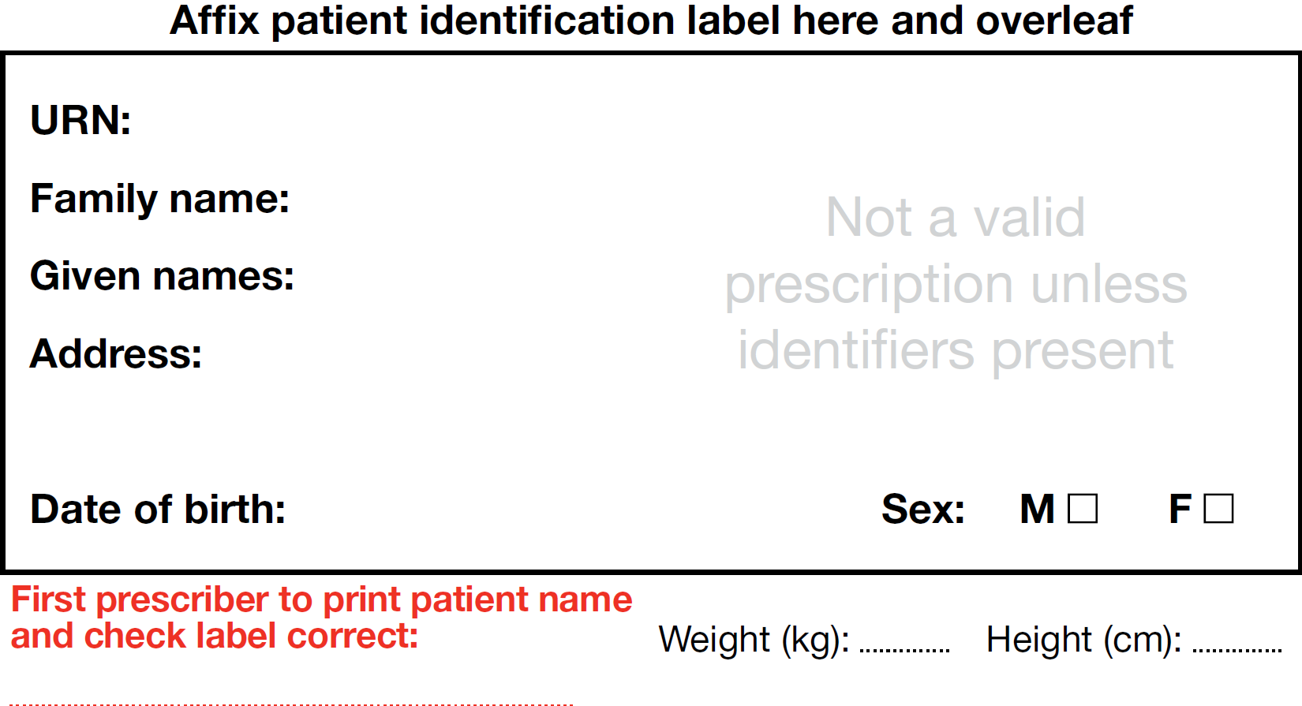
Figure above shows the NIMC identification section
Use | Adhere a patient identification label in the space provided or hand write the patient name, UR number, date of birth and gender in legible print.  The first prescriber must check the patient’s identity and print the patient’s name to document confirmation. This should occur on the front and back page where ID labels are adhered.  Medicine orders should not be administered if the prescriber does not document the patient identification.
Risk addressed | Not correctly identifying patients can result in missed and incorrect doses.  Using three approved patient identifiers to establish patient identity satisfies NSQHS Standard 4.

4.2 Patient weight and height
Found on all NIMCs with additional information required in NIMC (paediatric) and NIMC (paediatric long-stay)
Purpose | To ensure patient weight and height are available at the point of prescribing as it is important clinical information and vital for confirming doses of certain medicines

Figure above shows the NIMC weight and height recording section.
Use | Write patient weight and height in the space provided.  For the NIMC (paediatric) and NIMC (paediatric long-stay), also write when weight was measured, body surface area and gestational age at birth.
Risk addressed | Weight is important clinical information for correctly prescribing some medicines and for at risk patients such as paediatric patients and patients with renal impairment.


Figure above shows the NIMC (paediatric) and the NIMC (paediatric long-stay) weight and height recording section.

4.3 Patient location
Found on all NIMCs
Purpose
To record patient location on the medicines record of truth

Figure above shows the NIMC patient location section.
Use | Write the patient’s current location in the NIMC patient location section.
Risk addressed | Patient location details reduce the risk of the wrong NIMC being used for patients.

4.4 NIMC numbering
Found on all NIMCs

Purpose | To communicate the existence of more than one active NIMC
Figure above shows the NIMC numbering device.
Use | Write the number of the NIMC in the sequence of active NIMCs e.g. Medication chart number 1 of 2. The information must be updated if additional active NIMCs are created.
Risk addressed | Failure to communicate that there is more than one active NIMC can result in missed doses or duplicate prescribing.  Clinicians need access to all medicines information to ensure safe treatment and care of patients.

4.5 Additional charts
Found on all NIMCs
Purpose |  | To communicate the existence of other specialist charts.  Please also refer to section 6.7 Regular medicine orders- Further information, Medicine orders prescribed on an additional (specialty) chart
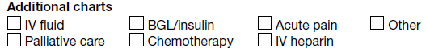
Figure above shows the NIMC additional charts section.
Use | Place a tick or cross in the space provided to indicate additional specialist charts in use.
Risk addressed | Failure to communicate additional specialist charts may result in missed doses or duplicate prescribing.

4.6 Allergies and ADR alert
Found on all NIMCs
Purpose | To communicate the existence of previous allergies, adverse drug events (ADRs) and related information
Figure above shows the NIMC allergies and ADR section.
Use | Attending health professionals must obtain and record previous allergies and ADRs including:  - the medicine (or substance)  - reaction details (e.g. rash, diarrhoea) and type (e.g. allergy, anaphylaxis)  - date that it occurred or approximate time frame (e.g. 20 years ago).  Tick Nil known if the patient is not aware of any previous ADRs or allergies.  Tick Unknown if no information is available about previous reactions (e.g. if the patient is unable to communicate).  If there are more than four previous allergies or ADRs to record, use the fifth line to refer other health professionals to the health record for additional information.  Once completed, sign the space underneath, print name and date.  Note: This is the minimum information that should be documented. It is preferable also to document how the reaction was managed (e.g. withdraw and avoid offending agent) and the source of the information (e.g. patient self report, previous documentation in health record etc).  Any information added after the initial recording needs to be initialled in the side column.
Risk addressed | Failure to communicate previous allergies or ADRs can result in re-prescribing of offending medicines and avoidable patient harm.

4.7 ADR alert sticker
Found on all NIMCs
Purpose | To communicate highlight the existence of previous allergies and adverse drug events ADRs) recorded in the Allergies and ADR alert section.
Figure above shows the NIMC ADR alert sticker section.
Use | Affix an ADR alert sticker to the front and back page of the NIMC in the spaces provided if alert stickers are available in your facility.
Risk addressed | Failure to communicate and alert health professionals to previous allergies or ADRs can result in re-prescribing of offending medicines.
Adverse Drug Reaction

Figure above shows the NIMC ADR sticker (available on the Commission’s web site).

5. Recording medication history

5.1 Medicines taken prior to presentation to hospital
Found on all NIMCs
Purpose | To record and communicate the patient’s medication history
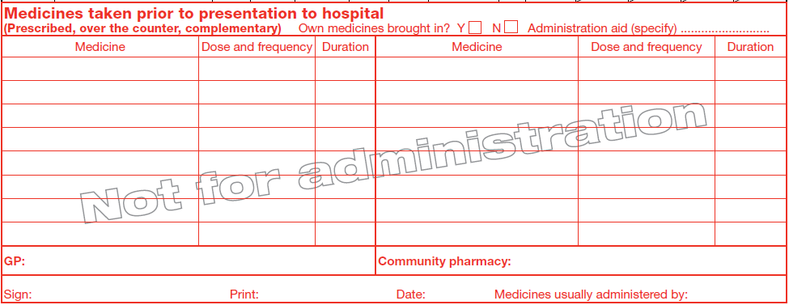
Figure above shows the NIMC medication history section.
Use | A health professional trained in medication history taking must document:  - A complete list of all medicines taken normally at home (prescription, non-prescription and complementary medicines) including drug identification details (generic name, strength and form), dose and frequency, and duration of therapy/when therapy started.  - Whether the patient:  - has their own medicines with them  - uses a dose administration aid (e.g. Webster Pack or other blister pack)  - has a preferred dosage form (e.g. suspension for paediatric patients)  - receives assistance to administer/manage their medicines.  - Contact details for the patient’s community health providers (general practitioner and community pharmacist).  Any unintentional discrepancies between the medication history and the medicine orders must be brought to the attention of the prescriber.  Use a separate medication history form (such as the National Medication Management Plan) for patients presenting with sixteen or more medicines.  Note: It is also helpful to document the indication for use and to use a checklist as a prompt to ensure a comprehensive history is obtained.
Risk addressed | A correct and complete medication history at the point of prescribing reduces the risk of medication misadventure.

Recording medication history: Further information
Patient medication history may also be recorded on:
- National Medication Management Plan form
- Local medication history form.
If a separate form is used, it should be noted in the Medicines taken prior to admission section and the separate form should be kept with, or next to, the NIMC.

National Medication Management Plan (MMP) Form
The MMP provides health service organisations with a standardised form that can be used by nursing, medical, pharmacy and allied health staff to improve the accuracy of information recorded on admission and available to the clinician responsible for therapeutic decision making.
A standardised form to record the medicines taken prior to presentation at the health service organisation and used for reconciling patients’ medicines on admission, intra-health service transfer and at discharge is considered essential for the medication reconciliation process. The MMP provides Australian health service organisations with a form designed specifically for these purposes The MMP is designed for use in adult and paediatric patients.
The MMP aligns with the Australian Pharmaceutical Advisory Council’s Guiding principles to achieve continuity in medication management. It incorporates the minimum data set for a medication history outlined in Guiding Principle 4: Accurate medication history.
The MMP, National Medication Management Plan User Guide and other implementation resources are available from the Commission’s web site at https://www.safetyandquality.gov.au/our-work/medication-safety/medication-reconciliation/medication-management-plan
Refer to local health service policy for more information about a comprehensive approach to documenting the patient’s medication history.
Figure below shows pages 2 and 3 of the National Medication Management Plan form including the medication history section.
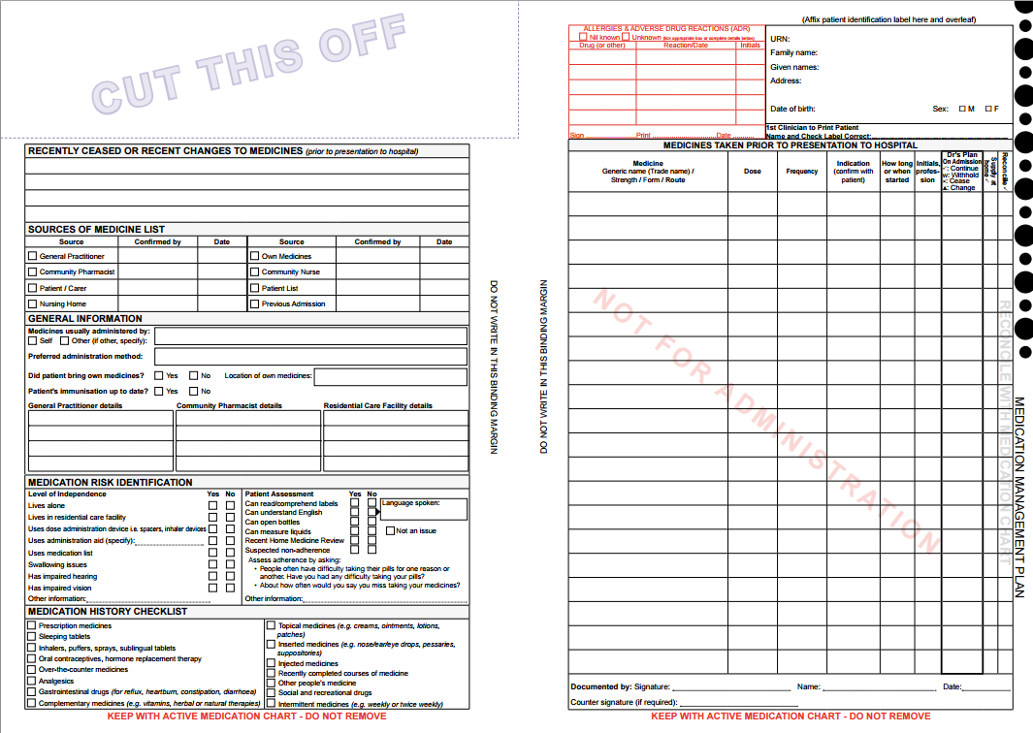

6. Medicine orders

6.1 Once only and nurse initiated medicines and pre-medications
Found on all NIMCs (section titled Once only medicines on NIMC (paediatric) and NIMC (paediatric long-stay)
Purpose | To document once only and nurse initiated medicines and pre-medications
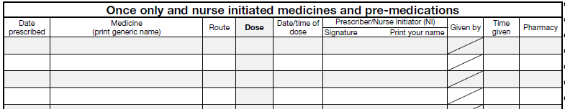Figure above shows the NIMC once only and nurse initiated medicines and pre-medications section.
Use | Once only medicines and pre-medications  Document the following for once only and pre-medication orders:  - date prescribed  - generic name of medicine  - route of administration  - dose to be administered including the dose calculation (e.g. mg/kg/dose) for paediatric NIMC orders  - date and time medicine is to be administered  - prescriber’s signature and printed name  - initials of person that administers the medicine, and initials of a second person to document double checking of the dose for paediatric NIMC orders  - time medicine administered  - pharmacist review of orders.  Standing orders  Document standing orders the same as once only medicines and pre-medications (see above) and consistent with the relevant local health service organisation policy or guideline.  Nurse initiated medicines  Document nurse initiated medicines the same as once only medicines and pre-medications (see above) and consistent with the relevant local health service organisation policy or guideline.
Risk addressed | Ensuring patients receive timely medicines requires a structured system of authorisations to mitigate potential patient safety risks.
Figure below shows the once only medicines section of the NIMC (paediatric) and NIMC (paediatric long-stay).
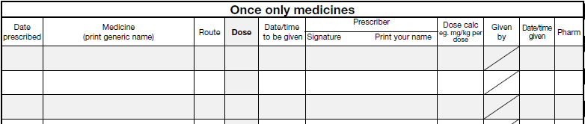

Nurse initiated medicines: Further information
Nurse initiated medicines are non-prescription medicines that may be administered by a registered nurse or midwife, or delegated to an authorised enrolled nurse in non-life threatening situations without a prior written or telephone instruction from an authorised prescriber.

The medicine must be listed on the health service organisation’s approved list of nurse initiated medicines and administered in accordance with local policy. Some health service organisations do not permit nurse initiated medicines to be administered to paediatric patients.

Local policy or guideline will outline when nurses can initiate medicines and will specify a limit on doses of nurse initiated medicines that can be given such as for one dose only or for a maximum of 24 hours only. Generally this applies to a limited list of unscheduled, Schedule 2 and Schedule 3 medicines. Typically this list includes:
- analgesics
- laxatives
- antacids
- cough suppressants
- sublingual nitrates
- inhaled bronchodilators
- artificial tears
- sodium chloride 0.9% flush
- IV infusion to keep IV line(s) patent as per local policy.

6.2 Telephone orders
Found on all NIMCs
Purpose | To document telephone orders
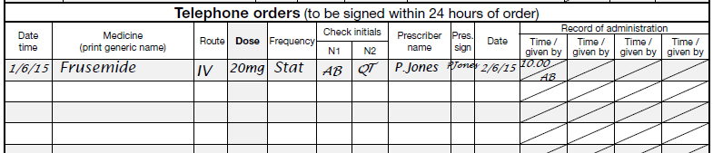
Figure above shows the NIMC telephone orders section with order recorded, checked and signed.
Use | Document the following for telephone orders:  - date prescribed  - generic name of medicine  - route of administration  - dose to be administered including the basis for the dose calculation (e.g. mg/kg/dose) for paediatric NIMC orders  - frequency medicine is to be administered  - initials of two nursing staff to confirm the verbal order heard and double checked (see example above)  - name of prescriber giving verbal order  - date and time medicine is to be administered  - prescriber’s signature and printed name  - initials of person that administers the medicine, and initials of a second person to document double checking of the dose  - time medicine administered.  Local policy/guideline will outline whether telephone orders are allowed and under what circumstances they are to be used.  The telephone order MUST be signed and dated, or otherwise confirmed in writing by the prescriber, within 24 hours.
Risk addressed | Ensuring patients receive timely medicines in the absence of a prescriber requires a structured system of authorisations to reduce risk of errors from verbal orders.

6.3 Variable dose medicines
Found on NIMC (acute), NIMC (GP e-version)

Purpose |  |  | To document variable dose medicine orders that require laboratory test results or are prescribed as a reducing protocol (e.g. gentamicin and steroids respectively)
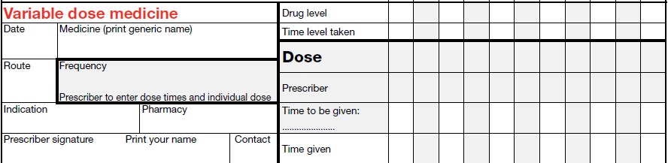
Figure above shows the NIMC variable dose medicine section.
Use |  |  | Document the following:  - date prescribed  - generic name of medicine  - route of administration  - time medicine to be administered  - indication.  Document the following for each day of therapy:  - drug level results for medicines requiring therapeutic monitoring  - time drug level taken.  Document the following for each dose:  - dose  - prescriber’s initials  - initials of the person who administers the dose (written in the Time to be given row)  - actual time of administration which may be different from the dose time (written in the Time given row).  If a patient requires a second variable dose medicine, or twice daily dosing, prescribe the second medicine or the second dose in a regular medicine space using the same format as in the Variable Dose Medicine section.
Risk addressed |  |  | There is no designated area to record drug levels if these agents are ordered in the regular ordering section.  The risk of omission is increased if variable dose medicines are ordered in the once-only ordering section.
Variable medicine doses: Further information
The NIMC (long-stay) does not have a dedicated variable dose section. Health service organisations will need to ensure policies are in place so that variable dose therapies are transferred accurately for patients transitioning from the NIMC to the NIMC (long-stay).

6.4 Venous thromboembolism prophylaxis
 |  | Found on NIMC (acute) and NIMC (GP e-version) In a modified form on NIMC (day surgery)
Purpose |  | To document VTE risk, contraindication and prophylaxis orders
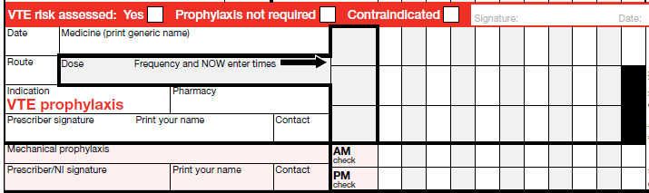 Figure above shows the NIMC VTE prophylaxis section.
Use | Assessing VTE risk and chemo and mechanical prophylaxis contraindication  Assess patient’s VTE risk and:  - Tick the risk assessed box  - Tick the prophylaxis not required box if appropriate  - Tick the contraindicated box if appropriate and document in the health record (and strike out chemo and/or mechanical prophylaxis sections as appropriate)  - Sign and date.  VTE chemo prophylaxis  Document the following:  - date prescribed  - generic name of medicine  - route of administration  - dose to be administered  - date and time medicine is to be administered  - prescriber’s signature, printed name and contact details  - initials of person that administers the medicine.  Three dose time sections allow these medicines to be administered up to three times a day.  The indication section is pre-printed with ‘VTE Prophylaxis’.  If the dose of VTE prophylaxis medicine needs to be changed, a new order should be prescribed on a subsequent chart.  VTE mechanical prophylaxis  Document the following:  - type of mechanical prophylaxis required e.g. graduated compression stockings  - prescriber’s signature, printed name and contact details.  Nursing staff may have responsibility for ordering mechanical prophylaxis depending on local policy.  AM and PM have been pre-printed in the administration space to encourage checking and documenting that patients receive mechanical prophylaxis correctly.

Risk addressed | Healthcare-associated VTE is a national health safety and quality issue. Research demonstrates that including a prompt for VTE risk assessment and for prophylaxis prescribing improves the rate of VTE risk assessment and of appropriate prophylaxis prescribing.
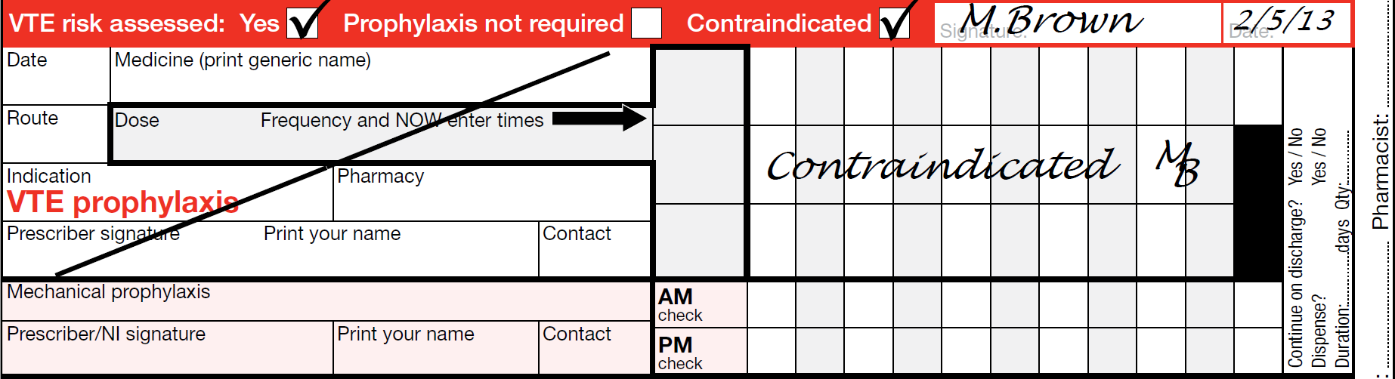
Figure above shows the VTE prophylaxis section with chemo prophylaxis section struck out, signed and dated as it is contraindicated.
VTE prophylaxis section: Further information
This VTE prophylaxis section is designed to prompt documentation of:
- VTE risk assessment
- contraindications to VTE prophylaxis
- ordering of pharmacological and mechanical VTE prophylaxis if indicated.
The VTE prophylaxis section is placed above the dedicated warfarin section to assist recognising patients who are already receiving therapeutic anticoagulation and do not require VTE prophylaxis.
Whoever is responsible for assessing patient VTE risk should do so according to local policy and then document the outcome.
In some health service organisations, documentation of the risk assessment will be done by the admitting medical officer/authorised prescriber. In others, it will be the responsibility of the nursing staff. The risk assessment should be completed consistent with local policy and in relation to the patient’s clinical status at that point. For patients who have multiple charts, the VTE risk assessment should be documented on the first chart. Reassessment of risk may be required depending on changes to clinical status, medicines and other circumstances and should be documented in the VTE risk assessment section on one of the subsequent charts.
If the dose of VTE prophylaxis medicine needs to be changed, a new order should be prescribed on a subsequent chart.
The NIMC (long-stay) does not have a dedicated VTE prophylaxis section. Health service organisations will need to ensure policies are in place so that VTE prophylaxis therapies are transferred accurately for patients transitioning from the NIMC to the NIMC (long-stay).

VTE therapy / treatment
If VTE therapy is required e.g. for a pre-existing DVT, it should be ordered in the regular medicines space and not in the pre-printed VTE prophylaxis section.

6.5 Warfarin
Found on NIMC (acute), NIMC (long-stay) and NIMC (GP e-version).

Purpose |  | To document warfarin orders and record INR results
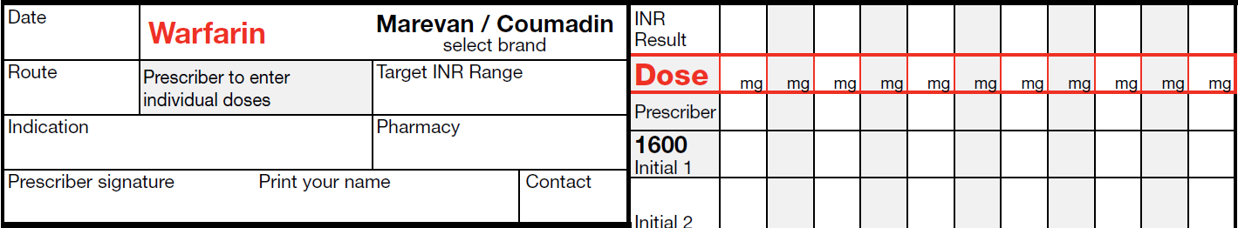
Figure above shows the NIMC warfarin section.
Use | Document the following:  - date prescribed  - circle required brand name  - route of administration  - dose to be administered  - target INR range  - indication  - prescriber’s signature, printed name and contact details.  For each day of therapy, document the following information:  - INR result  - warfarin dose  - prescriber’s initials  - initials of person that administers the medicine, and initials of a second person to document double checking of the dose
Risk addressed | Warfarin is a medicine with a high risk of patient harm from missed or duplicate doses and from prescribing not linked to INR results. The NIMC dedicated warfarin space incorporates warfarin prescribing with INR result recording, and incorporates it into the standard medication chart, reducing the risks from poor prescribing and from duplicate or missed doses resulting from a separate warfarin chart.
Warfarin section: Further information
The warfarin ordering section is printed in red as an extra alert to indicate that it is an anticoagulant (and a high-risk medicine).

It is recommended that a copy of guidelines for anticoagulation using warfarin is available for health professionals to assist when a patient is commenced on warfarin. The guidelines should include information about target INR, duration of therapy, dosing, management of excessive bleeding and drug interactions.
A standard administration time of 1600 hours (4 p.m.) is recommended (and pre-printed) as this allows the team caring for the patient to order the next dose based on INR results, rather than leaving it for after-hours staff to do.

6.6 Anticoagulant education record
Found on NIMC (acute), NIMC (long-stay) and NIMC (GP e-version).
Purpose | To document education provided at the initiation of anticoagulant therapy prescribed for ongoing treatment.
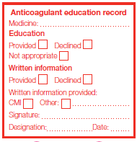 | 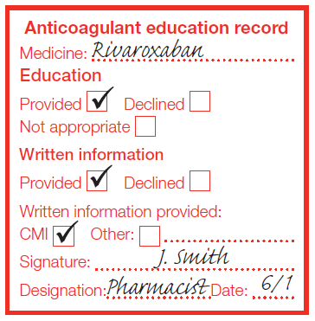

Figure above (left) shows the anticoagulant education record as printed on the chart. Figure above (right) shows an example of a completed anticoagulant education record.
Use | The health professional who intends to provide education should document:  - name of anticoagulant (medicine) prescribed for ongoing treatment  - whether education for the anticoagulant was provided, declined or was not considered appropriate for the patient. The choice of ‘not appropriate’ should be in line with local policy. It may include instances where the patient has taken the medicine before or where the patient is cognitively impaired.  - whether written information about the anticoagulant was provided or whether it was declined by the patient  - what written information was provided the patient; Consumer Medicine Information (CMI) and/ or other (specify)  - health professional signature  - their designation, for example nurse, pharmacist or doctor  - date signed.
Risk addressed | Anticoagulants are medicines with high risk of patient harm if not taken correctly. Documenting that an education session has been conducted with the patient ensures all healthcare staff know the patient has been instructed on how to manage their anticoagulant medicine safely, including any required monitoring and dose adjustment for ongoing use.  This section records a key risk mitigation activity, educating patients on how to safely manage their anticoagulant medicine for ongoing treatment.
Anticoagulant education record: Further information
Anticoagulants are high risk medicines. To safeguard against potential harms, all patients initiated on oral or injectable anticoagulants such as warfarin, direct oral anticoagulants (e.g. rivaroxaban) or low molecular weight heparin (e.g. enoxaparin) for ongoing treatment must receive education and written information about their new medicine.

6.7 Regular medicine order
Found on all NIMCs except NIMC (day surgery). Additional fields required for NIMC (paediatric) and NIMC (paediatric long-stay).
Purpose | To document regular medicine orders
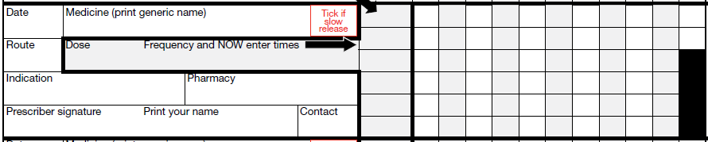
Figure above shows the NIMC regular medicine order space.
Use | Document the following:  - date – Note: this is the date on which the medicine order is being charted. generic medicine name  - tick slow release box if appropriate  - route  - dose  - frequency and enter administration times  - indication  - prescriber signature  - prescriber name printed  - prescriber contact details  - dose calculation (for NIMC (paediatric) and NIMC (paediatric long-stay) only)  - administration by initialling the provided space or double-initialling for the NIMC (paediatric) and the NIMC (paediatric long-stay).
Risk addressed | Standardising medicines prescribing and administering, and presentation of related information, reduces the risks of error through slips and lapses, the greatest causes of medicine error in health service organisations.

6.8 Pharmaceutical review
Found on all NIMCs except NIMC (day surgery).

Purpose | To document review of medicine orders by pharmacist
Figure above shows the NIMC pharmaceutical review space.
Use |  | Review the NIMC to ensure that all orders are clear, safe and appropriate for the patient and initial the space on the correct day.
Risk addressed |  | Unclear, unsafe and inappropriate medicine orders can risk patient safety.

6.9 Discharge supply
Found on all NIMCs except NIMC (day surgery).

Purpose | To order discharge supply
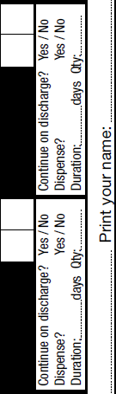
Figure above shows the NIMC discharge supply space which is displayed vertically in the regular medicine section and in the PRN medicine section.

Use | Document the following for each medicine:  - Continue on discharge? Circle yes if medicine is to be continued on discharge  - Dispense? Circle yes if the medicine is to be dispensed by the health service organisation pharmacy on discharge.  - Duration …days. Number of days the medicine is required on discharge.  - Qty………..Quantity of the medicine to be supplied.  For each page the following information is only required to be documented once:  - prescriber’s signature  - prescriber name printed and dated  - pharmacist signature and dated.
Risk addressed | Poor continuity of care, including ongoing medicines supply, risks patient recovery and safety. Prescribing discharge medicines directly from the medication chart reduces the risk of transcription error.
Figure above shows the private health service organisation NIMC discharge supply space which is displayed horizontally in the regular medicine section and vertically in the PRN medicines section.
Regular medicine orders: Further information
Limited duration medicines
When a regular medicine is ordered for a limited duration, this must be clearly indicated by crossing out the days/times when the medicine is NOT to be given. Boxing the specified times will help clarify when administration is required. Two options for ‘crossing and boxing’ are demonstrated in the following figures. Boxing must not obscure information included in the administration section.
Orders for antimicrobials must include a cease or review date.
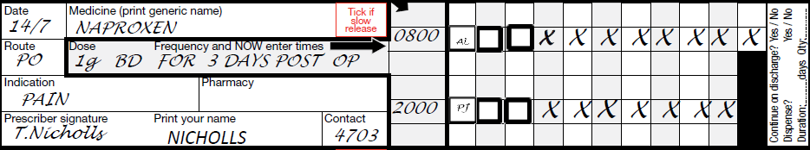

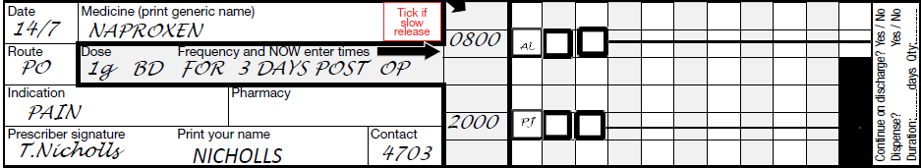

Figure above demonstrates how to cross and box administration days for a limited duration medicine.

Medicines intended for next day administration
Prescribers ordering medicines intended for next day administration should clearly cross out the days/times when the medicine is NOT to be given.

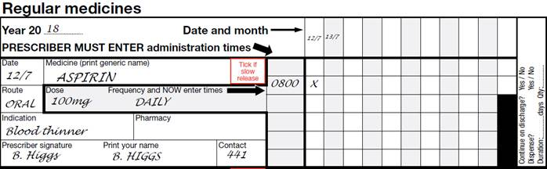

Intermittent dosing orders
Medicines requiring intermittent administration must be clearly indicated by crossing out the days/times when the medicine is NOT to be given. Boxing the specified times will help clarify when administration is required. 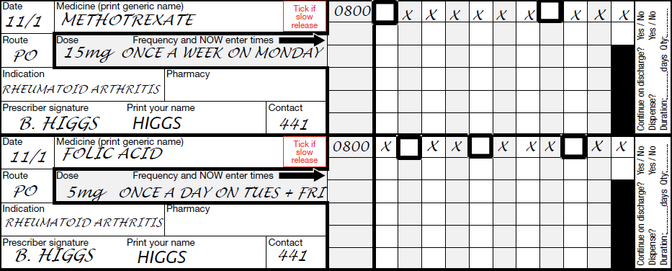

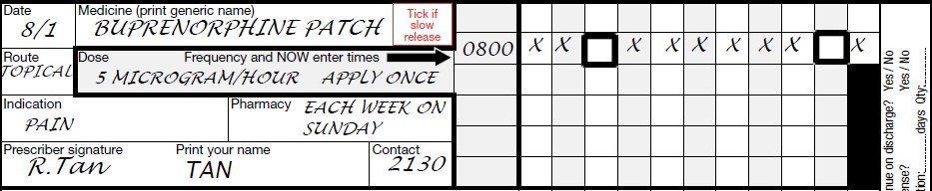
The three figures above demonstrate how to cross and box administration days for medicines with intermittent dosing

Medicine orders prescribed on an additional (specialty) chart
Regular medicines prescribed on specialty charts should be documented in the regular medicines section of the NIMC. The date and name of the medicine should be written into the ‘Medicine (Print generic name)’ field for the medicine order with a reference in the administration section indicating which specialty chart should be referred to, along with the initials of the prescriber. Administration of the medicine should be documented on the specialty chart to correspond with the medicine order.

Please also refer to section 4.5, Additional charts.

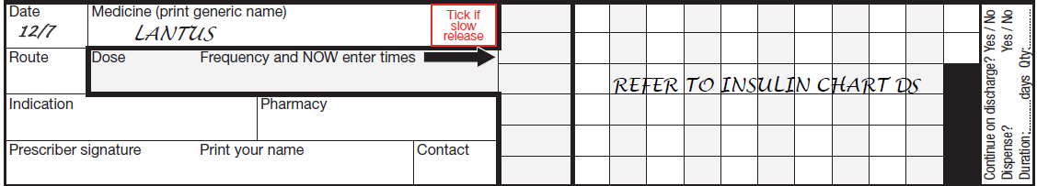
Figure above demonstrates how to cross-reference a regular medicine prescribed on an additional (specialty) chart.

Depot injectable medicines
Depot injectable medicines are commonly prescribed on a weekly, fortnightly, monthly or three-monthly basis and should be ordered using the same method as for intermittent dosing orders. These medicines may be ordered on the NIMC (acute) or the NIMC (long-stay). Inclusion of additional information such as site of injection and the next dose due date, will assist with discharge processes and continuity of care.
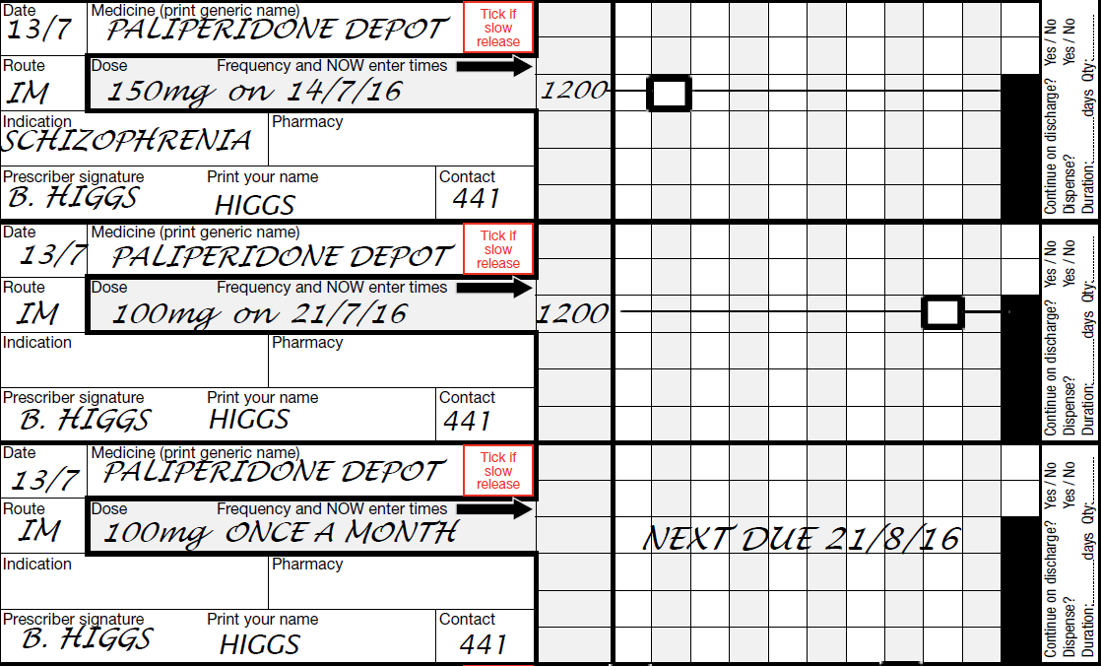
Figure above demonstrates how to cross and box administration days for a depot anti-psychotic on the NIMC (acute).

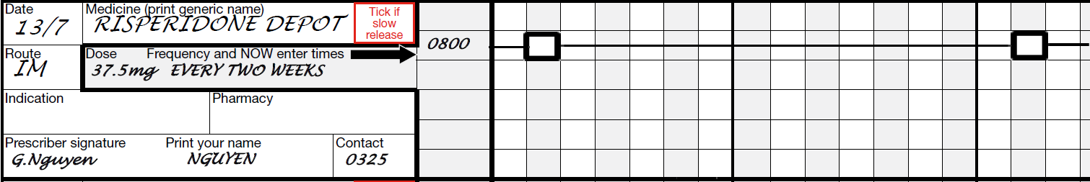

Figure above demonstrates how to cross and box administration days for a depot anti-psychotic on the NIMC (long-stay).
Ceased medicines
When stopping a medicine, the original order must not be obliterated. The prescriber must draw a clear line through the order in both the prescription and the administration record sections, taking care that the line does not impinge on other orders.
The prescriber must write the reason for changing the order (e.g. cease, written in error, increased dose etc), the date and their initials in the administration record section.
When a medicine order needs to be changed, the prescriber must not over write the order. The original order must be ceased and a new order written.
Note: The acronym D/C should not be used for ceased orders since this can be confused with Discharge. Always use Cease or Ceased.
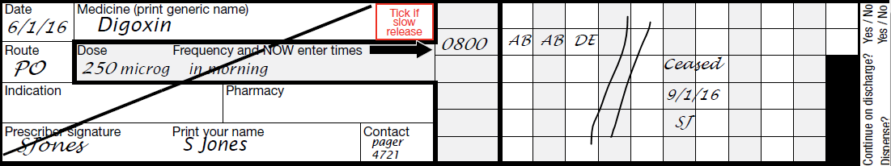
Figure above demonstrates how to cease an order on the NIMC.

Slow release medicines and other non-standard formulations
The Tick if Slow Release box is included in regular medicine spaces as a prompt to prescribers to consider whether or not the standard release form of the medicine is required. This box must be ticked to indicate a sustained, modified or controlled release form of an oral drug (e.g. verapamil SR, Diltiazem CD). If not ticked, then it is understood that the standard release form is to be administered.
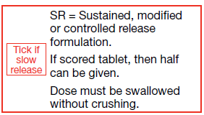
Figure above shows the Slow release legend box found in the middle of the NIMC and on the top of page 2 of the NIMC (GP e-version).

Reasons for not administering
Nurses administering medicine(s) should only sign in the administration box when the medicine has been observed to be administered.

When it is not possible to administer the prescribed medicine, the reason for not administering must be recorded by entering the appropriate code (see figure below) and circling. By circling the code it will not accidentally be misread as someone’s initials.

If a patient refuses medicine(s), then the prescriber must be notified. If medicine(s) are withheld, the reason must be documented in the patient’s medical notes.

If the medicine is not available when required, it is the responsibility of the person administering to notify the pharmacy and/or to obtain supply or to contact the prescriber to advise that the medicine ordered is not available.

Further information is available at Appendix B: Guidelines for administering and withholding medicines.
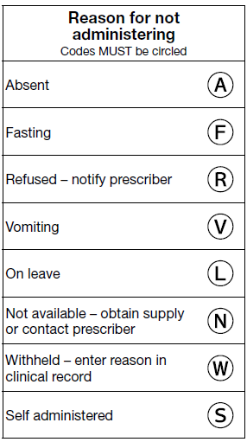

7. Medicine Orders: PRN (as required)

7.1 PRN order
Found on all NIMCs

Purpose | To order PRN (as required) medicines
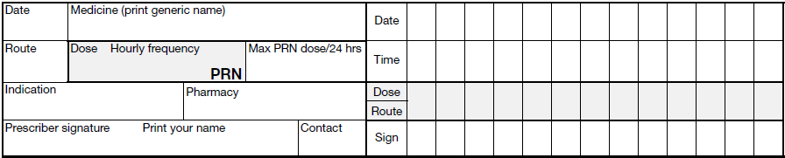
The figure above shows the NIMC PRN order section.
Use |  | Document the following for each medicine prescription:  - dose and hourly frequency. (PRN (pre-printed) alone is not sufficient.)  - route  - dose  - hourly frequency  - maximum daily dose (i.e. maximum PRN dose in 24 hours) e.g. Paracetamol 4g  - indication  - prescriber signature, printed name and contact details  Prescribing clinicians should exercise caution when prescribing PRN medicines and check the regular medicines section for possible duplicate orders.  Document the following for each medicine administration:  - date  - time  - dose given  - route  - initial  Administering clinicians should check the maximum PRN dose in 24 hours and also check the timing of the previous dose (either PRN or regular).
Risk addressed |  | Mistaking PRN orders for regular orders risks patient safety. Separating PRN from regular orders reduces the risk of error.
PRN (as required) medicines: Further information
Max PRN dose/24 hrs
The Max dose/ 24 hours prompt indicates the total amount of the medicine which may be administered in 24 hours for PRN doses only. The maximum daily dosage should not be exceeded for that PRN medicine.
Figure below is an example of an order with the PRN maximum daily dosage.
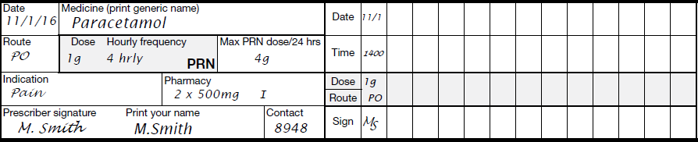
Multiple route orders
Generally, medicine orders should be for one route only. However, local requirements may indicate other practice. Health service organisations should be aware of risks associated with medicine orders with multiple routes of administration. A health service-specific list of exceptions to the general rule should be determined in conjunction with the health service’s drug and therapeutics committee or equivalent and appropriate risk mitigation strategies put in place.
Figure below is an example of an order for multiple routes and with the administration route recorded.
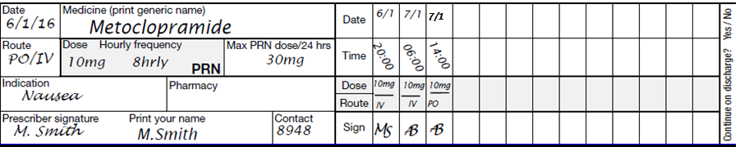

Prescribing PRN opioids
The sedation score may be specified in the ‘Max Dose/24 hrs’ section to indicate the maximum medicine amount to be administered when prescribing opioids in the PRN section.
When sedation scores are used, the local policy or guideline should specify a standard sedation scoring system and a process for recording the scores, and the record must be available at the point of care. Nursing and medical staff should be familiar with the sedation scale used.
For example, using the 4 point sedation scale of 0 to 3 published by the Victorian Quality Council, the PRN order could specify “if sedation score is less than 2”. The error-prone symbol < should not be used.
Figure below illustrates a sedation score specified in the Max Dose/24 hrs PRN order space.
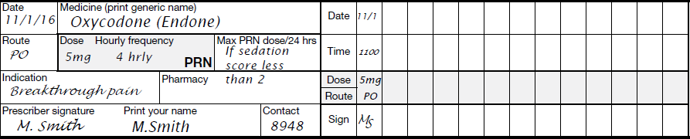

8. Paediatric NIMC: Additional safety features

The paediatric versions of the NIMC incorporate additional features identified as important for safe medicines use with paediatric and neonatal patients.

Patient weight, date, height, and body surface area
The child’s weight must be documented in the box on the front of the chart including the date when the child was weighed. The weight should also be documented on the back page when PRN medicines are ordered.
The height and body surface area should be documented for when body surface area (BSA) is used to calculate the dose of a medicine.

Gestational age at birth
There is space for recording gestational age at birth under the BSA and height box. This should be completed for premature infants.

Dose calculation
The prescriber must document the basis for the dose calculation in the dose calculation box (e.g. mg/kg/dose or microgram/m²/dose etc). Where a telephone order has been requested, the clinician receiving the order must also document the basis for the dose calculation as part of the order. This will assist pharmacists, nurses and other doctors in double-checking the dose to ensure that the intended and actual dose is calculated correctly.

Figure below is an example of an order for an infant weighing 10 kgs with dose calculation and double-signing for administration.
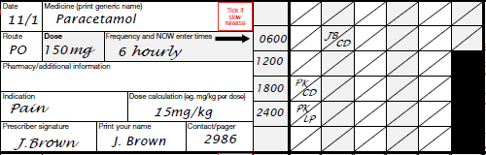

The basis for the dose calculation should first be checked in a current paediatric dosing reference endorsed by the local drug and therapeutics committee.
The actual dose should be calculated using an accurate weight or BSA (up to usual adult dose). If the child is obese or significantly oedematous, the ideal weight may be more appropriate.
All calculations should be double-checked.

Administration of medicines
There are two spaces for recording the administration of each dose of medicine to allow for the recording of two signatures, to document that the double checking process has occurred when required.

Additional reason for not administering medicine code
There is an additional reason for not administering medicine code on the NIMC paediatric charts. It is a P with a circle around it which records that the medicine was administered by the paediatric patient’s parent or carer.

Appendices

Appendix A: NIMC resources
The Commission maintains a range of resources to assist health services use the NIMC, audit its use and educate staff about it.

1. National standard medication charts (NSMC) (including design files and printing instructions)
https://www.safetyandquality.gov.au/our-work/medication-safety/medication-charts/

2. NIMC User Guide
https://www.safetyandquality.gov.au/publications-and-resources/resource-library/national-inpatient-medication-chart-nimc-user-guide

3. NIMC Local Management Guidelines
http://www.safetyandquality.gov.au/publications/nimc-local-management-guidelines-pdf-133kb/

4. NSMC Online Training Module (designed for all health professionals using the NIMC)
https://www.nps.org.au/cpd/activities/national-standard-medication-charts-course

5. Medication Safety Training (designed for all health professionals and to explore the causes of medication error)
https://www.nps.org.au/cpd/activities/medication-safety-training?profession=Pharmacists

6. NSMC national and local auditing
https://www.safetyandquality.gov.au/our-work/medication-safety/nsmc-audit/
7. Recommendations for Terminology, Abbreviations and Symbols used in medicines documentation
https://www.safetyandquality.gov.au/publications/recommendations-for-terminology-abbreviations-and-symbols-used-in-medicines-documentation/

8. National Medication Management Plan form and support materials
https://www.safetyandquality.gov.au/our-work/medication-safety/medication-reconciliation/medication-management-plan/

9. NIMC VTE Prophylaxis Section
https://www.safetyandquality.gov.au/our-work/medication-safety/vteprophylaxis/

10. High risk medicines resources
https://www.safetyandquality.gov.au/our-work/medication-safety/high-risk-medicines/

Appendix B: Guidelines for administering and withholding medicines

The NIMC is a legal document and therefore must be written in a clear, legible and unambiguous form.

Every nurse has a responsibility to ensure they can clearly read and understand the order before administering any medicines. For all incomplete or unclear orders, the prescriber should be contacted to clarify. Never make any assumptions about the prescriber’s intent.
Every medication chart must have the patient’s identification details completed.
Every medicine order must be complete and include:
- Date
- Route
- Generic medicine name
- Dose ordered in metric units & arabic numerals
- Frequency (using only accepted abbreviations)
- Times (must be entered by the authorised prescriber)
- Prescriber’s signature
If the medication chart is full (i.e. there is no appropriate space to sign for administration) then the medicine order is not valid. The chart must be re-written as soon as possible.

Withholding medicines
It is appropriate to withhold the medicine if there is a known adverse drug reaction (ADR) to the prescribed medicine.
Generally medicines should not be withheld if the patient is pre-operative or nil by mouth (NBM) / fasting unless specified by the authorised prescriber.

Remember the five Rs:
- The right medicine
- The right dose
- The right route
- The right time
- The right patient

Appendix C: Ordering oral and enteral nutrition supplements on the NIMC

The NIMC is not designed for ordering and recording administration of oral and enteral nutritional supplements. Its use for this purpose may result in:
- Confusion of nutritional supplements with medicines; (e.g. Pulmocare mistaken for the corticosteroid inhaler Pulmicort and amino acid liquid Nepro mistaken for the antiepileptic medicine Keppra)
- Potential for patients to receive unauthorised medicines
- Delays in provision and administration of nutrition to patients if the NIMC is sent to the pharmacy for dispensing.

Some health services have a separate clinical nutrition chart for ordering and administration of nutritional products including nutritional supplements. An example of clinical nutrition chart is available on the Commission web site at https://www.safetyandquality.gov.au/our-work/medication-safety/medication-charts/medication-charts-resources-and-tools/ordering-and-recording-nutritional-supplements-nimc-and-pbs-hmc

Health services that choose to use the NIMC for ordering nutritional supplements should undertake a risk assessment and have a local policy or procedure on ordering and recording administration of nutritional supplements. The same requirements that apply to safer prescribing and administration of medicines on the NIMC should also apply to ordering and recording administration of nutritional products on the NIMC. Local policies or procedures for ordering and recording administration of nutritional supplements on the NIMC should include:
- Who is responsible for ordering nutritional supplement on the NIMC (medical officer, authorised dietitian, etc.)
- The requirement for a dietitian to undertake training in the key principles of safe prescribing practices before ordering an approved nutritional supplement on the NIMC
- Where and how the nutritional supplement is ordered
- The requirement to annotate ‘nutritional supplement’ in the indication box or next to the product name
- How to cease the nutritional product
- Dietitian to regularly check NIMC for transcribing errors in nutritional product
- Regular auditing of prescriptions of nutritional supplements.

Example of a NIMC regular medicine space used for ordering and recording administration of nutritional supplement
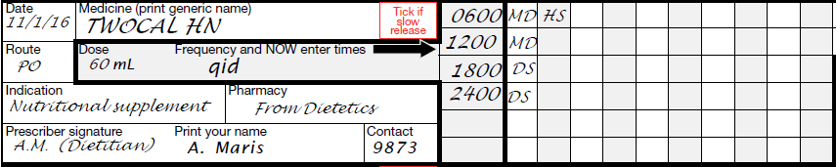

Appendix D: Ordering and administering medical gases on the NIMC

The NIMC should not be used to order or administer medical gases, such as oxygen. These medicines require specific features to safely order, administer and monitor their use. The necessary features are not included on the standard NIMC.

It is recognised that some jurisdictions have systems in place to order and administer medical gases, such as specific ancillary charts. Please contact your jurisdiction’s Health Services Medication Expert Advisory Group representative or health department for information on recommended processes for documenting orders and administration of medical gases.

Appendix E: NIMC (GP e-version) User Guide

Purpose
To provide guidance on use of the NIMC (GP e-version)

Key points
A four A4 page version of the NIMC (acute), the NIMC (GP e-version), was approved for use in 2009.
It is designed to assist general practitioners electronically prescribing for admitted patients primarily in rural and remote hospitals. The NIMC (GP e-version) should assist GPs (without access to A3 printers) to provide medicine orders for inpatients in a NIMC compliant format
Although not essential, colour printing is preferred as the document has contrasting red as a safety device to highlight:
- allergies and ADR information
- medicines taken prior to presentation (to distinguish from current medications)
- dedicated medicines boxes (for variable dose medication and warfarin)
- warfarin education box.

Differences between the NIMC (acute) and the NIMC (GP e-version)
The NIMC (acute) is a folded A3, double-side printed document. The NIMC (GP e-version) has the following differences:
- Each page requires full patient identification details (and which should be automatically populated when the chart is printed).
- Each page number is stated as part of the whole document, as in “Page 1 of 4”, Page 2 of 4” etc.
- Allergies and ADRs are detailed on page 1 and reference made to the page 1 details on successive pages.
- In instances where a patient has more than five allergies/ ADRs some versions of the NIMC (GP e-Version) will generate a fifth page (“Page 5 of 5”). The fifth page will contain the complete list of allergies and ADRs. All preceding pages will refer readers to the fifth page for the complete list of allergies and ADRs.
- Various boxed information (which is in the middle of pages 3 and 4 in the NIMC (acute) has been moved to underneath the allergy/ADR and patient ID space on page 2 of the NIMC (GP e-version).
- As a result of the boxed information on page 2, there is one less regular medicines space available than on the NIMC (acute).

Key practice issues
The same use requirements for the NIMC (GP e-version) apply as for the NIMC (acute) with the following additional requirements:
- All four pages (or five pages where an additional allergies/ADRs page has been generated), constitute a single chart and should not be printed in part.
- All pages of the chart must be kept together in the correct sequence.
- If the document is printed single-sided and placed in a ring folder, then pages 2 and 4 are punched on the right side so that the Regular Medicines section (across pages 2 and 3) can be seen and used as one page.
Hospitals and health services should develop local policies to manage introduction of the NIMC (GP e-version) into their facilities.

Background
Implementation of the NIMC (acute) in 2006 and 2007 resulted in problems for some general practitioners who electronically generated prescriptions for admitted patients in rural and remote hospitals on non NIMC compliant charts. These orders had to be transcribed by hand onto a complying NIMC which created additional patient safety risks.The NIMC Summary Rationale is attached for information.

Further NIMC support materials are available on the Commission website www.safetyandquality.gov.au

Appendix F: Summary Rationale for the National Inpatient Medication Chart

Ensuring patients receive the best therapy in a safe and effective manner is a complex process involving many health professionals often working in teams. One critical component of this process is the communication of medicines orders to allow safe and accurate dispensing, administration and reconciliation of medicines. Evidence suggests that communication can be made safer through education of safe prescribing and administration principles and with standardisation of best practice to reduce the potential for errors.

Additional potential benefits in patient safety are derived from:
- standardisation of best practice throughout the medication management cycle, within and between healthcare organisations
- standardisation of undergraduate, postgraduate and continuing professional education in the medication management cycle.

Key principles for ordering and administering medicines for an individual patient
When a medication chart is first written up, the patient’s name should always be handwritten at the top of the chart by the prescriber. This acts as a double check for pre-labelled charts and reduces the risk of ordering medicine for the wrong patient.
When subsequent new medicine orders are written, the chart should be checked to ensure it is for the correct patient.

A medication chart should include a section for recording adverse drug reaction information. This section should enable documentation of whether a reaction has previously occurred, the nature of the reaction (if one has occurred previously), the date the reaction occurred and the signature of the healthcare professional recording the information. If no previous reactions have occurred, this should be explicitly documented (e.g. ‘nil known’). If no information is available about previous reactions (e.g. if the patient is unable to communicate), this should also be documented (e.g. ‘unknown’). This section should be clearly visible where most regular prescriptions are written to reduce the risk of inadvertent exposure to a drug to which the patient is allergic.

A single medication chart should include a section for ‘once only’ and premedication orders so that they are neither on a separate chart nor included with regular orders. This minimises the risk of doses being missed or orders being continued inadvertently, as well as providing a more complete medication history on a single chart.

Telephone orders should be discouraged, unless essential due to work practice restrictions (for example, health service organisations with no resident medical staff). Where telephone orders are unavoidable, the medication chart should contain a section that facilitates the safe practice of two staff independently receiving and reading back the order to the prescriber. These orders should allow no more than four doses to be administered before being signed by the prescriber.

There should be a section on the medication chart for recording medicines taken by the patient prior to admission, except when a facility uses a dedicated medication reconciliation chart that accompanies the current medication chart. The inclusion of this information on or with the medication chart, or on a dedicated chart, facilitates reconciliation of pre-admission medicines with medicines prescribed whilst the patient is in care and at transfer. It also aids communication of changes to medicines made during admission to patients and primary care clinicians.

A medication chart must include a specific section for prescribing variable doses of medicines. This section should facilitate ordering and documentation of drug levels, as appropriate, to assist selection of suitable subsequent doses. It is recommended that this variable dose section be on the inside of the chart with other regular orders to reduce the risk of dose omissions.

A medication chart should include a specific section for documenting venous thrombo-embolism (VTE) risk, prophylaxis appropriateness, ordering and recording administration of VTE chemo-prophylaxis and ordering and recording checking of mechanical prophylaxis. Hospital-associated VTE is a national safety and quality issue with research showing that medication chart prompts can improve the rate of VTE risk assessment and of appropriate prophylaxis prescribing.

A medication chart should include a specific section for prescribing warfarin. Warfarin is associated with adverse events both through under-dosing and overdosing. The warfarin section should enable documentation of both the International Normalised Ration (INR) target range and INR results to facilitate dosing decisions. Ideally, warfarin should be administered at 4 p.m. to ensure morning results are reviewed and the next dose is ordered by a prescriber familiar with the patient’s medication management, rather than by ‘after-hours’ medical staff.

A medication chart should have a separate section for ‘when required’ (PRN) medicines in order to distinguish them from medicines that need to be given regularly. The PRN orders should be unambiguous, with clearly defined doses or dose ranges, minimum hourly frequency of administration and a recommended maximum dose in 24 hours, together with the indication for use.

A medication chart should include a specific section for nurse-initiated medicine, in accordance with state regulations and local practices.

Medicine orders should be dated from when the medication chart is rewritten, although medication management review is aided by documenting the date the medicine is started. It is useful to record in the National Medication Management Plan when medicines were commenced.

The chart should encourage prescribing using generic (active ingredient) medicine names. This is to reduce the risk of duplicate orders of the same medicine being made because of unfamiliarity with different trade (brand) names. In addition, medicines are usually stocked on the ward alphabetically by generic name, therefore generic prescribing facilitates location of the drug.

The chart should discourage the use of abbreviations, particularly those known to be error-prone. This reduces the risk of misinterpretation. Recommendations for Terminology, Abbreviations and Symbols used in the Prescribing and Administration of Medicines should be reflected in local health service organisation policy.

The chart should facilitate recording of the administration times by the prescriber, based on a locally agreed standard. This reduces the potential for nurses to misinterpret prescribed administration frequency instructions.

The chart should include a section for clinical pharmacist annotation regarding supply and administration. In addition, a section enabling pharmacists to sign the chart following review by a pharmacist facilitates peer review and improves communication with pharmacists covering the same ward or unit.

The chart should facilitate dispensing of discharge medicine directly from the medication chart, to avoid transcription errors. This may not be applicable for those sites using the PBS for discharge medicines or where separate discharge prescriptions are used. In such cases, local procedures should be developed to ensure that transcription errors are minimised and full medication reconciliation at discharge is facilitated.

The chart should include a section for prescriber contact details (for example, pager number), so that they can be easily contacted.

