
On the Radar
Issue 670
14 October 2024

On the Radar is a summary of some of the recent publications in the areas of safety and quality in health care. Inclusion in this document is not an endorsement or recommendation of any publication or provider. Access to particular documents may depend on whether they are Open Access or not, and/or your individual or institutional access to subscription sites/services. Material that may require subscription is included as it is considered relevant.

On the Radar is available online, via email or as a PDF or Word document from https://www.safetyandquality.gov.au/newsroom/subscribe-news/radar

If you would like to receive On the Radar via email, you can subscribe on our website https://www.safetyandquality.gov.au/newsroom/subscribe-news
or by emailing us at HUmail@safetyandquality.gov.auU.
You can also send feedback and comments to HUmail@safetyandquality.gov.auU.

For information about the Commission and its programs and publications, please visit https://www.safetyandquality.gov.au

On the Radar
Editor: Dr Niall Johnson

Reports

Guidance for best practices for clinical trials
World Health Organization
Geneva: WHO; 2024. p. 76.
URL | https://www.who.int/publications/i/item/9789240097711
Notes | The World Health Organization (WHO) has produced this document to help strengthen the role of clinical trials in producing high-quality evidence on health interventions and to improve research quality and coordination. It seeks to provide guidance for people ‘whose work is related to clinical trials in any way, including the planning, conduct, analysis, oversight, interpretation and funding of all clinical trials to assess the effects of any health intervention for any purpose in any setting.’

Journal articles

Moving from crisis response to a learning health system: Experiences from an Australian regional primary care network
Forrester B, Fisher G, Ellis LA, Giddy A, Smith CL, Zurynski Y, et al
Learning Health Systems. 2024:e10458.
DOI | https://doi.org/10.1002/lrh2.10458
Notes | Paper describing the experience of an Australian primary care network that was spurred into change by the COVID-19 pandemic. The pandemic crisis saw the Western Victorian Primary Health Network (WVPHN) establish a COVID-19 online Community of Practice comprising general practitioners, practice nurses, pharmacists, aged care and disability workers, health administrators, public health experts, medical specialists, and consumers. This has then evolved into a ‘Learning Health System’ (LHS). The authors report that ‘New models of care and care pathways were codeveloped in sessions and network leaders contributed to the development of guidelines and policy advice. These innovations enabled WVPHN to lead the Australian state of Victoria on rates of COVID vaccine uptake and GP antiviral prescribing.’

Defects in Value Associated With Hospital-Acquired Conditions: How Improving Quality Could Save U.S. Healthcare $50 Billion
Padula WV, Pronovost PJ
Journal of Patient Safety. 2024;20(7):512-515.
DOI | https://doi.org/10.1097/PTS.0000000000001259
Notes | This piece in the Journal of Patient Safety looks at the continuing issue of hospital-acquired conditions or complications (HACs) in the US context. The authors observe that ‘Currently, over 3.7 million patients experience a hospital-acquired condition in the United States each year, which costs the U.S. healthcare delivery system an excess of $48 billion.’ The authors note that current approaches include penalising health systems. They suggest that ‘A series of policy and health system solutions, including tracking of hospital-acquired condition rates in electronic health records, identifying centers of excellence at reducing rates of harm with the use of clinical practice guidelines, and rewarding them monetarily for reduced rates could create equal-sided risk and opportunity to engage health systems in improved performance.’

For information on the Commission’s work on hospital-acquired complications (HACs), including the national list of Hospital-Acquired Complications, see https://www.safetyandquality.gov.au/our-work/indicators-measurement-and-reporting/hospital-acquired-complications-hacs

Risk factors for wrong-site surgery: a study of 1,166 reports of informed consent and schedule errors
Taylor MA, Yonash RA
Patient Safety. 2024;6(1):1-11.
DOI | https://doi.org/10.33940/001c.117084
Notes | One of the most feared errors is that of wrong-site surgery. This study examined four years of data from the Pennsylvania Patient Safety Reporting System (PA-PSRS) database in order to examine consent and scheduling issues. The authors note that ‘The accuracy of informed consent and procedural schedule are important components in a process for preventing wrong-site surgery.’ In the 1,166 event reports examined, the study found that ‘56% described a schedule error, 34% had a consent error, and 10% involved both error types’.  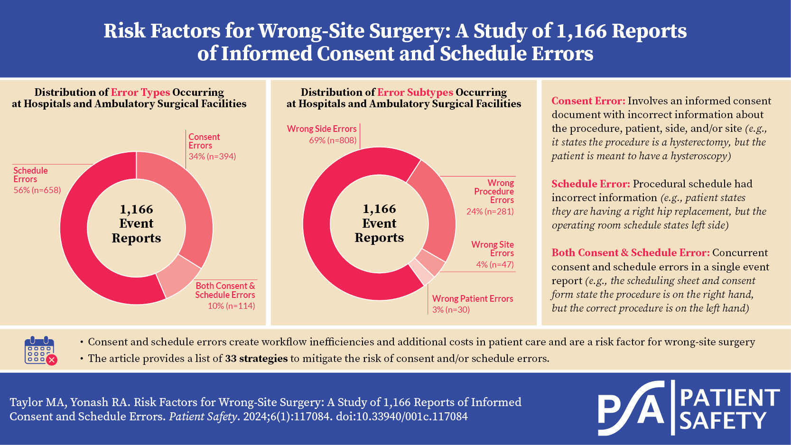

Australian Health Review
Volume 48, Number 5, October 2024
URL | https://www.publish.csiro.au/ah/issue/11613
Notes | A new issue of Australian Health Review has been published. Articles in this issue of Australian Health Review include:  - The current state of sustainable healthcare in Australia (Krista Verlis, Rebecca Haddock and Alexandra Barratt)  - The treatment gap for deep brain stimulation in Parkinson’s disease: a comparative analysis of cost and utilisation in high-income countries (Athena Stein, Nathan Higgins, Mehul Gajwani and Christian A Gericke)  - Multi-parametric magnetic resonance imaging of the prostate in Victoria, Australia; unintended consequences of changing Medicare Benefits Schedule access (Patrick Gordon, Evan Urquhart, Symrin Oad, Kenneth Mackenzie, Eldho Paul and Philip McCahy)  - Variation in direct healthcare costs to the health system by residents living in long-term care facilities: a Registry of Senior Australians study (Jyoti Khadka, Julie Ratcliffe, Gillian Caughey, Tracy Air, Steve Wesselingh, Megan Corlis, Keith Evans and Maria Inacio)  - Hospital staff perspectives on the cost and efficiency of peripheral intravenous catheter use: a case study from three Australian hospitals (Kathleen McFadden, Claire M. Rickard, Christine Brown, Amanda Corley, Jessica A Schults, Alison Craswell and Joshua Byrnes)  - A preference-based value framework to assess healthcare provision in an oil and gas industry (Anton Pak, Thomas Pols, Srinivas Kondalsamy-Chennakesavan, Matthew McGrail, Tiana Gurney, J L Fox and H Tuffaha)  - Temporal trends in medical device implant procedures in Australia 2008–22: evidence from the Australian Institute of Health and Welfare National Hospital Morbidity database (Mohammad Afshar Ali, Thu-Lan Kelly and Marianne Gillam)  - Antimicrobial surveillance in South Australian prisons: a pilot study (Ajmal Dalwai and Nadine Hillock)  - Turnover factors and retention strategies for chief executive officers in Australian hospitals (Nebu Mathew, Chaojie (George) Liu and Hanan Khalil)  - Clinical care ratios: differences in allied health roles in New Zealand (Seamus Gary McNicholl, Duncan Reid and Felicity Bright)  - Clinical care ratios for allied health practitioners: an update and implications for workforce planning (Cherie Hearn, Julie-Anne Ross, Adam Govier and Adam Ivan Semciw)  - Australian medical practitioners: trends in demographics and regions of work 2013–2022 (Colin H Cortie, David Garne, Lyndal Parker-Newlyn, Rowena G Ivers, Judy Mullan, Kylie J. Mansfield and Andrew Bonney)  - Evaluating anti-bullying training in surgery: surgeons’ perceptions from Australia and Aotearoa New Zealand (Paul Gretton-Watson, Jodi Oakman and Sandra G Leggat)  - A collaborative approach to support people with a disability living in Australian group homes during the COVID-19 pandemic: a case study (James Everingham, Sarah Todd, Sarita Y Lo and Vasi Naganathan)  - What is the impact of successive COVID-19 lockdowns on population mental health? Findings from an Australian natural experiment using health service data (Ali Lakhani and Vijaya Sundararajan)  - Informing the management of the post-COVID condition: insights from the Western Australian experience comparing those who tested positive and negative to early COVID-19 strains (Kristen Grove, Vinicius Cavalheri, HuiJun Chih, Varsha Natarajan, Meg Harrold, Sheeraz Mohd, Elizabeth Hurn, Lisa Van der Lee, Andrew Maiorana, Jessica Tearne, Carol Watson, Jane Pearce, Angela Jacques, Ann White, Caitlin Vicary, Caroline Roffman, Emma-Leigh Synnott, Ian Suttie, Ivan Lin, Jade Larsson, Louise Naylor, Linda Woodhouse, Mercedes Elliott, Paul Gittings, Peta Winship, Robyn Timms, Sheldon Wulff, Tracy Hebden-Todd and Dale W Edgar)  - Reducing surgical site infections: prioritising change in Australian and New Zealand healthcare (Kevin Tetsworth)  - The [AMA] doth protest too much, methinks’ (Jonathon Bruce Ryan)

Health Affairs
Volume 43, Number 10, October 2024
URL | https://www.healthaffairs.org/toc/hlthaff/43/10
Notes | A new issue of Health Affairs has been published with the themes ‘Children, Medicare, Pharmaceuticals and more’. Articles in this issue of Health Affairs include:  - The Disproportionate Burden Of Alzheimer’s On Latino Communities  La Carga Desproporcionada Del Alzheimer En Las Comunidades Latinas (Heidi de Marco)  - Intended And Unintended Outcomes After FDA Pediatric Antidepressant Warnings: A Systematic Review (Stephen B Soumerai, Ross Koppel, Huseyin Naci, Jeanne M Madden, Andra Fry, Alyssa Halbisen, Jesenia Angeles, Jonah Koppel, Rachelle Rubin, and Christine Y Lu)  - Cost-Effectiveness And Health Impact Of Increasing Emergency Department Pediatric Readiness In The US (Christopher Weyant, Amber Lin, Craig D Newgard, Nathan Kuppermann, Marianne Gausche-Hill, Katherine E Remick, Hilary A Hewes, R S Burd, N C Mann, S G Ames, B G Carr, S Malveau, K J McConnell, J N B Cook, and J D Goldhaber-Fiebert)  - State Variations In Progress Toward Eliminating Disparities In Infant Mortality, 2007–19 (Samantha Goldfarb, Megan Deichen Hansen, Jessica Day, Joedrecka S Brown Speights, George Rust, and Jeffrey Harman)  - Institutional Special Needs Plans In Nursing Homes: Substantial Enrollment Growth But Low Availability, 2006–21 (Amanda C Chen, Joseph G P Hnath, and David C. Grabowski)  - Cost-Associated Unmet Dental, Vision, And Hearing Needs Among Low-Income Medicare Advantage Beneficiaries (Avni Gupta, Kenton J Johnston, Diana Silver, David J. Meyers, Sherry A Glied, and José A Pagán)  - Postapproval Innovation For Oncology Drugs And The Inflation Reduction Act (Henry Grabowski, Joseph A DiMasi, and Genia Long)  - Low- And Middle-Income Countries Experienced Delays Accessing New Essential Medicines, 1982–2024 (Olivier J Wouters, and Jouni Kuha)  - Medicare Part D Protected-Class Policy Is Associated With Lower Drug Rebates (Pragya Kakani, Michael Anne Kyle, Amitabh Chandra, and L Maini)  - A Majority Of Americans Have No Or Low Awareness Of Paxlovid, The At-Home COVID-19 Treatment (Gillian K SteelFisher, Mary G Findling, Hannah L Caporello, Keri M Lubell, Lindsay Lane, Ericka McGowan, Laura C Espino, Jazmyne Sutton, and Michael L Barnett)  - Addressing Problems With Medicaid Home And Community-Based Services In The Age Of Rebalancing (Katherine Rohde, Norma B Coe, Pilar Gonalons-Pons, Katherine Miller, Amanda R Kreider, and A K Hoffman)  - Implementation Of New Mexico’s ‘No Behavioral Health Cost Sharing’ Law: A Qualitative Study (Samantha J Harris, Ezra Golberstein, Johanna Catherine Maclean, Bradley D Stein, Susan L Ettner, and Brendan Saloner)  - High-Deductible Health Insurance May Exacerbate Racial And Ethnic Wealth Disparities (Naomi Zewde, Sergio Rivera Rodriguez, and S A Glied)  - Food Insufficiency Increased After The Expiration Of COVID-19 Emergency Allotments For SNAP Benefits In 2023 (Whitney Wells, Kaitlyn Jackson, Cindy W Leung, and Rita Hamad)  - Unsustainable: Why I Left Primary Care (Laura M Hahn)

JBI Evidence Synthesis
Volume 22, Issue 10, October 2024
URL | https://journals.lww.com/jbisrir/toc/2024/10000
Notes | A new issue of JBI Evidence Synthesis has been published. Articles in this issue of JBI Evidence Synthesis include:  - Editorial: From chaos to clarity: how COVID-19 exposed the urgent need for better evidence synthesis (Amy E L Stone, Sherli Koshy-Chenthittayil, Megan DeArmond)  - Comparison of diagnostic accuracy of rapid antigen tests for COVID-19 compared to the viral genetic test in adults: a systematic review and meta-analysis (Ellyn Hirabayashi, Guadalupe Mercado, Brandi Hull, Sabrina Soin, Sherli Koshy-Chenthittayil, Sarina Raman, Timothy Huang, Chathushya Keerthisinghe, Shelby Feliciano, Andrew Dongo, James Kal, Azliyati Azizan, Karen Duus, Terry Else, Megan DeArmond, Amy E L Stone)  - Bereavement care guidelines used in health care facilities immediately following perinatal loss: a scoping review (Lisa R Roberts, Jan M Nick, Nancy L Sarpy, Judith Peters, Shanalee Tamares)  - Midwives’ and registered nurses’ role and scope of practice in acute early pregnancy care services: a scoping review (Nicole Freeman, Jane Warland, Kate Cheney, Zoe Bradfield)  - Economic burden and economic impact associated with non-communicable diseases among countries of the World Health Organization South-East Asia Region: a systematic review protocol (Geetha R Menon, Sheuli Misra, Vishal Deo, Jeetendra Yadav, Pradeep Joshi, Cherian Varghese, Denny John)  - Experiences of accessing mental health services for women living on a low income in Canada: a qualitative systematic review protocol (Emma Vanderlee, Addisu Taye Abate, Christina Godfrey, Lenora Duhn, Pilar Camargo-Plazas)  - Occupational therapy assessments and interventions for patients with ankylosing spondylitis: a scoping review protocol (John V Rider, Abigail E LaVerdure, Megan De Armond)  - Treatment outcomes in maxillofacial rehabilitation: a scoping review protocol (Sreelakshmi Viswanath, Saranya Sreekumar, Chandrasekhar Janakiram, Suresh Nayar, Anil Mathew)  - eHealth early intervention programs to support premature parents transitioning from NICU to home on parental and infant outcomes: a systematic review protocol (Liliana Ferraz, Maria Raul Xavier, Manuel Gameiro, Ana Filipa Cardoso, Daniela Cardoso, Lúcia Paradela, Daniela Dinis, Estela Coutinho, Ananda Fernandes)  - Experiences of parents of teenagers with life-threatening food allergies: a qualitative systematic review protocol (Karen Dobbin-Williams, Renee Crossman, Michelle Swab)  - Transformative engagement with community music-making for older adults: a scoping review protocol (Helen Jane English, Suzanne Lewis, Jane W. Davidson, Nicholas Goodwin)  - Views of general practice staff on sharing general practice data for research: a scoping review protocol (Heidi Green, Belinda Fabrianesi, Lucy Carolan, Annette Braunack-Mayer)

BMJ Quality & Safety online first articles
URL | https://qualitysafety.bmj.com/content/early/recent
Notes | BMJ Quality &Safety has published a number of ‘online first’ articles, including:  - County-level racial bias is associated with worse care for white and especially black older US adults: a cross-sectional observational study (Matthew L Mizel, Ann Haas, John L Adams, Steven C Martino, Amelia M Haviland, Bonnie Ghosh-Dastidar, Jacob W Dembosky, Malcolm Williams, Gary Abel, Jessica Maksut, Jennifer Gilder, Marc N Elliott)  - Editorial: Rising above the strain? Adaptive strategies used by healthcare providers in intensive care units to promote safety (Debbie Massey, Brigid M Gillespie)  - Editorial: Patient-activated escalation in hospital: patients and their families are ready! (Christian Peter Subbe, Alison V Phillips, Lorelei Jones)  - Factors affecting implementation of a National Clinical Programme for self-harm in hospital emergency departments: a qualitative study (Selena O'Connell, Grace Cully, Sheena McHugh, Margaret Maxwell, Anne Jeffers, Katerina Kavalidou, Sally Lovejoy, Rhona Jennings, Vincent Russell, Ella Arensman, Eve Griffin)  - WHO research agenda on the role of the institutional safety climate for hand hygiene improvement: a Delphi consensus-building study (Ermira Tartari, Julie Storr, Nita Bellare, Claire Kilpatrick, Maryanne McGuckin, Mitchell J Schwaber, Didier Pittet, Benedetta Allegranzi)

International Journal for Quality in Health Care online first articles
URL | https://academic.oup.com/intqhc/advance-articles
Notes | International Journal for Quality in Health Care has published a number of ‘online first’ articles, including:  - Promoting holistic and inclusive care for women: A call for updated health policies (Danilo V Rogayan et al)

Online resources

Australian Living Evidence Collaboration
https://livingevidence.org.au/

[UK] Decision support tools
https://www.england.nhs.uk/personalisedcare/shared-decision-making/decision-support-tools/
NHS England have added 5 new decision support tools or patient decision aids to this webpage. These tools are designed to support shared decision making between people and a clinician. People may find they are useful before, during or between consultations depending on their care pathway. The latest additions include:
- Abdominal aortic aneurysm: making a decision about abdominal aortic aneurysm (AAA)
- Angina: making a decision about stable angina
- Depression: making decisions about managing depression
- Glue ear: making a decision about glue ear if your child has hearing loss
- Chronic primary pain: making decisions to help you live well with chronic primary pain.

For information on the Commission’s work on shared decision making see https://www.safetyandquality.gov.au/our-work/partnering-consumers/shared-decision-making
For information on the Commission’s work on decision support tools see https://www.safetyandquality.gov.au/our-work/partnering-consumers/shared-decision-making/decision-support-tools-specific-conditions

COVID-19 resources
https://www.safetyandquality.gov.au/covid-19
The Australian Commission on Safety and Quality in Health Care has developed a number of resources to assist healthcare organisations, facilities and clinicians. These and other material on COVID-19 are available at https://www.safetyandquality.gov.au/covid-19
These resources include:
- Poster – Combined contact and droplet precautions https://www.safetyandquality.gov.au/publications-and-resources/resource-library/infection-prevention-and-control-poster-combined-contact-and-droplet-precautions
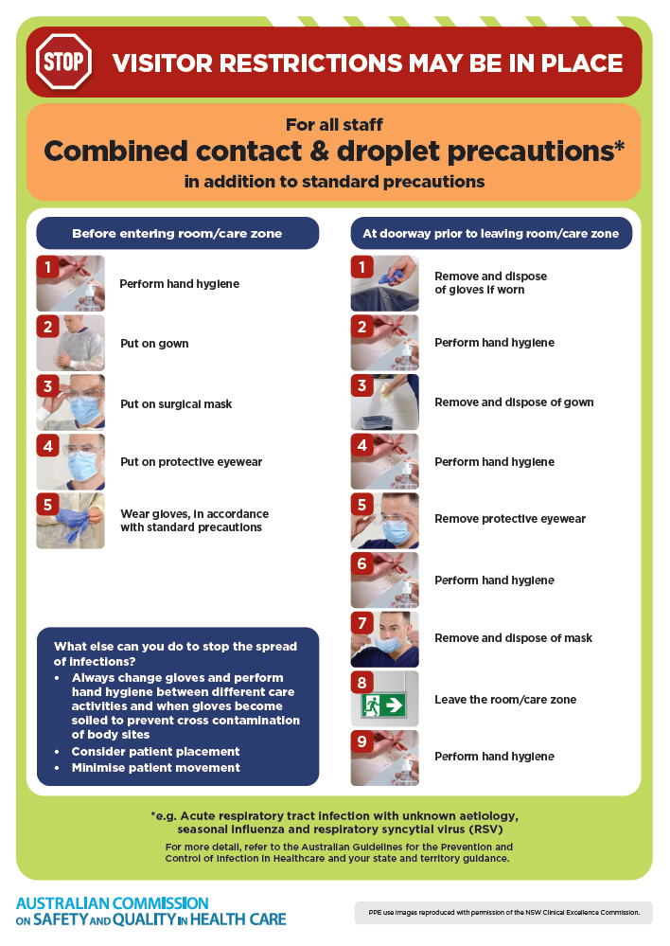
- Poster – Combined airborne and contact precautions
https://www.safetyandquality.gov.au/publications-and-resources/resource-library/infection-prevention-and-control-poster-combined-airborne-and-contact-precautions
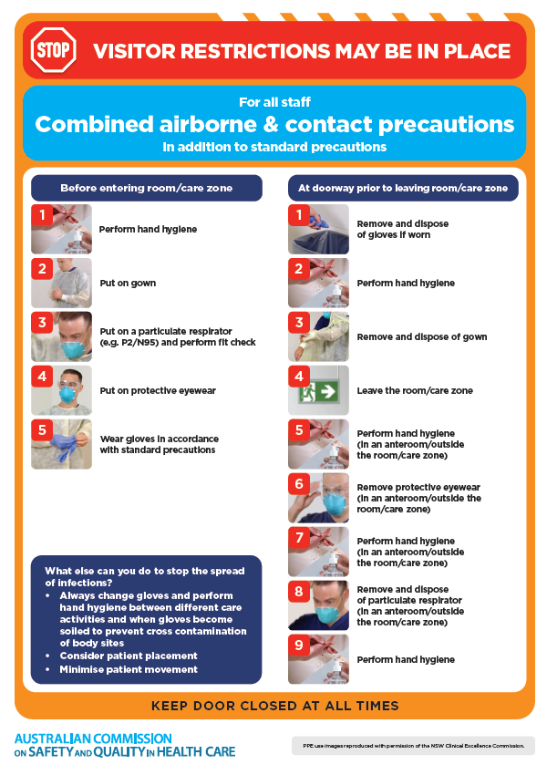
- Environmental Cleaning and Infection Prevention and Control www.safetyandquality.gov.au/environmental-cleaning
- COVID-19 infection prevention and control risk management – Guidance https://www.safetyandquality.gov.au/publications-and-resources/resource-library/covid-19-infection-prevention-and-control-risk-management-guidance
- Safe care for people with cognitive impairment during COVID-19
https://www.safetyandquality.gov.au/our-work/cognitive-impairment/cognitive-impairment-and-covid-19
- Break the chain of infection poster
https://www.safetyandquality.gov.au/publications-and-resources/resource-library/break-chain-infection-poster
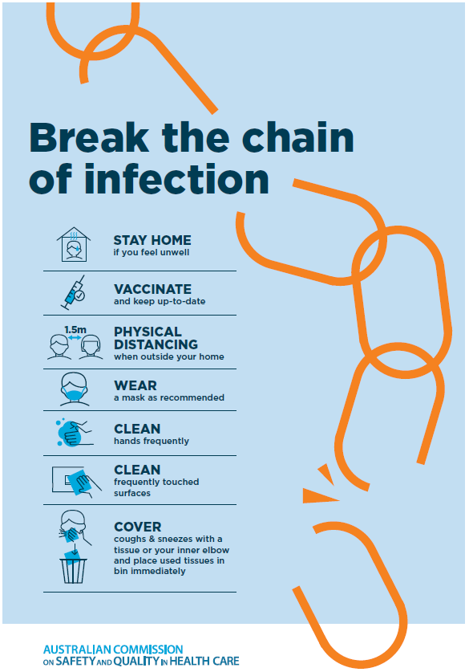
- COVID-19 and face masks – Information for consumers https://www.safetyandquality.gov.au/publications-and-resources/resource-library/covid-19-and-face-masks-information-consumers
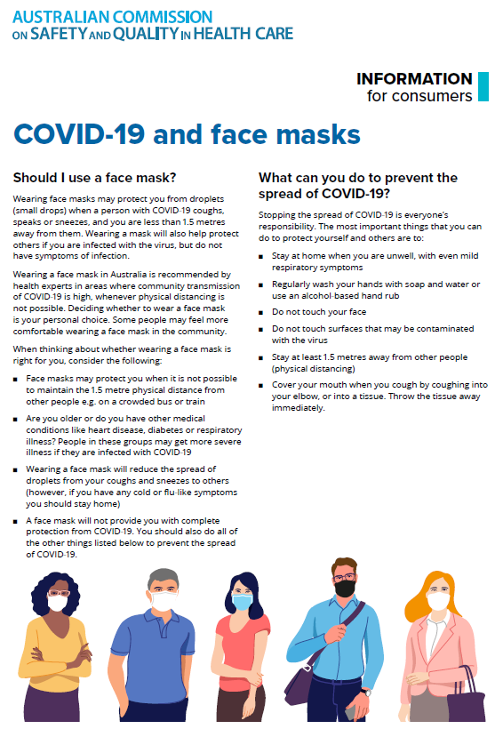

Disclaimer
On the Radar is an information resource of the Australian Commission on Safety and Quality in Health Care. The Commission is not responsible for the content of, nor does it endorse, any articles or sites listed. The Commission accepts no liability for the information or advice provided by these external links. Links are provided on the basis that users make their own decisions about the accuracy, currency and reliability of the information contained therein. Any opinions expressed are not necessarily those of the Australian Commission on Safety and Quality in Health Care.

